 |  | E  TG/209/1 Rev.  ORIGINAL: English  DATE: 2003-04-09 + 2006-04-05  + 2009-04-01
INTERNATIONAL UNION FOR THE PROTECTION OF NEW VARIETIES OF PLANTS
GENEVA

 | DENDROBIUM  (Dendrobium Sw.) | *

GUIDELINES

FOR THE CONDUCT OF TESTS

FOR DISTINCTNESS, UNIFORMITY AND STABILITY

Alternative Names:*

Latin | English | French | German | Spanish
Dendrobium Sw. | Dendrobium | Dendrobium | Dendrobium | Dendrobium

ASSOCIATED DOCUMENTS

These guidelines should be read in conjunction with document TG/1/3, “General Introduction to the Examination of Distinctness, Uniformity and Stability and the Development of Harmonized Descriptions of New Varieties of Plants” (hereinafter referred to as the “General Introduction”) and its associated “TGP” documents.

TABLE OF CONTENTS PAGE

1. Subject of these Test Guidelines 3
2. Material Required 3
3. Method of Examination 3
3.1 Duration of Tests 3
3.2 Testing Place 3
3.3 Conditions for Conducting the Examination 3
3.4 Test Design 4
3.5 Number of Plants / Parts of Plants to be Examined 4
3.6 Additional Tests 4
4. Assessment of Distinctness, Uniformity and Stability 4
4.1 Distinctness 4
4.2 Uniformity 5
4.3 Stability 5
5. Grouping of Varieties and Organization of the Growing Trial 5
6. Introduction to the Table of Characteristics 6
6.1 Categories of Characteristics 6
6.2 States of Expression and Corresponding Notes 6
6.3 Types of Expression 7
6.4 Example Varieties 7
6.5 Legend 7
7. Table of Characteristics 8
8. Explanations on the Table of Characteristics 34
8.1 Explanations covering several characteristics 34
8.2 Explanations for individual characteristics 34
9. Literature 41
10. Technical Questionnaire 42

Subject of these Test Guidelines
These Test Guidelines apply to all varieties of sect. Brachyanthe, sect. Callista, sect. Calyptochilus, sect. Ceratobium, sect. Dendrocoryne, sect. Eleutheroglossum, sect. Eugenanthe, sect. Latourea, sect. Oxygenianthe, sect. Oxyglossum, sect. Pedilonum, sect. Phalaenanthe, sect. Stachyobium, of Dendrobium Sw. of the family Orchidaceae and their hybrids.

Material Required
2.1 The competent authorities decide on the quantity and quality of the plant material required for testing the variety and when and where it is to be delivered. Applicants submitting material from a State other than that in which the testing takes place must ensure that all customs formalities and phytosanitary requirements are complied with.

2.2 The material is to be supplied in the form of two-year old plants that have not previously flowered.

2.3 The minimum quantity of plant material, to be supplied by the applicant, should be:

10 two-year-old plants, each with at least two pseudobulbs.

2.4 The plant material supplied should be visibly healthy, not lacking in vigor, nor affected by any important pest or disease.

2.5 The plant material should not have undergone any treatment which would affect the expression of the characteristics of the variety, unless the competent authorities allow or request such treatment. If it has been treated, full details of the treatment must be given.

Method of Examination

3.1 Duration of Tests
The minimum duration of tests should normally be a single growing cycle.

3.2 Testing Place
The tests should normally be conducted at one place. If any characteristics of the variety, which are relevant for the examination of DUS, cannot be seen at that place, the variety may be tested at an additional place.

3.3 Conditions for Conducting the Examination
3.3.1 The tests should be carried out under conditions ensuring satisfactory growth for the expression of the relevant characteristics of the variety and for the conduct of the examination.

3.3.2 The tests should be conducted in a greenhouse with the following conditions for the Northern Hemisphere:

Time of submission of plant material: | First half of February
Planting: | February ~ March
Substrate: | Porous with good aeration  Size of pot: medium
Temperature: | D. nobile type varieties: minimum 10° C  D. phalaenopsis type varieties: minimum 20° C
Shading: | Summer season 30% shading (optimum 50 thousand Lux)
Fertilizing: | April ~ July
Low temperature treatment (flower differentiation): | D. nobile type varieties; 10 ~ 13° C for one month in November

3.4 Test Design
3.4.1 The design of the tests should be such that plants or parts of plants may be removed for measurement or counting without prejudice to the observations which must be made up to the end of the growing cycle.

3.4.2 Each test should be designed to result in a total of at least 10 plants.

3.5 Number of Plants / Parts of Plants to be Examined
Unless otherwise indicated, all observations determined by measuring or counting should be made on 10 plants or parts taken from each of 10 plants.

3.6 Additional Tests
Additional tests, for examining relevant characteristics, may be established.

Assessment of Distinctness, Uniformity and Stability

4.1 Distinctness

4.1.1 General Recommendations

It is of particular importance for users of these Test Guidelines to consult the General Introduction prior to making decisions regarding distinctness. However, the following points are provided for elaboration or emphasis in these Test Guidelines.

4.1.2 Consistent Differences

The minimum duration of tests recommended in section 3.1 reflects, in general, the need to ensure that any differences in a characteristic are sufficiently consistent.

4.1.3 Clear Differences

Determining whether a difference between two varieties is clear depends on many factors, and should consider, in particular, the type of expression of the characteristic being examined, i.e. whether it is expressed in a qualitative, quantitative, or pseudo-qualitative manner. Therefore, it is important that users of these Test Guidelines are familiar with the recommendations contained in the General Introduction prior to making decisions regarding distinctness.

4.2 Uniformity
4.2.1 It is of particular importance for users of these Test Guidelines to consult the General Introduction prior to making decisions regarding uniformity. However, the following points are provided for elaboration or emphasis in these Test Guidelines:

4.2.2 For the assessment of uniformity a population standard of 1% and an acceptance probability of at least 95% should be applied. In the case of a sample size of 10 plants, 1 off-type is allowed.

4.3 Stability
4.3.1 In practice, it is not usual to perform tests of stability that produce results as certain as those of the testing of distinctness and uniformity. However, experience has demonstrated that, for many types of variety, when a variety has been shown to be uniform, it can also be considered to be stable.

4.3.2 Where appropriate, or in cases of doubt, stability may be tested, either by growing a further generation, or by testing a new plant stock to ensure that it exhibits the same characteristics as those shown by the previous material supplied.

4.3.3 The stability of a hybrid variety may, in addition to an examination of the hybrid variety itself, also be assessed by examination of the uniformity and stability of its parent lines.

Grouping of Varieties and Organization of the Growing Trial
5.1 The selection of varieties of common knowledge to be grown in the trial with the candidate varieties and the way in which these varieties are divided into groups to facilitate the assessment of distinctness is aided by the use of grouping characteristics.

5.2 Grouping characteristics are those in which the documented states of expression, even where produced at different locations, can be used, either individually or in combination with other such characteristics: (a) to select varieties of common knowledge that can be excluded from the growing trial used for examination of distinctness; and (b) to organize the growing trial so that similar varieties are grouped together.
5.3 The following have been agreed as useful grouping characteristics:

(a) Plant: size (characteristic 1)
(b) Inflorescence: position of flowers (characteristic 18)
(c) Flower: length in front view (characteristic 27)
(d) Flower: width in front view (characteristic 28)
(e) Lip: presence of lateral lobe (characteristic 71)
(f) Lip: eye (characteristic 77)
(g) Lip: color pattern (except middle part, eye and throat) (characteristic 80)
(h) Lip: main color (characteristic 82) with the following groups:

Gr. 1: green
Gr. 2: white
Gr. 3: yellow
Gr. 4: pink
Gr. 5: red
Gr. 6: purple
Gr. 7: reddish

5.4 Guidance for the use of grouping characteristics, in the process of examining distinctness, is provided through the General Introduction.

Introduction to the Table of Characteristics

6.1 Categories of Characteristics
6.1.1 Standard Test Guidelines Characteristics

Standard Test Guidelines characteristics are those which are approved by UPOV for examination of DUS and from which members of the Union can select those suitable for their particular circumstances.

6.1.2 Asterisked Characteristics

Asterisked characteristics (denoted by *) are those included in the Test Guidelines which are important for the international harmonization of variety descriptions and should always be examined for DUS and included in the variety description by all members of the Union, except when the state of expression of a preceding characteristic or regional environmental conditions render this inappropriate.

6.2 States of Expression and Corresponding Notes
States of expression are given for each characteristic to define the characteristic and to harmonize descriptions. Each state of expression is allocated a corresponding numerical note for ease of recording of data and for the production and exchange of the description.

6.3 Types of Expression
An explanation of the types of expression of characteristics (qualitative, quantitative and pseudo-qualitative) is provided in the General Introduction.

6.4 Example Varieties
6.4.1 Where appropriate, example varieties are provided to clarify the states of expression of each characteristic. So far only few varieties exist; therefore, mainly species and only few example varieties are indicated in the Table of Characteristics. All variety denominations are preceded by group names (GREX). General remark: In orchids, a particular grouping on the basis of known parentage, of which the unit is the GREX is in long standing use.

6.4.2 Variety denominations are placed between single quotation marks (e.g. ‘Akebono’).

6.5 Legend
(*) Asterisked characteristic – see Section 6.1.2

QL Qualitative characteristic – see Section 6.3
QN Quantitative characteristic – see Section 6.3
PQ Pseudo-Qualitative characteristic – see Section 6.3

(a)-(e) See Explanations on the Table of Characteristics in Chapter 8, Section 8.1

(+) See Explanations on the Table of Characteristics in Chapter 8, Section 8.2

Table of Characteristics/Tableau des caractères/Merkmalstabelle/Tabla de caracteres
 |  | English | français | deutsch | español | Example Varieties  Exemples  Beispielssorten  Variedades ejemplo | Note/  Nota
1.  (*) |  | Plant: size | Plante: taille | Pflanze: Größe | Planta: tamaño
QN |  | very small | très petite | sehr klein | muy pequeña | Enobi Komachi ‘Shirayukihime’ | 1
 |  | small | petite | klein | pequeña | Dendrobium kingianum | 3
 |  | medium | moyenne | mittel | media | Wave King ‘Akebono’ | 5
 |  | large | grande | groß | grande | Lucky Girl ‘Emiko’ | 7
 |  | very large | très grande | sehr groß | muy grande |  | 9
2.  (*) | (a) | Pseudobulb: attitude | Pseudobulbe: disposition | Pseudobulbe: Haltung | Pseudobulbo: porte
QN |  | erect | dressé | aufrecht | erecto | ‘Formidible’ | 1
 |  | semi-erect | demi-dressé | halbaufrecht | semierecto |  | 3
 |  | horizontal | horizontal | waagerecht | horizontal |  | 5
 |  | semi-drooping | demi-retombant | halbüberhängend | semicolgante |  | 7
 |  | drooping | retombant | überhängend | colgante |  | 9
3.  (*) | (a) | Pseudobulb: length | Pseudobulbe: longueur | Pseudobulbe: Länge | Pseudobulbo: longitud
QN |  | very short | très court | sehr kurz | muy corto | Enobi Komachi ‘Shirayukihime’ | 1
 |  | short | court | kurz | corto | Dendrobium kingianum | 3
 |  | medium | moyen | mittel | medio | Wave King ‘Akebono’ | 5
 |  | long | long | lang | largo | Snow Cap ‘Love Song’ | 7
 |  | very long | très long | sehr lang | muy largo |  | 9
4.  (*) | (a) | Pseudobulb: thickness | Pseudobulbe: épaisseur | Pseudobulbe: Dicke | Pseudobulbo: grosor
QN |  | very thin | très fin | sehr dünn | muy delgado |  | 1
 |  | thin | fin | dünn | delgado | Enobi Komachi ‘Shirayukihime’ | 3
 |  | medium | moyen | mittel | medio | Enobi Parade ‘Milky Way’ | 5
 |  | thick | épais | dick | grueso |  | 7
 |  | very thick | très épais | sehr dick | muy grueso |  | 9
5.  (*) | (a) | Pseudobulb: shape in longitudinal section | Pseudobulbe:  forme en section longitudinale | Pseudobulbe: Form im Längsschnitt | Pseudobulbo: forma en sección longitudinal
PQ |  | linear | linéaire | linear | lineal | ‘Formidible’ | 1
 |  | lanceolate | lancéolé | lanzettlich | lanceolada |  | 2
 |  | ovate | ovale | eiförmig | oval |  | 3
6. | (a) | Pseudobulb: shape in cross section | Pseudobulbe:  forme en section transversale | Pseudobulbe: Form im Querschnitt | Pseudobulbo: forma en sección transversal
PQ |  | elliptic | elliptique | elliptisch | elíptica |  | 1
 |  | circular | arrondi | rund | circular | ‘Formidible’ | 2
 |  | angular | anguleux | kantig | angular | Dendrobium densiflorum | 3
7. |  | Plant: age of flowering pseudobulb (principally) | Plante: âge du pseudobulbe florifère (principalement) | Pflanze: Alter der blühenden Pseudobulbe (hauptsächlich) | Planta: tiempo de floración del pseudobulbo (principalmente)
QL |  | one year | un an | ein Jahr | un año | ‘Formidible’ | 1
 |  | two years or more | deux ans et plus | zwei Jahre oder mehr | dos años o más |  | 2
8.  (*) | (b) | Leaf: length | Feuille: longueur | Blatt: Länge | Hoja: longitud
QN |  | short | courte | kurz | corta | Stardust ‘Chiyomi’ | 3
 |  | medium | moyenne | mittel | media | Wave King ‘Akebono’ | 5
 |  | long | longue | lang | larga |  | 7
9.  (*) | (b) | Leaf: width | Feuille: largeur | Blatt: Breite | Hoja: anchura
QN |  | narrow | étroite | schmal | estrecha | Stardust ‘Chiyomi’ | 3
 |  | medium | moyenne | mittel | media | Wave King ‘Akebono’ | 5
 |  | broad | large | breit | ancha | Snow Cap ‘Love Song’ | 7
10.  (*)  (+) | (b) | Leaf: shape | Feuille: forme | Blatt: Form | Hoja: forma
PQ |  | narrow elliptic | elliptique étroite | schmal elliptisch | elíptica estrecha |  | 1
 |  | elliptic | elliptique | elliptisch | elíptica |  | 2
 |  | narrow ovate | ovale étroite | schmal eiförmig | oval estrecha |  | 3
 |  | narrow obovate | obovale étroite | schmal verkehrt eiförmig | oboval estrecha |  | 4
 |  | spatulate | spatulée | spatelförmig | espatulada |  | 5
11. | (b) | Leaf: main green color | Feuille: couleur verte principale | Blatt: hauptsächliche Grünfärbung | Hoja: color verde principal
QN |  | light | claire | hell | claro |  | 3
 |  | medium | moyenne | mittel | medio | Enobi Komachi ‘Shirayukihime’ | 5
 |  | dark | foncée | dunkel | oscuro | Enobi Parade ‘Milky Way’ | 7
12. | (b) | Leaf: presence of variegation | Feuille: présence de panachure | Blatt: Vorhandensein einer Panaschierung | Hoja: presencia de variegado
QL |  | absent | absente | fehlend | ausente | Enobi Komachi ‘Shirayukihime’ | 1
 |  | present | présente | vorhanden | presente |  | 9
13.  (+) | (b) | Leaf: type of variegation | Feuille: type de panachure | Blatt: Art der Panaschierung | Hoja: tipo de variegado
QL |  | brindled | mouchetée | gescheckt | pinto |  | 1
 |  | spotted | tachetée | gefleckt | manchado |  | 2
 |  | striped | striée | gestreift | estriado |  | 3
 |  | centered | centrée | in der Mitte | centrado |  | 4
 |  | edged | bordée | gerändert | ribeteado |  | 5
14. | (b) | Leaf: color of variegation | Feuille: couleur de la panachure | Blatt: Farbe der Panaschierung | Hoja: color del variegado
QL |  | white | blanche | weiß | blanco |  | 1
 |  | yellow | jaune | gelb | amarillo |  | 2
 |  | yellow green | vert-jaune | gelbgrün | verde amarillento |  | 3
 |  | white and yellow | blanche et jaune | weiß und gelb | blanco y amarillo |  | 4
 |  | white and yellow green | blanche et vert-jaune | weiß und gelbgrün | blanco y verde amarillento |  | 5
 |  | yellow and yellow green | jaune et vert-jaune | gelb und gelbgrün | amarillo y verde amarillento |  | 6
15. | (b) | Leaf: pubescence | Feuille: pilosité | Blatt: Behaarung | Hoja: pubescencia
QL |  | absent | absente | fehlend | ausente |  | 1
 |  | present | présente | vorhanden | presente | ‘Formidible’ | 9
16. | (b) | Leaf: color of pubescence | Feuille: couleur des poils | Blatt: Farbe der Behaarung | Hoja: color de la pubescencia
QL |  | white | blancs | weiß | blanco |  | 1
 |  | black | noirs | schwarz | negro | ‘Formidible’ | 2
17.  (*) | (c) | Inflorescence: position of adherence to pseudobulb | Inflorescence: emplacement de l’adhérence au pseudobulbe | Blütenstand: Position des Anhaftens an der Pseudobulbe | Inflorescencia: posición de la adherencia al pseudobulbo
QL |  | along whole length | sur toute la longueur | entlang der ganzen Länge | a lo largo de todo el tallo |  | 1
 |  | top part only | seulement sur la partie supérieure | nur am oberen Teil | únicamente en la parte superior | Dendrobium kingianum | 2
18.  (*) | (c) | Inflorescence: position of flowers | Inflorescence: position des fleurs | Blütenstand: Position der Blüten | Inflorescencia: posición de las flores
QL |  | along peduncle | le long du pédoncule | entlang des Blütenstiels | a lo largo del pedúnculo | Snow Cap ‘Love Song’ | 1
 |  | apex only | seulement sur le sommet | nur an der Spitze | únicamente en el ápice | Pink Beauty ‘Queen’ | 2
19.  (*) | (c) | Inflorescence: number of flowers | Inflorescence: nombre de fleurs | Blütenstand: Anzahl Blüten | Inflorescencia: número de flores
QN |  | few | rares | gering | bajo | Enobi Komachi ‘Shirayukihime’ | 3
 |  | medium | assez nombreuses | mittel | medio | Snow Cap ‘Love Song’ | 5
 |  | many | nombreuses | groß | alto |  | 7
20.  (*)  (+) |  | Peduncle: length | Pédoncule: longueur | Blütenstiel: Länge | Pedúnculo: longitud
QN |  | short | court | kurz | corto | Lucky Girl ‘Emiko’ | 3
 |  | medium | moyen | mittel | medio | Enobi Parade ‘Milky Way’ | 5
 |  | long | long | lang | largo | Queen Southeast ‘Crystal Queen’ | 7
21.  (*) |  | Peduncle: thickness | Pédoncule: épaisseur | Blütenstiel: Dicke | Pedúnculo: grosor
QN |  | thin | fin | dünn | delgado |  | 3
 |  | medium | moyen | mittel | medio | Lucky Girl ‘Emiko’ | 5
 |  | thick | épais | dick | grueso |  | 7
22.  (*) |  | Peduncle: attitude | Pédoncule: disposition | Blütenstiel: Haltung | Pedúnculo: porte
PQ |  | erect | dressé | aufrecht | erecto | Enobi Komachi ‘Shirayukihime’ | 1
 |  | semi-erect | demi-dressé | halbaufrecht | semierecto | Snow Cap ‘Love Song’ | 2
 |  | horizontal | horizontal | waagerecht | horizontal |  | 3
 |  | recurving | retombant | zurückgebogen | curvado hacia abajo |  | 4
23.  (*)  (+) |  | Pedicellate-ovary: length | Ovaire pédonculaire: longueur | Fruchtknoten mit gestielten Blüten: Länge | Ovario pedicelado: longitud
QN |  | short | courte | kurz | corto | Wave King ‘Akebono’ | 3
 |  | medium | moyenne | mittel | medio | Snow Cap ‘Love Song’ | 5
 |  | long | longue | lang | largo |  | 7
24.  (*) |  | Pedicellate-ovary: thickness | Ovaire pédonculaire: épaisseur | Fruchtknoten mit gestielten Blüten: Dicke | Ovario pedicelado: grosor
QN |  | thin | fine | dünn | delgado | Wave King ‘Akebono’ | 3
 |  | medium | moyenne | mittel | medio |  | 5
 |  | thick | épaisse | dick | grueso |  | 7
25.  (*) | (c) | Flower: general appearance of petals and sepals | Fleur: apparence générale des pétales et sépales | Blüte: Allgemeine Erscheinung der Blütenblätter und der Kelchblätter | Flor: aspecto general de pétalos y sépalos
PQ |  | all incurving | tous incurvés | alle eingebogen | todos curvados hacia adentro |  | 1
 |  | some incurving,  some spreading | quelques-uns incurvés,  quelques-un étalés | einige eingebogen, einige gespreizt | algunos curvados hacia adentro,  otros extendidos | Stardust ‘Chiyomi’ | 2
 |  | all spreading | tous étalés | alle gespreizt | todos extendidos |  | 3
 |  | some spreading,  some reflexing | quelques-uns étalés, quelques-uns réfléchis | einige gespreizt, einige zurückgebogen | algunos extendidos, otros curvados hacia afuera | Enobi Komachi ‘Shirayukihime’ | 4
 |  | all reflexing | tous réfléchis | alle zurückgebogen | todos curvados hacia afuera |  | 5
 |  | some incurving,  some reflexing | quelques-uns incurvés, quelques-uns réfléchis | einige eingebogen, einige zurückgebogen | algunos curvados hacia adentro y otros hacia afuera |  | 6
26. | (d) | Flower: length of mentum | Fleur: longueur du mentum | Blüte: Länge des Mentums | Flor: longitud del mentón
QN |  | short | court | kurz | corto | Dendrobium kingianum | 3
 |  | medium | moyen | mittel | medio | ‘Formidible’ | 5
 |  | long | long | lang | largo |  | 7
27.  (*)  (+) | (d) | Flower: length in front view | Fleur: longueur en vue de face | Blüte: Länge in der Vorderansicht | Flor: longitud en vista frontal
QN |  | short | courte | kurz | corta | Enobi Komachi ‘Shirayukihime’ | 3
 |  | medium | moyenne | mittel | media | Lucky Girl ‘Emiko’ | 5
 |  | long | longue | lang | larga |  | 7
28.  (*)  (+) | (d) | Flower: width in front view | Fleur: largeur en vue de face | Blüte: Breite in der Vorderansicht | Flor: anchura en vista frontal
QN |  | narrow | étroite | schmal | estrecha | Enobi Komachi ‘Shirayukihime’ | 3
 |  | medium | moyenne | mittel | media | Lucky Girl ‘Emiko’ | 5
 |  | broad | large | breit | ancha |  | 7
29. | (c) | Flower: fragrance | Fleur: parfum | Blüte: Duft | Flor: fragancia/perfume
QL |  | absent | absent | fehlend | ausente |  | 1
 |  | present | présent | vorhanden | presente | Snow Cap ‘Love Song’ | 9
30.  (*) | (c) | Dorsal sepal: curvature of longitudinal axis | Sépale dorsal: courbure de l’axe longitudinal | Dorsales Kelchblatt: Biegung der Längsachse | Sépalo dorsal: curvatura del eje longitudinal
QN |  | strongly incurving | fortement incurvé | stark eingebogen | fuertemente curvado hacia arriba |  | 1
 |  | moderately incurving | moyennement incurvé | mäßig eingebogen | moderadamente curvado hacia arriba |  | 3
 |  | straight | droit | gerade | recto | Snow Cap ‘Love Song’ | 5
 |  | moderately recurving | moyennement retombant | mäßig zurückgebogen | moderadamente curvado hacia abajo | Enobi Komachi ‘Shirayukihime’ | 7
 |  | strongly recurving | fortement retombant | stark zurückgebogen | fuertemente recurvado hacia abajo |  | 9
31.  (*) | (d) | Dorsal sepal: length | Sépale dorsal: longueur | Dorsales Kelchblatt: Länge | Sépalo dorsal: longitud
QN |  | short | court | kurz | corto | Enobi Parade ‘Milky Way’ | 3
 |  | medium | moyen | mittel | medio | Wave King ‘Akebono’ | 5
 |  | long | long | lang | largo |  | 7
32.  (*) | (d) | Dorsal sepal: width | Sépale dorsal: largeur | Dorsales Kelchblatt: Breite | Sépalo dorsal: anchura
QN |  | narrow | étroit | schmal | estrecho | Enobi Parade ‘Milky Way’ | 3
 |  | medium | moyen | mittel | medio | Wave King ‘Akebono’ | 5
 |  | broad | large | breit | ancho |  | 7
33.  (*)  (+) | (d) | Dorsal sepal: shape | Sépale dorsal: forme | Dorsales Kelchblatt: Form | Sépalo dorsal: forma
PQ |  | narrow elliptic | elliptique étroit | schmal elliptisch | elíptica estrecha | Stardust ‘Chiyomi’ | 1
 |  | elliptic | elliptique | elliptisch | elíptica | Lucky Girl ‘Emiko’ | 2
 |  | ovate | ovale | eiförmig | oval |  | 3
 |  | obovate | obovale | verkehrt eiförmig | oboval |  | 4
 |  | transverse elliptic | elliptique transversal | quer elliptisch | elíptica transversal |  | 5
 |  | spatulate | spatulé | spatelförmig | espatulada |  | 6
34.  (*)  (+) | (c) | Dorsal sepal: cross section | Sépale dorsal:  section transversale | Dorsales Kelchblatt: Querschnitt | Sépalo dorsal: sección transversal
QN |  | strongly concave | fortement concave | stark konkav | fuertemente cóncava |  | 1
 |  | moderately concave | moyennement concave | mittel konkav | moderadamente cóncava |  | 3
 |  | flat | plate | flach | plana | Snow Cap ‘Love Song’ | 5
 |  | moderately convex | moyennement convexe | mittel konvex | moderadamente convexa |  | 7
 |  | strongly convex | fortement convexe | stark konvex | fuertemente convexa | Pink Beauty ‘Queen’ | 9
35.  (*) | (c) | Dorsal sepal: twisting | Sépale dorsal: torsion | Dorsales Kelchblatt: Drehung | Sépalo dorsal: torsión
QN |  | absent or very weak | nulle ou très faible | fehlend oder sehr gering | ausente o muy débil |  | 1
 |  | weak | faible | gering | débil | Stardust ‘Chiyomi’ | 3
 |  | medium | moyenne | mittel | media |  | 5
 |  | strong | forte | stark | fuerte |  | 7
 |  | very strong | très forte | sehr stark | muy fuerte |  | 9
36.  (*) | (c) | Dorsal sepal: undulation of margin | Sépale dorsal: ondulation du bord | Dorsales Kelchblatt: Randwellung | Sépalo dorsal: ondulación del margen
QN |  | absent or very weak | nulle ou très faible | fehlend oder sehr gering | ausente o muy débil |  | 1
 |  | weak | faible | gering | débil |  | 3
 |  | medium | moyenne | mittel | media | Pink Beauty ‘Queen’ | 5
 |  | strong | forte | stark | fuerte |  | 7
 |  | very strong | très forte | sehr stark | muy fuerte |  | 9
37.  (*) | (c) | Lateral sepal: curvature of longitudinal axis | Sépale latéral: courbure de l’axe longitudinal | Seitliches Kelchblatt: Biegung der Längsachse | Sépalo lateral: curvatura del eje longitudinal
QN |  | strongly incurving | fortement incurvé | stark eingebogen | fuertemente curvado hacia arriba |  | 1
 |  | moderately incurving | moyennement incurvé | mittel eingebogen | moderadamente curvado hacia arriba |  | 3
 |  | straight | droit | gerade | recto | Snow Cap ‘Love Song’ | 5
 |  | moderately recurving | moyennement retombant | mittel zurückgebogen | moderadamente curvado hacia abajo | Enobi Komachi ‘Shirayukihime’ | 7
 |  | strongly recurving | fortement courbé | stark zurückgebogen | fuertemente curvado hacia abajo |  | 9
38.  (*) | (d) | Lateral sepal: length | Sépale latéral: longueur | Seitliches Kelchblatt: Länge | Sépalo lateral: longitud
QN |  | short | court | kurz | corto | Enobi Parade ‘Milky Way’ | 3
 |  | medium | moyen | mittel | medio | Wave King ‘Akebono’ | 5
 |  | long | long | lang | largo |  | 7
39.  (*) | (d) | Lateral sepal: width | Sépale latéral: largeur | Seitliches Kelchblatt: Breite | Sépalo lateral: anchura
QN |  | narrow | étroit | schmal | estrecho | Enobi Parade ‘Milky Way’ | 3
 |  | medium | moyen | mittel | medio | Wave King ‘Akebono’ | 5
 |  | broad | large | breit | ancho |  | 7
40.  (*)  (+) | (c) | Lateral sepal: shape | Sépale latéral: forme | Seitliches Kelchblatt: Form | Sépalo lateral: forma
PQ |  | narrow elliptic | elliptique étroit | schmal elliptisch | elíptica estrecha |  | 1
 |  | elliptic | elliptique | elliptisch | elíptica | Enobi Komachi ‘Shirayukihime’ | 2
 |  | ovate | ovale | eiförmig | oval |  | 3
 |  | obovate | obovale | verkehrt eiförmig | oboval |  | 4
 |  | transverse elliptic | elliptique transversal | quer elliptisch | elíptica transversal |  | 5
 |  | spatulate | spatulé | spatelförmig | espatulada |  | 6
41.  (*)  (+) | (c) | Lateral sepal: cross section | Sépale latéral: section transversale | Seitliches Kelchblatt: Querschnitt | Sépalo lateral: sección transversal
QN |  | strongly concave | fortement concave | stark konkav | fuertemente cóncava |  | 1
 |  | moderately concave | moyennement concave | mittel konkav | moderadamente cóncava | Stardust ‘Chiyomi’ | 3
 |  | straight | droit | gerade | recta | Enobi Parade ‘Milky Way’ | 5
 |  | moderately convex | moyennement convexe | mittel konvex | moderadamente convexa |  | 7
 |  | strongly convex | fortement convexe | stark konvex | fuertemente convexa |  | 9
42.  (*) | (c) | Lateral sepal: twisting | Sépale latéral: torsion | Seitliches Kelchblatt: Drehung | Sépalo lateral: torsión
QN |  | absent or very weak | nulle ou très faible | fehlend oder sehr gering | ausente o muy débil |  | 1
 |  | weak | faible | gering | débil | Stardust ‘Chiyomi’ | 3
 |  | medium | moyenne | mittel | media |  | 5
 |  | strong | forte | stark | fuerte |  | 7
 |  | very strong | très forte | sehr stark | muy fuerte |  | 9
43.  (*) | (c) | Lateral sepal: undulation of margin | Sépale latéral: ondulation du bord | Seitliches Kelchblatt: Randwellung | Sépalo lateral: ondulación del margen
QN |  | absent or very weak | nulle ou très faible | fehlend oder sehr gering | ausente o muy débil |  | 1
 |  | weak | faible | gering | débil | Wave King ‘Akebono’ | 3
 |  | medium | moyenne | mittel | media | Pink Beauty ‘Queen’ | 5
 |  | strong | forte | stark | fuerte |  | 7
 |  | very strong | très forte | sehr stark | muy fuerte |  | 9
44.  (*) | (c)  (e) | Sepal: number of colors | Sépale: nombre de couleurs | Kelchblatt: Anzahl Farben | Sépalo: número de colores
QL |  | one | une | eine | uno |  | 1
 |  | two | deux | zwei | dos | Snow Cap ‘Love Song’ | 2
 |  | three | trois | drei | tres |  | 3
 |  | more than three | plus de trois | mehr als drei | más de tres |  | 4
45.  (*) | (c)  (e) | Sepal: color pattern | Sépale: répartition de la couleur | Kelchblatt: Farbverteilung | Sépalo: distribución del color
QL |  | self-colored | unicolore | einfarbig | del mismo color | Stardust ‘Chiyomi’ | 1
 |  | shaded | dégradée | schattiert | sombreado | Snow Cap ‘Love Song’ | 2
 |  | edged | bordée | gerändert | ribeteado | Holy Night ‘Yumeji’ | 3
 |  | striped | striée | gestreift | estriado |  | 4
 |  | netted | réticulée | netzartig | reticulado |  | 5
 |  | spotted | tachetée | fleckig | manchado |  | 6
 |  | shaded and striped | dégradée et striée | schattiert und gestreift | sombreado y estriado |  | 7
 |  | shaded and netted | dégradée et réticulée | schattiert und netzartig | sombreado y reticulado |  | 8
 |  | shaded and spotted | dégradée et tachetée | schattiert und fleckig | sombreado y manchado |  | 9
46. | (c)  (e) | Sepal: main color | Sépale: couleur principale | Kelchblatt: Hauptfarbe | Sépalo: color principal
PQ |  | RHS Colour Chart (indicate reference number) | Code RHS des couleurs (indiquer le numéro de référence) | RHS-Farbkarte (Nummer angeben) | Carta de colores RHS (indíquese el número de referencia)
47. | (c)  (e) | Varieties with shaded sepals only: Sepal: extent of shading | Variétés à sépales dégradés seulement: Sépale: étendue du dégradé | Nur Sorten mit schattierten Kelchblättern: Kelchblatt: Ausdehnung der Schattierung | Sólo variedades de sépalos sombreados: Sépalo: extensión del sombreado
QN |  | small | petite | gering | pequeño |  | 3
 |  | medium | moyenne | mittel | medio | Snow Cap ‘Love Song’ | 5
 |  | large | grande | groß | grande |  | 7
48. | (c)  (e) | Varieties with shaded sepals only: Sepal: color of shading | Variétés à sépales dégradés seulement: Sépale: couleur du dégradé | Nur Sorten mit schattierten Kelchblättern: Kelchblatt: Farbe der Schattierung | Sólo variedades de sépalos sombreados: Sépalo: color del sombreado
PQ |  | RHS Colour Chart (indicate reference number) | Code RHS des couleurs (indiquer le numéro de référence) | RHS-Farbkarte (Nummer angeben) | Carta de colores RHS (indíquese el número de referencia)
49. | (c)  (e) | Varieties with edged sepals only: Sepal: color of edging | Variétés à sépales bordés seulement: Sépale: couleur de la bordure | Nur Sorten mit geränderten Kelchblättern: Kelchblatt: Farbe der Ränderung | Sólo variedades de sépalos ribeteados: Sépalo: color del ribeteado
PQ |  | RHS Colour Chart (indicate reference number) | Code RHS des couleurs (indiquer le numéro de référence) | RHS-Farbkarte (Nummer angeben) | Carta de colores RHS (indíquese el número de referencia)
50. | (c)  (e) | Varieties with striped sepals only: Sepal: color of stripes | Variétés à sépales striés seulement: Sépale: couleur des stries | Nur Sorten mit gestreiften Kelchblättern: Kelchblatt: Farbe der Streifen | Sólo variedades de sépalos estriados: Sépalo: color de las estrías
PQ |  | RHS Colour Chart (indicate reference number) | Code RHS des couleurs (indiquer le numéro de référence) | RHS-Farbkarte (Nummer angeben) | Carta de colores RHS: (indíquese el número de referencia)
51. | (c)  (e) | Varieties with netted sepals only: Sepal: color of netting | Variétés à sépales réticulés seulement: Sépale: couleur de la réticulation | Nur Sorten mit netzartigen Kelchblättern: Kelchblatt: Farbe des Netzes | Solamente variedades de sépalos reticulados: Sépalo: color del reticulado
PQ |  | RHS Colour Chart (indicate reference number) | Code RHS des couleurs (indiquer le numéro de référence) | RHS-Farbkarte (Nummer angeben) | Carta de colores RHS (indíquese el número de referencia)
52. | (c)  (e) | Varieties with spotted sepals only: Sepal: color of spots | Variétés à sépales tachetés seulement: Sépale: couleur des taches | Nur Sorten mit fleckigen Kelchblättern: Kelchblatt: Farbe der Flecken | Sólo variedades de sépalos manchados: Sépalo: color de las manchas
PQ |  | RHS Colour Chart (indicate reference number) | Code RHS des couleurs (indiquer le numéro de référence) | RHS-Farbkarte (Nummer angeben) | Carta de colores RHS (indíquese el número de referencia)
53.  (*) | (c) | Petal: curvature of longitudinal axis | Pétale: courbure de l’axe longitudinal | Blütenblatt: Biegung der Längsachse | Pétalo: curvatura del eje longitudinal
QN |  | strongly incurving | fortement incurvé | stark eingebogen | fuertemente curvado hacia arriba |  | 1
 |  | moderately incurving | moyennement incurvé | mittel eingebogen | moderadamente curvado hacia arriba |  | 3
 |  | straight | droit | gerade | recto | Lucky Girl ‘Emiko’ | 5
 |  | moderately recurving | moyennement retombant | mittel zurückgebogen | moderadamente curvado hacia abajo | Enobi Komachi ‘Shirayukihime’ | 7
 |  | strongly recurving | fortement retombant | stark zurückgebogen | fuertemente curvado hacia abajo |  | 9
54.  (*) | (d) | Petal: length | Pétale: longueur | Blütenblatt: Länge | Pétalo: longitud
QN |  | short | court | kurz | corto | Enobi Parade ‘Milky Way’ | 3
 |  | medium | moyen | mittel | medio | Wave King ‘Akebono’ | 5
 |  | long | long | lang | largo |  | 7
55.  (*) | (d) | Petal: width | Pétale: largeur | Blütenblatt: Breite | Pétalo: anchura
QN |  | narrow | étroit | schmal | estrecho | Enobi Parade ‘Milky Way’ | 3
 |  | medium | moyen | mittel | medio | Wave King ‘Akebono’ | 5
 |  | broad | large | breit | ancho |  | 7
56.  (*)  (+) | (c) | Petal: shape | Pétale: forme | Blütenblatt: Form | Pétalo: forma
PQ |  | narrow elliptic | elliptique étroit | schmal elliptisch | elíptica estrecha |  | 1
 |  | elliptic | elliptique | elliptisch | elíptica | Stardust ‘Chiyomi’ | 2
 |  | ovate | ovale | eiförmig | oval |  | 3
 |  | obovate | obovale | verkehrt eiförmig | oboval |  | 4
 |  | transverse elliptic | elliptique transversal | quer elliptisch | elíptica transversal |  | 5
 |  | spatulate | spatulé | spatelförmig | espatulada |  | 6
57.  (*)  (+) | (c) | Petal: cross section | Pétale: section transversale | Blütenblatt: Querschnitt | Pétalo: sección transversal
QN |  | strongly concave | fortement concave | stark konkav | fuertemente cóncava |  | 1
 |  | moderately concave | moyennement concave | mittel konkav | moderadamente cóncava |  | 3
 |  | straight | droit | gerade | recto | Enobi Parade ‘Milky Way’ | 5
 |  | moderately convex | moyennement convexe | mittel konvex | moderadamente convexa |  | 7
 |  | strongly convex | fortement convexe | stark konvex | fuertemente convexa |  | 9
58.  (*) | (c) | Petal: twisting | Pétale: torsion | Blütenblatt: Drehung | Pétalo: torsión
QN |  | absent or very weak | absente ou très faible | fehlend oder sehr gering | ausente o muy débil |  | 1
 |  | weak | faible | gering | débil | Pink Beauty ‘Queen’ | 3
 |  | medium | moyenne | mittel | media |  | 5
 |  | strong | forte | stark | fuerte |  | 7
 |  | very strong | très forte | sehr stark | muy fuerte |  | 9
59.  (*) | (c) | Petal: undulation of margin | Pétale: ondulation du bord | Blütenblatt: Randwellung | Pétalo: ondulación del margen
QN |  | absent or very weak | nulle ou très faible | fehlend oder sehr gering | ausente o muy débil |  | 1
 |  | weak | faible | gering | débil | Stardust ‘Chiyomi’ | 3
 |  | medium | moyenne | mittel | media | Wave King ‘Akebono’ | 5
 |  | strong | forte | stark | fuerte | Pink Beauty ‘Queen’ | 7
 |  | very strong | très forte | sehr stark | muy fuerte |  | 9
60.  (*) | (c)  (e) | Petal: number of colors | Pétale: nombre de couleurs | Blütenblatt: Anzahl Farben | Pétalo: número de colores
QL |  | one | une | eine | uno |  | 1
 |  | two | deux | zwei | dos | Holy Night ‘Yumeji’ | 2
 |  | three | trois | drei | tres |  | 3
 |  | more than three | plus de trois | mehr als drei | más de tres |  | 4
61.  (*) | (c)  (e) | Petal: color pattern | Pétale: répartition des couleurs | Blütenblatt: Farbverteilung | Pétalo: distribución del color
QL |  | self-colored | unicolore | einfarbig | del mismo color |  | 1
 |  | shaded | dégradée | schattiert | sombreado |  | 2
 |  | edged | bordée | gerändert | ribeteado | Holy Night ‘Yumeji’ | 3
 |  | striped | striée | gestreift | estriado |  | 4
 |  | netted | réticulée | netzartig | reticulado |  | 5
 |  | spotted | tachetée | fleckig | manchado |  | 6
 |  | shaded and striped | dégradée et striée | schattiert und gestreift | sombreado y estriado |  | 7
 |  | shaded and netted | dégradée et réticulée | schattiert und netzartig | sombreado y reticulado |  | 8
 |  | shaded and spotted | dégradée et tachetée | schattiert und fleckig | sombreado y manchado |  | 9
62. | (c)  (e) | Petal: main color | Pétale: couleur principale | Blütenblatt: Hauptfarbe | Pétalo: color principal
PQ |  | RHS Colour Chart (indicate reference number) | Code RHS des couleurs (indiquer le numéro de référence) | RHS-Farbkarte (Nummer angeben) | Carta de colores RHS (indíquese el número de referencia)
63. | (c) | Varieties with shaded petals only: Petal: extent of shading | Variétés à pétales dégradés seulement: Pétale: étendue du dégradé | Nur Sorten mit schattierten Blütenblättern: Sorten: Blütenblatt: Ausdehnung der Schattierung | Sólo variedades de pétalos sombreados: Pétalo: extensión del sombreado
QN |  | small | petite | gering | pequeño |  | 3
 |  | medium | moyenne | mittel | medio |  | 5
 |  | large | grande | groß | grande |  | 7
64. | (c)  (e) | Varieties with shaded petals only: Petal: color of shading | Variétés à pétales dégradés seulement: Pétale: couleur du dégradé | Nur Sorten mit schattierten Blütenblättern: Blütenblatt: Farbe der Schattierung | Sólo variedades de pétalos sombreados: Pétalo: color del sombreado
PQ |  | RHS Colour Chart (indicate reference number) | Code RHS des couleurs (indiquer le numéro de référence) | RHS-Farbkarte (Nummer angeben) | Carta de colores RHS (indíquese el número de referencia)
65. | (c)  (e) | Varieties with edged petals only: Petal: color of edging | Variétés à pétales bordés seulement: Pétale: couleur de la bordure | Nur Sorten mit geränderten Blütenblättern: Blütenblatt: Farbe der Ränderung | Sólo variedades de pétales ribeteados: Pétalo: color del ribeteado
PQ |  | RHS Colour Chart (indicate reference number) | Code RHS des couleurs (indiquer le numéro de référence) | RHS-Farbkarte (Nummer angeben) | Carta de colores RHS (indíquese el número de referencia)
66. | (c)  (e) | Varieties with striped petals only: Petal: color of stripes | Variétés à pétales striés seulement: Pétale: couleur des stries | Nur Sorten mit gestreiften Blütenblättern: Blütenblatt: Farbe der Streifen | Sólo variedades de pétalos estriados: Pétalo: color de las estrías
PQ |  | RHS Colour Chart (indicate reference number) | Code RHS des couleurs (indiquer le numéro de référence) | RHS-Farbkarte (Nummer angeben) | Carta de colores RHS (indíquese el número de referencia)
67. | (c)  (e) | Varieties with netted petals only: Petal: color of netting | Variétés à pétales réticulés seulement: Pétales: couleur de la réticulation | Nur Sorten mit netzartigen Blütenblättern: Blütenblatt: Farbe des Netzes | Sólo variedades de pétalos reticulados: Pétalo: color del reticulado
PQ |  | RHS Colour Chart (indicate reference number) | Code RHS des couleurs (indiquer le numéro de référence) | RHS-Farbkarte (Nummer angeben) | Carta de colores RHS (indíquese el número de referencia)
68. | (c)  (e) | Varieties with spotted petals only: Petal: color of spots | Variétés à pétales tachetés seulement: couleur des taches | Nur Sorten mit fleckigen Blütenblättern: Blütenblatt: Farbe der Flecken | Sólo variedades de pétalos manchados: Pétalo: color de las manchas
PQ |  | RHS Colour Chart (indicate reference number) | Code RHS des couleurs (indiquer le numéro de référence) | RHS-Farbkarte (Nummer angeben) | Carta de colores RHS (indíquese el número de referencia)
69.  (*) | (c)  (d) | Lip: length | Labelle: longueur | Lippe: Länge | Labio: longitud
QN |  | short | court | kurz | corto | Enobi Parade ‘Milky Way’ | 3
 |  | medium | moyen | mittel | medio | Wave King ‘Akebono’ | 5
 |  | long | long | lang | grande |  | 7
70.  (*) | (c)  (d) | Lip: width | Labelle: largeur | Lippe: Breite | Labio: anchura
QN |  | narrow | étroit | schmal | estrecho | Enobi Parade ‘Milky Way’ | 3
 |  | medium | moyen | mittel | medio | Himezakura ‘Fujikko’ | 5
 |  | broad | large | breit | ancho | Wave King ‘Akebono’ | 7
71.  (*) | (c) | Lip: presence of lateral lobe | Labelle: présence du lobe latéral | Lippe: Vorhandensein des Seitenlappens | Labio: presencia de lóbulo lateral
QL |  | absent | absent | fehlend | ausente | Stardust ‘Chiyomi’ | 1
 |  | present | présent | vorhanden | presente | Dendrobium bellatulum | 9
72.  (*)  (+) | (c) | Varieties without lateral lobes only: Lip: shape | Variétés sans lobes latéraux seulement: Labelle: forme | Nur Sorten ohne Seitenlappen: Lippe: Form | Sólo variedades sin lóbulos laterales: Labio: forma
PQ |  | elliptic | elliptique | elliptisch | elíptica | Stardust ‘Chiyomi’ | 1
 |  | circular | arrondi | rund | circular | Pink Beauty ‘Queen’ | 2
 |  | transverse elliptic | elliptique transversale | quer elliptisch | elíptica transversal |  | 3
73.  (*)  (+) | (c) | Varieties without lateral lobes only: Lip: overlapping of basal part | Variétés sans lobes latéraux seulement: Labelle: chevauchement de la partie basale | Nur Sorten ohne Seitenlappen: Lippe: Überlappen des basalen Teils | Sólo variedades sin lóbulos laterales: Labio: solapado de la parte basal
QL |  | absent | absent | fehlend | ausente | Stardust ‘Chiyomi’ | 1
 |  | present | présent | vorhanden | presente |  | 9
74.  (*)  (+) | (c) | Varieties with lateral lobes only: Lip: shape of lateral lobe | Variétés avec lobes latéraux seulement: Labelle: forme du lobe latéral | Nur Sorten mit Seitenlappen: Lippe: Form des Seitenlappens | Sólo variedades con lóbulos laterales: Labio: forma del lóbulo lateral
PQ |  | triangular | triangulaire | dreieckig | triangular |  | 1
 |  | ovate | ovale | eiförmig | oval |  | 2
 |  | narrow trapezoid | trapézoïdal étroit | schmal trapezförmig | trapezoidal estrecha |  | 3
 |  | broad trapezoid | trapézoïdal large | breit trapezförmig | trapezoidal ancha |  | 4
75.  (*)  (+) | (c) | Varieties with lateral lobes only: Lip: shape of apical lobe | Variétés avec lobes latéraux seulement: Labelle: forme du lobe apical | Nur Sorten mit Seitenlappen: Lippe: Form des apikalen Lappens | Sólo variedades con lóbulos laterales: Labio: forma del lóbulo apical
PQ |  | reniform | réniforme | nierenförmig | reniforme |  | 1
 |  | rhombic | losangique | rautenförmig | rómbica |  | 2
 |  | transverse elliptic | elliptique transversale | quer elliptisch | elíptica transversal |  | 3
 |  | elliptic | elliptique | elliptisch | elíptica |  | 4
76.  (*)  (+) | (c) | Lip: type of curving | Labelle: type de courbure | Lippe: Typ der Biegung | Labio: tipo de curvatura
PQ |  | type I | type I | Typ I | tipo I |  | 1
 |  | type II | type II | Typ II | tipo II |  | 2
 |  | type III | type III | Typ III | tipo III |  | 3
 |  | type IV | type IV | Typ IV | tipo IV |  | 4
 |  | type V | type V | Typ V | tipo V |  | 5
 |  | type VI | type VI | Typ VI | tipo VI |  | 6
77.  (*)  (+) | (c) | Lip: eye | Labelle: œil | Lippe: Kelch | Labio: ojo
QL |  | absent | absent | fehlend | ausente | Enobi Komachi ‘Shirayukihime’ | 1
 |  | present | présent | vorhanden | presente | Fantasia ‘King’ | 9
78.  (*)  (+) | (c) | Lip: shape of eye | Labelle: forme de l’œil | Lippe: Form des Kelchs | Labio: forma del ojo
PQ |  | type I | type I | Typ I | tipo I |  | 1
 |  | type II | type II | Typ II | tipo II |  | 2
 |  | type III | type III | Typ III | tipo III |  | 3
 |  | type IV | type IV | Typ IV | tipo IV |  | 4
79.  (*) | (c)  (e) | Lip: number of colors (excluding eye and throat) | Labelle: nombre de couleurs (sauf oeil et gorge) | Lippe: Anzahl Farben (ohne Kelch und Schlund) | Labio: número de colores (excepto el ojo y la garganta)
QL |  | one | une | eine | uno |  | 1
 |  | two | deux | zwei | dos | Snow Cap ‘Love Song’ | 2
 |  | three | trois | drei | tres |  | 3
 |  | four | quatre | vier | cuatro |  | 4
 |  | five | cinq | fünf | cinco |  | 5
 |  | more than five | plus de cinq | mehr als fünf | más de cinco |  | 6
80.  (*) | (c)  (e) | Lip: color pattern (except middle part, eye and throat) | Labelle: répartition de la couleur (sauf partie centrale, œil et gorge) | Lippe: Farbverteilung (außer mittlerer Teil, Kelch und Schlund) | Labio: distribución del color (excepto en la parte central, el ojo y la garganta)
QL |  | self-colored | unicolore | einfarbig | del mismo color |  | 1
 |  | shaded | dégradée | schattiert | sombreado | Snow Cap ‘Love Song’ | 2
 |  | edged | bordée | gerändert | ribeteado | Pink Beauty ‘Queen’ | 3
 |  | striped | striée | gestreift | estriado |  | 4
 |  | netted | réticulée | netzartig | reticulado |  | 5
 |  | spotted | tachetée | fleckig | manchado |  | 6
 |  | shaded and striped | dégradée et striée | schattiert und gestreift | sombreado y estriado |  | 7
 |  | shaded and netted | dégradée et réticulée | schattiert und netzartig | sombreado y reticulado |  | 8
 |  | shaded and spotted | dégradée et en taches | schattiert und fleckig | sombreado y manchado |  | 9
81. | (c)  (e) | Varieties with shaded lips only: Lip: extent of shading | Variétés à labelles dégradés seulement: étendue du dégradé | Nur Sorten mit schattierten Lippen: Lippe: Ausdehnung der Schattierung | Sólo variedades con labios sombreados: Labio: extensión del sombreado
QN |  | small | petit | gering | pequeño |  | 3
 |  | medium | moyen | mittel | medio |  | 5
 |  | large | grand | groß | grande | Snow Cap ‘Love Song’ | 7
82. | (c)  (e) | Lip: main color | Labelle: couleur principale | Lippe: Hauptfarbe: | Labio: color principal
PQ |  | RHS Colour Chart (indicate reference number) | Code RHS des couleurs (indiquer le numéro de référence) | RHS-Farbkarte (Nummer angeben) | Carta de colores RHS (indíquese el número de referencia)
83.  (+) | (c)  (e) | Lip: color of middle part (if different from 82.) | Labelle: couleur de la partie médiane (si différente de 82.) | Lippe: Farbe des mittleren Teils (falls von 82. verschieden) | Labio: color de la parte central (si diferente de 82.)
PQ |  | RHS Colour Chart (indicate reference number) | Code RHS des couleurs (indiquer le numéro de référence) | RHS-Farbkarte (Nummer angeben) | Carta de colores RHS (indíquese el número de referencia)
84. | (c)  (e) | Varieties with shaded lips only: Lip: color of shading | Variétés à labelles dégradés seulement: Labelle: couleur du dégradé | Nur Sorten mit schattierten Lippen: Lippe: Farbe der Schattierung | Sólo variedades de labios sombreados: Labio: color del sombreado
PQ |  | RHS Colour Chart (indicate reference number) | Code RHS des couleurs (indiquer le numéro de référence) | RHS-Farbkarte (Nummer angeben) | Carta de colores RHS (indíquese el número de referencia)
85. | (c)  (e) | Varieties with edged lips only: Lip: color of edging | Variétés à labelles bordés seulement: Labelle: couleur de la bordure | Nur Sorten mit geränderten Lippen: Lippe: Farbe der Ränderung | Sólo variedades de labios ribeteados: Labio: color del ribeteado
PQ |  | RHS Colour Chart (indicate reference number) | Code RHS des couleurs (indiquer le numéro de référence) | RHS-Farbkarte (Nummer angeben) | Carta de colores RHS (indíquese el número de referencia)
86. | (c)  (e) | Varieties with striped lips only: Lip: color of stripes | Variétés à labelles striés seulement: Labelle: couleur des stries | Nur Sorten mit gestreiften Lippen: Lippe: Farbe der Streifen | Sólo variedades de labios estriados: Labio: color de las estrías
PQ |  | RHS Colour Chart (indicate reference number) | Code RHS des couleurs (indiquer le numéro de référence) | RHS-Farbkarte (Nummer angeben) | Carta de colores RHS (indíquese el número de referencia)
87. | (c)  (e) | Varieties with netted lips only: Lip: color of netting | Variétés à labelles réticulés seulement: Labelle: couleur de la réticulation | Nur Sorten mit netzartigen Lippen: Lippe: Farbe des Netzes | Sólo variedades de labios reticulados: Labio: color del reticulado
PQ |  | RHS Colour Chart (indicate reference number) | Code RHS des couleurs (indiquer le numéro de référence) | RHS-Farbkarte (Nummer angeben) | Carta de colores RHS (indíquese el número de referencia)
88. | (c)  (e) | Varieties with spotted lips only: Lip: color of spots | Variétés à labelles tachetés seulement: Labelle: couleur des taches | Nur Sorten mit fleckigen Lippen: Lippe: Farbe der Flecken | Sólo variedades de labios manchados: Labio: color de las manchas
PQ |  | RHS Colour Chart (indicate reference number) | Code RHS des couleurs (indiquer le numéro de référence) | RHS-Farbkarte (Nummer angeben) | Carta de colores RHS (indíquese el número de referencia)
89. | (c)  (e) | Varieties with eye only: Lip: color of eye | Variétés avec oeil seulement: Labelle: couleur de l’œil | Nur Sorten mit Kelch: Lippe: Farbe des Kelchs | Sólo variedades con ojo: Labio: color del ojo
PQ |  | RHS Colour Chart (indicate reference number) | Code RHS des couleurs (indiquer le numéro de référence) | RHS-Farbkarte (Nummer angeben) | Carta de colores RHS (indíquese el número de referencia)
90. | (c)  (e) | Varieties with different colored throat only: Lip: color of throat | Variétés avec une gorge de couleur différente seulement: Labelle: couleur de la gorge | Nur Sorten mit verschieden-farbigem Schlund: Lippe: Farbe des Schlundes | Sólo variedades con garganta de diferentes colores: Labio: color de la garganta
PQ |  | RHS Colour Chart (indicate reference number) | Code RHS des couleurs (indiquer le numéro de référence) | RHS-Farbkarte (Nummer angeben) | Carta de colores RHS (indíquese el número de referencia)
91.  (*) | (c) | Lip: twisting | Labelle: torsion | Lippe: Drehung | Labio: torsión
QN |  | absent or weak | nulle ou faible | fehlend oder gering | ausente o débil | Enobi Komachi ‘Shirayukihime’ | 1
 |  | intermediate | moyenne | mittel | intermedia |  | 2
 |  | strong | forte | stark | fuerte |  | 3
92.  (*) | (c) | Lip: undulation of margin | Labelle: ondulation du bord | Lippe: Randwellung | Labio: ondulación del margen
QN |  | absent or weak | nulle ou faible | fehlend oder gering | ausente o débil | Enobi Parade ‘Milky Way’ | 1
 |  | intermediate | moyenne | mittel | intermedia | Stardust ‘Chiyomi’ | 2
 |  | strong | forte | stark | fuerte | Pink Beauty ‘Queen’ | 3
93.  (*) | (c) | Lip: fringing of margin | Labelle: frange du bord | Lippe: Randfransen | Labio: orlado del margen
QN |  | absent or very fine | nulle ou très fine | fehlend oder sehr fein | ausente o muy fino | Enobi Komachi ‘Shirayukihime’ | 1
 |  | fine | fine | fein | fino |  | 3
 |  | medium | moyenne | mittel | medio |  | 5
 |  | coarse | grossière | grob | burdo |  | 7
94.  (*) | (c) | Lip: callus | Labelle: callosité | Lippe: Kallusbildung | Labio: callo
QL |  | absent | absente | fehlend | ausente |  | 1
 |  | present | présente | vorhanden | presente | Dendrobium bellatulum | 9
95.  (*) | (c) | Lip: pubescence | Labelle: pilosité | Lippe: Behaarung | Labio: pubescencia
QN |  | absent or weak | nulle ou faible | fehlend oder gering | ausente o débil |  | 1
 |  | intermediate | moyenne | mittel | intermedia |  | 2
 |  | strong | forte | stark | fuerte | Dendrobium ‘Parishii’ | 3
96.  (*) | (c) | Column: length | Colonnette: longueur | Säule: Länge | Columna: longitud
QN |  | short | courte | kurz | corta |  | 3
 |  | medium | moyenne | mittel | media |  | 5
 |  | long | longue | lang | larga |  | 7
97. | (f) | Column: color of anther cap | Colonnette: couleur du sommet des anthères | Säule: Farbe der Antherenkappe | Columna: color de la caperuza de la antera
PQ  (+) |  | RHS Colour Chart (indicate reference number) | Code RHS des couleurs (indiquer le numéro de référence) | RHS-Farbkarte (Nummer angeben) | Carta de colores RHS (indíquese el número de referencia)
98.  (*) | (c) | Time of flowering | Époque de floraison | Zeitpunkt der Blüte | Época de floración
PQ |  | very late | très tardive | sehr spät | muy tardía |  | 1
 |  | early | précoce | früh | temprana |  | 2
 |  | spring | printemps | Frühjahr | en primavera |  | 3
 |  | summer | été | Sommer | en verano |  | 4
 |  | medium | moyenne | mittel | intermedia |  | 5

Explanations on the Table of Characteristics

8.1 Explanations covering several characteristics
Characteristics containing the following key in the second column of the Table of Characteristics should be examined as indicated below:

(a) Observations on the pseudobulb should be made on the flowering pseudobulb.

(b) Observations on the leaf should be made on the longest leaf of a flowering pseudobulb.

(c) Observations on the inflorescence and the flower should be made at the time when 50% of the flowers on the inflorescence have opened, on the most recently fully opened flower on the inflorescence before the color starts to fade.

(d) To be assessed on the most recently opened flower on the inflorescence, before the color starts to fade, at the time when 50% of the flowers on the inflorescence have opened.

(e) Observations on the color of the sepal, the petal and the lip should be made on the inner side.

8.2 Explanations for individual characteristics

Ad. 10: Leaf: shape

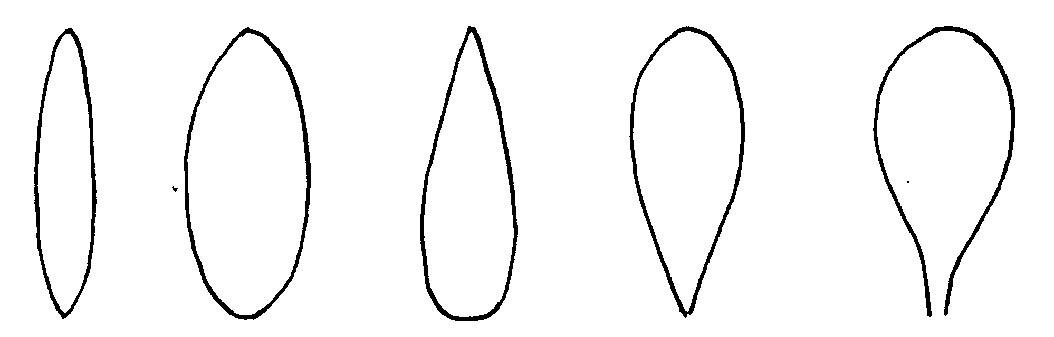
1 | 2 | 3 | 4 | 5
narrow elliptic | elliptic | narrow  ovate | narrow  obovate | spatulate

Ad. 13: Leaf: type of variegation

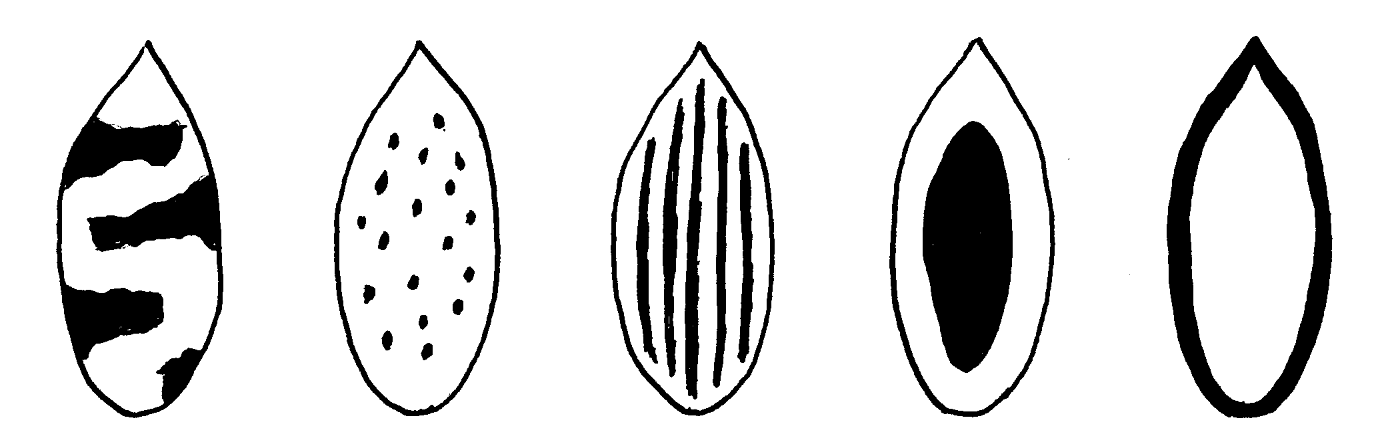
1 | 2 | 3 | 4 | 5
brindled | spotted | striped | centered | edged

variegation

Ad. 20: Peduncle: length
Ad. 23: Pedicellate-ovary: length

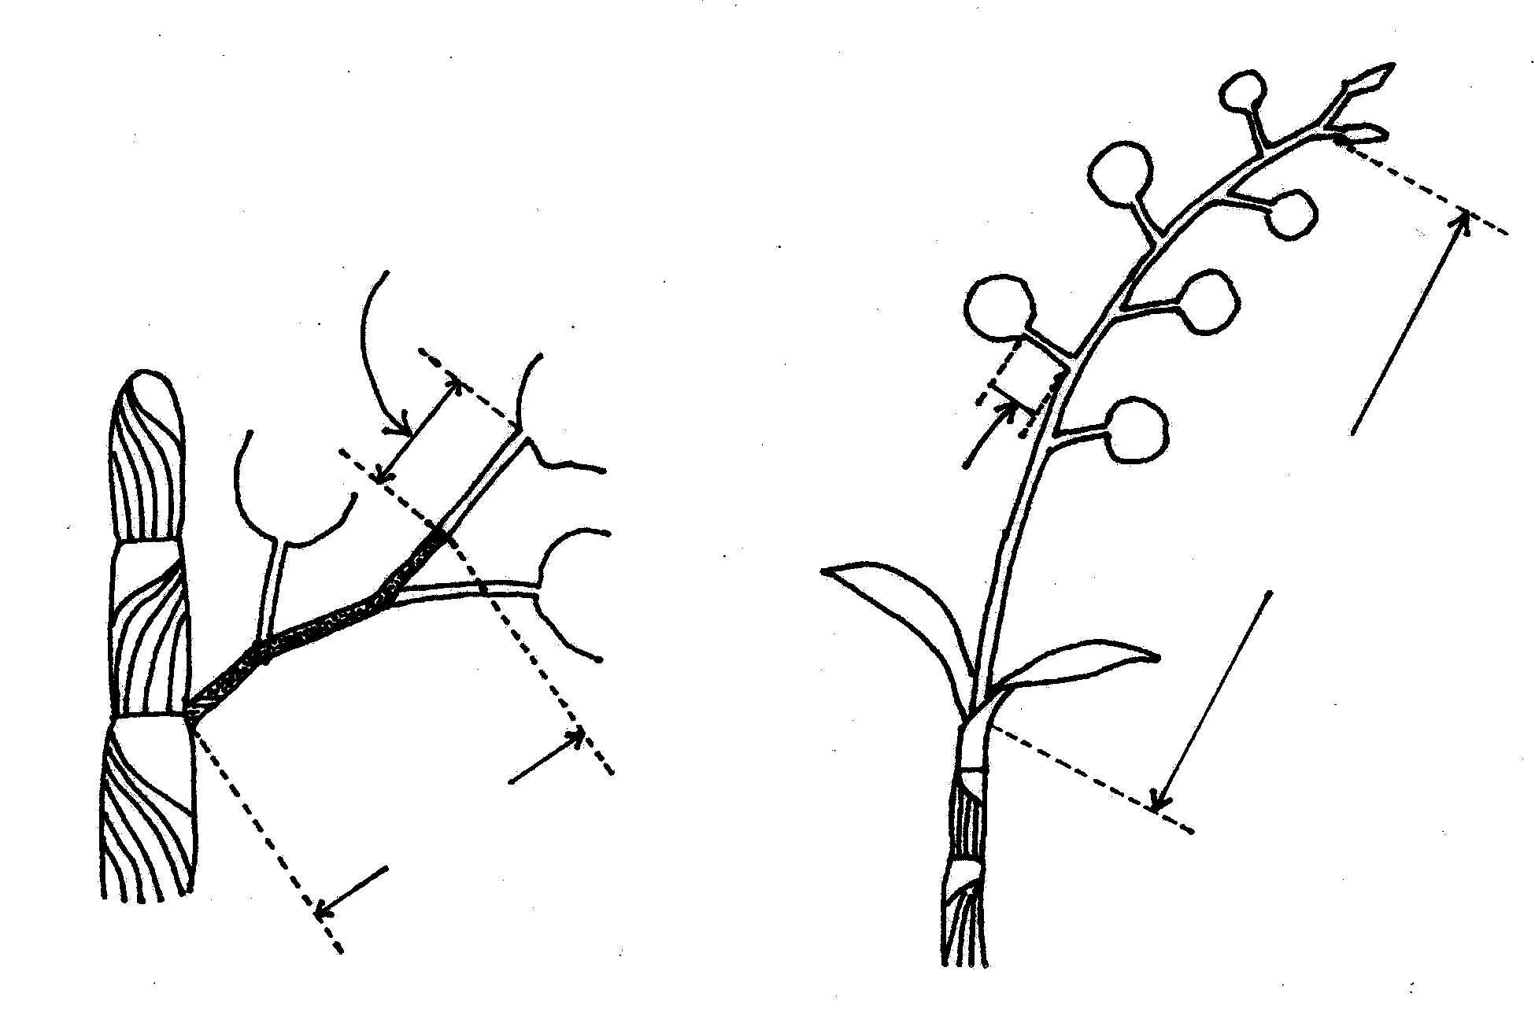
Pedicellate-ovary: length
Pedicellate-ovary: length
Peduncle: length
Peduncle: length
Flower
Flower
Flower

Ad. 27: Flower: length in front view
Ad. 28: Flower: width in front view

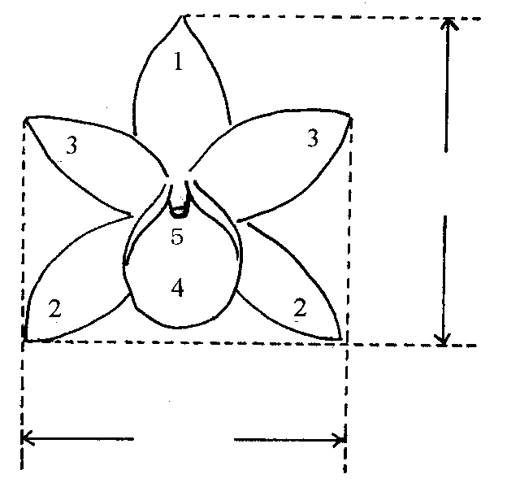

1: Dorsal sepal
length
2: Lateral sepal
3: Petal
4: Lip
5: Column

width

Ad. 33: Dorsal sepal: shape
Ad. 40: Lateral sepal: shape
Ad. 56: Petal: shape

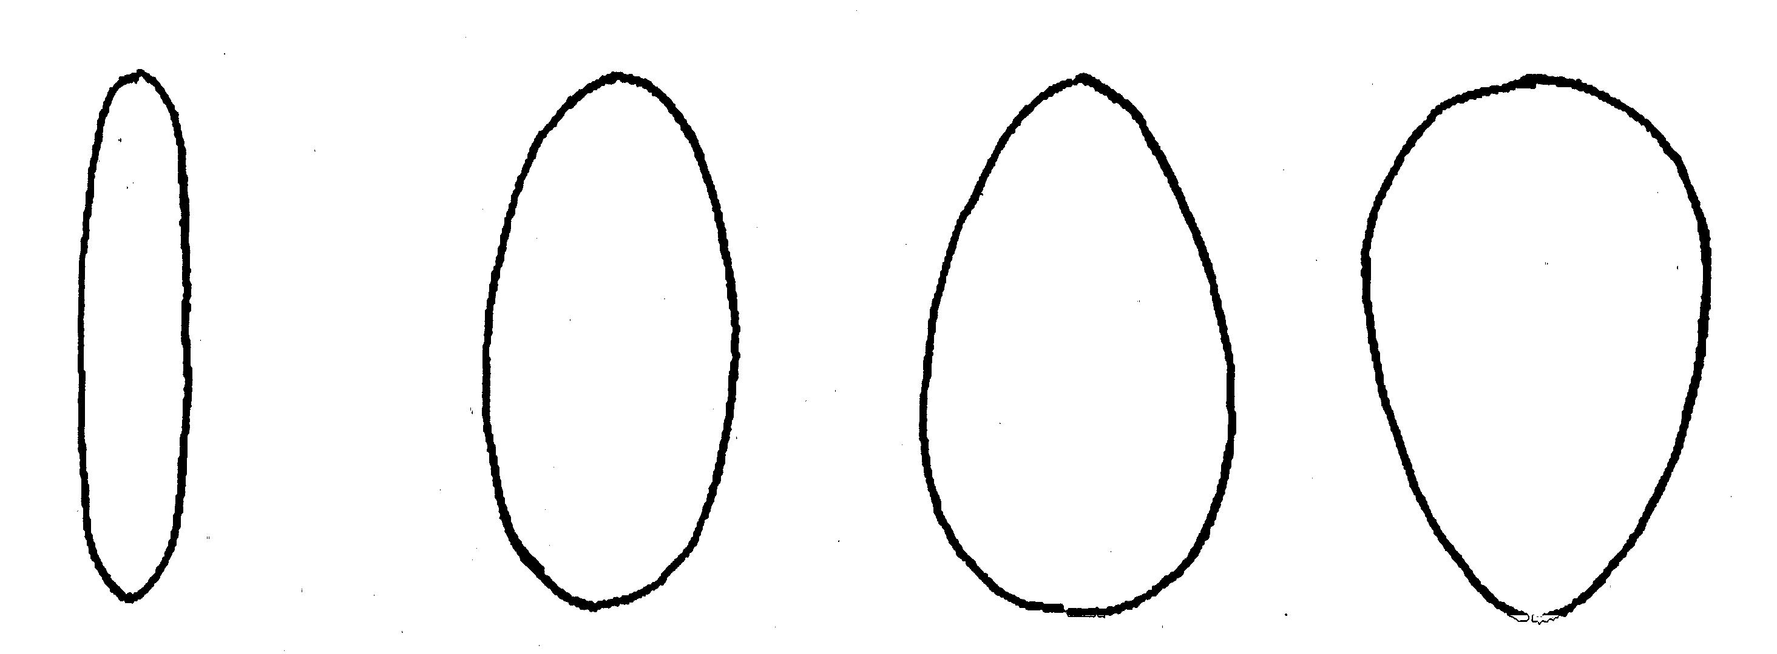
1 | 2 | 3 | 4
narrow elliptic | elliptic | ovate | obovate

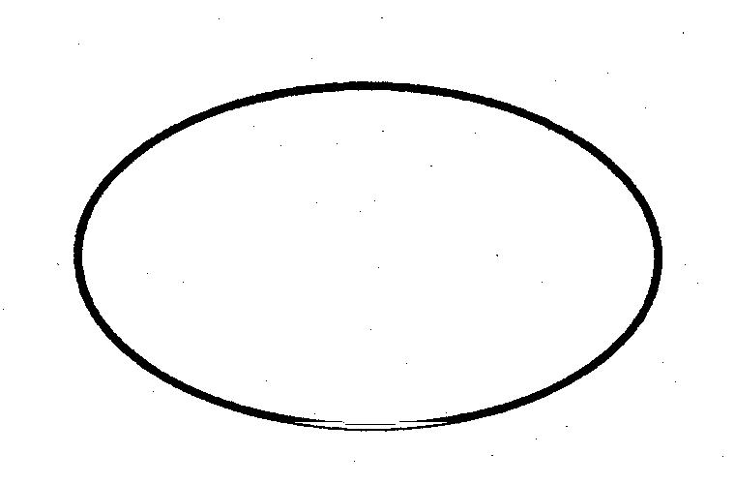 | 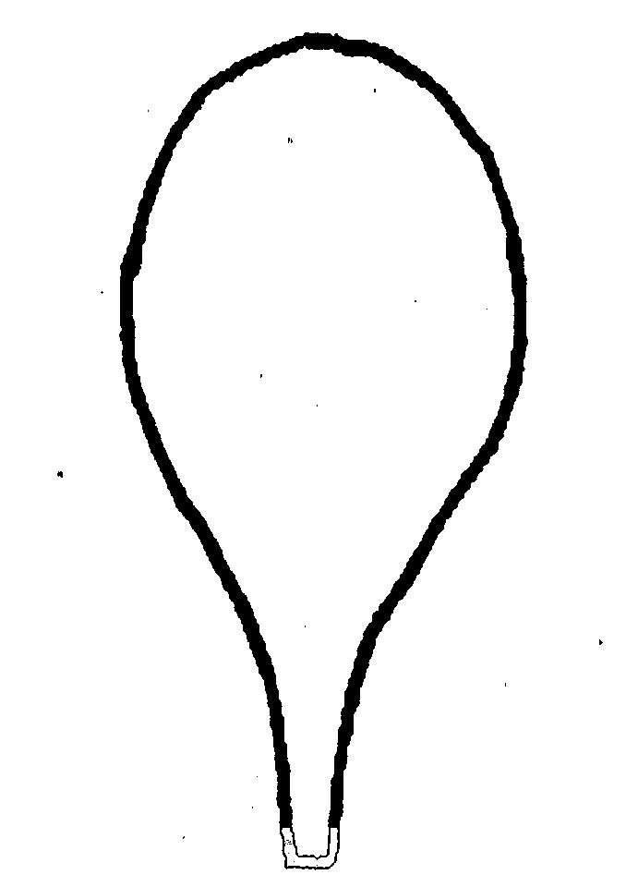
5 | 6
transverse elliptic | spatulate

Ad. 34: Dorsal sepal: cross section
Ad. 41: Lateral sepal: cross section
Ad. 57: Petal: cross section

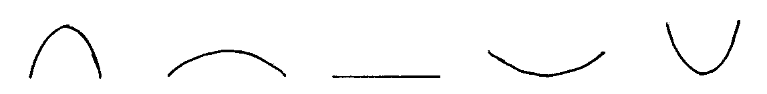
inner side↑
1 | 3 | 5 | 7 | 9
strongly  concave | moderately  concave | straight | moderately  convex | strongly  convex

Ad. 72: Varieties without lateral lobes only: Lip: shape

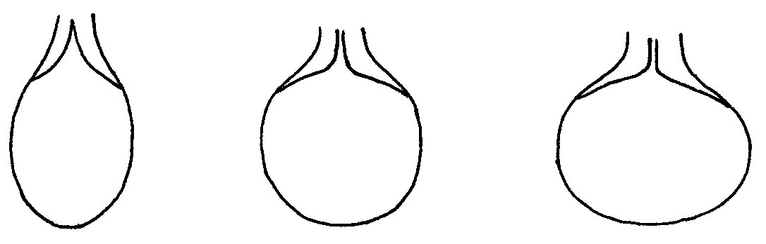
1 | 2 | 3
elliptic | circular | transverse elliptic

Ad. 73: Varieties without lateral lobes only: Lip: overlapping of basal part

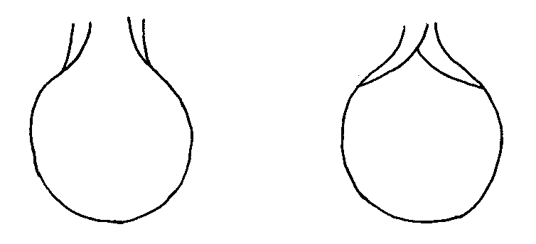
1 | 9
absent | present

Ad. 74: Varieties with lateral lobes only: Lip: shape of lateral lobe

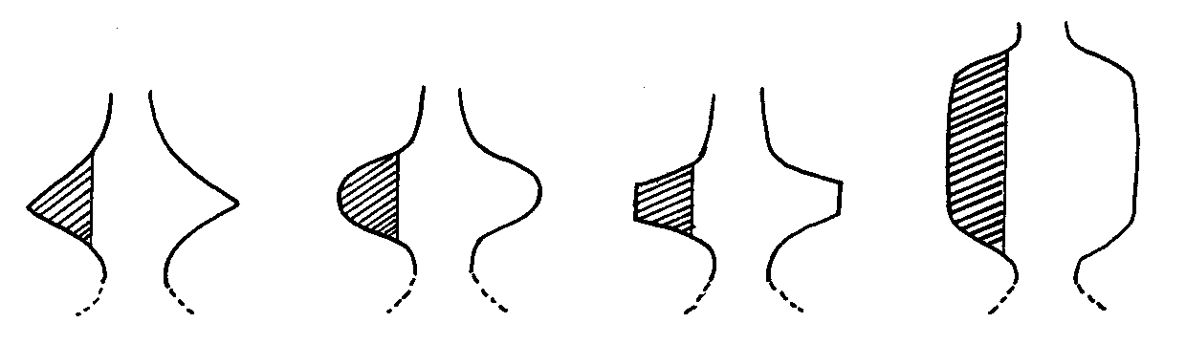
1 | 2 | 3 | 4
triangular | ovate | narrow trapezoid | broad trapezoid

Ad. 75: Varieties with lateral lobes only: Lip: shape of apical lobe

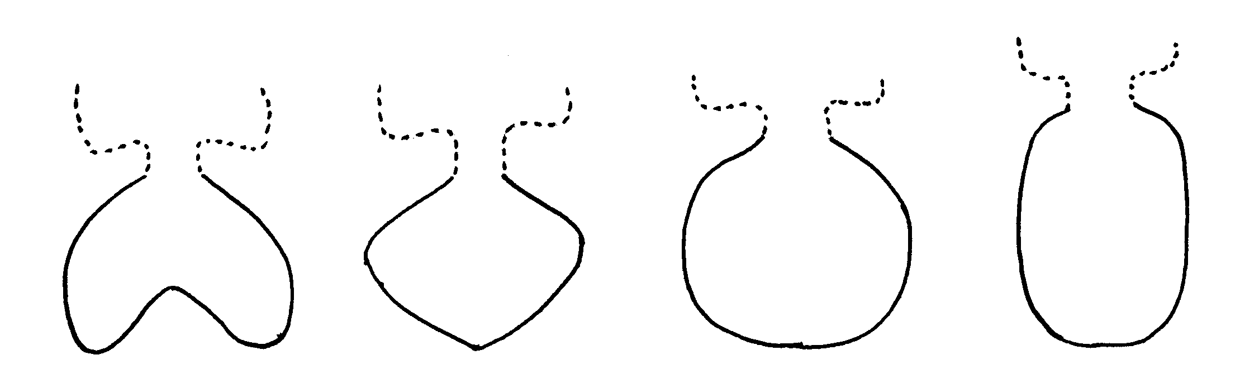
1 | 2 | 3 | 4
reniform | rhombic | transverse elliptic | elliptic

Ad. 76: Lip: type of curving

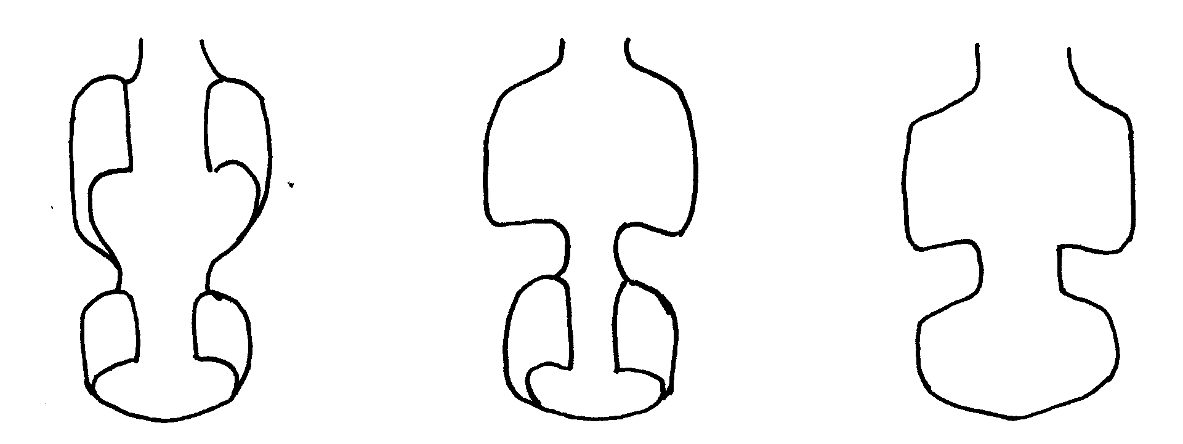
1 | 2 | 3
type I | type II | type III

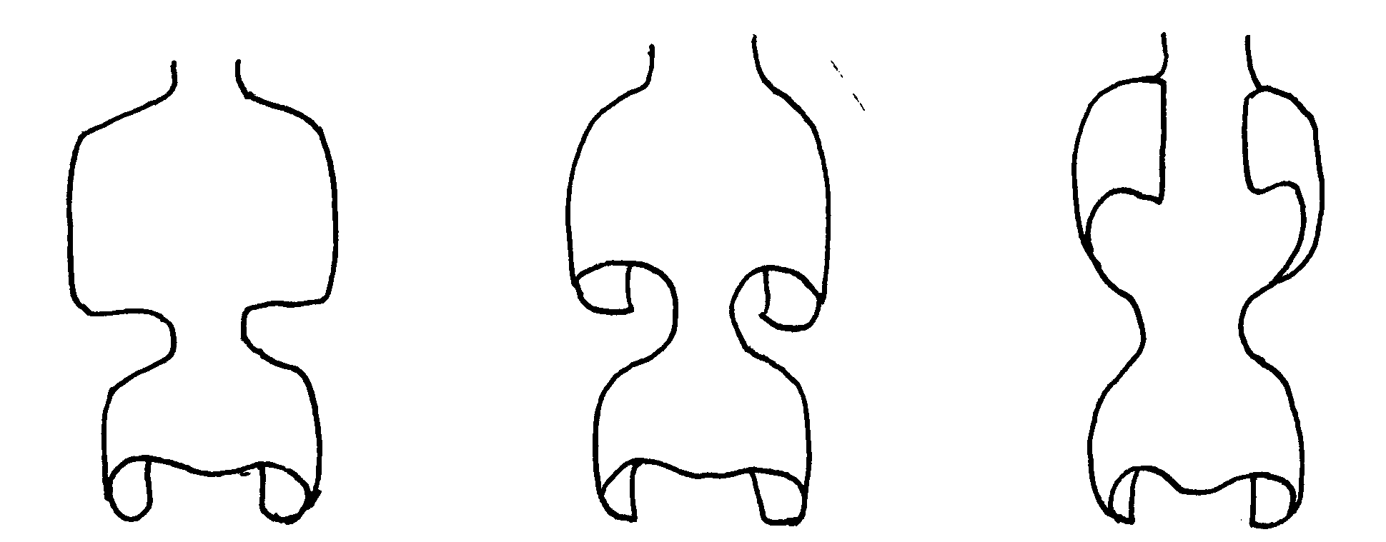
4 | 5 | 6
type IV | type V | type VI

Ad. 77: Lip: eye
Ad. 83: Lip: color of middle part (if different from 82.)

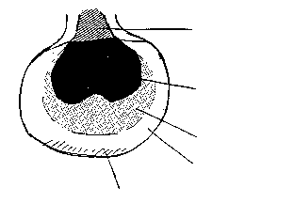
throat
eye
middle part
base
shade

Ad. 78: Lip: shape of eye

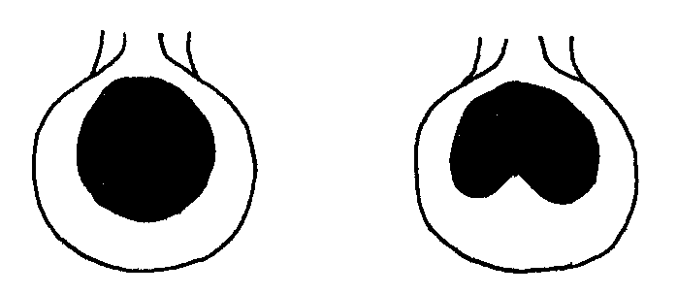
1 | 2
type I | type II

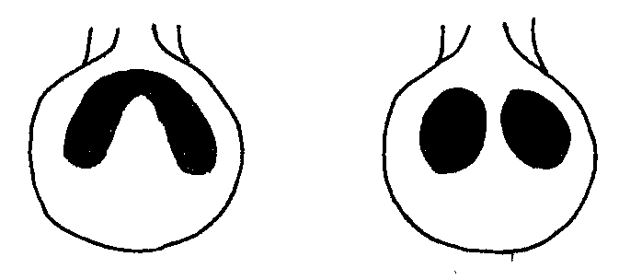

3 | 4
type III | type IV

Ad. 97: Column: color of anther cap

Observations on the color of the column should be made on the dorsal side.

Literature
Encyclopedia of Horticulture, Seibun-Do Shinkosha, Tokyo, Japan (in Japanese), JP.

Karasawa, K., 1994: “Orchid Atlas”, Vol. 4, Dendrobium, Orchid Atlas Publishing Society, c/o Yasaka Syobo, Inc., Tokyo, Japan, JP.

Technical Questionnaire
TECHNICAL QUESTIONNAIRE |  |  |  | Page {x} of {y} |  | Reference Number:
 |  |  |  |  |  | Application date:
 |  |  |  |  |  | (not to be filled in by the applicant)
TECHNICAL QUESTIONNAIRE
to be completed in connection with an application for plant breeders’ rights

1. Subject of the Technical Questionnaire
1.1 Genus
1.1.1 Latin Name |  |  | Dendrobium Sw.
1.1.2 Common Name |  |  | Dendrobium
1.2 Species (please complete)
1.2.1 Latin Name
1.2.2 Common Name
2. Applicant
Name
Address
Telephone No.
Fax No.
E-mail address
Breeder (if different from applicant)
3. Proposed denomination and breeder’s reference
Proposed denomination
(if available)

Breeder’s reference
4. Information on the breeding scheme and propagation of the variety

4.1 Breeding Scheme

Variety resulting from:

4.1.1 Crossing

(a) controlled cross [ ]
(please state parent varieties)

(b) partially unknown cross [ ]
(please state known parent variety(ies))

(c) totally unknown cross [ ]

4.1.2 Mutation [ ]
(please state parent variety)

4.1.3 Discovery [ ]
(please state where, when and how developed)

4.1.4 Other [ ]
(please provide details)

4.2 Method of Propagating the Variety

(a) cuttings [ ]

(b) in vitro propagation [ ]

(c) other (state method) [ ]

5. Characteristics of the variety to be indicated (the number in brackets refers to the corresponding characteristic in Test Guidelines; please mark the note which best corresponds).

 | Characteristics |  |  |  |  | Example Varieties |  |  | Note
5.1  (1) | Plant: size
 | very small |  |  |  |  | Enobi Komachi ‘Shirayukihime’ |  |  | 1[ ]
 | small |  |  |  |  | Dendrobium kingianum |  |  | 3[ ]
 | medium |  |  |  |  | Wave King ‘Akebono’ |  |  | 5[ ]
 | large |  |  |  |  | Lucky Girl ‘Emiko’ |  |  | 7[ ]
 | very large |  |  |  |  |  |  |  | 9[ ]
5.2  (18) | Inflorescence: position of flowers
 | along peduncle |  |  |  |  | Snow Cap ‘Love Song’ |  |  | 1[ ]
 | apex only |  |  |  |  | Pink Beauty ‘Queen’ |  |  | 2[ ]
5.3  (27) | Flower: length in front view
 | short |  |  |  |  | Enobi Komachi ‘Shirayukihime’ |  |  | 3[ ]
 | medium |  |  |  |  | Lucky Girl ‘Emiko’ |  |  | 5[ ]
 | long |  |  |  |  |  |  |  | 7[ ]
5.4  (28) | Flower: width in front view
 | narrow |  |  |  |  | Enobi Komachi ‘Shirayukihime’ |  |  | 3[ ]
 | medium |  |  |  |  | Lucky Girl ‘Emiko’ |  |  | 5[ ]
 | broad |  |  |  |  |  |  |  | 7[ ]
5.5  (71) | Lip: presence of lateral lobe
 | absent |  |  |  |  | Stardust ‘Chiyomi’ |  |  | 1[ ]
 | present |  |  |  |  | Dendrobium bellatulum |  |  | 9[ ]
 | Characteristics |  |  |  |  | Example Varieties |  |  | Note
5.6  (77) | Lip: eye
 | absent |  |  |  |  | Enobi Komachi ‘Shirayukihime’ |  |  | 1[ ]
 | present |  |  |  |  | Fantasia ‘King’ |  |  | 9[ ]
5.7  (80) | Lip: color pattern (except middle part, eye and throat)
 | self-colored |  |  |  |  |  |  |  | 1[ ]
 | shaded |  |  |  |  | Snow Cap ‘Love Song’ |  |  | 2[ ]
 | edged |  |  |  |  | Pink Beauty ‘Queen’ |  |  | 3[ ]
 | striped |  |  |  |  |  |  |  | 4[ ]
 | netted |  |  |  |  |  |  |  | 5 [ ]
 | spotted |  |  |  |  |  |  |  | 6 [ ]
 | shaded and striped |  |  |  |  |  |  |  | 7[ ]
 | shaded and netted |  |  |  |  |  |  |  | 8[ ]
 | shaded and spotted |  |  |  |  |  |  |  | 9[ ]
5.8i  (82) | Lip: main color
RHS Colour Chart (indicate reference number)
………………………………………………..
5.8ii  (82) | Lip: main color
 | green |  |  |  |  |  |  |  | 1[ ]
 | white |  |  |  |  | Enobi Komachi ‘Shirayukihime’ |  |  | 2[ ]
 | yellow |  |  |  |  | Stardust ‘Chiyomi’ |  |  | 3[ ]
 | pink |  |  |  |  | Snow Cap ‘Love Song’ |  |  | 4[ ]
 | red |  |  |  |  |  |  |  | 5[ ]
 | purple |  |  |  |  | Queen Southeast ‘Crystal Queen’ |  |  | 6[ ]
 | reddish |  |  |  |  |  |  |  | 7[ ]
6. Similar varieties and differences from these varieties

Denomination(s) of variety(ies) similar to your candidate variety |  | Characteristic(s) in which your candidate variety differs from the similar variety(ies) |  |  | Describe the expression of the characteristic(s) for the similar variety(ies) |  | Describe the expression of the characteristic(s) for your candidate variety
(Example) |  | Lip: color pattern |  |  | shaded |  | shaded and striped
Comments:
7. Additional information which may help in the examination of the variety

7.1 In addition to the information provided in sections 5 and 6, are there any additional characteristics which may help to distinguish the variety?

Yes [ ] No [ ]

(If yes, please provide details)

7.2 Special conditions for the examination of the variety

7.2.1 Are there any special conditions for growing the variety or conducting the examination?

Yes [ ] No [ ]

7.2.2 If yes, please give details:

7.3 Other information

A representative color photograph of the variety should accompany the Technical Questionnaire.

8. Authorization for release

(a) Does the variety require prior authorization for release under legislation concerning the protection of the environment, human and animal health?

Yes [ ] No [ ]

(b) Has such authorization been obtained?

Yes [ ] No [ ]

If the answer to (b) is yes, please attach a copy of the authorization.

9. I hereby declare that, to the best of my knowledge, the information provided in this form is correct:

Applicant’s name

Signature Date

[End of document]

* These names were correct at the time of the introduction of these Test Guidelines but may be revised or updated. [Readers are advised to consult the UPOV Code, which can be found on the UPOV Website (www.upov.int), for the latest information.]

