 |  | E  TG/201/1 Rev.  ORIGINAL: English  DATE: 2003–04-09 + 2015-03-25
INTERNATIONAL UNION FOR THE PROTECTION OF NEW VARIETIES OF PLANTS
GENEVA

Citrus L. – Group 1
MANDARINS

GUIDELINES

FOR THE CONDUCT OF TESTS

FOR DISTINCTNESS, UNIFORMITY AND STABILITY

Alternative Names:

[ See the list of alternative names and corresponding subgroups on page 2 ]

ASSOCIATED DOCUMENTS
These guidelines should be read in conjunction with document TG/1/3, “General Introduction to the Examination of Distinctness, Uniformity and Stability and the Development of Harmonized Descriptions of New Varieties of Plants” (hereinafter referred to as the “General Introduction”) and its associated “TGP” documents.

Other associated documents: CITRUS L. – GROUP 2: TG/202 – Oranges
CITRUS L. – GROUP 3: TG/203 – Lemons and Limes
CITRUS L. – GROUP 4: TG/204– Grapefruit and Pummelo
CITRUS L. – GROUP 5: TG/83 – Trifoliate Orange

GROUP 1 – ALTERNATIVE NAMES AND CORRESPONDING SUBGROUPS*

Latin | Subgroup | English | French | German | Spanish
Citrus amblycarpa (Hassk.) Ochse | HMA
Citrus benikoji hort. ex Tanaka | PMN
Citrus chuana hort. ex Tseng | PMN
Citrus clementina hort. ex Tan. | CLE | Clementine | Clémentinier | Clementine | Clementina
Citrus crenatifolia Lush. | PMN
Citrus deliciosa Ten. | MMM | Mediterranean Mandarin | Mandarinier | Mandarine | Mandarina común
Citrus depressa Hayata | HMA
Citrus genshokan (Hayata) hort. ex Tanaka | PMN
Citrus hainanensis Tanaka | HMA
Citrus haniana hort. ex Tseng | PMN
Citrus ichangensis Swing. x C. reticulata Blanco | HMR | Ichandarin
Citrus ichangensis Swing. x C. unshiu (Mak.) Marc. | HMR | Ichandarin
Citrus inflata hort. ex Tanaka | HMA
Citrus inflatorugosa hort. ex Tanaka | HMA
Citrus keraji hort. ex Tanaka | HMA
Citrus leiocarpa hort. ex Tanaka | HMA
Citrus lycopersicaeformis (Lush.) hort. ex Tanaka | HMA
Citrus madurensis Lour. | HMA | Calamondin
Citrus maxima (Burm.) Merr. x C. ichangensis Swing. | HMR | Ichangelo
Citrus nippokoreana Tanaka | HMA
Citrus nobilis Lour. | HMA
Citrus oto hort. ex Yu. Tanaka | HMA
Citrus paratangerina hort. ex Tanaka | PMN
Citrus platymamma hort. ex Tanaka | PMN
Citrus pseudo-aurantium hort. ex Yu. Tanaka | HMA
Citrus pseudosunki hort. ex Tanaka | HMA
Citrus reshni hort. ex Tanaka | HMA
Citrus reticulata Blanco | PMN | Tangerine | Mandarinier | Tangerine | Mandarina Ponkan
Citrus reticulata Blanco x C. paradisi Macfad | TNL | Tangelo | Tangelo | Tangelo | Tangelo
Citrus reticulata Blanco x C. sinensis (L.) Osb. | TNR | Tangor | Tangor | Tangor | Tangor
Citrus reticulata Blanco x Fortunella sp. | HMR | Kumandarin
Citrus suavissima hort. ex Tanaka | PMN
Citrus succosa hort. ex Tanaka | PMN
Citrus suhuiensis hort. ex Tanaka | PMN
Citrus sunki (Hayata) hort. ex Tanaka | HMA
Citrus tangerina hort. ex Tanaka | PMN
Citrus tardiferax hort. ex Tanaka | PMN
Citrus tardiva hort. ex Shirai | HMA
Citrus tarogayo hort. ex Yu. Tanaka | HMA
Citrus temple hort. ex Y. Tan. x C. paradisi Macfad | HMA | Siamelo
Citrus temple hort. ex Yu. Tanaka | TNR
Citrus tumida hort. ex Tanaka | HMA
Citrus unshiu Marcow. | SAT | Satsuma | Satsuma | Satsuma | Satsuma
Citrus yatsushiro hort. ex Tanaka | HMA
Citrus yuko hort. ex Tanaka | HMA
Tangelo x C. paradisi Macfad | HMA | Tangelolo
Tangor x C. temple hort. ex Y. Tan. | HMA | Tangorgelo

TABLE OF CONTENTS PAGE

1. Subject of these Test Guidelines 5
2. Material Required 5
3. Method of Examination 6
3.1 Duration of Tests 6
3.2 Testing Place 6
3.3 Conditions for Conducting the Examination 6
3.4 Test Design 6
3.5 Number of Plants / Parts of Plants to be Examined 6
3.6 Additional Tests 6
4. Assessment of Distinctness, Uniformity and Stability 7
4.1 Distinctness 7
4.1.1 General Recommendations 7
4.1.2 Consistent Differences 7
4.1.3 Clear Differences 7
4.2 Uniformity 7
4.3 Stability 7
5. Grouping of Varieties and Organization of the Growing Trial 7
6. Introduction to the Table of Characteristics 8
6.1 Categories of Characteristics 8
6.1.1 Standard Test Guidelines Characteristics 8
6.1.2 Asterisked Characteristics 8
6.2 States of Expression and Corresponding Notes 8
6.3 Types of Expression 8
6.4 Example Varieties 9
6.5 Legend 9
6.6 Abbreviation 9
7. Table of Characteristics 10
8. Explanations on the Table of Characteristics 35
8.1 Explanations covering several characteristics 35
8.2 Explanations for individual characteristics 36
9. Literature 43
10. Technical Questionnaire 44
ANNEX: OVERALL TABLE OF CHARACTERISTICS

Subject of these Test Guidelines
1.1 The following Test Guidelines have been developed from the standard Citrus Test Guidelines template. In particular, the Table of Characteristics has been selected from the overall set of citrus characteristics presented in the Annex.

1.2 These Test Guidelines apply to all varieties of the following group of the genus Citrus L. (Rutaceae), and their hybrids:

Group 1: MANDARINS AND THEIR HYBRIDS
See page 2 for the list of species and their subgroups.

1.3 In the case of hybrids between species within the genus Citrus L., the Test Guidelines to be used should be those for which the overall appearance of fruit is most suited. However, if the variety cannot be clearly distinguished from all varieties covered by other Test Guidelines, those other Test Guidelines should also be used to examine the variety.

1.4 In the case of hybrids between species within the genus Citrus L., even where the variety is clearly distinguishable from all other varieties covered by other Test Guidelines, it may still be necessary to use additional citrus characteristics to examine the variety. In these circumstances the characteristics from the Test Guidelines covering the parent species, or characteristics from the overall set of citrus characteristics, presented in the Annex, may be particularly useful.

Material Required
2.1 The competent authorities decide on the quantity and quality of the plant material required for testing the variety and when and where it is to be delivered. Applicants submitting material from a State other than that in which the testing takes place must ensure that all customs formalities and phytosanitary requirements are complied with.

2.2 The material is to be supplied in the form of bud sticks of 6 to 10 mm in diameter (one year old), each cut just behind a typical fruit or, if required by the competent authorities, one-year-old grafted trees. In the case of rootstock varieties, rooted cuttings or polyembryonic seeds may be required in addition.

2.3 The minimum quantity of plant material, to be supplied by the applicant, should be:

10 bud sticks sufficient to establish 10 plants or,
if required by the competent authorities,
10 one-year-old grafted trees.

2.4 The plant material supplied should be visibly healthy, not lacking in vigor, nor affected by any important pest or disease. It should preferably not be obtained from in vitro propagation. If it has been produced by in vitro propagation this fact must be stated by the applicant.

2.5 The plant material must not have undergone any treatment which would affect the expression of the characteristics of the variety, unless the competent authorities allow or request such treatment. If it has been treated, full details of the treatment must be given.

Method of Examination

3.1 Duration of Tests
The minimum duration of tests should normally be two independent growing cycles. For the purposes of these Test Guidelines, a growing cycle refers to the fruiting cycle.

3.2 Testing Place
The tests should normally be conducted at one place. If any characteristics of the variety, which are relevant for the examination of DUS, cannot be seen at that place, the variety may be tested at an additional place.

3.3 Conditions for Conducting the Examination
3.3.1 The tests should be carried out under conditions ensuring satisfactory growth for the expression of the relevant characteristics of the variety and for the conduct of the examination. In particular, a satisfactory crop of fruit must be produced in at least two fruiting cycles. Where necessary for the examination of fruit varieties, a standard specified rootstock should be used for each group.

3.3.2 All observations should be made on plants of the same age not less than three years after planting. The age of the plants should be specified.

3.4 Test Design
3.4.1 The design of the tests should be such that plants or parts of plants may be removed for measurement or counting without prejudice to the observations which must be made up to the end of the growing cycle.

3.4.2 Each test should be designed to result in a total of, at least, 5 plants.

3.5 Number of Plants / Parts of Plants to be Examined
Unless otherwise indicated, all observations determined by measuring or counting should be made on 5 plants or 2 parts taken from each of 5 plants.

3.6 Additional Tests
Additional tests, for examining relevant characteristics, may be established.

Assessment of Distinctness, Uniformity and Stability

4.1 Distinctness

4.1.1 General Recommendations
It is of particular importance for users of these Test Guidelines to consult the General Introduction prior to making decisions regarding distinctness. However, the following points are provided for elaboration or emphasis in these Test Guidelines.

4.1.2 Consistent Differences
The minimum duration of tests recommended in section 3.1 reflects, in general, the need to ensure that any differences in a characteristic are sufficiently consistent.

4.1.3 Clear Differences
Determining whether a difference between two varieties is clear depends on many factors, and should consider, in particular, the type of expression of the characteristic being examined, i.e. whether it is expressed in a qualitative, quantitative, or pseudo-qualitative manner. Therefore, it is important that users of these Test Guidelines are familiar with the recommendations contained in the General Introduction prior to making decisions regarding distinctness.

4.2 Uniformity
It is of particular importance for users of these Test Guidelines to consult the General Introduction prior to making decisions regarding uniformity. However, the following points are provided for elaboration or emphasis in these Test Guidelines:

For the assessment of uniformity a population standard of 1% and an acceptance probability of at least 95% should be applied. In the case of a sample size of 5 plants no off-types are allowed.

4.3 Stability
4.3.1 In practice, it is not usual to perform tests of stability that produce results as certain as those of the testing of distinctness and uniformity. However, experience has demonstrated that, for many types of variety, when a variety has been shown to be uniform, it can also be considered to be stable.

4.3.2 Where appropriate, or in cases of doubt, stability may be tested, either by growing a further generation, or by testing a new plant stock to ensure that it exhibits the same characteristics as those shown by the previous material supplied.

Grouping of Varieties and Organization of the Growing Trial
5.1 The selection of varieties of common knowledge to be grown in the trial with the candidate varieties and the way in which these varieties are divided into groups to facilitate the assessment of distinctness is aided by the use of grouping characteristics.
5.2 Grouping characteristics are those in which the documented states of expression, even where produced at different locations, can be used, either individually or in combination with other such characteristics: (a) to select varieties of common knowledge that can be excluded from the growing trial used for examination of distinctness; and (b) to organize the growing trial so that similar varieties are grouped together.

5.3 The following have been agreed as useful grouping characteristics:

(a) Fruit: length (characteristic 28)
(b) Fruit: diameter (characteristic 29)
(c) Fruit: presence of neck (characteristic 34)
(d) Fruit surface: predominant color(s) (characteristic 61)
(e) Time of maturity of fruit for consumption (characteristic 108)

5.4 Guidance for the use of grouping characteristics, in the process of examining distinctness, is provided through the General Introduction.

Introduction to the Table of Characteristics

6.1 Categories of Characteristics

6.1.1 Standard Test Guidelines Characteristics
Standard Test Guidelines characteristics are those which are approved by UPOV for examination of DUS and from which members of the Union can select those suitable for their particular circumstances.

6.1.2 Asterisked Characteristics
Asterisked characteristics (denoted by *) are those included in the Test Guidelines which are important for the international harmonization of variety descriptions and should always be examined for DUS and included in the variety description by all members of the Union, except when the state of expression of a preceding characteristic or regional environmental conditions render this inappropriate.

6.2 States of Expression and Corresponding Notes
States of expression are given for each characteristic to define the characteristic and to harmonize descriptions. Each state of expression is allocated a corresponding numerical note for ease of recording of data and for the production and exchange of the description.

6.3 Types of Expression
An explanation of the types of expression of characteristics (qualitative, quantitative and pseudo-qualitative) is provided in the General Introduction.

6.4 Example Varieties
Where appropriate, example varieties are provided to clarify the states of expression of each characteristic. Each example variety is followed by the abbreviation of its subgroup in brackets.

6.5 Legend
(*) Asterisked characteristic – see section 6.1.2
QL Qualitative characteristic – see section 6.3
QN Quantitative characteristic – see section 6.3
PQ Pseudo-Qualitative characteristic – see section 6.3
[###] Corresponding number of characteristic in the citrus overall table of characteristics (starting from 200)

(a)-(f) See Explanations on the Table of Characteristics in Chapter 8, Section 8.1
(+) See Explanations on the Table of Characteristics in Chapter 8, Section 8.2

6.6 Abbreviation
See page 2 for the list of species and their subgroups.

Table of Characteristics/Tableau des caractères/Merkmalstabelle/Tabla de caracteres
 |  | English | français | deutsch | español | Example Varieties  Exemples  Beispielssorten  Variedades ejemplo | Note/  Nota
1. |  | Ploidy | Ploïdie | Ploidie | Ploidía
QL |  | diploid | diploïde | diploid | diploide |  | 2
 |  | triploid | triploïde | triploid | triploide |  | 3
[201] |  | tetraploid | tétraploïde | tetraploid | tetraploide |  | 4
2.  (*)  (+) |  | Tree: growth habit | Arbre: port | Baum: Wuchstyp | Árbol: porte
PQ |  | upright | droit | aufrecht | erguido | Marisol (CLE) | 1
 |  | spreading | étalé | breitbuschig | abierto | Clemenules (CLE) | 2
[202] |  | drooping | retombant | hängend | colgante | Owari (SAT) | 3
3. |  | Tree: density of spines | Arbre: densité des épines | Baum: Dichte der Stacheln | Árbol: densidad de las espinas
QN |  | absent or sparse | absentes ou éparses | fehlend oder locker | ausentes o laxa | Owari (SAT) | 1
 |  | intermediate | intermédiaires | mittel | media | Marisol (CLE) | 2
[203] |  | dense | denses | dicht | densa |  | 3
4. |  | Tree: length of spines | Arbre: longueur des épines | Baum: Länge der Stacheln | Árbol: longitud de las espinas
QN |  | short | courtes | kurz | cortas | Marisol (CLE) | 3
 |  | medium | moyennes | mittel | medias |  | 5
[204] |  | long | longues | lang | largas |  | 7
5. |  | Leaf blade: length (apical leaflet in case of compound leaf) | Limbe: longueur (foliole apicale en cas de feuille composée) | Blattspreite: Länge (apikales Teilblatt bei zusammengesetztem Blatt) | Limbo: longitud (foliolo atípico en caso de hoja compuesta)
QN | (a) | short | court | kurz | corto | Común (MMN) | 3
 |  | medium | moyen | mittel | medio | Nova (HMA) | 5
[210] |  | long | long | lang | largo | Kara (HMA) | 7
6. |  | Leaf blade: width (as for 5) | Limbe: largeur (comme pour 5) | Blattspreite: Breite (wie für 5) | Limbo: anchura (como para 5)
QN | (a) | narrow | étroit | schmal | estrecho | Común (MMN) | 3
 |  | medium | moyen | mittel | medio | Clemenules (CLE) | 5
[211] |  | broad | large | breit | ancho | Page (HMA) | 7
7. |  | Leaf blade: ratio length/width (as for 5) | Limbe: rapport longueur/largeur (comme pour 5) | Blattspreite: Verhältnis Länge/ Breite (wie für 5) | Limbo: relación longitud/anchura (como para 5)
QN | (a) | small | faible | klein | pequeña | Orlando (TNL) | 3
 |  | medium | moyen | mittel | media | Fino (CLE) | 5
[212] |  | large | élevé | groß | grande | Clemenules (CLE) | 7
8. |  | Leaf blade: shape in cross section (as for 5) | Limbe: forme en section transversale (comme pour 5) | Blattspreite: Form im Querschnitt (wie für 5) | Limbo: forma en sección transversal (como para 5)
QN | (a) | straight or weakly concave | droit ou légèrement concave | gerade oder leicht konkav | recto o ligeramente cóncavo | Owari (SAT) | 1
 |  | intermediate | intermédiaire | mittel | intermedio | Minneola (TNL) | 2
[217] |  | strongly concave | fortement concave | stark konkav | fuertemente cóncavo |  | 3
9. |  | Leaf blade: twisting | Limbe: torsion | Blattspreite: Drehung | Limbo: torsión
QN | (a) | absent or weak | absente ou faible | fehlend oder gering | ausente o débil |  | 1
 |  | intermediate | intermédiaire | mittel | media |  | 2
[218] |  | strong | forte | stark | fuerte |  | 3
10. |  | Leaf blade: blistering | Limbe: cloqûre | Blattspreite: Blasigkeit | Limbo: abullonado o ampollado
QN | (a) | absent or weak | absente ou faible | fehlend oder gering | ausente o débil |  | 1
 |  | intermediate | intermédiaire | mittel | medio |  | 2
[219] |  | strong | forte | stark | fuerte |  | 3
11. |  | Leaf blade: green color | Limbe: couleur verte | Blattspreite: Grünfärbung | Limbo: color verde
QN | (a) | light | claire | hell | claro | Nova (HMA) | 3
 |  | medium | moyenne | mittel | medio | Owari (SAT) | 5
[220] |  | dark | foncée | dunkel | oscuro | Oroval (CLE) | 7
12. |  | Leaf blade: undulation of margin | Limbe: ondulation du bord | Blattspreite: Randwellung | Limbo: ondulación del borde
QN | (a) | absent or weak | absente ou faible | fehlend oder gering | ausente o débil |  | 1
 |  | intermediate | intermédiaire | mittel | media |  | 2
[222] |  | strong | forte | stark | fuerte |  | 3
13. |  | Leaf blade: incisions of margin | Limbe: incisions du bord | Blattspreite: Randeinschnitte | Limbo: incisiones del borde
PQ | (a) | absent | absentes | fehlend | ausentes |  | 1
 |  | crenate | crénelées | gekerbt | crenadas |  | 2
[223] |  | dentate | dentelées | gezähnt | dentadas |  | 3
14.  (+) |  | Leaf blade: shape of apex | Limbe: forme de l’extrémité | Blattspreite: Form der Spitze | Limbo: forma del ápice
PQ | (a) | acuminate | acuminée | mit aufgesetzter Spitze | acuminado |  | 1
 |  | acute | pointue | spitz | agudo | Clemenules (CLE) | 2
 |  | obtuse | obtuse | stumpf | obtuso | Minneola (TNL) | 3
[224] |  | rounded | arrondie | abgerundet | redondeado |  | 4
15.  (+) |  | Leaf blade: emargination at tip | Limbe: échancrure à l’extrémité | Blattspreite: Einkerbung an der Spitze | Limbo: emarginado en la parte superior
QL | (a) | absent | absente | fehlend | ausente |  | 1
[225] |  | present | présente | vorhanden | presente |  | 9
16. |  | Petiole: length | Pétiole: longueur | Blattstiel: Länge | Pecíolo: longitud
QN | (a) | short | court | kurz | corto | Clemenules (CLE) | 3
 |  | medium | moyen | mittel | medio | Fortune (HMA) | 5
[226] |  | long | long | lang | largo | Minneola (TNL) | 7
17. |  | Petiole: presence of wings | Pétiole: présence d’ailes | Blattstiel: Vorhandensein von Flügeln | Pecíolo: presencia de alas
QL | (a) | absent | absentes | fehlend | ausentes | Clemenules (CLE) | 1
[227] |  | present | présentes | vorhanden | presentes | Owari (SAT) | 9
18. |  | Varieties with petiole wings present only: Petiole: width of wings | Seulement les variétés présentant des ailes au pétiole: Pétiole: largeur des ailes | Nur Sorten mit vorhandenen Flügeln am Blattstiel: Blattstiel: Breite der Flügel | Sólo variedades con alas presentes en el pecíolo: Pecíolo: anchura de las alas
QN | (a) | narrow | étroites | schmal | estrechas | Owari (SAT) | 3
 |  | medium | moyennes | mittel | medias |  | 5
[228] |  | broad | larges | breit | anchas |  | 7
19. |  | Flower: diameter of calyx | Fleur: diamètre du calice | Blüte: Durchmesser des Kelches | Flor: diámetro del cáliz
QN | (b) | small | petit | klein | pequeño |  | 3
 |  | medium | moyen | mittel | medio |  | 5
[231] |  | large | grand | groß | grande |  | 7
20. |  | Flower: length of petal | Fleur: longueur du pétale | Blüte: Länge des Blütenblattes | Flor: longitud del pétalo
QN | (b) | short | court | kurz | corto | Fino (CLE) | 3
 |  | medium | moyen | mittel | medio | Ellendale (TNR) | 5
[232] |  | long | long | lang | largo | Owari (SAT) | 7
21. |  | Flower: width of petal | Fleur: largeur du pétale | Blüte: Breite des Blütenblattes | Flor: anchura del pétalo
QN | (b) | narrow | étroit | schmal | estrecho | Clemenules (CLE) | 3
 |  | medium | moyen | mittel | medio | Ellendale (TNR) | 5
[233] |  | broad | large | breit | ancho | Owari (SAT) | 7
22. |  | Flower: ratio length/ width of petal | Fleur: rapport longueur/largeur du pétale | Blüte: Verhältnis Länge/Breite des Blütenblattes | Flor: relación longitud/anchura del pétalo
QN | (b) | small | faible | klein | pequeña | Wilking (HMA) | 3
 |  | medium | moyen | mittel | media | Fino (CLE) | 5
[234] |  | large | élevé | groß | grande | Page (HMA) | 7
23. |  | Flower: length of stamens | Fleur: longueur des étamines | Blüte: Länge der Staubfäden | Flor: longitud de los estambres
QN | (b) | short | courtes | kurz | cortos | Encore (HMA) | 3
 |  | medium | moyennes | mittel | medios | Owari (SAT) | 5
[235] |  | long | longues | lang | largos | Page (HMA) | 7
24. |  | Anther: color | Anthère: couleur | Anthere: Farbe | Antera: color
PQ | (b) | white | blanc | weiß | blanco |  | 1
 |  | light yellow | jaune clair | hellgelb | amarillo claro | Owari (SAT) | 2
[238] |  | medium yellow | jaune moyen | mittelgelb | amarillo medio | Fino (CLE) | 3
25.  (+) |  | Anther: viable pollen | Anthère: pollen viable | Anthere: keimfähiger Pollen | Antera: polen viable
QN | (b) | absent or very low | absent ou très faible | fehlend oder sehr gering | ausente o muy bajo | Owari (SAT) | 1
 |  | low | faible | gering | bajo |  | 3
 |  | medium | moyen | mittel | medio | Marisol (CLE) | 5
 |  | high | élevé | hoch | alto | Murcott (HMA) | 7
[339] |  | very high | très élevé | sehr hoch | muy alto | Fortune (HMA) | 9
26. |  | Style: length | Style: longueur | Griffel: Länge | Estilo: longitud
QN | (b) | short | court | kurz | corto | Pixie (HMA) | 3
 |  | medium | moyen | mittel | medio | Fino (CLE) | 5
[240] |  | long | long | lang | largo | Owari (SAT) | 7
27. |  | Infructescence: clustering of fruits | Fructification: formation de grappes | Fruchtstand: Früchte in Büscheln | Infructescencia: arracimado de los frutos
QL |  | absent | absente | fehlend | ausente |  | 1
[243] |  | present | présente | vorhanden | presente |  | 9
28.  (*) |  | Fruit: length | Fruit: longueur | Frucht: Länge | Fruto: longitud
QN | (c) | short | court | kurz | corto | Wilking (HMA) | 3
 |  | medium | moyen | mittel | medio | Clemenules (CLE) | 5
[244] |  | long | long | lang | largo | Minneola (TNL) | 7
29.  (*) |  | Fruit: diameter | Fruit: diamètre | Frucht: Durchmesser | Fruto: diámetro
QN | (c) | small | petit | klein | pequeño | Fino (CLE) | 3
 |  | medium | moyen | mittel | medio | Clemenules (CLE) | 5
[245] |  | large | grand | groß | grande | Ortanique (TNR) | 7
30.  (*) |  | Fruit: ratio length/diameter | Fruit: rapport longueur/diamètre | Frucht: Verhältnis Länge/Durchmesser | Fruto: relación longitud/diámetro
QN | (c) | small | faible | klein | pequeña | Encore (HMA) | 3
 |  | medium | moyen | mittel | media | Clemenules (CLE) | 5
[246] |  | large | élevé | groß | grande | Minneola (TNL) | 7
31.  (*) |  | Fruit: position of broadest part | Fruit: position de la partie la plus large | Frucht: Position des breitesten Teils | Fruto: posición de la parte más ancha
QN | (c) | towards stalk end | vers l’extrémité pédonculaire | zum Stielende hin | hacia el extremo peduncular |  | 1
 |  | at middle | au milieu | in der Mitte | en el medio | Clemenules (CLE) | 2
[247] |  | towards distal end | vers la partie distale | zum distalen Ende hin | hacia el extremo distal |  | 3
32.  (+) |  | Fruit: shape in transverse section | Fruit: forme en section transverse | Frucht: Form im Querschnitt | Fruto: forma en sección transversal
PQ | (c) | circular | circulaire | rund | circular | Ortanique (TNR) | 1
 |  | somewhat angular | légèrement anguleuse | etwas kantig | ligeramente angular | Clemenules (CLE) | 2
[248] |  | scalloped | dentelée | muschelförmig | festoneado |  | 3
33.  (*)  (+) |  | Fruit: general shape of proximal part (excluding neck, collar and depression at stalk end) | Fruit: forme générale de la partie proximale (à l’exclusion du col, de la collerette et de la dépression à l’extrémité pédonculaire) | Frucht: allgemeine Form des proximalen Teils (ohne Hals, Kragen und Einsenkung am Stielende) | Fruto: forma general de la parte proximal (excluidos el cuello, el collar y la depresión del extremo peduncular)
PQ | (c) | flattened | aplatie | abgeflacht | aplanada | Clemenules (CLE) | 1
 |  | slightly rounded | légèrement arrondie | leicht abgerundet | ligeramente redondeada | Ortanique (TNR) | 2
 |  | strongly rounded | fortement arrondie | stark abgerundet | fuertemente redondeada |  | 3
[249] |  | tapered | effilée | spitz | afilada |  | 4
34.  (*)  (+) |  | Fruit: presence of neck | Fruit: présence d’un col | Frucht: Vorhandensein eines Halses | Fruto: presencia de cuello
QL | (c) | absent | absent | fehlend | ausente | Clemenules (CLE) | 1
[250] |  | present | présent | vorhanden | presente |  | 9
35. |  | Necked varieties only: Fruit: length of neck | Seulement les variétés dont le fruit présente un col: Fruit: longueur du col | Nur Sorten mit Fruchthals: Frucht: Länge des Halses | Sólo variedades con fruto con cuello: Fruto: longitud del cuello
QN | (c) | short | court | kurz | corto |  | 3
 |  | medium | moyen | mittel | medio |  | 5
[251] |  | long | long | lang | largo |  | 7
36. |  | Necked varieties only: Fruit: thickness of neck | Seulement les variétés dont le fruit présente un col: Fruit: épaisseur du col | Nur Sorten mit Fruchthals: Frucht: Dicke des Halses | Sólo variedades con fruto con cuello: Fruto: grosor del cuello
QN | (c) | thin | mince | dünn | delgado |  | 3
 |  | medium | moyen | mittel | medio |  | 5
[252] |  | thick | épais | dick | grueso |  | 7
37.  (*)  (+) |  | Only varieties without fruit neck: Fruit: presence of depression at stalk end | Seulement les variétés dont le fruit ne présente pas de col: Fruit: présence d’une dépression à l’extrémité pédonculaire | Nur Sorten ohne Fruchthals: Frucht: Vorhandensein einer Einsenkung am Stielende | Sólo variedades con fruto sin cuello: Fruto: presencia de una depresión en el extremo peduncular
QL | (c) | absent | absente | fehlend | ausente | Ortanique (TNR) | 1
[253] |  | present | présente | vorhanden | presente | Marisol (CLE) | 9
38. |  | Only varieties without fruit neck: Fruit: depth of depression at stalk end | Seulement les variétés dont le fruit ne présente pas de col: Fruit: profondeur de la dépression à l’extrémité pédonculaire | Nur Sorten ohne Fruchthals: Frucht: Tiefe der Einsenkung am Stielende | Sólo variedades con fruto sin cuello: Fruto: profundidad de la depresión en el extremo peduncular
QN | (c) | shallow | peu profonde | flach | poco profunda |  | 3
 |  | medium | moyenne | mittel | media |  | 5
[254] |  | deep | profonde | tief | profunda |  | 7
39.  (+) |  | Fruit: presence of constriction at stalk end | Fruit: présence d’un étranglement à l’extrémité pédonculaire | Frucht: Vorhandensein einer Einschnürung am Stielende | Fruto: presencia de un estrechamiento en el extremo peduncular
QL | (c) | absent | absent | fehlend | ausente | Clemenules (CLE) | 1
[255] |  | present | présent | vorhanden | presente |  | 9
40. |  | Fruit: expression of constriction at stalk end | Fruit: expression de l’étranglement à l’extrémité pédonculaire | Frucht: Ausprägung der Einschnürung am Stielende | Fruto: expresión del estrechamiento en el extremo peduncular
QN | (c) | weak | faible | gering | débil |  | 3
 |  | medium | moyenne | mittel | medio |  | 5
[256] |  | strong | forte | stark | fuerte |  | 7
41. |  | Fruit: number of radial grooves at stalk end | Fruit: nombre de cannelures radiales à l’extrémité pédonculaire | Frucht: Anzahl radialer Furchen am Stielende | Fruto: número de acanaladuras radiales en el extremo peduncular
QN | (c) | absent or few | absentes ou peu nombreuses | fehlend oder sehr gering | ausentes o bajo | Nova (HMA) | 1
 |  | intermediate | moyennement nombreuses | mittel | medio | Clemenules (CLE) | 2
[257] |  | many | nombreuses | groß | alto |  | 3
42. |  | Fruit: length of radial grooves at stalk end | Fruit: longueur des cannelures radiales à l’extrémité pédonculaire | Frucht: Länge der radialen Furchen am Stielende | Fruto: longitud de las acanaladuras radiales en el extremo peduncular
QN | (c) | short | courtes | kurz | cortas |  | 3
 |  | medium | moyennes | mittel | medias |  | 5
[258] |  | long | longues | lang | largas |  | 7
43. |  | Necked varieties only: Fruit: depression at stalk attachment | Seulement les variétés dont le fruit présente un col: Fruit: dépression à l’attache pédonculaire | Nur Sorten mit Fruchthals: Frucht: Einsenkung am Stielansatz | Sólo variedades con fruto con cuello: Fruto: depresión en la inserción peduncular
QN | (c) | absent or shallow | absente ou peu profonde | fehlend oder flach | ausente o poco profunda |  | 1
 |  | intermediate | intermédiaire | mittel | intermedia |  | 2
[259] |  | deep | profonde | tief | profunda |  | 3
44.  (+) |  | Fruit: presence of collar | Fruit: présence d’une corolle | Frucht: Vorhandensein eines Kragens | Fruto: presencia de un collar
QL | (c) | absent | absente | fehlend | ausente | Clemenules (CLE) | 1
[260] |  | present | présente | vorhanden | presente |  | 9
45. |  | Fruit: height of collar | Fruit: hauteur de la corolle | Frucht: Höhe des Kragens | Fruto: altura del collar
QN | (c) | low | basse | niedrig | bajo |  | 3
 |  | medium | moyenne | mittel | medio |  | 5
[261] |  | high | haute | hoch | alto |  | 7
46. |  | Fruit: diameter of collar | Fruit: diamètre de la corolle | Frucht: Durchmesser des Kragens | Fruto: diámetro del collar
QN | (c) | small | petit | klein | pequeño |  | 3
 |  | medium | moyen | mittel | medio |  | 5
[262] |  | large | grand | groß | grande |  | 7
47. |  | Fruit: abscission layer between floral disc and fruit | Fruit: abscission entre le disque floral et le fruit | Frucht: Trennschicht zwischen Blütenscheibe und Frucht | Fruto: capa de abscisión entre el disco floral y el fruto
QN | (c) | absent or weakly developed | absente ou faiblement développée | fehlend oder schwach entwickelt | ausente o débilmente desarrollada |  | 1
 |  | intermediate | intermédiaire | mittel | intermedia |  | 2
[263] |  | strongly developed | fortement développée | stark entwickelt | fuertemente desarrollada |  | 3
48.  (*)  (+) |  | Fruit: general shape of distal part (excluding nipple, bulging of navel and depression at distal end) | Fruit: forme générale de la partie distale (à l’exclusion du mamelon, de la courbure du fruit secondaire et de la dépression à l’extrémité distale) | Frucht: allgemeine Form des distalen Teils (ohne Warze, Wölbung der sekundären Frucht und Einsenkung am distalen Ende) | Fruto: forma general de la parte distal (excluidos el mamelón o pezón, el abultamiento del ombligo y la depresión en el extremo distal)
QN | (c) | flattened | aplatie | abgeflacht | aplanada | Clemenules (CLE) | 1
 |  | slightly rounded | légèrement arrondie | leicht abgerundet | ligeramente redondeada |  | 2
[264] |  | strongly rounded | fortement arrondie | stark abgerundet | fuertemente redondeada |  | 3
49.  (*)  (+) |  | Fruit: presence of depression at distal end | Fruit: présence d’une dépression à l’extrémité distale | Frucht: Vorhandensein einer Einsenkung am distalen Ende | Fruto: presencia de una depresión en el extremo distal
QL | (c) | absent | absente | fehlend | ausente | Ortanique (TNR) | 1
[265] |  | present | présente | vorhanden | presente | Arrufatina (CLE) | 9
50. |  | Fruit: depth of depression at distal end | Fruit: profondeur de la dépression à l’extrémité distale | Frucht: Tiefe der Einsenkung am distalen Ende | Fruto: profundidad de la depresión en el extremo distal
QN | (c) | shallow | peu profonde | flach | poco profunda |  | 3
 |  | medium | moyenne | mittel | media |  | 5
[266] |  | deep | profonde | tief | profunda |  | 7
51. |  | Fruit: diameter of depression at distal end | Fruit: diamètre de la dépression à l’extrémité distale | Frucht: Durchmesser der Einsenkung am distalen Ende | Fruto: diámetro de la depresión en el extremo distal
QN | (c) | small | petit | klein | pequeño |  | 3
 |  | medium | moyen | mittel | medio |  | 5
[267] |  | large | grand | groß | grande |  | 7
52.  (*) |  | Fruit: presence of areola | Fruit: présence d’une aréole | Frucht: Vorhandensein einer Areola | Fruto: presencia de un areola
QL | (c) | absent | absente | fehlend | ausente | Nova (HMA) | 1
 |  | incomplete | incomplète | unvollständig | incompleta |  | 2
[270] |  | complete | complète | vollständig | completa | Ortanique (TNR) | 3
53.  (+) |  | Fruit: type of areola | Fruit: type d’aréole | Frucht: Typ der Areola | Fruto: tipo de areola
QL | (c) | smooth | régulière | glatt | lisa |  | 1
 |  | grooved | cannelée | gerieft | acanalada |  | 2
[271] |  | ridged | annelée | geringelt | acrestada |  | 3
54. |  | Fruit: diameter of areola | Fruit: diamètre de l’aréole | Frucht: Durchmesser der Areola | Fruto: diámetro de la areola
QN | (c) | small | petit | klein | pequeño | Arrufatina (CLE) | 3
 |  | medium | moyen | mittel | medio | Owari (SAT) | 5
[272] |  | large | grand | groß | grande | Ortanique (TNR) | 7
55. |  | Fruit: diameter of stylar scar | Fruit: diamètre de la cicatrice stylaire | Frucht: Durchmesser der Griffelnarbe | Fruto: diámetro de la cicatriz estilar
QN | (c) | small | petit | klein | pequeño | Clemenules (CLE) | 3
 |  | medium | moyen | mittel | medio | Owari (SAT) | 5
[273] |  | large | grand | groß | grande |  | 7
56. |  | Fruit: persistence of style | Fruit: persistance du style | Frucht: Persistenz des Griffels | Fruto: persistencia del estilo
PQ | (c) | none | aucune | fehlend | ninguna |  | 1
 |  | partial | partielle | teilweise gegeben | parcial |  | 2
[275] |  | total | totale | vollständig gegeben | total |  | 3
57. |  | Fruit: presence of navel opening | Fruit: présence d’une ouverture du fruit secondaire | Frucht: Vorhandensein der Öffnung der sekundären Frucht | Fruto: presencia de un apertura del ombligo
PQ | (c) | absent | absente | fehlend | ausente | Clemenules (CLE) | 1
 |  | occasionally present | présente occasionnellemnent | zuweilen vorhanden | ocasionalmente presente | Fortune (HMA) | 2
[276] |  | always present | toujours présente | immer vorhanden | siempre presente |  | 3
58. |  | Fruit: diameter of navel opening | Fruit: diamètre de l’ouverture du fruit secondaire | Frucht: Durchmesser der Öffnung der sekundären Frucht | Fruto: diámetro de la apertura del ombligo
QN | (c) | small | petit | klein | pequeño | Ellendale (TNR) | 3
 |  | medium | moyen | mittel | medio | Fortune (HMA) | 5
[277] |  | large | grand | groß | grande |  | 7
59. |  | Fruit: presence of radial grooves at distal end | Fruit: présence de cannelures radiales à l’extrémité distale | Frucht: Vorhandensein radialer Furchen am distalen Ende | Fruto: presencia de acanaladuras radiales en el extremo distal
QL | (c) | absent | absentes | fehlend | ausentes |  | 1
[279] |  | present | présentes | vorhanden | presentes |  | 9
60. |  | Fruit: expression of radial grooves at distal end | Fruit: expression des cannelures radiales à l’extrémité distale | Frucht: Ausprägung der radialen Furchen am distalen Ende | Fruto: expresión de las acanaladuras radiales en el extremo distal
QN | (c) | weak | faible | gering | débil |  | 3
 |  | medium | moyenne | mittel | media |  | 5
[280] |  | strong | forte | stark | fuerte |  | 7
61.  (*) |  | Fruit surface: predominant color(s) | Surface du fruit: couleur(s) prédominante(s) | Fruchtoberfläche: Hauptfarbe(n) | Superficie del fruto: color(es) predominante(s)
PQ | (c) | green | vert | grün | verde |  | 1
 | (d) | yellow green | vert-jaune | gelbgrün | verde amarillento |  | 2
 |  | light yellow | jaune clair | hellgelb | amarillo claro |  | 3
 |  | medium yellow | jaune moyen | mittelgelb | amarillo medio | Mapo (TNL) | 4
 |  | yellow orange | orange-jaune | gelborange | naranja amarillento |  | 5
 |  | medium orange | orange moyen | mittelorange | naranja medio | Clemenules (CLE) | 6
 |  | dark orange | orange foncé | dunkelorange | naranja oscuro |  | 7
 |  | orange red | rouge orangé | orangerot | rojo anaranjado | Nova (HMA) | 8
[282] |  | red | rouge | rot | rojo |  | 9
62.  (*) |  | Fruit surface: glossiness | Surface du fruit: brillance | Fruchtoberfläche: Glanz | Superficie del fruto: brillo
QN | (c) | absent or very weak | absente ou très faible | fehlend oder sehr gering | ausente o muy débil | Clemenules (CLE) | 1
 | (d) | weak | faible | gering | débil |  | 3
 |  | medium | moyenne | mittel | medio | Afourer (TNR) | 5
 |  | strong | forte | stark | fuerte |  | 7
[285] |  | very strong | très forte | sehr stark | muy fuerte |  | 9
63. |  | Fruit surface: roughness | Surface du fruit: rugosité | Fruchtoberfläche: Rauheit | Superficie del fruto: rugosidad
QN | (c) | smooth | lisse | glatt | lisa | Murcott (TNR) | 3
 | (d) | medium | intermédiaire | mittel | media | Clemenules (CLE) | 5
[286] |  | rough | rugueuse | rauh | rugosa | Temple (HMA) | 7
64. |  | Fruit surface: size of oil glands | Surface du fruit: taille des glandes à huile | Fruchtoberfläche: Größe der Öldrüsen | Superficie del fruto: tamaño de las glándulas de aceite
PQ | (c) | all more or less the same size | toutes plus ou moins de la même taille | alle mehr oder weniger gleich groß | todas más o menos del mismo tamaño |  | 1
[287] | (d) | larger ones interspersed by smaller ones | grandes et petites intercalées | größere vermischt mit kleineren | glándulas grandes intercaladas con otras más pequeñas |  | 2
65. |  | Fruit surface: size of larger oil glands | Surface du fruit: taille des glandes à huile les plus grosses | Fruchtoberfläche: Größe der größeren Öldrüsen | Superficie del fruto: tamaño de las glándulas de aceite más grandes
QN | (c) | small | petites | klein | pequeñas |  | 3
 | (d) | medium | moyennes | mittel | medianas |  | 5
[288] |  | large | grosses | groß | grandes |  | 7
66. |  | Fruit surface: conspicuousness of larger oil glands | Surface du fruit: netteté des glandes à huile les plus grosses | Fruchtoberfläche: Sichtbarkeit der größeren Öldrüsen | Superficie del fruto: visibilidad de las glándulas de aceite más grandes
QN | (c) | weak | faible | gering | débil | Clemenules (CLE) | 3
 | (d) | medium | moyenne | mittel | media |  | 5
[289] |  | strong | forte | stark | fuerte | Owari (SAT) | 7
67. |  | Fruit surface: presence of pitting and pebbling on oil glands | Surface du fruit: présence de dépression et de protubérance sur les glandes à huile | Fruchtoberfläche: Vorhandensein von Grübchen und Körnern an den Öldrüsen | Superficie del fruto: presencia de picado y granulado en las glándulas de aceite
PQ | (c) | pitting and pebbling absent | dépression et protubérance absentes | Grübchen und Körner fehlend | picado y granulado ausentes |  | 1
 | (d) | pitting absent, pebbling present | dépression absente, protubérance présente | Grübchen fehlend, Körner vorhanden | picado ausente, granulado presente |  | 2
 |  | pitting present, pebbling absent | dépression présente, protubérance absente | Grübchen vorhanden, Körner fehlend | picado presente, granulado ausente |  | 3
[290] |  | pitting and pebbling present | dépression et protubérance présentes | Grübchen und Körner vorhanden | picado y granulado presentes |  | 4
68. |  | Varieties with fruit surface: pitting on oil glands present only: Fruit surface: density of pitting | Variétés avec surface du fruit: présence seulement de dépression sur les glandes à huile: Surface du fruit: densité de la dépression | Sorten mit Fruchtoberfläche: nur Grübchen an den Öldrüsen vorhanden: Fruchtoberfläche: Dichte der Grübchen | Variedades con superficie del fruto: presencia solamente de picado en las glándulas de aceite: Superficie del fruto: densidad del picado
QN | (c) | sparse | éparse | locker | dispersa |  | 3
 | (d) | medium | moyenne | mittel | media |  | 5
[291] |  | dense | dense | dicht | densa |  | 7
69. |  | Varieties with fruit surface: pebbling on oil glands present only: Fruit surface: density of pebbling | Variétés avec surface du fruit: présence seulement de protubérance sur les glandes à huile: Surface du fruit: densité de la protubérance | Sorten mit Fruchtoberfläche: nur Körner an den Öldrüsen vorhanden: Fruchtoberfläche: Dichte der Körner | Variedades con superficie del fruto: presencia solamente de granulado en las glándulas de aceite: Superficie del fruto: densidad del granulado
QN | (c) | sparse | éparse | locker | dispersa |  | 3
 | (d) | medium | moyenne | mittel | media |  | 5
[293] |  | dense | dense | dicht | densa |  | 7
70. |  | Varieties with fruit surface: pebbling on oil glands present only: Fruit surface: degree of pebbling | Variétés avec surface du fruit: présence seulement de protubérance sur les glandes à huile: Surface du fruit: degré de protubérance | Sorten mit Fruchtoberfläche: nur Körner an den Öldrüsen vorhanden: Fruchtoberfläche: Grad der Körnerbildung | Variedades con superficie del fruto: presencia solamente de granulado en las glándulas de aceite: Superficie del fruto: nivel de granulado
QN | (c) | weak | faible | gering | débil |  | 3
 | (d) | medium | moyen | mittel | medio |  | 5
[294] |  | strong | fort | stark | fuerte |  | 7
71.  (*) |  | Fruit rind: thickness | Écorce du fruit: épaisseur | Fruchtschale: Dicke | Corteza del fruto: espesor
QN | (c) | thin | fine | dünn | delgada | Murcott (TNR) | 3
 | (d) | medium | moyenne | mittel | media | Clemenules (CLE) | 5
[295] |  | thick | épaisse | dick | gruesa | Minneola (TNL) | 7
72.  (*) |  | Fruit rind: adherence to flesh | Écorce du fruit: adhérence à la chair | Fruchtschale: Anhaften am Fleisch | Corteza del fruto: adherencia a la pulpa
QN | (c) | weak | faible | gering | débil | Clemenules (CLE) | 3
 | (d) | medium | moyenne | mittel | media | Fortune (HMA) | 5
[296] |  | strong | forte | stark | fuerte | Ortanique (TNR) | 7
73. |  | Fruit rind: strength | Écorce du fruit: rigidité | Fruchtschale: Festigkeit | Corteza del fruto: vigor
QN | (c) | weak | faible | gering | débil |  | 3
 | (d) | medium | moyenne | mittel | medio |  | 5
[297] |  | strong | forte | groß | fuerte |  | 7
74. |  | Fruit rind: oiliness | Écorce du fruit: onctuosité | Fruchtschale: Öligkeit | Corteza del fruto: oleosidad
QN | (c) | dry | sèche | trocken | seca |  | 3
 | (d) | medium | moyenne | mittel | mediana | Clemenules (CLE) | 5
[298] |  | oily | grasse | ölig | oleosa | Ortanique (TNR) | 7
75. |  | Fruit rind: conspicuousness of oil glands on inner surface | Écorce du fruit: netteté des glandes à huile sur la face interne | Fruchtschale: Sichtbarkeit der Öldrüsen an der inneren Oberfläche | Corteza del fruto: glándulas de aceite en la superficie interna
QN | (c) | absent or weakly conspicuous | absentes ou peu nettes | fehlend oder schwach sichtbar | ausentes o poco visibles |  | 1
 | (d) | intermediate | moyennes | mittel | intermedias | Clemenules (CLE) | 2
[299] |  | strongly conspicuous | très nettes | gut sichtbar | muy visibles |  | 3
76. |  | Fruit: color of albedo | Fruit: couleur de l’albédo | Frucht: Farbe der Albedo | Fruto: color del albedo
PQ | (c) | greenish | verdâtre | grünlich | verdoso |  | 1
 |  | white | blanc | weiß | blanco | Clemenules (CLE) | 2
 |  | light yellow | jaune clair | hellgelb | amarillo claro | Murcott (TNR) | 3
 |  | light orange | orange clair | hellorange | naranja claro | Afourer (TNR) | 4
 |  | pink | rose | rosa | rosa |  | 5
[300] |  | reddish | rougeâtre | rötlich | rojizo |  | 6
77. |  | Fruit: density of albedo | Fruit: densité de l’albédo | Frucht: Dichte der Albedo | Fruto: densidad del albedo
QN | (c) | loose | faible | locker | laxo | Clemenules (CLE) | 3
 |  | medium | moyenne | mittel | medio | Fortune (HMA) | 5
[301] |  | dense | dense | dicht | denso | Ortanique (TNR) | 7
78.  (*) |  | Fruit: amount of albedo adhering to flesh (strands excluded) | Fruit: quantité d’albédo adhérant à la chair (à l’exclusion des brins) | Frucht: Umfang der am Fleisch anhaftenden Albedo (ohne Fasern) | Fruto: cantidad de albedo que se adhiere a la pulpa (excluidos los filamentos)
QN | (c) | absent or very small | absent ou très faible | fehlend oder sehr gering | ausente o muy pequeña | Clemenules (CLE) | 1
 |  | small | faible | gering | pequeña |  | 3
 |  | medium | moyenne | mittel | media |  | 5
 |  | large | forte | groß | grande |  | 7
[302] |  | very large | très forte | sehr groß | muy grande |  | 9
79. |  | Fruit: presence of albedo strands | Fruit: présence de brins d’albédo | Frucht: Vorhandensein von Albedofasern | Fruto: presencia de filamentos de albedo
QL | (c) | absent | absents | fehlend | ausentes |  | 1
[303] |  | present | présents | vorhanden | presentes | Clemenules (CLE) | 9
80. |  | Fruit: amount of albedo strands | Fruit: quantité de brins d’albédo | Frucht: Anzahl Albedofasern | Fruto: cantidad de filamentos de albedo
QN | (c) | small | faible | klein | baja |  | 3
 |  | medium | moyenne | mittel | media |  | 5
[304] |  | large | forte | groß | alta |  | 7
81.  (*) |  | Fruit: main color of flesh | Fruit: couleur principale de la chair | Frucht: Hauptfarbe des Fleisches | Fruto: color principal de la pulpa
PQ | (c) | whitish | blanchâtre | weißlich | blanquecino |  | 1
 | (e) | light green | vert clair | hellgrün | verde claro |  | 2
 |  | light yellow | jaune clair | hellgelb | amarillo claro |  | 3
 |  | medium yellow | jaune moyen | mittelgelb | amarillo medio |  | 4
 |  | light orange | orange clair | hellorange | naranja claro |  | 5
 |  | medium orange | orange moyen | mittelorange | naranja medio | Clemenules (CLE) | 6
 |  | dark orange | orange foncé | dunkelorange | naranja oscuro |  | 7
 |  | red | rouge | rot | rojo |  | 8
[307] |  | purple | violet | purpur | púrpura |  | 9
82. |  | Fruit: filling of core | Fruit : structure du cœur | Frucht: Ausfüllung des inneren Fruchtfleisches | Fruto: relleno del hueco central
QN | (c) | absent or very sparse | absente ou très lâche | fehlend oder sehr locker | ausente o muy laxo | Fortune (HMA) | 1
 | (e) | sparse | lâche | locker | laxo |  | 3
 |  | medium | intermédiaire | mittel | medio | Clemenules (CLE) | 5
 |  | dense | dense | dicht | denso | Murcott (TNR) | 7
[309] |  | very dense | très dense | sehr dicht | muy denso |  | 9
83. |  | Fruit: diameter of core | Fruit: diamètre du cœur | Frucht: Durchmesser des inneren Fruchtfleisches | Fruto: diámetro del hueco central
QN | (c) | small | petit | klein | pequeño | Murcott (TNR) | 3
 | (e) | medium | moyen | mittel | medio | Clemenules (CLE) | 5
[310] |  | large | grand | groß | grande | Hernandina (CLE) | 7
84. |  | Fruit: presence of rudimentary segments | Fruit: présence de segments rudimentaires | Frucht: Vorhandensein von unvollständigen Segmenten | Fruto: presencia de gajos rudimentarios
QN | (c) | absent or weak | nulle ou faible | fehlend oder schwach | nula o débil | Clemenules (CLE) | 1
 | (e) | intermediate | intermédiaire | mittel | intermedia |  | 2
[311] |  | strong | forte | stark | fuerte |  | 3
85. |  | Fruit: number of well developed segments | Fruit: nombre de segments bien développés | Frucht: Anzahl gut entwickelter Segmente | Fruto: número de gajos bien desarrollados
QN | (c) | few | peu | gering | bajo | Oroval (CLE) | 3
 | (e) | medium | moyen | mittel | medio | Ortanique (TNR) | 5
[312] |  | many | beaucoup | groß | alto | Temple (HMA) | 7
86. |  | Fruit: coherence of adjacent segment walls | Fruit: adhérence des parois des segments adjacents | Frucht: Zusammenhalt der nebeneinanderliegenden Segmentwände | Fruto: adherencia entre los gajos adyacentes
QN | (c) | weak | faible | gering | débil | Clemenules (CLE) | 3
 | (e) | medium | moyenne | mittel | media | Fortune (HMA) | 5
[313] |  | strong | forte | stark | fuerte |  | 7
87. |  | Fruit: strength of segment walls | Fruit: rigidité des parois des segments | Frucht: Festigkeit der Segmentwände | Fruto: firmeza de las paredes de los gajos
QN | (c) | weak | faible | schwach | débil | Mapo (TNL) | 3
 | (e) | medium | moyenne | mittel | media | Fino (CLE) | 5
[314] |  | strong | forte | stark | fuerte | Oronules (CLE) | 7
88. |  | Fruit: length of juice vesicles | Fruit: longueur des vésicules de jus | Frucht: Länge der Saftbläschen | Fruto: longitud de las vesículas de jugo
QN | (c) | short | courtes | kurz | corta | Wilking (HMA) | 3
 | (e) | medium | moyennes | mittel | media |  | 5
[315] |  | long | longues | lang | larga | Clemenules (CLE) | 7
89. |  | Fruit: thickness of juice vesicles | Fruit: épaisseur des vésicules de jus | Frucht: Dicke der Saftbläschen | Fruto: grosor de las vesículas de jugo
QN | (c) | thin | fines | dünn | delgadas | Clemenules (CLE) | 3
 | (e) | medium | moyennes | mittel | medianas |  | 5
[316] |  | thick | épaisses | dick | gruesas | Mapo (TNL) | 7
90. |  | Fruit: conspicuousness of juice vesicle walls | Fruit: netteté des parois des vésicules de jus | Frucht: Sichtbarkeit der Saftbläschenwände | Fruto: visibilidad de las paredes de las vesículas de jugo
QN | (c) | low | faible | gering | baja |  | 3
 | (e) | medium | moyenne | mittel | media |  | 5
[317] |  | high | forte | stark | alta |  | 7
91. |  | Fruit: coherence of juice vesicles | Fruit: adhérence des vésicules de jus | Frucht: Zusammenhalt der Saftbläschen | Fruto: coherencia de las vesículas de jugo
QN | (c) | weak | faible | gering | débil |  | 3
 | (e) | medium | moyenne | mittel | media |  | 5
[318] |  | strong | forte | stark | fuerte |  | 7
92.  (*) |  | Fruit: presence of navel (viewed internally) | Fruit: présence de fruit secondaire (vue interne) | Frucht: Vorhandensein von sekundären Früchten (von innen gesehen) | Fruto: presencia de ombligo (visto internamente)
PQ | (c) | absent or very rare | absent ou très rare | fehlend oder sehr selten | ausente o muy rara | Clemenules (CLE) | 1
 |  | occasionally present | présent occasionnellement | zuweilen vorhanden | ocasionalmente presente | Nova (HMA) | 2
[319] |  | always present | toujours présent | immer vorhanden | siempre presente |  | 3
93. |  | Fruit: size of navel (viewed internally) | Fruit: taille du fruit secondaire (vue interne) | Frucht: Größe der sekundären Frucht (von innen gesehen) | Fruto: tamaño del ombligo visto internamente
QN | (c) | small | petit | klein | pequeño |  | 3
 |  | medium | moyen | mittel | medio |  | 5
[320] |  | large | grand | groß | grande |  | 7
94. |  | Fruit: juiciness | Fruit: succulence | Frucht: Saftigkeit | Fruto: contenido de jugo
QN | (c) | low | faible | gering | bajo |  | 3
 |  | medium | moyenne | mittel | medio | Campeona (HMA) | 5
[321] |  | high | élevée | hoch | alto | Marisol (CLE) | 7
95.  (*) |  | Fruit juice: total soluble solids | Jus du fruit: quantité de solides solubles | Fruchtsaft: Gehalt an löslicher Trockensubstanz | Jugo del fruto: cantidad de sólidos solubles
QN | (c) | low | faible | niedrig | baja | Okitsu (SAT) | 3
 |  | medium | moyenne | mittel | media | Temple (HMA) | 5
[322] |  | high | élevée | hoch | alta | Honey (HMA) | 7
96. |  | Fruit juice: acidity | Jus du fruit: acidité | Fruchtsaft: Säure | Jugo del fruto: acidez
QN | (c) | low | faible | gering | baja | Hernandina (CLE) | 3
 |  | medium | moyenne | mittel | media | Clemenules (CLE) | 5
[323] |  | high | forte | stark | alta | Fortune (HMA) | 7
97. |  | Fruit: strength of fibre | Fruit: rigidité des fibres | Frucht: Festigkeit der Fasern | Fruto: vigor de la fibra
QN | (c) | weak | faible | schwach | débil |  | 3
 |  | medium | moyenne | mittel | medio |  | 5
[324] |  | strong | forte | stark | fuerte |  | 7
98.  (+) |  | Fruit: number of seeds (controlled manual self-pollination) | Fruit: nombre de pépins (autopollinisation manuelle contrôlée) | Frucht: Anzahl Samen (manuelle kontrollierte Selbstbestäubung) | Fruto: número de semillas (autopolinización manual controlada)
QN | (c) | absent or very few | absents ou très peu nombreux | fehlend oder sehr gering | ausentes o muy bajo | Clemenules (CLE) | 1
 |  | few | peu nombreux | gering | bajo |  | 3
 |  | medium | moyen | mittel | medio | Kara (HMA) | 5
 |  | many | nombreux | groß | alto |  | 7
[325] |  | very many | très nombreux | sehr groß | muy alto | Común (MMN) | 9
99. |  | Fruit: number of seeds (open pollination) | Fruit: nombre de pépins (fécondation libre) | Frucht: Anzahl Samen (frei abblühend) | Fruto: número de semillas (polinización libre)
QN  (+) | (c) | absent or very few | absents ou très peu nombreux | fehlend oder sehr gering | ausentes o muy bajo | Clemenules (CLE) | 1
 |  | few | peu nombreux | gering | bajo | Ellendale (TNR) | 3
 |  | medium | moyen | mittel | medio |  | 5
[326] |  | many | nombreux | groß | alto | Común (MMN) | 7
100.  (*) |  | Seed: polyembryony | Pépin: polyembryonnie | Samen: Polyembryonie | Semilla: poliembrionía
QL | (f) | absent | absente | fehlend | ausente | Wilking (HMA) | 1
[327] |  | present | présente | vorhanden | presente | Común (MMN) | 9
101. |  | Seed: length | Pépin: longueur | Samen: Länge | Semilla: longitud
QN | (f) | short | court | kurz | corta | Temple (HMA) | 3
 |  | medium | moyen | mittel | media |  | 5
[328] |  | long | long | lang | larga | Campeona (HMA) | 7
102. |  | Seed: width | Pépin: largeur | Samen: Breite | Semilla: anchura
QN | (f) | narrow | étroit | schmal | estrecha | Temple (HMA) | 3
 |  | medium | moyen | mittel | media |  | 5
[329] |  | broad | large | breit | ancha | Campeona (HMA) | 7
103. |  | Seed: surface | Pépin: surface | Samen: Oberfläche | Semilla: superficie
QL | (f) | smooth | lisse | glatt | lisa | Kinow (HMA) | 1
[330] |  | wrinkled | ridée | runzlig | rugosa | Wilking (HMA) | 2
104. |  | Varieties with seed: surface wrinkled only: Seed: prominence of wrinkles | Variétés avec pépin: surface ridée seulement: Pépin: proéminence des rides | Sorten mit Samen: nur runzlige Oberfläche: Samen: Ausprägung der Runzeln | Variedades con semilla: superficie solamente rugosa: Semilla: prominencia de la rugosidad
QN | (f) | weak | faible | schwach | débil |  | 3
 |  | medium | moyenne | mittel | media |  | 5
[331] |  | strong | forte | stark | fuerte |  | 7
105. |  | Seed: external color | Pépin: couleur externe | Samen: Außenfarbe | Semilla: color externo
PQ | (f) | greenish | verdâtre | grünlich | verdoso | Kara (HMA) | 1
 |  | whitish | blanchâtre | weißlich | blanquecino |  | 2
 |  | yellowish | jaunâtre | gelblich | amarillento |  | 3
 |  | pinkish | rosâtre | rosa | rosado |  | 4
[332] |  | brownish | brunâtre | bräunlich | amarronado |  | 5
106. |  | Seed: color of inner seed coat | Pépin: couleur du tégument interne | Samen: Farbe der inneren Samenschale | Semilla: color de la cubierta interna
PQ | (f) | white | blanc | weiß | blanco |  | 1
 |  | light yellow | jaune clair | hellgelb | amarillo claro |  | 2
 |  | light brown | marron clair | hellbraun | marrón claro | Murcott (TNR) | 3
 |  | medium brown | marron moyen | mittelbraun | marrón medio |  | 4
 |  | dark brown | marron foncé | dunkelbraun | marrón oscuro |  | 5
 |  | red | rouge | rot | rojo |  | 6
[333] |  | purple | violet | purpur | púrpura |  | 7
107. |  | Only varieties with seed: polyembryony present: Seed: color of cotyledons | Seulement variétés avec pépin: polyembryonnie présente: Pépin: couleur des cotylédons | Nur Sorten mit Samen: Polyembryonie vorhanden: Samen: Farbe der Kotyledonen | Sólo variedades con semilla: poliembrionía presente: Semilla: color de los cotiledones
PQ | (f) | white | blanc | weiß | blanco | Murcott (TNR) | 1
 |  | cream | crème | cremefarben | crema | Kara (HMA) | 2
 |  | light green | vert clair | hellgrün | verde claro | Común (MMN) | 3
[334] |  | dark green | vert foncé | dunkelgrün | verde oscuro |  | 4
108.  (*) |  | Time of maturity of fruit for consumption | Époque de maturité du fruit pour la consommation | Zeitpunkt der Genußreife | Época de madurez del fruto para su consumo
QN |  | early | précoce | früh | temprana | Okitsu (SAT) | 3
 |  | medium | moyenne | mittel | media | Clemenules (CLE) | 5
[336] |  | late | tardive | spät | tardía | Murcott (TNR) | 7
109.  (*) |  | Fruit: parthenocarpy | Fruit: parthénocarpie | Frucht: Parthenokarpie | Fruto: partenocarpia
QL |  | absent | absente | fehlend | ausente | Temple (HMA) | 1
[337] |  | present | présente | vorhanden | presente | Clemenules (CLE) | 9
110.  (+) |  | Plant: self-incompatibility | Plante: auto-incompatibilité | Pflanze: Selbstinkompatibilität | Planta: autoincompatibilidad
QL |  | absent | absente | fehlend | ausente | Ellendale (TNR) | 1
[338] |  | present | présente | vorhanden | presente | Clemenules (CLE) | 9

Explanations on the Table of Characteristics

8.1 Explanations covering several characteristics
Characteristics containing the following key in the second column of the Table of Characteristics should be examined as indicated below:

(a) Leaf: Observations on the leaf should be made on fully developed leaves on the middle third of the youngest spring flush branch sections not showing signs of active growth.

(b) Flower: Unless otherwise indicated, observations on the flower bud and the flower should be made on the terminal flower bud and flower, at the time of full flowering of the variety.

Observations on the open flower should be made on the first day of opening.

(c) Fruit: Observations on the fruit should be made at the stage of optimum ripeness. The fruit should be tested weekly and harvested as soon as this stage has been reached.

All fruits for observation should be taken from the periphery of the tree and fruit misformed as a result of clustering should not be sampled.

(d) Fruit surface and fruit rind: Observations on the fruit surface and on the fruit rind should be made at the middle, between the base and apex of the fruit.

The observation on the oiliness of the fruit rind should be made, by peeling the fruit, within three to seven days after harvesting.

(e) Fruit flesh: Observations on the flesh of the fruit should be made on a cross section through the middle of the fruit.

(f) Seed: Observations on the seed should be made on the fresh seed.

8.2 Explanations for individual characteristics
Ad. 2 ([202]): Tree: Growth habit

The observation on the growth habit of the tree should be made immediately after harvest.

Ad. 14 ([224]): Leaf blade: shape of apex

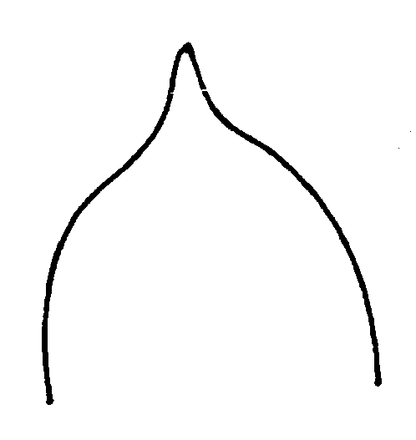 | 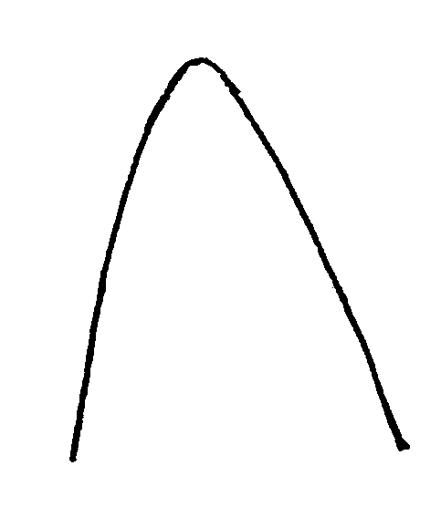
1 | 2
acuminate | acute
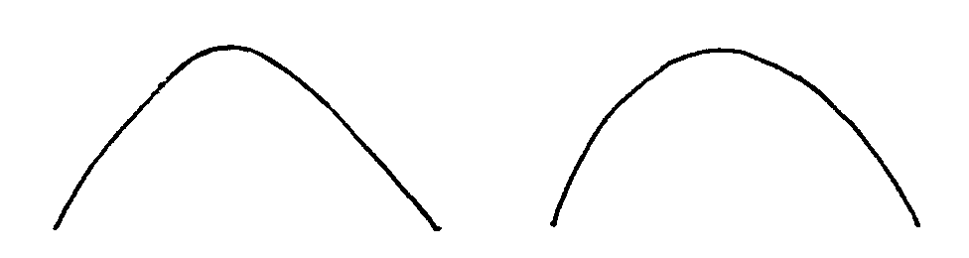
3 | 4
obtuse | rounded

Ad. 15 ([225]): Leaf blade: emargination at tip

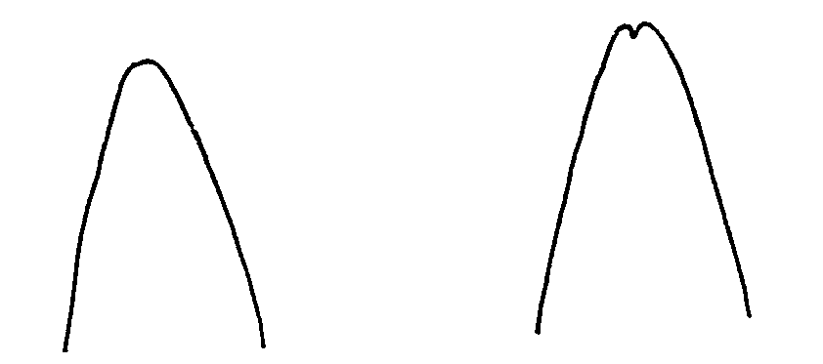
1 | 9
absent | present

Ad. 25 ([339]): Anther: viable pollen

Method to determine the percentage of viable pollen:

The pollen should be collected when the petals begin to open (but with the anthers closed). The anthers should be introduced into a Petri dish and placed inside a silica gel dryer at room temperature, for 20-48 hours of darkness. When the anthers are open they should be moved to an 8 ºC chamber with a 70-80 % Relative Humidity for one hour. Afterwards, the pollen should be brushed onto a microscope slide with 2 ml of Brewbacker medium (Brewbaker and Kwack. 1963). Finally, the microscope slide should be placed in a 24 ºC chamber with a 75 % RH for 20 hours.

The percentage of pollen fertility is calculated as the average of germinated pollen grains observed with a binocular in 15 visual fields from 2 different microscope slides.

(Brewbaker, J.L. and Kwack, B.H. 1963. The essential role of calcium ion in pollen germination and pollen tube growth. Amer. Jour. Botany. 50: 859-865.)

Percentage range indication for the states of expression:

Example varieties | Note | Range
Owari (SAT) | 1 | ≤ 7%
 | 2 | > 7 ≤ 14%
 | 3 | > 14 ≤ 21%
 | 4 | > 21 ≤ 28%
Marisol (CLE) | 5 | > 28 ≤ 35%
 | 6 | > 35 ≤ 45%
Murcott (HMA) | 7 | > 45 < 55%
 | 8 | > 55 < 65%
Fortune (HMA) | 9 | ≥ 65%

Ad. 32 ([248]): Fruit: shape in transverse section

1 | 2 | 3
circular | somewhat angular | scalloped

Ad. 33 ([249]): Fruit: general shape of proximal part (excluding neck, collar and depression at stalk end)

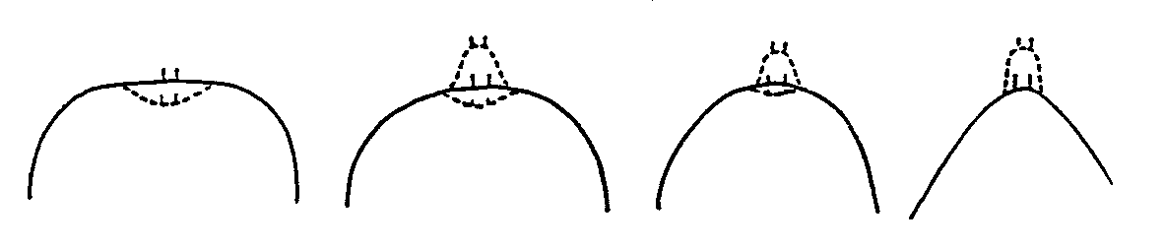
1 | 2 | 3 | 4
flattened | slightly rounded | strongly rounded | tapered
Ad. 34 ([250]): Fruit: presence of neck

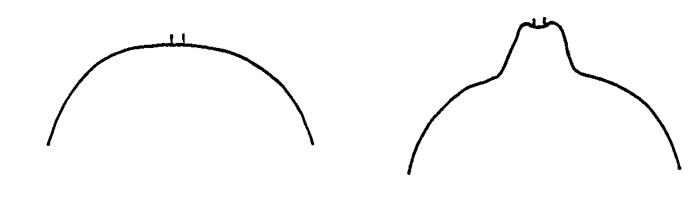
1 | 9
absent | present

Ad. 37 ([253]): Only varieties without fruit neck: Fruit: presence of depression at stalk end

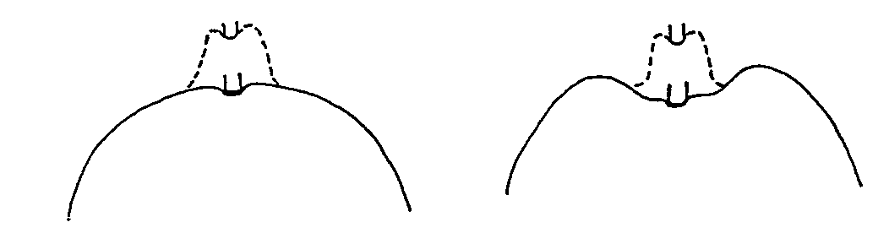
1 | 9
absent | present

Ad. 39 ([255]): Fruit: presence of constriction at stalk end

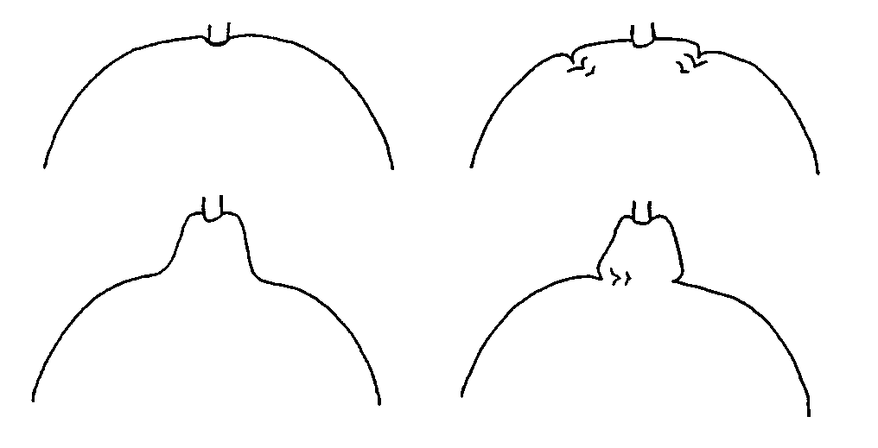
1 | 9
absent | present

Ad. 44 ([260]): Fruit: presence of collar

1 | 9
absent | present

Ad. 48 ([264]): Fruit: general shape of distal part (excluding nipple, bulging of navel and depression at distal end)

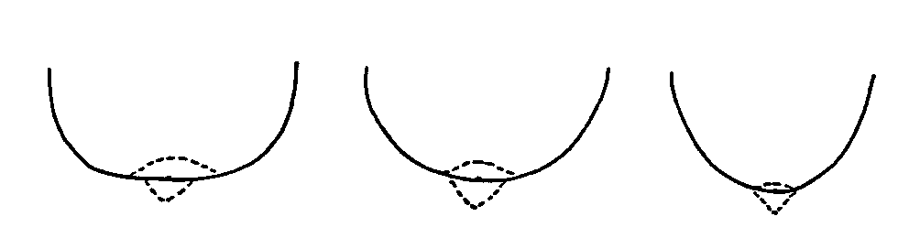
1 | 2 | 3
flattened | slightly rounded | strongly rounded

Ad. 49 ([265]): Fruit: presence of depression at distal end

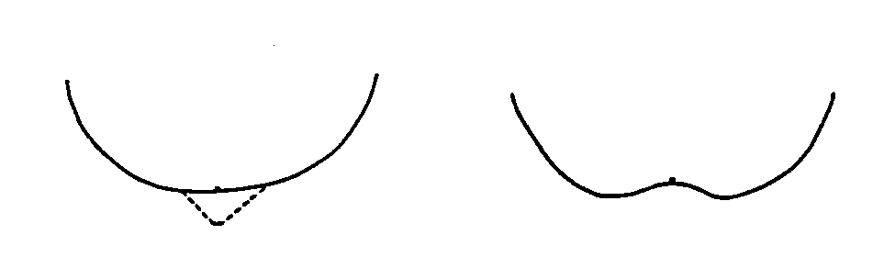
1 | 9
absent | present

Ad. 53 ([271]): Fruit: type of areola

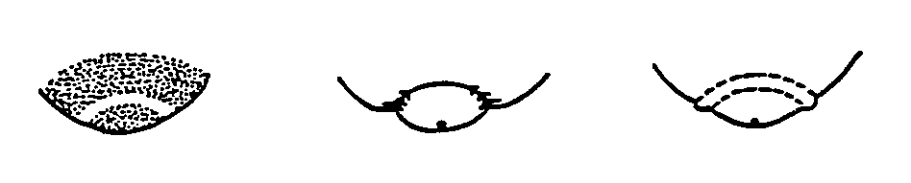
1 | 2 | 3
smooth | grooved | ridged

Ad. 98 ([325]): Fruit: number of seeds (controlled manual self-pollination)

Manual self-pollination is necessary to ensure a consistent production of seed.

Ad. 99 ([326]): Fruit: number of seeds (open pollination)

Open pollination means natural pollination between trees of the same variety.

Ad. 110 ([338]): Plant: self-incompatibility

A variety is self-incompatible when the fertile pollen of its own flower or of other flowers of the same variety is not able to fertilize the ovary.

LIST OF EXAMPLE VARIETIES FOR MANDARINS

Variety denomination | Subgroup | Observations | Associated indication
Afourer | TNR |  | Murcott Afourer
Arrufatina | CLE
Campeona | HMA | Citrus nobilis Lour.
Clemenules | CLE |  | Clementina de Nules
Comun | MMN |  | Wilowleaf, Avana, Mediterranea
Ellendale | TNR
Encore | HMA | Citrus nobilis Lour. x C. deliciosa Ten.
Fino | CLE |  | Clementina Fina
Fortune | HMA | Citrus clementina hort. ex Tan. x C. tangerina hort. ex Tan.
Hernandina | CLE
Honey | HMA | Citrus nobilis Lour. x C. deliciosa Ten.
Kara | HMA | Citrus unshiu Marcow. x C. nobilis Lour.
Kinow | HMA | Citrus nobilis Lour. x C. deliciosa Ten.
Mapo | TNL
Marisol | CLE
Minneola | TNL | Citrus paradisi Macfad. x C. tangerina hort. ex Tan.  Grapefruit Duncan x Mandarin Dancy | Honeybell
Murcott | TNR
Nova | HMA | Citrus clementina hort. ex Tan. x Tangelo Orlando | Clemenvilla
Okitsu | SAT
Orlando | TNL | Citrus paradisi Macfad. x C. tangerina hort. ex Tan.  Grapefruit Duncan x Mandarin Dancy | Lake Tangelo
Oronules | CLE
Oroval | CLE
Ortanique | TNR
Owari | SAT
Page | HMA | Tangelo Minneola x Citrus clementina hort. ex Tan.
Pixie | HMA | Citrus nobilis Lour. x C. tangerina hort. ex Tan.
Temple | HMA | Citrus temple Ort. ex Yu. Tanaka
Wilking | HMA | Citrus nobilis Lour. x C. deliciosa Ten.

Literature
Alexander, D. McE., 1983: “Some citrus species and varieties in Australia,” Commonwealth Scientific and Industrial Research Organization, Australia, 64 pp.

Blondel, L., 1978: Botanical classification of species of the genus Citrus, Fruits 33 (11): pp. 695 - 720.

Bono, R., Soler, J., Fernandez de Cordova, L., 1986: “Variedades de agrios cultivadas en España”. Generalitat Valenciana, 70 pp.

Damigella, P., Tribulato, E., Calabrese, F., Crescimanno, F.G., Continella, G., 1980: “Gli Agrumi,” Cultivar. R.E.D.A., Roma, Italy, pp. 9 - 70.

Ortiz Marcide, J.M., 1985: “Nomenclatura botánica de los cítricos”. Levante Agrícola nº 259-260, pp. 71-79.

Reuther, W., Webber, H.J., Batchelor, L.D. (Editors), 1967: “The Citrus Industry,” Volume I, University of California, Division of Agricultural Sciences, 611 pp.

Soler, J., 1999: Reconocimiento de variedades de cítricos en campo. Generalitat Valenciana. 187 pp.

Saunt, J., 1990: “Citrus varieties of the world: an illustrated guide,” Sinclair International Ltd., Norwich, England, 126 pp.

Spina, P., Russo, F., Geraci, G., Martelli, S., 1980: “Schede per il registro varietale dei fruttiferi I - ARANCIO e MANDARINO,” Ministèro Agricoltura e Foreste - S.O.I., Roma, Italy, 92 pp.

Tanaka, T., 1932: “A Monograph of the Satsuma orange with special reference to the occurrence of new varieties through bud variation,” reprinted from the “Memoirs of the Faculty of Science and Agriculture, Taihoku Imperial University,” Volume IV, Taihoku, Formosa, Japan, 626 pp.

Zaragoza, S., Navarro, L., Cebolla, V., 1997: “Evaluation of the field collection through the germo data-base”. Proceedings of the sectorial meeting of the mediterranean citrus net work (Mecinet) on global cooperation for citrus germplasm conservation and use, pp. 142-148.

Zaragoza, S., Trenor, I., Alonso, E., Medina, A., Pina, J.A., Navarro, L., 1995: “Evaluación de la colección de variedades del Banco de Germoplasma de Cítricos del IVIA: Planteamiento y primeros resultados generales”. Levante Agrícola nº 331, pp. 145-149.

Technical Questionnaire
TECHNICAL QUESTIONNAIRE |  |  |  | Page {x} of {y} |  | Reference Number:
 |  |  |  |  |  | Application date:
 |  |  |  |  |  | (not to be filled in by the applicant)
TECHNICAL QUESTIONNAIRE
to be completed in connection with an application for plant breeders’ rights
1. Subject of the Technical Questionnaire
(a) Subgroup: (i) CLE [ ] (v) TNL [ ]
(ii) MMN [ ] (vi) TNR [ ]
(iii) PMN [ ] (vii) HMA [ ]
(iv) SAT [ ]
(b) Species (please specify):
2. Applicant
Name
Address
Telephone No.
Fax No.
E-mail address
Breeder (if different
from applicant)
3. Proposed denomination and breeder’s reference
Proposed denomination
(if available)
Breeder’s reference
4. Information on the breeding scheme and propagation of the variety

4.1 Breeding Scheme

4.1.1 Variety resulting from:

(a) controlled cross [ ]
(please state parent varieties:
)
(b) partially unknown cross [ ]
(please state known parent variety(ies):
)
(c) totally unknown cross [ ]

4.1.2 Mutation [ ]
(please state parent variety: )

4.1.3 Discovery [ ]
(please state where, when and how developed:
)

4.1.4 Other [ ]
(please provide details:
)

4.2 Method of Propagating the Variety

4.3 Virus status
4.3.1 The plant material is virus-free [ ]
4.3.2 The plant material is virus tested [ ]
(indicate against which viruses:
)
4.3.3 The virus status is unknown [ ]

5. Characteristics of the variety to be indicated (the number in brackets refers to the corresponding characteristic in Test Guidelines; please mark the note which best corresponds).

 | Characteristics |  |  |  |  |  | Example Varieties |  |  | Note
5.1  (28) | Fruit: length
 | short |  |  |  |  |  | Wilking (HMA) |  |  | 3[ ]
 | medium |  |  |  |  |  | Clemenules (CLE) |  |  | 5[ ]
 | long |  |  |  |  |  | Minneola (TNL) |  |  | 7[ ]
5.2  (29) | Fruit: diameter
 | small |  |  |  |  |  | Fino (CLE) |  |  | 3[ ]
 | medium |  |  |  |  |  | Clemenules (CLE) |  |  | 5[ ]
 | large |  |  |  |  |  | Ortanique (TNR) |  |  | 7[ ]
5.3  (34) | Fruit: presence of neck
 | absent |  |  |  |  |  | Clemenules (CLE) |  |  | 1[ ]
 | present |  |  |  |  |  |  |  |  | 9[ ]
5.4  (61) | Fruit surface: predominant color(s)
 | green |  |  |  |  |  |  |  |  | 1[ ]
 | yellow green |  |  |  |  |  |  |  |  | 2[ ]
 | light yellow |  |  |  |  |  |  |  |  | 3[ ]
 | medium yellow |  |  |  |  |  | Mapo (TNL) |  |  | 4[ ]
 | yellow orange |  |  |  |  |  |  |  |  | 5[ ]
 | medium orange |  |  |  |  |  | Clemenules (CLE) |  |  | 6[ ]
 | dark orange |  |  |  |  |  |  |  |  | 7[ ]
 | orange red |  |  |  |  |  | Nova (HMA) |  |  | 8[ ]
 | red |  |  |  |  |  |  |  |  | 9[ ]
 | Characteristics |  |  |  |  |  | Example Varieties |  |  | Note
5.5  (81) | Fruit: main color of flesh
 | whitish |  |  |  |  |  |  |  |  | 1[ ]
 | light green |  |  |  |  |  |  |  |  | 2[ ]
 | light yellow |  |  |  |  |  |  |  |  | 3[ ]
 | medium yellow |  |  |  |  |  |  |  |  | 4[ ]
 | light orange |  |  |  |  |  |  |  |  | 5[ ]
 | medium orange |  |  |  |  |  | Clemenules (CLE) |  |  | 6[ ]
 | dark orange |  |  |  |  |  |  |  |  | 7[ ]
 | red |  |  |  |  |  |  |  |  | 8[ ]
 | purple |  |  |  |  |  |  |  |  | 9[ ]
5.6  (108) | Time of maturity of fruit for consumption
 | early |  |  |  |  |  | Okitsu (SAT) |  |  | 3[ ]
 | medium |  |  |  |  |  | Clemenules (CLE) |  |  | 5[ ]
 | late |  |  |  |  |  | Murcott (TNR) |  |  | 7[ ]
5.7  (109) | Fruit: parthenocarpy
 | absent |  |  |  |  |  | Temple (HMA) |  |  | 1[ ]
 | present |  |  |  |  |  | Clemenules (CLE) |  |  | 9[ ]
6. Similar varieties and differences from these varieties

Denomination(s) of variety(ies) similar to your candidate variety |  | Characteristic(s) in which your candidate variety differs from the similar variety(ies) |  |  | Describe the expression of the characteristic(s) for the similar variety(ies) |  |  | Describe the expression of the characteristic(s) for your candidate variety
(Example) |  | Fruit surface:  predominant color(s) |  |  | medium orange |  |  | dark orange
7. Additional information which may help in the examination of the variety

7.1 In addition to the information provided in sections 5 and 6, are there any additional characteristics which may help to distinguish the variety?

Yes [ ] No [ ]

If yes, please provide details:

7.2 Special conditions for the examination of the variety

7.2.1 Are there any special conditions for growing the variety or conducting the examination?

Yes [ ] No [ ]

If yes, please provide details:

7.3 Other information

A representative color photograph of the variety should accompany the Technical Questionnaire

8. Authorization for release

(a) Does the variety require prior authorization for release under legislation concerning the protection of the environment, human and animal health?

Yes [ ] No [ ]

(b) Has such authorization been obtained?

Yes [ ] No [ ]

If the answer to (b) is yes, please attach a copy of the authorization.

9. I hereby declare that, to the best of my knowledge, the information provided in this form is correct:

Applicant’s name

Signature Date

[Annex follows]

[see pdf version]

[End of document]

* These names were correct at the time of the introduction of these Test Guidelines but may be revised or updated. [Readers are advised to consult the UPOV Code, which can be found on the UPOV Web Site (www.upov.int), for the latest information.]

