 |  | E  TG/163/3

INTERNATIONAL UNION FOR THE PROTECTION  OF NEW VARIETIES OF PLANTS | UNION INTERNATIONALE POUR LA PROTECTION  DES OBTENTIONS VÉGÉTALES | INTERNATIONALER VERBAND ZUM SCHUTZ VON PFLANZEN-ZÜCHTUNGEN | UNIÓN INTERNACIONAL PARA LA PROTECCIÓN  DE LAS OBTENCIONES VEGETALES

GUIDELINES

FOR THE CONDUCT OF TESTS

FOR DISTINCTNESS, UNIFORMITY AND STABILITY

APPLE ROOTSTOCKS

(Malus Mill.)

GENEVA
1999

Copies of this document are available on request at the price of 10 Swiss francs each, including surface mail, from the Office of UPOV, 34, chemin des Colombettes, P.O. Box 18, 1211 Geneva 20, Switzerland

This document or parts of it may be reproduced, translated and published without obtaining the specific consent of UPOV, provided that the source is acknowledged.

* * * * * * *
TG/163/3
ORIGINAL: English
DATE: 1999-03-24

INTERNATIONAL UNION FOR THE PROTECTION  OF NEW VARIETIES OF PLANTS | UNION INTERNATIONALE POUR LA PROTECTION  DES OBTENTIONS VÉGÉTALES | INTERNATIONALER VERBAND ZUM SCHUTZ VON PFLANZEN-ZÜCHTUNGEN | UNIÓN INTERNACIONAL PARA LA PROTECCIÓN  DE LAS OBTENCIONES VEGETALES

GUIDELINES

FOR THE CONDUCT OF TESTS

FOR DISTINCTNESS, UNIFORMITY AND STABILITY

APPLE ROOTSTOCKS

(Malus Mill.)

These Guidelines should be read in conjunction with document TG/1/2, which contains explanatory notes on the general principles on which the Guidelines have been established.

TABLE OF CONTENTS PAGE

I. Subject of these Guidelines ........................................................................... 3

II. Material Required ........................................................................................ 3

III. Conduct of Tests .......................................................................................... 3

IV. Methods and Observations............................................................................ 3

V. Grouping of Varieties ................................................................................... 4

VI. Characteristics and Symbols ........................................................................ 4

VII. Table of Characteristics ............................................................................... 5

VIII. Explanations on the Table of Characteristics .............................................. 13

IX. Literature ..................................................................................................... 15

X. Technical Questionnaire ............................................................................. 16

I. Subject of these Guidelines

These Test Guidelines apply to all vegetatively propagated rootstock varieties of Malus Mill. If characteristics of the flower, the fruit or the seed are necessary to establish distinctness, the Test Guidelines for Apple Fruit Varieties (TG/14/8) should be used for those characteristics, if applicable.

II. Material Required

1. The competent authorities decide when, where and in what quantity and quality the plant material required for testing the variety is to be delivered. Applicants submitting material from a State other than that in which the testing takes place must make sure that all customs formalities are complied with. As a minimum, the following quantity of plant material is recommended:

25 one-year-old rooted plants (virus free).

2. The plant material supplied should be visibly healthy, not lacking in vigor or affected by any important pests or diseases. It should preferably not be obtained from in vitro propagation.

3. The plant material must not have undergone any treatment unless the competent authorities allow or request such treatment. If it has been treated, full details of the treatment must be given.

III. Conduct of Tests

1. The minimum duration of tests should normally be two similar growing periods.

2. From the submitted 25 plants 20 plants should be cut back annually in the stoolbed and 5 plants should be grown to produce trees, in case characteristics of the adult tree are needed for the establishment of distinctness.

3. The tests should normally be conducted at one place. If any important characteristics of the variety cannot be seen at that place, the variety may be tested at an additional place.

4. The tests should be carried out under conditions ensuring normal growth. Each test should include a total of 20 plants. Separate plots for observation and for measuring can only be used if they have been subject to similar environmental conditions.

5. Additional tests for special purposes may be established.

IV. Methods and Observations

1. All observations determined by measurements, weighing or counting should be made on 10 plants or parts taken from each of 10 plants.

2. For the assessment of uniformity, a population standard of 1% and an acceptance probability of at least 95% should be applied. In the case of a sample size of 20 plants, the maximum number of off-types allowed would be 1.

3. Unless otherwise stated, observations of vegetative characteristics should be made on plants which are cut back annually in the stoolbed.

4. Unless otherwise stated, all observations on the plant and on the shoot should be made on the middle third of the one-year-old shoot in the dormant season.

5. Unless otherwise stated, all observations on the leaf should be made on fully developed leaves from the middle third of a vigorous shoot in summer.

V. Grouping of Varieties

1. The collection of varieties to be grown should be divided into groups to facilitate the assessment of distinctness. Characteristics which are suitable for grouping purposes are those which are known from experience not to vary, or to vary only slightly, within a variety. Their various states of expression should be fairly evenly distributed throughout the collection.

2. It is recommended that the competent authorities use the following characteristics for grouping varieties:

- Plant: habit of shoot (characteristic 3)
- Plant: growth of shoot (characteristic 4)
- Expanding leaf: anthocyanin coloration of blade (characteristic 18)
- Time of beginning of bud burst (characteristic 32)

VI. Characteristics and Symbols

1. To assess distinctness, uniformity and stability, the characteristics and their states as given in the Table of Characteristics should be used.

2. Notes (numbers), for the purposes of electronic data processing, are given opposite the states of expression for each characteristic.

3. Legend

(*) Characteristics that should be used on all varieties in every growing period over which examinations are made and always be included in the variety descriptions, except when the state of expression of a preceding characteristic or regional environmental conditions render this impossible.

(+) See Explanations on the Table of Characteristics in Chapter VIII.

VII. Table of Characteristics/Tableau des caractères/Merkmalstabelle/Tabla de caracteres

 | English | français | deutsch | español | Example Varieties  Exemples  Beispielssorten  Variedades ejemplo | Note/  Nota
1.  (*) | Plant: vigor | Plante: vigueur | Pflanze: Wuchsstärke | Planta: vigor
 | weak | faible | gering | débil | M 27 | 3
 | medium | moyenne | mittel | media | M 7, M 26 | 5
 | strong | forte | stark | fuerte | MM 106 | 7
2. | Plant: number of shoots | Plante: nombre de rameaux | Pflanze: Anzahl Triebe | Planta: número de ramas
 | very few | très petit | sehr gering | muy bajo | M 27 | 1
 | few | petit | gering | bajo | M 9 | 3
 | medium | moyen | mittel | medio | M 26 | 5
 | many | grand | groß | alto | M 9, MM 106, MM 111 | 7
 | very many | très grand | sehr groß | muy alto | M 25 | 9
3.  (*) | Plant: habit of shoot | Plante: port du rameau | Pflanze: Haltung der Triebe | Planta: porte de la rama
 | upright | dressé | aufrecht | erecto | M 4 | 1
 | spreading | étalé | breitwüchsig | rastrero | Cepiland | 2
 | drooping | retombant | hängend | colgante | Marubakaido | 3
4.  (*) | Plant: growth of shoot | Plante: croissance du rameau | Pflanze: Wuchs der Triebe | Planta: crecimiento de las ramas
 | straight | droite | gerade | recto | M 9 | 1
 | wavy or zigzag | ondulée ou en zigzag | gewellt oder zickzackförmig | ondulado o en zigzag | M 2, M 25 | 2

 | English | français | deutsch | español | Example Varieties  Exemples  Beispielssorten  Variedades ejemplo | Note/  Nota
5.  (*) | Shoot: pubescence (on upper half of shoot) | Rameau: pubescence (moitié supérieure du rameau) | Trieb: Behaarung (obere Triebhälfte) | Rama: pubescencia (en la mitad superior de la rama)
 | absent or very weak | absente ou très faible | fehlend oder sehr gering | ausente o muy débil |  | 1
 | weak | faible | gering | débil | B 9, M 26 | 3
 | medium | moyenne | mittel | media | M 27 | 5
 | strong | forte | stark | fuerte | M 9 | 7
 | very strong | très forte | sehr stark | muy fuerte | Crab C | 9
6.  (*) | Shoot: glossiness of bark | Rameau: brillance de l’écorce | Trieb: Glanz der Rinde | Rama: brillo de la corteza
 | absent or very weak | absente ou très faible | fehlend oder sehr gering | ausente o muy débil |  | 1
 | weak | faible | gering | débil | M 26 | 3
 | medium | moyenne | mittel | medio |  | 5
 | strong | forte | stark | fuerte | M 27 | 7
 | very strong | très forte | sehr stark | muy fuerte |  | 9
7.  (*) | Shoot: thickness (at midlength) | Rameau: épaisseur (à mi-longueur) | Trieb: Dicke (in der Mitte) | Rama: grosor (a media longitud)
 | thin | mince | dünn | delgada | M 7, M 27 | 3
 | medium | moyen | mittel | media | MM 111 | 5
 | thick | épais | dick | gruesa | M 106 | 7
8.  (*) | Shoot: length of internodes (as for 7) | Rameau: longueur des entre-nœuds (comme pour 7) | Trieb: Länge der Internodien (wie unter 7) | Rama: longitud de los entrenudos (como en 7)
 | short | courts | kurz | corta | M 25 | 3
 | medium | moyens | mittel | media | M 26 | 5
 | long | longs | lang | larga | M 7 | 7

 | English | français | deutsch | español | Example Varieties  Exemples  Beispielssorten  Variedades ejemplo | Note/  Nota
9.  (*) | Shoot: number of lenticels | Rameau: nombre de lenticelles | Trieb: Anzahl Lentizellen | Rama: número de lenticelas
 | absent or very few | absent ou très petit | fehlend oder sehr gering | ausente o muy bajo |  | 1
 | few | petit | gering | bajo | M 9 | 3
 | medium | moyen | mittel | medio | M 26 | 5
 | many | grand | groß | alto | M 2, MM 111 | 7
 | very many | très grand | sehr groß | muy alto | MM 104 | 9
10. | Shoot: size of lenticels | Rameau: taille des lenticelles | Trieb: Größe der Lentizellen | Rama: tamaño de las lenticelas
 | small | petites | klein | pequeñas |  | 3
 | medium | moyennes | mittel | medias | M 9, M 26 | 5
 | large | grandes | groß | grandes | M 2 | 7
11. | Shoot: shape of lenticels | Rameau: forme des lenticelles | Trieb: Form der Lentizellen | Rama: forma de las lenticelas
 | elliptic | elliptiques | elliptisch | elípticas | M 25 | 1
 | broad elliptic | elliptiques larges | breit elliptisch | elípticas anchas | M 26, M 111 | 2
 | circular | rondes | rund | circulares | M 9, M 27 | 3
12.  (*) | Shoot: predominant color on sunny side | Rameau: couleur prédominante de la face ensoleillée | Trieb: vorherrschende Farbe auf der Sonnenseite | Rama: color predominante de la parte soleada
 | greenish brown | brun verdâtre | grünlichbraun | marrón grisáceo |  | 1
 | reddish brown | brun rougeâtre | rötlichbraun | marrón rojizo | M 9 | 2
 | medium brown | brun moyen | mittelbraun | marrón medio | M 25, M 27 | 3
 | dark brown | brun foncé | dunkelbraun | marrón oscuro | B 9, M 2, M 26, MM 106 | 4

 | English | français | deutsch | español | Example Varieties  Exemples  Beispielssorten  Variedades ejemplo | Note/  Nota
13.  (*) | Shoot: size of bud | Rameau: taille de l’œil | Trieb: Größe der Knospe | Rama: tamaño de la yema
 | small | petit | klein | pequeño | M 25, MM 111 | 3
 | medium | moyen | mittel | mediano | MM 106 | 5
 | large | grand | groß | grande | M2, M 9, M 27 | 7
14.  (+) | Shoot: shape of tip of bud | Rameau: forme du sommet de l’œil | Trieb: Form der Spitze der Knospe | Rama: forma del extremo de la yema
 | pointed | pointu | spitz | puntiagudo | M 9, M 27 | 1
 | rounded | arrondi | abgerundet | redondeado | Bemali, MM 111 | 2
15.  (+) | Shoot: position of bud relative to axis | Rameau: position de l’œil par rapport à l’axe | Trieb: Stellung der Knospe im Verhältnis zur Achse | Rama: posición de la yema en relación con el eje
 | adpressed | appliquée | anliegend | alineado | MM 106 | 1
 | slightly held out | faiblement divergente | leicht abstehend | ligeramente divergente | M 9, M 26 | 2
 | markedly held out | nettement divergente | deutlich abstehend | claramente divergente |  | 3
16.  (+) | Shoot: size of bud support | Rameau: taille du support de l’œil | Trieb: Größe des Knospenwulstes | Rama: tamaño del soporte de la yema
 | small | petit | klein | pequeño | M 9 | 3
 | medium | moyen | mittel | medio | M 7, M 27 | 5
 | large | grand | groß | grande | M 2 | 7
17.  (*) | Shoot: color of growing tip | Rameau: couleur  du sommet en croissance | Trieb: Farbe der wachsenden Spitze | Rama: color del ápice de crecimiento
 | whitish | blanchâtre | weißlich | blancuzco | M 25 | 1
 | greenish | verdâtre | grünlich | verdoso | M 2, M 27, MM 106 | 2
 | reddish | rougeâtre | rötlich | rojizo | M 9 | 3
 | blackish | noirâtre | schwärzlich | negruzco | B 9, M 10, M 26 | 4

 | English | français | deutsch | español | Example Varieties  Exemples  Beispielssorten  Variedades ejemplo | Note/  Nota
18.  (*) | Expanding leaf: anthocyanin coloration of blade | Feuille en cours de croissance: pigmentation anthocyanique du limbe | Sich entfaltendes Blatt: Anthocyanfärbung der Blattspreite | Hoja en crecimiento: pigmentación antociánica del limbo
 | absent | absente | fehlend | ausente | M 27 | 1
 | present | présente | vorhanden | presente | B 9 | 9
19.  (*) | Expanding leaf: hue of anthocyanin coloration of blade | Feuille en cours de croissance: teinte de pigmentation anthocyanique du limbe | Sich entfaltendes Blatt: Ton der Anthocyanfärbung der Blattspreite | Hoja en crecimiento: matiz de la pigmentación antociánica del limbo
 | bronze | bronze | bronzefarben | bronce | P 22 | 1
 | purple | pourpre | purpurn | púrpura | B 9 | 2
20.  (+) | Leaf blade: attitude in relation to shoot | Limbe: port par rapport au rameau | Blattspreite: Stellung im Verhältnis zum Trieb | Limbo: porte en relación con la rama
 | semi-upwards | demi-dressé | halbaufrecht | semiascendente | M 111 | 3
 | outwards | horizontal | waagerecht | horizontal | M 7, MM 106 | 5
 | semi-downwards | demi-retombant | halbhängend | semidescendente |  | 7
21.  (*) | Leaf blade: length | Limbe: longueur | Blattspreite: Länge | Limbo: longitud
 | short | court | kurz | corto | M 26, M 27 | 3
 | medium | moyen | mittel | medio | M 111 | 5
 | long | long | lang | largo | M 9, P 16 | 7
22.  (*) | Leaf blade: width | Limbe: largeur | Blattspreite: Breite | Limbo: anchura
 | narrow | étroit | schmal | estrecho | M 26 | 3
 | medium | moyen | mittel | medio | M 9, M 27 | 5
 | broad | large | breit | ancho | P 14 | 7

 | English | français | deutsch | español | Example Varieties  Exemples  Beispielssorten  Variedades ejemplo | Note/  Nota
23.  (*) | Leaf blade: ratio length/width | Limbe: rapport longueur/largeur | Blattspreite: Verhältnis Länge/ Breite | Limbo: relación longitud/anchura
 | small | petit | klein | pequeña | M 7 | 3
 | medium | moyen | mittel | media | M 26 | 5
 | large | grand | groß | grande | P 16 | 7
24.  (*) | Leaf blade: profile in cross section | Limbe: profil en section transversale | Blattspreite: Profil im Querschnitt | Limbo: perfil en sección transversal
 | concave | concave | konkav | cóncava | M 27, M 111 | 1
 | straight | droit | gerade | recta | M 9 | 2
 | convex | convexe | konvex | convexa | M 25 | 3
25.  (*) | Leaf blade: length of pointed tip | Feuille: longueur de la pointe | Blatt: Länge der Spitze | Limbo: longitud del extremo
 | short | courte | kurz | corto | M 27 | 3
 | medium | moyenne | mittel | medio | M 9 | 5
 | long | longue | lang | largo | P 16 | 7
26.  (*) | Leaf blade: incisions of margin | Limbe: incisions du bord | Blattspreite: Randeinschnitte | Limbo: incisiones del borde
 | crenate | crénelé | gekerbt | crenadas | M 9 | 1
 | serrate | denté | gesägt | serradas | M 26, M 27 | 2
27. | Leaf blade: pubescence on lower side | Limbe: pilosité de la face inférieure | Blattspreite: Behaarung der Unterseite | Limbo: pubescencia del envés
 | weak | faible | gering | débil | M 9 | 3
 | medium | moyenne | mittel | media | M 27 | 5
 | strong | forte | stark | fuerte | MM 106 | 7

 | English | français | deutsch | español | Example Varieties  Exemples  Beispielssorten  Variedades ejemplo | Note/  Nota
28.  (*) | Leaf blade: anthocyanin coloration of veins | Limbe: pigmentation anthocyanique des nervures | Blattspreite: Anthocyanfärbung der Adern | Limbo: pigmentación antociánica de las nervaduras
 | weak | faible | gering | débil | M 9 | 3
 | medium | moyenne | mittel | media | M 26 | 5
 | strong | forte | stark | fuerte | MM 106, MM 109 | 7
29.  (*) | Petiole: length | Pétiole: longueur | Blattstiel: Länge | Peciolo: longitud
 | short | court | kurz | corto | M 26, M 27 | 3
 | medium | moyen | mittel | medio | M 9 | 5
 | long | long | lang | largo | MM 106, MM 111 | 7
30.  (*) | Leaf: ratio length of blade/length of petiole | Feuille: rapport longueur du limbe/ longueur du pétiole | Blatt: Verhältnis Länge der Spreite/ Länge des Stieles | Hoja: relación longitud del limbo/longitud del peciolo
 | small | petit | klein | pequeña |  | 3
 | medium | moyen | mittel | media | B 9, M 9 | 5
 | large | grand | groß | grande | P 2, P 16 | 7
31.  (*) | Stipule: size | Stipule: taille | Nebenblatt: Größe | Estípula: tamaño
 | small | petit | klein | pequeño | M 27 | 3
 | medium | moyen | mittel | medio | M 9, M 26 | 5
 | large | grand | groß | grande | MM 106 | 7

 | English | français | deutsch | español | Example Varieties  Exemples  Beispielssorten  Variedades ejemplo | Note/  Nota
32.  (*) | Time of beginning of bud burst | Époque de début  du débourrement | Zeitpunkt des Beginns des Knospenaufbruchs | Época de inicio de apertura de yemas
 | very early | très précoce | sehr früh | muy temprano | P 16 | 1
 | early | précoce | früh | temprano | M 9, MM 106 | 3
 | medium | moyenne | mittel | media | M 25 | 5
 | late | tardive | spät | tarde | MM 111 | 7
 | very late | très tardive | sehr spät | muy tarde | M 26 | 9

VIII. Explanation on the Table of Characteristics

Ad. 14: Shoot: shape of tip of bud

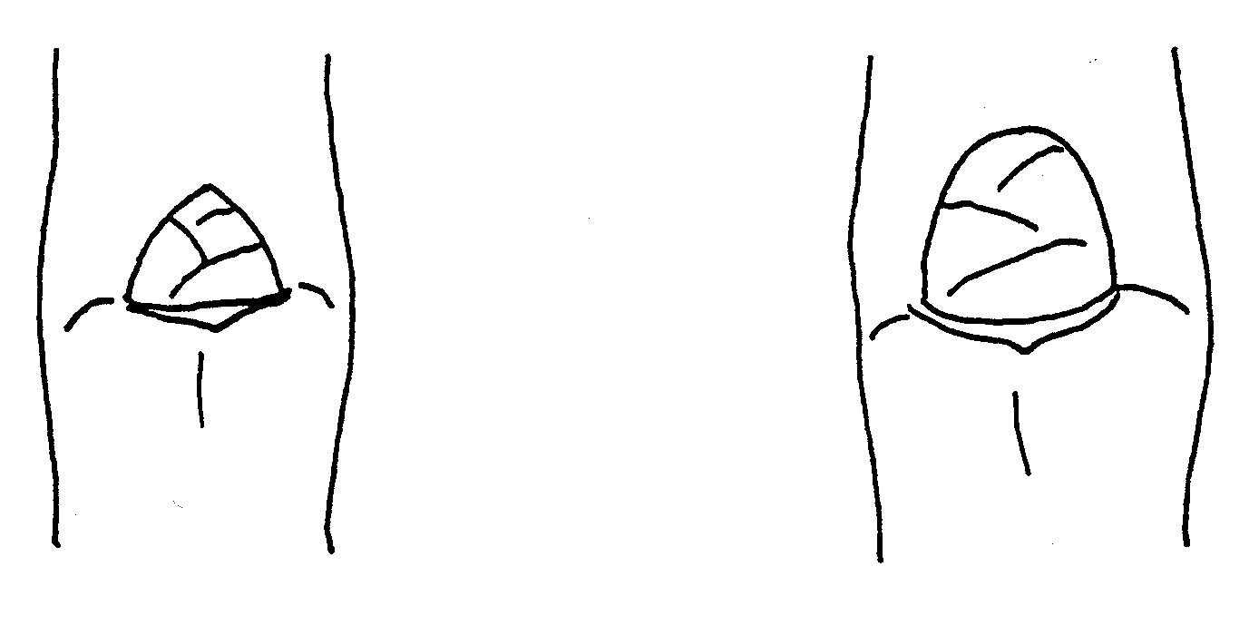
1 | 2
pointed | rounded

Ad. 15: Shoot: position of bud relative to axis

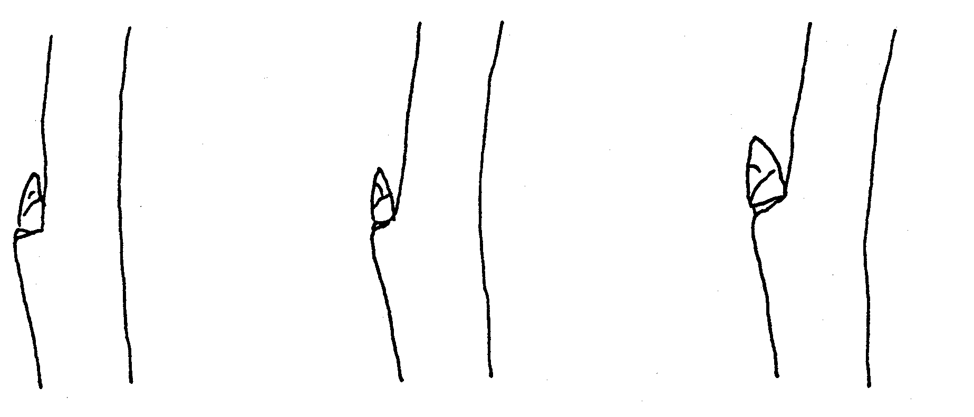

1 | 2 | 3
adpressed | slightly held out | markedly held out

Ad. 16: Shoot: size of bud support

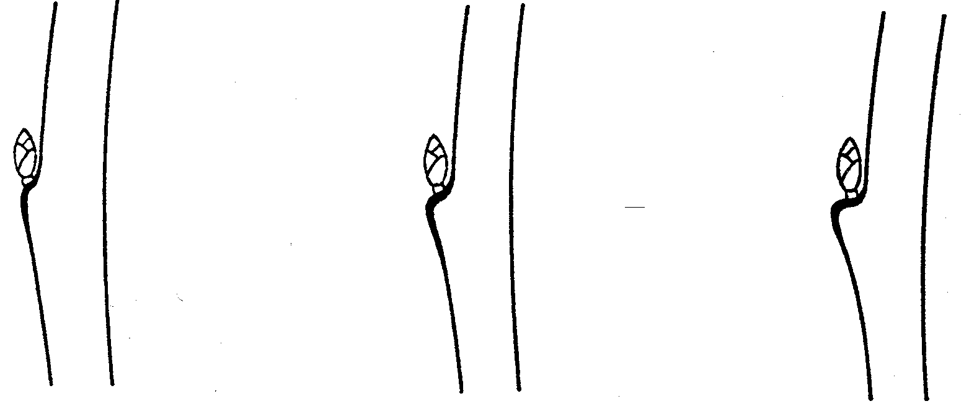

3 | 5 | 7
small | medium | large

Ad. 20: Leaf blade: attitude in relation to shoot

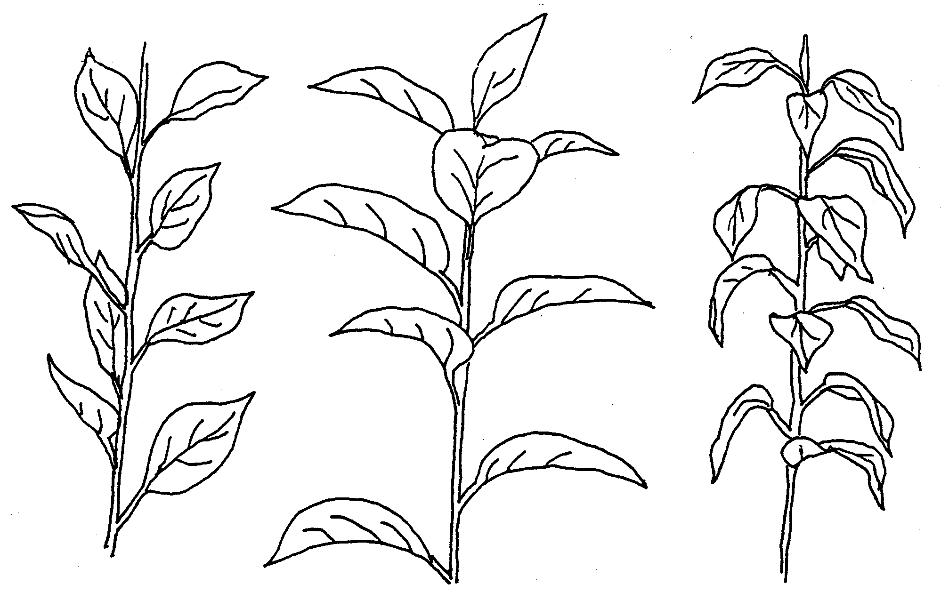

3 | 5 | 7
semi-upwards | outwards | semi-downwards
IX. Literature

Embree, C.G. 1995: “A Photographic Description of the Fruit of Certain Apple Rootstocks,” Fruit Varieties Journal, 49 (1):59-64, USA

Ferree, David C., Carlson, Robert F., 1987: “Apple Rootstocks” in Rootstocks for Fruit Crops, Ed. Rom, Roy C. and Carlson, Robert F., Wiley, 107-143, USA

Krummel, H., 1956: “Die vegetativ vermehrbaren Unterlagen des Kern- und Steinobstes,” Berlin: Deutscher Bauernverlag, Germany

Maurer, Erich.,1939: “Die Unterlagen der Obstgehölze,” Berlin: Parey Verlag, Germany

Simons, Roy K., 1986: “Leaf Characteristics of Apple Dwarfing Rootstocks,” Fruit Varieties Journal, 40 (3): 71-79, USA

Tydeman, H.M., 1953: “A Description of Classification of the Malling-Herton and Malling XXV Apple Rootstocks,” Report East Malling Research Station for 1952, pp. 53-63, United Kingdom

Tydeman, H.M., 1954: “A Description of Certain MIX Crosses,” Report East Malling Research Station for 1953, United Kingdom

Tydeman, H.M., 1955: “Descriptions of the Malling Apple Rootstocks,” Report East Malling Research Station for 1954, pp. 64-66, United Kingdom

X. Technical Questionnaire

Reference Number
(not to be filled in by the applicant)

TECHNICAL QUESTIONNAIRE
to be completed in connection with an application for plant breeders’ rights

1.1 Genus Malus Mill.

APPLE ROOTSTOCKS

1.2 Species ........................................
(indicate species)

2. Applicant (Name and address)

3. Proposed denomination or breeder’s reference

4. Information on origin, maintenance and reproduction of the variety

4.1 Origin

(a) Seedling of unknown parentage [ ]

(b) Produced by controlled pollination [ ]
(indicate parent varieties)

− Seed bearing parent (indicate parent)

................................................................................................

− Pollen parent (indicate parent)

................................................................................................

(c) Produced by open pollination of [ ]
(indicate seed bearing parent plant)
................................................................................................

(d) Mutation or sport from (indicate original parent variety)

................................................................................................ [ ]

(e) Discovery (indicate where and when)

................................................................................................ [ ]

4.2 In vitro propagation

The plant material of the candidate variety has been obtained
by in vitro propagation yes [ ]
no [ ]

4.3 Virus status

- The variety is free from all known viruses as follows: [ ]
(indicate from which viruses)
...................................................................................................
- The plant material is virus tested [ ]
(indicate against which viruses)
...................................................................................................
- The virus status is unknown [ ]

4.4 Other information

5. Characteristics of the variety to be indicated (the number in brackets refers to the corresponding characteristic in Test Guidelines; please mark the state of expression which best corresponds).

 | Characteristics |  |  |  | Example Varieties |  | Note
5.1  (3) |  |  | Plant: habit of shoot
 |  | upright |  |  | M 4 |  | 3[ ]
 |  | spreading |  |  | Cepiland |  | 5[ ]
 |  | drooping |  |  | Marubakaido |  | 7[ ]
5.2  (4) |  | Plant: growth of shoot
 |  | straight |  |  | M 9 |  | 1[ ]
 |  | wavy or zigzag |  |  | M 2, M 25 |  | 2[ ]
5.3  (18) |  | Expanding leaf: anthocyanin coloration of blade
 |  | absent |  |  | M 27 |  | 1[ ]
 |  | present |  |  | B 9 |  | 9[ ]
5.4  (32) |  | Time of beginning of bud burst
 |  | very early |  |  | P 16 |  | 1[ ]
 |  | early |  |  | M 9, MM 106 |  | 3[ ]
 |  | medium |  |  | M 25 |  | 5[ ]
 |  | late |  |  | MM 111 |  | 7[ ]
 |  | very late |  |  | M 26 |  | 9[ ]

6. Similar varieties and differences from these varieties

Denomination of similar variety | Characteristic in which the similar variety is different ^{o)} | State of expression of similar variety | State of expression of candidate variety
______________
^{o)} In the case of identical states of expressions of both varieties, please indicate the size of the difference.

7. Additional information which may help to distinguish the variety

7.1 Resistance to pests and diseases

7.2 Special conditions for the examination of the variety

7.3 Other information

A representative color photo of the variety should be added to the Technical Questionnaire.

8. Authorization for release

- Does the variety require prior authorization for release under legislation concerning the protection of the environment, human and animal health?
Yes [ ] No [ ] Yes [ ] No [ ]
- Has such authorization been obtained?

Yes [ ] No [ ]

If the answer to that question is yes, please attach a copy of such an authorization.

[End of document]

