 |  | E  TG/117/4

INTERNATIONAL UNION FOR THE PROTECTION  OF NEW VARIETIES OF PLANTS | UNION INTERNATIONALE POUR LA PROTECTION  DES OBTENTIONS VÉGÉTALES | INTERNATIONALER VERBAND ZUM SCHUTZ VON PFLANZEN-ZÜCHTUNGEN | UNIÓN INTERNACIONAL PARA LA PROTECCIÓN  DE LAS OBTENCIONES VEGETALES

GUIDELINES

FOR THE CONDUCT OF TESTS

FOR DISTINCTNESS, UNIFORMITY AND STABILITY

EGG PLANT

(Solanum melongena L.)

GENEVA
2002

Copies of this document are available on request at the price of 10 Swiss francs each, including surface mail, from the Office of UPOV, 34, chemin des Colombettes, P.O. Box 18, 1211 Geneva 20, Switzerland

This document or parts of it may be reproduced, translated and published without obtaining the specific consent of UPOV, provided that the source is acknowledged.

* * * * * * *
E
TG/117/4
ORIGINAL: English
DATE : 2002-04-17

INTERNATIONAL UNION FOR THE PROTECTION  OF NEW VARIETIES OF PLANTS | UNION INTERNATIONALE POUR LA PROTECTION  DES OBTENTIONS VÉGÉTALES | INTERNATIONALER VERBAND ZUM SCHUTZ VON PFLANZEN-ZÜCHTUNGEN | UNIÓN INTERNACIONAL PARA LA PROTECCIÓN  DE LAS OBTENCIONES VEGETALES

GUIDELINES

FOR THE CONDUCT OF TESTS

FOR DISTINCTNESS, UNIFORMITY AND STABILITY

EGG PLANT

(Solanum melongena L.)

These Guidelines should be read in conjunction with document TG/1/2, which contains explanatory notes on the general principles on which the Guidelines have been established.
TABLE OF CONTENTS PAGE

I. | Subject of these Guidelines | 3
II. | Material Required | 3
III. | Conduct of Tests | 3
IV. | Methods and Observations | 3
V. | Grouping of Varieties | 4
VI. | Characteristics and Symbols | 4
VII. | Table of Characteristics | 5
VIII. | Explanations on the Table of Characteristics | 16
IX. | Literature | 18
X. | Technical Questionnaire | 19

I. Subject of these Guidelines

These Test Guidelines apply to all varieties of Solanum melongena L.

II. Material Required

1. The competent authorities decide when, where and in what quantity and quality the seed required for testing the variety is to be delivered. Applicants submitting material from a State other than that in which the testing takes place must ensure that all customs formalities are complied with. The minimum quantity of seed to be supplied by the applicant should be:

10 g or 2500 seeds

2. The seed should meet the minimum requirements for germination, species and analytical purity, health and moisture content, specified by the competent authority. In cases where the seed is to be stored, the germination capacity should be as high as possible and should be stated by the applicant.

3. The plant material must not have undergone any treatment unless the competent authorities allow or request such treatment. If it has been treated, full details of the treatment must be given.

III. Conduct of Tests

1. The minimum duration of tests should normally be two independent growing cycles.

2. The tests should normally be conducted at one place. If any important characteristics of the variety cannot be seen at that place, the variety may be tested at an additional place.

3. The tests should be carried out under conditions ensuring satisfactory growth for the expression of the relevant characteristics of the variety and for the conduct of the examination. The size of the plots should be such that plants or parts of plants may be removed for measurement and counting without prejudice to the observations which must be made up to the end of the growing cycle. Each test should be designed to result in a total of at least 20 plants, which should be divided between two or more replicates. Separate plots for observation and for measuring should only be used if they have been subject to similar environmental conditions.

4. Additional tests for special purposes may be established.

- Methods and Observations

1. All observations determined by measurement or counting should be made on 10 plants or parts taken from each of 10 plants.

2. For the assessment of uniformity a population standard of 1% with an acceptance probability of at least 95% should be applied. In the case of a size of 20 plants, the maximum number of off-types allowed would be one.

3. Unless otherwise indicated, all observations on the plant and leaves should be made after the first inflorescence starts to flower and before the start of the harvest.

4. Unless otherwise indicated, all observations on the fruit should be made on the first normally developed fruits.

V. Grouping of Varieties

1. The collection to be grown should be divided into groups to facilitate the assessment of distinctness. Characteristics which are suitable for grouping purposes are those which are known from experience not to vary, or to vary only slightly, within a variety and which in their various states are fairly evenly distributed within the collection.

2. It is recommended that the competent authorities use the following characteristics for grouping varieties:

(i) Fruit: length (characteristic 16)
(ii) Fruit: ratio length/maximum diameter (characteristic 18)
(iii) Fruit: general shape (characteristic 19)
(iv) Fruit: main color of skin at harvest maturity (characteristic 24)
(v) Fruit: stripes (characteristic 28)
(vi) Fruit: color of flesh (characteristic 40)

VI. Characteristics and Symbols

1. To assess distinctness, uniformity and stability, the characteristics and their states as given in the Table of Characteristics should be used.

2. Notes (numbers), for the purposes of electronic data processing, are given opposite the states of the different characteristics.

3. Legend:

(*) Characteristics that should be used every growing cycle for the examinations of all varieties and should always be included in the description of the variety, except when the state of expression of a preceding characteristic or regional environmental conditions render this impossible.

(+) See Explanations on the Table of Characteristics in chapter VIII.

VII. Table of Characteristics/Tableau des caractères/Merkmalstabelle/Tabla de caracteres

 | English | français | deutsch |  |  | español | Example Varieties  Exemples  Beispielssorten  Variedades ejemplo | Note/  Nota
1.  (*) | Seedling: anthocyanin coloration of hypocotyl | Plantule: pigmentation anthocyanique de l’hypocotyle | Keimpflanze: Anthocyanfärbung des Hypokotyls |  |  | Plántula: pigmentación antociánica del hipocotilo
 | absent | absente | fehlend |  |  | ausente | Listada de Gandia | 1
 | present | présente | vorhanden |  |  | presente | Baluroi, Bonica | 9
2. | Seedling: intensity of anthocyanin coloration of hypocotyl | Plantule: intensité de la pigmentation anthocyanique de l’hypocotyle | Keimpflanze: Intensität der Anthocyanfärbung des Hypokotyls |  |  | Plántula: intensidad de la pigmentación antociánica del hipocotilo
 | very weak | très faible | sehr gering |  |  | muy débil | Whitegg | 1
 | weak | faible | gering |  |  | débil | Bonica | 3
 | medium | moyenne | mittel |  |  | media | Baluroi | 5
 | strong | forte | stark |  |  | fuerte | Larga Morada | 7
 | very strong | très forte | sehr stark |  |  | muy fuerte |  | 9
3.  (*) | Plant: growth habit | Plante: port | Pflanze: Wuchsform |  |  | Planta: porte
 | erect | dressé | aufrecht |  |  | erecto | Baluroi, Pingtung Long, Purpura Violetta Lunga 2 | 1
 | semi-erect | demi-dressé | halbaufrecht |  |  | semierecto | Bonica, Ovana | 3
 | horizontal | horizontal | waagerecht |  |  | horizontal | Black Bell, Irene, Listada de Gandia, Slim Purple | 5
4. | Plant: height | Plante: hauteur | Pflanze: Höhe |  |  | Planta: altura
 | very short | très basse | sehr niedrig |  |  | muy baja |  | 1
 | short | basse | niedrig |  |  | baja | Adona, Monstrueuse de New York, Whitegg | 3
 | medium | moyenne | mittel |  |  | media | Short Tom, Tudela | 5
 | tall | haute | hoch |  |  | alta | Avan, Baluroi | 7
 | very tall | très haute | sehr hoch |  |  | muy alta | Nilo | 9
5. | Stem: distance from cotyledons to the node of the first flower | Tige: distance des cotylédons jusqu’au nœud de la première fleur | Stiel: Distanz von den Keimblättern zum Ansatz der ersten Blüte |  |  | Tallo: distancia desde los cotiledones al nudo de la primera flor
 | very short | très courte | sehr kurz |  |  | muy corta | Ova | 1
 | short | courte | kurz |  |  | corta | Dourga | 3
 | medium | moyenne | mittel |  |  | media | Bonica | 5
 | long | longue | lang |  |  | larga | De Barbentane | 7
 | very long | très longue | sehr lang |  |  | muy larga | Nilo | 9
6.  (*) | Stem: anthocyanin coloration | Tige: pigmentation anthocyanique | Stiel: Anthocyanfärbung |  |  | Tallo: pigmentación antociánica
 | absent | absente | fehlend |  |  | ausente | Whitegg | 1
 | present | présente | vorhanden |  |  | presente | Baluroi | 9
7. | Stem: intensity of anthocyanin coloration | Tige: intensité de la pigmentation anthocyanique | Stiel: Intensität der Anthocyanfärbung |  |  | Tallo: intensidad de la pigmentación antociánica
 | very weak | très faible | sehr gering |  |  | muy débil |  | 1
 | weak | faible | gering |  |  | débil | Bonica | 3
 | medium | moyenne | mittel |  |  | media | Baluroi | 5
 | strong | forte | stark |  |  | fuerte | Redonda de Valencia, Short Tom | 7
 | very strong | très forte | sehr stark |  |  | muy fuerte |  | 9
8. | Stem: pubescence | Tige: pilosité | Stiel: Behaarung |  |  | Tallo: vellosidad
 | weak | faible | gering |  |  | débil | Baluroi, Black Oval | 3
 | medium | moyenne | mittel |  |  | media | Abrivado, Bonica | 5
 | strong | forte | stark |  |  | fuerte | Bolan, Estival, Mistral | 7
9. | Leaf blade: size | Limbe: taille | Blattspreite: Größe |  |  | Limbo: tamaño
 | very small | très petit | sehr klein |  |  | muy pequeño |  | 1
 | small | petit | klein |  |  | pequeño | Short Tom | 3
 | medium | moyen | mittel |  |  | medio | Baluroi | 5
 | large | grand | groß |  |  | grande | Bonica | 7
 | very large | très grand | sehr groß |  |  | muy grande | Morisca | 9
10. | Leaf blade: sinuation of margin | Limbe: sinuosité du bord | Blattspreite: Randzähnung |  |  | Limbo: sinuosidad del borde
 | absent or very weak | nulle ou très faible | fehlend oder sehr gering |  |  | ausente o muy débil | Baluroi, Bonica | 1
 | weak | faible | gering |  |  | débil | Adria | 3
 | medium | moyenne | mittel |  |  | media | Epic, Fabiola | 5
 | strong | forte | stark |  |  | fuerte | Dalia, Niteking, Tosca | 7
 | very strong | très forte | sehr stark |  |  | muy fuerte |  | 9
11. | Leaf blade: blistering | Limbe: cloqûre | Blattspreite: Blasigkeit |  |  | Limbo: abullonado
 | absent or very weak | nulle ou très faible | fehlend oder sehr gering |  |  | ausente o muy débil | Baluroi | 1
 | weak | faible | gering |  |  | débil | Ritmo | 3
 | medium | moyenne | mittel |  |  | medio | Bonica | 5
 | strong | forte | stark |  |  | fuerte | Oria | 7
 | very strong | très forte | sehr stark |  |  | muy fuerte |  | 9
12. | Leaf blade: intensity of green color | Limbe: intensité de la couleur verte | Blattspreite: Intensität der Grünfärbung |  |  | Limbo: intensidad del color verde
 | light | claire | hell |  |  | claro | Black Beauty | 3
 | medium | moyenne | mittel |  |  | medio | Baluroi, Bonica | 5
 | dark | foncée | dunkel |  |  | oscuro | Purpura, Short Tom | 7
13. | Inflorescence: number of flowers | Inflorescence: nombre de fleurs | Blütenstand: Anzahl Blüten |  |  | Inflorescencia: número de flores
 | one to three | une à trois | eine bis drei |  |  | una a tres |  | 1
 | more than three | plus de trois | mehr als drei |  |  | más de tres | Whitegg | 2
14. | Flower: size | Fleur: taille | Blüte: Größe |  |  | Flor: tamaño
 | small | petite | klein |  |  | pequeña | Cima viola | 3
 | medium | moyenne | mittel |  |  | media | Violetta di new York | 5
 | large | grande | groß |  |  | grande | Prosperosa | 7
15. | Flower: intensity of purple color | Fleur: intensité de la couleur pourpre | Blüte: Intensität der Purpurfärbung |  |  | Flor: intensidad del color púrpura
 | light | claire | hell |  |  | claro | Listada de Gandia | 3
 | medium | moyenne | mittel |  |  | medio | Baluroi | 5
 | dark | foncée | dunkel |  |  | oscuro | Redonda Negra | 7
16. (*) | Fruit: length | Fruit: longueur | Frucht: Länge |  |  | Fruto: longitud
 | very short | très court | sehr kurz |  |  | muy corto | Whitegg | 1
 | short | court | kurz |  |  | corto | Birgah | 3
 | medium | moyen | mittel |  |  | medio | Cava | 5
 | long | long | lang |  |  | largo | Mistral | 7
 | very long | très long | sehr lang |  |  | muy largo | Indira, Slim Purple | 9
17. | Fruit: maximum diameter | Fruit: diamètre maximal | Frucht: maximaler Durchmesser |  |  | Fruto: diámetro máximo
 | very small | très petit | sehr klein |  |  | muy pequeño | Slim Purple, Whitegg | 1
 | small | petit | klein |  |  | pequeño | Mistral, Indira | 3
 | medium | moyen | mittel |  |  | medio | Cava | 5
 | large | grand | groß |  |  | grande | Bonica | 7
 | very large | très grand | sehr groß |  |  | muy grande | Birgah | 9
18. (*) | Fruit: ratio length/maximum diameter | Fruit: rapport longueur/diamètre maximal | Frucht: Verhältnis Länge/maximaler Durchmesser |  |  | Fruto: relación entre la longitud y el diámetro máximo
 | very small | très petit | sehr klein |  |  | muy pequeña | Birgah, Kermit | 1
 | small | petit | klein |  |  | pequeña | Bonica | 3
 | medium | moyen | mittel |  |  | media | Cava | 5
 | large | grand | groß |  |  | grande | Mistral | 7
 | very large | très grand | sehr groß |  |  | muy grande | Indira, Slim Purple | 9
19. (*)  (+) | Fruit: general shape | Fruit: forme générale | Frucht: allgemeine Form | Fruto: forma general
 | globular | circulaire | kugelförmig |  | globular |  | Kermit, Purpura, Violetta di New York | 1
 | ovoid | ovoïde | eiförmig |  | ovoidal |  | Beatrice, Whitegg | 2
 | obovate | obovale | verkehrt eiförmig |  | oboval |  | Black King, Oria | 3
 | pear shaped | piriforme | birnenförmig |  | en forma de pera |  | Listada de Gandia | 4
 | club shaped | en massue | keulenförmig |  | en forma de maza |  | Baluroi, Mileda, Solara | 5
 | ellipsoid | ellipsoïde | ellipsoid |  | elipsoide |  | Volta | 6
 | cylindrical | cylindrique | zylindrisch |  | cilíndrica |  | Mirabelle, Slim Purple, Tango | 7
20. | Fruit: size of pistil scar | Fruit: taille de l’attache pistillaire | Frucht: Größe der Griffelnarbe |  | Fruto: tamaño de la cicatriz del pistilo
 | very small | très petite | sehr klein |  | muy pequeña |  | Whitegg | 1
 | small | petite | klein |  | pequeña |  | Baluroi | 3
 | medium | moyenne | mittel |  | media |  | Bonica | 5
 | large | grande | groß |  | grande |  | Semi Redonda Negra | 7
 | very large | très grande | sehr groß |  | muy grande |  | Purpura | 9
21.  (+) | Fruit: apex | Fruit: sommet | Frucht: Spitze |  | Fruto: ápice
 | indented | déprimé | eingesenkt |  | hundido |  |  | 1
 | flattened | aplati | abgeflacht |  | aplanado |  | Prosperosa | 2
 | rounded | arrondi | abgerundet |  | redondeado |  | Baluroi | 3
 | pointed | pointu | spitz |  | puntiagudo |  | Short Tom, Slim Purple | 4
22. | Fruit: depth of indentation of pistil scar | Fruit: profondeur de l’échancrure de l’attache pistillaire | Frucht: Tiefe der Einsenkung der Griffelnarbe |  | Fruto: profundidad de la hendidura de la cicatriz del pistilo
 | absent or very shallow | nulle ou très peu profonde | fehlend oder sehr flach |  | ausente o muy poco profunda |  |  | 1
 | shallow | peu profonde | flach |  | poco profunda |  |  | 3
 | medium | moyenne | mittel |  | media |  |  | 5
 | deep | profonde | tief |  | profunda |  |  | 7
 | very deep | très profonde | sehr tief |  | muy profunda |  |  | 9
23. | Only for varieties with cylindrical fruits: Fruit: curvature | Seulement variétés à fruits cylindriques: fruit: courbure | Nur für Sorten mit zylindrischen Früchten: Frucht: Krümmung |  | Sólo para variedades con frutos cilíndricos: Fruto: curvatura
 | absent or very weak | nulle ou très faible | fehlend oder sehr gering |  | ausente o muy débil |  |  | 1
 | weak | faible | gering |  | débil |  |  | 3
 | medium | moyenne | mittel |  | media |  |  | 5
 | strong | forte | stark |  | fuerte |  |  | 7
 | very strong | très forte | sehr stark |  | muy fuerte |  |  | 9
24. (*) | Fruit: main color of skin at harvest maturity | Fruit: couleur principale de l’épiderme au stade de maturité de récolte | Frucht: Hauptfarbe der Schale im Stadium der Erntereife |  | Fruto: color principal de la epidermis en el momento de la madurez para la cosecha
 | white | blanc | weiß |  | blanco |  | Dourga | 1
 | green | vert | grün |  | verde |  | Kermit | 2
 | violet | violet | violett |  | violeta |  | Baluroi, Purpura | 3
25. | Only for varieties with green and violet skin color: Fruit: intensity of main color of skin  (as for 24) | Seulement les variétés dont l’épiderme est de couleur verte et violette: Fruit: intensité de la couleur principale de l’épiderme (comme pour 24) | Nur für Sorten mit grüner und violetter Hautfarbe: Frucht: Intensität der Hauptfarbe der Schale (wie für 24) |  | Sólo para variedades cuyo color de la epidermis sea verde y violeta: Fruto: intensidad del color principal de la epidermis  (como en 24)
 | very light | très claire | sehr hell |  | muy claro |  |  | 1
 | light | claire | hell |  | claro |  | Bride | 3
 | medium | moyenne | mittel |  | medio |  | Purpura | 5
 | dark | foncée | dunkel |  | oscuro |  |  | 7
 | very dark | très foncée | sehr dunkel |  | muy oscuro |  | Faselis | 9
26. | Fruit: glossiness  (as for 24) | Fruit: brillance (como pour 24) | Frucht: Glanz  (wie für 24) |  | Fruto: brillo  (como en 24)
 | weak | faible | schwach |  | débil |  | Short Tom | 3
 | medium | moyenne | mittel |  | medio |  | Baluroi | 5
 | strong | forte | stark |  | fuerte |  | Elisa | 7
27.  (+) | Fruit: patches | Fruit: taches | Frucht: Flecken |  | Fruto: manchas
 | absent | absentes | fehlend |  | ausentes |  | Baluroi | 1
 | present | présentes | vorhanden |  | presentes |  | Kermit | 9
28. (*)  (+) | Fruit: stripes | Fruit: zébrure | Frucht: Streifen |  | Fruto: rayas
 | absent | absente | fehlend |  | ausentes |  | Baluroi | 1
 | present | présente | vorhanden |  | presentes |  | Bandera | 9
29. | Fruit: prominence of stripes | Fruit: intensité de la zébrure | Frucht: Ausprägung der Streifen |  | Fruto: prominencia de las rayas
 | weak | faible | schwach |  | débil |  | Bride | 3
 | medium | moyenne | mittel |  | media |  |  | 5
 | strong | forte | stark |  | fuerte |  | Bandera | 7
30. | Fruit: density of stripes | Fruit: densité de la zébrure | Frucht: Dichte der Streifen |  | Fruto: densidad de las rayas
 | sparse | faible | locker |  | escasa |  |  | 3
 | medium | moyenne | mittel |  | media |  |  | 5
 | dense | forte | dicht |  | densa |  | Bandera | 7
31. (*) | Fruit: ribs | Fruit: côtes | Frucht: Rippung |  | Fruto: acostillado
 | absent or very weak | absentes ou très faibles | fehlend oder sehr gering |  | ausente o muy débil |  | Bonica, Reina Negra | 1
 | weak | faibles | gering |  | débil |  | Bibo | 3
 | medium | moyennes | mittel |  | medio |  | Redonda Morada | 5
 | strong | fortes | stark |  | fuerte |  | Black Beauty | 7
 | very strong | très fortes | sehr stark |  | muy fuerte |  |  | 9
32. | Fruit: length of peduncle | Fruit: longueur du pédoncule | Frucht: Länge des Stieles |  | Fruto: longitud del pedúnculo
 | very short | très court | sehr kurz |  | muy corto |  | Golden Eggs | 1
 | short | court | kurz |  | corto |  | Globo | 3
 | medium | moyen | mittel |  | medio |  | Madonna | 5
 | long | long | lang |  | largo |  | Telar | 7
 | very long | très long | sehr lang |  | muy largo |  | Adria, Avan | 9
33. (*) | Fruit: anthocyanin coloration underneath calyx | Fruit: pigmentation anthocyanique sous le calice | Frucht: Anthocyanfärbung unter dem Kelch |  | Fruto: pigmentación antociánica debajo del cáliz
 | absent | absente | fehlend |  | ausente |  | Pingtung Long, Ronde de Valence | 1
 | present | présente | vorhanden |  | presente |  | Baluroi | 9
34. | Fruit: intensity of anthocyanin coloration underneath calyx | Fruit: intensité de la pigmentation anthocyanique sous le calice | Frucht: Intensität der Anthocyanfärbung unter dem Kelch |  | Fruto: intensidad de la pigmentación antociánica debajo del cáliz
 | weak | faible | gering |  | débil |  | Short Tom | 3
 | medium | moyenne | mittel |  | media |  | Black Beauty | 5
 | strong | forte | stark |  | fuerte |  | Baluroi | 7
35. | Fruit: size of calyx | Fruit: taille du calice | Frucht: Größe des Kelchs |  | Fruto: tamaño del cáliz
 | very small | très petit | sehr klein |  | muy pequeño |  | Whitegg | 1
 | small | petit | klein |  | pequeño |  | Dourga | 3
 | medium | moyen | mittel |  | medio |  | Baluroi | 5
 | large | grand | groß |  | grande |  | Larga Morada | 7
 | very large | très grand | sehr groß |  | muy grande |  | Solara | 9
36. (*) | Fruit: anthocyanin coloration of calyx | Fruit: pigmentation anthocyanique du calice | Frucht: Anthocyanfärbung des Kelchs |  | Fruto: pigmentación antociánica del cáliz
 | absent | absente | fehlend |  | ausente |  | Whitegg | 1
 | present | présente | vorhanden |  | presente |  | Short Tom | 9
37. | Fruit: intensity of anthocyanin coloration of calyx | Fruit: intensité de la pigmentation anthocyanique du calice | Frucht: Intensität der Anthocyanfärbung des Kelchs |  | Fruto: intensidad de la pigmentación antociánica del cáliz
 | very weak | très faible | sehr gering |  | muy débil |  | Dourga | 1
 | weak | faible | gering |  | débil |  | Baluroi | 3
 | medium | moyenne | mittel |  | media |  | Mileda | 5
 | strong | forte | stark |  | fuerte |  | De Barbentane | 7
 | very strong | très forte | sehr stark |  | muy fuerte |  | Ronde de Valence, Short Tom | 9
38. (*)  (+) | Fruit: spininess of calyx | Fruit: épines sur le calice | Frucht: Stacheligkeit des Kelchs |  | Fruto: espinosidad del cáliz
 | absent or very weak | absentes ou très faibles | fehlend oder sehr gering |  | ausente o muy débil |  | Freia | 1
 | weak | faibles | gering |  | débil |  | Bonica | 3
 | medium | moyennes | mittel |  | media |  | Baluroi | 5
 | strong | fortes | stark |  | fuerte |  | Bibo | 7
 | very strong | très fortes | sehr stark |  | muy fuerte |  |  | 9
39. | Fruit: creasing of calyx | Fruit: plissement du calice | Frucht: Faltung des Kelchs |  | Fruto: plegado del cáliz
 | very weak | très faible | sehr gering |  | muy débil |  |  | 1
 | weak | faible | gering |  | débil |  | Telar | 3
 | medium | moyen | mittel |  | medio |  | Bonica | 5
 | strong | fort | stark |  | fuerte |  | Talina | 7
 | very strong | très fort | sehr stark |  | muy fuerte |  | Linda | 9
40. (*) | Fruit: color of flesh | Fruit: couleur de la chair | Frucht: Farbe des Fleisches |  | Fruto: color de la pulpa
 | whitish | blanchâtre | weißlich |  | blanquecino |  | Dourga | 1
 | greenish | verdâtre | grünlich |  | verdoso |  | Baluroi | 2
41. | Fruit: color of skin at physiological ripeness | Fruit: couleur de l’épiderme à maturité physiologique | Frucht: Farbe der Schale im Stadium der physiologischen Reife |  | Fruto: color de la epidermis en el momento de la madurez fisiológica
 | yellow | jaune | gelb |  | amarilla |  | Dourga | 1
 | orange | orange | orange |  | naranja |  | Comprido Verde Claro | 2
 | ochre | ocre | ockerfarben |  | ocre |  | Adria, Vernal | 3
 | brown | brun | braun |  | marron |  | Baluroi, Abrivado | 4
42. (*) | Time of beginning of flowering | Époque de début de floraison | Zeitpunkt des Blühbeginns |  | Época del comienzo de la floración
 | early | précoce | früh |  | temprana |  | Prelane | 3
 | medium | moyenne | mittel |  | media |  | Bonica | 5
 | late | tardive | spät |  | tardía |  | Monstrueuse de New York | 7
43. | Time of physiological ripeness | Époque de maturité physiologique | Zeitpunkt der physiologischen Reife |  | Época de la madurez fisiológica
 | early | précoce | früh |  | temprana |  | Dourga, Prelane | 3
 | medium | moyenne | mittel |  | media |  | Bonica | 5
 | late | tardive | spät |  | tardía |  | Monstrueuse de New York | 7

VIII. Explanations on the Table of Characteristics

Ad. 19: Fruit: general shape

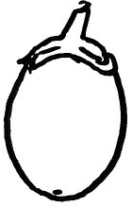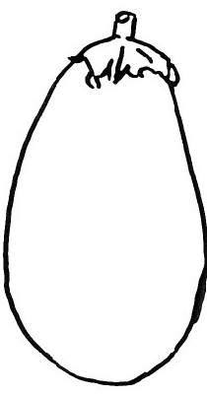
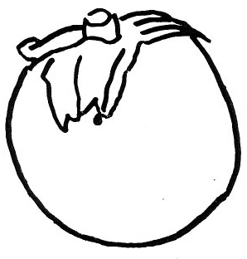
1 | 2 | 3
globular | ovoid | obovate

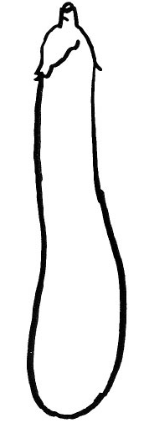
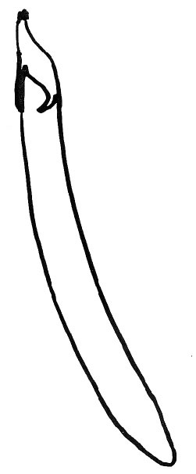
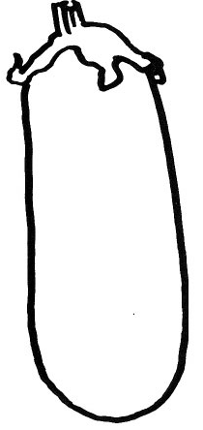
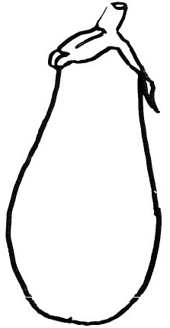

4 | 5 | 6 | 7
pear shaped | club shaped | ellipsoid | cylindrical

Ad. 21: Fruit: apex

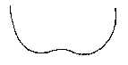 | 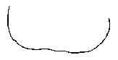 | 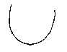 | 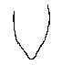
1 | 2 | 3 | 4
indented | flattened | rounded | pointed

Ad. 27: Fruit patches Ad. 28: Fruit stripes
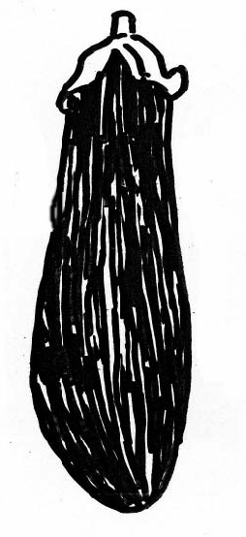
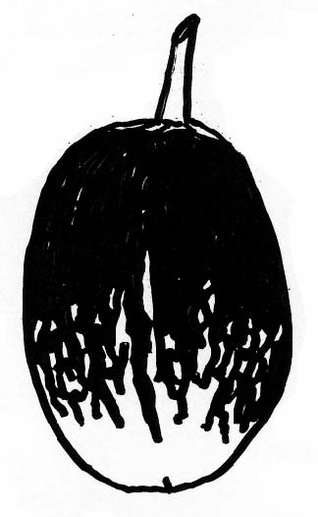

9 | 9
present | present

Ad. 38: Fruit: spininess of calyx

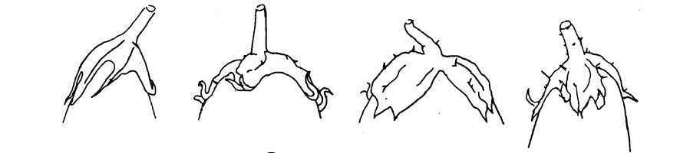

1 | 3 | 5 | 7
absent or very weak | weak | medium | strong

IX. Literature

Adinolfi, Angelo, Bianchi, Maurizio: “Caratterizzazione di varieta di Melanzana,” Quaderno n. 38 dell’E.N.S.E.

Phillips, Roger & Rix, Martyn, 1995: “Vegetables,” Macmillan Reference Books.

Daunay, M. C., Lester, R. N., Ano, G., 2001: “Eggplant,” p. 199-222 in Tropical Plant Breeding (569 p.), Scient. Ed., Charrier, A., Jacquot, M., Hamon, S., Nicolas, D., CIRAD; Science Publishers, Inc., Enfield (USA), Plymouth UK, 569 p.

X. Technical Questionnaire

 |  |  |  |  | Reference Number
 |  |  |  |  | (not to be filled in by the applicant)
TECHNICAL QUESTIONNAIRE
to be completed in connection with an application for plant breeders’ rights

1. Species Solanum melongena L.

Egg Plant

 | 2. Applicant (Name and address)
 | 3. Proposed denomination or breeder’s reference
4. Information on origin, maintenance and reproduction of the variety

5. Characteristics of the variety to be indicated (the number in brackets refers to the corresponding characteristic in the Test Guidelines; please mark the state of expression which best corresponds).

 |  |  | Characteristics |  | Example Varieties | Note
5.1  (16) |  |  | Fruit length
 |  |  | very short |  | Whitegg | 1[ ]
 |  |  | short |  | Birgah | 3[ ]
 |  |  | medium |  | Cava | 5[ ]
 |  |  | long |  | Mistral | 7[ ]
 |  |  | very long |  | Indira, Slim Purple | 9[ ]
5.2  (18) |  |  | Fruit: ratio length/maximum diameter
 |  |  | very small |  | Birgah, Kermit | 1[ ]
 |  |  | small |  | Bonica | 3[ ]
 |  |  | medium |  | Cava | 5[ ]
 |  |  | large |  | Mistral | 7[ ]
 |  |  | very large |  | Indira, Slim Purple | 9[ ]

 | Characteristics | Example Varieties | Note
5.3  (19) | Fruit: general shape
 | globular | Kermit, Purpura,  Violetta di New York | 1[ ]
 | ovoid | Beatrice, Whitegg | 2[ ]
 | obovate | Black King, Oria, | 3[ ]
 | pear shaped | Listada de Gandia | 4[ ]
 | club shaped | Baluroi, Mileda, Solara | 5[ ]
 | ellipsoid | Volta | 6[ ]
 | cylindrical | Mirabelle, Slim Purple, Tango | 7[ ]
5.4  (24) | Fruit: main color of skin at harvest maturity
 | white | Dourga | 1[ ]
 | green | Kermit | 2[ ]
 | violet | Baluroi, Purpura | 3[ ]
5.5  (28) | Fruit: stripes
 | absent | Baluroi | 1[ ]
 | present | Bandera | 9[ ]
5.6  (40) | Fruit: color of flesh
 | whitish | Dourga | 1[ ]
 | greenish | Baluroi | 2[ ]

6. Similar varieties and differences from these varieties

Denomination of similar variety | Characteristic in which the similar variety is different ^{o)} | State of expression of similar variety | State of expression of candidate variety
______________
^{o)} In the case of identical states of expressions of both varieties, please indicate the size of the difference.

7. Additional information which may help to distinguish the variety

7.1 Resistance to pests and diseases

7.2 Special conditions for the examination of the variety

7.3 Other information

8. Authorization for release

- Does the variety require prior authorization for release under legislation concerning the protection of the environment, human and animal health?
Yes [ ] No [ ]

- Has such authorization been obtained?

Yes [ ] No [ ]

If the answer to that question is yes, please attach a copy of such an authorization.

[End of document]

