 |  | E  TG/115/4  ORIGINAL: English  DATE: 2006-04-05
INTERNATIONAL UNION FOR THE PROTECTION OF NEW VARIETIES OF PLANTS
GENEVA

 | TULIP  UPOV Code: TULIP  Tulipa L. | *

GUIDELINES

FOR THE CONDUCT OF TESTS

FOR DISTINCTNESS, UNIFORMITY AND STABILITY

Alternative Names:*

Botanical name | English | French | German | Spanish
Tulipa L. | Tulip | Tulipe | Tulpe | Tulipán

The purpose of these guidelines (“Test Guidelines”) is to elaborate the principles contained in the General Introduction (document TG/1/3), and its associated TGP documents, into detailed practical guidance for the harmonized examination of distinctness, uniformity and stability (DUS) and, in particular, to identify appropriate characteristics for the examination of DUS and production of harmonized variety descriptions.

ASSOCIATED DOCUMENTS

These Test Guidelines should be read in conjunction with the General Introduction and its associated TGP documents.

TABLE OF CONTENTS PAGE

1. Subject of these Test Guidelines 3
2. Material Required 3
3. Method of Examination 3
3.1 Number of Growing Cycles 3
3.2 Testing Place 3
3.3 Conditions for Conducting the Examination 3
3.4 Test Design 4
3.5 Number of Plants / Parts of Plants to be Examined 4
3.6 Additional Tests 4
4. Assessment of Distinctness, Uniformity and Stability 4
4.1 Distinctness 4
4.2 Uniformity 5
4.3 Stability 5
5. Grouping of Varieties and Organization of the Growing Trial 5
6. Introduction to the Table of Characteristics 7
6.1 Categories of Characteristics 7
6.2 States of Expression and Corresponding Notes 7
6.3 Types of Expression 7
6.4 Example Varieties 7
6.5 Legend 7
7. Table of Characteristics/Tableau des caractères/Merkmalstabelle/Tabla de caracteres 8
8.1 Explanations on the Table of Characteristics 16
8.2 Explanations on Grouping Characteristics 17
8.3 Species of the Example Varieties 18
9. Literature 19
10. Technical Questionnaire 20

1. Subject of these Test Guidelines
These Test Guidelines apply to all varieties of Tulipa L.

2. Material Required
2.1 The competent authorities decide on the quantity and quality of the plant material required for testing the variety and when and where it is to be delivered. Applicants submitting material from a State other than that in which the testing takes place must ensure that all customs formalities and phytosanitary requirements are complied with.

2.2 The material is to be supplied in the form of bulbs of flowering and commercial size.

2.3 The minimum quantity of plant material, to be supplied by the applicant, should be:

30 bulbs.

2.4 The plant material supplied should be visibly healthy, not lacking in vigor, nor affected by any important pest or disease.

2.5 The plant material should not have undergone any treatment which would affect the expression of the characteristics of the variety, unless the competent authorities allow or request such treatment. If it has been treated, full details of the treatment must be given.

3. Method of Examination

3.1 Number of Growing Cycles
The minimum duration of tests should normally be a single growing cycle

3.2 Testing Place
Tests are normally conducted at one place. In the case of tests conducted at more than one place, guidance is provided in TGP/9 “Examining Distinctness”.

3.3 Conditions for Conducting the Examination
3.3.1 The tests should be carried out in the open, under conditions ensuring satisfactory growth for the expression of the relevant characteristics of the variety and for the conduct of the examination. In particular, unless otherwise indicated, all observations should be made on fully grown, typical organs, shortly after the flower has opened for the first time.

3.3.2 Observation of color by eye

Because daylight varies, color determinations made against a color chart should be made either in a suitable cabinet providing artificial daylight or in the middle of the day in a room without direct sunlight. The spectral distribution of the illuminant for artificial daylight should conform with the CIE Standard of Preferred Daylight D 6500 and should fall within the tolerances set out in the British Standard 950, Part I. These determinations should be made with the plant part placed against a white background.

3.4 Test Design
3.4.1 Each test should be designed to result in a total of at least 25 flowering plants.

3.4.2 The design of the tests should be such that plants or parts of plants may be removed for measurement or counting without prejudice to the observations which must be made up to the end of the growing cycle.

3.5 Number of Plants / Parts of Plants to be Examined
Unless otherwise indicated, all observations should be made on 10 plants or parts taken from each of 10 plants. In the case of parts of plants, the number to be taken from each of the plants should be one.

3.6 Additional Tests
Additional tests, for examining relevant characteristics, may be established.

4. Assessment of Distinctness, Uniformity and Stability

4.1 Distinctness
4.1.1 General Recommendations

It is of particular importance for users of these Test Guidelines to consult the General Introduction prior to making decisions regarding distinctness. However, the following points are provided for elaboration or emphasis in these Test Guidelines.

4.1.2 Consistent Differences

The differences observed between varieties may be so clear that more than one growing cycle is not necessary. In addition, in some circumstances, the influence of the environment is not such that more than a single growing cycle is required to provide assurance that the differences observed between varieties are sufficiently consistent. One means of ensuring that a difference in a characteristic, observed in a growing trial, is sufficiently consistent is to examine the characteristic in at least two independent growing cycles.

4.1.3 Clear Differences

Determining whether a difference between two varieties is clear depends on many factors, and should consider, in particular, the type of expression of the characteristic being examined, i.e. whether it is expressed in a qualitative, quantitative, or pseudo-qualitative manner. Therefore, it is important that users of these Test Guidelines are familiar with the recommendations contained in the General Introduction prior to making decisions regarding distinctness.

4.2 Uniformity
4.2.1 It is of particular importance for users of these Test Guidelines to consult the General Introduction prior to making decisions regarding uniformity. However, the following points are provided for elaboration or emphasis in these Test Guidelines:

4.2.2 For the assessment of uniformity, a population standard of 1% and an acceptance probability of at least 95 % should be applied. In the case of a sample size of 25 plants,
1 off-type is allowed.

4.3 Stability
4.3.1 In practice, it is not usual to perform tests of stability that produce results as certain as those of the testing of distinctness and uniformity. However, experience has demonstrated that, for many types of variety, when a variety has been shown to be uniform, it can also be considered to be stable.

4.3.2 Where appropriate, or in cases of doubt, stability may be tested, either by growing a further generation, or by testing a new plant stock to ensure that it exhibits the same characteristics as those shown by the previous material supplied.

5. Grouping of Varieties and Organization of the Growing Trial
5.1 The selection of varieties of common knowledge to be grown in the trial with the candidate varieties and the way in which these varieties are divided into groups to facilitate the assessment of distinctness are aided by the use of grouping characteristics.

5.2 Grouping characteristics are those in which the documented states of expression, even where produced at different locations, can be used, either individually or in combination with other such characteristics: (a) to select varieties of common knowledge that can be excluded from the growing trial used for examination of distinctness; and (b) to organize the growing trial so that similar varieties are grouped together.

5.3 Tulips can be classified as follows:

Class I: Botanical species: botanical species with their subspecies, botanical and cultivated varieties and hybrids which resemble the botanical species. The botanical species can be further classified into the following groups:

1. Tulipa kaufmanniana Regel
2. Tulipa fosteriana W. Irving
3. Tulipa greigii Regel
4. Other species

Class II: Modern hybrids

5.4 The following have been agreed as useful grouping characteristics:

(a) Flower: type (characteristic 10)
(b) Flower: main color (characteristic 13) with the following groups:
Gr. 1: white Snowparrot
Gr. 2: off white
Gr. 3: light yellow Yellow Purissima
Gr. 4: medium yellow Yellow Flight
Gr. 5: dark yellow Lady Margot
Gr. 6: orange Orange Monarch
Gr. 7: orange red Temple of Beauty
Gr. 8: medium red Lefeber’s Memory
Gr. 9: dark red Prominence
Gr. 10: purple red Blenda
Gr. 11: light pink Bright Pink Lady
Gr. 12: medium pink Angélique
Gr. 13: dark pink Pink Impression
Gr. 14: medium purple Attila
Gr. 15: dark purple Queen of Night
Gr. 16 brown Cairo

5.5 In the case of modern hybrids (see Chapter 5.3), the following groupings have been agreed to be useful:

(a) Flower: fringe (characteristic 17)

(b) Flower: appearance of tepals (see also characteristic 20) with the following groups:
Gr. 1: convex or flat (Standard)
Gr. 2: pointed and reflexed (Lily flowered)
Gr. 3: laciniate, curled and twisted (Parrot)
(see Chapter 8.2)

(c) Flower: partly greenish tepals (characteristics 21 and 22) with the following groups:
Gr. 1: absent
Gr. 2: present (Viridiflora)
(see Chapter 8.2)

(d) Plant: beginning of flowering (natural conditions) (characteristic 31)

5.6 Guidance for the use of grouping characteristics, in the process of examining distinctness, is provided through the General Introduction.

6. Introduction to the Table of Characteristics

6.1 Categories of Characteristics
6.1.1 Standard Test Guidelines Characteristics

Standard Test Guidelines characteristics are those which are approved by UPOV for examination of DUS and from which members of the Union can select those suitable for their particular circumstances.

6.1.2 Asterisked Characteristics

Asterisked characteristics (denoted by *) are those included in the Test Guidelines which are important for the international harmonization of variety descriptions and should always be examined for DUS and included in the variety description by all members of the Union, except when the state of expression of a preceding characteristic or regional environmental conditions render this inappropriate.

6.2 States of Expression and Corresponding Notes
States of expression are given for each characteristic to define the characteristic and to harmonize descriptions. Each state of expression is allocated a corresponding numerical note for ease of recording of data and for the production and exchange of the description.

6.3 Types of Expression
An explanation of the types of expression of characteristics (qualitative, quantitative and pseudo-qualitative) is provided in the General Introduction.

6.4 Example Varieties
Where appropriate, example varieties are provided to clarify the states of expression of each characteristic.

6.5 Legend
(*) Asterisked characteristic – see Chapter 6.1.2

QL Qualitative characteristic – see Chapter 6.3
QN Quantitative characteristic – see Chapter 6.3
PQ Pseudo-qualitative characteristic – see Chapter 6.3

(+) See Explanations on the Table of Characteristics in Chapter 8.1

7. Table of Characteristics/Tableau des caractères/Merkmalstabelle/Tabla de caracteres
 |  | English | français | deutsch | español | Example Varieties/  Exemples/  Beispielssorten/  Variedades ejemplo | Note/  Nota
1.  (*) |  | Plant: height | Plante: hauteur | Pflanze: Höhe | Planta: altura
QN |  | very short | très courte | sehr niedrig | muy baja | Lilliput, Red Hunter | 1
 |  | short | courte | niedrig | baja | Canasta, Peach Blossom | 3
 |  | medium | moyenne | mittel | media | Upstar | 5
 |  | tall | haute | hoch | alta | Apeldoorn | 7
 |  | very tall | très haute | sehr hoch | muy alta | Temple of Beauty | 9
2.  (*) |  | Stem: number of flowers | Tige: nombre de fleurs | Stengel: Anzahl Blüten | Tallo: número de flores
QL |  | one | une | eine | una | Apeldoorn | 1
 |  | more than one | plus d’une | mehr als eine | más de una | Georgette | 2
3.  (*) |  | Stem: anthocyanin coloration | Tige: pigmentation anthocyanique | Stengel: Anthocyanfärbung | Tallo: coloración antociánica
QL |  | absent | absente | fehlend | ausente | Upstar | 1
 |  | present | présente | vorhanden | presente | Dow Jones | 9
4.  (*) |  | Stem: position of anthocyanin coloration | Tige: emplacement de la pigmentation anthocyanique | Stengel: Position der Anthocyanfärbung | Tallo: posición de la coloración antociánica
QL |  | distal part only | partie distale seulement | nur am distalen Teil | únicamente en la parte distal | Dow Jones | 1
 |  | whole stem | toute la tige | am ganzen Stengel | en todo el tallo | Halloween | 2
5.  (*) |  | Leaf: shape | Feuille: forme | Blatt: Form | Hoja: forma
PQ |  | linear | linéaire | linear | lineal | Lilliput | 1
 |  | narrow elliptic | elliptique étroite | schmal elliptisch | elíptica estrecha |  | 2
 |  | medium elliptic | elliptique moyenne | mittel elliptisch | elíptica media | Blushing Beauty | 3
 |  | broad elliptic | elliptique large | breit elliptisch | elíptica ancha | Apeldoorn | 4
 |  | narrow ovate | ovale étroite | schmal eiförmig | oval estrecha |  | 5
 |  | medium ovate | ovale moyenne | mittel eiförmig | oval media | Havran | 6
 |  | broad ovate | ovale large | breit eiförmig | oval ancha | Grand Prestige | 7
6.  (*) |  | Leaf: variegation | Feuille: panachure | Blatt: Panaschierung | Hoja: variegación
QL |  | absent | absente | fehlend | ausente | Apeldoorn | 1
 |  | present | présente | vorhanden | presente | Unicum | 9
7.  (*) |  | Leaf: distribution of variegation | Feuille: répartition de la panachure | Blatt: Verteilung der Panaschierung | Hoja: distribución de la variegación
PQ |  | on margin | sur le bord | am Rand | en el borde | Happy Generation, Madame Lefeber | 1
 |  | marginal zone | zone marginale | Randzone | en la zona del borde | Diplomate, Flash Point | 2
 |  | dots | points | Punkte | en puntos | Grand Prestige | 3
 |  | dots and stripes | points et stries | Punkte und Streifen | en puntos y rayas | Ali Baba, Calypso | 4
 |  | stripes | stries | Streifen | en rayas | Toulon | 5
8.  (*) |  | Leaf: color of variegation | Feuille: couleur de la panachure | Blatt: Farbe der Panaschierung | Hoja: color de la variegación
PQ |  | white | blanche | weiß | blanco | Madame Lefeber, Unicum | 1
 |  | yellow green | vert-jaune | gelbgrün | verde amarillento | Darwidesign | 2
 |  | yellow | jaune | gelb | amarillo | Ton Augustinus | 3
 |  | pink | rose | rosa | rosa |  | 4
 |  | red | rouge | rot | rojo |  | 5
 |  | purple | pourpre | purpurn | púrpura | First Love, Copenhagen | 6
9.  (*) |  | Leaf: undulation of margin | Feuille: ondulation du bord | Blatt: Wellung des Randes | Hoja: ondulación del borde
QL |  | absent | absente | fehlend | ausente | Apeldoorn | 1
 |  | present | présente | vorhanden | presente | Christmas Marvel | 9
10.  (*)  (+) |  | Flower: type | Fleur: type | Blüte: Typ | Flor: tipo
QL |  | single | simple | einfach | única | Apeldoorn | 1
 |  | double | double | gefüllt | doble | Monte Carlo | 2
11.  (*) |  | Flower: length | Fleur: longueur | Blüte: Länge | Flor: longitud
QN |  | very short | très courte | sehr kurz | muy corta | Lilliput | 1
 |  | short | courte | kurz | corta | Monte Carlo | 3
 |  | medium | moyenne | mittel | media | Pink Impression | 5
 |  | long | longue | lang | larga | Gander | 7
 |  | very long | très longue | sehr lang | muy larga | Tender Beauty | 9
12.  (*)  (+) |  | Only single flower type varieties: Flower: shape | Seulement les variétés à une fleur: Fleur: forme | Nur Sorten mit einfachen Blüten: Blüte: Form | Sólo variedades de flor simple: Flor: forma
PQ |  | ellipsoid | ellipsoïde | ellipsoid | elipsoide | Prinses Irene | 1
 |  | ovoid | ovoïde | eiförmig | ovoide | Apeldoorn, Purple States | 2
 |  | lily flower | fleurs de lys | lilienblütig | con pétalos puntiagudos | Aladdin | 3
13.  (*) |  | Flower: main color | Fleur: couleur principale | Blüte: Hauptfarbe | Flor: color principal
PQ |  | RHS Colour Chart  (indicate reference number) | Code RHS des couleurs  (indiquer le numéro de référence) | RHS-Farbkarte  (Nummer angeben) | Carta de colores RHS  (sírvase indicar el número de referencia)
14.  (*) |  | Flower: number of colors on outer side | Fleur: nombre de couleurs de la face externe | Blüte: Anzahl Farben auf der Außenseite | Flor: número de colores en la parte externa
QL |  | one | une | eine | uno | Apeldoorn | 1
 |  | two | deux | zwei | dos | Early Surprise | 2
 |  | three or more | trois ou plus | drei oder mehr | tres o más | Tricolette | 3
15.  (*) |  | Only varieties with more than one color on outer side:  Flower: distribution of secondary color on outer side | Seulement les variétés à plus d’une couleur sur la face externe: Fleur: distribution de la couleur secondaire sur la face externe | Nur Sorten mit mehr als einer Farbe auf der Außenseite: Blüte: Verteilung der Sekundärfarbe der Außenseite | Únicamente variedades con más de un color en la parte externa:  Flor: distribución del color secundario en la parte externa
PQ |  | on margin | am Rand | sur le bord | en el borde | Yellow Pompenette | 1
 |  | marginal zone | Randzone | zone marginale | en la zona del borde | Lustige Witwe | 2
 |  | flamed | flaméolée | geflammt | flameado | Prinses Irene | 3
 |  | flushed | floue | flächig | difuso | Peach Blossom | 4
 |  | at base | à la base | an der Basis | en la base | Gudoshnik | 5
16. |  | Only varieties with more than one color on outer side: Flower: secondary color on outer side | Seulement les variétés à plus d’une couleur sur la face externe: Fleur: couleur secondaire de la face externe | Nur Sorten mit mehr als einer Farbe auf der Außenseite: Blüte: Sekundärfarbe der Außenseite | Únicamente variedades con más de un color en la parte externa: Flor: color secundario en la parte externa
PQ |  | RHS Colour Chart  (indicate reference number) | Code RHS des couleurs  (indiquer le numéro de référence) | RHS-Farbkarte  (Nummer angeben) | Carta de colores RHS  (sírvase indicar el número de referencia)
17.  (*) |  | Flower: fringe | Fleur: frange | Blüte: Fransung | Flor: rizado
QL |  | absent | absente | fehlend | ausente | Apeldoorn | 1
 |  | present | présente | vorhanden | presente | Barbados, Fancy Frills | 9
18.  (*) |  | Flower: conspicuousness of fringe | Fleur: netteté de la frange | Blüte: Ausprägung der Fransung | Flor: evidencia del rizado
QN |  | weak | faible | gering | ausente o débil | Arma | 1
 |  | intermediate | intermédiaire | mittel | intermedios | Crystal Beauty | 2
 |  | strong | nette | stark | fuerte | Barbados, Valery Gergiev | 3
19.  (*) |  | Flower: position of fringe on tepals | Fleur: position de la frange sur les tépales | Blüte: Verteilung der Fransung an den Perigonblättern | Flor: posición del rizado en los tépalos
PQ |  | top only | sommet seulement | nur an der Spitze | únicamente en la parte superior | Calibra | 1
 |  | all over margin | sur tout le bord | am gesamten Rand | en todo el borde | Capri, Hamilton | 2
 |  | irregular | irrégulière | unregelmäßig | irregular |  | 3
20.  (*) |  | Flower: shape of tip of outer tepal | Fleur: forme de l’extrémité du tépale externe | Blüte: Form der Spitze des äußeren Perigonblattes | Flor: forma del extremo del tépalo externo
PQ |  | acuminate | acuminée | zugespitzt | acuminado | Aladdin | 1
 |  | acute | aiguë | spitz | agudo | Temple of Beauty | 2
 |  | rounded | arrondie | abgerundet | redondeado | Caravelle | 3
 |  | emarginate | émarginée | eingekerbt | emarginado | Jan van Nes | 4
21.  (*) |  | Flower: main color of central part of outer side of inner tepal | Fleur: couleur principale de la partie centrale de la face externe du tépale interne | Blüte: Hauptfarbe des mittleren Teils der Außenseite des inneren Perigonblattes | Flor: color principal de la parte central de la parte externa del tépalo interno
PQ |  | RHS Colour Chart  (indicate reference number) | Code RHS des couleurs  (indiquer le numéro de référence) | RHS-Farbkarte  (Nummer angeben) | Carta de colores RHS  (sírvase indicar el número de referencia)
22.  (*) |  | Flower: main color of marginal part of outer side of inner tepal | Fleur: couleur principale de la partie marginale de la face externe du tépale interne | Blüte: Hauptfarbe des marginalen Teils der Außenseite des inneren Perigonblattes | Flor: color principal de la parte del borde de la parte externa del tépalo interno
PQ |  | RHS Colour Chart  (indicate reference number) | Code RHS des couleurs  (indiquer le numéro de référence) | RHS-Farbkarte  (Nummer angeben) | Carta de colores RHS  (sírvase indicar el número de referencia)
23.  (*) |  | Flower: main color of central part of inner side of inner tepal | Fleur: couleur principale de la partie centrale de la face interne du tépale interne | Blüte: Hauptfarbe des mittleren Teils der Innenseite des inneren Perigonblattes | Flor: color principal de la parte central de la parte interna del tépalo interno
PQ |  | RHS Colour Chart  (indicate reference number) | Code RHS des couleurs  (indiquer le numéro de référence) | RHS-Farbkarte  (Nummer angeben) | Carta de colores RHS  (sírvase indicar el número de referencia)
24.  (*) |  | Flower: main color of marginal part of inner side of inner tepal | Fleur: couleur principale de la partie marginale de la face interne du tépale interne | Blüte: Hauptfarbe des marginalen Teils der Innenseite des inneren Perigonblattes | Flor: color principal de la parte del borde de la parte interna del tépalo interno
PQ |  | RHS Colour Chart  (indicate reference number) | Code RHS des couleurs  (indiquer le numéro de référence) | RHS-Farbkarte  (Nummer angeben) | Carta de colores RHS  (sírvase indicar el número de referencia)
25.  (+) |  | Flower: main color of macule on inner side | Fleur: couleur principale de la macule sur la face interne | Blüte: Hauptfarbe des Basisflecks auf der Innenseite | Flor: color principal de la mácula en la parte interna
PQ |  | RHS Colour Chart  (indicate reference number) | Code RHS des couleurs  (indiquer le numéro de référence) | RHS-Farbkarte  (Nummer angeben) | Carta de colores RHS  (sírvase indicar el número de referencia)
26.  (*) |  | Flower: different color of border of macule | Fleur: couleur différente du bord de la macule | Blüte: andere Farbe des Randes des Basisflecks | Flor: distinto color del borde de la mácula
QL |  | absent | absente | fehlend | ausente | Blushing Apeldoorn | 1
 |  | present | présente | vorhanden | presente | Apeldoorn | 9
27.  (*) |  | Stamen: number of colors of filament | Étamine: nombre de couleurs du filament | Staubgefäß: Anzahl Farben des Staubfadens | Estambre: número de colores del filamento
QL |  | one | une | eine | uno |  | 1
 |  | two | deux | zwei | dos |  | 2
28. |  | Stamen: color of basal half of filament | Étamine: couleur de la moitié basale du filament | Staubgefäß: Farbe der basalen Hälfte des Staubfadens | Estambre: color de la mitad basal del filamento
PQ |  | white | blanche | weiß | blanco |  | 1
 |  | light yellow | jaune clair | hellgelb | amarillo claro |  | 2
 |  | medium yellow | jaune moyen | mittelgelb | amarillo medio |  | 3
 |  | dark yellow | jaune foncé | dunkelgelb | amarillo oscuro |  | 4
 |  | purple | pourpre | purpurn | púrpura |  | 5
 |  | blue | bleue | blau | azul |  | 6
 |  | black | noire | schwarz | negro |  | 7
29. |  | Stamen: color of distal half of filament | Étamine: couleur de la moitié distale du filament | Staubgefäß: Farbe der distalen Hälfte des Staubfadens | Estambre: color de la mitad distal del filamento
PQ |  | white | blanche | weiß | blanco |  | 1
 |  | light yellow | jaune clair | hellgelb | amarillo claro |  | 2
 |  | medium yellow | jaune moyen | mittelgelb | amarillo medio |  | 3
 |  | dark yellow | jaune foncé | dunkelgelb | amarillo oscuro |  | 4
 |  | purple | pourpre | purpurn | púrpura |  | 5
 |  | blue | bleue | blau | azul |  | 6
 |  | black | noire | schwarz | negro |  | 7
30.  (*) |  | Stamen: color of pollen | Étamine: couleur du pollen | Staubgefäß: Farbe des Pollens | Estambre: color del polen
PQ |  | greenish | verdâtre | grünlich | verdoso | Easter Moon | 1
 |  | yellow | jaune | gelb | amarillo | Gander Special | 2
 |  | yellow and purple or black | jaune et pourpre ou noir | gelb und purpurn oder schwarz | amarillo y púrpura o negro |  | 3
 |  | purple or black | pourpre ou noir | purpurn oder schwarz | púrpura o negro | Christmas Orange | 4
31.  (*) |  | Plant: beginning of flowering (natural conditions) | Plante: début de la floraison (conditions naturelles) | Pflanze: Zeitpunkt des Blühbeginns (natürliche Bedingungen) | Planta: inicio de la floración (condiciones naturales)
QN |  | very early | très précoce | sehr früh | muy temprana | Love Song, Showwinner, Early Harvest | 1
 |  | early | précoce | früh | temprana | Bestseller, Apricot Beauty, Flair | 3
 |  | medium | moyenne | mittel | media | Apeldoorn, Prinses Irene | 5
 |  | late | tardive | spät | tardía | Temple of Beauty, Renown,  Queen of Night | 7
 |  | very late | très tardive | sehr spät | muy tardía | Dillenburg, Princess Margaret Rose | 9

8.1 Explanations on the Table of Characteristics
Ad. 10: Flower: type

Double varieties are varieties with 12 or more tepals.

Ad. 12: Only single flower type varieties: Flower: shape

Ad. 25: Flower: main color of macule on inner side

The macule should be observed as an entity and the tepals should not be spread.

8.2 Explanations on Grouping Characteristics
Chapter 5.5(b): Flower: appearance of tepals

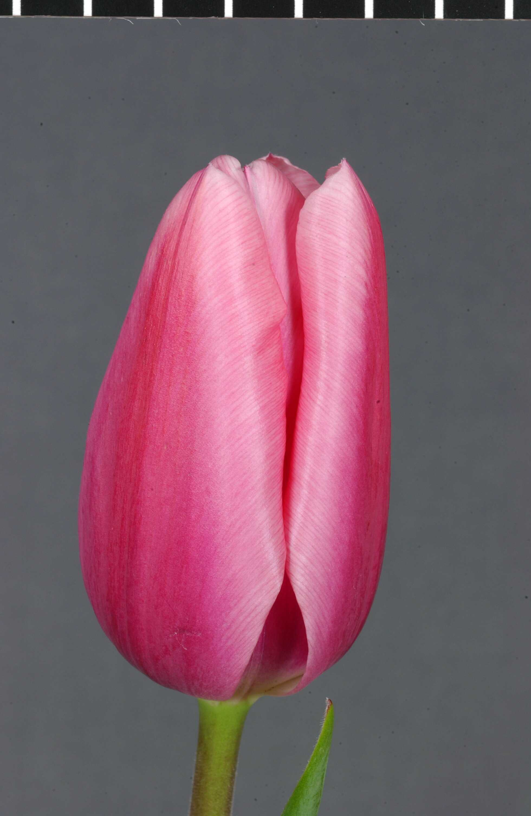 | 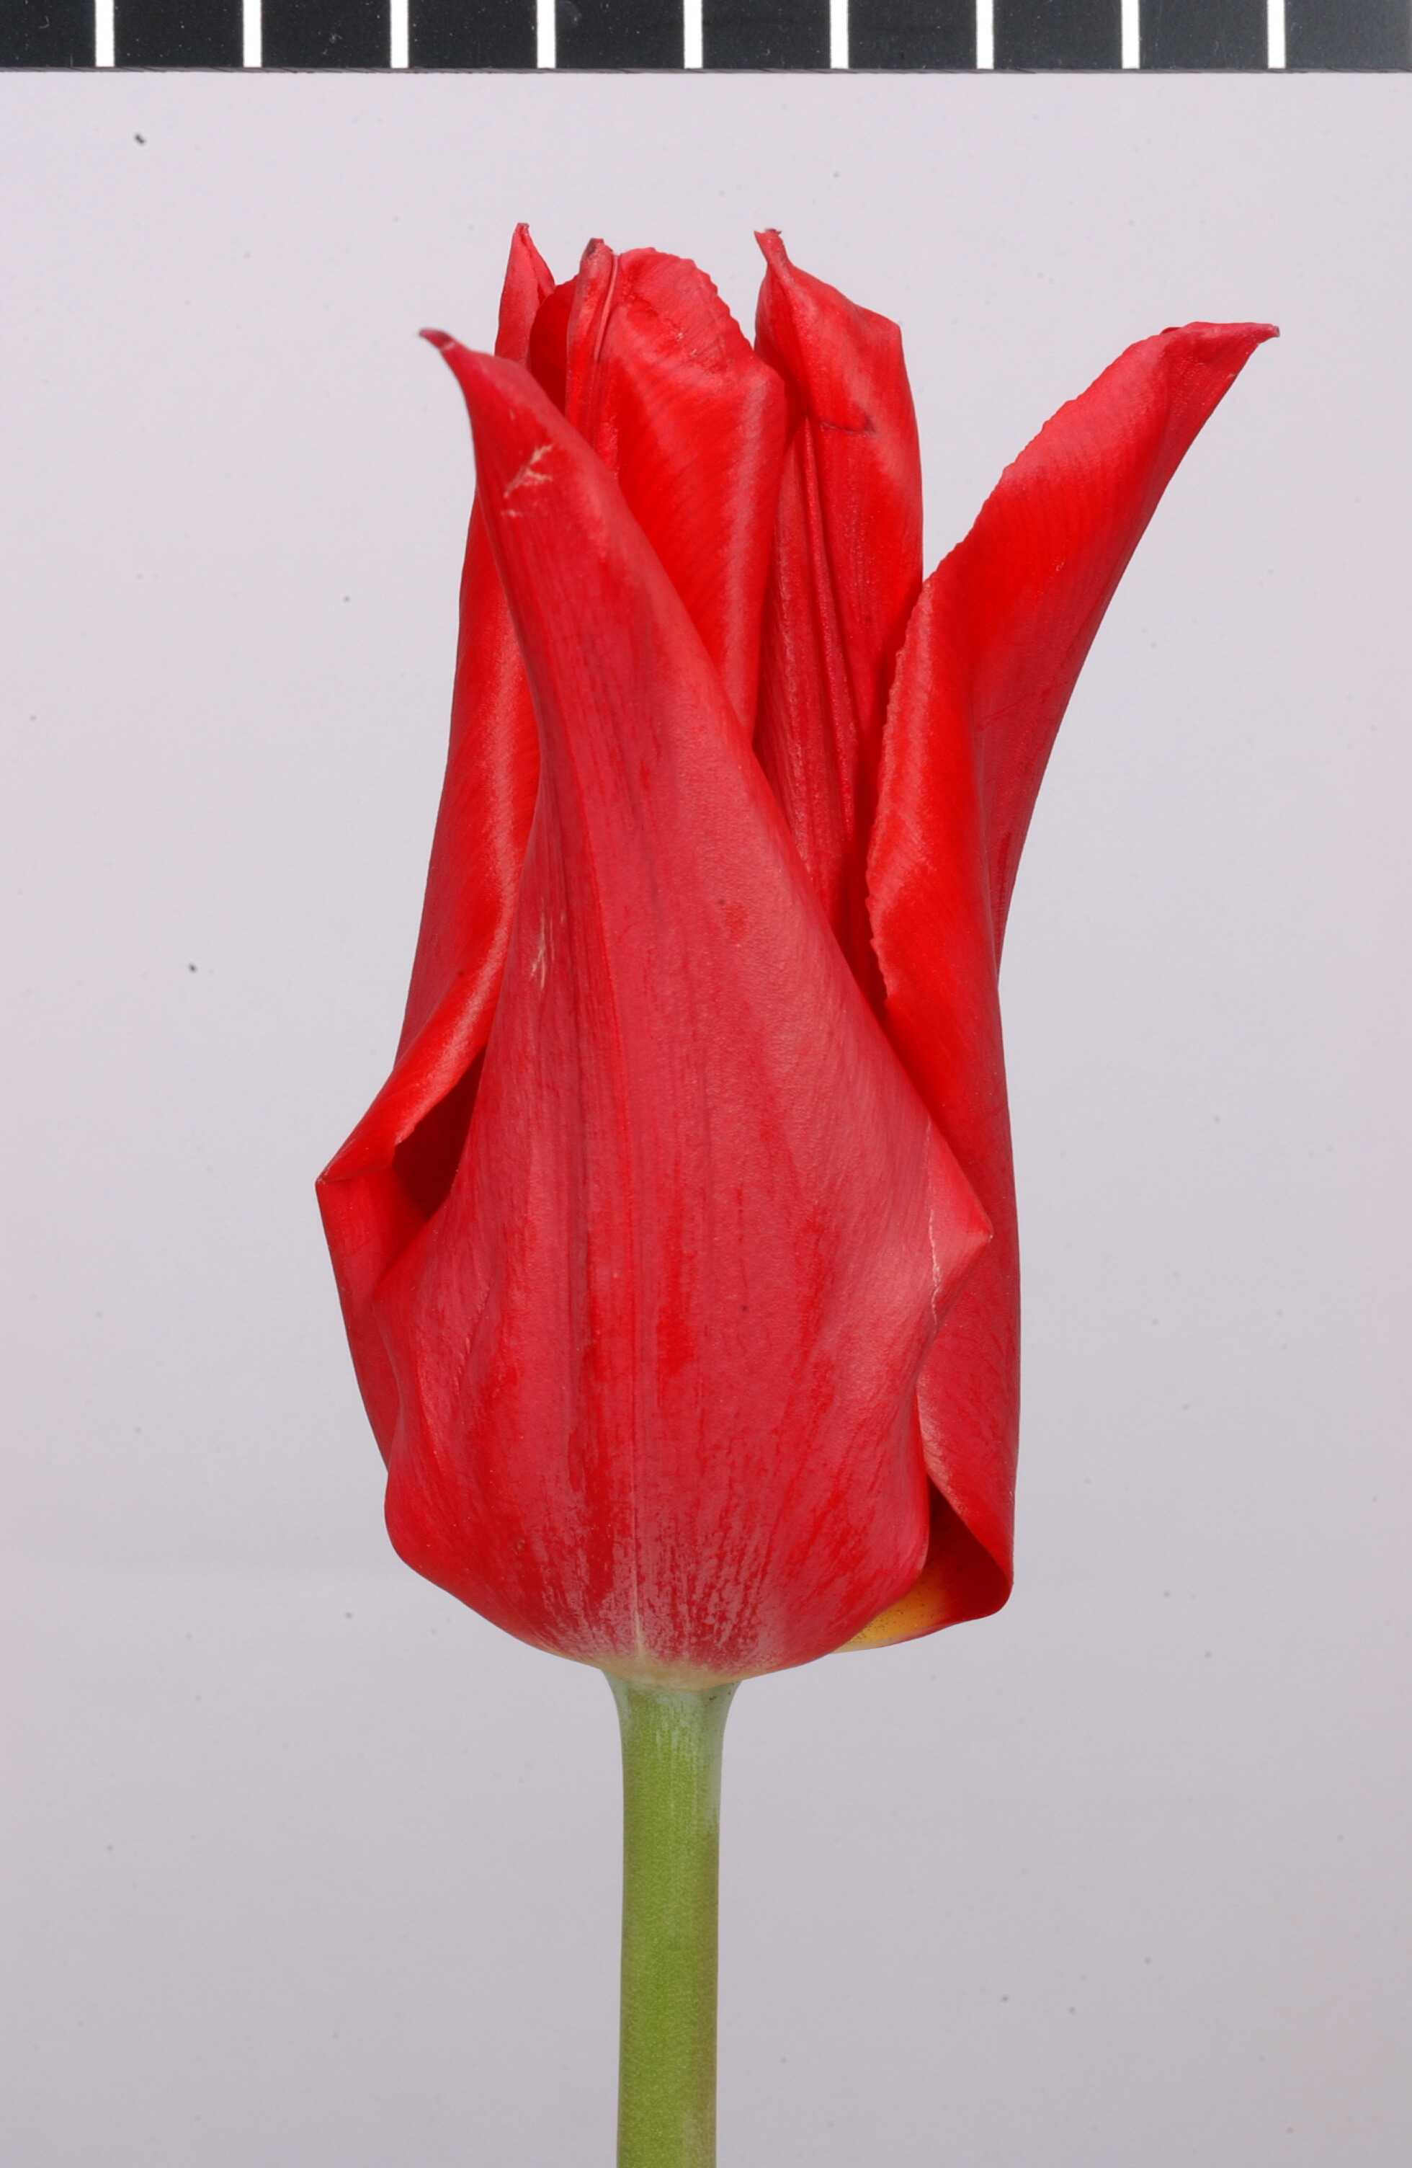 | 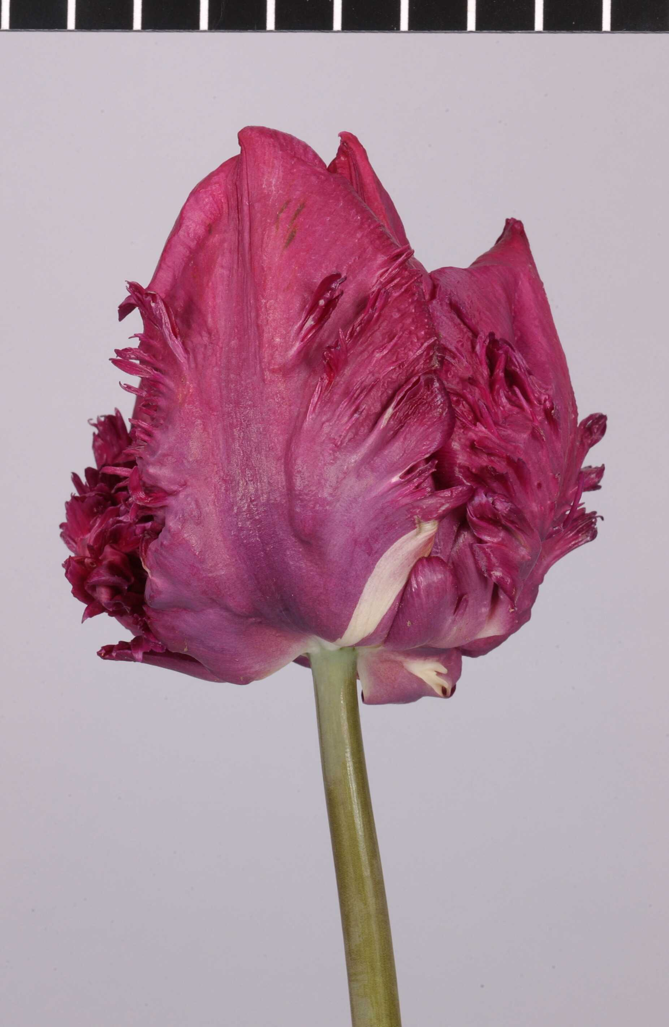
Group 1:  convex or flat  (Standard) | Group 2:  pointed and reflexed  (Lily flowered) | Group 3:  laciniate, curled and twisted (Parrot)

Chapter 5.5(c): Flower: partly greenish tepals

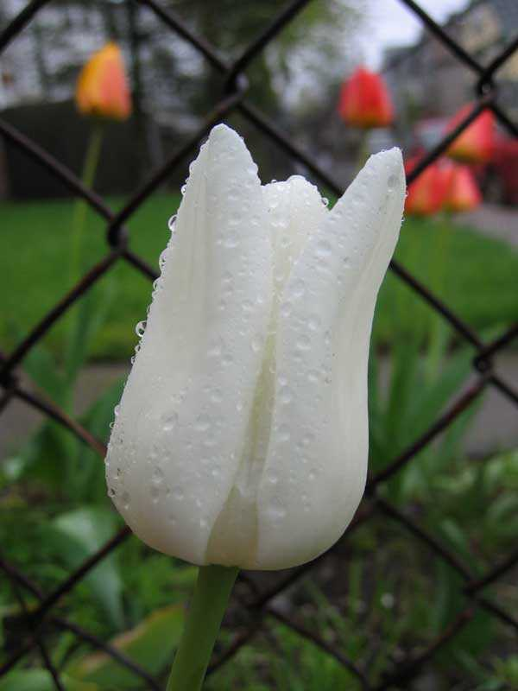 | 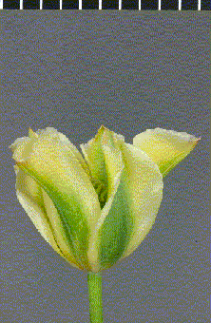
absent | present (Viridiflora)

8.3 Species of the Example Varieties

Species | Varieties
Tulipa batalinii Regel | Red Hunter
Tulipa fosteriana W. Irving | Copenhagen, Easter Moon, Madame Lefeber, Toulon, Yellow Purissima
Tulipa greigii Regel | Ali Baba, Calypso, First Love, Grand Prestige
Tulipa humilis Herb. | Lilliput
Tulipa kaufmanniana Regel | Early Harvest, Love Song, Showwinner
Tulipa praestans Hoog | Unicum

All other example varieties included in the Table of Characteristics are modern hybrids.

9. Literature

Baker, Chr., Lemmers W. and E.Sweeney , 1999: ‘Tulipa a Photographer’s Botanical’, Artisan, New York, USA, ISBN 1-57965-122-4

Bodegom S. and J. van Scheepen (eds), 2005: Supplement 2005, ‘Classified List and International Reigster of Tulip Names’, KAVB, Hillegom, NL,
ISBN-10: 90-73350034, ISBN-13: 97-89073350038

Dobs, L, Perry, C. and C. Breed, 2002 : ‘Tulipa’, Quadrille Publishing Ltd. London, UK
ISBN 1-903845-49-1

Frank, R., 1986: ‘Zwiebel und Knollengewächse’ Eugen Ulmer Verlag, Stuttgart, DE, ISBN 3-8001-6159-1

Grunert, Chr., 1990: ‘Das grosse Blumenzwiebelbuch’, Deutscher Landwirtschaftsverlag, Berlin, DE, ISBN 3-331-00193-7

Heath, Brent and Becky, 2001: ‘Tulips for North American Gardens’, Bright sky press, Albany, New York, USA, ISBN 0-9704729-6-X

Kreuzer, Joh., 1999: ‘Kreuzers Gartenpflanzen-Lexicon’, Band 4, Thalacker Medien, Thalacker Verlag, Braunsweig, DE, ISBN 3-87815-140-3

Le Nard, M. and A.A. de Hertogh,: ‘Tulipa’ in: ‘The Physiology of flower bulbs’, 1993, Chapter 35, p. 616-682, Elsevier, Amsterdam, NL, ISBN 0-444-87458-4

Scheepen, J. van, 1995: ‘Cultivar groups in the genus Tulipa L. (Liliaceae)’, Acta Hort. 413, p. 137-143 [Users may wish to check for an update of this publication which may have relevant information concerning classification groups.]

Scheepen, J. van, 1996 (comp.): ‘Classified List and International Register of Tulip Names’, KAVB, Hillegom, NL, ISBN 90-73350-026

10. Technical Questionnaire
TECHNICAL QUESTIONNAIRE |  |  |  | Page {x} of {y} |  | Reference Number:
 |  |  |  |  |  | Application date:
 |  |  |  |  |  | (not to be filled in by the applicant)
TECHNICAL QUESTIONNAIRE
to be completed in connection with an application for plant breeders’ rights

1. Subject of the Technical Questionnaire
1.1 Botanical name |  |  | Tulipa L.
1.2 Common name |  |  | Tulip
2. Applicant
Name
Address
Telephone No.
Fax No.
E-mail address
Breeder (if different from applicant)
3. Proposed denomination and breeder’s reference
Proposed denomination
(if available)

Breeder’s reference
#4. Information on the breeding scheme and propagation of the variety

4.1 Breeding scheme

Variety resulting from:

4.1.1 Crossing

(a) controlled cross [ ]
(please state parent varieties)
(b) partially known cross [ ]
(please state known parent variety(ies))
(c) unknown cross [ ]

4.1.2 Mutation [ ]
(please state parent variety)

4.1.3 Discovery and development [ ]
(please state where and when discovered
and how developed)

4.1.4 Other [ ]
(please provide details)

4.2 Method of propagating the variety

5. Characteristics of the variety to be indicated (the number in brackets refers to the corresponding characteristic in Test Guidelines; please mark the note which best corresponds).

 | Characteristics |  |  |  |  |  | Example Varieties |  |  | Note
5.1 | Plant: classification
 | I. Botanical species |  |  |  |  |  |  |  |  | 1[ ]
 | II. Modern hybrid |  |  |  |  |  |  |  |  | 2[ ]
5.2 | Botanical species only: Species
 | Tulipa kaufmanniana Regel |  |  |  |  |  |  |  |  | 1[ ]
 | Tulipa fosteriana W. Irving |  |  |  |  |  |  |  |  | 2[ ]
 | Tulipa greigii Regel |  |  |  |  |  |  |  |  | 3[ ]
 | Other species (please specify)  .............................................................. |  |  |  |  |  |  |  |  | 4[ ]
5.3  (10) | Flower: type
 | single |  |  |  |  |  | Apeldoorn |  |  | 1[ ]
 | double |  |  |  |  |  | Monte Carlo |  |  | 2[ ]
5.4i  (13) | Flower: main color
RHS Colour Chart
(indicate reference number)
.................................................................................................
 | Characteristics |  |  |  |  |  | Example Varieties |  |  | Note
5.4ii  (13) | Flower: main color group
 | white |  |  |  |  |  | Snowparrot |  |  | 1[ ]
 | off white |  |  |  |  |  |  |  |  | 2[ ]
 | light yellow |  |  |  |  |  | Yellow Purissima |  |  | 3[ ]
 | medium yellow |  |  |  |  |  | Yellow Flight |  |  | 4[ ]
 | dark yellow |  |  |  |  |  | Lady Margot |  |  | 5[ ]
 | orange |  |  |  |  |  | Orange Monarch |  |  | 6[ ]
 | orange red |  |  |  |  |  | Temple of Beauty |  |  | 7[ ]
 | medium red |  |  |  |  |  | Lefeber’s Memory |  |  | 8[ ]
 | dark red |  |  |  |  |  | Prominence |  |  | 9[ ]
 | purple red |  |  |  |  |  | Blenda |  |  | 10[ ]
 | light pink |  |  |  |  |  | Bright Pink Lady |  |  | 11[ ]
 | medium pink |  |  |  |  |  | Angélique |  |  | 12[ ]
 | dark pink |  |  |  |  |  | Pink Impression |  |  | 13[ ]
 | medium purple |  |  |  |  |  | Attila |  |  | 14[ ]
 | dark purple |  |  |  |  |  | Queen of Night |  |  | 15[ ]
 | brown |  |  |  |  |  | Cairo |  |  | 16[ ]
5.5  (17) | Flower: fringe
 | absent |  |  |  |  |  | Apeldoorn |  |  | 1[ ]
 | present |  |  |  |  |  | Barbados, Fancy Frills |  |  | 9[ ]
 | Characteristics |  |  |  |  |  | Example Varieties |  |  | Note
5.6 | Flower: appearance of tepals
 | convex or flat (Standard) |  |  |  |  |  | Apeldoorn |  |  | 1[ ]
 | pointed and reflexed (Lily flowered) |  |  |  |  |  | Aladdin |  |  | 2[ ]
 | laciniate, curled and twisted (Parrot) |  |  |  |  |  | Snowparrot |  |  | 3[ ]
5.7 | Flower: partly greenish tepals
 | absent |  |  |  |  |  | Apeldoorn |  |  | 1[ ]
 | present (Viridiflora) |  |  |  |  |  | Virigold |  |  | 2[ ]
5.8  (31) | Plant: beginning of flowering (natural conditions)
 | very early |  |  |  |  |  | Love Song, Showwinner, Early Harvest |  |  | 1[ ]
 | early |  |  |  |  |  | Bestseller, Apricot Beauty, Flair |  |  | 3[ ]
 | medium |  |  |  |  |  | Apeldoorn, Prinses Irene |  |  | 5[ ]
 | late |  |  |  |  |  | Temple of Beauty, Renown,  Queen of Night |  |  | 7[ ]
 | very late |  |  |  |  |  | Dillenburg,  Princess Margaret Rose |  |  | 9[ ]
6. Similar varieties and differences from these varieties

Please use the following table and box for comments to provide information on how your candidate variety differs from the variety (or varieties) which, to the best of your knowledge, is (or are) most similar. This information may help the examination authority to conduct its examination of distinctness in a more efficient way.

Denomination(s) of variety(ies) similar to your candidate variety |  | Characteristic(s) in which your candidate variety differs from the similar variety(ies) |  |  | Describe the expression of the characteristic(s) for the similar variety(ies) |  |  | Describe the expression of the characteristic(s) for your candidate variety
Example |  | Flower: type |  |  | single |  |  | double
Comments:

#7. Additional information which may help in the examination of the variety

7.1 In addition to the information provided in Sections 5 and 6, are there any additional characteristics which may help to distinguish the variety?

Yes [ ] No [ ]

(If yes, please provide details)

7.2 Are there any special conditions for growing the variety or conducting the examination?

Yes [ ] No [ ]

(If yes, please provide details)

7.3 Other information

A representative color photograph of the variety should accompany the Technical Questionnaire.

8. Authorization for release

(a) Does the variety require prior authorization for release under legislation concerning the protection of the environment, human and animal health?

Yes [ ] No [ ]

(b) Has such authorization been obtained?

Yes [ ] No [ ]

If the answer to (b) is yes, please attach a copy of the authorization.

9. Information on plant material to be examined or submitted for examination

9.1 The expression of a characteristic or several characteristics of a variety may be affected by factors, such as pests and disease, chemical treatment (e.g. growth retardants or pesticides), effects of tissue culture, different rootstocks, scions taken from different growth phases of a tree, etc.

9.2 The plant material should not have undergone any treatment which would affect the expression of the characteristics of the variety, unless the competent authorities allow or request such treatment. If the plant material has undergone such treatment, full details of the treatment must be given. In this respect, please indicate below, to the best of your knowledge, if the plant material to be examined has been subjected to:

(a) Microorganisms (e.g. virus, bacteria, phytoplasma) Yes [ ] No [ ]

(b) Chemical treatment (e.g. growth retardant, pesticide) Yes [ ] No [ ]

(c) Tissue culture Yes [ ] No [ ]

(d) Other factors Yes [ ] No [ ]

Please provide details for where you have indicated “yes”.

……………………………………………………………

10. I hereby declare that, to the best of my knowledge, the information provided in this form is correct:

Applicant’s name

Signature Date

[End of document]

* These names were correct at the time of the introduction of these Test Guidelines but may be revised or updated. [Readers are advised to consult the UPOV Code, which can be found on the UPOV Website (www.upov.int), for the latest information.]
# Authorities may allow certain of this information to be provided in a confidential section of the Technical Questionnaire.
# Authorities may allow certain of this information to be provided in a confidential section of the Technical Questionnaire.

