 |  | E  TG/112/4 Corr.  ORIGINAL: English  DATE: 2006-04-05 + 2017-04-05
INTERNATIONAL UNION FOR THE PROTECTION OF NEW VARIETIES OF PLANTS
GENEVA

 | Mango  UPOV Code: MANGI_IND  Mangifera indica L. | *

GUIDELINES

FOR THE CONDUCT OF TESTS

FOR DISTINCTNESS, UNIFORMITY AND STABILITY

Alternative Names:*
Botanical name | English | French | German | Spanish
Mangifera indica L. | Mango | Manguier | Mango | Mango

The purpose of these guidelines (“Test Guidelines”) is to elaborate the principles contained in the General Introduction (document TG/1/3), and its associated TGP documents, into detailed practical guidance for the harmonized examination of distinctness, uniformity and stability (DUS) and, in particular, to identify appropriate characteristics for the examination of DUS and production of harmonized variety descriptions.

ASSOCIATED DOCUMENTS

These Test Guidelines should be read in conjunction with the General Introduction and its associated TGP documents.
TABLE OF CONTENTS page

1. Subject of these Test Guidelines 3
2. Material Required 3
3. Method of Examination 3
3.1 Number of Growing Cycles 3
3.2 Testing Place 3
3.3 Conditions for Conducting the Examination 3
3.4 Test Design 4
3.5 Number of Plants / Parts of Plants to be Examined 4
3.6 Additional Tests 4
4. Assessment of Distinctness, Uniformity and Stability 4
4.1 Distinctness 4
4.1.1 General Recommendations 4
4.1.2 Consistent Differences 4
4.1.3 Clear Differences 4
4.2 Uniformity 4
4.3 Stability 5
5. Grouping of Varieties and Organization of the Growing Trial 5
6. Introduction to the Table of Characteristics 5
6.1 Categories of Characteristics 5
6.1.1 Standard Test Guidelines Characteristics 5
6.1.2 Asterisked Characteristics 6
6.2 States of Expression and Corresponding Notes 6
6.3 Types of Expression 6
6.4 Example Varieties 6
6.5 Legend 6
7. Table of Characteristics/Tableau des caractères/Merkmalstabelle/Tabla de caracteres 7
8. Explanations on the Table of Characteristics 22
8.1 Explanations covering several characteristics 22
8.2 Explanations for individual characteristics 23
9. Literature 30
10. Technical Questionnaire 31

Subject of these Test Guidelines

These Test Guidelines apply to all varieties of Mangifera indica L.

Material Required

2.1 The competent authorities decide on the quantity and quality of the plant material required for testing the variety and when and where it is to be delivered. Applicants submitting material from a State other than that in which the testing takes place must ensure that all customs formalities and phytosanitary requirements are complied with.

2.2 The material is to be supplied in the form of budsticks.

2.3 The minimum quantity of plant material, to be supplied by the applicant, should be:

12 budsticks, sufficient to propagate 5 trees.

2.4 The plant material supplied should be visibly healthy, not lacking in vigor, nor affected by any important pest or disease.

2.5 The plant material should not have undergone any treatment, which would affect the expression of the characteristics of the variety, unless the competent authorities allow or request such treatment. If it has been treated, full details of the treatment must be given.

Method of Examination

3.1 Number of Growing Cycles
The minimum duration of tests should normally be two independent growing cycles.

The growing cycle is considered to be the period ranging from the beginning of active vegetative growth or flowering, continuing through active vegetative growth or flowering and fruit development and concluding with the harvesting of fruit.

3.2 Testing Place
Tests are normally conducted at one place. In the case of tests conducted at more than one place, guidance is provided in TGP/9 “Examining Distinctness”.

3.3 Conditions for Conducting the Examination
The tests should be carried out under conditions ensuring satisfactory growth for the expression of the relevant characteristics of the variety and for the conduct of the examination. In particular, it is essential that the trees produce a satisfactory crop of fruit in each of the two growing cycles.

3.4 Test Design
The design of the tests should be such that plants or parts of plants may be removed for measurement or counting without prejudice to the observations which must be made up to the end of the growing cycle.

3.5 Number of Plants / Parts of Plants to be Examined
Unless otherwise indicated, all observations should be made on 5 plants or parts taken from each of 5 plants. In the case of parts of plants, the number to be taken from each of the plants should be 2.

3.6 Additional Tests
Additional tests, for examining relevant characteristics, may be established.

Assessment of Distinctness, Uniformity and Stability

4.1 Distinctness

4.1.1 General Recommendations
It is of particular importance for users of these Test Guidelines to consult the General Introduction prior to making decisions regarding distinctness. However, the following points are provided for elaboration or emphasis in these Test Guidelines.

4.1.2 Consistent Differences
The differences observed between varieties may be so clear that more than one growing cycle is not necessary. In addition, in some circumstances, the influence of the environment is not such that more than a single growing cycle is required to provide assurance that the differences observed between varieties are sufficiently consistent. One means of ensuring that a difference in a characteristic, observed in a growing trial, is sufficiently consistent is to examine the characteristic in at least two independent growing cycles.

4.1.3 Clear Differences
Determining whether a difference between two varieties is clear depends on many factors, and should consider, in particular, the type of expression of the characteristic being examined, i.e. whether it is expressed in a qualitative, quantitative, or pseudo-qualitative manner. Therefore, it is important that users of these Test Guidelines are familiar with the recommendations contained in the General Introduction prior to making decisions regarding distinctness.

4.2 Uniformity
4.2.1 It is of particular importance for users of these Test Guidelines to consult the General Introduction prior to making decisions regarding uniformity. However, the following points are provided for elaboration or emphasis in these Test Guidelines.
4.2.2 For the assessment of uniformity, a population standard of 1% and an acceptance probability of at least 95% should be applied. In the case of a sample size of 5 plants, no off-types are allowed.

4.3 Stability
4.3.1 In practice, it is not usual to perform tests of stability that produce results as certain as those of the testing of distinctness and uniformity. However, experience has demonstrated that, for many types of variety, when a variety has been shown to be uniform, it can also be considered to be stable.

4.3.2 Where appropriate, or in cases of doubt, stability may be tested, either by growing a further generation, or by testing a new plant stock to ensure that it exhibits the same characteristics as those shown by the previous material supplied.

Grouping of Varieties and Organization of the Growing Trial

5.1 The selection of varieties of common knowledge to be grown in the trial with the candidate varieties and the way in which these varieties are divided into groups to facilitate the assessment of distinctness are aided by the use of grouping characteristics.

5.2 Grouping characteristics are those in which the documented states of expression, even where produced at different locations, can be used, either individually or in combination with other such characteristics: (a) to select varieties of common knowledge that can be excluded from the growing trial used for examination of distinctness; and (b) to organize the growing trial so that similar varieties are grouped together.

5.3 The following have been agreed as useful grouping characteristics:

(a) Mature fruit: ratio length/width (characteristic 22);
(b) Mature fruit: shape of ventral shoulder (characteristic 32);
(c) Seed: embryony (characteristic 55);
(d) Time of fruit maturity (characteristic 57).

5.4 Guidance for the use of grouping characteristics, in the process of examining distinctness, is provided through the General Introduction.

Introduction to the Table of Characteristics

6.1 Categories of Characteristics

6.1.1 Standard Test Guidelines Characteristics
Standard Test Guidelines characteristics are those which are approved by UPOV for examination of DUS and from which members of the Union can select those suitable for their particular circumstances.

6.1.2 Asterisked Characteristics
Asterisked characteristics (denoted by *) are those included in the Test Guidelines which are important for the international harmonization of variety descriptions and should always be examined for DUS and included in the variety description by all members of the Union, except when the state of expression of a preceding characteristic or regional environmental conditions render this inappropriate.

6.2 States of Expression and Corresponding Notes
States of expression are given for each characteristic to define the characteristic and to harmonize descriptions. Each state of expression is allocated a corresponding numerical note for ease of recording of data and for the production and exchange of the description.

6.3 Types of Expression
An explanation of the types of expression of characteristics (qualitative, quantitative and pseudo-qualitative) is provided in the General Introduction.

6.4 Example Varieties
Where appropriate, example varieties are provided to clarify the states of expression of each characteristic.

6.5 Legend
(*) Asterisked characteristic – see Chapter 6.1.2

QL Qualitative characteristic – see Chapter 6.3
QN Quantitative characteristic – see Chapter 6.3
PQ Pseudo-Qualitative characteristic – see Chapter 6.3

(a)–(e) See Explanations on the Table of Characteristics in Chapter 8.1

(+) See Explanations on the Table of Characteristics in Chapter 8.2

Table of Characteristics/Tableau des caractères/Merkmalstabelle/Tabla de caracteres

 |  | English | français | deutsch | español | Example Varieties  Exemples  Beispielssorten  Variedades ejemplo | Note/  Nota
1.  (*) |  | Tree: attitude of main branches | Arbre: port des rameaux principaux | Baum: Haltung der Hauptzweige | Árbol: porte de las ramas principales
PQ |  | erect | dressé | aufrecht | erecto | Kent, Palmer | 1
 |  | spreading | horizontal | waagerecht | extendido | Irwin, Peach, Tommy Atkins, Zill | 2
 |  | drooping | retombant | hängend | colgante | Sensation | 3
2.  (*)  (+) |  | Young leaf: intensity of anthocyanin coloration | Jeune feuille: intensité de la pigmentation anthocyanique | Junges Blatt: Intensität der Anthocyanfärbung | Hoja joven: intensidad de la pigmentación antociánica
QN |  | absent or very weak | absente ou très faible | fehlend oder sehr gering | ausente o muy débil | Palmer | 1
 |  | weak | faible | gering | débil | Early Gold, Irwin | 3
 |  | medium | moyenne | mittel | media |  | 5
 |  | strong | forte | stark | fuerte |  | 7
 |  | very strong | très forte | sehr stark | muy fuerte | Osteen | 9
3. |  | Leaf blade: length | Limbe: longueur | Blattspreite: Länge | Limbo: longitud
QN | (a) | short | court | kurz | corto | Adams, Heidi | 3
 |  | medium | moyen | mittel | medio | Kent, Peach, Tommy Atkins | 5
 |  | long | long | lang | largo | Florigon, Hood, Keitt | 7
4. |  | Leaf blade: width | Limbe: largeur | Blattspreite: Breite | Limbo: anchura
QN | (a) | narrow | étroit | schmal | estrecho | Heidi, Long Green, Peach | 3
 |  | medium | moyen | mittel | medio | Kent, Tommy Atkins | 5
 |  | broad | large | breit | ancho | Hood, Keitt, Nimrod, Osteen, Palmer | 7
5.  (*) |  | Leaf blade: ratio length/width | Limbe: rapport longueur/ largeur | Blattspreite: Verhältnis Länge/Breite | Limbo: relación longitud/anchura
QN | (a) | small | petit | klein | pequeña | Hood, Nimrod | 3
 |  | medium | moyen | mittel | media | Adams, Irwin, Sensation | 5
 |  | large | grand | groß | grande | Florigon | 7
 |  | very large | très grand | sehr groß | muy grande | Chené, Peach | 9
6.  (+) |  | Leaf blade: shape | Limbe: forme | Blattspreite: Form | Limbo: forma
PQ | (a) | ovate | ovale | eiförmig | oval | Van Dyke | 1
 |  | elliptic | elliptique | elliptisch | elíptico |  | 2
 |  | oblong | oblong | rechteckig | oblongo | Hood | 3
7. |  | Leaf blade: color | Limbe: couleur | Blattspreite: Farbe | Limbo: color
PQ | (a) | yellow green | vert jaune | gelbgrün | verde amarillo | Carrie, Zill | 1
 |  | light green | vert clair | hellgrün | verde claro |  | 2
 |  | medium green | vert moyen | grün | verde medio |  | 3
 |  | dark green | vert foncé | dunkelgrün | verde oscuro | Fascell, Long Green, Nimrod | 4
8.  (+) |  | Leaf blade: twisting | Limbe: torsion | Blattspreite: Drehung | Limbo: torsión
QL | (a) | absent | absente | fehlend | ausente | Heidi, Hood, Keitt | 1
 |  | present | présente | vorhanden | presente | Florigon, Peach, Zill | 9
9. |  | Leaf blade: spacing of secondary veins | Limbe: espacement entre les nervures secondaires | Blattspreite: Abstand zwischen den sekundären Adern | Limbo: espacio entre los nervios secundarios
QN | (a) | very close | très faible | sehr gering | muy escaso | Early Gold | 1
 |  | close | faible | gering | escaso | Sensation | 3
 |  | medium | moyen | mittel | medio | Adams | 5
 |  | wide | grand | groß | grande | Nimrod | 7
 |  | very wide | très grand | sehr groß | muy grande | Hood | 9
10. |  | Leaf blade: undulation of margin | Limbe: ondulation du bord | Blattspreite: Wellung des Randes | Limbo: ondulación del borde
QN | (a) | absent or weak | absente ou faible | fehlend oder gering | ausente o débil | Keitt, Kent, Tommy Atkins, Van Dyke | 1
 |  | medium | moyenne | mittel | medio | Long Green, Zill | 2
 |  | strong | forte | stark | fuerte | Chené, Early Gold, Florigon | 3
11.  (+) |  | Leaf blade: shape of base | Limbe: forme de la base | Blattspreite: Form der Basis | Limbo: forma de la base
PQ | (a) | acute | aiguë | spitz | aguda | Florigon, Sabre | 1
 |  | obtuse | obtuse | stumpf | obtusa |  | 2
 |  | rounded | arrondie | abgerundet | redondeada | Fascell, Kent | 3
12.  (+) |  | Leaf blade: shape of apex | Limbe: forme du sommet | Blattspreite: Form der Spitze | Limbo: forma del ápice
PQ | (a) | attenuate | pointu | mit lang ausgezogener Spitze | afilado | Florigon | 1
 |  | acuminate | acuminé | mit aufgesetzter Spitze | acuminado | Gouveia, Nimrod | 2
 |  | acute | aigu | spitz | agudo | Hood | 3
13. |  | Petiole: attitude in relation to shoot | Pétiole: port par rapport à la tige | Stiel: Haltung im Verhältnis zum Trieb | Peciolo: porte en relación con el brote
QN | (a) | erect | dressé | aufrecht | erecto | Sensation | 1
 |  | semi erect | demi-dressé | halb aufrecht | semierecto | Peach | 3
 |  | perpendicular | perpendiculaire | senkrecht | perpendicular | Haden, Zill | 5
 |  | moderately recurved | modérément retombant | mäßig zurückgebogen | medianamente colgante |  | 7
 |  | strongly recurved | très retombant | stark zurückgebogen | muy colgante |  | 9
14. |  | Petiole: length | Pétiole: longueur | Stiel: Länge | Peciolo: longitud
QN | (a) | short | court | kurz | corto | Adams | 3
 |  | medium | moyen | mittel | medio |  | 5
 |  | long | long | lang | largo | Kensington | 7
15.  (*)  (+) |  | Inflorescence: length | Inflorescence: longueur | Blütenstand: Länge | Inflorescencia: longitud
QN | (b) | short | courte | kurz | corta | Carrie, Long Green, Peach, Sabre | 3
 |  | medium | moyenne | mittel | media | Osteen, Zill | 5
 |  | long | longue | lang | larga | Haden, Keitt, Kent | 7
16.  (+) |  | Inflorescence: diameter | Inflorescence: diamètre | Blütenstand: Durchmesser | Inflorescencia: diámetro
QN | (b) | small | petit | klein | estrecha | Peach, Sabre | 3
 |  | medium | moyen | mittel | media | Sensation, Zill | 5
 |  | large | grand | groß | ancha | Haden, Keitt | 7
17.  (+) |  | Inflorescence: ratio length/diameter | Inflorescence: rapport longueur/ diamètre | Blütenstand: Verhältnis Länge/  Durchmesser | Inflorescencia: relación longitud/ diámetro
QN | (b) | small | petit | klein | pequeña | Kensington | 3
 |  | medium | moyen | mittel | media | Haden, Tommy Atkins, Zill | 5
 |  | large | grand | groß | grande | Irwin | 7
18.  (+) |  | Inflorescence: number of primary branches | Inflorescence: nombre de rameaux primaires | Blütenstand: Anzahl primäre Seitentriebe | Inflorescencia: número de ramas primarias
QN | (b) | few | petit | gering | bajo | Sensation, Smith | 3
 |  | medium | moyen | mittel | medio |  | 5
 |  | many | grand | groß | elevado | Haden, Keitt, Osteen | 7
19.  (*) |  | Inflorescence: anthocyanin coloration of axis and branches | Inflorescence: pigmentation anthocyanique de l’axe et des rameaux | Blütenstand: Anthocyanfärbung der Achse und der Zweige | Inflorescencia: pigmentación antociánica del eje y las ramas
QN | (b) | absent or very weak | absente ou très faible | fehlend oder sehr gering | ausente o muy débil |  | 1
 |  | weak | faible | gering | débil | Early gold, Kensington, Long Green | 3
 |  | medium | moyenne | mittel | medio | Haden, Peach, Sensation | 5
 |  | strong | forte | stark | fuerte | Heidi, Hood, Irwin, Kent, Palmer, Smith, Van Dyke, Zill | 7
 |  | very strong | très forte | sehr stark | muy fuerte | Osteen, Tommy Atkins | 9
20.  (*)  (+) |  | Mature fruit: length | Fruit prêt à cueillir: longueur | Erntereife Frucht: Länge | Fruto listo para la cosecha: longitud
QN | (c) | short | court | kurz | corto | Adams | 3
 |  | medium | moyen | mittel | medio | Irwin | 5
 |  | long | long | lang | largo | Sabre, Tommy Atkins | 7
 |  | very long | très long | sehr lang | muy largo | Anderson | 9
21.  (*)  (+) |  | Mature fruit: width | Fruit prêt à cueillir: largeur | Erntereife Frucht: Breite | Fruto listo para la cosecha: anchura
QN | (c) | narrow | étroit | schmal | estrecho | Adams | 3
 |  | medium | moyen | mittel | medio | Irwin, Zill | 5
 |  | broad | large | breit | ancho | Keitt, Nimrod | 7
 |  | very broad | très large | sehr breit | muy ancho | Extrema | 9
22.  (*)  (+) |  | Mature fruit: ratio length/width | Fruit prêt à cueillir: rapport longueur/largeur | Erntereife Frucht: Verhältnis Länge/Breite | Fruto listo para la cosecha: relación longitud/anchura
QN | (c) | very small | très petit | sehr klein | muy pequeña | Extrema,  Santa Alexandrina | 1
 |  | small | petit | klein | pequeña | Fascell, Sheil | 3
 |  | medium | moyen | mittel | media | Sensation, Tommy Atkins | 5
 |  | large | grand | groß | grande | Carrie, Gouveia | 7
 |  | very large | très grand | sehr groß | muy grande | Anderson, Sabre | 9
23.  (*)  (+) |  | Mature fruit: shape in cross section | Fruit prêt à cueillir: forme en section transversale | Erntereife Frucht: Form im Querschnitt | Fruto listo para la cosecha: forma en sección transversal
PQ | (c) | medium elliptic | elliptique moyen | mittel elliptisch | elíptica media | Gouveia | 1
 |  | broad elliptic | elliptique large | breit elliptisch | elíptica ancha | Sabre, Tommy Atkins | 2
 |  | circular | arrondie | rund | circular | Extrema, Santa Alexandrina | 3
24.  (*) |  | Mature fruit: color of skin | Fruit prêt à cueillir: couleur de l’épiderme | Erntereife Frucht: Farbe der Schale | Fruto listo para la cosecha: color de la cáscara
PQ | (c) | only yellow | seulement jaune | nur gelb | solo amarilla |  | 1
 |  | only green | seulement vert | nur grün | solo verde | Carrie | 2
 |  | green and yellow | vert et jaune | grün und gelb | verde y amarilla |  | 3
 |  | green and orange | vert et orange | grün und orange | verde y naranja | Gouveia | 4
 |  | green and pink | vert et rose | grün und rosa | verde y rosa | Kensington | 5
 |  | green and red | vert et rouge | grün und rot | verde y roja | Fascell | 6
 |  | green and purple | vert et violet | grün und purpurn | verde y violeta | Sensation, Zill | 7
25. |  | Mature fruit: density of lenticels | Fruit prêt à cueillir: densité des lenticelles | Erntereife Frucht: Dichte der Lentizellen | Fruto listo para la cosecha: densidad de las lenticelas
QN | (c) | sparse | faible | locker | débil | Carrie, Fascell, Kensington | 3
 | (e) | medium | moyenne | mittel | media | Sabre, Tommy Atkins | 5
 |  | dense | forte | dicht | fuerte | Haden, Hood, Kent, Sensation | 7
26. |  | Mature fruit: color contrast between lenticels and skin | Fruit prêt à cueillir: contraste de couleur entre les lenticelles et l’épiderme | Erntereife Frucht: Farbkontrast zwischen den Lentizellen und der Schale | Fruto listo para la cosecha: contraste de colores entre lenticelas y cáscara
QN | (c) | weak | faible | gering | débil | Peach, Sandersha | 3
 | (e) | medium | moyen | mittel | media | Sheil | 5
 |  | strong | fort | stark | fuerte | Haden, Ruby | 7
27. |  | Mature fruit: size of lenticels | Fruit prêt à cueillir: taille des lenticelles | Erntereife Frucht: Größe der Lentizellen | Fruto listo para la cosecha: tamaño de las lenticelas
QN | (c) | small | petites | klein | pequeñas | Sandersha, Sensation | 3
 | (e) | medium | moyennes | mittel | medias |  | 5
 |  | large | grandes | groß | grandes | Haden, Sheil | 7
28. |  | Mature fruit: roughness of surface (corkiness) caused by lenticels | Fruit prêt à cueillir: rugosité de la surface (liège) causée par des lenticelles | Erntereife Frucht: durch Lentizellen bedingte Rauheit der Oberfläche (Korkbildung) | Fruto listo para la cosecha: rugosidad de la superficie (acorchado) causada por las lenticelas
QL | (c) | absent | absente | fehlend | ausente | Hood, Peach, Zill | 1
 | (e) | present | présente | vorhanden | presente | Haden, Kensington | 9
29.  (+) |  | Mature fruit: stalk cavity | Fruit prêt à cueillir: cavité pédonculaire | Erntereife Frucht: Stielhöhle | Fruto listo para la cosecha: cavidad peduncular
QN | (c) | absent or shallow | absente ou peu profonde | fehlend oder flach | ausente o poco profunda | Adams, Ruby | 1
 |  | medium | moyenne | mittel | media | Haden | 2
 |  | deep | profonde | tief | profunda | Nimrod | 3
30.  (+) |  | Mature fruit: presence of neck | Fruit prêt à cueillir: présence du collet | Erntereife Frucht: Hals | Fruto listo para la cosecha: cuello
QL | (c) | absent | absent | fehlend | ausente | Fascell, Zill | 1
 |  | present | présent | vorhanden | presente | Long Green, Ruby | 9
31. |  | Mature fruit: length of neck | Fruit prêt à cueillir: longueur du collet | Erntereife Frucht: Länge des Halses | Fruto listo para la cosecha: longitud del cuello
QN | (c) | short | court | kurz | corto | Peach, Sandersha | 3
 |  | medium | moyen | mittel | medio |  | 5
 |  | long | long | lang | largo | Ruby | 7
32.  (*)  (+) |  | Mature fruit: shape of ventral shoulder | Fruit prêt à cueillir: forme de l’épaule ventrale | Erntereife Frucht: Form der ventralen Schulter | Fruto listo para la cosecha: forma del hombro izquierdo
PQ | (c) | rounded upward | arrondie vers le haut | abgerundet nach oben | redondeado hacia arriba | Tommy Atkins | 1
 |  | rounded outward | arrondie horizontale | abgerundet abstehend | redondeado horizontal | Florigon, Irwin, Palmer, Zill | 2
 |  | rounded downward | arrondie vers le bas | abgerundet nach unten | redondeado hacia abajo | Keitt, Ruby, Sandersha | 3
 |  | sloping downward | inclinée vers le bas | nach unten geneigt | inclinado hacia abajo | Long Green | 4
 |  | falling abruptly | en rupture brusque | abrupt abfallend | en descenso abrupto |  | 5
33.  (*)  (+) |  | Mature fruit: shape of dorsal shoulder | Fruit prêt à cueillir: forme de l’épaule dorsale | Erntereife Frucht: Form der dorsalen Schulter | Fruto listo para la cosecha: forma del hombro derecho
PQ | (c) | rounded upward | arrondie vers le haut | abgerundet nach oben | redondeado hacia arriba |  | 1
 |  | rounded outward | arrondie horizontale | abgerundet abstehend | redondeado horizontal | Fascell | 2
 |  | rounded downward | arrondie vers le bas | abgerundet nach unten | redondeado hacia abajo | Irwin, Ruby, Zill | 3
 |  | sloping downward | inclinée vers le bas | nach unten geneigt | inclinado hacia abajo | Keitt | 4
 |  | falling abruptly | en rupture brusque | abrupt abfallend | en descenso abrupto | Long Green, Palmer, Sandersha | 5
34.  (+) |  | Mature fruit: length of groove in ventral shoulder | Fruit prêt à cueillir: longueur du sillon dans l’épaule ventrale | Erntereife Frucht: Länge der Furche in der ventralen Schulter | Fruto listo para la cosecha: longitud del surco en el hombro izquierdo
QN | (c) | absent or short | absent ou court | fehlend oder kurz | ausente o corto | Fascell, Sheil | 1
 |  | medium | moyen | mittel | medio | Kensington | 2
 |  | long | long | lang | largo |  | 3
35.  (+) |  | Mature fruit: depth of groove in ventral shoulder | Fruit prêt à cueillir: profondeur du sillon dans l’épaule ventrale | Erntereife Frucht: Tiefe der Furche in der ventralen Schulter | Fruto listo para la cosecha: profundidad del surco en el hombro izquierdo
QN | (c) | absent or shallow | absent ou peu profond | fehlend oder flach | ausente o poco profundo | Fascell | 1
 |  | medium | moyen | mittel | medio | Sheil | 2
 |  | deep | profond | tief | profundo | Kensington | 3
36.  (+) |  | Mature fruit: bulging on ventral shoulder | Fruit prêt à cueillir: excroissance sur l’épaule ventrale | Erntereife Frucht: Auswuchs auf der ventralen Schulter | Fruto listo para la cosecha: protuberancia en el hombro izquierdo
QL | (c) | absent | absente | fehlend | ausente | Peach, Ruby | 1
 |  | present | présente | vorhanden | presente | Fascell, Zill | 9
37.  (*)  (+) |  | Mature fruit: presence of sinus | Fruit prêt à cueillir: présence du sinus | Erntereife Frucht: Vorhandensein von Buchten | Fruto listo para la cosecha: seno
QL | (c) | absent | absent | fehlend | ausente | Fascell, Hood, Kent | 1
 |  | present | présent | vorhanden | presente | Gouveia, Sabre, Sandersha | 9
38.  (*) |  | Mature fruit: depth of sinus | Fruit prêt à cueillir: profondeur du sinus | Erntereife Frucht: Tiefe der Buchten | Fruto listo para la cosecha: profundidad del seno
QN | (c) | shallow | peu profond | flach | poco profundo | Florigon, Peach | 3
 |  | medium | moyen | mittel | medio | Kensington | 5
 |  | deep | profond | tief | profundo | Anderson, Sabre | 7
39.  (*)  (+) |  | Mature fruit: bulging proximal of stylar scar | Fruit prêt à cueillir: excroissance proximale de la cicatrice stylaire | Erntereife Frucht: Auswuchs proximal von der Griffelnarbe | Fruto listo para la cosecha: protuberancia proximal de la cicatriz estilar
QN | (c) | absent or weak | absente ou faible | fehlend oder gering | ausente o débil | Adams, Anderson | 1
 |  | medium | moyenne | mittel | media |  | 2
 |  | strong | forte | stark | fuerte | Nimrod, Sheil | 3
40.  (+) |  | Mature fruit: point at stylar scar | Fruit prêt à cueillir: point à la cicatrice stylaire | Erntereife Frucht: Spitze an der Griffelnarbe | Fruto listo para la cosecha: punto en la cicatriz estilar
QN | (c) | absent or small | absent ou petit | fehlend oder klein | ausente o pequeño | Kent, Sheil | 1
 |  | medium | moyen | mittel | medio |  | 2
 |  | large | grand | groß | grande | Kensington, Long Green, Sandersha | 3
41. |  | Mature fruit: diameter of stalk attachment | Fruit prêt à cueillir: diamètre du pédoncule | Erntereife Frucht: Durchmesser des Stielansatzes | Fruto listo para la cosecha: diámetro del pedúnculo
QN | (c) | small | petit | klein | pequeño | Irwin, Sensation | 3
 |  | medium | moyen | mittel | mediano | Adams | 5
 |  | large | grand | groß | grande | Tommy Atkins | 7
42.  (*) |  | Ripe fruit: predominant color of skin | Fruit mûr: couleur prédominante de l’épiderme | Eßreife Frucht: überwiegende Farbe der Schale | Fruto maduro: color predominante de la cáscara
PQ | (d) | green | vert | grün | verde | Long Green | 1
 |  | yellow green | vert jaune | gelbgrün | verde amarillo | Carrie, Sandersha | 2
 |  | green and yellow | vert et jaune | grün und gelb | verde y amarillo | Early Gold | 3
 |  | yellow | jaune | gelb | amarillo | Ataulfo, Carabao | 4
 |  | yellow orange | orange jaune | gelborange | naranja amarillo | Kensington | 5
 |  | yellow and orange | jaune et orange | gelb und orange | amarillo y naranja | Peach | 6
 |  | orange | orange | orange | naranja |  | 7
 |  | yellow and red | jaune et rouge | gelb und rot | amarillo y rojo | Adams, Haden, Ruby, Sensation, Zill | 8
 |  | orange and red | orange et rouge | orange und rot | naranja y rojo |  | 9
 |  | red | rouge | rot | rojo | Van Dyke | 10
 |  | orange and purple | orange et violet | orange und purpurn | naranja y violeta | Tommy Atkins | 11
 |  | red and purple | rouge et violet | rot und purpurn | rojo y violeta |  | 12
 |  | purple | violet | purpurn | violeta |  | 13
43. |  | Ripe fruit: speckling of skin | Fruit mûr: tacheture de l’épiderme | Eßreife Frucht: Fleckung der Schale | Fruto maduro: moteado de la cáscara
QN | (d) | absent or very weak | absente ou très faible | fehlend oder sehr gering | ausente o muy débil |  | 1
 | (e) | weak | faible | gering | débil | Kensington | 3
 |  | medium | moyenne | mittel | media |  | 5
 |  | strong | forte | stark | fuerte | Sheil | 7
44. |  | Ripe fruit: thickness of skin | Fruit mûr: épaisseur de l’épiderme | Eßreife Frucht: Dicke der Schale | Fruto maduro: espesor de la cáscara
QN | (d) | thin | fin | dünn | fina | Adams, Carrie, Florigon | 3
 |  | medium | moyen | mittel | media | Sabre, Sheil | 5
 |  | thick | épais | dick | espesa | Haden | 7
45. |  | Ripe fruit: adherence of skin to flesh | Fruit mûr: adhérence de l’épiderme à la chair | Eßreife Frucht: Anhaften der Schale am Fleisch | Fruto maduro: adherencia de la cáscara a la pulpa
QN | (d) | weak | faible | gering | débil | Peach | 3
 |  | medium | moyenne | mittel | media |  | 5
 |  | strong | forte | stark | fuerte | Fascell, Sheil, Zill | 7
46. |  | Ripe fruit: main color of flesh | Fruit mûr: couleur principale de la chair | Eßreife Frucht: Hauptfarbe des Fleisches | Fruto maduro: color principal de la pulpa
PQ | (d) | greenish yellow | jaune verdâtre | grünlichgelb | amarillo verdoso |  | 1
 |  | light yellow | jaune pâle | hellgelb | amarillo claro |  | 2
 |  | medium yellow | jaune moyen | mittelgelb | amarillo |  | 3
 |  | light orange | orange pâle | hellorange | naranja claro |  | 4
 |  | medium orange | orange | mittelorange | naranja |  | 5
 |  | dark orange | orange foncé | dunkelorange | naranja oscuro |  | 6
47. |  | Ripe fruit: firmness of flesh | Fruit mûr: fermeté de la chair | Eßreife Frucht: Festigkeit des Fleisches | Fruto maduro: firmeza de la pulpa
QN | (d) | soft | molle | weich | blanda | Carrie, Sheil | 3
 |  | medium | moyenne | mittel | media | Haden, Zill | 5
 |  | firm | ferme | fest | firme | Peach, Sensation, Tommy Atkins | 7
48. |  | Ripe fruit: juiciness | Fruit mûr: succulence | Eßreife Frucht: Saftigkeit | Fruto maduro: jugosidad
QN | (d) | low | bas | hoch | baja |  | 3
 |  | medium | moyen | mittel | media | Tommy Atkins | 5
 |  | high | haut | niedrig | alta | Carrie | 7
49. |  | Ripe fruit: texture of flesh | Fruit mûr: texture de la chair | Eßreife Frucht: Textur des Fleisches | Fruto maduro: textura de la pulpa
QN | (d) | fine | fine | fein | fina | Adams, Fascell | 3
 |  | medium | moyenne | mittel | media | Tommy Atkins | 5
 |  | coarse | grossière | grob | gruesa | Sheil | 7
50.  (*) |  | Ripe fruit: amount of fiber attached to stone | Fruit mûr: importance de la fibre attachée au noyau | Eßreife Frucht: Anteil der am Kern anliegenden Fasern | Fruto maduro: cantidad de fibra pegada al hueso
QN | (d) | very low | très faible | sehr klein | muy escasa | Haden, Heidi, Irwin, Keitt, Kensington, Kent, Zill | 1
 |  | low | faible | klein | escasa | Tommy Atkins | 3
 |  | medium | moyenne | mittel | media | Sabre | 5
 |  | high | forte | groß | elevada |  | 7
 |  | very high | très forte | sehr groß | muy elevada | Kidney, Peach | 9
51. |  | Ripe fruit: amount of fiber attached to skin | Fruit mûr: importance de la fibre attachée à l’épiderme | Eßreife Frucht: Anteil der an der Schale anliegenden Fasern | Fruto maduro: cantidad de fibra pegada a la cáscara
QN | (d) | low | faible | klein | escasa |  | 3
 |  | medium | moyenne | mittel | media |  | 5
 |  | high | forte | groß | elevada |  | 7
52.  (*)  (+) |  | Ripe fruit: “turpentine flavor” | Fruit mûr: “saveur térébenthine” | Eßreife Frucht: „Terpentingeschmack“ | Fruto maduro: “sabor a trementina”
QL | (d) | absent | absente | fehlend | ausente | Kent, Sensation | 1
 |  | present | présente | vorhanden | presente | Extrema, Kensington, Sandersha | 9
53. |  | Stone: relief of surface | Noyau: relief de la surface | Kern: Relief der Oberfläche | Hueso: relieve de la superficie
PQ |  | grooved | cannelé | gefurcht | acanalada | Extrema, Keitt, Kensington, Long Green, Peach, Sabre, Zill | 1
 |  | smooth | lisse | glatt | lisa | Ruby | 2
 |  | ridged | annelé | geringelt | anillada | Heidi, Irwin, Kent, Tommy Atkins | 3
54.  (+) |  | Seed: shape in lateral view | Pépin: forme en vue latérale | Samen: Form in der Seitenansicht | Semilla: forma en perspectiva lateral
QL |  | oblong | rectangulaire | rechteckig | rectangular | Sabre | 1
 |  | reniform | réniforme | nierenförmig | reniforme | Carabao | 2
55.  (*) |  | Seed: embryony | Pépin: embryonnie | Samen: Embryonie | Semilla: embronía
QL |  | monoembryonic | monoembryonnique | monoembryonisch | monoembriónico | Sensation, Tommy Atkins | 1
 |  | polyembryonic | polyembryonnique | polyembryonisch | poliembriónico | Peach, Sabre | 2
56. |  | Time of beginning of flowering | Époque de début de floraison | Zeitpunkt des Blühbeginns | Época de comienzo de floración
QN |  | early | précoce | früh | temprana | Early Gold | 3
 |  | medium | moyenne | mittel | media | Fascell | 5
 |  | late | tardive | spät | tardía | Sensation | 7
57.  (*) |  | Time of fruit maturity | Époque de maturité des fruits | Zeitpunkt der Fruchtreife | Época de madurez de los frutos
QN |  | very early | très précoce | sehr früh | muy temprana | Early Gold, Florigon, Long Green | 1
 |  | early | précoce | früh | temprana | Zill | 3
 |  | medium | moyenne | mittel | media | Fascell, Nimrod, Tommy Atkins | 5
 |  | late | tardive | spät | tardía | Sensation | 7
 |  | very late | très tardive | sehr spät | muy tardía | Keitt | 9

Explanations on the Table of Characteristics

8.1 Explanations covering several characteristics
Characteristics containing the following key in the second column of the Table of Characteristics should be examined as indicated below:

(a) Observations on the leaf which should be made on mature leaves in the middle third of the youngest shoots not showing signs of active growth. The attitude of the petiole should be observed on upward growing shoots.

(b) Inflorescences should be selected from terminal panicles of typical shoots from the exposed regions of the tree. Observations should be made at the time of full flowering.

(c) The mature fruit is the fruit at the stage ready for harvesting. This stage is reached when the flesh is still quite firm and has not become juicy but has started coloring around the stone.

(d) The ripe fruit is the fruit at the stage ready for consumption. This stage is reached when the flesh is juicy and has become colored from the stone to the skin.

(e) Observations on the lenticels and the speckling of the skin should be made on the lateral side of the fruit.

8.2 Explanations for individual characteristics
Ad. 2: Young leaf: intensity of anthocyanin coloration

Observations should be made on active growth (flush) on the youngest leaves.

Ad. 6: Leaf blade: shape

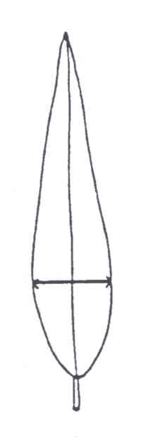 | 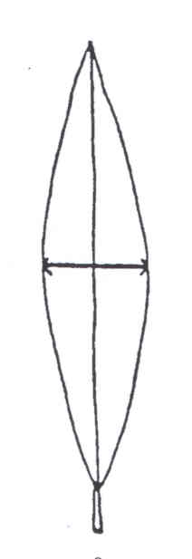 | 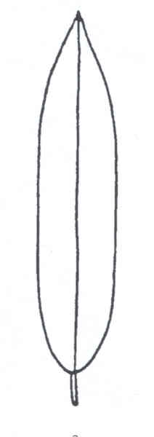
1 | 2 | 3
ovate | elliptic | oblong

Ad. 8: Leaf blade: twisting

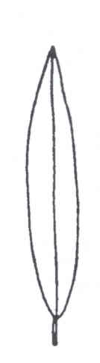 | 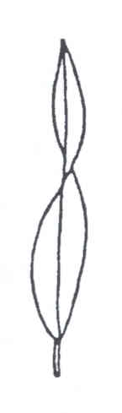
1 | 9
absent | present

Ad. 11: Leaf blade: shape of base

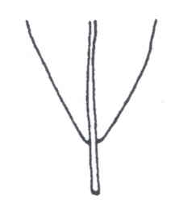 | 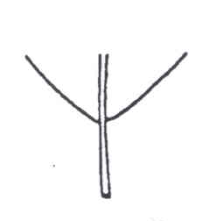 | 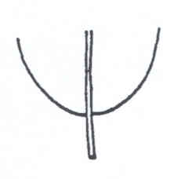
1 | 2 | 3
acute | obtuse | rounded

Ad. 12: Leaf blade: shape of apex
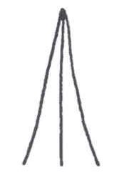 | 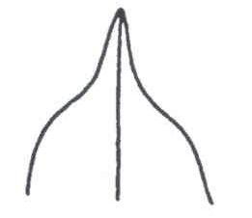 | 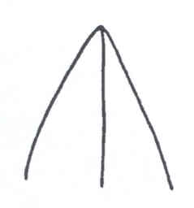
1 | 2 | 3
attenuate | acuminate | acute

Ad. 15: Inflorescence: length
Ad. 16: Inflorescence: diameter
Ad. 17: Inflorescence: ratio length/diameter
Ad. 18: Inflorescence: number of primary branches
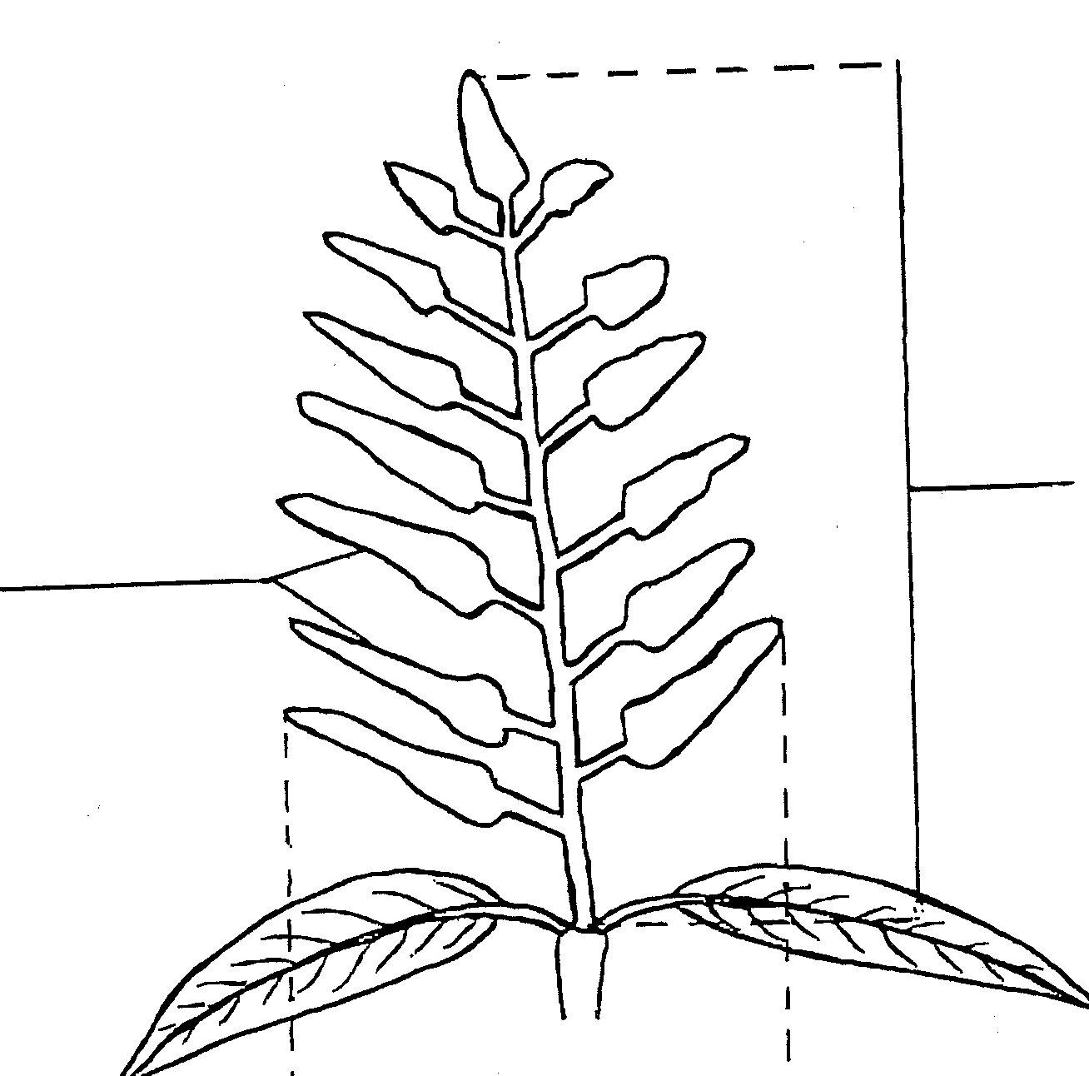
length
primary branches
diameter

Ad. 20: Mature fruit: length (= L)
Ad. 21: Mature fruit: width (= W)
Ad. 22: Mature fruit: ratio length/width

For observations on the length and width of the fruit, the fruit should be sawed lengthwise, through the stalk attachment and the stylar scar. The outline may be traced and measurements made on paper. The length of the fruit is taken along the axis through the stalk attachment and the furthest point. The width is taken at the broadest part perpendicular to the length.

W  W  W  L  L  L | 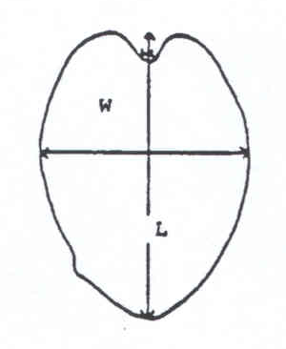 | 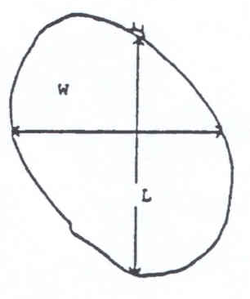

Ad. 23: Mature fruit: shape in cross section

To determine the shape in cross section, the fruit should be sawed through the broadest part, at a right angle (perpendicular) to the length.

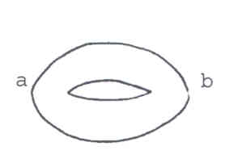 | 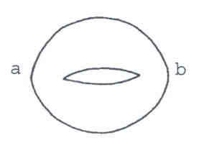 | 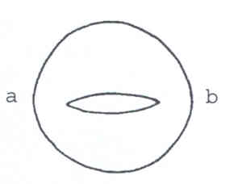
1 | 2 | 3
medium elliptic | broad elliptic | circular

Ad. 29: Mature fruit: stalk cavity
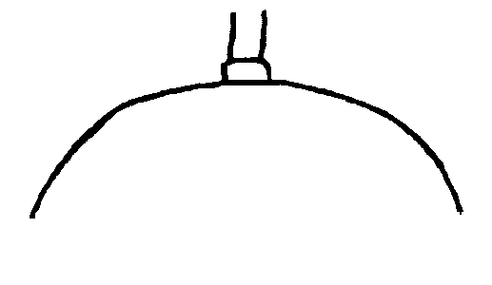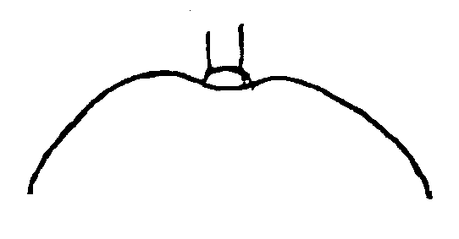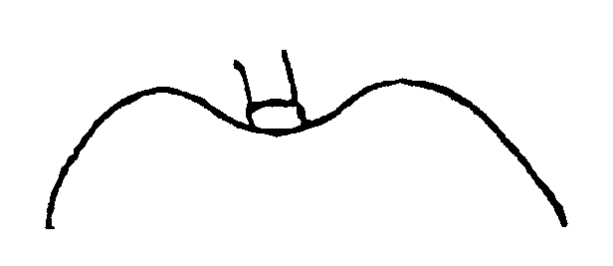

1 | 2 | 3
absent or shallow | medium | deep

Ad. 30: Mature fruit: presence of neck

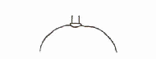 | 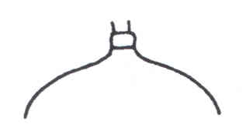
1 | 9
absent | present

Ad. 32: Mature fruit: shape of ventral shoulder
Ad. 33: Mature fruit: shape of dorsal shoulder

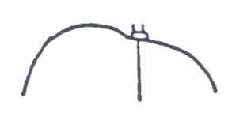 | 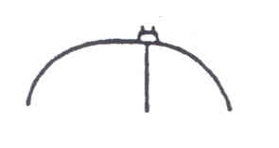 |  | 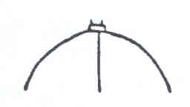
1 | 2 |  | 3
rounded upward | rounded outward |  | rounded downward
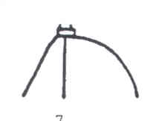 |  | 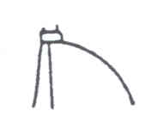
4 |  | 5
sloping downward |  | falling abruptly

Ad. 34: Mature fruit: length of groove in ventral shoulder
Ad. 35: Mature fruit: depth of groove in ventral shoulder

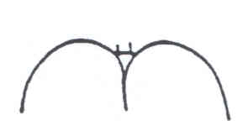
groove

Ad. 36: Mature fruit: bulging on ventral shoulder

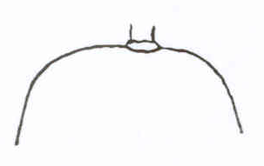 | 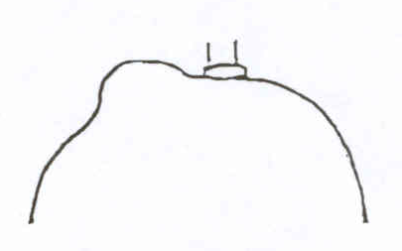
1 | 9
absent | present

Ad. 37: Mature fruit: presence of sinus

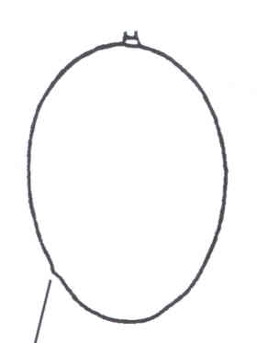 | sinus | 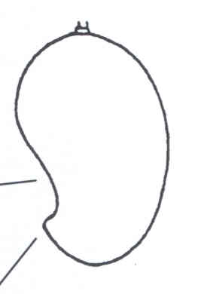
stylar scar | stylar scar
1 |  | 9
absent |  | present

Ad. 39: Mature fruit: bulging proximal of stylar scar

bulge  stylar scar | 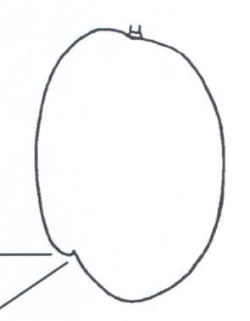

Ad. 40: Mature fruit: point at stylar scar

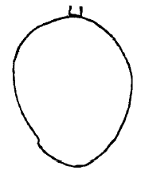
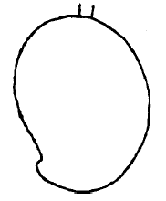
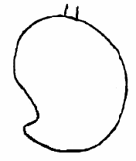

1 | 2 | 3
absent or small | medium | large

Ad. 52: Ripe fruit: “Turpentine flavor”

“Turpentine flavor” is a very recognizable aromatic flavor.

Ad. 54: Seed: shape in lateral view

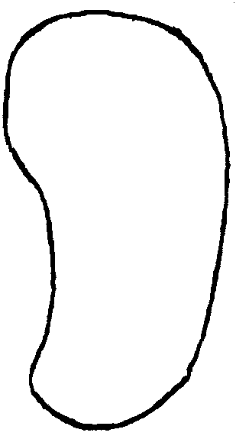
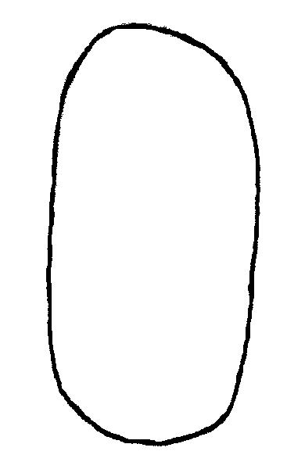
1 | 2
oblong | reniform

Literature

Campbell, R.J. (ed.). 1992. Mango: A Guide to Mangos in Florida. Fairchild Tropical Garden, Miami, Fla., USA

Gangolly, S.R., Singh, R., Katyal, S.L., Singh, D., 1957: “The Mango,” Indian Council of Agricultural Research, New Delhi, India, pp. 19-459

Kurup, C.G.R. (Chief Editor), 1967: “The Mango: A Handbook,” Indian Council of Agricultural Research, New Delhi, India, pp. 14-31

“Mango Number,” Punjab Fruit Journal, nn. 82-83, 1960

Naik, K.C., Gangolly, S.R., 1950: “A Monograph on Classification and Nomenclature of South Indian Mangoes”, Superintendent, Government Press, Madras, India, pp. 36-273

Singh, L.B., 1960: “The Mango: Botany, Cultivation and Utilization,” Interscience Publishers, Leonard Hill, London, GB, New York, US, pp. 91-142

Singh, L.B., and Sturrock, D. 1969: Mango. In: Ferwerda, F.P., and Wit, F. (eds.). Outlines of Perennial Crop Breeding in the Tropics, pp. 309-327. H. Veenman and Zonen, N.V. Wageningen, The Netherlands

Valmayor, R., 1962: “The Mango: Its Botany and Production,” University of the Philippines, College, Laguna

Technical Questionnaire

TECHNICAL QUESTIONNAIRE |  |  |  | Page {x} of {y} |  | Reference Number:
 |  |  |  |  |  | Application date:
 |  |  |  |  |  | (not to be filled in by the applicant)
TECHNICAL QUESTIONNAIRE
to be completed in connection with an application for plant breeders’ rights

1. Subject of the Technical Questionnaire
1.1 Botanical name |  |  | Mangifera indica L.
1.2 Common name |  |  | Mango
2. Applicant
Name
Address
Telephone No.
Fax No.
E-mail address
Breeder (if different from applicant)
3. Proposed denomination and breeder’s reference
Proposed denomination
(if available)

Breeder’s reference
#4. Information on the breeding scheme and propagation of the variety

4.1 Breeding scheme

Variety resulting from:

4.1.1 Crossing

(a) controlled cross [ ]
(please state parent varieties)
(b) partially known cross [ ]
(please state known parent variety(ies))
(c) unknown cross [ ]

4.1.2 Mutation [ ]
(please state parent variety)

4.1.3 Discovery and development [ ]
(please state where and when discovered
and how developed)

4.1.4 Other [ ]
(please provide details)

4.2 Method of propagating the variety

5. Characteristics of the variety to be indicated (the number in brackets refers to the corresponding characteristic in Test Guidelines; please mark the note which best corresponds).
 | Characteristics |  |  |  |  |  | Example Varieties |  |  | Note
5.1  (22) | Mature fruit: ratio length/width
 | very small |  |  |  |  |  | Extrema, Santa Alexandrina |  |  | 1[ ]
 | small |  |  |  |  |  | Fascell, Sheil |  |  | 3[ ]
 | medium |  |  |  |  |  | Sensation, Tommy Atkins |  |  | 5[ ]
 | large |  |  |  |  |  | Carrie, Gouveia |  |  | 7[ ]
 | very large |  |  |  |  |  | Anderson, Sabre |  |  | 9[ ]
5.2  (32) | Mature fruit: shape of ventral shoulder
 | rounded upward |  |  |  |  |  | Tommy Atkins |  |  | 1[ ]
 | rounded outward |  |  |  |  |  | Florigon, Irwin, Palmer, Zill |  |  | 2[ ]
 | rounded downward |  |  |  |  |  | Keitt, Ruby, Sandersha |  |  | 3[ ]
 | sloping downward |  |  |  |  |  | Long Green |  |  | 4[ ]
 | falling abruptly |  |  |  |  |  |  |  |  | 5[ ]
5.3  (33) | Mature fruit: shape of dorsal shoulder
 | rounded upward |  |  |  |  |  |  |  |  | 1[ ]
 | rounded outward |  |  |  |  |  | Fascell |  |  | 2[ ]
 | rounded downward |  |  |  |  |  | Irwin, Ruby, Zill |  |  | 3[ ]
 | sloping downward |  |  |  |  |  | Keitt |  |  | 4[ ]
 | falling abruptly |  |  |  |  |  | Long Green, Palmer, Sandersha |  |  | 5[ ]
5.4  (37) | Mature fruit: presence of sinus
 | absent |  |  |  |  |  | Fascell, Hood, Kent |  |  | 1[ ]
 | present |  |  |  |  |  | Gouveia, Sabre, Sandersha |  |  | 9[ ]
 | Characteristics |  |  |  |  |  | Example Varieties |  |  | Note
5.5  (39) | Mature fruit: bulging proximal of stylar scar
 | absent or weak |  |  |  |  |  | Adams, Anderson |  |  | 1[ ]
 | medium |  |  |  |  |  |  |  |  | 2[ ]
 | strong |  |  |  |  |  | Nimrod, Sheil |  |  | 3[ ]
5.6  (55) | Seed: embryony
 | monoembryonic |  |  |  |  |  | Sensation, Tommy Atkins |  |  | 1[ ]
 | polyembryonic |  |  |  |  |  | Peach, Sabre |  |  | 2[ ]
5.7  (57) | Time of fruit maturity
 | very early |  |  |  |  |  | Early Gold, Florigon, Long Green |  |  | 1[ ]
 | early |  |  |  |  |  | Zill |  |  | 3[ ]
 | medium |  |  |  |  |  | Fascell, Nimrod, Tommy Atkins |  |  | 5[ ]
 | late |  |  |  |  |  | Sensation |  |  | 7[ ]
 | very late |  |  |  |  |  | Keitt |  |  | 9[ ]
6. Similar varieties and differences from these varieties

Please use the following table and box for comments to provide information on how your candidate variety differs from the variety (or varieties) which, to the best of your knowledge, is (or are) most similar. This information may help the examination authority to conduct its examination of distinctness in a more efficient way.

Denomination(s) of variety(ies) similar to your candidate variety |  | Characteristic(s) in which your candidate variety differs from the similar variety(ies) |  |  | Describe the expression of the characteristic(s) for the similar variety(ies) |  |  | Describe the expression of the characteristic(s) for your candidate variety
Example |  | Mature fruit: shape of ventral shoulder |  |  | rounded upward |  |  | sloping downward
#7. Additional information which may help in the examination of the variety

7.1 In addition to the information provided in sections 5 and 6, are there any additional characteristics which may help to distinguish the variety?

Yes [ ] No [ ]

(If yes, please provide details)

7.2 Are there any special conditions for growing the variety or conducting the examination?

Yes [ ] No [ ]

(If yes, please provide details)

7.3 Other information

A representative color photograph of the variety should accompany the Technical Questionnaire.

8. Authorization for release

(a) Does the variety require prior authorization for release under legislation concerning the protection of the environment, human and animal health?

Yes [ ] No [ ]

(b) Has such authorization been obtained?

Yes [ ] No [ ]

If the answer to (b) is yes, please attach a copy of the authorization.

9. Information on plant material to be examined or submitted for examination

9.1 The expression of a characteristic or several characteristics of a variety may be affected by factors, such as pests and disease, chemical treatment (e.g. growth retardants or pesticides), effects of tissue culture, different rootstocks, scions taken from different growth phases of a tree, etc.

9.2 The plant material should not have undergone any treatment which would affect the expression of the characteristics of the variety, unless the competent authorities allow or request such treatment. If the plant material has undergone such treatment, full details of the treatment must be given. In this respect, please indicate below, to the best of your knowledge, if the plant material to be examined has been subjected to:

(a) Microorganisms (e.g. virus, bacteria, phytoplasma) Yes [ ] No [ ]

(b) Chemical treatment (e.g. growth retardant, pesticide) Yes [ ] No [ ]

(c) Tissue culture Yes [ ] No [ ]

(d) Other factors Yes [ ] No [ ]

Please provide details for where you have indicated “yes”.

……………………………………………………………

10. I hereby declare that, to the best of my knowledge, the information provided in this form is correct:

Applicant’s name

Signature Date

[End of document]

* These names were correct at the time of the introduction of these Test Guidelines but may be revised or updated. [Readers are advised to consult the UPOV Code, which can be found on the UPOV Website (www.upov.int), for the latest information.]
# Authorities may allow certain of this information to be provided in a confidential section of the Technical Questionnaire.
# Authorities may allow certain of this information to be provided in a confidential section of the Technical Questionnaire.

