 |  | E  TG/100/4  ORIGINAL: English  DATE: April 9, 2003
INTERNATIONAL UNION FOR THE PROTECTION OF NEW VARIETIES OF PLANTS
GENEVA

 | QUINCE  (Cydonia Mill. sensu stricto) | *

GUIDELINES

FOR THE CONDUCT OF TESTS

FOR DISTINCTNESS, UNIFORMITY AND STABILITY

Alternative Names:*

Latin | English | French | German | Spanish
Cydonia Mill. sensu stricto | Quince | Cognassier | Quitte | Membrillero

ASSOCIATED DOCUMENTS

These guidelines should be read in conjunction with document TG/1/3, “General Introduction to the Examination of Distinctness, Uniformity and Stability and the Development of Harmonized Descriptions of New Varieties of Plants” (hereinafter referred to as the “General Introduction”) and its associated “TGP” documents.

TABLE OF CONTENTS PAGE

1. Subject of these Test Guidelines 3
2. Material Required 3
3. Method of Examination 3
3.1 Duration of Tests 3
3.2 Testing Place 3
3.3 Conditions for Conducting the Examination 3
3.4 Test Design 4
3.5 Number of Plants / Parts of Plants to be Examined 4
3.6 Additional Tests 4
4. Assessment of Distinctness, Uniformity and Stability 4
4.1 Distinctness 4
4.2 Uniformity 4
4.3 Stability 5
5. Grouping of Varieties and Organization of the Growing Trial 5
6. Introduction to the Table of Characteristics 5
6.1 Categories of Characteristics 5
6.2 States of Expression and Corresponding Notes 6
6.3 Types of Expression 6
6.4 Example Varieties 6
6.5 Legend 6
7. Table of Characteristics/Tableau des caractères/Merkmalstabelle/Tabla de caracteres 7
8. Explanations on the Table of Characteristics 15
8.1 Explanations covering several characteristics 15
8.2 Explanations for individual characteristics 15
9. Literature 20
10. Technical Questionnaire 21

Subject of these Test Guidelines
These Test Guidelines apply to all varieties of Cydonia Mill. sensu stricto.

Material Required
2.1 The competent authorities decide on the quantity and quality of the plant material required for testing the variety and when and where it is to be delivered. Applicants submitting material from a State other than that in which the testing takes place must ensure that all customs formalities and phytosanitary requirements are complied with.

2.2 The material is to be supplied in the form of grafted plants or grafting material.

2.3 The minimum quantity of plant material, to be supplied by the applicant, should be:

5 two-year-old grafted plants or grafting material sufficient for 5 trees.

It is recommended that one of the following rootstock varieties should be used:
quince 'East Malling A' or 'BA 29'
or any other rootstock specified by the competent authorities.

2.4 The plant material supplied should be visibly healthy, not lacking in vigor, nor affected by any important pest or disease. It should especially be free from viruses as required by the competent authorities. It should preferably not be obtained from in vitro propagation. If it has been produced by in vitro propagation, this fact must be stated by the applicant.

2.5 The plant material should not have undergone any treatment which would affect the expression of the characteristics of the variety, unless the competent authorities allow or request such treatment. If it has been treated, full details of the treatment must be given.

Method of Examination

3.1 Duration of Tests
The minimum duration of tests should normally be two independent growing cycles. For the purposes of these Test Guidelines, a growing cycle refers to the fruiting cycle.

3.2 Testing Place
The tests should normally be conducted at one place. If any characteristics of the variety, which are relevant for the examination of DUS, cannot be seen at that place, the variety may be tested at an additional place.

3.3 Conditions for Conducting the Examination
The tests should be carried out under conditions ensuring satisfactory growth for the expression of the relevant characteristics of the variety and for the conduct of the examination. In particular, it is essential that the trees produce a satisfactory crop of fruit in each of the two growing cycles.

3.4 Test Design
3.4.1 Each test should be designed to result in a total of at least 5 plants.

3.4.2 The design of the tests should be such that plants or parts of plants may be removed for measurement or counting without prejudice to the observations which must be made up to the end of the growing cycle.

3.5 Number of Plants / Parts of Plants to be Examined
Unless otherwise indicated, all observations determined by measuring or counting should be made on 5 plants or parts taken from each of 5 plants. In the case of plant parts, the number to be taken from each of the plants should be 2.

3.6 Additional Tests
Additional tests, for examining relevant characteristics, may be established.

Assessment of Distinctness, Uniformity and Stability

4.1 Distinctness
4.1.1 General Recommendations

It is of particular importance for users of these Test Guidelines to consult the General Introduction prior to making decisions regarding distinctness. However, the following points are provided for elaboration or emphasis in these Test Guidelines.

4.1.2 Consistent Differences

The minimum duration of tests recommended in section 3.1 reflects, in general, the need to ensure that any differences in a characteristic are sufficiently consistent.

4.1.3 Clear Differences

Determining whether a difference between two varieties is clear depends on many factors, and should consider, in particular, the type of expression of the characteristic being examined, i.e. whether it is expressed in a qualitative, quantitative, or pseudo-qualitative manner. Therefore, it is important that users of these Test Guidelines are familiar with the recommendations contained in the General Introduction prior to making decisions regarding distinctness.

4.2 Uniformity
4.2.1 It is of particular importance for users of these Test Guidelines to consult the General Introduction prior to making decisions regarding uniformity. However, the following points are provided for elaboration or emphasis in these Test Guidelines.
4.2.2 For the assessment of uniformity a population standard of 1% and an acceptance probability of at least 95% should be applied. In the case of a sample size of 5 plants, no off-types are allowed.

4.3 Stability
4.3.1 In practice, it is not usual to perform tests of stability that produce results as certain as those of the testing of distinctness and uniformity. However, experience has demonstrated that, for many types of variety, when a variety has been shown to be uniform, it can also be considered to be stable.

4.3.2 Where appropriate, or in cases of doubt, stability may be tested, either by growing a further generation, or by testing a new plant stock to ensure that it exhibits the same characteristics as those shown by the previous material supplied

Grouping of Varieties and Organization of the Growing Trial
5.1 The selection of varieties of common knowledge to be grown in the trial with the candidate varieties and the way in which these varieties are divided into groups to facilitate the assessment of distinctness is aided by the use of grouping characteristics.

5.2 Grouping characteristics are those in which the documented states of expression, even where produced at different locations, can be used, either individually or in combination with other such characteristics: (a) to select varieties of common knowledge that can be excluded from the growing trial used for examination of distinctness; and (b) to organize the growing trial so that similar varieties are grouped together.

5.3 The following have been agreed as useful grouping characteristics:

(a) Plant: habit (characteristic 2);
(b) Leaf blade: shape (characteristic 12);
(c) Fruit: general shape in longitudinal section (characteristic 27).

5.4 Guidance for the use of grouping characteristics, in the process of examining distinctness, is provided through the General Introduction.

Introduction to the Table of Characteristics

6.1 Categories of Characteristics
6.1.1 Standard Test Guidelines Characteristics

Standard Test Guidelines characteristics are those which are approved by UPOV for examination of DUS and from which members of the Union can select those suitable for their particular circumstances.

6.1.2 Asterisked Characteristics

Asterisked characteristics (denoted by *) are those included in the Test Guidelines which are important for the international harmonization of variety descriptions and should always be examined for DUS and included in the variety description by all members of the Union, except when the state of expression of a preceding characteristic or regional environmental conditions render this inappropriate.

6.2 States of Expression and Corresponding Notes
States of expression are given for each characteristic to define the characteristic and to harmonize descriptions. Each state of expression is allocated a corresponding numerical note for ease of recording of data and for the production and exchange of the description.

6.3 Types of Expression
An explanation of the types of expression of characteristics (qualitative, quantitative and pseudo-qualitative) is provided in the General Introduction.

6.4 Example Varieties
Where appropriate, example varieties are provided to clarify the states of expression of each characteristic.

6.5 Legend
(*) Asterisked characteristic – see Section 6.1.2

QL Qualitative characteristic – see Section 6.3
QN Quantitative characteristic – see Section 6.3
PQ Pseudo-Qualitative characteristic – see Section 6.3

(a)-(d) See Explanations on the Table of Characteristics in Chapter 8, Section 8.1

(+) See Explanations on the Table of Characteristics in Chapter 8, Section 8.2

Table of Characteristics/Tableau des caractères/Merkmalstabelle/Tabla de caracteres

 |  | English | français | deutsch | español | Example Varieties  Exemples  Beispielssorten  Variedades ejemplo | Note/  Nota
1.  (*)  (+) | (a) | Plant: vigor | Plante: vigueur | Pflanze: Wüchsigkeit | Planta: vigor
QN |  | weak | faible | gering | débil | Moldoveneşti, Pear Shaped | 3
 |  | medium | moyenne | mittel | medio | Ekmek Ayvasi, Hemus | 5
 |  | strong | forte | stark | fuerte | Otličnica, Sekergeurek, Vranja | 7
2.  (*) | (a) | Plant: habit | Plante: port | Pflanze: Wuchsform | Planta: porte
PQ |  | upright | dressé | aufrecht | erecto | Vranja | 1
 |  | semi-upright | demi-dressé | halbaufrecht | semierecto | Champion | 2
 |  | spreading | étalé | breitwüchsig | rastrero | Bourgeault | 3
3. | (a) | One-year-old shoot: form | Rameau d’un an: forme | Einjähriger Trieb: Form | Rama de un año: forma
PQ |  | straight | droit | gerade | recto | Selena | 1
 |  | wavy | ondulé | gewellt | ondulado | Vranja | 2
 |  | zig-zag | en zigzag | zickzackförmig | en zig-zag | Pear Shaped | 3
4. | (a) | One-year-old shoot: length of internode | Rameau d’un an: longueur de l’entre-nœud | Einjähriger Trieb: Länge des Internodiums | Rama de un año: longitud del entrenudo
QN |  | short | court | kurz | corto | Bencikli | 3
 |  | medium | moyen | mittel | medio | Bourgeault, Champion | 5
 |  | long | long | lang | largo | Matador | 7
5.  (*) | (a) | One-year-old shoot: pubescence (upper third) | Rameau d’un an: pubescence (tiers supérieur) | Einjähriger Trieb: Behaarung (oberes Drittel) | Rama de un año: pubescencia (tercio superior)
QN |  | weak | faible | gering | débil | Ronda | 3
 |  | medium | moyenne | mittel | media | Bereczki | 5
 |  | strong | forte | stark | fuerte | Champion | 7
6.  (*) | (a) | One-year-old shoot: color | Rameau d’un an: couleur | Einjähriger Trieb: Farbe | Rama de un año: color
PQ |  | grey brown | brun gris | graubraun | marrón grisáceo | d’Angers | 1
 |  | greenish brown | brun verdâtre | grünlichbraun | marrón verdoso | Selena | 2
 |  | reddish brown | brun rougeâtre | rötlichbraun | marrón rojizo | Cydopom | 3
 |  | medium brown | brun moyen | mittelbraun | marrón medio | Ronda | 4
 |  | dark brown | brun foncé | dunkelbraun | marrón oscuro | Shams | 5
7. | (a) | One-year-old shoot: size of lenticels | Rameau d’un an: taille des lenticelles | Einjähriger Trieb: Größe der Lentizellen | Rama de un año: tamaño de las lenticelas
QN |  | small | petite | klein | pequeñas | Champion | 3
 |  | medium | moyenne | mittel | medianas | Bereczki | 5
 |  | large | grande | groß | grandes | Cydopom | 7
8.  (+) |  | Shoot: position of vegetative bud in relation to shoot | Rameau: position du bourgeon par rapport aux rameaux | Trieb: Stellung der vegetativen Knospe im Verhältnis zum Trieb | Rama: posición de la yema de madera en relación con la rama
QN |  | adpressed | appliqué | anliegend | alineada | Vranja | 1
 |  | slightly held out | légèrement divergent | leicht abstehend | ligeramente divergente | Krymska | 2
 |  | strongly held out | fortement divergent | deutlich abstehend | fuertemente divergente | Ronda | 3
9.  (*)  (+) | (b) | Leaf blade: attitude | Limbe: port | Blattspreite: Haltung | Limbo: porte
QN |  | upright | dressé | aufrecht | erecto ascendente | Pinter | 1
 |  | horizontal | horizontal | waagerecht | horizontal | Leskovacz | 2
 |  | downwards | vers le bas | abwärtsgerichtet | descendente | Hruskovita | 3
10.  (*) | (b) | Leaf blade: length | Limbe: longueur | Blattspreite: Länge | Limbo: longitud
QN |  | short | court | kurz | corto | Pinter | 3
 |  | medium | moyen | mittel | medio | Ronda | 5
 |  | long | long | lang | largo | Matador, Vranja | 7
11.  (*) | (b) | Leaf blade: width | Limbe: largeur | Blattspreite: Breite | Limbo: anchura
QN |  | narrow | étroit | schmal | estrecho | Pinter | 3
 |  | medium | moyen | mittel | medio | Otličnica | 5
 |  | broad | large | breit | ancho | Isfahan | 7
12.  (*)  (+) | (b) | Leaf blade: shape | Limbe: forme | Blattspreite: Form | Limbo: forma
PQ |  | elliptic | elliptique | elliptisch | elíptica | Della Cina | 1
 |  | circular | circulaire | kreisförmig | circular | Constantinopel, Mollesca | 2
 |  | ovate | ovale | eiförmig | oval | Fabre | 3
 |  | obovate | obovale | verkehrt eiförmig | oboval | Tavsambas | 4
13.  (+) | (b) | Leaf blade: shape of base | Limbe: forme de la base | Blattspreite: Form der Basis | Limbo: forma de la base
PQ |  | cuneate | cunéiforme | keilförmig | cuneiforme | Asenica | 1
 |  | rounded | arrondie | abgerundet | redondeada | Guzuk Gobek | 2
 |  | truncate | tronquée | gerade | truncada | Alesa | 3
 |  | cordate | cordée | herzförmig | cordiforme | Kocurova | 4
14.  (*)  (+) | (b) | Leaf blade: angle at apex (excluding pointed tip) | Limbe: angle au sommet (sans l’extrêmité pointue) | Blattspreite: Winkel an der Spitze (ohne aufgesetzte Spitze) | Limbo: ángulo del extremo (excluyendo el ápice)
QN |  | acute | aigu | spitz | agudo | Shams | 1
 |  | right-angled | droit | rechtwinklig | en ángulo recto | Mezőtúri | 2
 |  | obtuse | obtus | stumpf | obtuso | Di Bazine, Champion | 3
15.  (*)  (+) | (b) | Leaf blade: length of tip | Limbe: longueur de l’extrêmité | Blattspreite: Länge der Spitze | Limbo: longitud del ápice
QN |  | short | courte | kurz | corto | Jurak, Triumph | 3
 |  | medium | moyenne | mittel | medio | Hemus | 5
 |  | long | longue | lang | largo | Otličnica | 7
16. | (b) | Leaf blade: profile in cross section | Limbe: profil en section transversale | Blattspreite: Profil im Querschnitt | Limbo: perfil de la sección transversal
PQ |  | straight | droit | gerade | recto | Guzuk Gobek | 1
 |  | concave | concave | konkav | concavo | Vranja | 2
17. | (b) | Leaf blade: undulation of margin | Limbe: ondulation du bord | Blattspreite: Randwellung | Limbo: ondulación del margen
QN |  | absent or very weak | nulle ou très faible | fehlend oder  sehr gering | ausente o muy débil | Muskatnaja | 1
 |  | weak | faible | gering | débil | Champion | 3
 |  | medium | moyenne | mittel | media | Bereczki | 5
 |  | strong | forte | stark | fuerte | Ekmek Ayvasi | 7
18. | (b) | Petiole: length | Pétiole: longueur | Blattstiel: Länge | Pecíolo: longitud
QN |  | short | court | kurz | corto | Portugal | 3
 |  | medium | moyen | mittel | medio | Bourgeault | 5
 |  | long | long | lang | largo | Champion | 7
19. |  | Stipule: size | Stipule: taille | Nebenblatt: Größe | Estípulas: tamaño
QN |  | absent or very small | nul ou très petit | fehlend oder sehr klein | ausentes o muy pequeñas | Otličnica | 1
 |  | small | petit | klein | pequeñas | Adams | 3
 |  | medium | moyen | mittel | medias | Pear Shaped, Constantinopel | 5
 |  | large | grand | groß | grandes | Vranja | 7
 |  | very large | très grand | sehr groß | muy grandes | Aurii, Buchlowice | 9
20.  (*) | (c) | Flower: size | Fleur: taille | Blüte: Größe | Flor: tamaño
QN |  | small | petite | klein | pequeña | Della Cina | 3
 |  | medium | moyenne | mittel | media | Champion | 5
 |  | large | grande | groß | grande | Turunchuksaya, Vranja | 7
21.  (+) | (c) | Flower: color | Fleur: couleur | Blüte: Farbe | Flor: color
PQ |  | white | blanche | weiß | blanco | d’Angers | 1
 |  | light pink | rose clair | hellrosa | rosa claro | Mezőtúri | 2
 |  | dark pink | rose foncé | dunkelrosa | rosa oscuro | Vranja | 3
22.  (+) | (c) | Flower: arrangement of petals | Fleur: disposition des pétales | Blüte: Anordnung der Blütenblätter | Flor: disposición de los pétalos
PQ |  | free | disjoints | freistehend | separados | Della Cina | 1
 |  | touching | tangents | sich berührend | tocándose | Hemus | 2
 |  | overlapping | chevauchants | überlappend | solapados | Vranja | 3
 |  | irregular | irréguliers | unregelmäßig | irregulares | Portugal | 4
23.  (+) | (c) | Petal: shape | Pétale: forme | Blütenblatt: Form | Pétalo: forma
PQ |  | elliptic | elliptique | elliptisch | elíptica | Patrasso | 1
 |  | circular | circulaire | kreisförmig | circular | Champion | 2
 |  | square | carré | quadratisch | cuadrada | Portugal | 3
 |  | oblong | oblong | rechteckig | oblonga | Tekes | 4
24. | (c) | Petal: undulation of margin | Pétale: ondulation du bord | Blütenblatt: Randwellung | Pétalo: ondulación del margen
QN |  | weak | faible | gering | débil | Brno, Constantinopel | 3
 |  | medium | moyenne | mittel | media | Turkey No. 4 | 5
 |  | strong | forte | stark | fuerte | Şafranii | 7
25. | (c) | Flower: position of stigma relative to anthers | Fleur: position du stigmate par rapport aux anthères | Blüte: Stellung der Narbe im Verhältnis zu den Antheren | Flor: posición del estigma en relación con las anteras
QN |  | below | en dessous | unterhalb | por debajo | Ekmek, Mezőtúri | 1
 |  | same level | au même niveau | auf gleicher Höhe | al mismo nivel | Aurii | 2
 |  | above | au-dessus | oberhalb | por encima | Bereczki | 3
26.  (*) | (d) | Fruit: size | Fruit: taille | Frucht: Größe | Fruto: tamaño
QN |  | small | petit | gering | pequeño | Bourgeault | 3
 |  | medium | moyen | mittel | medio | Champion | 5
 |  | large | grand | groß | grande | Vranja | 7
27.  (*)  (+) | (d) | Fruit: general shape in longitudinal section | Fruit: forme générale en section longitudinale | Frucht: allgemeine Form im Längsschnitt | Fruto: forma general en sección longitudinal
PQ |  | elliptic | elliptique | elliptisch | elíptica | Della Cina | 1
 |  | circular | circulaire | kreisförmig | circular | Fruits Ronds, Jurak | 2
 |  | square | carré | quadratisch | cuadrada | Aurii | 3
 |  | obovate | obovale | verkehrt eiförmig | oboval | Ispolinskaya | 4
 |  | pyriform | pyriforme | birnenförmig | piriforme | Hruskovita, Vranja | 5
28.  (*) | (d) | Fruit: symmetry in longitudinal section | Fruit: symétrie en section longitudinale | Frucht: Symmetrie im Längsschnitt | Fruto: simetría en sección longitudinal
PQ |  | asymmetric | asymétrique | asymmetrisch | asimétrico | Radonia | 1
 |  | symmetric | symétrique | symmetrisch | simétrico | Leskovacz | 2
29.  (*)  (+) | (d) | Fruit: neck | Fruit: col | Frucht: Hals | Fruto: cuello
QL |  | absent | absent | fehlend | ausente | Aurii | 1
 |  | present | présent | vorhanden | presente | Vranja | 9
30.  (*)  (+) | (d) | Fruit: length of neck | Fruit: longueur du col | Frucht: Länge des Halses | Fruto: longitud del cuello
QN |  | short | court | kurz | corto | Portugal | 3
 |  | medium | moyen | mittel | medio | Limon | 5
 |  | long | long | lang | largo | Hruskovita | 7
31.  (*) | (d) | Fruit: prominence of ribs at stalk end | Fruit: importance des côtes à l’extrémité pédonculaire | Frucht: Ausprägung  der Rippen am Stielende | Fruto: prominencia del acostillado en el extremo peduncular
QN |  | absent or very weak | nulle ou très faible | fehlend oder  sehr gering | ausente o muy débil | Krymskaya | 1
 |  | weak | faible | gering | débil | Ronda | 3
 |  | medium | moyenne | mittel | medio | Portugal | 5
 |  | strong | forte | stark | fuerte | Constantinopel | 7
32.  (*) | (d) | Fruit: prominence of ribs at calyx end | Fruit: importance des côtes au sommet | Frucht: Ausprägung der Rippen am Kelchende | Fruto: prominencia del acostillado en el extremo del caliz
QN |  | absent or very weak | nulle ou très faible | fehlend oder  sehr gering | ausente o muy débil | Pinter | 1
 |  | weak | faible | gering | débil | Ronda | 3
 |  | medium | moyenne | mittel | medio | Champion | 5
 |  | strong | forte | stark | fuerte | Bereczki | 7
33. | (d) | Fruit: stalk cavity | Fruit: cavité pédonculaire | Frucht: Stielgrube | Fruto: cavidad peduncular
QN |  | absent or very small | nulle ou très petite | fehlend oder  sehr klein | ausente o muy pequeña | Bereczki | 1
 |  | small | petite | klein | pequeña | Patrasso | 3
 |  | medium | moyenne | mittel | media | Portugal | 5
 |  | large | grande | groß | grande | Tekes | 7
34. | (d) | Fruit: size of eye basin | Fruit: taille de la cuvette de l’œil | Frucht: Größe der Kelchgrube | Fruto: tamaño de la cavidad del ojo
QN |  | small | petite | klein | pequeña | Ronda | 3
 |  | medium | moyenne | mittel | media | Vranja | 5
 |  | large | grande | groß | grande | Tekes | 7
35. | (d) | Fruit: color | Fruit: couleur | Frucht: Farbe | Fruto: color
PQ |  | yellow green | vert jaune | gelbgrün | verde amarillento | Champion, Ispolinskaya | 1
 |  | yellow | jaune | gelb | amarillo | Constantinopel | 2
 |  | yellow orange | jaune orange | gelborange | naranja amarillento | Moldoveneşti | 3
36.  (*) |  | Time of leaf bud burst | Epoque de débourrement des bourgeons | Zeitpunkt des Blattaustriebs | Época de aparición de la yema foliar
QN |  | early | précoce | früh | temprana | Vranja | 3
 |  | medium | moyenne | mittel | media | Bereczki | 5
 |  | late | tardive | spät | tardía |  | 7
37.  (*) |  | Time of beginning of flowering | Époque du début de la floraison | Zeitpunkt des Blühbeginns | Época del comienzo de la floración
QN |  | early | précoce | früh | temprana | Turunchuksaya | 3
 |  | medium | moyenne | mittel | media | Vranja | 5
 |  | late | tardive | spät | tardía | Constantinopel | 7
38.  (*)  (+) |  | Time of beginning of fruit ripening | Époque du début de la maturité des fruits | Zeitpunkt des Beginns der Fruchtreife | Época del comienzo de la maduración del fruto
QN |  | early | précoce | früh | temprana | Radonia | 3
 |  | medium | moyenne | mittel | media | Hemus | 5
 |  | late | tardive | spät | tardía | Ispolinskaja | 7

Explanations on the Table of Characteristics

8.1 Explanations covering several characteristics
Characteristics containing the following key in the second column of the Table of Characteristics should be examined as indicated below:

(a) Plant/One-year-old shoot: Observations on the plant and on the one-year-old shoot should be made during winter on plants that have fruited at least once. The length of the internode should be observed in the middle of the shoot.

(b) Leaf: Observations on the leaf should be made in summer on fully developed leaves from the middle third of a current season’s shoot.

(c) Flower: Observations on the flower should be made on fully developed flowers at the beginning of anther dehiscence.

(d) Fruit: Observations on the fruit should be made on fully ripened fruits.

8.2 Explanations for individual characteristics

Ad. 1. Plant: vigor

The vigor of the plant should be considered as the overall abundance of vegetative growth.

Ad. 8: Shoot: position of vegetative bud in relation to shoot

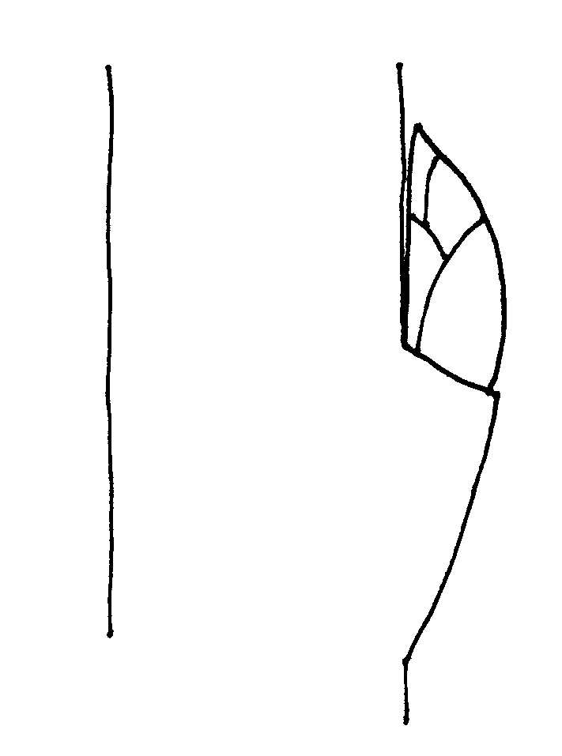 | 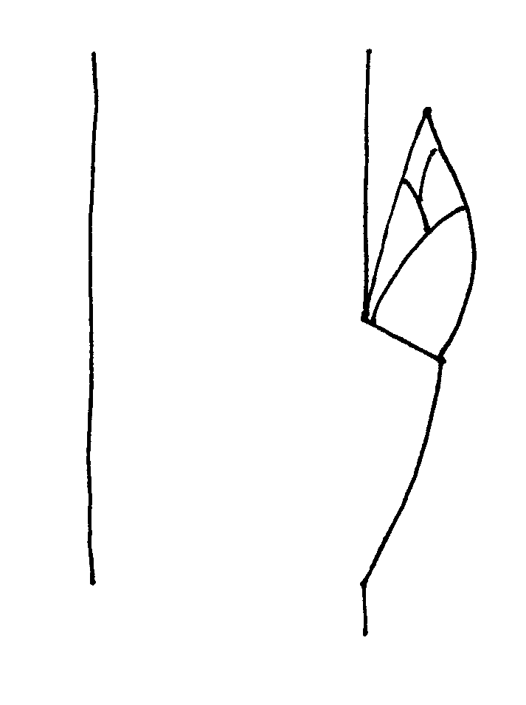 | 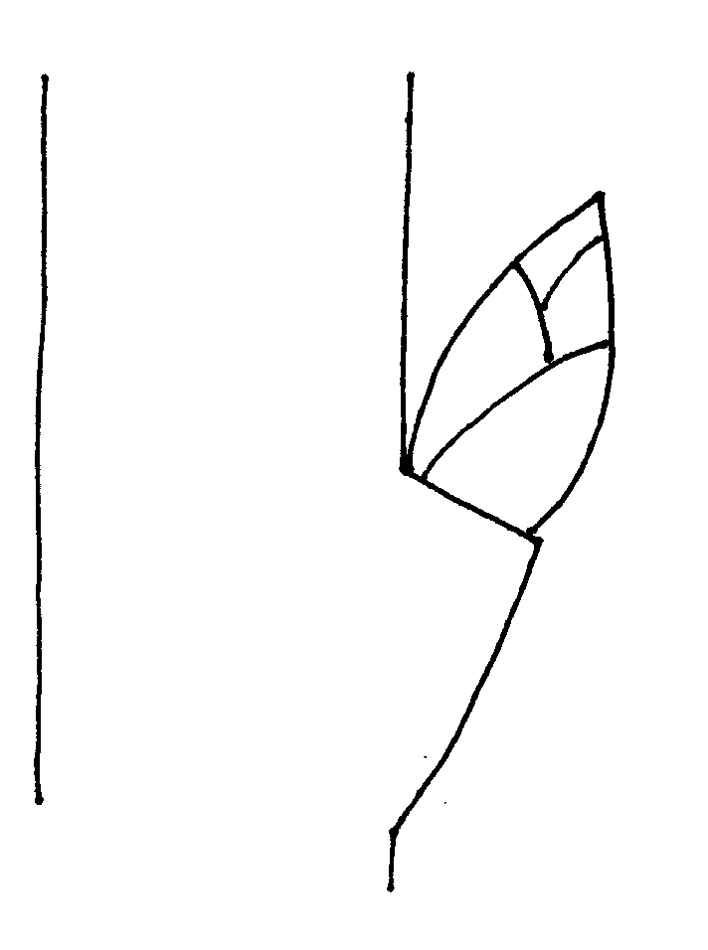
1 | 2 | 3
adpressed | slightly held out | strongly held out

Ad. 9: Leaf blade: attitude

The attitude of the leaf blade should be observed on erect shoots.

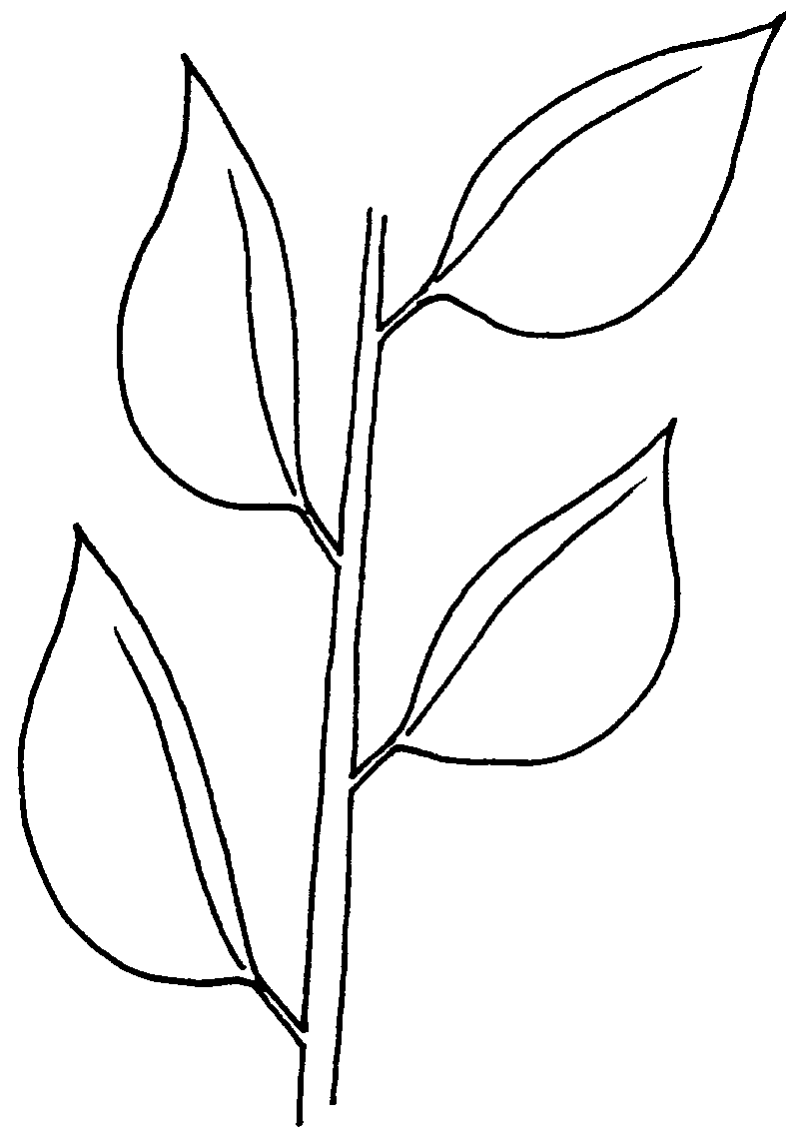 | 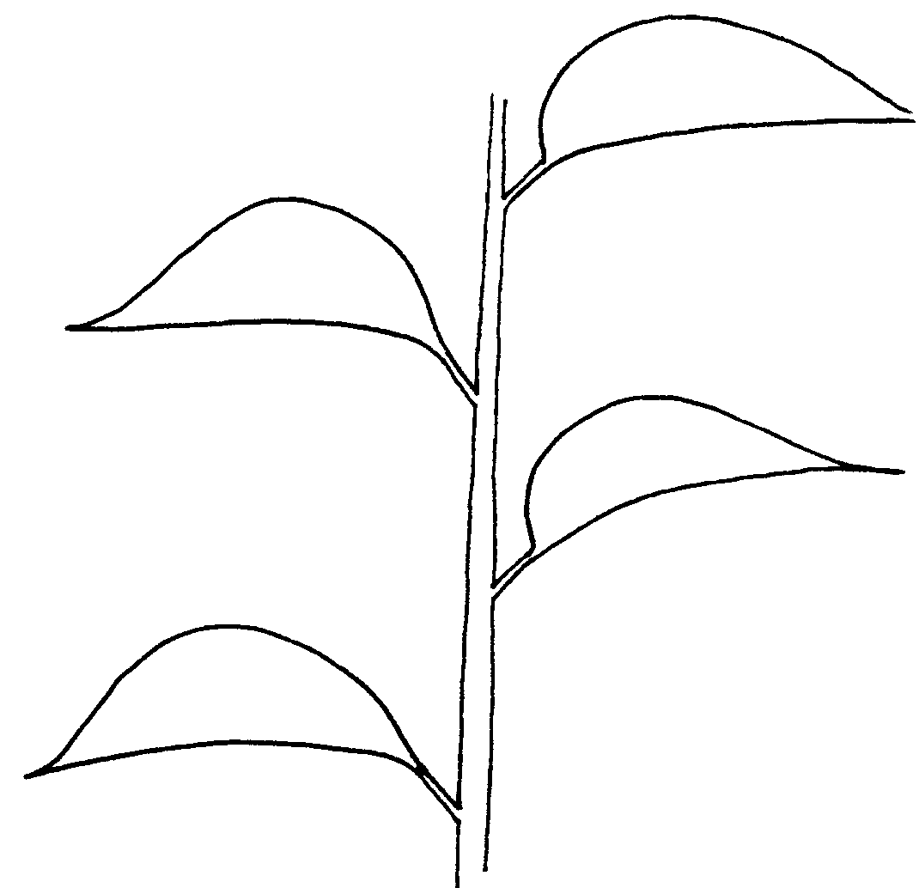 | 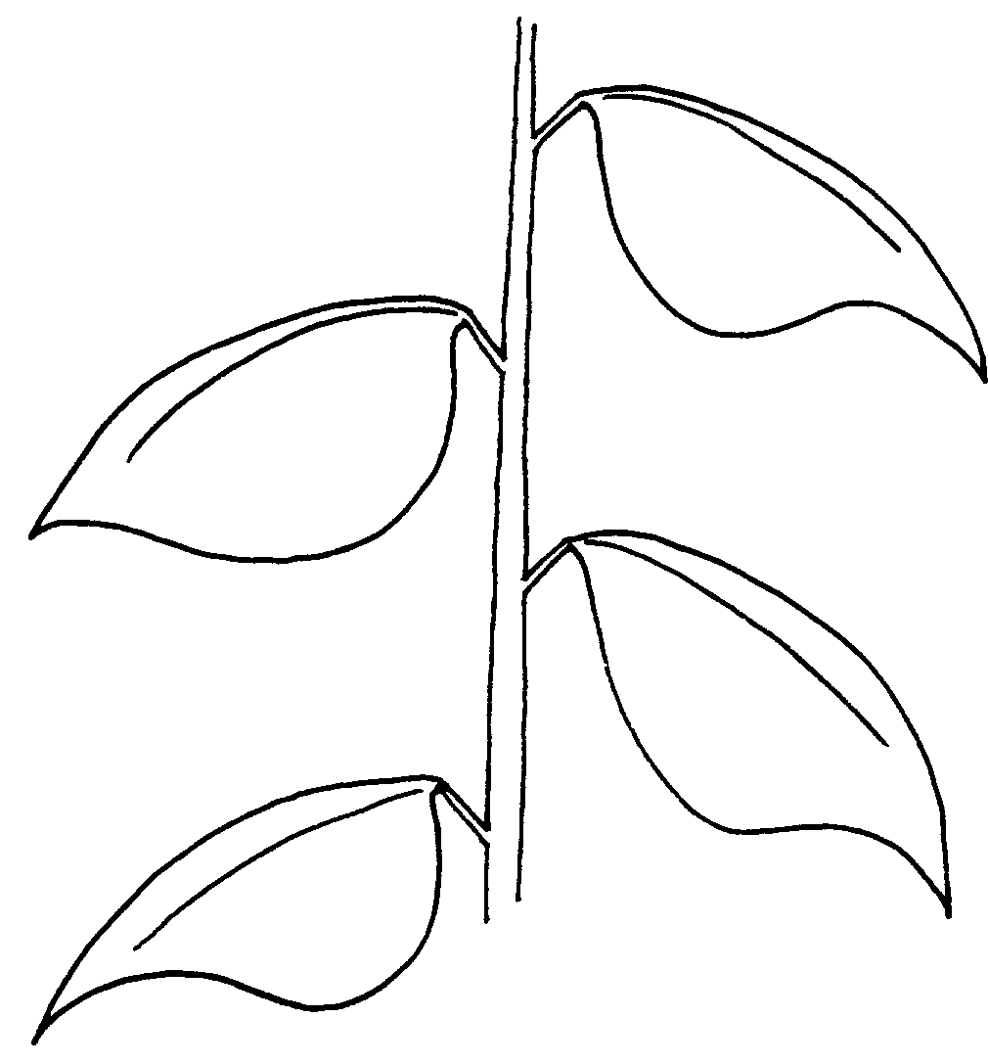

1 | 2 | 3
upright | horizontal | downwards

Ad. 12: Leaf blade: shape

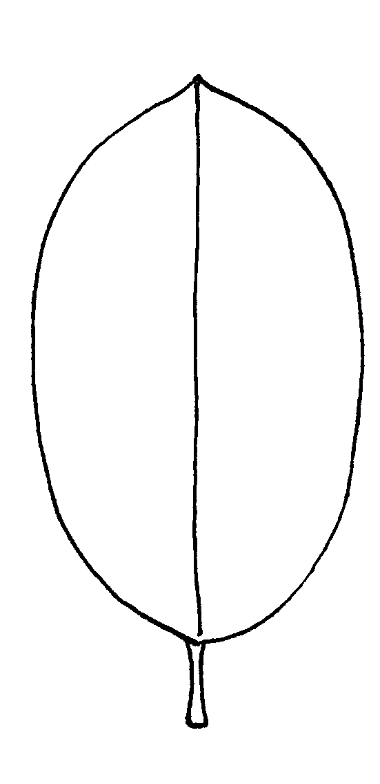 | 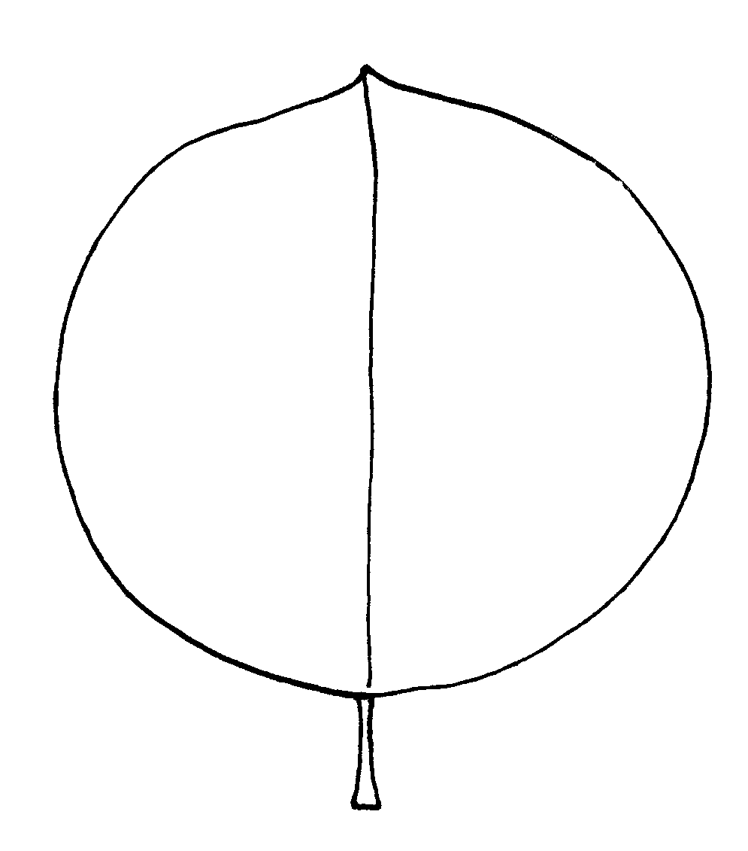 | 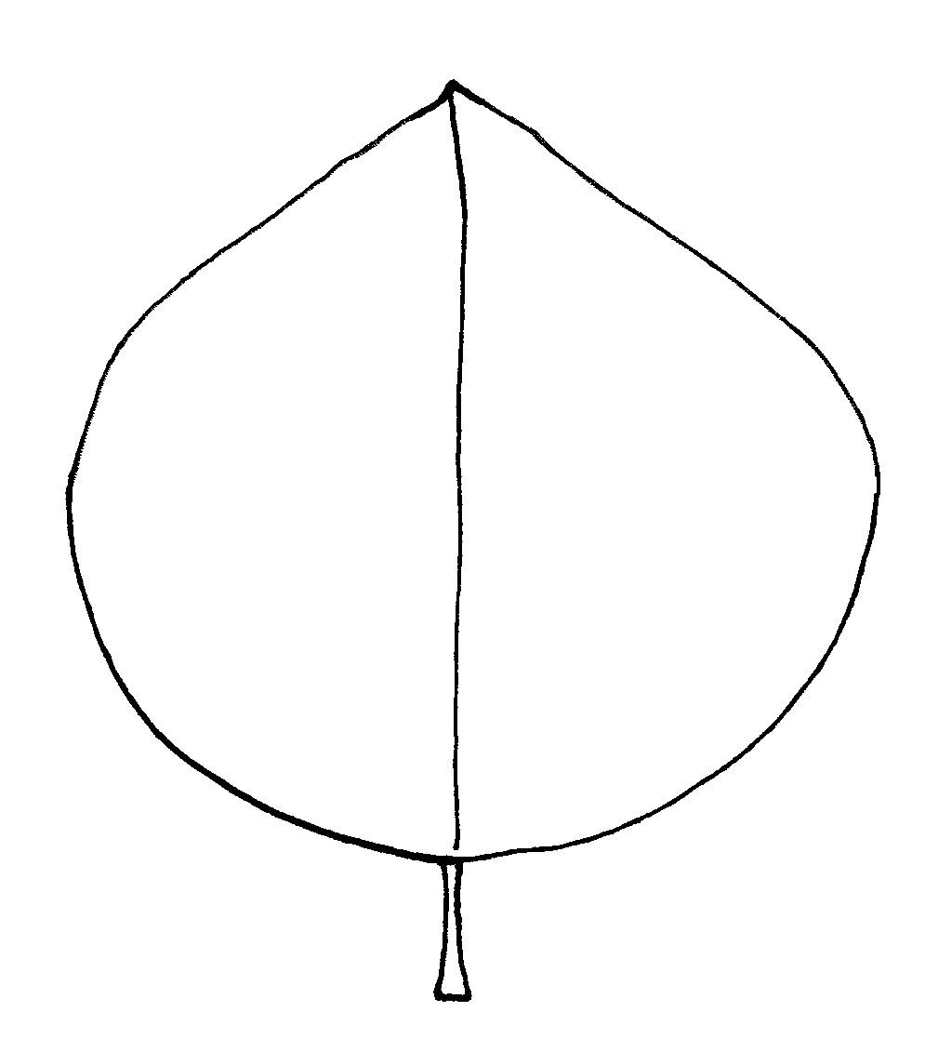 | 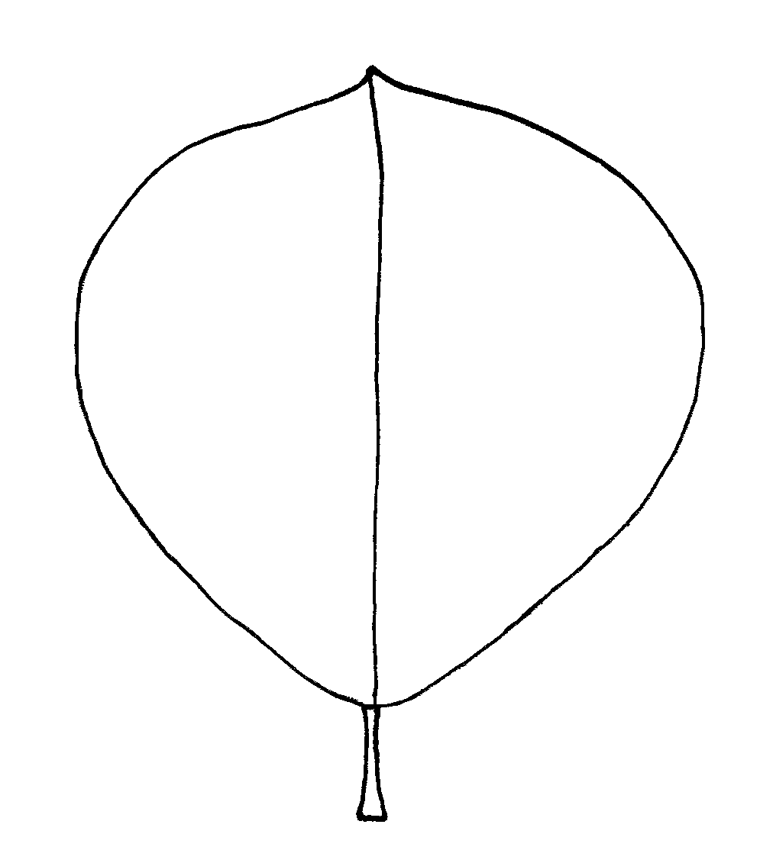

1 | 2 | 3 | 4
elliptic | circular | ovate | obovate

Ad. 13: Leaf blade: shape of base

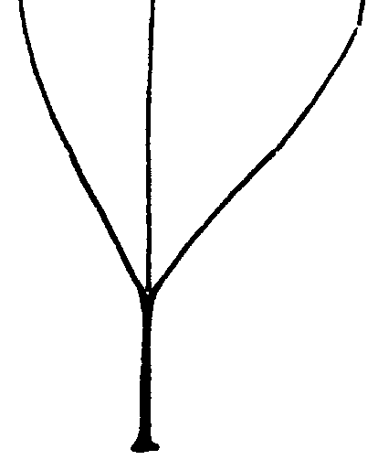 | 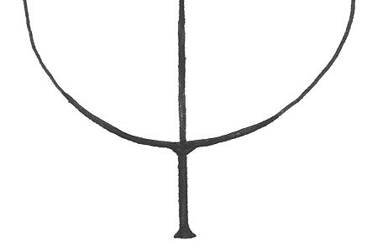 | 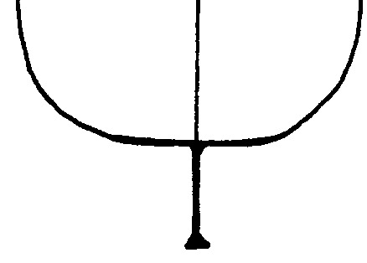 | 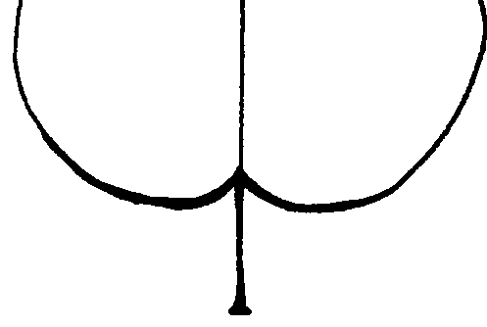

1 | 2 | 3 | 4
cuneate | rounded | truncate | cordate
Ad. 14: Leaf blade: angle at apex (excluding pointed tip)

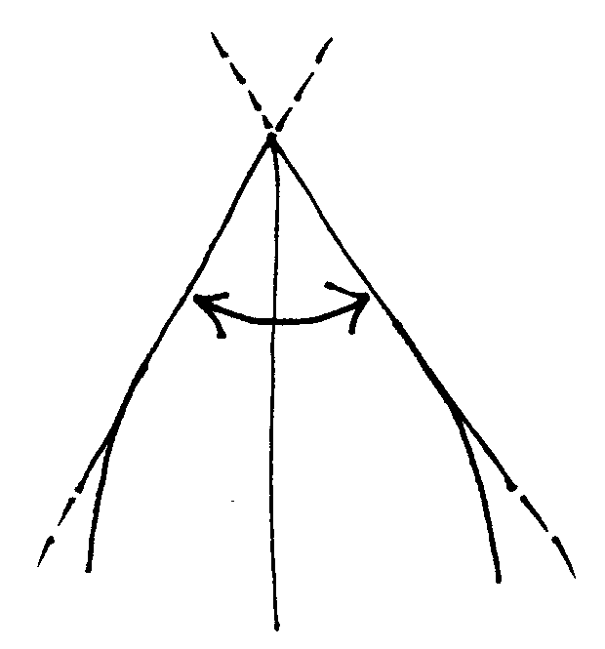 | 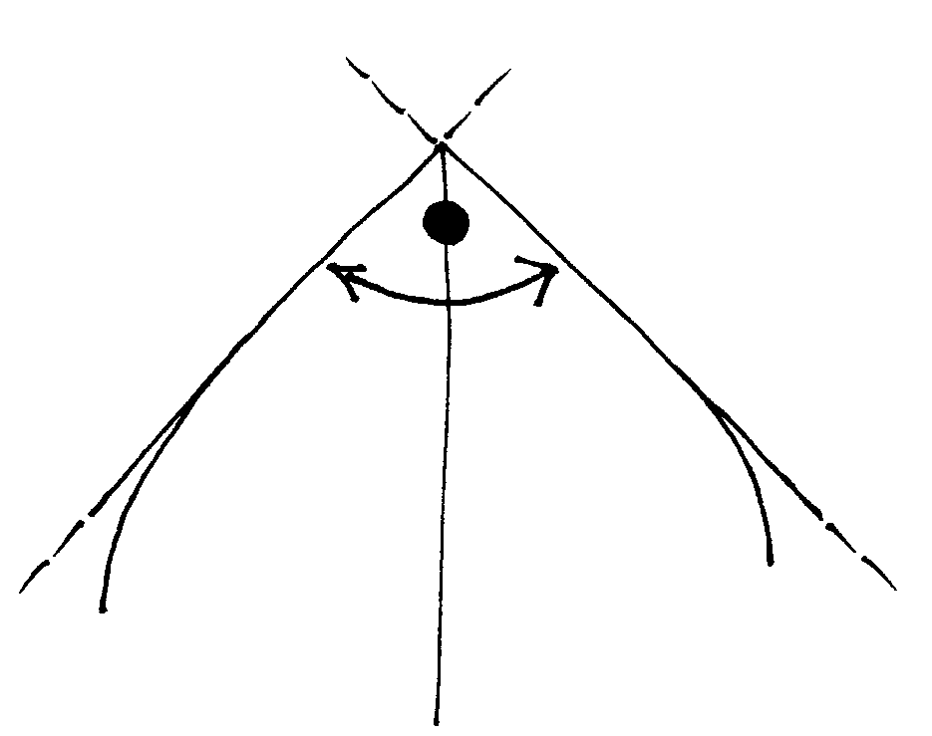 | 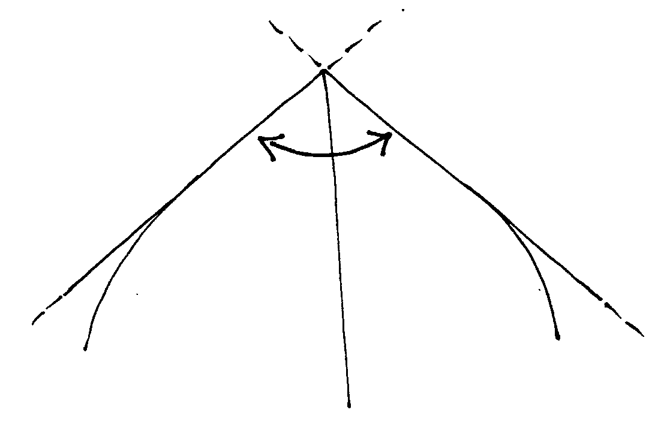
1 | 2 | 3
acute | right-angled | obtuse

Ad. 15: Leaf blade: length of tip

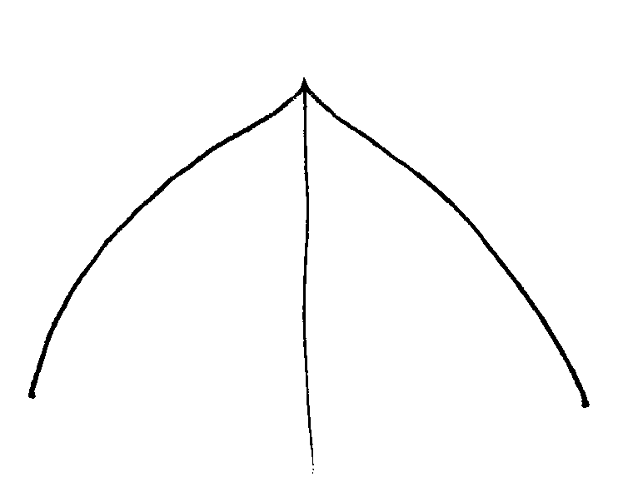 | 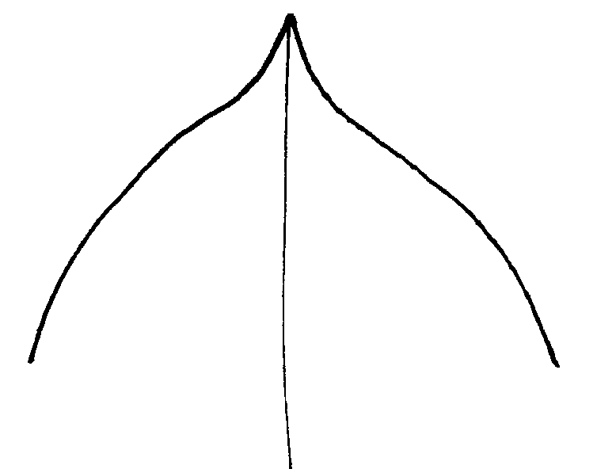 | 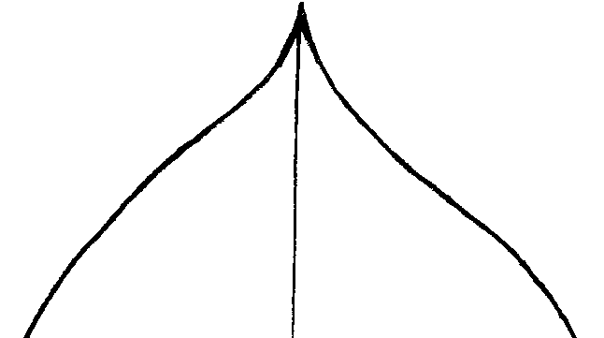

3 | 5 | 7
short | medium | long

Ad. 21: Flower: color

The color of the flower should be observed on the first day on which it opens.

Ad. 22: Flower: arrangement of petals

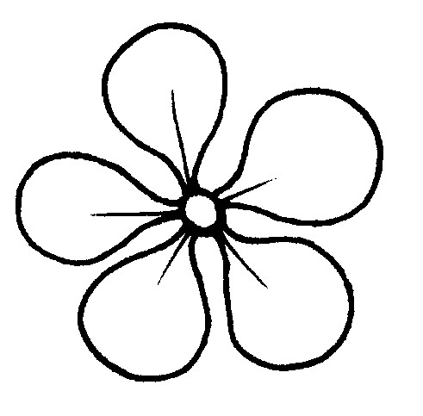 | 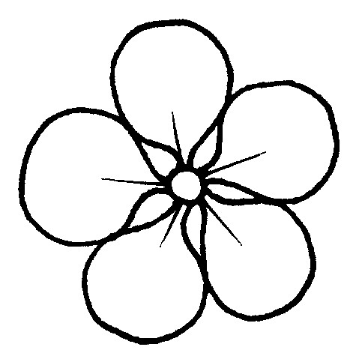 | 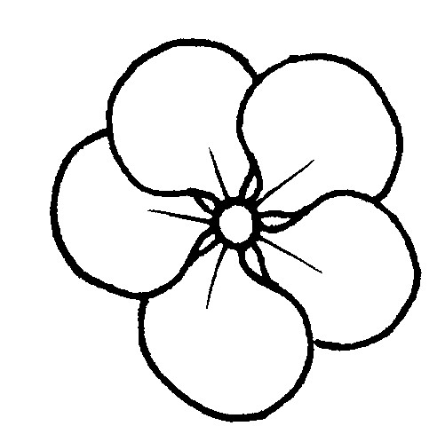 | 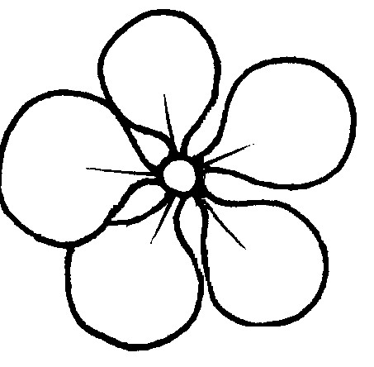
1 | 2 | 3 | 4
free | touching | overlapping | irregular

Ad 23. Petal: shape

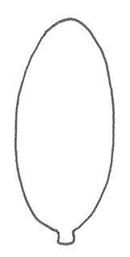 | 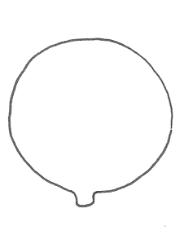 | 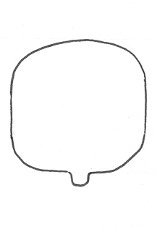 | 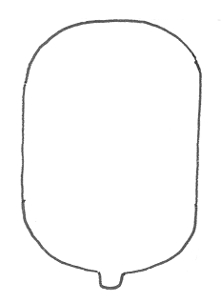
1 | 2 | 3 | 4
elliptic | circular | square | oblong

Ad. 27: Fruit: general shape in longitudinal section

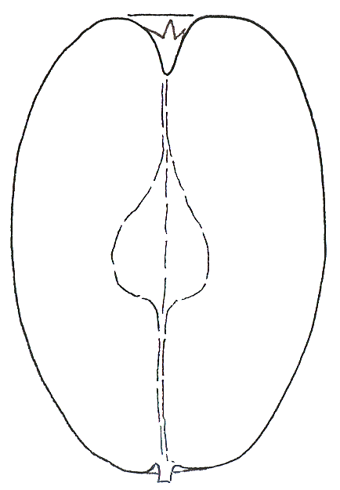 | 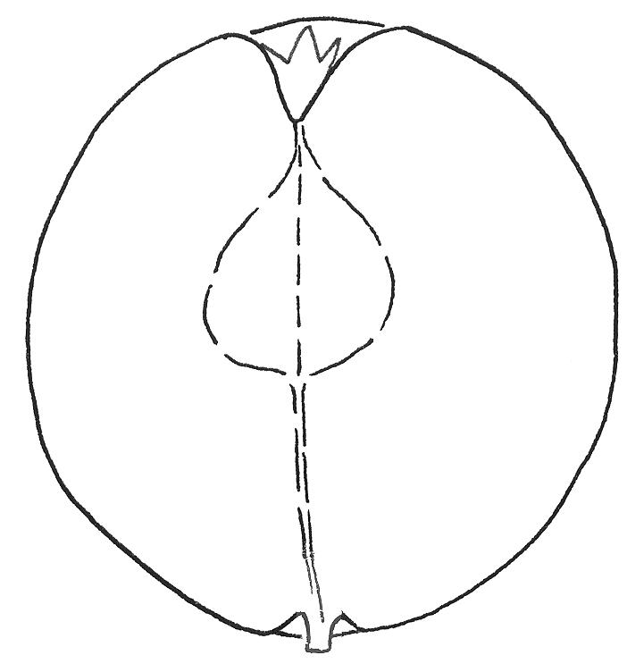 | 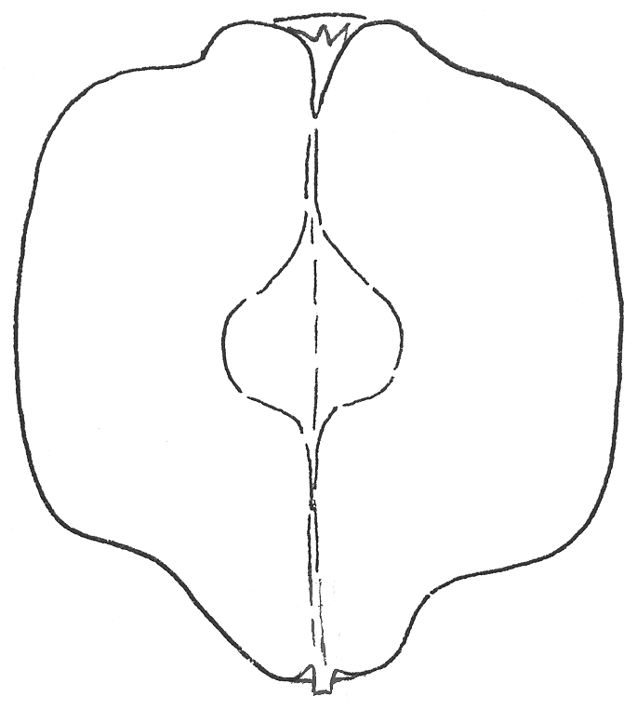
1 | 2 | 3
elliptic | circular | square

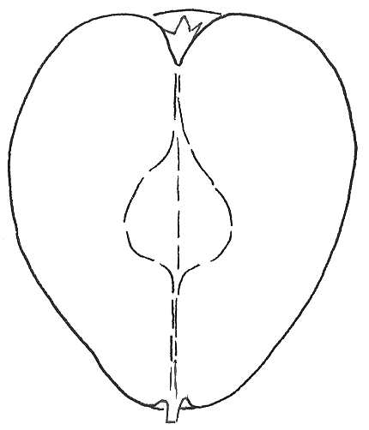 | 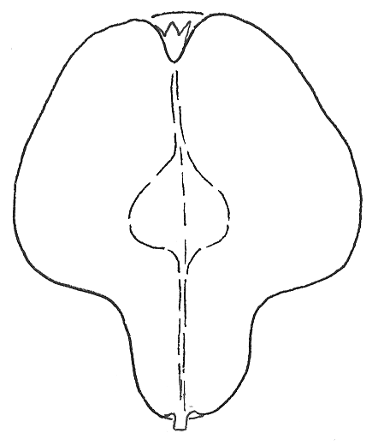
4 | 5
obovate | pyriform

Ads. 29, 30: Fruit: neck and length of neck

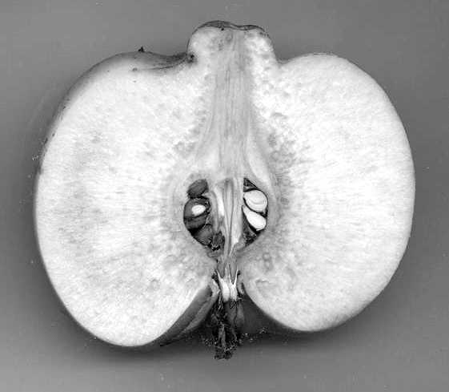

Ad. 38: Time of beginning of fruit ripening

The time of beginning of fruit ripening is when the fruit is most easily picked from the tree.

Literature
Alibert, J.-P., Masseron, A., 1979: “Le cognassier à fruits”, Ctifl-Documents No. 62, pp. 69-79

Bordeianu, T.; Constantinescu, N.; Stefan, N., 1968: “Pomologia, Bd. VII”, Editura Academiei Republicii Socialiste Romania, Bukarest, 775 pp.

Krüssmann, G., 1951: “Die Quitten”, Verlag Deutsche Gärtnerbörse, Aachen, 27 pp.

Michelesi, J.C., Brossier, J., Flick, J.D., 1973: “Première observations sur plusieurs variétés de cognassiers à fruits”, Arboriculture Fruitière, pp. 233/234

Popov, E., 1958: “B”lgarska Pomologiya”. D”rzhavno Izdatelstvo za Selskostopanska Literatura, Sofiya

Schuricht W.; Friedrich, G., 1988: “Nüsse und Quitten”, Neumann Verlag, Leipzig u. Radebeul, 144 pp.

Technical Questionnaire
TECHNICAL QUESTIONNAIRE |  |  |  | Page {x} of {y} |  |  | Reference Number:
 |  |  |  |  |  |  | Application date:
 |  |  |  |  |  |  | (not to be filled in by the applicant)
TECHNICAL QUESTIONNAIRE
to be completed in connection with an application for plant breeders’ rights

1. Subject of the Technical Questionnaire
1.1 Latin Name |  |  | Cydonia Mill. sensu stricto
1.2 Common Name |  |  | Quince
2. Applicant
Name
Address
Telephone No.
Fax No.
E-mail address
Breeder (if different from applicant)
3. Proposed denomination and breeder’s reference
Proposed denomination
(if available)

Breeder’s reference
4. Information on the breeding scheme and propagation of the variety

4.1 Breeding Scheme

Variety resulting from:

4.1.1 Crossing

(a) controlled cross [ ]
(please state parent varieties)
(b) partially unknown cross [ ]
(please state known parent variety(ies))
(c) totally unknown cross [ ]

4.1.2 Mutation [ ]
(please state parent variety)

4.1.3 Discovery [ ]
(please state where, when and how developed)

4.1.4 Other [ ]
(please provide details)

4.2 Method of Propagating the Variety

4.2.1 Vegetative propagation

(a) in vitro propagation [ ]

(b) other (e.g. leaf cutting, hardwood cutting, layer) [ ]
(state method)

4.2.2 Other [ ]
(please provide details)

4.3 Virus status

4.3.1 The variety is free from all known viruses as follows: [ ]
(indicate from which viruses)

4.3.2 The plant material is virus free [ ]

4.3.3 The virus status is unknown [ ]

5. Characteristics of the variety to be indicated (the number in brackets refers to the corresponding characteristic in Test Guidelines; please mark the note which best corresponds).

 | Characteristics |  |  |  |  | Example Varieties |  |  |  | Note
5.1  (2) | Plant: habit
 | upright |  |  |  |  | Vranja |  |  |  | 1[ ]
 | semi-upright |  |  |  |  | Champion |  |  |  | 2[ ]
 | spreading |  |  |  |  | Bourgeault |  |  |  | 3[ ]
5.2  (12) | Leaf blade: shape
 | elliptic |  |  |  |  | Della Cina |  |  |  | 1[ ]
 | circular |  |  |  |  | Constantinopel, Mollesca |  |  |  | 2[ ]
 | ovate |  |  |  |  | Fabre |  |  |  | 3[ ]
 | obovate |  |  |  |  | Tavsambas |  |  |  | 4[ ]
5.3  (27) | Fruit: general shape in longitudinal section
 | elliptic |  |  |  |  | Della Cina |  |  |  | 1[ ]
 | circular |  |  |  |  | Fruits Ronds, Jurak |  |  |  | 2[ ]
 | square |  |  |  |  | Aurii |  |  |  | 3[ ]
 | obovate |  |  |  |  | Ispolinskaya |  |  |  | 4[ ]
 | pyriform |  |  |  |  | Hruskovita, Vranja |  |  |  | 5[ ]
6. Similar varieties and differences from these varieties

Denomination(s) of variety(ies) similar to your candidate variety |  | Characteristic(s) in which your candidate variety differs from the similar variety(ies) |  |  | Describe the expression of the characteristic(s) for the similar variety(ies) |  |  | Describe the expression of the characteristic(s) for your candidate variety
(Example) |  | Leaf blade: shape |  |  | circular |  |  | obovate
7. Additional information which may help in the examination of the variety

7.1 In addition to the information provided in sections 5 and 6, are there any additional characteristics which may help to distinguish the variety?

Yes [ ] No [ ]

(If yes, please provide details)

7.2 Special conditions for the examination of the variety

7.2.1 Are there any special conditions for growing the variety or conducting the examination?

Yes [ ] No [ ]

7.2.2 If yes, please give details:

7.3 Other information

A representative colour photograph of the variety should accompany the Technical Questionnaire.

8. Authorization for release

(a) Does the variety require prior authorization for release under legislation concerning the protection of the environment, human and animal health?

Yes [ ] No [ ]

(b) Has such authorization been obtained?

Yes [ ] No [ ]

If the answer to (b) is yes, please attach a copy of the authorization.

9. I hereby declare that, to the best of my knowledge, the information provided in this form is correct:

Applicant’s name

Signature Date

[End of document]

* These names were correct at the time of the introduction of these Test Guidelines but may be revised or updated. [Readers are advised to consult the UPOV Code, which can be found on the UPOV Website (www.upov.int), for the latest information.]

