 |  | E  TG/99/4  ORIGINAL: English  DATE: 2011-10-20
INTERNATIONAL UNION FOR THE PROTECTION OF NEW VARIETIES OF PLANTS
GENEVA

 | OLIVE  UPOV Code: OLEAA_EUR  Olea europaea L. | *

GUIDELINES

FOR THE CONDUCT OF TESTS

FOR DISTINCTNESS, UNIFORMITY AND STABILITY

^{Alternative Names:}*
Botanical name | English | French | German | Spanish
Olea europaea L. | Olive | Olivier | Ölbaum, Olive | Olivo

The purpose of these guidelines (“Test Guidelines”) is to elaborate the principles contained in the General Introduction (document TG/1/3), and its associated TGP documents, into detailed practical guidance for the harmonized examination of distinctness, uniformity and stability (DUS) and, in particular, to identify appropriate characteristics for the examination of DUS and production of harmonized variety descriptions.

ASSOCIATED DOCUMENTS

These Test Guidelines should be read in conjunction with the General Introduction and its associated TGP documents.
TABLE OF CONTENTS PAGE

1. Subject of these Test Guidelines 3
2. Material Required 3
3. Method of Examination 3
3.1 Number of Growing Cycles 3
3.2 Testing Place 3
3.3 Conditions for Conducting the Examination 3
3.4 Test Design 3
3.5 Additional Tests 4
4. Assessment of Distinctness, Uniformity and Stability 4
4.1 Distinctness 4
4.2 Uniformity 5
4.3 Stability 5
5. Grouping of Varieties and Organization of the Growing Trial 6
6. Introduction to the Table of Characteristics 6
6.1 Categories of Characteristics 6
6.2 States of Expression and Corresponding Notes 7
6.3 Types of Expression 7
6.4 Example Varieties 8
6.5 Legend 8
7. Table of Characteristics/Tableau des caractères/Merkmalstabelle/Tabla de caracteres 9
8. Explanations on the Table of Characteristics 19
8.1 Explanations covering several characteristics 19
8.2 Explanations for individual characteristics 20
9. Literature 27
10. Technical Questionnaire 28

Subject of these Test Guidelines
These Test Guidelines apply to all varieties of Olea europaea L.

Material Required

2.1 The competent authorities decide on the quantity and quality of the plant material required for testing the variety and when and where it is to be delivered. Applicants submitting material from a State other than that in which the testing takes place must ensure that all customs formalities and phytosanitary requirements are complied with.

2.2 According to the specification of the authority, the material is to be supplied in the form of trees (one-year-old) on their own roots, or on one-year-old trees grafted on rootstock specified by authority.

  - The minimum quantity of plant material, to be supplied by the applicant, should be:

5 plants

2.4 The plant material supplied should be visibly healthy, not lacking in vigor, nor affected by any important pest or disease.

2.5 The plant material should not have undergone any treatment which would affect the expression of the characteristics of the variety, unless the competent authorities allow or request such treatment. If it has been treated, full details of the treatment must be given.

Method of Examination

3.1 Number of Growing Cycles
The minimum duration of tests should normally be two independent growing cycles. In particular, it is essential that the plants produce a satisfactory crop of fruit in each of the two growing cycles.

3.2 Testing Place
Tests are normally conducted at one place. In the case of tests conducted at more than one place, guidance is provided in TGP/9 “Examining Distinctness”.

3.3 Conditions for Conducting the Examination
The tests should be carried out under conditions ensuring satisfactory growth for the expression of the relevant characteristics of the variety and for the conduct of the examination.

3.4 Test Design
3.4.1 Each test should be designed to result in a total of at least 5 plants.

3.4.2 The design of the tests should be such that plants or parts of plants may be removed for measurement or counting without prejudice to the observations which must be made up to the end of the growing cycle.

3.5 Additional Tests
Additional tests, for examining relevant characteristics, may be established.

Assessment of Distinctness, Uniformity and Stability

4.1 Distinctness
4.1.1 General Recommendations

It is of particular importance for users of these Test Guidelines to consult the General Introduction prior to making decisions regarding distinctness. However, the following points are provided for elaboration or emphasis in these Test Guidelines.

4.1.2 Consistent Differences

The differences observed between varieties may be so clear that more than one growing cycle is not necessary. In addition, in some circumstances, the influence of the environment is not such that more than a single growing cycle is required to provide assurance that the differences observed between varieties are sufficiently consistent. One means of ensuring that a difference in a characteristic, observed in a growing trial, is sufficiently consistent is to examine the characteristic in at least two independent growing cycles.

4.1.3 Clear Differences

Determining whether a difference between two varieties is clear depends on many factors, and should consider, in particular, the type of expression of the characteristic being examined, i.e. whether it is expressed in a qualitative, quantitative, or pseudo-qualitative manner. Therefore, it is important that users of these Test Guidelines are familiar with the recommendations contained in the General Introduction prior to making decisions regarding distinctness.

4.1.4 Number of Plants / Parts of Plants to be Examined
Unless otherwise indicated, for the purposes of distinctness, all observations on single plants should be made on 5 plants or parts taken from each of 5 plants and any other observations made on all plants in the test, disregarding any off-type plants. In the case of observations of parts taken from single plants, the number of parts to be taken from each of the plants should be 5.
    - Method of Observation

The recommended method of observing the characteristic for the purposes of distinctness is indicated by the following key in the second column of the Table of Characteristics (see document TGP/9 “Examining Distinctness”, Section 4 “Observation of characteristics”):

MG: single measurement of a group of plants or parts of plants
MS: measurement of a number of individual plants or parts of plants
VG: visual assessment by a single observation of a group of plants or parts of plants
VS: visual assessment by observation of individual plants or parts of plants

Type of observation: visual (V) or measurement (M)

“Visual” observation (V) is an observation made on the basis of the expert’s judgment. For the purposes of this document, “visual” observation refers to the sensory observations of the experts and, therefore, also includes smell, taste and touch. Visual observation includes observations where the expert uses reference points (e.g. diagrams, example varieties, side-by-side comparison) or non-linear charts (e.g. color charts). Measurement (M) is an objective observation against a calibrated, linear scale e.g. using a ruler, weighing scales, colorimeter, dates, counts, etc.

Type of record: for a group of plants (G) or for single, individual plants (S)

For the purposes of distinctness, observations may be recorded as a single record for a group of plants or parts of plants (G), or may be recorded as records for a number of single, individual plants or parts of plants (S). In most cases, “G” provides a single record per variety and it is not possible or necessary to apply statistical methods in a plant-by-plant analysis for the assessment of distinctness.

In cases where more than one method of observing the characteristic is indicated in the Table of Characteristics (e.g. VG/MG), guidance on selecting an appropriate method is provided in document TGP/9, Section 4.2.

4.2 Uniformity
4.2.1 It is of particular importance for users of these Test Guidelines to consult the General Introduction prior to making decisions regarding uniformity. However, the following points are provided for elaboration or emphasis in these Test Guidelines:

4.2.2 For the assessment of uniformity, a population standard of 1% and an acceptance probability of at least 95 % should be applied. In the case of a sample size of 5 plants, no off-type are allowed.

4.3 Stability
4.3.1 In practice, it is not usual to perform tests of stability that produce results as certain as those of the testing of distinctness and uniformity. However, experience has demonstrated that, for many types of variety, when a variety has been shown to be uniform, it can also be considered to be stable.

4.3.2 Where appropriate, or in cases of doubt, stability may be further examined by testing a new plant stock to ensure that it exhibits the same characteristics as those shown by the initial material supplied.

Grouping of Varieties and Organization of the Growing Trial
5.1 The selection of varieties of common knowledge to be grown in the trial with the candidate varieties and the way in which these varieties are divided into groups to facilitate the assessment of distinctness are aided by the use of grouping characteristics.

5.2 Grouping characteristics are those in which the documented states of expression, even where produced at different locations, can be used, either individually or in combination with other such characteristics: (a) to select varieties of common knowledge that can be excluded from the growing trial used for examination of distinctness; and (b) to organize the growing trial so that similar varieties are grouped together.

5.3 The following have been agreed as useful grouping characteristics:

(a) Tree: growth habit (characteristic 2)
(b) Fruit: weight (characteristic 16)
(c) Fruit: over color at full maturity (characteristic 22)
(d) Fruit: symmetry in position A (characteristic 23)
(e) Fruit: shape of apex in position A (characteristic 24)
(f) Fruit: nipple (characteristic 25)
(g) Stone: ratio length/width (characteristic 31)
(h) Stone: weight (characteristic 32)
(i) Stone: mucron (characteristic 38)
(j) Stone: rugosity of surface (characteristic 40)

5.4 Guidance for the use of grouping characteristics, in the process of examining distinctness, is provided through the General Introduction and document TGP/9 “Examining Distinctness”.

Introduction to the Table of Characteristics

6.1 Categories of Characteristics
6.1.1 Standard Test Guidelines Characteristics

Standard Test Guidelines characteristics are those which are approved by UPOV for examination of DUS and from which members of the Union can select those suitable for their particular circumstances.

6.1.2 Asterisked Characteristics

Asterisked characteristics (denoted by *) are those included in the Test Guidelines which are important for the international harmonization of variety descriptions and should always be examined for DUS and included in the variety description by all members of the Union, except when the state of expression of a preceding characteristic or regional environmental conditions render this inappropriate.

6.2 States of Expression and Corresponding Notes
6.2.1 States of expression are given for each characteristic to define the characteristic and to harmonize descriptions. Each state of expression is allocated a corresponding numerical note for ease of recording of data and for the production and exchange of the description.

6.2.2 In the case of qualitative and pseudo-qualitative characteristics (see Chapter 6.3), all relevant states of expression are presented in the characteristic. However, in the case of quantitative characteristics with 5 or more states, an abbreviated scale may be used to minimize the size of the Table of Characteristics. For example, in the case of a quantitative characteristic with 9 states, the presentation of states of expression in the Test Guidelines may be abbreviated as follows:

State | Note
small | 3
medium | 5
large | 7

However, it should be noted that all of the following 9 states of expression exist to describe varieties and should be used as appropriate:

State | Note
very small | 1
very small to small | 2
small | 3
small to medium | 4
medium | 5
medium to large | 6
large | 7
large to very large | 8
very large | 9

6.2.3 Further explanation of the presentation of states of expression and notes is provided in document TGP/7 “Development of Test Guidelines”.

6.3 Types of Expression
An explanation of the types of expression of characteristics (qualitative, quantitative and pseudo qualitative) is provided in the General Introduction.

6.4 Example Varieties
Where appropriate, example varieties are provided to clarify the states of expression of each characteristic.

6.5 Legend
(*) Asterisked characteristic – see Chapter 6.1.2

QL: Qualitative characteristic – see Chapter 6.3
QN: Quantitative characteristic – see Chapter 6.3
PQ: Pseudo-qualitative characteristic – see Chapter 6.3

MG, MS, VG, VS – see Chapter 4.1.5

(a)-(f) See Explanations on the Table of Characteristics in Chapter 8.1

(+) See Explanations on the Table of Characteristics in Chapter 8.2

Table of Characteristics/Tableau des caractères/Merkmalstabelle/Tabla de caracteres
 |  | English | français | deutsch | español | Example Varieties  Exemples  Beispielssorten  Variedades ejemplo | Note/  Nota
1.  (*)  (+) | VG | Tree: vigor | Arbre : vigueur | Baum: Wuchsstärke | Árbol: vigor
QN |  | weak | faible | gering | débil | Aloreña | 3
 |  | medium | moyenne | mittel | medio | Picual | 5
 |  | strong | forte | stark | fuerte | Lechin de Sevilla, MGS ASC315 | 7
2.  (*)  (+) | VG | Tree: growth habit | Arbre : port | Baum: Wuchsform | Árbol: porte
QN |  | upright | dressé | aufrecht | erguido | Alameño de Cabra | 1
 |  | spreading | étalé | breitwüchsig | rastrero | Picual | 3
 |  | drooping | retombant | überhängend | colgante | Sikitita | 5
3.  (*)  (+) | VG | Tree: canopy density | Arbre : densité du feuillage | Baum: Laubdichte | Árbol: densidad de la cobertura foliar
QN |  | sparse | lâche | locker | laxa | Gordal de Granada | 3
 |  | medium | moyenne | mittel | media | MGS GRAP561, Picudo | 5
 |  | dense | compacte | dicht | densa | Lechin de Sevilla | 7
4.  (+) | VG | Fruiting shoot: number of lateral shoots | Rameau fructifère : nombre de ramifications latérales | Fruchttrieb: Anzahl Seitentriebe | Rama fructífera: número de tallos laterales
QN |  | absent or very few | nul ou très faible | fehlend oder sehr gering | ausentes o muy pocos | Manzanilla de Sevilla | 1
 |  | few | faible | gering | pocos | Lechin de Granada | 2
 |  | medium | moyen | mittel | medio | Kalamata | 3
 |  | many | élevé | groß | numerosos | Carrasqueño de la Sierra | 4
5.  (*) | MS | Leaf blade: length | Limbe : longueur | Blattspreite: Länge | Limbo: longitud
QN | (a) | short | court | kurz | corto | Arbequina | 3
 |  | medium | moyen | mittel | medio | MGS ASC315,  Picudo | 5
 |  | long | long | lang | largo | Gordal Sevillana | 7
6. (*) | MS | Leaf blade: width | Limbe : largeur | Blattspreite: Breite | Limbo: anchura
QN | (a) | narrow | étroit | schmal | estrecho | Callosina,  MGS MARIENSE | 3
 |  | medium | moyen | mittel | medio | Hojiblanca,  MGS ASC315 | 5
 |  | broad | large | breit | ancho | Picudo | 7
7. (*) (+) | MS | Leaf blade: ratio length/width | Limbe : rapport longueur/largeur | Blattspreite: Verhältnis Länge/Breite | Limbo: relación longitud/anchura
QN | (a) | slightly elongated | légèrement allongé | leicht langgezogen | ligeramente alargado | Manzanilla de Sevilla | 3
 |  | moderately elongated | modérément allongé | mäßig langgezogen | moderadamente alargado | Picual | 5
 |  | very elongated | très allongé | stark langgezogen | muy alargado | Cornezuelo de Jaen, MGS MARIENSE | 7
8. | VG | Leaf blade: intensity of green color of upper side | Limbe : intensité de la couleur verte de la face supérieure | Blattspreite: Intensität der Grünfärbung der Oberseite | Limbo: intensidad del color verde de la parte superior
QN | (a) | light | faible | hell | claro | Arbosana | 1
 |  | medium | moyenne | mittel | medio | Lechin de Sevilla | 2
 |  | dark | forte | dunkel | oscuro | Gordal Sevillana | 3
9.  (*)  (+) | VG | Leaf blade: curvature of longitudinal axis | Limbe : courbure de l’axe longitudinal | Blattspreite: Biegung der Längsachse | Limbo: curvatura en el eje longitudinal
PQ | (a) | incurved | incurvé | aufgebogen | curvado hacia arriba | Picual | 1
 |  | straight | droit | gerade | recto | Galego | 2
 |  | recurved | recourbé | zurückgebogen | recurvado hacia abajo | Zarza | 3
10. | VG | Leaf blade: twisting | Limbe : torsion | Blattspreite: Verdrehung | Limbo: torsión
QN |  | absent or weak | absente ou faible | fehlend oder gering | ausente o leve |  | 1
 |  | moderate | moyenne | mäßig | moderada |  | 2
 |  | strong | forte | stark | fuerte |  | 3
11.  (+) | VG | Inflorescence: length | Inflorescence : longueur | Blütenstand: Länge | Inflorescencia: longitud
QN | (b) | short | courte | kurz | corta | Carolea | 1
 |  | medium | moyenne | mittel | media | Koroneiki | 2
 |  | long | longue | lang | larga | Konservolia,  MGS GRAP541 | 3
12.  (+) | VG | Inflorescence: width | Inflorescence : largeur | Blütenstand: Breite | Inflorescencia: anchura
QN | (b) | narrow | étroite | schmal | estrecha | MGS GRAP541, Ogliarola Messinese | 1
 |  | medium | moyenne | mittel | media | Mission | 2
 |  | broad | large | breit | ancha | Barnea | 3
13.  (+) | VG | Flower: attitude of corolla lobe | Fleur : port du lobe de la corolle | Blüte: Haltung des Kronlappens | Flor: porte del lóbulo de la corola
QN | (b) | erect | dressé | aufgerichtet | erecto | Giarraffa | 1
 |  | horizontal | horizontal | waagerecht | horizontal | Carolea | 2
 |  | reflexed | réfléchi | abgeknickt | recurvado | Frantoio | 3
14. | MS | Fruit: length | Fruit : longueur | Frucht: Länge | Fruto: longitud
QN | (c) | very short | très courte | sehr kurz | muy corto | Arbequina,  MGS MARIENSE | 1
 |  | short | courte | kurz | corto | Manzanilla de Sevilla | 3
 |  | medium | moyenne | mittel | medio | Konservolia,  MGS GRAP561 | 5
 |  | long | longue | lang | largo | Barouni | 7
 |  | very long | très longue | sehr lang | muy largo | Bella di Cerignola | 9
15. | MS | Fruit: width in position B | Fruit : largeur en position B | Frucht: Breite in Position B | Fruto: anchura en posición B
QN | (c) | very narrow | très étroite | sehr schmal | muy estrecho | Koroneiki | 1
 |  | narrow | étroite | schmal | estrecho | Mission | 3
 |  | medium | moyenne | mittel | medio | Manzanilla de Sevilla | 5
 |  | broad | large | breit | ancho | Barouni | 7
 |  | very broad | très large | sehr breit | muy ancho | Gordal Sevillana | 9
16.  (*) | MG | Fruit: weight | Fruit : poids | Frucht: Gewicht | Fruto: peso
QN | (c) | very low | très faible | sehr gering | muy bajo |  | 1
 |  | low | faible | gering | bajo | Koroneiki | 3
 |  | medium | moyen | mittel | medio | Carrasqueño de la Sierra | 5
 |  | high | élevé | hoch | elevado | Picudo | 7
 |  | very high | très élevé | sehr hoch | muy elevado | Gordal Sevillana | 9
17.  (+) | VG | Fruit: shape in position A | Fruit : forme en position A | Frucht: Form in Position A | Fruto: forma en posición A
PQ | (c) | ovate | ovale | eiförmig | ovado | Gordal Sevillana | 1
 |  | oblong | oblongue | rechteckig | oblongo | Frantoio | 2
 |  | narrow elliptic | étroitement elliptique | schmal elliptisch | elíptico estrecho | Cornezuelo de Jaen | 3
 |  | medium elliptic | moyennement elliptique | mittel elliptisch | elíptico medio | Lechin de Sevilla | 4
 |  | circular | circulaire | kreisförmig | circular | Manzanilla de Sevilla | 5
 |  | obovate | obovale | verkehrt eiförmig | obovado | Verdial de Huevar | 6
18.  (*) | VG | Fruit: ratio length/ width in position A | Fruit : rapport longueur/largeur en position A | Frucht: Verhältnis Länge/Breite in Position A | Fruto: relación longitud/ anchura en posición A
QN | (c) | slightly elongated | légèrement allongé | leicht langgezogen | ligeramente alargado | Manzanilla de Sevilla | 3
 |  | moderately elongated | modérément allongé | mäßig langgezogen | moderadamente alargado | Frantoio | 5
 |  | very elongated | très allongé | stark langgezogen | muy alargado | Cornezuelo de Jaen | 7
19. | VG | Immature fruit: intensity of green color | Fruit immature : intensité de la couleur verte | Unreife Frucht: Intensität der Grünfärbung | Fruto no maduro: intensidad del color verde
QN | (d) | light | faible | hell | claro | Arbequina | 1
 |  | medium | moyenne | mittel | medio | Barouni | 2
 |  | dark | forte | dunkel | oscuro | Itrana | 3
20. | VG | Immature fruit: size of lenticels | Fruit immature : taille des lenticelles | Unreife Frucht: Größe der Lentizellen | Fruto no maduro: tamaño de las lenticelas
QN | (d) | small | petites | klein | pequeñas | Leccino | 1
 |  | medium | moyennes | mittel | medianas | Ascolana Tenera, MGS ASC315 | 2
 |  | large | grandes | groß | grandes | Itrana | 3
21. | VG | Immature fruit: number of lenticels | Fruit immature : nombre de lenticelles | Unreife Frucht: Anzahl Lentizellen | Fruto no maduro: número de lenticelas
QN | (d) | few | faible | gering | escaso | Maurino | 1
 |  | medium | moyen | mittel | medio | Itrana, MGS ASC315 | 2
 |  | many | élevé | groß | numeroso | FS 17 | 3
22.  (*) | VG | Fruit: over color at full maturity | Fruit : couleur du lavis à pleine maturité | Frucht: Deckfarbe bei Vollreife | Fruto: sobrecolor en plena madurez
PQ | (c) | medium violet | violet moyen | mittelviolett | violeta medio | Ascolana Tenera | 1
 |  | dark violet | violet foncé | dunkelviolett | violeta oscuro | Maurino, Mission, Verdial de Huevar | 2
 |  | black | noire | schwarz | negro | Picual | 3
23.  (*) | VG | Fruit: symmetry in position A | Fruit : symétrie en position A | Frucht: Symmetrie in Position A | Fruto: simetría en posición A
QN | (c) | symmetric | symétrique | symmetrisch | simétrico | Manzanilla de Sevilla | 1
 |  | weakly asymmetric | légèrement asymétrique | leicht asymmetrisch | ligeramente asimétrico | Hojiblanca,  MGS MARIENSE | 2
 |  | strongly asymmetric | fortement asymétrique | stark asymmetrisch | fuertemente asimétrico | Picudo | 3
24.  (*) | VG | Fruit: shape of apex in position A | Fruit : forme du sommet en position A | Frucht: Form der Spitze in Position A | Fruto: forma del ápice en posición A
PQ | (c) | acute | pointu | spitz | agudo | Cornezuelo de Jaén | 1
 |  | obtuse | obtus | stumpf | obtuso | Coratino,  Gordal Sevillana | 2
 |  | rounded | arrondi | abgerundet | redondeado | Manzanilla de Sevilla, MGS GRAP541 | 3
25.  (*) (+) | VG | Fruit: nipple | Fruit : mamelon | Frucht: Höcker | Fruto: protuberancia
QN | (c) | absent or weak | absente ou faible | fehlend oder gering | ausente o ligera | Hojiblanca | 1
 |  | moderate | moyenne | mäßig | moderada | Pajarero | 2
 |  | strong | forte | stark | fuerte | Limoncillo,  MGS ASC315 | 3
26.  (*) (+) | VG | Fruit: shape of base in position A | Fruit : forme de la base en position A | Frucht: Form der Basis in Position A | Fruto: forma de la base en posición A
QN | (c) | rounded | arrondie | abgerundet | redondeada | Gordal Sevillana, MGS GRAP541 | 1
 |  | rounded to truncate | arrondie à tronquée | abgerundet bis gerade | redondeada a truncada |  | 2
 |  | truncate | tronquée | gerade | truncada | Manzanilla de Sevilla | 3
27.  (+) | VG | Fruit: bloom of surface | Fruit : pruine sur la surface | Frucht: Bereifung der Oberfläche | Fruto: pruína de la superficie
QN | (c) | weak | légère | gering | leve | Coratina, Picual | 3
 |  | medium | moyenne | mittel | media | Frantoio | 5
 |  | strong | forte | stark | fuerte | Barnea | 7
28.  (+) | VG | Stone: shape in position B | Noyau : forme en position B | Stein: Form in Position B | Hueso: forma en posición B
PQ | (e) | ovate | ovale | eiförmig | ovado | Bella di Spagna | 1
 |  | oblong | oblongue | rechteckig | oblongo | Leccino | 2
 |  | elliptic | elliptique | elliptisch | elíptico | Hojiblanca,  MGS GRAP541 | 3
 |  | circular | circulaire | kreisförmig | circular | Itrana | 4
 |  | obovate | obovale | verkehrt eiförmig | obovado | Aloreña | 5
29. | MS | Stone: length | Noyau : longueur | Stein: Länge | Hueso: longitud
QN | (e) | short | court | kurz | corto | Arbosana | 3
 |  | medium | moyen | mittel | medio | Konservolia | 5
 |  | long | long | lang | largo | Bella di Cerignola | 7
30. | MS | Stone: width in position B | Noyau : largeur en position B | Stein: Breite in Position B | Hueso: anchura en posición B
QN | (e) | narrow | étroit | schmal | estrecho | Koroneiki | 3
 |  | medium | moyen | mittel | medio | Mission | 5
 |  | broad | large | breit | ancho | Gordal Sevillana | 7
31.  (*) | VG | Stone: ratio  length/ width | Noyau : rapport longueur/largeur | Stein: Verhältnis Länge/Breite | Hueso: relación  longitud/anchura
QN | (e) | slightly elongated | légèrement allongé | leicht langgezogen | ligeramente alargado | Arbequina | 1
 |  | moderately elongated | modérément allongé | mäßig langgezogen | moderadamente alargado | Barouni | 2
 |  | very elongated | très allongé | stark langgezogen | muy alargado | Bella di Cerignola | 3
32.  (*) | MG | Stone: weight | Noyau : poids | Stein: Gewicht | Hueso: peso
QN | (e) | very low | très faible | sehr gering | muy bajo |  | 1
 |  | low | faible | gering | bajo | Arbequina | 3
 |  | medium | moyen | mittel | medio | Imperial, Itrana | 5
 |  | high | élevé | hoch | elevado | Barouni, Picudo | 7
 |  | very high | très élevé | sehr hoch | muy elevado | Gordal Sevillana | 9
33.  (*)  (+) | VG | Stone: symmetry in position A | Noyau : symétrie en position A | Stein: Symmetrie in Position A | Hueso: simetría en posición A
QN | (e) | symmetric | symétrique | symmetrisch | simétrico | Arbequina | 1
 |  | weakly asymmetric | légèrement asymétrique | leicht asymmetrisch | ligeramente asimétrico | Lechin de Sevilla,  MGS MARIENSE | 2
 |  | strongly asymmetric | fortement asymétrique | stark asymmetrisch | fuertemente asimétrico | Picudo | 3
34.  (*)  (+) | VG | Stone: symmetry in position B | Noyau : symétrie en position B | Stein: Symmetrie in Position B | Hueso: simetría en posición B
QN | (e) | symmetric | symétrique | symmetrisch | simétrico | Hojiblanca | 1
 |  | weakly asymmetric | légèrement asymétrique | leicht asymmetrisch | ligeramente asimétrico | Lechin de Sevilla,  MGS MARIENSE | 2
 |  | strongly asymmetric | fortement asymétrique | stark asymmetrisch | fuertemente asimétrico | Pajarero | 3
35.  (*)  (+) | VG | Stone: number of grooves on basal end | Noyau : nombre de cannelures à l’extrémité basale | Stein: Anzahl Furchen am Basisende | Hueso: número de surcos en la base
QN | (e) | less than 7 | inférieur à 7 | weniger als 7 | menos de 7 | Bical, MGS GRAP541 | 1
 |  | between 7 and 10 | entre 7 et 10 | zwischen 7 und 10: | entre 7 y 10 | Picual | 2
 |  | more than 10 | supérieur à 10 | mehr als 10 | más de 10 | Manzanilla Prieta | 3
36.  (*)  (+) | VG | Stone: distribution of grooves on basal end | Noyau : distribution des sillons fibrovasculaires à l’extrémité basale | Stein: Verteilung der Furchen am Basisende | Hueso: distribución de surcos en la base
PQ | (e) | evenly distributed | répartis uniformément | gleichmäßig verteilt | repartidos uniformemente | Hojiblanca,  MGS GRAP541, MGS MARIENSE | 1
 |  | weakly grouped around suture | faiblement regroupées au niveau de la suture | leicht um die Naht gruppiert | levemente agrupados en torno a la sutura |  | 2
 |  | strongly grouped around suture | fortement regroupés au niveau de la suture | stark um die Naht gruppiert | firmemente agrupados en torno a la sutura | Villalonga | 3
37.  (*)  (+) | VG | Stone: shape of apex in position A | Noyau : forme du sommet en position A | Stein: Form der Spitze in Position A | Hueso: forma del ápice en posición A
PQ | (e) | acute | pointu | spitz | agudo | Picudo | 1
 |  | obtuse | obtus | stumpf | obtuso |  | 2
 |  | rounded | arrondi | abgerundet | redondeado | Chorrúo | 3
38.  (*) (+) | VG | Stone: mucron | Noyau : mucron | Stein: aufgesetzte Spitze | Hueso: mucrón
QL | (e) | absent | absent | fehlend | ausente | Lucio,  MGS MARIENSE | 1
 |  | present | présent | vorhanden | presente | Chorruo,  MGS GRAP561 | 9
39.  (*) (+) | VG | Stone: shape of base in position A | Noyau : forme de la base en position A | Stein: Form der Basis in Position A | Hueso: forma de la base en posición A
PQ | (e) | acute | pointue | spitz | aguda | Cornezuelo de Jaen | 1
 |  | rounded | arrondie | abgerundet | redondeada | Morona | 2
 |  | truncate | tronquée | gerade | truncada | Azapa,  MGS GRAP561 | 3
40. (*) | VG | Stone: rugosity of surface | Noyau : rugosité de la surface | Stein: Rauheit der Oberfläche | Hueso: rugosidad de la superficie
QN | (e) | weak | légère | gering | leve | Lechin de Sevilla | 1
 |  | medium | moyenne | mittel | media | Cacereña,  Manzanilla de Sevilla | 2
 |  | strong | forte | stark | fuerte | Bodoquera,  MGS ASC315 | 3
41.  (+) | VG | Time of fruit ripening | Époque de maturité du fruit | Zeitpunkt der Fruchtreife | Época de comienzo de madurez del fruto
QN | (c) | very early | très précoce | sehr früh | muy temprana |  | 1
 |  | early | précoce | früh | temprana | Picual | 3
 |  | medium | moyenne | mittel | media | Gordal Sevillana | 5
 |  | late | tardive | spät | tardía | Hojiblanca | 7
 |  | very late | très tardive | sehr spät | muy tardía | Don Carlo | 9

Explanations on the Table of Characteristics

8.1 Explanations covering several characteristics
Characteristics containing the following key in the second column of the Table of characteristics should be examined as indicated below:

(a) Leaf blade: Observations should be made on fully developed leaves from
the central part of one-year-old shoots in full growth.

(b) Inflorescence: Observations should be made on inflorescences from the
central part of fruiting branches.

(c) Fruit: Observations should be made on fully ripened fruits at time of ripening. Time of ripening is when 80% of the fruit on the tree has colored. For the fruit two positions (A and B) are used. Position A is the position in which the organ shows its largest asymmetry. Position B is reached from position A by turning 90° along the longitudinal axis in a way to present the most developed part of the organ to the observer.

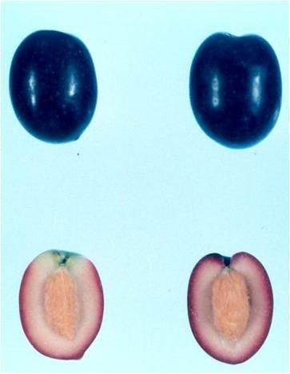
Position A Turn fruit 90º Position B
Most asymmetric Most symmetric

(d) Immature fruit: All observations of the immature fruit should be done when 10% of the fruit on the tree has colored. The fruit to be observed should be fully developed and not yet have colored.

(e) Stone: All observations on the stone should be made on dry well-cleaned stones of the same sample used for the observations on the fruit. For the stone two positions (A and B) are used. Position A is the position in which the organ shows its largest asymmetry. Position B is reached from position A by turning 90º along the longitudinal axis in a way to present the most developed part of the organ to the observer.

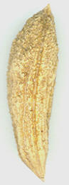 Turn stone 90º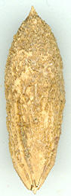
Position A Position B
Most asymmetric Most symmetric

8.2 Explanations for individual characteristics

Ad. 1: Tree: vigor

The tree vigor should be considered as the overall abundance of vegetative growth which includes the development of the canopy in both height and volume.

Ad. 2: Tree: growth habit

The tree growth habit states the natural attitude of the branches and shoots

Ad. 3: Tree: canopy density

The canopy density refers to the overall abundance of canopy vegetation. The following measures should be taken into account, length of internodes, number and vigor of the shoots and the size of the leaves.

Ad. 4: Fruiting shoot: number of lateral shoots

Observations should be made on 5 fruiting branches of each tree.

Ad. 7: Leaf blade: ratio length/width

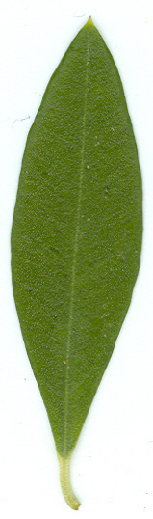 | 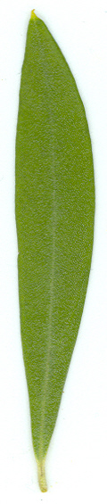 | 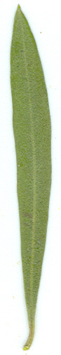
3 | 5 | 7
slightly elongated | moderately elongated | very elongated

Ad. 9: Leaf blade: curvature of longitudinal axis

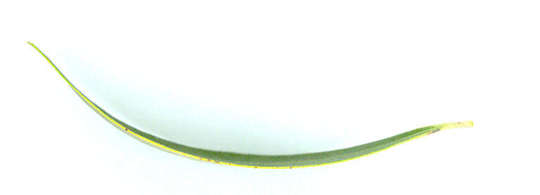 | 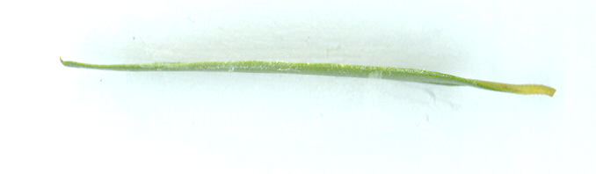 | 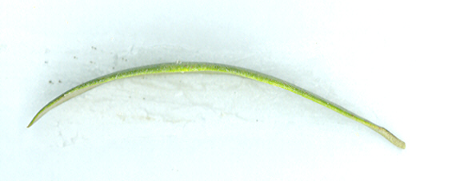
1 | 2 | 3
incurved | straight | recurved

Ad. 11: Inflorescence: length
Ad. 12: Inflorescence: width

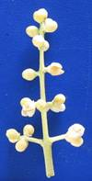

Ad. 13: Flower: attitude of corolla lobe

 |  | 
1 | 2 | 3
erect | horizontal | reflexed

Ad. 17: Fruit: shape in position A

 |  |  |  | ← broadest part →
 |  |  |  | (below middle) |  | at middle | (above middle)
broad (compressed) ← width (ratio length/width) → narrow (elongated)
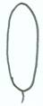
2
oblong
 |  |  | 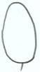  1  ovate |  | 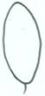  4  elliptic |  |  | 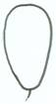  6  obovate

5
circular

Ad. 25: Fruit: nipple

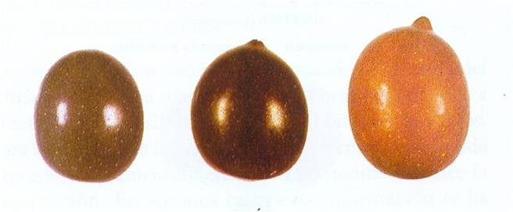
1 | 2 | 3
absent or weak | moderate | strong

Ad. 26: Fruit: shape of base in position A

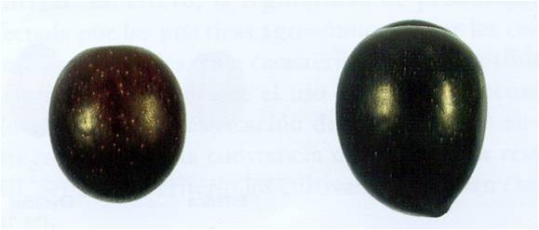
1 |  | 3
rounded | truncate

Ad. 27: Fruit: bloom of surface

Observation should be done on fully mature fruit. Bloom is the waxiness on the skin that can be removed by rubbing.

Ad. 28: Stone: shape in position B

 |  | ← broadest part →
 |  | (below middle) | at middle | (above middle)

broad (compressed) ← width (ratio length/width)→ narrow (elongated) |  | 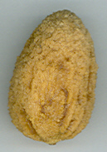  1  ovate | 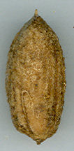  2  oblong | 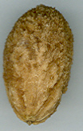  5  obovate
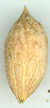
3
elliptic
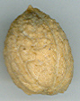
4
circular

Ad. 33: Stone: symmetry in position A
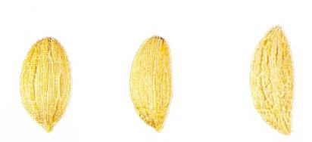
1 | 2 | 3
symmetric | weakly asymmetric | strongly asymmetric

Ad. 34: Stone: symmetry in position B

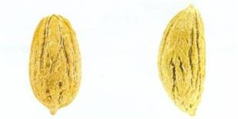
1 | 3
symmetric | strongly asymmetric

Ad. 35: Stone: number of grooves on basal end

To count the number of grooves that can be seen from the stalk insertion point.

Ad. 36: Stone: distribution of grooves on basal end

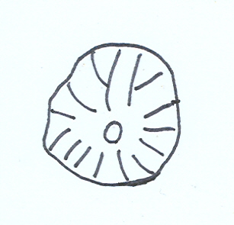 | 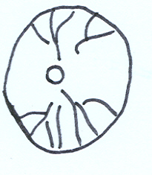
1 | 3
evenly distributed | strongly grouped around suture

Ad. 37: Stone: shape of apex in position A

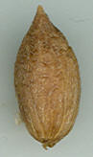 | 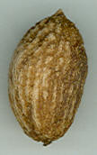 | 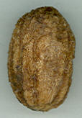
1 | 2 | 3
acute | obtuse | rounded

Ad. 38: Stone: mucron

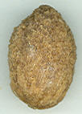
1 | 9
absent | present

Ad. 39: Stone: shape of base in position A

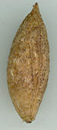 | 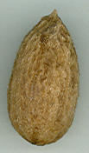 | 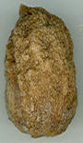
1 | 2 | 3
acute | rounded | truncate

Ad. 41: Time of fruit ripening

Time of fruit ripening is when 80% of the fruit on the tree has colored.

Literature
Barranco, D., Rallo, L. 1984: Las variedades de olivo cultivadas en Andalucía. Ministerio de Agricultura. Junta de Andalucía, Madrid, ES

Barranco, D., Cimato A., Fiorino P., Rallo L., Touzani A., Castañeda C., Serafini F., Trujillo I. 2000: World catalogue of olive varieties. International Olive Oil Council, Madrid, ES

Barranco, D., Trujillo I., Rallo L. 2005: Libro I Elaiografıa Hispanica, p. 45–231. In: Rallo L., Barranco D., Caballero J.M., Del Rio C., Martin A., Tous J., Trujillo I. (eds.). Variedades de olivo en España. Junta de Andalucía. MAPA y Ediciones Mundi-Prensa, Madrid, ES

Moutier N. (coord.), Pinatel C., Martre A., Roger J.P., Khadari B., Burgevin J.F., Ollivier D., Artaud J., 2004. Identification et caractérisation des variétés d'olivier cultivées en France - tome 1. Naturalia publications, Turriers. 248 p.

Moutier N. (coord.), Pinatel C., Martre A., Roger J.P., Khadari B., Burgevin J.F., Ollivier D., Artaud J., 2011. Identification et caractérisation des variétés d'olivier cultivées en France - tome 2. Naturalia publications, Turriers (sous presse)

Technical Questionnaire
TECHNICAL QUESTIONNAIRE |  |  |  | Page {x} of {y} |  | Reference Number:
 |  |  |  |  |  | Application date:
 |  |  |  |  |  | (not to be filled in by the applicant)
TECHNICAL QUESTIONNAIRE
to be completed in connection with an application for plant breeders’ rights

1. Subject of the Technical Questionnaire
1.1 Botanical name |  |  | Olea europaea L.
1.2 Common name |  |  | Olive
2. Applicant
Name
Address
Telephone No.
Fax No.
E-mail address
Breeder (if different from applicant)
3. Proposed denomination and breeder’s reference
Proposed denomination
(if available)

Breeder’s reference
#4. Information on the breeding scheme and propagation of the variety

4.1 Breeding scheme

Variety resulting from:

4.1.1 Crossing

(a) controlled cross [ ]
(please state parent varieties)

(…………………..……………..…) x (……………..…………………..…)
female parent male parent

(b) partially known cross [ ]
(please state known parent variety(ies))

(…………………..……………..…) x (……………..…………………..…)
female parent male parent

(c) unknown cross [ ]

4.1.2 Mutation [ ]
(please state parent variety)

4.1.3 Discovery and development [ ]
(please state where and when discovered and how developed)

4.1.4 Other [ ]
(please provide details)

  - Method of propagating the variety

4.2.1 Vegetative propagation

(a) cuttings [ ]

(b) in vitro propagation [ ]

(c) other (state method) [ ]

4.2.2 Seed [ ]

4.2.3 Other [ ]
(please provide details)

5. Characteristics of the variety to be indicated (the number in brackets refers to the corresponding characteristic in Test Guidelines; please mark the note which best corresponds).

 | Characteristics |  |  |  |  |  | Example Varieties |  |  | Note
5.1  (2) | Tree: growth habit
 | upright |  |  |  |  |  | Alameño de Cabra |  |  | 1[ ]
 | spreading |  |  |  |  |  | Picual |  |  | 3[ ]
 | drooping |  |  |  |  |  | Sikitita |  |  | 5[ ]
5.2  (16) | Fruit: weight
 | very low |  |  |  |  |  |  |  |  | 1[ ]
 | very low to low |  |  |  |  |  |  |  |  | 2[ ]
 | low |  |  |  |  |  | Koroneiki |  |  | 3[ ]
 | low to medium |  |  |  |  |  |  |  |  | 4[ ]
 | medium |  |  |  |  |  | Carrasqueño de la Sierra |  |  | 5[ ]
 | medium to high |  |  |  |  |  |  |  |  | 6[ ]
 | high |  |  |  |  |  | Picudo |  |  | 7[ ]
 | high to very high |  |  |  |  |  |  |  |  | 8[ ]
 | very high |  |  |  |  |  | Gordal Sevillana |  |  | 9[ ]
5.3  (22) | Fruit: over color at full maturity
 | medium violet |  |  |  |  |  | Ascolana Tenera |  |  | 1[ ]
 | dark violet |  |  |  |  |  | Maurino, Mission,  Verdial de Huevar |  |  | 2[ ]
 | black |  |  |  |  |  | Picual |  |  | 3[ ]
 | Characteristics |  |  |  |  |  | Example Varieties |  |  | Note
5.4  (23) | Fruit: symmetry in position A
 | symmetric |  |  |  |  |  | Manzanilla de Sevilla |  |  | 1[ ]
 | weakly asymmetric |  |  |  |  |  | Hojiblanca,  MGS MARIENSE |  |  | 2[ ]
 | strongly asymmetric |  |  |  |  |  | Picudo |  |  | 3[ ]
5.5  (24) | Fruit: shape of apex in position A
 | acute |  |  |  |  |  | Cornezuelo de Jaén |  |  | 1[ ]
 | obtuse |  |  |  |  |  | Coratino,  Gordal Sevillana |  |  | 2[ ]
 | rounded |  |  |  |  |  | Manzanilla de Sevilla,  MGS GRAP541 |  |  | 3[ ]
5.6  (25) | Fruit: nipple
 | absent or weak |  |  |  |  |  | Hojiblanca |  |  | 1[ ]
 | moderate |  |  |  |  |  | Pajarero |  |  | 2[ ]
 | strong |  |  |  |  |  | Limoncillo,  MGS ASC315 |  |  | 3[ ]
5.7  (31) | Stone: ratio length/width
 | slightly elongated |  |  |  |  |  | Arbequina |  |  | 1[ ]
 | moderately elongated |  |  |  |  |  | Barouni |  |  | 2[ ]
 | very elongated |  |  |  |  |  | Bella di Cerignola |  |  | 3[ ]
 | Characteristics |  |  |  |  |  | Example Varieties |  |  | Note
5.9  (32) | Stone: weight
 | very low |  |  |  |  |  |  |  |  | 1[ ]
 | very low to low |  |  |  |  |  |  |  |  | 2[ ]
 | low |  |  |  |  |  | Arbequina |  |  | 3[ ]
 | low to medium |  |  |  |  |  |  |  |  | 4[ ]
 | medium |  |  |  |  |  | Imperial, Itrana |  |  | 5[ ]
 | medium to high |  |  |  |  |  |  |  |  | 6[ ]
 | high |  |  |  |  |  | Barouni, Picudo |  |  | 7[ ]
 | high to very high |  |  |  |  |  |  |  |  | 8[ ]
 | very high |  |  |  |  |  | Gordal Sevillana |  |  | 9[ ]
5.8  (38) | Stone: mucron
 | absent |  |  |  |  |  | Lucio,  MGS MARIENSE |  |  | 1[ ]
 | present |  |  |  |  |  | Chorruo,  MGS GRAP561 |  |  | 9[ ]
5.9  (40) | Stone: rugosity of surface
 | weak |  |  |  |  |  | Lechin de Sevilla |  |  | 1[ ]
 | medium |  |  |  |  |  | Cacereña, Manzanilla de Sevilla |  |  | 2[ ]
 | strong |  |  |  |  |  | Bodoquera,  MGS ASC315 |  |  | 3[ ]
6. Similar varieties and differences from these varieties

Please use the following table and box for comments to provide information on how your candidate variety differs from the variety (or varieties) which, to the best of your knowledge, is (or are) most similar. This information may help the examination authority to conduct its examination of distinctness in a more efficient way.

Denomination(s) of variety(ies) similar to your candidate variety |  | Characteristic(s) in which your candidate variety differs from the similar variety(ies) |  |  | Describe the expression of the characteristic(s) for the similar variety(ies) |  |  | Describe the expression of the characteristic(s) for your candidate variety
Example |  | Fruit: weight |  |  | low |  |  | medium
Comments:

#7. Additional information which may help in the examination of the variety

7.1 In addition to the information provided in sections 5 and 6, are there any additional characteristics which may help to distinguish the variety?

Yes [ ] No [ ]

(If yes, please provide details)

7.2 Are there any special conditions for growing the variety or conducting the examination?

Yes [ ] No [ ]

(If yes, please provide details)

8. Authorization for release

(a) Does the variety require prior authorization for release under legislation concerning the protection of the environment, human and animal health?

Yes [ ] No [ ]

(b) Has such authorization been obtained?

Yes [ ] No [ ]

If the answer to (b) is yes, please attach a copy of the authorization.

9. Information on plant material to be examined or submitted for examination.

9.1 The expression of a characteristic or several characteristics of a variety may be affected by factors, such as pests and disease, chemical treatment (e.g. growth retardants or pesticides), effects of tissue culture, different rootstocks, scions taken from different growth phases of a tree, etc.

9.2 The plant material should not have undergone any treatment which would affect the expression of the characteristics of the variety, unless the competent authorities allow or request such treatment. If the plant material has undergone such treatment, full details of the treatment must be given. In this respect, please indicate below, to the best of your knowledge, if the plant material to be examined has been subjected to:

(a) Microorganisms (e.g. virus, bacteria, phytoplasma) Yes [ ] No [ ]

(b) Chemical treatment (e.g. growth retardant, pesticide) Yes [ ] No [ ]

(c) Tissue culture Yes [ ] No [ ]

(d) Other factors Yes [ ] No [ ]

Please provide details for where you have indicated “yes”.

……………………………………………………………

10. I hereby declare that, to the best of my knowledge, the information provided in this form is correct:

Applicant’s name

Signature Date

[End of document]

* These names were correct at the time of the introduction of these Test Guidelines but may be revised or updated. [Readers are advised to consult the UPOV Code, which can be found on the UPOV Website (www.upov.int), for the latest information.]
# Authorities may allow certain of this information to be provided in a confidential section of the Technical Questionnaire.
# Authorities may allow certain of this information to be provided in a confidential section of the Technical Questionnaire.

