 |  | E  TG/98/7 Rev. 2  ORIGINAL: English  DATE: 2012-03-28 + 2019-06-14  + 2020-11-10 + 2021-10-26
INTERNATIONAL UNION FOR THE PROTECTION OF NEW VARIETIES OF PLANTS
GENEVA

 | ACTINIDIA  UPOV Code: ACTIN  Actinidia Lindl. | *

GUIDELINES

FOR THE CONDUCT OF TESTS

FOR DISTINCTNESS, UNIFORMITY AND STABILITY

Alternative Names:*

Botanical name | English | French | German | Spanish
Actinidia Lindl. | Actinidia, Kiwifruit | Actinidia, Kiwi | Strahlengriffel, Kiwi | Actinidia, Kiwi

The purpose of these guidelines (“Test Guidelines”) is to elaborate the principles contained in the General Introduction (document TG/1/3), and its associated TGP documents, into detailed practical guidance for the harmonized examination of distinctness, uniformity and stability (DUS) and, in particular, to identify appropriate characteristics for the examination of DUS and production of harmonized variety descriptions.

ASSOCIATED DOCUMENTS

These Test Guidelines should be read in conjunction with the General Introduction and its associated TGP documents.

TABLE OF CONTENTS PAGE

1. Subject of these Test Guidelines 3
2. Material Required 3
3. Method of Examination 3
3.1 Number of Growing Cycles 3
3.2 Testing Place 3
3.3 Conditions for Conducting the Examination 4
3.4 Test Design 4
3.5 Additional Tests 4
4. Assessment of Distinctness, Uniformity and Stability 4
4.1 Distinctness 4
4.2 Uniformity 5
4.3 Stability 6
5. Grouping of Varieties and Organization of the Growing Trial 6
6. Introduction to the Table of Characteristics 7
6.1 Categories of Characteristics 7
6.2 States of Expression and Corresponding Notes 7
6.3 Types of Expression 8
6.4 Example Varieties 8
6.5 Legend 8
7. Table of Characteristics/Tableau des caractères/Merkmalstabelle/Tabla de caracteres 9
8. Explanations on the Table of Characteristics 32
8.1 Explanations covering several characteristics 32
8.2 Explanations for individual characteristics 33
9. Literature 47
10. Technical Questionnaire 48

Subject of these Test Guidelines
These Test Guidelines apply to all varieties of Actinidia Lindl..

Material Required
2.1 The competent authorities decide on the quantity and quality of the plant material required for testing the variety and when and where it is to be delivered. Applicants submitting material from a State other than that in which the testing takes place must ensure that all customs formalities and phytosanitary requirements are complied with.

2.2 The material is to be supplied in the form of plants on their own roots or plants on a clonal rootstock. The competent authorities should specify the form of material to be supplied and select the most appropriate rootstock.

2.3 The minimum quantity of plant material, to be supplied by the applicant, should be:

5 plants on their own roots or,
5 plants on the clonal rootstock as specified by the authority.

2.4 The plant material supplied should be visibly healthy, not lacking in vigor, nor affected by any important pest or disease.

2.5 The plant material should not have undergone any treatment which would affect the expression of the characteristics of the variety, unless the competent authorities allow or request such treatment. If it has been treated, full details of the treatment must be given.

Method of Examination

Number of Growing Cycles
3.1.1 The minimum duration of tests should normally be two independent growing cycles. In particular, it is essential that the plants produce a satisfactory crop of fruit in each of the two growing cycles.

3.1.2 The growing cycle is considered to be the duration of a single growing season, beginning with vegetative bud burst, flowering and fruit harvest and concluding when the following dormant period ends with the swelling of new season buds.

3.2 Testing Place
Tests are normally conducted at one place. In the case of tests conducted at more than one place, guidance is provided in TGP/9 “Examining Distinctness”.

3.3 Conditions for Conducting the Examination
3.3.1 The tests should be carried out under conditions ensuring satisfactory growth for the expression of the relevant characteristics of the variety and for the conduct of the examination.

3.3.2 For female varieties, the competent authorities should ensure that an appropriate male variety is available for adequate pollination.

3.4 Test Design
3.4.1 Each test should be designed to result in a total of at least 5 plants.

3.4.2 The design of the tests should be such that plants or parts of plants may be removed for measurement or counting without prejudice to the observations which must be made up to the end of the growing cycle.

3.5 Additional Tests
Additional tests, for examining relevant characteristics, may be established.

Assessment of Distinctness, Uniformity and Stability

4.1 Distinctness

4.1.1 General Recommendations

It is of particular importance for users of these Test Guidelines to consult the General Introduction prior to making decisions regarding distinctness. However, the following points are provided for elaboration or emphasis in these Test Guidelines.

4.1.2 Consistent Differences

The differences observed between varieties may be so clear that more than one growing cycle is not necessary. In addition, in some circumstances, the influence of the environment is not such that more than a single growing cycle is required to provide assurance that the differences observed between varieties are sufficiently consistent. One means of ensuring that a difference in a characteristic, observed in a growing trial, is sufficiently consistent is to examine the characteristic in at least two independent growing cycles.

4.1.3 Clear Differences

Determining whether a difference between two varieties is clear depends on many factors, and should consider, in particular, the type of expression of the characteristic being examined, i.e. whether it is expressed in a qualitative, quantitative, or pseudo-qualitative manner. Therefore, it is important that users of these Test Guidelines are familiar with the recommendations contained in the General Introduction prior to making decisions regarding distinctness.
    - Number of Plants / Parts of Plants to be Examined

Unless otherwise indicated, for the purposes of distinctness, all observations should be made on 5 plants or parts taken from each of 5 plants. In the case of observations of parts taken from single plants, the number of parts to be taken from each of the plants should be 2.

4.1.5 Method of observation
The recommended method of observing the characteristic for the purposes of distinctness is indicated by the following key in the second column of the Table of Characteristics (see document TGP/9 “Examining Distinctness”, Section 4 “Observation of characteristics”):

MG: single measurement of a group of plants or parts of plants
MS: measurement of a number of individual plants or parts of plants
VG: visual assessment by a single observation of a group of plants or parts of plants
VS: visual assessment by observation of individual plants or parts of plants

Type of observation: visual (V) or measurement (M)

“Visual” observation (V) is an observation made on the basis of the expert’s judgment. For the purposes of this document, “visual” observation refers to the sensory observations of the experts and, therefore, also includes smell, taste and touch. Visual observation includes observations where the expert uses reference points (e.g. diagrams, example varieties, side-by-side comparison) or non-linear charts (e.g. color charts). Measurement (M) is an objective observation against a calibrated, linear scale e.g. using a ruler, weighing scales, colorimeter, dates, counts, etc.

Type of record: for a group of plants (G) or for single, individual plants (S)

For the purposes of distinctness, observations may be recorded as a single record for a group of plants or parts of plants (G), or may be recorded as records for a number of single, individual plants or parts of plants (S). In most cases, “G” provides a single record per variety and it is not possible or necessary to apply statistical methods in a plant-by-plant analysis for the assessment of distinctness.

In cases where more than one method of observing the characteristic is indicated in the Table of Characteristics (e.g. VG/MG), guidance on selecting an appropriate method is provided in document TGP/9, Section 4.2.

4.2 Uniformity
4.2.1 It is of particular importance for users of these Test Guidelines to consult the General Introduction prior to making decisions regarding uniformity. However, the following points are provided for elaboration or emphasis in these Test Guidelines:

4.2.2 For the assessment of uniformity, a population standard of 1 % and an acceptance probability of at least 95 % should be applied. In the case of a sample size of 5 plants, no off-type is allowed.

4.3 Stability
4.3.1 In practice, it is not usual to perform tests of stability that produce results as certain as those of the testing of distinctness and uniformity. However, experience has demonstrated that, for many types of variety, when a variety has been shown to be uniform, it can also be considered to be stable.

4.3.2 Where appropriate, or in cases of doubt, stability may be further examined by testing a new plant stock to ensure that it exhibits the same characteristics as those shown by the initial material supplied.

Grouping of Varieties and Organization of the Growing Trial
5.1 The selection of varieties of common knowledge to be grown in the trial with the candidate varieties and the way in which these varieties are divided into groups to facilitate the assessment of distinctness are aided by the use of grouping characteristics.

5.2 Grouping characteristics are those in which the documented states of expression, even where produced at different locations, can be used, either individually or in combination with other such characteristics: (a) to select varieties of common knowledge that can be excluded from the growing trial used for examination of distinctness; and (b) to organize the growing trial so that similar varieties are grouped together.

5.3 The following have been agreed as useful grouping characteristics:

For male varieties

(a) Time of beginning of flowering (characteristic 76)

For female and hermaphrodite varieties (fruiting varieties)

(a) Fruit: weight (characteristic 47)
(b) Fruit: shape (characteristic 51)
(c) Fruit: stylar end (characteristic 53)
(d) Fruit: hairiness of skin (characteristic 60)
(e) Fruit: color of outer pericarp (characteristic 66)
(f) Fruit: color of locules (characteristic 67)
(g) Time of maturity for harvest (characteristic 77)

5.4 Guidance for the use of grouping characteristics, in the process of examining distinctness, is provided through the General Introduction and document TGP/9 “Examining Distinctness”.

Introduction to the Table of Characteristics

6.1 Categories of Characteristics
6.1.1 Standard Test Guidelines Characteristics

Standard Test Guidelines characteristics are those which are approved by UPOV for examination of DUS and from which members of the Union can select those suitable for their particular circumstances.

6.1.2 Asterisked Characteristics

Asterisked characteristics (denoted by *) are those included in the Test Guidelines which are important for the international harmonization of variety descriptions and should always be examined for DUS and included in the variety description by all members of the Union, except when the state of expression of a preceding characteristic or regional environmental conditions render this inappropriate.

6.2 States of Expression and Corresponding Notes
6.2.1 States of expression are given for each characteristic to define the characteristic and to harmonize descriptions. Each state of expression is allocated a corresponding numerical note for ease of recording of data and for the production and exchange of the description.

6.2.2 In the case of qualitative and pseudo-qualitative characteristics (see Chapter 6.3), all relevant states of expression are presented in the characteristic. However, in the case of quantitative characteristics with 5 or more states, an abbreviated scale may be used to minimize the size of the Table of Characteristics. For example, in the case of a quantitative characteristic with 9 states, the presentation of states of expression in the Test Guidelines may be abbreviated as follows:

State | Note
small | 3
medium | 5
large | 7

However, it should be noted that all of the following 9 states of expression exist to describe
varieties and should be used as appropriate:

State | Note
very small | 1
very small to small | 2
small | 3
small to medium | 4
medium | 5
medium to large | 6
large | 7
large to very large | 8
very large | 9

6.2.3 Further explanation of the presentation of states of expression and notes is provided in
document TGP/7 “Development of Test Guidelines”.

6.3 Types of Expression
An explanation of the types of expression of characteristics (qualitative, quantitative and pseudo-qualitative) is provided in the General Introduction.

6.4 Example Varieties
Where appropriate, example varieties are provided to clarify the states of expression of each characteristic. The varieties have particular relevance to Actinidia arguta, A. chinensis, A. deliciosa, A. melanandra, A. kolomikta, A. eriantha, A. rufa, A. polygama and interspecific hybrids of these species.

Example varieties are separated into two groups:

Group A: All varieties belonging to A. deliciosa, A. chinensis, A. kolomikta, A. eriantha,
A. rufa

Group B: All varieties belonging to A. arguta, A. polygama, A. melanandra, A. macrosperma

6.5 Legend
(*) Asterisked characteristic – see Chapter 6.1.2

QL Qualitative characteristic – see Chapter 6.3
QN Quantitative characteristic – see Chapter 6.3
PQ Pseudo-qualitative characteristic – see Chapter 6.3

MG, MS, VG, VS – see Chapter 4.1.5

(a)-(h) See Explanations on the Table of Characteristics in Chapter 8.1

(1) The characteristic only applies to varieties in Group A
(2) The characteristic only applies to varieties in Group B
See Chapter 6.4 and explanations on the Table of Characteristics in Chapter 8.1

(+) See Explanations on the Table of Characteristics in Chapter 8.2

Table of Characteristics/Tableau des caractères/Merkmalstabelle/Tabla de caracteres
 |  | English | français | deutsch | español | Example Varieties/  Exemples/  Beispielssorten/  Variedades ejemplo | Note/  Nota
1  (*)  (+) | VG | Plant: sex | Plante : sexe | Pflanze: Geschlecht | Planta: sexo
QL |  | female | femelle | weiblich | femenino | Hayward (A),  Shinzan (B) | 1
 |  | male | mâle | männlich | masculino | a-Awaji (B), Matua (A) | 2
 |  | hermaphrodite | hermaphrodite | zwittrig | hermafrodita | Jenny (A) | 3
2.  (+) | VG | Plant: self fruit setting | Plante : autonouaison | Pflanze: Fruchtbildung nach Selbstfruchtung | Planta: autofructificación
QL |  | absent | absente | fehlend | ausente |  | 1
 |  | present | présente | vorhanden | presente |  | 9
3.  (+) | VG | Plant: vigor | Plante : vigueur | Pflanze: Wuchsstärke | Planta: vigor
QN |  | weak | faible | gering | débil |  | 3
 |  | medium | moyenne | mittel | medio | Hayward (A) | 5
 |  | strong | forte | stark | fuerte | Bruce (A) | 7
 |  | very strong | très forte | sehr stark | muy fuerte |  | 9
4.  (*) | VG | Young shoot: density of hairs | Jeune pousse : densité de la pilosité | Junger Trieb: Dichte der Behaarung | Tallo joven: densidad de la vellosidad
QN | (a) | very sparse | très faible | sehr locker | muy escasa |  | 1
 |  | sparse | faible | locker | escasa | a-Awaji (B),  Kuimi (A) | 3
 |  | medium | dense | mittel | media | Hayward (A),  Shinzan (B) | 5
 |  | dense | dense | dicht | densa | King (A), Mitsukou (B) | 7
5.  (*) | VG | Young shoot: anthocyanin coloration of growing tip | Jeune pousse : pigmentation anthocyanique du sommet de croissance | Junger Trieb: Anthocyanfärbung der wachsenden Spitze | Tallo joven: pigmentación antociánica del ápice de crecimiento
QN | (a) | absent or very weak | absente ou très faible | fehlend oder sehr gering | ausente o muy débil | Hort16A (A),  Mitsukou (B) | 1
 | (e) | weak | faible | gering | débil | King (A), Shinzan (B) | 3
 |  | medium | moyenne | mittel | media | Kousui (B), Tomua (A) | 5
 |  | strong | forte | stark | fuerte | Houkou (B),  Koryoku (A) | 7
6.  (*) | VG | Stem: thickness | Tige : épaisseur | Trieb: Dicke | Tallo: grosor
QN | (b) | thin | mince | dünn | fino | a-Gassan (B), Sparkler (A) | 1
 |  | medium | moyenne | mittel | medio | a-Awaji (B),  Hayward (A) | 2
 |  | thick | épaisse | dick | grueso | Bruno (A),  Shinzan (B) | 3
7.  (*) | VG | Stem: color of shoot on sunny side | Tige : couleur de la pousse sur le côté ensoleillé | Trieb: Farbe des Triebs auf der Sonnenseite | Tallo: color del tallo en la parte soleada
PQ | (b) | green white | blanc vert | grünweiß | blanco verdoso |  | 1
 |  | grey brown | brun gris | graubraun | marrón grisáceo | King (A), Mitsukou (B) | 2
 |  | yellow brown | brun jaune | gelbbraun | marrón amarillento | Sparkler (A) | 3
 |  | light brown | brun clair | hellbraun | marrón claro | a-Hirano (B), Hort16A (A) | 4
 |  | red brown | brun rouge | rotbraun | marrón rojizo | Ranger (A) | 5
 |  | purple brown | brun pourpre | purpurbraun | marrón violáceo | Bruno (A) | 6
 |  | dark brown | brun foncé | dunkelbraun | marrón oscuro | Kousui (B) | 7
8. | VG | Stem: texture of bark | Tige : texture de l’écorce | Trieb: Beschaffenheit der Rinde | Tallo: textura de la corteza
QN | (b) | smooth | lisse | glatt | lisa | Shinzan (B), Sparkler (A) | 1
 |  | moderately rough | modérément grossière | mäßig rauh | moderadamente rugosa | a-Gassan (B), Meteor (A) | 2
 |  | very rough | très grossière | sehr rauh | muy rugosa | a-Awaji (B), Hayward (A) | 3
9. | VG | Stem: density of hairs | Tige : densité de la pilosité | Trieb: Dichte der Behaarung | Tallo: densidad de la vellosidad
QN | (b) | absent or sparse | absente ou peu dense | fehlend oder locker | ausente o escasa | Meteor (A) | 1
 | (1) | medium | moyenne | mittel | media | Hayward (A) | 2
 |  | dense | dense | dicht | densa |  | 3
10. (*) | VG | Stem: size of lenticels | Tige : taille des lenticelles | Trieb: Größe der Lentizellen | Tallo: tamaño de las lenticelas
QN | (b) | very small | très petite | sehr klein | muy pequeño | Kaimai (A) | 1
 |  | small | petite | klein | pequeño | Monty (A),  Shinzan (B) | 2
 |  | medium | moyenne | mittel | medio | Hayward (A),  r-Gassan (B) | 3
 |  | large | grande | groß | grande | Hort16A (A) | 4
11. (*) | VG | Stem: number of lenticels | Tige : nombre de lenticelles | Trieb: Anzahl der Lentizellen | Tallo: número de lenticelas
QN | (b) | few | rares | wenige | bajo | Meteor (A),  Shigemidori (B) | 3
 |  | medium | moyen | mittel | medio | Hayward (A),  Shinzan (B) | 5
 |  | many | nombreuses | viele | alto | Bruno (A),  Mitsukou (B) | 7
12. (*)  (+) | VG | Stem: prominence of bud support | Tige : proéminence du support des bourgeons | Trieb: Hervortreten des Knospenwulstes | Tallo: prominencia del soporte de la yema
QN | (b) | very weak | très faible | sehr gering | muy débil | Sparkler (A) | 1
 |  | weak | faible | gering | débil | Hayward (A) | 2
 |  | medium | moyenne | mittel | media | a-Awaji (B), King (A) | 3
 |  | strong | forte | stark | fuerte | Kaimai (A)  Shinzan (B) | 4
 |  | very strong | très forte | sehr stark | muy fuerte | Kuimi (A) | 5
13. (*)  (+) | VG | Stem: presence of bud cover | Tige : présence de l’opercule du bourgeon | Trieb: Vorhandensein einer Knospenhülle | Tallo: presencia de opérculo
QL | (b) | absent | absente | fehlend | ausente | Hort16A (A),  Kousui (B) | 1
 |  | present | présente | vorhanden | presente | Hayward (A)  Mitsukou (B) | 9
14.  (*)  (+) | VG | Stem: size of hole in bud cover | Tige : taille de l’ouverture de l’opercule du bourgeon | Trieb: Größe der Öffnung in der Knospenhülle | Tallo: tamaño del orificio del opérculo
QN | (b) | small | petite | klein | pequeño | Abbott (A)  Mitsukou (B) | 1
 |  | medium | moyenne | mittel | medio | Hayward (A),  r-Awaji (B) | 2
 |  | large | grande | groß | grande | Elmwood (A),  r-Nagano (B) | 3
15.  (+) | VG | Stem: leaf scar | Tige : cicatrice pétiolaire | Trieb: Blattnarbe | Tallo: cicatriz foliar
QN | (b) | flat | plate | flach | plana | Meteor (A),  Shinzan (B) | 1
 |  | moderately depressed | modérément déprimée | mäßig eingesenkt | moderadamente deprimida | Hort16A (A),  r-Nagano (B) | 2
 |  | strongly depressed | fortement déprimée | stark eingesenkt | fuertemente deprimida | Kousui (B), Monty (A) | 3
16.  (*)  (+) | VG | Stem: pith | Tige : moelle | Trieb: Mark | Tallo: médula
PQ |  | absent | absente | fehlend | ausente |  | 1
 |  | lamellate | lamellaire | lamellenartig | laminada | Hayward (A) | 2
 |  | solid | solide | ganzflächig | maciza |  | 3
17. (*)  (+) | VG | Leaf blade: shape | Limbe : forme | Blattspreite: Form | Limbo: forma
PQ | (c) | lanceolate | lancéolée | lanzettlich | lanceolado | Kaimai (A) | 1
 | (d) | ovate | ovale | eiförmig | oval | Hayward (A) | 2
 |  | obovate | obovale | verkehrt eiförmig | oboval | Bruno (A) | 3
18.  (*) | VG/MG | Leaf blade: ratio length/width | Limbe : rapport longueur/largeur | Blattspreite: Verhältnis Länge/Breite | Limbo: relación entre la longitud y la anchura
QN | (c) | very low | très bas | sehr klein | muy baja |  | 1
 | (d) | very low to low | très bas à bas | sehr klein bis klein | muy baja a baja |  | 2
 |  | low | bas | klein | baja | Matua (A) | 3
 |  | low to medium | bas à moyen | klein bis mittel | baja a media | Hayward (A) | 4
 |  | medium | moyen | mittel | media | Bruno (A), Zesy002(A) | 5
 |  | medium to high | moyen à élevé | mittel bis groß | media a alta | Jintao (A), SkeltonA19 (A) | 6
 |  | high | élevé | groß | alta | Wuzhi5 (A) | 7
 |  | high to very high | élevé à très élevé | groß bis sehr groß | alta a muy alta |  | 8
 |  | very high | très élevé | sehr groß | muy alta |  | 9
19.  (*)  (+) | VG | Leaf blade: shape of apex | Limbe : forme du sommet | Blattspreite: Form der Spitze | Limbo: forma del ápice
PQ | (c) | caudate | en forme de queue | geschwänzt | caudado | Hortgem Tahi (B) | 1
 | (d) | acuminate | acuminée | zugespitzt | acuminado | Kaimai (A), Yukimusume (B) | 2
 |  | acute | aigue | spitz | agudo | Hayward (A) | 3
 |  | emarginate with cuspidate | émargé avec cuspidé | eingekerbt mit längerer aufgesetzter Spitze | emarginado cuspidado |  | 4
 |  | rounded | arrondie | abgerundet | redondeado | Satoizumi (B) | 5
 |  | retuse | échancrée | eingedrückt | retuso | Shinzan (B) | 6
 |  | emarginate | émargée | eingekerbt | emarginado | Kuimi (A) | 7
20. (*)  (+) | VG | Leaf blade: basal lobes | Limbe : disposition des lobes | Blattspreite: Basallappen | Limbo: lóbulos basales
QN | (c) | none | aucun | keine | ninguno |  | 1
 | (d) | far apart | très éloignés | weit auseinanderstehend | muy alejados | Kaimai (A) | 2
 | (1) | slightly apart | légèrement éloignés | leicht auseinanderstehend | ligeramente alejados | Matua (A) | 3
 |  | touching each other | en contact l’un avec l’autre | sich berührend | en contacto uno con otro | Hort16A (A) | 4
 |  | slightly overlapping | légèrement chevauchants | leicht überlappend | ligeramente solapados | Hayward (A) | 5
 |  | strongly overlapping | très chevauchants | stark überlappend | muy solapados |  | 6
21.  (+) | VG | Leaf blade: number of ciliate serrations | Limbe : nombre de denticulations ciliées | Blattspreite: Anzahl der bewimperten Zähne | Limbo: número de dientes ciliados
QN | (c) | few | faible | gering | bajo | a-Shouwa (B) | 3
 | (d) | medium | moyen | mittel | medio | a-Gassan (B) | 5
 | (2) | many | élevé | groß | alto | Mitsukou (B) | 7
22. | VG | Leaf blade: density of hairs on upper side | Limbe : densité de la pilosité sur la face supérieure | Blattspreite: Dichte der Behaarung der Oberseite | Limbo: densidad de la vellosidad en el haz
QN | (c) | absent or very sparse | absente ou très lâche | fehlend oder sehr locker | ausente o muy escasa | Hort16A (A) | 1
 | (d) | sparse | lâche | locker | escasa | Kaimai (A) | 3
 | (1) | medium | moyenne | mittel | media | Bruno (A) | 5
 |  | dense | dense | dicht | densa | Meteor (A) | 7
23. | VG | Leaf blade: density of hairs on lower side | Limbe : densité de la pilosité sur la face inférieure | Blattspreite: Dichte der Behaarung der Unterseite | Limbo: densidad de la vellosidad en el envés
QN | (c) | absent or very sparse | absente ou très lâche | fehlend oder sehr locker | ausente o muy escasa | Hortgem Tahi (B), Kousui (B) | 1
 | (d) | sparse | lâche | locker | escasa | a-Gassan (B),  Kuimi (A) | 3
 |  | medium | moyenne | mittel | media | a-Shouwa (B), Hayward (A) | 5
 |  | dense | dense | dicht | densa | Ranger (A),  Shinzan (B) | 7
24. (*) | VG | Leaf blade: intensity of green color of upper side | Limbe : intensité de la couleur verte de la face supérieure | Blattspreite: Intensität der Grünfärbung der Oberseite | Limbo: intensidad del color verde del haz
QN | (c) | light | claire | gering | claro | a- Gassan (B) | 3
 | (d) | medium | moyenne | mittel | medio | Hayward (A), Satoizumi (B) | 5
 |  | dark | foncée | stark | oscuro | Bruno (A),  Shinzan (B) | 7
25. (*)  (+) | VG | Leaf blade: color of lower side | Limbe : couleur de la face inférieure | Blattspreite: Farbe der Unterseite | Limbo: color del envés
PQ | (c) | whitish | blanchâtre | weißlich | blanquecino | Shinzan (B) | 1
 | (d) | light green | vert clair | hellgrün | verde claro | a-Awaji (B),  Hortgem Tahi (B) | 2
 |  | medium green | vert moyen | mittelgrün | verde medio | Bruno (A) | 3
 |  | yellow green | vert jaune | gelbgrün | verde amarillento | Hayward (A) | 4
 |  | yellow brown | brun jaune | gelbbraun | marrón amarillento |  | 5
26. | VG | Leaf blade: variegation | Limbe : panachure | Blattspreite: Panaschierung | Limbo: variegación
QL | (c) | absent | absente | fehlend | ausente |  | 1
 | (d) | present | présente | vorhanden | presente |  | 9
27. | VG | Leaf blade: color of variegation | Limbe : couleur de la panachure | Blattspreite: Farbe der Panaschierung | Limbo: color de la variegación
PQ | (c) | white only | blanc seulement | nur weiß | sólo blanco |  | 1
 | (d) | white and yellow | blanc et jaune | weiß und gelb | blanco y amarillo |  | 2
 |  | yellow only | jaune seulement | nur gelb | sólo amarillo |  | 3
28. (*) | VG | Leaf: length of petiole relative to blade | Feuille : longueur du pétiole par rapport au limbe | Blatt: Länge des Blattstiels im Verhältnis zur Spreite | Hoja: longitud del peciolo respecto del limbo
QN | (c) | very small | très petite | sehr kurz | muy pequeño | Kaimai (A) | 1
 | (d) | small | petite | kurz | pequeño | Gracie (A) | 3
 |  | medium | moyenne | mittel | medio | Kousui (B),  Meteor (A) | 5
 |  | large | grande | lang | grande | Hayward (A),  Satoizumi (B) | 7
29. | VG | Petiole: density of pubescence | Pétiole : densité de la pilosité | Blattstiel: Dichte der Behaarung | Peciolo: densidad de la pubescencia
QN | (c) | absent or sparse | absente ou lâche | fehlend oder locker | ausente o laxa | Hayward (A), Hort 16A (A),  Sparkler (A) | 1
 | (d) | medium | moyenne | mittel | media | Russell (A), Meris (A) | 2
 |  | dense | dense | dicht | densa | Meteor (A),  Minkigold (A) | 3
30. | VG | Petiole: anthocyanin coloration of upper side | Pétiole : pigmentation anthocyanique de la face supérieure | Blattstiel: Anthocyanfärbung der Oberseite | Peciolo: pigmentación antociánica de la cara superior
QN | (c) | absent or very weak | absente ou très faible | fehlend oder sehr gering | ausente o muy débil | Kaimai (A),  Mitsukou (B) | 1
 | (d) | weak | faible | gering | débil | Houkou (B),  Sparkler (A) | 3
 | (e) | medium | moyenne | mittel | media | Hayward (A),  Shinzan (B) | 5
 |  | strong | forte | stark | fuerte | a-Hirano (B),  Tomua (A) | 7
31.  (+) | VG | Inflorescence: type | Inflorescence : type | Blütenstand: Typ | Inflorescencia: tipo
QL |  | solitary | solitaire | einzeln | aislada | Jinkui | 1
 |  | dichasium | dichasium | Dichasium | dicasio | Jinyan | 2
 |  | pleiochasium | pleiochasium | Pleiochasium | pleiocasio | Moshan No.4 | 3
32.  (+) | VG/MG | Inflorescence: number of flowers | Inflorescence : nombre de fleurs | Blütenstand: Anzahl der Blüten | Inflorescencia: número de flores
QN |  | very few | très rares | sehr gering | muy bajo | Hayward (A),  Hortgem Rua (B) | 1
 |  | few | rares | gering | bajo | Matua (A) | 2
 |  | medium | moyen | mittel | medio | Hort22D (A) | 3
 |  | many | nombreuses | groß | alto |  | 4
33.  (+) | VG | Flower bud: position of first spike | Bouton floral : position du premier épi | Blütenknospe: Position der ersten Dolde | Botón floral: posición de la primera espiga
QN | (2) | low | bas | gering | baja |  | 1
 |  | medium | moyen | mittel | media | a-Shouwa (B) | 2
 |  | high | haut | hoch | alta | a-Gassan (B) | 3
34. | VG | Flower: number of sepals | Fleur : nombre de sépales | Blüte: Anzahl der Kelchblätter | Flor: número de sépalos
QN | (f) | few | rares | gering | bajo | Skelton (A) | 1
 |  | medium | moyen | mittel | medio | Hortgem Tahi (B) | 2
 |  | many | nombreux | groß | alto | Bruce (A) | 3
35.  (*)  (+) | VG | Flower: main color of sepals | Fleur : couleur principale des sépales | Blüte: Hauptfarbe der Kelchblätter | Flor: color principal de los sépalos
PQ | (f) | white | blanche | weiß | blanco | Yukimusume (B) | 1
 |  | green | verte | grün | verde | Hort16A (A),  Mitsukou (B) | 2
 |  | brown | brune | braun | marrón | Shinzan (B),  Tomua (A) | 3
 |  | reddish brown | brune rougeâtre | rötlichbraun | marrón rojizo | a-Awaji (B),  Hortgem Tahi (B) | 4
36. | VG | Flower: density of sepal hairs | Fleur : densité de la pilosité des sépales | Blüte: Dichte der Behaarung der Kelchblätter | Flor: densidad de la vellosidad de los sépalos
QN | (f) | absent or sparse | absente ou peu dense | fehlend oder locker | ausentes o escasa |  | 1
 | (1) | medium | moyenne | mittel | media |  | 2
 |  | dense | dense | dicht | densa | Bruce (A) | 3
37.  (*) | MG/MS | Flower: diameter | Fleur : diamètre | Blüte: Durchmesser | Flor: diámetro
QN | (f) | small | petit | klein | pequeño | a-Gassan (B),  Sparkler (A) | 3
 |  | medium | moyen | mittel | medio | Matua (A),  Satoizumi (B) | 5
 |  | large | grand | groß | grande | Hort51-1785 (A), Shinzan (B) | 7
 |  | very large | très grand | sehr groß | muy grande | Hayward (A) | 9
38.  (*)  (+) | VG | Flower: arrangement of petals | Fleur : disposition des pétales | Blüte: Anordnung der Blütenblätter | Flor: disposición de los pétalos
QN | (f) | free | libres | auseinanderstehend | separados | Abbott (A),  a-Shouwa (B) | 1
 |  | touching | tangents | sich berührend | en contacto | Matua (A),  Satoizumi (B) | 2
 |  | overlapping | chevauchants | überlappend | solapados | Hayward (A)  Shinzan (B) | 3
39. | VG | Flower: shape in profile | Fleur : forme de profil | Blüte: Form im Profil | Flor: forma de perfil
PQ | (f) | concave | concave | konkav | cóncava | Hayward (A) | 1
 |  | flat | plate | flach | plana | Bruno (A) | 2
 |  | convex | convexe | konvex | convexa | Tamara (A) | 3
40. | VG | Flower: number of styles | Fleur : nombre de styles | Blüte: Anzahl Griffel | Flor: número de estilos
QN | (f) | few | petit | gering | bajo | Yamagatamusume (B) | 1
 |  | medium | moyen | mittel | medio | Hort16A (A), Satoizumi (B) | 2
 |  | many | grand | groß | alto | Hayward (A),  Shinzan (B) | 3
41.  (*)  (+) | VG | Flower: attitude of styles | Fleur : port des styles | Blüte: Stellung der Griffel | Flor: porte del estilo
PQ | (f) | erect | dressé | aufrecht | erecto |  | 1
 |  | semi-erect | demi-dressé | halbaufrecht | semierecto | Houkou (B) | 2
 |  | horizontal | horizontal | waagrecht | horizontal | Bruno (A),  Shinzan (B) | 3
 |  | irregular | irrégulier | unregelmäßig | irregular | Hayward (A) | 4
42.  (+) | VG | Petal: main color on adaxial side | Pétale : couleur principale de la face ventrale | Blütenblatt: Hauptfarbe der adaxialen Seite | Pétalo: color principal en el lado adaxial
PQ |  | white | blanc | weiß | blanco | Hayward (A),  Shinzan (B) | 1
 |  | greenish white | blanc verdâtre | grünlichweiß | blanco verdoso | Hortgem Tahi (B), Satoizumi (B) | 2
 |  | yellowish white | blanc jaunâtre | gelblichweiß | blanco amarillento | Bruce (A),  Mitsukou (B) | 3
 |  | yellowish green | vert jaunâtre | gelblichgrün | verde amarillento |  | 4
 |  | yellow | jaune | gelb | amarillo |  | 5
 |  | light pink | rose clair | hellrosa | rosa claro |  | 6
 |  | red pink | rose rouge | rotrosa | rosa rojizo |  | 7
 |  | red | rouge | rot | rojo |  | 8
43.  (+) | VG | Petal: shading of main color | Pétale : dégradé de la couleur principale | Blütenblatt: Schattierung der Hauptfarbe | Pétalo: sombreado del color principal
QN | (f) | lighter towards base | plus claire vers la base | heller zur Basis hin | más claro hacia la base |  | 1
 |  | even | régulier | gleichmäßig | uniforme | Hort16A (A) | 2
 |  | lighter towards apex | plus claire vers le sommet | heller zur Spitze hin | más claro hacia el ápice |  | 3
44.  (+) | VG | Petal: second color on adaxial side | Pétale : couleur secondaire de la face ventrale | Blütenblatt: Sekundärfarbe der adaxialen Seite | Pétalo: segundo color en el lado adaxial
PQ | (f) | none | aucune | keine | ninguno |  | 1
 |  | white | blanche | weiß | blanco |  | 2
 |  | green | verte | grün | verde | Hayward (A) | 3
 |  | light pink | rose clair | hellrosa | rosa claro |  | 4
 |  | dark pink | rose foncé | dunkelrosa | rosa oscuro | Meteor (A) | 5
45.  (+) | VG | Petal: distribution of second color | Pétale : répartition de la couleur secondaire | Blütenblatt: Verteilung der Sekundärfarbe | Pétalo: distribución del segundo color
PQ | (f) | marginal only | marginale seulement | nur am Rand | sólo en el borde |  | 1
 |  | irregular spotted | moucheté irrégulier | unregelmäßig gepunktet | manchado irregular | Meteor (A) | 2
 |  | basal spot only | tache à la base seulement | nur Basalfleck | sólo mancha basal | Hayward (A) | 3
46. | VG | Anther: color | Anthère : couleur | Anthere: Farbe | Antera: color
PQ | (f) | yellow | jaune | gelb | amarillo | r-Nagano (B) | 1
 |  | yellow orange | jaune orangé | gelborange | naranja amarillento | Bruce (A) | 2
 |  | grey | gris | grau | gris |  | 3
 |  | dark purple | pourpre foncé | dunkelpurpurn | púrpura oscuro | Mitsukou (B) | 4
 |  | black | noir | schwarz | negro | a-Shouwa (B) | 5
47.  (*)  (+) | MG | Fruit: weight | Fruit : poids | Frucht: Gewicht | Fruto: peso
QN | (g) | very low | très bas | sehr gering | muy bajo |  | 1
 |  | low | bas | gering | bajo | Huaguang2 (A) | 3
 |  | medium | moyen | mittel | medio | Hort16A (A),  Hortgem Tahi (B), Tomua (A) | 5
 |  | high | élevé | hoch | elevado | Hayward (A),  Jin Feng (A) | 7
 |  | very high | très élevé | sehr hoch | muy elevado | Jade Moon (A) | 9
48.  (*)  (+) | VG/MS | Fruit: length | Fruit : longueur | Frucht: Länge | Fruto: longitud
QN | (g) | short | petit | kurz | corto | Kuimi (A),  Hortgem Tahi (B) | 3
 |  | medium | moyen | mittel | medio | Hayward (A) | 5
 |  | long | long | lang | largo | Bruno (A),  Hortgem Toru (B) | 7
49.  (*)  (+) | VG/MS | Fruit: width | Fruit : largeur | Frucht: Breite | Fruto: anchura
QN | (g) | narrow | étroit | schmal | estrecho | Bruno (A) | 3
 |  | medium | moyen | mittel | medio | Hayward (A) | 5
 |  | broad | large | breit | ancho | Kuimi (A) | 7
50.  (*)  (+) | VG/MG | Fruit: ratio length/width | Fruit : rapport longueur/largeur | Frucht: Verhältnis Länge/Breite | Fruto: relación entre la longitud y la anchura
QN | (g) | very low | très bas | sehr klein | muy baja |  | 1
 |  | very low to low | très bas à bas | sehr klein bis klein | muy baja a baja |  | 2
 |  | low | bas | klein | baja | Hort22D (A) | 3
 |  | low to medium | bas à moyen | klein bis mittel | baja a media | Tsechelidis (A),  Wuzhi5 (A) | 4
 |  | medium | moyen | mittel | medio | Hayward (A), Zesy002 (A) | 5
 |  | medium to high | moyen à élevé | mittel bis groß | media a alta | Alison (A) | 6
 |  | high | élevé | groß | alta | Bruno (A) | 7
 |  | high to very high | élevé à très élevé | groß bis sehr groß | alta a muy alta |  | 8
 |  | very high | très élevé | sehr groß | muy alta |  | 9
51.  (*)  (+) | VG | Fruit: shape | Fruit : forme | Frucht: Form | Fruto: forma
PQ | (g) | ovate | ovale | eiförmig | oval | Hort16A (A),  Jecy Gold (A), Yamagatamusume (B) | 1
 |  | oblong | oblongue | breitrund | oblongo | Hortgem Toru (B), Wilkins Super (A) | 2
 |  | elliptic | elliptique | elliptisch | elíptico | Hayward (A),  Mitsukou (B) | 3
 |  | circular | circulaire | rund | circular | Hort51-1785 (A) | 4
 |  | oblate | aplatie | breitrund | oblato | Kuimi (A),  Shinzan (B) | 5
 |  | obovate | obovale | verkehrt eiförmig | oboval | Monty (A) | 6
52.  (*)  (+) | VG | Fruit: shape in cross section (at median) | Fruit : forme en section transversale (au milieu) | Frucht: Form im Querschnitt (in der Mitte) | Fruto: forma en la sección transversal (en el medio)
PQ | (g) | circular | circulaire | rund | circular | Bruno (A),  Mitsukou (B) | 1
 |  | oblate | aplatie | breitrund | oblata | Hortgem Tahi (B), Kousui (B),  Wilkins Super (A) | 2
 |  | transverse elliptic | elliptique transverse | quer elliptisch | elíptica transversal | Hayward (A) | 3
53.  (*)  (+) | VG | Fruit: stylar end | Fruit : extrémité stylaire | Frucht: Griffelende | Fruto: extremo estilar
PQ | (g) | strongly depressed | fortement déprimée | stark eingesenkt | muy deprimido |  | 1
 |  | weakly depressed | légèrement déprimée | leicht eingesenkt | levemente deprimido | Jade Moon (A) | 2
 |  | flat | plate | flach | plano | Hayward (A),  Satoizumi (B) | 3
 |  | rounded | arrondie | abgerundet | redondeado | Kousui (B), Tomua (A) | 4
 |  | weakly blunt protruding | saillante légèrement tronquée | leicht stumpf herausragend | saliente levemente truncado | Skelton (A) | 5
 |  | strongly blunt protruding | saillante fortement tronquée | stark stumpf herausragend | saliente muy truncado | Hort16A (A) | 6
 |  | pointed protrusion | fortement saillante | spitz herausragend | protusión puntiaguda | Hortgem Toru (B) | 7
54.  (+) | VG | Fruit: degree of pointed protusion | Fruit : degré de protubérance pointue | Frucht: Grad der spitzen Vorwölbung | Fruto: grado de la protusión puntiaguda
QN | (g) | weak | faible | schwach | débil |  | 1
 | (2) | medium | moyen | mittel | medio |  | 2
 |  | strong | fort | stark | fuerte |  | 3
55.  (+) | VG | Fruit: presence of calyx ring | Fruit : présence de l’anneau du calice | Frucht: Vorhandensein eines Kelchrings | Fruto: presencia del anillo del cáliz
QN | (g) | absent or weakly expressed | absente ou faiblement exprimée | fehlend oder schwach ausgeprägt | ausente o débilmente expresada | Bruno (A) | 1
 | (1) | medium expressed | moyennement exprimée | mittel ausgeprägt | intensidad de expresión media | Hayward (A) | 2
 |  | strongly expressed | fortement exprimée | stark ausgeprägt | fuertemente expresada | Hort16A (A),  Qinmei (A) | 3
56.  (*)  (+) | VG | Fruit: shape of shoulder at stalk end | Fruit : forme de l’épaulement à l’extrémité pédonculaire | Frucht: Form der Schulter am Stielende | Fruto: forma del hombro en el extremo peduncular
PQ | (g) | truncate | tronquée | stumpf | truncado | Hortgem Tahi (B), Mitsukou (B) | 1
 |  | weakly sloping | faiblement inclinée | leicht zugespitzt | levemente inclinado | Hayward (A),  Kousui (B) | 2
 |  | strongly sloping | fortement inclinée | stark zugespitzt | muy inclinado | Skelton (A) | 3
57.  (*) | VG/MS | Fruit: length of stalk | Fruit : longueur du pédoncule | Frucht: Länge des Stiels | Fruto: longitud del pedúnculo
QN | (g) | short | court | kurz | corto | Hortgem Tahi (B), Houmitu (A) | 3
 |  | medium | moyen | mittel | medio | Sanuki Gold (A), Shinzan (B) | 5
 |  | long | long | lang | largo | Hayward (A) | 7
58.  (*)  (+) | VG/MS | Fruit: length of stalk relative to length of fruit | Fruit : longueur du pédoncule par rapport à celle du fruit | Frucht: Länge des Stiels im Verhältnis zur Länge der Frucht | Fruto: longitud del pedúnculo respecto de la longitud del fruto
QN | (g) | very short | très court | sehr kurz | muy corta | Wuzhi3 (A) | 1
 |  | short | court | kurz | corta | Bruno (A), Kousui (B) | 3
 |  | medium | moyen | mittel | media | Allison (A),  Shinzan (B) | 5
 |  | long | long | lang | larga | Hayward (A) | 7
 |  | very long | très long | sehr lang | muy larga | Jade Moon (A) | 9
59. | VG | Fruit: conspicuousness of lenticels on skin | Fruit : netteté des lenticelles sur l’épiderme | Frucht: Ausprägung der Lentizellen auf der Schale | Fruto: notabilidad de las lenticelas en la epidermis
QN | (g) | weak | faible | gering | débil | Hort16A (A),  Mitsukou (B) | 1
 |  | medium | moyenne | mittel | media | Hayward (A) | 2
 |  | strong | forte | stark | fuerte | Kousui (B),  Topstar Vantini (A) | 3
60.  (*) | VG | Fruit: hairiness of skin | Fruit : pilosité de l’épiderme | Frucht: Behaarung der Schale | Fruto: vellosidad de la epidermis
QL | (g) | absent | absente | fehlend | ausente | Shinzan (B),  a-Shouwa (B) | 1
 |  | present | présente | vorhanden | presente | Hayward (A) | 9
61.  (*)  (+) | VG | Fruit: density of hairs | Fruit : densité de la pilosité | Frucht: Dichte der Behaarung | Fruto: densidad de la vellosidad
QN | (g) | very sparse | très faible | sehr locker | muy escasa | Topstar Vantini (A) | 1
 | (1) | sparse | faible | locker | escasa | Hort16A (A) | 3
 |  | medium | moyenne | mittel | media | Hayward (A) | 5
 |  | dense | dense | dicht | densa | Bruno (A) | 7
62. | VG | Fruit: color of hairs | Fruit : couleur des poils | Frucht: Farbe der Haare | Fruto: color del vello
PQ | (g) | white | blanc | weiß | blanco |  | 1
 | (1) | yellow | jaune | gelb | amarillo |  | 2
 |  | yellow brown | jaune brun | gelbbraun | marrón amarillento | Hort16A (A) | 3
 |  | reddish brown | brun rougeâtre | rötlichbraun | marrón rojizo |  | 4
 |  | medium brown | brun moyen | mittelbraun | marrón medio | Hayward (A) | 5
 |  | dark brown | brun foncé | dunkelbraun | marrón oscuro | Bruno (A) | 6
63.  (*)  (+) | VG | Fruit: adherence of hairs to skin | Fruit : adhérence des poils à l’épiderme | Frucht: Anhaften der Haare an der Schale | Fruto: adherencia del vello a la epidermis
QN | (g) | very weak | très faible | sehr schwach | muy débil | Tomua (A) | 1
 | (1) | weak | faible | schwach | débil | Hort16A (A) | 3
 |  | medium | moyenne | mittel | medio | Abbott (A) | 5
 |  | strong | forte | stark | fuerte | Hayward (A) | 7
64.  (*)  (+) | VG | Fruit: color of skin | Fruit : couleur de l’épiderme | Frucht: Farbe der Schale | Fruto: color de la piel
PQ | (h) | light green | vert clair | hellgrün | verde claro | Hortgem Rua (B) | 1
 |  | medium green | vert moyen | mittelgrün | verde medio | Hortgem Tahi (B), Mitsukou (B) | 2
 |  | reddish green | vert rougeâtre | rötlichgrün | verde rojizo |  | 3
 |  | yellow | jaune | gelb | amarillo |  | 4
 |  | greenish brown | brun verdâtre | grünlichbraun | marrón verdoso | Hayward (A),  Shinzan (B) | 5
 |  | reddish brown | brun rougrâtre | rötlichbraun | marrón rojizo |  | 6
 |  | light brown | brun clair | hellbraun | marrón claro | Hort16A (A) | 7
 |  | medium brown | brun moyen | mittelbraun | marrón medio | Sanuki Gold (A) | 8
 |  | dark brown | brun foncé | dunkelbraun | marrón oscuro | Kousui (B),  Tomua (A) | 9
 |  | purple red | rouge pourpre | purpurrot | rojo púrpura |  | 10
65. | VG | Fruit: adherence of skin to flesh | Fruit: adhérence de l’épiderme à la chair | Frucht: Anhaften der Schale am Fleisch | Fruto: adherencia de la epidermis a la pulpa
QN | (h) | weak | faible | schwach | débil |  | 1
 | (2) | medium | moyenne | mittel | media | Hortgem Tahi (B) | 2
 |  | strong | forte | stark | fuerte | Hortgem Toru (B) | 3
66.  (*)  (+) | VG | Fruit: color of outer pericarp | Fruit : couleur du péricarpe externe | Frucht: Farbe des äußeren Perikarps | Fruto: color del pericarpio exterior
PQ | (h) | light green | vert clair | hellgrün | verde claro | Shinzan (B) | 1
 |  | medium green | vert moyen | mittelgrün | verde medio | Hayward (A) | 2
 |  | dark green | vert foncé | dunkelgrün | verde oscuro | Hortgem Toru (B) | 3
 |  | greenish yellow | jaune verdâtre | grünlichgelb | amarillo verdoso | Hort22D (A), Satoizumi (B) | 4
 |  | medium yellow | jaune moyen | mittelgelb | amarillo medio | Hort16A (A),  Kousui (B) | 5
 |  | dark yellow | jaune foncé | dunkelgelb | amarillo oscuro | Hort51-1785 (A) | 6
 |  | yellowish orange | orange jaunâtre | gelblichorange | anaranjado amarillento |  | 7
 |  | orange | orangé | orange | anaranjado |  | 8
 |  | red | rouge | rot | rojo |  | 9
 |  | red purple | rouge pourpre | rotpurpurn | púrpura rojizo |  | 10
67.  (*)  (+) | VG | Fruit: color of locules | Fruit : couleur des loges | Frucht: Farbe der Kammern | Fruto: color de los lóculos
PQ | (h) | light green | vert clair | hellgrün | verde claro | Shinzan (B) | 1
 |  | medium green | vert moyen | mittelgrün | verde medio | Hayward (A),  Hortgem Tahi (B) | 2
 |  | dark green | vert foncé | dunkelgrün | verde oscuro | Hortgem Toru (B) | 3
 |  | greenish yellow | jaune verdâtre | grünlichgelb | amarillo verdoso | Satoizumi (B) | 4
 |  | medium yellow | jaune moyen | mittelgelb | amarillo medio | Hort16A (A),  Kousui (B) | 5
 |  | dark yellow | jaune foncé | dunkelgelb | amarillo oscuro | Hort51-1785 (A) | 6
 |  | red | rouge | rot | rojo | Hort22D (A),  Hortgem Rua (B) | 7
 |  | red purple | rouge pourpre | rotpurpurn | púrpura rojizo |  | 8
68.  (+) | VG | Fruit: spread of reddish color along locules | Fruit : distribution de la couleur rougeâtre le long des loges | Frucht: Ausbreitung der rötlichen Farbe entlang der Kammern | Fruto: distribución del color rojizo a lo largo de los lóculos
QN | (h) | very weak | très faible | sehr gering | muy débil | Red Princess (A) | 1
 |  | weak | faible | gering | débil | Honghua (A) | 2
 |  | medium | moyenne | mittel | medio | Chuhong (A) | 3
 |  | strong | forte | groß | fuerte |  | 4
 |  | very strong | très forte | sehr groß | muy fuerte | Hort22D (A) | 5
69. | VG | Fruit: intensity of reddish color in locules | Fruit : intensité de la couleur rougeâtre dans les loges | Frucht: Intensität der rötlichen Farbe in den Kammern | Fruto: intensidad del color rojizo en los lóculos
QN | (h) | light | légère | hell | claro | Red Princess (A) | 3
 |  | medium | moyenne | mittel | medio |  | 5
 |  | dark | foncée | dunkel | oscuro | Hort22D (A) | 7
70.  (*)  (+) | VG | Fruit: width of core relative to fruit | Fruit : largeur du cœur par rapport au fruit | Frucht: Breite der Mittelzone im Verhältnis zur Frucht | Fruto: anchura del corazón respecto del fruto
QN | (h) | small | petite | klein | pequeña | Hort16A (A) | 3
 |  | small to medium | petite à moyenne | klein bis mittel | pequeña a media |  | 4
 |  | medium | moyenne | mittel | media | Bruno (A) | 5
 |  | medium to large | moyenne à large | mittel bis groß | media a grande | Tomua (A) | 6
 |  | large | large | groß | grande | Hayward (A) | 7
71.  (*)  (+) | VG | Fruit: general shape of core in cross section | Fruit : forme générale du cœur en section transversale | Frucht: allgemeine Form der Mittelzone im Querschnitt | Fruto: forma general del corazón en la sección transversal
PQ | (h) | circular | circulaire | rund | circular | Jintao (A),  Yukimusume (B) | 1
 |  | oblate | aplatie | breitrund | oblata | Hort22D (A),  Hortgem Tahi (B), Shinzan (B) | 2
 |  | transverse elliptic | elliptique transverse | quer elliptisch | elíptica transversal | Hort16A (A),  Mitsukou (B) | 3
72.  (*) | VG | Fruit: color of core | Fruit : couleur du cœur | Frucht: Farbe der Mittelzone | Fruto: color del corazón
PQ | (h) | white | blanc | weiß | blanco | Hort22D (A) | 1
 |  | greenish white | blanc verdâtre | grünlichweiß | blanco verdoso | Hayward (A),  Hortgem Tahi (B) | 2
 |  | yellow white | blanc jaunâtre | gelbweiß | blanco amarillento | Hort16A (A),  Shinzan (B) | 3
 |  | red purple | rouge pourpre | rotpurpurn | púrpura rojizo |  | 4
73.  (+) | MS | Fruit: sweetness | Fruit : goût sucré | Frucht: Süße | Fruto: dulzura
QN | (h) | very low | très faible | sehr gering | muy baja | Jade Moon (A) | 1
 |  | low | faible | gering | baja | Hayward (A),  Satoizumi (B) | 3
 |  | medium | moyen | mittel | media | Tomua (A),  Yukimusume (B) | 5
 |  | high | élevé | hoch | alta | Hort16A (A),  Kousui (B) | 7
74.  (+) | MG | Fruit: acidity | Fruit : acidité | Frucht: Säure | Fruto: acidez
QN | (h) | low | faible | gering | baja | Sanuki Gold (A), Satoizumi (B) | 3
 |  | medium | moyenne | mittel | media | Hayward (A), Yamagatamusume (B) | 5
 |  | high | élevé | hoch | alta | a-Gassan (B),  Bruno (A) | 7
75.  (*) | VG/MG | Time of vegetative bud burst | Époque du début du débourrement | Zeitpunkt des vegetativen Knospenaufbruchs | Época de brotación de las yemas de madera
QN |  | very early | très précoce | sehr früh | muy temprana | Hort16A (A),  Hortgem Rua (B) | 1
 |  | early | précoce | früh | temprana | Tomua (A), Yukimusume (B) | 3
 |  | medium | moyenne | mittel | media | Hayward (A),  Shinzan (B) | 5
 |  | late | tardive | spät | tardía | Mitsukou (B) | 7
76.  (*)  (+) | VG/MG | Time of beginning of flowering | Époque du début de la floraison | Zeitpunkt des Blühbeginns | Época del inicio de la floración
QN |  | early | précoce | früh | temprana | Hort16A (A), Yukimusume (B) | 3
 |  | medium | moyenne | mittel | media | Abbott (A),  Kousui (B) | 5
 |  | late | tardive | spät | tardía | Hayward (A) | 7
77.  (*)  (+) | VG/MG | Time of maturity for harvest | Époque de la maturité pour la récolte | Zeitpunkt der Pflückreife | Época de madurez para la cosecha
QN | (g) | very early | très précoce | sehr früh | muy temprana | Hortgem Rua (B) | 1
 |  | early | précoce | früh | temprana | Hort22D (A),  Hortgem Tahi (B), Yamagatamusume (B) | 3
 |  | medium | moyenne | mittel | media | Kousui (B),  Tomua (A) | 5
 |  | late | tardive | spät | tardía | Hayward (A), Yukimusume (B) | 7

Explanations on the Table of Characteristics

8.1 Explanations covering several characteristics
Characteristics containing the following key in the second column of the Table of Characteristics should be examined as indicated below:

(1) Applies to Group A type varieties only

(2) Applies to Group B type varieties only

(a) All observations on the young shoot should be made during active vegetative growth. Observation of hairs should be made on internodes from the middle third of growing shoots.

(b) All observations on the stem (including observations on the buds and bud support) should be made in the middle third of the replacement stem after leaf fall.

(c) The shape, size and hairiness of leaves can vary greatly according to the type and vigor of the shoot on which they are borne. Unless specified, the shoots should be replacement canes, i.e., those that will be tied down and retained for the following season’s flowering.

(d) All observations on the leaf should be made near the middle of the current season’s growth on sufficiently mature, but not old leaves. The most basal leaves of a shoot should be excluded since they do not usually attain full size or typical shape.

(e) All observations on the presence or absence of anthocyanin coloration in vegetative organs refer to the general appearance of the organ, irrespective of whether red pigments are present in hairs or in the underlying surface.

(f) All observations on the flower should be made on recently fully-opened terminal (king) flowers.

(g) Observations on fruit characteristics should be made at harvest maturity.

(h) Observations on fruit characteristics should be made when ripe for eating.

8.2 Explanations for individual characteristics
Ad. 1: Plant: sex

A hermaphrodite variety has flowers with stigmas and anthers with pollen.

Ad. 2: Plant: self fruit setting

A self fruiting variety will set viable fruit without the presence of polleniser male plants or if flowers are bagged to prevent cross pollination.

Ad. 3: Plant: vigor

Plant vigor is determined by the evaluation of the overall abundance of vegetative growth.

Ad. 12: Stem: prominence of bud support
Ad. 15: Stem: leaf scar

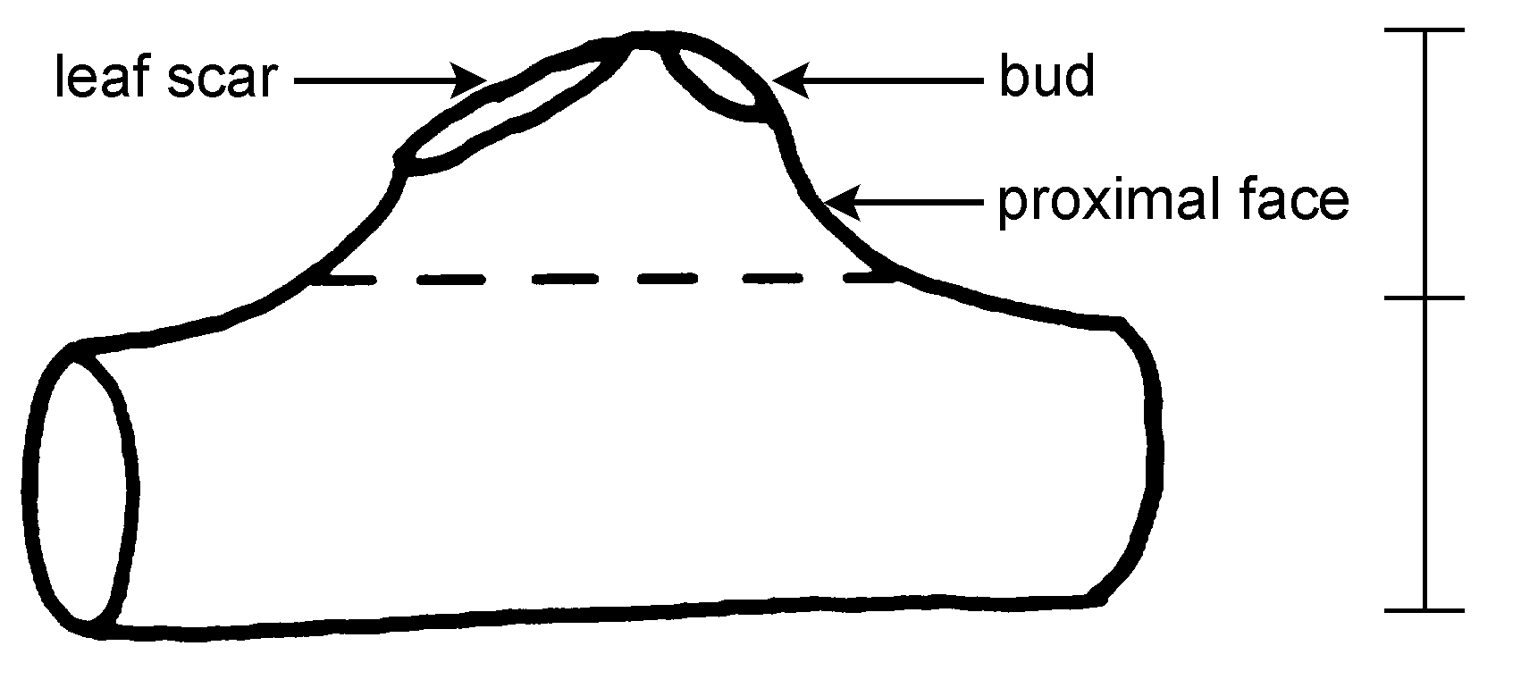 | bud support height  stem diameter

The prominence of the bud support is determined by the bud support height/stem diameter contrast.

Ad. 13: Stem: presence of bud cover
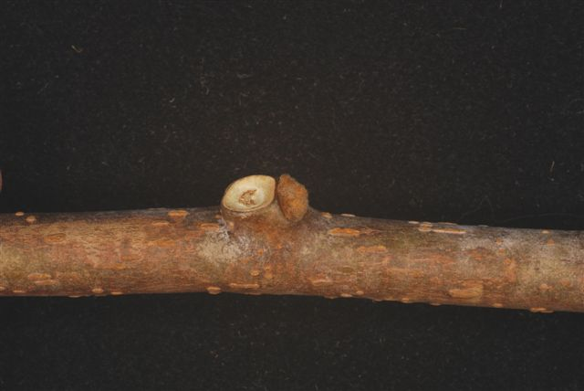 | 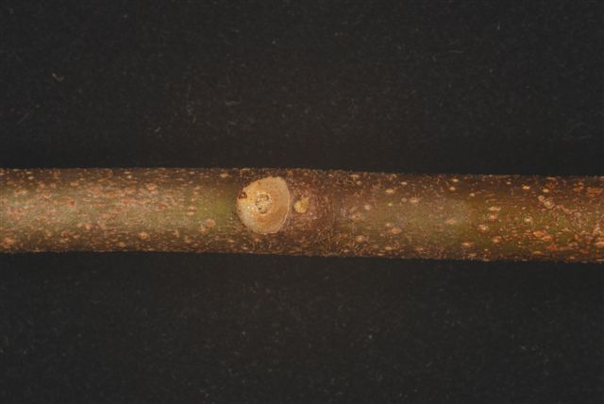
1 | 9
absent | present

The absence or presence of the bud cover is indicated by the visibility of the bud. A variety with no bud cover has a strongly protruding bud which is clearly visible. A variety with a bud cover has an almost invisible bud that appears sunk into the stem.

Ad. 14: Stem: size of hole in bud cover
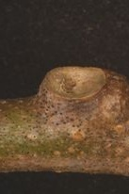 |  | 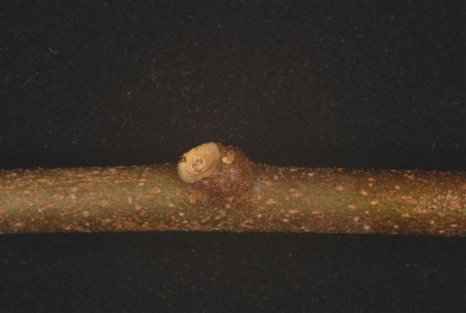
1 | bud cover | 2
small |  | medium
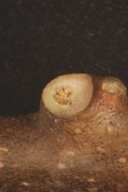
3
large

Ad. 16: Stem: pith
The stem is cut in longitudinal section and the inner part is observed from above.

1 absent: The inner part is empty or hollow.

2 lamellate: The pith consists of layers of thin plates, one against another.

3 solid: The pith consists of a dense mass.
Ad. 17: Leaf blade: shape

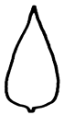 | 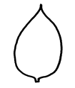 | 
1 | 2 | 3
lanceolate | ovate | obovate

Ad. 19: Leaf blade: shape of apex
pointed | 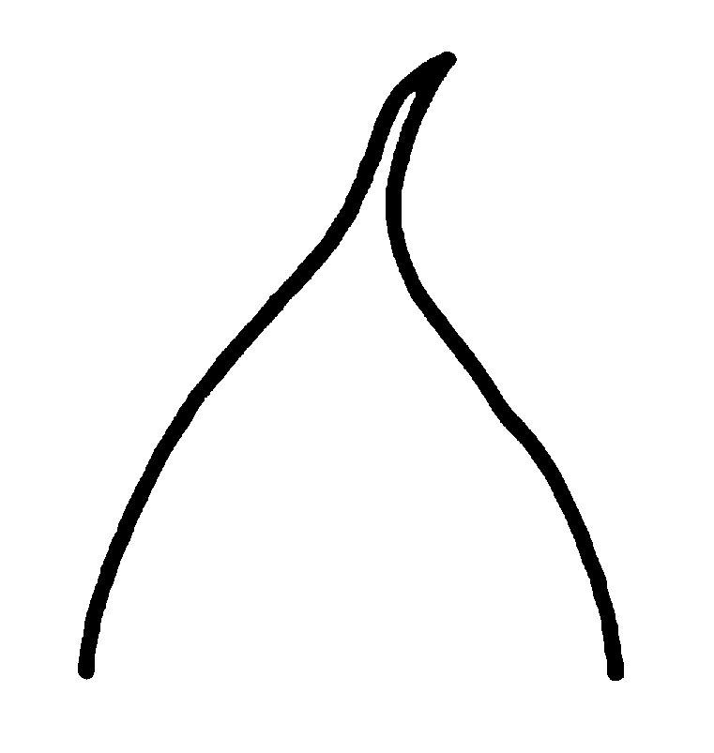 | 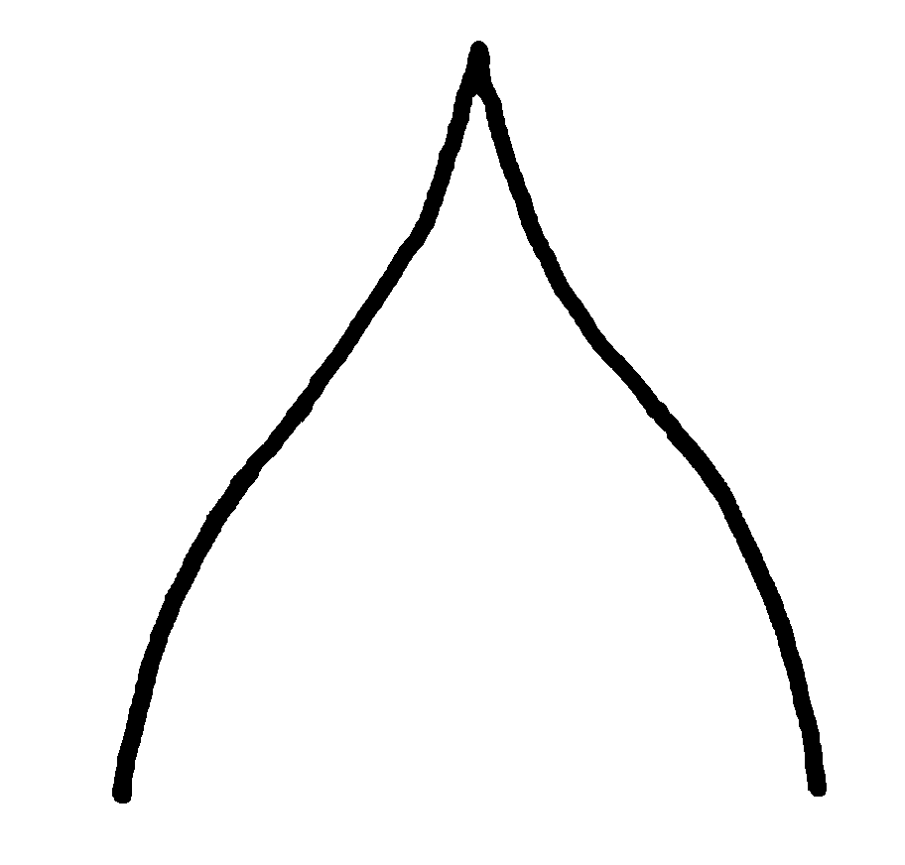 | 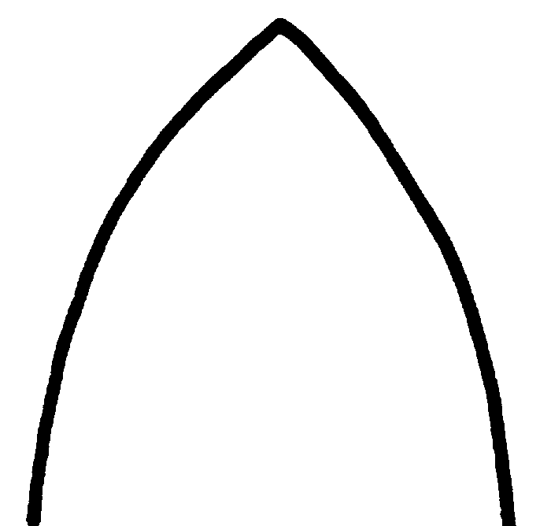 | 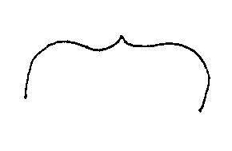
 | 1  caudate | 2  acuminate | 3  acute | 4  emarginate with cuspidate
rounded | 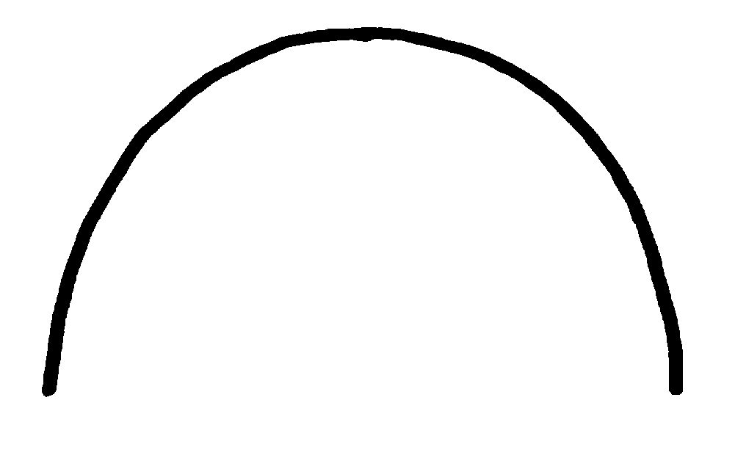
5
rounded
notched | 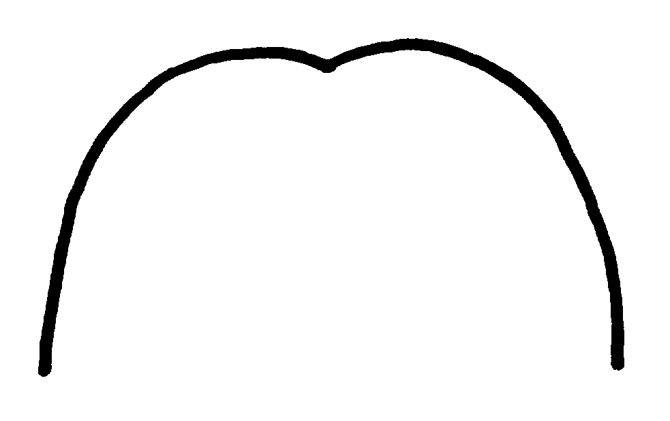 | 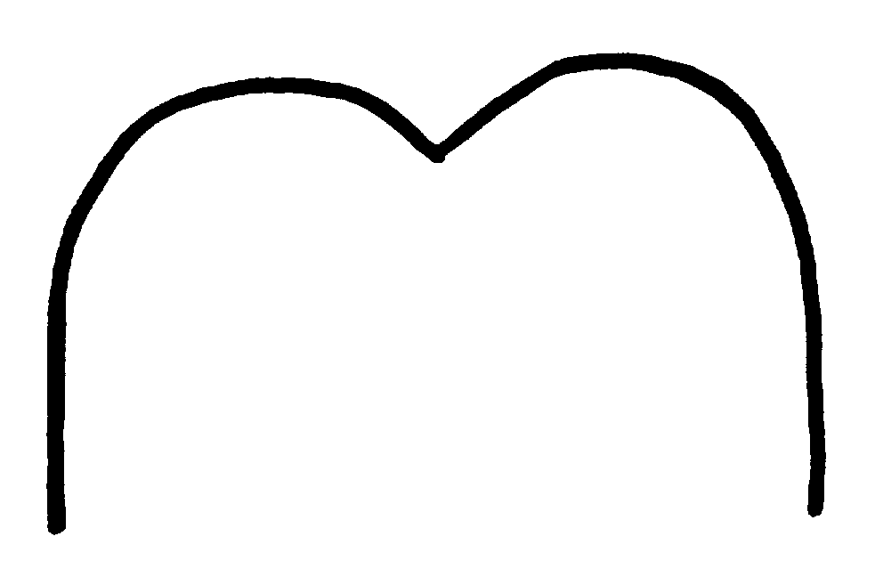
 | 6  retuse | 7  emarginate

Ad. 20: Leaf blade: basal lobes
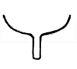 | 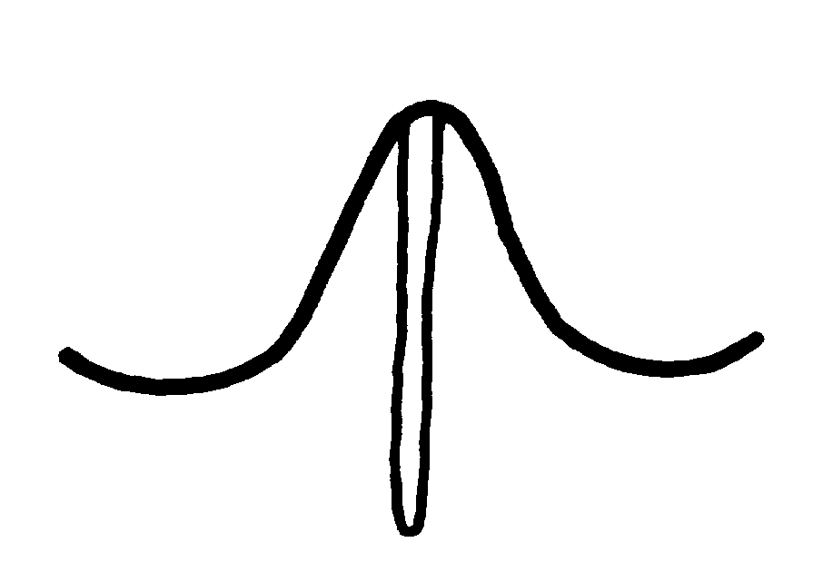 | 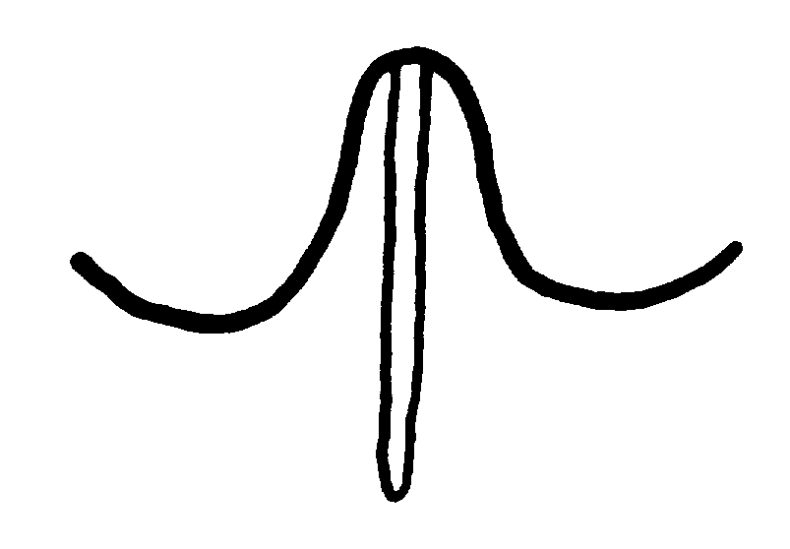
1  none | 2  far apart | 3  slightly apart
 | 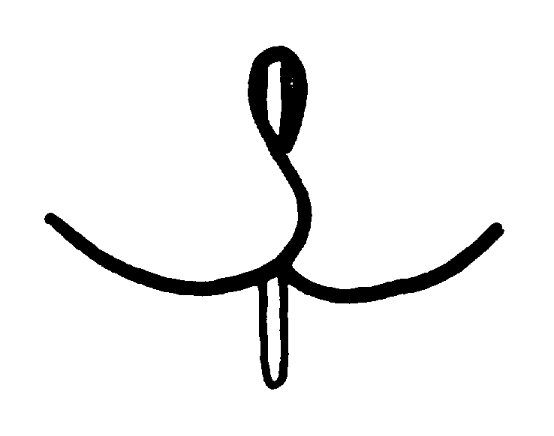 | 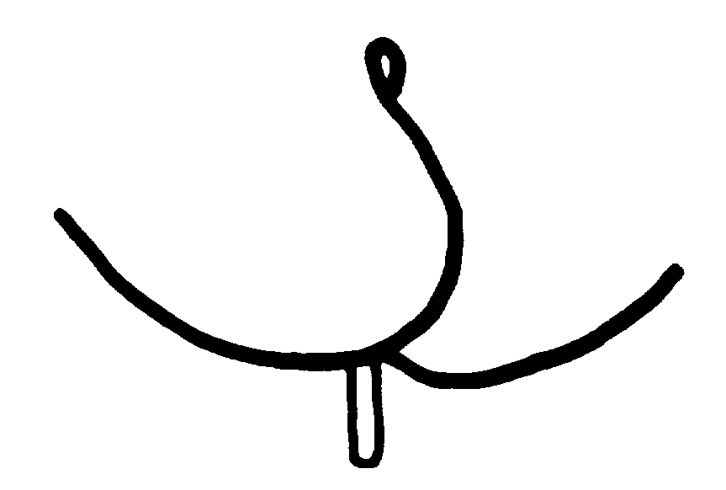
4  touching each other | 5  slightly overlapping | 6  strongly overlapping

Ad. 21: Leaf blade: number of ciliate serrations

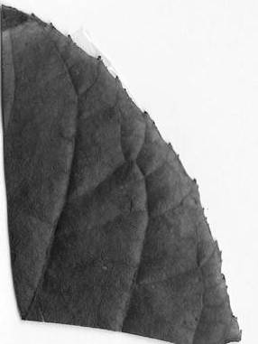 | 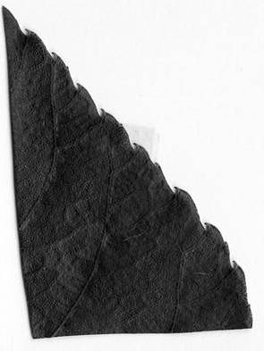 | 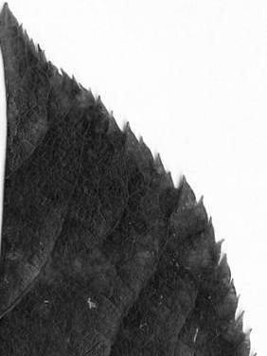
3 | 5 | 7
few | medium | many

Ad. 25: Leaf blade: color of lower side

The observation on the lower side of the leaf is an overall visual impression. The observation includes hairs and leaf surface.

Ad. 31: Inflorescence: type

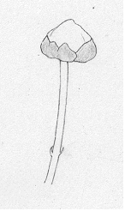 | 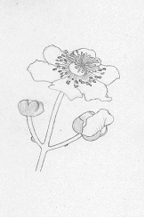 | 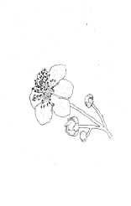 | 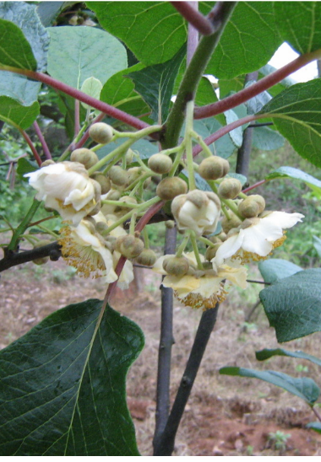
1 | 2 | 3
solitary | dichasium | pleiochasium

Ad. 32: Inflorescence: number of flowers

Flowers occur on the first 1-6 nodes on a current season’s shoot. The observation should be made immediately before flower opening, when at least 2 nodes have developed. The number of flowers present at each node is recorded. It is recommended that at least two shoots are observed per plant.

Ad. 33: Flower bud: position of first spike

The position of the first spike is determined by node order, of which the first spike is set, from the base. Some varieties set the first spike at the lowest node from the base.

Ad. 35: Flower: main color of sepals
The sepal may have more than one color. The main color is the color with the largest surface area on the organ

Ad. 38: Flower: arrangement of petals
Flowers are viewed from beneath as shown in the diagrams.

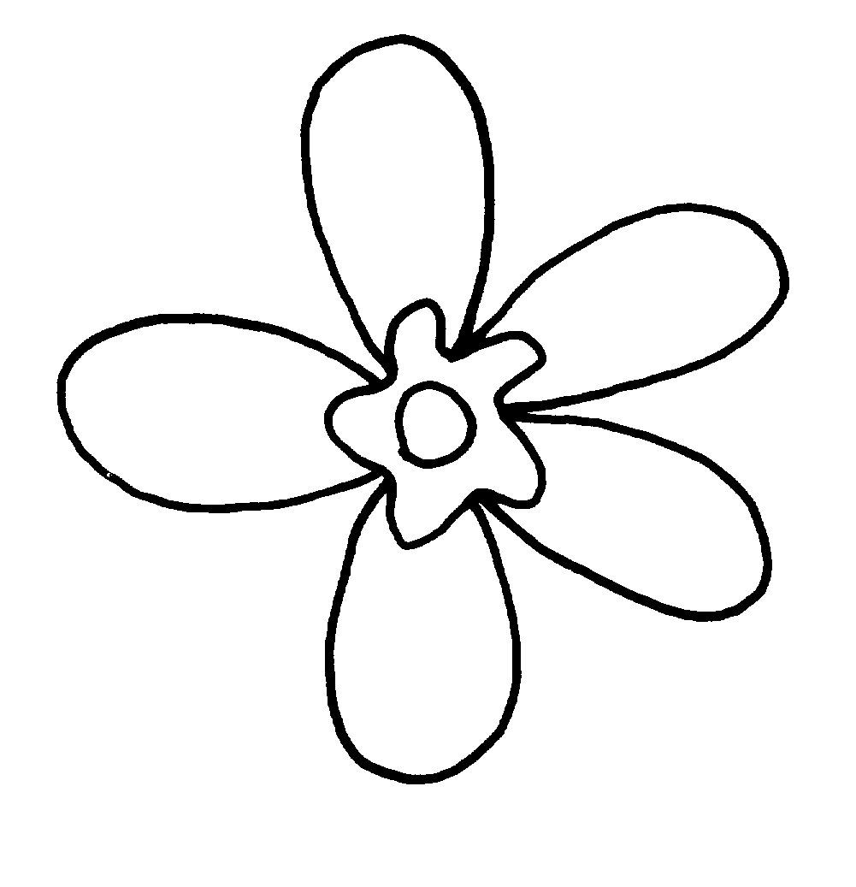 | 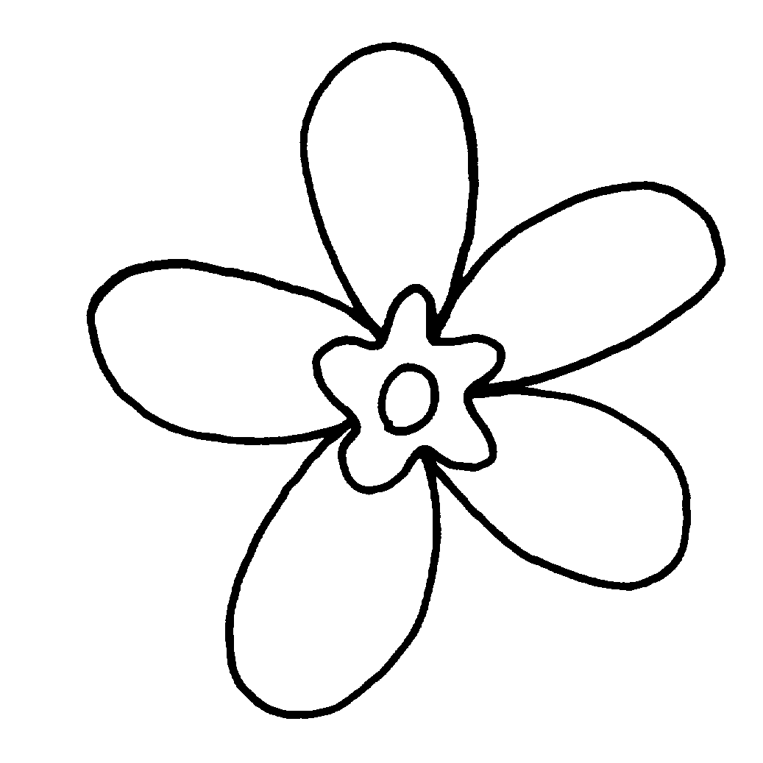 | 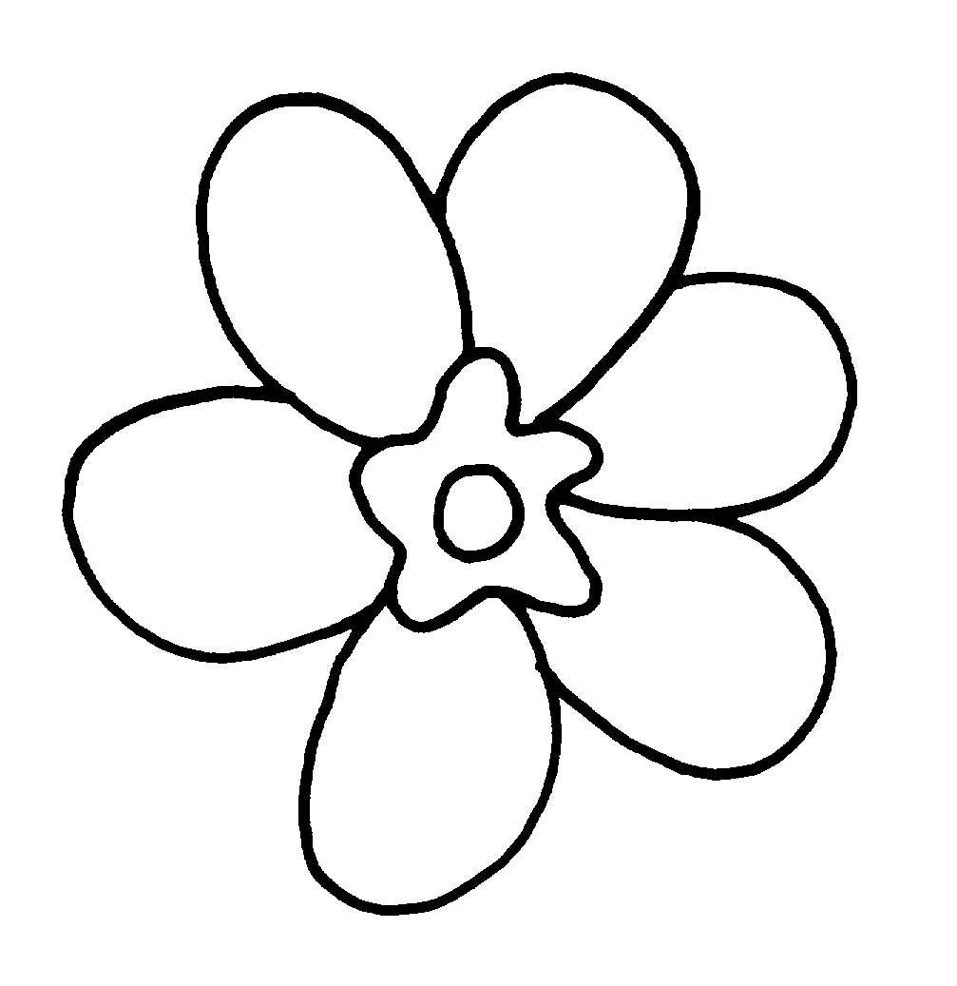
1 | 2 | 3
free | touching | overlapping

Ad. 41: Flower: attitude of styles

State 4 irregular: The attitude of the styles is a mixture of erect, semi erect and horizontal in any combination of two of three different attitudes. The general impression of the flowers is one of no consistency of style attitude or a single predominant style attitude.

Ad. 42: Petal: main color on adaxial side
Ad. 43: Petal: shading of main color

The main color is the color with the largest surface area on the petal. The main color may be shaded, being darker or lighter from base to apex. This is also referred to as a different intensity of color or color gradient on an organ.

The adaxial side is facing the axis of the flower, the upper side. Note that the upper side may be facing downwards when observed on the plant.

Ad. 44: Petal: second color on adaxial side
Ad. 45: Petal: distribution of second color

The secondary color is identified as the color with the second largest surface area on the organ. The second color occurs as a single basal spot, irregular spotting over the entire petal or solid coloration on or near the margin.

Ad. 47: Fruit: weight

Fruit weight should be determined by a sample size of 25 harvested fruits, 5 each from 5 plants.

Ad 48: Fruit: length
Ad 49: Fruit: width

width

length
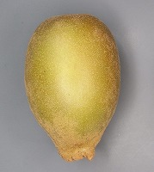

Ad. 50: Fruit: ratio length/width

Ad. 51: Fruit: shape

← broadest part →

below the middle | at middle | above middle

high |  | 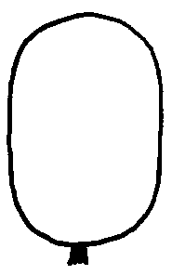
high |  | 2  oblong
← length/width ratio → | 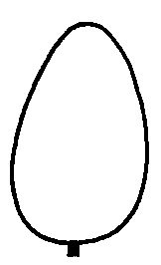 | 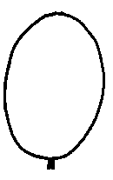 | 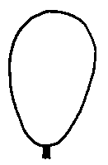
← length/width ratio → | 1  ovate | 3  elliptic | 6  obovate
← length/width ratio → |  | 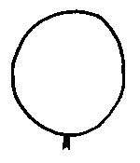
← length/width ratio → |  | 4  circular
low |  | 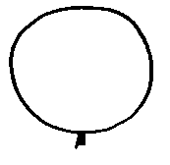
low |  | 5  oblate

Ad. 52: Fruit: shape in cross section (at median)
 | 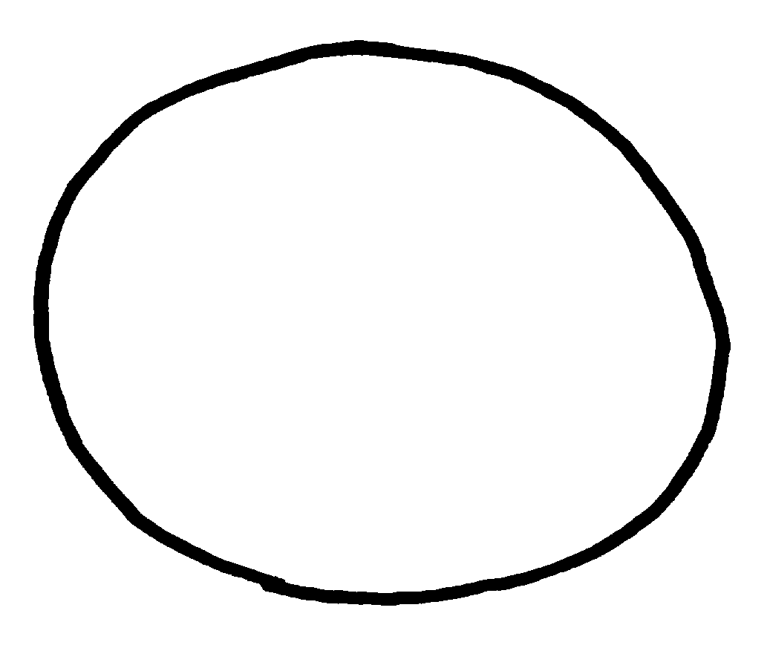 | 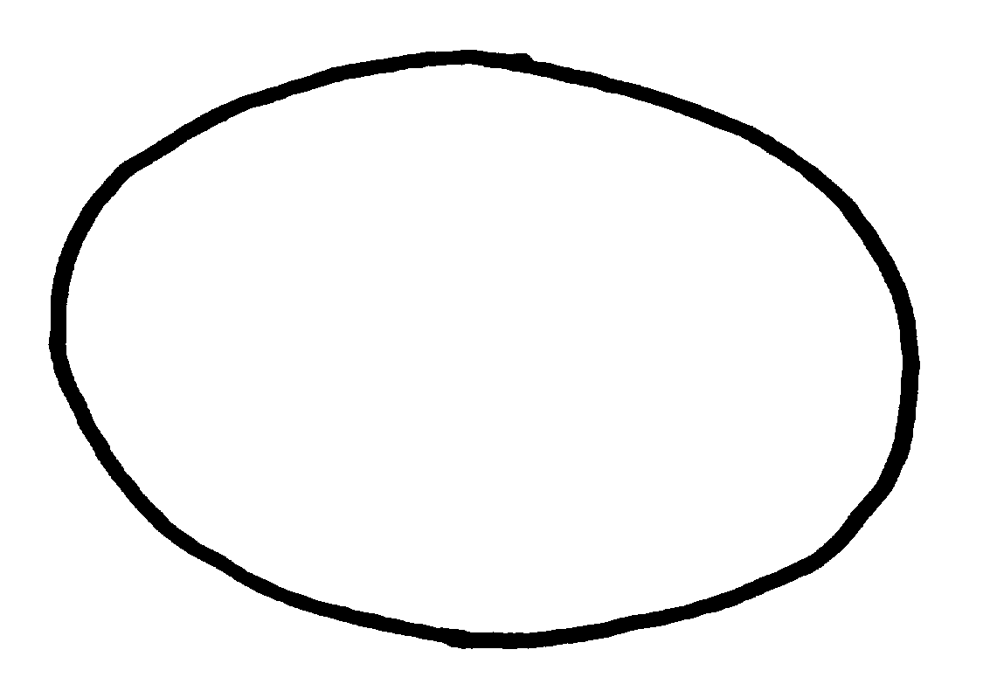
1 | 2 | 3
circular | oblate | transverse elliptic

Ad. 53: Fruit: stylar end

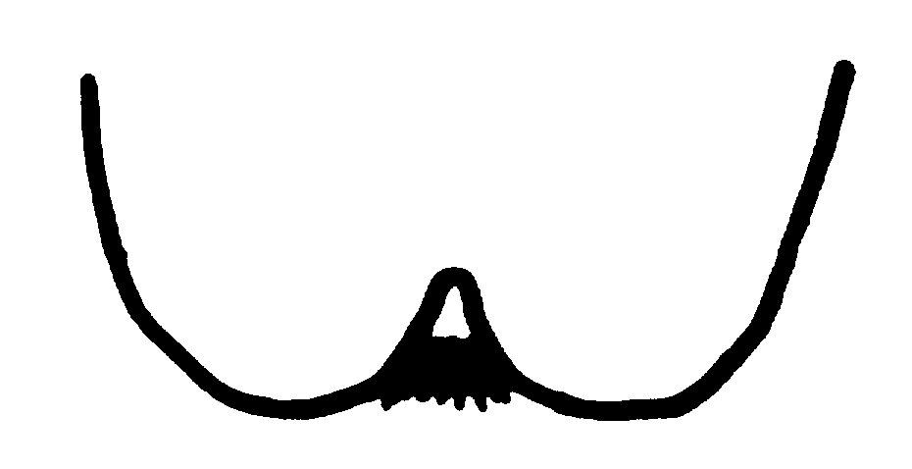 | 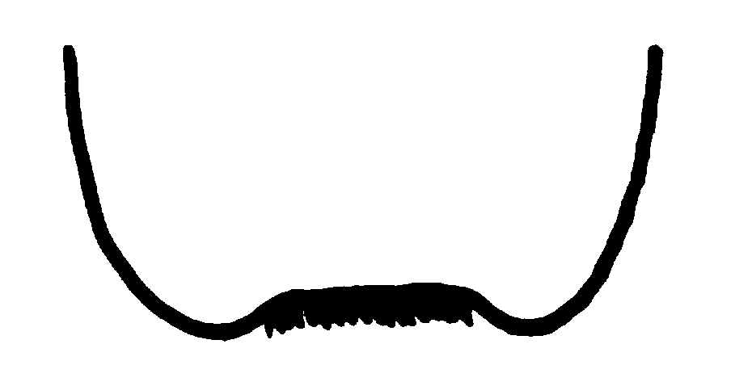
1  strongly depressed | 2  weakly depressed
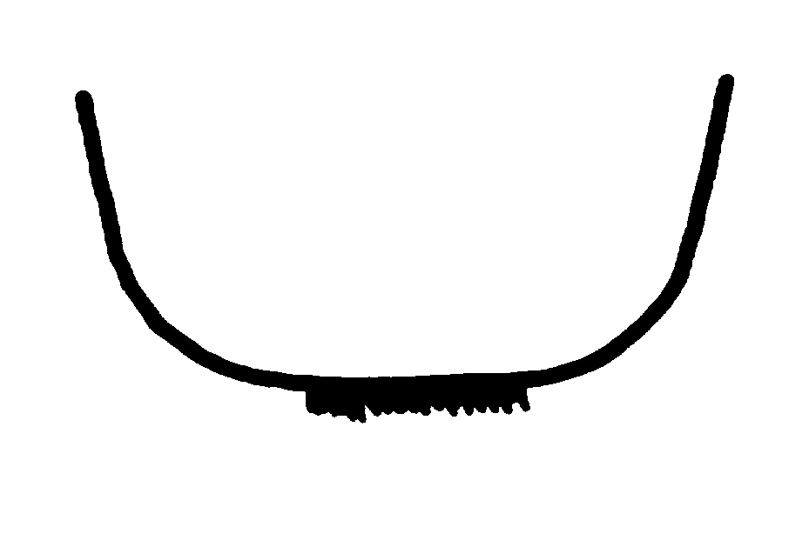 | 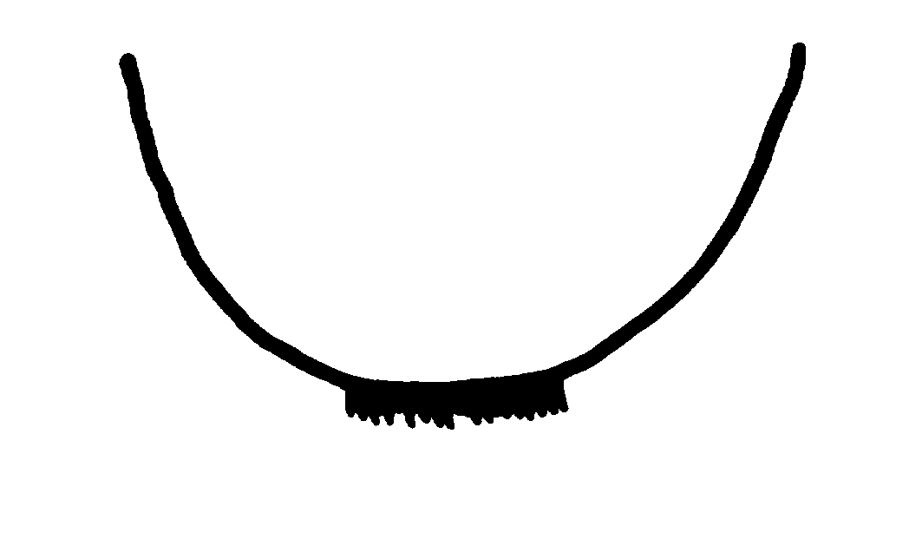
3  flat | 4  rounded
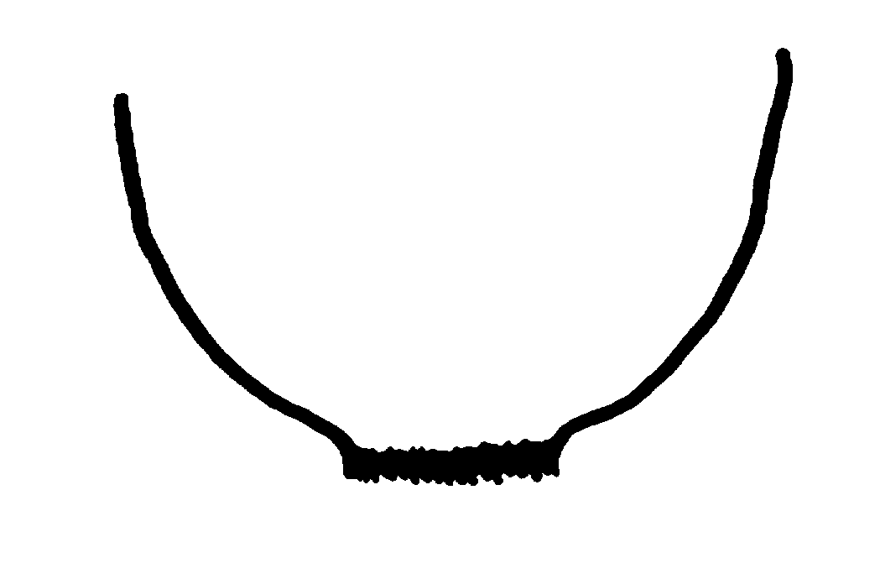 | 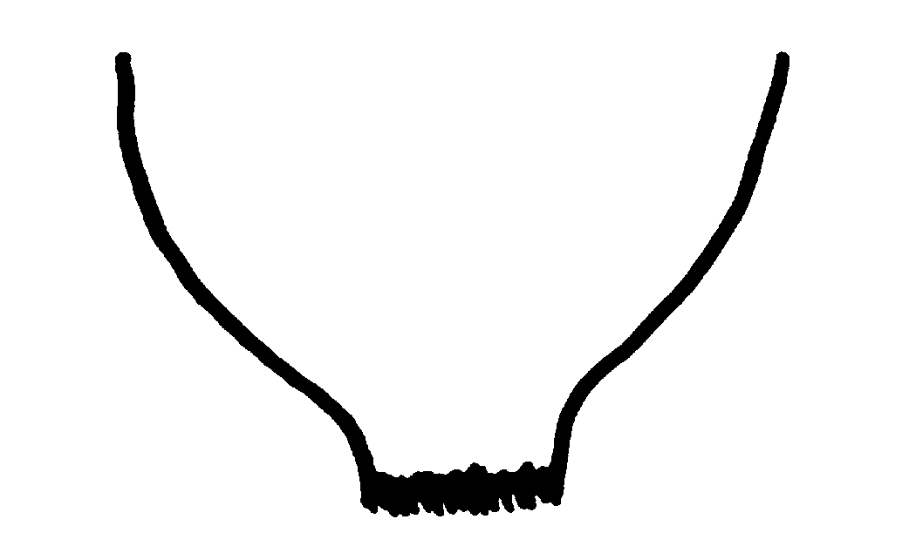
5  weakly blunt protruding | 6  strongly blunt protruding
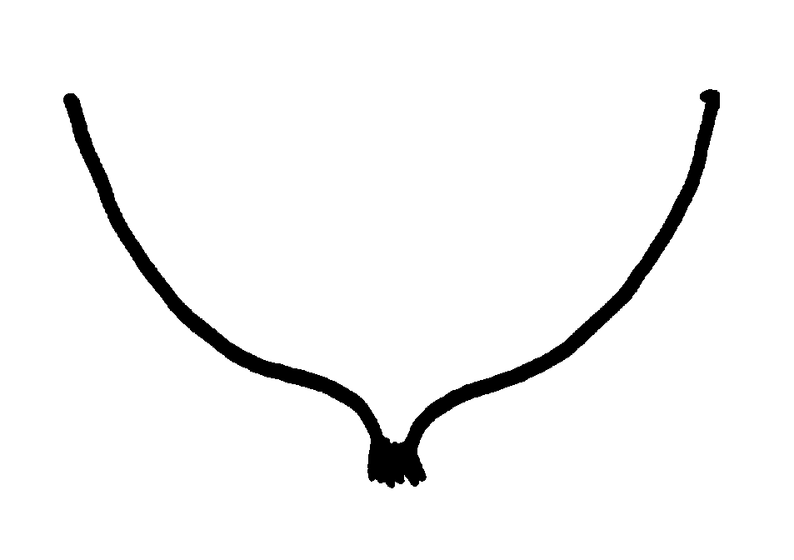
7
pointed protrusion

Ad. 54: Fruit: degree of pointed protrusion

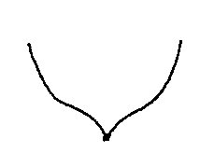 |  | 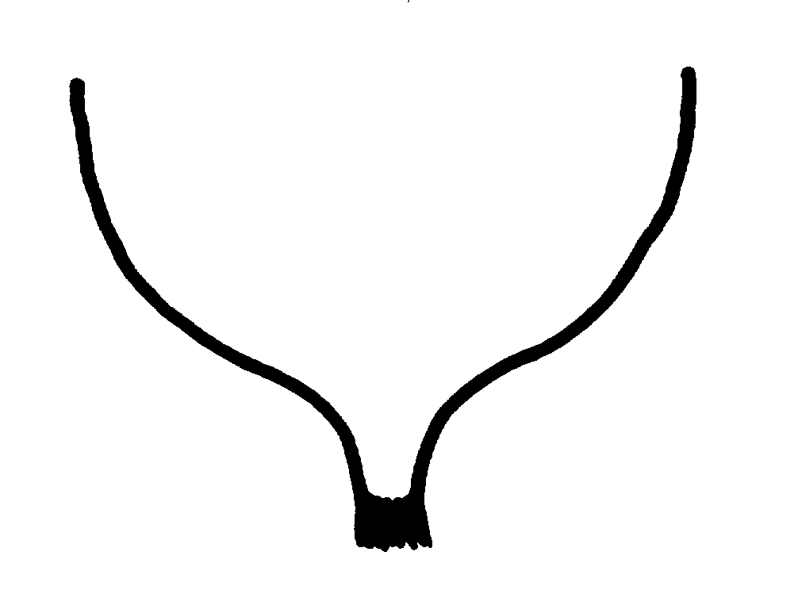
1 | 2 | 3
weak | medium | strong

Ad. 55: Fruit: presence of calyx ring

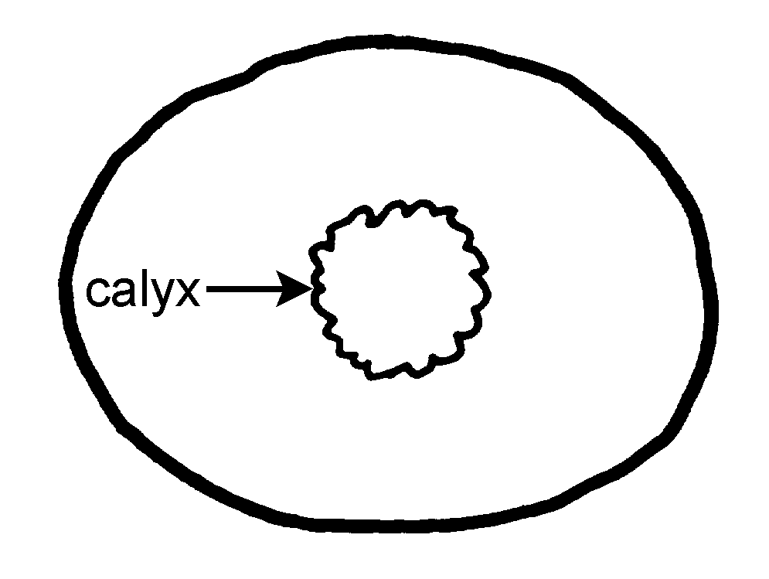 | 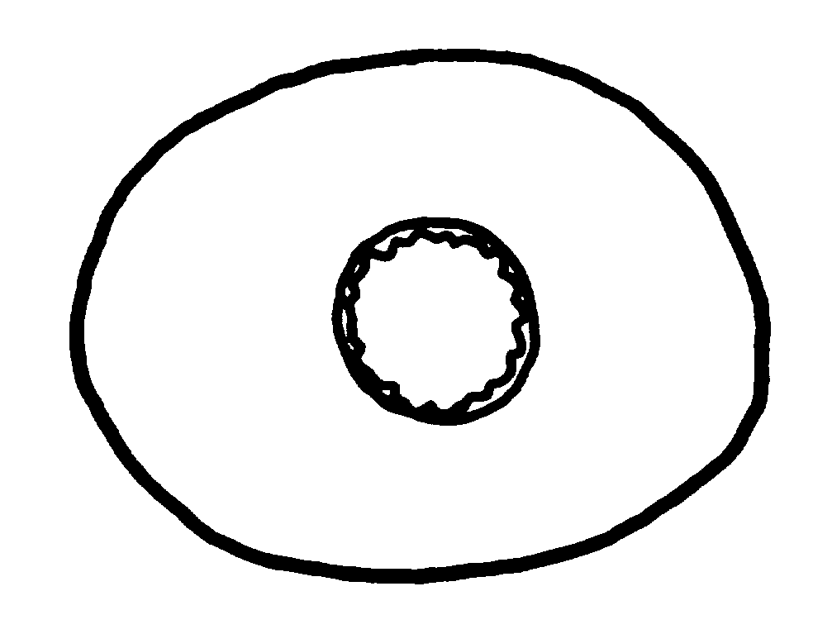 | 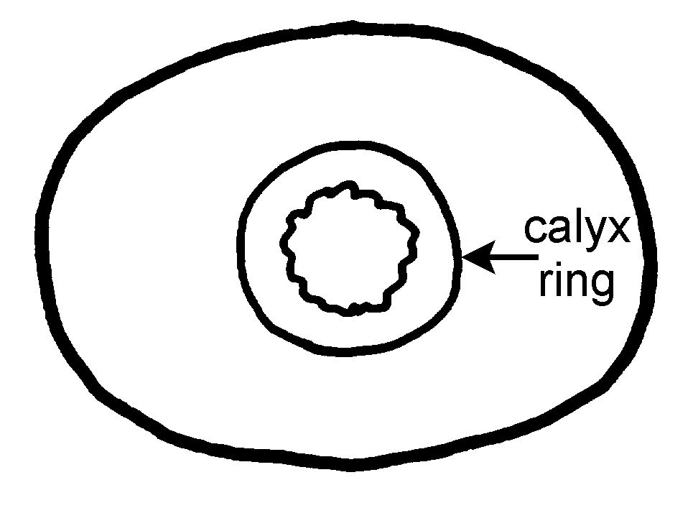
1 | 2 | 3
absent or weakly expressed | medium expressed | strongly expressed

Ad. 56: Fruit: shape of shoulder at stalk end

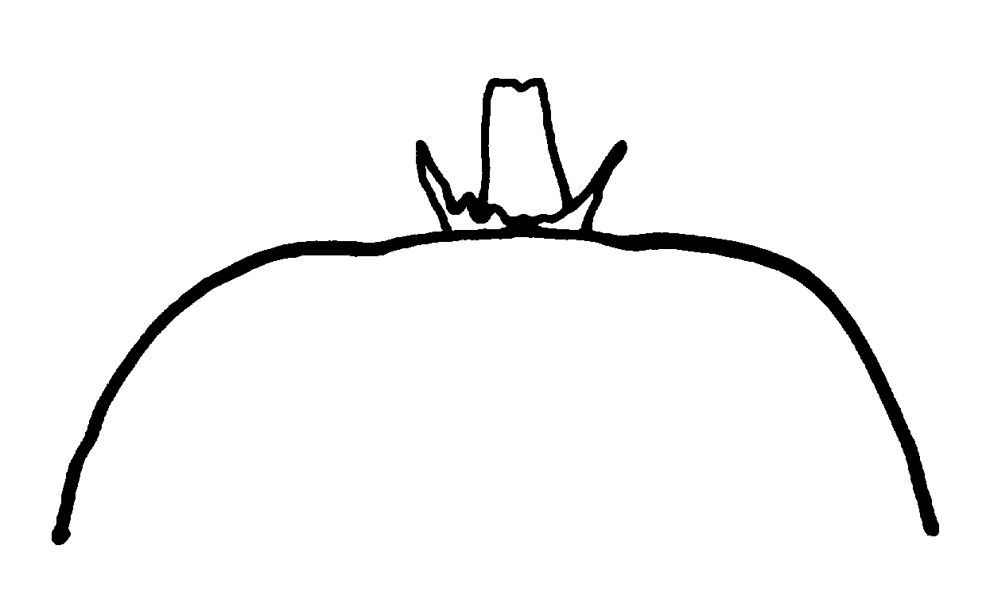 | 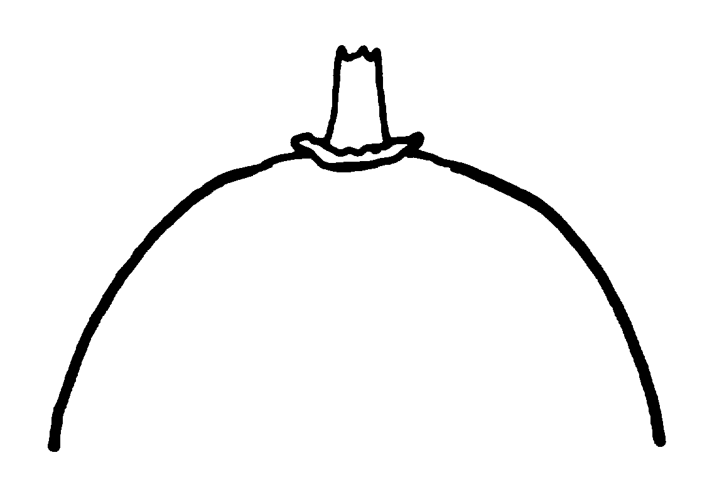 | 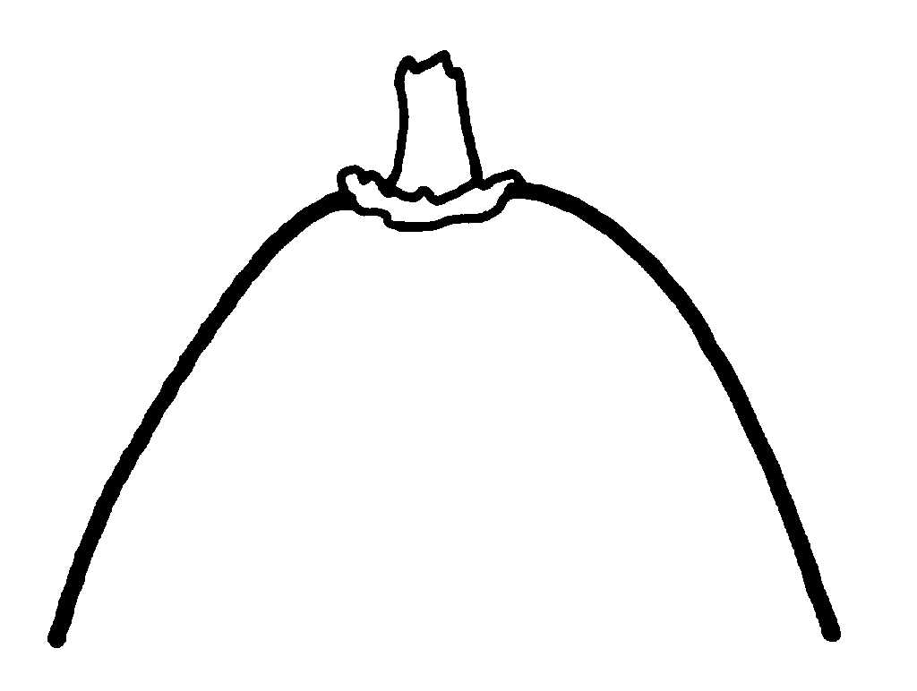
1 | 2 | 3
truncate | weakly sloping | strongly sloping

Ad. 58: Fruit: length of stalk relative to length of fruit

The relativity is determined by the size of the difference between the length of the stalk and the length of the fruit.

short means moderately shorter stalk to length of fruit
medium means similar stalk length to fruit length
long means moderately longer stalk to length of fruit

Ad. 59: Fruit: conspicuousness of lenticels on skin

The conspicuousness of lenticels is determined by the size and number on the skin

Ad. 61: Fruit: density of hairs

The density is determined by the combination of the number of hairs and length of individual hairs

Ad. 63: Fruit: adherence of hairs to skin

Observation is made by rubbing a finger across the fruit surface and determining the ease or difficulty of hair removal.

Ad. 64: Fruit: color of skin

The color of skin is assessed at harvest after removal of as much hair as practical. The color of the skin does not include coloration from hair.

Ad. 66: Fruit: color of outer pericarp
Ad. 67: Fruit: color of locules

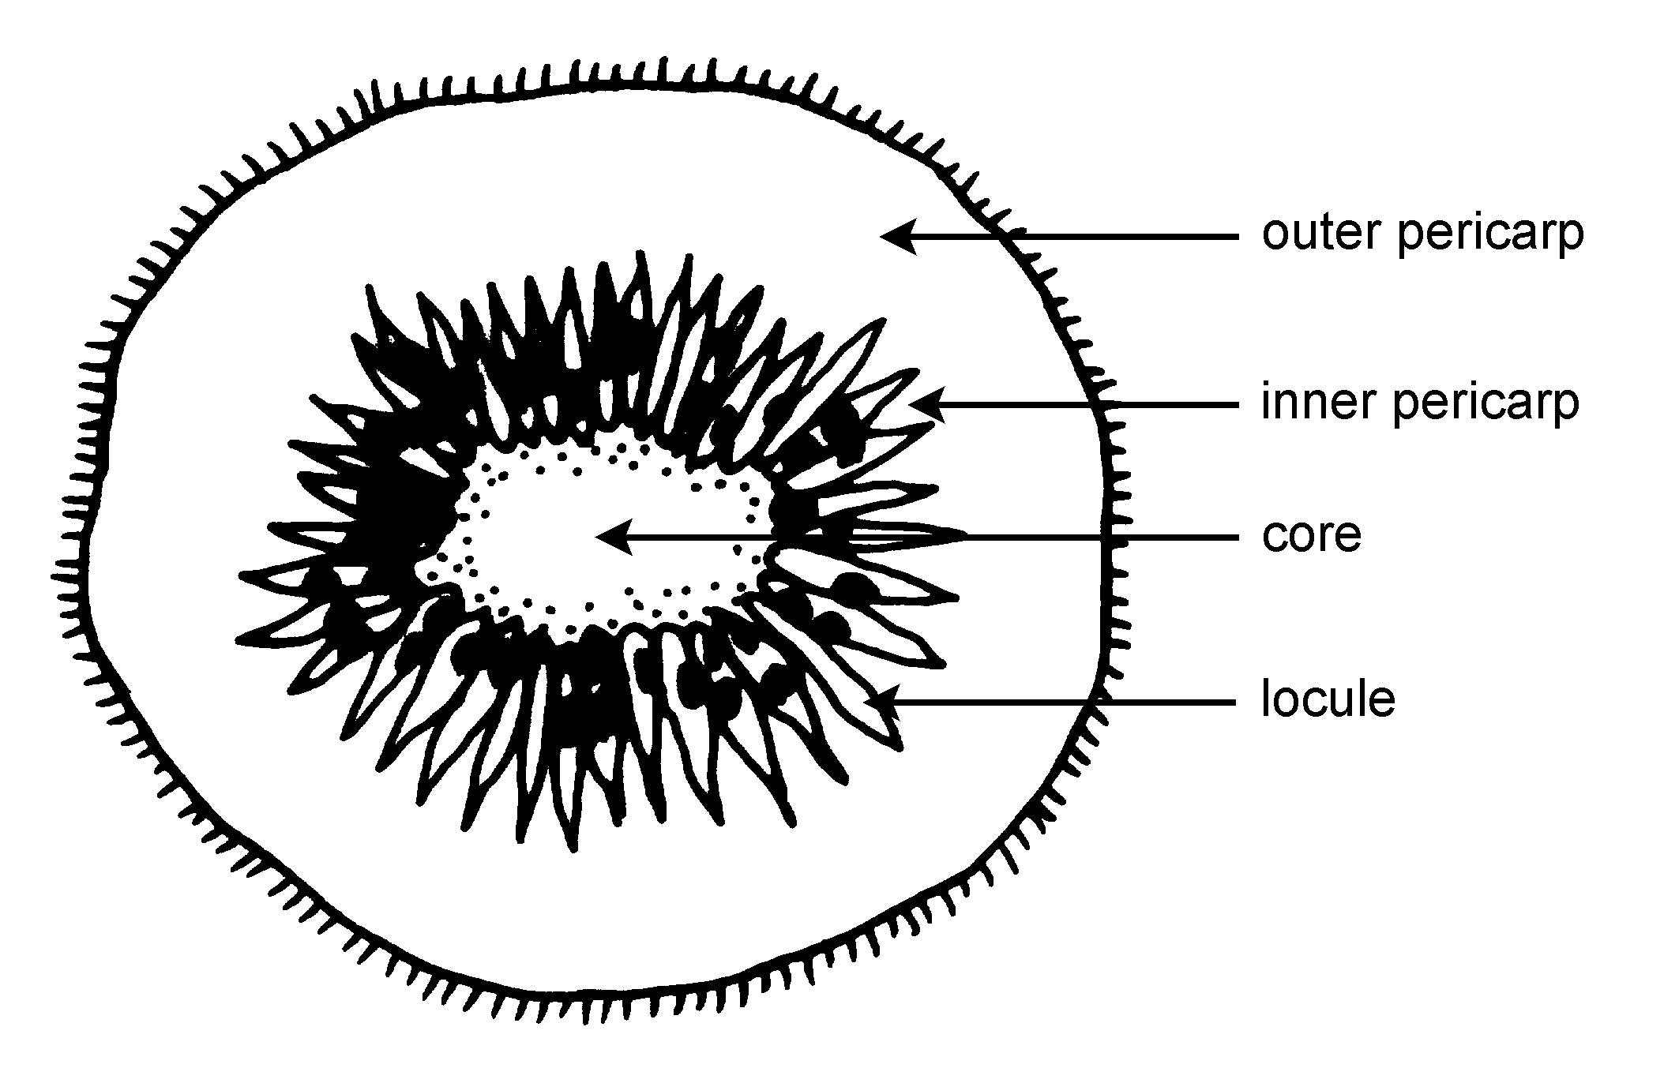

outer pericarp base color of locule

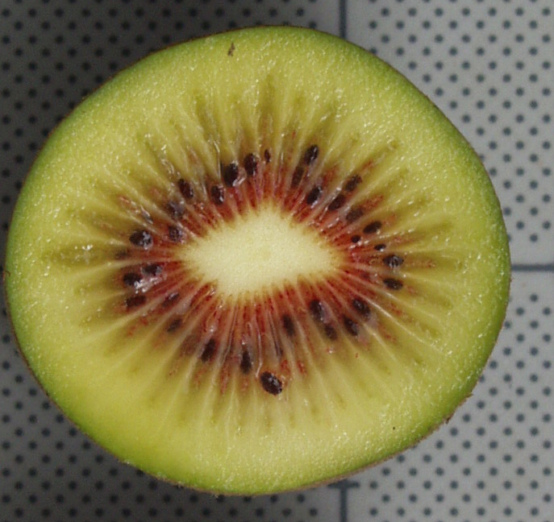

Ad. 68: Fruit: spread of reddish color along locules

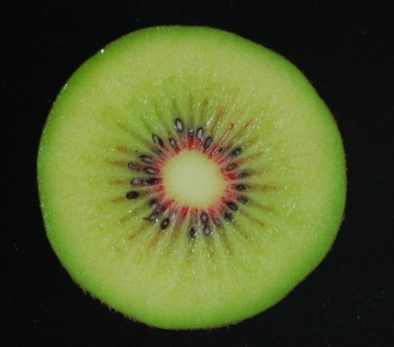 | 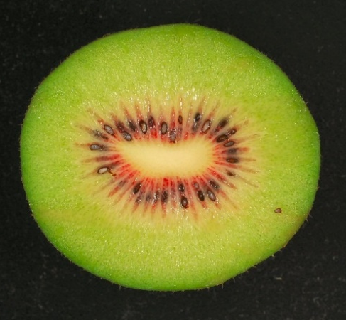
1 | 2
very weak | weak
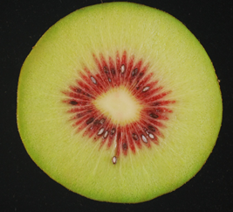 | 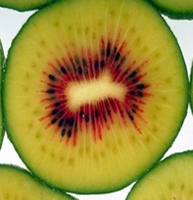
3 | 4
medium | strong
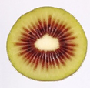
5
very strong

Ad. 70: Fruit: width of core relative to fruit

width of fruit (diameter of fruit)

width of core

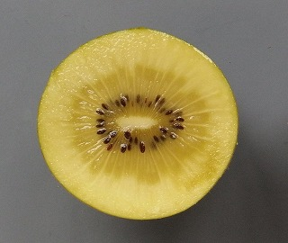

Ad. 71: Fruit: general shape of core in cross section

1 | 2 | 3
circular | oblate | transverse elliptic

Ad. 73: Fruit: sweetness
The total soluble solids content is measured by refractometer.

Ad. 74: Fruit: acidity
Acidity is determined by titration of titrateable acids.

Ad. 75: Time of vegetative bud burst

When 10% of buds are showing green shoots.

Ad. 76: Time of beginning of flowering

When 10% of flower buds have fully opened.

Ad. 77: Time of maturity for harvest
It is recommended that harvest occur when the total soluble solids content is at the level determined by national or regional harvest requirements. The total soluble solids can be measured by Brix test.

Literature
Astridge, S.J., 1975: Cultivars of Chinese gooseberry (Actinidia chinensis) in New Zealand. Economic Botany 29. pp. 357 to 360.

Bellini, E., Monastra, F., 1986: Propagazione, problemi vivaistici, scelta varietale e miglioramento genetico dell’actinidia. pp. 43 to 83. In: G. Bargioni, F. Lalatta and A. Febi (coord.). Incontro frutticolo la coltura dell’actinidia. Atti del Convegno, Verona, 29 Aprile 1986. Verona, Cassa di Risparmio di Verona, Vicennza e Belluno per l’Agricoltura.

Bergamini, A., Monastra, F., 1989: Schede per lo studio dell’actinidia in uso presso l’Istituto sperimentale per la Frutticoltura di Roma. Annali dell’Istituto Sperimentale per la Frutticoltura. pp. 20, 121 to 134.

Cui, Z.-X., 1993: [Actinidia in China] (in Chinese) Shandong Scientific and Technology Press. Jinan, CN.

Ferguson, A.R., 1997: Kiwifruit (Chinese gooseberry). In: The Brooks and Olmo Register of Fruit & Nut Varieties, 3rd Edition. ASHS Press. Alexandria, VA, US, pp. 319 to 323.

Matatabi, K., 1995: Japanese National Test Guidelines for Kiwifruit.

Organisation for Economic Co-operation and Development 1992: Kiwis. Kiwifruit. International Standardisation of Fruit and Vegetables. OECD. Paris.
Testolin, R., Crivello, V., 1987: Il kiwi e il suo mondo. Venezia: Federazione Regionale Coltivatore Diretti del Veneto; Centrol Regionale IRIPSA-Quadrifoglio.

Valmori, I., 1991: Nuove varieta in frutticoltura. Bologna: Edizioni Agricole.

Zhang, J., Thorp, T.G., 1986: Morphology of nine pistillate and three staminate New Zealand clones of kiwifruit (Actinidia deliciosa (A. Chev.) C.F. Liang et A.R. Ferguson var. deliciosa). New Zealand Journal of Botany. pp 24, 589 to 613.

Technical Questionnaire
TECHNICAL QUESTIONNAIRE |  |  |  | Page {x} of {y} |  |  | Reference Number:
 |  |  |  |  |  |  | Application date:
 |  |  |  |  |  |  | (not to be filled in by the applicant)
TECHNICAL QUESTIONNAIRE
to be completed in connection with an application for plant breeders’ rights
1. Subject of the Technical Questionnaire
  - Genus
- Botanical name |  |  | Actinidia Lindl.
1.3 Common name |  |  | Actinidia, Kiwifruit, Kiwi, Mihoutao
1.4 Species
(please complete)
1.5 Common name (please complete)
2. Applicant
Name
Address
Telephone No.
Fax No.
E-mail address
Breeder (if different from applicant)
3. Proposed denomination and breeder’s reference
Proposed denomination
(if available)

Breeder’s reference
#4. Information on the breeding scheme and propagation of the variety

4.1 Breeding scheme

Variety resulting from:

4.1.1 Crossing

(a) controlled cross [ ]
(please state parent varieties)

(…………………..……………..…) x (……………..…………………..…)
female parent male parent

(b) partially known cross [ ]
(please state known parent variety(ies))

(…………………..……………..…) x (……………..…………………..…)
female parent male parent

(c) unknown cross [ ]

4.1.2 Mutation [ ]
(please state parent variety)

4.1.3 Discovery and development [ ]
(please state where and when discovered and how developed)

4.1.4 Other [ ]
(please provide details)

4.2 Method of propagating the variety

4.2.1 Vegetative propagation

(a) cuttings [ ]

(b) grafting (budding) indicate usual rootstock [ ]

(c) in vitro propagation [ ]

(d) other (state method) [ ]

5. Characteristics of the variety to be indicated (the number in brackets refers to the corresponding characteristic in Test Guidelines; please mark the note which best corresponds).

 | Characteristics |  |  |  |  |  |  | Example Varieties |  |  |  | Note
5.1  (76) | Time of beginning of flowering (for all varieties)
 | very early |  |  |  |  |  |  |  |  |  |  | 1[ ]
 | very early to early |  |  |  |  |  |  |  |  |  |  | 2[ ]
 | early |  |  |  |  |  |  | Hort16A (A), Yukimusume (B) |  |  |  | 3[ ]
 | early to medium |  |  |  |  |  |  |  |  |  |  | 4[ ]
 | medium |  |  |  |  |  |  | Abbott (A), Kousui (B) |  |  |  | 5[ ]
 | medium to late |  |  |  |  |  |  |  |  |  |  | 6[ ]
 | late |  |  |  |  |  |  | Hayward (A) |  |  |  | 7[ ]
 | late to very late |  |  |  |  |  |  |  |  |  |  | 8[ ]
 | very late |  |  |  |  |  |  |  |  |  |  | 9[ ]
5.2  (13) | Stem: presence of bud cover (for all varieties)
 | absent |  |  |  |  |  |  | Hort16A (A), Kousui (B) |  |  |  | 1[ ]
 | present |  |  |  |  |  |  | Hayward (A), Mitsukou (B) |  |  |  | 9[ ]
5.3  (14) | Stem: size of hole in bud cover (for all varieties)
 | small |  |  |  |  |  |  | Abbott (A), Mitsukou (B) |  |  |  | 1[ ]
 | medium |  |  |  |  |  |  | Hayward (A), r-Awaji (B) |  |  |  | 2[ ]
 | large |  |  |  |  |  |  | Elmwood (A), r-Nagano (B) |  |  |  | 3[ ]
5.4  (17) | Leaf blade: shape (for all varieties)
 | lanceolate |  |  |  |  |  |  | Kaimai (A) |  |  |  | 1[ ]
 | ovate |  |  |  |  |  |  | Hayward (A) |  |  |  | 2[ ]
 | obovate |  |  |  |  |  |  | Bruno (A) |  |  |  | 3[ ]
 | Characteristics |  |  |  |  |  |  | Example Varieties |  |  |  | Note
5.5  (19) | Leaf blade: shape of apex (for all varieties)
 | caudate |  |  |  |  |  |  | Hortgem Tahi (B) |  |  |  | 1[ ]
 | acuminate |  |  |  |  |  |  | Kaimai (A), Yukimusume (B) |  |  |  | 2[ ]
 | acute |  |  |  |  |  |  | Hayward (A) |  |  |  | 3[ ]
 | emarginate with cuspidate |  |  |  |  |  |  |  |  |  |  | 4[ ]
 | rounded |  |  |  |  |  |  | Satoizumi (B) |  |  |  | 5[ ]
 | retuse |  |  |  |  |  |  | Shinzan (B) |  |  |  | 6[ ]
 | emarginate |  |  |  |  |  |  | Kuimi (A) |  |  |  | 7[ ]
5.6  (42) | Petal: main color on adaxial side (for all varieties)
 | white |  |  |  |  |  |  | Hayward (A), Shinzan (B) |  |  |  | 1[ ]
 | greenish white |  |  |  |  |  |  | Hortgem Tahi (B), Satoizumi (B) |  |  |  | 2[ ]
 | yellowish white |  |  |  |  |  |  | Bruce (A), Mitsukou (B) |  |  |  | 3[ ]
 | yellowish green |  |  |  |  |  |  |  |  |  |  | 4[ ]
 | yellow |  |  |  |  |  |  |  |  |  |  | 5[ ]
 | light pink |  |  |  |  |  |  |  |  |  |  | 6[ ]
 | red pink |  |  |  |  |  |  |  |  |  |  | 7[ ]
 | red |  |  |  |  |  |  |  |  |  |  | 8[ ]
5.7  (46) | Anther: color (for all varieties)
 | yellow |  |  |  |  |  |  | r-Nagano (B) |  |  |  | 1[ ]
 | yellow orange |  |  |  |  |  |  | Bruce (A) |  |  |  | 2[ ]
 | grey |  |  |  |  |  |  |  |  |  |  | 3[ ]
 | dark purple |  |  |  |  |  |  | Mitsukou (B) |  |  |  | 4[ ]
 | black |  |  |  |  |  |  | a-Shouwa (B) |  |  |  | 5[ ]
 | Characteristics |  |  |  |  |  |  | Example Varieties |  |  |  | Note
5.8  (47) | Fruit: weight (for female and hermaphrodite varieties)
 | very low |  |  |  |  |  |  |  |  |  |  | 1[ ]
 | very low to low |  |  |  |  |  |  |  |  |  |  | 2[ ]
 | low |  |  |  |  |  |  | Huaguang2 (A) |  |  |  | 3[ ]
 | low to medium |  |  |  |  |  |  |  |  |  |  | 4[ ]
 | medium |  |  |  |  |  |  | Hort16A (A), Hortgem Tahi (B),  Tomua (A) |  |  |  | 5[ ]
 | medium to high |  |  |  |  |  |  |  |  |  |  | 6[ ]
 | high |  |  |  |  |  |  | Hayward (A), Jin Feng (A) |  |  |  | 7[ ]
 | high to very high |  |  |  |  |  |  |  |  |  |  | 8[ ]
 | very high |  |  |  |  |  |  | Jade Moon (A) |  |  |  | 9[ ]
 | not applicable |  |  |  |  |  |  |  |  |  |  | [ ]
5.9  (51) | Fruit: shape (for female and hermaphrodite varieties)
 | ovate |  |  |  |  |  |  | Hort16A (A), Jecy Gold (A), Yamagatamusume (B) |  |  |  | 1[ ]
 | oblong |  |  |  |  |  |  | Hortgem Toru (B),  Wilkins Super (A) |  |  |  | 2[ ]
 | elliptic |  |  |  |  |  |  | Hayward (A), Mitsukou (B) |  |  |  | 3[ ]
 | circular |  |  |  |  |  |  | Hort51-1785 (A) |  |  |  | 4[ ]
 | oblate |  |  |  |  |  |  | Kuimi (A), Shinzan (B) |  |  |  | 5[ ]
 | obovate |  |  |  |  |  |  | Monty (A) |  |  |  | 6[ ]
 | not applicable |  |  |  |  |  |  |  |  |  |  | [ ]
5.10  (52) | Fruit: shape in cross section (at median) (for female and hermaphrodite varieties)
 | circular |  |  |  |  |  |  | Bruno (A), Mitsukou (B) |  |  |  | 1[ ]
 | oblate |  |  |  |  |  |  | Hortgem Tahi (B), Kousui (B),  Wilkins Super (A) |  |  |  | 2[ ]
 | transverse elliptic |  |  |  |  |  |  | Hayward (A) |  |  |  | 3[ ]
 | not applicable |  |  |  |  |  |  |  |  |  |  | [ ]
 | Characteristics |  |  |  |  |  |  | Example Varieties |  |  |  | Note
5.11  (53) | Fruit: stylar end (for female and hermaphrodite varieties)
 | strongly depressed |  |  |  |  |  |  |  |  |  |  | 1[ ]
 | weakly depressed |  |  |  |  |  |  | Jade Moon (A) |  |  |  | 2[ ]
 | flat |  |  |  |  |  |  | Hayward (A), Satoizumi (B) |  |  |  | 3[ ]
 | rounded |  |  |  |  |  |  | Kousui (B), Tomua (A) |  |  |  | 4[ ]
 | weakly blunt protruding |  |  |  |  |  |  | Skelton (A) |  |  |  | 5[ ]
 | strongly blunt protruding |  |  |  |  |  |  | Hort16A (A) |  |  |  | 6[ ]
 | pointed protrusion |  |  |  |  |  |  | Hortgem Toru (B) |  |  |  | 7[ ]
 | not applicable |  |  |  |  |  |  |  |  |  |  | [ ]
5.12  (56) | Fruit: shape of shoulder at stalk end (for female and hermaphrodite varieties)
 | truncate |  |  |  |  |  |  | Hortgem Tahi (B), Mitsukou (B) |  |  |  | 1[ ]
 | weakly sloping |  |  |  |  |  |  | Hayward (A), Kousui (B) |  |  |  | 2[ ]
 | strongly sloping |  |  |  |  |  |  | Skelton (A) |  |  |  | 3[ ]
 | not applicable |  |  |  |  |  |  |  |  |  |  | [ ]
5.13  (60) | Fruit: hairiness of skin (for female and hermaphrodite varieties)
 | absent |  |  |  |  |  |  | Shinzan (B), a-Shouwa (B) |  |  |  | 1[ ]
 | present |  |  |  |  |  |  | Hayward (A) |  |  |  | 9[ ]
 | not applicable |  |  |  |  |  |  |  |  |  |  | [ ]
 | Characteristics |  |  |  |  |  |  | Example Varieties |  |  |  | Note
5.14  (64) | Fruit: color of skin(for female and hermaphrodite varieties)
 | light green |  |  |  |  |  |  | Hortgem Rua (B) |  |  |  | 1[ ]
 | medium green |  |  |  |  |  |  | Hortgem Tahi (B), Mitsukou (B) |  |  |  | 2[ ]
 | reddish green |  |  |  |  |  |  |  |  |  |  | 3[ ]
 | yellow |  |  |  |  |  |  |  |  |  |  | 4[ ]
 | greenish brown |  |  |  |  |  |  | Hayward (A), Shinzan (B) |  |  |  | 5[ ]
 | reddish brown |  |  |  |  |  |  |  |  |  |  | 6[ ]
 | light brown |  |  |  |  |  |  | Hort16A (A) |  |  |  | 7[ ]
 | medium brown |  |  |  |  |  |  | Sanuki Gold (A) |  |  |  | 8[ ]
 | dark brown |  |  |  |  |  |  | Kousui (B), Tomua (A) |  |  |  | 9[ ]
 | purple red |  |  |  |  |  |  |  |  |  |  | 10[ ]
 | not applicable |  |  |  |  |  |  |  |  |  |  | [ ]
5.15  (66) | Fruit: color of outer pericarp (for female and hermaphrodite varieties)
 | light green |  |  |  |  |  |  | Shinzan (B) |  |  |  | 1[ ]
 | medium green |  |  |  |  |  |  | Hayward (A) |  |  |  | 2[ ]
 | dark green |  |  |  |  |  |  | Hortgem Toru (B) |  |  |  | 3[ ]
 | greenish yellow |  |  |  |  |  |  | Hort22D (A), Satoizumi (B) |  |  |  | 4[ ]
 | medium yellow |  |  |  |  |  |  | Hort16A (A), Kousui (B) |  |  |  | 5[ ]
 | dark yellow |  |  |  |  |  |  | Hort51-1785 (A) |  |  |  | 6[ ]
 | yellowish orange |  |  |  |  |  |  |  |  |  |  | 7[ ]
 | orange |  |  |  |  |  |  |  |  |  |  | 8[ ]
 | red |  |  |  |  |  |  |  |  |  |  | 9[ ]
 | red purple |  |  |  |  |  |  |  |  |  |  | 10[ ]
 | not applicable |  |  |  |  |  |  |  |  |  |  | [ ]
 | Characteristics |  |  |  |  |  |  | Example Varieties |  |  |  | Note
5.16  (67) | Fruit: color of locules (for female and hermaphrodite varieties)
 | light green |  |  |  |  |  |  | Shinzan (B) |  |  |  | 1[ ]
 | medium green |  |  |  |  |  |  | Hayward (A), Hortgem Tahi (B) |  |  |  | 2[ ]
 | dark green |  |  |  |  |  |  | Hortgem Toru (B) |  |  |  | 3[ ]
 | greenish yellow |  |  |  |  |  |  | Satoizumi (B) |  |  |  | 4[ ]
 | medium yellow |  |  |  |  |  |  | Hort16A (A), Kousui (B) |  |  |  | 5[ ]
 | dark yellow |  |  |  |  |  |  | Hort51-1785 (A) |  |  |  | 6[ ]
 | red |  |  |  |  |  |  | Hort22D (A), Hortgem Rua (B) |  |  |  | 7[ ]
 | red purple |  |  |  |  |  |  |  |  |  |  | 8[ ]
 | not applicable |  |  |  |  |  |  |  |  |  |  | [ ]
5.17  (72) | Fruit: color of core (for female and hermaphrodite varieties)
 | white |  |  |  |  |  |  | Hort22D (A) |  |  |  | 1[ ]
 | greenish white |  |  |  |  |  |  | Hayward (A), Hortgem Tahi (B) |  |  |  | 2[ ]
 | yellow white |  |  |  |  |  |  | Hort16A (A), Shinzan (B) |  |  |  | 3[ ]
 | red purple |  |  |  |  |  |  |  |  |  |  | 4[ ]
 | not applicable |  |  |  |  |  |  |  |  |  |  | [ ]
5.18  (75) | Time of vegetative bud burst (for all varieties)
 | very early |  |  |  |  |  |  | Hort16A (A), Hortgem Rua (B) |  |  |  | 1[ ]
 | very early to early |  |  |  |  |  |  |  |  |  |  | 2[ ]
 | early |  |  |  |  |  |  | Tomua (A), Yukimusume (B) |  |  |  | 3[ ]
 | early to medium |  |  |  |  |  |  |  |  |  |  | 4[ ]
 | medium |  |  |  |  |  |  | Hayward (A), Shinzan (B) |  |  |  | 5[ ]
 | medium to late |  |  |  |  |  |  |  |  |  |  | 6[ ]
 | late |  |  |  |  |  |  | Mitsukou (B) |  |  |  | 7[ ]
 | late to very late |  |  |  |  |  |  |  |  |  |  | 8[ ]
 | very late |  |  |  |  |  |  |  |  |  |  | 9[ ]
 | Characteristics |  |  |  |  |  |  | Example Varieties |  |  |  | Note
5.19  (77) | Time of maturity for harvest (for female and hermaphrodite varieties)
 | very early |  |  |  |  |  |  | Hortgem Rua (B) |  |  |  | 1[ ]
 | very early to early |  |  |  |  |  |  |  |  |  |  | 2[ ]
 | early |  |  |  |  |  |  | Hort 22D (A), Hortgem Tahi (B), Yamagatamusume (B) |  |  |  | 3[ ]
 | early to medium |  |  |  |  |  |  |  |  |  |  | 4[ ]
 | medium |  |  |  |  |  |  | Kousui (B), Tomua (A) |  |  |  | 5[ ]
 | medium to late |  |  |  |  |  |  |  |  |  |  | 6[ ]
 | late |  |  |  |  |  |  | Hayward (A), Yukimusume (B) |  |  |  | 7[ ]
 | late to very late |  |  |  |  |  |  |  |  |  |  | 8[ ]
 | very late |  |  |  |  |  |  |  |  |  |  | 9[ ]
 | not applicable |  |  |  |  |  |  |  |  |  |  | [ ]
6. Similar varieties and differences from these varieties

Please use the following table and box for comments to provide information on how your candidate variety differs from the variety (or varieties) which, to the best of your knowledge, is (or are) most similar. This information may help the examination authority to conduct its examination of distinctness in a more efficient way.

Denomination(s) of variety(ies) similar to your candidate variety |  | Characteristic(s) in which your candidate variety differs from the similar variety(ies) |  |  | Describe the expression of the characteristic(s) for the similar variety(ies) |  |  |  | Describe the expression of the characteristic(s) for your candidate variety
Example |  | Fruit: weight |  |  |  | low |  |  |  | medium
Comments:

#7. Additional information which may help in the examination of the variety

7.1 In addition to the information provided in sections 5 and 6, please provide information concerning: Plant: ploidy:

Plant: ploidy
diploid | Hort16A (A), Kousui (B) | 2[ ]
triploid |  | 3[ ]
tetraploid | Hortgem Tahi (B), Kuimi(A) | 4[ ]
pentaploid | Shinzan (B) | 5[ ]
hexaploid | Hayward (A), Mitsukou (B) | 6[ ]
octoploid |  | 8[ ]

7.2 Are there any special conditions for growing the variety or conducting the examination?

Yes [ ] No [ ]

(If yes, please provide details)

7.3 Other information

A representative color photograph of the variety should accompany the Technical Questionnaire.

8. Authorization for release

(a) Does the variety require prior authorization for release under legislation concerning the protection of the environment, human and animal health?

Yes [ ] No [ ]

(b) Has such authorization been obtained?

Yes [ ] No [ ]

If the answer to (b) is yes, please attach a copy of the authorization.

9. Information on plant material to be examined or submitted for examination.

9.1 The expression of a characteristic or several characteristics of a variety may be affected by factors, such as pests and disease, chemical treatment (e.g. growth retardants or pesticides), effects of tissue culture, different rootstocks, scions taken from different growth phases of a tree, etc.

9.2 The plant material should not have undergone any treatment which would affect the expression of the characteristics of the variety, unless the competent authorities allow or request such treatment. If the plant material has undergone such treatment, full details of the treatment must be given. In this respect, please indicate below, to the best of your knowledge, if the plant material to be examined has been subjected to:

(a) Microorganisms (e.g. virus, bacteria, phytoplasma) Yes [ ] No [ ]

(b) Chemical treatment (e.g. growth retardant, pesticide) Yes [ ] No [ ]

(c) Tissue culture Yes [ ] No [ ]

(d) Other factors Yes [ ] No [ ]

Please provide details for where you have indicated “yes”.

……………………………………………………………

9.3 Has the plant material to be examined been tested for the presence of virus or other pathogens?

Yes [ ]
(please provide details as specified by the Authority)

No [ ]

10. I hereby declare that, to the best of my knowledge, the information provided in this form is correct:

Applicant’s name

Signature Date

[End of document]

* These names were correct at the time of the introduction of these Test Guidelines but may be revised or updated. [Readers are advised to consult the UPOV Code, which can be found on the UPOV Website (www.upov.int), for the latest information.]
## Authorities may allow certain of this information to be provided in a confidential section of the Technical Questionnaire.
## Authorities may allow certain of this information to be provided in a confidential section of the Technical Questionnaire.

