 |  | E  TG/78/4 Rev.  ORIGINAL: English  DATE: 2012-03-28
INTERNATIONAL UNION FOR THE PROTECTION OF NEW VARIETIES OF PLANTS
GENEVA

 | KALANCHOE  UPOV Code: KALAN_BLO  Kalanchoe blossfeldiana Poelln. and its hybrids | *

GUIDELINES

FOR THE CONDUCT OF TESTS

FOR DISTINCTNESS, UNIFORMITY AND STABILITY

Alternative Names:*

Botanical name | English | French | German | Spanish
Kalanchoe blossfeldiana Poelln. and its hybrids | Kalanchoe | Kalanchoe | Kalanchoe,  Flammendes Kätchen | Kalancho

The purpose of these guidelines (“Test Guidelines”) is to elaborate the principles contained in the General Introduction (document TG/1/3), and its associated TGP documents, into detailed practical guidance for the harmonized examination of distinctness, uniformity and stability (DUS) and, in particular, to identify appropriate characteristics for the examination of DUS and production of harmonized variety descriptions.

ASSOCIATED DOCUMENTS

These Test Guidelines should be read in conjunction with the General Introduction and its associated TGP documents.
TABLE OF CONTENTS PAGE

1. Subject of these Test Guidelines 3
2. Material Required 3
3. Method of Examination 3
3.1 Number of Growing Cycles 3
3.2 Testing Place 3
3.3 Conditions for Conducting the Examination 3
3.4 Test Design 4
3.5 Number of Plants / Parts of Plants to be Examined 4
3.6 Additional Tests 4
4. Assessment of Distinctness, Uniformity and Stability 4
4.1 Distinctness 4
4.2 Uniformity 5
4.3 Stability 5
5. Grouping of Varieties and Organization of the Growing Trial 5
6. Introduction to the Table of Characteristics 6
6.1 Categories of Characteristics 6
6.2 States of Expression and Corresponding Notes 6
6.3 Types of Expression 6
6.4 Example Varieties 6
6.5 Legend 7
7. Table of Characteristics/Tableau des caractères/Merkmalstabelle/
Tabla de caracteres 8
8. Explanations on the Table of Characteristics 17
8.1 Explanations covering several characteristics 17
8.2 Explanations for individual characteristics 17
9. Literature 22
10. Technical Questionnaire 23

Subject of these Test Guidelines
These Test Guidelines apply to all varieties of Kalanchoe blossfeldiana Poelln. as well as to hybrids between that species and other species of Kalanchoe Adans. of the family Crassulaceae.

Material Required
2.1 The competent authorities decide on the quantity and quality of the plant material required for testing the variety and when and where it is to be delivered. Applicants submitting material from a State other than that in which the testing takes place must ensure that all customs formalities and phytosanitary requirements are complied with.

2.2 The material is to be supplied in the form of unrooted cuttings.

2.3 The minimum quantity of plant material, to be supplied by the applicant, should be:

20 unrooted cuttings.

2.4 The plant material supplied should be visibly healthy, not lacking in vigor, nor affected by any important pest or disease.

2.5 The plant material should not have undergone any treatment which would affect the expression of the characteristics of the variety, unless the competent authorities allow or request such treatment. If it has been treated, full details of the treatment must be given.

Method of Examination

3.1 Number of Growing Cycles
The minimum duration of tests should normally be a single growing cycle.

3.2 Testing Place
Tests are normally conducted at one place. In the case of tests conducted at more than one place, guidance is provided in TGP/9 “Examining Distinctness”.

3.3 Conditions for Conducting the Examination
3.3.1 The tests should be carried out under conditions ensuring satisfactory growth for the expression of the relevant characteristics of the variety and for the conduct of the examination. The plants should receive an appropriate short day treatment after potting. The day length during the short day treatment should be less than 10 hours for at least seven weeks.

3.3.2 The optimum stage of development for the assessment of the characteristics is when three quarters of the flowers per plant are fully open.

3.3.3 Because daylight varies, color determinations made against a color chart should be made either in a suitable cabinet providing artificial daylight or in the middle of the day in a room without direct sunlight. The spectral distribution of the illuminant for artificial daylight should conform with the CIE Standard of Preferred Daylight D 6500 and should fall within the tolerances set out in the British Standard 950, Part I. These determinations should be made with the plant part placed against a white background.

3.4 Test Design
3.4.1 Each test should be designed to result in a total of at least 20 plants.

3.4.2 The design of the tests should be such that plants or parts of plants may be removed for measurement or counting without prejudice to the observations which must be made up to the end of the growing cycle.

3.5 Number of Plants / Parts of Plants to be Examined
Unless otherwise indicated, all observations on single plants should be made on 10 plants or parts taken from each of 10 plants and any other observations made on all plants in the test.

3.6 Additional Tests
Additional tests, for examining relevant characteristics, may be established.

Assessment of Distinctness, Uniformity and Stability

4.1 Distinctness

4.1.1 General Recommendations

It is of particular importance for users of these Test Guidelines to consult the General Introduction prior to making decisions regarding distinctness. However, the following points are provided for elaboration or emphasis in these Test Guidelines.

4.1.2 Consistent Differences

The differences observed between varieties may be so clear that more than one growing cycle is not necessary. In addition, in some circumstances, the influence of the environment is not such that more than a single growing cycle is required to provide assurance that the differences observed between varieties are sufficiently consistent. One means of ensuring that a difference in a characteristic, observed in a growing trial, is sufficiently consistent is to examine the characteristic in at least two independent growing cycles.

4.1.3 Clear Differences

Determining whether a difference between two varieties is clear depends on many factors, and should consider, in particular, the type of expression of the characteristic being examined, i.e. whether it is expressed in a qualitative, quantitative, or pseudo-qualitative manner. Therefore, it is important that users of these Test Guidelines are familiar with the recommendations contained in the General Introduction prior to making decisions regarding distinctness.

4.2 Uniformity
4.2.1 It is of particular importance for users of these Test Guidelines to consult the General Introduction prior to making decisions regarding uniformity. However, the following points are provided for elaboration or emphasis in these Test Guidelines:

4.2.2 For the assessment of uniformity a population standard of 2% and an acceptance probability of at least 95% should be applied. In the case of a sample size of 20 plants, 2 off-types are allowed.

4.3 Stability
4.3.1 In practice, it is not usual to perform tests of stability that produce results as certain as those of the testing of distinctness and uniformity. However, experience has demonstrated that, for many types of variety, when a variety has been shown to be uniform, it can also be considered to be stable.

4.3.2 Where appropriate, or in cases of doubt, stability may be tested, either by growing a further generation, or by testing a new plant stock to ensure that it exhibits the same characteristics as those shown by the previous material supplied.

Grouping of Varieties and Organization of the Growing Trial
5.1 The selection of varieties of common knowledge to be grown in the trial with the candidate varieties and the way in which these varieties are divided into groups to facilitate the assessment of distinctness are aided by the use of grouping characteristics.

5.2 Grouping characteristics are those in which the documented states of expression, even where produced at different locations, can be used, either individually or in combination with other such characteristics: (a) to select varieties of common knowledge that can be excluded from the growing trial used for examination of distinctness; and (b) to organize the growing trial so that similar varieties are grouped together.

5.3 The following have been agreed as useful grouping characteristics:

(a) Flower: type (characteristic 18)
(b) Corolla lobe: number of colors of upper side (characteristic 29)
(c) Corolla lobe: main color of upper side (characteristic 30) with the following groups:
Gr. 1: white
Gr. 2: yellow
Gr. 3: orange
Gr. 4: red
Gr. 5: purple red
Gr. 6: purple
Gr. 7: blue pink
(d) Corolla lobe: secondary color of upper side (characteristic 31) with the following groups:
Gr. 1: white
Gr. 2: yellow
Gr. 3: orange
Gr. 4: red
Gr. 5: purple red
Gr. 6: blue pink

5.4 Guidance for the use of grouping characteristics, in the process of examining distinctness, is provided through the General Introduction.

Introduction to the Table of Characteristics

6.1 Categories of Characteristics
6.1.1 Standard Test Guidelines Characteristics

Standard Test Guidelines characteristics are those which are approved by UPOV for examination of DUS and from which members of the Union can select those suitable for their particular circumstances.

6.1.2 Asterisked Characteristics

Asterisked characteristics (denoted by *) are those included in the Test Guidelines which are important for the international harmonization of variety descriptions and should always be examined for DUS and included in the variety description by all members of the Union, except when the state of expression of a preceding characteristic or regional environmental conditions render this inappropriate.

6.2 States of Expression and Corresponding Notes
States of expression are given for each characteristic to define the characteristic and to harmonize descriptions. Each state of expression is allocated a corresponding numerical note for ease of recording of data and for the production and exchange of the description.

6.3 Types of Expression
An explanation of the types of expression of characteristics (qualitative, quantitative and pseudo-qualitative) is provided in the General Introduction.

6.4 Example Varieties
Where appropriate, example varieties are provided to clarify the states of expression of each characteristic.

6.5 Legend
(*) Asterisked characteristic – see Chapter 6.1.2

QL Qualitative characteristic – see Chapter 6.3
QN Quantitative characteristic – see Chapter 6.3
PQ Pseudo-qualitative characteristic – see Chapter 6.3

(a)-(d) See Explanations on the Table of Characteristics in Chapter 8.1
(+) See Explanations on the Table of Characteristics in Chapter 8.2

7. Table of Characteristics/Tableau des caractères/Merkmalstabelle/Tabla de caracteres
 |  | English | français | Deutsch | español | Example Varieties  Exemples  Beispielssorten  Variedades ejemplo | Note/  Nota
1.  (*) |  | Plant: height (including inflorescence) | Plante : hauteur (y compris l’inflorescence) | Pflanze: Höhe (einschließlich Blütenstand) | Planta: altura (incluida la inflorescencia)
QN |  | very short | très basse | sehr niedrig | muy baja | Avalon | 1
 |  | short | basse | niedrig | baja | Rarakoe | 3
 |  | medium | moyenne | mittel | media | Amy | 5
 |  | tall | haute | hoch | alta | Taos | 7
 |  | very tall | très haute | sehr hoch | muy alta | Petero | 9
2. |  | Plant: width | Plante : largeur | Pflanze: Breite | Planta: anchura
QN |  | narrow | étroite | schmal | estrecha | Sumaco | 3
 |  | medium | moyenne | mittel | media | Amy | 5
 |  | broad | large | breit | ancha | Pago | 7
3.  (*) |  | Leaf: length | Feuille : longueur | Blatt: Länge | Hoja: longitud
QN | (a) | short | courte | kurz | corta | Dark Cora | 3
 |  | medium | moyenne | mittel | media | Amy | 5
 |  | long | longue | lang | larga | Avalon | 7
4.  (*) |  | Leaf: width | Feuille : largeur | Blatt: Breite | Hoja: anchura
QN | (a) | narrow | étroite | schmal | estrecha | Arina | 3
 |  | medium | moyenne | mittel | media | Sumaco | 5
 |  | broad | large | breit | ancha | Avalon | 7
5.  (+) |  | Leaf: shape | Feuille : forme | Blatt: Form | Hoja: forma
PQ | (a) | ovate | ovale | eiförmig | oval |  | 1
 |  | elliptic | elliptique | elliptisch | elíptica |  | 2
 |  | rounded | arrondie | rundlich | redondeada |  | 3
 |  | linear | linéaire | linear | lineal |  | 4
 |  | obovate | obovale | verkehrt eiförmig | oboval |  | 5
 |  | tripartite pinnate | pennée tripartite | dreizählig gefiedert | tripartita pinnada |  | 6
6.  (*) |  | Leaf: variegation | Feuille : panachure | Blatt: Panaschierung | Hoja: variegación
QL | (a) | absent | absente | fehlend | ausente | Rarakoe | 1
 |  | present | présente | vorhanden | presente | Debora | 9
7. |  | Leaf: intensity of green color of upper side | Feuille : intensité de la couleur verte de la face supérieure | Blatt: Intensität der Grünfärbung der Oberseite | Hoja: intensidad del color verde del haz
QN | (a) | light | claire | hell | clara |  | 3
 |  | medium | moyenne | mittel | media | Taos | 5
 |  | dark | foncée | dunkel | oscura | Arina | 7
8.  (*) |  | Leaf: anthocyanin coloration of upper side | Feuille : pigmentation anthocyanique de la face supérieure | Blatt: Anthocyan-färbung der Ober-seite | Hoja: pigmentación antociánica del haz
QN | (a) | absent or very weak | nulle ou très faible | fehlend oder sehr gering | ausente o muy débil | Amy | 1
 |  | weak | faible | gering | débil | Banda | 3
 |  | medium | moyenne | mittel | media | Misunpink | 5
 |  | strong | forte | stark | fuerte | Axrose | 7
9.  (+) |  | Leaf: cross section | Feuille : section transversale | Blatt: Querschnitt | Hoja: sección transversal
QN | (a) | strongly concave | fortement concave | stark konkav | fuertemente cóncava | Dark Cora | 1
 |  | flat | plate | gerade | plana | Fonda | 3
 |  | strongly convex | fortement convexe | stark konvex | fuertemente convexa |  | 5
10.  (+) |  | Leaf: number of incisions of margin | Feuille : nombre d’incisions du bord | Blatt: Anzahl der Randeinschnitte | Hoja: número de incisiones del margen
QN | (a) | absent or very few | absentes ou très peu nombreuses | fehlend oder sehr gering | ausentes o muy pocas |  | 1
 |  | few | peu nombreuses | gering | pocas |  | 3
 |  | medium | moyennes | mittel | medio |  | 5
 |  | many | nombreuses | groß | abundantes |  | 7
11.  (+) |  | Leaf: depth of incisions of margin | Feuille : profondeur des incisions du bord | Blatt: Tiefe der Randeinschnitte | Hoja: profundidad de las incisiones del margen
QN | (a) | very shallow | très peu profondes | sehr flach | muy poco profunda |  | 1
 |  | shallow | peu profondes | flach | poco profunda | Amy | 3
 |  | medium | moyennes | mittel | media | Pago | 5
 |  | deep | profondes | tief | profunda | Axrose | 7
12.  (+) |  | Leaf: attitude of apex | Feuille : port du sommet | Blatt: Haltung der Spitze | Hoja: porte del ápice
QN | (a) | strongly incurving | fortement incurvé | stark aufgebogen | fuertemente curvado hacia arriba | Rachel | 1
 |  | straight | droit | gerade | recto | Sumaco | 3
 |  | strongly recurving | fortement recurvé | stark zurückgebogen | fuertemente curvado hacia abajo | Hakon | 5
13.  (+) |  | Flowering shoot: number of flowers of highest pleiochasium | Pousse florifère : nombre de fleurs du pleïochasium le plus haut | Blühender Trieb: Anzahl Blüten der obersten Trugdolde | Rama floral: número de flores del pleiocasio superior
QN |  | few | petit | gering | pocas | Amrum | 3
 |  | medium | moyen | mittel | medio | Fonda | 5
 |  | many | grand | groß | abundantes | Pago | 7
14.  (+) |  | Flowering shoot: width of highest pleiochasium | Pousse florifère : largeur du pleïochasium le plus haut | Blühender Trieb: Breite der obersten Trugdolde | Rama floral: anchura del pleiocasio superior
QN |  | narrow | étroit | schmal | estrecha | Don Ramon | 3
 |  | medium | moyen | mittel | media | Sumaco | 5
 |  | broad | large | breit | ancha | Pago | 7
15.  (+) |  | Young flower: number of colors of upper side of corolla lobes | Jeune fleur : nombre de couleurs de la face supérieure des lobes de la corolle | Junge Blüte: Anzahl Farben der Ober-seite der Kronzipfel | Flor joven: número de colores de la cara superior de los lóbulos de la corola
QL | (b) | one | une | eine | uno |  | 1
 |  | two or more | deux ou plus | zwei oder mehr | dos o más |  | 2
16. |  | Young flower: main color of upper side of corolla lobes | Jeune fleur : couleur principale de la face supérieure des lobes de la corolle | Junge Blüte: Hauptfarbe der Oberseite der Kronzipfel | Flor joven: color principal de la cara superior de los lóbulos de la corola
PQ | (b)  (c) | RHS Colour Chart (indicate reference number) | Code RHS des couleurs (indiquer le numéro de référence) | RHS-Farbkarte (Nummer angeben) | Carta de colores RHS (indicar el número de referencia)
17. |  | Young flower: secondary color of upper side of corolla lobes | Jeune fleur : couleur secondaire de la face supérieure des lobes de la corolle | Junge Blüte: Sekundärfarbe der Oberseite der Kronzipfel | Flor joven: color secundario de la cara superior de los lóbulos de la corola
PQ | (b)  (c) | RHS Colour Chart (indicate reference number) | Code RHS des couleurs (indiquer le numéro de référence) | RHS-Farbkarte (Nummer angeben) | Carta de colores RHS (indicar el número de referencia)
18.  (*)  (+) |  | Flower: type | Fleur : type | Blüte: Typ | Flor: tipo
QL |  | single | simple | einfach | simple | Dark Cora | 1
 |  | double | double | gefüllt | doble | Pago | 2
19. |  | Only varieties with single flowers: Flower: number of corolla lobes | Variétés à fleurs simples seulement : fleur : nombre de lobes de corolle | Nur Sorten mit einfachen Blüten: Blüte: Anzahl Kronzipfel | Únicamente variedades con flores simples:  Flor: número de lóbulos de la corola
QN |  | only 4 | 4 seulement | nur 4 | sólo 4 | Dark Cora | 1
 |  | 4 or 5 | 4 ou 5 | 4 oder 5 | 4 ó 5 | Parina | 2
 |  | only 5 | 5 seulement | nur 5 | sólo 5 |  | 3
20.  (*) |  | Only varieties with double flowers: Flower: number of corolla lobes | Variétés à fleurs doubles seulement : fleur : nombre de lobes de corolle | Nur Sorten mit gefüllten Blüten: Blüte: Anzahl Kronzipfel | Únicamente variedades con flores dobles:  Flor: número de lóbulos de la corola
QN |  | few | petit | gering | pocas | RB 56141 | 3
 |  | medium | moyen | mittel | medio | Naomi | 5
 |  | many | élevé | hoch | abundantes | Yazmin | 7
21.  (*) |  | Flower: diameter | Fleur : diamètre | Blüte: Durchmesser | Flor: diámetro
QN |  | small | petit | klein | pequeño | Arina | 3
 |  | medium | moyen | mittel | medio | Amy | 5
 |  | large | grand | groß | grande | Jodie | 7
22.  (+) |  | Only varieties with single flowers: Corolla lobe: attitude | Variétés à fleurs simples seulement : lobe de la corolle : port | Nur Sorten mit einfachen Blüten: Kronzipfel: Haltung | Únicamente variedades con flores simples:  Lóbulo de la corola: porte
QN | (d) | upwards | dressé | nach oben | hacia arriba | Runa | 1
 |  | horizontal | horizontal | waagerecht | horizontal | Goldie | 2
 |  | downwards | retombant | nach unten | hacia abajo | Ingrid | 3
23.  (+) |  | Corolla lobe: rolling of margin | Lobe de la corolle : enroulement du bord | Kronzipfel: Umbiegung des Randes | Lóbulo de la corola: curvatura del margen
QL | (d) | absent | absent | fehlend | ausente | Irmin | 1
 |  | present | présent | vorhanden | presente | Jackie | 9
24.  (+) |  | Corolla lobe: incisions of margin | Lobe de la corolle : incisions du bord | Kronzipfel: Randeinschnitte | Lóbulo de la corola: incisiones del margen
QL | (d) | absent | absentes | fehlend | ausentes | Irmin | 1
 |  | present | présentes | vorhanden | presentes | Krystle | 9
25.  (+) |  | Corolla lobe: shape of apex | Lobe de la corolle : forme du sommet | Kronzipfel: Form der Spitze | Lóbulo de la corola: forma del ápice
PQ | (d) | acute | aigu | spitz | aguda | Jackie | 1
 |  | apiculate | apiculé | zugespitzt | apiculada | Impromeru | 2
 |  | acuminate | acuminé | mit aufgesetzter Spitze | acuminada | White Cora | 3
26.  (*) |  | Only varieties with single flowers: Corolla lobe: length | Variétés à fleurs simples seulement: lobe de la corolle : longueur | Nur Sorten mit einfachen Blüten: Kronzipfel: Länge | Únicamente variedades con flores simples:  Lóbulo de la corola: longitud
QN | (d) | short | court | kurz | corta | Debora | 3
 |  | medium | moyen | mittel | media | Amy | 5
 |  | long | long | lang | larga | Jackie | 7
27.  (*) |  | Only varieties with single flowers: Corolla lobe: width | Variétés à fleurs simples seulement: lobe de la corolle : largeur | Nur Sorten mit einfachen Blüten: Kronzipfel: Breite | Únicamente variedades con flores simples:  Lóbulo de la corola: anchura
QN | (d) | narrow | étroit | schmal | estrecha | Debora | 3
 |  | medium | moyen | mittel | media | Parina | 5
 |  | broad | large | breit | ancha | Dark Cora | 7
28. |  | Only varieties with single flowers: Corolla lobe: ratio length/width | Variétés à fleurs simples seulement : lobe de la corolle : rapport longueur/largeur | Nur Sorten mit einfachen Blüten: Kronzipfel: Verhältnis Länge/Breite | Únicamente variedades con flores simples:  Lóbulo de la corola: relación longitud/anchura
QN | (d) | small | petit | klein | pequeña |  | 3
 |  | medium | moyen | mittel | media |  | 5
 |  | large | grand | groß | grande |  | 7
29.  (*)  (+) |  | Corolla lobe: number of colors of upper side | Lobe de la corolle : nombre de couleurs de la face supérieure | Kronzipfel: Anzahl Farben der Ober-seite | Lóbulo de la corola: número de colores de la cara superior
QL | (d) | one | une | eine | uno | Amy | 1
 |  | two | deux | zwei | dos | Graciosa | 2
 |  | more than two | plus de deux | mehr als zwei | más de dos | Oberon | 3
30.  (*) |  | Corolla lobe: main color of upper side | Lobe de la corolle : couleur principale de la face supérieure | Kronzipfel: Hauptfarbe der Oberseite | Lóbulo de la corola: color principal de la cara superior
PQ | (c)  (d) | RHS Colour Chart (indicate reference number) | Code RHS des couleurs (indiquer le numéro de référence) | RHS-Farbkarte (Nummer angeben) | Carta de colores RHS (indicar el número de referencia)
31.  (*) |  | Corolla lobe: secondary color of upper side | Lobe de la corolle : couleur secondaire de la face supérieure | Kronzipfel: Sekundärfarbe der Oberseite | Lóbulo de la corola: color secundario de la cara superior
PQ | (c)  (d) | RHS Colour Chart (indicate reference number) | Code RHS des couleurs (indiquer le numéro de référence) | RHS-Farbkarte (Nummer angeben) | Carta de colores RHS (indicar el número de referencia)
32.  (*)  (+) |  | Corolla lobe: distribution of secondary color | Lobe de la corolle : distribution de la couleur secondaire | Kronzipfel: Verteilung der Sekundärfarbe | Lóbulo de la corola: distribución del color secundario
PQ | (d) | at margin only | en bordure seulement | nur am Rand | únicamente en el margen | Alcedo | 1
 |  | at margin and at base | en bordure et à la base | am Rand und an der Basis | en el margen y en la base | Mipinkstar | 2
 |  | at base only | à la base seulement | nur an der Basis | únicamente en la base | Impromero | 3
 |  | at base and in median stripe | à la base et une raie médiane | an der Basis und als Mittelstreifen | en la base y en la estría central | Milos | 4
 |  | median stripe only | raie médiane seulement | nur als Mittelstreifen | únicamente estría central |  | 5
 |  | mainly on one half | principalement sur une moitié | hauptsächlich auf einer Hälfte | principalmente en una mitad | Rewiros | 6
 |  | dotted | pointillée | gepunktet | salpicado | Greco | 7
 |  | brindled | panachée | gescheckt | pinto |  | 8
 |  | at apex | au sommet | an der Spitze | en el ápice |  | 9
33. |  | Only varieties with single flowers: Corolla lobe: color of lighter part of lower side | Variétés à fleurs simples seulement : lobe de la corolle : couleur de la partie plus claire de la face inférieure | Nur Sorten mit einfachen Blüten: Kronzipfel: Farbe des helleren Teils der Unterseite | Únicamente variedades con flores simples:  Lóbulo de la corola: color de la parte más clara de la cara inferior
PQ | (d) | RHS Colour Chart (indicate reference number) | Code RHS des couleurs (indiquer le numéro de référence) | RHS-Farbkarte (Nummer angeben) | Carta de colores RHS (indicar el número de referencia)
34. |  | Only varieties with single flowers: Corolla lobe: color of darker part of lower side | Variétés à fleurs simples seulement : lobe de la corolle : couleur de la partie plus foncée de la face inférieure | Nur Sorten mit einfachen Blüten Kronzipfel: Farbe des dunkleren Teils der Unterseite | Únicamente variedades con flores simples:  Lóbulo de la corola: color de la parte más oscura de la cara inferior
PQ | (d) | RHS Colour Chart (indicate reference number) | Code RHS des couleurs (indiquer le numéro de référence) | RHS-Farbkarte (Nummer angeben) | Carta de colores RHS (indicar el número de referencia)
35.  (*) |  | Only varieties with double flowers: Outer corolla lobe: number of colors of upper side | Variétés à fleurs doubles seulement : lobe extérieur de la corolle: nombre de couleurs de la face supérieure | Nur Sorten mit gefüllten Blüten: Äußerer Kronzipfel: Anzahl Farben der Oberseite | Únicamente variedades con flores dobles: Lóbulo exterior de la corola: número de colores de la cara superior
QL | (d) | one | une | eine | uno |  | 1
 |  | two | deux | zwei | dos |  | 2
 |  | more than two | plus de deux | mehr als zwei | más de dos |  | 3
36.  (*) |  | Only varieties with double flowers: Outer corolla lobe: main color of upper side | Variétés à fleurs doubles seulement : lobe extérieur de la corolle : couleur principale de la face supérieure | Nur Sorten mit gefüllten Blüten: Äußerer Kronzipfel: Hauptfarbe der Oberseite | Únicamente variedades con flores dobles:  Lóbulo exterior de la corola: color principal de la cara superior
PQ | (c)  (d) | RHS Colour Chart (indicate reference number) | Code RHS des couleurs (indiquer le numéro de référence) | RHS-Farbkarte (Nummer angeben) | Carta de colores RHS (indicar el número de referencia)
37. |  | Only varieties with double flowers: Outer corolla lobe: secondary color of upper side | Variétés à fleurs doubles seulement : lobe extérieur de la corolle : couleur secondaire de la face supérieure | Nur Sorten mit gefüllten Blüten: Äußerer Kronzipfel: Sekundärfarbe der Oberseite | Únicamente variedades con flores dobles:  Lóbulo exterior de la corola: color secundario de la cara superior
PQ | (c)  (d) | RHS Colour Chart (indicate reference number) | Code RHS des couleurs (indiquer le numéro de référence) | RHS-Farbkarte (Nummer angeben) | Carta de colores RHS (indicar el número de referencia)
38.  (+) |  | Only varieties with double flowers: Outer corolla lobe: distribution of secondary color | Variétés à fleurs doubles seulement : lobe extérieur de la corolle : distribution de la couleur secondaire | Nur Sorten mit gefüllten Blüten: Äußerer Kronzipfel: Verteilung der Sekundärfarbe | Únicamente variedades con flores dobles:  Lóbulo exterior de la corola: distribución del color secundario
PQ | (c) | at margin only | en bordure seulement | nur am Rand | únicamente en el margen |  | 1
 |  | at margin and at base | en bordure et à la base | am Rand und an der Basis | en el margen y en la base |  | 2
 |  | at base only | à la base seulement | nur an der Basis | únicamente en la base |  | 3
 |  | at base and in median stripe | à la base et une raie médiane | an der Basis und als Mittelstreifen | en la base y en la estría central |  | 4
 |  | median stripe only | raie médiane seulement | nur als Mittelstreifen | únicamente estría central |  | 5
 |  | mainly on one half | principalement sur une moitié | hauptsächlich auf einer Hälfte | principalmente en una mitad |  | 6
 |  | dotted | pointillé | gepunktet | salpicado |  | 7
 |  | brindled | panachée | gescheckt | pinto |  | 8
 |  | at apex | au sommet | an der Spitze | en el ápice |  | 9
39. |  | Time of beginning of flowering | Époque de début de floraison | Zeitpunkt des Blühbeginns | Época de inicio de la floración
QN |  | early | précoce | früh | temprana |  | 3
 |  | medium | moyenne | mittel | media |  | 5
 |  | late | tardive | spät | tardía |  | 7

8. Explanations on the Table of Characteristics

8.1 Explanations covering several characteristics
The optimum stage of development for the assessment of the characteristics is when three quarters of the flowers per plant are fully open.

Characteristics containing the following key in the second column of the Table of characteristics should be examined as indicated below:

- Observations on the leaf should be made on a fully developed leaf from the middle part of the plant.
- Observations on the young flower of varieties with single flowers should be made when the corolla lobes have just opened. Observations on the young flower of varieties with double flowers should be made on the inner corolla lobes when these have just opened.
- The main color is the color with the largest area and the secondary color is the color with the second largest area: in cases where the area of the main and secondary colors are nearly equal, the darker color should be considered to be the main color.
- Observations on the corolla lobes should be made on a fully developed flower. Unless otherwise indicated observations on the corolla lobes of double flowers should be made on the inner corolla lobes.

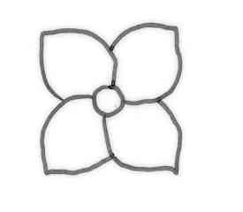
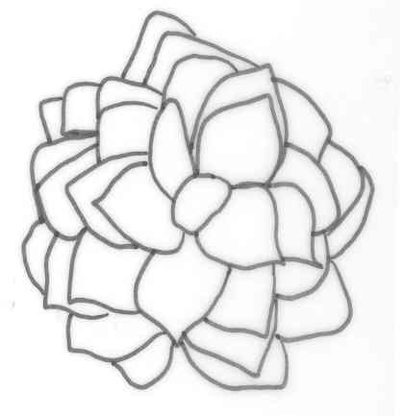
single flower
outer corolla lobes
inner corolla lobes
double flower

corolla lobe

8.2 Explanations for individual characteristics

Ad. 5: Leaf: shape

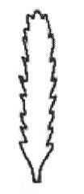
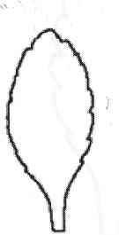
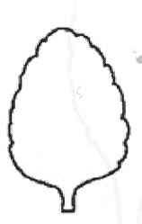
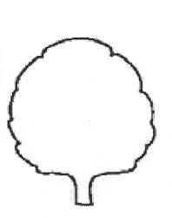
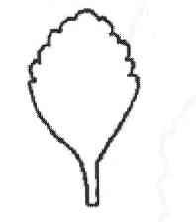
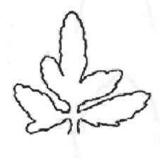

1 | 2 | 3 | 4 | 5 | 6
ovate | elliptic | rounded | linear | obovate | tripartite pinnate
Ad. 9: Leaf: cross section

1 | 3 | 5
strongly concave | flat | strongly convex

Ad. 10: Leaf: number of incisions of margin

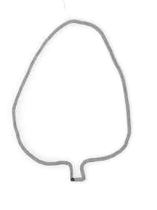
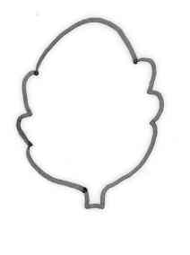
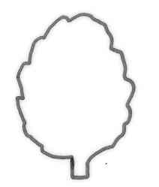
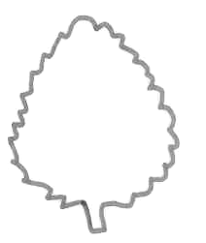

1 | 3 | 5 | 7
absent or very few | few | medium | many

In the case of pinnate leaves, the top lobe should be observed.

Ad. 11: Leaf: depth of incisions of margin
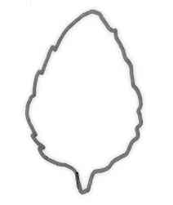
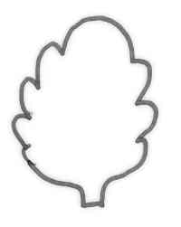
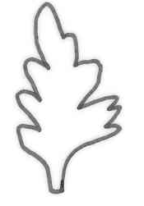

1 | 3 | 5 | 7
very shallow | shallow | medium | deep

In the case of pinnate leaves, the top lobe should be observed.

Ad. 12: Leaf: attitude of apex

(flower end)

1 | 3 | 5
strongly incurving | straight | strongly recurving

Ad. 13: Flowering shoot: number of flowers of highest pleiochasium
Ad. 14: Flowering shoot: width of highest pleiochasium

width

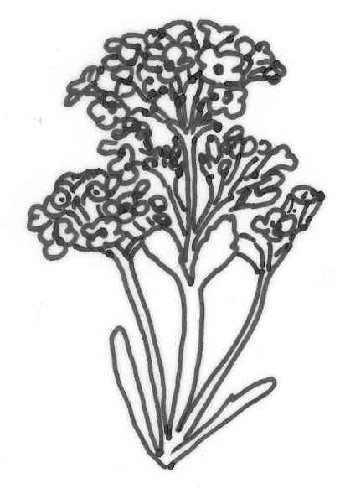
highest pleiochasium

Ad. 15: Young flower: number of colors of upper side of corolla lobes

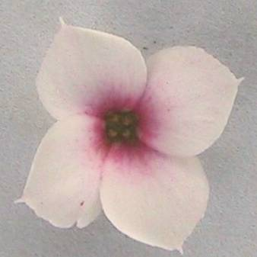
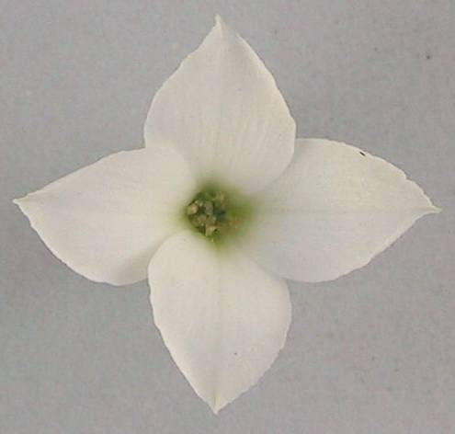

one | two
1 | 2

Ad. 18: Flower: type

A single flower has four or five corolla lobes only. A double flower has more than five corolla lobes.

Ad. 22: Only varieties with single flowers: Corolla lobe: attitude

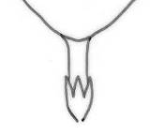
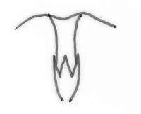
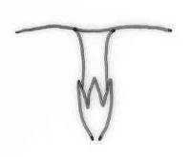

1 | 2 | 3
upwards | horizontal | downwards

Ad. 23: Corolla lobe: rolling of margin

On corolla lobes with a rolled margin present, the color of the lower side of the corolla lobes can be seen when viewing the flower from the upper side.

Ad. 24: Corolla lobe: incisions of margin
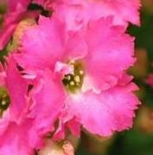
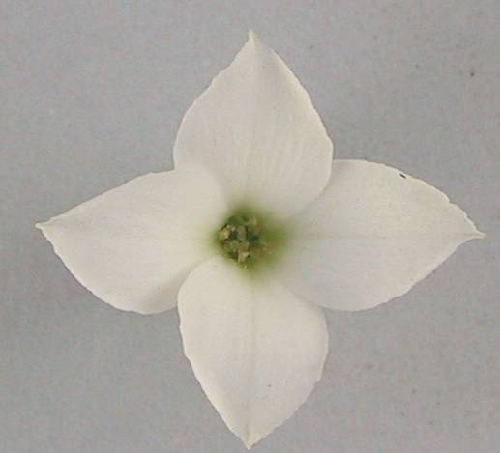

absent | present
1 | 9

Ad. 25: Corolla lobe: shape of apex

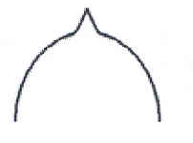
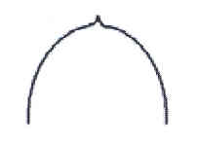
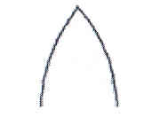

acute | apiculate | acuminate
1 | 2 | 3

Ad. 29: Corolla lobe: number of colors of upper side

one | two
1 | 2

Ad. 32: Corolla lobe: distribution of secondary color
Ad. 38: Only varieties with double flowers: outer corolla lobe: distribution of secondary color

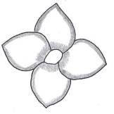
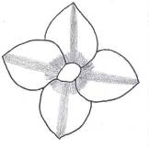
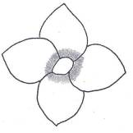
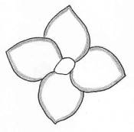

1 | 2 | 3 | 4
at margin only | at margin and base | at base only | at base and in median stripe

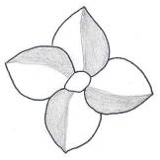
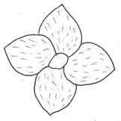
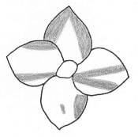
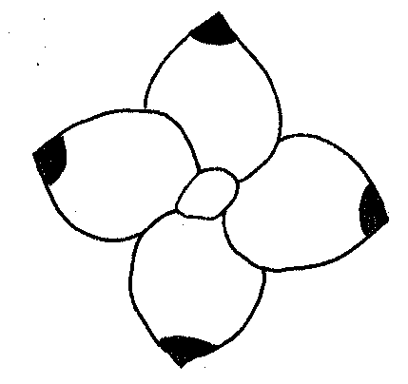
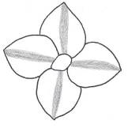

5 | 6 | 7 | 8 | 9
median stripe only | mainly on one half | dotted | brindled | at apex

(Illustrations are of single-flower varieties)

Literature
Sajeva, M., Costanzo, M., 1997: Succulents, The Illustrated Dictionary. Timber Press.

Urs, E., 1994: Sukkulenten. Ulmer, Stuttgart.

Urs, E., 2003: Illustrated Handbook of Succulent Plants. Springer.

Technical Questionnaire
TECHNICAL QUESTIONNAIRE |  |  |  | Page {x} of {y} |  | Reference Number:
 |  |  |  |  |  | Application date:
 |  |  |  |  |  | (not to be filled in by the applicant)
TECHNICAL QUESTIONNAIRE
to be completed in connection with an application for plant breeders’ rights

1. Subject of the Technical Questionnaire
1.1.1 Botanical name |  |  | Kalanchoe blossfeldiana Poelln. |  |  |  |  | [ ]
1.1.2 Common name |  |  | Kalanchoe
Hybrid: please indicate name(s) of species used in the crossing
1.2.1 Botanical name |  |  |  |  |  |  |  | [ ]
1.2.2 Common name
2. Applicant
Name
Address
Telephone No.
Fax No.
E-mail address
Breeder (if different from applicant)
3. Proposed denomination and breeder’s reference
Proposed denomination
(if available)

Breeder’s reference
#4. Information on the breeding scheme and propagation of the variety

4.1 Breeding scheme

Variety resulting from:

4.1.1 Crossing

(a) controlled cross [ ]
(please state parent varieties)
(b) partially known cross [ ]
(please state known parent variety(ies))
(c) unknown cross [ ]

4.1.2 Mutation [ ]
(please state parent variety)

4.1.3 Discovery and development [ ]
(please state where and when discovered and how developed)

4.1.4 Other [ ]
(please provide details)

4.2 Method of propagating the variety

4.2.1 Vegetative propagation

(a) cuttings [ ]
(b) in vitro propagation [ ]
(c) other (state method) [ ]

4.2.2 Other [ ]
(please provide details)

5. Characteristics of the variety to be indicated (the number in brackets refers to the corresponding characteristic in Test Guidelines; please mark the note which best corresponds).

 | Characteristics |  |  |  |  | Example Varieties |  |  | Note
5.1  (1) | Plant: height (including inflorescence)
 | very short |  |  |  |  | Avalon |  |  | 1[ ]
 | short |  |  |  |  | Rarakoe |  |  | 3[ ]
 | medium |  |  |  |  | Amy |  |  | 5[ ]
 | tall |  |  |  |  | Taos |  |  | 7[ ]
 | very tall |  |  |  |  | Petero |  |  | 9[ ]
5.2  (8) | Leaf: anthocyanin coloration of upper side
 | absent or very weak |  |  |  |  | Amy |  |  | 1[ ]
 | weak |  |  |  |  | Banda |  |  | 3[ ]
 | medium |  |  |  |  | Misunpink |  |  | 5[ ]
 | strong |  |  |  |  | Axrose |  |  | 7[ ]
5.3  (18) | Flower: type
 | single |  |  |  |  | Dark Cora |  |  | 1[ ]
 | double |  |  |  |  | Pago |  |  | 2[ ]
5.4  (20) | Only varieties with double flowers:  Flower: number of corolla lobes
 | few |  |  |  |  | RB 56141 |  |  | 3[ ]
 | medium |  |  |  |  | Naomi |  |  | 5[ ]
 | many |  |  |  |  | Yazmin |  |  | 7[ ]
5.5  (29) | Corolla lobe: number of colors of upper side  (for double flowers describe inner corolla lobes)
 | one |  |  |  |  | Amy |  |  | 1[ ]
 | two |  |  |  |  | Graciosa |  |  | 2[ ]
 | more than two |  |  |  |  | Oberon |  |  | 3[ ]
 | Characteristics |  |  |  |  | Example Varieties |  |  | Note
5.6i  (30) | Corolla lobe: main color of upper side
 | RHS Colour Chart (indicate reference number) |  |  |  |  | ……………………………………..
5.6ii  (30) | Corolla lobe: main color of upper side
 | white |  |  |  |  | Yazmin |  |  | 1[ ]
 | yellow |  |  |  |  | Ingrid |  |  | 2[ ]
 | orange |  |  |  |  | Naomi |  |  | 3[ ]
 | red |  |  |  |  | Bola |  |  | 4[ ]
 | purple red |  |  |  |  | Dorry |  |  | 5[ ]
 | purple |  |  |  |  | Kuni |  |  | 6[ ]
 | blue pink |  |  |  |  | Aniak |  |  | 7[ ]
 | other (indicate color) |  |  |  |  | ……………………………………..
5.7i  (31) | Corolla lobe: secondary color of upper side
 | RHS Colour Chart (indicate reference number) |  |  |  |  | ……………………………………..
5.7ii  (31) | Corolla lobe: secondary color of upper side
 | white |  |  |  |  | Alcedo |  |  | 1[ ]
 | yellow |  |  |  |  |  |  |  | 2[ ]
 | orange |  |  |  |  | Taos |  |  | 3[ ]
 | red |  |  |  |  |  |  |  | 4[ ]
 | purple red |  |  |  |  | Impromeru |  |  | 5[ ]
 | blue pink |  |  |  |  |  |  |  | 6[ ]
 | other (indicate color) |  |  |  |  | ……………………………………..
 | Characteristics |  |  |  |  | Example Varieties |  |  | Note
5.8  (32) | Corolla lobe: distribution of secondary color
 | at margin only |  |  |  |  | Alcedo |  |  | 1[ ]
 | at margin and at base |  |  |  |  | Mipinkstar |  |  | 2[ ]
 | at base only |  |  |  |  | Impromeru |  |  | 3[ ]
 | at base and in median stripe |  |  |  |  | Milos |  |  | 4[ ]
 | median stripe |  |  |  |  |  |  |  | 5[ ]
 | mainly on one half |  |  |  |  | Rewiros |  |  | 6[ ]
 | dotted |  |  |  |  | Greco |  |  | 7[ ]
 | brindled |  |  |  |  |  |  |  | 8[ ]
 | at apex |  |  |  |  |  |  |  | 9[ ]
 | other distribution (indicate) |  |  |  |  | ..........................................................
6. Similar varieties and differences from these varieties

Please use the following table and box for comments to provide information on how your candidate variety differs from the variety (or varieties) which, to the best of your knowledge, is (or are) most similar. This information may help the examination authority to conduct the examination of distinctness in a more efficient way.

Denomination(s) of variety(ies) similar to your candidate variety |  | Characteristic(s) in which your candidate variety differs from the similar variety(ies) |  |  | Describe the expression of the characteristic(s) for the similar variety(ies) |  | Describe the expression of the characteristic(s) for your candidate variety
Example |  | Flower: number of colors |  |  | one |  | two
#7. Additional information which may help in the examination of the variety

7.1 In addition to the information provided in sections 5 and 6, are there any additional characteristics which may help to distinguish the variety?

Yes [ ] No [ ]

(If yes, please provide details)

7.2 Are there any special conditions for growing the variety or conducting the examination?

Yes [ ] No [ ]

(If yes, please provide details):

7.3 Other information

A representative color photograph of the variety should accompany the Technical Questionnaire.

8. Authorization for release

(a) Does the variety require prior authorization for release under legislation concerning the protection of the environment, human and animal health?

Yes [ ] No [ ]

(b) Has such authorization been obtained?

Yes [ ] No [ ]

If the answer to (b) is yes, please attach a copy of the authorization.

9. Information on plant material to be examined or submitted for examination.

9.1 The expression of a characteristic or several characteristics of a variety may be affected by factors, such as pests and disease, chemical treatment (e.g. growth retardants or pesticides), effects of tissue culture, different rootstocks, scions taken from different growth phases of a tree, etc.

9.2 The plant material should not have undergone any treatment which would affect the expression of the characteristics of the variety, unless the competent authorities allow or request such treatment. If the plant material has undergone such treatment, full details of the treatment must be given. In this respect, please indicate below, to the best of your knowledge, if the plant material to be examined has been subjected to:

(a) Microorganisms (e.g. virus, bacteria, phytoplasma) Yes [ ] No [ ]

(b) Chemical treatment (e.g. growth retardant, pesticide) Yes [ ] No [ ]

(c) Tissue culture Yes [ ] No [ ]

(d) Other factors Yes [ ] No [ ]

Please provide details for where you have indicated “yes”.

……………………………………………………………

10. I hereby declare that, to the best of my knowledge, the information provided in this form is correct:

Applicant’s name

Signature Date

[End of document]

* These names were correct at the time of the introduction of these Test Guidelines but may be revised or updated. [Readers are advised to consult the UPOV Code, which can be found on the UPOV Website (www.upov.int), for the latest information.]
# Authorities may allow certain of this information to be provided in a confidential section of the Technical Questionnaire.
# Authorities may allow certain of this information to be provided in a confidential section of the Technical Questionnaire.

