 |  | E  TG/77/9

INTERNATIONAL UNION FOR THE PROTECTION  OF NEW VARIETIES OF PLANTS | UNION INTERNATIONALE POUR LA PROTECTION  DES OBTENTIONS VÉGÉTALES | INTERNATIONALER VERBAND ZUM SCHUTZ VON PFLANZEN-ZÜCHTUNGEN | UNIÓN INTERNACIONAL PARA LA PROTECCIÓN  DE LAS OBTENCIONES VEGETALES

GUIDELINES

FOR THE CONDUCT OF TESTS

FOR DISTINCTNESS, UNIFORMITY AND STABILITY

GERBERA

(Gerbera Cass.)

GENEVA
2000

Copies of this document are available on request at the price of 10 Swiss francs each, including surface mail, from the Office of UPOV, 34, chemin des Colombettes, P.O. Box 18, 1211 Geneva 20, Switzerland

This document or parts of it may be reproduced, translated and published without obtaining the specific consent of UPOV, provided that the source is acknowledged.

* * * * * * *
TG/77/9
ORIGINAL: English
DATE: 2000-04-05

INTERNATIONAL UNION FOR THE PROTECTION  OF NEW VARIETIES OF PLANTS | UNION INTERNATIONALE POUR LA PROTECTION  DES OBTENTIONS VÉGÉTALES | INTERNATIONALER VERBAND ZUM SCHUTZ VON PFLANZEN-ZÜCHTUNGEN | UNIÓN INTERNACIONAL PARA LA PROTECCIÓN  DE LAS OBTENCIONES VEGETALES

GUIDELINES

FOR THE CONDUCT OF TESTS

FOR DISTINCTNESS, UNIFORMITY AND STABILITY

GERBERA

(Gerbera Cass.)

These Guidelines should be read in conjunction with document TG/1/2, which contains explanatory notes on the general principles on which the Guidelines have been established.

TABLE OF CONTENTS PAGE

I. | Subject of these Guidelines ......................................................................... | 3
II. | Material Required ........................................................................................ | 3
III. | Conduct of Tests .......................................................................................... | 3
IV. | Methods and Observations........................................................................... | 4
V. | Grouping of Varieties .................................................................................. | 4
VI. | Characteristics and Symbols ........................................................................ | 5
VII. | Table of Characteristics ............................................................................... | 6
VIII. | Explanations on the Table of Characteristics .............................................. | 21
IX. | Literature ..................................................................................................... | 24
X. | Technical Questionnaire ............................................................................. | 25

I. Subject of these Guidelines

These Test Guidelines apply to all vegetatively propagated varieties of Gerbera Cass. of the family Compositae (Asteraceae).

II. Material Required

1. The competent authorities decide when, where and in what quantity and quality the plant material required for testing the variety is to be delivered. Applicants submitting material from a State other than that in which the testing takes place must make sure that all customs formalities are complied with. As a minimum, the following quantity of material is recommended:

12 young plants of normal commercial standard.

2. The plant material supplied should be visibly healthy, not lacking in vigor or affected by any important pests or diseases.

3. The plant material must not have undergone any treatment unless the competent authorities allow or request such treatment. If it has been treated, full details of the treatment must be given.

III. Conduct of Tests

1. A test should normally be conducted for one growing period. If distinctness and/or uniformity cannot be sufficiently established in one growing period, the test should be extended for a second growing period.

2. The test should normally be conducted at one place. If any important characteristics of the variety cannot be seen at that place, the variety may be tested at an additional place.

3. The test should be carried out in the glasshouse, in pots with well aired substrate with good water drainage under the following growing conditions.

Planting of plants
for the test: At the beginning of May (Northern Hemisphere).

Soil: Well-drained fertile soil, with a high content of organic matter. For good water drainage the pots must be first partly filled with clay granules.

Size of pot: 19 cm

Number of plants per pot: 1

Temperature: Minima of 20ºC (day) and 18ºC (night) are recommended.

Light: During periods of high light intensity shading is necessary.

The size of the tests should be such that plants or parts of plants may be removed for measurement and counting without prejudice to the observations which must be made up to the end of the growing period. Each test should include a total of 10 plants. Separate plots for observation and for measuring can only be used if they have been subject to similar environmental conditions.

4. Additional tests for special purposed may be established.

IV. Methods and Observations

1. All observations determined by measurement or counting should be made on 10 plants or parts taken from each of 10 plants.

2. For the assessment of uniformity a population standard of 1% with an acceptance probability of at least 95% should be applied. In the case of a sample size of 10 plants, the maximum number of off-types allowed would be 1.

3. Unless otherwise indicated, all observations should be made on typical organs of 10 plants at the time of full flowering. All observations on the leaf should be made on the largest leaves of the middle third of the rosette.

4. Because daylight varies, color determinations made against a color chart should be made either in a suitable cabinet providing artificial daylight or in the middle of the day in a room without direct sunlight. The spectral distribution of the illuminant for artificial daylight should conform with the CIE Standard of Preferred Daylight D 6500 and should fall within the tolerance set out in British Standard 950, Part I. These determinations should be made with the plant part placed against a white background.

V. Grouping of Varieties

1. The collection of varieties to be grown should be divided into groups to facilitate the assessment of distinctness. Characteristics which are suitable for grouping purposes are those which are known from experience not to vary, or to vary only slightly, within a variety. Their various states of expression should be fairly evenly distributed throughout the collection.

2. It is recommended that the competent authorities use the following characteristics for grouping varieties:

(a) Flower head: type (characteristic 12)
(b) Outer ray floret: color of inner side (characteristic 31)
(c) Single or semi-double varieties only: Dark disc (before opening of disc florets) (characteristic 42)

VI. Characteristics and Symbols

1. To assess distinctness, uniformity and stability, the characteristics and their states as given in the Table of Characteristics should be used.

2. Notes (numbers), for the purposes of electronic data processing, are given opposite the states of expression for each characteristic.

3. Legend:

(*) Characteristics that should be used on all varieties in every growing period over which examinations are made and always be included in the variety descriptions, except when the state of expression of a preceding characteristic or regional environmental conditions render this impossible.

(+) See Explanations on the Table of Characteristics in Chapter VIII.

VII. Table of Characteristics/Tableau des caractères/Merkmalstabelle/Tabla de caracteres

 | English | français | deutsch | español | Example Varieties  Exemples  Beispielssorten  Variedades ejemplo | Note/  Nota
1.  (*) | Leaf: length | Feuille: longueur | Blatt: Länge | Hoja: longitud
 | short | courte | kurz | corta | Planluck, Planpret | 3
 | medium | moyenne | mittel | media | Terfame | 5
 | long | longue | lang | larga | Pretalex | 7
2.  (*) | Leaf: width | Feuille: largeur | Blatt: Breite | Hoja: anchura
 | narrow | étroite | schmal | estrecha | Planluck, Planpret | 3
 | medium | moyenne | mittel | media | Pretalex | 5
 | broad | large | breit | ancha | Terflame | 7
3.  (*) | Leaf blade: blistering | Limbe: cloqûre | Blattspreite: Blasigkeit | Limbo: abullonado
 | absent or very weak | nulle ou très faible | fehlend oder sehr gering | ausente o muy débil |  | 1
 | weak | faible | gering | débil | Planluck | 3
 | medium | moyenne | mittel | medio | Ferrari | 5
 | strong | forte | stark | fuerte | Daydream | 7
 | very strong | très forte | sehr stark | muy fuerte |  | 9
4.  (*) | Leaf blade: pubescence on upper side (midrib excluded) | Limbe: pilosité sur la face supérieure (nervure principale exclue) | Blattspreite: Behaarung auf der Oberseite (ohne Mittelrippe) | Limbo: pubescencia en el haz (excluida la nervadura principal)
 | absent or very sparse | nulle ou très lâche | fehlend oder sehr locker | ausente o muy laxa | Daydream, Terflame | 1
 | sparse | lâche | locker | laxa | Ferrari | 3
 | medium | moyenne | mittel | media | Indian-Summer | 5
 | dense | dense | dicht | densa | Pretalex | 7
 | very dense | très dense | sehr dicht | muy densa |  | 9

 | English | français | deutsch | español | Example Varieties  Exemples  Beispielssorten  Variedades ejemplo | Note/  Nota
5. | Leaf blade: depth of incisions on the middle third | Limbe: profondeur des incisions du tiers moyen | Blattspreite: Tiefe der Einschnitte am mittleren Drittel | Limbo: profundidad de las incisiones en el tercio central
 | shallow | peu profondes | flach | poco profundo | Preparet, Pretaram | 3
 | medium | moyennes | mittel | medio |  | 5
 | deep | profondes | tief | profundo | Ferrari | 7
6. | Leaf blade: green color of upper side | Limbe: couleur verte de la face supérieure | Blattspreite: Grünfärbung der Oberseite | Limbo: color verde del haz
 | light | claire | hell | claro | Termoulin | 3
 | medium | moyenne | mittel | medio | Ferrari, Indian-Summer | 5
 | dark | foncée | dunkel | oscuro | Prevamoon | 7
7. | Leaf blade: shape of apex | Limbe: forme du sommet | Blattspreite: Form der Spitze | Limbo: forma del ápice
 | narrow acute | fortement aigu | schmal spitz | agudo estrecho | Luna, Otelly | 1
 | moderately acute | moyennement étroit | mittel spitz | moderadamente agudo | Ferrari, Indian-Summer | 3
 | right angle | en angle droit | rechtwinklig | en ángulo recto | Planluck, Pretaram | 5
 | obtuse | obtus | stumpf | obtuso | Bluebell | 7
 | rounded | arrondi | abgerundet | redondeado | Rosa-Lin | 9
8.  (*) | Peduncle: length | Pédoncule: longueur | Blütenstandsstiel: Länge | Pedúnculo: longitud
 | short | court | kurz | corto | Planluck | 3
 | medium | moyen | mittel | medio | Ferrari, Indian-Summer | 5
 | long | long | lang | largo | Sedandy | 7

 | English | français | deutsch | español | Example Varieties  Exemples  Beispielssorten  Variedades ejemplo | Note/  Nota
9.  (*) | Peduncle: intensity of anthocyanin coloration at base | Pédoncule: intensité de la pigmentation anthocyanique à la base | Blütenstandsstiel: Intensität der Anthocyanfärbung an der Basis | Pedúnculo: intensidad de la pigmentación antociánica en la base
 | absent or very weak | nulle ou très faible | fehlend oder sehr gering | ausente o muy débil | Victory | 1
 | weak | faible | gering | débil | Planpret, Sedandy | 3
 | medium | moyenne | mittel | media | Ferrari, Schrepal | 5
 | strong | forte | stark | fuerte | Daydream, Testarossa | 7
 | very strong | très forte | sehr stark | muy fuerte |  | 9
10. | Peduncle: anthocyanin coloration at top | Pédoncule: pigmentation anthocyanique au sommet | Blütenstandsstiel: Anthocyanfärbung am oberen Ende | Pedúnculo: pigmentación antociánica en la punta
 | absent | absente | fehlend | ausente | Ferrari, Testarossa | 1
 | present | présente | vorhanden | presente | Ashley, Lucifer | 9
11. | Peduncle: bracts below involucre | Pédoncule: bractées sous l’involucre | Blütenstandsstiel: Hüllblättern unter der Hülle | Pedúnculo: brácteas debajo del involucro
 | absent | absentes | fehlend | ausentes | Ashley, Testarossa | 1
 | present | présentes | vorhanden | presentes | Indian-Summer, Pretalex | 9
12.  (*)  (+) | Flower head: type | Capitule: type | Blütenstand: Typ | Capítulo: tipo
 | single | simple | einfach | sencillo | Lucifer | 1
 | semi-double | demi-double | halbgefüllt | semidoble | Ferrari, Indian-Summer | 2
 | double | double | gefüllt | doble | Floricitrine | 3

 | English | français | deutsch | español | Example Varieties  Exemples  Beispielssorten  Variedades ejemplo | Note/  Nota
13.  (*) | Flower head: diameter | Capitule: diamètre | Blütenstand: Durchmesser | Capítulo: diámetro
 | very small | très petit | sehr klein | muy pequeño | Teroranje | 1
 | small | petit | klein | pequeño | Ashley | 3
 | medium | moyen | mittel | medio | Daydream, Ferrari | 5
 | large | grand | groß | grande | Nevada, Premodal | 7
 | very large | très grand | sehr groß | muy grande |  | 9
14.  (+) | Semi-double or double varieties only: Flower head: diameter of mass of inner ray florets compared to that of flower head | Seulement pour les variétés demi-  doubles ou doubles: Capitule: diamètre de la masse des fleurs ligulées internes par rapport à celui du capitule | Nur halbgefüllte oder gefüllte Sorten:  Blütenstand: Durchmesser der Masse der inneren Zungenblüten im Vergleich zum Durchmesser des Blütenstandes | Variedades semidobles o dobles únicamente: Capítulo: diámetro de la masa de las flores liguladas interiores comparado con el del capítulo
 | small | petit | klein | pequeño | Indian-Summer, Nevada | 3
 | medium | moyen | mittel | medio | Ferrari | 5
 | large | grand | groß | grande | Baby-Doll, Bugatti | 7
15.  (+) | Semi-double or double varieties only: Flower head: border of mass of inner ray florets | Seulement pour les variétés demi-  doubles ou doubles:  Capitule: bord de la masse des fleurs ligulées internes | Nur halbgefüllte oder gefüllte Sorten:  Blütenstand: Rand der Masse der inneren Zungenblüten | Variedades semidobles o dobles únicamente: Capítulo: borde de la masa de las flores liguladas interiores
 | regular | régulier | regelmäßig | regular | Testarossa | 1
 | irregular | irrégulier | unregelmäßig | irregular | Ferrari | 2
16. | Flower head: height of involucre | Capitule: hauteur de l’involucre | Blütenstand: Höhe der Hülle | Capítulo: altura del involucro
 | short | basse | niedrig | bajo | Charlim, Flocarin | 3
 | medium | moyenne | mittel | medio | Daydream, Ferrari | 5
 | tall | haute | hoch | alto | Ashley, Planluck | 7

 | English | français | deutsch | español | Example Varieties  Exemples  Beispielssorten  Variedades ejemplo | Note/  Nota
17. | Flower head: diameter of involucre | Capitule: diamètre de l’involucre | Blütenstand: Durchmesser der Hülle | Capítulo: diámetro del involucro
 | small | petit | klein | pequeño | Baby-Doll, Terflash | 3
 | medium | moyen | mittel | medio | Ferrari, Indian-Summer | 5
 | large | grand | groß | grande | Moana, Zsa-Zsa | 7
18. | Flower head: position of distal part of bracts in relation to outer ray florets | Capitule: position de la partie distale des bractées par rapport aux fleurs ligulées externes | Blütenstand: Stellung des oberen Teils der Hüllblätter im Verhältnis zu den äußeren Zungenblüten | Capítulo: posición de la parte distal de las brácteas en relación con las flores liguladas exteriores
 | apart | écartée | getrennt | separada | Ferrair, Indian-Summer | 1
 | touching | contiguë | sich berührend | en contacto | Testarossa, Zsa-Zsa | 9
19.  (*) | Flower head: anthocyanin coloration at distal part of inner bracts | Capitule: pigmentation anthocyanique au niveau de la partie distale des bractées internes | Blütenstand: Anthocyanfärbung am oberen Teil der inneren Hüllblätter | Capítulo: pigmentación antociánica en la parte distal de las brácteas interiores
 | absent | absente | fehlend | ausente | Baby-Doll, Ferrari | 1
 | present | présente | vorhanden | presente | Ashley, Nevada | 9
20. | Flower head: intensity of anthocyanin coloration at distal part of inner bracts | Capitule: intensité de la pigmentation anthocyanique au niveau de la partie distale des bractées internes | Blütenstand: Intensität der Anthocyanfärbung am oberen Teil der inneren Hüllblätter | Capitulo: intensidad de la pigmentación antociánica en la parte distal de las brácteas interiores
 | weak | faible | gering | débil | Moana, Planpret | 3
 | medium | moyenne | mittel | media | Lucifer, Zsa-Zsa | 5
 | strong | forte | stark | fuerte | Terthermo | 7

 | English | français | deutsch | español | Example Varieties  Exemples  Beispielssorten  Variedades ejemplo | Note/  Nota
21.  (+) | Outer ray floret: level of apex relative to top of involucre | Fleur ligulée externe: niveau du sommet par rapport au sommet de l’involucre | Äußere Zungenblüte: Höhe der Spitze im Verhältnis zum oberen Ende der Hülle | Flor ligulada exterior: nivel del ápice en relación con la punta del involucro
 | below | au-dessous | unterhalb | debajo | Daydream | 1
 | same level | au même niveau | auf gleicher Höhe | mismo nivel | Indian-Summer, Pretalex | 2
 | above | au-dessus | oberhalb | encima | Ashley, Nevada | 3
22.  (*) | Outer ray floret: shape | Fleur ligulée externe: forme | Äußere Zungenblüte: Form | Flor ligulada exterior: forma
 | narrow elliptic | elliptique étroite | schmal elliptisch | elíptica estrecha | Ashley, Ferrari | 1
 | narrow obovate | obovale étroite | schmal verkehrt eiförmig | obovada estrecha | Baby-Doll, Teroranje | 2
23.  (*) | Outer ray floret: longitudinal axis | Fleur ligulée externe: axe longitudinal | Äußere Zungenblüte: Längsachse | Flor ligulada exterior: eje longitudinal
 | strongly incurving | fortement incurvé | stark aufgebogen | fuertemente curvado hacia arriba | Floricitrine | 1
 | moderately incurving | moyennement incurvé | gering aufgebogen | moderadamente curvado hacia arriba |  | 2
 | straight | droit | gerade | recto | Ferrari | 3
 | moderately reflexing | moyennement réfléchi | gering zurückgebogen | moderadamente curvado hacia abajo | Ashley, Indian-Summer | 4
 | strongly reflexing | fortement réfléchi | stark zurückgebogen | fuertemente curvado hacia abajo |  | 5

 | English | français | deutsch | español | Example Varieties  Exemples  Beispielssorten  Variedades ejemplo | Note/  Nota
24. | Inner ray floret: longitudinal axis | Fleur ligulée interne: axe longitudinal | Innere Zungenblüte: Längsachse | Flor ligulada exterior: eje longitudinal
 | strongly incurving | fortement incurvé | stark aufgebogen | fuertemente incurvado | Floricitrine | 1
 | moderately incurving | moyennement incurvé | gering aufgebogen | moderadamente incurvado | Eeuwsar | 2
 | straight | droit | gerade | recto | Ferrari, Moana | 3
 | moderately reflexing | moyennement réfléchi | gering zurückgebogen | moderadamente recurvado | Ashley, Nevada | 4
 | strongly reflexing | fortement réfléchi | stark zurückgebogen | fuertemente recurvado |  | 5
25.  (*) | Outer ray floret: profile in cross section of middle part of ray | Fleur ligulée externe: profil de la section transversale du milieu de la ligule | Äußere Zungenblüte: Profil im Querschnitt des Mittelteils der Zunge | Flor ligulada exterior: perfil en sección transversal de la parte mediana de la lígula
 | concave | concave | konkav | cóncavo | Floricitrine, Terflorin | 1
 | straight | droite | gerade | recto | Ashley, Indian-Summer | 2
 | convex | convexe | konvex | convexo | Ferrari, Planpret | 3
26.  (*) | Outer ray floret: length | Fleur ligulée externe: longueur | Äußere Zungenblüte: Länge | Flor ligulada exterior: longitud
 | very short | très courte | sehr kurz | muy corta | Tersnow | 1
 | short | courte | kurz | corta | Ashley, Teroranje | 3
 | medium | moyenne | mittel | media | Ferrari, Indian-Summer | 5
 | long | longue | lang | larga | Nevada, Testarossa | 7
 | very long | très longue | sehr lang | muy larga |  | 9

 | English | français | deutsch | español | Example Varieties  Exemples  Beispielssorten  Variedades ejemplo | Note/  Nota
27.  (*) | Outer ray floret: width | Fleur ligulée externe: largeur | Äußere Zungenblüte: Breite | Flor ligulada exterior: anchura
 | narrow | étroite | schmal | estrecha | Planluck, Tersnow | 3
 | medium | moyenne | mittel | media | Ashley, Ferrari | 5
 | broad | large | breit | ancha | Planorg | 7
28. | Outer ray floret: shape of apex | Fleur ligulée externe: forme du sommet | Äußere Zungenblüte: Form der Spitze | Flor ligulada exterior: forma del ápice
 | pointed | pointu | spitz | puntiagudo | Ferrari, Tersnow | 1
 | rounded | arrondi | abgerundet | redondeado | Ashley, Pretalex | 2
29. | Outer ray floret: depth of incisions | Fleur ligulée externe: profondeur des découpures | Äußere Zungenblüte: Tiefe der Einschnitte | Flor ligulada exterior: profundidad de las incisiones
 | absent or very shallow | absentes ou très peu profondes | fehlend oder sehr flach | ausente o poco profunda | Planpret | 1
 | shallow | peu profondes | flach | poco profunda | Nevada | 3
 | medium | moyennes | mittel | media | Ashley, Ferrari | 5
 | deep | profondes | tief | profunda | Pretatrix | 7
 | very deep | très profondes | sehr tief | muy profunda | Daydream, Lucifer | 9
30.  (+) | Outer ray floret: tendency to form long free petals | Fleur ligulée externe: tendance à présenter de longs pétales libres | Äußere Zungenblüte: Neigung zur Bildung langer freier Blütenblätter | Flor ligulada exterior: tendencia a formar largos pétalos libres
 | absent | absente | fehlend | ausente | Ashley, Baby-Doll | 1
 | present | présente | vorhanden | presente | Ferrari, Tersnow | 9

 | English | français | deutsch | español | Example Varieties  Exemples  Beispielssorten  Variedades ejemplo | Note/  Nota
31.  (*) | Outer ray floret: color of inner side | Fleur ligulée externe: couleur de la face interne | Äußere Zungenblüte: Farbe der Innenseite | Flor ligulada exterior: color del lado interno
 | RHS Colour Chart  (Indicate reference number) | Code RHS des couleurs  (indiquer le numéro de référence) | RHS-Farbkarte  (Referenznummer angeben) | diágrama de colores RHS  (Indíquese el número de referencia)
32.  (*) | Outer ray floret: number of colors | Fleur ligulée externe: nombre de couleurs | Äußere Zungenblüte: Anzahl Farben | Flor ligulada exterior: número de colores
 | one | une | eine | un | Ferrari, Nevada | 1
 | two | deux | zwei | dos | Indian-Summer, Terbase | 2
33. | Single colored varieties only: Outer ray floret only: distribution of color | Seulement pour les variétés unicolores: Fleur ligulée externe uniquement: répartition de la couleur | Nur einfarbige Sorten: Nur äußere Zungenblüte: Verteilung der Farbe | Variedades de un solo color únicamente: Flor ligulada exterior únicamente: distribución del color
 | none | nulle | fehlend | ausente | Ferrari, Indian-Summer | 1
 | lighter towards base | plus claire vers la base | heller zur Basis | más claro en la base | Planper | 2
 | lighter towards top | plus claire vers le sommet | heller zum oberen Ende | más claro en la parte superior | Indian-Summer, Nevada | 3
34. | Outer ray floret: presence of striation | Fleur ligulée externe: striure | Äußere Zungenblüte: Vorhandensein von Streifen | Flor ligulada exterior: presencia de estrías
 | absent | absente | fehlend | ausentes | Ashley, Ferrari | 1
 | present | présente | vorhanden | presentes | Indian-Summer, Planluck | 9

 | English | français | deutsch | español | Example Varieties  Exemples  Beispielssorten  Variedades ejemplo | Note/  Nota
35. | Bicolored varieties only: Outer ray floret: secondary color at basal half | Seulement pour les variétés bicolores: Fleur ligulée externe: couleur secondaire au niveau de la moitié basale | Nur zweifarbige Sorten: Äußere Zungenblüte: sekundäre Farbe an der basalen Hälfte | Variedades bicolores únicamente: Flor ligulada exterior: color secundario en la mitad inferior
 | absent | absente | fehlend | ausente | Baby-Doll | 1
 | present | présente | vorhanden | presente | Planper | 9
36. | Bicolored varieties only: Outer ray floret: secondary color at distal half | Seulement pour les variétés bicolores: Fleur ligulée externe: couleur secondaire au niveau de la moitié distale | Nur zweifarbige Sorten: Äußere Zungenblüte: sekundäre Farbe an der distalen Hälfte | Variedades bicolores únicamente: Flor ligulada exterior: color secundario en la mitad distal
 | absent | absente | fehlend | ausente | Indian-Summer, Planper | 1
 | present | présente | vorhanden | presente | Baby-Doll | 9
37. | Bicolored varieties only: Outer ray floret: secondary color at margin | Seulement pour les variétés bicolores: Fleur ligulée externe: couleur secondaire au bord | Nur zweifarbige Sorten: Äußere Zungenblüte: sekundäre Farbe am Rand | Variedades bicolores únicamente: Flor ligulada exterior: color secundario en el borde
 | absent | absente | fehlend | ausente | Baby-Doll, Indian-Summer | 1
 | present | présente | vorhanden | presente | Terflame | 9
38. | Bicolored varieties only: Outer ray floret: secondary color at tip only | Seulement pour les variétés bicolores: Fleur ligulée externe: couleur secondaire au sommet uniquement | Nur zweifarbige Sorten: Äußere Zungenblüte: sekundäre Farbe nur an der Spitze | Variedades bicolores únicamente: Flor ligulada exterior: color secundario en la punta únicamente
 | absent | absente | fehlend | ausente | Indian-Summer | 1
 | present | présente | vorhanden | presente | Baby-Doll, Terfetti | 9

 | English | français | deutsch | español | Example Varieties  Exemples  Beispielssorten  Variedades ejemplo | Note/  Nota
39. | Bicolored varieties only: Outer ray floret: secondary color | Seulement pour les variétés bicolores: Fleur ligulée externe: couleur secondaire | Nur zweifarbige Sorten: Äußere Zungenblüte: sekundäre Farbe | Variedades bicolores únicamente: Flor ligulada exterior: color secundario
 | white | blanc | weiß | blanco | Baby-Doll | 1
 | yellow | jaune | gelb | amarillo | Planper, Terflame | 2
 | orange | orange | orange | anaranjado | Indian-Summer | 3
 | pink | rose | rosa | rosa | Terfetti | 4
 | red | rouge | rot | rojo | Glory | 5
 | purple | pourpre | purpur | púrpura | Josiane | 6
40. | Outer ray floret: main color of outer side | Fleur ligulée externe: couleur principale de la face externe | Äußere Zungenblüte: Hauptfarbe der Außenseite | Flor ligulada exterior: color principal del lado exterior
 | white | blanc | weiß | blanco | Baby-Doll | 1
 | yellow white | blanc-jaune | gelbweiß | blanco amarillento | Tersnow | 2
 | yellow green | vert-jaune | gelbgrün | verde amarillento | Ashley | 3
 | green | vert | grün | verde | Adventure, Terstrom | 4
 | yellow | jaune | gelb | amarillo | Indian-Summer, Nevada | 5
 | orange | orange | orange | anaranjado | Daydream, Ferrari | 6
 | pink | rose | rosa | rosa | Planpret, Zsa-Zsa | 7
 | red | rouge | rot | rojo | Lucifer, Testarossa | 8
 | purple | pourpre | purpur | púrpura | Moana | 9
41. | Single or semi-double varieties only: Disc: diameter | Seulement pour les variétés simples ou demi-doubles: Disque: diamètre | Nur einfache oder halbgefüllte Sorten: Scheibe: Durchmesser | Variedades sencillos o semidobles solamente: Disco: diámetro
 | small | petit | klein | pequeño | Tersnow | 3
 | medium | moyen | mittel | medio | Ashley, Lucifer | 5
 | large | grand | groß | grande | Floru | 7

 | English | français | deutsch | español | Example Varieties  Exemples  Beispielssorten  Variedades ejemplo | Note/  Nota
42.  (*) | Single or semi-double varieties only: Dark disc (before opening of disc florets) | Seulement pour les variétés simples ou demi-doubles: Disque sombre (avant l’ouverture des fleurons) | Nur einfache oder halbgefüllte Sorten: Dunkle Scheibe (vor dem Öffnen der Röhrenblüten) | Variedades sencillos o semidobles solamente: Disco oscuro (antes de abrirse las florecillas del disco)
 | absent | absent | fehlend | ausente | Baby-Doll, Ferrari | 1
 | present | présent | vorhanden | presente | Ashley, Indian-Summer | 9
43.  (*) | Single varieties only: Disc florets of outer rows: main color of perianth lobes | Seulement pour les variétés simples: Fleurons des rangs externes: couleur principale des lobes du périanthe | Nur einfache Sorten: Röhrenblüten der äußeren Reihen: Hauptfarbe der Blütenhüllenlappen | Variedades sencillos solamente: Florecillas del disco de las hileras exteriores: color principal de los lóbulos del perianto
 | white | blanc | weiß | blanco | Tersnow | 1
 | yellow | jaune | gelb | amarillo | Bugatti, Nevada | 2
 | orange | orange | orange | anaranjado | Daydream, Indian-Summer | 3
 | pink | rose | rosa | rosa | Ashley, Baby-Doll | 4
 | red | rouge | rot | rojo | Ferrari, Lucifer | 5
 | purple | pourpre | purpur | púrpura | Planpret | 6
 | brown | brun | braun | marrón |  | 7
44.  (*) | Semi-double and double varieties only: Disc florets of outer rows: main color of perianth lobes | Seulement pour les variétés demi-doubles ou doubles: Fleurons des rangs externes: couleur principale des lobes du périanthe | Nur halbgefüllte und gefüllte Sorten: Röhrenblüten der äußeren Reihen: Hauptfarbe der Blütenhüllenlappen | Variedades semidobles y dobles únicamente: Florecillas de disco de las hileras exteriores: color principal de los lóbulos del perianto
 | RHS Colour Chart (indicate reference number) | Code RHS des couleurs (indiquer le numéro de référence) | RHS-Farbkarte (Referenznummer angeben) | Carta de colores RHS (indíquese el número de referencia)

 | English | français | deutsch | español | Example Varieties  Exemples  Beispielssorten  Variedades ejemplo | Note/  Nota
45. | Disc: main color of perianth lobes of bisexual florets | Disque: couleur principale des lobes du périanthe des fleurs bisexuées | Scheibe: Hauptfarbe der Blütenhüllenlappen der bisexuellen Blüten | Disco: color princial de los lóbulos del perianto de las florecillas bisexuadas
 | white | blanc | weiß | blanco | Tersnow | 1
 | yellow | jaune | gelb | amarillo | Indian-Summer, Nevada | 2
 | orange | orange | orange | anaranjado | Daydream | 3
 | pink | rose | rosa | rosa | Ashley, Baby-Doll | 4
 | red | rouge | rot | rojo | Ferrari, Zsa-Zsa | 5
 | purple | pourpre | purpur | púrpura | Planpret | 6
 | brown | brun | braun | marrón |  | 7
46.  (*) | Style: main color of distal part | Style: couleur principale de la partie distale | Griffel: Hauptfarbe des oberen Endes | Pistilo: color principal de la parte distal
 | white | blanc | weiß | blanco | Ferrari, Nevada | 1
 | yellow | jaune | gelb | amarillo | Indian-Summer, Lucifer | 2
 | orange | orange | orange | anaranjado | Bugatti, Testarossa | 3
 | pink | rose | rosa | rosa | Floru, Zsa-Zsa | 4
 | red | rouge | rot | rojo | Ponsy | 5
 | purple | pourpre | purpur | púrpura | Ashley | 6
 | brown | brun | braun | marrón |  | 7

 | English | français | deutsch | español | Example Varieties  Exemples  Beispielssorten  Variedades ejemplo | Note/  Nota
47. | Stigma: main color | Stigmate: couleur principale | Narbe: Hauptfarbe | Estigma: color principal
 | white | blanc | weiß | blanco | Ashley, Tersnow | 1
 | yellow | jaune | gelb | amarillo | Ferrari, Terflash | 2
 | orange | orange | orange | anaranjado | Jodi, Sunburn | 3
 | pink | rose | rosa | rosa | Ponsy | 4
 | red | rouge | rot | rojo | Teractie | 5
 | purple | pourpre | purpur | púrpura | Bluebell, Commodore | 6
 | brown | brun | braun | marrón | Malou | 7
48. | Anthers: main color | Anthères: couleur principale | Staubblätter: Hauptfarbe | Anteras: color principal
 | yellow | jaune | gelb | amarillo | Ferrari | 1
 | orange | orange | orange | anaranjado | Indian-Summer, Tersnow | 2
 | pink | rose | rosa | rosa | Alami, Sunburn | 3
 | red | rouge | rot | rojo | Amarou | 4
 | purple | pourpre | purpur | púrpura | Tersanne | 5
 | brown | brun | braun | marrón | Shanty | 6
49. | Anthers: color of top relative to other parts | Anthères: couleur du sommet par rapport aux autres parties | Staubblätter: Farbe der Spitze im Verhältnis zu anderen Teilen | Anteras: color del extremo en relación con las demás partes
 | lighter | plus claire | heller | más claro | Ferrari, Terflash | 1
 | same | identique | gleich | el mismo | Indian-Summer, Tersnow | 2
 | darker | plus sombre | dunkler | más oscuro | Ashley, Nevada | 3

 | English | français | deutsch | español | Example Varieties  Exemples  Beispielssorten  Variedades ejemplo | Note/  Nota
50. | Anthers: longitudinal stripes | Anthères: stries longitudinales | Staubblätter: Längsstreifen | Anteras: rayas longitudinales
 | absent | absentes | fehlend | ausentes | Ferrari, Indian-Summer | 1
 | present | présentes | vorhanden | presentes | Ashley, Nevada | 9
51.  (*) | Pappus: color of top relative to other parts | Pappus: couleur du sommet par rapport aux autres parties | Pappus: Farbe des oberen Endes im Verhältnis zu anderen Teilen | Papus: color del extremo en relación con las demás partes
 | lighter | plus claire | heller | más claro |  | 1
 | same | identique | gleich | el mismo | Ferrari, Tersnow | 2
 | darker | plus sombre | dunkler | más oscuro | Ashley, Lucifer | 3
52. | Pappus: level of top relative to closed disc florets | Pappus: niveau du sommet par rapport aux fleurons fermés | Pappus: Höhe des oberen Endes im Verhältnis zu den geschlossenen Röhrenblüten | Papus: nivel del extremo en relación con las florecillas de disco cerradas
 | below | au-dessous | unterhalb | debajo | Baby-Doll | 1
 | same level | au même niveau | auf gleicher Höhe | mismo nivel | Indian-Summer | 2
 | above | au-dessus | oberhalb | encima | Ferrari, Tersnow | 3

VIII. Explanations on the Table of Characteristics

Ad. 12: Flower head: type

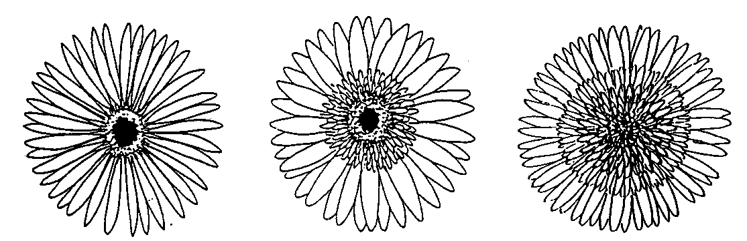

1 | 2 | 3
single | semi-double | double

Ad. 14: Semi-double or double varieties only: Flower head: diameter of mass of inner ray florets (A) compared to that of flower head (B)

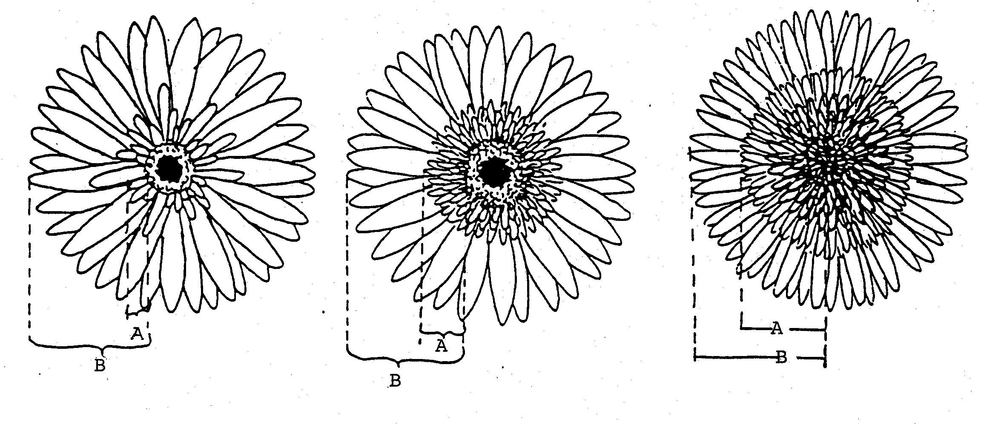

3 | 5 | 7
small | medium | large

Ad. 15: Semi-double or double varieties only: Flower head: border of mass of inner ray 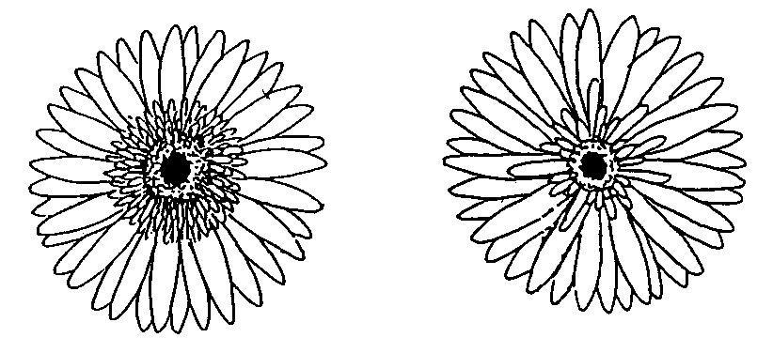florets

1 | 2
regular | irregular

Ad. 21: Outer ray floret: level of apex relative to top of involucre

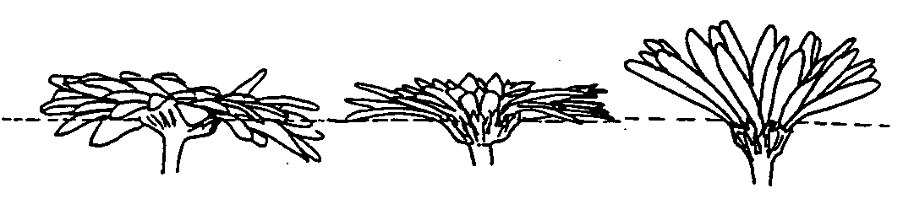

1 | 2 | 3
below | same level | above

Ad. 30: Outer ray floret: tendency to form long free petals

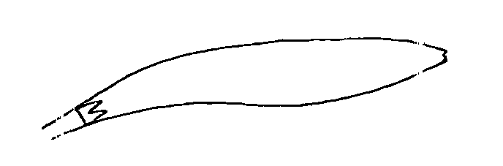

1
absent

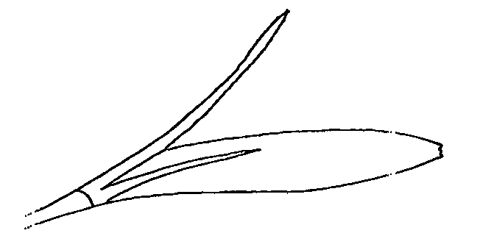

9
present
IX. Literature

Hansen, H.V., 1985: “A Taxanomic Revision of the Genus Gerbera (Compositae, Mitiseae), Sections Gerbera, Parra, Pieloselloides (in Africa) and Lasropus”, Opera Botanica, Vl. 78, pp. 5-36.

Hilliard, O.M., 1977: “Compositae in Natal”, University of Natal Press, Pietermaritzburg, ZA.

X. Technical Questionnaire

Reference Number
(not to be filled in by the applicant)

TECHNICAL QUESTIONNAIRE
to be completed in connection with an application for plant breeders’ rights

1. Species Gerbera Cass.

GERBERA (vegetatively propagated)

2. Applicant (Name and address)

3. Proposed denomination or breeder’s reference

4. Information on origin, maintenance and reproduction of the variety

4.1 Origin

- Seedling (indicate parent varieties)

................................................................................................ [ ]

- Mutation (indicate parent variety)

................................................................................................ [ ]

- Discovery (indicate where and when)

................................................................................................ [ ]

- Other (specify)

................................................................................................ [ ]

4.2 Method of reproduction

- cuttings [ ]

- in vitro propagation [ ]

- other (state method) [ ]

4.3 Other information

5. Characteristics of the variety to be indicated (the number in brackets refers to the corresponding characteristic in Test Guidelines; please mark the state of expression which best corresponds).

 | Characteristics |  |  |  | Example Varieties |  | Note
5.1  (12) |  |  | Flower head: type
 |  | single |  |  | Lucifer |  | 1[ ]
 |  | semi-double |  |  | Ferrari, Indian-Summer |  | 2[ ]
 |  | double |  |  | Floricitrine |  | 3[ ]
5.2  (31) |  | Outer ray floret: color of inner side
 |  | RHS Colour chart (indicate reference number) |  |  | ………………………………………
5.3  (42) |  | Single or semi-double varieties only: Dark disc (before opening of disc florets)
 |  | absent |  |  | Baby-Doll, Ferrari |  | 1[ ]
 |  | present |  |  | Ashley, Indian-Summer |  | 9[ ]
5.4  (43) | Single varieties only: Disc florets of outer rows: main color of perianth lobes
 | white |  |  |  | Tersnow |  | 1[ ]
 | yellow |  |  |  | Bugatti, Nevada |  | 2[ ]
 | orange |  |  |  | Daydream, Indian-Summer |  | 3[ ]
 | pink |  |  |  | Ashley, Baby-Doll |  | 4[ ]
 | red |  |  |  | Ferrari, Lucifer |  | 5[ ]
 | purple |  |  |  | Planpret |  | 6[ ]
 | brown |  |  |  |  |  | 7[ ]
5.5  (44) | Semi-double and double varieties only: Disc florets of outer rows: main color of perianth lobes
 | RHS Colour Chart (indicate reference number) |  |  |  | ………………………………………

6. Similar varieties and differences from these varieties

Denomination of similar variety | Characteristic in which the similar variety is different ^{o)} | State of expression of similar variety | State of expression of candidate variety
______________
^{o)} In the case of identical states of expressions of both varieties, please indicate the size of the difference.

7. Additional information which may help to distinguish the variety

7.1 Resistance to pest and diseases

7.2 Special conditions for the examination of the variety

7.3 Other information

A representative color photo of the variety should be added to the Technical Questionnaire.

8. Authorization for release

(a) Does the variety require prior authorization for release under legislation concerning the protection of the environment, human and animal health?

Yes [ ] No [ ]

(b) Has such authorization been obtained?

Yes [ ] No [ ]

If the answer to that question is yes, please attach a copy of such an authorization.

[End of document]

