 |  | E  TG/70/4 Rev.  ORIGINAL: English  DATE: 2007-03-28
INTERNATIONAL UNION FOR THE PROTECTION OF NEW VARIETIES OF PLANTS
GENEVA

 | APRICOT  UPOV Code: PRUNU_ARM  Prunus armeniaca L. | *

GUIDELINES

FOR THE CONDUCT OF TESTS

FOR DISTINCTNESS, UNIFORMITY AND STABILITY

Alternative Names:*
Botanical name | English | French | German | Spanish
Prunus armeniaca L.,  Armeniaca vulgaris Lam. | Apricot | Abricotier | Aprikose, Marille | Albaricoquero, Chabacano, Damasco

The purpose of these guidelines (“Test Guidelines”) is to elaborate the principles contained in the General Introduction (document TG/1/3), and its associated TGP documents, into detailed practical guidance for the harmonized examination of distinctness, uniformity and stability (DUS) and, in particular, to identify appropriate characteristics for the examination of DUS and production of harmonized variety descriptions.

ASSOCIATED DOCUMENTS

These Test Guidelines should be read in conjunction with the General Introduction and its associated TGP documents.
TABLE OF CONTENTS PAGE

1. Subject of these Test Guidelines 3
2. Material Required 3
3. Method of Examination 3
3.1 Number of Growing Cycles 3
3.2 Testing Place 3
3.3 Conditions for Conducting the Examination 3
3.4 Test Design 4
3.5 Number of Plants / Parts of Plants to be Examined 4
3.6 Additional Tests 4
4. Assessment of Distinctness, Uniformity and Stability 4
4.1 Distinctness 4
4.2 Uniformity 5
4.3 Stability 5
5. Grouping of Varieties and Organization of the Growing Trial 5
6. Introduction to the Table of Characteristics 6
6.1 Categories of Characteristics 6
6.2 States of Expression and Corresponding Notes 6
6.3 Types of Expression 6
6.4 Example Varieties 6
6.5 Legend 6
7. Table of Characteristics/Tableau des caractères/Merkmalstabelle/Tabla de caracteres 7
8. Explanations on the Table of Characteristics 23
8.1 Explanations Covering Several Characteristics 23
8.2 Explanations for Individual Characteristics 23
8.3 Synonym(s) of Example Varieties 31
9. Literature 32
10. Technical Questionnaire 34

Subject of these Test Guidelines
These Test Guidelines apply to all varieties of Prunus armeniaca L.

Material Required
2.1 The competent authorities decide on the quantity and quality of the plant material required for testing the variety and when and where it is to be delivered. Applicants submitting material from a State other than that in which the testing takes place must ensure that all customs formalities and phytosanitary requirements are complied with.

2.2 The material is to be supplied in the form of one-year-old grafts, budsticks or dormant shoots for grafting.

2.3 The minimum quantity of plant material, to be supplied by the applicant, should be:

5 trees (one-year-old grafts) or
5 budsticks or
5 dormant shoots for grafting.

The rootstock to be used is specified by the competent authority.

2.4 The plant material supplied should be visibly healthy, not lacking in vigor, nor affected by any important pest or disease.

2.5 The plant material should not have undergone any treatment which would affect the expression of the characteristics of the variety, unless the competent authorities allow or request such treatment. If it has been treated, full details of the treatment must be given.

Method of Examination

3.1 Number of Growing Cycles
The minimum duration of tests should normally be two independent growing cycles. The growing cycle is considered to be the duration of a single growing season, beginning with bud burst, and concluding when the following dormant period ends with the swelling of new season buds.

3.2 Testing Place
Tests are normally conducted at one place. In the case of tests conducted at more than one place, guidance is provided in TGP/9 “Examining Distinctness.”

3.3 Conditions for Conducting the Examination
The tests should be carried out under conditions ensuring satisfactory growth for the expression of the relevant characteristics of the variety and for the conduct of the examination. In particular, it is essential that the trees produce a satisfactory crop of fruit in each of the two growing cycles.

3.4 Test Design
3.4.1 Each test should be designed to result in a total of at least 5 trees.

3.4.2 The design of the tests should be such that plants or parts of plants may be removed for measurement or counting without prejudice to the observations which must be made up to the end of the growing cycle.

3.5 Number of Plants / Parts of Plants to be Examined
Unless otherwise indicated, all observations should be made on 5 plants or parts taken from each of 5 plants. In the case of parts of plants, the number to be taken from each of the plants should be 3.

3.6 Additional Tests
Additional tests, for examining relevant characteristics, may be established.

Assessment of Distinctness, Uniformity and Stability

4.1 Distinctness

4.1.1 General Recommendations
It is of particular importance for users of these Test Guidelines to consult the General Introduction prior to making decisions regarding distinctness. However, the following points are provided for elaboration or emphasis in these Test Guidelines.

4.1.2 Consistent Differences
The differences observed between varieties may be so clear that more than one growing cycle is not necessary. In addition, in some circumstances, the influence of the environment is not such that more than a single growing cycle is required to provide assurance that the differences observed between varieties are sufficiently consistent. One means of ensuring that a difference in a characteristic, observed in a growing trial, is sufficiently consistent is to examine the characteristic in at least two independent growing cycles.

4.1.3 Clear Differences
Determining whether a difference between two varieties is clear depends on many factors, and should consider, in particular, the type of expression of the characteristic being examined, i.e. whether it is expressed in a qualitative, quantitative, or pseudo-qualitative manner. Therefore, it is important that users of these Test Guidelines are familiar with the recommendations contained in the General Introduction prior to making decisions regarding distinctness.

4.2 Uniformity
4.2.1 It is of particular importance for users of these Test Guidelines to consult the General Introduction prior to making decisions regarding uniformity. However, the following points are provided for elaboration or emphasis in these Test Guidelines:

4.2.2 For the assessment of uniformity, a population standard of 1% and an acceptance probability of at least 95% should be applied. In the case of a sample size of 5 plants, no off-types are allowed.

4.3 Stability
4.3.1 In practice, it is not usual to perform tests of stability that produce results as certain as those of the testing of distinctness and uniformity. However, experience has demonstrated that, for many types of variety, when a variety has been shown to be uniform, it can also be considered to be stable.

4.3.2 Where appropriate, or in cases of doubt, stability may be tested, either by growing a further generation, or by testing a new plant stock to ensure that it exhibits the same characteristics as those shown by the previous material supplied.

Grouping of Varieties and Organization of the Growing Trial
5.1 The selection of varieties of common knowledge to be grown in the trial with the candidate varieties and the way in which these varieties are divided into groups to facilitate the assessment of distinctness are aided by the use of grouping characteristics.

5.2 Grouping characteristics are those in which the documented states of expression, even where produced at different locations, can be used, either individually or in combination with other such characteristics: (a) to select varieties of common knowledge that can be excluded from the growing trial used for examination of distinctness; and (b) to organize the growing trial so that similar varieties are grouped together.

5.3 The following have been agreed as useful grouping characteristics:

(a) Fruit: size (characteristic 28)
(b) Fruit: ground color of skin (characteristic 44)
(c) Fruit: relative area of over color (characteristic 45)
(d) Fruit: color of flesh (characteristic 49)
(e) Time of beginning of flowering (characteristic 56)
(f) Time of beginning of fruit ripening (characteristic 57).

5.4 Guidance for the use of grouping characteristics, in the process of examining distinctness, is provided through the General Introduction.

Introduction to the Table of Characteristics

6.1 Categories of Characteristics

6.1.1 Standard Test Guidelines Characteristics
Standard Test Guidelines characteristics are those which are approved by UPOV for examination of DUS and from which members of the Union can select those suitable for their particular circumstances.

6.1.2 Asterisked Characteristics
Asterisked characteristics (denoted by *) are those included in the Test Guidelines which are important for the international harmonization of variety descriptions and should always be examined for DUS and included in the variety description by all members of the Union, except when the state of expression of a preceding characteristic or regional environmental conditions render this inappropriate.

6.2 States of Expression and Corresponding Notes
States of expression are given for each characteristic to define the characteristic and to harmonize descriptions. Each state of expression is allocated a corresponding numerical note for ease of recording of data and for the production and exchange of the description.

6.3 Types of Expression
An explanation of the types of expression of characteristics (qualitative, quantitative and pseudo-qualitative) is provided in the General Introduction.

6.4 Example Varieties
Where appropriate, example varieties are provided to clarify the states of expression of each characteristic.

6.5 Legend
(*) Asterisked characteristic – see Chapter 6.1.2

QL: Qualitative characteristic – see Chapter 6.3
QN: Quantitative characteristic – see Chapter 6.3
PQ: Pseudo-qualitative characteristic – see Chapter 6.3

(a)–(d) See Explanations on the Table of Characteristics in Chapter 8.1

(+) See Explanations on the Table of Characteristics in Chapter 8.2

Table of Characteristics/Tableau des caractères/Merkmalstabelle/Tabla de caracteres
 |  | English | français | Deutsch | Español | Example Varieties  Exemples  Beispielssorten  Variedades ejemplo | Note/  Nota
1.  (+) | (a) | Tree: vigor | Arbre: vigueur | Baum: Wuchsstärke | Árbol: vigor
QN |  | very weak | très faible | sehr gering | muy débil | Sub-zero | 1
 |  | weak | faible | gering | débil | Ninfa, Polonais | 3
 |  | medium | moyenne | mittel | medio | Bergeron, Canino, Peeka, Rouge du Roussillon | 5
 |  | strong | forte | stark | fuerte | Earle Orange, Magyar kajszi, Palsteyn, Pisana, Portici | 7
 |  | very strong | très forte | sehr stark | muy fuerte | Ceglédi bíbor, Monaco Bello, Moniquí, Viceroy | 9
2.  (+) | (a) | Tree: habit | Arbre: port | Baum: Wuchsform | Árbol: porte
QN |  | fastigiate | très dressé | sehr aufrecht | fastigiado | Japan’s Early | 1
 |  | upright | dressé | aufrecht | erguido | Harcot, Reale d’Imola | 2
 |  | upright to spreading | dressé à étalé | aufrecht bis breitwüchsig | entre erguido y divergente | Ceglégi óriás, Proimo Tyrinthos, Veecot | 3
 |  | spreading | étalé | breitwüchsig | divergente | Blenheim, Canino, Hargrand, Magyar kajszi | 4
 |  | drooping | retombant | überhängend | colgante | Palsteyn, Pisana, Polonais, Vesna | 5
 |  | weeping | pleureur | lang überhängend | llorón |  | 6
3.  (+) | (a) | Tree: degree of branching | Arbre: degré de ramification | Baum: Grad der Verzweigung | Árbol: grado de ramificación
QN |  | weak | faible | gering | débil | Earle Orange, Roxana | 3
 |  | medium | moyen | mittel | medio | Bergeron, Magyar kajszi, San Castrese | 5
 |  | strong | fort | stark | fuerte | Harlayne, Prevete, Veecot | 7
4.  (*) | (a) | Tree: distribution of flower buds | Arbre: répartition des boutons floraux | Baum: Verteilung der Blütenknospen | Árbol: distribución de las yemas florales
PQ |  | predominantly on spurs | le plus souvent sur bouquets de mai | vorwiegend an Bukettrieben | predominantemente en los espolones de mayo | Earle Orange, Nugget, Sun Glo | 1
 |  | equally on spurs and on one-year-old shoots | autant sur bouquets de mai que sur rameaux d’un an | gleichermaßen an Bukettrieben und an einjährigen Trieben | tanto en los espolones de mayo como en las ramas de un año | Bergeron, Canino, San Castrese, Veecot | 2
 |  | predominantly on one-year-old shoots | essentiellement sur rameaux d’un an | vorwiegend an einjährigen Trieben | predominantemente en las ramas de un año | Amal, Ouardi, Roxana | 3
5.  (*) |  | Young shoot: anthocyanin coloration of apex (during rapid growth) | Jeune rameau: pigmentation anthocyanique de l’apex (pendant la croissance rapide) | Jungtrieb: Anthozyanfärbung der Spitze (während des raschen Wachstums) | Rama joven: pigmentación antociánica del ápice (durante el crecimiento rápido)
QN |  | weak | faible | gering | débil | Blenheim, Hargrand, Perla, Samarkandskij rannij | 3
 |  | medium | moyenne | mittel | media | Polonais, San Castrese, Sun Glo | 5
 |  | strong | forte | stark | fuerte | Ceglédi bíbor, Harcot, Ohaicos, Roxana | 7
6.  (+) | (a) | One-year-old shoot: color on sunny side | Rameau d’un an: couleur de la face exposée au soleil | Einjähriger Trieb: Farbe an der Sonnenseite | Rama de un año: color en la parte soleada
PQ |  | yellow brown | brun-jaune | gelbbraun | marrón amarillento | Bebeco, Grandir | 1
 |  | red brown | brun-rouge | rotbraun | marrón rojizo | Palsteyn, Polonais, Veecot | 2
 |  | purple brown | brun-pourpre | purpurbraun | marrón violáceo | Blenheim, Harcot | 3
7. | (a) | One-year-old shoot: size of bud support | Rameau d’un an: taille du support de l’œil | Einjähriger Trieb: Größe des Knospenwulstes | Rama de un año: tamaño del soporte de la yema
QN |  | small | petit | klein | pequeño | Canino, Harcot, Vitillo | 3
 |  | medium | moyen | mittel | medio | Hargrand, Magyar kajszi, Palsteyn, Portici | 5
 |  | large | grand | groß | grande | Ceglédi arany, Hamidi, Roxana | 7
8. | (b) | Leaf blade: length | Limbe: longueur | Blattspreite: Länge | Limbo: longitud
QN |  | short | court | kurz | corta | Early Biady, Perla, Samarkandskij rannij | 3
 |  | medium | moyen | mittel | media | Canino, Portici, Rouge du Roussillon, Veecot | 5
 |  | long | long | lang | larga | A. Vecchioni, Ceglédi arany, Moniquí, Roxana | 7
9. | (b) | Leaf blade: width | Limbe: largeur | Blattspreite: Breite | Limbo: anchura
QN |  | narrow | étroit | schmal | estrecha | Ceglédi bíbor, Monaco Bello, Rouget de Sernhac, Veecot | 3
 |  | medium | moyen | mittel | media | Canino, Harcot, Vitillo | 5
 |  | broad | large | breit | ancha | Ceglédi piroska, Moniquí, Pisana | 7
10. | (b) | Leaf blade: ratio length/width | Limbe: rapport longueur/largeur | Blattspreite: Verhältnis Länge/Breite | Limbo: relación longitud/anchura
QN |  | very small | très petit | sehr klein | muy pequeña | Canino, Portici | 1
 |  | small | petit | klein | pequeña | Cafona, Hargrand | 3
 |  | medium | moyen | mittel | media | Harcot, San Castrese | 5
 |  | large | grand | groß | grande | A. Vecchioni, Ceglédi bíbor, Rouget de Sernhac | 7
 |  | very large | très grand | sehr groß | muy grande | Colorado Temprano, Noemi | 9
11. | (b) | Leaf blade: intensity of green color of upper side | Limbe: intensité de la couleur verte de la face supérieure | Blattspreite: Intensität der Grünfärbung der Oberseite | Limbo: intensidad del color verde en el haz
QN |  | light | claire | hell | claro | San Castrese, Veecot, Velasquez | 3
 |  | medium | moyenne | mittel | medio | Canino, Ceglédi óriás, Flaming Gold, Harcot | 5
 |  | dark | foncée | dunkel | oscuro | A. Vecchioni, Earle Orange, Moniquí | 7
12.  (+) | (b) | Leaf blade: shape of base | Limbe: forme de la base | Blattspreite: Form der Basis | Limbo: forma de la base
PQ |  | acute | pointue | spitz | aguda | Ceglédi bíbor, Rouget de Sernhac, San Francesco | 1
 |  | obtuse | obtuse | stumpf | obtusa | Bhart, Magyar kajszi, Portici | 2
 |  | truncate | tronquée | gerade | truncada | Bergeron, Blenheim, Canino, Perla | 3
 |  | cordate | cordiforme | herzförmig | cordiforme | Moniquí | 4
13.  (+) | (b) | Leaf blade: angle of apex (excluding tip) | Limbe: angle de l’apex (pointe exclue) | Blattspreite: Winkel der Spitze (ohne aufgesetzte Spitze) | Limbo: ángulo del ápice (excluido la punta)
QN |  | acute | aigu | spitz | agudo | San Castrese | 1
 |  | right-angled | droit | rechtwinklig | en ángulo recto | Canino, Ceglédi óriás | 2
 |  | moderately obtuse | modérément obtus | mittel stumpf | moderadamente obtuso | Bergeron, Polonais, Portici | 3
 |  | strongly obtuse | fortement obtus | stark stumpf | fuertemente obtuso | Hargrand, Moniquí | 4
14. | (b) | Leaf blade: length of tip | Limbe: longueur de la pointe | Blattspreite: Länge der aufgesetzten Spitze | Limbo: longitud de la punta
QN |  | absent or very short | absente ou très courte | fehlend oder sehr kurz | ausente o muy corta | Alpha | 1
 |  | short | courte | kurz | corta | Bhart, Harmat, Moniquí | 3
 |  | medium | moyenne | mittel | media | Magyar kajszi | 5
 |  | long | longue | lang | larga | Ivonne Liverani, Roxana | 7
15.  (+) | (b) | Leaf blade: incisions of margin | Limbe: incisions du bord | Blattspreite: Randeinschnitte | Limbo: incisiones del borde
PQ |  | crenate | crénelées | gekerbt | crenadas | Canino, San Castrese, Verdun | 1
 |  | bicrenate | bicrénelées | doppelt gekerbt | bicrenadas | Bhart, Ninfa | 2
 |  | serrate | dentelées | gesägt | serradas | Vitillo | 3
 |  | biserrate | bidentelées | doppelt gesägt | biserradas | Hamidi, Rakovszky, Roxana, San Francesco | 4
16. | (b) | Leaf blade: undulation of margin | Limbe: ondulation du bord | Blattspreite: Randwellung | Limbo: ondulación del borde
QN |  | weak | faible | gering | débil | Harcot, Palsteyn, Portici | 3
 |  | medium | moyenne | mittel | media | Blenheim, Nonno, Roxana | 5
 |  | strong | forte | stark | fuerte | Piet Cillié, Polonais, San Francesco | 7
17.  (+) | (b) | Leaf blade: profile in cross section | Limbe: profil en section transversale | Blattspreite: Profil im Querschnitt | Limbo: perfil en sección transversal
QN |  | straight or weakly concave | droit ou faiblement concave | gerade oder leicht konkav | recto o débilmente cóncavo | Earle Orange, Rouget de Sernhac, San Castrese | 1
 |  | moderately concave | modérément concave | mittel konkav | moderadamente cóncavo | Bergeron, Dulcinea, Moniquí | 2
 |  | strongly concave | fortement concave | stark konkav | fuertemente cóncavo | Polonais | 3
18.  (*) | (b) | Petiole: length | Pétiole: longueur | Blattstiel: Länge | Pecíolo: longitud
QN |  | short | court | kurz | corta | Moniquí, Ninfa, Veecot | 3
 |  | medium | moyen | mittel | media | Bergeron, Cafona, Canino, Hargrand | 5
 |  | long | long | lang | larga | Reale d’Imola, Skopska Krupna | 7
19. | (b) | Leaf: ratio length of blade /length of petiole | Feuille: rapport longueur du limbe/ longueur du pétiole | Blatt: Verhältnis Länge der Blattspreite/Länge des Blattstiels | Hoja: relación longitud del limbo/ longitud del pecíolo
QN |  | small | faible | klein | pequeña | Earle Orange, Harcot, Pisana, Rouget de Sernhac | 3
 |  | medium | moyen | mittel | media | Bergeron, Hâtif Colomer, Portici, Rouge du Roussillon | 5
 |  | large | élevé | groß | grande | Bebeco, Flaming Gold, Monaco Bello, Moniquí | 7
20. | (b) | Petiole: thickness | Pétiole: épaisseur | Blattstiel: Dicke | Pecíolo: grosor
QN |  | thin | mince | dünn | fino | Flaming Gold, San Castrese, Veecot | 3
 |  | medium | moyen | mittel | medio | Harcot, Portici | 5
 |  | thick | épais | dick | grueso | Ceglédi arany, Moniquí, Reale d’Imola | 7
21. | (b) | Petiole: anthocyanin coloration of upper side | Pétiole: pigmentation anthocyanique de la face supérieure | Blattstiel: Anthozyanfärbung an der Oberseite | Pecíolo: pigmentación antociánica de la parte superior
QN |  | weak | faible | gering | débil | Cibo del Paradiso | 3
 |  | medium | moyenne | mittel | media | Bebeco, Bhart, San Castrese | 5
 |  | strong | forte | stark | fuerte | Canino, Ceglédi bíbor, Early Biady, Harogem | 7
22.  (*) | (b) | Petiole: predominant number of nectaries | Pétiole: nombre le plus fréquent de nectaires | Blattstiel: Vorwiegende Anzahl Nektarien | Pecíolo: número predominante de nectarios
QN |  | none or one | aucun ou un | keine oder eine | ninguno o uno | Mandulakajszi, Rouget de Sernhac, Sant’ Ambrogio | 1
 |  | two or three | deux ou trois | zwei oder drei | dos o tres | Cafona, Magyar kajszi, Veecot | 2
 |  | more than three | plus de trois | mehr als drei | más de tres | Canino, Moniquí, Pisana | 3
23. | (b) | Petiole: size of nectaries | Pétiole: taille des nectaires | Blattstiel: Größe der Nektarien | Pecíolo: tamaño de los nectarios
QN |  | small | petits | klein | pequeño | Alpha, San Francesco, Yerevani | 3
 |  | medium | moyens | mittel | medio | Ceglédi óriás, San Castrese, Tilton | 5
 |  | large | grands | groß | grande | Canino, Early Biady, Harmat, Pisana | 7
24.  (*)  (+) | (c) | Flower: diameter | Fleur: diamètre | Blüte: Durchmesser | Flor: diámetro
QN |  | small | petit | klein | pequeño | Borsi rózsa, Hâtif Colomer, Portici | 3
 |  | medium | moyen | mittel | medio | Magyar kajszi, Polonais, Reale d’Imola | 5
 |  | large | grand | groß | grande | Hargrand, Harmat, San Castrese | 7
25. | (c) | Flower: position of stigma relative to anthers | Fleur: position du stigmate par rapport aux anthères | Blüte: Stellung der Narbe im Vergleich zu den Antheren | Flor: posición del estigma en relación a las anteras
QN |  | below | au-dessous | unterhalb | por debajo | Canetta, Harmat | 1
 |  | same level | au même niveau | auf gleicher Höhe | al mismo nivel | Hargrand, Portici | 2
 |  | above | au-dessus | oberhalb | por encima | Canino, Pisana, Polonais | 3
26.  (+) | (c) | Petal: shape (excluding claw) | Pétale: forme (onglet exclu) | Blütenblatt: Form (ohne Nagel) | Pétalo: forma (excluyendo la uña)
PQ |  | broad elliptic | elliptique large | breit elliptisch | elíptica ancha | Sant’ Ambrogio | 1
 |  | circular | rond | kreisförmig | circular | Harcot, Luizet | 2
 |  | oblate | oblong | breitrund | oblonga | Canino, Polonais, Vitillo | 3
27.  (+) | (c) | Petal: color on lower side | Pétale: couleur de la face inférieure | Blütenblatt: Farbe an der Unterseite | Pétalo: color de la parte inferior
PQ |  | white | blanc | weiß | blanco | Cafona, Polonais | 1
 |  | light pink | rose clair | hellrosa | rosa claro | Magyar kajszi, San Castrese | 2
 |  | dark pink | rose foncé | dunkelrosa | rosa oscuro | Harcot | 3
28.  (*) | (d) | Fruit: size | Fruit: taille | Frucht: Größe | Fruto: tamaño
QN |  | very small | très petite | sehr klein | muy pequeño | Haggith, Menace, Zard | 1
 |  | small | petite | klein | pequeño | Borsi rózsa, Hâtif Colomer, Patriarca Temprano | 3
 |  | medium | moyenne | mittel | medio | Cafona, Canino, Harcot | 5
 |  | large | grande | groß | grande | Ceglédi bíbor, Moniquí, Portici | 7
 |  | very large | très grande | sehr groß | muy grande | Ceglédi óriás, Hargrand, Palsteyn, Pisana | 9
29.  (+) | (d) | Fruit: shape in lateral view | Fruit: forme en vue latérale | Frucht: Form in der Seitenansicht | Fruto: forma en vista lateral
PQ |  | triangular | triangulaire | dreieckig | triangular | Luizet | 1
 |  | ovate | ovale | eiförmig | oval | Bergeron, Pisana | 2
 |  | oblong | oblongue | rechteckig | oblonga | Blenheim, Portici, Sundrop | 3
 |  | elliptic | elliptique | elliptisch | elíptica | Précoce d’Imola, Wenatchee, Yerevani | 4
 |  | circular | ronde | kreisförmig | circular | Earle Orange, Ninfa, Ouardi, Polonais | 5
 |  | oblate | aplatie | breitrund | achatada | Korai zamatos, Nugget, Patriarca Temprano | 6
 |  | obovate | obovale | verkehrt eiförmig | oboval | Harcot, Harmat, Trevatt | 7
 |  | oblique rhombic | oblique rhombique | schräg rautenförmig | oblicua rómbica | Canino, Vulcan | 8
30.  (+) | (d) | Fruit: shape in ventral view | Fruit: forme en vue ventrale | Frucht: Form in der Bauchansicht | Fruto: forma en vista ventral
PQ |  | triangular | triangulaire | dreieckig | triangular | Luizet, Mandulakajszi, Reale d’Imola | 1
 |  | ovate | ovale | eiförmig | oval | Bergeron, Canino, Fracasso | 2
 |  | oblong | oblongue | rechteckig | oblonga | Baracca, Hargrand, Hâtif Colomer, Veecot | 3
 |  | elliptic | elliptique | elliptisch | elíptica | Bella d’Imola, Flaming Gold, Sant’ Ambrogio, Yerevani | 4
 |  | circular | ronde | kreisförmig | circular | Rouge du Roussillon, Polonais, San Castrese, Viceroy | 5
 |  | oblate | aplatie | breitrund | achatada | Nugget | 6
 |  | obovate | obovale | verkehrt eiförmig | oboval | Portici, Harcot, Harmat | 7
31.  (+) | (d) | Fruit: height | Fruit: hauteur | Frucht: Höhe | Fruto: altura
QN |  | short | petite | niedrig | baja | Patriarca Temprano, Samarkandskij rannij, Sayeb | 3
 |  | medium | moyenne | mittel | media | Bebeco, Bergeron, Canino, Polonais | 5
 |  | tall | grande | hoch | alta | Goldrich, Mandulakajszi, Vitillo | 7
32.  (+) | (d) | Fruit: lateral width | Fruit: largeur latérale | Frucht: laterale Breite | Fruto: anchura lateral
QN |  | narrow | étroite | schmal | estrecha | Cerasiello, Harmat, Samarkandskij rannij | 3
 |  | medium | moyenne | mittel | media | Bergeron, Bhart, Cafona | 5
 |  | broad | large | breit | ancha | Hargrand, Moniquí, Vitillo | 7
33.  (+) | (d) | Fruit: ventral width | Fruit: largeur ventrale | Frucht: ventrale Breite | Fruto: anchura ventral
QN |  | narrow | étroite | schmal | estrecha | Cerasiello, Harlayne, Hâtif Colomer | 3
 |  | medium | moyenne | mittel | media | Bebeco, Bhart, Palummella | 5
 |  | broad | large | breit | ancha | Ceglédi arany, Goldrich, Moniquí | 7
34.  (+) | (d) | Fruit: ratio height/ventral width | Fruit: rapport hauteur/largeur ventrale | Frucht: Verhältnis Höhe/ventrale Breite | Fruto: relación altura/anchura ventral
QN |  | small | faible | klein | pequeña | Korai zamatos, Monaco Bello, Patriarca Temprano | 3
 |  | medium | moyen | mittel | media | Cafona, Canino, Magyar kajszi, Rouge du Roussillon | 5
 |  | large | élevé | groß | grande | Bergeron, Hâtif Colomer, Vitillo | 7
35.  (+) | (d) | Fruit: ratio lateral width/ventral width | Fruit: rapport largeur latérale/ largeur ventrale | Frucht: Verhältnis laterale Breite/ ventrale Breite | Fruto: relación anchura lateral/ventral
QN |  | small | faible | klein | pequeña | Mandorlon, Maria Ferez, Vesna | 3
 |  | medium | moyen | mittel | media | Bergeron, Luizet, Pisana, Rouge du Roussillon | 5
 |  | large | élevé | groß | grande | Henderson, Borsi rózsa | 7
36. | (d) | Fruit: symmetry in ventral view | Fruit: symétrie en vue ventrale | Frucht: Symmetrie in der Bauchansicht | Fruto: simetría en vista ventral
PQ |  | symmetric | symétrique | symmetrisch | simétrica | Canino, Hâtif Colomer, Magyar kajszi, Polonais, Portici | 1
 |  | slightly asymmetric | légèrement dissymétrique | leicht asymmetrisch | ligeramente asimétrica | Boccuccia, Ceglédi óriás, Royal | 2
 |  | clearly asymmetric | nettement dissymétrique | deutlich asymmetrisch | claramente asimétrica | Borsi rózsa, Reale d’Imola | 3
37.  (*) | (d) | Fruit: suture | Fruit: suture | Frucht: Naht | Fruto: sutura
PQ |  | raised | en relief | vorgewölbt | protuberante | Priboto | 1
 |  | slightly sunken | légèrement en creux | leicht eingesunken | ligeramente hundida | Magyar kajszi, Ninfa, Rouge du Roussillon | 2
 |  | moderately sunken | modérément en creux | mäßig eingesunken | moderadamente hundida | Bergeron, Monaco Bello, Pineapple | 3
 |  | deeply sunken | profondément en creux | tief eingesunken | profundamente hundida | Dima, Henderson, Kech-pshar, Portici | 4
38. | (d) | Fruit: depth of stalk cavity | Fruit: profondeur de la dépression pédonculaire | Frucht: Tiefe der Stielhöhle | Fruto: profundidad de la cavidad peduncular
QN |  | shallow | peu profonde | flach | poco profunda | Harlayne, Rouge du Roussillon, San Castrese | 3
 |  | medium | moyenne | mittel | mediana | Blenheim, Magyar kajszi, Vitillo | 5
 |  | deep | profonde | tief | profunda | Canino, Ceglédi óriás, Hâtif Colomer, Palsteyn | 7
39.  (*)  (+) | (d) | Fruit: shape of apex | Fruit: forme de l’apex | Frucht: Form der Spitze | Fruto: forma del ápice
PQ |  | acute | pointu | spitz | aguda | Mandulakajszi, Reale d’Imola | 1
 |  | rounded | rond | abgerundet | redondeada | Bergeron, Goldrich, Luizet, Portici | 2
 |  | truncate | tronqué | abgestumpft | truncada | Bella d’Imola, Hargrand, Hâtif Colomer | 3
 |  | retuse | échancré | eingedrückt | retusa | Early Ril, Perfection, San Castrese | 4
40.  (+) | (d) | Fruit: presence of mucro | Fruit: présence de mucron | Frucht: Vorhandensein der aufgesetzten Spitze | Fruto: presencia de la uña
QL |  | absent | absent | fehlend | ausente | Blenheim, Canino, San Castrese | 1
 |  | present | présent | vorhanden | presente | Bhart, Pisana | 9
41. | (d) | Fruit: surface | Fruit: surface | Frucht: Oberfläche | Fruto: superficie
QL |  | smooth | lisse | glatt | lisa | Bergeron, Palsteyn, Portici, Rouge du Roussillon | 1
 |  | bumpy | bosselée | höckerig | abollada | Canino, Ceglédi óriás, Nonno | 2
42. | (d) | Fruit: pubescence | Fruit: pilosité | Frucht: Behaarung | Fruto: pubescencia
QL |  | absent | absente | fehlend | ausente | Glattschalige Frühmarille | 1
 |  | present | présente | vorhanden | presente | Bergeron, Canino, Magyar kajszi | 9
43. | (d) | Only varieties with pubescence absent: Fruit: glossiness | Seulement les variétés sans pilosité: Fruit: brillance | Nur Sorten ohne Behaarung: Frucht: Glanz | Sólo variedades con pubescencia ausente: Fruto: brillo
QN |  | absent or weak | nulle ou faible | fehlend oder gering | ausente o débil |  | 1
 |  | medium | moyenne | mittel | medio | Harcot | 2
 |  | strong | forte | stark | fuerte | Cluthagold, Sun Glo | 3
44.  (*) | (d) | Fruit: ground color of skin | Fruit: couleur de fond de la peau | Frucht: Grundfarbe der Haut | Fruto: color de fondo de la eperdermis
PQ |  | not visible | non visible | nicht sichtbar | no visible | A3759, A3844 | 1
 |  | white | blanche | weiß | blanco | San Nicola, Shirazskij belyj | 2
 |  | yellowish | jaunâtre | gelblich | amarillento | Piet Cillié, Vitillo, Yerevani | 3
 |  | yellow green | vert-jaune | gelbgrün | verde amarillento | Grüne Spätmarille, Kaisi Ashtarak, Sateni Karmir | 4
 |  | light orange | orange clair | hellorange | anaranjado claro | Canino Hargrand, Goldcot, Portici, Rouge du Roussillon | 5
 |  | medium orange | orange moyen | mittelorange | anaranjado medio | Hâtif Colomer, Luizet, Pisana, Veecot | 6
 |  | dark orange | orange foncé | dunkelorange | anaranjado oscuro | Bhart, Harcot, Harogem | 7
45.  (*) | (d) | Fruit: relative area of over color | Fruit: proportion du lavis | Frucht: Anteil der Deckfarbe | Fruto: proporción de color superpuesto
QN |  | absent or very small | nulle ou très petite | fehlend oder sehr gering | ausente o muy baja | Maria Matilde, Moniquí, Yerevani | 1
 |  | small | petite | gering | baja | Cafona, Canino, Goldrich | 3
 |  | medium | moyenne | mittel | media | Hâtif Colomer, Magyar kajszi, Palsteyn, Portici | 5
 |  | large | grande | hoch | alta | Bergeron, Bhart, Pisana | 7
 |  | very large | très grande | sehr hoch | muy alta | A3759, A3844 | 9
46. | (d) | Fruit: hue of over color | Fruit: teinte du lavis | Frucht: Ton der Deckfarbe | Fruto: tono del color superpuesto
PQ |  | orange red | rouge orangé | orangerot | rojo anaranjado |  | 1
 |  | red | rouge | rot | rojo |  | 2
 |  | pink | rose | rosa | rosa |  | 3
 |  | purple | violet | purpurn | violeta |  | 4
47. | (d) | Fruit: intensity of over color | Fruit: intensité du lavis | Frucht: Intensität der Deckfarbe | Fruto: intensidad del color superpuesto
QN |  | light | claire | hell | clara |  | 3
 |  | medium | moyenne | mittel | media |  | 5
 |  | dark | foncée | dunkel | oscura |  | 7
48. | (d) | Fruit: pattern of over color | Fruit: distribution du lavis | Frucht: Verteilung der Deckfarbe | Fruto: distribución del color superpuesto
PQ |  | isolated flecks (spots) | panachure isolée (tâches) | isolierte Panaschierung (Flecken) | manchas aisladas (lunares) | Rouge du Roussillon | 1
 |  | solid flush | en plages continues | ganzflächig | tono uniforme | Bergeron | 2
 |  | covered all over with very small dots | totalement recouvert avec de très petits points | überall sehr fein gepunktet | cubierto con puntos muy pequeños | Moniquí | 3
49.  (*) | (d) | Fruit: color of flesh | Fruit: couleur de la chair | Frucht: Farbe des Fleisches | Fruto: color de la pulpa
PQ |  | whitish green | vert blanchâtre | weißlichgrün | verde blanquecino | Amban | 1
 |  | white | blanche | weiß | blanco | Cibo del Paradiso, Mouchbah Mourry, Spitak | 2
 |  | cream | crème | cremefarben | crema | Barese, Malatya, Moniquí, Patriarca Temprano | 3
 |  | light orange | orange clair | hellorange | anaranjado claro | Canino, Harmat, San Castrese, Yerevani | 4
 |  | medium orange | orange moyen | mittelorange | anaranjado medio | Harglow, Pisana, Rouge du Roussillon, Screara | 5
 |  | dark orange | orange foncé | dunkelorange | anaranjado oscuro | Francese, Harcot, Hâtif Colomer, Palsteyn | 6
50. | (d) | Fruit: texture of flesh | Fruit: texture de la chair | Frucht: Textur des Fleisches | Fruto: textura de la pulpa
QN |  | fine | fine | fein | fina | Fracasso, Harlayne, Peeka | 1
 |  | medium | intermédiaire | mittel | mediana | Canino, Magyar kajszi, Piet Cillié | 2
 |  | coarse | grossière | grob | grosera | Bergeron, Précoce d’Imola | 3
51. | (d) | Fruit: firmness of flesh | Fruit: fermeté de la chair | Frucht: Festigkeit des Fleisches | Fruto: firmeza de la pulpa
QN |  | very soft | très molle | sehr weich | muy blanda | Sant’ Ambrogio, Viceroy | 1
 |  | soft | molle | weich | blanda | Alessandrino, Goldcot | 3
 |  | medium | moyenne | mittel | mediana | Magyar kajszi, Piet Cillié, Rouge du Roussillon, San Castrese | 5
 |  | firm | ferme | fest | firme | Bella d’Imola, Bergeron, Palsteyn | 7
 |  | very firm | très ferme | sehr fest | muy firme | Boccuccia Liscia, Borsi rózsa, Čačansko zlato, Harogem | 9
52. | (d) | Fruit: ratio weight of fruit/weight of stone | Fruit: rapport poids du fruit/poids du noyau | Frucht: Verhältnis Gewicht der Frucht/ Gewicht des Steins | Fruto: relación entre el peso del fruto/peso del hueso
QN |  | small | faible | klein | pequeña | Borsi rózsa, Reale d’Imola | 3
 |  | medium | moyen | mittel | media | Blenheim, Hâtif Colomer, Portici | 5
 |  | large | élevé | groß | grande | Badami, Bergeron, San Castrese | 7
53.  (*) | (d) | Fruit: adherence of stone to flesh | Fruit: adhérence du noyau à la chair | Frucht: Anhaften des Steins am Fleisch | Fruto: adherencia del hueso a la pulpa
QN |  | absent or very weak | nulle ou très faible | fehlend oder sehr gering | ausente o muy débil | Bergeron, Hargrand, Ninfa, Peeka | 1
 |  | weak | faible | gering | débil | Canino, Nonno, Rouge du Roussillon, Sirena | 3
 |  | medium | moyenne | mittel | media | Tardif de Bordaneil | 5
 |  | strong | forte | stark | fuerte | Comandor, Precoce di Toscana | 7
54.  (*)  (+) | (d) | Stone: shape in lateral view | Noyau: forme en vue latérale | Stein: Form in der Seitenansicht | Hueso: forma en vista lateral
PQ |  | ovate | ovale | eiförmig | oval | Goldcot, Magyar kajszi, Portici | 1
 |  | oblong | oblong | rechteckig | oblonga | Bella d’Imola, Palsteyn, Rouge du Roussillon | 2
 |  | elliptic | elliptique | elliptisch | elíptica | Bergeron, Vitillo | 3
 |  | circular | rond | kreisförmig | circular | Canino, Eten Bey, Hargrand, Monaco Bello | 4
 |  | obovate | obovale | verkehrt eiförmig | oboval | Harcot, Harmat | 5
55. | (d) | Kernel: bitterness | Amande: amertume | Kern: Bitterkeit | Almendra: amargor
QN |  | absent or weak | nulle ou faible | fehlend oder gering | ausente o débil | Bergeron, Harcot, Magyar kajszi, Moniquí, Reale d’Imola | 1
 |  | medium | moyenne | mittel | medio | Bella d’Imola, Harlayne, Palsteyn | 2
 |  | strong | forte | stark | muy fuerte | Borsi rózsa, Canino, Prevete, Viceroy | 3
56.  (*)  (+) |  | Time of beginning of flowering | Époque du début de la floraison | Zeitpunkt des Blühbeginns | Época de inicio de la floración
QN |  | very early | très précoce | sehr früh | muy precoz | Bakour, Currots, Harmat, Ninfa | 1
 |  | early | précoce | früh | precoz | Canino, Harcot, Hâtif Colomer, San Castrese | 3
 |  | medium | moyenne | mittel | intermedia | Magyar kajszi, Moniquí, Portici, San Francesco | 5
 |  | late | tardive | spät | tardía | Bergeron, Boccuccia Liscia, Harlayne, Polonais | 7
 |  | very late | très tardive | sehr spät | muy tardía | Harglow, Skromnyj, Zard | 9
57.  (*)  (+) |  | Time of beginning of fruit ripening | Époque du début de la maturation des fruits | Zeitpunkt des Beginns der Fruchtreife | Época de inicio de maduración del fruto
QN |  | very early | très précoce | sehr früh | muy precoz | Bakour, Ninfa, Patriarca Temprano, Rutbhart, Samarkandskij rannij | 1
 |  | early | précoce | früh | precoz | Bhart, Hâtif Colomer, Monaco Bello, Rouget de Sernhac, Tomcot | 3
 |  | medium | moyenne | mittel | intermedia | Bergeron, Harlayne, Pisana, Polonais | 5
 |  | late | tardive | spät | tardía | Larquen | 7
 |  | very late | très tardive | sehr spät | muy tardía | Lartago | 9

Explanations on the Table of Characteristics

8.1 Explanations Covering Several Characteristics
Characteristics containing the following key in the second column of the Table of Characteristics should be examined as indicated below:

(a) Tree/One-year-old shoot: Unless otherwise stated, all observations on the tree and on the one-year-old shoot should be made during winter, on trees that have fruited at least once.

(b) Leaf: Unless otherwise stated, all observations on the leaf should be made in summer on fully developed leaves from the middle third of a well developed current season’s shoot.

(c) Flower: Unless otherwise stated, all observations on the flower should be made on fully developed flowers at the beginning of anther dehiscence.

(d) Fruit/Stone: All observations on the fruit and stone should be made on 25 fruits, five from each of five trees.

8.2 Explanations for Individual Characteristics

Ad. 1: Tree: vigor

The tree vigor should be considered as the overall abundance of vegetative growth.

Ad. 2: Tree: habit

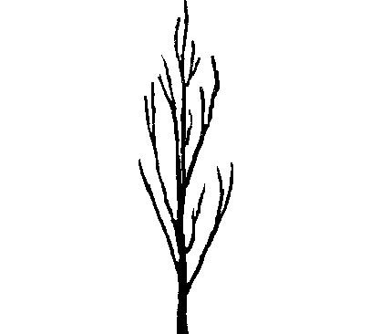 | 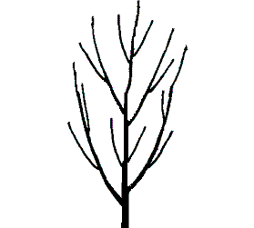
1 | 2
fastigiate | upright
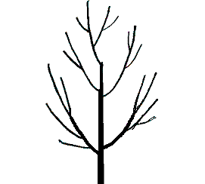 | 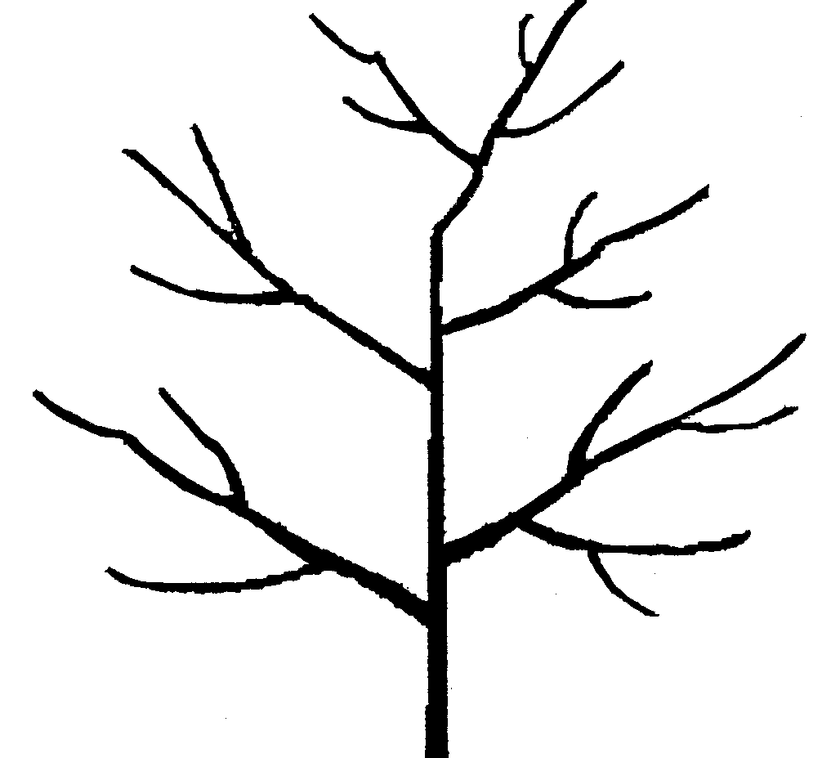
3 | 4
upright to spreading | spreading
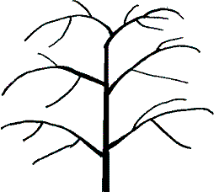 | 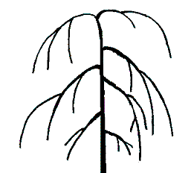
5 | 6
drooping | weeping

Ad. 3: Tree: degree of branching

Observations should relate to the number of branches with the degree of branching being indicated by the density of lateral branches and shoots, excluding fruiting shoots.

Ad. 6: One-year-old shoot: color on sunny side

Observations should be carried out in the middle of one-year-old primary shoots.

Ad. 12: Leaf blade: shape of base

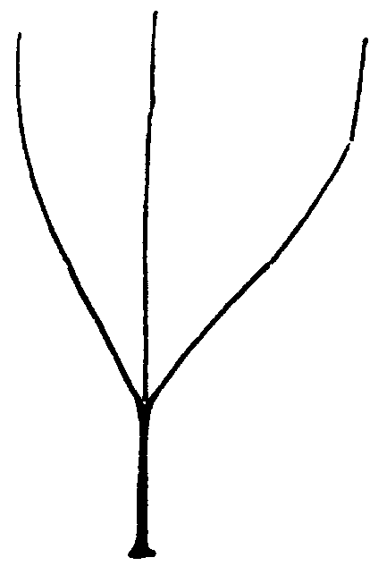
1 | 2
acute | obtuse
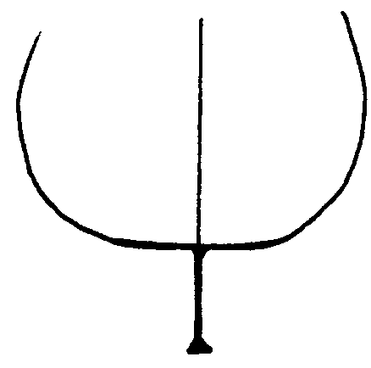 | 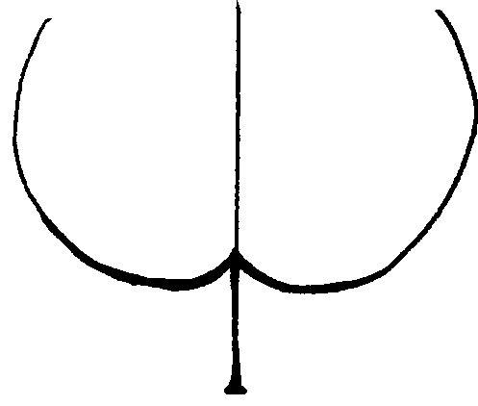
3 | 4
truncate | cordate

Ad. 13: Leaf blade: angle of apex (excluding tip)

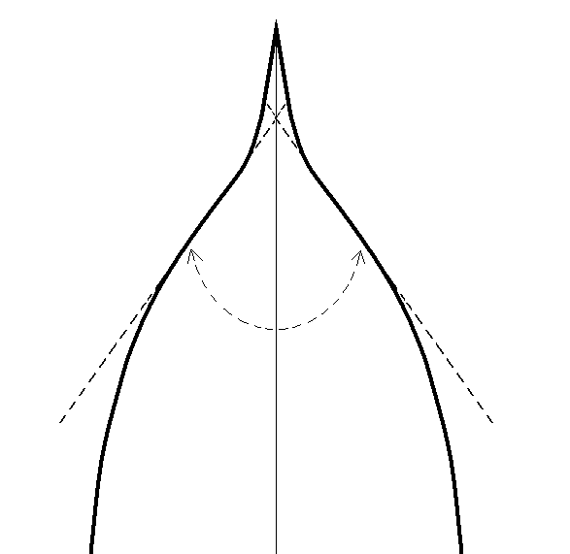 | 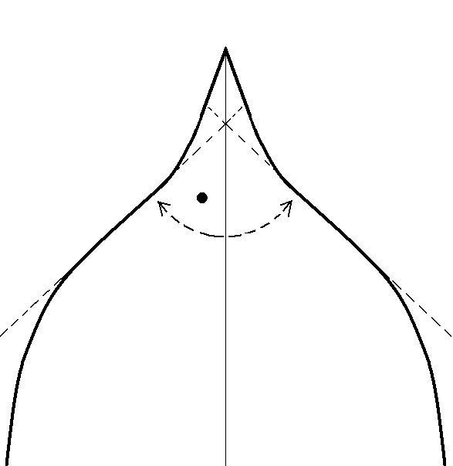
1 | 2
acute | right-angled
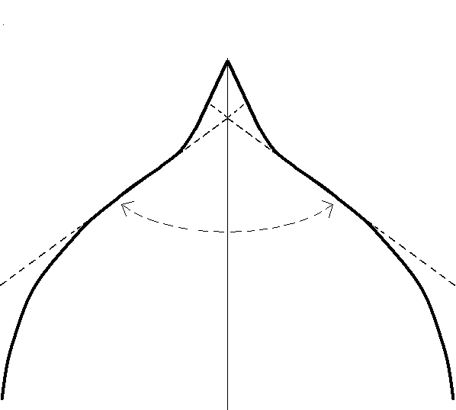 | 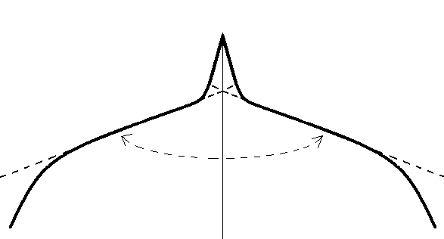
3 | 4
moderately obtuse | strongly obtuse

Ad. 15: Leaf blade: incisions of margin

 | 
1  crenate | 2  bicrenate
 | 
3  serrate | 4  biserrate

Ad. 17: Leaf blade: profile in cross section

Leaves observed should be on spurs or at base of flowering shoots.

Ad. 24: Flower: diameter

Observations or measurements should be carried out on flowers with petals pressed into horizontal position.
Ad. 26: Petal: shape (excluding claw)

 |  | 
1  broad elliptic | 2  circular | 3  oblate

Ad. 27: Petal: color on lower side

Observations should be carried out just after opening of sepals on the lower side.

Ad. 29: Fruit: shape in lateral view

Ad. 30: Fruit: shape in ventral view

Ad. 31: Fruit: height
Ad. 32: Fruit: lateral width

Ad. 33: Fruit: ventral width

Ad. 34: Fruit: ratio height/ventral width

Ad. 35: Fruit: ratio lateral width/ventral width
Ad. 40: Fruit: presence of mucro

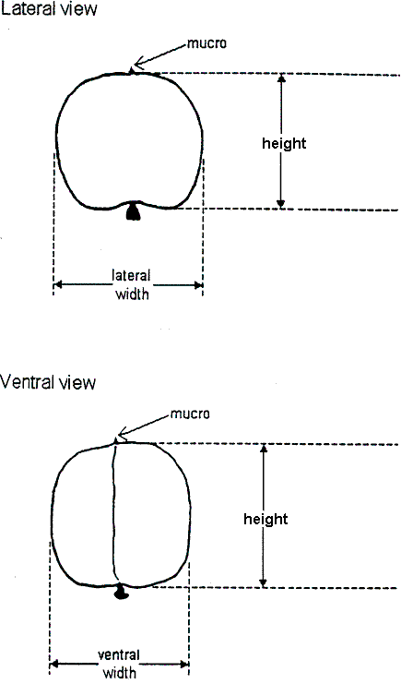

Ad. 29: Fruit: shape in lateral view
Ad. 30: Fruit: shape in ventral view
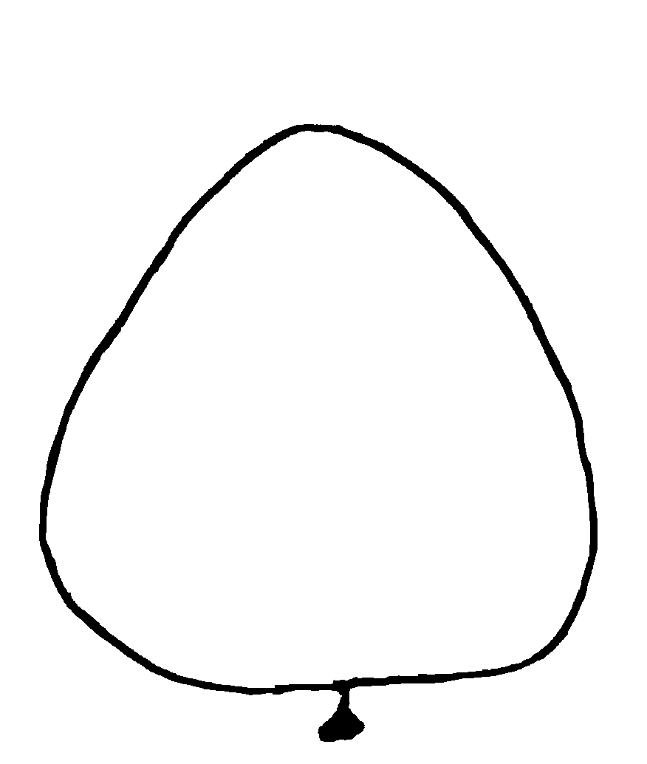 | 
1  triangular | 2  ovate
 | 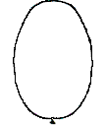
3  oblong | 4  elliptic
 | 
5  circular | 6  oblate
 | 
7  obovate | 8  oblique rhombic  (not applicable for characteristic 30)

Ad. 39: Fruit: shape of apex

Observations should be carried out on fruits in lateral cross-section.

 | 
1  acute | 2  rounded
 | 
3  truncate | 4  retuse

Ad. 54: Stone: shape in lateral view

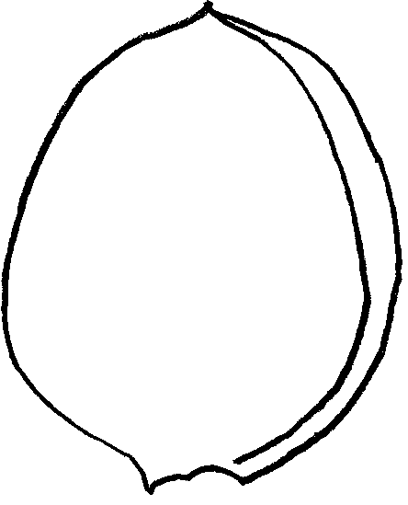 | 
1  ovate | 2  oblong
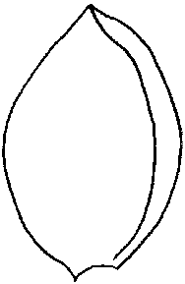 | 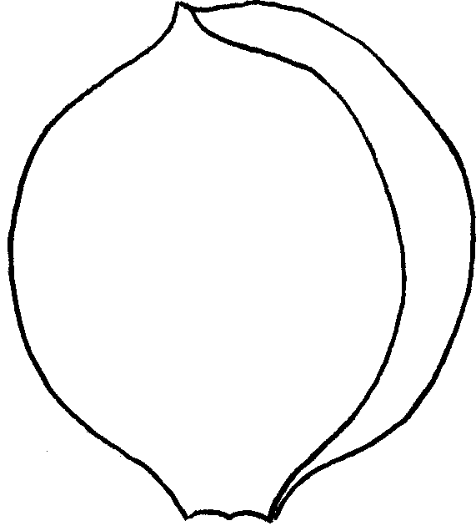
3  elliptic | 4  circular
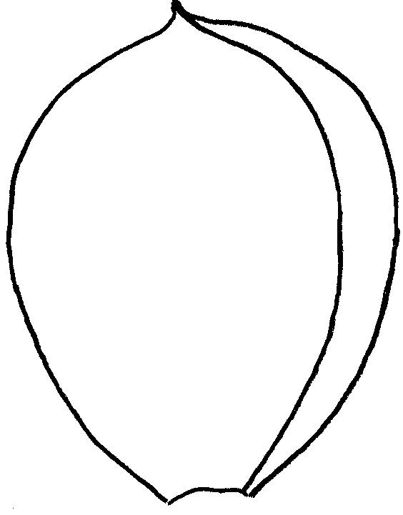
5
obovate

Ad. 56: Time of beginning of flowering

When 5-10% open flowers can be observed.

Ad. 57: Time of beginning of fruit ripening

When 5-10% ripen fruits can be observed. Fruit ripening should be considered as the time of eating ripeness, when the fruit is most easily removed.

8.3 Synonym(s) of Example Varieties
Example Varieties | Synonym(s)
Sant’ Ambrogio | Ambrosia, Saint Ambroise
Bhart | NJA 32
Borsi rózsa | Kecskemeter rose, Ružova neskora, Trandafirii tirzi
Čačacansko zlato | Čačak’s Gold
Earle Orange | Erle Orange, Stark Earli Orange
Goldrich | Sungiant
Magyar kajszi | Cea mai bună de Ungaria, Hungarian Best, Klosterneuburger Aprikose, Krasnoshchokij, Mađarska najbolja, Meilleur d’Hongrie, Ungarische Beste, Velkopavlovická
Pineapple | Abricot d’Ananas, Ananas-Marille, Ananasnyj
Proimo Tyrinthos | Précoce de Tyrinthe
Rutbhart | Early Blush
Sateni Karmir | Tabarza
Yerevani | Shalakh

Literature
Anonymous, 1997: “The Brooks and Olmo register of new fruit and nut varieties”. Third edition, ASHS Press, Alexandria, VA, US.

Agulian, S. L., et al., 1977: “Abrikosy Armenii” “Apricots of Armenia” (bilingual book). Izdatel’stvo Aiastan, Yerevan, AM.

Boček, O., 1954: “Pomologie”. Státní Zemědělske Nakladatelství, Praha, CZ.

Beketovskaya, A. A., 1977: “Dima”. Sadovodstvo No.7, p. 28, Moskva, RU.

Bordeianu, T., et al., 1963: “Pomologia Republicii Populare Romîne”. Vol. 1-8, Editura Academiei Republicii Populare Romîne, Bucuresti, RO.

Cifranič, P., et al., 1978: “Pomologia”. Priroda, Bratislava, SK.

Couranjou, J., 1977: “Variétés d’abricotiers”. INVUFLEC, Paris, FR.

Della Strada, G., Pennone, F., Fideghelli, C., Monastra, F., Cobianchi, D., 1989: “Monografia di cultivar di albicocco”. Istituto Sperimentale per la Frutticoltura, Roma, IT.

Guerriero, R., 1982: “L’albicocco, (Apricot)” Cultivar. R.E.D.A., Roma, IT.

Guerriero R., Monteleone P., 1992: “Distribuzione di alcuni caratteri tassonomici in una collezione di oltre 100 cultivar di albicocco”. Atti del Congresso su “Germoplasma frutticolo. Salvaguardia e valorizzazione delle risorse genetiche” Alghero; p. 343-348, IT.

Guerriero R., Monteleone P., 1992: “Principali caratteristiche tassonomiche e agronomiche di 28 cultivar di albicocco italiane in pericolo di estinzione”. Atti del Congresso su “Germoplasma frutticolo. Salvaguardia e valorizzazione delle risorse genetiche” Alghero; 349-356, IT.

G. Tóth M., 1997. “Gyümölcsészet (Pomology)” PRIMOM, Nyíregyháza, HU.

Krümmel, H., Groh, W., Friedrich, G., 1964: “Deutsche Obstsorten”. Bd. 1-3. Deutscher Landwirtschaftsverlag, Berlin, DE.

Löschnig, J., Passecker, F., 1954: “Die Marille (Aprikose) und ihre Kultur”. Österreichischer Agrarverlag, Wien, AT.

Nagano-ken, 1980: “The report on the characterization and classification of apricot varieties”, Nagano-ken Fruit Tree Experiment Station (by consignment of the MAFF), JP.

Nyujtó, F., Surányi, D., 1981: “Kajszibarack (Apricot)”, Mezőgazdasági Kiadó, Budapest, HU.

Nyujtó, F., Tomcsányi, P., 1959: “A kajszibarack és termesztése (Apricot growing)”, Mezőgazdasági Kiadó, Budapest, HU.

Pochyba, D., et al., 1964: “Pomologia”, Slov. Vyd. Polnohosp. Lit., Bratislava, SK.
Rayman, J., Tomcsányi, P., 1964: “Gyümölcsfajták zsebkönyve. Almagyümölcsűek és csonthéjasok (Pocket manual of fruit varieties 1.)”. Mezőgazdasági Kiadó, Budapest, HU.

Shepelskij, A. I., 1966: “Novye sorta plodovykh i yagodnykh kul’tur Ukrain (New fruit varieties of Ukraine)”. Urozhai, Kiev, UA.

Simirenko, L. P., 1963: “Pomologiia”. Vol. 1-3. Izd S/h. Lit. Ukr. SSR, Kiev, UA.

Sinskaya, E. N., 1949: “Kulturnaya flora SSSR. XVIII. Plodovye kostochkovye” (Cultivated plants of USSR. Stone fruits)”. OGIZ-Sel’khozgiz, Moskva-Leningrad, RU.

Smirnov, V. F., 1972: “Novye sorta kostochkovykh kul’tur, vyvedennye v SSSR (New stone fruit varieties bred in USSR)”. Izdatel’stvo Nauka, Moskva, RU.

Smykov, V. K., et al., 1974: “Kostochkovye kul’tury (Stone fruits)”. Izdatel’stvo Kartya Moldovenyaske, Kishinev, MD.

Smykov, V. K., et al., 1974: “Kul’tura abrikosa v neoroshaemykh usloviyakh Moldavii (Apricot growing under non-irrigated conditions of Moldavia)”. Izdatel’stvo Stiinca, Kishinev, MD.

Stoichkov, J., et al., 1960: “B’’lgarska pomologiya (Bulgarian Pomology)”. Zemizdat, Sofia, BG.

Tomcsányi, P., et al., 1979: “Gyümölcsfajtáink, Gyakorlati pomológia (Practical Pomology)”. Mezőgazdasági Kiadó, Budapest, HU.

Technical Questionnaire
TECHNICAL QUESTIONNAIRE |  |  |  | Page (x) of {y} |  | Reference Number:
 |  |  |  |  |  | Application date:
 |  |  |  |  |  | (not to be filled in by the applicant)
TECHNICAL QUESTIONNAIRE
to be completed in connection with an application for plant breeders’ rights

1. Subject of the Technical Questionnaire
1.1 Botanical name |  |  | Prunus armeniaca L.
1.2 Common Name |  |  | Apricot
2. Applicant
Name
Address
Telephone No.
Fax No.
E-mail address
Breeder (if different from applicant)
3. Proposed denomination and breeder’s reference
Proposed denomination
(if available)

Breeder’s reference
#4. Information on the breeding scheme and propagation of the variety

4.1 Breeding scheme

Variety resulting from:

4.1.1 Crossing

(a) controlled cross [ ]
(please state parent varieties)
(b) partially known cross [ ]
(please state known parent variety(ies))
(c) unknown cross [ ]

4.1.2 Mutation [ ]
(please state parent variety)

4.1.3 Discovery and development [ ]
(please state where and when discovered
and how developed)

4.1.4 Other [ ]
(please provide details)

4.2 Method of propagating the variety

4.2.1 Vegetative propagation

(a) budding or grafting [ ]

(b) other (state method) [ ]

4.2.2 Other [ ]
(please provide details)

5. Characteristics of the variety to be indicated (the number in brackets refers to the corresponding characteristic in Test Guidelines; please mark the note which best corresponds).

 | Characteristics |  |  |  |  |  | Example Varieties |  |  | Note
5.1  (28) | Fruit: size
 | very small |  |  |  |  |  | Haggith, Menace, Zard |  |  | 1[ ]
 | small |  |  |  |  |  | Borsi rózsa, Hâtif Colomer, Patriarca Temprano |  |  | 3[ ]
 | medium |  |  |  |  |  | Cafona, Canino, Harcot |  |  | 5[ ]
 | large |  |  |  |  |  | Ceglédi bíbor, Moniquí, Portici |  |  | 7[ ]
 | very large |  |  |  |  |  | Ceglédi óriás, Hargrand, Palsteyn, Pisana |  |  | 9[ ]
5.2  (44) | Fruit: ground color of skin
 | not visible |  |  |  |  |  | A3759, A3844 |  |  | 1[ ]
 | white |  |  |  |  |  | San Nicola, Shirazskij belyj |  |  | 2[ ]
 | yellowish |  |  |  |  |  | Piet Cillié, Vitillo, Yerevani |  |  | 3[ ]
 | yellow green |  |  |  |  |  | Grüne Spätmarille, Kaisi Ashtarak, Sateni Karmir |  |  | 4[ ]
 | light orange |  |  |  |  |  | Canino Hargrand, Goldcot, Portici, Rouge du Roussillon |  |  | 5[ ]
 | medium orange |  |  |  |  |  | Hâtif Colomer, Luizet, Pisana, Veecot |  |  | 6[ ]
 | dark orange |  |  |  |  |  | Bhart, Harcot, Harogem |  |  | 7[ ]
5.3  (45) | Fruit: relative area of over color
 | absent or very small |  |  |  |  |  | Maria Matilde, Moniquí, Yerevani |  |  | 1[ ]
 | small |  |  |  |  |  | Cafona, Canino, Goldrich |  |  | 3[ ]
 | medium |  |  |  |  |  | Hâtif Colomer, Magyar kajszi, Palsteyn, Portici |  |  | 5[ ]
 | large |  |  |  |  |  | Bergeron, Bhart, Pisana |  |  | 7[ ]
 | very large |  |  |  |  |  | A3759, A3844 |  |  | 9[ ]
 | Characteristics |  |  |  |  |  | Example Varieties |  |  | Note
5.4  (49) | Fruit: color of flesh
 | whitish green |  |  |  |  |  | Amban |  |  | 1[ ]
 | white |  |  |  |  |  | Cibo del Paradiso, Mouchbah Mourry, Spitak |  |  | 2[ ]
 | cream |  |  |  |  |  | Barese, Malatya, Moniquí, Patriarca Temprano |  |  | 3[ ]
 | light orange |  |  |  |  |  | Canino, Harmat, San Castrese, Yerevani |  |  | 4[ ]
 | medium orange |  |  |  |  |  | Harglow, Pisana, Rouge du Roussillon, Screara |  |  | 5[ ]
 | dark orange |  |  |  |  |  | Francese, Harcot, Hâtif Colomer, Palsteyn |  |  | 6[ ]
5.5  (56) | Time of beginning of flowering
 | very early |  |  |  |  |  | Bakour, Currots, Harmat, Ninfa |  |  | 1[ ]
 | early |  |  |  |  |  | Canino, Harcot, Hâtif Colomer, San Castrese |  |  | 3[ ]
 | medium |  |  |  |  |  | Magyar kajszi, Moniquí, Portici, San Francesco |  |  | 5 [ ]
 | late |  |  |  |  |  | Bergeron, Boccuccia Liscia, Harlayne, Polonais |  |  | 7 [ ]
 | very late |  |  |  |  |  | Harglow, Skromnyj, Zard |  |  | 9[ ]
5.6  (57) | Time of beginning of fruit ripening
 | very early |  |  |  |  |  | Bakour, Ninfa, Patriarca Temprano, Rutbhart, Samarkandskij rannij |  |  | 1[ ]
 | early |  |  |  |  |  | Bhart, Hâtif Colomer, Monaco Bello, Rouget de Sernhac, Tomcot |  |  | 3[ ]
 | medium |  |  |  |  |  | Bergeron, Harlayne, Pisana, Polonais |  |  | 5[ ]
 | late |  |  |  |  |  | Larquen |  |  | 7[ ]
 | very late |  |  |  |  |  | Lartago |  |  | 9[ ]
6. Similar varieties and differences from these varieties

Please use the following table and box for comments to provide information on how your candidate variety differs from the variety (or varieties) which, to the best of your knowledge, is (or are) most similar. This information may help the examination authority to conduct its examination of distinctness in a more efficient way.

Denomination(s) of variety(ies) similar to your candidate variety |  | Characteristic(s) in which your candidate variety differs from the similar variety(ies) |  |  | Describe the expression of the characteristic(s) for the similar variety(ies) |  |  | Describe the expression of the characteristic(s) for your candidate variety
Example |  | Fruit: size |  |  | small |  |  | medium
Comments:

#7. Additional information which may help in the examination of the variety

7.1 In addition to the information provided in sections 5 and 6, are there any additional characteristics which may help to distinguish the variety?

Yes [ ] No [ ]

(If yes, please provide details)

7.2 Are there any special conditions for growing the variety or conducting the examination?

Yes [ ] No [ ]

(If yes, please provide details)

7.3 Other information

A representative color photograph of the variety should accompany the Technical Questionnaire.

8. Authorization for release

(a) Does the variety require prior authorization for release under legislation concerning the protection of the environment, human and animal health?

Yes [ ] No [ ]

(b) Has such authorization been obtained?

Yes [ ] No [ ]

If the answer to (b) is yes, please attach a copy of the authorization.

9. Information on plant material to be examined or submitted for examination

9.1 The expression of a characteristic or several characteristics of a variety may be affected by factors, such as pests and disease, chemical treatment (e.g. growth retardants or pesticides), effects of tissue culture, different rootstocks, scions taken from different growth phases of a tree, etc.

9.2 The plant material should not have undergone any treatment which would affect the expression of the characteristics of the variety, unless the competent authorities allow or request such treatment. If the plant material has undergone such treatment, full details of the treatment must be given. In this respect, please indicate below, to the best of your knowledge, if the plant material to be examined has been subjected to:

(a) Microorganisms (e.g. virus, bacteria, phytoplasma) Yes [ ] No [ ]

(b) Chemical treatment (e.g. growth retardant, pesticide) Yes [ ] No [ ]

(c) Tissue culture Yes [ ] No [ ]

(d) Other factors Yes [ ] No [ ]

Please provide details of where you have indicated “yes”:

……………………………………………………………

10. I hereby declare that, to the best of my knowledge, the information provided in this form is correct:

Applicant’s name

Signature Date

[End of document]

* These names were correct at the time of the introduction of these Test Guidelines but may be revised or updated. [Readers are advised to consult the UPOV Code, which can be found on the UPOV Website (www.upov.int), for the latest information.]
# Authorities may allow certain of this information to be provided in a confidential section of the Technical Questionnaire.
# Authorities may allow certain of this information to be provided in a confidential section of the Technical Questionnaire.

