 |  | E  TG/18/5  ORIGINAL: English  DATE: 2007-03-28
INTERNATIONAL UNION FOR THE PROTECTION OF NEW VARIETIES OF PLANTS
GENEVA

 | ELATIOR BEGONIA  UPOV Code: BEGON_HIE  Begonia ×hiemalis Fotsch | *

GUIDELINES

FOR THE CONDUCT OF TESTS

FOR DISTINCTNESS, UNIFORMITY AND STABILITY

Alternative Names:*

Botanical name | English | French | German | Spanish
Begonia ×hiemalis Fotsch,  Begonia ×elatior hort. | Elatior Begonia, Winter-flowering begonia | Bégonia élatior | Elatior-Begonie | Begonia elatior

The purpose of these guidelines (“Test Guidelines”) is to elaborate the principles contained in the General Introduction (document TG/1/3), and its associated TGP documents, into detailed practical guidance for the harmonized examination of distinctness, uniformity and stability (DUS) and, in particular, to identify appropriate characteristics for the examination of DUS and production of harmonized variety descriptions.

ASSOCIATED DOCUMENTS
These Test Guidelines should be read in conjunction with the General Introduction and its associated TGP documents.

TABLE OF CONTENTS PAGE

1. Subject of these Test Guidelines 3
2. Material Required 3
3. Method of Examination 3
3.1 Number of Growing Cycles 3
3.2 Testing Place 3
3.3 Conditions for Conducting the Examination 3
3.4 Test Design 4
3.5 Number of Plants / Parts of Plants to be Examined 4
3.6 Additional Tests 4
4. Assessment of Distinctness, Uniformity and Stability 4
4.1 Distinctness 4
4.1.1 General Recommendations 4
4.1.2 Consistent Differences 4
4.1.3 Clear Differences 4
4.2 Uniformity 5
4.3 Stability 5
5. Grouping of Varieties and Organization of the Growing Trial 5
6. Introduction to the Table of Characteristics 6
6.1 Categories of Characteristics 6
6.1.1 Standard Test Guidelines Characteristics 6
6.1.2 Asterisked Characteristics 6
6.2 States of Expression and Corresponding Notes 6
6.3 Types of Expression 6
6.4 Example Varieties 6
6.5 Legend 6
7. Table of Characteristics/Tableau des caractères/Merkmalstabelle/Tabla de caracteres 7
8. Explanations on the Table of Characteristics 13
8.1 Explanations covering several characteristics 13
8.2 Explanations for individual characteristics 13
9. Literature 16
10. Technical Questionnaire 17

Subject of these Test Guidelines
These Test Guidelines apply to all varieties of Begonia ×hiemalis Fotsch, of the family Begoniaceae.

Material Required
2.1 The competent authorities decide on the quantity and quality of the plant material required for testing the variety and when and where it is to be delivered. Applicants submitting material from a State other than that in which the testing takes place must ensure that all customs formalities and phytosanitary requirements are complied with.

2.2 The material is to be supplied in the form of young plants from non-induced terminal cuttings.

2.3 The minimum quantity of plant material, to be supplied by the applicant, should be:

20 young plants from non-induced terminal cuttings

2.4 The plant material supplied should be visibly healthy, not lacking in vigor, nor affected by any important pest or disease.

2.5 The plant material should not have undergone any treatment which would affect the expression of the characteristics of the variety, unless the competent authorities allow or request such treatment. If it has been treated, full details of the treatment must be given.

Method of Examination

3.1 Number of Growing Cycles
The minimum duration of tests should normally be a single growing cycle.

3.2 Testing Place
Tests are normally conducted at one place. In the case of tests conducted at more than one place, guidance is provided in TGP/9 “Examining Distinctness”.

3.3 Conditions for Conducting the Examination
3.3.1 The tests should be carried out under conditions ensuring satisfactory growth for the expression of the relevant characteristics of the variety and for the conduct of the examination. Three weeks after potting, the plants should receive a short day treatment for two weeks. The day length during the short day treatment should be 9 hours.

3.3.2 The optimum stage of development for the assessment of the characteristics is at the time of full flowering.

3.3.3 Because daylight varies, color determinations made against a color chart should be made either in a suitable cabinet providing artificial daylight or in the middle of the day in a room without direct sunlight. The spectral distribution of the illuminant for artificial daylight should conform with the CIE Standard of Preferred Daylight D 6500 and should fall within the tolerances set out in the British Standard 950, Part I. These determinations should be made with the plant part placed against a white background.

3.4 Test Design
3.4.1 Each test should be designed to result in a total of at least 20 plants.

3.4.2 The design of the tests should be such that plants or parts of plants may be removed for measurement or counting without prejudice to the observations which must be made up to the end of the growing cycle.

3.5 Number of Plants / Parts of Plants to be Examined
Unless otherwise indicated, all observations on single plants should be made on 10 plants or parts taken from each of 10 plants and any other observations made on all plants in the test.

3.6 Additional Tests
Additional tests, for examining relevant characteristics, may be established.

Assessment of Distinctness, Uniformity and Stability

4.1 Distinctness

4.1.1 General Recommendations
It is of particular importance for users of these Test Guidelines to consult the General Introduction prior to making decisions regarding distinctness. However, the following points are provided for elaboration or emphasis in these Test Guidelines.

4.1.2 Consistent Differences
The differences observed between varieties may be so clear that more than one growing cycle is not necessary. In addition, in some circumstances, the influence of the environment is not such that more than a single growing cycle is required to provide assurance that the differences observed between varieties are sufficiently consistent. One means of ensuring that a difference in a characteristic, observed in a growing trial, is sufficiently consistent is to examine the characteristic in at least two independent growing cycles.

4.1.3 Clear Differences
Determining whether a difference between two varieties is clear depends on many factors, and should consider, in particular, the type of expression of the characteristic being examined, i.e. whether it is expressed in a qualitative, quantitative, or pseudo-qualitative manner. Therefore, it is important that users of these Test Guidelines are familiar with the recommendations contained in the General Introduction prior to making decisions regarding distinctness.

4.2 Uniformity
4.2.1 It is of particular importance for users of these Test Guidelines to consult the General Introduction prior to making decisions regarding uniformity. However, the following points are provided for elaboration or emphasis in these Test Guidelines:

4.2.2 For the assessment of uniformity a population standard of 2% and an acceptance probability of at least 95% should be applied. In the case of a sample size of 20 plants, 2 off-types are allowed.

4.3 Stability
4.3.1 In practice, it is not usual to perform tests of stability that produce results as certain as those of the testing of distinctness and uniformity. However, experience has demonstrated that, for many types of variety, when a variety has been shown to be uniform, it can also be considered to be stable.

4.3.2 Where appropriate, or in cases of doubt, stability may be tested, either by growing a further generation, or by testing a new plant stock to ensure that it exhibits the same characteristics as those shown by the previous material supplied.

Grouping of Varieties and Organization of the Growing Trial
5.1 The selection of varieties of common knowledge to be grown in the trial with the candidate varieties and the way in which these varieties are divided into groups to facilitate the assessment of distinctness are aided by the use of grouping characteristics.

5.2 Grouping characteristics are those in which the documented states of expression, even where produced at different locations, can be used, either individually or in combination with other such characteristics: (a) to select varieties of common knowledge that can be excluded from the growing trial used for examination of distinctness; and (b) to organize the growing trial so that similar varieties are grouped together.

5.3 The following have been agreed as useful grouping characteristics:

(a) Flower: type (characteristic 14)
(b) Flower: number of colors (characteristic 18)
(c) Outer petal: color of middle of upper side (characteristic 20) with the following groups:
Gr. 1: white
Gr. 2: yellow
Gr. 3: orange
Gr. 4: red
Gr. 5: red pink
Gr. 6: blue pink
(d) Outer petal: incisions of margin (characteristic 21)
(e) Inner petal: color of middle of upper side (characteristic 23) with the following groups:
Gr. 1: white
Gr. 2: yellow
Gr. 3: orange
Gr. 4: red
Gr. 5: red pink
Gr. 6: blue pink

5.4 Guidance for the use of grouping characteristics, in the process of examining distinctness, is provided through the General Introduction.

Introduction to the Table of Characteristics

6.1 Categories of Characteristics

6.1.1 Standard Test Guidelines Characteristics
Standard Test Guidelines characteristics are those which are approved by UPOV for examination of DUS and from which members of the Union can select those suitable for their particular circumstances.

6.1.2 Asterisked Characteristics
Asterisked characteristics (denoted by *) are those included in the Test Guidelines which are important for the international harmonization of variety descriptions and should always be examined for DUS and included in the variety description by all members of the Union, except when the state of expression of a preceding characteristic or regional environmental conditions render this inappropriate.

6.2 States of Expression and Corresponding Notes
States of expression are given for each characteristic to define the characteristic and to harmonize descriptions. Each state of expression is allocated a corresponding numerical note for ease of recording of data and for the production and exchange of the description.

6.3 Types of Expression
An explanation of the types of expression of characteristics (qualitative, quantitative and pseudo-qualitative) is provided in the General Introduction.

6.4 Example Varieties
Where appropriate, example varieties are provided to clarify the states of expression of each characteristic.

6.5 Legend
(*) Asterisked characteristic – see Chapter 6.1.2

QL Qualitative characteristic – see Chapter 6.3
QN Quantitative characteristic – see Chapter 6.3
PQ Pseudo-Qualitative characteristic – see Chapter 6.3

(a), (b), (c) See Explanations on the Table of Characteristics in Chapter 8.1.
(+) See Explanations on the Table of Characteristics in Chapter 8.2.

Table of Characteristics/Tableau des caractères/Merkmalstabelle/Tabla de caracteres
 |  | English | français | Deutsch | español | Example Varieties  Exemples  Beispielssorten  Variedades ejemplo | Note/  Nota
1.  (*) |  | Plant: height (including flowers) | Plante: hauteur (y compris les fleurs) | Pflanze: Höhe (einschließlich Blüten) | Planta: altura (incluidas las flores)
QN |  | short | faible | niedrig | baja |  | 3
 |  | medium | moyenne | mittel | media | Berseko | 5
 |  | tall | grande | hoch | alta | Dark Britt | 7
2.  (*) |  | Plant: width (including flowers) | Plante: largeur (y compris les fleurs) | Pflanze: Breite (einschließlich Blüten) | Planta: anchura (incluidas las flores)
QN |  | narrow | étroite | schmal | estrecha |  | 3
 |  | medium | moyenne | mittel | media | Julie | 5
 |  | broad | large | breit | ancha | Nadine | 7
3. |  | Petiole: anthocyanin coloration on upper side | Pétiole: pigmentation anthocyanique de la face supérieure | Blattstiel: Anthocyanfärbung auf der Oberseite | Pecíolo: pigmentación antociánica de la parte superior
QN | (a) | absent or very weak | absente ou très faible | fehlend oder sehr gering | ausente o muy débil | Beman Soft Pink | 1
 |  | weak | faible | gering | débil | BBTosca | 3
 |  | medium | moyenne | mittel | media |  | 5
 |  | strong | forte | stark | fuerte | Binos Pink | 7
 |  | very strong | très forte | sehr stark | muy fuerte |  | 9
4.  (*) (+) |  | Leaf blade: length of midrib | Limbe: longueur de la nervure principale | Blattspreite: Länge der Mittelrippe | Limbo: longitud del nervio central
QN | (a) | short | courte | kurz | corta |  | 3
 |  | medium | moyenne | mittel | media | Beman Rose | 5
 |  | long | longue | lang | larga | Barkos | 7
5.  (*)  (+) |  | Leaf blade: width | Limbe: largeur | Blattspreite: Breite | Limbo: anchura
QN | (a) | narrow | étroit | schmal | estrecha |  | 3
 |  | medium | moyen | mittel | media | Julie | 5
 |  | broad | large | breit | ancha | Barkos | 7
6.  (*) |  | Leaf blade: color of upper side | Limbe: couleur de la face supérieure | Blattspreite: Farbe der Oberseite | Limbo: color del haz
PQ | (a) | light green | vert clair | hellgrün | verde claro |  | 1
 |  | medium green | vert moyen | mittelgrün | verde medio | Azotus | 2
 |  | dark green | vert foncé | dunkelgrün | verde oscuro | Barkos | 3
 |  | reddish green | vert rougeâtre | rötlich grün | verde roijza | Debbie | 4
7. |  | Leaf blade: color of lower side | Limbe: couleur de la face inférieure | Blattspreite: Farbe der Unterseite | Limbo: color del envés
PQ | (a) | light green | vert clair | hellgrün | verde claro | Azotus | 1
 |  | medium green | vert moyen | mittelgrün | verde medio |  | 2
 |  | dark green | vert foncé | dunkelgrün | verde oscuro |  | 3
 |  | red and green | vert rougeâtre | rot und grün | verde e roijza | Fuga | 4
 |  | reddish brown | brun rougeâtre | rötlich braun | marrón rojizo |  | 5
8.  (+) |  | Leaf blade: base | Limbe: base | Blattspreite: Basis | Limbo: base
QN | (a) | wide open | très ouverte | weit offen | muy abierta |  | 1
 |  | moderately open | ouverte | mäßig offen | moderadamente abierta |  | 3
 |  | closed | fermée | geschlossen | cerrada |  | 5
 |  | slightly overlapping | à lobes peu chevauchants | gering überlappend | debilmente solapada |  | 7
 |  | strongly overlapping | à lobes très chevauchants | stark überlappend | fuertemente solapada |  | 9
9.  (+) |  | Leaf blade: angle of apex | Limbe: largeur du sommet | Blattspreite: Winkel der Spitze | Limbo: ángulo del ápice
QN | (a) | moderately acute | modérément aigu | mäßig spitz | moderadamente agudo |  | 3
 |  | right angled | droit | rechtwinklig | en ángulo recto |  | 5
 |  | moderately obtuse | modérément obtus | mäßig stumpf | moderadamente obtuso |  | 7
10.  (+) |  | Leaf blade: incisions of margin | Limbe: incisions du bord | Blattspreite: Randeinschnitte | Limbo: incisiones del borde
QN | (a) | absent or very shallow | absentes ou très faibles | fehlend oder sehr flach | ausente o poco profunda | Azotus | 1
 |  | shallow | faibles | flach | poco profunda | Kristy Franje | 3
 |  | medium | moyennes | mittel | media | Cindy Franje Dark | 5
 |  | deep | fortes | tief | profunda |  | 7
11. |  | Leaf blade: undulation of margin | Limbe: ondulation du bord | Blattspreite: Randwellung | Limbo: ondulación del borde
QN | (a) | absent or very weak | absente ou très faible | fehlend oder sehr gering | ausente o muy débil |  | 1
 |  | weak | faible | gering | débil | Nadine | 3
 |  | medium | moyenne | mittel | media | Azotus | 5
 |  | strong | forte | stark | fuerte |  | 7
 |  | very strong | très forte | sehr stark | muy fuerte |  | 9
12. |  | Bract: size | Bractée: taille | Hochblatt: Größe | Bráctea: tamaño
QN | (b) | small | petite | klein | pequeña | Nadine | 3
 |  | medium | moyenne | mittel | media |  | 5
 |  | large | grande | groß | grande | Azotus | 7
13. |  | Bract: color | Bractée: couleur | Hochblatt: Farbe | Bráctea: color
QL | (b) | green | verte | grün | verde |  | 1
 |  | red and green | rouge et verte | grün und rot | verde y rojo |  | 2
 |  | red | rouge | rot | rojo |  | 3
14.  (*)  (+) |  | Flower: type | Fleur: type | Blüte: Typ | Flor: tipo
QL |  | single | simple | einfach | simple |  | 1
 |  | double | double | gefüllt | doble |  | 2
15.  (*) |  | Only varieties with double flowers: Flower: number of petals | Seulement variétés à fleur double: Fleur: nombre de pétales | Nur Sorten mit gefüllten Blüten: Blüte: Anzahl Blütenblätter | Sólo variedades con flores dobles: Flor: número de petales
QN |  | few | petit | gering | pocos | Peggy | 3
 |  | medium | moyen | mittel | medio |  | 5
 |  | many | grand | hoch | numerosos | BBTosca | 7
16.  (*)  (+) |  | Flower: length | Fleur: longueur | Blüte: Länge | Flor: longitud
QN |  | short | courte | kurz | corta |  | 3
 |  | medium | moyenne | mittel | media |  | 5
 |  | long | longue | lang | larga |  | 7
17.  (*)  (+) |  | Flower: width | Fleur: largeur | Blüte: Breite | Flor: anchura
QN |  | narrow | étroite | schmal | estrecha |  | 3
 |  | medium | moyenne | mittel | media |  | 5
 |  | broad | large | breit | ancha |  | 7
18.  (*)  (+) |  | Flower: number of colors | Fleur: nombre de couleurs | Blüte: Anzahl Farben | Flor: número de colores
QL |  | one | une | eine | uno |  | 1
 |  | two | deux | zwei | dos |  | 2
 |  | more than two | plus de deux | mehr als zwei | más de dos |  | 3
19.  (*) |  | Outer petal: color of margin of upper side | Pétale externe: couleur du bord de la face supérieure | Äußeres Blütenblatt: Farbe des Randes der Oberseite | Pétalo externo: color del borde de la cara superior
PQ |  | RHS Colour Chart (indicate reference number) | Code RHS des couleurs (indiquer le numéro de référence) | RHS-Farbkarte (Nummer angeben) | Carta de colores RHS (indíquese el número de referencia)
20.  (*) |  | Outer petal: color of middle of upper side | Pétale externe: couleur du centre de la face supérieure | Äußeres Blütenblatt: Farbe der Mitte der Oberseite | Pétalo externo: color de la zona central de la cara superior
PQ |  | RHS Colour Chart (indicate reference number) | Code RHS des couleurs (indiquer le numéro de référence) | RHS-Farbkarte (Nummer angeben) | Carta de colores RHS (indíquese el número de referencia)
21.  (*)  (+) |  | Outer petal: incisions of margin | Pétale externe: incisions du pétale | Äußeres Blütenblatt: Randeinschnitte | Pétalo externo: incisiones del borde
QN |  | absent or very shallow | absentes ou très peu profondes | fehlend oder sehr flach | ausentes o muy poco profundas | BBTosca | 1
 |  | shallow | peu profondes | flach | poco profundas | Bela | 3
 |  | medium | moyennes | mittel | medias | Cindy Franje Dark | 5
 |  | deep | profondes | tief | profundas | Daisy Franje | 7
22.  (*) |  | Inner petal: color of margin of upper side | Pétale interne: couleur du bord de la face supérieure | Inneres Blütenblatt: Farbe des Randes der Oberseite | Pétalo interno: color del borde de la cara superior
PQ | (c) | RHS Colour Chart (indicate reference number) | Code RHS des couleurs (indiquer le numéro de référence) | RHS-Farbkarte (Nummer angeben) | Carta de colores RHS (indíquese el número de referencia)
23.  (*) |  | Inner petal: color of middle of upper side | Pétale interne: couleur du centre de la face supérieure | Inneres Blütenblatt: Farbe der Mitte der Oberseite | Pétalo interno: color de la zona central de la cara superior
PQ | (c) | RHS Colour Chart (indicate reference number) | Code RHS des couleurs (indiquer le numéro de référence) | RHS-Farbkarte (Nummer angeben) | Carta de colores RHS (indíquese el número de referencia)
24. |  | Inner petal: color of margin of lower side | Pétale interne: couleur du bord de la face inférieure | Inneres Blütenblatt: Farbe des Randes der Unterseite | Pétalo interno: color del borde de la cara inferior
PQ | (c) | RHS Colour Chart (indicate reference number) | Code RHS des couleurs (indiquer le numéro de référence) | RHS-Farbkarte (Nummer angeben) | Carta de colores RHS (indíquese el número de referencia)
25. |  | Inner petal: color of middle of lower side | Pétale interne: couleur du centre de la face inférieure | Inneres Blütenblatt: Farbe der Mitte der Unterseite | Pétalo interno: color de la zona central de la cara inferior
PQ | (c) | RHS Colour Chart (indicate reference number) | Code RHS des couleurs (indiquer le numéro de référence) | RHS-Farbkarte (Nummer angeben) | Carta de colores RHS (indíquese el número de referencia)
26.  (+) |  | Inner petal: incisions of margin | Pétale interne: incisions du pétale | Inneres Blütenblatt: Randeinschnitte | Pétalo interno: incisiones del borde
QN | (c) | absent or very shallow | absentes ou très peu profondes | fehlend oder sehr flach | ausentes o muy poco profundas |  | 1
 |  | shallow | peu profondes | flach | poco profundas |  | 3
 |  | medium | moyennes | mittel | medias |  | 5
 |  | deep | profondes | tief | profundas |  | 7
27. |  | Inner petal: undulation of margin | Fleur: ondulation du pétale | Inneres Blütenblatt: Wellung des Randes | Pétalo interno: ondulación del borde
QN | (c) | absent or very weak | absente ou très faible | fehlend oder sehr gering | ausente o muy débil | Rita | 1
 |  | weak | faible | gering | débil | Dark Britt | 3
 |  | medium | moyenne | mittel | media | Boraskio | 5
 |  | strong | forte | stark | fuerte |  | 7
 |  | very strong | très forte | sehr stark | muy fuerte |  | 9

Explanations on the Table of Characteristics

8.1 Explanations covering several characteristics
Characteristics containing the following key in the second column of the Table of Characteristics should be examined as indicated below:

- Leaf and petiole: observations on the leaf and the petiole should be made on a fully developed leaf from the middle part of the plant.
- Bract: observations on the bract should be made on a fully developed bract from a fully developed flower.
- Inner petal: observations on the inner petal should be made on a fully developed petal from the second outer row of the inner petals.

8.2 Explanations for individual characteristics
Ad. 4: Leaf blade: length of midrib
Ad. 5: Leaf blade: width

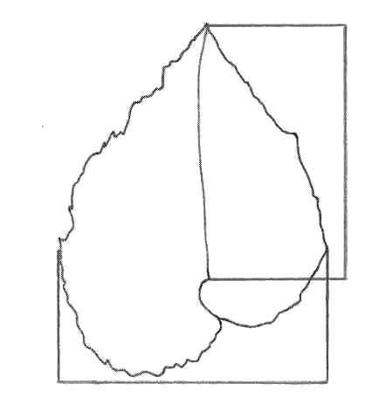 | Leaf blade: length of midrib
Leaf blade: width

Ad. 8: Leaf blade: base

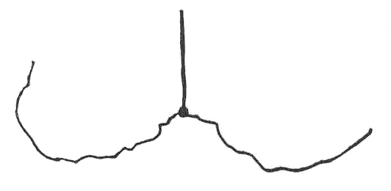 | 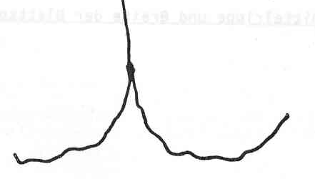 | 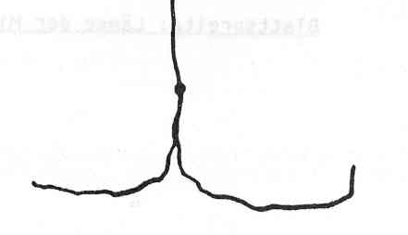 | 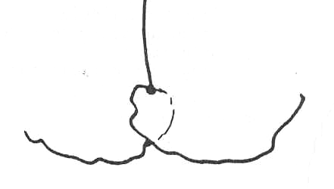 | 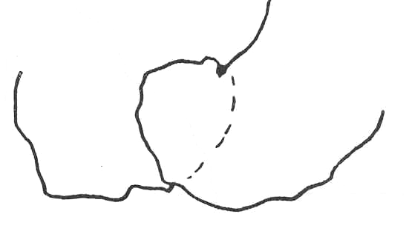
1 | 3 | 5 | 7 | 9
wide open | moderately open | closed | slightly overlapping | strongly overlapping

Ad. 9: Leaf blade: angle of apex

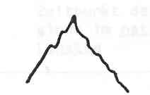 | 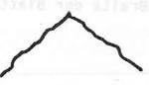 | 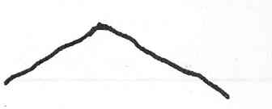
3 | 5 | 7
moderately acute | right angled | moderately obtuse

Ad. 10: Leaf blade: incisions of margin

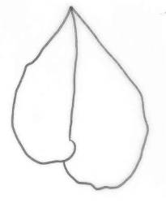 | 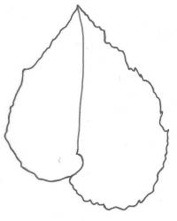 | 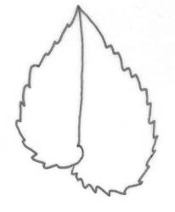 | 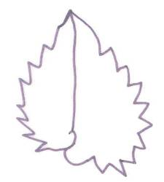
1 | 3 | 5 | 7
absent or very shallow | shallow | medium | deep

Ad. 14: Flower: type

A single flower has two outer and two inner petals only. A double flower has two outer petals and more than two inner petals.

Ad. 16: Flower: length
Ad. 17: Flower: width

Outer petal  Inner petal | 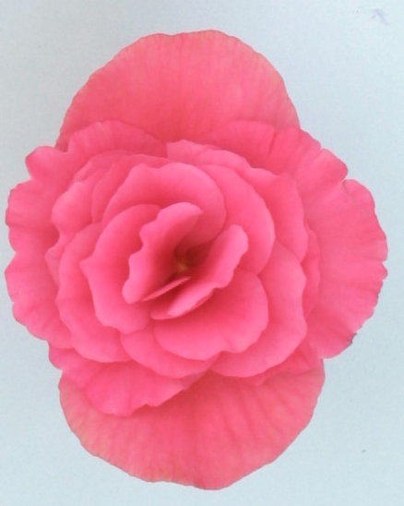 | Flower: length
 | Flower: width

Ad. 18: Flower: number of colors

One Flowers with only one color on the upper side of the petals. Although there is only one color, there might be parts of the flower which are somewhat lighter or darker than the rest.
Two Flowers with two different colors on the upper side of the petals, e.g. red and white
More than two Flowers with more than two different colors on the upper side of the petals, e.g. red, white and yellow.

Ad. 21: Outer petal: incisions of margin

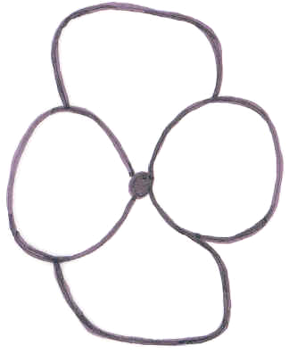 | 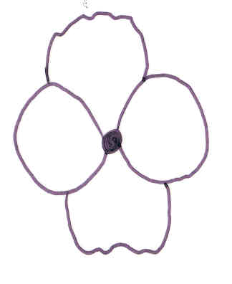 | 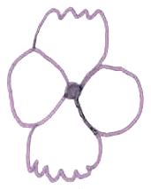 | 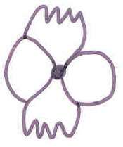
1 | 3 | 5 | 7
absent or very shallow | shallow | medium | deep

Ad. 26: Inner petal: incisions of margin

 | 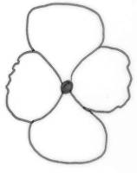 | 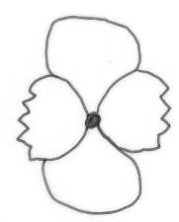 | 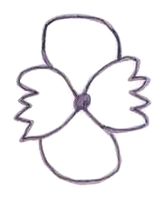
1 | 3 | 5 | 7
absent or very shallow | shallow | medium | deep

Literature
Thompson, Mildred L., Thompson Edward J., 1981: Begonias. The complete reference guide. Times Books, New York, US.

Technical Questionnaire
TECHNICAL QUESTIONNAIRE |  |  |  | Page {x} of {y} |  | Reference Number:
 |  |  |  |  |  | Application date:
 |  |  |  |  |  | (not to be filled in by the applicant)
TECHNICAL QUESTIONNAIRE
to be completed in connection with an application for plant breeders’ rights

1. Subject of the Technical Questionnaire
1.1 Botanical name |  |  | Begonia ×hiemalis Fotsch  (syn. Begonia ×elatior hort.)
1.2 Common name |  |  | Elatior Begonia
2. Applicant
Name
Address
Telephone No.
Fax No.
E-mail address
Breeder (if different from applicant)
3. Proposed denomination and breeder’s reference
Proposed denomination
(if available)

Breeder’s reference
#4. Information on the breeding scheme and propagation of the variety

4.1 Breeding scheme

Variety resulting from:

4.1.1 Crossing

(a) controlled cross [ ]
(please state parent varieties)
(b) partially known cross [ ]
(please state known parent variety(ies))
(c) unknown cross [ ]

4.1.2 Mutation [ ]
(please state parent variety)

4.1.3 Discovery and development [ ]
(please state where and when discovered and how developed)

4.1.4 Other [ ]
(please provide details)

4.2 Method of propagating the variety

4.2.1 Vegetative propagation

(a) cuttings [ ]
(b) in vitro propagation [ ]
(c) other (state method) [ ]

4.2.2 Seed [ ]

4.2.3 Other [ ]
(please provide details)

5. Characteristics of the variety to be indicated (the number in brackets refers to the corresponding characteristic in Test Guidelines; please mark the note which best corresponds).

 | Characteristics |  |  |  |  | Example Varieties |  |  | Note
5.1  (14) | Flower: type
 | single |  |  |  |  |  |  |  | 1[ ]
 | double |  |  |  |  |  |  |  | 2[ ]
5.2  (15) | Only varieties with double flowers:  Flower: number of petals
 | few |  |  |  |  | Peggy |  |  | 3[ ]
 | medium |  |  |  |  |  |  |  | 5[ ]
 | many |  |  |  |  | BBTosca |  |  | 7[ ]
5.3  (18) | Flower: number of colors
 | one |  |  |  |  |  |  |  | 1[ ]
 | two |  |  |  |  |  |  |  | 2[ ]
 | more than two |  |  |  |  |  |  |  | 3[ ]
5.4i  (20) | Outer petal: color of middle of upper side
 | RHS Colour Chart (indicate reference number) |  |  |  |  | ……………………………………..
5.4ii  (20) | Outer petal: color of middle of upper side
 | white |  |  |  |  |  |  |  | 1[ ]
 | yellow |  |  |  |  |  |  |  | 2[ ]
 | orange |  |  |  |  |  |  |  | 3[ ]
 | red |  |  |  |  |  |  |  | 4[ ]
 | red pink |  |  |  |  |  |  |  | 5[ ]
 | blue pink |  |  |  |  |  |  |  | 6[ ]
 | other (indicate color) |  |  |  |  | ……………………………………..
 | Characteristics |  |  |  |  | Example Varieties |  |  | Note
5.5  (21) | Outer petal: incisions of margin
 | absent or very shallow |  |  |  |  | BBTosca |  |  | 1[ ]
 | shallow |  |  |  |  | Bela |  |  | 3[ ]
 | medium |  |  |  |  | Cindy Franje Dark |  |  | 5[ ]
 | deep |  |  |  |  | Daisy Franje |  |  | 7[ ]
5.6i  (23) | Inner petal: color of middle of upper side
 | RHS Colour Chart (indicate reference number) |  |  |  |  | ……………………………………..
5.6ii  (23) | Inner petal: color of middle of upper side
 | white |  |  |  |  |  |  |  | 1[ ]
 | yellow |  |  |  |  |  |  |  | 2[ ]
 | orange |  |  |  |  |  |  |  | 3[ ]
 | red |  |  |  |  |  |  |  | 4[ ]
 | red pink |  |  |  |  |  |  |  | 5[ ]
 | blue pink |  |  |  |  |  |  |  | 6[ ]
 | other (indicate color) |  |  |  |  | ……………………………………..
6. Similar varieties and differences from these varieties

Please use the following table and box for comments to provide information on how your candidate variety differs from the variety (or varieties) which, to the best of your knowledge, is (or are) most similar. This information may help the examination authority to conduct ist examination of distinctness in a more efficient way.

Denomination(s) of variety(ies) similar to your candidate variety |  | Characteristic(s) in which your candidate variety differs from the similar variety(ies) |  |  | Describe the expression of the characteristic(s) for the similar variety(ies) |  | Describe the expression of the characteristic(s) for your candidate variety
(Example) |  | Flower: number of colors |  |  | one |  | two
#7. Additional information which may help in the examination of the variety

7.1 In addition to the information provided in sections 5 and 6, are there any additional characteristics which may help to distinguish the variety?

Yes [ ] No [ ]

(If yes, please provide details)

7.2 Are there any special conditions for growing the variety or conducting the examination?

Yes [ ] No [ ]

(If yes, please provide details):

7.3 Other information

A representative color photograph of the variety should accompany the Technical Questionnaire.

8. Authorization for release

(a) Does the variety require prior authorization for release under legislation concerning the protection of the environment, human and animal health?

Yes [ ] No [ ]

(b) Has such authorization been obtained?

Yes [ ] No [ ]

If the answer to (b) is yes, please attach a copy of the authorization.

9. Information on plant material to be examined or submitted for examination.

9.1 The expression of a characteristic or several characteristics of a variety may be affected by factors, such as pests and disease, chemical treatment (e.g. growth retardants or pesticides), effects of tissue culture, different rootstocks, scions taken from different growth phases of a tree, etc.

9.2 The plant material should not have undergone any treatment which would affect the expression of the characteristics of the variety, unless the competent authorities allow or request such treatment. If the plant material has undergone such treatment, full details of the treatment must be given. In this respect, please indicate below, to the best of your knowledge, if the plant material to be examined has been subjected to:

(a) Microorganisms (e.g. virus, bacteria, phytoplasma) Yes [ ] No [ ]

(b) Chemical treatment (e.g. growth retardant, pesticide) Yes [ ] No [ ]

(c) Tissue culture Yes [ ] No [ ]

(d) Other factors Yes [ ] No [ ]

Please provide details for where you have indicated “yes”.

……………………………………………………………

10. I hereby declare that, to the best of my knowledge, the information provided in this form is correct:

Applicant’s name

Signature Date

[End of document]

* These names were correct at the time of the introduction of these Test Guidelines but may be revised or updated. [Readers are advised to consult the UPOV Code, which can be found on the UPOV Website (www.upov.int), for the latest information.]
# Authorities may allow certain of this information to be provided in a confidential section of the Technical Questionnaire.
# Authorities may allow certain of this information to be provided in a confidential section of the Technical Questionnaire.

