 |  | E  TG/16/8  ORIGINAL: English  DATE: 2004-03-31
INTERNATIONAL UNION FOR THE PROTECTION OF NEW VARIETIES OF PLANTS
GENEVA

 | RICE  (Oryza sativa L.) | *

GUIDELINES

FOR THE CONDUCT OF TESTS

FOR DISTINCTNESS, UNIFORMITY AND STABILITY

Alternative Names:*

Latin | English | French | German | Spanish
Oryza sativa L. | Rice | Riz | Reis | Arroz

ASSOCIATED DOCUMENTS

These guidelines should be read in conjunction with document TG/1/3, “General Introduction to the Examination of Distinctness, Uniformity and Stability and the Development of Harmonized Descriptions of New Varieties of Plants” (hereinafter referred to as the “General Introduction”) and its associated “TGP” documents.

TABLE OF CONTENTS PAGE

1. Subject of these Test Guidelines 3
2. Material Required 3
3. Method of Examination 3
3.1 Duration of Tests 3
3.2 Testing Place 4
3.3 Conditions for Conducting the Examination 4
3.4 Test Design 4
3.5 Number of Plants / Parts of Plants to be Examined 4
3.6 Additional Tests 4
4. Assessment of Distinctness, Uniformity and Stability 5
4.1 Distinctness 5
4.2 Uniformity 5
4.3 Stability 6
5. Grouping of Varieties and Organization of the Growing Trial 6
6. Introduction to the Table of Characteristics 6
6.1 Categories of Characteristics 6
6.2 States of Expression and Corresponding Notes 7
6.3 Types of Expression 7
6.4 Example Varieties 7
6.5 Legend 7
7. Table of Characteristics/Tableau des caractères/Merkmalstabelle/Tabla de caracteres 8
8. Explanations on the Table of Characteristics 26
8.1 Explanations covering several characteristics 26
8.2 Explanations for individual characteristics 26
9. Literature 39
10. Technical Questionnaire 40

Subject of these Test Guidelines
These Test Guidelines apply to all varieties of Oryza sativa L.

Material Required
2.1 The competent authorities decide on the quantity and quality of the plant material required for testing the variety and when and where it is to be delivered. Applicants submitting material from a State other than that in which the testing takes place must ensure that all customs formalities and phytosanitary requirements are complied with.

2.2 The material is to be supplied in the form of seed.

2.3 The minimum quantity of plant material, to be supplied by the applicant, should be:

2.3.1 General

2 kg.

2.3.2 Hybrid varieties

If requested, an additional 2 kg of seed of each component should be submitted.

2.3.2 Panicles

If requested by the competent authority, at least 100 panicles should also be submitted. The panicles should be well developed and not obviously affected by any pest or disease. They should contain a sufficient number of viable seeds to establish a satisfactory row of plants for observation.

2.4 The seed should meet the minimum requirements for germination, species and analytical purity, health and moisture content, specified by the competent authority. In cases where the seed is to be stored, the germination capacity should be as high as possible and should be stated by the applicant.

2.5 The plant material supplied should be visibly healthy, not lacking in vigor, nor affected by any important pest or disease.

2.6 The plant material should not have undergone any treatment which would affect the expression of the characteristics of the variety, unless the competent authorities allow or request such treatment. If it has been treated, full details of the treatment must be given.

Method of Examination

3.1 Duration of Tests

The minimum duration of tests should normally be two independent growing cycles.

3.2 Testing Place
The tests should normally be conducted at one place. If any characteristics of the variety, which are relevant for the examination of DUS, cannot be observed at that place, the variety may be tested at an additional place.

3.3 Conditions for Conducting the Examination
The tests should be carried out under conditions ensuring satisfactory growth for the expression of the relevant characteristics of the variety and for the conduct of the examination.

3.3.1 Stage of development for the assessment

The optimal stage of development for the assessment of each characteristic is indicated by a number in the second column of the Table of Characteristics. The stages of development denoted by each number are described at the end of Chapter 8.

3.3.2 Type of observation – visual or measurement

The recommended method of observing the characteristic is indicated by the following key in the second column of the Table of Characteristics:

MG: single measurement of a group of plants or parts of plants
MS: measurement of a number of individual plants or parts of plants
VG: visual assessment by a single observation of a group of plants or parts of plants
VS: visual assessment by observation of individual plants or parts of plants

3.4 Test Design
3.4.1 The design of the tests should be such that plants or parts of plants may be removed for measurement or counting without prejudice to the observations which must be made up to the end of the growing cycle.

3.4.2 Each test should be designed to result in a total of, at least 1500 plants, which should be divided between two or more replicates.

Single panicle-rows: If tests on panicle-rows are conducted, at least 50 panicle-rows should be observed.

3.5 Number of Plants / Parts of Plants to be Examined
Unless otherwise indicated, all observations made on individual plants or determined by measurement or counting should be made on at least 20 plants or parts taken from each of the 20 plants.

3.6 Additional Tests
Additional tests, for examining relevant characteristics, may be established.

Assessment of Distinctness, Uniformity and Stability

4.1 Distinctness
4.1.1 General Recommendations

It is of particular importance for users of these Test Guidelines to consult the General Introduction prior to making decisions regarding distinctness. However, the following points are provided for elaboration or emphasis in these Test Guidelines.

4.1.2 Consistent Differences

The minimum duration of tests recommended in Section 3.1 reflects, in general, the need to ensure that any differences in a characteristic are sufficiently consistent.

4.1.3 Clear Differences

Determining whether a difference between two varieties is clear depends on many factors, and should consider, in particular, the type of expression of the characteristic being examined, i.e. whether it is expressed in a qualitative, quantitative, or pseudo-qualitative manner. Therefore, it is important that users of these Test Guidelines are familiar with the recommendations contained in the General Introduction prior to making decisions regarding distinctness.

4.2 Uniformity
4.2.1 It is of particular importance for users of these Test Guidelines to consult the General Introduction prior to making decisions regarding uniformity. However, the following points are provided for elaboration or emphasis in these Test Guidelines:

4.2.2 Self-pollinated varieties

(a) Plots: For the assessment of uniformity of characteristics on the plot as a whole, a population standard of 0.1 % with an acceptance probability of at least 95% should be applied. In the case of a sample size of 1,500 plants the maximum number of off-types allowed would be 4.

(b) Single panicle-rows: For the assessment of uniformity of characteristics on single panicle-rows, plants or parts of plants, a population standard of 1% with an acceptance probability of at least 95% should be applied. In the case of a sample size of 50 panicle rows, the maximum number of aberrant panicle-rows should not exceed 2.

4.2.3 Hybrid varieties

For the assessment of uniformity of single hybrids, a population standard of 1% with an acceptance probability of at least 95% should be applied. In the case of a sample size of 1,500 plants the maximum number of off-types allowed would be 39.

4.3 Stability
4.3.1 In practice, it is not usual to perform tests of stability that produce results as certain as those of the testing of distinctness and uniformity. However, experience has demonstrated that, for many types of variety, when a variety has been shown to be uniform, it can also be considered to be stable.

4.3.2 Where appropriate, or in cases of doubt, stability may be tested, either by growing a further generation, or by testing a new seed stock to ensure that it exhibits the same characteristics as those shown by the previous material supplied.

Grouping of Varieties and Organization of the Growing Trial
5.1 The selection of varieties of common knowledge to be grown in the trial with the candidate varieties and the way in which these varieties are divided into groups to facilitate the assessment of distinctness is aided by the use of grouping characteristics.

5.2 Grouping characteristics are those in which the documented states of expression, even where produced at different locations, can be used, either individually or in combination with other such characteristics: (a) to select varieties of common knowledge that can be excluded from the growing trial used for examination of distinctness; and (b) to organize the growing trial so that similar varieties are grouped together.

5.3 The following have been agreed as useful grouping characteristics:

(a) Leaf: anthocyanin coloration of auricles (characteristic 9)
(b) Time of heading (50% of plants with heads) (characteristic 19)
(c) Non-prostrate varieties only: Stem: length (excluding panicle) (characteristic 26)
(d) Decorticated grain: length (characteristic 58)
(e) Decorticated grain: color (characteristic 61)
(f) Decorticated grain: aroma (characteristic 65)

5.4 Guidance for the use of grouping characteristics, in the process of examining distinctness, is provided through the General Introduction.

Introduction to the Table of Characteristics

6.1 Categories of Characteristics
6.1.1 Standard Test Guidelines Characteristics

Standard Test Guidelines characteristics are those which are approved by UPOV for examination of DUS and from which members of the Union can select those suitable for their particular circumstances.

6.1.2 Asterisked Characteristics

Asterisked characteristics (denoted by *) are those included in the Test Guidelines which are important for the international harmonization of variety descriptions and should always be examined for DUS and included in the variety description by all members of the Union, except when the state of expression of a preceding characteristic or regional environmental conditions render this inappropriate.

6.2 States of Expression and Corresponding Notes
States of expression are given for each characteristic to define the characteristic and to harmonize descriptions. Each state of expression is allocated a corresponding numerical note for ease of recording of data and for the production and exchange of the description.

6.3 Types of Expression
An explanation of the types of expression of characteristics (qualitative, quantitative and pseudo-qualitative) is provided in the General Introduction.

6.4 Example Varieties
Where appropriate, example varieties are provided to clarify the states of expression of each characteristic.

Regional sets of example varieties will be presented in an annex to these
Test Guidelines to be published on the UPOV Website (www.upov.int)

6.5 Legend
(*) Asterisked characteristic – see Section 6.1.2

QL Qualitative characteristic – see Section 6.3
QN Quantitative characteristic – see Section 6.3
PQ Pseudo-qualitative characteristic – see Section 6.3

MG Single measurement of a group of plants or parts of plants – see Section 3.3.1
MS Measurement of a number of individual plants or parts of plants – see Section 3.3.1
VG Visual assessment by a single observation of a group of plants or parts of plants –
see Section 3.3.1
VS Visual assessment by observation of individual plants or parts of plants –
see Section 3.3.1

(a) See Explanations on the Table of Characteristics in Chapter 8, Section 8.1

(+) See Explanations on the Table of Characteristics in Chapter 8, Section 8.2

Stage of development: see Section 3.3.2

7. Table of Characteristics/Tableau des caractères/Merkmalstabelle/Tabla de caracteres
 |  | English | français | deutsch | español | Example Varieties  Exemples  Beispielssorten  Variedades ejemplo | Note/  Nota
1  (+) | 10  VS | Coleoptile: anthocyanin coloration | Coléoptile: pigmentation anthocyanique | Keimscheide: Anthocyanfärbung | Coleóptilo: pigmentación antociánica
QN |  | absent or very weak | absente ou très faible | fehlend oder sehr gering | ausente o muy débil |  | 1
 |  | weak | faible | gering | débil |  | 3
 |  | strong | forte | stark | fuerte |  | 5
2 | 40  VS | Basal leaf: sheath color | Feuille basilaire: couleur de la gaine | Basisblatt: Farbe der Blattscheide | Hoja basal: color de la vaina
PQ |  | green | verte | grün | verde |  | 1
 |  | green with purple lines | verte à stries violettes | grün mit purpurfarbenen Linien | verde con líneas púrpura |  | 2
 |  | light purple | violet clair | hellpurpurn | púrpura claro |  | 3
 |  | purple | violette | purpurn | púrpura |  | 4
3 | 40  VG | Leaf: intensity of green color | Feuille: intensité de la couleur verte | Blatt: Intensität der Grünfärbung | Hoja: intensidad del color verde
QN | (a) | light | claire | hell | claro |  | 3
 |  | medium | moyenne | mittel | medio |  | 5
 |  | dark | foncée | dunkel | oscuro |  | 7
4 | 40  VG | Leaf: anthocyanin coloration | Feuille: pigmentation anthocyanique | Blatt: Anthocyanfärbung | Hoja: pigmentación antociánica
QL | (a) | absent | absente | fehlend | ausente |  | 1
 |  | present | présente | vorhanden | presente |  | 9
5 | 40  VG | Leaf: distribution of anthocyanin coloration | Feuille: répartition de la pigmentation anthocyanique | Blatt: Verteilung der Anthocyanfärbung | Hoja: distribución de la pigmentación antociánica
PQ | (a) | on tips only | seulement au sommet | nur an der Spitze | sólo en el extremo |  | 1
 |  | on margins only | seulement en bordure | nur an den Rändern | sólo en los bordes |  | 2
 |  | in blotches only | seulement en taches | nur in Flecken | sólo en manchas |  | 3
 |  | even | uniforme | gleichmäßig | uniforme |  | 4
6 | 40  VG | Leaf sheath: anthocyanin coloration | Gaine de la feuille: pigmentation anthocyanique | Blattscheide: Anthocyanfärbung | Vaina de la hoja: pigmentación antociánica
QL | (a) | absent | absente | fehlend | ausente |  | 1
 |  | present | présente | vorhanden | presente |  | 9
7 | 40  VG | Leaf sheath: intensity of anthocyanin coloration | Gaine de la feuille: intensité de la pigmentation anthocyanique | Blattscheide: Stärke der Anthocyan-färbung | Vaina de la hoja: intensidad de la pigmentación antociánica
QN | (a) | very weak | très faible | sehr gering | muy débil |  | 1
 |  | weak | faible | gering | débil |  | 3
 |  | medium | moyenne | mittel | media |  | 5
 |  | strong | forte | stark | fuerte |  | 7
8 | 40  VS | Leaf blade: pubescence of surface | Limbe: pubescence de la surface | Blattspreite: Behaarung der Oberfläche | Limbo: pubescencia de la superficie
QN | (a) | absent or very weak | nulle ou très faible | fehlend oder sehr gering | ausente o muy débil |  | 1
 |  | weak | faible | gering | débil |  | 3
 |  | medium | moyenne | mittel | media |  | 5
 |  | strong | forte | stark | fuerte |  | 7
9  (*) | 40  VS | Leaf: anthocyanin coloration of auricles | Feuille: pigmentation anthocyanique des oreillettes | Blatt: Anthocyanfärbung der Blattöhrchen | Hoja:  pigmentación antociánica de las aurículas
QL | (a) | absent | absente | fehlend | ausente |  | 1
 |  | present | présente | vorhanden | presente |  | 9
10 | 40  VS | Leaf: anthocyanin coloration of collar | Feuille: pigmentation anthocyanique de la collerette | Blatt: Anthocyanfärbung des Kragens | Hoja:  pigmentación antociánica del collar
QL | (a) | absent | absente | fehlend | ausente |  | 1
 |  | present | présente | vorhanden | presente |  | 9
11  (+) | 40  VS | Leaf: shape of ligule | Feuille: forme de la ligule | Blatt: Form des Blatthäutchens | Hoja: forma de la lígula
PQ | (a) | truncate | tronquée | stumpf | truncada |  | 1
 |  | acute | pointue | spitz | aguda |  | 2
 |  | cleft | divisée | gespalten | hendida |  | 3
12 | 40  VS | Leaf: color of ligule | Feuille: couleur de la ligule | Blatt: Farbe des Blatthäutchens | Hoja: color de la lígula
PQ | (a) | colorless | incolore | farblos | incolora |  | 1
 |  | green | verte | grün | verde |  | 2
 |  | green with purple lines | verte à stries violettes | grün mit purpurfarbenen Linien | verde con líneas púrpura |  | 3
 |  | light purple | violet clair | hellpurpurn | púrpura claro |  | 4
 |  | purple | violette | purpurn | púrpura |  | 5
13 | 40  MS | Leaf blade: length | Limbe: longueur | Blattspreite: Länge | Limbo: longitud
QN | (a) | short | court | kurz | corto |  | 3
 |  | medium | moyen | mittel | medio |  | 5
 |  | long | long | lang | largo |  | 7
14 | 40  MS | Leaf blade: width | Limbe: largeur | Blattspreite: Breite | Limbo: anchura
QN | (a) | narrow | étroit | schmal | estrecho |  | 3
 |  | medium | moyen | mittel | medio |  | 5
 |  | broad | large | breit | ancho |  | 7
15  (*)  (+) | 60  VG | Flag leaf: attitude of blade (early observation) | Dernière feuille: port du limbe (observation précoce) | Fahnenblatt: Haltung der Spreite (frühe Erfassung) | Hoja bandera: porte del limbo (observación temprana)
QN |  | erect | dressé | aufrecht | erecto |  | 1
 |  | semi-erect | demi-dressé | halbaufrecht | semierecto | Galatxo | 3
 |  | horizontal | horizontal | waagerecht | horizontal | Veta | 5
 |  | recurved | recourbé | zurückgebogen | recurvado |  | 7
16  (*)  (+) | 90  VG | Flag leaf: attitude of blade (late observation) | Dernière feuille: port du limbe (observation tardive) | Fahnenblatt: Haltung der Spreite (späte Erfassung) | Hoja bandera: porte del limbo (observación tardía)
QN |  | erect | dressé | aufrecht | erecto |  | 1
 |  | semi-erect | demi-dressé | halbaufrecht | semierecto | Fonsa | 3
 |  | horizontal | horizontal | waagerecht | horizontal | Puebla | 5
 |  | recurved | recourbé | zurückgebogen | recurvado |  | 7
17  (+) | 40  VS | Culm: habit | Tige: port | Seitentrieb: Wuchsform | Macollo: porte
PQ |  | erect | dressé | aufrecht | erecto |  | 1
 |  | semi-erect | demi-dressé | halbaufrecht | semierecto |  | 3
 |  | open | ouvert | offen | abierto |  | 5
 |  | spreading | étalé | breitwüchsig | extendido |  | 7
 |  | prostrate | rampant | liegend | postrado |  | 9
18  (+) | 40  VS | Prostrate varieties only: Culm: kneeing ability | Variétés rampantes seulement: Tige: géniculation | Nur liegende Sorten: Seitentrieb: Biegsamkeit | Variedades postradas solamente: Macollo: capacidad de emergencia de los tallos
QL |  | absent | absente | fehlend | ausente |  | 1
 |  | present | présente | vorhanden | presente |  | 9
19  (*) | 55  VG | Time of heading (50% of plants with heads) | Époque d’épiaison (50% des plantes avec des panicules) | Zeitpunkt des Ährenschiebens (50% der Pflanzen mit Rispen) | Época de espigado (50% de las plantas con panículas)
QN |  | very early | très précoce | sehr früh | muy temprana | Loto | 1
 |  | early | précoce | früh | temprana | Albada, Cripto | 3
 |  | medium | moyenne | mittel | media | Ariete, Bahia | 5
 |  | late | tardive | spät | tardía | Bomba, Puntal | 7
20  (+) | 60  VS/  MS | Male sterility | Stérilité mâle | Männliche Sterilität | Androesterilidad
PQ |  | absent | absente | fehlend | ausente |  | 1
 |  | partially male sterile | stérilité mâle partielle | teilweise männlich-steril | parcialmente androestéril |  | 2
 |  | male sterile | mâle stérile | männlich-steril | androestéril |  | 3
21  (+) | 65.  VS | Lemma: anthocyanin coloration of keel (early observation) | Glumelle inférieure: pigmentation anthocyanique de la carène (observation précoce) | Deckspelze: Anthocyanfärbung des Kiels (frühe Erfassung) | Lema: pigmentación antociánica de la quilla (observación temprana)
QN |  | absent or very weak | absente ou très faible | fehlend oder sehr gering | ausente o muy débil |  | 1
 |  | weak | faible | gering | débil |  | 3
 |  | medium | moyenne | mittel | media |  | 5
 |  | strong | forte | stark | fuerte |  | 7
22  (+) | 65.  VS | Lemma: anthocyanin coloration of area below apex (early observation) | Glumelle inférieure: pigmentation anthocyanique de la zone sous l'apex (observation précoce) | Deckspelze: Anthocyanfärbung der Fläche unterhalb der Spitze (frühe Erfassung) | Lema: pigmentación antociánica de la zona bajo el ápice (observación temprana)
QN |  | absent or very weak | absente ou très faible | fehlend oder sehr gering | ausente o muy débil |  | 1
 |  | weak | faible | gering | débil |  | 3
 |  | medium | moyenne | mittel | media |  | 5
 |  | strong | forte | stark | fuerte |  | 7
23  (*)  (+) | 65.  VS | Lemma: anthocyanin coloration of apex (early observation) | Glumelle inférieure: pigmentation anthocyanique de l’apex (observation précoce) | Deckspelze: Anthocyanfärbung der Spitze (frühe Erfassung) | Lema: pigmentación antociánica del ápice (observación temprana)
QN |  | absent or very weak | absente ou très faible | fehlend oder sehr gering | ausente o muy débil | Ariete, Bomba | 1
 |  | weak | faible | gering | débil | Thaibonnet | 3
 |  | medium | moyenne | mittel | media | Cripto | 5
 |  | strong | forte | stark | fuerte | Elio, Puntal | 7
 |  | very strong | très forte | sehr stark | muy fuerte | Arborio | 9
24  (*) | 65.  VS | Spikelet: color of stigma | Épillet: couleur du stigmate | Ährchen: Farbe der Narbe | Espiguilla: color del estigma
PQ |  | white | blanc | weiß | blanco | Ariete, Bahia | 1
 |  | light green | vert clair | hellgrün | verde claro |  | 2
 |  | yellow | jaune | gelb | amarillo |  | 3
 |  | light purple | violet clair | hellpurpurn | púrpura claro |  | 4
 |  | purple | violet | purpurn | púrpura | Vialone Nano | 5
25  (+) | 70.  VS | Stem: thickness | Tige: épaisseur | Halm: Dicke | Tallo: grosor
QN |  | thin | mince | dünn | delgado |  | 3
 |  | medium | moyenne | mittel | medio |  | 5
 |  | thick | épaisse | dick | grueso |  | 7
26  (*) | 70  VS | Non-prostrate varieties only: Stem length (excluding panicle) | Variétés non rampantes seulement: Tige: longueur (panicule non comprise) | Nur nicht liegende Sorten: Halm: Länge (ohne Rispe) | Variedades no postradas solamente: Tallo: longitud (excluida la panícula)
QN |  | very short | très courte | sehr kurz | muy corto | Lampo, Leda | 1
 |  | short | courte | kurz | corto | Loto, Thaibonnet | 3
 |  | medium | moyenne | mittel | medio | Ariete, Bahia | 5
 |  | long | longue | lang | largo | Baldo | 7
 |  | very long | très longue | sehr lang | muy largo | Carnaroli | 9
27  (*) | 70  VS | Stem: anthocyanin coloration of nodes | Tige: pigmentation anthocyanique des nœuds | Halm: Anthocyanfärbung der Knoten | Tallo: pigmentación antociánica de los nudos
QL |  | absent | absente | fehlend | ausente |  | 1
 |  | present | présente | vorhanden | presente |  | 9
28 | 70  VS | Stem: intensity of anthocyanin coloration of nodes | Tige: intensité de la pigmentation anthocyanique des nœuds | Halm: Intensität der Anthocyanfärbung der Knoten | Tallo: intensidad de la pigmentación antociánica de los nudos
QN |  | weak | faible | gering | débil |  | 3
 |  | medium | moyenne | mittel | media |  | 5
 |  | strong | forte | stark | fuerte |  | 7
29 | 70  VS | Stem: anthocyanin coloration of internodes | Tige: pigmentation anthocyanique des entre-nœuds | Halm: Anthocyanfärbung der Internodien | Tallo: pigmentación antociánica de los entrenudos
QL |  | absent | absente | fehlend | ausente |  | 1
 |  | present | présente | vorhanden | presente |  | 9
30  (*)  (+) | 72-90  MS | Panicle: length of main axis | Panicule: longueur de l’axe central | Rispe: Länge der Hauptachse | Panícula: longitud del eje principal
QN |  | short | court | kurz | corto | Ariete, Lido | 3
 |  | medium | moyen | mittel | medio | Thaibonnet, Thainato | 5
 |  | long | long | lang | largo | Carnaroli, Lemont | 7
31 | 70.  MS | Panicle: number per plant | Panicule: nombre par plante | Rispe: Anzahl pro Pflanze | Panícula: número por planta
QN |  | few | petit | gering | bajo |  | 3
 |  | medium | moyen | mittel | medio |  | 5
 |  | many | grand | groß | alto |  | 7
32 | 60.  VS | Panicle: awns | Panicule: arêtes | Rispe: Grannen | Panícula: aristas
QL |  | absent | absentes | fehlend | ausentes |  | 1
 |  | present | présentes | vorhanden | presentes |  | 9
33 | 60  VS | Panicle: color of awns (early observation) | Panicule: couleur des arêtes (observation précoce) | Rispe: Farbe der Grannen (frühe Erfassung) | Panícula: color de las aristas (observación temprana)
PQ |  | light gold | doré clair | hellgolden | dorado claro |  | 1
 |  | gold | dorées | gelblichbraun | dorado |  | 2
 |  | brown | brunes | braun | marrón |  | 3
 |  | reddish brown | brun rougeâtre | rötlichbraun | marrón rojizo |  | 4
 |  | light red | rouge clair | hellrot | rojo claro |  | 5
 |  | red | rouges | rot | rojo |  | 6
 |  | light purple | violet clair | hellpurpurn | púrpura claro |  | 7
 |  | purple | violettes | purpurn | púrpura |  | 8
 |  | black | noires | schwarz | negro |  | 9
34  (*) | 70-80  VS | Panicle: distribution of awns | Panicule: répartition des arêtes | Rispe: Verteilung der Begrannung | Panícula: distribución de las aristas
PQ |  | tip only | au sommet seulement | nur an der Spitze | sólo en el ápice | Thaimato, Senia | 1
 |  | upper quarter only | sur le quart supérieur seulement | nur am oberen Viertel | en el quarto superior solamente | Galaxto | 2
 |  | upper half only | sur la moitié supérieure seulement | nur in der oberen Hälfte | en la mitad superior | Puebla | 3
 |  | upper three quarters only | sur les trois quarts supérieurs seulement | nur an den oberen drei Vierteln | en los tres quartos superiores solamente |  | 4
 |  | whole length | sur toute la longueur | auf der ganzen Länge | a todo lo largo | Bomba, Carnaroli | 5
35 | 70-80  VS | Panicle: length of longest awns | Panicule: longueur des arêtes les plus longues | Rispe: Länge der längsten Grannen | Panícula: longitud de las aristas más largas
QN |  | very short | très courtes | sehr kurz | muy cortas |  | 1
 |  | short | courtes | kurz | cortas |  | 3
 |  | medium | moyennes | mittel | medias |  | 5
 |  | long | longues | lang | largas |  | 7
 |  | very long | très longues | sehr lang | muy largas |  | 9
36  (*) | 60-80  VS | Spikelet: pubescence of lemma | Épillet: pubescence de la glumelle inférieure | Ährchen: Behaarung der Deckspelze | Espiguilla: pubescencia de la lema
QN |  | absent or very weak | absente ou très faible | fehlend oder sehr gering | ausente o muy débil | Puntal, Thaibonnet | 1
 |  | weak | faible | gering | débil | Guadiamar, Thaibonnet | 3
 |  | medium | moyenne | mittel | media | Galatxo, Vialone Nano | 5
 |  | strong | forte | stark | fuerte | Bomba, Calca, S. Andrea | 7
 |  | very strong | très forte | sehr stark | muy fuerte |  | 9
37  (+) | 80-90  VS | Spikelet: color of tip of lemma | Épillet: couleur du sommet de la glumelle inférieure | Ährchen: Farbe der Spitze der Deckspelze | Espiguilla: color del extremo de la lema
PQ |  | white | blanc | weiß | blanco |  | 1
 |  | yellowish | jaunâtre | gelblich | amarillento |  | 2
 |  | brown | brun | braun | marrón |  | 3
 |  | red | rouge | rot | rojo |  | 4
 |  | purple | pourpre | purpurn | púrpura |  | 5
 |  | black | noir | schwarz | negro |  | 6
38 | 90  VS | Panicle: color of awns (late observation) | Panicule: couleur des arêtes (observation tardive) | Rispe: Farbe der Grannen (späte Erfassung) | Panícula: color de las aristas (observación tardía)
PQ |  | light gold | doré clair | hellgolden | dorado claro |  | 1
 |  | gold | dorées | golden | dorado |  | 2
 |  | brown | brunes | braun | marrón |  | 3
 |  | reddish brown | brun rougeâtre | rötlichbraun | marrón rojizo |  | 4
 |  | light red | rouge clair | hellrot | rojo claro |  | 5
 |  | red | rouges | rot | rojo |  | 6
 |  | light purple | violet clair | hellpurpurn | púrpura claro |  | 7
 |  | purple | violettes | purpurn | púrpura |  | 8
 |  | black | noires | schwarz | negro |  | 9
39  (*)  (+) | 90  VG | Panicle: attitude in relation to stem | Panicule: port par rapport à la tige | Rispe: Haltung im Verhältnis zum Halm | Panícula: porte en relación con el tallo
PQ |  | upright | dressée | aufrecht | erecto | Elio, Roncolo | 1
 |  | semi-upright | demi-dressée | halbaufrecht | semierecto | Ariete, Lido | 2
 |  | slightly drooping | légèrement retombante | etwas überhängend | ligeramente colgante | Guadiamar, Thaibonnet | 3
 |  | strongly drooping | fortement retombante | stark überhängend | fuertemente colgante | Galatxo, Vialone Nano | 4
40  (+) | 90  VS | Panicle: presence of secondary branching | Panicule: présence de ramification secondaire | Rispe: Vorhandensein der sekundären Verzweigung | Panícula: presencia de ramificación secundaria
QL |  | absent | absente | fehlend | ausente |  | 1
 |  | present | présente | vorhanden | presente |  | 9
41  (+) | 90  VS | Panicle: type of secondary branching | Panicule: type de la ramification secondaire | Rispe: Typ der sekundären Verzweigung | Panícula: tipo de ramificación secundaria
PQ |  | type 1 | type 1 | Typ 1 | tipo 1 |  | 1
 |  | type 2 | type 2 | Typ 2 | tipo 2 |  | 2
 |  | type 3 | type 3 | Typ 3 | tipo 3 |  | 3
42  (*)  (+) | 90  VS | Panicle: attitude of branches | Panicule: port des ramifications | Rispe: Stellung der Seitenäste | Panícula: porte de las ramificaciones
QN |  | erect | dressé | aufrecht | erectas |  | 1
 |  | semi-erect | demi-dressé | halbaufrecht | semierectas | Bahia | 3
 |  | spreading | étalé | breitwüchsig | extendidas | Koral | 5
43  (+) | 90  VG | Panicle: exsertion | Panicule: déploiement | Rispe: Hervorstehen | Panícula: exerción
QN |  | enclosed | inclue | eingeschlossen | envuelta |  | 1
 |  | partly exserted | partiellement saillante | teilweise hervorstehend | parcialmente exerta |  | 3
 |  | just exserted | tout juste saillante | gerade noch hervorstehend | apenas exerta |  | 5
 |  | moderately-well exserted | moyennement saillante | mäßig deutlich hervorstehend | moderadamente exerta |  | 7
 |  | well exserted | bien saillante | deutlich hervorstehend | muy exerta |  | 9
44 | 90  VG | Time of maturity | Époque de maturité | Zeitpunkt der Reife | Época de madurez
QN |  | very early | très précoce | sehr früh | muy temprana |  | 1
 |  | early | précoce | früh | temprana |  | 3
 |  | intermediate | intermédiaire | mittel | media |  | 5
 |  | late | tardive | spät | tardía |  | 7
 |  | very late | très tardive | sehr spät | muy tardía |  | 9
45  (+) | 92  VG | Leaf: time of senescence | Feuille: époque de sénescence | Blatt: Zeitpunkt des Alterns | Hoja: época de senescencia
QN |  | early | précoce | früh | precoz |  | 3
 |  | intermediate | intermédiaire | mittel | intermedia |  | 5
 |  | late | tardive | spät | tardía |  | 7
46 | VS | Lemma: color | Glumelle inférieure: couleur | Deckspelze: Farbe | Lema: color
PQ |  | light gold | doré clair | hellgolden | dorado claro |  | 1
 |  | gold | dorée | golden | dorado |  | 2
 |  | brown | brune | braun | marrón |  | 3
 |  | reddish to light purple | rougeâtre à violet clair | rötlich bis hellpurpurn | rojizo a púrpura claro |  | 4
 |  | purple | violette | purpurn | púrpura |  | 5
 |  | black | noire | schwarz | negro |  | 6
47 | VS | Lemma: ornamentation | Glumelle inférieure: ornementation | Deckspelze: Ornamentierung | Lema: ornamento
PQ |  | absent | absente | Fehlend | ausente |  | 1
 |  | gold furrows | sillons dorés | goldene Furchen | surcos dorados |  | 2
 |  | brown furrows | sillons bruns | braune Furchen | surcos marrones |  | 3
 |  | purple spots | taches violettes | purpurfarbene Flecken | puntos púrpura |  | 4
 |  | purple furrows | sillons violets | purpurfarbene Furchen | surcos púrpura |  | 5
48  (+) | 92.  VS | Lemma: anthocyanin coloration of keel (late observation) | Glumelle inférieure: pigmentation anthocyanique de la carène (observation tardive) | Deckspelze: Anthocyanfärbung des Kiels (späte Erfassung) | Lema: pigmentación antociánica de la quilla (observación tardía)
QN |  | absent or very weak | absente ou très faible | fehlend oder sehr gering | ausente o muy débil |  | 1
 |  | weak | faible | gering | débil |  | 3
 |  | medium | moyenne | mittel | media |  | 5
 |  | strong | forte | stark | fuerte |  | 7
49  (+) | 92.  VS | Lemma: anthocyanin coloration of area below apex (late observation) | Glumelle inférieure: pigmentation anthocyanique de la zone sous l'apex (observation tardive) | Deckspelze: Anthocyanfärbung der Fläche unterhalb der Spitze (späte Erfassung) | Lema: pigmentación antociánica de la zona bajo el ápice (observación tardía)
QN |  | absent or very weak | absente ou très faible | fehlend oder sehr gering | ausente o muy débil |  | 1
 |  | weak | faible | gering | débil |  | 3
 |  | medium | moyenne | mittel | media |  | 5
 |  | strong | forte | stark | fuerte |  | 7
 |  | very strong | très forte | sehr stark | muy fuerte |  | 9
50  (+) | 92.  VS | Lemma: anthocyanin coloration of apex (late observation) | Glumelle inférieure: pigmentation anthocyanique de l’apex (observation tardive) | Deckspelze: Anthocyanfärbung der Spitze (späte Erfassung) | Lema: pigmentación antociánica del ápice (observación tardía)
QN |  | absent or very weak | absente ou très faible | fehlend oder sehr gering | ausente o muy débil |  | 1
 |  | weak | faible | gering | débil |  | 3
 |  | medium | moyenne | mittel | media |  | 5
 |  | strong | forte | stark | fuerte |  | 7
 |  | very strong | très forte | sehr stark | muy fuerte |  | 9
51  (+) | 92  MS | Glume: length | Glume: longueur | Hüllspelze: Länge | Gluma: longitud
QN |  | short | courte | kurz | corta |  | 3
 |  | medium | moyenne | mittel | media |  | 5
 |  | long | longue | lang | larga |  | 7
52  (+) | 92  MS | Glume: color | Glume: couleur | Hüllspelze: Farbe | Gluma: color
PQ |  | straw | paille | strohfarben | pajizo |  | 1
 |  | gold | dorée | golden | dorado |  | 2
 |  | red | rouge | rot | rojo |  | 3
 |  | purple | pourpre | purpurn | púrpura |  | 4
53  (+) | 92  MS | Grain: weight of 1000 (fully developed grains) | Grain: poids de 1000 (grains complètement développés) | Korn: Tausendkornmasse (voll entwickelter Körner) | Grano:  peso de 1.000 (granos completamente desarrollados)
QN |  | low | petit | niedrig | pequeño |  | 3
 |  | medium | moyen | mittel | medio |  | 5
 |  | high | grand | hoch | grande |  | 7
54 | 92.  MS | Grain: length | Grain: longueur | Korn: Länge | Grano: longitud
QN |  | short | court | kurz | corto |  | 3
 |  | medium | moyen | mittel | medio |  | 5
 |  | long | long | lang | largo |  | 7
55 | 92.  MS | Grain: width | Grain: largeur | Korn: Breite | Grano: anchura
QN |  | narrow | étroit | schmal | estrecho |  | 3
 |  | medium | moyen | mittel | medio |  | 5
 |  | broad | large | breit | ancho |  | 7
56  (+) | 92  VG | Lemma: phenol reaction | Glumelle inférieure: réaction au phénol | Deckspelze: Phenolreaktion | Lema: reacción al fenol
QL |  | absent | absente | fehlend | ausente |  | 1
 |  | present | présente | vorhanden | presente |  | 9
57  (+) | 92  VS | Lemma: intensity of phenol reaction | Glumelle inférieure: intensité de la réaction au phénol | Deckspelze: Intensität der Phenolreaktion | Lema: intensidad de la reacción al fenol
QN |  | light | claire | hell | clara |  | 3
 |  | medium | moyenne | mittel | media |  | 5
 |  | dark | foncée | dunkel | oscura |  | 7
58  (*) | 92  MS | Decorticated grain: length | Caryopse: longueur | Geschältes Korn: Länge | Cariópside: longitud
QN |  | short | court | kurz | corta | Balilla, Bomba | 3
 |  | medium | moyen | mittel | media | Bahia, Lido | 5
 |  | long | long | lang | larga | Puntal, Thaibonnet | 7
59 | 92  MS | Decorticated grain:  width | Caryopse: largeur | Geschältes Korn: Breite | Cariópside: anchura
QN |  | narrow | étroit | schmal | estrecha |  | 3
 |  | medium | moyen | mittel | media |  | 5
 |  | broad | large | breit | ancha |  | 7
60  (*)  (+) | 92  VS | Decorticated grain: shape (in lateral view) | Caryopse: forme  (de profil) | Geschältes Korn: Form (in Seitenansicht) | Cariópside: forma (vista lateral)
PQ |  | round | arrondi | rund | redonda |  | 1
 |  | semi-round | demi-arrondi | halbrund | semi redonda | Bahia | 2
 |  | half spindle-shaped | demi-fusiforme | halb spindelförmig | medio fusiforme | Lido | 3
 |  | spindle-shaped | fusiforme | spindelförmig | fusiforme | Ariete | 4
 |  | long spindle-shaped | très fusiforme | lang spindelförmig | muy fusiforme | Thaibonnet | 5
61  (*) | 92  VS | Decorticated grain: color | Caryopse: couleur | Geschältes Korn: Farbe | Cariópside: color
PQ |  | white | blanc | weiß | blanco | Bahia, Senia | 1
 |  | light brown | brun clair | hellbraun | marrón claro |  | 2
 |  | variegated brown | brun panaché | panachiert braun | marrón variegado |  | 3
 |  | dark brown | brun foncé | dunkelbraun | marrón oscuro | Venere | 4
 |  | light red | rouge clair | hellrot | rojo claro |  | 5
 |  | red | rouge | rot | rojo |  | 6
 |  | variegated purple | pourpre panaché | panachiert purpurn | púrpura variegado |  | 7
 |  | purple | pourpre | purpurn | púrpura |  | 8
 |  | dark purple/black | pourpre foncé/noir | dunkelpurpurn/ schwarz | púrpura oscuro/negro |  | 9
62  (+) | 92  VS | Endosperm: type | Endosperme: type | Endosperm: Typ | Endosperma: tipo
PQ |  | glutinous | glutineux | mit Gluten | glutinoso |  | 1
 |  | intermediate | intermédiaire | Zwischentyp | intermedio |  | 2
 |  | non-glutinous | non glutineux | ohne Gluten | no glutinoso |  | 3
63  (+) | 92  MG | Endosperm: content of amylose | Endosperme: contenu en amylose | Endosperm: Amylosegehalt | Endosperma: contenido de amilosa
PQ |  | State 1 | Niveau 1 | Stufe 1 | Nivel 1 |  | 1
 |  | State 2 | Niveau 2 | Stufe 2 | Nivel 2 |  | 2
 |  | State 3 | Niveau 3 | Stufe 3 | Nivel 3 |  | 3
 |  | State 4 | Niveau 4 | Stufe 4 | Nivel 4 |  | 4
 |  | State 5 | Niveau 5 | Stufe 5 | Nivel 5 |  | 5
 |  | State 6 | Niveau 6 | Stufe 6 | Nivel 6 |  | 6
 |  | State 7 | Niveau 7 | Stufe 7 | Nivel 7 |  | 7
64  (+) | 92  MG | Alkali digestion | Digestion par des alcalis | Zersetzung durch Alkali | Digestión alcalina
QN |  | not digested | non digérés | nicht ausgelaugt | no digerido |  | 1
 |  | low digested | peu digérés | wenig ausgelaugt | poco digerido |  | 3
 |  | intermediate | moyennement digérés | mittel ausgelaugt | intermedia |  | 5
 |  | completely digested | totalement digérés | vollständig ausgelaugt | completamente digerido |  | 7
65  (*)  (+) | 92  MG | Decorticated grain: aroma | Caryopse: arôme | Geschältes Korn: Aroma | Cariópside: aroma
QN |  | absent or very weak | absent ou très faible | fehlend oder sehr gering | ausente o muy débil | Bahia, Thaibonnet | 1
 |  | weak | faible | gering | débil |  | 2
 |  | strong | fort | stark | fuerte | Arome, Gange | 3

8. Explanations on the Table of Characteristics

8.1 Explanations covering several characteristics
Characteristics containing the following key in the second column of the Table of Characteristics should be examined as indicated below:

(a) Unless otherwise indicated, all observations on the leaf should be made on the penultimate leaf.

8.2 Explanations for individual characteristics

Ad. 1: Coleoptile: anthocyanin coloration

Non-dormant grains are placed on moistened filter paper and covered with a petri-dish lid during germination. After the coleoptiles have reached a length of about 5 mm in darkness they are placed in artificial light (daylight equivalent) at 750-1250 lux continuously for 3 to 4 days, at a temperature of 25 to 30 degrees Centigrade. The color of the coleoptiles is observed when they are fully developed at stage 09-11 (about 6 to 7 days).

Ad. 11: Leaf: shape of ligule

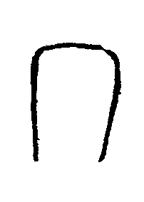
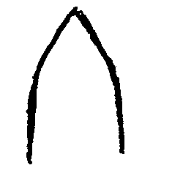
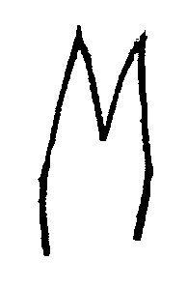

1 | 2 | 3
truncate | acute | cleft

Ad. 15 and 16: Flag leaf: attitude of blade (early and late observation)
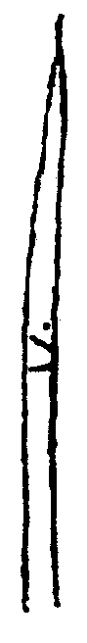
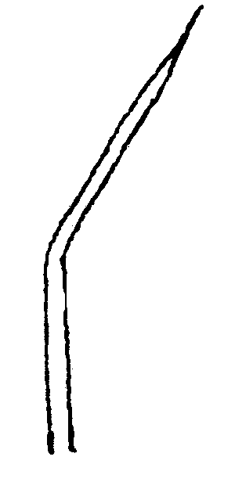
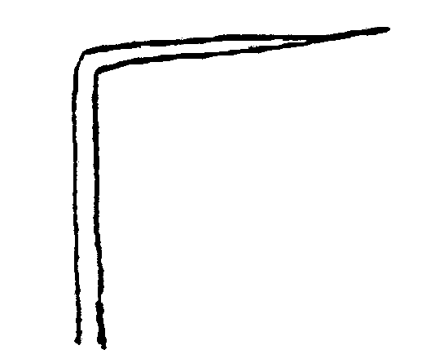
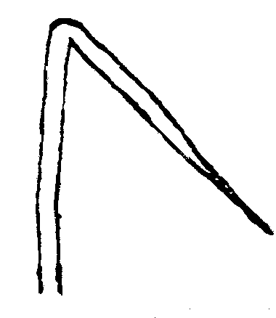

1  erect | 3  semi-erect | 5  horizontal | 7  recurved

Ad. 17: Culm: habit

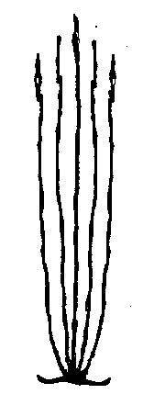
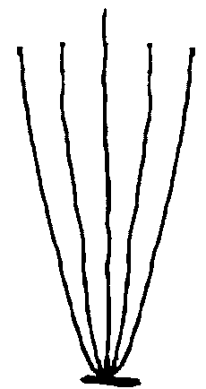
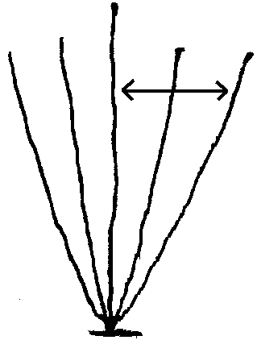

1 | 3 | 5
erect | semi-erect | open

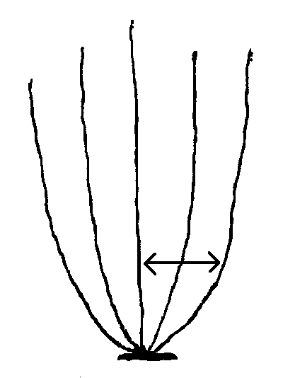
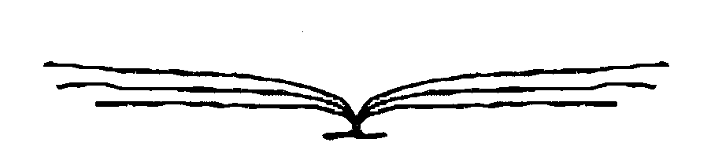

7 | 9
spreading | prostrate

Ad. 18: Prostrate varieties only: Culm: kneeing ability

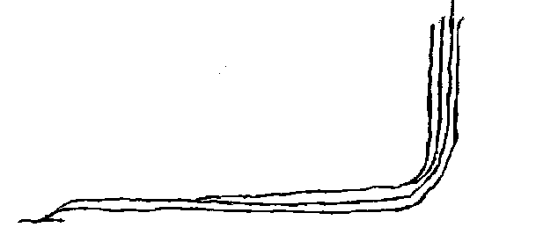

Kneeing ability is one of the most important characteristics for deep water/floating types of rice. After falling flat due to receding water flow, the stems of varieties with kneeing ability start to grow upright with 3 to 4 nodes and bear panicles.

Ad. 20: Male sterility

absent | less than 25 % sterile pollen | 1
partially male sterile | 25 to 95 % sterile pollen | 2
male sterile | more than 95 % sterile pollen | 3

Ads. 21, 22, 23 and 48, 49, 50: Lemma: anthocyanin coloration (early and late observation); Ad. 37: Spikelet: color of tip; Ads 51 and 52: Glume: length (51) and color (52)

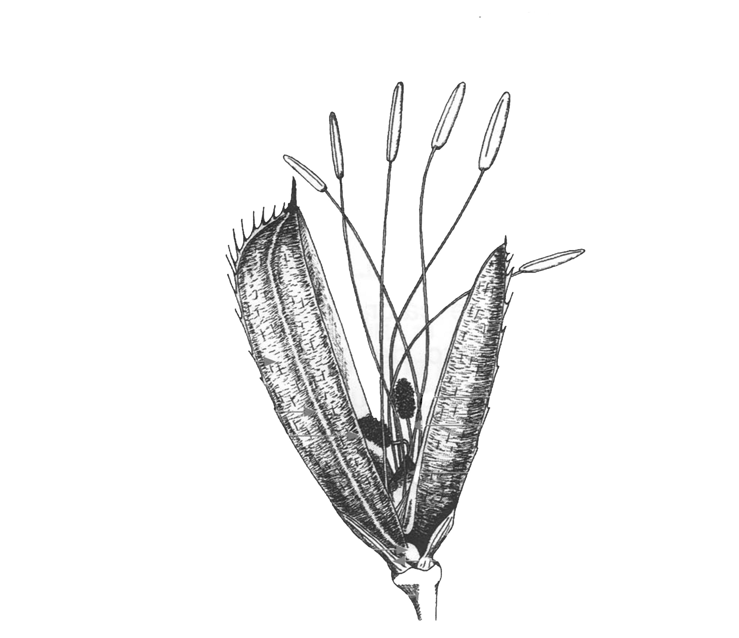

Tip (37)
Apex (23, 50)

Area below the apex (22, 49)
Lemma

Keel (21, 48)

Glume (51, 52)

Ad. 25: Stem: thickness

At the lowest internode.

Ads. 30 and 39: Panicle: length of main axis (30) and attitude in relation to stem (39)

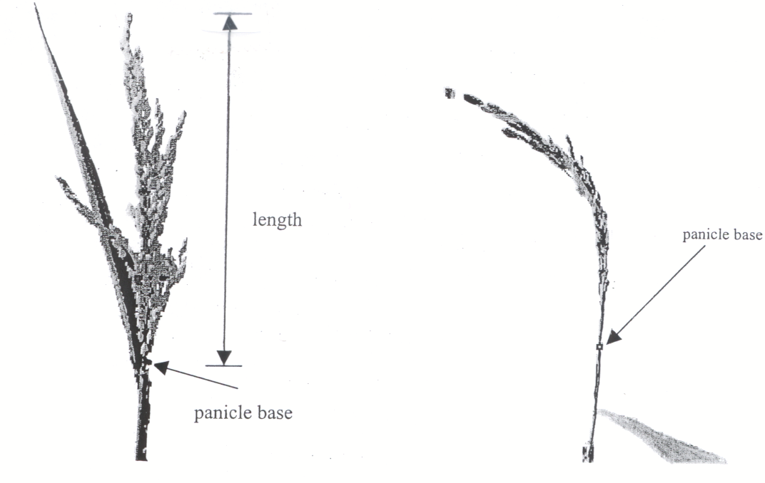
length
panicle base
panicle base
2
semi-upright
1
upright

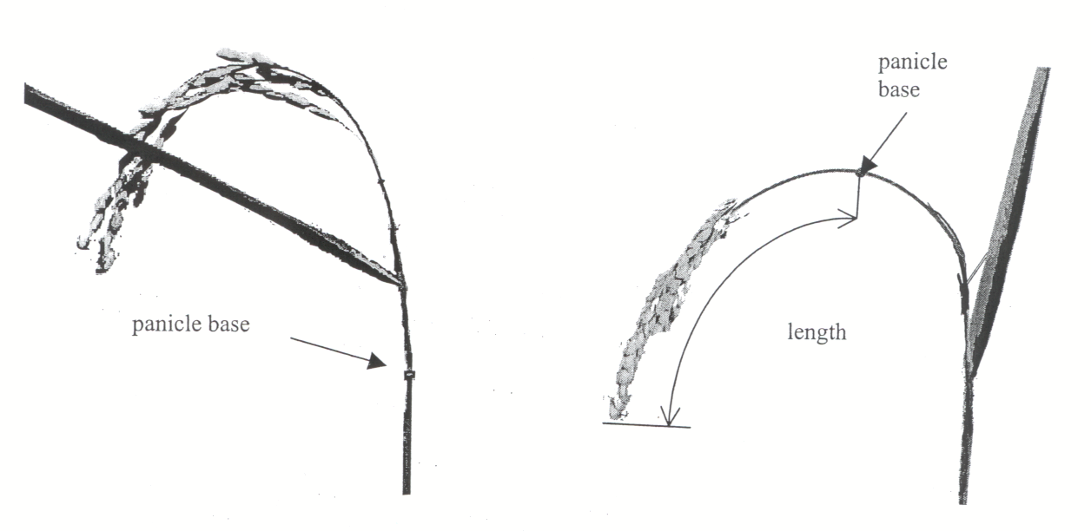
panicle base
panicle base
length
4
strongly drooping
3
slightly drooping

Ad. 40: Panicle: presence of secondary branching
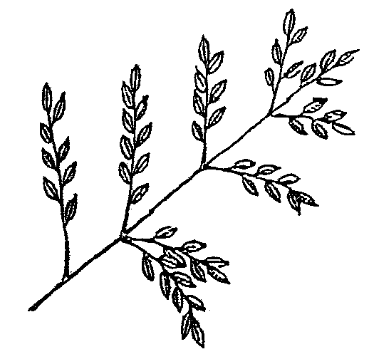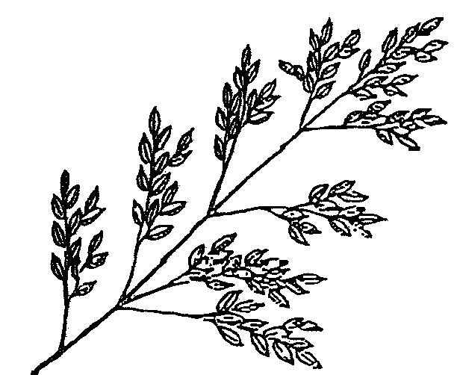

1 | 9
absent | present

Ad. 41: Panicle: type of secondary branching
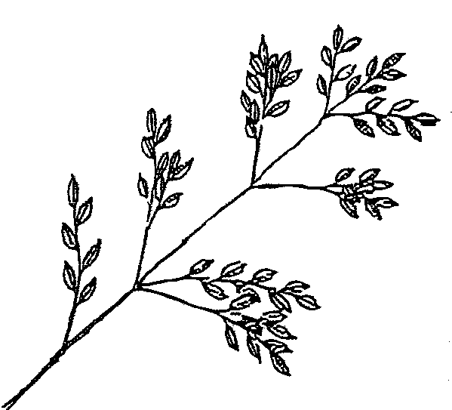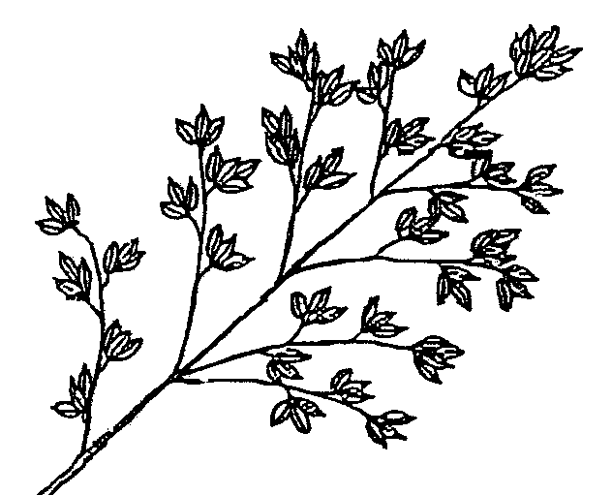

1 | 2 | 3
type 1 | type 2 | type 3

Ad. 42: Panicle: attitude of branches: to be observed on a flat, horizontal surface
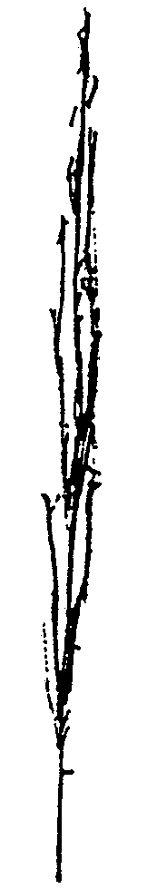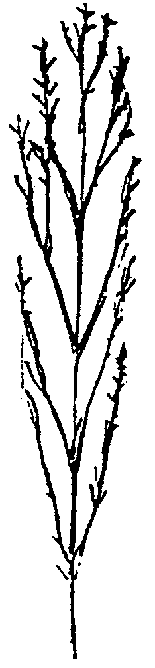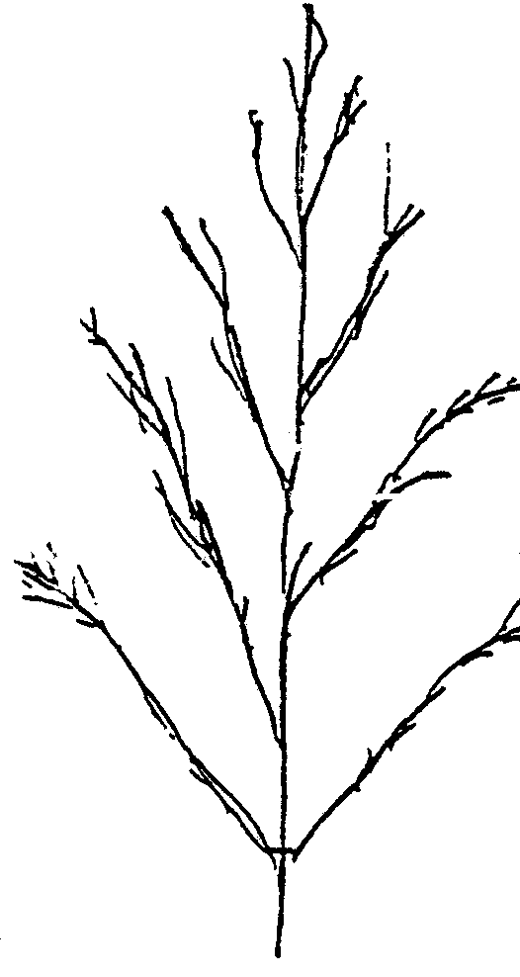
1 | 3 | 5
erect | semi-erect | spreading

Ad. 43: Panicle: exsertion

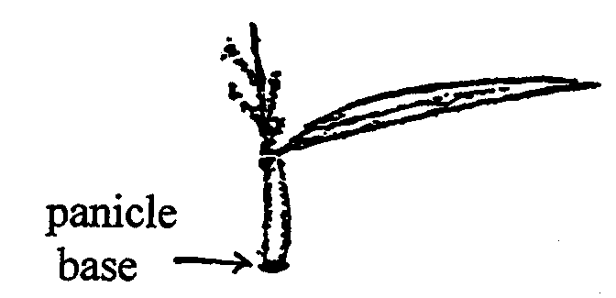
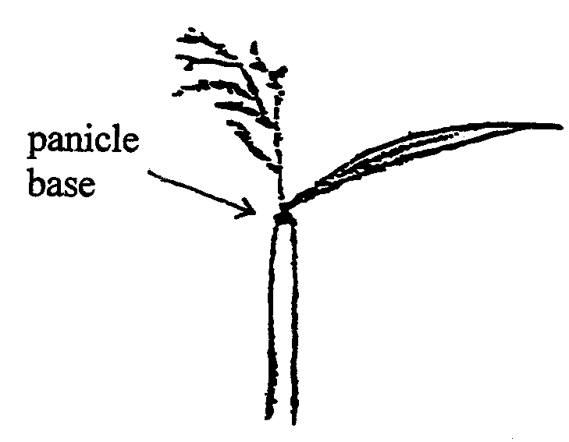
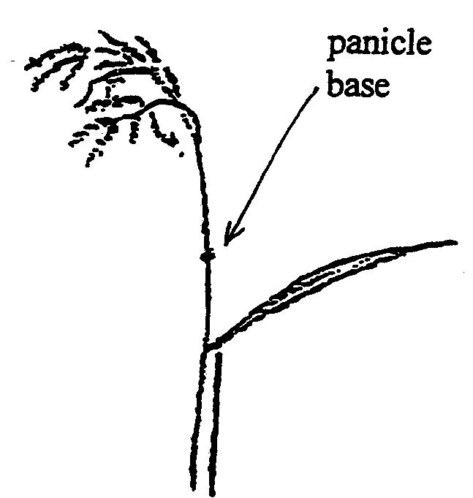
panicle base
panicle base
panicle base

3  partly exserted | 5  just exserted | 9  well exserted

Ad. 45: Leaf: time of senescence

The leaves below the flag leaf are observed at the time of harvest for their retention of greenness. State (3), leaves are dead when the grains have become fully ripened; state (5), intermediate (there must be 1 leaf which retains its color); state (7), 2 or more leaves retain their color at maturity.

Ad. 51: Glume: length

The measurement is made on each of the two glumes.

Ad. 53: Grain: weight of 1000 (fully developed grains)

To be calculated at 14% moisture.

Ads. 56 and 57: Lemma: phenol reaction (56) and intensity of phenol reaction (57)

Method of Testing: Place hulls from 10 grains into a petri dish of 5 cm diameter, and add 5 ml of 1.5% phenol solution; cover the petri dish, and keep at room temperature (not very cold) for one day.

Ad. 60: Decorticated grain: shape (in lateral view)

 |  | length/width
round | 1 | < 1.50
semi-round | 2 | 1.50-1.99
half spindle-shaped | 3 | 2.00-2.49
spindle-shaped | 4 | 2.50-2.99
long spindle-shaped | 5 | ≥ 3.00

Ad. 62: Endosperm: type

The three states of expression can be simply defined by reaction to KI-I solution; glutinous type endosperm is stained to reddish purple, non-glutinous type to dark blue purple, and intermediate type to reddish blue purple.

One can observe that glutinous rice has waxy grains, and non-glutinous rice has non-waxy to transparent grains, with various grades according to the amylose content of the endosperm. When it is necessary to differentiate glutinous rice and rice with very low amylose content, chemical analysis is needed.

Note: In general, the amylose content of pure line varieties of glutinous rice is 0%. However, many commercial varieties, especially local and traditional varieties may contain between 1% and 4% of amylose. This is because the waxy gene is recessive, and when outcrossed by non-glutinous rice, the endosperm becomes non-glutinous. Also, some methods of testing may result in a low % of amylose. Research on chemical structure of waxy rice is still in progress in Japan. Recently, various genes (named “dull” genes) for producing semi-waxy rice have been identified. At present, amylose content of those semi-waxy rice varieties is not less than 5%, though it is not sure if further lower amylose lines will be bred in the future.

Intermediate rice is non-glutinous but with very low amylose.

KI-I solution is prepared by mixing 0.1 % I₂ solution and 0.2 % KI solution.

Ad. 63: Endosperm: content of amylose

Method ISO 6647 should be used.

Modified from IRRI system by rounding due to variability of data especially in cool climates, and adding a rank of very high amylose content considering rice in some area of southern India.

State 1 <5%
State 2 5-10%
State 3 11-15%
State 4 16-20%
State 5 21-25%
State 6 25-30%
State 7 >30%

Ad. 64: Alkali digestion

Put 10 milled complete (unbroken) rice grains in a petri dish with 1.5% solution of KOH, and keep still under room temperature of around 25ºC for about 24 hours.

Note 1 (not digested): rice grains are not affected.
Note 3 (low digested): only the margin of the grains are dissolved.
Note 5 (intermediate): shape of grains become unclear, but incompletely dissolved.
Note 7 (completely digested): no margin is identified between the core part and the outer skirt.

Ad. 65: Decorticated grain: aroma

The main component of the aroma in rice is the 2-acetyl-1-pirroline (AcPy). To vaporize this chemical, 10 ml. of a 1.7 % solution of KOH should be added to 2 gr. of decorticated grains. The aroma, which is similar to that in pop-corn, is released within 10 minutes. The level of expression is determined by reference to the example varieties.

Decimal Code for the Growth Stages of Cereals*

2-digit Code |  | General Description |  |  |  |  |  |  | Feekes’ Scale |  |  | Additional Remarks on Wheat, Barley, Rye, Oats and Rice
 |  | Germination
00 |  | Dry seed
01 |  | Start of imbibition
02 |  | -
03 |  | Imbibition complete
04 |  | -
05 |  | Radicle emerged from caryopsis
06 |  | -
07 |  | Coleoptile emerged from caryopsis
08 |  | -
09 |  | Leaf just at coleoptile tip
 |  | Seedling growth
10 |  | First leaf through coleoptile | ⎬⎬ |  |  |  |  |  | 1 |  |  | Second leaf visible (less than 1 cm)
11 |  | First leaf unfolded (1) | ⎬
12 |  | 2 leaves unfolded |  |  |  |  |  |  |  |  | ⎬
13 |  | 3 leaves unfolded |  |  |  |  |  |  |  |  | ⎬
14 |  | 4 leaves unfolded |  |  |  |  |  |  |  |  | ⎬
15 |  | 5 leaves unfolded |  |  |  |  |  |  |  |  | ⎬ | 50% of laminae unfolded
16 |  | 6 leaves unfolded |  |  |  |  |  |  |  |  | ⎬
17 |  | 7 leaves unfolded |  |  |  |  |  |  |  |  | ⎬
18 |  | 8 leaves unfolded |  |  |  |  |  |  |  |  | ⎬
19 |  | 9 or more leaves unfolded |  |  |  |  |  |  |  |  | ⎬
 |  | Germination
20 |  | Main shoot only
21 |  | Main shoot and 1 tiller |  |  |  |  |  |  | 2 |  | ⎬
22 |  | Main shoot and 2 tillers | ⎬ |  |  |  |  |  |  |  | ⎬ | This section to be used to supplement
23 |  | Main shoot and 3 tillers | ⎬ |  |  |  |  |  |  |  | ⎬ | records from other sections of the table:
24 |  | Main shoot and 4 tillers | ⎬ |  |  |  |  |  |  |  | ⎬ | “concurrent codes”
25 |  | Main shoot and 5 tillers | ⎬ |  |  |  |  |  |  |  | ⎬
26 |  | Main shoot and 6 tillers | ⎬ |  |  |  |  |  | 3 |  | ⎬
27 |  | Main shoot and 7 tillers | ⎬ |  |  |  |  |  |  |  | ⎬
28 |  | Main shoot and 8 tillers | ⎬ |  |  |  |  |  |  |  | ⎬
29 |  | Main shoot and 9 or more tillers | ⎬ |  |  |  |  |  |  |  | ⎬
 |  | Stem elongation
30 |  | Pseudo stem erection (2) |  |  |  |  |  |  | 4 - 5 |  |  | In rice: vegetative lag phase
31 |  | 1st node detectable |  |  |  |  |  |  | 6 |  | ⎬ ⎬
 |  |  |  |  |  |  |  |  |  |  | ⎬ ⎬ | Jointing stage
32 |  | 2nd node detectable |  |  |  |  |  |  | 7 |  | ⎬ ⎬
33 |  | 3rd node detectable |  |  |  |  |  |  |  |  | ⎬
34 |  | 4th node detectable |  |  |  |  |  |  |  |  | ⎬ | Above crown nodes
35 |  | 5th node detectable |  |  |  |  |  |  |  |  | ⎬
36 |  | 6th node detectable |  |  |  |  |  |  |  |  | ⎬
37 |  | Flag leaf just visible |  |  |  |  |  |  | 8
38 |  | -
39 |  | Flag leaf ligule/collar just visible |  |  |  |  |  |  | 9 |  |  | Pre-boot stage  In rice: opposite auricle stage
 |  | Booting
40 |  | - |  |  |  |  |  |  |  |  |  | Little enlargement of the inflorescence, early-boot stage
41 |  | Flag leaf sheath extending
42 |  | -
43 |  | Boots just visibly swollen | ⎬ |  |  |  |  |  |  |  |  | Mid-boot stage
44 |  | - | ⎬ |  |  |  |  |  | 10
45 |  | Boots swollen | ⎬ |  |  |  |  |  |  |  |  | Late-boot stage
46 |  | -
47 |  | Flag leaf sheath opening |  |  |  |  |  |  | ⎬
48 |  | - |  |  |  |  |  |  | ⎬
49 |  | First awns visible |  |  |  |  |  |  | ⎬10.1 |  |  | In awned forms only
 |  |  |  |  |  |  |  |  | ⎬
 |  | Inflorescence emergence |  |  |  |  |  |  | ⎬
 |  |  |  |  |  |  |  |  | ⎬
50 | ⎬ | First spikelet of | ⎬ |  |  |  |  |  | N⎬ |  |  | N = non-synchronous crops
 | ⎬ | inflorescence just | ⎬ |  |  |  |  |  | ⎬
51 | ⎬ | visible | ⎬ |  |  |  |  |  | S⎬ |  |  | S = synchronous crops
52 | ⎬ |  | ⎬ |  |  |  |  |  | N
 | ⎬ | ¼ of inflorescence emerged | ⎬ |  |  |  |  |  | 10.2
53 | ⎬ |  | ⎬ |  |  |  |  |  | S
54 | ⎬ |  | ⎬ |  |  |  |  |  | N
 | ⎬ | ½ of inflorescence emerged | ⎬ |  |  |  |  |  | 10.3
55 | ⎬ |  | ⎬ |  |  |  |  |  | S
56 | ⎬ |  | ⎬ |  |  |  |  |  | N
 | ⎬ | ¾ of inflorescence emerged | ⎬ |  |  |  |  |  | 10.4
57 | ⎬ |  | ⎬ |  |  |  |  |  | S
58 | ⎬ |  | ⎬ |  |  |  |  |  | N
 | ⎬ | Emergence of inflorescence | ⎬ |  |  |  |  |  | 10.5
59 | ⎬ | completed | ⎬ |  |  |  |  |  | S
 |  | Anthesis
60 | ⎬ |  |  | ⎬ | N
 | ⎬ | Beginning of anthesis |  | ⎬ | 10.51
61 | ⎬ |  |  | ⎬ | S |  |  |  |  |  |  |  |  | Not easily detectable in barley.
 |  |  |  |  |  |  |  |  |  |  |  |  |  | In rice: Usually immediately
62 |  | - |  |  |  |  |  |  |  |  |  |  |  | following heading
63 |  | -
64 | ⎬ |  |  | ⎬ | N
 | ⎬ | Anthesis half-way |  | ⎬ | 10.52
65 | ⎬ |  |  | ⎬ | S
66 |  | -
67 |  | -
68 | ⎬ |  |  | ⎬ | N
 | ⎬ | Anthesis complete |  | ⎬ | 10.53
69 | ⎬ |  |  | ⎬ | S
 |  | Milk development
70 |  | -
71 |  | Caryopsis watery ripe |  |  | 10.54
72 |  | -
73 |  | Early milk |  | ⎬
74 |  | - |  | ⎬
75 |  | Medium milk |  | ⎬ | 11.1 |  |  |  |  |  | ⎬ |  |  | Increase in solids of liquid endosperm
 |  |  |  | ⎬ |  |  |  |  |  |  | ⎬ |  |  | notable when crushing the caryopsis
76 |  | - |  | ⎬ |  |  |  |  |  |  | ⎬ |  |  | between fingers
77 |  | Late milk |  | ⎬
78 |  | -
79 |  | -
 |  | Dough development
80 |  | -
81 |  | -
82 |  | -
83 |  | Early dough |  | ⎬ |  |  |  |  |  |  |  |  |  | Fingernail impression not held.
84 |  | - | ⎬
85 |  | Soft dough | ⎬ |  |  | 11.2
86 |  | - | ⎬
87 |  | Hard dough | ⎬
88 |  | - |  |  |  |  |  |  |  |  |  | Fingernail impression held, inflorescence
 |  |  |  |  |  |  |  |  |  |  |  | losing chlorophyll
89 |  | -
 |  | Ripening
90 |  | - |  |  |  |  |  |  |  |  |  | In rice: Terminal spikelets ripened.
91 |  | Caryopsis hard (difficult to divide by thumbnail) (3) |  |  |  | 11.3 |  |  |  |  |  | In rice: 50% of spikelets ripened
92 |  | Caryopsis hard (can no longer be dented by thumbnail) (4) |  |  |  | 11.4 |  |  |  |  |  | In rice: Over 90% of spikelets ripened (5)
93 |  | Caryopsis loosening in daytime |  |  |  |  |  |  |  |  |  | Risk of grain loss by shedding
94 |  | Over-ripe, straw dead and collapsing
 |  | Ripening (continued)
95 |  | Seed dormant
96 |  | Viable seed giving 50% germination
97 |  | Seed not dormant
98 |  | Secondary dormancy induced
99 |  | Secondary dormancy lost
 |  | Transplanting and recovery (rice only)
T1 |  | Uprooting of seedlings
T2 |  | -
T3 |  | Rooting
T4 |  | -
T5 |  | -
T6 |  | -
T7 |  | Recovery of shoots
T8 |  | -
T9 |  | Resumption of vegetative growth

Notes on the Table

(1) Stage of seedling inoculation with rust in the greenhouse.

(2) Only applicable to cereals with a prostrate or semi-prostrate early growth habit.

(3) Ripeness for binder (ca. 16% water content). Chlorophyll of inflorescence largely lost.

(4) Ripeness for combine harvester (< 16% water content).

(5) Optimum harvest time.

9. Literature

T. Matsuo (edit.), 1993-97: Science of the Rice Plant (volume 1-3), Nosan Gyoson Bunka Kyokai (Nobunkyo), Tokyo, JP

Vol. 1 Morphology (1993)
Vol. 2 Physiology (1995)
Vol. 3 Genetics (1997)
Indices (1997)

10. Technical Questionnaire
TECHNICAL QUESTIONNAIRE |  |  |  | Page {x} of {y} |  | Reference Number:
 |  |  |  |  |  | Application date:
 |  |  |  |  |  | (not to be filled in by the applicant)
TECHNICAL QUESTIONNAIRE
to be completed in connection with an application for plant breeders’ rights

In the case of hybrid varieties which are the subject of an application for plant breeders’ rights, and where the parent lines are to be submitted as a part of the examination of the hybrid variety, this Technical Questionnaire should be completed for each of the parent lines, in addition to being completed for the hybrid variety.

1. Subject of the Technical Questionnaire
1.1 Latin Name |  |  | Oryza sativa L
1.2 Common Name |  |  | Rice
2. Applicant
Name
Address
Telephone No.
Fax No.
E-mail address
Breeder (if different from applicant)
3. Proposed denomination and breeder’s reference
Proposed denomination
(if available)

Breeder’s reference
4. Information on the breeding scheme and propagation of the variety

4.1 Breeding scheme

4.2 Method of propagating the variety

4.2.1 Type of material

(a) line

male fertile line [ ]

male sterile line [ ]

(b) hybrid [ ]

(c) other (specify) [ ]

In the case of hybrid varieties the production scheme for the hybrid should be provided on a separate sheet. This should provide details of all the parent lines required for propagating the hybrid e.g.

Single Hybrid

(… female parent …) x (… male parent …)

Three-Way Hybrid

(… female line …) x (… male line …)

=> single hybrid used as female parent x (… male parent …)

and should identify in particular:

(a) any male sterile lines
(b) maintenance system of male sterile lines

4.3 Other information

5. Characteristics of the variety to be indicated (the number in brackets refers to the corresponding characteristic in Test Guidelines; please mark the note which best corresponds).

 | Characteristics |  |  |  |  |  | Example Varieties |  |  | Note
5.1  (2) | Basal leaf: sheath color
 | green |  |  |  |  |  |  |  |  | 1[ ]
 | green with purple lines |  |  |  |  |  |  |  |  | 2[ ]
 | light purple |  |  |  |  |  |  |  |  | 3[ ]
 | purple |  |  |  |  |  |  |  |  | 4[ ]
5.2  (9) | Leaf: anthocyanin coloration of auricles
 | absent |  |  |  |  |  |  |  |  | 1[ ]
 | present |  |  |  |  |  |  |  |  | 9[ ]
5.3  (19) | Time of heading (50% of plants with heads)
 | very early |  |  |  |  |  | Loto |  |  | 1[ ]
 | early |  |  |  |  |  | Albada, Cripto |  |  | 3[ ]
 | medium |  |  |  |  |  | Ariete, Bahia |  |  | 5[ ]
 | late |  |  |  |  |  | Bomba, Puntal |  |  | 7[ ]
5.4  (26) | Non-prostrate varieties only: Stem length (excluding panicle)
 | very short |  |  |  |  |  | Lampo, Leda |  |  | 1[ ]
 | short |  |  |  |  |  | Loto, Thaibonnet |  |  | 3[ ]
 | medium |  |  |  |  |  | Ariete, Bahia |  |  | 5[ ]
 | long |  |  |  |  |  | Baldo |  |  | 7[ ]
 | very long |  |  |  |  |  | Carnaroli |  |  | 9[ ]
 | Characteristics |  |  |  |  |  | Example Varieties |  |  | Note
5.5  (58) | Decorticated grain: length
 | short |  |  |  |  |  | Balilla, Bomba |  |  | 3[ ]
 | medium |  |  |  |  |  | Bahia, Lido |  |  | 5[ ]
 | long |  |  |  |  |  | Puntal, Thaibonnet |  |  | 7[ ]
5.6  (61) | Decorticated grain: color
 | white |  |  |  |  |  | Bahia, Senia |  |  | 1[ ]
 | light brown |  |  |  |  |  |  |  |  | 2[ ]
 | variegated brown |  |  |  |  |  |  |  |  | 3[ ]
 | dark brown |  |  |  |  |  | Venere |  |  | 4[ ]
 | light red |  |  |  |  |  |  |  |  | 5[ ]
 | red |  |  |  |  |  |  |  |  | 6[ ]
 | variegated purple |  |  |  |  |  |  |  |  | 7[ ]
 | purple |  |  |  |  |  |  |  |  | 8[ ]
 | dark purple/black |  |  |  |  |  |  |  |  | 9[ ]
6. Similar varieties and differences from these varieties

Please use the table, and space provided for comments, below to provide information on how your candidate variety differs from the variety (or varieties) which, to the best of your knowledge, is (or are) most similar. This information may help the examination authority to conduct its examination of distinctness in a more efficient way.

Denomination(s) of variety(ies) similar to your candidate variety |  | Characteristic(s) in which your candidate variety differs from the similar variety(ies) |  |  | Describe the expression of the characteristic(s) for the similar variety(ies) |  |  | Describe the expression of the characteristic(s) for your candidate variety
Example |  | Decorticated grain: length |  |  | short |  |  | medium
Comments:

7. Additional information which may help in the examination of the variety

7.1 In addition to the information provided in sections 5 and 6, are there any additional characteristics which may help to distinguish the variety?

Yes [ ] No [ ]

(If yes, please provide details)

7.2 Special conditions for the examination of the variety

7.2.1 Are there any special conditions for growing the variety or conducting the examination?

Yes [ ] No [ ]

7.2.2 If yes, please give details:

7.3 Other information

8. Authorization for release

(a) Does the variety require prior authorization for release under legislation concerning the protection of the environment, human and animal health?

Yes [ ] No [ ]

(b) Has such authorization been obtained?

Yes [ ] No [ ]

If the answer to (b) is yes, please attach a copy of the authorization.

9. Information on plant material to be examined.

9.1 The expression of a characteristic or several characteristics of a variety may be affected by factors, such as pests and disease, chemical treatment (e.g. growth retardants or pesticides), effects of tissue culture, different rootstocks, scions taken from different growth phases of a tree, etc.

9.2 The plant material should not have undergone any treatment which would affect the expression of the characteristics of the variety, unless the competent authorities allow or request such treatment. If the plant material has undergone such treatment, full details of the treatment must be given. In this respect, please indicate below, to the best of your knowledge, if the plant material to be examined has been subjected to:

(a) Microorganisms (e.g. virus, bacteria, phytoplasma) Yes [ ] No [ ]

(b) Chemical treatment (e.g. growth retardant or pesticide) Yes [ ] No [ ]

(c) Tissue culture Yes [ ] No [ ]

(d) Other factors Yes [ ] No [ ]

Please provide details of where you have indicated “yes”.

……………………………………………………………

10. I hereby declare that, to the best of my knowledge, the information provided in this form is correct:

Applicant’s name

Signature Date

[End of document]

* These names were correct at the time of the introduction of these Test Guidelines but may be revised or updated. [Readers are advised to consult the UPOV Code, which can be found on the UPOV Website (www.upov.int), for the latest information.]
* Reproduced from EUCARPIA Bulletin No. 7, 1974, pages 49 - 52, with the kind permission of the authors. For further information, see J.C. Zadoks, T.T. Chang and C.F. Konzak, EUCARPIA Bulletin No 7, 1974, pages 42 - 52.

