 |  | E  TG/9/5  ORIGINAL: English  DATE: April 9, 2003
INTERNATIONAL UNION FOR THE PROTECTION OF NEW VARIETIES OF PLANTS
GENEVA

 | RUNNER BEAN  (Phaseolus coccineus L.) | *

GUIDELINES

FOR THE CONDUCT OF TESTS

FOR DISTINCTNESS, UNIFORMITY AND STABILITY

Alternative Names:*

Latin | English | French | German | Spanish
Phaseolus coccineus L. | Runner Bean | Haricot d’Espagne | Prunkbohne | Judía escarlata

ASSOCIATED DOCUMENTS

These guidelines should be read in conjunction with document TG/1/3, “General Introduction to the Examination of Distinctness, Uniformity and Stability and the Development of Harmonized Descriptions of New Varieties of Plants” (hereinafter referred to as the “General Introduction”) and its associated “TGP” documents.

TABLE OF CONTENTS PAGE

1. Subject of these Test Guidelines 3
2. Material Required 3
3. Method of Examination 3
3.1 Duration of Tests 3
3.2 Testing Place 3
3.3 Conditions for Conducting the Examination 3
3.4 Test Design 4
3.5 Number of Plants / Parts of Plants to be Examined 4
3.6 Additional Tests 4
4. Assessment of Distinctness, Uniformity and Stability 4
4.1 Distinctness 4
4.2 Uniformity 4
4.3 Stability 5
5. Grouping of Varieties and Organization of the Growing Trial 5
6. Introduction to the Table of Characteristics 6
6.1 Categories of Characteristics 6
6.2 States of Expression and Corresponding Notes 6
6.3 Types of Expression 6
6.4 Example Varieties 6
6.5 Legend 6
7. Table of Characteristics/Tableau des caractères/Merkmalstabelle/Tabla de caracteres 7
8. Explanations on the Table of Characteristics 14
8.1 Explanations covering several characteristics 14
8.2 Explanations for individual characteristics 14
9. Literature 18
10. Technical Questionnaire 19

Subject of these Test Guidelines
These Test Guidelines apply to all varieties of Phaseolus coccineus L.

Material Required
2.1 The competent authorities decide on the quantity and quality of the plant material required for testing the variety and when and where it is to be delivered. Applicants submitting material from a State other than that in which the testing takes place must ensure that all customs formalities and phytosanitary requirements are complied with.

2.2 The material is to be supplied in the form of seed.

2.3 The minimum quantity of plant material, to be supplied by the applicant, should be:

2,000 g or at least 6,000 seeds.

2.4 The seed should meet the minimum requirements for germination, species and analytical purity, health and moisture content, specified by the competent authority. In cases where the seed is to be stored, the germination capacity should be as high as possible and should, be stated by the applicant.

2.5 The plant material supplied should be visibly healthy, not lacking in vigor, nor affected by any important pest or disease.

2.6 The plant material should not have undergone any treatment which would affect the expression of the characteristics of the variety, unless the competent authorities allow or request such treatment. If it has been treated, full details of the treatment must be given.

Method of Examination

3.1 Duration of Tests
The minimum duration of tests should normally be two independent growing cycles.

3.2 Testing Place
The tests should normally be conducted at one place. If any characteristics of the variety, which are relevant for the examination of DUS, cannot be seen at that place, the variety may be tested at an additional place.

3.3 Conditions for Conducting the Examination
The tests should be carried out under conditions ensuring satisfactory growth for the expression of the relevant characteristics of the variety and for the conduct of the examination.

3.4 Test Design
3.4.1 The design of the tests should be such that plants or parts of plants may be removed for measurement or counting without prejudice to the observations which must be made up to the end of the growing cycle.

3.4.2 Each test should be designed to result in a total of at least 60 plants, which should be divided between two or more replicates.

3.5 Number of Plants / Parts of Plants to be Examined
Unless otherwise indicated, all observations determined by measuring or counting should be made on 20 plants or parts taken from each of 20 plants.

3.6 Additional Tests
Additional tests, for examining relevant characteristics, may be established.

Assessment of Distinctness, Uniformity and Stability

4.1 Distinctness
4.1.1 General Recommendations

It is of particular importance for users of these Test Guidelines to consult the General Introduction prior to making decisions regarding distinctness. However, the following points are provided for elaboration or emphasis in these Test Guidelines.

4.1.2 Consistent Differences

The minimum duration of tests recommended in section 3.1 reflects, in general, the need to ensure that any differences in a characteristic are sufficiently consistent.

4.1.3 Clear Differences

Determining whether a difference between two varieties is clear depends on many factors, and should consider, in particular, the type of expression of the characteristic being examined, i.e. whether it is expressed in a qualitative, quantitative, or pseudo-qualitative manner. Therefore, it is important that users of these Test Guidelines are familiar with the recommendations contained in the General Introduction prior to making decisions regarding distinctness.

4.2 Uniformity
4.2.1 It is of particular importance for users of these Test Guidelines to consult the General Introduction prior to making decisions regarding uniformity. However, the following points are provided for elaboration or emphasis in these Test Guidelines.

4.2.2. The assessment of uniformity should be according to the recommendations for cross-pollinated varieties in the General Introduction.

4.3 Stability
4.3.1 In practice, it is not usual to perform tests of stability that produce results as certain as those of the testing of distinctness and uniformity. However, experience has demonstrated that, for many types of variety, when a variety has been shown to be uniform, it can also be considered to be stable.

4.3.2 Where appropriate, or in cases of doubt, stability may be tested, either by growing a further generation, or by testing a new seed or plant stock to ensure that it exhibits the same characteristics as those shown by the previous material supplied.

Grouping of Varieties and Organization of the Growing Trial
5.1 The selection of varieties of common knowledge to be grown in the trial with the candidate varieties and the way in which these varieties are divided into groups to facilitate the assessment of distinctness is aided by the use of grouping characteristics.

5.2 Grouping characteristics are those in which the documented states of expression, even where produced at different locations, can be used, either individually or in combination with other such characteristics: (a) to select varieties of common knowledge that can be excluded from the growing trial used for examination of distinctness; and (b) to organize the growing trial so that similar varieties are grouped together.

5.3 The following have been agreed as useful grouping characteristics:

(a) Plant: growth type (characteristic 2);

(b) Flower: color of standard (characteristic 12);

(c) Flower: color of wing (characteristic 13);

(d) Pod: suture strings (characteristic 17);

(e) Seed: main color (characteristic 28);

(f) Varieties with seeds with more than one color only: Seed: predominant secondary color (characteristic 29);

(g) Varieties with seeds with more than one color only: Seed: distribution of predominant secondary color (characteristic 30).

5.4 Guidance for the use of grouping characteristics, in the process of examining distinctness, is provided through the General Introduction.

Introduction to the Table of Characteristics

6.1 Categories of Characteristics
6.1.1 Standard Test Guidelines Characteristics

Standard Test Guidelines characteristics are those which are approved by UPOV for examination of DUS and from which members of the Union can select those suitable for their particular circumstances.

6.1.2 Asterisked Characteristics

Asterisked characteristics (denoted by *) are those included in the Test Guidelines which are important for the international harmonization of variety descriptions and should always be examined for DUS and included in the variety description by all members of the Union, except when the state of expression of a preceding characteristic or regional environmental conditions render this inappropriate.

6.2 States of Expression and Corresponding Notes
States of expression are given for each characteristic to define the characteristic and to harmonize descriptions. Each state of expression is allocated a corresponding numerical note for ease of recording of data and for the production and exchange of the description.

6.3 Types of Expression
An explanation of the types of expression of characteristics (qualitative, quantitative and pseudo-qualitative) is provided in the General Introduction.

6.4 Example Varieties
Where appropriate, example varieties are provided to clarify the states of expression of each characteristic.

6.5 Legend
(*) Asterisked characteristic – see Section 6.1.2

(a)-(b) See Explanations on the Table of Characteristics in Chapter 8, Section 8.1

(+) See Explanations on the Table of Characteristics in Chapter 8, Section 8.2

Table of Characteristics/Tableau des caractères/Merkmalstabelle/Tabla de caracteres

 |  | English | français | Deutsch | español | Example Varieties  Exemples  Beispielssorten  Variedades ejemplo | Note/  Nota
1.  (*) |  | Plant: anthocyanin coloration of hypocotyl | Plante: pigmentation anthocyanique de l’hypocotyle | Pflanze: Anthocyanfärbung des Hypokotyls | Planta: pigmentación antociánica del hipocótilo
 |  | absent | absente | fehlend | ausente | Emergo, White Lady | 1
 |  | present | présente | vorhanden | presente | Fergie, Streamline | 9
2.  (*) |  | Plant: growth type | Plante: type de croissance | Pflanze: Wuchstyp | Planta: tipo de crecimiento
 |  | dwarf | naine | Buschform | enana | Pickwick | 1
 |  | climbing | à rames | Rankform | trepadora | Enorma | 2
3. |  | Dwarf bean varieties only: Plant: height | Variétés de haricot nain seulement: Plante: hauteur | Nur Sorten der Buschform: Pflanze: Höhe | Sólo variedades de judías enanas: Planta: altura
 |  | short | basse | niedrig | baja |  | 3
 |  | medium | moyenne | mittel | media | Hammond’s Dwarf Scarlet | 5
 |  | tall | haute | hoch | alta |  | 7
4. |  | Climbing bean varieties only: Plant: start of climbing (80% of plants) | Variétés de haricot à rames seulement: Plante: précocité d’enroulement (80% des plantes) | Nur Sorten der Rankenform: Pflanze: Beginn des Rankens (80% der Pflanzen) | Sólo variedades de judías trepadoras: Planta: época en que empieza a trepar (80% de las plantas)
 |  | early | précoce | früh | temprana | Butler | 3
 |  | medium | moyenne | mittel | media | Flame, White Lady | 5
 |  | late | tardive | spät | tardía | White Apollo | 7
5. |  | Climbing bean varieties only: Plant: speed of climbing | Variétés de haricot à rames seulement: Plante: vitesse de croissance | Nur Sorten der Rankenform: Pflanze: Geschwindigkeit des Rankens | Sólo variedades de judías trepadoras: Planta: velocidad a la que trepa
 |  | slow | lente | langsam | lenta | White Apollo | 3
 |  | medium | moyenne | mittel | media | Emergo Stringless | 5
 |  | rapid | rapide | schnell | rápida | Butler, Fergie | 7
6. |  | Leaf: ground color | Feuille: couleur de fond | Blatt: Grundfarbe | Hoja: color de base
 |  | yellow green | vert jaune | gelbgrün | verde amarillento | Sun Bright | 1
 |  | green | vrai | grün | verdadero | Kelvedon Wonder | 2
7.  (*) |  | Varieties with green color only: Intensity of color | Variétés de couleur verte uniquement: Intensité de la couleur | Nur Sorten mit Grünfärbung: Intensität der Farbe | Sólo variedades de color verde: Intensidad del color
 |  | light | claire | hell | claro | Red Rum, White Lady | 3
 |  | medium | moyenne | mittel | medio | Galaxy, Kelvedon Stringless | 5
 |  | dark | foncée | dunkel | oscuro | Emergo Stringless, Pallas | 7
8.  (*) |  | Leaf: blistering | Feuille: cloqûre | Blatt: Blasigkeit | Hoja: abullonado
 |  | weak | faible | gering | débil | Desiree, Titan | 3
 |  | medium | moyenne | mittel | medio | Riley | 5
 |  | strong | forte | stark | fuerte | Enorma | 7
9. |  | Terminal leaflet: size | Foliole terminale: taille | Endfieder: Größe | Folíolo terminal: tamaño
 |  | small | petite | klein | pequeño | Pallas, Sun Bright | 3
 |  | medium | moyenne | mittel | medio | Red Rum | 5
 |  | large | grande | groß | grande | Emergo | 7
10.  (+) |  | Terminal leaflet: shape | Foliole terminale: forme | Endfieder: Form | Folíolo terminal: forma
 |  | triangular | triangulaire | dreieckig | triangular | Red Rum | 1
 |  | triangular to circular | triangulaire à circulaire | dreieckig bis rund | triangular a circular | Flame | 2
 |  | circular | circulaire | rund | circular |  | 3
 |  | circular to quadrangular | circulaire à quadrangulaire | rund bis viereckig | circular a cuadrangular | Pallas | 4
 |  | quadrangular | quadrangulaire | viereckig | cuadrangular | Armstrong, Sun Bright | 5
11.  (+) |  | Terminal leaflet: apex | Foliole terminale: sommet | Endfieder: Spitze | Folíolo terminal: ápice
 |  | short acuminate | à pointe courte | kurz zugespitzt | acuminado corto |  | 3
 |  | medium acuminate | à pointe moyenne | mittel zugespitzt | acuminado medio | Armstrong | 5
 |  | long acuminate | à pointe longue | lang zugespitzt | acuminado largo | Pallas | 7
12.  (*) |  | Flower: color of standard | Fleur: couleur de l’étendard | Blüte: Farbe der Fahne | Flor: color del estandarte
 |  | white | blanc | weiß | blanco | Desiree, Emergo | 1
 |  | pink | rose | rosa | rosa | Riley | 2
 |  | red | rouge | rot | rojo | Armstrong, Painted Lady, Streamline | 3
13.  (*) |  | Flower: color of wing | Fleur: couleur de l’aile | Blüte: Farbe des Flügels | Flor: color del ala
 |  | white | blanche | weiß | blanco | Desiree, Painted Lady | 1
 |  | pink | rose | rosa | rosa | Riley | 2
 |  | red | rouge | rot | rojo | Armstrong, Streamline | 3
14.  (*) | (a) | Pod: length (including beak) | Gousse: longueur (style inclus) | Hülse: Länge (einschließlich Zahn) | Vaina: longitud (incluido el pico)
 |  | very short | très courte | sehr kurz | muy corta | Sun Bright | 1
 |  | short | courte | kurz | corta | Esparot, Painted Lady | 3
 |  | medium | moyenne | mittel | media | Emergo | 5
 |  | long | longue | lang | larga | Armstrong | 7
 |  | very long | très longue | sehr lang | muy larga | Liberty | 9
15. | (a) | Pod: maximum median width | Gousse: largeur médiane maximale | Hülse: maximale mittlere Breite | Vaina: anchura central máxima
 |  | narrow | étroite | schmal | estrecha | Sun Bright | 3
 |  | medium | moyenne | mittel | media | Armstrong, Riley | 5
 |  | broad | large | breit | ancha | Titan | 7
16. | (a) | Pod: intensity of green color | Gousse: intensité de la couleur verte | Hülse: Intensität der Grünfärbung | Vaina: intensidad del color verde
 |  | very light | très claire | sehr hell | muy claro | Sun Bright | 1
 |  | light | claire | hell | claro | Emergo | 3
 |  | medium | moyenne | mittel | medio | Armstrong, Esparot | 5
 |  | dark | foncée | dunkel | oscuro | Pallas | 7
 |  | very dark | très foncée | sehr dunkel | muy oscuro |  | 9
17.  (*) | (a) | Pod: suture strings | Gousse: fils de la suture | Hülse: Nahtfäden | Vaina: hilos de sutura
 |  | absent | absents | fehlend | ausentes | Armstrong, Emergo Stringless | 1
 |  | present | présents | vorhanden | presentes | Enorma, Kelvedon Marvel | 9
18. | (a) | Pod: degree of curvature | Gousse: degré de la courbure | Hülse: Ausmaß der Krümmung | Vaina: grado de curvatura
 |  | absent or very slight | nulle ou très faible | fehlend oder  sehr gering | ausente o muy débil | Hestia | 1
 |  | slight | faible | gering | débil | Red Rum | 3
 |  | medium | moyenne | mittel | medio | Painted Lady | 5
 |  | strong | forte | stark | fuerte | Galaxy | 7
 |  | very strong | très forte | sehr stark | muy fuerte |  | 9
19. | (a) | Pod: shape of curvature | Gousse: forme de la courbure | Hülse: Form der Krümmung | Vaina: forma de la curvatura
(+) |  | concave | concave | konkav | cóncava |  | 1
 |  | s-shaped | en s | s-förmig | en forma de s |  | 2
 |  | convex | convexe | konvex | convexa |  | 3
20.  (+) | (a) | Pod: shape of distal part (excluding beak) | Gousse: forme de la partie distale (style exclu) | Hülse: Form des distalen Teils (ohne Zahn) | Vaina: forma del extremo distal (excluido el pico)
 |  | pointed | pointue | spitz | puntiaguda | Emergo | 1
 |  | pointed to truncate | pointue à tronquée | spitz bis abgestumpft | puntiaguda a truncada | Fergie | 2
 |  | truncate | tronquée | abgeflacht | truncada | Kelvedon Stringless | 3
21. | (a) | Pod: length of beak | Gousse: longueur du style | Hülse: Länge des Zahns | Vaina: longitud del pico
 |  | short | court | kurz | corto | Armstrong, Desiree | 3
 |  | medium | moyen | mittel | medio | Titan | 5
 |  | long | long | lang | largo | Flame, Red Rum | 7
22.  (+) | (a) | Pod: curvature of beak | Gousse: courbure du style | Hülse: Krümmung des Zahns | Vaina: curvatura del pico
 |  | absent or very weak | nulle ou très faible | fehlend oder  sehr gering | ausente o muy débil | Sun Bright | 1
 |  | weak | faible | gering | débil | Emergo, Red Rum | 3
 |  | medium | moyenne | mittel | media | Desiree, Galaxy | 5
 |  | strong | forte | stark | fuerte | Armstrong | 7
 |  | very strong | très forte | sehr stark | muy fuerte |  | 9
23. | (a) | Pod: constrictions (at harvest maturity) | Gousse: étranglements (à maturité de récolte) | Hülse: Einschnürung (zur Erntereife) | Vaina: estrangulamiento  (en el momento de madurez para la cosecha)
 |  | absent or very weak | absents ou très faibles | fehlend oder  sehr gering | ausente o muy débil | Titan | 1
 |  | weak | faibles | gering | débil | Galaxy, Red Rum | 3
 |  | medium | moyens | mittel | medio | Armstrong, Emergo | 5
 |  | strong | forts | stark | fuerte | Enorma | 7
 |  | very strong | très forts | sehr stark | muy fuerte |  | 9
24.  (*) | (b) | Seed: weight | Graine: poids | Samen: Gewicht | Semilla: peso
 |  | very low | très petit | sehr niedrig | muy pequeño | Sun Bright | 1
 |  | low | petit | niedrig | pequeño | Esparot | 3
 |  | medium | moyen | mittel | medio | Hammond’s Dwarf Scarlet | 5
 |  | high | élevé | hoch | alto | Streamline Stringless | 7
 |  | very high | très élevé | sehr hoch | muy alto | Liberty | 9
25.  (+) | (b) | Seed: shape of median longitudinal section | Graine: forme de la section longitudinale médiane | Samen: Form des medianen Längsschnitts | Semilla: forma de la sección longitudinal central
 |  | narrow elliptic | elliptique étroite | schmal elliptisch | elíptica estrecha | Painted Lady | 1
 |  | elliptic | elliptique | elliptisch | elíptica | Emergo, Pallas | 2
 |  | broad elliptic | elliptique large | breit elliptisch | elíptica ancha | Galaxy, Prizenwinner Stringless | 3
 |  | kidney shaped | réniforme | nierenförmig | reniforme | Armstrong, Flame, Red Rum | 4
26.  (+) | (b) | Seed: shape of median cross-section | Graine: forme de la section transversale médiane | Samen: Form des mittleren Querschnitts | Semilla: forma de la sección transversal en la parte media
 |  | narrow elliptic | elliptique étroite | schmal elliptisch | elíptica estrecha | Desiree | 1
 |  | elliptic | elliptique | elliptisch | elíptica | Armstrong, Flame, Red Rum | 2
 |  | circular | circulaire | kreisförmig | circular |  | 3
27.  (*) | (b) | Seed: number of colors | Graine: nombre de couleurs | Samen: Anzahl Farben | Semilla: número de colores
 |  | one | une | eine | uno | Emergo, Riley | 1
 |  | two | deux | zwei | dos | Crusader, Enorma | 2
28.  (*) | (b) | Seed: main color | Graine: couleur principale | Samen: Hauptfarbe | Semilla: color principal
 |  | white | blanc | weiß | blanco | Desiree, Emergo | 1
 |  | light tan | brun clair | hellbraun | pardo claro | Melange, Painted Lady | 2
 |  | pinkish purple | pourpre rosâtre | hellrosa violett | púrpura rosado | Armstrong, Bonela, Sun Bright | 3
 |  | violet | violet | violett | violeta | Ivanhoe | 4
 |  | black | noir | schwarz | negro | Riley | 5
29.  (*) | (b) | Varieties with seeds with more than one color only: Seed: predominant secondary color | Variétés à graines de plusieurs couleurs seulement: Graine: couleur secondaire prédominante | Nur Sorten mit mehr als einer Farbe: Samen: überwiegende Sekundärfarbe | Sólo variedades con semillas de más de un color: Semilla: color secundario predominante
 |  | brown | brun | braun | marrón | Painted Lady | 1
 |  | black | noir | schwarz | negro | Armstrong | 2
30.  (*)  (+) | (b) | Varieties with seeds with more than one color only: Seed: distribution of predominant secondary color | Variétés à graines de plusieurs couleurs seulement: Graine: répartition de la couleur secondaire prédominante | Nur Sorten mit mehr als einer Farbe: Samen: Verteilung der überwiegenden Sekundärfarbe | Sólo variedades con semillas de más de un color: Semilla: distribución del color secundario predominante
 |  | spotted | en taches | fleckig | manchado | Enorma, Prijswinner | 1
 |  | mottled | en marbrures | marmoriert | jaspeado | Crusader, Kelvedon Stringless | 2
31. | (b) | Varieties with seed: main color white only: Seed: veining | Variétés à graines dont la couleur principale est le blanc seulement: Graine: veinure | Sorten mit Samen: nur Hauptfarbe weiß: Samen: Aderung | Variedades con semillas: color principal solo blanco: Semilla: venación
 |  | weak | faible | gering | débil | Enorma | 3
 |  | medium | moyenne | mittel | media | Desiree | 5
 |  | strong | forte | stark | fuerte |  | 7
32. | (b) | Seed: color of hilar ring | Graine: couleur du cerne hilaire | Samen: Farbe der Nabelumrandung | Semilla: color del anillo del hilo
 |  | same color as seed | même couleur que la graine | gleiche Farbe wie Samen | del mismo color que la semilla | Desiree | 1
 |  | different color to seed | différente de celle de la graine | andere Farbe als Samen | de distinto color que la semilla | Flame, Red Rum | 2
33.  (*) |  | Time of flowering (50% of the plants with at least one flower) | Époque de floraison (50% des plantes avec au moins une fleur) | Zeitpunkt der Blüte (50% der Pflanzen mit mindestens einer Blüte) | Época de floración (50% de las plantas con al menos una flor)
 |  | early | précoce | früh | temprana | Hestia, Red Rum | 3
 |  | medium | moyenne | mittel | media | Armstrong, Flame | 5
 |  | late | tardive | spät | tardía | Esparot, Sun Bright | 7

Explanations on the Table of Characteristics

8.1 Explanations covering several characteristics
Characteristics containing the following key in the second column of the Table of Characteristics should be examined as indicated below:

(a) Pod: Observations on the pod should be made at fresh harvest maturity.

(b) Seed: All observations on the seed should be made at the mature dry stage on the harvested material.

8.2 Explanations for individual characteristics

Ad. 10: Terminal leaflet: shape

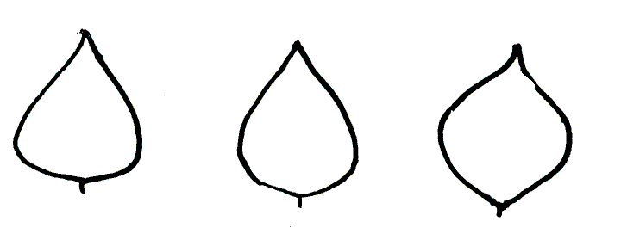
1 | 2 | 3
triangular | triangular to circular | circular

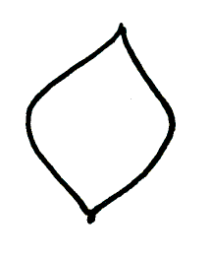 | 
4 | 5
circular to quadrangular | quadrangular

Ad. 11: Terminal leaflet: apex

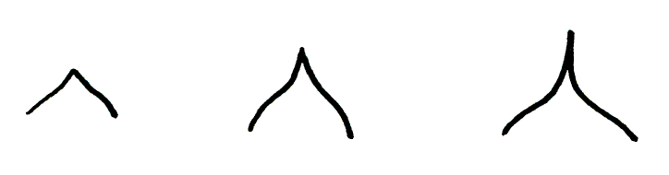
3 | 5 | 7
short acuminate | medium acuminate | long acuminate

Ad. 19: Pod: shape of curvature

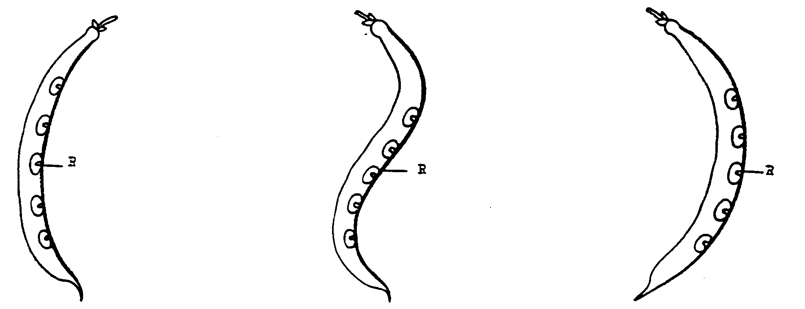

1 | 2 | 3
concave | s-shaped | convex

Ad. 20: Pod: shape of distal part (excluding beak)

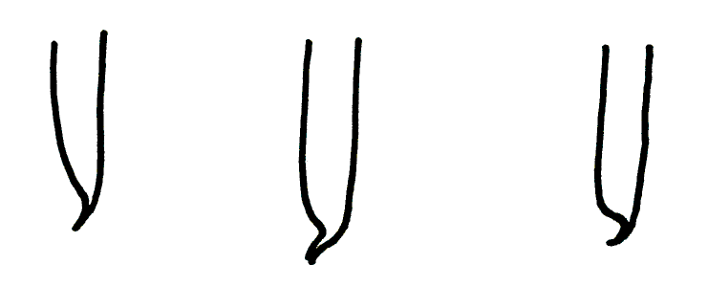
1 | 2 | 3
pointed | pointed to truncate | truncate
Ad. 22: Pod: curvature of beak

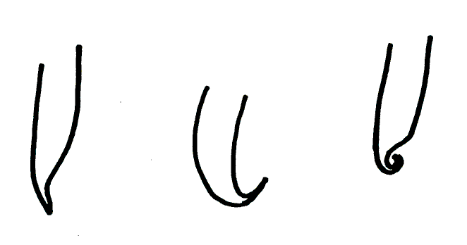
3 | 5 | 7
weak | medium | strong

Ad. 25: Seed: shape of median longitudinal section

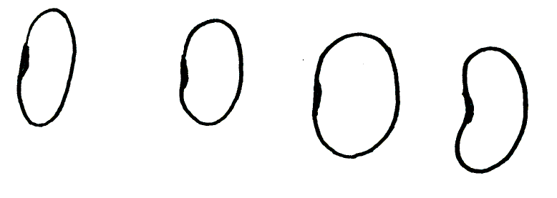
1 | 2 | 3 | 4
narrow elliptic | elliptic | broad elliptic | kidney shaped

Ad. 26: Seed: shape of median cross-section


1 | 2 | 3
narrow elliptic | elliptic | circular

Ad. 30: Seed: distribution of predominant secondary color

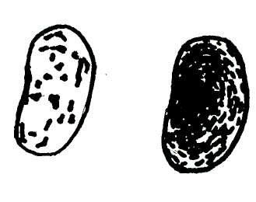
1 | 2
spotted | mottled

Literature
Bowring, J.D.C., 1970: “The identification of varieties of Runner Bean (Phaseolus coccineus L.)” J. Nat. inst. Agric. Botany 12, 46-56.

Hedrick, V.P., 1931: “Beans of New York” Vol I, Part II, Vegetables of New York.

Sneddon J.L. and Squibbs F.L., 1963: “Differences of seed stocks of runner beans” J. Nat. inst. Agric. Botany 9, 346-352.

Andeweg J.M. en van Steenbergen A., 1957: “Fieldtests with Dutch runner beans 1955-1956” Wageningen: Inst. Veredeling Tuinbouwgewassen. Mededelingen 115.

Technical Questionnaire
TECHNICAL QUESTIONNAIRE |  |  |  | Page {x} of {y} |  |  | Reference Number:
 |  |  |  |  |  |  | Application date:
 |  |  |  |  |  |  | (not to be filled in by the applicant)
TECHNICAL QUESTIONNAIRE
to be completed in connection with an application for plant breeders’ rights

1. Subject of the Technical Questionnaire
1.1 Latin Name |  |  | Phaseolus coccineus L.
1.2 Common Name |  |  | Runner Bean
2. Applicant
Name
Address
Telephone No.
Fax No.
E-mail address
Breeder (if different from applicant)
3. Proposed denomination and breeder’s reference
Proposed denomination
(if available)

Breeder’s reference
4. Information on the breeding scheme and propagation of the variety

4.1 Breeding Scheme

Variety resulting from:

4.1.1 Crossing

(a) controlled cross [ ]
(please state parent varieties)
(b) partially known cross [ ]
(please state known parent variety(ies))
(c) totally unknown cross [ ]

4.1.2 Mutation [ ]
(please state parent variety)

4.1.3 Discovery [ ]
(please state where, when and how developed)

4.1.4 Other [ ]
(please provide details)

4.2 Method of Propagating the Variety

(a) Cross-pollination
(i) population [ ]
(ii) synthetic variety [ ]

(b) Other [ ]
(please provide details)

5. Characteristics of the variety to be indicated (the number in brackets refers to the corresponding characteristic in Test Guidelines; please mark the note which best corresponds).

 | Characteristics |  |  |  |  | Example Varieties |  |  |  | Note
5.1  (2) | Plant: growth type
 | dwarf |  |  |  |  | Pickwick |  |  |  | 1[ ]
 | climbing |  |  |  |  | Enorma |  |  |  | 2[ ]
 | Characteristics |  |  |  |  | Example Varieties |  |  |  | Note
5.2  (12) | Flower: color of standard
 | white |  |  |  |  | Desiree, Emergo |  |  |  | 1[ ]
 | pink |  |  |  |  | Riley |  |  |  | 2[ ]
 | red |  |  |  |  | Armstrong, Painted Lady, Streamline |  |  |  | 3[ ]
5.3  (13) | Flower: color of wing
 | white |  |  |  |  | Desiree, Painted Lady |  |  |  | 1[ ]
 | pink |  |  |  |  | Riley |  |  |  | 2[ ]
 | red |  |  |  |  | Armstrong, Streamline |  |  |  | 3[ ]
5.4  (17) | Pod: suture strings
 | absent |  |  |  |  | Armstrong, Emergo Stringless |  |  |  | 1[ ]
 | present |  |  |  |  | Enorma, Kelvedon Marvel |  |  |  | 9[ ]
5.5  (28) | Seed: main color
 | white |  |  |  |  | Desiree, Emergo |  |  |  | 1[ ]
 | light tan |  |  |  |  | Melange, Painted Lady |  |  |  | 2[ ]
 | pinkish purple |  |  |  |  | Armstrong, Bonela, Sun Bright |  |  |  | 3[ ]
 | violet |  |  |  |  | Ivanhoe |  |  |  | 4[ ]
 | black |  |  |  |  | Riley |  |  |  | 5[ ]
5.6  (29) | Varieties with seeds with more than one color only:  Seed: predominant secondary color
 | brown |  |  |  |  | Painted Lady |  |  |  | 1[ ]
 | black |  |  |  |  | Armstrong |  |  |  | 2[ ]
5.7  (30) | Varieties with seeds with more than one color only:  Seed: distribution of predominant secondary color
 | spotted |  |  |  |  | Enorma, Prijswinner |  |  |  | 1[ ]
 | mottled |  |  |  |  | Crusader, Kelvedon Stringless |  |  |  | 2[ ]
6. Similar varieties and differences from these varieties

Denomination(s) of variety(ies) similar to your candidate variety |  | Characteristic(s) in which your candidate variety differs from the similar variety(ies) |  |  | Describe the expression of the characteristic(s) for the similar variety(ies) |  |  | Describe the expression of the characteristic(s) for your candidate variety
(Example) |  | Pod: length |  |  | short |  |  | medium
7. Additional information which may help in the examination of the variety

7.1 In addition to the information provided in sections 5 and 6, are there any additional characteristics which may help to distinguish the variety?

Yes [ ] No [ ]

(If yes, please provide details)

7.2 Special conditions for the examination of the variety

7.2.1 Are there any special conditions for growing the variety or conducting the examination?

Yes [ ] No [ ]

7.2.2 If yes, please give details:

7.3 Other information

8. Authorization for release

(a) Does the variety require prior authorization for release under legislation concerning the protection of the environment, human and animal health?

Yes [ ] No [ ]

(b) Has such authorization been obtained?

Yes [ ] No [ ]

If the answer to (b) is yes, please attach a copy of the authorization.

9. I hereby declare that, to the best of my knowledge, the information provided in this form is correct:

Applicant’s name

Signature Date

[End of document]

* These names were correct at the time of the introduction of these Test Guidelines but may be revised or updated. [Readers are advised to consult the UPOV Code, which can be found on the UPOV Website (www.upov.int), for the latest information.]

