E
UPOV/WG-DST/1/3
ORIGINAL: English
DATE: September 4, 2014
INTERNATIONAL UNION FOR THE PROTECTION OF NEW VARIETIES OF PLANTS
Geneva
WORKING GROUP FOR THE DEVELOPMENT OF A UPOV DENOMINATION SIMILARITY SEARCH TOOL
First Session
Geneva, September 3, 2014
similarity search options

Document prepared by WIPO
Disclaimer: this document does not represent UPOV policies or guidance

The Annex to this document contains a copy of a presentation on Similarity Search Options made by Mr. Glenn Mac Stravic, Brand Database Section, World Intellectual Property Organization, at the Working Group on Variety Denomination Search Tool (WG-DST).

[Annex follows]

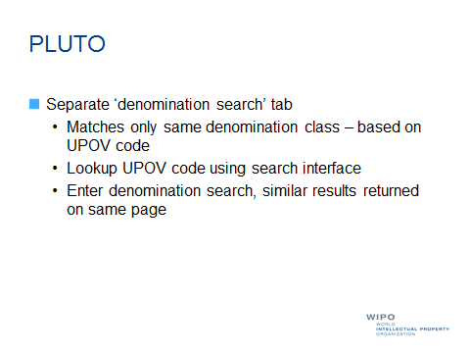

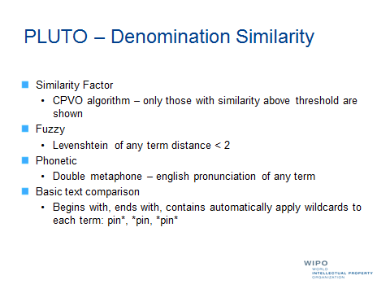

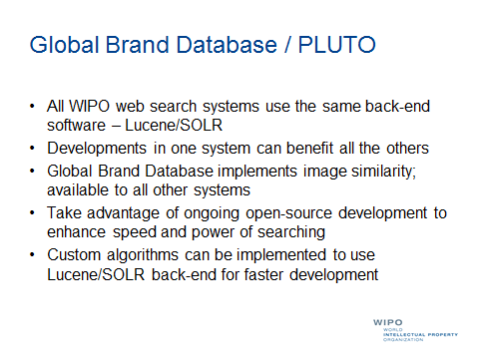

[End of Annex and of document]

