E
International Union for the Protection of New Varieties of Plants

Meeting on the development of an electronic application form  Eleventh Meeting  Geneva, March 28, 2018 | UPOV/EAF/11/2  Original: English  Date: March 14, 2018
Developments concerning the Electronic Application Form
Document prepared by the Office of the Union
Disclaimer: this document does not represent UPOV policies or guidance

EXECUTIVE SUMMARY

The purpose of this document is to report on developments since the tenth meeting (“EAF/10 meeting”) on the development of the electronic application form (EAF), held in Geneva on October 27, 2017, and to present proposals for future developments.

Participating members in the development of the electronic application form are invited to:

- note the developments concerning UPOV PRISMA, as set out in paragraphs 7 to 9;
- consider the plans for UPOV PRISMA Version 2.1, as set out in paragraphs 10 to 23;
- note the communications concerning UPOV PRISMA, as set out in paragraphs 24 and 25;
- note the developments concerning financing of UPOV PRISMA, as set out in paragraphs 26 to 30.

The structure of this document is as follows:
EXECUTIVE SUMMARY 1
DEVELOPMENTS AT THE TENTH MEETING ON THE DEVELOPMENT OF AN ELECTRONIC APPLICATION FORM 1
DEVELOPMENTS SINCE EAF/10 2
Versions 2
Version 2.0 2
PLANNED FUTURE DEVELOPMENTS 3
Version 2.1 3
Coverage 3
New Functionalities 4
Timetable for release 4
Communication 4
FinancING OF UPOV PRISMA 5

BACKGROUND

The background to the development of the EAF is provided in document UPOV/EAF/10/2 “Developments concerning the electronic application form”.

DEVELOPMENTS AT THE eaf/10 meeting

At the EAF/10 meeting, the participating members considered document UPOV/EAF/10/2 “Developments concerning the electronic application form” and received a presentation from the Office of the Union (see document UPOV/EAF/10/3 “Report”, paragraphs 4 to 19).

DEVELOPMENTS SINCE THE EAF/10 MEETING

Versions

Version 2.0 of the EAF, renamed as UPOV PRISMA (see document UPOV/EAF/10/3 “Report”, paragraph 5), was released on February 9, 2018.

Version 2.0

Participating UPOV members and crops/species covered

The table below summarizes the participating PVP Offices and the crops supported in UPOV PRISMA Version 2.0:

Authority |  | Crop coverage
Argentina | AR | Apple Fruit Varieties, Potato, Rose, Soyabean, Wheat, Barley, Maize and Grapevine
Australia | AU | All genera & species
Bolivia (Plurinational State of) | BO | Rice, wheat
Canada | CA | All genera & species excluding algae, bacteria and fungi
Chile | CL | All genera & species
China | CN | Lettuce, Rose
Colombia | CO | Rose, Carnation, Alstroemeria, Chrysanthemum, Gypsophila
European Union | QZ | Apple Fruit Varieties, Lettuce, Potato, Rose, Soyabean
France | FR | All genera & species
Georgia | GE | Maize, Wheat, Field Bean, French Bean, Apple (fruit varieties), Pear, Barley, Oats, Potato, Cherry (Sweet Cherry), Raspberry, Tomato, Peach, Hazelnut, Blackberry, Soya Bean, Sunflower, Walnut, Blueberry, Chick-Pea, Lentil
Kenya | KE | All genera & species
Mexico | MX | 87 selected crops
Netherlands | NL | All genera & species
New Zealand | NZ | All genera & species
Norway | NO | All genera & species
Paraguay | PY | Soyabean
Republic of Moldova | MD | Maize, Wheat, Pea, Barley, European Plum, Tomato, Grapevine, Sweet Pepper, Hot Pepper, Paprika, Chili, Sunflower, Walnut, Apple Fruit Varieties, Lettuce, Potato, Rose, Soyabean
Switzerland | CH | All genera & species
Tunisia | TN | All genera & species
Turkey | TR | All genera & species
United States of America | US | Lettuce, Potato, Soyabean and Wheat
Uruguay | UY | All genera & species
Total | 22

Languages

UPOV PRISMA Version 2.0 presents pages and items (questions) for application forms and technical questionnaires for participating PVP Offices in English, French, German, Spanish, Chinese and Japanese (“navigation languages”).

UPOV PRISMA Version 2.0 generates application forms and technical questionnaires in the languages required by the participating PVP Offices (“output form languages”), in English, French, German, Spanish, Chinese, Georgian, Norwegian, Romanian and Turkish (information must be completed by the applicant in an acceptable language for the PVP Office concerned, although answers selected from drop-down lists (e.g. characteristics and states of expression) will be automatically translated for output form languages.

PLANNED FUTURE DEVELOPMENTS

Version 2.1

Coverage

UPOV members

Participation in EAF Version 2.1 is possible for authorities that participated in the development of Prototype Electronic Form (PV2) or in the development of the Electronic Application Form
Versions 1.0 or 1.1 (African Intellectual Property Organization (OAPI), Argentina, Australia, Bolivia (Plurinational State of), Brazil, Chile, China, Canada, Colombia, Czech Republic, European Union, France, Georgia, Japan, Kenya, Mexico, Netherlands, New Zealand, Norway, Paraguay, Republic of Korea, Republic of Moldova, South Africa, Switzerland, Tunisia, Turkey, United States of America, Uruguay and Viet Nam), according to available resources.

Members of the Union that did not participate in the development of a Prototype Electronic Form (PV2) or in the development of the Electronic Application Form Versions 1.0 or 1.1 need to provide their forms for relevant crops (application form and technical questionnaire) in a UPOV language and, if appropriate, to provide translations of the questions of the application forms and technical questionnaires of the other languages used in the EAF. The timetable for addition of new members of the Union will be developed according to available resources and will vary according to the content of the application forms and technical questionnaires.

Circular E-17/264, issued on December 12, 2017, invited all UPOV members not currently participating in UPOV PRISMA PBR Application Tool and that have not already expressed a wish to participate, to indicate to the Office of the Union their wish to join in 2018.

Crops/ species

Circular E-18/011, issued on February 22, 2018, invited participating members in UPOV PRISMA who do not yet cover all genera and species (Argentina, Bolivia (Plurinational State of), China, Colombia Georgia, Mexico, Republic of Moldova and United States of America) to indicate their wish to increase the scope of coverage for genera and species for Version 2.1.

Circular E-18/010, issued on February 21, and March 12, 2018, invited UPOV members who have already expressed an interest to participate in UPOV PRISMA (African Intellectual Property Organization (OAPI), Brazil, Czech Republic, Germany, Japan, Republic of Korea, South Africa, Sweden, United Republic of Tanzania and Viet Nam) to confirm their intention to participate in the Version 2.1 and to clarify the scope of coverage for genera and species. Other UPOV members who have already expressed interest to participate in UPOV PRISMA Version 2.1 (Costa Rica, Serbia, United Kingdom and Uzbekistan) have been contacted to clarify the scope of coverage for genera and species.

In UPOV PRISMA Version 2.1, technical questionnaires (TQ) from all UPOV Test Guidelines will be available with the inclusion of apple rootstocks and avocado rootstocks.

Languages

Additional navigation and output languages can be introduced according to available resources and if the necessary information is provided.

The anticipated coverage of countries crops and languages of UPOV PRISMA Version 2.1 will be presented at the EAF/11 meeting.

After the launch of Version 2.1, other members of the Union will be invited to indicate their wish to participate in a subsequent release.

New Functionalities

Guidance on next steps

It is proposed to add information on the next steps in relation to PVP Offiices procedures once a submission has been made via UPOV PRISMA. This information will be sent to the applicants together with the confirmation of a successful submission. The relevant information will need to be provided to the Office of the Union by the participating PVP Offices in UPOV PRISMA. More information on this functionality will be presented at the EAF/11 meeting.

Deadline for submitting application

It is proposed to add information on deadlines for submitting applications in a selected authority such that an automatic reminder could be generated, if and when relevant. This information would need to be provided by authorities. More information on this functionality will be presented at the EAF/11 meeting.

Breeding Scheme

The breeding scheme section in Version 2.0 is available with a pre-defined list of options. Additional options for more specific breeding schemes (e.g. crop specific) might be considered for development in a subsequent version. This functionality will be presented and considered by the participants of the EAF/11 meeting.

Novelty

For novelty requirements, it was agreed that each participating authority should indicate, if appropriate, which of the supported crops were considered by that authority to be vines or trees in terms of novelty (see document UPOV/EAF/10/3 “Report”, paragraph 15). By default, 4 years is used in the system. It is proposed to add a “novelty alert” for applicants. This functionality will be presented at the EAF/11 meeting.

Timetable for release

Participating members in the development of the Version 2.1 of UPOV PRISMA will be invited to test the Tool through different releases during a test campaign in July-August 2018. Subject to their validation, Version 2.1 would be released in August 2018.

Communication

The EAF/10 meeting noted that the following elements were planned in 2018 (see document UPOV/EAF/10/3 “Report”, paragraph 19):

- targeted communication to potential users of the UPOV EAF (e.g. agents, representatives, breeding companies, breeders’ associations);
- training sessions (in situ and online);
- participation in international breeders’ events (e.g. ISF, AOHE, CIOPORA, ASTA);
- updated communication materials (posters, flyers, tutorials) with the new name and logo and the new coverage of crops and countries;
- press articles;
- update of the UPOV EAF PBR webpage with new testimonials from breeders and PVP Offices;
- inclusion of information in existing UPOV and UPOV members’ training programs.

Since the launch of UPOV PRISMA Version 2.0 (February 9, 2018), the following initiatives have been taken:

- update of the dedicated webpage on the UPOV Website available at: http://www.upov.int/upovprisma, containing all necessary information to access and use UPOV PRISMA;

- UPOV Press Release 113 concerning the launch of UPOV PRISMA Version 2.0, sent to all UPOV members and subscribers to the UPOV news feed;
- on February 9, 2018, the Office of the Union informed breeders’ organizations and PVP Offices on the availability of the system inviting them to inform all their relevant stakeholders and potential users (e.g. breeders, representatives, agents, etc.), and to disseminate information about the special offer to use UPOV PRISMA for free until June 2018;

- on February 21, 2018, the Office of the Union sent electronic mails to potential users on the availability of UPOV PRISMA Version 2.0, including information on the special promotional offer;

- the following communication materials have been updated and disseminated to requesting UPOV members and breeders’ organizations (still available on demand):

  - posters and roll-up banners in English, Spanish and German (as reproduced in Annex I of this document),
  - flyers in English, French, Spanish and German (as reproduced in Annex II of this document),
  - a series of short videos have been created (in English) and posted on the UPOV website to explain key steps to start an application and functionalities of the system;

- three meetings (online sessions & webinars) have been organized since January 2018 for individual applicants or groups of applicants upon request;

- presentations have been made at the following meetings: AFSTA congress, AOHE Annual meeting and ASTA annual meetings;
- regular updating of the UPOV PRISMA LinkedIn page, available at: https://www.linkedin.com/showcase/24973258/;

- creation of a Twitter account, available at: https://twitter.com/upovprisma.

FinancING OF UPOV PRISMA

At the EAF/10 meeting, it was noted that a proposal for the financing of the EAF had been made to the Consultative Committee at its ninety-fourth session, held in Geneva, on October 25, 2017, and, agreed by the Council at its fifty-first ordinary session, held in Geneva on October 26, 2017 (see document C/51/22 “Report”), as follows.

The Council at its fifty-first ordinary session, held in Geneva on October 26, 2017 approved the UPOV charge for the EAF at CHF150 per application for the 2018-2019 biennium, but agreed that the EAF could be made free of charge for an introductory period if the budgeted costs of the EAF were funded by means other than the regular budget. In that regard, the Council noted that the Office of the Union had received a letter from the Secretary General of the International Seed Federation (ISF) offering to contribute CHF20,000 in order to increase the use of the EAF during the launch period and to extend the system to a larger number of crops and UPOV members. It further noted that Canada and Australia would be interested to explore the possibility of funding the EAF in the form of an annual subscription (see document C/51/22 “Report”, paragraph 20(d)).

Since the fifty-first ordinary session of the Council, the Office of the Union received the following contributions:

- 20,000 Swiss francs from the ISF;
- 2,500 Swiss francs from the International Community of Breeders of Asexually Reproduced Ornamental and Fruit-Tree Varieties (CIOPORA);
- 10,000 Swiss francs from CropLife International.

At the launch of Version 2.0, in January 2018, UPOV PRISMA was made free of charge for an initial period to encourage users to test the system. The initial free-of-charge period was announced until June 2018, and will be extended until December 2018.

Any further proposals concerning the financing of the UPOV PRISMA will be considered by the Council at its fifty-second ordinary session, to be held in Geneva on November 2, 2018. Any decision taken will be reported to the subsequent EAF meeting.

Participating members in the development of the electronic application form are invited to:

- note the developments concerning UPOV PRISMA, as set out in paragraphs 7 to 9;

- consider the plans for UPOV PRISMA Version 2.1, as set out in paragraphs 10 to 23;

- note the communications concerning UPOV PRISMA, as set out in paragraphs 24 and 25;

- note the developments concerning financing of UPOV PRISMA, as set out in paragraphs 26 to 30.

[Annexes follow]

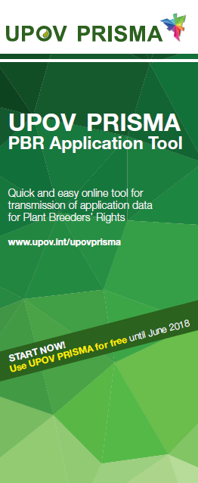

[Annex II follows]

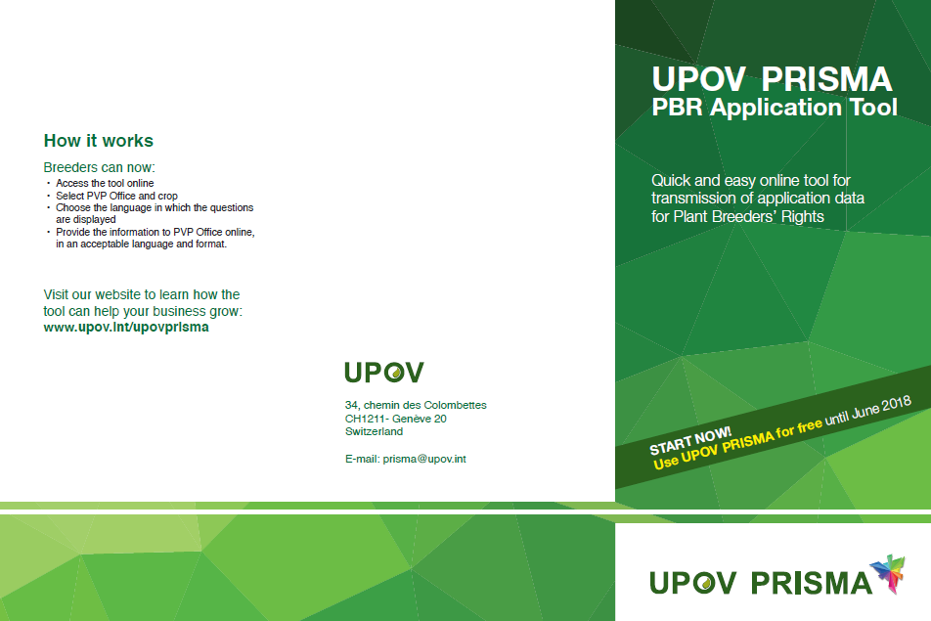
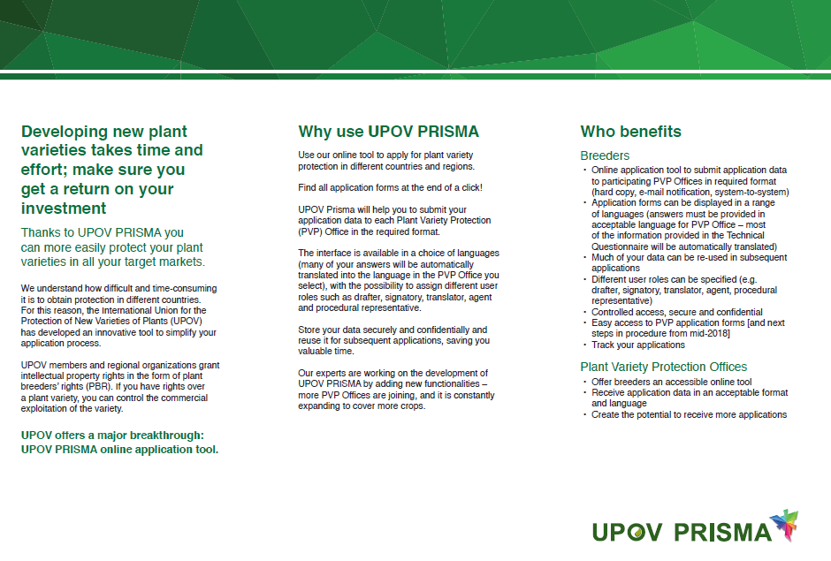
[End of Annex II and of document]

