E
International Union for the Protection of New Varieties of Plants

Technical Working Party for Vegetables  Fifty-Second Session  Beijing, China, September 17 to 21, 2018 | TWV/52/6  Original: English  Date: August 21, 2018
Partial revision of the Test Guidelines for spinach
Document prepared by an expert from the Netherlands
Disclaimer: this document does not represent UPOV policies or guidance
The purpose of this document is to present a proposal for a partial revision of the Test Guidelines for spinach (document TG/55/7) Rev. 4.

The Technical Working Party for Vegetables (TWV), at its fifty-first session, held in Roelofarendsveen, Netherlands, from July 3 to 7, 2017, agreed that the Test Guidelines for Spinach (document TG/55/7 Rev. 4) be partially revised for Characteristics 17 and 18 (see document TWV/51/16 “Report”, Annex IV).

The following changes are proposed:

- Revision of Characteristic 17 “Seed: spines (harvested seed)”:
  - Addition of a state of expression with note 2 “partially present” and changing note 9 to note 3 and to reword state of expression “fully present”;
  - Revision of the explanation Ad. 17 in Chapter 8.2 “Explanations for individual characteristics”.

- Revision of Characteristic 18 “Resistance to Peronospora farinosa f. sp. spinaciae”:
  - Addition of “Race Pfs: 17”, including example varieties and to add to TQ 7.3;
  - Revision of explanation Ad. 18 in Chapter 8.2 “Explanations for individual characteristics”.
  - Addition of “Race Pfs: 17” to Chapter TQ 7.3 “Other information”

The proposed changes are presented below in grey highlight and underline (insertion) and strikethrough (deletion).

The changes in yellow highlight and underline (insertion) and strikethrough (deletion) had been agreed by the TWV at its fifty-first session held in Roelofarendsveen, Netherlands, July 3 to 7, 2017, and have been circulated to the Technical Committee for adoption by correspondence with a deadline of September 20, 2018 (see Circular E-18/091).

Proposal to revise Characteristic 17 “Seed: spines (harvested seed)”

Current wording

 |  | English | français | Deutsch | español | Example Varieties  Exemples  Beispielssorten  Variedades ejemplo | Note/  Nota
17.  (+) | VG | Seed: spines (harvested seed) | Semence : épines  (grains récoltés) | Samen: Stacheln (geernteter Samen) | Semilla: espinas (semilla cosechada)
QL |  | absent | absentes | fehlend | ausentes | Resistoflay | 1
 |  | present | présentes | vorhanden | presentes | Breedblad Scherpzaad, Marimba | 9

Proposed new wording

 |  | English | français | Deutsch | español | Example Varieties  Exemples  Beispielssorten  Variedades ejemplo | Note/  Nota
17.  (+) | VG | Seed: spines (harvested seed) | Semence : épines  (grains récoltés) | Samen: Stacheln (geernteter Samen) | Semilla: espinas (semilla cosechada)
QL |  | absent | absentes | fehlend | ausentes | Resistoflay | 1
 |  | partially present | partiellement présentes | teilweise vorhanden | parcialmente presentes | Benten, Quinto | 2
 |  | fully present | pleinement présentes | vollständig vorhanden | completamente presentes | Breedblad Scherpzaad, Marimba | 9 3

Current explanation

Ad. 17: Seed: spines (harvested seed)

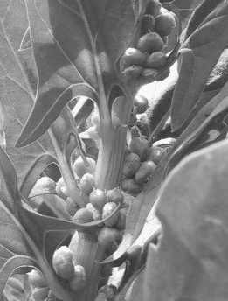 | 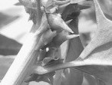
1 | 9
absent | present

Proposed new explanation

Ad. 17: Seed: spines (harvested seed)

Observations should be made on female and monoecious plants when the seed is fully grown. A plant has either only seeds without spines (round seeds), or only seeds with spines (spined seeds): A plant has only one type of seeds. Varieties may consist of only round seeded plants (1: spines absent) , round seeded plants as well as spine seeded plants (2: spines partially present) or only spine seeded plants (3: spines present).

1 | 9
spines absent | spines present

Proposed change to Characteristic 18 “Resistance to Peronospora farinosa f. sp. spinaciae”

 |  | English | français | Deutsch | español | Example Varieties  Exemples  Beispielssorten  Variedades ejemplo | Note/  Nota
18.  (+) | VG | Resistance to Peronospora farinosa f. sp. spinaciae (Pfs) | Résistance à Peronospora farinosa f. sp. spinaciae (Pfs) | Resistenz gegen Peronospora farinosa f. sp. spinaciae (Pfs) | Resistencia a Peronospora  farinosa f. sp. spinaciae (Pfs)
 |  | [18.1 to 18.10 ] | [18.1 à 18.10 ] | [18.1 bis 18.10 ] | [18.1 a 18.10 ]
 |  | -------------------------- | -------------------------- | -------------------------- | -------------------------- | ------------------------------ | ---------
18.11 |  | Race Pfs: 12 | Race Pfs: 12 | Pathotyp Pfs: 12 | Raza Pfs: 12
QL |  | absent | absente | fehlend | ausente | Boeing, Campania | 1
 |  | present | présente | vorhanden | presente | Finch, Pigeon, Red Kitten, Zebu | 9
 |  | -------------------------- | -------------------------- | -------------------------- | -------------------------- | ------------------------------ | ---------
18.12 |  | Race Pfs: 13 | Race Pfs: 13 | Pathotyp Pfs: 13 | Raza Pfs: 13
QL |  | absent | absente | fehlend | ausente | Campania | 1
 |  | present | présente | vorhanden | presente | Boeing, Lion | 9
 |  | -------------------------- | -------------------------- | -------------------------- | -------------------------- | ------------------------------ | ---------
18.13 |  | Race Pfs: 14 | Race Pfs: 14 | Pathotyp Pfs: 14 | Raza Pfs: 14
QL |  | absent | absente | fehlend | ausente | Campania, Pigeon | 1
 |  | present | présente | vorhanden | presente | Califlay, Lion | 9
 |  | -------------------------- | -------------------------- | -------------------------- | -------------------------- | ------------------------------ | ---------
18.14 |  | Race Pfs: 15 | Race Pfs: 15 | Pathotyp Pfs: 15 | Raza Pfs: 15
QL |  | absent | absente | fehlend | ausente | Caladonia | 1
 |  | present | présente | vorhanden | presente | Pigeon | 9
 |  | -------------------------- | -------------------------- | -------------------------- | -------------------------- | ------------------------------ | ---------
18.15 |  | Race Pfs: 16 | Race Pfs: 16 | Pathotyp Pfs: 16 | Raza Pfs: 16
QL |  | absent | absente | fehlend | ausente | Meerkat | 1
 |  | present | présente | vorhanden | presente | Caladonia | 9
 |  | -------------------------- | -------------------------- | -------------------------- | -------------------------- | ------------------------------ | ---------
18.16 |  | Race Pfs: 17 | Race Pfs: 17 | Pathotyp Pfs: 17 | Raza Pfs: 17
QL |  | absent | absente | fehlend | ausente | Pigeon | 1
 |  | present | présente | vorhanden | presente | Hydrus | 9

Current explanation

Ad. 18: Resistance to Peronospora farinosa f. sp. spinaciae

Maintenance of races

Type of medium: Living host plants, obtainable from:
Naktuinbouw
P.O. Box 40
NL-2370 AA Roelofarendsveen
Netherlands
www.naktuinbouw.com
or plant material with spores stored at -20° C for a maximum of one year
Execution of test

Growth stage of plants: First cotyledons/leaf, eleven-day-old plants

Temperature: 15°C during day/12°C during night

Light: 15 hours per day, after emergence

Growing method: In soil in pots or trays in a glasshouse or growth chamber

Method of inoculation: Sporulating leaves, taken from host plants that were infected seven days before, are thoroughly rinsed with sterile tap water (maximum 150 ml water per 224 plants). The spore suspension is filtered through cheesecloth and sprayed on test plants until the inoculum covers the leaves but does not run off. 150 ml of suspension is enough for up to 3 x 224 plants. Spore density should be 20,000 to 100,000 conidia/ml water. The spore suspension should be used fresh.

Remarks: Spinach downy mildew is wind-borne. Sporulating plants should be kept in closed containers or isolated chambers to prevent any cross-contamination. Resistant controls are needed in each multiplication and in each test to ensure the race identity.

Light and humidity conditions during seedling development and incubation are critical. Optimal humidity of approximately 80-90% RH allows plant growth and fungal growth; strong light inhibits spore germination and infection.

The test should be carried out in wintertime with protection against direct sunshine. After inoculation, the plants should remain under plastic for three days. After this time, the plastic should be slightly raised during the daytime.

Duration of test

- Multiplication harvest spores 7 days after inoculation
- Sowing to inoculation: 11 days
- Inoculation to reading: 10 days

Number of plants tested 56 plants

Evaluation of infection: Resistance is usually complete; sometimes necrotic spots are visible as a result of infection. Susceptible plants show varying degrees of sporulation. Sporulation is visible as a grey covering on leaves, starting on the more humid abaxial side.

Differential varieties to identify races

Races Pfs: 1-8 and 10-15 of Peronospora farinosa f. sp. spinaciae are defined with a standard set of “differential varieties” according to the following table:

Differential variety | Pfs: 1 | Pfs: 2 | Pfs: 3 | Pfs: 4 | Pfs: 5 | Pfs: 6 | Pfs: 7 | Pfs: 8 | Pfs: 10 | Pfs: 11 | Pfs: 12 | Pfs: 13 | Pfs:14 | Pfs: 15
Viroflay | S | S | S | S | S | S | S | S | S | S | S | S | S | S
Resistoflay | R | R | S | S | S | S | S | S | S | S | S | S | S | S
Califlay | R | S | R | S | R | S | S | R | S | R | R | S | R | S
Clermont | R | R | R | R | S | S | S | S | S | S | S | S | S | R
Campania | R | R | R | R | R | S | R | S | S | R | S | S | S | R
Boeing | R | R | R | R | R | R | R | S | S | R | S | R | S | R
Lion | R | R | R | R | R | R | R | R | S | R | R | R | R | R
Lazio | R | R | R | R | R | R | R | R | R | S | S | S | S | R
Whale | R | R | R | R | R | R | R | R | S | R | R | S | R | S
Pigeon | R | R | R | R | R | R | R | R | R | R | R | R | S | R
Caladonia | R | R | R | R | R | R | R | R | R | R | R | R | R | S
Legend: R= resistance present; S = resistance absent, susceptible

Proposed new explanation

Maintenance of races

Type of medium: Living host plants, obtainable from:
Naktuinbouw
P.O. Box 40
NL-2370 AA Roelofarendsveen
Netherlands
www.naktuinbouw.com
or plant material with spores stored at -20° C for a maximum of one year
Execution of test

Growth stage of plants: First cotyledons/leaf, eleven-day-old plants

Temperature: 15°C during day/12°C during night

Light: 15 hours per day, after emergence

Growing method: In soil in pots or trays in a glasshouse or growth chamber

Method of inoculation: Sporulating leaves, taken from host plants that were infected seven days before, are thoroughly rinsed with sterile tap water (maximum 150 ml water per 224 plants). The spore suspension is filtered through cheesecloth and sprayed on test plants until the inoculum covers the leaves but does not run off. 150 ml of suspension is enough for up to 3 x 224 plants. Spore density should be 20,000 to 100,000 conidia/ml water. The spore suspension should be used fresh.

Remarks: Spinach downy mildew is wind-borne. Sporulating plants should be kept in closed containers or isolated chambers to prevent any cross-contamination. Resistant controls are needed in each multiplication and in each test to ensure the race identity.

Light and humidity conditions during seedling development and incubation are critical. Optimal humidity of approximately 80-90% RH allows plant growth and fungal growth; strong light inhibits spore germination and infection.

The test should be carried out in wintertime with protection against direct sunshine. After inoculation, the plants should remain under plastic for three days. After this time, the plastic should be slightly raised during the daytime.

Duration of test

- Multiplication harvest spores 7 days after inoculation
- Sowing to inoculation: 11 days
- Inoculation to reading: 10 days

Number of plants tested 56 plants at least 20 plants

Evaluation of infection: Resistance is usually complete; sometimes necrotic spots are visible as a result of infection. Some varieties may have a slightly lower level of resistance. In the table this is indicated by (-), showing for example a slight tip sporulation.
Susceptible plants show varying degrees of sporulation. Sporulation is visible as a grey covering on leaves, starting on the more humid abaxial side.

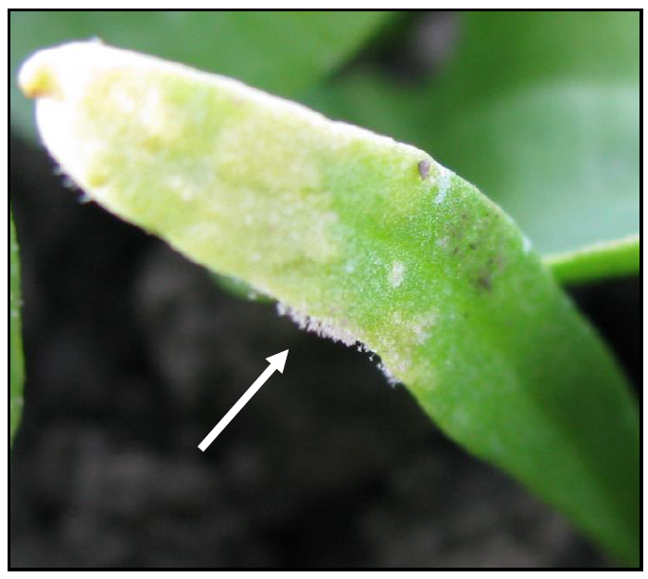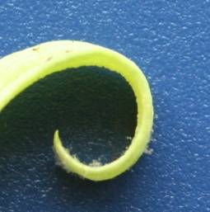
S: Susceptible (R): Resistant, but slightly lower level

Differential varieties to identify races
Disease resistance reactions of spinach downy mildew races on IWGP differentials.

Races Pfs: 1-8 and 10-15 17 of Peronospora farinosa f. sp. spinaciae are defined with a standard set of “differential varieties” differentials according to the following table:

Differentials and type isolates are available at Naktuinbouw:
Naktuinbouw
P.O. Box 40
NL-2370 AA Roelofarendsveen
Netherlands
www.naktuinbouw.com

Race - Pfs:
Differential variety/NIL | 1 | 2 | 3 | 4 | 5 | 6 | 7 | 8 | 10 | 11 | 12 | 13 | 14 | 15 | 16 | 17
Viroflay | S | S | S | S | S | S | S | S | S | S | S | S | S | S | S | S
NIL 5 | R | R | S | S | S | S | S | S | S | S | S | S | S | S | S | S
NIL 3 | R | S | R | S | R | S | S | R | S | R | R | S | R | S | R | S
NIL 4 | R | R | R | R | S | S | S | S | S | S | S | S | S | R | S | S
NIL 6 | R | S | R | R | R | S | R | S | S | R | S | (R) | S | R | R | S
NIL 1 | R | R | R | R | R | R | R | S | S | R | S | R | S | R | R | S
Whale | R | R | R | (R) | R | (R) | (R) | R | (R) | R | R | S | R | (R) | R | S
Pigeon | R | R | R | R | R | R | R | R | R | R | R | R | S | R | S | S
Caladonia | R | R | R | R | R | R | R | R | R | R | R | R | R | S | R | S
Meerkat | R | R | R | R | R | R | R | R | R | R | R | R | R | R | S | (R)
Hydrus | R | R | R | R | R | R | R | R | R | R | R | R | R | R | R | R
Legend: S = susceptible, R or (R) = resistant

http://www.worldseed.org/wp-content/uploads/2018/04/Spinach-downy-mildew_April2018.pdf

Proposal to add “Race Pfs: 16” to TQ 7.3 “Other information”

“7.3 Other information

[…]

“(b) Resistance to pests and diseases (specify)

“(i) Resistance to Peronospora farinosa f. sp. spinaciae

Race Pfs: 1 [ ] absent [ ] present [ ] not tested
Race Pfs: 2 [ ] absent [ ] present [ ] not tested
Race Pfs: 3 [ ] absent [ ] present [ ] not tested
Race Pfs: 4 [ ] absent [ ] present [ ] not tested
Race Pfs: 5 [ ] absent [ ] present [ ] not tested
Race Pfs: 6 [ ] absent [ ] present [ ] not tested
Race Pfs: 7 [ ] absent [ ] present [ ] not tested
Race Pfs: 8 [ ] absent [ ] present [ ] not tested
Race Pfs: 10 [ ] absent [ ] present [ ] not tested
Race Pfs: 11 [ ] absent [ ] present [ ] not tested
Race Pfs: 12 [ ] absent [ ] present [ ] not tested
Race Pfs: 13 [ ] absent [ ] present [ ] not tested
Race Pfs: 14 [ ] absent [ ] present [ ] not tested
Race Pfs: 15 [ ] absent [ ] present [ ] not tested
Race Pfs: 16 [ ] absent [ ] present [ ] not tested
Race Pfs: 17 [ ] absent [ ] present [ ] not tested

[…]”

[End of document]

