E
International Union for the Protection of New Varieties of Plants

Technical Working Party for Vegetables  Fifty-First Session  Roelofarendsveen, Netherlands, July 3 to 7, 2017 | TWV/51/10 Add.  Original: English  Date: August 4, 2017
ADDENDUM TO Partial revision of the Test Guidelines for TOMATO
Document prepared by the Office of the Union
Disclaimer: this document does not represent UPOV policies or guidance
The annex to this document contains a copy of the presentation made at the fifty-first session of the Technical Working Party for Vegetables, by Ms. Amanda van Dijk (Netherlands) on “The use of DNA markers in the DUS of tomato and tomato rootstocks, proposal to revise the UPOV Test Guidelines”.

[Annex follows]

THE USE OF DNA MARKERS IN THE DUS- EXAMINATION OF TOMATO EN TOMATO ROOTSTOCKS, PROPOSAL TO REVISE THE UPOV TEST GUIDELINES

BY AN EXPERT FROM THE NETHERLANDS

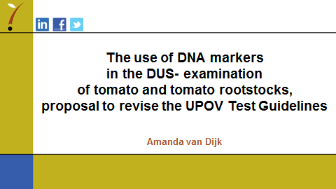

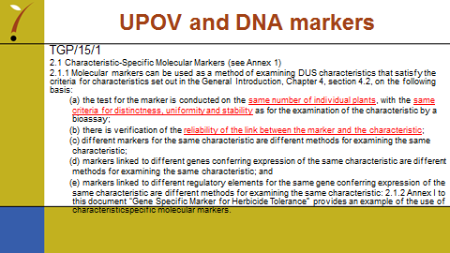

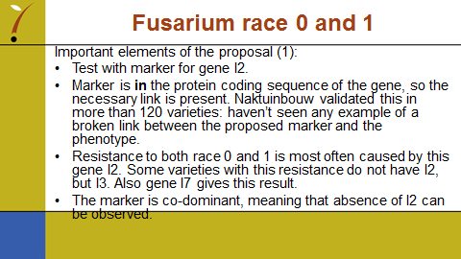

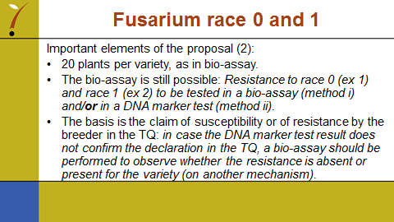

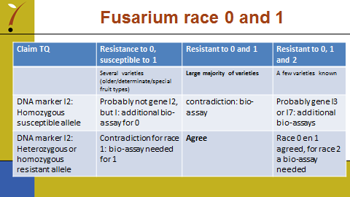

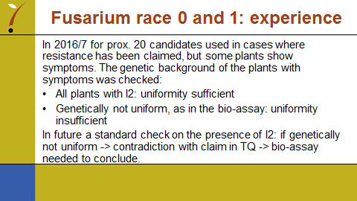

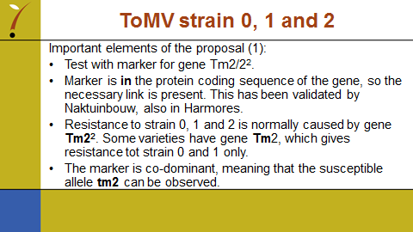

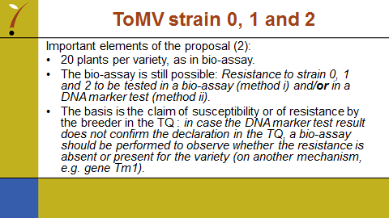

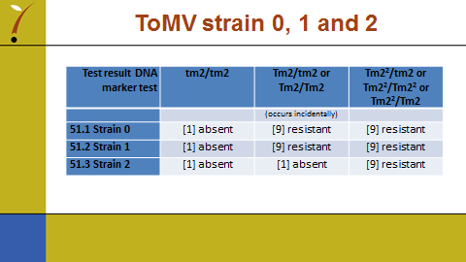

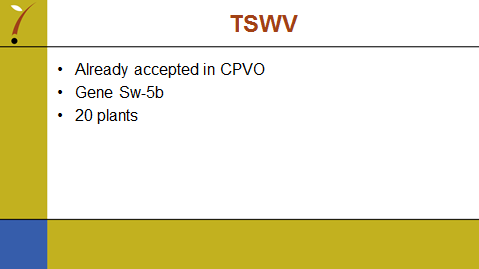

[End of Annex and of document]

