E
TWV/48/41
ORIGINAL: English
DATE: June 12, 2014
INTERNATIONAL UNION FOR THE PROTECTION OF NEW VARIETIES OF PLANTS
Geneva
Technical working party for vegetables
Forty-Eighth Session
Paestum, Italy, June 23 to 27, 2014
Correction of the Test Guidelines for Carrot (Document TG/49/8)
Document prepared by the Office of the Union
Disclaimer: this document does not represent UPOV policies or guidance
The purpose of this document is to present a proposal for the correction of the Test Guidelines for Carrot (document TG/49/8).

Chapter 4.2 of the Test Guidelines for Carrot reads as follows:

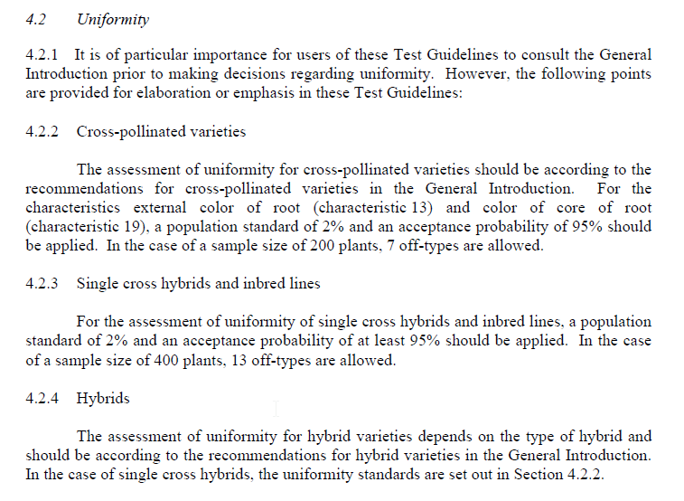
It is proposed to correct the reference in the last sentence of Chapter 4.2.4 to read as follows:

“4.2.4 Hybrids

The assessment of uniformity for hybrid varieties depends on the type of hybrid and should be according to the recommendations for hybrid varieties in the General Introduction. In the case of single cross hybrids, the uniformity standards are set out in Section 4.2.2 4.2.3.”

[End of document]

