E
TWV/48/33
ORIGINAL: English
DATE: May 15, 2014
INTERNATIONAL UNION FOR THE PROTECTION OF NEW VARIETIES OF PLANTS
Geneva
Technical working party for VEGETABLES
Forty-Eighth Session
Paestum, Italy, June 23 to 27, 2014
PARTIAL REVISION of the Test Guidelines for French Bean (document TG/12/9 Rev.)
Document prepared by an expert from the Netherlands
Disclaimer: this document does not represent UPOV policies or guidance
The purpose of this document is to present the proposal for the partial revision of the Test Guidelines for French Bean (document TG/12/9 Rev.).

The following change is proposed:

- a revised format for explanations of disease resistance characteristics:
  - Ad. 49: Resistance to Bean anthracnose (Colletotrichum lindemuthianum)
  - Ad. 50: Resistance to Bean Common Mosaic Necrosis Virus (BCMNV)
  - Ad. 51: Resistance to Halo Blight (Pseudomonas syringae pv. phaseolicola)
  - Ad. 52: Resistance to Common Blight (Xanthomonas campestris pv. phaseoli), Isolate 422

Proposal to Include a Revised Format for Disease Resistance Characteristics

Current wording:

Ad. 49: Resistance to Bean anthracnose (Colletotrichum lindemuthianum)

Maintenance of races |  | In a test tube on glucose-peptone agar
Pre-germination of seed (about 4 to 5 days) |  | At least twice, 10 seeds are placed at 20°C in petri-dishes on moist vermiculite. After the start of germination (1 to 2 cm root length) the seed coat is removed.
Inoculum and inoculation |  | Growth on GPA in 1 liter glass bottles for 12 to 14 days. Removal of inoculum with a scraper. The germinated seeds are dipped in a suspension of spores of Colletotrichum lindemuthianum for 2 minutes. The concentration of spores should be 1 million spores per ml
Sowing: |  | Sowing in pots with sand, covering of seed with sand to 1 cm.
Culture of plants: |  | The pots are placed in a Phytotron at 20°C with 16 hours of daylight. Regular watering is needed, no special air humidity requirements.
Observation: |  | The symptoms are visible during sprouting of the plants or up to 10 days thereafter. The observations can be made after 10 to 14 days.
Scheme of observation: |  | Resistance present: healthy plants with no symptoms, or weak reaction with small superficial necroses in the form of dots or stripes  Resistance absent: reaction with up to 5 necrotic flecks on stem, or strong reaction with necroses larger than 3 mm, sunk deeply into the tissue, or dying plants with strong formation of necroses during sprouting or thereafter.

proposed new wording:

Ad. 49: Resistance to Bean anthracnose (Colletotrichum lindemuthianum)

* 1. Pathogen | Colletotrichum lindemuthianum  (Anthracnose)
2. Quarantine status | No
* 3. Host species | Phaseolus vulgaris
* 4. Source of inoculum | GEVES (FR), Naktuinbouw (NL), INIA (ES)
* 5. Isolate | 6, Kappa
6. Establishment isolate identity | On differentials:
 | Old race name: |  |  | - | (no longer in guideline) Lambda | Kappa
 | Binary race name: |  |  | 6 | 55 | 31
Differential |  | Gene | Binary
A | Michelite |  | 1 | R | S | S
B | Michigan Dark Red Kidney | Co-1 | 2 | S | S | S
C | Perry Marrow | Co-1³ | 4 | S | S | S
D | Cornell 49242 | Co-2 (Are) | 8 | R | R | S
E | Widusa | Co-1⁵ | 16 | R | S | S
F | Kaboon | Co-1² | 32 | R | S | R
G | Mexico 222 | Co-3 | 64 | R | R | R
H | PI 207262 |  | 128 | R | R | R
I | TO | Co-4 | 256 | R | R | R
J | TU | Co-5 | 512 | R | R | R
K | AB 136 | Co-6 | 1024 | R | R | R
L | G 2333 | Co-4-2/5/7 | 2048 | R | R | R

7. Establishment pathogenicity | On susceptible variety
8. Multiplication inoculum
8.1 Multiplication medium | PDA (Potato Dextose Agar) or Mathur medium (20-25°C)
8.2 Multiplication variety | e.g. Masai
8.3 Plant stage at inoculation | Seed for soaking  5 days old seedlings for spraying
8.4 Inoculation medium | -
8.5 Inoculation method | Soaking or spraying seedlings
8.6 Harvest of inoculum | Scrape spores with scraper from 7-20 d old plates grown at 20-25°C
8.7 Check of harvested inoculum | Count spores and adjust to 10⁶ spores per mL
8.8 Shelf life/viability inoculum | About 4 hours  Long term storage of strains: at -80°C in 20% glycerol
9. Format of the test
* 9.1 # plants per genotype | At least 20 plants
* 9.2 # replicates | -
* 9.3 Control varieties Susceptible: | Goldrush, Michelet à longue cosse, Masai
Resistant for race 6 and race lambda: | Booster, Pastoral
9.4 Test design | -
9.5 Test facility | Climate cell
9.6 Temperature | 20-22°C
9.7 Light | -
9.8 Season | -
9.9 Special measures | Plants are placed in high humidity
10. Inoculation
10.1 Preparation inoculum | Culture on PDA or Mathur medium
10.2 Quantification inoculum | Count spores and adjust to 10⁶ spores per mL
*10.3 Plant stage at inoculation | Pre-germinated seed for soaking  5 days old seedlings for spraying
*10.4 Inoculation method | One of two methods may be applied:  - Soaking pre-germinated seeds in a spore suspension for 2 minutes. Seeds are planted in soil after inoculation  - Spraying cotyledons with inoculum suspension 5 days after sowing
10.5 First observation | 7 days after inoculation
10.6 Second observation | 12 days after inoculation
*10.7 End of test | 14 days after inoculation
11. Observations
*11.1 Method | Visual observation of symptoms
*11.2 Observation scale (for both methods) | 0: no symptoms
 | 1: weak reaction with small superficial necrosis (dots or stripes)
 | 2: necrotic lesions larger than 3 mm and/or deeply sunk into the tissue of hypocotyls and/or stems
 | 3: dying plants
*11.3 Validation of test | Standards must show expected symptoms
11.4 Off-types | -
*12. Interpretation of data in terms of UPOV characteristic states | -
For soaking seeds: | Resistant: class 0 an 1
 | Susceptible: class 2 and 3
For spraying cotyledons: | Some flecks of necrosis can occur in the stem and some in the cotyledons of resistant varieties
13. Critical control points: | Monitor the inoculation pressure with a suitable variety e.g. with Pastoral. This variety has a weaker resistance and can give an indication of aggressiveness of the test.

Current wording:

Ad. 50: Resistance to Bean Common Mosaic Necrosis Virus (BCMNV)

Production of infection material
Nature of medium: |  | Plants or dry leaves
Special conditions: |  | Glasshouse culture (plants) or deep-frozen leaves
Identification: |  | Use of virus strain “NL 3”
Conduct of trials
Plant stage: |  | Two-leaf
Temperature: |  | Culture at 20 to 25°C, following inoculation 30°C for a period of 8 days
Light: |  | Normal daylight, if necessary shaded
Culture: |  | Glasshouse
Type of inoculation: |  | Mechanical, by rubbing the inoculum on the leaves
Duration of trials
- Sowing to inoculation: |  | 8 to 9 days
- Inoculation to observation: |  | 6 to 21 days
Number of plants tested: |  | 60 (20 pots with 3 plants each)

Description of the Method
(1) Obtaining the inoculation material.- The virus strain “NL 3” is used for the tolerance testing since it covers practically all the groups of strains of Bean Common Mosaic Virus. To begin with, dwarf bean plants of the variety “Dufrix” or of another variety highly sensitive to the virus are infected, around the beginning of Spring, by rubbing with pressed juice containing the virus, obtained from own maintenance culture or from freeze-dried leaves (provided for instance by the Institute for Biochemistry and Virus Diseases of the Federal Biological Institute in Brunswick (= strain “NL 3”)). These infected plants are then used, around two months later, for producing pressed juice containing the virus with which the test plants are inoculated.

(2) Inoculation.- The pressed juice containing the virus is diluted for inoculation (approximately one part juice to two parts water). After the two leaves have been strewn with carborundum or celite, the diluted juice is lightly rubbed on using a firm sponge. The leaves are then rinsed with water some 15 to 20 minutes later using a watering can with a fine spout.

(3) Incubation.- Following inoculation, the air temperature in the glasshouse must be kept at 30°C for at least one week. (Important!!! The temperature must be maintained throughout the day and also at night). First lesions may already occur after 3 to 4 days. Top necrosis will already become visible one week after inoculation. Varieties with tolerance absent demonstrate the typical mosaic symptoms after approximately two weeks. The final observations can be made some three weeks after inoculation.

(4) Observation: The first assessment should be made on the sixth day following the day of innoculation. The mosaic symptoms and the necrotic symptoms can be distinguished as follows:

(i) Mosaic symptoms: pale-colored leaves; light and dark green mosaic; dark green areas between veins blistered; narrow chlorotic bands along veins and leaf margin rolling downwards. Various symptoms may be expressed in various degrees. The mosaic symptoms may be recorded using a scale from 1 to 9 to assess the reaction of the candidate variety
(1 = no symptoms, 9 = strongest stage of expression). If a candidate variety does not show any mosaic symptoms, while the susceptible standard varieties do so, that candidate variety should be regarded as being resistant to mosaic.

(ii) Blackroot symptoms: there are two types of necrosis (especially when tested with strain “NL3”), which are to be classified as “Blackroot.”

Local necrosis (local hypersensitivity): characterized by brown necrotic netting (the veins) localized on a part of the leaf blade;

Systemic necrosis (top necrosis): characterized by a rapid development of necrosis through out the stem, the petiole and the roots, resulting in top necrosis or even complete necrosis of the plant. (The vascular bundles of the stem, the petiole and finally the roots, if innoculated at a young plant stage, turn brown, hence the term “Blackroot”).

Varieties or strains showing blackroot symptoms (both local hypersensitivity and top necrosis) generally prove to be resistant to mosaic in the field.

During the resistance testing most local necroses develop into top necroses.

Remarks:

The genetics of resistance to Bean Common Mosaic Virus (BCMV) and/or Blackroot is based on a number of a-specific and specific recessive genes of which some are allelic. Drijfhout found at least 4 genes; e.g.:

bc-u
bc-1/bc-1²
bc-2/bc-2²
and bc-3.

A dominant necrosis gene ‘I’ interferes with these resistance genes. The recessive form ‘I+’ in combination with bc-3 and bc-22 gives complete resistance to both BCMV and Blackroot (Example variety: Great Northern 31).

(for more details, see Drijfhout (1978))

proposed new wording:

Ad. 50: Resistance to Bean Common Mosaic Necrosis Virus (BCMNV)

* 1. Pathogen | Bean common necrosis mosaic virus (BCMNV)
2. Quarantine status | No
* 3. Host species | Phaseolus vulgaris
* 4. Source of inoculum | GEVES (FR), Naktuinbouw (NL), INIA (ES)
* 5. Isolate | NL3 or NL5 (Pathogenicity group VI)
6. Establishment isolate identity | On differentials Widusa and Top Crop;  Widusa (I) must show top or vein necrosis;  Top Crop (bc-1, I) must show only local necrosis
7. Establishment pathogenicity | On susceptible variety
8. Multiplication inoculum
8.1 Multiplication medium | -
8.2 Multiplication variety | Dufrix or Flandria
8.3 Plant stage at inoculation | First leaf expanded (8 days)
8.4 Inoculation medium | PBS (Phosphate Buffer Saline) and carborundum
8.5 Inoculation method | Rubbing
8.6 Harvest of inoculum | Pick leaves with mosaic and/or leaf rolling 14 days after inoculation on susceptible variety
8.7 Check of harvested inoculum | -
8.8 Shelf life/viability inoculum | Very long in dry or freeze dried leaves
9. Format of the test
* 9.1 # plants per genotype | 20
* 9.2 # replicates | 2
* 9.3 Control varieties susceptible | Dufrix, Flandria
Resistant with necrosis | Booster, Odessa
Resistant without necrosis | Bizet
9.4 Test design | -
9.5 Test facility | Glasshouse
9.6 Temperature | Initial 5-7 days after inoculation  25° day / 18°C night or 30°C day and night  After 5-7 days:  25°C day and night
9.7 Light | See remark 13.
9.8 Season | -
9.9 Special measures | Rinse leaves after inoculation to reduce damage by carborundum
10. Inoculation
10.1 Preparation inoculum | Maceration in PBS
10.2 Quantification inoculum | -
*10.3 Plant stage at inoculation | First leaf expanded (8 days after sowing)
*10.4 Inoculation method | Rubbing
10.5 First observation | 6 days after inoculation
10.6 Second observation | 9 days after inoculation
*10.7 End of test | 14 days after inoculation
11. Observations
*11.1 Method | Visual observation
*11.2 Observation scale | 1: mosaic and/or leaf rolling
 | 2: top necrosis, vein necrosis and/or small necrotic lesions
 | 3: no symptoms
*11.3 Validation of test | Standards must show expected symptoms
11.4 Off-types | -
*12. Interpretation of data in terms of UPOV characteristic states | Classify in three classes corresponding with observation scale:  1: resistant absent  2: resistant present with necrosis  3: resistant present without necrosis
13. Critical control points: | Temperature-dependent expression of symptoms in some varieties, necrosis increasing with temperature. Light may also enhance symptom development.

Current wording

Ad. 51: Resistance to Halo Blight (Pseudomonas syringae pv. phaseolicola)

Maintenance of strains
Type of medium |  | Infected, dry leaves
Identification: |  | On the basis of preliminary trials, the European strains (which probably belong to the African race-by J.D. Taylor, H.R.I. Wellesbourne) have a higher level of virulence than the US race 1 and race 2. The aggressivity of the pathogen is measured by the spot size of the pod of sensitive varieties. The isolates used for the test should cause a grease spot with a minimum diameter of 3 mm.
Execution of test
Growth stage of plants: |  | When the first and second trifoliate leaves are 2 to 3 cm in length
Temperature: |  | Day: 24°C; night: 18°C
Humidity: |  | 100% relative humidity until inoculated leaves are fully developed
Growing method: |  | In the glasshouse
Inoculum: |  | Bacterial suspension with a concentration of 108 bacterial cells/ml.
Method of inoculation: |  | Mechanical, using a camel-hair brush
Duration of test
- from inoculation to reading: |  | Until infected leaves are fully developed
Number of plants to be tested: |  | 10-20 plants
Multiplication/propagation of bacteria: |  | Bouillon-Agar (2 g Na₂ HPO₄, 2 g NaH2PO4, 3 g NaCl, 25 g Bouillon-Agar/1000 ml distilled water)
Remarks: |  | - Leaf reaction is very commonly studied nowadays. The reaction of the pod is of polygenic character, and there is no genetic linkage between leaf and pod reaction. There are as yet no varieties with pod resistance.  - Resistance means, genetically, that this host has the recessive gene with or without the presence of the modifiers; in the case where the modifiers are present the sources of these genes are: PI 150 414 (USA), CNRA-HW5A (Fr.).  It is possible to evaluate the lesions at the stage of the fully developed leaf. The different types of symptom are shown below.

Legend of illustration following hereafter

healthy tissue water-soaked lesion without discoloration

toxically chlorotic tissue water-soaked lesion with discoloration

some cell-size brownish red
necrotic spots

Scheme of observation

Resistance absent
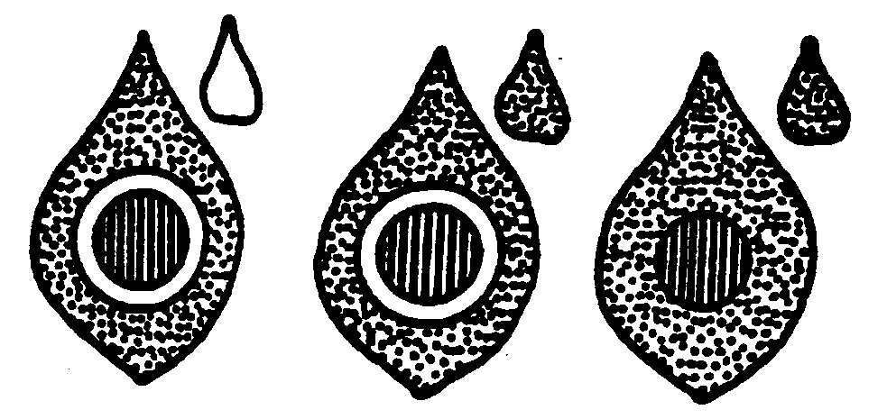

water-soaked lesion with toxically
chlorotic halo, systemic chlorosis;
water-soaked lesion with halo, no
systemic chlorosis;
water-soaked lesion without halo, no
systemic chlorosis

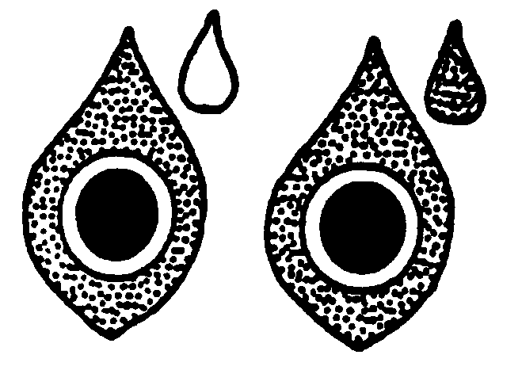
discoloration of water-soaked lesions
with halo, systemic chlorosis;
discoloration of water-soaked lesions with
halo, no systemic chlorosis

Resistance present

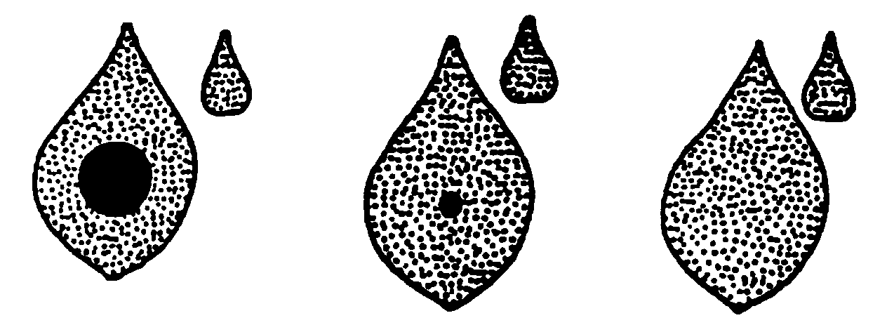

necrotic spots of 1-2 mm diameter, no systemic chlorosis or some cell-size brownish-red hypersensitive necrotic spots or healthy, uninfected plant

Proposed new wording

Ad. 51: Resistance to Halo Blight (Pseudomonas syringae pv. phaseolicola)

* 1. Pathogen | Pseudomonas savastanoi pv. phaseolicola  (Halo blight)
2. Quarantine status | No
* 3. Host species | Phaseolus vulgaris
* 4. Source of inoculum | GEVES (FR), Naktuinbouw (NL),  HRI (UK), INIA (ES)
* 5. Isolate | Race 6
6. Establishment isolate identity | All differentials should be susceptible  (Canadian Wonder, A52, RM UI3, 1072,  Q53, A43, Guatemala 196-B)
7. Establishment pathogenicity | On susceptible variety
8. Multiplication inoculum
8.1 Multiplication medium | King’s B or Yeast Dextrose Agar at 27°C
8.2 Multiplication variety | -
8.3 Plant stage at inoculation | First leaf (14 days after sowing)
8.4 Inoculation medium | Tap water
8.5 Inoculation method | -
8.6 Harvest of inoculum | 4 days after start of pure culture
8.7 Check of harvested inoculum | -
8.8 Shelf life/viability inoculum | Max. 3 weeks on plate, and max. 2 x subculturing
9. Format of the test
* 9.1 # plants per genotype | 20
* 9.2 # replicates | 2
* 9.3 Control varieties susceptible | Michelet à longue cosse
resistant | Masai, Vaillant
9.4 Test design | -
9.5 Test facility | Glasshouse or climate cell
9.6 Temperature | 22/20°C day/night
9.7 Light | -
9.8 Season | -
9.9 Special measures | High humidity required during first 1-3 days after inoculation
10. Inoculation
10.1 Preparation inoculum | Rinse bacteria from plate with tap water and add 2 g carborundum per 100 ml.
10.2 Quantification inoculum | 10⁸ cfu/ ml or 1-2 full-grown plates per 100 ml water for 100 plants
*10.3 Plant stage at inoculation | First pair of leaves spreading (14 d after sowing)
*10.4 Inoculation method | Rubbing with sponge
10.5 First observation | 7 days after inoculation
10.6 Second observation | 14 days after inoculation
*10.7 End of test | -
11. Observations
*11.1 Method | Visual observation
*11.2 Observation scale Resistant | No symptoms or necrotic pinpoints
Susceptible | Light green halo around minute lesions  Water soaked (“oily”) lesions (few or many)  Water soaked lesions, later turning necrotic  Deformation and chlorosis on first trifoliate leaves  Necrosis on stems  Dying plants
*11.3 Validation of test | Standards must show expected symptoms
11.4 Off-types | -
*12. Interpretation of data in terms of UPOV characteristic states | 11.2
13. Critical control points: | Inoculation may produce some damage on susceptible and resistant plants

Current wording

Ad. 52: Resistance to Common Blight (Xanthomonas campestris pv. phaseoli), Isolate 422

Maintenance of races
Type of medium: |  | Infected, dry leaves
Execution of test
Growth stage of plants: |  | When the first and second trifoliate leaves are 2 to 3 cm in length
Temperature: |  | Day: 26°C; night: 20°C
Humidity: |  | 100% relative humidity during, and 1 to 2 days after, inoculation, thereafter normal relative humidity
Growing method: |  | In the glasshouse
Inoculum: |  | Bacterial suspension with a concentration of 10⁸ bacterial cells/ml.
Method of inoculation: |  | Mechanical, using a camel-hair brush
Duration of test
- from inoculation to reading: |  | Until infected leaves are fully developed
Number of plants tested: |  | 10-20 plants
Multiplication/propagation of bacteria: |  | 20 g extract of yeast powder, 20 g glucose, 20 g CaCO3, 20 g agar-agar/1000 ml distilled water)
Remarks: |  | - Isolate 422 can be obtained from the Vegetable Research Institute, 1775 Budapest, P.O. Box 95, Hungary.  - The reaction of pods to X. phaseoli is not yet clear enough today.

Legend of illustration following hereafter

healthy tissue (2) dying tissues

(1) chlorotic tissue (3) some cell-size brownish red hypersensitive
necrotic spots

Scheme of observation

If chlorotic tissues (1) and/or dying tissue (2) are observed, the variety should be regarded as non-resistant.

If only some cell-size brownish red hypersensitive necrotic spots (3) are observed, the variety should be regarded as resistant.

Possible combinations of symptoms

Resistance absent

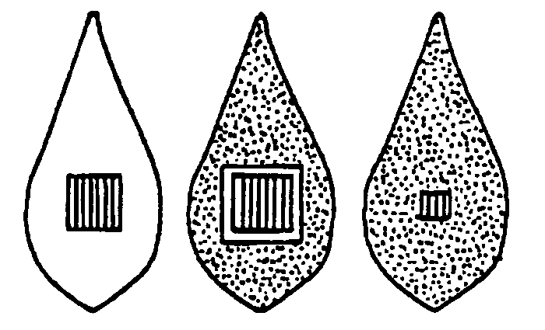

Resistance present

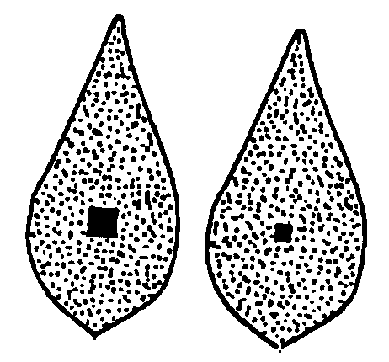

Proposed new wording

Ad. 52: Resistance to Common Blight (Xanthomonas campestris pv. phaseoli), Isolate 422

* 1. Pathogen | Xanthomonas campestris pv. phaseoli  (Common blight)
2. Quarantine status | No
* 3. Host species | Phaseolus vulgaris
* 4. Source of inoculum | Vegetable Research Institute, Budapest
* 5. Isolate | Isolate 422
6. Establishment isolate identity | -
7. Establishment pathogenicity | -
8. Multiplication inoculum
8.1 Multiplication medium | Yeast Glucose Agar  (20 g yeast extract powder, 20 g glucose, 20 g CaCO₃, 20 g agar/ 1000 ml distilled water)
8.2 Multiplication variety | -
8.3 Plant stage at inoculation | First leaf pair 2-3 cm long
8.4 Inoculation medium | -
8.5 Inoculation method | 100% relative humidity during 2 days after inoculation, later normal humidity
8.6 Harvest of inoculum | -
8.7 Check of harvested inoculum | -
8.8 Shelf life/viability inoculum | -
9. Format of the test
* 9.1 # plants per genotype | -
* 9.2 # replicates | -
* 9.3 Control varieties | -
9.4 Test design | -
9.5 Test facility
9.6 Temperature | 26/20°C day/night
9.7 Light | -
9.8 Season | -
9.9 Special measures | 100% relative humidity during 2 days after inoculation, later normal humidity
10. Inoculation
10.1 Preparation inoculum | -
10.2 Quantification inoculum | 10⁸ cfu/ml
*10.3 Plant stage at inoculation | -
*10.4 Inoculation method | Mechanical, with camel hair brush
10.5 First observation | 7 days after inoculation
10.6 Second observation | 14 days after inoculation
*10.7 End of test | When infected leaves are fully developed
11. Observations
*11.1 Method | -
*11.2 Observation scale | Visual
susceptible | Extensive necrosis sometimes surrounded by an increasing ring of chlorotic tissue
resistant | Cell-sized brownish or red necrotic spots
*11.3 Validation of test | -
11.4 Off-types | -
*12. Interpretation of data in terms of UPOV characteristic states | 11.2
13. Critical control points: | -

[End of document]

