E
TWV/48/17
ORIGINAL: English
DATE: May 27, 2014
INTERNATIONAL UNION FOR THE PROTECTION OF NEW VARIETIES OF PLANTS
Geneva
TECHNICAL WORKING PARTY FOR VEGETABLES
Forty-Eighth Session
Paestum, Italy, from June 23 to 27, 2014
Revision of document TGP/8: Part II: Selected Techniques used in DUS Examination, New Section 11: Examining DUS in Bulk Samples
Document prepared by the Office of the Union
Disclaimer: this document does not represent UPOV policies or guidance
The purpose of this document is to report on developments concerning guidance on examining DUS in bulk samples for inclusion in a future revision of document TGP/8.

The following abbreviations are used in this document:

TC: Technical Committee
TC-EDC: Enlarged Editorial Committee
TWA: Technical Working Party for Agricultural Crops
TWC: Technical Working Party on Automation and Computer Programs
TWF: Technical Working Party for Fruit Crops
TWO: Technical Working Party for Ornamental Plants and Forest Trees
TWPs: Technical Working Parties
TWV: Technical Working Party for Vegetables

The TC, at its forty-ninth session, held in Geneva, from March 18 to 20, 2013, agreed to replace the proposed text for new Section 11 “Examining DUS in Bulk Samples” in the Annex to document TC/49/28 with guidance on the use of characteristics examined on the basis of bulk samples, in order to ensure that the characteristics fulfill the basic requirements for a characteristic. In particular, it agreed that Leading Experts of Test Guidelines could be requested to provide data from different years to demonstrate that the expression of the characteristic is “sufficiently consistent and repeatable in a particular environment”. It was further agreed that, on the basis of information provided to the TWPs, consideration could be given to statistical analysis for such characteristics (see document TC/49/41 “Report on the conclusions”, paragraph 64).

At their sessions in 2013, the TWO, TWF, TWV, TWC and TWA considered documents TWO/46/17, TWF/44/17, TWV/47/17, TWC/31/17 and TWA/42/17, respectively.

The TWO, TWF, TWV, TWC and TWA agreed that Leading Experts of Test Guidelines could be requested to provide data from different years to demonstrate that the expression of the characteristic was “sufficiently consistent and repeatable in a particular environment” (see documents TWO/46/29 “Report”, paragraph 39, document TWF/44/31 “Report”, paragraph 42, document TWV/47/34 “Report”, paragraph 42, document TWC/31/32 “Report”, paragraph 39, and document TWA/42/31 “Report”, paragraph 43, respectively).

The TC, at its fiftieth session, held in Geneva, April 7 to 9, 2014, invited experts from France and the Netherlands to provide examples of their experience in the development of characteristics based on bulk samples, for seed- and vegetatively propagated varieties, as a basis to develop guidance on the development of characteristics examined on the basis of bulk samples.

The Annex to this document presents an example of the characteristic “Content of Glycoraphanin”, prepared by an expert from the Netherlands.

The TWV is invited to consider the example of a bulk characteristic from the Netherlands and to consider the development of guidance on the development of characteristics examined on the basis of bulk samples.

AN EXAMPLE OF A BULK CHARACTERISTIC FORM THE NETHERLANDS: CONTENT OF GLYCORAPHANIN

- Consideration if the characteristic is suitable as a characteristic for DUS testing
- Description of the characteristic
- Method of detection

- Consideration if the characteristic is suitable as a characteristic for DUS testing

Selection of Characteristics is mentioned in the technical guidance of the UPOV: TG/1/3 page 9
In this chapter we consider if the characteristic Content of Glycoraphanin in broccoli does fulfil the requirements of a characteristic in the sense of UPOV.

4.2 Selection of Characteristics

4.2.1 The basic requirements that a characteristic should fulfill before it is used for DUS testing or producing a variety description are that its expression:

(a) results from a given genotype or combination of genotypes
(this requirement is specified in Article l(vi) of the 1991 Act of the UPOV Convention but is a basic requirement in all cases);

The content of Glycoraphanin is stable per variety over the years, but different between varieties.

(b) is sufficiently consistent and repeatable in a particular environment;

The content of Glycoraphanin is stable per variety over three years tested. The results between the contents as stated by the TQ is in congruence with the data recorded in a trial at Naktuinbouw.
(c) exhibits sufficient variation between varieties to be able to establish distinctness;
Very clear.
(d) is capable of precise definition and recognition
(this requirement is specified in Article 6 of the 1961/1972 and 1978 Acts of the UPOV Convention, but is a basic requirement.in all çases);

Yes, see method.

(e) allows uniformity requirements to be fulfilled;

At the moment we do not have reasons to doubt the uniformity within this characteristic. As mentioned above the results per variety are stable over the years with only 3 plants per variety. This is an indication that the characteristic is uniform between plants within the variety. Because of the cost aspect we did not yet test the uniformity of 20 plants within several varieties. However technically this is very well possible to carry out.

(f) allows stability requirements to be fulfilled, meaning that it produces consistent and repeatable results after repeated propagation or, where appropriate, at the end of each cycle of propagation.

Yes. The content of Glycoraphanin was tested over several years.

Conclusion:
In principle all requirements mentioned by UPOV are fulfilled. The uniformity requirement is not fully proven.

- Description of the characteristic

Type of characteristic
Quantitative characteristic
Characteristic:
Glucoraphanin content

3. Low
5. Medium
7. High

Growth stage
Harvest maturity

Type of observation of characteristic
MG – single Measurement on a Group of plants
(specification in protocol see method)

States of expression (µmol/g DW)
1. 0-5
2. 5-10
3. 10-15
4. 15-20
5. 20-25
6. 25-30
7. 30-35
8. 35-40
9 > 40

Remark
Although genetics play a major role in the glucoraphanin levels in a variety, values can vary due to growing conditions and geographic locations, so the results of measurements should be related to example varieties. The values given in this example are based on repeated trials at Naktuinbouw in the Netherlands.

Example varieties
Low: Ironman
Medium: Steel
High: BRM533934

Note

- Method of detection

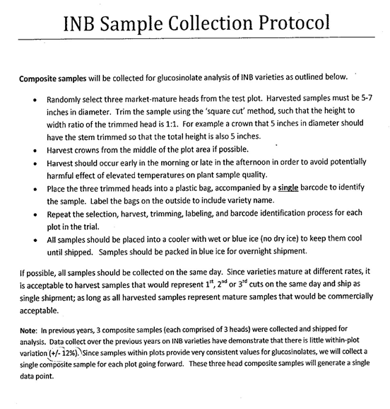
[End of Annex and of document]

