E
TWV/48/12 Add.
ORIGINAL: English
DATE: September 16, 2014
INTERNATIONAL UNION FOR THE PROTECTION OF NEW VARIETIES OF PLANTS
Geneva
Technical working party for VEGETABLES
Forty-Eighth Session
Paestum, Italy, from June 23 to 27, 2014

ADDENDUM TO DOCUMENT TWV/48/12

Revision to document tgp/7: PLANT MATERIAL SUBMITTED FOR EXAMINATION
Document prepared by the Netherlands
Disclaimer: this document does not represent UPOV policies or guidance

The annex to this document contains a copy of the presentation made by an expert from the Netherlands, at the forty-eighth session of the Technical Working Party for Vegetables (TWV), on “Plant Material submitted for Examination: The Case of Vegetatively Propagated Leek”.

[Annex follows]

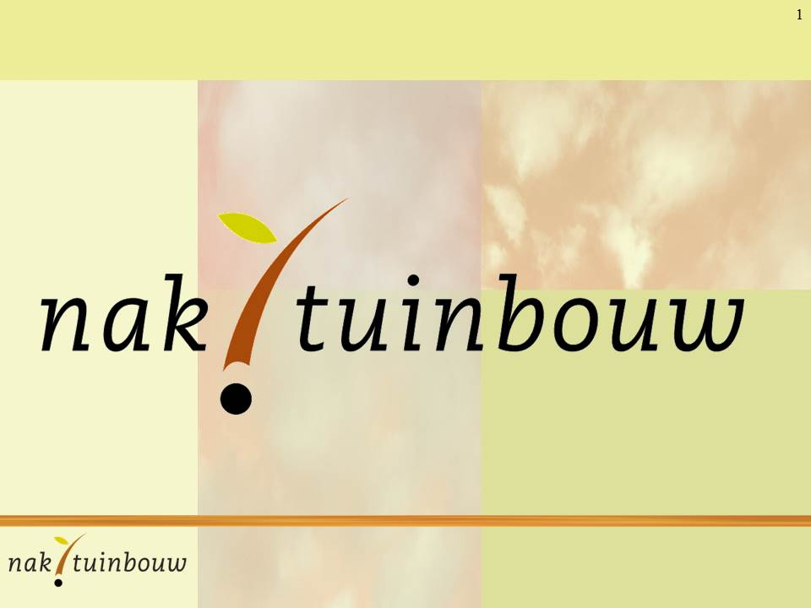

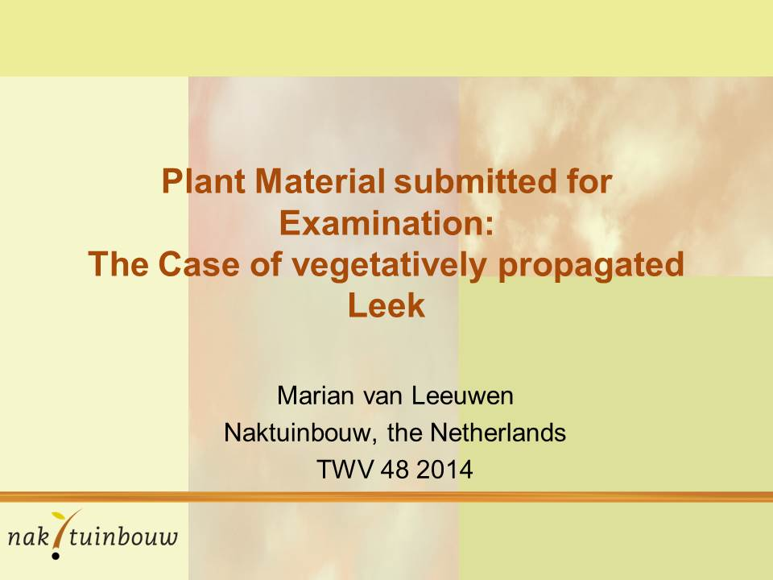
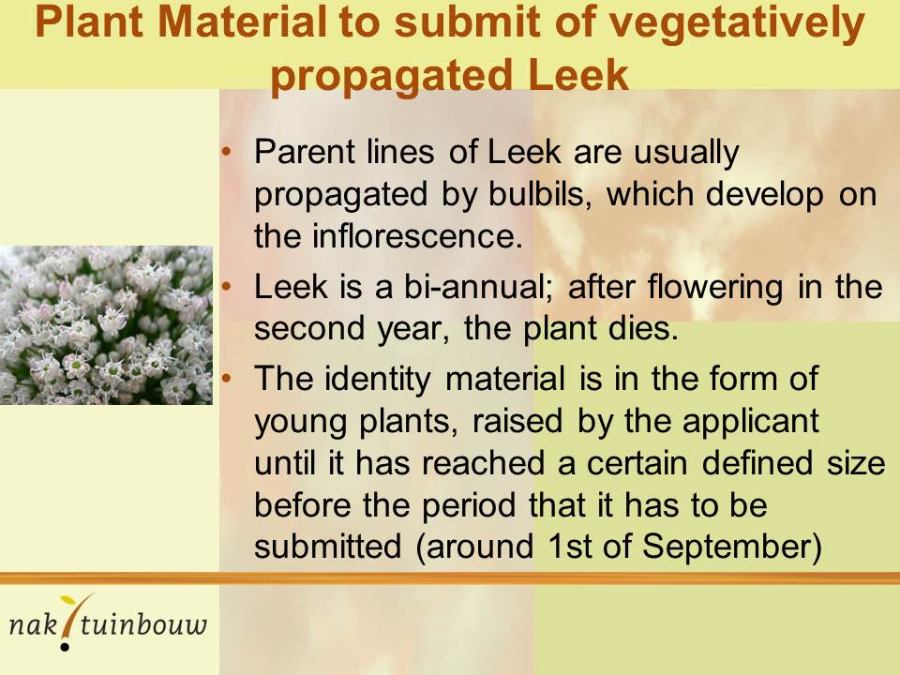

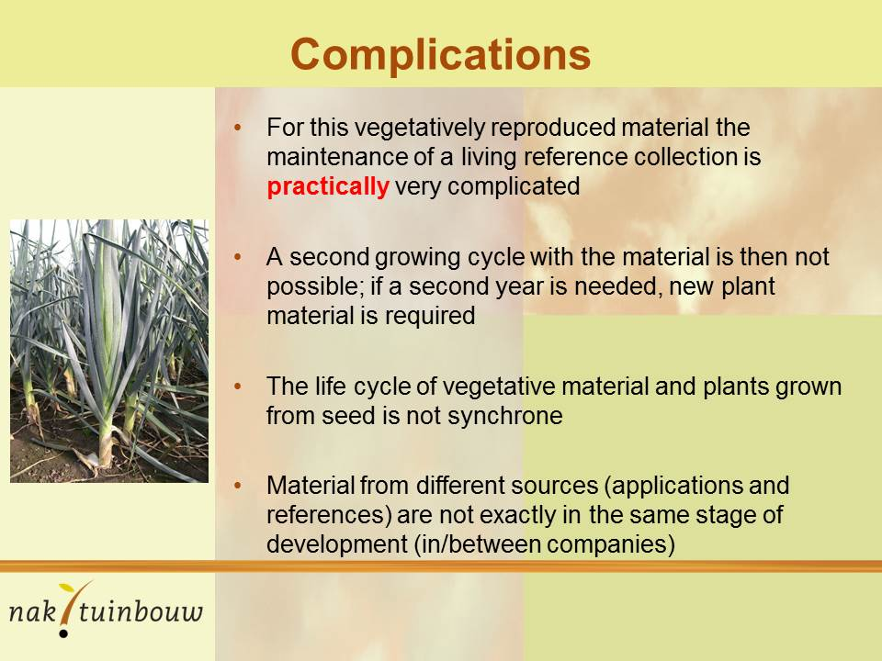
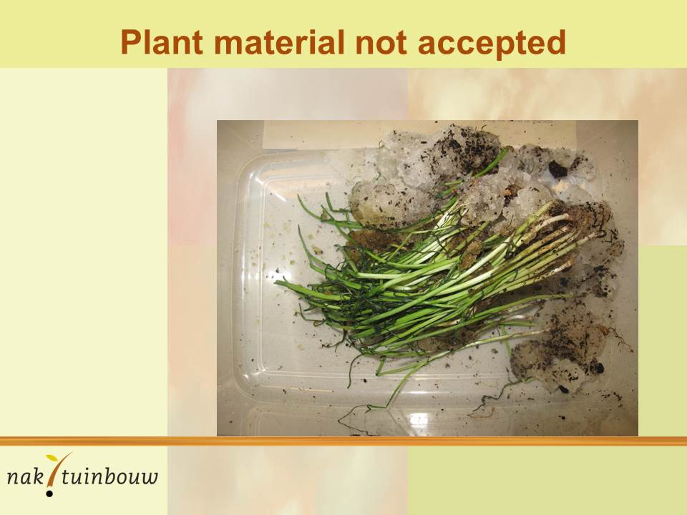

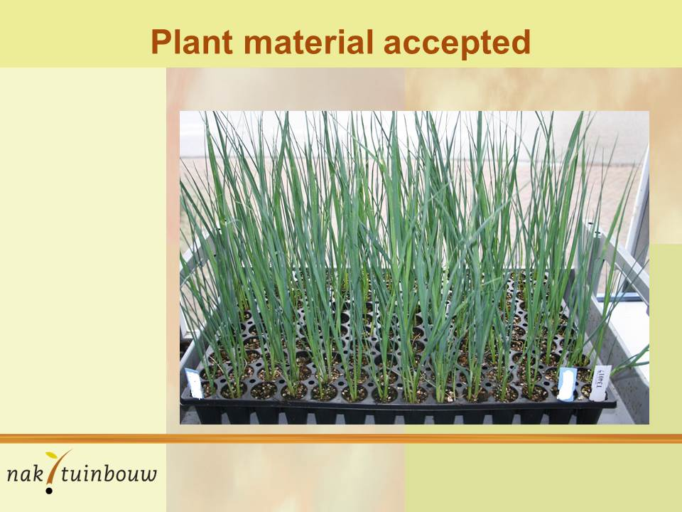
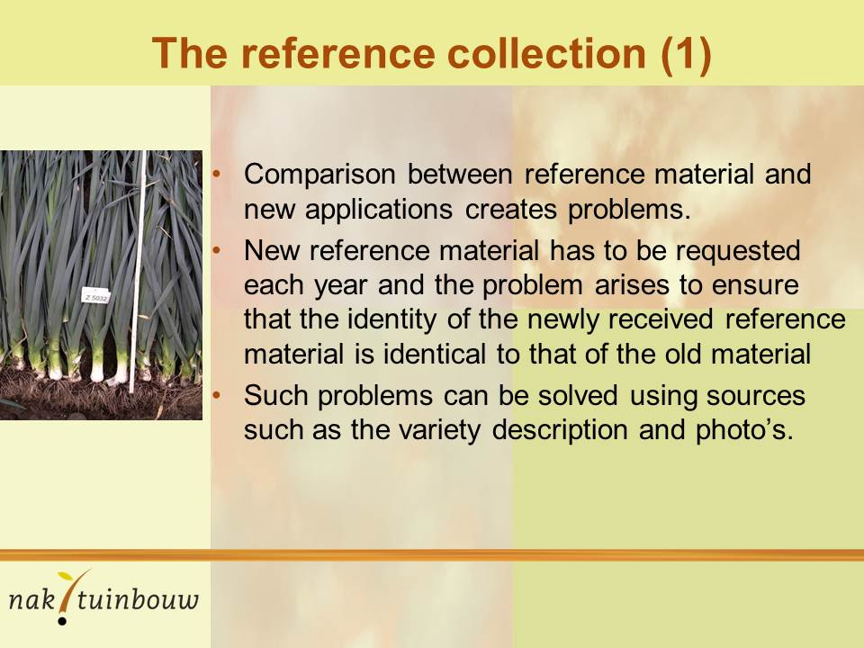

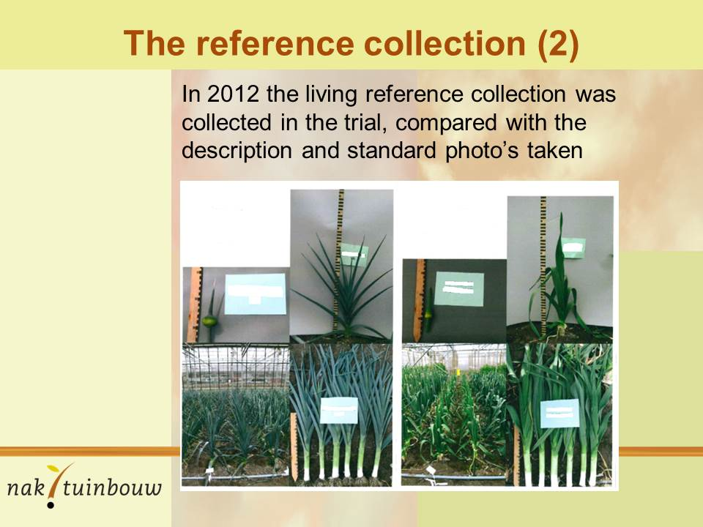
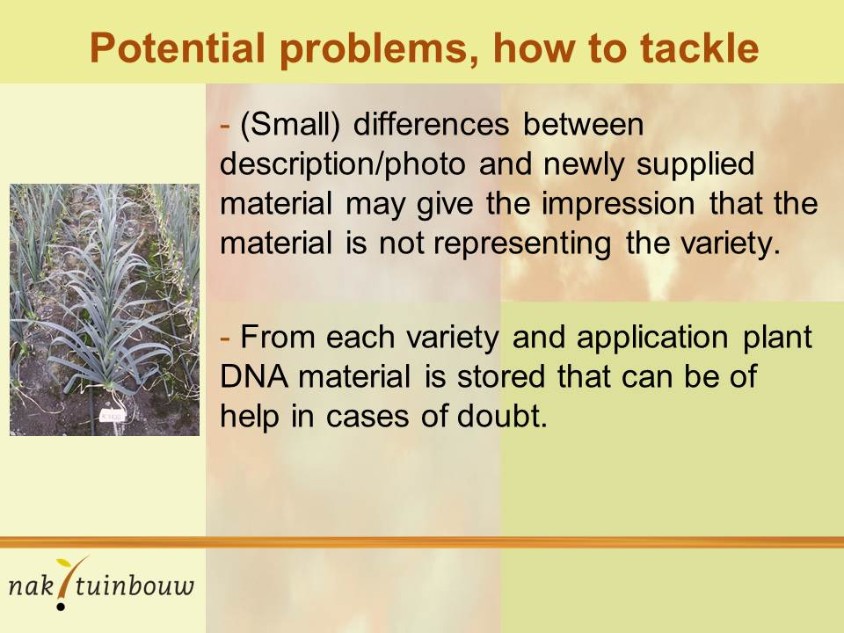

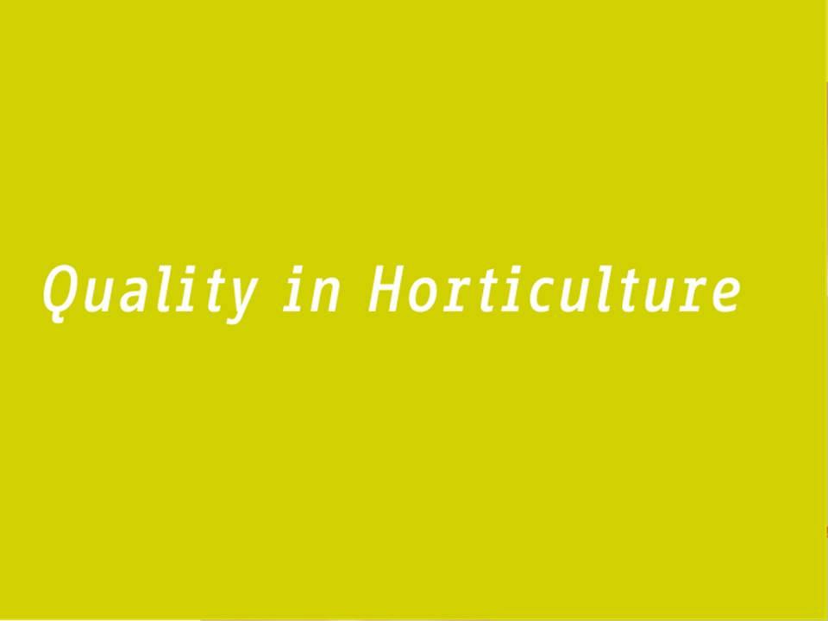

[End of document]

