 |  |  |  |  |  |  | E  TG/BRASS_JUN(proj.2)  ORIGINAL: English  DATE: 2014-05-09
INTERNATIONAL UNION FOR THE PROTECTION OF NEW VARIETIES OF PLANTS
Geneva
 |  |  | DRAFT
 |  | Brown Mustard  UPOV Code: BRASS_JUN  Brassica juncea (L.) Czern. |  |  | *

GUIDELINES

FOR THE CONDUCT OF TESTS

FOR DISTINCTNESS, UNIFORMITY AND STABILITY

prepared by an expert from Japan

to be considered by the
Technical Working Party for Vegetables
at its forty-eighth session, to be held in Paestum, Italy, from June 23 to 27, 2014

Alternative Names:*

Botanical name | English | French | German | Spanish
Brassica juncea (L.) Czern. | Brown mustard,  India mustard,  Indian mustard,  Oriental mustard | Moutarde brune | Sareptasenf | Mostaza de Sarepta; Mostaza india

The purpose of these guidelines (“Test Guidelines”) is to elaborate the principles contained in the General Introduction (document TG/1/3), and its associated TGP documents, into detailed practical guidance for the harmonized examination of distinctness, uniformity and stability (DUS) and, in particular, to identify appropriate characteristics for the examination of DUS and production of harmonized variety descriptions.

ASSOCIATED DOCUMENTS
These Test Guidelines should be read in conjunction with the General Introduction and its associated TGP documents.

TABLE OF CONTENTS PAGE

1. Subject of these Test Guidelines 3
2. Material Required 3
3. Method of Examination 3
3.1 Number of Growing Cycles 3
3.2 Testing Place 3
3.3 Conditions for Conducting the Examination 3
3.4 Test Design 3
3.5 Additional Tests 3
4. Assessment of Distinctness, Uniformity and Stability 4
4.1 Distinctness 4
4.2 Uniformity 5
4.3 Stability 5
5. Grouping of Varieties and Organization of the Growing Trial 5
6. Introduction to the Table of Characteristics 5
6.1 Categories of Characteristics 5
6.2 States of Expression and Corresponding Notes 6
6.3 Types of Expression 6
6.4 Example Varieties 6
6.5 Legend 7
7. Table of Characteristics/Tableau des caractères/Merkmalstabelle/Tabla de caracteres 8
8. Explanations on the Table of Characteristics 13
8.1 Explanations for Individual Characteristics 13
8.2 Key for the Stage of Development 19
9. Literature 21
10. Technical Questionnaire 22

ANNEX COMMENTS BY THE SUBGROUP

Subject of these Test Guidelines

These Test Guidelines apply to all varieties of Brassica juncea (L.) Czern.

Material Required

2.1 The competent authorities decide on the quantity and quality of the plant material required for testing the variety and when and where it is to be delivered. Applicants submitting material from a State other than that in which the testing takes place must ensure that all customs formalities and phytosanitary requirements are complied with.

2.2 The material is to be supplied in the form of seed.

2.3 The minimum quantity of plant material, to be supplied by the applicant, should be:

sufficient seeds to produce 40 for vegetable, and 300 for agricultural plants

The seed should meet the minimum requirements for germination, species and analytical purity, health and moisture content, specified by the competent authority. In cases where the seed is to be stored, the germination capacity should be as high as possible and should, be stated by the applicant.

2.4 The plant material supplied should be visibly healthy, not lacking in vigor, nor affected by any important pest or disease.

2.5 The plant material should not have undergone any treatment which would affect the expression of the characteristics of the variety, unless the competent authorities allow or request such treatment. If it has been treated, full details of the treatment must be given.

Method of Examination

3.1 Number of Growing Cycles

The minimum duration of tests should normally be two independent growing cycles.

3.2 Testing Place

Tests are normally conducted at one place. In the case of tests conducted at more than one place, guidance is provided in TGP/9 “Examining Distinctness”.

3.3 Conditions for Conducting the Examination

The tests should be carried out under conditions ensuring satisfactory growth for the expression of the relevant characteristics of the variety and for the conduct of the examination.

(a) Stage of development for the assessment

The optimum stage of development for the assessment of each characteristic is indicated by a number in the second column of the Table of Characteristics. The stages of development denoted by each number are described in Chapter 8. Explanations on the Table of Characteristics.

3.4 Test Design

Each test should be designed to result in a total of at least 40 for vegetable, and 300 for agricultural plants, which should be divided between at least 2 replicates.

3.5 Additional Tests

Additional tests, for examining relevant characteristics, may be established.

Assessment of Distinctness, Uniformity and Stability

4.1 Distinctness

4.1.1 General Recommendations

It is of particular importance for users of these Test Guidelines to consult the General Introduction prior to making decisions regarding distinctness. However, the following points are provided for elaboration or emphasis in these Test Guidelines.

4.1.2 Consistent Differences

The differences observed between varieties may be so clear that more than one growing cycle is not necessary. In addition, in some circumstances, the influence of the environment is not such that more than a single growing cycle is required to provide assurance that the differences observed between varieties are sufficiently consistent. One means of ensuring that a difference in a characteristic, observed in a growing trial, is sufficiently consistent is to examine the characteristic in at least two independent growing cycles.

4.1.3 Clear Differences

Determining whether a difference between two varieties is clear depends on many factors, and should consider, in particular, the type of expression of the characteristic being examined, i.e. whether it is expressed in a qualitative, quantitative, or pseudo-qualitative manner. Therefore, it is important that users of these Test Guidelines are familiar with the recommendations contained in the General Introduction prior to making decisions regarding distinctness.

4.1.4 Number of Plants / Parts of Plants to be Examined

Unless otherwise indicated, for the purposes of distinctness, all observations on single plants should be made on 30 plants or parts taken from each of 30 plants and any other observations made on all plants in the test, disregarding any off-type plants.

4.1.5 Method of Observation

The recommended method of observing the characteristic for the purposes of distinctness is indicated by the following key in the second column of the Table of Characteristics (see document TGP/9 “Examining Distinctness”, Section 4 “Observation of characteristics”):

MG: single measurement of a group of plants or parts of plants
MS: measurement of a number of individual plants or parts of plants
VG: visual assessment by a single observation of a group of plants or parts of plants
VS: visual assessment by observation of individual plants or parts of plants

Type of observation: visual (V) or measurement (M)

“Visual” observation (V) is an observation made on the basis of the expert’s judgment. For the purposes of this document, “visual” observation refers to the sensory observations of the experts and, therefore, also includes smell, taste and touch. Visual observation includes observations where the expert uses reference points (e.g. diagrams, example varieties, side-by-side comparison) or non-linear charts (e.g. color charts). Measurement (M) is an objective observation against a calibrated, linear scale e.g. using a ruler, weighing scales, colorimeter, dates, counts, etc.

Type of record: for a group of plants (G) or for single, individual plants (S)

For the purposes of distinctness, observations may be recorded as a single record for a group of plants or parts of plants (G), or may be recorded as records for a number of single, individual plants or parts of plants (S). In most cases, “G” provides a single record per variety and it is not possible or necessary to apply statistical methods in a plant-by-plant analysis for the assessment of distinctness.

In cases where more than one method of observing the characteristic is indicated in the Table of Characteristics (e.g. VG/MG), guidance on selecting an appropriate method is provided in document TGP/9, Section 4.2.

4.2 Uniformity

4.2.1 It is of particular importance for users of these Test Guidelines to consult the General Introduction prior to making decisions regarding uniformity. However, the following points are provided for elaboration or emphasis in these Test Guidelines:

4.2.2 The assessment of uniformity should be according to the recommendations for cross pollinated varieties in the General Introduction.

4.3 Stability

4.3.1 In practice, it is not usual to perform tests of stability that produce results as certain as those of the testing of distinctness and uniformity. However, experience has demonstrated that, for many types of variety, when a variety has been shown to be uniform, it can also be considered to be stable.

4.3.2 Where appropriate, or in cases of doubt, stability may be further examined by testing a new seed stock to ensure that it exhibits the same characteristics as those shown by the initial material supplied.

4.3.3 Where appropriate, or in cases of doubt, the stability of a hybrid variety may, in addition to an examination of the hybrid variety itself, also be assessed by examination of the uniformity and stability of its parent lines.

Grouping of Varieties and Organization of the Growing Trial

5.1 The selection of varieties of common knowledge to be grown in the trial with the candidate varieties and the way in which these varieties are divided into groups to facilitate the assessment of distinctness are aided by the use of grouping characteristics.

5.2 Grouping characteristics are those in which the documented states of expression, even where produced at different locations, can be used, either individually or in combination with other such characteristics: (a) to select varieties of common knowledge that can be excluded from the growing trial used for examination of distinctness; and (b) to organize the growing trial so that similar varieties are grouped together.

5.3 The following have been agreed as useful grouping characteristics:

(a) Leaf: type (characteristic 4)
(b) Leaf: shape (characteristic 5)
(c) Leaf blade: anthocyanin coloration (characteristic 14)
(d) Leaf blade: density of incision of margin (characteristic 18)
(e) Leaf blade: blistering (characteristic 19)
(f) Plant: head formation (characteristic 22)
(g) Seed: color (characteristic 30)

5.4 Guidance for the use of grouping characteristics, in the process of examining distinctness, is provided through the General Introduction and document TGP/9 “Examining Distinctness”.

Introduction to the Table of Characteristics

6.1 Categories of Characteristics

6.1.1 Standard Test Guidelines Characteristics

Standard Test Guidelines characteristics are those which are approved by UPOV for examination of DUS and from which members of the Union can select those suitable for their particular circumstances.

6.1.2 Asterisked Characteristics

Asterisked characteristics (denoted by *) are those included in the Test Guidelines which are important for the international harmonization of variety descriptions and should always be examined for DUS and included in the variety description by all members of the Union, except when the state of expression of a preceding characteristic or regional environmental conditions render this inappropriate.

6.2 States of Expression and Corresponding Notes

6.2.1 States of expression are given for each characteristic to define the characteristic and to harmonize descriptions. Each state of expression is allocated a corresponding numerical note for ease of recording of data and for the production and exchange of the description.

6.2.2 In the case of qualitative and pseudo-qualitative characteristics (see Chapter 6.3), all relevant states of expression are presented in the characteristic. However, in the case of quantitative characteristics with 5 or more states, an abbreviated scale may be used to minimize the size of the Table of Characteristics. For example, in the case of a quantitative characteristic with 9 states, the presentation of states of expression in the Test Guidelines may be abbreviated as follows:

State | Note
small | 3
medium | 5
large | 7

However, it should be noted that all of the following 9 states of expression exist to describe varieties and should be used as appropriate:

State | Note
very small | 1
very small to small | 2
small | 3
small to medium | 4
medium | 5
medium to large | 6
large | 7
large to very large | 8
very large | 9

6.2.3 Further explanation of the presentation of states of expression and notes is provided in document TGP/7 “Development of Test Guidelines”.

6.3 Types of Expression

An explanation of the types of expression of characteristics (qualitative, quantitative and pseudo-qualitative) is provided in the General Introduction.

6.4 Example Varieties

Where appropriate, example varieties are provided to clarify the states of expression of each characteristic.

6.5 Legend

(*) Asterisked characteristic – see Chapter 6.1.2

QL Qualitative characteristic – see Chapter 6.3
QN Quantitative characteristic – see Chapter 6.3
PQ Pseudo-qualitative characteristic – see Chapter 6.3

MG, MS, VG, VS – see Chapter 4.1.5

(+) See Explanations on the Table of Characteristics in Chapter 8.1
00-89 Stage of development: see 8.2

Table of Characteristics/Tableau des caractères/Merkmalstabelle/Tabla de caracteres

 |  | English | français | deutsch | español | Example Varieties  Exemples  Beispielssorten  Variedades ejemplo | Note/  Nota
1 | 10  VG | Hypocotyl: anthocyanin coloration
QN |  | absent or weak |  |  |  | Zasai FM-58 | 1
 |  | medium |  |  |  | Shinkoku seisai | 2
 |  | strong |  |  |  | Kigarashina | 3
2 | 10  MS/VG | Cotyledon: length
QN |  | short |  |  |  | Junkei yamashiona | 3
 |  | medium |  |  |  | Katsuona | 5
 |  | long |  |  |  |  | 7
3 | 10  MS/VG | Cotyledon: width
QN |  | narrow |  |  |  | Junkei yamashiona | 3
 |  | medium |  |  |  | Katsuona | 5
 |  | broad |  |  |  |  | 7
4  (*)  (+) | 19  VG | Leaf: type
PQ |  | type1 |  |  |  | Kigarashina | 1
 |  | type2 |  |  |  | Riasu karashina | 2
 |  | type3 |  |  |  | Katsuona, Red Giant | 3
 |  | type4 |  |  |  | Miike takana | 4
5  (*)  (+) | 19  VG | Leaf: shape
PQ |  | ovate |  |  |  | Serihon | 1
 |  | circular |  |  |  | Shinkoku seisai | 2
 |  | elliptic |  |  |  | Akariasu | 3
 |  | oblong |  |  |  | Zasai FM-58 | 4
 |  | obovate |  |  |  | Katsuona | 5
 |  | spatulate |  |  |  | Kikarashina | 6
6  (*)  (+) | 19  VG | Leaf: attitude
QN |  | erect |  |  |  | Junkei yamashiona | 1
 |  | semi-erect |  |  |  | Akaoba takana | 3
 |  | horizontal |  |  |  | Miike takana | 5
7  (+) | 19  MS/VG | Leaf: length
QN |  | short |  |  |  | Chirimen hakarashina | 3
 |  | medium |  |  |  | Miike takana | 5
 |  | long |  |  |  |  | 7
8  (+) | 19  MS/VG | Leaf: width
QN |  | narrow |  |  |  |  | 3
 |  | medium |  |  |  |  | 5
 |  | broad |  |  |  |  | 7
9  (+) | 19  MS/VG | Leaf: length of petiole
QN |  | absent or very short |  |  |  | Serihon | 1
 |  | short |  |  |  | Miike takana | 3
 |  | medium |  |  |  | Junkei yamashiona | 5
 |  | long |  |  |  | Kigarashina | 7
10  (+) | 19  MS/VG | Leaf: width of petiole
QN |  | narrow |  |  |  | Kigarashina | 3
 |  | medium |  |  |  | Katsuona | 5
 |  | broad |  |  |  | Shinkoku seisai | 7
11  (+) | 19  MS/VG | Only varieties with leaf: type: type 1 or 2: Leaf blade: size of terminal lobe
QN |  | small |  |  |  | Chirimen hakarashina | 3
 |  | medium |  |  |  | Kigarashina | 5
 |  | large |  |  |  |  | 7
12  (+) | 19  VG | Only varieties with leaf: type: type 1 or 2: Leaf blade: density of lateral lobe
QN |  | sparse |  |  |  | Akariasu | 3
 |  | medium |  |  |  | Kigarashina | 5
 |  | dense |  |  |  |  | 7
13 | 19  VG | Leaf blade: pubescence
QN |  | absent or very weak |  |  |  | Miike takana | 1
 |  | weak |  |  |  |  | 3
 |  | medium |  |  |  | Katsuona | 5
 |  | strong |  |  |  | Kigarashina | 7
14  (*) | 19  VG | Leaf blade: anthocyanin coloration
QL |  | absent |  |  |  | Kekkyu takana | 1
 |  | present |  |  |  | Akaoba takana | 9
15  (*) | 19  VG | Only varieties with anthocyanin coloration: present: Leaf blade: intensity of anthocyanin coloration
QN |  | weak |  |  |  | Kigarashina | 3
 |  | medium |  |  |  | Miike takana | 5
 |  | strong |  |  |  | Akaoba takana | 7
16 | 19  VG | Leaf: intensity of green color
QN |  | light |  |  |  | Kekkyu takana | 3
 |  | medium |  |  |  | Katsuona | 5
 |  | dark |  |  |  | Kigarashina | 7
17  (*) | 19  VG | Leaf blade: undulation of margin
QN |  | absent or very weak |  |  |  |  | 1
 |  | weak |  |  |  | Akaoba takana | 3
 |  | medium |  |  |  | Katsuona | 5
 |  | strong |  |  |  | Chirimen hakarashina | 7
18  (*)  (+) | 19  VG | Leaf blade: density of incision of margin
QN |  | absent or very sparse |  |  |  | Katsuona | 1
 |  | sparse |  |  |  |  | 3
 |  | medium |  |  |  | Junkei yamashiona | 5
 |  | dense |  |  |  | Chirimen hakarashina | 7
19  (*)  (+) | 19  VG | Leaf blade: blistering
QN |  | absent or weak |  |  |  | Kigarashina | 1
 |  | medium |  |  |  |  | 2
 |  | strong |  |  |  | Katsuona | 3
20  (+) | 19  MS/VG | Only varieties with leaf: type: type 4: Leaf blade: width of midrib at widest point
QN |  | narrow |  |  |  | Kigarashina | 3
 |  | medium |  |  |  | Katsuona | 5
 |  | broad |  |  |  | Shinkoku seisai | 7
21  (+) | 20-29  VG | Stem: type of main stem (excluding heading type)
PQ |  | not enlarged |  |  |  | Kigarashina | 1
 |  | laterally enlarged |  |  |  | Umino | 2
 |  | longitudinally enlarged |  |  |  | Zasai FM-58 | 3
 |  | budding enlarged |  |  |  | FE-K226 | 4
22  (*)  (+) | 19  VG | Plant: head formation
QL |  | absent |  |  |  | Kigarashina | 1
 |  | present |  |  |  | Kekkyu takana | 9
23 | 19  MS/VG | Head type only: Plant: head height
QN |  | short |  |  |  |  | 1
 |  | medium |  |  |  | Unzen kekkyu takana | 2
 |  | tall |  |  |  |  | 3
24 | 19  MS/VG | Head type only: Plant: head diameter
QN |  | narrow |  |  |  |  | 1
 |  | medium |  |  |  | Kekkyu takana | 2
 |  | broad |  |  |  |  | 3
25 | 19  MS/VG | Head type only: Plant: head number of leaf
QN |  | few |  |  |  |  | 3
 |  | medium |  |  |  | Kekkyu takana | 5
 |  | many |  |  |  |  | 7
26 | 19  VG | Head type only: Plant: internal color of head
PQ |  | yellowish white |  |  |  | Unzen kekkyu takana | 1
 |  | light green |  |  |  |  | 2
 |  | green |  |  |  | Kekkyu takana | 3
27  (+) | 19  MS/VG | Head type only: Plant: length of core of head
QN |  | short
 |  | medium
 |  | long
28  (*)  (+) | 19,  49  VG | Plant: branching
QL |  | absent |  |  |  | Akaoba takana | 1
 |  | present |  |  |  | Riasu karashina | 9
29  (+) | 30-39  MG | Time of beginning of bolting
QN |  | early |  |  |  | Junkei yamashiona | 3
 |  | medium |  |  |  | Katsuona | 5
 |  | late |  |  |  | Akaoba takana | 7
30  (*)  (+) | 79  VG | Seed: color
PQ |  | yellow |  |  |  | Kikarashina | 1
 |  | brown |  |  |  | Miike takana | 2
 |  | black |  |  |  | Akaoba takana | 3

Explanations on the Table of Characteristics

8.1 Explanations for Individual Characteristics

Ad. 4: Leaf: type

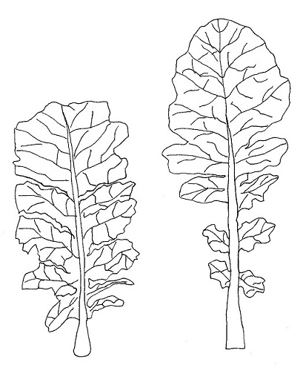 | 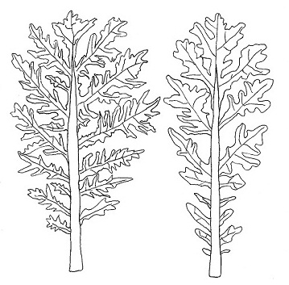
1 | 2
type 1 | type 2
(lyrate) | division
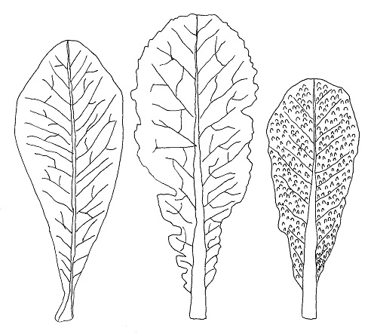 | 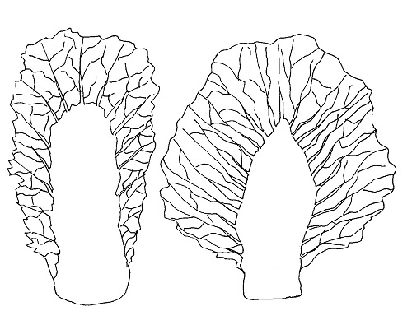
3 | 4
type 3 | type 4
(entire and narrow midrib) | (entire and broad midrib)

Ad. 5: Leaf: shape

 |  | ← broadest part→
 |  | (below middle) | at middle | (above middle)
broad (low) ← width (ratio length/width) → narrow (high) |  |  | 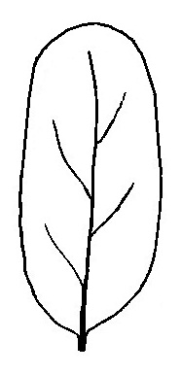  4  oblong | 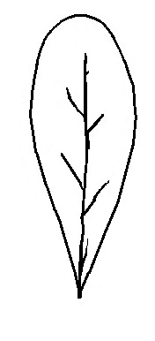  6  spatulate
broad (low) ← width (ratio length/width) → narrow (high) |  | 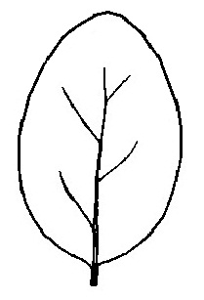  1  ovate | 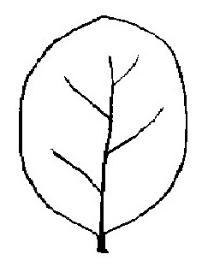  3  elliptic | 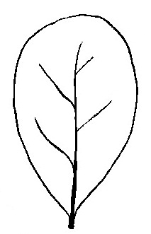  5  obovate
broad (low) ← width (ratio length/width) → narrow (high) |  |  | 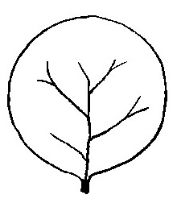  2  circular

Ad. 6: Leaf: attitude

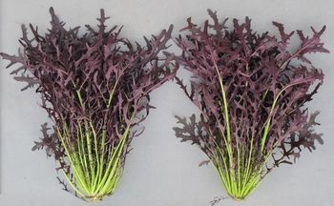 | 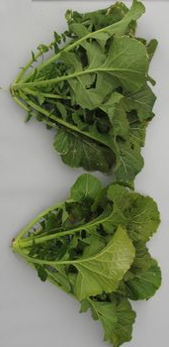 | 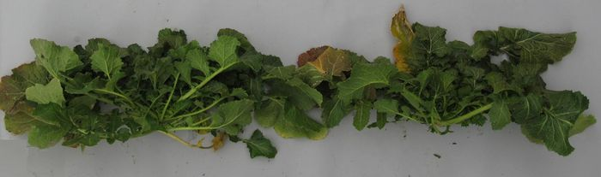
1 | 3 | 5
erect | semi-erect | horizontal

Ad. 7: Leaf: length
Ad. 8: Leaf: width
Ad. 9: Leaf: length of petiole
Ad. 10: Leaf: width of petiole
Ad. 20: Leaf: Only varieties with leaf: type: type 4: Leaf blade: width of midrib at widest point

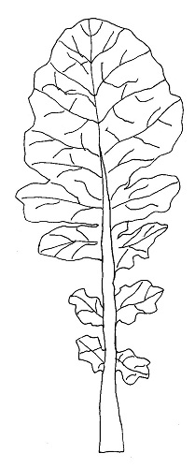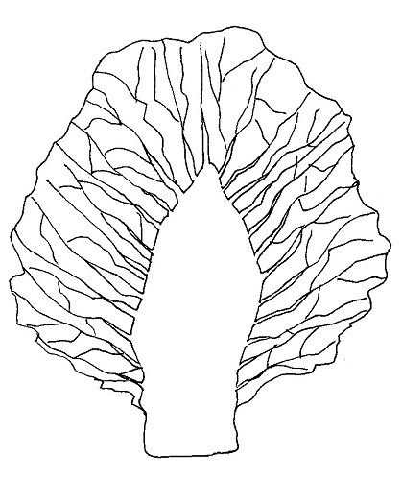
Petiole: length
Leaf: length
Leaf: width
Leaf: length
Leaf: width
Petiole: length
Petiole: width
Petiole:
width
midrib:
width

Ad. 11: Only varieties with leaf: type: type 1 or 2: Leaf blade: size of terminal lobe

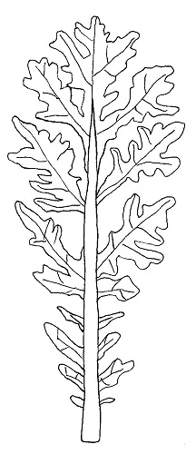
terminal
lobe
lateral
lobe

Parts of the leaf blade are considered as lobes if their length is at least equivalent to the width of the leaf petiole at their point of attachment and if both notches of the blade have at least half the length of the lobe itself. Terminal lobe is top of the lobe of leaf blade.
Ad. 12: Only varieties with leaf: type: type 1 or 2: Leaf blade: density of lateral lobe

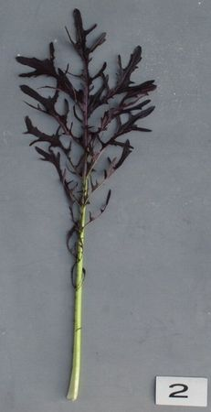 | 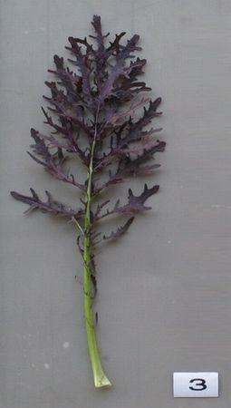 | 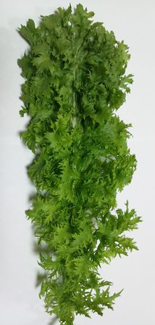
3 | 5 | 7
sparse | medium | dense

Ad. 18: Leaf blade: density of incision of margin

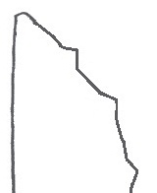 | 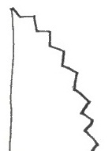 | 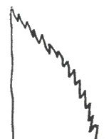
3 | 5 | 7
sparse | medium | dense

Ad. 19: Leaf blade: blistering

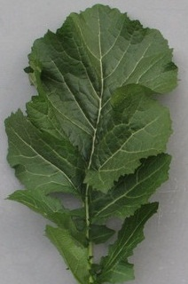 | 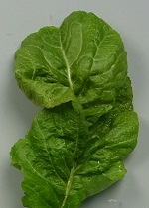 | 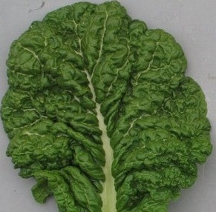
1 | 2 | 3
absent or weak | medium | strong

Ad. 21: Stem: type of main stem (excluding heading type)

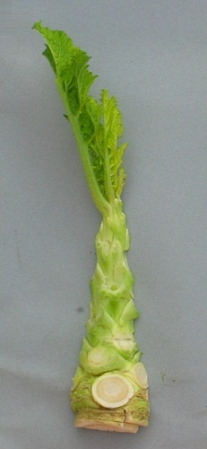 | 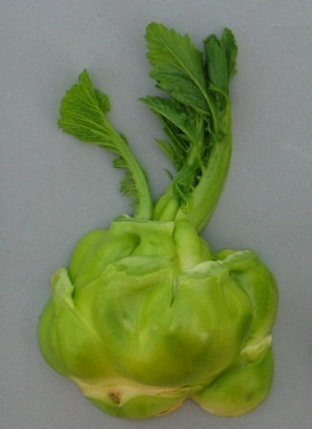 | 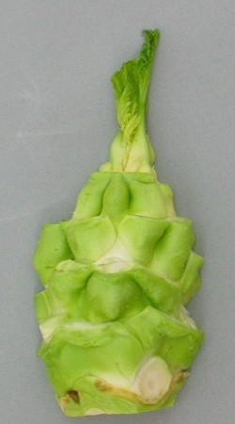 | 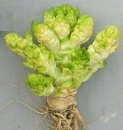
1 | 2 | 3 | 4
not enlarged | laterally enlarged | longitudinally enlarged | budding enlarged

Ad. 22: Plant: head formation

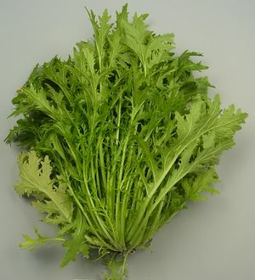 | 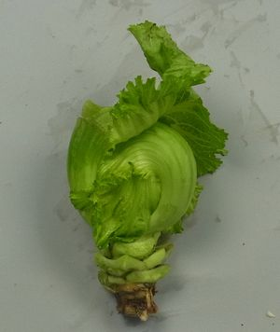
1 | 9
absent | present

Ad. 27: Head type only: Plant: length of core of head

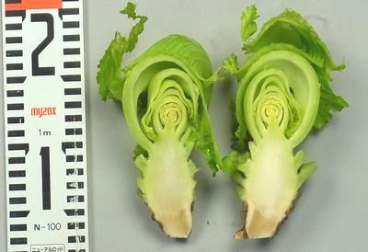
Core: length

Ad. 28: Plant: branching

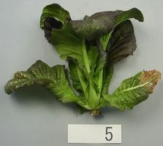 | 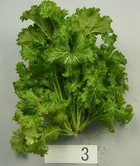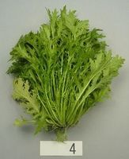
1 | 9
absent | present

Ad. 29: Time of beginning of bolting

Time of beginning of bolting should be observed after low temperature season. Beginning of bolting time is considered as visible main stem in rosette leaf.

Ad. 30: Seed: color

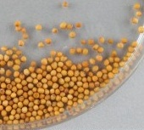 | 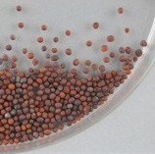 | 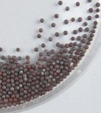
1 | 2 | 3
yellow | brown | black

8.2 Key for the Stage of Development

KEY | GENERAL DESCRIPTION
0  01  03  05  07  08  09 | Principal growth stage 0: Germination  Beginning of seed imbibition  Seed imbibition complete  Radicle emerged from seed  Hypocotyl with cotyledons emerged from seed  Hypocotyl with cotyledons growing towards soil surface  Emergence: cotyledons emerge through soil surface
1  10  11  12  13  14  15  16  17  18  19 | Principal growth stage 1: Leaf development  Cotyledons completely unfolded  First leaf unfolded  2 leaves unfolded  3 leaves unfolded  4 leaves unfolded  5 leaves unfolded  6 leaves unfolded  7 leaves unfolded  8 leaves unfolded  9 or more leaves unfolded
2  20  21  22  23  24  25  26  27  28  29 | Principal growth stage 2: Formation of side shoots  No side shoots  first side shoot detectable  2 side shoots detectable  3 side shoots detectable  4 side shoots detectable  5 side shoots detectable  6 side shoots detectable  7 side shoots detectable  8 side shoots detectable  9 or more side shoots detectable
3  30  31  32  33  34  35  36  37  38  39 | Principal growth stage 3: Stem elongation  no internodes (“rosette”)  1 visibly extended internode  2 visibly extended internode  3 visibly extended internode  4 visibly extended internode  5 visibly extended internode  6 visibly extended internode  7 visibly extended internode  8 visibly extended internode  9 or more visibly extended internodes
4  40  41  42  43  45  47  49 | Principal growth stage 5: Inflorescence emergence  Flower buds present, still enclosed by leaves  Flower buds visible from above (“green bud”)  Flower buds free, level with the youngest leaves  Flower buds raised above the youngest leaves  Individual flower buds (main inflorescence) visible but still closed  Individual flower buds (secondary inflorescences) visible but still closed  First petals visible, flower buds still closed (“yellow bud”)
5  50  51  52  53  54  55  57  59 | Principal growth stage 6: Flowering  First flowers open  10% of flowers on main raceme open, main raceme elongating  20% of flowers on main raceme open  30% of flowers on main raceme open  40% of flowers on main raceme open  Full flowering: 50% flowers on main raceme open, older petals falling  Flowering declining: majority of petals fallen  End of flowering
6  61  62  63  64  65  66  67  68  69 | Principal growth stage 7: Development of fruit  10% of pods have reached final size  20% of pods have reached final size  30% of pods have reached final size  40% of pods have reached final size  50% of pods have reached final size  60% of pods have reached final size  70% of pods have reached final size  80% of pods have reached final size  Nearly all pods have reached final size
7  70  71  72  73  74  75  76  77  78  79 | Principal growth stage 8: Ripening  seed green, filling pod cavity  10% of pods ripe, seeds dark and hard  20% of pods ripe, seeds dark and hard  30% of pods ripe, seeds dark and hard  40% of pods ripe, seeds dark and hard  50% of pods ripe, seeds dark and hard  60% of pods ripe, seeds dark and hard  70% of pods ripe, seeds dark and hard  80% of pods ripe, seeds dark and hard  Fully ripe: nearly all pods ripe, seeds dark and hard
8  87  89 | Principal growth stage 9: Senescence  Plant dead and dry  Harvested product

Literature

Ministry of Agriculture, Forestry & Fisheries of Japan., 1994: National Test Guideline for Karashina.

Tsukamoto, Y., 1994: The Grand Dictionary of Horticulture Volume 1. The Shogakukan Ltd., Tokyo, Japan, pp. 520 to 522.

Takasi A., 2004: Yasai-engei-daihyakka 17. Shadanhojin Nousan-gyoson-bunkakyokai. Tokyo, Japan. 169-233

Fujishiro, T., 1996: Breeding processes and characteristics of a newly bred leaf mustard (Brassica Juncea Coss.)., Kanagawa, Japan.

Uwe Meier. Federal Biological Research Centre for Agriculture and Forestry, 2001: Growth stages of mono-and dicotyledonous plants, BBCH Monograph,

Roger Phillips, Martyn Rix., 1993: VEGETABLES (The Pan Garden Plants Series) p.44

Joy Larkcom., 1991: Oriental Vegetables (The Complete guide for Garden and Kitchen) London, United Kingdom. pp. 39 to 45

Technical Questionnaire

TECHNICAL QUESTIONNAIRE |  |  |  | Page {x} of {y} |  | Reference Number:
 |  |  |  |  |  | Application date:
 |  |  |  |  |  | (not to be filled in by the applicant)
TECHNICAL QUESTIONNAIRE
to be completed in connection with an application for plant breeders’ rights

1. Subject of the Technical Questionnaire
1.1 Botanical name |  |  | Brassica juncea (L.) Czern
1.2 Common name |  |  | Brown Mustard
2. Applicant
Name
Address
Telephone No.
Fax No.
E-mail address
Breeder (if different from applicant)
3. Proposed denomination and breeder’s reference
Proposed denomination
(if available)

Breeder’s reference
#4. Information on the breeding scheme and propagation of the variety

4.1 Breeding scheme

Variety resulting from:

4.1.1 Crossing

(a) controlled cross [ ]
(please state parent varieties)

(…………………..……………..…) x (……………..…………………..…)
female parent male parent

(b) partially known cross [ ]
(please state known parent variety(ies))

(…………………..……………..…) x (……………..…………………..…)
female parent male parent

(c) unknown cross [ ]

4.1.2 Mutation [ ]
(please state parent variety)

4.1.3 Discovery and development [ ]
(please state where and when discovered and how developed)

4.1.4 Other [ ]
(please provide details)

4.2 Method of propagating the variety

4.2.1 Seed-propagated varieties

(a) Self-pollination [ ]
(b) Cross-pollination
(i) population [ ]
(ii) synthetic variety [ ]
(c) Hybrid [ ]
(d) Other [ ]
(please provide details)”

4.2.2 Other [ ]
(please provide details)

In the case of hybrid varieties the production scheme for the hybrid should be provided on a separate sheet. This should provide details of all the parent lines required for propagating the hybrid e.g.

Single Hybrid

(…………………..……………..) x (……………..…………………..)
female parent male parent

Three-Way Hybrid

(…………………..……………..) x (……………..…………………..)
female line male line

(……………..…………………..) x (……………..…………………..)
single hybrid used as female parent male parent

and should identify in particular:

(a) any male sterile lines
(b) maintenance system of male sterile lines.
5. Characteristics of the variety to be indicated (the number in brackets refers to the corresponding characteristic in Test Guidelines; please mark the note which best corresponds).

 | Characteristics |  |  |  |  |  | Example Varieties |  |  | Note
5.1  (4) | Only for vegetable varieties: Leaf: type
 | type1 |  |  |  |  |  | Kigarashina |  |  | 1 [ ]
 | type2 |  |  |  |  |  | Riasu karashina |  |  | 2 [ ]
 | type3 |  |  |  |  |  | Katsuona, Red Giant |  |  | 3 [ ]
 | type4 |  |  |  |  |  | Miike takana |  |  | 4 [ ]
5.2  (5) | Leaf: type
 | ovate |  |  |  |  |  | Serihon |  |  | 1 [ ]
 | circular |  |  |  |  |  | Shinkoku seisai |  |  | 2 [ ]
 | elliptic |  |  |  |  |  | Akariasu |  |  | 3 [ ]
 | oblong |  |  |  |  |  | Zasai FM-58 |  |  | 4 [ ]
 | obovate |  |  |  |  |  | Katsuona |  |  | 5 [ ]
 | spatulate |  |  |  |  |  | Kikarashina |  |  | 6 [ ]
5.3  (6) | Leaf: attitude
 | erect |  |  |  |  |  | Junkei yamashiona |  |  | 1 [ ]
 | erect to semi-erect |  |  |  |  |  |  |  |  | 2 [ ]
 | semi-erect |  |  |  |  |  | Akaoba takana |  |  | 3 [ ]
 | semi-erect to horizontal |  |  |  |  |  |  |  |  | 4 [ ]
 | horizontal |  |  |  |  |  | Miike takana |  |  | 5 [ ]
5.4  (14) | Leaf blade: anthocyanin coloration
 | absent |  |  |  |  |  | Kekkyu takana |  |  | 1 [ ]
 | present |  |  |  |  |  | Akaoba takana |  |  | 9 [ ]
 | Characteristics |  |  |  |  |  | Example Varieties |  |  | Note
5.5  (15) | Only varieties with anthocyanin coloration: present: Leaf blade: intensity of anthocyanin coloration
 | very weak |  |  |  |  |  |  |  |  | 1 [ ]
 | very weak to weak |  |  |  |  |  |  |  |  | 2 [ ]
 | weak |  |  |  |  |  | Kigarashina |  |  | 3 [ ]
 | weak to medium |  |  |  |  |  |  |  |  | 4 [ ]
 | medium |  |  |  |  |  | Miike takana |  |  | 5 [ ]
 | medium to strong |  |  |  |  |  |  |  |  | 6 [ ]
 | strong |  |  |  |  |  | Akaoba takana |  |  | 7 [ ]
 | strong to very strong |  |  |  |  |  |  |  |  | 8 [ ]
 | very strong |  |  |  |  |  |  |  |  | 9 [ ]
5.6  (17) | Leaf blade: undulation of margin
 | absent or very weak |  |  |  |  |  |  |  |  | 1 [ ]
 | very weak to weak |  |  |  |  |  |  |  |  | 2 [ ]
 | weak |  |  |  |  |  | Akaoba takana |  |  | 3 [ ]
 | weak to medium |  |  |  |  |  |  |  |  | 4 [ ]
 | medium |  |  |  |  |  | Katsuona |  |  | 5 [ ]
 | medium to strong |  |  |  |  |  |  |  |  | 6 [ ]
 | strong |  |  |  |  |  | Chirimen hakarashina |  |  | 7 [ ]
 | strong to very strong |  |  |  |  |  |  |  |  | 8 [ ]
 | very strong |  |  |  |  |  |  |  |  | 9 [ ]
5.7  (18) | Leaf blade: density of incision of margin
 | absent or very sparse |  |  |  |  |  | Katsuona |  |  | 1 [ ]
 | very sparse to sparse |  |  |  |  |  |  |  |  | 2 [ ]
 | sparse |  |  |  |  |  |  |  |  | 3 [ ]
 | sparse to medium |  |  |  |  |  |  |  |  | 4 [ ]
 | medium |  |  |  |  |  | Junkei yamashiona |  |  | 5 [ ]
 | medium to dense |  |  |  |  |  |  |  |  | 6 [ ]
 | dense |  |  |  |  |  | Chirimen hakarashina |  |  | 7 [ ]
 | dense to very dense |  |  |  |  |  |  |  |  | 8 [ ]
 | very dense |  |  |  |  |  |  |  |  | 9 [ ]
 | Characteristics |  |  |  |  |  | Example Varieties |  |  | Note
5.8  (19) | Leaf blade: blistering
 | absent or weak |  |  |  |  |  | Kigarashina |  |  | 1 [ ]
 | medium |  |  |  |  |  |  |  |  | 2 [ ]
 | strong |  |  |  |  |  | Katsuona |  |  | 3 [ ]
5.9  (22) | Plant: head formation
 | absent |  |  |  |  |  | Kigarashina |  |  | 1 [ ]
 | present |  |  |  |  |  | Kekkyu takana |  |  | 9 [ ]
5.10  (28) | Plant: branching
 | absent |  |  |  |  |  | Akaoba takana |  |  | 1 [ ]
 | present |  |  |  |  |  | Riasu karashina |  |  | 9 [ ]
5.11  (30) | Seed: color
 | yellow |  |  |  |  |  | Kikarashina |  |  | 1 [ ]
 | brown |  |  |  |  |  | Miike takana |  |  | 2 [ ]
 | black |  |  |  |  |  | Akaoba takana |  |  | 3 [ ]
6. Similar varieties and differences from these varieties

Please use the following table and box for comments to provide information on how your candidate variety differs from the variety (or varieties) which, to the best of your knowledge, is (or are) most similar. This information may help the examination authority to conduct its examination of distinctness in a more efficient way.

Denomination(s) of variety(ies) similar to your candidate variety |  | Characteristic(s) in which your candidate variety differs from the similar variety(ies) |  |  | Describe the expression of the characteristic(s) for the similar variety(ies) |  |  | Describe the expression of the characteristic(s) for your candidate variety
Example |  | Leaf blade: shape of apex |  |  | acute |  |  | obtuse
Comments:

#7. Additional information which may help in the examination of the variety

7.1 In addition to the information provided in sections 5 and 6, are there any additional characteristics which may help to distinguish the variety?

Yes [ ] No [ ]

(If yes, please provide details)

7.2 Are there any special conditions for growing the variety or conducting the examination?

Yes [ ] No [ ]

(If yes, please provide details)

7.3 Other information

7.3.1 Main use

(a) | vegetable | [ ]
(b) | seed | [ ]
(c) | other  (please provide details) | [ ]

A representative color image of the variety should accompany the Technical Questionnaire.

8. Authorization for release

(a) Does the variety require prior authorization for release under legislation concerning the protection of the environment, human and animal health?

Yes [ ] No [ ]

(b) Has such authorization been obtained?

Yes [ ] No [ ]

If the answer to (b) is yes, please attach a copy of the authorization.

9. Information on plant material to be examined or submitted for examination.

9.1 The expression of a characteristic or several characteristics of a variety may be affected by factors, such as pests and disease, chemical treatment (e.g. growth retardants or pesticides), effects of tissue culture, different rootstocks, scions taken from different growth phases of a tree, etc.

9.2 The plant material should not have undergone any treatment which would affect the expression of the characteristics of the variety, unless the competent authorities allow or request such treatment. If the plant material has undergone such treatment, full details of the treatment must be given. In this respect, please indicate below, to the best of your knowledge, if the plant material to be examined has been subjected to:

(a) Microorganisms (e.g. virus, bacteria, phytoplasma) Yes [ ] No [ ]

(b) Chemical treatment (e.g. growth retardant, pesticide) Yes [ ] No [ ]

(c) Tissue culture Yes [ ] No [ ]

(d) Other factors Yes [ ] No [ ]

Please provide details for where you have indicated “yes”.

……………………………………………………………

10. I hereby declare that, to the best of my knowledge, the information provided in this form is correct:

Applicant’s name

Signature Date

[Annex follows]
Comments by the Subgroup

ZA Comments on Brown Mustard 2014

2.3 | To read: “sufficient seeds to produce 40 plants for vegetable varieties, and 300 plants for agricultural varieties”
3.4 | To read: “… at least 40 plants for vegetable varieties, and 300 plants for agricultural varieties, which ….”
Char. 11 | State 7 to read “broad”
Char. 37 | “peduncle” to be replaced with “pedicel”
Char. 40 | “peduncle” to be replaced with “pedicel”

NL Comments on Brown Mustard 2014

2.3 | NL: 20,000? seeds for agricultural varieties  3.000 seeds for vegetable varieties
4.2.3 | 4.2.3 For the assessment of uniformity of single cross hybrids, a population standard of 3% and an acceptance probability of at least 95% should be applied for inbred plants obviously resulting from the selfing of a parent line. In the case of a sample size of 40 plants, 3 inbred plants are allowed. In the case of a sample size of 300 plants, 14 off-types are allowed.
4.2.4 | 4.2.4 For the assessment of uniformity of hybrid varieties resulting from at least one cross-pollinated parent, the recommendations in the General Introduction for cross-pollinated varieties should be followed, as appropriate NL: This is not according to the draft TG 05 April 2013 nor to the abstract report mustard TWV_47_34.
5.3 | NL: (g) Seed: color (characteristic 41)
Char. 4 | . NL agrees
Char. 5 | type3 Katsuona NL: Red Giant
Char. 6 | to delete NL agrees
Char. 20 | to delete NL agrees
Char. 23 | to delete. There are correlations leaf and midrib anthocyanin. NL agrees
Char. 24 | NL: We do not know varieties with state 2,3,4 so we can not decide
Char. 26 | Head type only: Plant: head height
Char. 27 | Head type only: Plant: head diameter
Char. 28 | Head type only: Plant: number of leaves on head
Char. 29 | Head type only: Plant: internal color of head
Char. 30 | Head type only: Plant: length of core of head
Char. 33 | to delete NL agrees
Char. 34 | to delete NL agrees
Char. 35 | to delete NL agrees
Char. 36 | If there is no appropriate example variety, to be deleted NL agrees
Char. 37 | If there is no appropriate example variety, to be deleted NL agrees
Char. 38 | If there is no appropriate example variety, to be deleted NL agrees
Char. 39 | If there is no appropriate example variety, to be deleted NL agrees
Char. 40 | If there is no appropriate example variety, to be deleted NL agrees
Ad. 25 | NL: To add example for Note 1 absent
Ad. 32 | Time of beginning of bolting should be observed at after low temperature season. Beginning of bolting time is considered as visible main stem in rosette leaf.
 | Some of the text boxes at 8.1 EXPLANATIONS FOR INDIVIDUAL CHARACTERISTICS are too small and do not show the full text.

DE Comments on Brown Mustard 2014

ISF Comments on Brown Mustard 2014

Char. 24 | As we read it, Japan does not wish to distinguish between vegetable and agricultural species, however char. 5 and 6 are "only for vegetable varieties". If there is no explanation added on how to distinguish the two types, it does not look logical to us. Option could be to leave this distinction out of char. 5 and 6.

KR Comments on Brown Mustard 2014

Char. 5 | Can we change the order of state of expressions and wording of Characteristics No 5. Only for vegetable varieties: Leaf: type like that  (4) type 4 (entire and broad midrib) => (1) broad midrib with entire leaf  (3) type 3 (entire and narrow midrib) => (2) Narrow midrib with entire or lobed incision  (1) type 1 (lyrate) => (3) Narrow midrib with cleft or parted incision  (2) type 2 (division) => (4) Narrow midrib with bipinnate incision

[End of Annex and of document]

* These names were correct at the time of the introduction of these Test Guidelines but may be revised or updated. [Readers are advised to consult the UPOV Code, which can be found on the UPOV Website (www.upov.int), for the latest information.]
# Authorities may allow certain of this information to be provided in a confidential section of the Technical Questionnaire.
# Authorities may allow certain of this information to be provided in a confidential section of the Technical Questionnaire.

