Table of Characteristics/Tableau des caractères/Merkmalstabelle/Tabla de caracteres
 |  | English | français | Deutsch | español | Example Varieties/ Exemples/  Beispielssorten/  Variedades ejemplo | Note/ Nota
1.  (*) |  | Plant: height | Plante: hauteur | Pflanze: Höhe | Planta: altura
QN |  | very short | très basse | sehr niedrig | muy baja | Giwhisto 12 | 1
 |  | short | basse | niedrig | baja |  | 3
 |  | medium | moyenne | mittel | media | Yasflos | 5
 |  | tall | haute | hoch | alta | Sumsut 02 | 7
2.  (*) |  | Shoot: length | Pousse: longueur | Trieb: Länge | Rama: longitud
QN |  | short | courte | kurz | corta | Wesbadream | 3
 |  | medium | moyenne | mittel | media | Giwhisto 12 | 5
 |  | long | longue | lang | larga | Dancoplace | 7
3.  (+) |  | Shoot: length of internodes | Pousse: longueur des entre-noeuds | Trieb: Internodienlänge | Rama: longitud de los entrenudos
QN |  | short | courts | kurz | corta | Gicomwhi 14 | 3
 |  | medium | moyens | mittel | media | Giwhisto 12 | 5
 |  | long | longs | lang | larga | Yaspea | 7
4.  (+) |  | Shoot: anthocyanin coloration | Pousse: pigmentation anthocyanique | Trieb: Anthocyanfärbung | Rama: pigmentación antociánica
QN |  | absent or very weak | nulle ou très faible | fehlend oder sehr gering | ausente o muy débil |  | 1
 |  | weak | faible | gering | débil | Sumsut 03 | 3
 |  | medium | moyenne | mittel | media |  | 5
 |  | strong | forte | stark | fuerte | Novasnow | 7
 |  | very strong | très forte | sehr stark | muy fuerte |  | 9
5. |  | Petiole: length | Pétiole: longueur | Blattstiel: Länge | Pecíolo: longitud
QN | (a) | absent or very short | absent ou très court | fehlend oder sehr kurz | ausente o muy corta |  | 1
 |  | short | court | kurz | corta | Sumsut 03 | 3
 |  | medium | moyen | mittel | media |  | 5
 |  | long | long | lang | larga | Dancop 18 | 7
6.  (*)  (+) |  | Leaf: type | Feuille: type | Blatt: Typ | Hoja: tipo
QL | (a) | simple | simple | einfach | simple |  | 1
 |  | pinnate | pennée | gefiedert | pinnada |  | 2
7.  (*)  (+) |  | Leaf blade: length | Limbe: longueur | Blattspreite: Länge | Limbo: longitud
QN | (a) | short | court | kurz | corta | Wesbadream | 3
 |  | medium | moyen | mittel | media | Eskimo | 5
 |  | long | long | lang | larga | Giwhisto 12 | 7
8.  (*)  (+) |  | Leaf blade: width | Limbe: largeur | Blattspreite: Breite | Limbo: anchura
QN | (a) | narrow | étroit | schmal | estrecha | Wesbadream | 3
 |  | medium | moyen | mittel | media | Eskimo | 5
 |  | broad | large | breit | ancha | Giwhisto 12 | 7
9. |  | Leaf blade: ratio length/width | Limbe: rapport longueur/largeur | Blattspreite: Verhältnis Länge/Breite | Limbo: relación longitud/anchura
QN | (a) | small | petit | klein | pequeña |  | 3
 |  | medium | moyen | mittel | media |  | 5
 |  | large | grand | groß | grande |  | 7
10.  (+) |  | Leaf blade: position of broadest part | Limbe: position de la partie la plus large | Blattspreite: Position der breitesten Stelle | Limbo: posición de la parte más ancha
QN | (a) | in middle | au milieu | in der Mitte | en la mitad |  | 1
 |  | between middle and base | entre le milieu et la base | zwischen Mitte und Basis | entre la mitad y la base |  | 2
 |  | at base | à la base | an der Basis | en la base |  | 3
11.  (+) |  | Only varieties with simple leaves: Leaf blade: depth of incisions of margin | Seulement variétés à feuilles simples: Limbe: profondeur des incisions du bord | Nur Sorten mit einfachen Blättern: Blattspreite: Tiefe der Randeinschnitte | Sólo variedades con hojas simples: Limbo: profundidad de las incisiones del borde
QN | (a) | absent or very shallow | nulles ou très peu profondes | fehlend oder sehr flach | ausente o muy poco profunda |  | 1
 |  | shallow | peu profondes | flach | poco profunda |  | 3
 |  | medium | moyennes | mittel | media |  | 5
 |  | deep | profondes | tief | profunda |  | 7
12. |  | Young leaf blade: main color (if clearly different from color of fully developed leaf blade) | Jeune limbe: couleur principale (si elle est clairement différente de la couleur du limbe complètement développé) | Junge Blattspreite: Hauptfarbe (falls deutlich verschieden von der Farbe der ausgewachsenen Blattspreite) | Limbo joven: color principal (si se diferencia claramente del color del limbo completamente desarrollado)
QL | (b) | white | blanche | weiß | blanco |  | 1
 |  | yellow | jaune | gelb | amarillo | Dancop 15 | 2
13.  (*) |  | Leaf blade: variegation | Limbe: panachure | Blattspreite: Panaschierung | Limbo: variegación
QL | (a) | absent | absente | fehlend | ausente | Wesbadream | 1
 |  | present | présente | vorhanden | presente | Olympic Gold | 9
14. |  | Leaf blade: main color | Limbe: couleur principale | Blattspreite: Hauptfarbe | Limbo: color principal
PQ | (a) | yellow | jaune | gelb | amarillo |  | 1
 | (b) | light green | vert clair | hellgrün | verde claro | Dancop 15 | 2
 |  | medium green | vert moyen | mittelgrün | verde medio | Eskimo | 3
 |  | dark green | vert foncé | dunkelgrün | verde oscuro |  | 4
15.  (*)  (+) |  | Flower: type | Fleur: type | Blüte: Typ | Flor: tipo
QL |  | single | simple | einfach | simple | Wesbadream | 1
 |  | double | double | gefüllt | doble | Sumsut 03 | 2
16.  (*)  (+) |  | Flower: length | Fleur: longueur | Blüte: Länge | Flor: longitud
QN |  | short | courte | kurz | corta |  | 3
 |  | medium | moyenne | mittel | media |  | 5
 |  | long | longue | lang | larga |  | 7
17.  (*)  (+) |  | Flower: width | Fleur: largeur | Blüte: Breite | Flor: anchura
QN |  | very narrow | très étoite | sehr schmal | muy estrecha |  | 1
 |  | narrow | étroite | schmal | estrecha | Wesbadream | 3
 |  | medium | moyenne | mittel | media | Wesbavio | 5
 |  | broad | large | breit | ancha | Giwhisto 12 | 7
 |  | very broad | très large | sehr breit | muy ancha |  | 9
18.  (*)  (+) |  | Corolla: number of colors (excluding mouth of corolla tube) | Corolle: nombre de couleurs (à l’exclusion de l’orifice du tube de la corolle) | Krone: Anzahl Farben (ohne Schlund) | Corola: número de colores (excluida la boca del tubo de la corola)
QL |  | one | une | eine | uno | Wesbadream | 1
 |  | two | deux | zwei | dos | Dancop 18 | 2
 |  | more than two | plus de deux | mehr als zwei | más de dos |  | 3
19.  (*)  (+) |  | Corolla: main color | Corolle: couleur principale | Krone: Hauptfarbe | Corola: color principal
PQ |  | RHS Colour Chart (indicate reference number) | Code RHS des couleurs (indiquer le numéro de référence) | RHS-Farbkarte (Nummer angeben) | Carta de colores RHS (indicar número de referencia)
20.  (*)  (+) |  | Corolla: secondary color | Corolle: couleur secondaire | Krone: Sekundärfarbe | Corola: color secundario
PQ |  | white | blanche | weiß | blanco | Dancop 18 | 1
 |  | yellow | jaune | gelb | amarillo |  | 2
 |  | dark pink | rose foncé | dunkelrosa | rosa oscuro |  | 3
 |  | dark purple | pourpre foncé | dunkelpurpurn | púrpura oscuro | Yagemag | 4
 |  | dark violet | violet foncé | dunkelviolett | violeta oscuro | Dancop 17 | 5
21.  (+) |  | Corolla lobe: width | Lobe de la corolle: largeur | Kronlappen: Breite | Lóbulo de la corola: anchura
QN | (c) | narrow | étroit | schmal | estrecha | Wesbadream | 3
 |  | medium | moyen | mittel | media | Wesbavio | 5
 |  | broad | large | breit | ancha | Gicomwhi 14 | 7
22.  (+) |  | Corolla lobe: shape of apex | Lobe de la corolle: forme du sommet | Kronlappen: Form der Spitze | Lóbulo de la corola: forma del ápice
PQ | (c) | pointed | pointu | spitz | puntiaguda |  | 1
 |  | rounded | arrondi | rundlich | redondeada |  | 2
 |  | truncate | tronqué | flach | truncada |  | 3
 |  | retuse | échancré | eingedrückt | retusa |  | 4
23.  (+) |  | Corolla tube: length | Tube de la corolle: longueur | Kronröhre: Länge | Tubo de la corola: longitud
QN |  | short | court | kurz | corta |  | 3
 |  | medium | moyen | mittel | media |  | 5
 |  | long | long | lang | larga |  | 7
24.  (+) |  | Only varieties with single flowers: Corolla tube: main color at mouth | Seulement variétés à fleurs simples: Tube de la corolle: couleur principale à l’orifice | Nur Sorten mit einfachen Blüten: Kronröhre: Hauptfarbe des Schlundes | Sólo variedades con flores simples: tubo de la corola: color principal de la boca
PQ |  | yellow | jaune | gelb | amarillo |  | 1
 |  | yellow orange | jaune orange | gelborange | naranja amarillo |  | 2
 |  | orange | orange | orange | naranja |  | 3

Explanations on the Table of Characteristics

8.1 Explanations covering several characteristics
Characteristics containing the following key in the second column of the Table of Characteristics should be examined as indicated below:

- Observations on the leaf should be made on the fully developed basal leaf (leaf located at the base of the shoot).

- The main color is the color with the largest area. In cases where the relative areas are equal, the darker color is the main color.

- Observations on the corolla lobe of double flowers should be made on the largest lobe.

8.2 Explanations for individual characteristics
Ad. 3: Shoot: length of internodes

Observations on the internode length should be made in the middle third of the shoot.

Ad. 4: Shoot: anthocyanin coloration

Observations on anthocyanin coloration should be made on the upper third of the shoot.

Ad. 6: Leaf: type
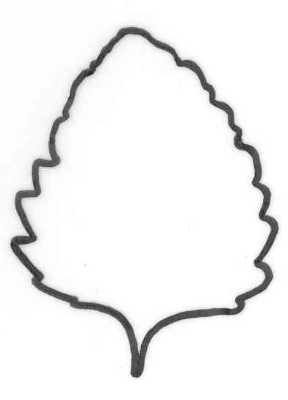
1 | 2
simple | pinnate

Ad. 7: Leaf blade: length
Ad. 8: Leaf blade: width

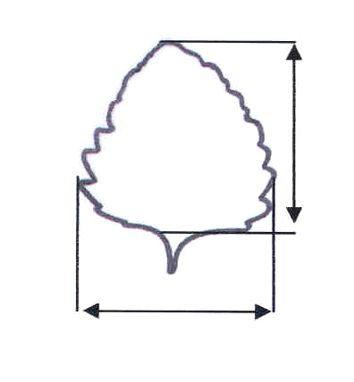 |  | Leaf blade: length | 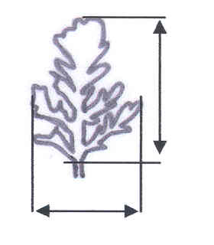 | Leaf blade: length
Leaf blade: width |  |  | Leaf blade: width

Ad. 10: Leaf blade: position of broadest part

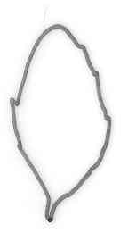 |  | 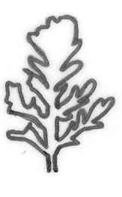 | 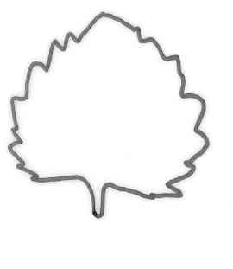 | 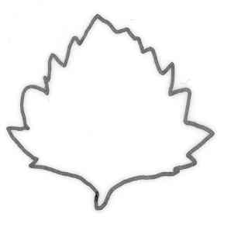
1 | 2 |  |  |  | 3
in middle | between middle and base |  |  |  | at base

Ad. 11: Only varieties with simple leaves: Leaf blade: depth of incisions of margin

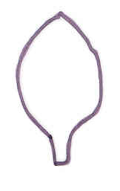 | 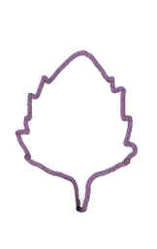 | 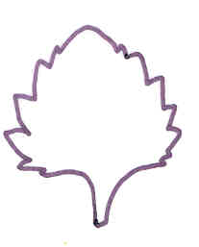 | 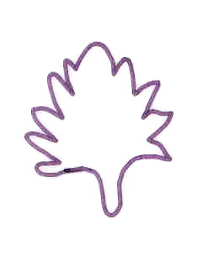
1 | 3 | 5 | 7
absent or very shallow | shallow | medium | deep

Ad. 15: Flower: type

A single flower has only 5 corolla lobes. A double flower has more than 5 corolla lobes.

Ad. 16: Flower: length
Ad. 17: Flower: width
Ad. 21: Corolla lobe: width

Flower: length | 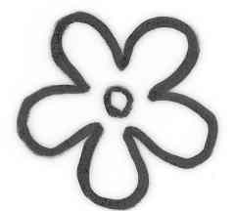 | Corolla lobe: width |  | Flower: length
 | Flower: width |  | Flower: width

Ad. 18: Corolla: number of colors (excluding mouth of corolla tube)
Ad. 19: Corolla: main color
Ad. 20: Corolla: secondary color
Ad. 24: Only varieties with single flowers: Corolla tube: main color at mouth

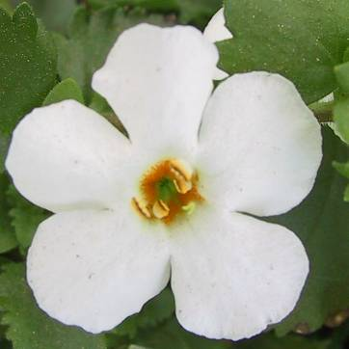 | Corolla tube: main color at mouth (on both pictures: orange)  Corolla: main color | 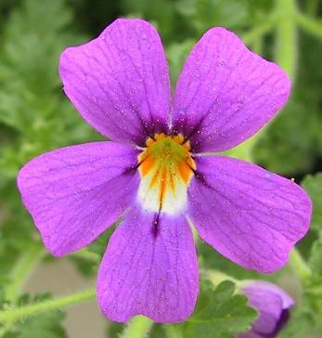 | Corolla: secondary color (here: dark purple)

Ad. 22: Corolla lobe: shape of apex

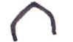 |  | 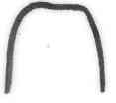 | 
1 | 2 | 3 | 4
pointed | rounded | truncate | retuse

Ad. 23: Corolla tube: length

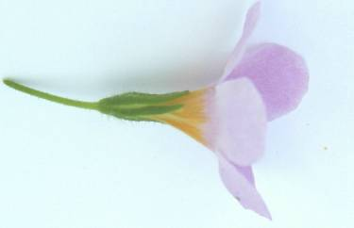
length

[End of document]

