E
TWO/49/15 Add.
ORIGINAL: English
DATE: May 31, 2016
INTERNATIONAL UNION FOR THE PROTECTION OF NEW VARIETIES OF PLANTS
Geneva
Technical working party for ORNAMENTAL PLANTS AND FOREST TREES
Forty-Ninth Session
Gimcheon City, Republic of Korea, June 13 to 17, 2016
addendum to
number of growing cycles in dus examination
Document prepared by the Office of the Union
Disclaimer: this document does not represent UPOV policies or guidance

The Annex to this document contains a copy of the presentation “The Impact of Using Different Numbers of Growing Cycles on DUS Decisions of Vegetatively Propagated Ornamental Varieties” to be made by an expert from Germany at the forty-ninth session of the Technical Working Party for Ornamental Plants and Forest Trees (TWO).

[Annex follows]

TWO/49/15 Add.

ANNEX

THE IMPACT OF USING DIFFERENT NUMBERS OF GROWING CYCLES ON DUS DECISIONS
OF VEGETATIVELY PROPAGATED ORNAMENTAL VARIETIES

Presentation by Ms. Andrea Menne, Germany.

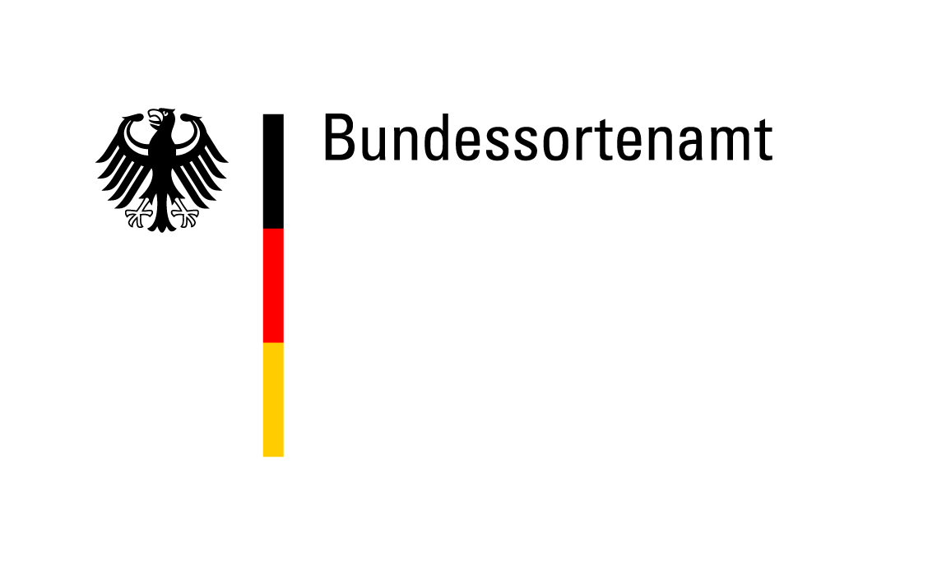
TWO/49/15

NUMBER OF GROWING CYCLES IN DUS EXAMINATION

The Impact Of Using Different Numbers Of Growing Cycles On DUS Decisions

Of Vegetatively Propagated Ornamental Varieties

Presentation by Andrea Menne, Germany

2

In most of the TGs for ornamental varieties one year of testing is recommended.

For the DUS test one year of testing is in most cases sufficient for vegetatively propagated ornamental varieties, because

- The differences between the varieties are big compared to environmental effects and the variation within varieties.

- The decision on distinctness is based on a side-by-side visual comparison in the growing trial.

- The detection of off-types is normally not influenced by the environment.

But: The growing cycle may have an impact on the variety description due to differences in the expression of characteristics between growing cycles.

3

Example: Pelargonium variety, description of 2013 and 2014

 | One note difference compared to 2013 |  | 2 notes difference compared to 2013

 | Characteristic | State of Expression | 2013 |  | 2014
1 | Plant: growth type | upright | 1 |  | 1
2 | Plant: height of foliage | medium to tall | 6 | tall to very tall | 8
4 | Plant: width | medium to broad | 6 |  | 6
5 | Stem: color | green | 2 |  | 2
6 | Stem: anthocyanin coloration | medium to strong | 4 | medium | 3
7 | Leaf blade: length | long | 7 | medium to long | 6
8 | Leaf blade: width | medium to broad | 6 |  | 6
9 | Leaf blade: depth of sinus | shallow to medium | 4 | medium | 5
10 | Leaf blade: undulation of margin | medium | 5 | weak to medium | 4
11 | Leaf blade: base | slightly open | 3 | slightly open to closed | 4
12 | Leaf blade: variegation | absent | 1 |  | 1
13 | Leaf blade: main color | dark green | 6 |  | 6
16 | Leaf blade: conspicuous. of zone | medium to strong | 6 |  | 6
17 | Leaf blade: position of zone | in middle | 2 |  | 2
18 | Leaf blade: relative size of zone | small | 1 |  | 1
19 | Peduncle: length | medium to long | 6 |  | 6

4

 | Characteristic | State of Expression | 2013 |  | 2014
20 | Peduncle: anthocyanin coloration | strong to very strong | 8 |  | 8
21 | Inflorescence: height | tall to very tall | 8 | medium to tall | 6
22 | Inflorescence: width | broad | 7 | medium | 5
23 | Inflorescence: no of open flowers | medium to many | 6 |  | 6
24 | Inflorescence: length of largest fl. | short to medium | 4 | medium | 5
25 | Inflorescence: width of largest flower | medium to broad | 6 |  | 6
26 | Inflorescence: length of pedicel | long | 7 | medium to long | 6
27 | Pedicel: anthocyanin coloration | strong | 7 | strong to very strong | 8
28 | Pedicel: swelling | absent | 1 |  | 1
29 | Flower: type | double | 2 |  | 2
31 | Flower: number of petals | medium | 5 |  | 5
32 | Flower: cross section in lateral view | flat | 2 |  | 2
33 | Flower: presence of stripes | absent | 1 |  | 1
36 | Sepal: reflexing | absent or weak | 1 |  | 1
37 | Sepal: anthocyanin coloration | medium | 5 | medium to strong | 6
38 | Upper petal: width | medium | 5 | medium to broad | 6
39 | Upper petal: shape | spatulate | 4 |  | 4
40 | Upper petal: margin at apex | entire | 1 |  | 1
41 | Upper petal: color of margin | red | 50A | red | 46C
42 | Upper petal: color of middle | red | 50A | red | 46C

5

 | Characteristic | State of Expression | 2013 |  | 2014
43 | Upper petal: color of lower side | red | 43B | red | 43A
44 | Upper petal: conspicuou. of marking | absent or very weak | 1 |  | 1
45 | Upper petal: type of marking | stripes only | 1 |  | 1
48 | Upper petal: zone at base | absent | 1 |  | 1
51 | Lower petal: color of margin | red | 46C | red | 50A
52 | Lower petal: color of middle | red | 50A | red | 50A
53 | Lower petal: color of lower side | red | 46C | red | 43B
54 | Lower petal: conspicuou. of marking | absent or very weak | 1 |  | 1
57 | Lower petal: zone at base | absent | 1 |  | 1
60 | Inner petal: colour of upper side | red | 46C | red | 46C

- Out of 46 characteristics only 3 deviate from one year to the next by two notes.

- 10 characteristics deviate by one note.

6

Consequences

- When taking a decision on distinctness the expert needs to be aware which characteristics are sensitive to the environment.

Environmental effects have to be considered for:

(a) The comparison of similar varieties in the same growing trial (side-by-side comparison).

(b) The exclusion of clearly distinct varieties from the growing trial (comparison with descriptions in the variety collection).

(c) The test for stability/identity (comparison side-by-side with previous sample or with description).

It is very important to emphasize that the variety description is linked to the year of testing.

Question: Are all varieties in the same trial reacting in the same way on the environmental conditions?

7

Example: Two varieties of Impatiens New Guinea Group

 | One note difference compared to 2010 |  | 2 notes difference compared to 2010

 |  |  | Variety | One |  |  | Variety | Two
 |  | Characteristic | 2010 | 2012 | 2013 |  | 2010 | 2012 | 2013
1 | QN | Plant: height of foliage | 5 | 5 | 5 |  | 6 | 7 | 5
2 | QN | Plant: width | 3 | 5 | 5 |  | 6 | 6 | 6
3 | QN | Shoot: anthocyanin coloration | 6 | 6 | 6 |  | 8 | 8 | 8
4 | QN | Petiole: length | 3 | 5 | 4 |  | 4 | 5 | 4
5 | QN | Petiole: anthocyanin coloration | 3 | 3 | 3 |  | 6 | 6 | 6
6 | QN | Leaf blade: length | 5 | 5 | 5 |  | 6 | 5 | 6
7 | QN | Leaf blade: width | 4 | 5 | 5 |  | 4 | 5 | 5
8 | QN | Leaf blade: length/width ratio | 6 | 5 | 6 |  | 6 | 6 | 7
11 | QN | Leaf blade: anthocyanin coloration | 3 | 2 | 2 |  | 2 | 2 | 2
15 | QN | Pedicel: length | 4 | 4 | 4 |  | 6 | 6 | 6
16 | QN | Pedicel: anthocyanin coloration | 5 | 5 | 5 |  | 8 | 8 | 8
18 | QN | Flower: width | 6 | 6 | 6 |  | 7 | 7 | 6
26 | QN | Upper petal: width | 6 | 7 | 7 |  | 7 | 7 | 7
27 | QN | Lateral petal: width | 5 | 5 | 5 |  | 5 | 4 | 4
28 | QN | Lower petal: length | 5 | 6 | 6 |  | 6 | 6 | 6
24 | QN | Flower: size of eye zone | 4 | 4 | 4 |  | 4 | 4 | 4

8

 |  |  | Variety | One |  |  | Variety | Two
 |  | Characteristic | 2010 | 2012 | 2013 |  | 2010 | 2012 | 2013
12 | QL | Leaf blade: color of lower side between veins | 1 | 1 | 1 |  | 1 | 1 | 1
14 | QL | Leaf blade: color of veins on lower side | 2 | 2 | 2 |  | 2 | 2 | 2
17 | QL | Flower: type | 1 | 1 | 1 |  | 1 | 1 | 1
19 | QL | Flower: number of colors | 1 | 1 | 1 |  | 1 | 1 | 1
23 | QL | Flower: eye zone | 9 | 9 | 9 |  | 9 | 9 | 9
20 | PQ | Flower: main color of upper side | N30A | N30A | N30A |  | N30A | N30A | N30A
25 | PQ | Flower: main color of eye zone | 46B | 46B | 45A |  | 46B | 46B | 45A

9

General Observations

- In particular, the state of expression of quantitative characteristics can be more variable over the years.

- Some quantitative characteristics react more sensitive to the environment than others.

- Not all varieties react in the same way to changes of the environment.

- If a variety is observed in one growing period only, the possible variation in the state of expression is unknown.

Besides the growing conditions during the testing period also other factors can influence the expression of the plant characteristics, e.g. the conditions under which the mother plants were kept, or the position on the mother plant where the cutting was taken.

[End of document]

[End of Annex and of document]

