E
TWO/49/14 Add.2
ORIGINAL: English
DATE: June 29, 2016
INTERNATIONAL UNION FOR THE PROTECTION OF NEW VARIETIES OF PLANTS
Geneva
Technical working party for ORNAMENTAL PLANTS AND FOREST TREES
Forty-Ninth Session
Gimcheon City, Republic of Korea, June 13 to 17, 2016
SECOND addendum to
MATTERS CONCERNING Variety Descriptions
Document prepared by an expert from Australia
Disclaimer: this document does not represent UPOV policies or guidance

The Annex to this document contains a presentation by an expert from Australia on the “Role and functions of variety descriptions in Australia” made at the forty-ninth session of the Technical Working Party for Ornamental Plants and Forest Trees (TWO).

[Annex follows]

TWO/49/14 Add.2

ANNEX

UPDATING VARIETY DESCRIPTIONS - OUTCOME OF THE SURVEY

Presentation by Mr. Nik Hulse, Australia

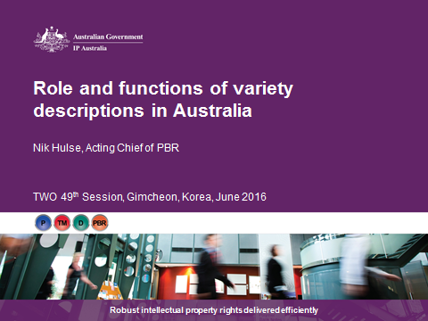

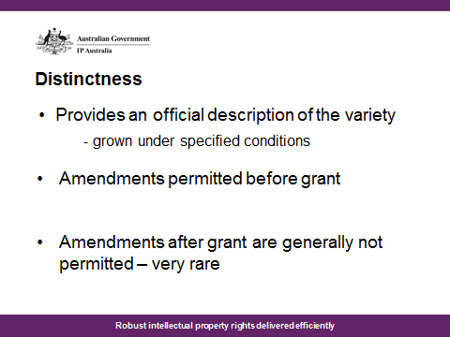

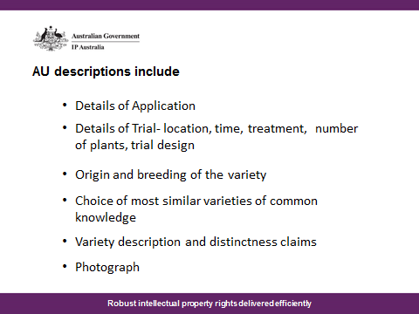

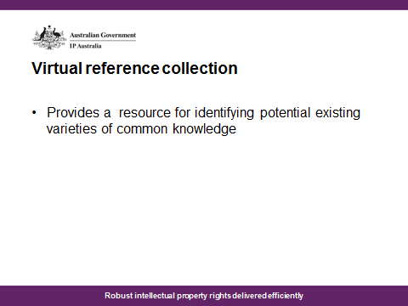

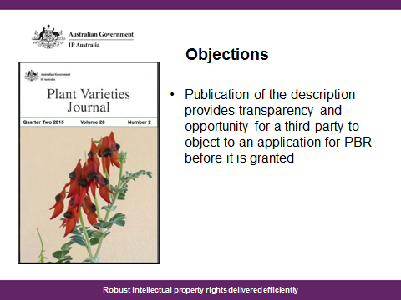

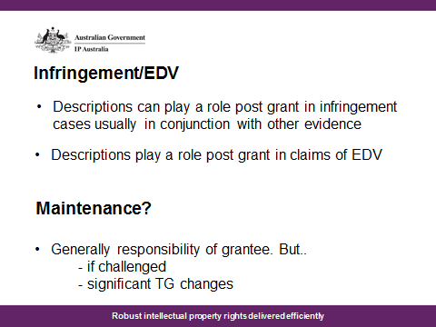

[End of Annex and of document]

