E
TWO/48/23
ORIGINAL: English
DATE: August 20, 2015
INTERNATIONAL UNION FOR THE PROTECTION OF NEW VARIETIES OF PLANTS
Geneva
Technical working party for ORNAMENTAL PLANTS AND FOREST TREES
Forty-Eighth Session
Cambridge, United Kingdom, September 14 to 18, 2015
Matters to be resolved concerning Test Guidelines adopted by the Technical Committee
Test Guidelines for ALOE
Document prepared by the Office of the Union
Disclaimer: this document does not represent UPOV policies or guidance
EXECUTIVE SUMMARY

The purpose of this document is to propose amended illustrations for the Test Guidelines for Aloe.

The Technical Working Party for Ornamental Plants and Forest Trees (TWO) is invited to consider whether to replace illustrations in the adopted Test Guidelines for Aloe as proposed in this document.

BACKGROUND

The TWO, at its forty-seventh session, held in Naivasha, Kenya, from May 19 to 23, 2014, agreed that the Test Guidelines for Aloe (document TG/ALOE(proj.3)) be submitted to the Technical Committee (TC) for adoption at its fifty-first session, held in Geneva from March 23 to 25, 2015 (see document TWO/47/28, Annex IV).

The Technical Committee (TC), at its fifty-first session, adopted the Test Guidelines for Aloe on the basis of document TG/ALOE(proj.5) subject to the amendments specified in document TC/51/39 “Report”, Annex II, and the linguistic changes recommended by the TC-EDC, as presented in the Annex to this document.

In response to the request by the TC, at its fifty-first session, the Leading Expert, Mr. Adriaan de Villiers (South Africa), proposed to replace certain illustrations contained in document TG/ALOE(proj.5).

Proposal

It is proposed to replace the following illustrations in document TG/ALOE(proj.5):

Proposed New Illustrations

8.1 (f)

(f) Observations on the stamens should be made shortly after dehiscence of the anthers.

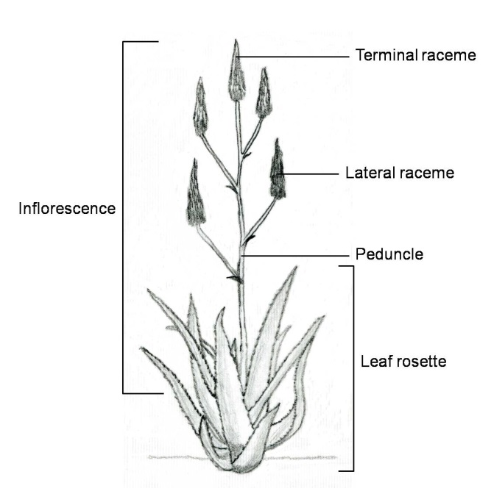 | 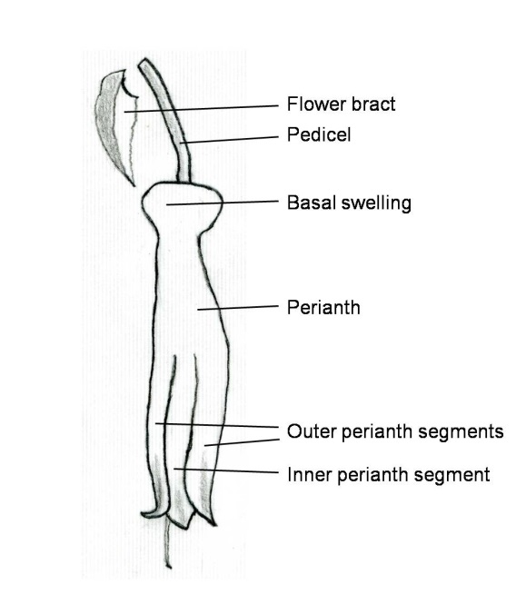
Plant parts | Flower parts

Ad. 1: Plant: height
Ad. 2: Plant: width

Observations should exclude the inflorescence.

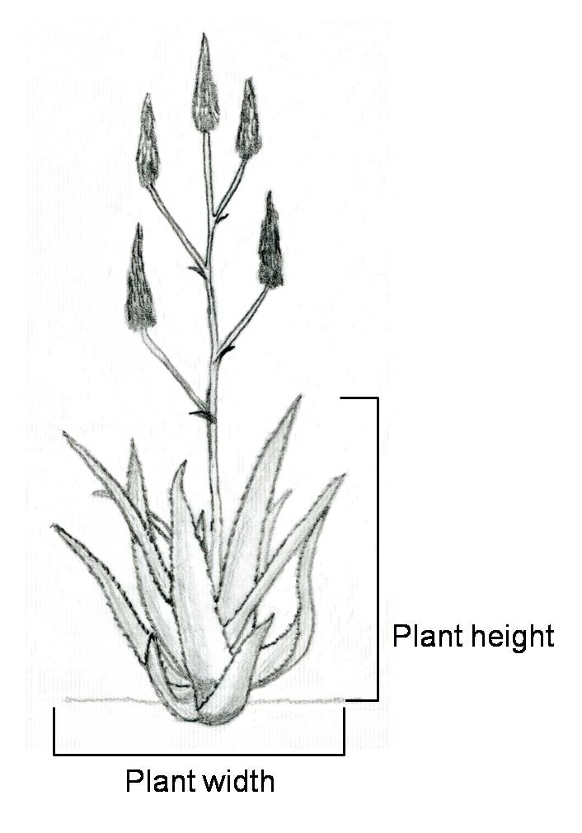

Ad. 8: Leaf: curvature

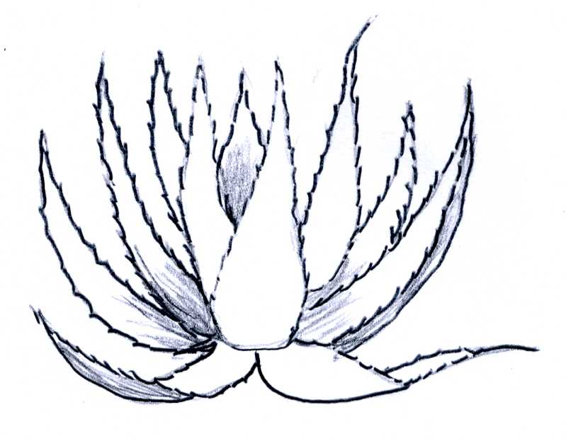 | 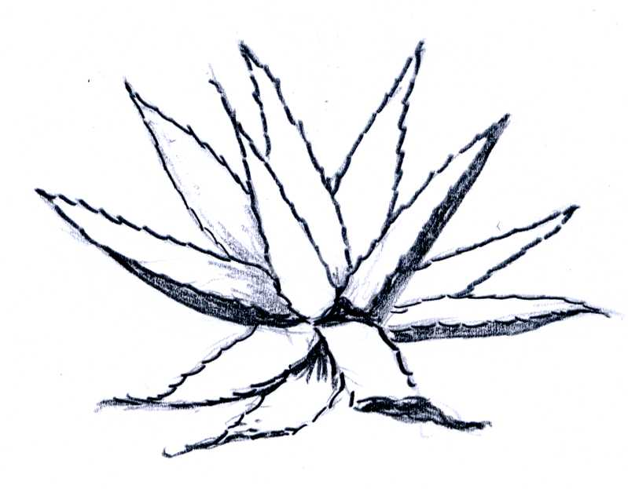 | 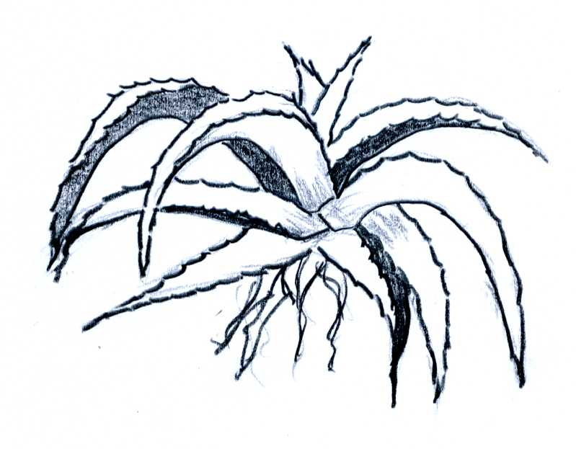
3 | 5 | 7
moderately incurved | straight | moderately recurved

Ad. 12: Leaf: stripes on upper side

(only illustration for state 9 “present” is a proposed new illustration)

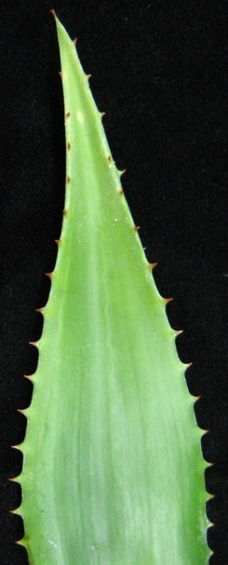 | 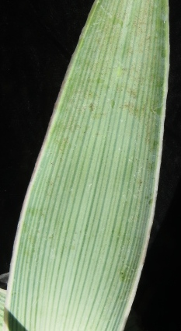
1 | 9
absent | present

Ad. 14: Leaf: marginal teeth
Ad. 16: Leaf: spines or white tubercles

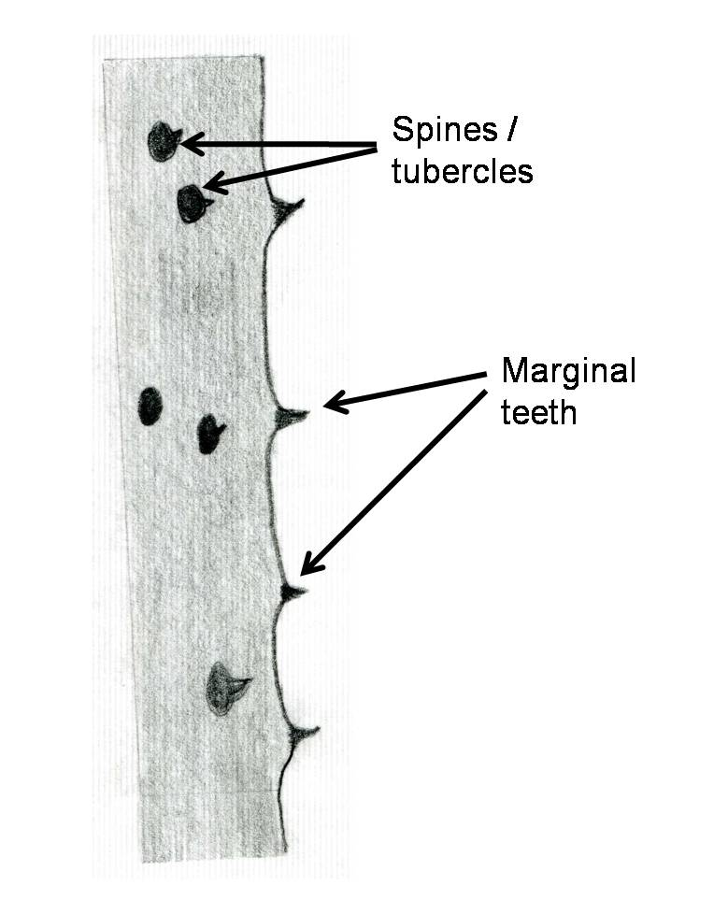
Ad. 20: Inflorescence: length
Ad. 21: Peduncle: length

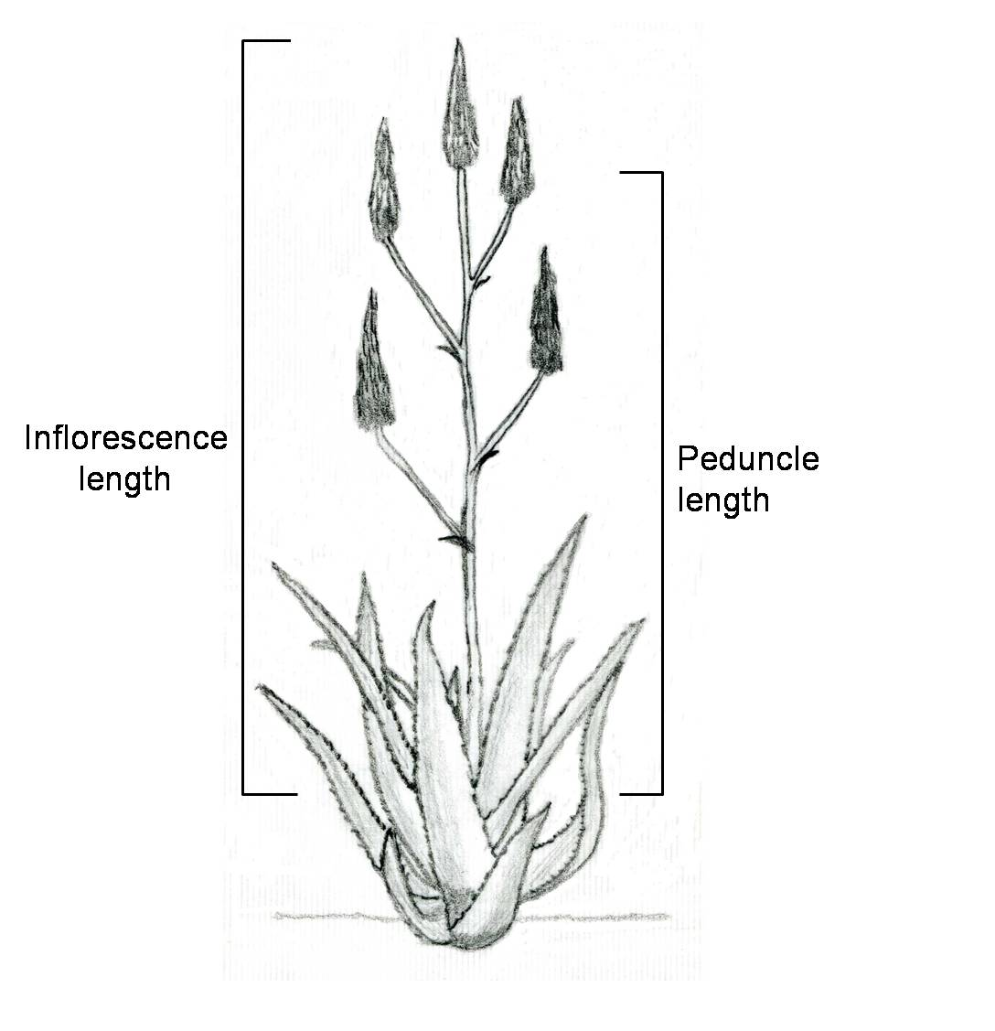

Ad. 23: Lateral raceme: attitude

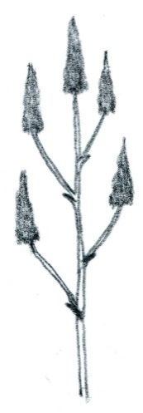 | 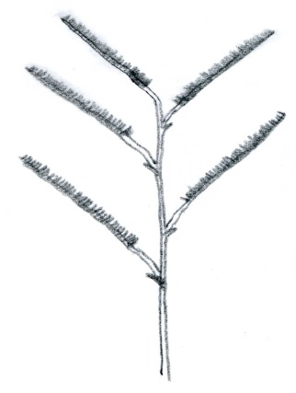 | 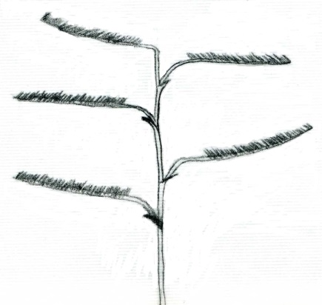
1 | 2 | 3
erect | semi-erect | horizontal

Ad. 24: Terminal raceme: length of flowering part

The flowering part includes open flowers and buds.

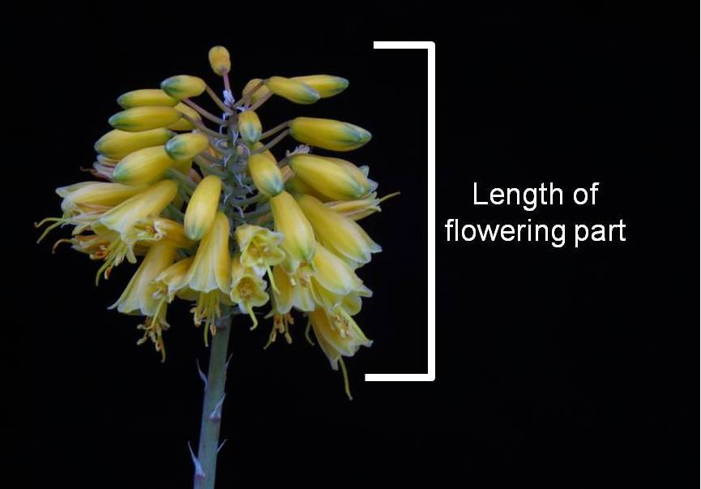

Ad. 26: Terminal raceme: ratio length/width

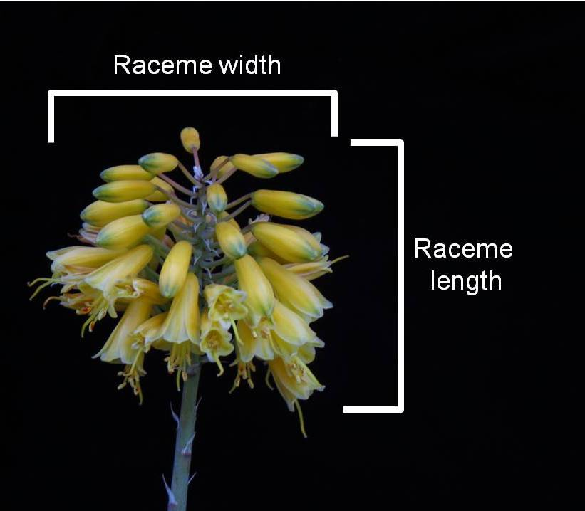

Ad. 35: Pedicel: length

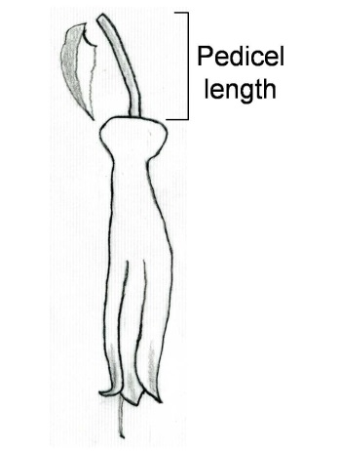

Ad. 38: Perianth: length
Ad. 39: Perianth: diameter

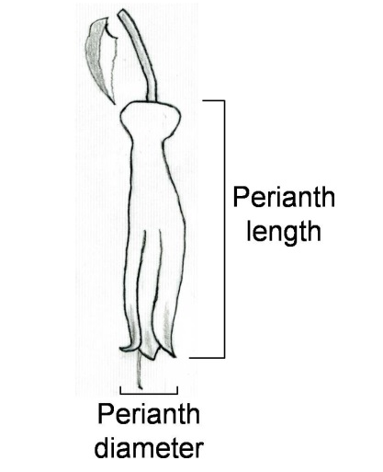

The TWO is invited to consider the proposed amended illustrations for the Test Guidelines for Aloe, as presented in paragraph 6 of this document.

[Annex follows]

EXTRACT OF DOCUMENT TC/51/39 “REPORT”, ANNEX II

Aloe (Aloe L.) | TG/ALOE(proj.5)

[…]

(b) Changes proposed by the TC-EDC in March 2015, which are to be included in the document submitted to the TC:

General | Leading Expert to confirm that all IP rights on photos, illustrations and text have been respected
Char. 25 | to change name of characteristic back to read “Terminal raceme: shape”
Char. 26 | to replace asymmetric scale by “very low” (1) to “very high” (9)
TQ 7.4 | to update ASW 16 (where a photograph of the variety is to be provided) according to new wording in TGP/7/4)

[End of document]

