E
TG/PLECTR(proj.2)
ORIGINAL: English
DATE: 2015-08-03
INTERNATIONAL UNION FOR THE PROTECTION OF NEW VARIETIES OF PLANTS
Geneva
DRAFT

 | Plectranthus  UPOV Code: PLECT  Plectranthus L’Hér. | *

GUIDELINES
FOR THE CONDUCT OF TESTS
FOR DISTINCTNESS, UNIFORMITY AND STABILITY

prepared by (an) expert(s) from South Africa

to be considered by the
Technical Working Party for Ornamental Plants and Forest Trees
at its forty-eighth session
to be held in Cambridge, United Kingdom,
from 2015-09-14
to 2015-09-18

Alternative Names:*
Botanical name | English | French | German | Spanish
Plectranthus L’Hér., Coleus Lour., Plectranthus L’Herit. | Spurflower |  | Harfenstrauch

The purpose of these guidelines (“Test Guidelines”) is to elaborate the principles contained in the General Introduction (document TG/1/3), and its associated TGP documents, into detailed practical guidance for the harmonized examination of distinctness, uniformity and stability (DUS) and, in particular, to identify appropriate characteristics for the examination of DUS and production of harmonized variety descriptions.

ASSOCIATED DOCUMENTS
These Test Guidelines should be read in conjunction with the General Introduction and its associated TGP documents.
TABLE OF CONTENTS PAGE

1. Subject of these Test Guidelines 3
2. Material Required 3
3. Method of Examination 3
3.1 Number of Growing Cycles 3
3.2 Testing Place 3
3.3 Conditions for Conducting the Examination 3
3.4 Test Design 3
3.5 Additional Tests 4
4. Assessment of Distinctness, Uniformity and Stability 4
4.1 Distinctness 4
4.2 Uniformity 5
4.3 Stability 5
5. Grouping of Varieties and Organization of the Growing Trial 5
6. Introduction to the Table of Characteristics 5
6.1 Categories of Characteristics 5
6.2 States of Expression and Corresponding Notes 6
6.3 Types of Expression 6
6.4 Example Varieties 6
6.5 Legend 7
7. Table of Characteristics/Tableau des caractères/Merkmalstabelle/Tabla de caracteres 8
8. Explanations on the Table of Characteristics 17
9. Literature 25
10. Technical Questionnaire 26

Subject of these Test Guidelines

These Test Guidelines apply to all varieties of Plectranthus L’Hér..

excluding Plectranthus scutellarioides.

Material Required

2.1 The competent authorities decide on the quantity and quality of the plant material required for testing the variety and when and where it is to be delivered. Applicants submitting material from a State other than that in which the testing takes place must ensure that all customs formalities and phytosanitary requirements are complied with.

  - The material is to be supplied in the form of plants capable of expressing all relevant characteristics of the variety during the first growing cycle.

2.3 The minimum quantity of plant material, to be supplied by the applicant, should be:

10 plants.

2.4 The plant material supplied should be visibly healthy, not lacking in vigor, nor affected by any important pest or disease.

2.5 The plant material should not have undergone any treatment which would affect the expression of the characteristics of the variety, unless the competent authorities allow or request such treatment. If it has been treated, full details of the treatment must be given.

Method of Examination

3.1 Number of Growing Cycles

3.1.1 The minimum duration of tests should normally be a single growing cycle.

3.2 Testing Place

Tests are normally conducted at one place. In the case of tests conducted at more than one place, guidance is provided in TGP/9 “Examining Distinctness”.

3.3 Conditions for Conducting the Examination

3.3.1 The tests should be carried out under conditions ensuring satisfactory growth for the expression of the relevant characteristics of the variety and for the conduct of the examination.

3.3.2 Because daylight varies, color determinations made against a color chart should be made either in a suitable cabinet providing artificial daylight or in the middle of the day in a room without direct sunlight. The spectral distribution of the illuminant for artificial daylight should conform with the CIE Standard of Preferred Daylight D 6500 and should fall within the tolerances set out in the British Standard 950, Part I. These determinations should be made with the plant part placed against a white background. The color chart and version used should be specified in the variety description.

3.4 Test Design

3.4.1 Each test should be designed to result in a total of at least 10 plants.

3.4.2 The design of the tests should be such that plants or parts of plants may be removed for measurement or counting without prejudice to the observations which must be made up to the end of the growing cycle.

3.5 Additional Tests

Additional tests, for examining relevant characteristics, may be established.

Assessment of Distinctness, Uniformity and Stability

4.1 Distinctness

4.1.1 General Recommendations

It is of particular importance for users of these Test Guidelines to consult the General Introduction prior to making decisions regarding distinctness. However, the following points are provided for elaboration or emphasis in these Test Guidelines.

4.1.2 Consistent Differences

The differences observed between varieties may be so clear that more than one growing cycle is not necessary. In addition, in some circumstances, the influence of the environment is not such that more than a single growing cycle is required to provide assurance that the differences observed between varieties are sufficiently consistent. One means of ensuring that a difference in a characteristic, observed in a growing trial, is sufficiently consistent is to examine the characteristic in at least two independent growing cycles.

4.1.3 Clear Differences

Determining whether a difference between two varieties is clear depends on many factors, and should consider, in particular, the type of expression of the characteristic being examined, i.e. whether it is expressed in a qualitative, quantitative, or pseudo-qualitative manner. Therefore, it is important that users of these Test Guidelines are familiar with the recommendations contained in the General Introduction prior to making decisions regarding distinctness.

4.1.4 Number of Plants / Parts of Plants to be Examined

Unless otherwise indicated, for the purposes of distinctness, all observations on single plants should be made on 5 plants or parts taken from each of 5 plants and any other observations made on all plants in the test, disregarding any off-type plants. In the case of observations of parts taken from single plants, the number of parts to be taken from each of the plants should be 1.

4.1.5 Method of Observation

The recommended method of observing the characteristic for the purposes of distinctness is indicated by the following key in the second column of the Table of Characteristics (see document TGP/9 “Examining Distinctness”, Section 4 “Observation of characteristics”):

MG: single measurement of a group of plants or parts of plants
MS: measurement of a number of individual plants or parts of plants
VG: visual assessment by a single observation of a group of plants or parts of plants
VS: visual assessment by observation of individual plants or parts of plants

Type of observation: visual (V) or measurement (M)

“Visual” observation (V) is an observation made on the basis of the expert’s judgment. For the purposes of this document, “visual” observation refers to the sensory observations of the experts and, therefore, also includes smell, taste and touch. Visual observation includes observations where the expert uses reference points (e.g. diagrams, example varieties, side-by-side comparison) or non-linear charts (e.g. color charts). Measurement (M) is an objective observation against a calibrated, linear scale e.g. using a ruler, weighing scales, colorimeter, dates, counts, etc.

Type of record: for a group of plants (G) or for single, individual plants (S)

For the purposes of distinctness, observations may be recorded as a single record for a group of plants or parts of plants (G), or may be recorded as records for a number of single, individual plants or parts of plants (S). In most cases, “G” provides a single record per variety and it is not possible or necessary to apply statistical methods in a plant-by-plant analysis for the assessment of distinctness.

In cases where more than one method of observing the characteristic is indicated in the Table of Characteristics (e.g. VG/MG), guidance on selecting an appropriate method is provided in document TGP/9, Section 4.2.

4.2 Uniformity

    - It is of particular importance for users of these Test Guidelines to consult the General Introduction prior to making decisions regarding uniformity. However, the following points are provided for elaboration or emphasis in these Test Guidelines:

4.2.2 For the assessment of uniformity, a population standard of 1% and an acceptance probability of at least 95% should be applied. In the case of a sample size of 10 plants, 1 off-type is allowed.

4.3 Stability

4.3.1 In practice, it is not usual to perform tests of stability that produce results as certain as those of the testing of distinctness and uniformity. However, experience has demonstrated that, for many types of variety, when a variety has been shown to be uniform, it can also be considered to be stable.

4.3.2 Where appropriate, or in cases of doubt, stability may be further examined by testing a new plant stock to ensure that it exhibits the same characteristics as those shown by the initial material supplied.

Grouping of Varieties and Organization of the Growing Trial

5.1 The selection of varieties of common knowledge to be grown in the trial with the candidate varieties and the way in which these varieties are divided into groups to facilitate the assessment of distinctness are aided by the use of grouping characteristics.

5.2 Grouping characteristics are those in which the documented states of expression, even where produced at different locations, can be used, either individually or in combination with other such characteristics: (a) to select varieties of common knowledge that can be excluded from the growing trial used for examination of distinctness; and (b) to organize the growing trial so that similar varieties are grouped together.

5.3 The following have been agreed as useful grouping characteristics:

(a) Plant: height (characteristic 2)
(b) Leaf blade: variegation (characteristic 12)
(c) Leaf blade: anthocyanin coloration of lower side (characteristic 15)
(d) Flower: main color (characteristic 24)

5.4 Guidance for the use of grouping characteristics, in the process of examining distinctness, is provided through the General Introduction and document TGP/9 “Examining Distinctness”.

Introduction to the Table of Characteristics

6.1 Categories of Characteristics

6.1.1 Standard Test Guidelines Characteristics

Standard Test Guidelines characteristics are those which are approved by UPOV for examination of DUS and from which members of the Union can select those suitable for their particular circumstances.

6.1.2 Asterisked Characteristics

Asterisked characteristics (denoted by *) are those included in the Test Guidelines which are important for the international harmonization of variety descriptions and should always be examined for DUS and included in the variety description by all members of the Union, except when the state of expression of a preceding characteristic or regional environmental conditions render this inappropriate.

6.2 States of Expression and Corresponding Notes

6.2.1 States of expression are given for each characteristic to define the characteristic and to harmonize descriptions. Each state of expression is allocated a corresponding numerical note for ease of recording of data and for the production and exchange of the description.

6.2.2 In the case of qualitative and pseudo-qualitative characteristics (see Chapter 6.3), all relevant states of expression are presented in the characteristic. However, in the case of quantitative characteristics with 5 or more states, an abbreviated scale may be used to minimize the size of the Table of Characteristics. For example, in the case of a quantitative characteristic with 9 states, the presentation of states of expression in the Test Guidelines may be abbreviated as follows:

State | Note
small | 3
medium | 5
large | 7

However, it should be noted that all of the following 9 states of expression exist to describe varieties and should be used as appropriate:

State | Note
very small | 1
very small to small | 2
small | 3
small to medium | 4
medium | 5
medium to large | 6
large | 7
large to very large | 8
very large | 9

6.2.3 Further explanation of the presentation of states of expression and notes is provided in document TGP/7 “Development of Test Guidelines”.

6.3 Types of Expression

An explanation of the types of expression of characteristics (qualitative, quantitative and pseudo-qualitative) is provided in the General Introduction.

6.4 Example Varieties

Where appropriate, example varieties are provided to clarify the states of expression of each characteristic.

6.5 Legend

(*) Asterisked characteristic – see Chapter 6.1.2

QL Qualitative characteristic – see Chapter 6.3
QN Quantitative characteristic – see Chapter 6.3
PQ Pseudo-qualitative characteristic – see Chapter 6.3

MG, MS, VG, VS – see Chapter 4.1.5

(a)-(d) See Explanations on the Table of Characteristics in Chapter 8.

(+) See Explanations on the Table of Characteristics in Chapter 8.

Unless otherwise indicated, observations should be made at the time of full flowering.

Table of Characteristics/Tableau des caractères/Merkmalstabelle/Tabla de caracteres

English | français | deutsch | español | Example Varieties Exemples Beispielssorten Variedades ejemplo | Note/ Nota
1. QN VG (+)
Plant: growth habit
upright |  |  |  | Erma | 1
semi-upright |  |  |  | Cloud Nine | 3
spreading |  |  |  | Amanda, Verandah Jacaranda | 5
trailing |  |  |  | Variegated Cape GC | 7
2. (*) QN MS VG (+)
Plant: height
short |  |  |  | Hadi Variegated | 3
medium |  |  |  | Chimanimani | 5
tall |  |  |  | Erma | 7
3. QN MS VG
Plant: width
narrow |  |  |  | Hadi Variegated | 3
medium |  |  |  | Chimanimani | 5
broad |  |  |  | Variegated Cape GC | 7
4. QN MS VG (a)
Petiole: length
short |  |  |  | Jazz Pink | 1
medium |  |  |  | Variegated Cape GC | 2
long |  |  |  | Verandah Jacaranda | 3

English | français | deutsch | español | Example Varieties Exemples Beispielssorten Variedades ejemplo | Note/ Nota
5. (*) QN MS VG (a)
Leaf blade: length
short |  |  |  | Chimanimani | 3
medium |  |  |  | Jaws | 5
long |  |  |  | Erma, Trish | 7
6. (*) QN MS VG (a)
Leaf blade: width
narrow |  |  |  | Chimanimani | 3
medium |  |  |  | Jazz Purple | 5
broad |  |  |  | Erma | 7
very broad |  |  |  | Trish | 9
7. QN VG (a)
Leaf blade: ratio length/width
low |  |  |  | Chimanimani | 1
medium |  |  |  | Jazz Purple | 2
high |  |  |  | Tommy White | 3
8. QN VG (a)
Leaf blade: thickness
thin |  |  |  | Erma | 1
medium |  |  |  | Jazz White | 2
thick |  |  |  | Verandah Jacaranda | 3

English | français | deutsch | español | Example Varieties Exemples Beispielssorten Variedades ejemplo | Note/ Nota
9. (*) QN VG (+) (a)
Leaf blade: shape of base
acute |  |  |  | Amanda, Erma | 1
obtuse |  |  |  | Plepalila | 2
rounded |  |  |  | Cloud Nine, Jazz Purple | 3
truncate |  |  |  | Coral Cloud, Jaws | 4
10. (*) QN VG (+) (a)
Leaf blade: shape of apex
acute |  |  |  | Guru's Choice | 1
obtuse |  |  |  | Coral Cloud | 2
rounded |  |  |  | Amanda, Trish | 3
11. QN VG (a)
Leaf blade: position of broadest part
at middle |  |  |  | P 00 06 07 | 1
slightly towards base |  |  |  | Jazz Purple | 2
moderately towards base |  |  |  | Variegated Cape GC | 3
12. (*) QL VG (a)
Leaf blade: variegation
absent |  |  |  | Jaws, Jazz Purple | 1
present |  |  |  | Variegated Cape GC | 9
13. (*) QN VG (a)
Leaf blade: intensity of green color of upper side
light |  |  |  | Jaws | 1
medium |  |  |  | Amanda | 2
dark |  |  |  | Erma | 3

English | français | deutsch | español | Example Varieties Exemples Beispielssorten Variedades ejemplo | Note/ Nota
14. (*) QN VG (a)
Leaf blade: anthocyanin coloration of upper side
absent or weak |  |  |  |  | 1
medium |  |  |  |  | 2
strong |  |  |  |  | 3
15. (*) QN VG (a)
Leaf blade: anthocyanin coloration of lower side
absent or very weak |  |  |  | Cloud Nine | 1
weak |  |  |  | Tommy White | 3
medium |  |  |  | Jazz Blush Pink | 5
strong |  |  |  | Jazz Purple | 7
16. (*) PQ VG (a)
Leaf blade: distribution of anthocyanin coloration of lower side
between veins |  |  |  | Verandah Jacaranda | 1
veins only |  |  |  | Coral Cloud | 2
throughout |  |  |  | Amanda, P 00 06 07 | 3
17. (*) PQ VG (+) (a)
Leaf blade: type of incisions of margin
biserrate |  |  |  | Tommy White | 1
serrate |  |  |  | Erma | 2
serrate to dentate |  |  |  | Jazz Blush Pink | 3
dentate |  |  |  | Variegated Cape GC | 4
dentate to crenate |  |  |  | Amanda | 5
crenate |  |  |  | Cloud Nine | 6

English | français | deutsch | español | Example Varieties Exemples Beispielssorten Variedades ejemplo | Note/ Nota
18. (*) QN VG (a)
Leaf blade: depth of incisions of margin
very shallow |  |  |  | Hadi Variegated | 1
shallow |  |  |  | Erma | 2
medium |  |  |  | Variegated Cape GC | 3
deep |  |  |  | Tommy White | 4
very deep |  |  |  | Jaws | 5
19. QN VG (a)
Leaf blade: blistering
weak |  |  |  | Coral Cloud | 1
medium |  |  |  | Amanda | 2
strong |  |  |  | Jazz Purple | 3
20. (*) QN VG (a)
Leaf blade: pubescence
absent or very sparse |  |  |  | Erma | 1
sparse |  |  |  | P 00 06 07 | 2
medium |  |  |  | Tommy White | 3
dense |  |  |  | Plepalila | 4
very dense |  |  |  | Jaws | 5
21. QN VG (b)
Flowering branch: density of flowers
very sparse |  |  |  | Jazz Pink | 1
sparse |  |  |  | Jazz Purple | 3
medium |  |  |  | Jazz Variegated White | 5
dense |  |  |  | Chimanimani | 7

English | français | deutsch | español | Example Varieties Exemples Beispielssorten Variedades ejemplo | Note/ Nota
22. (*) QN VG (b)
Flowering branch: pubescence
absent or very sparse |  |  |  | Jazz Purple | 1
sparse |  |  |  | Chimanimani | 2
medium |  |  |  | Variegated Cape GC | 3
dense |  |  |  |  | 4
very dense |  |  |  | Jaws | 5
23. (*) QN VG (b)
Flowering branch: anthocyanin coloration
absent or very weak |  |  |  | Guru's Choice | 1
weak |  |  |  |  | 2
medium |  |  |  | Coral Cloud | 3
strong |  |  |  |  | 4
very strong |  |  |  | Amanda | 5
24. (*) PQ VG (+) (c) (d)
Flower: main color
white |  |  |  | Jazz Variegated White | 1
yellow |  |  |  |  | 2
pink |  |  |  | Jazz Blush Pink | 3
reddish purple |  |  |  | P 00 06 07 | 4
purple |  |  |  | Amanda | 5
violet |  |  |  | Jazz Purple | 6
violet blue |  |  |  | Hadi Variegated | 7

English | français | deutsch | español | Example Varieties Exemples Beispielssorten Variedades ejemplo | Note/ Nota
25. (*) QN MS VG (+) (d)
Corolla: length
very short |  |  |  | Chimanimani | 1
short |  |  |  | Jazz Variegated White | 3
medium |  |  |  | Jazz Blush Pink | 5
long |  |  |  | Jazz Purple | 7
very long |  |  |  |  | 9
26. QN MS VG (+) (d)
Corolla: height
low |  |  |  |  | 1
medium |  |  |  |  | 3
high |  |  |  |  | 5
27. (*) QN MS VG (+) (d)
Corolla tube: length
very short |  |  |  | Coral Cloud | 1
short |  |  |  | Amanda | 3
medium |  |  |  | Guru's Choice | 5
long |  |  |  | Cloud Nine | 7
very long |  |  |  |  | 9
28. (*) QN MS VG (+) (d)
Corolla tube: height
very low |  |  |  | Chimanimani | 1
low |  |  |  | Coral Cloud, Jazz Variegated White | 3
medium |  |  |  | Jazz Pink | 5
high |  |  |  | Guru's Choice | 7

English | français | deutsch | español | Example Varieties Exemples Beispielssorten Variedades ejemplo | Note/ Nota
29. (*) QN VG (+) (d)
Corolla tube: ratio length/height
low |  |  |  |  | 1
medium |  |  |  |  | 2
high |  |  |  |  | 3
30. QN VG (+) (d)
Corolla tube: longitudinal curving
absent or weak |  |  |  | Cloud Nine | 1
medium |  |  |  | Variegated Cape GC | 2
strong |  |  |  | Guru's Choice | 3
31. (*) PQ VG (c) (d)
Corolla tube: main color
RHS Colour Chart
(indicate reference number)
32. (*) PQ VG (c) (d)
Upper corolla lobe: main color of outer side
RHS Colour Chart
(indicate reference number)
33. (*) PQ VG (+) (c) (d)
Upper corolla lobe: main color of inner side
RHS Colour Chart
(indicate reference number)

English | français | deutsch | español | Example Varieties Exemples Beispielssorten Variedades ejemplo | Note/ Nota
34. (*) QN VG (d)
Upper corolla lobe: prominence of purple spots or markings
absent or weak |  |  |  | Jazz Blush Pink | 1
medium |  |  |  | Tommy White | 2
strong |  |  |  | P 00 06 07 | 3
35. (*) PQ VG (+) (c) (d)
Lower corolla lobe: main color of outer side
white |  |  |  | Guru's Choice | 1
yellow |  |  |  |  | 2
pink |  |  |  | Jazz Blush Pink | 3
reddish purple |  |  |  | P 00 06 07 | 4
purple |  |  |  | Amanda | 5
violet |  |  |  | Coral Cloud, Jazz Purple | 6
violet blue |  |  |  | Hadi Variegated | 7
36. QN MG (+)
Time of beginning of flowering
early |  |  |  |  | 3
medium |  |  |  |  | 5
late |  |  |  |  | 7

Explanations on the Table of Characteristics

8.1 Explanations covering several characteristics

Characteristics containing the following key in the second column of the Table of Characteristics should be examined as indicated below:
(a) Observations on the leaf should be made on fully developed leaves from the middle part of the plant.
(b) Observations on the flowering branch should be made on the highest flowering branch.
(c) The main color is the color with the largest surface area. In cases where the areas of the main and secondary color are too similar to reliably decide which color has the largest area, the darkest color is considered to be the main color.
(d) Observations on the flower and flower parts should be made on fresh, fully open flowers.

8.2 Explanations for individual characteristics

Ad. 1: Plant: growth habit
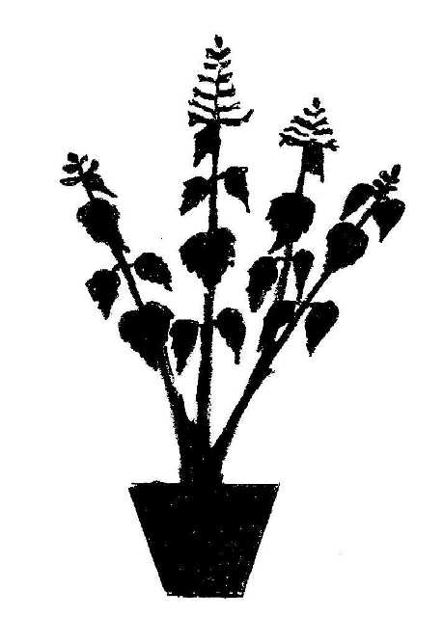
1 - upright
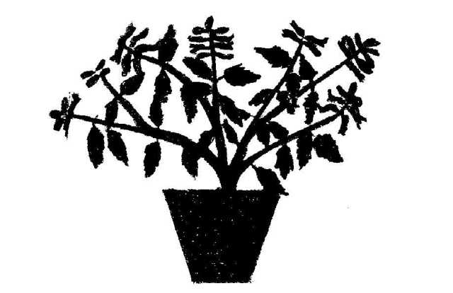
3 - semi-upright
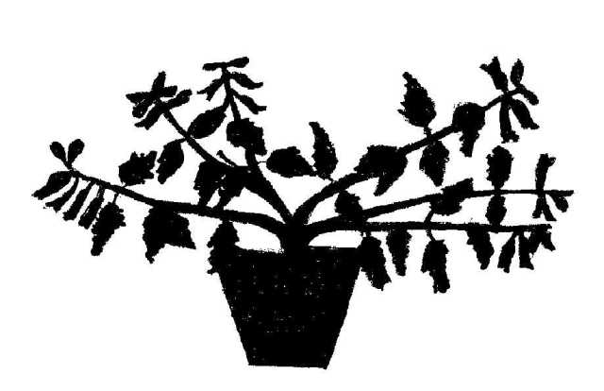
5 - spreading
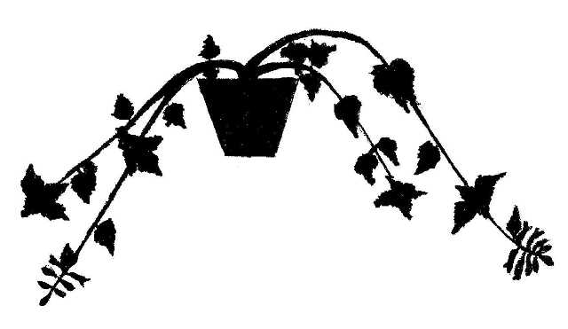
7 - trailing
Ad. 2: Plant: height

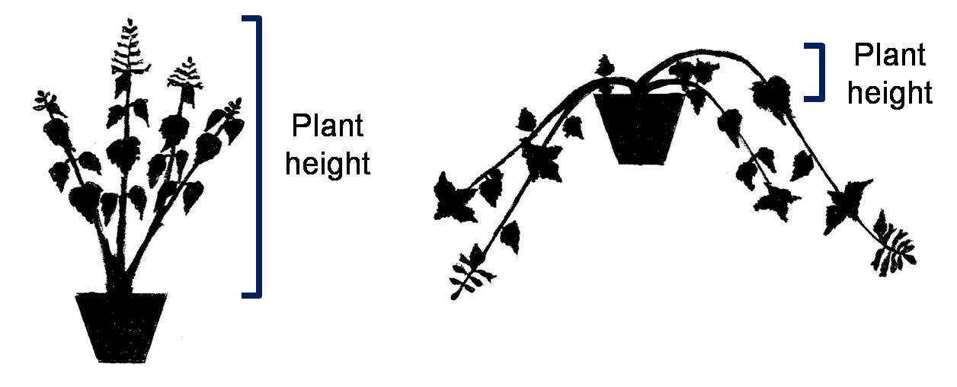

Ad. 9: Leaf blade: shape of base

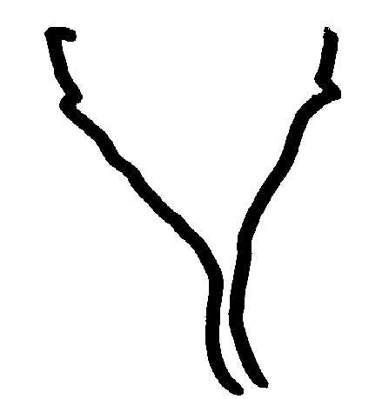
1 - acute
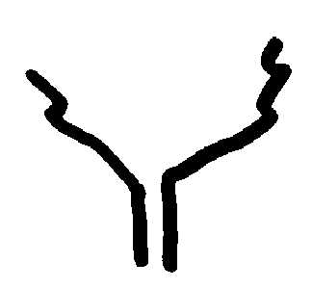
2 - obtuse
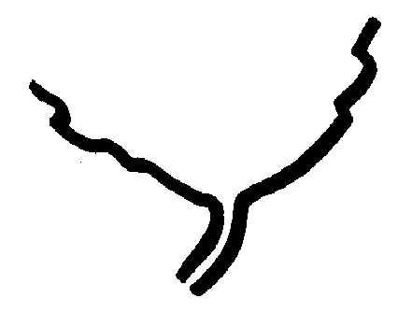
3 - rounded
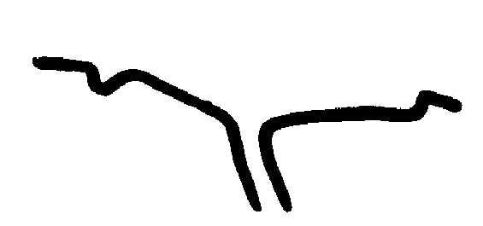
4 - truncate

Ad. 10: Leaf blade: shape of apex

1 - acute
2 - obtuse
3 - rounded

Ad. 17: Leaf blade: type of incisions of margin
1 - biserrate
2 - serrate
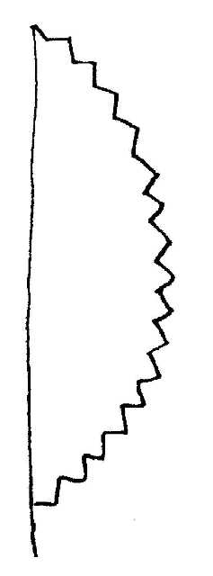
4 - dentate
6 - crenate

Ad. 18: Leaf blade: depth of incisions of margin

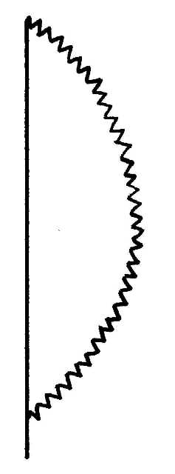
2 - shallow
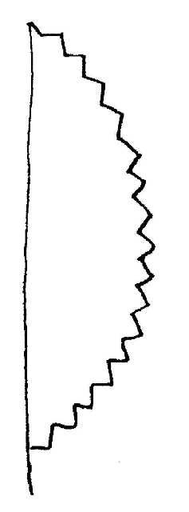
3 - medium
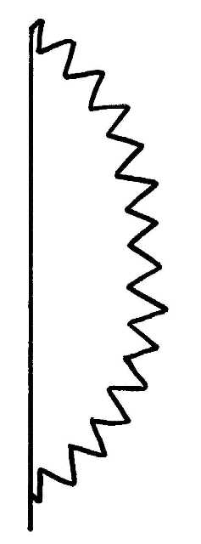
4 - deep

Ad. 24: Flower: main color

This characteristic refers to the general color impression of the flowers, and should be observed while standing one or two steps away from the plants.

Ad. 25: Corolla: length

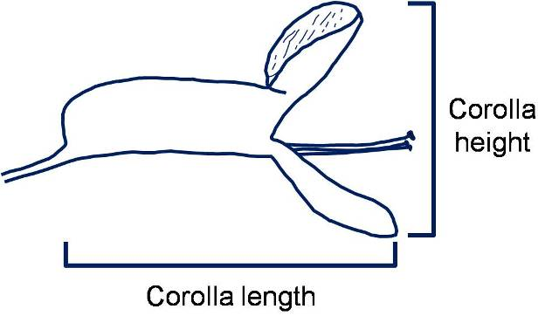

Ad. 26: Corolla: height

Ad. 27: Corolla tube: length

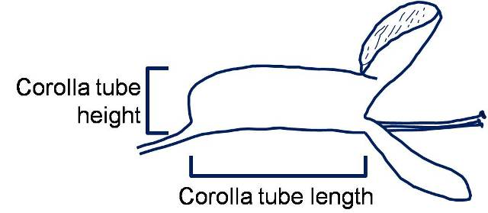

Ad. 28: Corolla tube: height

Ad. 29: Corolla tube: ratio length/height

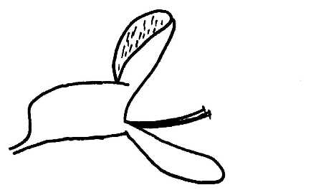
1 - low
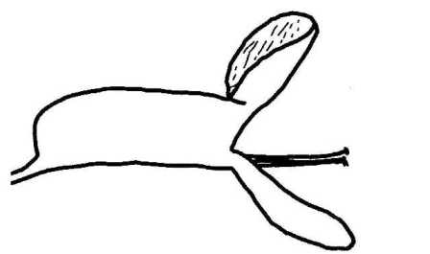
2 - medium
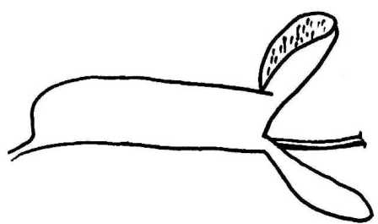
3 - high

Ad. 30: Corolla tube: longitudinal curving

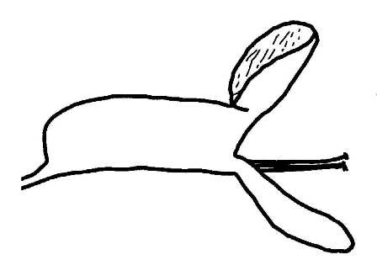
1 - absent or weak
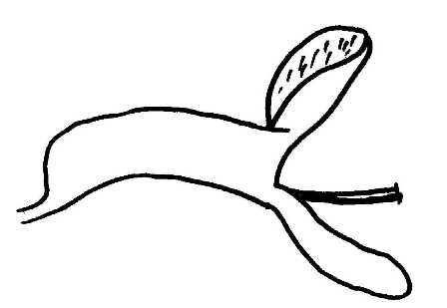
2 - medium
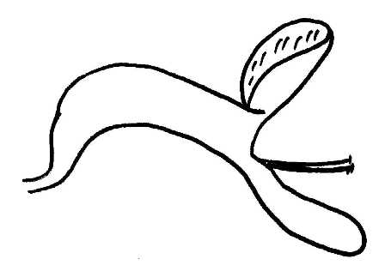
3 - strong

Ad. 33: Upper corolla lobe: main color of inner side

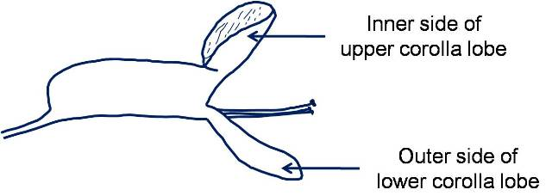

Ad. 35: Lower corolla lobe: main color of outer side

Ad. 36: Time of beginning of flowering

The time of beginning of flowering is when 50% of the plants have at least one open flower.

Literature

Blake, S.T., 1971: A Revision of Plectranthus (Labiatae) in Australasia. Contributions from the Queensland Herbarium No. 9. Brisbane, Queensland, AU.

Codd, L.E., 1975: Plectranthus (Labiatae) and allied genera in Southern Africa. Bothalia, vol. 11. Pretoria, ZA, pp. 371 to 442.

Van Jaarsveld, E.J. The Plectranthus Handbook. National Botanic Gardens. Cape Town, ZA.

Van Jaarsveld, E.J., 1981: The S.A. Plectranthus species as Garden Plants. National Botanic Gardens of South Africa. Cape Town, ZA, 9 pp.

Van Jaarsveld, E.J., Edwards, T.J., 1997: Notes on Plectranthus (Lamiaceae) from southern Africa. Bothalia, vol. 27. Pretoria, ZA, pp. 1 to 6.

Technical Questionnaire

TECHNICAL QUESTIONNAIRE |  | Page {x} of {y} | Reference Number:
 |  |  | Application date:
 |  |  | (not to be filled in by the applicant)
TECHNICAL QUESTIONNAIRE
to be completed in connection with an application for plant breeders’ rights

1. Subject of the Technical Questionnaire
1.1.1 | Botanical Name | Plectranthus L’Hér. |  | [ ]
1.1.2 | Common Name | Spurflower
1.1.3
1.2.1 | Botanical Name | Species |  | [ ]
1.2.2 | Common Name
1.2.3 | Please provide details
1.3.1 | Botanical Name | Hybrid |  | [ ]
1.3.2 | Common Name
1.3.3 | Please provide details

2. Applicant
Name
Address
Telephone No.
Fax No.
E-mail address
Breeder (if different from applicant)
3. Proposed denomination and breeder’s reference
Proposed denomination
(if available)

Breeder’s reference

TECHNICAL QUESTIONNAIRE |  | Page {x} of {y} | Reference Number:
4. Information on the breeding scheme and propagation of the variety

4.1 Breeding scheme

Variety resulting from:

4.1.1 Crossing

(a) controlled cross [ ]
(please state parent varieties)

(…………………..……………..…) x (……………..…………………..…)
female parent male parent

(b) partially known cross [ ]
(please state known parent variety(ies))

(…………………..……………..…) x (……………..…………………..…)
female parent male parent

(c) unknown cross [ ]

4.1.2 Mutation [ ]
(please state parent variety)

4.1.3 Discovery and development [ ]
(please state where and when discovered and how developed)

4.1.4 Other [ ]
(please provide details)

4.2 Method of propagating the variety

4.2.1 Vegetative propagation

(a) cuttings [ ]
(b) in vitro propagation [ ]
(c) Other (state method) [ ]
..................................................................................................................................................
: :
: :
:................................................................................................................................................:

4.2.2 Other [ ]
(please provide details)
..................................................................................................................................................
: :
: :
:................................................................................................................................................:

5. Characteristics of the variety to be indicated (the number in brackets refers to the corresponding characteristic in Test Guidelines; please mark the note which best corresponds).

 | Characteristics | Example Varieties | Note
5.1 (2) | Plant: height
 | very short |  | 1[ ]
 | very short to short |  | 2[ ]
 | short | Hadi Variegated | 3[ ]
 | short to medium |  | 4[ ]
 | medium | Chimanimani | 5[ ]
 | medium to tall |  | 6[ ]
 | tall | Erma | 7[ ]
 | tall to very tall |  | 8[ ]
 | very tall |  | 9[ ]
5.2 (12) | Leaf blade: variegation
 | absent | Jaws, Jazz Purple | 1[ ]
 | present | Variegated Cape GC | 9[ ]
5.3 (15) | Leaf blade: anthocyanin coloration of lower side
 | absent or very weak | Cloud Nine | 1[ ]
 | weak | Tommy White | 3[ ]
 | medium | Jazz Blush Pink | 5[ ]
 | strong | Jazz Purple | 7[ ]
5.4 (24) | Flower: main color
 | white | Jazz Variegated White | 1[ ]
 | yellow |  | 2[ ]
 | pink | Jazz Blush Pink | 3[ ]
 | reddish purple | P 00 06 07 | 4[ ]
 | purple | Amanda | 5[ ]
 | violet | Jazz Purple | 6[ ]
 | violet blue | Hadi Variegated | 7[ ]

6. Similar varieties and differences from these varieties

Please use the following table and box for comments to provide information on how your candidate variety differs from the variety (or varieties) which, to the best of your knowledge, is (or are) most similar. This information may help the examination authority to conduct its examination of distinctness in a more efficient way.

Denomination(s) of variety(ies) similar to your candidate variety | Characteristic(s) in which your candidate variety differs from the similar variety(ies) | Describe the expression of the characteristic(s) for the similar variety(ies) | Describe the expression of the characteristic(s) for your candidate variety
Example | Leaf blade: variegation | absent | present
Comments:

7. Additional information which may help in the examination of the variety

7.1 In addition to the information provided in sections 5 and 6, are there any additional characteristics which may help to distinguish the variety?

Yes [ ] No [ ]

(If yes, please provide details)

7.2 Are there any special conditions for growing the variety or conducting the examination?

Yes [ ] No [ ]

(If yes, please provide details)

7.3 Other information

Main use
(a) garden plant [ ]
(b) pot plant [ ]
(c) other [ ]
(please provide details)

7.4 A representative color photograph of the variety displaying its main distinguishing feature(s), should accompany the Technical Questionnaire. The photograph will provide a visual illustration of the candidate variety which supplements the information provided in the Technical Questionnaire.

The key points to consider when taking a photograph of the candidate variety are:

- Indication of the date and geographic location
- Correct labeling (breeder’s reference)
- Good quality printed photograph (minimum 10 cm x 15 cm) and/or sufficient resolution electronic format version (minimum 960 x 1280 pixels)

Further guidance on providing photographs with the Technical Questionnaire is available in document TGP/7 “Development of Test Guidelines”, Guidance Note 35 (http://www.upov.int/tgp/en/).

[The link provided may be deleted by members of the Union when developing authorities’ own test guidelines.]

8. Authorization for release

(a) Does the variety require prior authorization for release under legislation concerning the protection of the environment, human and animal health?

Yes [ ] No [ ]

(b) Has such authorization been obtained?

Yes [ ] No [ ]

If the answer to (b) is yes, please attach a copy of the authorization.

TECHNICAL QUESTIONNAIRE | Page {x} of {y} | Reference Number:
9. Information on plant material to be examined or submitted for examination

9.1 The expression of a characteristic or several characteristics of a variety may be affected by factors, such as pests and disease, chemical treatment (e.g. growth retardants or pesticides), effects of tissue culture, different rootstocks, scions taken from different growth phases of a tree, etc.

9.2 The plant material should not have undergone any treatment which would affect the expression of the characteristics of the variety, unless the competent authorities allow or request such treatment. If the plant material has undergone such treatment, full details of the treatment must be given. In this respect, please indicate below, to the best of your knowledge, if the plant material to be examined has been subjected to:

(a) Microorganisms (e.g. virus, bacteria, phytoplasma) Yes [ ] No [ ]

(b) Chemical treatment (e.g. growth retardant, pesticide) Yes [ ] No [ ]

(c) Tissue culture Yes [ ] No [ ]

(d) Other factors Yes [ ] No [ ]

Please provide details for where you have indicated “yes”.

9.3 Has the plant material to be examined been tested for the presence of virus or other pathogens? Yes [ ] (please provide details as specified by the Authority) No [ ]

10. I hereby declare that, to the best of my knowledge, the information provided in this form is correct:

Applicant’s name

Signature Date

[End of document]

* These names were correct at the time of the introduction of these Test Guidelines but may be revised or updated. [Readers are advised to consult the UPOV Code, which can be found on the UPOV Website (www.upov.int), for the latest information.]

