E
TG/GREVI(proj.3)
ORIGINAL: English
DATE: 2015-08-01
INTERNATIONAL UNION FOR THE PROTECTION OF NEW VARIETIES OF PLANTS
Geneva
DRAFT

 | Grevillea  UPOV Code: GREVI  Grevillea R. Br. corr. R. Br. | *

GUIDELINES
FOR THE CONDUCT OF TESTS
FOR DISTINCTNESS, UNIFORMITY AND STABILITY

prepared by (an) expert(s) from Australia

to be considered by the
Technical Working Party for Ornamental Plants and Forest Trees
at its forty-eighth session
to be held in Cambridge, United Kingdom,
from 2015-09-14
to 2015-09-18

Alternative Names:*
Botanical name | English | French | German | Spanish
Grevillea R. Br. corr. R. Br., Grevillea hybrid; Grevillea R. Br | Grevillea | Grevillea | Grevillea | Grevillea

The purpose of these guidelines (“Test Guidelines”) is to elaborate the principles contained in the General Introduction (document TG/1/3), and its associated TGP documents, into detailed practical guidance for the harmonized examination of distinctness, uniformity and stability (DUS) and, in particular, to identify appropriate characteristics for the examination of DUS and production of harmonized variety descriptions.

ASSOCIATED DOCUMENTS
These Test Guidelines should be read in conjunction with the General Introduction and its associated TGP documents.
TABLE OF CONTENTS PAGE

1. Subject of these Test Guidelines 3
2. Material Required 3
3. Method of Examination 3
3.1 Number of Growing Cycles 3
3.2 Testing Place 3
3.3 Conditions for Conducting the Examination 3
3.4 Test Design 3
3.5 Additional Tests 3
4. Assessment of Distinctness, Uniformity and Stability 4
4.1 Distinctness 4
4.2 Uniformity 5
4.3 Stability 5
5. Grouping of Varieties and Organization of the Growing Trial 5
6. Introduction to the Table of Characteristics 5
6.1 Categories of Characteristics 5
6.2 States of Expression and Corresponding Notes 6
6.3 Types of Expression 6
6.4 Example Varieties 6
6.5 Legend 6
7. Table of Characteristics/Tableau des caractères/Merkmalstabelle/Tabla de caracteres 7
8. Explanations on the Table of Characteristics 25
9. Literature 36
10. Technical Questionnaire 37

Subject of these Test Guidelines

These Test Guidelines apply to all varieties of Grevillea R. Br. corr. R. Br..

Material Required

2.1 The competent authorities decide on the quantity and quality of the plant material required for testing the variety and when and where it is to be delivered. Applicants submitting material from a State other than that in which the testing takes place must ensure that all customs formalities and phytosanitary requirements are complied with.

  - The material is to be supplied in the form of plants expressing relevant characteristics of the variety in the first growing cycle.

2.3 The minimum quantity of plant material, to be supplied by the applicant, should be:

10 plants.

2.4 The plant material supplied should be visibly healthy, not lacking in vigor, nor affected by any important pest or disease.

2.5 The plant material should not have undergone any treatment which would affect the expression of the characteristics of the variety, unless the competent authorities allow or request such treatment. If it has been treated, full details of the treatment must be given.

Method of Examination

3.1 Number of Growing Cycles

3.1.1 The minimum duration of tests should normally be a single growing cycle.

3.2 Testing Place

Tests are normally conducted at one place. In the case of tests conducted at more than one place, guidance is provided in TGP/9 “Examining Distinctness”.

3.3 Conditions for Conducting the Examination

3.3.1 The tests should be carried out under conditions ensuring satisfactory growth for the expression of the relevant characteristics of the variety and for the conduct of the examination.

3.4 Test Design

3.4.1 Each test should be designed to result in a total of at least 10 plants.

3.4.2 The design of the tests should be such that plants or parts of plants may be removed for measurement or counting without prejudice to the observations which must be made up to the end of the growing cycle.

3.5 Additional Tests

Additional tests, for examining relevant characteristics, may be established.

Assessment of Distinctness, Uniformity and Stability

4.1 Distinctness

4.1.1 General Recommendations

It is of particular importance for users of these Test Guidelines to consult the General Introduction prior to making decisions regarding distinctness. However, the following points are provided for elaboration or emphasis in these Test Guidelines.

4.1.2 Consistent Differences

The differences observed between varieties may be so clear that more than one growing cycle is not necessary. In addition, in some circumstances, the influence of the environment is not such that more than a single growing cycle is required to provide assurance that the differences observed between varieties are sufficiently consistent. One means of ensuring that a difference in a characteristic, observed in a growing trial, is sufficiently consistent is to examine the characteristic in at least two independent growing cycles.

4.1.3 Clear Differences

Determining whether a difference between two varieties is clear depends on many factors, and should consider, in particular, the type of expression of the characteristic being examined, i.e. whether it is expressed in a qualitative, quantitative, or pseudo-qualitative manner. Therefore, it is important that users of these Test Guidelines are familiar with the recommendations contained in the General Introduction prior to making decisions regarding distinctness.

4.1.4 Number of Plants / Parts of Plants to be Examined

Unless otherwise indicated, for the purposes of distinctness, all observations on single plants should be made on 9 plants or parts taken from each of 9 plants and any other observations made on all plants in the test, disregarding any off-type plants. In the case of observations of parts taken from single plants, the number of parts to be taken from each of the plants should be 9.

4.1.5 Method of Observation

The recommended method of observing the characteristic for the purposes of distinctness is indicated by the following key in the second column of the Table of Characteristics (see document TGP/9 “Examining Distinctness”, Section 4 “Observation of characteristics”):

MG: single measurement of a group of plants or parts of plants
MS: measurement of a number of individual plants or parts of plants
VG: visual assessment by a single observation of a group of plants or parts of plants
VS: visual assessment by observation of individual plants or parts of plants

Type of observation: visual (V) or measurement (M)

“Visual” observation (V) is an observation made on the basis of the expert’s judgment. For the purposes of this document, “visual” observation refers to the sensory observations of the experts and, therefore, also includes smell, taste and touch. Visual observation includes observations where the expert uses reference points (e.g. diagrams, example varieties, side-by-side comparison) or non-linear charts (e.g. color charts). Measurement (M) is an objective observation against a calibrated, linear scale e.g. using a ruler, weighing scales, colorimeter, dates, counts, etc.

Type of record: for a group of plants (G) or for single, individual plants (S)

For the purposes of distinctness, observations may be recorded as a single record for a group of plants or parts of plants (G), or may be recorded as records for a number of single, individual plants or parts of plants (S). In most cases, “G” provides a single record per variety and it is not possible or necessary to apply statistical methods in a plant-by-plant analysis for the assessment of distinctness.

In cases where more than one method of observing the characteristic is indicated in the Table of Characteristics (e.g. VG/MG), guidance on selecting an appropriate method is provided in document TGP/9, Section 4.2.

4.2 Uniformity

    - It is of particular importance for users of these Test Guidelines to consult the General Introduction prior to making decisions regarding uniformity. However, the following points are provided for elaboration or emphasis in these Test Guidelines:

4.2.2 For the assessment of uniformity, a population standard of 1% and an acceptance probability of at least 95 % should be applied. In the case of a sample size of 10 plants, 1 off-type is allowed.

4.3 Stability

4.3.1 In practice, it is not usual to perform tests of stability that produce results as certain as those of the testing of distinctness and uniformity. However, experience has demonstrated that, for many types of variety, when a variety has been shown to be uniform, it can also be considered to be stable.

4.3.2 Where appropriate, or in cases of doubt, stability may be further examined by testing a new seed or plant stock to ensure that it exhibits the same characteristics as those shown by the initial material supplied.

Grouping of Varieties and Organization of the Growing Trial

5.1 The selection of varieties of common knowledge to be grown in the trial with the candidate varieties and the way in which these varieties are divided into groups to facilitate the assessment of distinctness are aided by the use of grouping characteristics.

5.2 Grouping characteristics are those in which the documented states of expression, even where produced at different locations, can be used, either individually or in combination with other such characteristics: (a) to select varieties of common knowledge that can be excluded from the growing trial used for examination of distinctness; and (b) to organize the growing trial so that similar varieties are grouped together.

5.3 The following have been agreed as useful grouping characteristics:

(a) Plant: habit (characteristic 1)
(b) Leaf: division of blade (characteristic 12)
(c) Inflorescence: type (characteristic 36)
(d) Inflorescence: predominant color (characteristic 38)
(e) Perianth: color (characteristic 53)

5.4 Guidance for the use of grouping characteristics, in the process of examining distinctness, is provided through the General Introduction and document TGP/9 “Examining Distinctness”.

Introduction to the Table of Characteristics

6.1 Categories of Characteristics

6.1.1 Standard Test Guidelines Characteristics

Standard Test Guidelines characteristics are those which are approved by UPOV for examination of DUS and from which members of the Union can select those suitable for their particular circumstances.

6.1.2 Asterisked Characteristics

Asterisked characteristics (denoted by *) are those included in the Test Guidelines which are important for the international harmonization of variety descriptions and should always be examined for DUS and included in the variety description by all members of the Union, except when the state of expression of a preceding characteristic or regional environmental conditions render this inappropriate.

6.2 States of Expression and Corresponding Notes

6.2.1 States of expression are given for each characteristic to define the characteristic and to harmonize descriptions. Each state of expression is allocated a corresponding numerical note for ease of recording of data and for the production and exchange of the description.

6.2.2 In the case of qualitative and pseudo-qualitative characteristics (see Chapter 6.3), all relevant states of expression are presented in the characteristic. However, in the case of quantitative characteristics with 5 or more states, an abbreviated scale may be used to minimize the size of the Table of Characteristics. For example, in the case of a quantitative characteristic with 9 states, the presentation of states of expression in the Test Guidelines may be abbreviated as follows:

State | Note
small | 3
medium | 5
large | 7

However, it should be noted that all of the following 9 states of expression exist to describe varieties and should be used as appropriate:

State | Note
very small | 1
very small to small | 2
small | 3
small to medium | 4
medium | 5
medium to large | 6
large | 7
large to very large | 8
very large | 9

6.2.3 Further explanation of the presentation of states of expression and notes is provided in document TGP/7 “Development of Test Guidelines”.

6.3 Types of Expression

An explanation of the types of expression of characteristics (qualitative, quantitative and pseudo-qualitative) is provided in the General Introduction.

6.4 Example Varieties

Where appropriate, example varieties are provided to clarify the states of expression of each characteristic.

6.5 Legend

(*) Asterisked characteristic – see Chapter 6.1.2

QL Qualitative characteristic – see Chapter 6.3
QN Quantitative characteristic – see Chapter 6.3
PQ Pseudo-qualitative characteristic – see Chapter 6.3

MG, MS, VG, VS – see Chapter 4.1.5

(a)-(c) See Explanations on the Table of Characteristics in Chapter 8.

(+) See Explanations on the Table of Characteristics in Chapter 8.

Table of Characteristics/Tableau des caractères/Merkmalstabelle/Tabla de caracteres

English | français | deutsch | español | Example Varieties Exemples Beispielssorten Variedades ejemplo | Note/ Nota
1. (*) PQ VG (+) (a)
Plant: habit
upright | dressé | aufrecht | erecto | Callum’s Gold | 1
semi upright | demi-dressé | halbaufrecht | semierecto | Honey Gem | 2
spreading |  |  |  | Ninderry-Sunrise | 3
prostrate |  |  |  | Raptor | 4
2. (*) QN VG (a)
Plant: attitude of branches | Plante: port des ramifications | Pflanze: Stellung der Seitenäste | Planta: porte de las ramificaciones
erect | dressé | aufrecht | erecto | Callum’s Gold | 1
erect to semi-erect |  |  |  | Blood Orange | 2
semi-erect |  |  |  | Honey Gem | 3
semi-erect to horizontal |  |  |  | Ninderry-Sunrise | 4
horizontal |  |  |  | Raptor | 5
3. (*) QN MG VG (a)
Plant: height
short |  |  |  |  | 3
medium |  |  |  |  | 5
tall |  |  |  |  | 7
4. QN VG (a)
Plant: density of foliage | Plante : densité du feuillage | Pflanze: Dichte des Laubes | Planta: densidad del follaje
sparse |  |  |  | Raptor | 1
medium |  |  |  | Callum’s Gold | 2
dense |  |  |  | Billy Bonkers | 3

English | français | deutsch | español | Example Varieties Exemples Beispielssorten Variedades ejemplo | Note/ Nota
5. PQ VG (+) (b)
Young stem: color
yellow green |  |  |  | Honey Gem | 1
green |  |  |  | Coastal Prestige, Fireworks | 2
purple |  |  |  | Raptor | 3
orange |  |  |  | Callum’s Gold | 4
brown |  |  |  | Autumn Waterfall | 5
6. QL VG (b)
Young stem: hairiness
absent |  |  |  |  | 1
present |  |  |  | Knockout | 9
7. (*) PQ VG (+) (a)
Stem: color
yellow green |  |  |  | New Blood | 1
green |  |  |  | Burke 3 | 2
orange |  |  |  | Ninderry-Sunrise | 3
purple |  |  |  | Callum’s Gold | 4
brown |  |  |  | Honey Gem | 5
8. QN MS VG (+) (a)
Leaf: length of blade
short |  |  |  |  | 3
medium |  |  |  |  | 5
long |  |  |  |  | 7

English | français | deutsch | español | Example Varieties Exemples Beispielssorten Variedades ejemplo | Note/ Nota
9. QN MS VG (a)
Leaf: width of blade
narrow |  |  |  |  | 3
medium |  |  |  |  | 5
broad |  |  |  |  | 7
10. (*) QN VG (a)
Leaf: attitude relative to stem
erect |  |  |  | Raptor | 1
erect to semi-erect |  |  |  | Honey Gem | 2
semi erect |  |  |  | Callum’s Gold | 3
semi-erect to horizontal |  |  |  | Billy Bonkers | 4
horizontal |  |  |  | Prostrate Yellow | 5
11. QN VG (a)
Leaf: undulation of margin | Feuille: ondulation du bord | Blatt: Wellung des Randes | Hoja: ondulación del borde
weak |  |  |  | Callum’s Gold | 3
medium |  |  |  | Raptor | 5
strong |  |  |  | Entrée | 7
12. (*) QL VG (a)
Leaf: division of blade
absent |  |  |  | Fire Cracker | 1
present |  |  |  | Callum’s Gold | 9

English | français | deutsch | español | Example Varieties Exemples Beispielssorten Variedades ejemplo | Note/ Nota
13. (*) PQ VG (+) (a)
Leaf: blade shape
lanceolate |  |  |  | H22 | 1
ovate |  |  |  | Burke 3 | 2
linear |  |  |  | Fire Cracker | 3
oblong |  |  |  |  | 4
elliptic |  |  |  | TWD01 | 5
rhombic |  |  |  | Molly | 6
circular |  |  |  |  | 7
obovate |  |  |  |  | 8
14. (*) QL VG (+) (a)
Leaf: type of division of blade
primary |  |  |  | Raptor | 1
secondary |  |  |  | Autumn Waterfall | 2
tertiary |  |  |  | Callum’s Gold | 3
15. QN VG (+) (a)
Leaf: depth of sinus
less than one third to two thirds to midrib |  |  |  | Bedspread
greater than two thirds to midrib |  |  |  | Callum’s Gold
less than one third to midrib |  |  |  |  | 1
16. (*) QN VG (+) (a)
Leaf: number of lobes | Feuille: nombre de lobes | Blatt: Anzahl Lappen | Hoja: número de lóbulos
few | petit | gering | bajo | Parakeet Pink | 3
medium | moyen | mittel | medio | Callum’s Gold | 5
many | grand | groß | alto | Honey Gem | 7

English | français | deutsch | español | Example Varieties Exemples Beispielssorten Variedades ejemplo | Note/ Nota
17. QL VG (a)
Leaf: regularity of lobing
regular |  |  |  | Callum’s Gold | 1
irregular |  |  |  | Raptor | 2
18. QN VG (+) (a)
Leaf: attitude of primary lobes in relation to midrib
erect |  |  |  |  | 1
erect to semi-erect |  |  |  | Honey Gem | 2
semi-erect |  |  |  | Callum’s Gold | 3
semi-erect to horizontal |  |  |  |  | 4
horizontal |  |  |  |  | 5
19. PQ VG (+) (a)
Leaf: shape of apex of sinus
pointed |  |  |  | Ninderry-Sunrise | 1
rounded |  |  |  |  | 2
flattened |  |  |  |  | 3
20. QN MS VG (+) (a)
Leaf: width of sinus
very narrow |  |  |  |  | 1
narrow |  |  |  |  | 3
medium |  |  |  | Billy Bonkers | 5
broad |  |  |  | Callum’s Gold | 7
very broad |  |  |  |  | 9

English | français | deutsch | español | Example Varieties Exemples Beispielssorten Variedades ejemplo | Note/ Nota
21. (*) QN MS VG (+) (a)
Leaf: length of lobe
short |  |  |  | Autumn Waterfall | 3
medium |  |  |  | Billy Bonkers | 5
long |  |  |  | Callum’s Gold | 7
22. (*) QN MS VG (+) (a)
Leaf: width of lobe
narrow |  |  |  | Callum's Gold | 3
medium |  |  |  | Ivory Whip | 5
broad |  |  |  | Bedspread | 7
23. PQ VG (+) (a)
Leaf: shape of apex
apiculate |  |  |  | New Blood
mucronate |  |  |  | H22
acute |  |  |  | Little Honey | 1
obtuse |  |  |  |  | 2
truncate |  |  |  |  | 3
24. PQ VG (+) (a)
Leaf: profile in cross section
flat or slightly recurved |  |  |  | Raptor | 1
strongly recurved |  |  |  | Callum’s Gold | 2
angularly revolute to the mid vein |  |  |  |  | 3
smoothly revolute to the mid vein |  |  |  | Little Honey | 4

English | français | deutsch | español | Example Varieties Exemples Beispielssorten Variedades ejemplo | Note/ Nota
25. QN VG (a)
Leaf: intensity of green color of upper side
light |  |  |  | Autumn Waterfall | 1
medium |  |  |  | Raptor | 2
dark |  |  |  | Callum’s Gold | 3
26. PQ VG (+) (a)
Leaf: color of lower side
white |  |  |  | Callum’s Gold | 1
light green |  |  |  | Raptor | 2
medium green |  |  |  | Ninderry-Sunrise | 3
dark green |  |  |  |  | 4
red green |  |  |  |  | 5
27. QN VG (a)
Leaf: hairiness of upper side
weak |  |  |  | Ninderry-Sunrise | 1
medium |  |  |  | Callum’s Gold | 2
strong |  |  |  |  | 3
28. QN VG (a)
Leaf: hairiness of lower side
weak |  |  |  | Little Honey | 1
medium |  |  |  | Blood Orange | 2
strong |  |  |  | Ninderry-Sunrise | 3

English | français | deutsch | español | Example Varieties Exemples Beispielssorten Variedades ejemplo | Note/ Nota
29. QL VG (a)
Leaf: color of hairs on lower side
white |  |  |  | Callum’s Gold | 1
red brown |  |  |  | Honey Gem | 2
30. QN MS VG (a)
Leaf: length of petiole
short |  |  |  | Raptor | 3
medium |  |  |  | Callum’s Gold | 5
long |  |  |  | Red Rover | 7
31. PQ VG (c)
Flowering branch: position of inflorescence
terminal only |  |  |  | Ninderry-Sunrise | 1
both terminal and axillary |  |  |  | Callum’s Gold | 2
axillary only |  |  |  |  | 3
32. (*) QN VG (+) (c)
Inflorescence: attitude
erect |  |  |  | Red Rover | 1
erect to semi-erect |  |  |  | Little Honey | 2
semi-erect |  |  |  | Honey Gem | 3
semi-erect to horizontal |  |  |  | Blood Orange | 4
horizontal |  |  |  | Callum’s Gold | 5
horizontal to semi-drooping |  |  |  | Ninderry-Sunrise | 6
semi-drooping |  |  |  |  | 7
semi-drooping to drooping |  |  |  |  | 8
drooping |  |  |  | Entrée | 9

English | français | deutsch | español | Example Varieties Exemples Beispielssorten Variedades ejemplo | Note/ Nota
33. QN VG (a) (c)
Inflorescence: branching
absent or very weak |  |  |  | Ninderry-Sunrise | 1
weak |  |  |  | Red Rover | 2
medium |  |  |  | Autumn Waterfall | 3
strong |  |  |  |  | 4
34. (*) QN MS VG (c)
Inflorescence: length
medium |  |  |  | Callum’s Gold | 2
short |  |  |  | Raptor | 3
long |  |  |  | Autumn Waterfall | 3
35. (*) QN MS VG (c)
Inflorescence: width
medium |  |  |  | Callum’s Gold | 2
narrow |  |  |  | Raptor | 3
broad |  |  |  | Red Rover | 3
36. (*) PQ VG (+) (c)
Inflorescence: type
secund |  |  |  | Ninderry-Sunrise | 1
irregular |  |  |  | LadyO | 2
cylindrical |  |  |  | Callum’s Gold | 3
triangular |  |  |  | Fireworks | 4
umbellate |  |  |  |  | 5
ovoid |  |  |  |  | 6
domed |  |  |  | H22 | 7

English | français | deutsch | español | Example Varieties Exemples Beispielssorten Variedades ejemplo | Note/ Nota
37. (*) QL VG (+) (c)
Inflorescence: sequence of flower opening
acropetal |  |  |  | Callum’s Gold | 1
basipetal |  |  |  | Knockout | 2
synchronous |  |  |  | Coastal Prestige | 3
38. (*) PQ VG (c)
Inflorescence: predominant color
white |  |  |  | Ivory Whip | 1
green |  |  |  |  | 2
yellow |  |  |  | Callum’s Gold | 3
orange |  |  |  | Ninderry-Sunrise | 4
pink |  |  |  | Blood Orange | 5
red |  |  |  | Raptor | 6
black |  |  |  |  | 7
39. QN VG (c)
Inflorescence: density of flowers
sparse |  |  |  | Coastal Dawn | 3
medium |  |  |  | Honey Gem | 5
dense |  |  |  | Callum’s Gold | 7
40. QN MS VG (c)
Inflorescence: number of flowers
few |  |  |  | Fire Cracker | 3
medium |  |  |  | Raptor | 5
many |  |  |  | Red Rover | 7

English | français | deutsch | español | Example Varieties Exemples Beispielssorten Variedades ejemplo | Note/ Nota
41. QN MS VG (c)
Rachis: length
short |  |  |  | Raptor | 3
medium |  |  |  | Callum’s Gold | 5
long |  |  |  | Honey Gem | 7
42. QN VG (+) (c)
Pedicel: attitude in relation to rachis
leaning towards the apex |  |  |  | Callum’s Gold | 1
perpendicular |  |  |  | Ninderry-Sunrise | 2
leaning towards thebase |  |  |  | Autumn Waterfall | 3
43. QN MS VG (c)
Pedicel: length
very short |  |  |  |  | 1
short |  |  |  | Callum’s Gold | 2
medium |  |  |  | Billy Bonkers | 3
long |  |  |  | Autumn Waterfall | 4
44. QN VG (+) (c)
Flower bud: attitude of limb in relation to longitudinal axis of bud
upright |  |  |  | Ninderry-Sunrise | 1
horizontal |  |  |  | New Blood | 2
drooping |  |  |  | Callum’s Gold | 3

English | français | deutsch | español | Example Varieties Exemples Beispielssorten Variedades ejemplo | Note/ Nota
45. (*) PQ VG (c)
Flower bud: color of limb
green |  |  |  | Callum’s Gold | 1
yellow |  |  |  | Honey Gem | 2
orange |  |  |  | Sylvia | 3
pink |  |  |  |  | 4
red |  |  |  | Raptor | 5
reddish brown |  |  |  |  | 6
brown |  |  |  | New Blood | 7
black |  |  |  |  | 8
46. (*) PQ VG (c)
Flower bud: perianth color
white |  |  |  | Ivory Whip | 1
green |  |  |  | Ninderry-Sunrise | 2
yellow |  |  |  | Callum’s Gold | 3
orange |  |  |  | Entrée | 4
pink |  |  |  | Molly | 5
red |  |  |  | Raptor | 6
black |  |  |  |  | 7
47. (*) QN MS VG (c)
Perianth: length
short |  |  |  | Raptor | 3
medium |  |  |  | Callum’s Gold | 5
long |  |  |  | Red Rover | 7

English | français | deutsch | español | Example Varieties Exemples Beispielssorten Variedades ejemplo | Note/ Nota
48. (*) QN MS VG (c)
Perianth: width
narrow |  |  |  | Callum’s Gold | 3
medium |  |  |  | Ninderry-Sunrise | 5
broad |  |  |  | Entrée | 7
49. (*) QN VG (+) (c)
Perianth: hairiness
absent or very weak |  |  |  | Ninderry-Sunrise | 1
weak |  |  |  | Honey Gem | 2
medium |  |  |  | Raptor | 3
strong |  |  |  | Callum’s Gold | 4
50. QL VG (c)
Perianth: hair color
white |  |  |  | Raptor | 1
red brown |  |  |  | Callum’s Gold | 2
51. QN VG (+) (c)
Perianth: coherence of tepals on dorsal side
less than one third |  |  |  | Ninderry-Sunrise | 1
one third to two thirds |  |  |  | Molly | 2
greater than two thirds |  |  |  | Callum’s Gold | 3
52. QN VG (+) (c)
Perianth: coherence of tepals on ventral side
less than one third |  |  |  | Ninderry-Sunrise | 1
one third to two thirds |  |  |  | Molly | 2
greater than two thirds |  |  |  | Callum’s Gold | 3

English | français | deutsch | español | Example Varieties Exemples Beispielssorten Variedades ejemplo | Note/ Nota
53. (*) PQ VG (+) (c)
Perianth: color
white |  |  |  | Ivory Whip | 1
green |  |  |  | Sandra Gordon | 2
yellow |  |  |  | Callum’s Gold | 3
orange |  |  |  | Ninderry-Sunrise | 4
pink |  |  |  | Blood Orange | 5
red |  |  |  | Raptor | 6
black |  |  |  |  | 7
54. QN VG (c)
Tepal: flanging at margin
absent or very weak |  |  |  | Callum’s Gold | 1
weak |  |  |  | Blood Orange | 2
medium |  |  |  | Red Rover | 3
strong |  |  |  | Coastal Glimpse | 4
55. QN VG (c)
Ovary: hairiness
absent or very weak |  |  |  | Knockout | 1
weak |  |  |  | Jubilee | 2
medium |  |  |  | Raptor | 3
strong |  |  |  | Callum’s Gold | 4

English | français | deutsch | español | Example Varieties Exemples Beispielssorten Variedades ejemplo | Note/ Nota
56. PQ VG (c)
Ovary: color
white |  |  |  | Raptor | 1
green |  |  |  | Callum’s Gold | 2
yellow |  |  |  | Honey Gem | 3
orange |  |  |  |  | 4
pink |  |  |  |  | 5
red |  |  |  |  | 6
black |  |  |  |  | 7
57. QN VG (+) (c)
Style: curvature
straight |  |  |  | Callum’s Gold | 1
slightly curved |  |  |  | Ninderry-Sunrise | 2
sharply curved |  |  |  | Pink surprise | 3
58. QL VG (c)
Style: position of curve
continuous along length |  |  |  | Ninderry-Sunrise | 1
top half |  |  |  | Raptor | 2
59. QN VG (c)
Style: hairiness
absent or weak |  |  |  | Callum's Gold, Ivory Whip | 1
medium |  |  |  | Entree | 2
strong |  |  |  |  | 3

English | français | deutsch | español | Example Varieties Exemples Beispielssorten Variedades ejemplo | Note/ Nota
60. QN VG (c)
Style: distribution of hair
concentrated towards style end |  |  |  |  | 1
evenly distributed along length |  |  |  | Entrée | 2
concentrated towards ovary end |  |  |  | Ninderry-Sunrise | 3
61. (*) PQ VG (c)
Style: color
white |  |  |  | Ivory Whip | 1
green |  |  |  | Misty Pink | 2
yellow |  |  |  | Golden Yul-lo | 3
orange |  |  |  | Callum’s Gold | 4
pink |  |  |  | Knockout | 5
red |  |  |  | Raptor | 6
black |  |  |  |  | 7
62. QN VG (c)
Pistil: length
short |  |  |  | Knockout | 3
medium |  |  |  | Ninderry-Sunrise | 5
long |  |  |  | Callum’s Gold | 7
63. QN VG (c)
Pistil: length in relation to length of perianth
same length |  |  |  |  | 1
moderately longer |  |  |  | Ivory Whip | 2
much longer |  |  |  | Callum’s Gold | 3

English | français | deutsch | español | Example Varieties Exemples Beispielssorten Variedades ejemplo | Note/ Nota
64. PQ VG (c)
Stigma: color
white |  |  |  | Knockout | 1
green |  |  |  | Raptor | 2
yellow |  |  |  | Callum’s Gold | 3
orange |  |  |  | Jubilee | 4
pink |  |  |  | Billy Bonkers | 5
red |  |  |  | Red Rover | 6
black |  |  |  |  | 7
65. (*) PQ VG (+) (c)
Pollen presenter: attitude to style
lateral |  |  |  | Honey Gem | 1
oblique |  |  |  | Callum’s Gold | 2
transverse |  |  |  |  | 3
66. (*) QL VG (+) (c)
Pollen presenter: in-line with style
absent |  |  |  | Callum’s Gold | 1
present |  |  |  | Raptor | 9
67. (*) PQ VG (+) (c)
Pollen presenter: shape
domed |  |  |  | Callum’s Gold | 1
flat |  |  |  | LadyO | 2
conic |  |  |  | Raptor | 3
cylindric |  |  |  | Honey Gem | 4

English | français | deutsch | español | Example Varieties Exemples Beispielssorten Variedades ejemplo | Note/ Nota
68. (*) PQ VG (c)
Pollen presenter: color
white |  |  |  | Billy Bonkers | 1
green |  |  |  | Raptor | 2
yellow |  |  |  | Callum’s Gold | 3
orange |  |  |  | Autumn Waterfall | 4
pink |  |  |  | Fireworks | 5
red |  |  |  | LadyO | 6
black |  |  |  |  | 7
69. PQ VG (c)
Pollen: color
white |  |  |  | Little Honey | 1
yellow |  |  |  | Callum’s Gold | 2
purple |  |  |  | Raptor | 3

Explanations on the Table of Characteristics

8.1 Explanations covering several characteristicsCharacteristics containing the following key in the second column of the Table of Characteristics should be examined as indicated below:
(a) The assessment of plant characteristics should be carried out towards the end of active vegetative growth.
(b) Observations on the young stem below the shoot apex should be early in the season during active vegetative growth
(c) Observations on inflorescence and flower characteristics should be made on a main flowering branch.
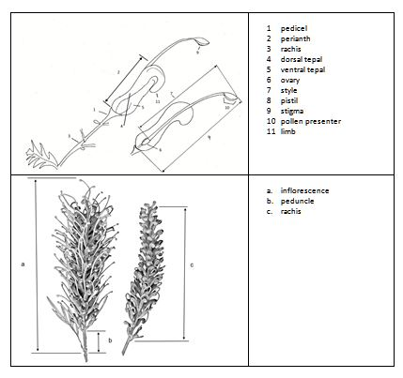

8.2 Explanations for individual characteristics
Ad. 1: Plant: habit

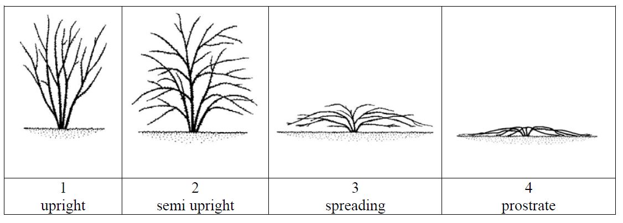
Ad. 5: Young stem: color
Sometimes there is a waxy layer covering the stem surface which gives a bluish or whitish appearance. The layer should be removed by rubbing before observing stem color.

Ad. 7: Stem: color
Assessed on side least exposed to sun. Sometimes there is a waxy layer covering the stem surface which gives a bluish or whitish appearance. The layer should be removed by rubbing before observing stem color.
Ad. 8: Leaf: length of blade
Observed on varieties with absent or primary division of leaves only
a - leaf length of blade, observed excluding petiole

b - leaf width of blade, observed at widest point
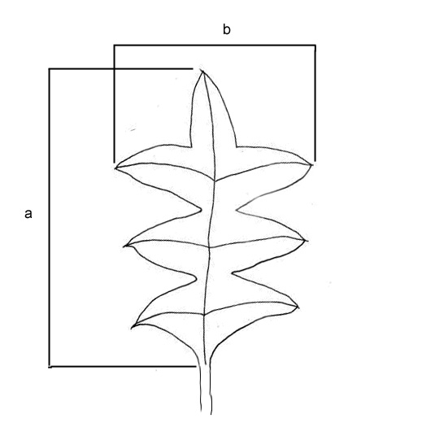
Where to observe leaf length and width
Ad. 13: Leaf: blade shape
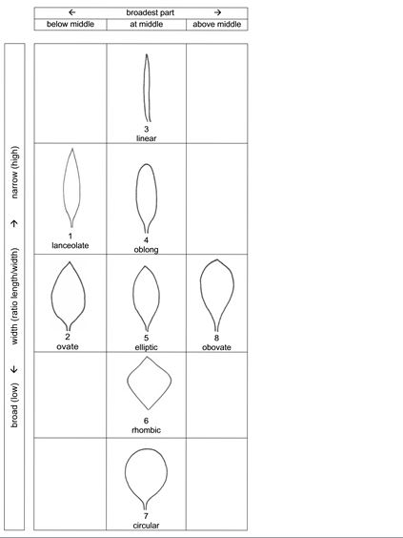
Only leaves with division of blade absent
Ad. 14: Leaf: type of division of blade
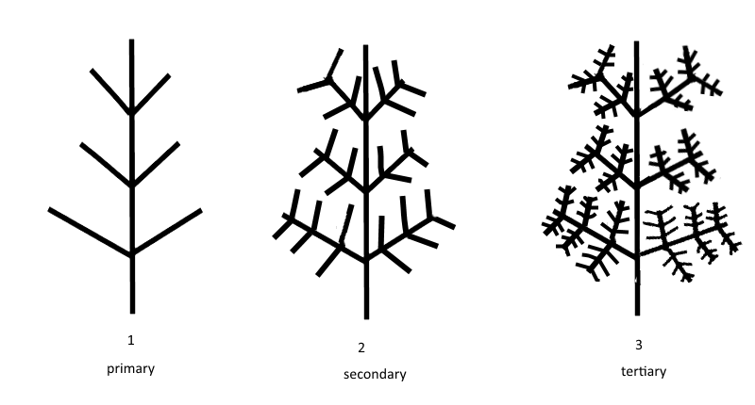
Ad. 15: Leaf: depth of sinus
Varieties with primary division present only.
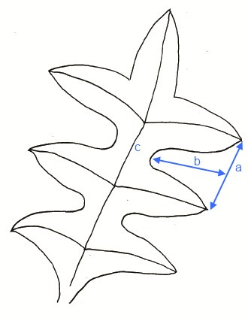
a: sinus width,
b:sinus depth,
c: midrib

Ad. 16: Leaf: number of lobes
Varieties with primary division of blade present only.

Ad. 18: Leaf: attitude of primary lobes in relation to midrib
Only varieties where division of leaf is present

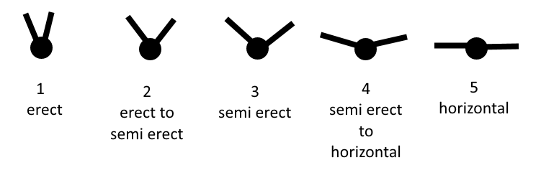

Ad. 19: Leaf: shape of apex of sinus
Varieties with primary division present only.

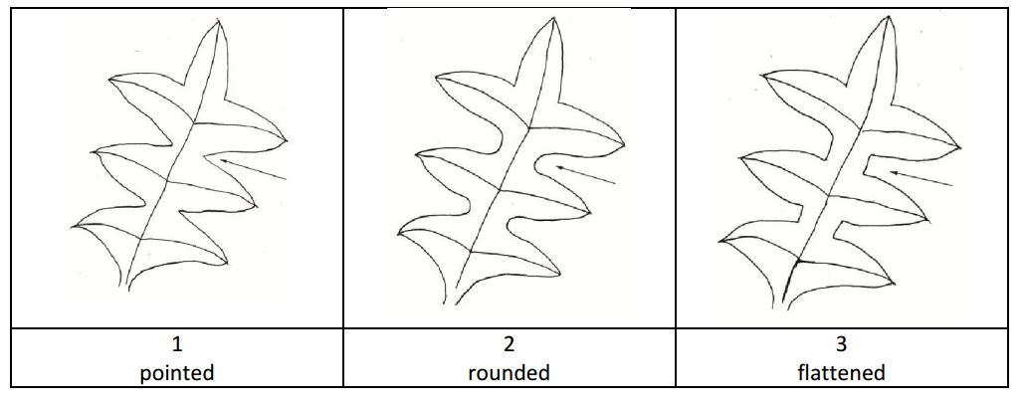

Ad. 20: Leaf: width of sinus
Observed, at widest point, on varieties with only primary division of blade present

Ad. 21: Leaf: length of lobe
Varieties with primary division of blade present only.

Ad. 22: Leaf: width of lobe
Varieties with primary division of blade present only.

Ad. 23: Leaf: shape of apex

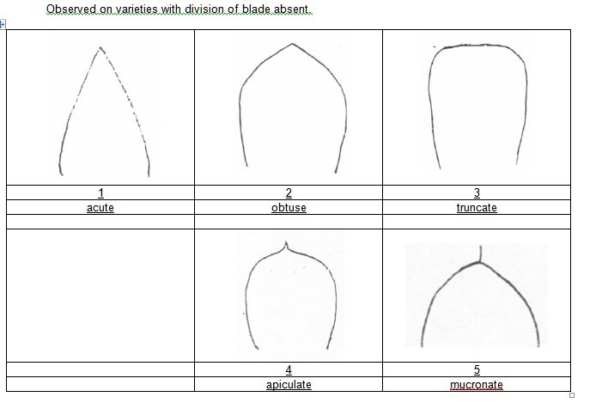
Ad. 24: Leaf: profile in cross section

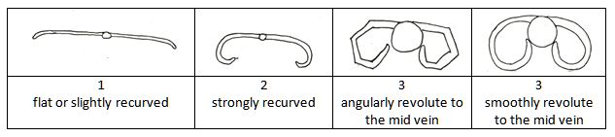

Ad. 26: Leaf: color of lower side
Overall appearance of color with hairs present

Ad. 32: Inflorescence: attitude
Observed on natural position on plant

Ad. 36: Inflorescence: type
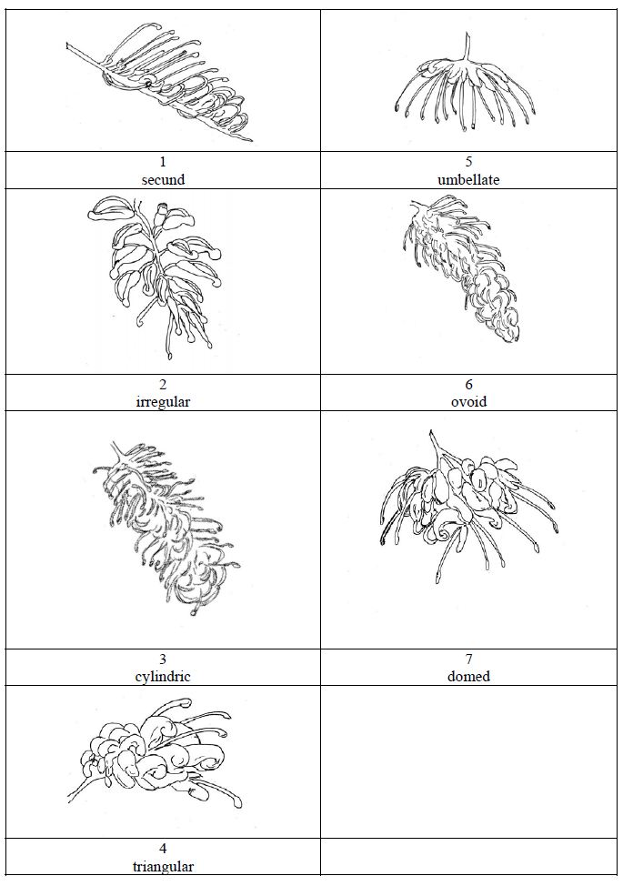

Ad. 37: Inflorescence: sequence of flower opening
Acropetal - flowers open sequentially towards the top of the inflorescence.
Basipetal - flowers open sequentially towards the base of the inflorescence.
Synchronous - flowers open approximately the same time across the length of the inflorescence

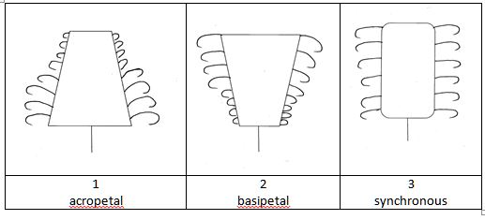

Ad. 42: Pedicel: attitude in relation to rachis
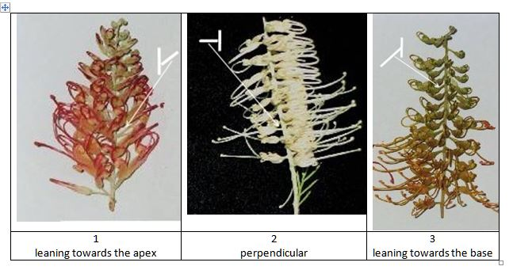

Ad. 44: Flower bud: attitude of limb in relation to longitudinal axis of bud
Observed during late bud prior to anthesis.

Ad. 49: Perianth: hairiness
observed on the outerside of perianth and including limb

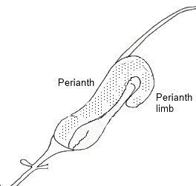

Ad. 51: Perianth: coherence of tepals on dorsal side
Observed as the length of tepal sticking (not fused) to the perianth

Ad. 52: Perianth: coherence of tepals on ventral side
Observed as the length of tepal sticking (not fused) to the perianth

Ad. 53: Perianth: color
Observed on open flower

Ad. 57: Style: curvature
Observed after anthesis before dehiscence of perianth.
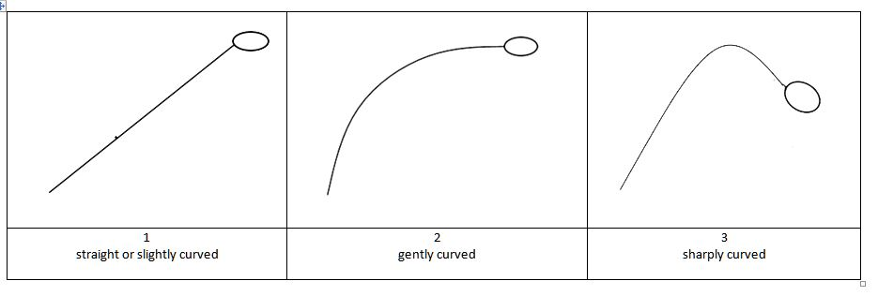

Ad. 65: Pollen presenter: attitude to style

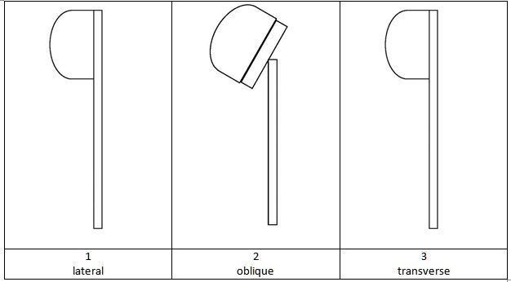

Ad. 66: Pollen presenter: in-line with style

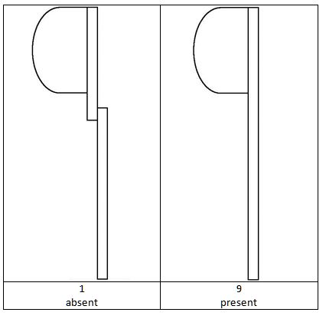

Ad. 67: Pollen presenter: shape

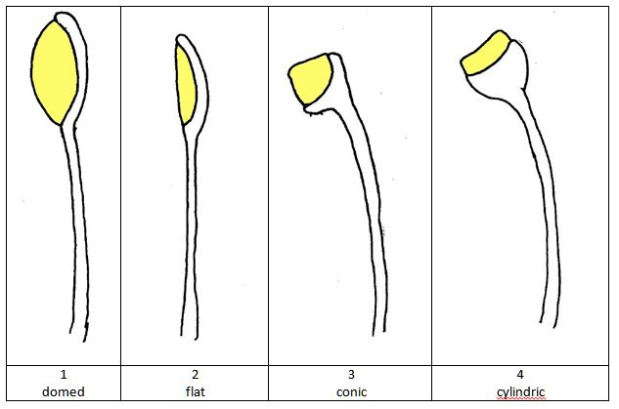

Literature

McGillivray, D. J.,Makinson, R. O., 1993: Grevillea, Proteaceae : a taxonomic revision. Melbourne University Press at the Miegunyah Press, Carlton, Vic. AU, 465 pp.

Elliott and Jones

Technical Questionnaire

TECHNICAL QUESTIONNAIRE |  | Page {x} of {y} | Reference Number:
 |  |  | Application date:
 |  |  | (not to be filled in by the applicant)
TECHNICAL QUESTIONNAIRE
to be completed in connection with an application for plant breeders’ rights

1. Subject of the Technical Questionnaire
1.1.1 | Botanical Name | Grevillea R. Br. corr. R. Br.
1.1.2 | Common Name | Grevillea

2. Applicant
Name
Address
Telephone No.
Fax No.
E-mail address
Breeder (if different from applicant)
3. Proposed denomination and breeder’s reference
Proposed denomination
(if available)

Breeder’s reference

TECHNICAL QUESTIONNAIRE |  | Page {x} of {y} | Reference Number:
4. Information on the breeding scheme and propagation of the variety

4.1 Breeding scheme

4.2 Method of propagating the variety

4.2.1 Other [ ]

(please provide details)
..................................................................................................................................................
: :
: :
:................................................................................................................................................:

5. Characteristics of the variety to be indicated (the number in brackets refers to the corresponding characteristic in Test Guidelines; please mark the note which best corresponds).

 | Characteristics | Example Varieties | Note
5.1 (1) | Plant: habit
 | upright | Callum’s Gold | 1[ ]
 | semi upright | Honey Gem | 2[ ]
 | spreading | Ninderry-Sunrise | 3[ ]
 | prostrate | Raptor | 4[ ]
5.2 (12) | Leaf: division of blade
 | absent | Fire Cracker | 1[ ]
 | present | Callum’s Gold | 9[ ]
5.3 (36) | Inflorescence: type
 | secund | Ninderry-Sunrise | 1[ ]
 | irregular | LadyO | 2[ ]
 | cylindrical | Callum’s Gold | 3[ ]
 | triangular | Fireworks | 4[ ]
 | umbellate |  | 5[ ]
 | ovoid |  | 6[ ]
 | domed | H22 | 7[ ]
5.4 (38) | Inflorescence: predominant color
 | white | Ivory Whip | 1[ ]
 | green |  | 2[ ]
 | yellow | Callum’s Gold | 3[ ]
 | orange | Ninderry-Sunrise | 4[ ]
 | pink | Blood Orange | 5[ ]
 | red | Raptor | 6[ ]
 | black |  | 7[ ]
5.5 (53) | Perianth: color
 | white | Ivory Whip | 1[ ]
 | green | Sandra Gordon | 2[ ]
 | yellow | Callum’s Gold | 3[ ]
 | orange | Ninderry-Sunrise | 4[ ]
 | pink | Blood Orange | 5[ ]
 | red | Raptor | 6[ ]
 | black |  | 7[ ]

6. Similar varieties and differences from these varieties

Please use the following table and box for comments to provide information on how your candidate variety differs from the variety (or varieties) which, to the best of your knowledge, is (or are) most similar. This information may help the examination authority to conduct its examination of distinctness in a more efficient way.

Denomination(s) of variety(ies) similar to your candidate variety | Characteristic(s) in which your candidate variety differs from the similar variety(ies) | Describe the expression of the characteristic(s) for the similar variety(ies) | Describe the expression of the characteristic(s) for your candidate variety
Example
Comments:

7. Additional information which may help in the examination of the variety

7.1 In addition to the information provided in sections 5 and 6, are there any additional characteristics which may help to distinguish the variety?

Yes [ ] No [ ]

(If yes, please provide details)

7.2 Are there any special conditions for growing the variety or conducting the examination?

Yes [ ] No [ ]

(If yes, please provide details)

7.3 Other information

8. Authorization for release

(a) Does the variety require prior authorization for release under legislation concerning the protection of the environment, human and animal health?

Yes [ ] No [ ]

(b) Has such authorization been obtained?

Yes [ ] No [ ]

If the answer to (b) is yes, please attach a copy of the authorization.

TECHNICAL QUESTIONNAIRE | Page {x} of {y} | Reference Number:
9. Information on plant material to be examined or submitted for examination

9.1 The expression of a characteristic or several characteristics of a variety may be affected by factors, such as pests and disease, chemical treatment (e.g. growth retardants or pesticides), effects of tissue culture, different rootstocks, scions taken from different growth phases of a tree, etc.

9.2 The plant material should not have undergone any treatment which would affect the expression of the characteristics of the variety, unless the competent authorities allow or request such treatment. If the plant material has undergone such treatment, full details of the treatment must be given. In this respect, please indicate below, to the best of your knowledge, if the plant material to be examined has been subjected to:

(a) Microorganisms (e.g. virus, bacteria, phytoplasma) Yes [ ] No [ ]

(b) Chemical treatment (e.g. growth retardant, pesticide) Yes [ ] No [ ]

(c) Tissue culture Yes [ ] No [ ]

(d) Other factors Yes [ ] No [ ]

Please provide details for where you have indicated “yes”.

10. I hereby declare that, to the best of my knowledge, the information provided in this form is correct:

Applicant’s name

Signature Date

[End of document]

* These names were correct at the time of the introduction of these Test Guidelines but may be revised or updated. [Readers are advised to consult the UPOV Code, which can be found on the UPOV Website (www.upov.int), for the latest information.]

