E
TG/AGLAO(proj.5)
ORIGINAL: English
DATE: 2015-08-03
INTERNATIONAL UNION FOR THE PROTECTION OF NEW VARIETIES OF PLANTS
Geneva
DRAFT

 | Aglaonema  UPOV Code: AGLAO  Aglaonema Schott | *

GUIDELINES
FOR THE CONDUCT OF TESTS
FOR DISTINCTNESS, UNIFORMITY AND STABILITY

prepared by (an) expert(s) from Japan

to be considered by the
Technical Working Party for Ornamental Plants and Forest Trees
at its forty-eighth session
to be held in Cambridge, United Kingdom,
from 2015-09-14
to 2015-09-18

Alternative Names:*
Botanical name | English | French | German | Spanish
Aglaonema Schott | Chinese Evergreen

The purpose of these guidelines (“Test Guidelines”) is to elaborate the principles contained in the General Introduction (document TG/1/3), and its associated TGP documents, into detailed practical guidance for the harmonized examination of distinctness, uniformity and stability (DUS) and, in particular, to identify appropriate characteristics for the examination of DUS and production of harmonized variety descriptions.

ASSOCIATED DOCUMENTS
These Test Guidelines should be read in conjunction with the General Introduction and its associated TGP documents.
TABLE OF CONTENTS PAGE

1. Subject of these Test Guidelines 3
2. Material Required 3
3. Method of Examination 3
3.1 Number of Growing Cycles 3
3.2 Testing Place 3
3.3 Conditions for Conducting the Examination 3
3.4 Test Design 3
3.5 Additional Tests 3
4. Assessment of Distinctness, Uniformity and Stability 4
4.1 Distinctness 4
4.2 Uniformity 5
4.3 Stability 5
5. Grouping of Varieties and Organization of the Growing Trial 5
6. Introduction to the Table of Characteristics 6
6.1 Categories of Characteristics 6
6.2 States of Expression and Corresponding Notes 6
6.3 Types of Expression 6
6.4 Example Varieties 6
6.5 Legend 7
7. Table of Characteristics/Tableau des caractères/Merkmalstabelle/Tabla de caracteres 8
8. Explanations on the Table of Characteristics 27
9. Literature 38
10. Technical Questionnaire 39

Subject of these Test Guidelines

These Test Guidelines apply to all varieties of Aglaonema Schott.

Material Required

2.1 The competent authorities decide on the quantity and quality of the plant material required for testing the variety and when and where it is to be delivered. Applicants submitting material from a State other than that in which the testing takes place must ensure that all customs formalities and phytosanitary requirements are complied with.

  - The material is to be supplied in the form of plants capable of expressing all relevant characteristics over the growing period.

2.3 The minimum quantity of plant material, to be supplied by the applicant, should be:

10 rooted cuttings.

2.4 The plant material supplied should be visibly healthy, not lacking in vigor, nor affected by any important pest or disease.

2.5 The plant material should not have undergone any treatment which would affect the expression of the characteristics of the variety, unless the competent authorities allow or request such treatment. If it has been treated, full details of the treatment must be given.

Method of Examination

3.1 Number of Growing Cycles

3.1.1 The minimum duration of tests should normally be a single growing cycle.

3.2 Testing Place

Tests are normally conducted at one place. In the case of tests conducted at more than one place, guidance is provided in TGP/9 “Examining Distinctness”.

3.3 Conditions for Conducting the Examination

3.3.1 The tests should be carried out under conditions ensuring satisfactory growth for the expression of the relevant characteristics of the variety and for the conduct of the examination.

3.3.2 Because daylight varies, color determinations made against a color chart should be made either in a suitable cabinet providing artificial daylight or in the middle of the day in a room without direct sunlight. The spectral distribution of the illuminant for artificial daylight should conform with the CIE Standard of Preferred Daylight D 6500 and should fall within the tolerances set out in the British Standard 950, Part I. These determinations should be made with the plant part placed against a white background. The color chart and version used should be specified in the variety description.

3.4 Test Design

3.4.1 Each test should be designed to result in a total of at least 10 plants.

3.4.2 The design of the tests should be such that plants or parts of plants may be removed for measurement or counting without prejudice to the observations which must be made up to the end of the growing cycle.

3.5 Additional Tests

Additional tests, for examining relevant characteristics, may be established.

Assessment of Distinctness, Uniformity and Stability

4.1 Distinctness

4.1.1 General Recommendations

It is of particular importance for users of these Test Guidelines to consult the General Introduction prior to making decisions regarding distinctness. However, the following points are provided for elaboration or emphasis in these Test Guidelines.

4.1.2 Consistent Differences

The differences observed between varieties may be so clear that more than one growing cycle is not necessary. In addition, in some circumstances, the influence of the environment is not such that more than a single growing cycle is required to provide assurance that the differences observed between varieties are sufficiently consistent. One means of ensuring that a difference in a characteristic, observed in a growing trial, is sufficiently consistent is to examine the characteristic in at least two independent growing cycles.

4.1.3 Clear Differences

Determining whether a difference between two varieties is clear depends on many factors, and should consider, in particular, the type of expression of the characteristic being examined, i.e. whether it is expressed in a qualitative, quantitative, or pseudo-qualitative manner. Therefore, it is important that users of these Test Guidelines are familiar with the recommendations contained in the General Introduction prior to making decisions regarding distinctness.

4.1.4 Number of Plants / Parts of Plants to be Examined

Unless otherwise indicated, for the purposes of distinctness, all observations on single plants should be made on 9 plants or parts taken from each of 9 plants and any other observations made on all plants in the test, disregarding any off-type plants.

4.1.5 Method of Observation

The recommended method of observing the characteristic for the purposes of distinctness is indicated by the following key in the second column of the Table of Characteristics (see document TGP/9 “Examining Distinctness”, Section 4 “Observation of characteristics”):

MG: single measurement of a group of plants or parts of plants
MS: measurement of a number of individual plants or parts of plants
VG: visual assessment by a single observation of a group of plants or parts of plants
VS: visual assessment by observation of individual plants or parts of plants

Type of observation: visual (V) or measurement (M)

“Visual” observation (V) is an observation made on the basis of the expert’s judgment. For the purposes of this document, “visual” observation refers to the sensory observations of the experts and, therefore, also includes smell, taste and touch. Visual observation includes observations where the expert uses reference points (e.g. diagrams, example varieties, side-by-side comparison) or non-linear charts (e.g. color charts). Measurement (M) is an objective observation against a calibrated, linear scale e.g. using a ruler, weighing scales, colorimeter, dates, counts, etc.

Type of record: for a group of plants (G) or for single, individual plants (S)

For the purposes of distinctness, observations may be recorded as a single record for a group of plants or parts of plants (G), or may be recorded as records for a number of single, individual plants or parts of plants (S). In most cases, “G” provides a single record per variety and it is not possible or necessary to apply statistical methods in a plant-by-plant analysis for the assessment of distinctness.

In cases where more than one method of observing the characteristic is indicated in the Table of Characteristics (e.g. VG/MG), guidance on selecting an appropriate method is provided in document TGP/9, Section 4.2.

4.2 Uniformity

    - It is of particular importance for users of these Test Guidelines to consult the General Introduction prior to making decisions regarding uniformity. However, the following points are provided for elaboration or emphasis in these Test Guidelines:

4.2.2 For the assessment of uniformity, a population standard of 1% and an acceptance probability of at least 95 % should be applied. In the case of a sample size of 10 plants, 1 off-type is allowed.

4.3 Stability

4.3.1 In practice, it is not usual to perform tests of stability that produce results as certain as those of the testing of distinctness and uniformity. However, experience has demonstrated that, for many types of variety, when a variety has been shown to be uniform, it can also be considered to be stable.

4.3.2 Where appropriate, or in cases of doubt, stability may be further examined by testing a new plant stock to ensure that it exhibits the same characteristics as those shown by the initial material supplied.

Grouping of Varieties and Organization of the Growing Trial

5.1 The selection of varieties of common knowledge to be grown in the trial with the candidate varieties and the way in which these varieties are divided into groups to facilitate the assessment of distinctness are aided by the use of grouping characteristics.

5.2 Grouping characteristics are those in which the documented states of expression, even where produced at different locations, can be used, either individually or in combination with other such characteristics: (a) to select varieties of common knowledge that can be excluded from the growing trial used for examination of distinctness; and (b) to organize the growing trial so that similar varieties are grouped together.

5.3 The following have been agreed as useful grouping characteristics:

(a) Leaf blade: length (characteristic 9)
(b) Leaf blade: width (characteristic 10)

(c) Leaf blade: color covering the largest surface area on upper side, with the following color groups:
Gr. 1: white
Gr. 2: green
Gr. 3: grey green
Gr. 4: yellow
Gr. 5: red
Gr. 6: red purple

(d) Leaf blade: color covering the second largest surface area on upper side, with the following color
groups:
Gr. 1: white
Gr. 2: green
Gr. 3: grey green
Gr. 4: yellow
Gr. 5: red
Gr. 6: red purple

5.4 Guidance for the use of grouping characteristics, in the process of examining distinctness, is provided through the General Introduction and document TGP/9 “Examining Distinctness”.

Introduction to the Table of Characteristics

6.1 Categories of Characteristics

6.1.1 Standard Test Guidelines Characteristics

Standard Test Guidelines characteristics are those which are approved by UPOV for examination of DUS and from which members of the Union can select those suitable for their particular circumstances.

6.1.2 Asterisked Characteristics

Asterisked characteristics (denoted by *) are those included in the Test Guidelines which are important for the international harmonization of variety descriptions and should always be examined for DUS and included in the variety description by all members of the Union, except when the state of expression of a preceding characteristic or regional environmental conditions render this inappropriate.

6.2 States of Expression and Corresponding Notes

6.2.1 States of expression are given for each characteristic to define the characteristic and to harmonize descriptions. Each state of expression is allocated a corresponding numerical note for ease of recording of data and for the production and exchange of the description.

6.2.2 In the case of qualitative and pseudo-qualitative characteristics (see Chapter 6.3), all relevant states of expression are presented in the characteristic. However, in the case of quantitative characteristics with 5 or more states, an abbreviated scale may be used to minimize the size of the Table of Characteristics. For example, in the case of a quantitative characteristic with 9 states, the presentation of states of expression in the Test Guidelines may be abbreviated as follows:

State | Note
small | 3
medium | 5
large | 7

However, it should be noted that all of the following 9 states of expression exist to describe varieties and should be used as appropriate:

State | Note
very small | 1
very small to small | 2
small | 3
small to medium | 4
medium | 5
medium to large | 6
large | 7
large to very large | 8
very large | 9

6.2.3 Further explanation of the presentation of states of expression and notes is provided in document TGP/7 “Development of Test Guidelines”.

6.3 Types of Expression

An explanation of the types of expression of characteristics (qualitative, quantitative and pseudo-qualitative) is provided in the General Introduction.

6.4 Example Varieties

Where appropriate, example varieties are provided to clarify the states of expression of each characteristic.

6.5 Legend

(*) Asterisked characteristic – see Chapter 6.1.2

QL Qualitative characteristic – see Chapter 6.3
QN Quantitative characteristic – see Chapter 6.3
PQ Pseudo-qualitative characteristic – see Chapter 6.3

MG, MS, VG, VS – see Chapter 4.1.5

(a)-(q) See Explanations on the Table of Characteristics in Chapter 8.

(+) See Explanations on the Table of Characteristics in Chapter 8.

Table of Characteristics/Tableau des caractères/Merkmalstabelle/Tabla de caracteres

English | français | deutsch | español | Example Varieties Exemples Beispielssorten Variedades ejemplo | Note/ Nota
1. QN MG VG
Plant: height | Plante: hauteur | Pflanze: Höhe | Planta: altura
short | basse | niedrig | baja | Subrungrueng | 3
medium | moyenne | mittel | media | Chalit's Pride | 5
tall | haute | hoch | alta | Thep Ranjuan | 7
2. QN MS VG (+)
Plant: number of basal shoots | Plante: nombre de pousses basales | Pflanze: Anzahl Basistriebe | Planta: número de ramas basales
absent or very few |  |  |  | Cassic | 1
few |  |  |  |  | 2
medium |  |  |  | Katharngen | 3
many |  |  |  | Chaowang | 4
3. QN MS VG (a) (b)
Petiole: length | Pétiole: longueur | Blattstiel: Länge | Peciolo: longitud
short | court | kurz | corta |  | 3
medium | moyen | mittel | media | Chalit | 5
long | long | lang | larga | Katharngen | 7
4. PQ VG (a) (c)
Petiole: main color | Pétiole : couleur principale | Blattstiel: Hauptfarbe | Pecíolo: color principal
RHS Colour Chart (indicate reference number) | Code RHS des couleurs (indiquer le numéro de référence) | RHS-Farbkarte (Nummer angeben) | Carta de colores RHS (indicar el número de referencia)
5. (*) PQ VG (a) (c)
Petiole: secondary color (if present)
RHS Colour Chart (indicate reference number)

English | français | deutsch | español | Example Varieties Exemples Beispielssorten Variedades ejemplo | Note/ Nota
6. (*) QN MS VG (a) (b)
Leaf sheath: length | Gaine de la feuille: longueur | Blattscheide: Länge | Vaina de la hoja: longitud
absent or very short |  |  |  | World Heritage | 1
short |  |  |  | Bebadary | 3
medium |  |  |  | Pritty | 5
long |  |  |  | Katharngen | 7
7. QN VG (+) (a)
Leaf sheath: angle of apical part
strongly acute |  |  |  | Saisamorn | 1
moderately acute |  |  |  |  | 2
rectangular |  |  |  | Supmongkon | 3
moderately obtuse |  |  |  |  | 4
strongly obtuse |  |  |  | Katharngen | 5
8. (*) PQ VG (a) (c)
Leaf sheath: main color of outer side
RHS Colour Chart (indicate reference number)
9. (*) QN MS VG (a) (d)
Leaf blade: length | Limbe : longueur | Blattspreite: Länge | Limbo: longitud
short | court | kurz | corto | Black Beauty | 3
medium |  |  |  | Tiara | 5
long |  |  |  | Thep Ranjuan | 7

English | français | deutsch | español | Example Varieties Exemples Beispielssorten Variedades ejemplo | Note/ Nota
10. (*) QN MS VG (a) (d)
Leaf blade: width | Limbe : largeur | Blattspreite: Breite | Limbo: anchura
narrow | étroit | schmal | estrecho | Thep Ranjuan | 3
medium |  |  |  | Katharngen | 5
broad |  |  |  | World Heritage | 7
11. QN MS VG (+) (a)
Leaf blade: ratio length/width | Limbe : rapport longueur/largeur | Blattspreite: Verhältnis Länge/Breite | Limbo: relación longitud/anchura
low |  |  |  | Parumruay | 3
medium |  |  |  | Katharngen | 5
high |  |  |  |  | 7
12. (*) QN VG (+) (a)
Leaf blade: position of broadest part
toward base | vers la base | zur Basis hin | hacia la base | Ribbon Evergreen | 1
at middle | au milieu | in der Mitte | en el medio | Pride of Sumatra | 2
toward apex | vers le sommet | zur Spitze hin | hacia el ápice | Ik Q san | 3
13. (*) PQ VG (+) (a)
Leaf blade: shape of apex | Limbe: forme du sommet | Blattspreite: Form der Spitze | Limbo: forma del ápice
strongly acute |  |  |  |  | 1
moderately acute |  |  |  |  | 2
obtuse |  |  |  |  | 3
14. (*) PQ VG (+) (a)
Leaf blade: shape of base | Limbe: forme de la base | Blattspreite: Form der Basis | Limbo: forma de la base
attenuate |  |  |  | Thep Ranjuan | 1
acute |  |  |  |  | 2
obtuse |  |  |  | Chalit | 3
truncate |  |  |  |  | 4
cordate |  |  |  | World Heritage | 5

English | français | deutsch | español | Example Varieties Exemples Beispielssorten Variedades ejemplo | Note/ Nota
15. (*) PQ VG (a) (e) (f) (g)
Leaf blade: color 1
RHS Colour Chart (indicate reference number)
16. (*) PQ VG (a) (e) (f) (g) (h) (i) (j) (k)
Leaf blade: distribution of color 1
along midrib |  |  |  |  | 1
at margin |  |  |  |  | 2
between midrib and margin |  |  |  |  | 3
along veins |  |  |  |  | 4
between veins |  |  |  |  | 5
throughout |  |  |  |  | 6
along midrib and at margin |  |  |  |  | 7
along midrib and along veins |  |  |  |  | 8
along midrib and throughout |  |  |  |  | 9
along veins and between veins |  |  |  |  | 10
at margin and throughout |  |  |  |  | 11
along midrib, along veins and throughout |  |  |  |  | 12
along midrib, along veins and between veins |  |  |  |  | 13
17. (*) QL VG (a) (e) (f) (g)
Leaf blade: pattern of color 1: brotches
absent |  |  |  |  | 1
present |  |  |  |  | 9

English | français | deutsch | español | Example Varieties Exemples Beispielssorten Variedades ejemplo | Note/ Nota
18. (*) QN VG (a) (e) (f) (g) (l)
Leaf blade: pattern of color 1: size of blotces
small |  |  |  |  | 1
medium |  |  |  |  | 2
large |  |  |  |  | 3
19. (*) QL VG (a) (e) (f) (g) (m)
Leaf blade: pattern of color 1: central bar
absent |  |  |  |  | 1
present |  |  |  |  | 9
20. (*) QL VG (a) (e) (f) (g) (n)
Leaf blade: pattern of color 1: stripes
absent |  |  |  |  | 1
present |  |  |  |  | 9
21. (*) QL VG (a) (e) (f) (g) (o)
Leaf blade: pattern of color 1: marginal zone
absent |  |  |  |  | 1
present |  |  |  |  | 9
22. (*) QL VG (a) (e) (f) (g) (p)
Leaf blade:pattern of color 1: solid or nearly solid
absent |  |  |  |  | 1
present |  |  |  |  | 9

English | français | deutsch | español | Example Varieties Exemples Beispielssorten Variedades ejemplo | Note/ Nota
23. (*) QN VG (a) (e) (f) (g)
Leaf blade: total area of color 1
small |  |  |  |  | 3
medium |  |  |  |  | 5
large |  |  |  |  | 7
24. (*) PQ VG (a) (e) (f) (g)
Leaf blade: color 2
RHS Colour Chart (indicate reference number)
25. (*) PQ VG (a) (e) (f) (g) (h) (i) (j) (k)
Leaf blade: distribution of color 2
along midrib |  |  |  |  | 1
at margin |  |  |  |  | 2
between midrib and margin |  |  |  |  | 3
along veins |  |  |  |  | 4
between veins |  |  |  |  | 5
throughtout |  |  |  |  | 6
along midrib and at margin |  |  |  |  | 7
along midrib and along veins |  |  |  |  | 8
along midrib and throughout |  |  |  |  | 9
along veins and between veins |  |  |  |  | 10
at margin and throughout |  |  |  |  | 11
along midrib, along veins and throught |  |  |  |  | 12
along midrib, along veins and between veins |  |  |  |  | 13
along midrib, at margin and along veins |  |  |  |  | 14

English | français | deutsch | español | Example Varieties Exemples Beispielssorten Variedades ejemplo | Note/ Nota
26. (*) QL VG (a) (e) (f) (g)
Leaf blade: pattern of color 2: blotches
absent |  |  |  |  | 1
present |  |  |  |  | 9
27. (*) QN VG (a) (e) (f) (g) (l)
Leaf blade: pattern of color 2: size of blotches
small |  |  |  |  | 1
medium |  |  |  |  | 2
large |  |  |  |  | 3
28. (*) QL VG (a) (e) (f) (g) (m)
Leaf blade: pattern of color 2: central bar
absent |  |  |  |  | 1
present |  |  |  |  | 9
29. (*) QL VG (a) (e) (f) (g) (n)
Leaf blade: pattern of color 2: stripes
absent |  |  |  |  | 1
present |  |  |  |  | 9
30. (*) QL VG (a) (e) (f) (g) (o)
Leaf blade: pattern of color 2: marginal zone
absent |  |  |  |  | 1
present |  |  |  |  | 9

English | français | deutsch | español | Example Varieties Exemples Beispielssorten Variedades ejemplo | Note/ Nota
31. (*) QL VG (a) (e) (f) (g) (p)
Leaf blade:pattern of color 2: solid or nearly solid
absent |  |  |  |  | 1
present |  |  |  |  | 9
32. (*) QN VG (a) (e) (f) (g)
Leaf blade: total area of color 2
small |  |  |  |  | 3
medium |  |  |  |  | 5
large |  |  |  |  | 7
33. (*) PQ VG (a) (e) (f) (g)
Leaf blade: color 3
RHS Colour Chart(indicate reference number)
34. (*) PQ VG (a) (e) (f) (g) (h) (i) (j) (k)
Leaf blade: distribution of color 3
along midrib |  |  |  |  | 1
at margin |  |  |  |  | 2
between midrib and margin |  |  |  |  | 3
along veins |  |  |  |  | 4
between veins |  |  |  |  | 5
throughout |  |  |  |  | 6
along midrib and at margin |  |  |  |  | 7
along midrib and along veins |  |  |  |  | 8
along midrib and throughout |  |  |  |  | 9
along veins and between veins |  |  |  |  | 10
at margin and throughout |  |  |  |  | 11
along midrib, along veins and throughout |  |  |  |  | 12
along midrib, along veins and between veins |  |  |  |  | 13
along midrib, at margin and along veins |  |  |  |  | 14

English | français | deutsch | español | Example Varieties Exemples Beispielssorten Variedades ejemplo | Note/ Nota
35. (*) QL VG (a) (e) (f) (g)
Leaf blade: pattern of color 3: blotches
absent |  |  |  |  | 1
present |  |  |  |  | 9
36. (*) QN VG (a) (e) (f) (g) (l)
Leaf blade: pattern of color 3: size of blotches
small |  |  |  |  | 1
medium |  |  |  |  | 2
large |  |  |  |  | 3
37. (*) QL VG (a) (e) (f) (g) (m)
Leaf blade: pattern of color 3: central bar
absent |  |  |  |  | 1
present |  |  |  |  | 9
38. (*) QL VG (a) (e) (f) (g) (n)
Leaf blade: pattern of color 3: stripes
absent |  |  |  |  | 1
present |  |  |  |  | 9
39. (*) QL VG (a) (e) (f) (g) (o)
Leaf blade: pattern of color 3: marginal zone
absent |  |  |  |  | 1
present |  |  |  |  | 9

English | français | deutsch | español | Example Varieties Exemples Beispielssorten Variedades ejemplo | Note/ Nota
40. (*) QL VG (a) (e) (f) (g) (p)
Leaf blade: pattern of color 3: solid or nearly solid
absent |  |  |  |  | 1
present |  |  |  |  | 9
41. (*) QN VG (a) (e) (f) (g)
Leaf blade: total area of color 3
small |  |  |  |  | 3
medium |  |  |  |  | 5
large |  |  |  |  | 7
42. (*) PQ VG (a) (e) (f) (g)
Leaf blade:color 4
RHS Colour Chart(indicate reference number)
43. (*) PQ VG (a) (e) (f) (g) (h) (i) (j) (k)
Leaf blade: distribution of color 4
along midrib |  |  |  |  | 1
at margin |  |  |  |  | 2
between midrib and margin |  |  |  |  | 3
along veins |  |  |  |  | 4
between veins |  |  |  |  | 5
throughout |  |  |  |  | 6
along midrib and at margin |  |  |  |  | 7
along midrib and along veins |  |  |  |  | 8
along midrib and throughout |  |  |  |  | 9
along veins and between veins |  |  |  |  | 10
at margin and throughout |  |  |  |  | 11
along midrib, along veins and throughout |  |  |  |  | 12
along midrib, along veins and between veins |  |  |  |  | 13
along midrib, at margin and along veins |  |  |  |  | 14

English | français | deutsch | español | Example Varieties Exemples Beispielssorten Variedades ejemplo | Note/ Nota
44. (*) QL VG (a) (e) (f) (g)
Leaf blade: pattern of color 4: blotches
absent |  |  |  |  | 1
present |  |  |  |  | 9
45. (*) QN VG (a) (e) (f) (g) (l)
Leaf blade: pattern of color 4: size of blotches
small |  |  |  |  | 1
medium |  |  |  |  | 2
large |  |  |  |  | 3
46. (*) QL VG (a) (e) (f) (g) (m)
Leaf blade: pattern of color 4: central bar
absent |  |  |  |  | 1
present |  |  |  |  | 9
47. (*) QL VG (a) (e) (f) (g) (n)
Leaf blade: pattern of color 4: stripes
absent |  |  |  |  | 1
present |  |  |  |  | 9
48. (*) QL VG (a) (e) (f) (g) (o)
Leaf blade: pattern of color 4: marginal zone
absent |  |  |  |  | 1
present |  |  |  |  | 9

English | français | deutsch | español | Example Varieties Exemples Beispielssorten Variedades ejemplo | Note/ Nota
49. (*) QL VG (a) (e) (f) (g) (p)
Leaf blade: pattern of color 4: solid or nearly solid
absent |  |  |  |  | 1
present |  |  |  |  | 9
50. (*) QN VG (a) (e) (f) (g)
Leaf blade: total area of color 4
small |  |  |  |  | 3
medium |  |  |  |  | 5
large |  |  |  |  | 7
51. (*) PQ VG (a) (e) (f) (g)
Leaf blade: color 1 of lower side
RHS Colour Chart (indicate referebce number)
52. (*) PQ VG (a) (e) (f) (g) (h) (q)
Leaf blade: distribution of color 1 of lower side
along midrib |  |  |  |  | 1
at margin |  |  |  |  | 2
between midrib and margin |  |  |  |  | 3
along veins |  |  |  |  | 4
between veins |  |  |  |  | 5
throughout |  |  |  |  | 6
along midrib and at margin |  |  |  |  | 7
along midrib and along veins |  |  |  |  | 8
along midrib and throughout |  |  |  |  | 9
along veins and between veins |  |  |  |  | 10
at margin and throughout |  |  |  |  | 11
along midrib, along veins and throughout |  |  |  |  | 12
along midrib, along veins and between veins |  |  |  |  | 13
along midrib, at margin and along veins |  |  |  |  | 14

English | français | deutsch | español | Example Varieties Exemples Beispielssorten Variedades ejemplo | Note/ Nota
53. (*) QL VG (a) (e) (f) (g)
Leafblade: pattern of color 1 of lower side: blotches
absent |  |  |  |  | 1
present |  |  |  |  | 9
54. (*) QN VG (a) (e) (f) (g) (l)
Leaf blade: pattern of color 1 of lower side: size of blotches
small |  |  |  |  | 1
medium |  |  |  |  | 2
large |  |  |  |  | 3
55. (*) QL VG (a) (e) (f) (g) (m)
Leaf blade: pattern of color 1 of lower side: central bar
absent |  |  |  |  | 1
present |  |  |  |  | 9
56. (*) QL VG (a) (e) (f) (g) (n)
Leaf blade: pattern of color 1 of lower side: stripes
absent |  |  |  |  | 1
present |  |  |  |  | 9
57. (*) QL VG (a) (e) (f) (g) (o)
Leaf blade:pattern of color 1 of lower side: marginal zone
absent |  |  |  |  | 1
present |  |  |  |  | 9

English | français | deutsch | español | Example Varieties Exemples Beispielssorten Variedades ejemplo | Note/ Nota
58. (*) QL VG (a) (e) (f) (g) (p)
Leaf blade: pattern of color 1 of lower side: solid or nearly solid
absent |  |  |  |  | 1
present |  |  |  |  | 9
59. (*) QL VG (a) (e) (f) (g)
Leaf blade: total area of color 1 of lower side
small |  |  |  |  | 3
medium |  |  |  |  | 5
large |  |  |  |  | 7
60. (*) PQ VG (a) (e) (f) (g)
Leafblade: color 2 of lower side
RHS Colour Chart (indicate reference number)
61. (*) PQ VG (a) (e) (f) (g) (h) (q)
Leaf blade: distribution of color 2 of lower side
along midrib |  |  |  |  | 1
at margin |  |  |  |  | 2
between midrib and margin |  |  |  |  | 3
along veins |  |  |  |  | 4
between veins |  |  |  |  | 5
throughout |  |  |  |  | 6
along midrib and at margin |  |  |  |  | 7
along midrib and along veins |  |  |  |  | 8
along midrib and throughout |  |  |  |  | 9
along veins and between veins |  |  |  |  | 10
at margin and throughout |  |  |  |  | 11
along midrib, along veins and throughout |  |  |  |  | 12
along midrib, along veins and between veins |  |  |  |  | 13
along midrib, at margin and along veins |  |  |  |  | 14

English | français | deutsch | español | Example Varieties Exemples Beispielssorten Variedades ejemplo | Note/ Nota
62. (*) QL VG (a) (e) (f) (g)
Leaf blade: pattern of color 2 of lower side: blotches
absent |  |  |  |  | 1
present |  |  |  |  | 9
63. (*) QN VG (a) (e) (f) (g) (l)
Leaf blade: pattern of color 2 of lower side: size of blotches
small |  |  |  |  | 1
medium |  |  |  |  | 2
large |  |  |  |  | 3
64. (*) QL VG (a) (e) (f) (g) (m)
Leaf blade: pattern of color 2 of lower side: central bar
absent |  |  |  |  | 1
present |  |  |  |  | 9
65. (*) QL VG (a) (e) (f) (g) (n)
Leaf blade: pattern of color 2 of lower side: stripes
absent |  |  |  |  | 1
present |  |  |  |  | 9
66. (*) QL VG (a) (e) (f) (g) (o)
Leaf blade:pattern of color 2 of lower side: marginal zone
absent |  |  |  |  | 1
present |  |  |  |  | 9

English | français | deutsch | español | Example Varieties Exemples Beispielssorten Variedades ejemplo | Note/ Nota
67. (*) QL VG (a) (e) (f) (g) (p)
Leaf blade: pattern of color 2 of lower side: solid or nearly solid
absent |  |  |  |  | 1
present |  |  |  |  | 9
68. (*) QN VG (a) (e) (f) (g)
Leaf blade: total area of color 2 of lower side
small |  |  |  |  | 3
medium |  |  |  |  | 5
large |  |  |  |  | 7
69. (*) PQ VG (a) (e) (f) (g)
Leaf blade: color 3 of lower side
RHS Color Chart (indicate reference number)
70. (*) PQ VG (a) (e) (f) (g) (h) (q)
Leaf blade: distribution of color 3 of lower side
along midrib |  |  |  |  | 1
at margin |  |  |  |  | 2
between midrib and margin |  |  |  |  | 3
along veins |  |  |  |  | 4
between veins |  |  |  |  | 5
throughout |  |  |  |  | 6
along midrib and at margin |  |  |  |  | 7
along midrib and along veins |  |  |  |  | 8
along midrib and throughout |  |  |  |  | 9
along midrib, at margin and along veins |  |  |  |  | 9
along veins and between veins |  |  |  |  | 10
at margin and throughout |  |  |  |  | 11
along midrib, along veins and throughout |  |  |  |  | 12
along midrib, along veins and between veins |  |  |  |  | 13
along midrib,at margin and alomg veins |  |  |  |  | 14

English | français | deutsch | español | Example Varieties Exemples Beispielssorten Variedades ejemplo | Note/ Nota
71. (*) QL VG (a) (e) (f) (g)
Leaf blade: pattern of color 3 of lower side: blotches
absent |  |  |  |  | 1
present |  |  |  |  | 9
72. (*) QN VG (a) (e) (f) (g) (l)
Leaf blade:pattern of color 3 of lower side: size of blotches
small |  |  |  |  | 1
medium |  |  |  |  | 2
large |  |  |  |  | 3
73. (*) QL VG (a) (e) (f) (g) (m)
Leaf blade: pattern of color 3 of lower side: central bar
absent |  |  |  |  | 1
present |  |  |  |  | 9
74. (*) QL VG (a) (e) (f) (g) (n)
Leaf blade: pattern of color 3 of lower side: stripes
absent |  |  |  |  | 1
present |  |  |  |  | 9
75. (*) QL VG (a) (e) (f) (g) (o)
Leaf blade: pattern of color 3 of lower side: marginal zone
absent |  |  |  |  | 1
present |  |  |  |  | 9

English | français | deutsch | español | Example Varieties Exemples Beispielssorten Variedades ejemplo | Note/ Nota
76. (*) QL VG (a) (e) (f) (g) (p)
Leaf blade: pattern of color 3 of lower side: solid or nearly solid
absent |  |  |  |  | 1
present |  |  |  |  | 9
77. (*) QN VG (a) (e) (f) (g)
Leaf blade: total area of color 3 of lower side
small |  |  |  |  | 3
medium |  |  |  |  | 5
large |  |  |  |  | 7
78. (*) QN VG (a) (e)
Leaf blade: glossiness
absent or very weak |  |  |  | Katharngen | 1
weak |  |  |  |  | 2
medium |  |  |  |  | 3
strong |  |  |  | Black Beauty | 4
79. (*) QN VG (+) (a)
Leaf blade: blistering
absent or weak |  |  |  | Katharngen | 1
medium |  |  |  | Tiara | 2
strong |  |  |  |  | 3
80. (*) QN VG (a)
Leaf blade: undulation of margin
absent or very weak |  |  |  | Chalit's Pride | 1
weak |  |  |  | Katharngen | 2
medium |  |  |  | Saisamorn | 3
strong |  |  |  | Black Beauty | 4

English | français | deutsch | español | Example Varieties Exemples Beispielssorten Variedades ejemplo | Note/ Nota
81. (*) QN VG (+) (a)
Leaf blade: profile in cross section
flat |  |  |  | Katharngen | 1
slightly concave |  |  |  |  | 2
moderately concave |  |  |  | Tiara | 3
82. (*) QN MS VG (+) (a)
Leaf blade: number of veins on lower side
few |  |  |  | Black Beauty | 1
medium |  |  |  |  | 2
many |  |  |  | Kwakngen | 3
83. (*) QN VG (+) (a)
Leaf blade: midrib: profile
raised |  |  |  | Legacy | 1
flat |  |  |  | Katharngen | 2
sunken |  |  |  | Russamithong | 3

Explanations on the Table of Characteristics

8.1 Explanations covering several characteristics

Characteristics containing the following key in the second column of the Table of Characteristics should be examined as indicated below:
(a) Leaf should be observed on the full grown leaves on middle third of foliage.
(b) Petiole: length and Leaf sheath: length should be observed as a following.
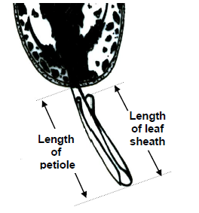
(c) The main color is the color with the largest surface area. in case where the areas of the main and secondary color are too similar to reliably decide which color has the largest area, the darkest color is considered to be the main color.
(d) Leaf blade: length and Leaf blade: width should be observed as followings.
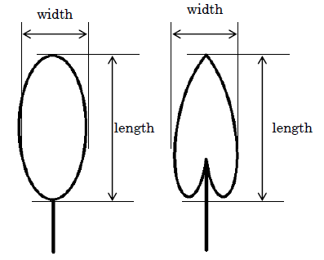
(e) Unless otherwise indicated, to be observed on the upper side of leaves.

(f) Where the characteristics refers to colors as "color 1", "color 2" etc.,they are to be recorded in the order that they appear on the RHS chart, i.e. color 1 is the one with the lowest number, color 2 with the second lowest and so on. For example, if the leaves are Green 137A patched with the White 155A, Green 137A will be a color 1 and White 155A color 2. If two colors are on the same page of the chart, for example Green 137A and Green 137D, 137A is regarded as the lower numbered color. It should be noted that under this system, ranking is independent of surface area, so the color covering the greatest surface area may be classified as color 3 or 4. The Guideline makes provision for four colors, if there are more, the color(s) with the smallest surface area(s) should be disregarded.
(g) In Aglaonema leaf color is very significant to the overall appearance of the variety. Leaves often have several colors in different patterns. This guideline allows the description of up to four colors using the RHS Colour Charts as well as the distributions, the patterns formed and the areas covered. Although the colors are referred to as "color 1", "color 2", "color 3" and "color 4" in the headings, this does not indicate a ranking according to prominence or area covered. The order in which the colors should be observed is dictated by the order the colors appear in the RHS Colour Charts, as described in followings. Example varieties have not been provided for the leaf color characteristics. This is because the number of combinations of observations that this guideline allows for, is larger than number of combinations seen. Providing example varieties for all states of expression in this cases would be misleading. In order to provide an illustration of the recording method, different worked examples are provided below, in (p),(q),(r) and (s).
(h) Leaf blade: distribution of color should be observed as followings. As additional explanation to these diagrums, the states of 'along midrib' may include the states of 'on mid rib'. 'veins' mean to primary lateral veins. 'along veins' may not mean along all primary veins.
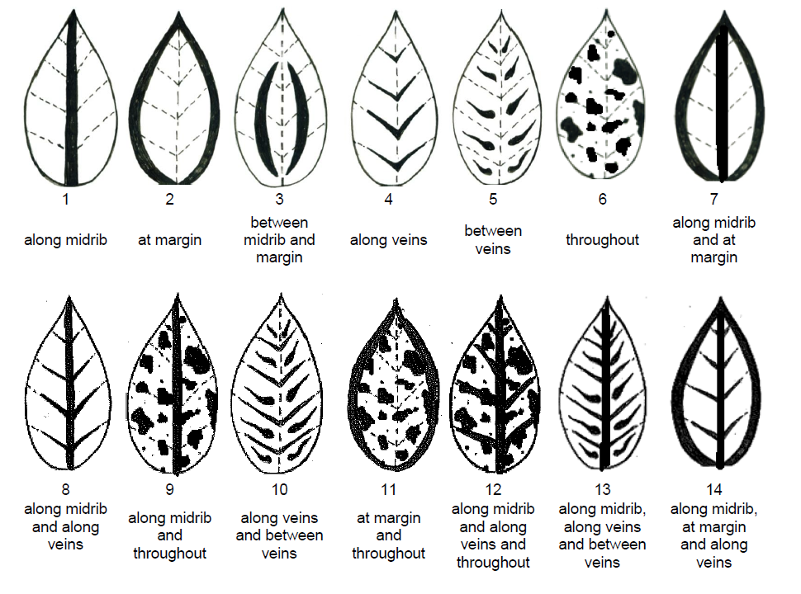

(i) Example-One Variety with three colors on upper side of leaf
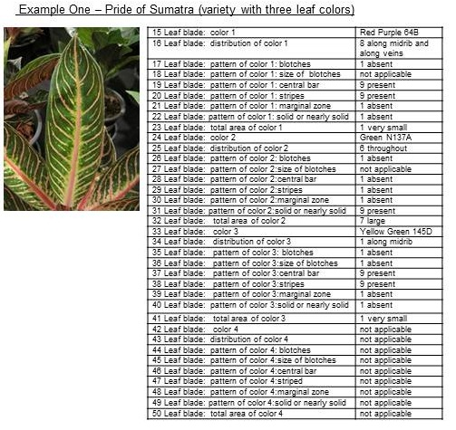

(j) Example-Two Variety with three colors on upper side of leaf
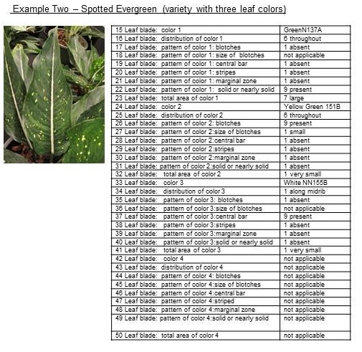

(k) Example-Three Variety with two colors on upper side of leaf
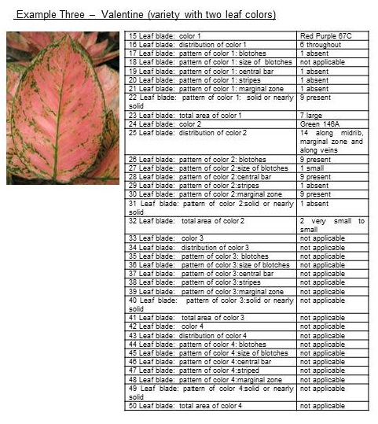

(l) Leaf blade: pattern of colors: size of brotches should be observed as followings.
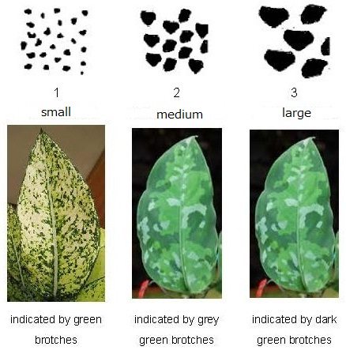
(m) Leaf blade: pattern of central bar should be observed as followings.
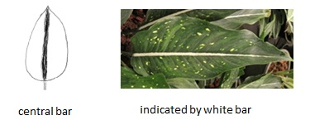
(n) Leaf blade: pattern of stripes should be observed as followings.
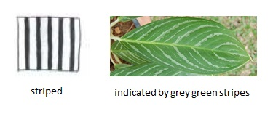
(o) Leaf blade: pattern of marginal zone should be observed as followings.
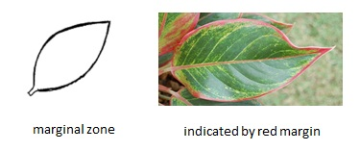
(p) Leaf blade: pattern of solid or nearly solid should be observed as followings.
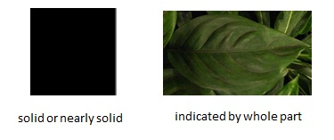

(q) Example-Four Variety with two colors on lower side of leaf
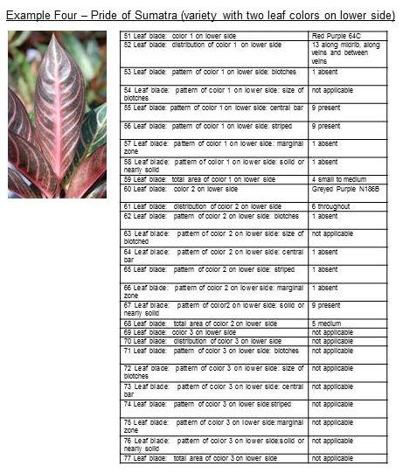

8.2 Explanations for individual characteristics

Ad. 2: Plant: number of basal shoots
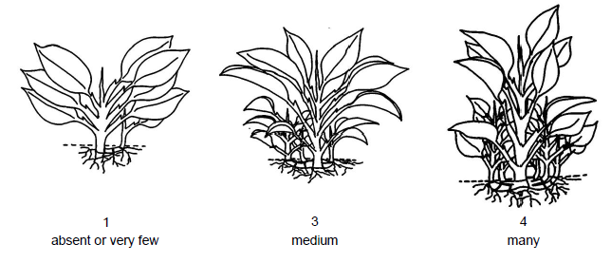

Ad. 7: Leaf sheath: angle of apical part

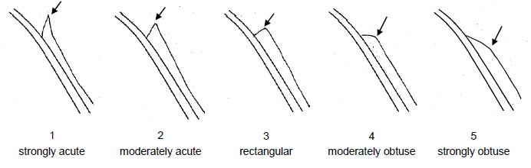

Ad. 11: Leaf blade: ratio length/width
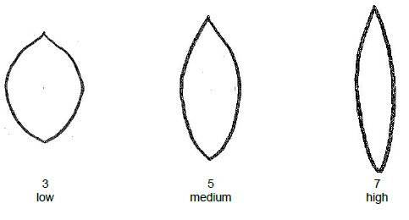

Ad. 12: Leaf blade: position of broadest part
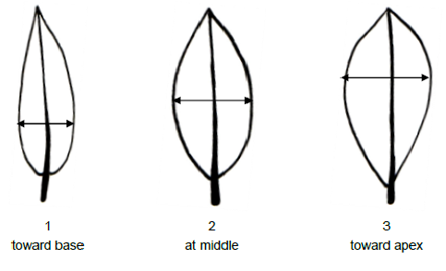

Ad. 13: Leaf blade: shape of apex

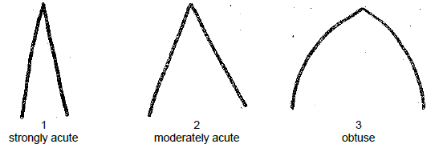

Ad. 14: Leaf blade: shape of base

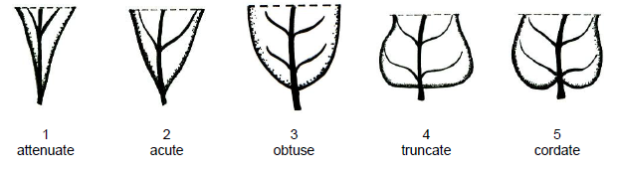

Ad. 79: Leaf blade: blistering

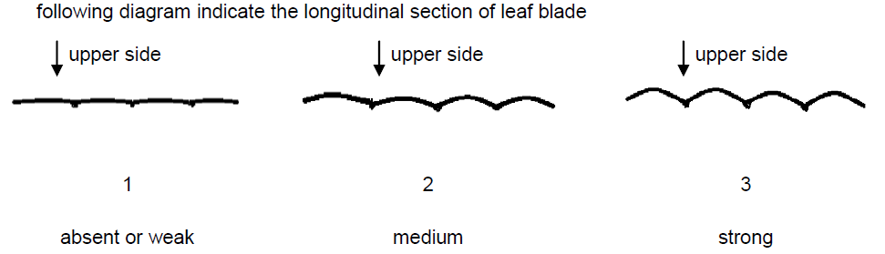

Ad. 81: Leaf blade: profile in cross section
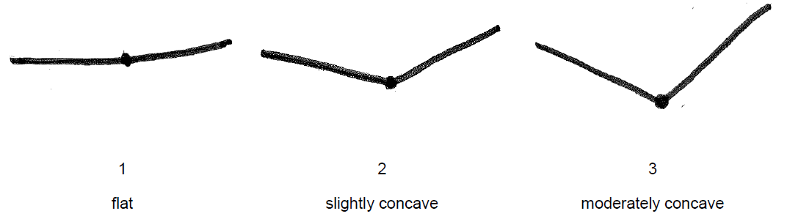
Ad. 82: Leaf blade: number of veins on lower side

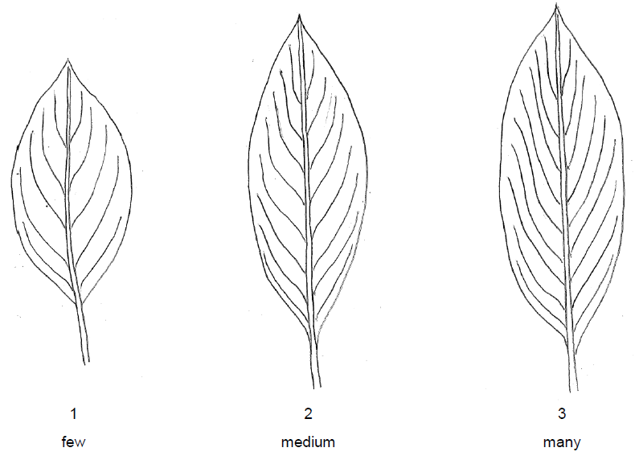
Ad. 83: Leaf blade: midrib: profile

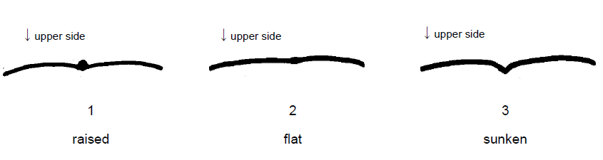

Literature

Nicolson, D.H., 1969: A revision of Genus Aglaonema(Araceae). Smithsonian Institution press. Washington, USA.63 pp.

Sinchaisri, N., et al., 2006: Catalog of Aglaonema in Thailand. Mitkaset Marketting and Advertisement company, Bangkok, Thailand TH,180 pp.

Thanabud P., 2000: Aglaonema, Amarin Printing and Publishing Public Co.,Ltd. Thailand, 239pp.

Technical Questionnaire

TECHNICAL QUESTIONNAIRE |  | Page {x} of {y} | Reference Number:
 |  |  | Application date:
 |  |  | (not to be filled in by the applicant)
TECHNICAL QUESTIONNAIRE
to be completed in connection with an application for plant breeders’ rights

1. Subject of the Technical Questionnaire
1.1.1 | Botanical Name | Aglaonema Schott
1.1.2 | Common Name | Chinese Evergreen
1.1.3 | Species

2. Applicant
Name
Address
Telephone No.
Fax No.
E-mail address
Breeder (if different from applicant)
3. Proposed denomination and breeder’s reference
Proposed denomination
(if available)

Breeder’s reference

TECHNICAL QUESTIONNAIRE |  | Page {x} of {y} | Reference Number:
4. Information on the breeding scheme and propagation of the variety

4.1 Breeding scheme

Variety resulting from:

4.1.1 Crossing

(a) controlled cross [ ]
(please state parent varieties)

(…………………..……………..…) x (……………..…………………..…)
female parent male parent

(b) partially known cross [ ]
(please state known parent variety(ies))

(…………………..……………..…) x (……………..…………………..…)
female parent male parent

(c) unknown cross [ ]

4.1.2 Mutation [ ]
(please state parent variety)

4.1.3 Discovery and development [ ]
(please state where and when discovered and how developed)

4.1.4 Other [ ]
(please provide details)

4.2 Method of propagating the variety

4.2.1 Vegetative propagation

(a) cuttings [ ]
(b) in vitro propagation [ ]
(c) [ ]
(d) Other (state method) [ ]
..................................................................................................................................................
: :
: :
:................................................................................................................................................:

4.2.2 [ ]

4.2.3 Other [ ]
(please provide details)
..................................................................................................................................................
: :
: :
:................................................................................................................................................:

5. Characteristics of the variety to be indicated (the number in brackets refers to the corresponding characteristic in Test Guidelines; please mark the note which best corresponds).

 | Characteristics | Example Varieties | Note
5.1 (9) | Leaf blade: length
 | very short |  | 1[ ]
 | very short to short |  | 2[ ]
 | short | Black Beauty | 3[ ]
 | short to medium |  | 4[ ]
 | medium | Tiara | 5[ ]
 | medium to long |  | 6[ ]
 | long | Thep Ranjuan | 7[ ]
 | long to very long |  | 8[ ]
 | very long |  | 9[ ]
5.2 (10) | Leaf blade: width
 | very narrow |  | 1[ ]
 | very narrow to narrow |  | 2[ ]
 | narrow | Thep Ranjuan | 3[ ]
 | narrow to medium |  | 4[ ]
 | medium | Katharngen | 5[ ]
 | medium to broad |  | 6[ ]
 | broad | World Heritage | 7[ ]
 | broad to very broad |  | 8[ ]
 | very broad |  | 9[ ]

6. Similar varieties and differences from these varieties

Please use the following table and box for comments to provide information on how your candidate variety differs from the variety (or varieties) which, to the best of your knowledge, is (or are) most similar. This information may help the examination authority to conduct its examination of distinctness in a more efficient way.

Denomination(s) of variety(ies) similar to your candidate variety | Characteristic(s) in which your candidate variety differs from the similar variety(ies) | Describe the expression of the characteristic(s) for the similar variety(ies) | Describe the expression of the characteristic(s) for your candidate variety
Example | Leaf blade: ratio length/width | low | medium
Comments:

7. Additional information which may help in the examination of the variety

7.1 In addition to the information provided in sections 5 and 6, are there any additional characteristics which may help to distinguish the variety?

Yes [ ] No [ ]

(If yes, please provide details)

7.2 Are there any special conditions for growing the variety or conducting the examination?

Yes [ ] No [ ]

(If yes, please provide details)

7.3 Other information

(c) Leaf blade: color covering the largest surface area on upper side, with the following color groups:

Gr.1: white […]
Gr.2: green […]
Gr.3: grey green […]
Gr.4: yellow […]
Gr.5: red […]
Gr.6: red purple […]

(d) Leaf blade: color covering the second largest surface area on upper side, with the following color groups:

Gr.1: white […]
Gr.2: green […]
Gr.3: grey green […]
Gr.4: yellow […]
Gr.5: red […]
Gr.6: red purple […]

7.4 A representative color photograph of the variety displaying its main distinguishing feature(s), should accompany the Technical Questionnaire. The photograph will provide a visual illustration of the candidate variety which supplements the information provided in the Technical Questionnaire.

The key points to consider when taking a photograph of the candidate variety are:

- Indication of the date and geographic location
- Correct labeling (breeder’s reference)
- Good quality printed photograph (minimum 10 cm x 15 cm) and/or sufficient resolution electronic format version (minimum 960 x 1280 pixels)

Further guidance on providing photographs with the Technical Questionnaire is available in document TGP/7 “Development of Test Guidelines”, Guidance Note 35 (http://www.upov.int/tgp/en/).

[The link provided may be deleted by members of the Union when developing authorities’ own test guidelines.]

8. Authorization for release

(a) Does the variety require prior authorization for release under legislation concerning the protection of the environment, human and animal health?

Yes [ ] No [ ]

(b) Has such authorization been obtained?

Yes [ ] No [ ]

If the answer to (b) is yes, please attach a copy of the authorization.

TECHNICAL QUESTIONNAIRE | Page {x} of {y} | Reference Number:
9. Information on plant material to be examined or submitted for examination

9.1 The expression of a characteristic or several characteristics of a variety may be affected by factors, such as pests and disease, chemical treatment (e.g. growth retardants or pesticides), effects of tissue culture, different rootstocks, scions taken from different growth phases of a tree, etc.

9.2 The plant material should not have undergone any treatment which would affect the expression of the characteristics of the variety, unless the competent authorities allow or request such treatment. If the plant material has undergone such treatment, full details of the treatment must be given. In this respect, please indicate below, to the best of your knowledge, if the plant material to be examined has been subjected to:

(a) Microorganisms (e.g. virus, bacteria, phytoplasma) Yes [ ] No [ ]

(b) Chemical treatment (e.g. growth retardant, pesticide) Yes [ ] No [ ]

(c) Tissue culture Yes [ ] No [ ]

(d) Other factors Yes [ ] No [ ]

Please provide details for where you have indicated “yes”.

10. I hereby declare that, to the best of my knowledge, the information provided in this form is correct:

Applicant’s name

Signature Date

[End of document]

* These names were correct at the time of the introduction of these Test Guidelines but may be revised or updated. [Readers are advised to consult the UPOV Code, which can be found on the UPOV Website (www.upov.int), for the latest information.]

