E
TG/ABELI(proj.3)
ORIGINAL: English
DATE: 2015-08-03
INTERNATIONAL UNION FOR THE PROTECTION OF NEW VARIETIES OF PLANTS
Geneva
DRAFT

 | Abelia  UPOV Code: ABELI  Abelia R. Br. | *

GUIDELINES
FOR THE CONDUCT OF TESTS
FOR DISTINCTNESS, UNIFORMITY AND STABILITY

prepared by (an) expert(s) from France

to be considered by the
Technical Working Party for Ornamental Plants and Forest Trees
at its forty-eighth session
to be held in Cambridge, United Kingdom,
from 2015-09-14
to 2015-09-18

Alternative Names:*
Botanical name | English | French | German | Spanish
Abelia R. Br. | Abelia | Abelia | Abelie | Abelia

The purpose of these guidelines (“Test Guidelines”) is to elaborate the principles contained in the General Introduction (document TG/1/3), and its associated TGP documents, into detailed practical guidance for the harmonized examination of distinctness, uniformity and stability (DUS) and, in particular, to identify appropriate characteristics for the examination of DUS and production of harmonized variety descriptions.

ASSOCIATED DOCUMENTS
These Test Guidelines should be read in conjunction with the General Introduction and its associated TGP documents.
TABLE OF CONTENTS PAGE

1. Subject of these Test Guidelines 3
2. Material Required 3
3. Method of Examination 3
3.1 Number of Growing Cycles 3
3.2 Testing Place 3
3.3 Conditions for Conducting the Examination 3
3.4 Test Design 3
3.5 Additional Tests 3
4. Assessment of Distinctness, Uniformity and Stability 4
4.1 Distinctness 4
4.2 Uniformity 5
4.3 Stability 5
5. Grouping of Varieties and Organization of the Growing Trial 5
6. Introduction to the Table of Characteristics 6
6.1 Categories of Characteristics 6
6.2 States of Expression and Corresponding Notes 6
6.3 Types of Expression 6
6.4 Example Varieties 7
6.5 Legend 7
7. Table of Characteristics/Tableau des caractères/Merkmalstabelle/Tabla de caracteres 8
8. Explanations on the Table of Characteristics 16
9. Literature 22
10. Technical Questionnaire 23

Subject of these Test Guidelines

These Test Guidelines apply to all varieties of Abelia R. Br..

Material Required

2.1 The competent authorities decide on the quantity and quality of the plant material required for testing the variety and when and where it is to be delivered. Applicants submitting material from a State other than that in which the testing takes place must ensure that all customs formalities and phytosanitary requirements are complied with.

  - The material is to be supplied in the form of plants capable of flowering and expressing all relevant characteristics of the variety during the first growing cycle.

2.3 The minimum quantity of plant material, to be supplied by the applicant, should be:

8 plants.

2.4 The plant material supplied should be visibly healthy, not lacking in vigor, nor affected by any important pest or disease.

2.5 The plant material should not have undergone any treatment which would affect the expression of the characteristics of the variety, unless the competent authorities allow or request such treatment. If it has been treated, full details of the treatment must be given.

Method of Examination

3.1 Number of Growing Cycles

3.1.1 The minimum duration of tests should normally be a single growing cycle.

3.2 Testing Place

Tests are normally conducted at one place. In the case of tests conducted at more than one place, guidance is provided in TGP/9 “Examining Distinctness”.

3.3 Conditions for Conducting the Examination

3.3.1 The tests should be carried out under conditions ensuring satisfactory growth for the expression of the relevant characteristics of the variety and for the conduct of the examination.

3.3.2 Because daylight varies, color determinations made against a color chart should be made either in a suitable cabinet providing artificial daylight or in the middle of the day in a room without direct sunlight. The spectral distribution of the illuminant for artificial daylight should conform with the CIE Standard of Preferred Daylight D 6500 and should fall within the tolerances set out in the British Standard 950, Part I. These determinations should be made with the plant part placed against a white background. The color chart and version used should be specified in the variety description.

3.4 Test Design

3.4.1 Each test should be designed to result in a total of at least 8 plants.

3.4.2 The design of the tests should be such that plants or parts of plants may be removed for measurement or counting without prejudice to the observations which must be made up to the end of the growing cycle.

3.5 Additional Tests

Additional tests, for examining relevant characteristics, may be established.

Assessment of Distinctness, Uniformity and Stability

4.1 Distinctness

4.1.1 General Recommendations

It is of particular importance for users of these Test Guidelines to consult the General Introduction prior to making decisions regarding distinctness. However, the following points are provided for elaboration or emphasis in these Test Guidelines.

4.1.2 Consistent Differences

The differences observed between varieties may be so clear that more than one growing cycle is not necessary. In addition, in some circumstances, the influence of the environment is not such that more than a single growing cycle is required to provide assurance that the differences observed between varieties are sufficiently consistent. One means of ensuring that a difference in a characteristic, observed in a growing trial, is sufficiently consistent is to examine the characteristic in at least two independent growing cycles.

4.1.3 Clear Differences

Determining whether a difference between two varieties is clear depends on many factors, and should consider, in particular, the type of expression of the characteristic being examined, i.e. whether it is expressed in a qualitative, quantitative, or pseudo-qualitative manner. Therefore, it is important that users of these Test Guidelines are familiar with the recommendations contained in the General Introduction prior to making decisions regarding distinctness.

4.1.4 Number of Plants / Parts of Plants to be Examined

Unless otherwise indicated, for the purposes of distinctness, all observations on single plants should be made on 7 plants or parts taken from each of 7 plants and any other observations made on all plants in the test, disregarding any off-type plants.

4.1.5 Method of Observation

The recommended method of observing the characteristic for the purposes of distinctness is indicated by the following key in the second column of the Table of Characteristics (see document TGP/9 “Examining Distinctness”, Section 4 “Observation of characteristics”):

MG: single measurement of a group of plants or parts of plants
MS: measurement of a number of individual plants or parts of plants
VG: visual assessment by a single observation of a group of plants or parts of plants
VS: visual assessment by observation of individual plants or parts of plants

Type of observation: visual (V) or measurement (M)

“Visual” observation (V) is an observation made on the basis of the expert’s judgment. For the purposes of this document, “visual” observation refers to the sensory observations of the experts and, therefore, also includes smell, taste and touch. Visual observation includes observations where the expert uses reference points (e.g. diagrams, example varieties, side-by-side comparison) or non-linear charts (e.g. color charts). Measurement (M) is an objective observation against a calibrated, linear scale e.g. using a ruler, weighing scales, colorimeter, dates, counts, etc.

Type of record: for a group of plants (G) or for single, individual plants (S)

For the purposes of distinctness, observations may be recorded as a single record for a group of plants or parts of plants (G), or may be recorded as records for a number of single, individual plants or parts of plants (S). In most cases, “G” provides a single record per variety and it is not possible or necessary to apply statistical methods in a plant-by-plant analysis for the assessment of distinctness.

In cases where more than one method of observing the characteristic is indicated in the Table of Characteristics (e.g. VG/MG), guidance on selecting an appropriate method is provided in document TGP/9, Section 4.2.

4.2 Uniformity

    - It is of particular importance for users of these Test Guidelines to consult the General Introduction prior to making decisions regarding uniformity. However, the following points are provided for elaboration or emphasis in these Test Guidelines:

4.2.2 For the assessment of uniformity of vegetatively propagated varieties, a population standard of 1% and an acceptance probability of at least 95% should be applied. In the case of a sample size of 8 plants, 1 off-type is allowed.

4.3 Stability

4.3.1 In practice, it is not usual to perform tests of stability that produce results as certain as those of the testing of distinctness and uniformity. However, experience has demonstrated that, for many types of variety, when a variety has been shown to be uniform, it can also be considered to be stable.

4.3.2 Where appropriate, or in cases of doubt, stability may be further examined by testing a new plant stock to ensure that it exhibits the same characteristics as those shown by the initial material supplied.

Grouping of Varieties and Organization of the Growing Trial

5.1 The selection of varieties of common knowledge to be grown in the trial with the candidate varieties and the way in which these varieties are divided into groups to facilitate the assessment of distinctness are aided by the use of grouping characteristics.

5.2 Grouping characteristics are those in which the documented states of expression, even where produced at different locations, can be used, either individually or in combination with other such characteristics: (a) to select varieties of common knowledge that can be excluded from the growing trial used for examination of distinctness; and (b) to organize the growing trial so that similar varieties are grouped together.

5.3 The following have been agreed as useful grouping characteristics:

(a) Plant: persistence of foliage (characteristic 1)
(b) Plant: growth habit (characteristic 2)
(c) Plant: height in relation to width (characteristic 3)
(d) Young shoot: anthocyanin (characteristic 6)
(e) Leaf blade: main color on upper side (characteristic 11)
green
yellow green
grey green
purple green
(f) Leaf blade: secondary color (characteristic 12)
white
pinkish white
yellow
yellow red
(g) Calyx lobes: color (characteristic 19)
pinkish white
light pink
orange pink
reddish
greenish
(h) Corolla lobe: main color of outer side (characteristic 27)
white
pink
violet pink

5.4 Guidance for the use of grouping characteristics, in the process of examining distinctness, is provided through the General Introduction and document TGP/9 “Examining Distinctness”.

Introduction to the Table of Characteristics

6.1 Categories of Characteristics

6.1.1 Standard Test Guidelines Characteristics

Standard Test Guidelines characteristics are those which are approved by UPOV for examination of DUS and from which members of the Union can select those suitable for their particular circumstances.

6.1.2 Asterisked Characteristics

Asterisked characteristics (denoted by *) are those included in the Test Guidelines which are important for the international harmonization of variety descriptions and should always be examined for DUS and included in the variety description by all members of the Union, except when the state of expression of a preceding characteristic or regional environmental conditions render this inappropriate.

6.2 States of Expression and Corresponding Notes

6.2.1 States of expression are given for each characteristic to define the characteristic and to harmonize descriptions. Each state of expression is allocated a corresponding numerical note for ease of recording of data and for the production and exchange of the description.

6.2.2 In the case of qualitative and pseudo-qualitative characteristics (see Chapter 6.3), all relevant states of expression are presented in the characteristic. However, in the case of quantitative characteristics with 5 or more states, an abbreviated scale may be used to minimize the size of the Table of Characteristics. For example, in the case of a quantitative characteristic with 9 states, the presentation of states of expression in the Test Guidelines may be abbreviated as follows:

State | Note
small | 3
medium | 5
large | 7

However, it should be noted that all of the following 9 states of expression exist to describe varieties and should be used as appropriate:

State | Note
very small | 1
very small to small | 2
small | 3
small to medium | 4
medium | 5
medium to large | 6
large | 7
large to very large | 8
very large | 9

6.2.3 Further explanation of the presentation of states of expression and notes is provided in document TGP/7 “Development of Test Guidelines”.

6.3 Types of Expression

An explanation of the types of expression of characteristics (qualitative, quantitative and pseudo-qualitative) is provided in the General Introduction.

6.4 Example Varieties

Where appropriate, example varieties are provided to clarify the states of expression of each characteristic.

6.5 Legend

(*) Asterisked characteristic – see Chapter 6.1.2

QL Qualitative characteristic – see Chapter 6.3
QN Quantitative characteristic – see Chapter 6.3
PQ Pseudo-qualitative characteristic – see Chapter 6.3

MG, MS, VG, VS – see Chapter 4.1.5

(a)-(f) See Explanations on the Table of Characteristics in Chapter 8.

(+) See Explanations on the Table of Characteristics in Chapter 8.

Table of Characteristics/Tableau des caractères/Merkmalstabelle/Tabla de caracteres

English | français | deutsch | español | Example Varieties Exemples Beispielssorten Variedades ejemplo | Note/ Nota
1. (*) QL VG (+) (a)
Plant: persistence of foliage
deciduous |  |  |  |  | 1
evergreen |  |  |  | Edward Goucher | 2
2. (*) PQ VG (+) (a)
Plant: growth habit | Plante : port | Pflanze: Wuchsform | Planta: hábito de crecimiento
upright | dressé | aufrecht | erguido | Edward Goucher | 1
semi-upright | semi-dressé | halbaufrecht | semierguido | Minaud | 2
rounded |  |  |  | Golden Panache | 3
spreading | étalé | breitwüchsig | extendido | Lynn | 4
3. (*) QN VG (a)
Plant: height in relation to width | Plante : hauteur par rapport à la largeur | Pflanze: Höhe im Verhältnis zur Breite | Planta: altura en relación con la anchura
taller than broad | plus haute que large | höher als breit | más alta que ancha | Edward Goucher, Sherwood | 1
as tall as broad | aussi haute que large | gleich hoch wie breit | tan alta como ancha | Golden Panache | 2
broader than tall | plus large que haute | breiter als hoch | más ancha que alta | Rupestri | 3
4. QN VG (+) (a)
Plant: density
sparse |  |  |  |  | 1
sparse to medium |  |  |  |  | 2
medium |  |  |  | Edward Goucher | 3
medium to dense |  |  |  |  | 4
dense |  |  |  | Golden Panache | 5

English | français | deutsch | español | Example Varieties Exemples Beispielssorten Variedades ejemplo | Note/ Nota
5. PQ VG (a) (b)
Stem: color
light brown |  |  |  |  | 1
dark brown |  |  |  |  | 2
reddish |  |  |  | Edward Goucher | 3
6. (*) QN VG (a) (b)
Young shoot: anthocyanin
absent or very weak |  |  |  |  | 1
weak |  |  |  |  | 3
medium |  |  |  |  | 5
strong |  |  |  |  | 7
7. QN MG MS VG (a) (c)
Leaf blade: length | Limbe : longueur | Blattspreite: Länge | Limbo: longitud
short |  |  |  | Golden Panache, Lynn | 3
medium |  |  |  | Edward Goucher | 5
long |  |  |  |  | 7
8. QN MG MS VG (a) (c)
Leaf blade: width | Limbe : largeur | Blattspreite: Breite | Limbo: anchura
narrow |  |  |  | Golden Panache, Lynn | 3
medium |  |  |  | Edward Goucher | 5
broad |  |  |  |  | 7

English | français | deutsch | español | Example Varieties Exemples Beispielssorten Variedades ejemplo | Note/ Nota
9. (*) QN MG VG (a) (d)
Leaf blade: ratio length/width | Limbe : rapport longueur/largeur | Blattspreite: Verhältnis Länge/Breite | Limbo: relación longitud/anchura
very low |  |  |  |  | 1
low |  |  |  |  | 2
medium |  |  |  |  | 3
high |  |  |  |  | 4
very high |  |  |  |  | 5
10. (*) PQ VG (a) (c) (d)
Leaf blade: shape | Limbe : forme | Blattspreite: Form | Limbo: forma
triangular |  |  |  |  | 1
ovate |  |  |  |  | 2
elliptic |  |  |  |  | 3
obovate |  |  |  |  | 4
lanceolate |  |  |  |  | 5
11. (*) PQ VG (+) (a) (c)
Leaf blade: main color on upper side
RHS Colour Chart (indicate reference number)
12. (*) PQ VG (a) (c)
Leaf blade: secondary color | Limbe : couleur secondaire | Blattspreite: Sekundärfarbe | Limbo: color secundario
RHS Colour Chart (indicate reference number)
13. (*) PQ VG (+) (a) (c)
Leaf blade: distribution of secondary color | Limbe : répartition de la couleur secondaire | Blattspreite: Verteilung der Sekundärfarbe | Limbo: distribución del color secundario
none |  |  |  |  | 1
on margin only |  |  |  |  | 2
broad margin |  |  |  |  | 3
central zone |  |  |  |  | 4
irregular |  |  |  |  | 5

English | français | deutsch | español | Example Varieties Exemples Beispielssorten Variedades ejemplo | Note/ Nota
14. (*) PQ VG (+) (a) (c)
Leaf blade: tertiary color
white |  |  |  |  | 1
green |  |  |  |  | 2
yellow |  |  |  |  | 3
pink |  |  |  |  | 4
red |  |  |  |  | 5
15. QN VG (a) (c)
Leaf blade: distribution of tertiary color
none |  |  |  |  | 1
on margin only |  |  |  |  | 2
irregular |  |  |  |  | 3
16. QN VG (a) (c)
Leaf blade: undulation
absent or very weak |  |  |  |  | 1
weak |  |  |  |  | 2
medium |  |  |  |  | 3
strong |  |  |  |  | 4
17. (*) QN VG (a) (c)
Leaf blade: glossiness
absent or weak |  |  |  | Panaché | 1
medium |  |  |  | Edward Goucher | 2
strong |  |  |  | Snowdrift | 3

English | français | deutsch | español | Example Varieties Exemples Beispielssorten Variedades ejemplo | Note/ Nota
18. QN VG (+) (a) (c)
Leaf blade: blistering | Limbe : cloqûre | Blattspreite: Blasigkeit | Limbo: abullonado
absent |  |  |  |  | 1
present |  |  |  |  | 9
19. (*) PQ VG (a)
Calyx lobes: color
pinkish white |  |  |  |  | 1
light pink |  |  |  | Gold Spot | 2
orange pink |  |  |  |  | 3
reddish |  |  |  | Edward Goucher | 4
greenish |  |  |  |  | 5
20. (*) QN MG VG (a)
Calyx lobes: number
only two |  |  |  | Edward Goucher | 1
only four |  |  |  | Francis Mason | 2
only five |  |  |  |  | 3
two to five |  |  |  | Minaud | 4
21. QN VG (+) (a)
Calyx lobes: width
narrow |  |  |  |  | 1
medium |  |  |  |  | 2
broad |  |  |  | Lynn | 3

English | français | deutsch | español | Example Varieties Exemples Beispielssorten Variedades ejemplo | Note/ Nota
22. (*) PQ VG (a)
Flower bud: color
RHS Colour Chart (indicate reference number)
23. (*) QN VG (+) (a)
Corolla lobe: attitude of upper part
erect |  |  |  |  | 1
semi-erect |  |  |  | Edward Goucher | 2
horizontal |  |  |  |  | 3
24. QN MG VG (a) (e)
Corolla: length | Corolle: longueur | Krone: Länge | Corola: longitud
very short |  |  |  |  | 1
short |  |  |  | Panaché | 3
medium |  |  |  | Minaud | 5
long |  |  |  |  | 7
very long |  |  |  | Lynn | 9
25. QN MG VG (a) (e) (f)
Corolla: diameter | Corolle : diamètre | Krone: Durchmesser | Corola: diámetro
narrow |  |  |  | Panaché | 1
medium |  |  |  | Minaud | 2
broad |  |  |  | Lynn | 3
26. (*) PQ VG (a) (f)
Corolla lobe: main color of inner side | Lobe de la corolle : couleur principale de la face interne | Kronlappen: Hauptfarbe der Innenseite | Lóbulo de la corola: color principal de la cara interna
RHS Colour Chart (indicate reference number)

English | français | deutsch | español | Example Varieties Exemples Beispielssorten Variedades ejemplo | Note/ Nota
27. (*) PQ VG (a)
Corolla lobe: main color of outer side
RHS Colour Chart (indicate reference number)
28. (*) QN VG (a)
Corolla tube: length | Tube de la corolle : longueur | Kronenröhre: Länge | Tubo de la corola: longitud
short |  |  |  |  | 1
medium |  |  |  | Kaleidoscope | 2
long |  |  |  |  | 3
29. (*) QL VG (+) (a)
Corolla throat: blotches
absent |  |  |  | Sherwood | 1
present |  |  |  | Minduo1 | 9
30. QN VG (a)
Corolla throat: hairiness
absent or sparse |  |  |  | Sherwood | 1
medium |  |  |  | Minduo1 | 2
dense |  |  |  |  | 3
31. (*) QN VG (a)
Stigma: position in relation to anthers | Stigmate : position par rapport aux anthères | Narbe: Stellung im Vergleich zu den Antheren | Estigma: posición en relación con las anteras
below |  |  |  |  | 1
same level |  |  |  | Minaud | 2
above |  |  |  | Minduo1 | 3

English | français | deutsch | español | Example Varieties Exemples Beispielssorten Variedades ejemplo | Note/ Nota
32. (*) PQ VG (a)
Anther: color | Anthère : couleur | Anthere: Farbe | Antera: color
white |  |  |  | Minaud | 1
yellowish |  |  |  | Minduo1 | 2
light purple |  |  |  |  | 3
33. QN VG (a)
Flower: fragrance | Fleur: parfum | Blüte: Duft | Flor: fragancia
absent or weak |  |  |  | Minaud | 1
medium |  |  |  | Sherwood | 2
strong |  |  |  |  | 3
34. (*) QN MG (+) (a)
Time of beginning of flowering | Époque de début de floraison | Zeitpunkt des Blühbeginns | Época del comienzo de la floración
early |  |  |  |  | 3
medium |  |  |  | Minaud | 5
late |  |  |  | Golden Panache | 7
35. (*) QN VG (a)
Plant: floriferousness | Plante : floribondité | Pflanze: Blütenreichhaltigkeit | Planta: capacidad florífera
sparse |  |  |  | Lynn | 3
medium |  |  |  | Minduo1 | 5
dense |  |  |  | Francis Mason | 7

Explanations on the Table of Characteristics

8.1 Explanations covering several characteristics

Characteristics containing the following key in the second column of the Table of Characteristics should be examined as indicated below:

(a) General illustration of flower
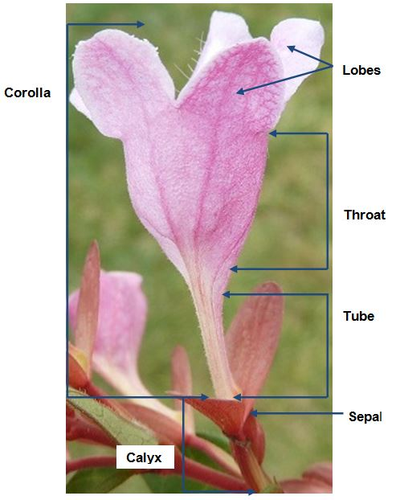
(b) Characteristics on shoots and leaves are to be observed on current year’s shoots.
(c) Observations are made on fully expanded leaves.

(d) Leaf blade: ratio length/width
Leaf blade: shape
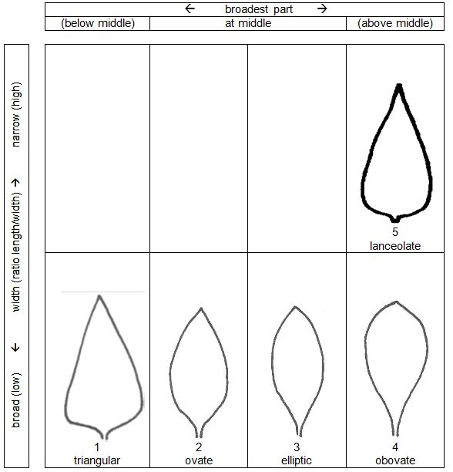
(e) Corolla: length
Corolla: diameter
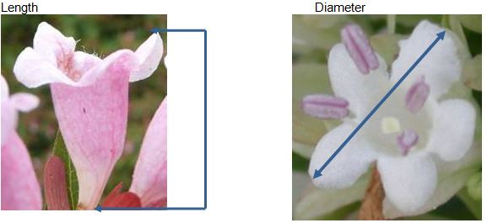

(f) Corolla lobe: main color of inner side
Corolla lobe: main color of outer side
The main color is the color with the largest surface area present on the inner side of a corolla lobe. In cases where the areas of the main and secondary colors are too similar to reliably decide which color has the largest area of the blade, the darkest color is considered to be the main color.
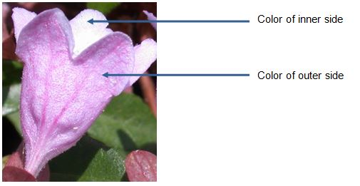

8.2 Explanations for individual characteristics

Ad. 1: Plant: persistence of foliage

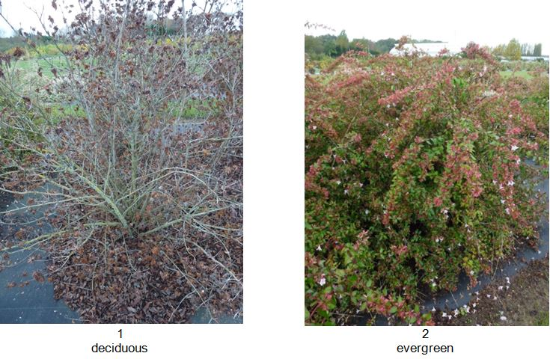
Ad. 2: Plant: growth habit
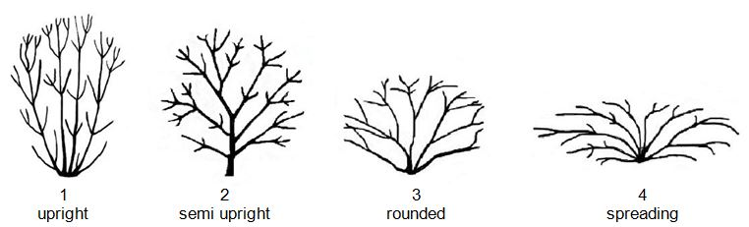

Ad. 4: Plant: density

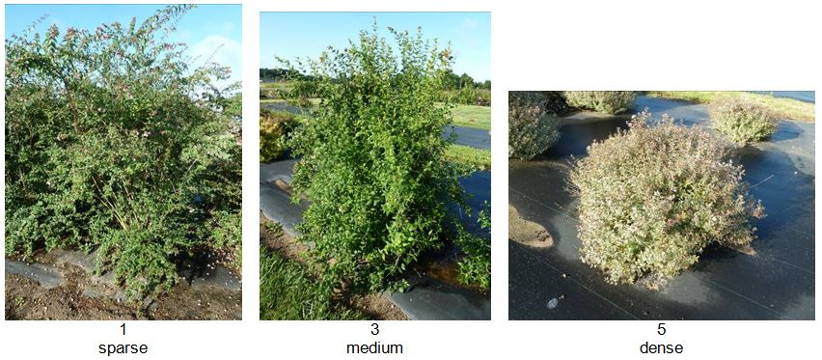

Ad. 11: Leaf blade: main color on upper side
The main color is the color with the largest surface area present on the upper side of a leaf. In cases where the areas of the main and secondary colors are too similar to reliably decide which color has the largest area of the blade, the darkest color is considered to be the main color.

Ad. 13: Leaf blade: distribution of secondary color
The secondary color is determined as the color with the second largest surface area, usually observed as a defined pattern on the upper side of a leaf.

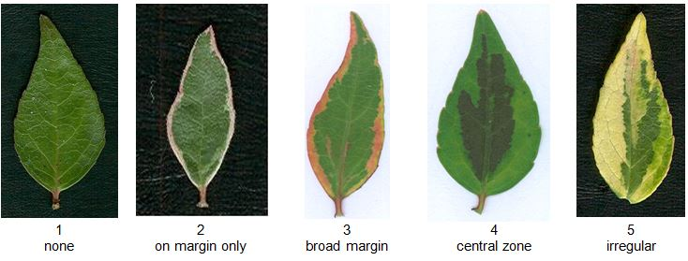

Ad. 14: Leaf blade: tertiary color
The tertiary color is determined as the color with the third largest surface area, usually observed as a defined pattern on the upper side of a leaf. The inner side is the same as the upper side.

Ad. 18: Leaf blade: blistering

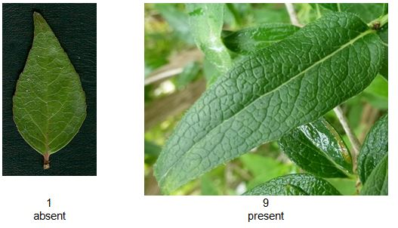

Ad. 21: Calyx lobes: width

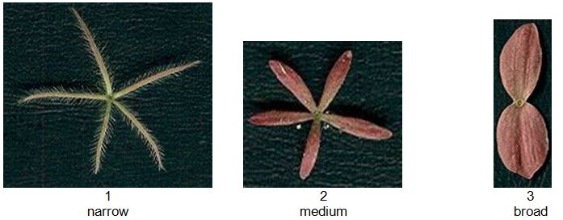

Ad. 23: Corolla lobe: attitude of upper part

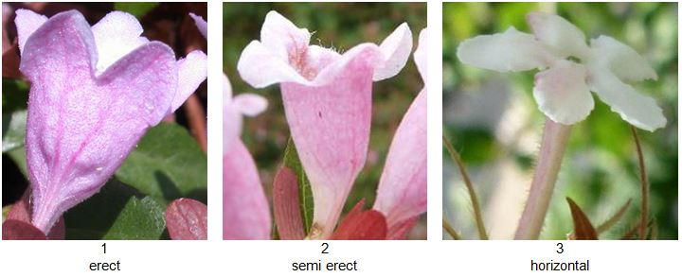

Ad. 29: Corolla throat: blotches

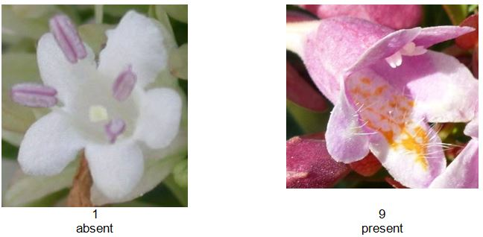

Ad. 34: Time of beginning of flowering
The time of beginning of flowering is when all plants have approximately 10% of inflorescences showing some open flowers.

Literature

Barnes, P. (2001) : Looking at Abelias New Plantsman. published by the Royal Horticultural Society.

Backlund, A. & N. Pyck (1998). Diervillaceae and Linnaeaceae, two new families of caprifolioids. Taxon 47(3) : 657-661.

Bailey, L.H. & E.Z. Bailey (1976) Hortus Third. New York, Macmillan.

Clarke, D. (1988) Supplement to Bean’s Trees and shrubs hardy in the British Isles. London, John Murray.

Griffiths, M. (ed.) (1994) The Royal Horticultural Society Index of Garden Plants. London, Macmillan.

Hayashi, Y. (1985) Woody plants of Japan. Tokyo, Yama-kei Publishers.

Hemsley, W.B. (1888) Journ. Linn. Soc. Bot. 23: 358. London.

Hooker, W.J. (ed.) (1853) Curtis’s Botanical Magazine t. 4694. London.

Hooker, J.D. (ed.) (1882) Curtis’s Botanical Magazine t. 6601. London.

Iconographia Cormophytorum Sinicorum (1976) 4 : 303

Iwatsuki, K., Yamazaki, T., Boufford, D.E. & Ohba, H. (eds.) (1993) Flora of Japan vol. 3a. Tokyo, Kodansha.

Kitamura, S., Murata,G., Colored illustrations of woody plants of Japan, 1: pl. 5 : 30, f.13:4 (1983). Osaka, Hoikusha.

Lindley, J. (1846) Botanical Register 32 : t. 8. London.

Lord, A.W. (ed.) (1999) The RHS Plant Finder 2000-2001. London, RHS & Dorling Kindersley.

Planchon, J.E. (1853) Abelia uniflora, in Flore des Serres 8 : 203, pl. 824.

Rehder, A. (1913) Abelia in Sargent, C.S. (ed.) Plantae Wilsonianae, 1 : 118-129. Jamaica Plain, Arnold Arboretum.

Rehder, A. (1940) Manual of cultivated trees and shrubs (2nd edition). New York, Macmillan.

RHS Good Plant Guide (1998). London, Dorling Kindersley. N.B., an electronic version with many of the illustrations, may be found on the RHS Plant Finder 2000-2001 CD-ROM. In some cases, the illustrations are much clearer than in the book.

Sugimoto, J. (1983) New Keys to Woody Plants of Japan (2nd edn.). Tokyo, Inoue Book Company.

Technical Questionnaire

TECHNICAL QUESTIONNAIRE |  | Page {x} of {y} | Reference Number:
 |  |  | Application date:
 |  |  | (not to be filled in by the applicant)
TECHNICAL QUESTIONNAIRE
to be completed in connection with an application for plant breeders’ rights

1. Subject of the Technical Questionnaire
1.1.1 | Botanical Name | Abelia R. Br.
1.1.2 | Common Name | Abelia
1.1.3 | Species

2. Applicant
Name
Address
Telephone No.
Fax No.
E-mail address
Breeder (if different from applicant)
3. Proposed denomination and breeder’s reference
Proposed denomination
(if available)

Breeder’s reference

TECHNICAL QUESTIONNAIRE |  | Page {x} of {y} | Reference Number:
4. Information on the breeding scheme and propagation of the variety

4.1 Breeding scheme

Variety resulting from:

4.1.1 Crossing

(a) controlled cross [ ]
(please state parent varieties)
(b) partially known cross [ ]
(please state known parent variety(ies))
(c) unknown cross [ ]

4.1.2 Mutation [ ]
(please state parent variety)

4.1.3 Discovery and development [ ]
(please state where and when discovered and how developed)

4.1.4 Other [ ]
(please provide details)

4.2 Method of propagating the variety

4.2.1 Vegetative propagation

(a) cuttings [ ]
(b) in vitro propagation [ ]
(c) Other (state method) [ ]
..................................................................................................................................................
: :
: :
:................................................................................................................................................:

4.2.2 Other [ ]

(please provide details)
..................................................................................................................................................
: :
: :
:................................................................................................................................................:

5. Characteristics of the variety to be indicated (the number in brackets refers to the corresponding characteristic in Test Guidelines; please mark the note which best corresponds).

 | Characteristics | Example Varieties | Note
5.1 (1) | Plant: persistence of foliage
 | deciduous |  | 1[ ]
 | evergreen | Edward Goucher | 2[ ]
5.2 (2) | Plant: growth habit
 | upright | Edward Goucher | 1[ ]
 | semi-upright | Minaud | 2[ ]
 | rounded | Golden Panache | 3[ ]
 | spreading | Lynn | 4[ ]
5.3 (3) | Plant: height in relation to width
 | taller than broad | Edward Goucher, Sherwood | 1[ ]
 | as tall as broad | Golden Panache | 2[ ]
 | broader than tall | Rupestri | 3[ ]
5.4 (4) | Plant: density
 | sparse |  | 1[ ]
 | sparse to medium |  | 2[ ]
 | medium | Edward Goucher | 3[ ]
 | medium to dense |  | 4[ ]
 | dense | Golden Panache | 5[ ]
5.5 (11) | Leaf blade: main color on upper side
 | RHS Colour Chart (indicate reference number)
 | green |  | 1[ ]
 | yellow green |  | 2[ ]
 | grey green |  | 3[ ]
 | purple green |  | 4[ ]
5.6 (12) | Leaf blade: secondary color
 | RHS Colour Chart (indicate reference number)
 | white |  | 1[ ]
 | pinkish white |  | 2[ ]
 | yellow |  | 3[ ]
 | yellow red |  | 4[ ]
5.7 (19) | Calyx lobes: color
 | pinkish white |  | 1[ ]
 | light pink | Gold Spot | 2[ ]
 | orange pink |  | 3[ ]
 | reddish | Edward Goucher | 4[ ]
 | greenish |  | 5[ ]
5.8 (27) | Corolla lobe: main color of outer side
 | RHS Colour Chart (indicate reference number)
 | white |  | 1[ ]
 | pink |  | 2[ ]
 | violet pink |  | 3[ ]

6. Similar varieties and differences from these varieties

Please use the following table and box for comments to provide information on how your candidate variety differs from the variety (or varieties) which, to the best of your knowledge, is (or are) most similar. This information may help the examination authority to conduct its examination of distinctness in a more efficient way.

Denomination(s) of variety(ies) similar to your candidate variety | Characteristic(s) in which your candidate variety differs from the similar variety(ies) | Describe the expression of the characteristic(s) for the similar variety(ies) | Describe the expression of the characteristic(s) for your candidate variety
Example | Leaf blade: main color of upper side | green | yellow green
Comments:

7. Additional information which may help in the examination of the variety

7.1 In addition to the information provided in sections 5 and 6, are there any additional characteristics which may help to distinguish the variety?

Yes [ ] No [ ]

(If yes, please provide details)

7.2 Are there any special conditions for growing the variety or conducting the examination?

Yes [ ] No [ ]

(If yes, please provide details)

7.3 Other information

7.4 A representative color photograph of the variety displaying its main distinguishing feature(s), should accompany the Technical Questionnaire. The photograph will provide a visual illustration of the candidate variety which supplements the information provided in the Technical Questionnaire.

The key points to consider when taking a photograph of the candidate variety are:

- Indication of the date and geographic location
- Correct labeling (breeder’s reference)
- Good quality printed photograph (minimum 10 cm x 15 cm) and/or sufficient resolution electronic format version (minimum 960 x 1280 pixels)

Further guidance on providing photographs with the Technical Questionnaire is available in document TGP/7 “Development of Test Guidelines”, Guidance Note 35 (http://www.upov.int/tgp/en/).

[The link provided may be deleted by members of the Union when developing authorities’ own test guidelines.]

8. Authorization for release

(a) Does the variety require prior authorization for release under legislation concerning the protection of the environment, human and animal health?

Yes [ ] No [ ]

(b) Has such authorization been obtained?

Yes [ ] No [ ]

If the answer to (b) is yes, please attach a copy of the authorization.

TECHNICAL QUESTIONNAIRE | Page {x} of {y} | Reference Number:
9. Information on plant material to be examined or submitted for examination

9.1 The expression of a characteristic or several characteristics of a variety may be affected by factors, such as pests and disease, chemical treatment (e.g. growth retardants or pesticides), effects of tissue culture, different rootstocks, scions taken from different growth phases of a tree, etc.

9.2 The plant material should not have undergone any treatment which would affect the expression of the characteristics of the variety, unless the competent authorities allow or request such treatment. If the plant material has undergone such treatment, full details of the treatment must be given. In this respect, please indicate below, to the best of your knowledge, if the plant material to be examined has been subjected to:

(a) Microorganisms (e.g. virus, bacteria, phytoplasma) Yes [ ] No [ ]

(b) Chemical treatment (e.g. growth retardant, pesticide) Yes [ ] No [ ]

(c) Tissue culture Yes [ ] No [ ]

(d) Other factors Yes [ ] No [ ]

Please provide details for where you have indicated “yes”.

10. I hereby declare that, to the best of my knowledge, the information provided in this form is correct:

Applicant’s name

Signature Date

[End of document]

* These names were correct at the time of the introduction of these Test Guidelines but may be revised or updated. [Readers are advised to consult the UPOV Code, which can be found on the UPOV Website (www.upov.int), for the latest information.]

