E
TWO/47/10
ORIGINAL: English
DATE: May 13, 2014
INTERNATIONAL UNION FOR THE PROTECTION OF NEW VARIETIES OF PLANTS
Geneva
Technical working party for ORNAMENTAL PLANTS AND FOREST TREES
Forty-Seventh Session
Naivasha, Kenya, May 19 to 23, 2014
GUIDANCE for Drafters of Test Guidelines
Document prepared by the Office of the Union
Disclaimer: this document does not represent UPOV policies or guidance
The purpose of this document is to report on guidance for drafters of Test Guidelines and on the development of a web-based TG Template for the development of Test Guidelines.

The following abbreviations are used in this document:

TC: Technical Committee
TC-EDC: Enlarged Editorial Committee
TWA: Technical Working Party for Agricultural Crops
TWC: Technical Working Party on Automation and Computer Programs
TWF: Technical Working Party for Fruit Crops
TWO: Technical Working Party for Ornamental Plants and Forest Trees
TWPs: Technical Working Parties
TWV: Technical Working Party for Vegetables

The structure of this document is as follows:

Consideration by the TWPs in 2013 1

consideration by the TC in 2014 2
“Features of the web-based TG Template 2

ANNEX Presentation: “Web-Based TG Template”

Consideration by the TWPs in 2013

At their sessions in 2013, the TWPs noted the information provided in the TG Drafters’ webpage of the UPOV website, including the Revised Practical Guide for Drafters (Leading Experts) of UPOV Test Guidelines, and the file “Summary information on quantity of plant material required on adopted Test Guidelines” available on the TG Drafters’ webpage of the UPOV website (see document TWO/46/29 “Report”, paragraphs 86 and 89, document TWF/44/31 “Report”, paragraphs 84 and 87, document TWV/47/34 “Report”, paragraphs 98 and 102, document TWC/31/32 “Report”, paragraphs 98 and 100 and document TWA/42/31 “Report”, paragraphs 94 and 98).

The TWO noted the difficulties experienced in using the TG Template available on UPOV website and proposed to include a demonstration of its use during the Preparatory Workshop. The TWO requested to have a short document with the standard wording applicable for the types of Test Guidelines discussed in each TWP (see document TWO/46/29 “Report”, paragraph 87).

The TWF proposed to include a template for a grid for shape and ratio in the future web-based TG Template that leading experts might use when drafting Test Guidelines (see document TWF/44/31 “Report”, paragraph 86).

The TWV and the TWA agreed with the proposal of the TWO at its forty-sixth session and the TWF at its forty-fourth session, to receive a demonstration during the Preparatory Workshop on how to use the TG Template available on UPOV website, and to include a template for a grid for shape and ratio in the future web-based TG Template that leading experts might use when drafting Test Guidelines (see document TWV/47/34 “Report”, paragraph 101 and document TWA/42/31 “Report”, paragraph 97).

The TWV and the TWA requested the Office of the Union to investigate the possibility of using a different way of sharing draft Test Guidelines between interested experts (e.g. SharePoint or restricted area on the TG Drafters’ webpage of the UPOV website), as the size of the documents could be an issue when using regular email addresses (see document TWV/47/34 “Report”, paragraph 100 and document TWA/42/31 “Report”, paragraph 96).

The TWPs noted the plan for the development of a prototype web-based TG Template for testing by interested experts by the end of 2013 and noted that the template would provide sufficient flexibility for drafters of Test Guidelines to introduce proposals that were not covered by existing standard wording and would retain flexibility in the structure for further development of Test Guidelines by UPOV members (see document TWO/46/29 “Report”, paragraph 88, document TWF/44/31 “Report”, paragraph 85, document TWV/47/34 “Report”, paragraph 99, document TWC/31/32 “Report”, paragraph 99 and document TWA/42/31 “Report”, paragraph 95).

consideration by the TC in 2014

The TC, at its fiftieth session, held in Geneva, from April 7 to 9, 2014, noted the report on developments concerning the new web-based TG Template in document TC/50/10 “Report on developments in UPOV including relevant matters discussed in the last sessions of the Administrative and Legal Committee, the Consultative Committee and the Council”, as follows (see document TC/50/10 “Report on developments in UPOV including relevant matters discussed in the last sessions of the Administrative and Legal Committee, the Consultative Committee and the Council” paragraphs 51 to 63):

“Features of the web-based TG Template

“The web-based TG Template will be developed in two separate phases in the form of Versions 1 and 2.

“Version 1

“Version 1 of the web-based TG Template will be fully functional for the development of UPOV Test Guidelines by Leading Experts and will enable Interested Experts to provide comments. Version 1 of the web-based TG Template will be completed in 2014 and a demonstration will be made at the TWPs sessions in 2014. A copy of the presentation is provided in the Annex to this document.

“Features

“The main features of Version 1 are as follows:

- “Draft Test Guidelines will be prepared by Leading Experts online via the web-based TG Template
- “Fixed template containing all universal standard wording which is appropriate for all Test Guidelines (see document TGP/7/3 “Development of Test Guidelines”, Section 3.1 “The TG Template”)
- “Options to add Additional Standard Wording (ASW) (see document TGP/7/3, Section 3.2 “Additional Standard Wording (ASW) for the TG Template”)
- “Links to Guidance Notes (GN) (see document TGP/7/3, Section 3.3 “Guidance Notes (GN) for the TG Template”)
- “A database of characteristics (in English, French, German and Spanish) from Test Guidelines adopted after the adoption of document TGP/7/1 “Development of Test Guidelines” the Collection of Approved Characteristics (adopted in 2004) (see document TGP/7/3, Annex 4 “Collection of Approved Characteristics”).
“The database will contain all information from the Table of Characteristics, including states of expression, notes, example varieties, etc. The database can be searched for relevant characteristics and a relevant characteristic uploaded into draft Test Guidelines with subsequent modification as required.

- “Comments boxes for Interested Experts to complete online with a facility to view all comments
- “Options to produce output in HTML or Word format.
- “English only version
- “Translators’ facility for the Table of Characteristics (Chapter 7)

“Characteristics uploaded, unchanged, from the database comprising the collection of approved characteristics will be indicated as not requiring translation. For other characteristics, translators will be able to search the database comprising the collection of approved characteristics and input the required translations. The translation of the other chapters of the Test Guidelines will be provided separately for Version 1.

“Implementation of Version 1

“The timetable for the preparation of Test Guidelines for the Technical Working Party sessions in 2014 is as follows:

Technical Working Party for: | Subgroup draft | Interested Experts’ comments | Technical Working Party draft | Technical Working Party session
Ornamental Plants and Forest Trees (TWO) | February 8 | March 8 | April 5 | May 19-23
Fruit Crops (TWF) | February 14 | March 14 | April 11 | May 26-30
Vegetables (TWV) | March 14 | April 11 | May 9 | June 23-27
Agricultural Crops (TWA) | August 8 | September 15 | October 3 | November 17-21

“A mock-up of Version 1 of the web-based TG Template was developed and tested at the end of 2013, in conjunction with experts from Australia and the Netherlands, and the fully-functioning software was tested by the same experts in March 2014. The Office of the Union will inform all Leading Experts of the development of the web-based TG Template and request all Leading Experts to participate in the testing of Version 1 in May and June 2014. A circular will be issued in due course to all Leading Experts providing all necessary information. In the case of the TWA, the web-based TG Template can be used to prepare the Subgroup drafts.

“In order to achieve the benefits of the web-based TG Template, it will be necessary for all Leading Experts and Interested Experts to use the web-based TG Template exclusively for the preparation of Test Guidelines for the Technical Working Parties. Therefore, the use of the web-based TG Template will be required for the preparation of all Test Guidelines from 2015. Training on the use of the web-based TG Template will initially be provided at the Technical Working Party sessions in 2014 and by means of e-workshops.

“Version 2

“Version 2 of the web-based TG Template will provide the two following additional features:

“Concurrent translation

“In version 2 of the web-based TG Template, the French, German and Spanish language versions of the Test Guidelines will be automatically developed concurrently with the English draft for the standard wording, Additional Standard Wording (ASW) and characteristics uploaded, unchanged, from the database comprising the collection of approved characteristics. Text that has not been automatically translated will be indicated for translation in the language concerned.

“Individual authorities’ test guidelines

“Version 1 of the web-based TG Template has been designed for the development of Test Guidelines for UPOV. However, it has also been designed such that Version 2 will enable members of the Union to use:

“(a) adopted UPOV Test Guidelines as a basis for the development of individual authorities’ test guidelines;

“(b) the web-based TG Template and database of characteristics to develop individual authorities’ test guidelines for which there are no UPOV Test Guidelines; and

“(c) use individual authorities’ test guidelines, developed using the web-based TG Template, as the basis for draft UPOV Test Guidelines.

“Version 2 will have a feature for individual authorities to modify the template wording, within the same structure, to act as a template for their own test guidelines and a feature to allow individual authorities to convert UPOV Test Guidelines into individual authorities’ test guidelines, with necessary modifications.

“Subject to successful implementation of Version 1 of the web-based TG Template in 2014, the development of Version 2 is planned for 2015.”

The TC agreed to the organization of a series of electronic workshops (e-workshops) to demonstrate the use of the new web-based TG template. The e-workshops would be organized to coincide with the start of drafting work by Leading Experts. The TC also agreed that a demonstration of the new web-based TG template should be made at the Technical Working Party sessions.

The TC noted that the Office of the Union would prepare a grid template for shape and ratio characteristics, for use by Leading Experts (see document TC/50/36 “Report on the Conclusions”, paragraphs 20 and 21).

The TC noted that the Office would request all Leading Experts to participate in the testing of Version 1 in May and June 2014. The TC also noted that the Leading and Interested Experts would be requested to use the web-based TG Template for the preparation of draft Test Guidelines for the forty-third session of the Technical Working Party for Agricultural Crops (TWA), to be held in Mar del Plata, Argentina, from November 17 to 21, 2014. The TC approved the plans for the implementation of the web-based TG Template, including the exclusive use of the web-based TG Template for the development of all Test Guidelines from 2015 (see document TC/50/36 “Report on the Conclusions”, paragraph 15).

A presentation on the web-based TG Template will be made at the forty-seventh session of the TWO.

The TWO is invited to note the:

(a) features of Version 1 of the web-based TG Template, as set out in paragraph 10;

(b) request for Leading Experts to participate in the testing of Version 1 of the web-based TG Template; and

(c) exclusive use of the web-based TG Template for the development of all Test Guidelines from 2015.

[Annex follows]

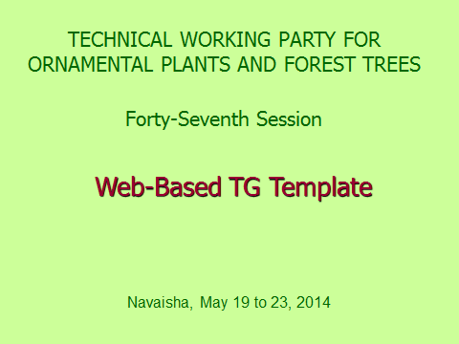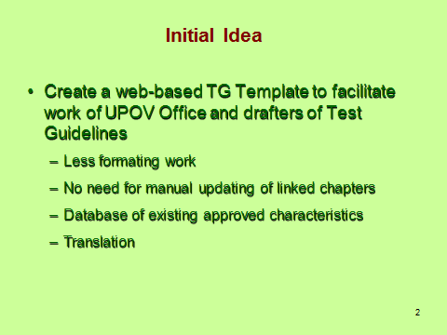

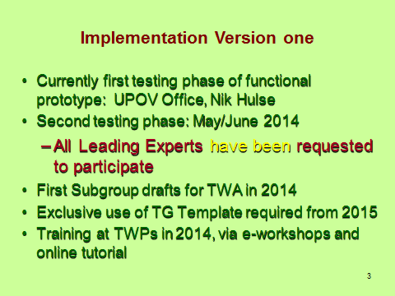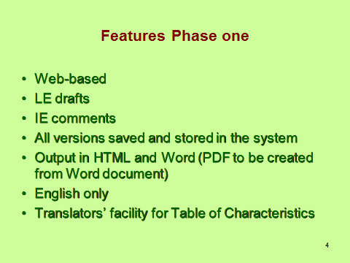

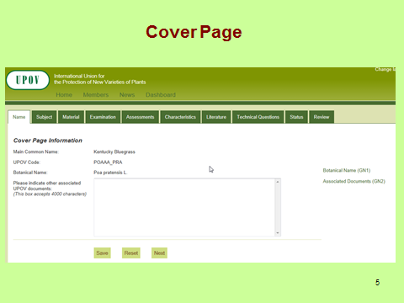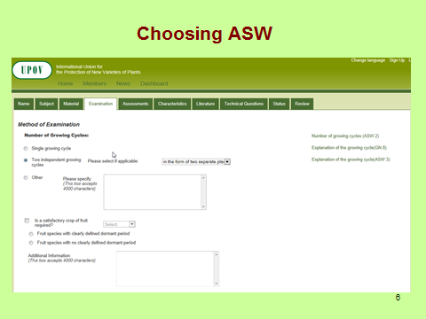

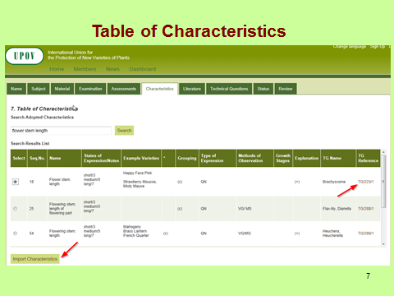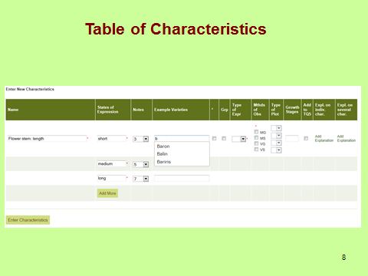

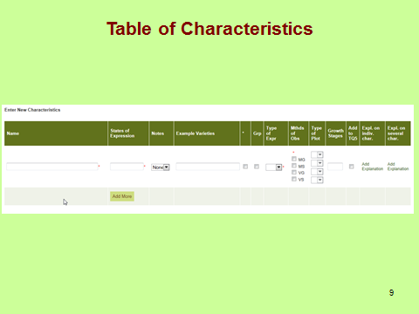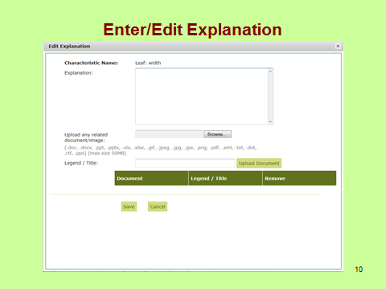

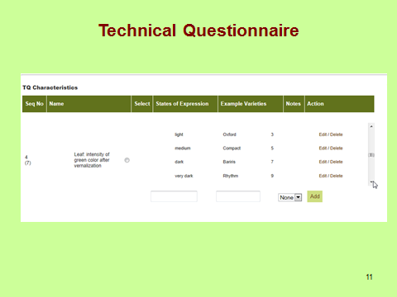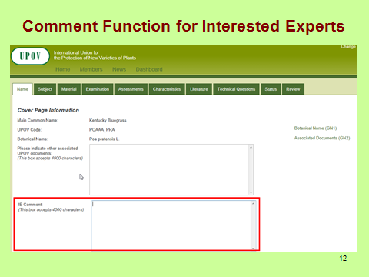

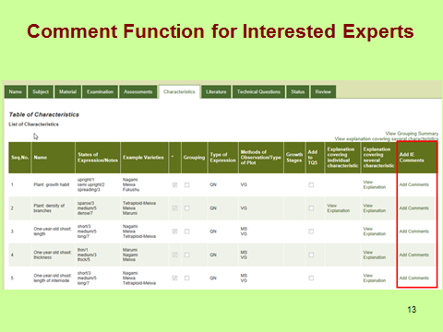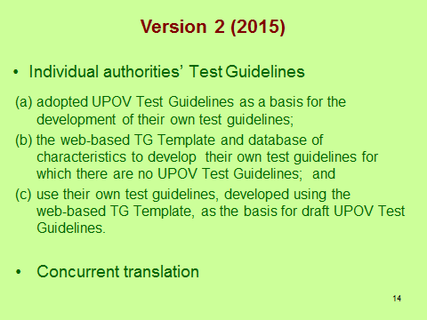

[End of Annex and of document]

