 |  |  |  |  |  |  | E  TG/DIANE(proj.3)  ORIGINAL: English  DATE: 2012-06-28
INTERNATIONAL UNION FOR THE PROTECTION OF NEW VARIETIES OF PLANTS
Geneva
 |  |  | DRAFT
 |  | DIANELLA  UPOV Code: DIANE  Dianella Lam. ex Juss. |  |  | *

GUIDELINES

FOR THE CONDUCT OF TESTS

FOR DISTINCTNESS, UNIFORMITY AND STABILITY

prepared by an expert from Australia

to be considered by the
Technical Working Party for Ornamental Plants and Forest Trees
at its forty-fifth session, to be held in Jeju, Republic of Korea, from August 6 to 10, 2012

Alternative Names:*

Botanical name | English | French | German | Spanish
Dianella Lam. ex Juss. | Flax-lily, Dianella

The purpose of these guidelines (“Test Guidelines”) is to elaborate the principles contained in the General Introduction (document TG/1/3), and its associated TGP documents, into detailed practical guidance for the harmonized examination of distinctness, uniformity and stability (DUS) and, in particular, to identify appropriate characteristics for the examination of DUS and production of harmonized variety descriptions.

ASSOCIATED DOCUMENTS
These Test Guidelines should be read in conjunction with the General Introduction and its associated TGP documents.
TABLE OF CONTENTS PAGE

1. Subject of these Test Guidelines 3
2. Material Required 3
3. Method of Examination 3
3.1 Number of Growing Cycles 3
3.2 Testing Place 3
3.3 Conditions for Conducting the Examination 3
3.4 Test Design 3
3.5 Additional Tests 4
4. Assessment of Distinctness, Uniformity and Stability 4
4.1 Distinctness 4
4.2 Uniformity 5
4.3 Stability 5
5. Grouping of Varieties and Organization of the Growing Trial 5
6. Introduction to the Table of Characteristics 5
6.1 Categories of Characteristics 5
6.2 States of Expression and Corresponding Notes 6
6.3 Types of Expression 6
6.4 Example Varieties 6
6.5 Legend 7
7. Table of Characteristics/Tableau des caractères/Merkmalstabelle/Tabla de caracteres 8
8. Explanations on the Table of Characteristics 15
8.1 Explanations covering several characteristics 15
8.2 Explanations for individual characteristics 15
9. Literature 19
10. Technical Questionnaire 20

ANNEX COMMENTS ON DOCUMENT TG/DIANE(PROJ.3)

Subject of these Test Guidelines

These Test Guidelines apply to all varieties of Dianella Lam. ex Juss..

Material Required

2.1 The competent authorities decide on the quantity and quality of the plant material required for testing the variety and when and where it is to be delivered. Applicants submitting material from a State other than that in which the testing takes place must ensure that all customs formalities and phytosanitary requirements are complied with.

2.2 The material is to be supplied in the form of plants expressing relevant characteristics of the variety in the first growing cycle.

2.3 The minimum quantity of plant material, to be supplied by the applicant, should be:

10 plants.

2.4 The plant material supplied should be visibly healthy, not lacking in vigor, nor affected by any important pest or disease.

2.5 The plant material should not have undergone any treatment which would affect the expression of the characteristics of the variety, unless the competent authorities allow or request such treatment. If it has been treated, full details of the treatment must be given.

Method of Examination

3.1 Number of Growing Cycles

The minimum duration of tests should normally be a single growing cycle.

3.2 Testing Place

Tests are normally conducted at one place. In the case of tests conducted at more than one place, guidance is provided in TGP/9 “Examining Distinctness”.

3.3 Conditions for Conducting the Examination

3.3.1 The tests should be carried out under conditions ensuring satisfactory growth for the expression of the relevant characteristics of the variety and for the conduct of the examination.

3.3.2 Observation of color by eye

Because daylight varies, color determinations made against a color chart should be made either in a suitable cabinet providing artificial daylight or in the middle of the day in a room without direct sunlight. The spectral distribution of the illuminant for artificial daylight should conform with the CIE Standard of Preferred Daylight D 6500 and should fall within the tolerances set out in the British Standard 950, Part I. These determinations should be made with the plant part placed against a white background. The color chart and version used should be specified in the variety description.

3.4 Test Design

3.4.1 Each test should be designed to result in a total of at least 10 plants.

3.4.2 The design of the tests should be such that plants or parts of plants may be removed for measurement or counting without prejudice to the observations which must be made up to the end of the growing cycle.

3.5 Additional Tests

Additional tests, for examining relevant characteristics, may be established.

Assessment of Distinctness, Uniformity and Stability

4.1 Distinctness

4.1.1 General Recommendations

It is of particular importance for users of these Test Guidelines to consult the General Introduction prior to making decisions regarding distinctness. However, the following points are provided for elaboration or emphasis in these Test Guidelines.

4.1.2 Consistent Differences

The differences observed between varieties may be so clear that more than one growing cycle is not necessary. In addition, in some circumstances, the influence of the environment is not such that more than a single growing cycle is required to provide assurance that the differences observed between varieties are sufficiently consistent. One means of ensuring that a difference in a characteristic, observed in a growing trial, is sufficiently consistent is to examine the characteristic in at least two independent growing cycles.

4.1.3 Clear Differences

Determining whether a difference between two varieties is clear depends on many factors, and should consider, in particular, the type of expression of the characteristic being examined, i.e. whether it is expressed in a qualitative, quantitative, or pseudo-qualitative manner. Therefore, it is important that users of these Test Guidelines are familiar with the recommendations contained in the General Introduction prior to making decisions regarding distinctness.

4.1.4 Number of Plants / Parts of Plants to be Examined

Unless otherwise indicated, for the purposes of distinctness, all observations on single plants should be made on 9 plants or parts taken from each of 9 plants and any other observations made on all plants in the test, disregarding any off-type plants.

4.1.5 Method of Observation

The recommended method of observing the characteristic for the purposes of distinctness is indicated by the following key in the second column of the Table of Characteristics (see document TGP/9 “Examining Distinctness”, Section 4 “Observation of characteristics”):

MG: single measurement of a group of plants or parts of plants
MS: measurement of a number of individual plants or parts of plants
VG: visual assessment by a single observation of a group of plants or parts of plants
VS: visual assessment by observation of individual plants or parts of plants

Type of observation: visual (V) or measurement (M)

“Visual” observation (V) is an observation made on the basis of the expert’s judgment. For the purposes of this document, “visual” observation refers to the sensory observations of the experts and, therefore, also includes smell, taste and touch. Visual observation includes observations where the expert uses reference points (e.g. diagrams, example varieties, side-by-side comparison) or non-linear charts (e.g. color charts). Measurement (M) is an objective observation against a calibrated, linear scale e.g. using a ruler, weighing scales, colorimeter, dates, counts, etc.

Type of record: for a group of plants (G) or for single, individual plants (S)

For the purposes of distinctness, observations may be recorded as a single record for a group of plants or parts of plants (G), or may be recorded as records for a number of single, individual plants or parts of plants (S). In most cases, “G” provides a single record per variety and it is not possible or necessary to apply statistical methods in a plant-by-plant analysis for the assessment of distinctness.

In cases where more than one method of observing the characteristic is indicated in the Table of Characteristics (e.g. VG/MG), guidance on selecting an appropriate method is provided in document TGP/9, Section 4.2.

4.2 Uniformity

4.2.1 It is of particular importance for users of these Test Guidelines to consult the General Introduction prior to making decisions regarding uniformity. However, the following points are provided for elaboration or emphasis in these Test Guidelines:

4.2.2 For the assessment of uniformity of vegetatively propagated varieties, a population standard of 1% and an acceptance probability of at least 95 % should be applied. In the case of a sample size of 10 plants, 1 off-type is allowed.

4.3 Stability

4.3.1 In practice, it is not usual to perform tests of stability that produce results as certain as those of the testing of distinctness and uniformity. However, experience has demonstrated that, for many types of variety, when a variety has been shown to be uniform, it can also be considered to be stable.

4.3.2 Where appropriate, or in cases of doubt, stability may be further examined by testing a new plant stock to ensure that it exhibits the same characteristics as those shown by the initial material supplied.

Grouping of Varieties and Organization of the Growing Trial

5.1 The selection of varieties of common knowledge to be grown in the trial with the candidate varieties and the way in which these varieties are divided into groups to facilitate the assessment of distinctness are aided by the use of grouping characteristics.

5.2 Grouping characteristics are those in which the documented states of expression, even where produced at different locations, can be used, either individually or in combination with other such characteristics: (a) to select varieties of common knowledge that can be excluded from the growing trial used for examination of distinctness; and (b) to organize the growing trial so that similar varieties are grouped together.

5.3 The following have been agreed as useful grouping characteristics:

- Leaf: glaucosity of adaxial side (characteristic 8)
- Leaf: variegation (characteristic 9)
- Leaf blade: shape (characteristic 15)
- Leaf: spines on margin (characteristic 18)
- Basal sheath: intensity of anthocyanin coloration (in summer) (characteristic 24)

5.4 Guidance for the use of grouping characteristics, in the process of examining distinctness, is provided through the General Introduction and document TGP/9 “Examining Distinctness”.

Introduction to the Table of Characteristics

6.1 Categories of Characteristics

6.1.1 Standard Test Guidelines Characteristics

Standard Test Guidelines characteristics are those which are approved by UPOV for examination of DUS and from which members of the Union can select those suitable for their particular circumstances.

6.1.2 Asterisked Characteristics

Asterisked characteristics (denoted by *) are those included in the Test Guidelines which are important for the international harmonization of variety descriptions and should always be examined for DUS and included in the variety description by all members of the Union, except when the state of expression of a preceding characteristic or regional environmental conditions render this inappropriate.

6.2 States of Expression and Corresponding Notes

6.2.1 States of expression are given for each characteristic to define the characteristic and to harmonize descriptions. Each state of expression is allocated a corresponding numerical note for ease of recording of data and for the production and exchange of the description.

6.2.2 In the case of qualitative and pseudo-qualitative characteristics (see Chapter 6.3), all relevant states of expression are presented in the characteristic. However, in the case of quantitative characteristics with 5 or more states, an abbreviated scale may be used to minimize the size of the Table of Characteristics. For example, in the case of a quantitative characteristic with 9 states, the presentation of states of expression in the Test Guidelines may be abbreviated as follows:

State | Note
small | 3
medium | 5
large | 7

However, it should be noted that all of the following 9 states of expression exist to describe varieties and should be used as appropriate:

State | Note
very small | 1
very small to small | 2
small | 3
small to medium | 4
medium | 5
medium to large | 6
large | 7
large to very large | 8
very large | 9

6.2.3 Further explanation of the presentation of states of expression and notes is provided in document TGP/7 “Development of Test Guidelines”.

6.3 Types of Expression

An explanation of the types of expression of characteristics (qualitative, quantitative and pseudo-qualitative) is provided in the General Introduction.

6.4 Example Varieties

Where appropriate, example varieties are provided to clarify the states of expression of each characteristic.

6.5 Legend

(*) Asterisked characteristic – see Chapter 6.1.2

QL Qualitative characteristic – see Chapter 6.3
QN Quantitative characteristic – see Chapter 6.3
PQ Pseudo-qualitative characteristic – see Chapter 6.3

MG, MS, VG, VS – see Chapter 4.1.5

(a)-(c) See Explanations on the Table of Characteristics in Chapter 8.1
(+) See Explanations on the Table of Characteristics in Chapter 8.2

Table of Characteristics/Tableau des caractères/Merkmalstabelle/Tabla de caracteres

 |  | English | français | deutsch | español | Example Varieties  Exemples  Beispielssorten  Variedades ejemplo | Note/  Nota
1  (*) | VG/  MG | Plant: height excluding inflorescence
QN | (a) | very short |  |  |  | Dinki Di | 1
 |  | short |  |  |  |  | 3
 |  | medium |  |  |  | Little Devil | 5
 |  | tall |  |  |  | REV101 | 7
 |  | very tall |  |  |  | Goddess | 9
2  (*) | VG | Plant: density
QN | (a) | very sparse |  |  |  |  | 1
 |  | sparse |  |  |  | LHC1 | 3
 |  | medium |  |  |  | Rainbow | 5
 |  | dense |  |  |  | Little Devil | 7
 |  | very dense |  |  |  | Dinki Di | 9
3  (+) | VG/  MG | Stem: internode length
QN | (a) | very short |  |  |  | TAS300 | 1
 |  | short |  |  |  | TR20 | 3
 |  | medium |  |  |  |  | 5
 |  | long |  |  |  | Goddess | 7
 |  | very long |  |  |  |  | 9
4  (*)  (+) | VG | Leaf: attitude of basal third
QN | (b) | erect |  |  |  | Little Devil | 1
 |  | erect to semi-erect |  |  |  | Rainbow | 2
 |  | semi-erect |  |  |  | TAS300 | 3
5  (*)  (+) | VG | Leaf: curvature of upper third
PQ | (b) | absent or very weak |  |  |  | LHC1 | 1
 |  | weak |  |  |  | TAS300 | 3
 |  | medium |  |  |  | TAS100 | 5
 |  | strong |  |  |  | DT23 | 7
 |  | very strong |  |  |  |  | 9
6 | VG/  MS | Leaf: length
QN | (b) | short |  |  |  | DTN03 | 3
 |  | medium |  |  |  | Allyn-Citation | 5
 |  | long |  |  |  |  | 7
7  (*) | VG/  MS | Leaf: width
QN | (b) | narrow |  |  |  | Little Devil | 3
 |  | medium |  |  |  | TAS100 | 5
 |  | wide |  |  |  | Goddess | 7
8  (*)  (+) | VG | Leaf: glaucosity of adaxial side
QN | (b) | absent or very weak |  |  |  | Goddess, TR20 | 1
 |  | weak |  |  |  | DT23 | 2
 |  | medium |  |  |  | Little Devil | 3
 |  | strong |  |  |  | DR5000 | 4
9  (*) | VG | Leaf: variegation
QL | (b) | absent |  |  |  | Splice | 1
 |  | present |  |  |  | Rainbow | 9
10  (*) | VG | Young leaf: main color of adaxial side
PQ |  | yellow |  |  |  |  | 1
 |  | yellow green |  |  |  |  | 2
 |  | light green |  |  |  |  | 3
 |  | medium green |  |  |  |  | 4
 |  | dark green |  |  |  |  | 5
 |  | blue green |  |  |  |  | 6
 |  | brown green |  |  |  |  | 7
11  (*) | VG | Leaf: main color of adaxial side
PQ | (b) | yellow |  |  |  | Rainbow | 1
 |  | yellow green |  |  |  | DCMP01 | 2
 |  | light green |  |  |  | TR20 | 3
 |  | medium green |  |  |  | DR 2006 | 4
 |  | dark green |  |  |  | TAS300 | 5
 |  | blue green |  |  |  |  | 6
 |  | brown green |  |  |  |  | 7
12  (*) | VG | Leaf: main color of abaxial side
PQ | (b) | yellow |  |  |  | Rainbow | 1
 |  | yellow green |  |  |  | DCMP01 | 2
 |  | light green |  |  |  | TR20 | 3
 |  | medium green |  |  |  | DR 2006 | 4
 |  | dark green |  |  |  | DTN03 | 5
 |  | blue green |  |  |  |  | 6
 |  | brown green |  |  |  |  | 7
 |  | grey green |  |  |  | TAS300 | 8
13  (*)  (+) | VG | Leaf: secondary color of adaxial side
PQ | (b) | whitish |  |  |  | Border Silver | 1
 |  | whitish yellow |  |  |  | DarwinGold | 2
 |  | yellow |  |  |  | Rainbow | 3
 |  | yellow green |  |  |  |  | 4
 |  | light green |  |  |  |  | 5
 |  | medium green |  |  |  |  | 6
 |  | dark green |  |  |  |  | 7
 |  | blue green |  |  |  |  | 8
 |  | brown green |  |  |  |  | 9
14 | VG | Leaf: distribution of secondary color on adaxial side
PQ | (b) | marginal |  |  |  |  | 1
 |  | between margin and midrib |  |  |  |  | 2
 |  | midrib |  |  |  |  | 3
15  (*)  (+) | VG | Leaf blade: shape
PQ | (b) | ligulate |  |  |  | Dinki Di | 1
 |  | linear |  |  |  | TAS300 | 2
 |  | ensiform |  |  |  | Border Silver | 3
16 (*)  (+) | VG | Leaf: shape of apex
PQ | (b) | acuminate |  |  |  | Goddess | 1
 |  | apiculate |  |  |  | Rainbow | 2
 |  | acute |  |  |  | Dinki Di | 3
17  (+) | VG | Leaf: cross section
QN | (b) | flat |  |  |  |  | 1
 |  | slightly convex |  |  |  | TR20 | 2
 |  | convex |  |  |  | Goddess | 3
 |  | strongly convex |  |  |  | DCMP01 | 4
 |  | revolute |  |  |  |  | 5
18  (*) | VG | Leaf: spines on margin
QL | (b) | absent |  |  |  | REV101 | 1
 |  | present |  |  |  | Rainbow | 9
19 | VG | Leaf: prominence of spines on margin
QN | (b) | weak |  |  |  | Little Devil | 1
 |  | medium |  |  |  | Rainbow | 2
 |  | strong |  |  |  |  | 3
20 | VG | Leaf: color of margin
QL | (b) | green |  |  |  | Goddess | 1
 |  | red |  |  |  | Rainbow | 2
21  (*) | VG | Leaf midrib: spines on abaxial side
QL | (b) | absent |  |  |  | REV101 | 1
 |  | present |  |  |  | Goddess | 9
22 | VG | Leaf midrib: prominence of spines on abaxial side
QN | (b) | weak |  |  |  | DTN03 | 1
 |  | medium |  |  |  | Goddess | 2
 |  | strong |  |  |  | DT23 | 3
23  (*) | VG | Basal sheath: anthocyanin coloration (in summer)
PQ | (b) | red purple |  |  |  | Dinki Di | 1
 |  | red brown |  |  |  | REV101 | 2
 |  | brown |  |  |  |  | 3
24  (*) | VG | Basal sheath: intensity of anthocyanin coloration (in summer)
QN | (b) | very weak |  |  |  | Goddess | 1
 |  | weak |  |  |  | REV101 | 3
 |  | medium |  |  |  | LHC1 | 5
 |  | strong |  |  |  | Little Devil, TAS300 | 7
 |  | very strong |  |  |  |  | 9
25  (+) | VG | Inflorescence: position in relation to foliage
QN | (c) | above |  |  |  | Little Devil | 1
 |  | same level |  |  |  |  | 2
 |  | below |  |  |  | Border Silver | 3
26 | VG | Flowering stem: color of middle third
PQ | (c) | RHS Colour Chart (indicate reference number)
27 | VG/  MS | Flowering stem: length of flowering part
QN | (c) | short |  |  |  |  | 3
 |  | medium |  |  |  |  | 5
 |  | long |  |  |  |  | 7
28 | VG | Inflorescence: density of flowers
QN | (c) | sparse |  |  |  |  | 3
 |  | medium |  |  |  |  | 5
 |  | dense |  |  |  |  | 7
29 | VG/  MG | Perianth: diameter
QN | (c) | small |  |  |  |  | 1
 |  | medium |  |  |  |  | 2
 |  | large |  |  |  |  | 3
30 | VG | Perianth: color
PQ | (c) | RHS Colour Chart (indicate reference number)
31 | VG | Anther: color
PQ | (c) | yellow |  |  |  | Border Silver | 1
 |  | orange |  |  |  | Splice | 2
 |  | brown |  |  |  | Goddess | 3
32 | VG | Immature fruit: color
PQ | (c) | RHS Colour Chart (indicate reference number)
33 | VG | Mature fruit: color
PQ | (c) | RHS Colour Chart (indicate reference number)

Explanations on the Table of Characteristics

8.1 Explanations covering several characteristics

Characteristics containing the following key in the second column of the Table of Characteristics should be examined as indicated below:

(a) The assessment of plant, shoot and stem characters should be carried out later in the growing season, towards the end of active vegetative growth.

(b) All observations on the leaf should be made on mature fully expanded leaves. Leaf colors for glaucous varieties should be observed with the waxy coating removed by rubbing. The main color is the color with the largest surface area. If the area of the colors is nearly equal the darker color is the main color. The main color may be the only color.

(c) All observations on the inflorescence flower and fruit should be made on the main flower inflorescence.

8.2 Explanations for individual characteristics

Ad. 3: Stem: internode length

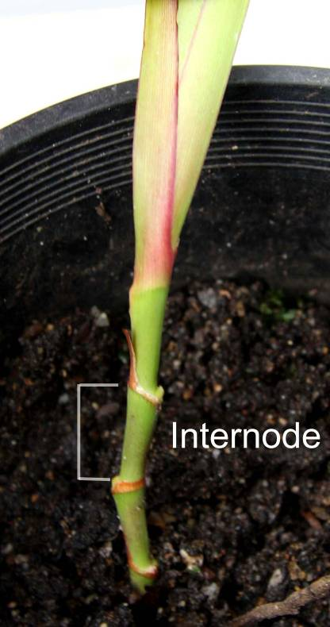

Ad. 4: Leaf: attitude of basal third

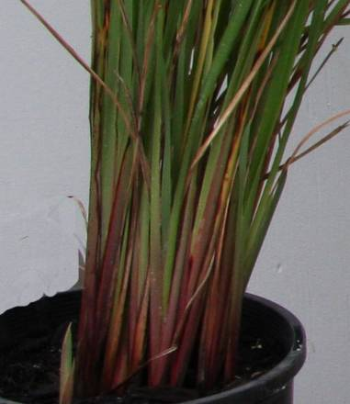 | 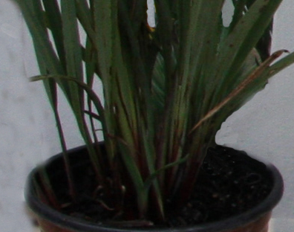 | 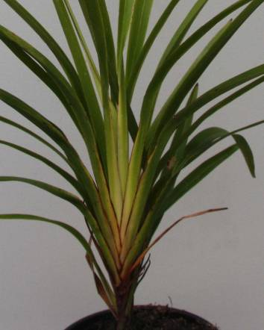
1 | 2 | 3
erect | erect to semi-erect | semi-erect

Ad. 5: Leaf: curvature of upper third

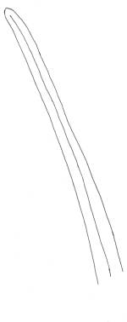 | 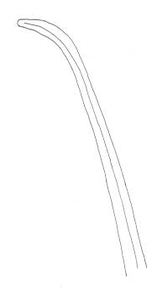 | 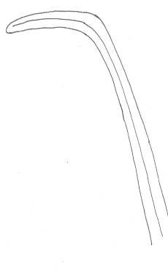 | 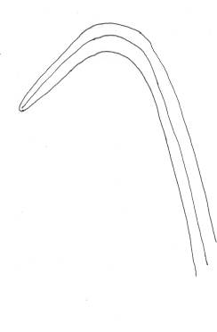 | 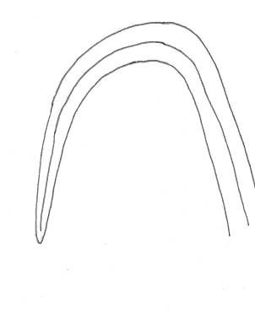
1 | 3 | 5 | 7 | 9
absent or very weak | weak | medium | strong | very strong

Ad. 8: Leaf: glaucosity of adaxial side

The glaucosity is the waxy layer covering the leaf surface and generally gives a leaf a bluish or whitish coloration. The layer can be removed by rubbing. It should be observed on the adaxial side of the middle third of the leaf.

Ad. 13: Leaf : secondary color of adaxial side

The secondary color is determined as the color with the second largest surface area, usually observed as a defined pattern on the adaxial side of a leaf. Observations should be made on plants not subjected to chilling. For varieties with glaucosity, the waxy layer is removed.

Ad. 15: Leaf blade: shape
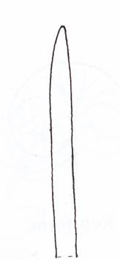 | 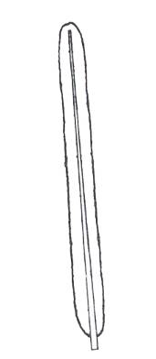 | 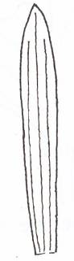
1 | 2 | 3
ligulate | linear | ensiform
lateral margins parallel along most of length, tapering towards apex, strap shaped. | lateral margins parallel along entire length to apex | widest point above the middle, sword shaped

Ad. 16: Leaf: shape of apex

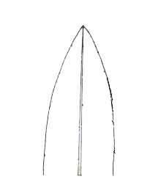 | 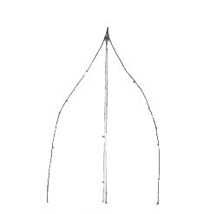 | 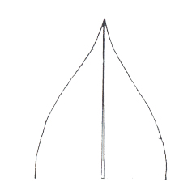
1 | 2 | 3
acuminate | apiculate | acute

Ad. 17: Leaf: cross section

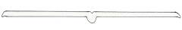 | 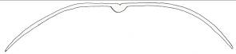 | 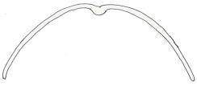 | 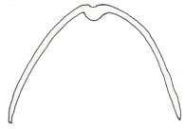 | 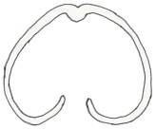
1 | 2 | 3 | 4 | 5
flat | slightly convex | convex | strongly convex | revolute

Ad. 19: Leaf: prominence of spines on margin
Ad. 22: Leaf midrib: prominence of spines on abaxial side

Prominence of spines is assessed visually and by touch. If spines can be seen easily with the naked eye at arms length then prominence is very strong. If spines cannot be seen but are felt by running the index finger backwards along the leaf then prominence is very weak.

Ad. 25: Inflorescence: position in relation to foliage

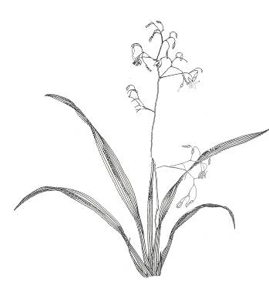 | 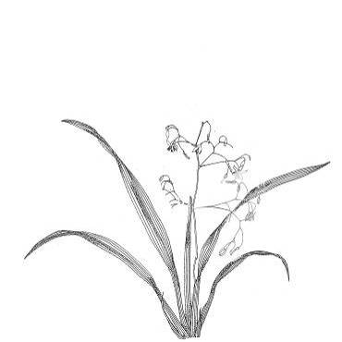 | 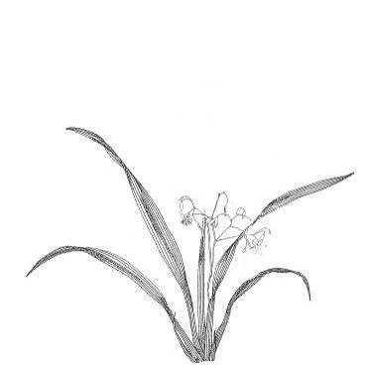
1 | 2 | 3
above | same level | below

Ad. 32: Immature fruit: color

Assessed when fruit has reached full size

Ad. 33: Mature fruit: color

Assessed when fruit has fully colored and before deterioration

Literature

Henderson R.J.F., 1987: Flora of Australia vol 45. Australian Government Publishing Service. Canberra, Australian Capital Territory, AU, pp. 194 to 225.

Technical Questionnaire

TECHNICAL QUESTIONNAIRE |  |  |  | Page {x} of {y} |  | Reference Number:
 |  |  |  |  |  | Application date:
 |  |  |  |  |  | (not to be filled in by the applicant)
TECHNICAL QUESTIONNAIRE
to be completed in connection with an application for plant breeders’ rights

1. Subject of the Technical Questionnaire
1.1 Genus
1.1 Botanical name |  |  | Dianella Lam. ex Juss.
1.2 Common name |  |  | Flax-lily, Dianella
1.2 Species
(please indicate)
2. Applicant
Name
Address
Telephone No.
Fax No.
E-mail address
Breeder (if different from applicant)
3. Proposed denomination and breeder’s reference
Proposed denomination
(if available)

Breeder’s reference
#4. Information on the breeding scheme and propagation of the variety

4.1 Breeding scheme

Variety resulting from:

4.1.1 Crossing

(a) controlled cross [ ]
(please state parent varieties)

(…………………..……………..…) x (……………..…………………..…)
female parent male parent

(b) partially known cross [ ]
(please state known parent variety(ies))

(…………………..……………..…) x (……………..…………………..…)
female parent male parent

(c) unknown cross [ ]

4.1.2 Mutation [ ]
(please state parent variety)

4.1.3 Discovery and development [ ]
(please state where and when discovered and how developed)

4.1.4 Other [ ]
(please provide details)

4.2 Method of propagating the variety

4.2.1 Vegetative propagation

(a) cuttings [ ]

(b) division [...]

(c) in vitro propagation [ ]

(d) other (state method) [ ]

4.2.2 Other [ ]
(please provide details)

5. Characteristics of the variety to be indicated (the number in brackets refers to the corresponding characteristic in Test Guidelines; please mark the note which best corresponds).

 | Characteristics |  |  |  |  |  | Example Varieties |  |  | Note
5.1  (8) | Leaf: glaucosity of adaxial side
 | absent or very weak |  |  |  |  |  | Goddess, TR20 |  |  | 1 [ ]
 | very weak to weak |  |  |  |  |  |  |  |  | 2 [ ]
 | weak |  |  |  |  |  | DT23 |  |  | 3 [ ]
 | weak to medium |  |  |  |  |  | Rainbow |  |  | 4 [ ]
 | medium |  |  |  |  |  | Little Devil |  |  | 5 [ ]
 | medium to strong |  |  |  |  |  | TAS300 |  |  | 6 [ ]
 | strong |  |  |  |  |  | DR5000 |  |  | 7 [ ]
 | strong to very strong |  |  |  |  |  |  |  |  | 8 [ ]
 | very strong |  |  |  |  |  |  |  |  | 9 [ ]
5.2  (9) | Leaf: variegation
 | absent |  |  |  |  |  | Splice |  |  | 1 [ ]
 | present |  |  |  |  |  | Rainbow |  |  | 9 [ ]
5.3  (15) | Leaf blade: shape
 | ligulate |  |  |  |  |  | Dinki Di |  |  | 1 [ ]
 | linear |  |  |  |  |  | TAS300 |  |  | 2 [ ]
 | ensiform |  |  |  |  |  | Border Silver |  |  | 3 [ ]
5.4  (18) | Leaf: spines on margin
 | absent |  |  |  |  |  | REV101 |  |  | 1 [ ]
 | present |  |  |  |  |  | Rainbow |  |  | 9 [ ]
6. Similar varieties and differences from these varieties

Please use the following table and box for comments to provide information on how your candidate variety differs from the variety (or varieties) which, to the best of your knowledge, is (or are) most similar. This information may help the examination authority to conduct its examination of distinctness in a more efficient way.

Denomination(s) of variety(ies) similar to your candidate variety |  | Characteristic(s) in which your candidate variety differs from the similar variety(ies) |  |  | Describe the expression of the characteristic(s) for the similar variety(ies) |  |  | Describe the expression of the characteristic(s) for your candidate variety
Example |  | Plant: density |  |  | sparse |  |  | dense
Comments:

#7. Additional information which may help in the examination of the variety

7.1 In addition to the information provided in sections 5 and 6, are there any additional characteristics which may help to distinguish the variety?

Yes [ ] No [ ]

(If yes, please provide details)

7.2 Are there any special conditions for growing the variety or conducting the examination?

Yes [ ] No [ ]

(If yes, please provide details)

7.3 Other information

A representative color image of the variety should accompany the Technical Questionnaire.

8. Authorization for release

(a) Does the variety require prior authorization for release under legislation concerning the protection of the environment, human and animal health?

Yes [ ] No [ ]

(b) Has such authorization been obtained?

Yes [ ] No [ ]

If the answer to (b) is yes, please attach a copy of the authorization.

9. Information on plant material to be examined or submitted for examination.

9.1 The expression of a characteristic or several characteristics of a variety may be affected by factors, such as pests and disease, chemical treatment (e.g. growth retardants or pesticides), effects of tissue culture, different rootstocks, scions taken from different growth phases of a tree, etc.

9.2 The plant material should not have undergone any treatment which would affect the expression of the characteristics of the variety, unless the competent authorities allow or request such treatment. If the plant material has undergone such treatment, full details of the treatment must be given. In this respect, please indicate below, to the best of your knowledge, if the plant material to be examined has been subjected to:

(a) Microorganisms (e.g. virus, bacteria, phytoplasma) Yes [ ] No [ ]

(b) Chemical treatment (e.g. growth retardant, pesticide) Yes [ ] No [ ]

(c) Tissue culture Yes [ ] No [ ]

(d) Other factors Yes [ ] No [ ]

Please provide details for where you have indicated “yes”.

……………………………………………………………

10. I hereby declare that, to the best of my knowledge, the information provided in this form is correct:

Applicant’s name

Signature Date

[Annex follows]
COMMENTS ON DOCUMENT TG/DIANE(PROJ.3)

Ref. in Proj 2 | TWO 44 Comments | Comments on changes in Proj 3 | Comments received from subgroup by 1 June2012 | Subsequent changes and final submission to UPOV for meeting
Cover page | to have English common names: “Flax-lily, Dianella” | Done. Also changed in TQ
Char. 1 | to delete | Also deleted from 5.3 (a), Ad 1 and TQ section 5
Char. 3 | to delete “ shoots” and to add (*) | Deleted “of shoots”, removed comment, added (*)
Char. 4 | to be indicated as VG/MG and to add example variety “ Goddess” for state (7) | Changed from VG/MS to VG/MG but the interpretation of MS and MG needs to be considered as there appears to be some confusion. In the EDC the view is MG is only used where a group of plants is measured (eg measuring stick in centre of plot, bulk sample when measuring fruit acidity).  Added ‘Goddess’
Char. 5 | to delete state (4) | done | UK: We still feel that the state semi-erect does not reflect varieties such as Little Jess and Tasred which appear to droop. Could the state "semi-drooping" be added? | Consider :semi-drooping – if to be included need photo for Ad 5
Char. 6 |  |  | CPVO: In the Lomandra guideline, this char is worded as “attitude of upper third”with 3 stages. Are 9 stages here necessary ? 5 could be sufficient ?
Char. 7 | to add example varieties | Not a commonly used characteristic as it can be variable. If kept, could use:  DTN03 – short (~20cm)  Allyn-Citation - medium (~50cm)  No clear example for long | CPVO: leaf blade? Why to keep 9 stages if variety for stage 7? | Keep ‘Leaf:”?  Changed to 1,2,3  Need example for “long”?
Char. 8 | to have states: narrow (3); medium (5); wide (7) | Deleted states 1 and 9 | CPVO: leaf blade?
Char. 9 | to have states (1), (2), (3), (4) | done
Char 11 |  | Changed from RHS to color groups. AU does not use this characteristic and has no example varieties | CPVO: if this char is kept, to define the young leave (char 11) compared to the leave (char 12)  NZ: move to before ch 5 | Propose to delete char
Chars. 12 | to consider same procedure for color characteristics as for Hebe | Changed from RHS to color groups and added example varieties. No examples for blue green and brown green | NZ: 12, 13 (+) standard explanation regarding what is main | Added (+)  Added “whitish” and “whitish yellow” renumbered notes
Char 13 |  | Changed from RHS to color groups and added example varieties. No examples for “blue green” and “brown green” | CPVO: Lower?  NZ: 12, 13 (+) standard explanation regarding what is main | Deleted lower  Added (+)  Added “whitish” and “whitish yellow” renumbered notes
Char 14 |  | Replaced “cream” with “whitish yellow”. Added example varieties. No examples for “yellow green” and “light green” |  | Reworded: Leaf: secondary color of adaxial side and added (+)  Added:  light green  medium green  dark green  blue green  brown green
Char 15 |  |  | NZ: consider distribution of secondary colour | Changed to distribution of secondary color
Char. 16 | to explain shapes | Added explanation to Ad.16 but not certain about usefulness in distinguishing between states 1 and 2. State 3 is easier as it distinguishes D. ensifolia varieties.
Char. 18 | to add (+) and provide illustration and to change state (5) to “ involute” | The “concave” states are incorrect. Replaced with “convex”. Revolute state is correct. Illustration added | NZ: 18 Consider where to look because it can vary along the leaf length. Suggest medium convex | Reworded 8.1 (b). Added “medium”
Chars 20 and 23 | to be indicated as QN | done
Char. 21 | unlikely to be QL | Propose to delete as it is not always present and dependent on temperature. | NZ: 21 Consider relationship with 12,13,14,15. What if the colour in 21 is the secondary colour? Can there be three colours. 21 should be with the other colour characters. Suggest review of all colour characters. We have the same issue in Phormium and have main, secondary, tertiary with distributions. | Propose to delete
Char. 24 | to add (*) | done | NZ: 24 Basal sheath hue of anthocyanin colouration | Added “hue of”
Char.25 | to add (*) if they grouping characteristic and to add in TQ | done
Chars.26 | to be indicated as PQ and VG and to read “ Flowering stem: color of middle third” | done
Char. 27 |  |  | CPVO: is-it really MS or MG ? | Changed to MG
Char. 29 | to move before Char. 26 | done
Char. 30 | to consider whether useful and to have notes (1), (2), (3) | Notes changed to 1,2,3 but propose to delete.
Char. 32 | to have states: yellow (1); orange (2); brown (3) | Done and added example varieties
Char. 33 | to check if necessary | Propose to delete. Not very useful
Table of Chars. | to check whether sufficient number of (*) characteristics | sufficient
8.1 (b) | to improve comments | Amended explanation. Also see Hebe for waxy layer removal | UK: We would prefer to assess leaf colour without the removal of wax | For discussion? If the waxy layer is not removed then color is influenced by the waxy layer and therefore to a certain extent linked to leaf glaucosity (ch 9)  Reworded:  (b) Unless indicated otherwise, all observations on the leaf should be made on mature fully expanded leaves.  Rest moved to Ad’ for relevant charactersitics
8.1 (c) |  |  | CPVO: to be reworded | Reworded: All observations on the flowering stem, inflorescence, flower and fruit should be made on the main flowering stem
Ad. 1 | to delete | done
Ad. 6 | to improve illustration | done
Ad. 9 | to provide explanation and remove illustration | done
Ad 14 |  |  |  | Ad. 14: Leaf : secondary color of adaxial side  The secondary colour is determined as the color with the second largest surface area, usually observed as a defined pattern on the adaxial side of a leaf. Observations should be made on plants not subjected to chilling. For varieties with glaucosity, the waxy layer is removed
Ad. 16 | to improve explanation | done
Ad. 17 | to add diagram | done | NZ: Ad 17 check. Diagrams 1 and 3 swapped | Reordered 1 and 3
9. | NZ to provide more literature
TQ 5.1 (9) |  |  | CPVO: to be consistent with ch 9  NZ: TQ 5 The list does not match the grouping list. Basal sheath anthocyanin is missing | Changed to 1 – 4 states as in Ch 9  Added ch 25
TQ 6 | to provide new example | done

[End of Annex and of document]

* These names were correct at the time of the introduction of these Test Guidelines but may be revised or updated. [Readers are advised to consult the UPOV Code, which can be found on the UPOV Website (www.upov.int), for the latest information.]
# Authorities may allow certain of this information to be provided in a confidential section of the Technical Questionnaire.
# Authorities may allow certain of this information to be provided in a confidential section of the Technical Questionnaire.

