E
International Union for the Protection of New Varieties of Plants

Technical Working Party for Fruit Crops  Forty-Eighth Session  Kelowna, British Columbia, Canada, September 18 to 22, 2017 | TWF/48/11  Original: English  Date: September 7, 2017
Minimum distance between varieties
Document prepared by the Office of the Union
Disclaimer: this document does not represent UPOV policies or guidance

BACKGROUND

The Technical Working Party for Fruit crops (TWF), at its forty-sixth session in 2015, held in Mpumalanga, South Africa, from August 24 to 28, 2015, agreed to discuss the item “Minimum distance between varieties” at its next session (see document TWF/46/29 Rev. “Revised Report”, paragraph 139).

The TWF, at its forty-seventh session in Angers, France, from November 14 to 18, 2016, noted the report by an expert from the European Union that it was too early to provide any results on the trial organized in relation to minimum distance between varieties (see document TWF/47/25 “Report”, paragraph 70).

The TWF requested the expert from the European Union to report on developments at its next session (see document TWF/47/25 “Report”, paragraph 70).

The Annex to this document contains a copy of a presentation “Case study on minimum distances between vegetatively reproduced ornamental and fruit varieties” to be made by the European Union at the forty-eighth session of the Technical Working Party for Fruit Crops.

[Annex follows]

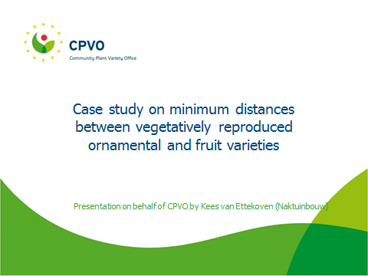

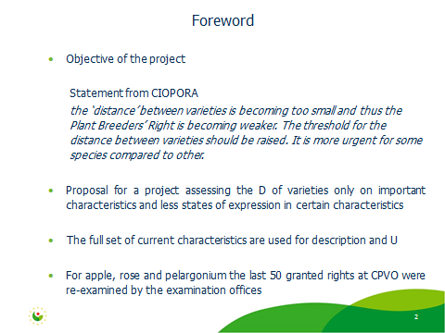

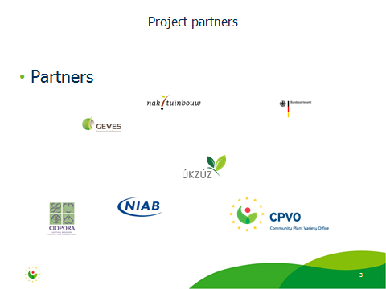

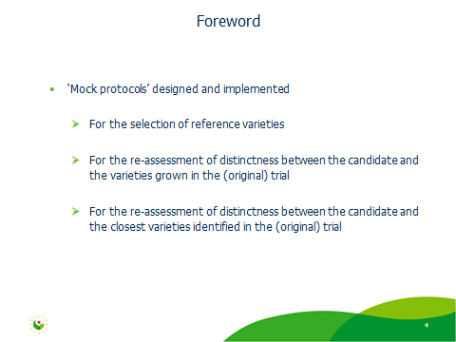

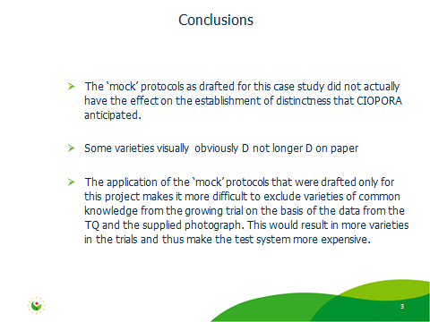

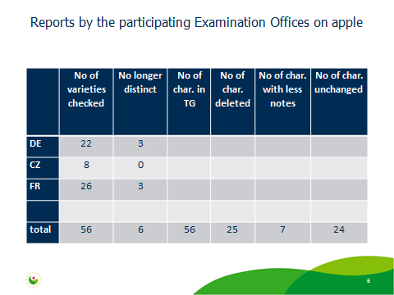

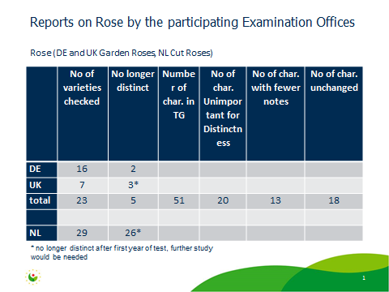

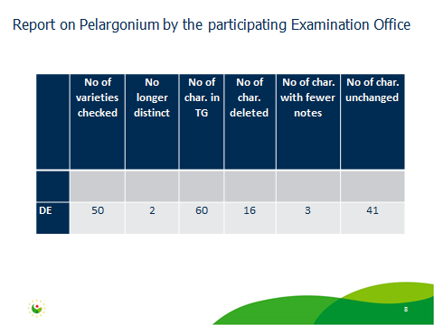

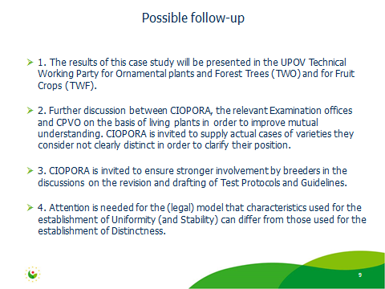

[End of document]

