|  |  |  |
| --- | --- | --- |
|  |  | E  TWF/47/23  **ORIGINAL:**  English  DATE:  November 8, 2016 |
| INTERNATIONAL UNION FOR THE PROTECTION OF NEW VARIETIES OF PLANTS | | |
| Geneva | | |

Technical working party for fruit cropS

Forty-Seventh Session  
Angers, France, November 14 to 18, 2016

Calibration book for harmonized variety description in apple

Document prepared by the European Union

# BACKGROUND

The Technical Working Party for Fruit crops (TWF), at its forty-sixth session in 2015, held in Mpumalanga, South Africa, from August 24 to 28, 2015, agreed that it would be useful to develop guidance on minimizing variation between authorities and agreed to study the possible development of a calibration book for the harmonization of variety descriptions.

The TWF agreed that Mr. Jean Maison (European Union) would coordinate the project and would search varieties that had been described by different UPOV members using the current version of the Test Guidelines for Apple.

The TWF agreed that the different descriptions for the same varieties should be compared and the causes of variation identified (environment and/or observer). The TWF agreed that participants to the development of the calibration book for harmonized variety descriptions in apple could meet by electronic means and provide information on developments to the TWF, at its next session (see document TWF/46/29 Rev. “Revised Report”, paragraphs 91 to 93).

PROJECT

A first objective of this project was to identify apple varieties that have been described by several examination offices according to the latest version of the UPOV guideline for apples. The Community Plant Variety Office of the European Union (CPVO) first requested its 6 examination offices accredited for the DUS testing of apple fruit varieties in the EU to provide such a list. The limit identified for this exercise was that the same variety may be recorded under different names in various National lists. The CPVO came back to contributors with an aggregated list, asking whether there would not be varieties recorded in a different name in various countries, this was indeed the case.

The purpose was then to identify a group of varieties for which participants could submit descriptions in order to compare them and study the differences. Natural candidates for this exercise would be the most frequently mentioned varieties in the above mentioned list. Nevertheless, it was considered that old varieties like ‘Golden Delicious’ may not be most appropriate for the exercise knowing the number of existing mutations of this variety. One cannot be sure that all examination offices have made their description on comparable material of the variety.

Another point raised by the CPVO was that it may not be necessary to exchange and analyze the description of too many varieties. Still, it is important that each examination Office has a minimum number of descriptions shared with another examination office.

On the basis of the list of varieties identified as being described by several countries in the EU, the situation of these varieties in non EU countries was considered with the help of data made available in the PLUTO/Variety Finder databases. The Office made an extract from the Variety Finder containing apple varieties registered in non EU countries with an application date as from 2006 and a registration date as from 2010. Those varieties have most likely been described according to the latest version of the guideline. This does not exclude that others may have been (re)described as well according to the latest version of the guidelines.

EU fruit experts commented that for some varieties, they could provide descriptions with only one year of observation or descriptions not emanating from official procedures. They recommended choosing relatively recent common varieties, avoiding that variation that may have arisen in maintenance breeding.

From the table mentioned above, the Office proposed to select varieties for which descriptions could be exchanged among the following list:

|  |  |  |  |  |  |  |  |  |  |  |  |  |
| --- | --- | --- | --- | --- | --- | --- | --- | --- | --- | --- | --- | --- |
|  | EU countries | | | | | | Non EU countries, only those regularly attending TWF | | | | |  |
|  | CZ | DE | ES | FR | HU | PL | AU | IL | ZA | NZ | CA |  |
| ‘Rafzubin’ | 1 | 1 |  | 1 | 1 | 1 | 1 | 1 | 1 | 1 |  | 9 |
| ‘Excel’ | 1 | 1 |  |  | 1 | 1 |  |  |  |  | 1 | 5 |
| ‘Jonagored | 1 | 1 |  |  | 1 | 1 | 1 | 1 | 1 | 1 | 1 | 9 |
| ‘Jonagored Supra’ | 1 | 1 |  |  | 1 | 1 |  |  |  |  | 1 | 5 |
| ‘Cripps Pink’ | 1 | 1 |  |  |  | 1 |  |  | 1 | 1 |  | 5 |
| ‘Red Jonaprince' | 1 | 1 |  |  |  | 1 | 1 |  | 1 | 1 | 1 | 7 |
| ‘Idared' | 1 | 1 |  | 1 | 1 | 1 |  |  |  |  |  | 5 |
| ‘Piros' |  | 1 |  | 1 | 1 | 1 |  |  |  |  |  | 4 |
| ‘Rubinstar' |  | 1 |  | 1 | 1 | 1 |  |  |  |  |  | 4 |
| ‘Pilot' | 1 | 1 |  | 1 | 1 |  |  |  |  |  |  | 4 |
| ‘Florina' | 1 | 1 |  |  | 1 | 1 |  |  |  |  |  | 4 |
| ‘Braeburn' | 1 | 1 |  |  | 1 | 1 |  |  | 1 |  |  | 5 |
| ‘Jonagold' | 1 | 1 |  |  | 1 | 1 |  |  | 1 |  |  | 5 |
|  | 11 | 13 | 0 | 5 | 11 | 12 | 3 | 2 | 6 | 4 | 4 | 71 |

For the reasons mentioned above, the varieties ‘Rafzubin’, ‘Cripps Pink’ and ‘Red Jonaprince’ have been identified for being part of the exercise. A mailing was sent to experts of the TWF in the summer 2016, asking to send the descriptions they may have for of these 3 varieties.

The Office received descriptions from AU, CA, CZ, DE, ES, HU, NZ, PL, ZA, resulting in 17 combinations country/description and produced an excel file (see Annex of this document) with one sheet per variety, displaying for each characteristic the notes attributing by countries which send their description. An additional sheet has been added, showing the spread of notes among various countries for each characteristic of the respective variety descriptions. The analysis below is based on the type of characteristic.

The apple fruit Test Guidelines contains a single qualitative characteristic. Descriptions provided reveal a consistent observation for this characteristic for all varieties. It can be concluded that this characteristic is clearly understood by all DUS examiners.

The apple fruit Test Guidelines contains 8 pseudo qualitative characteristics. The exercise reveals that the same note for all PQ characteristics is more the exception that the rule: all 5 countries providing their description have attributed the same note for the characteristic ‘fruit: colour of flesh’ for the variety ‘Red Jonaprince’. It is necessary to analyze the situation characteristic by characteristic.

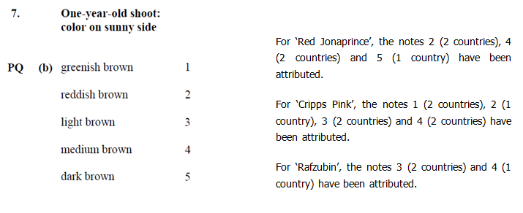

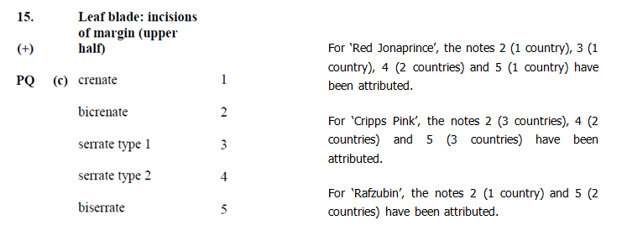

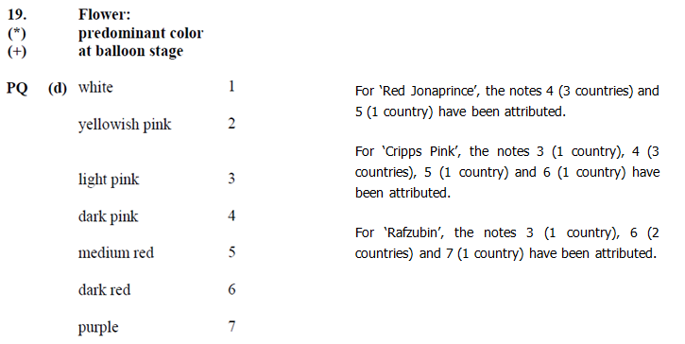

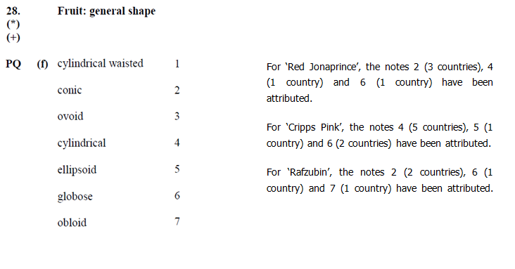

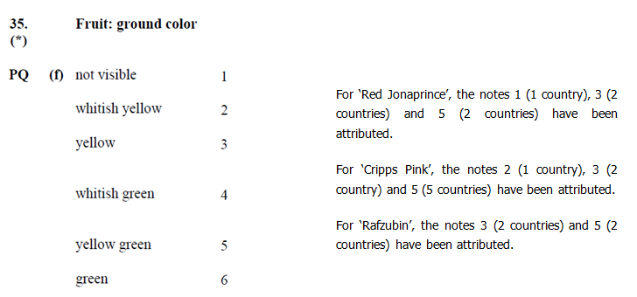

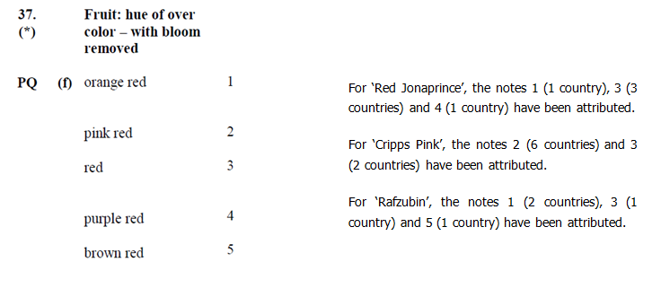

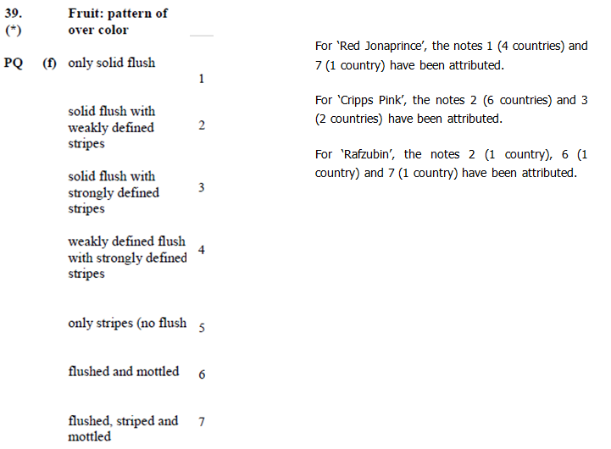

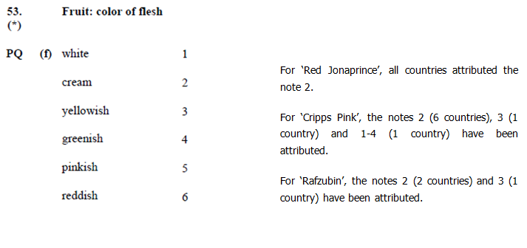

It seems that some characteristic show a more harmonized attribution of notes than others. Various factors may explain this variation:

• The influence of the environment

• Various interpretations of the characteristic by examiners

• Some characteristics or stages of expression may not be best appropriate for the guideline.

The apple fruit Test Guidelines contains 48 quantitative characteristic. The sheet ‘overall spread’ (see Annex of this document) reveals that the variation between notes attributed varies depending on the characteristics and the varieties. However, for some characteristics the variation between notes is particularly low and particularly large for others. This could be due to

• The influence of the environment

• The way notes are attributed for quantitative characteristics

Experts are requested to comment on these results and propose a follow up during the 2016 TWF.

[Annex follows]



[End of document]