E
TWF/47/17
ORIGINAL: English
DATE: October 19, 2016
INTERNATIONAL UNION FOR THE PROTECTION OF NEW VARIETIES OF PLANTS
Geneva
Technical working party for FRUIT CROPS
Forty-Seventh Session
Angers, France, November 14 to 18, 2016
GUIDANCE for Drafters of Test Guidelines
Document prepared by the Office of the Union
Disclaimer: this document does not represent UPOV policies or guidance
The Annex to this document contains a copy of a presentation on the tutorials for the following different user roles of the web-based Test Guidelines template to be made by the Office of the Union at the Technical Working Party (TWP) sessions in 2016:
- Leading Expert drafting tutorial
- Interested Expert comments tutorial
- Leading Expert checking tutorial

The tutorials contained in the Annex will be updated according to the comments and questions received during the drafting of Test Guidelines for the TWPs at their sessions in 2016 and the presentations at the TWPs in 2016.

The tutorials are available under the following link: http://upov.int/export/sites/upov/tgp/en/tg_template_tutorial_complete.pdf, as well as in the web-based TG Template under the link “Tutorials”:

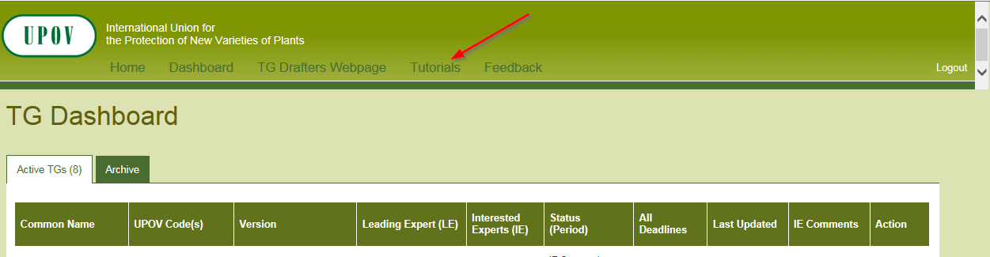

[Annex follows]

[End of Annex and of document]

