E
TG/COCOS(proj.4)
ORIGINAL: English
DATE: 2015-07-24
INTERNATIONAL UNION FOR THE PROTECTION OF NEW VARIETIES OF PLANTS
Geneva
DRAFT

 | Coconut  UPOV Code: COCOS_NUC  Cocos nucifera L. | *

GUIDELINES
FOR THE CONDUCT OF TESTS
FOR DISTINCTNESS, UNIFORMITY AND STABILITY

prepared by (an) expert(s) from Brazil

to be considered by the
Technical Working Party for Fruit Crops
at its forty-sixth session
to be held in Mpumalanga, South Africa
from 2015-08-24
to 2015-08-28

Alternative Names:*
Botanical name | English | French | German | Spanish
Cocos nucifera L. | Coconut | Cocotier | Kokosnuß | Cocotero

The purpose of these guidelines (“Test Guidelines”) is to elaborate the principles contained in the General Introduction (document TG/1/3), and its associated TGP documents, into detailed practical guidance for the harmonized examination of distinctness, uniformity and stability (DUS) and, in particular, to identify appropriate characteristics for the examination of DUS and production of harmonized variety descriptions.

ASSOCIATED DOCUMENTS
These Test Guidelines should be read in conjunction with the General Introduction and its associated TGP documents.
TABLE OF CONTENTS PAGE

1. Subject of these Test Guidelines 3
2. Material Required 3
3. Method of Examination 3
3.1 Number of Growing Cycles 3
3.2 Testing Place 3
3.3 Conditions for Conducting the Examination 3
3.4 Test Design 4
3.5 Additional Tests 4
4. Assessment of Distinctness, Uniformity and Stability 4
4.1 Distinctness 4
4.2 Uniformity 5
4.3 Stability 5
5. Grouping of Varieties and Organization of the Growing Trial 5
6. Introduction to the Table of Characteristics 6
6.1 Categories of Characteristics 6
6.2 States of Expression and Corresponding Notes 6
6.3 Types of Expression 6
6.4 Example Varieties 6
6.5 Legend 7
7. Table of Characteristics/Tableau des caractères/Merkmalstabelle/Tabla de caracteres 8
8. Explanations on the Table of Characteristics 15
9. Literature 28
10. Technical Questionnaire 29

Subject of these Test Guidelines

These Test Guidelines apply to all varieties of Cocos nucifera L..

In the case of fruit varieties, in particular, it may be necessary to use additional characteristics or additional states of expression to those included in the Table of Characteristics in order to examine Distinctness, Uniformity and Stability.

Material Required

2.1 The competent authorities decide on the quantity and quality of the plant material required for testing the variety and when and where it is to be delivered. Applicants submitting material from a State other than that in which the testing takes place must ensure that all customs formalities and phytosanitary requirements are complied with.

  - The material is to be supplied in the form of mature fruits.

2.3 The minimum quantity of plant material, to be supplied by the applicant, should be:

20 mature fruits.

The seed should meet the minimum requirements for germination, species and analytical purity, health and moisture content, specified by the competent authority. In cases where the seed is to be stored, the germination capacity should be as high as possible and should be stated by the applicant.

2.4 The plant material supplied should be visibly healthy, not lacking in vigor, nor affected by any important pest or disease.

2.5 The plant material should not have undergone any treatment which would affect the expression of the characteristics of the variety, unless the competent authorities allow or request such treatment. If it has been treated, full details of the treatment must be given.

Method of Examination

3.1 Number of Growing Cycles

3.1.1 The minimum duration of tests should normally be two independent growing cycles.

3.1.2 In particular, it is essential that the Plants produce a satisfactory crop of fruit in each of the two growing cycles.

3.1.3 The two independent growing cycles may be observed from a single planting, examined in two separate growing cycles.

3.1.4 The growing cycle is considered to be the period ranging from the beginning of development of an individual flower or inflorescence, through fruit development and concluding with the harvesting of fruit from the corresponding individual flower or inflorescence.

3.2 Testing Place

Tests are normally conducted at one place. In the case of tests conducted at more than one place, guidance is provided in TGP/9 “Examining Distinctness”.

3.3 Conditions for Conducting the Examination

3.3.1 The tests should be carried out under conditions ensuring satisfactory growth for the expression of the relevant characteristics of the variety and for the conduct of the examination.

3.4 Test Design

3.4.1 Each test should be designed to result in a total of at least 12 trees, which should be divided between at least 2 replicates.

3.5 Additional Tests

Additional tests, for examining relevant characteristics, may be established.

Assessment of Distinctness, Uniformity and Stability

4.1 Distinctness

4.1.1 General Recommendations

It is of particular importance for users of these Test Guidelines to consult the General Introduction prior to making decisions regarding distinctness. However, the following points are provided for elaboration or emphasis in these Test Guidelines.

4.1.2 Consistent Differences

The differences observed between varieties may be so clear that more than one growing cycle is not necessary. In addition, in some circumstances, the influence of the environment is not such that more than a single growing cycle is required to provide assurance that the differences observed between varieties are sufficiently consistent. One means of ensuring that a difference in a characteristic, observed in a growing trial, is sufficiently consistent is to examine the characteristic in at least two independent growing cycles.

4.1.3 Clear Differences

Determining whether a difference between two varieties is clear depends on many factors, and should consider, in particular, the type of expression of the characteristic being examined, i.e. whether it is expressed in a qualitative, quantitative, or pseudo-qualitative manner. Therefore, it is important that users of these Test Guidelines are familiar with the recommendations contained in the General Introduction prior to making decisions regarding distinctness.

4.1.4 Number of Plants / Parts of Plants to be Examined

Unless otherwise indicated, for the purposes of distinctness, all observations on single plants should be made on 12 plants or parts taken from each of 12 plants and any other observations made on all plants in the test, disregarding any off-type plants. In the case of observations of parts taken from single plants, the number of parts to be taken from each of the plants should be 2.

4.1.5 Method of Observation

The recommended method of observing the characteristic for the purposes of distinctness is indicated by the following key in the second column of the Table of Characteristics (see document TGP/9 “Examining Distinctness”, Section 4 “Observation of characteristics”):

MG: single measurement of a group of plants or parts of plants
MS: measurement of a number of individual plants or parts of plants
VG: visual assessment by a single observation of a group of plants or parts of plants
VS: visual assessment by observation of individual plants or parts of plants

Type of observation: visual (V) or measurement (M)

“Visual” observation (V) is an observation made on the basis of the expert’s judgment. For the purposes of this document, “visual” observation refers to the sensory observations of the experts and, therefore, also includes smell, taste and touch. Visual observation includes observations where the expert uses reference points (e.g. diagrams, example varieties, side-by-side comparison) or non-linear charts (e.g. color charts). Measurement (M) is an objective observation against a calibrated, linear scale e.g. using a ruler, weighing scales, colorimeter, dates, counts, etc.

Type of record: for a group of plants (G) or for single, individual plants (S)

For the purposes of distinctness, observations may be recorded as a single record for a group of plants or parts of plants (G), or may be recorded as records for a number of single, individual plants or parts of plants (S). In most cases, “G” provides a single record per variety and it is not possible or necessary to apply statistical methods in a plant-by-plant analysis for the assessment of distinctness.

In cases where more than one method of observing the characteristic is indicated in the Table of Characteristics (e.g. VG/MG), guidance on selecting an appropriate method is provided in document TGP/9, Section 4.2.

4.2 Uniformity

    - It is of particular importance for users of these Test Guidelines to consult the General Introduction prior to making decisions regarding uniformity. However, the following points are provided for elaboration or emphasis in these Test Guidelines:

4.2.2 The assessment of uniformity should be according to the recommendations for cross-pollinated varieties in the General Introduction.

4.2.3 For the assessment of uniformity, a population standard of 95% and an acceptance probability of at least 1 % should be applied. In the case of a sample size of 12 plants, 1 off-type is allowed.

4.3 Stability

4.3.1 In practice, it is not usual to perform tests of stability that produce results as certain as those of the testing of distinctness and uniformity. However, experience has demonstrated that, for many types of variety, when a variety has been shown to be uniform, it can also be considered to be stable.

4.3.2 Where appropriate, or in cases of doubt, stability may be further examined by testing a new seed stock to ensure that it exhibits the same characteristics as those shown by the initial material supplied.

Grouping of Varieties and Organization of the Growing Trial

5.1 The selection of varieties of common knowledge to be grown in the trial with the candidate varieties and the way in which these varieties are divided into groups to facilitate the assessment of distinctness are aided by the use of grouping characteristics.

5.2 Grouping characteristics are those in which the documented states of expression, even where produced at different locations, can be used, either individually or in combination with other such characteristics: (a) to select varieties of common knowledge that can be excluded from the growing trial used for examination of distinctness; and (b) to organize the growing trial so that similar varieties are grouped together.

5.3 The following have been agreed as useful grouping characteristics:

(a) Time of appearance of first inflorescence (characteristic 3)
(b) Stem: height (characteristic 7)
(c) Stem: width (characteristic 8)
(d) Fruit: color (characteristic 25)
(e) Fruit shape (characteristic 26)
(f) Nut: shape (characteristic 28)

5.4 Guidance for the use of grouping characteristics, in the process of examining distinctness, is provided through the General Introduction and document TGP/9 “Examining Distinctness”.

Introduction to the Table of Characteristics

6.1 Categories of Characteristics

6.1.1 Standard Test Guidelines Characteristics

Standard Test Guidelines characteristics are those which are approved by UPOV for examination of DUS and from which members of the Union can select those suitable for their particular circumstances.

6.1.2 Asterisked Characteristics

Asterisked characteristics (denoted by *) are those included in the Test Guidelines which are important for the international harmonization of variety descriptions and should always be examined for DUS and included in the variety description by all members of the Union, except when the state of expression of a preceding characteristic or regional environmental conditions render this inappropriate.

6.2 States of Expression and Corresponding Notes

6.2.1 States of expression are given for each characteristic to define the characteristic and to harmonize descriptions. Each state of expression is allocated a corresponding numerical note for ease of recording of data and for the production and exchange of the description.

6.2.2 In the case of qualitative and pseudo-qualitative characteristics (see Chapter 6.3), all relevant states of expression are presented in the characteristic. However, in the case of quantitative characteristics with 5 or more states, an abbreviated scale may be used to minimize the size of the Table of Characteristics. For example, in the case of a quantitative characteristic with 9 states, the presentation of states of expression in the Test Guidelines may be abbreviated as follows:

State | Note
small | 3
medium | 5
large | 7

However, it should be noted that all of the following 9 states of expression exist to describe varieties and should be used as appropriate:

State | Note
very small | 1
very small to small | 2
small | 3
small to medium | 4
medium | 5
medium to large | 6
large | 7
large to very large | 8
very large | 9

6.2.3 Further explanation of the presentation of states of expression and notes is provided in document TGP/7 “Development of Test Guidelines”.

6.3 Types of Expression

An explanation of the types of expression of characteristics (qualitative, quantitative and pseudo-qualitative) is provided in the General Introduction.

6.4 Example Varieties

Where appropriate, example varieties are provided to clarify the states of expression of each characteristic.

6.5 Legend

(*) Asterisked characteristic – see Chapter 6.1.2

QL Qualitative characteristic – see Chapter 6.3
QN Quantitative characteristic – see Chapter 6.3
PQ Pseudo-qualitative characteristic – see Chapter 6.3

MG, MS, VG, VS – see Chapter 4.1.5

(a)-(d) See Explanations on the Table of Characteristics in Chapter 8.

(+) See Explanations on the Table of Characteristics in Chapter 8.

The petiole length should be observed from base to the most proximal leaflet of the rachis.

Table of Characteristics/Tableau des caractères/Merkmalstabelle/Tabla de caracteres

English | français | deutsch | español | Example Varieties Exemples Beispielssorten Variedades ejemplo | Note/ Nota
1. QN MS VG (+)
Young Plant: number of leaves
few |  |  |  | Capi, Genjah Kuning Nias | 3
medium |  |  |  | Genjah Raja Brown, Híbrido Cancún | 5
many |  |  |  | Acapulco, Dalam Mapanget | 7
2. (*) QN VG|A (+)
Plant Young: time of leaf splitting
early |  |  |  | Dalam Sawarna | 1
medium |  |  |  | Dalam Tenga, Genjah Kuning Bali | 2
late |  |  |  |  | 3
3. (*) QN MG (+)
Time of appearance of first inflorescence
early |  |  |  | Brazilian Green Dwarf Jiqui, Genjah Tebing Tinggi, Malayan Red Dwarf, Malayan Yellow Dwarf | 3
medium |  |  |  | BRS 001, Dalam Mapanget, MATAG Hybrid Green | 5
late |  |  |  | Brazilian Tall Praia do Forte, Dalam Jepara, Malayan Tall, Tagnanan Tall | 7
4. (*) QN VG (+) (a)
Leaf: attitude of lower leaves
upwards |  |  |  |  | 1
outwards |  |  |  | Malayan Tall, Tagnanan Tall | 2
downwards |  |  |  | Brazilian Green Dwarf Jiqui, Malayan Red Dwarf, Malayan Yellow Dwarf | 3
5. QL VG (+) (a)
Stem: bole
absent |  |  |  | Brazilian Green Dwarf Jiqui, Genjah Kuning Nias, Malayan Red Dwarf, Malayan Yellow Dwarf | 1
present |  |  |  | BRS 001, Capi, Donaji, Malayan Tall, Tagnanan Tall | 9

English | français | deutsch | español | Example Varieties Exemples Beispielssorten Variedades ejemplo | Note/ Nota
6. (*) QN MS VG (+) (a)
Only varieties with bole:Stem: diameter of bole
small |  |  |  | Acapulco, BRS 001, Brazilian Tall Praia do Forte, Kelapa Hibrida Indonesia-1 | 1
medium |  |  |  | Brazilian Tall Praia do Forte, Dalam Mapanget, Híbrido Chactemal, Rennel Tall Green, West African Tall Green | 3
large |  |  |  | Dalam Tenga, Felicitos, Malayan Tall, Tagnanan Tall | 5
7. QN MS VG (+) (a)
Stem: height
low |  |  |  | Acapulco, Brazilian Green Dwarf Jiqui, Malayan Red Dwarf, Malayan Yellow Dwarf | 3
medium |  |  |  | Híbrido Cancún, Rennel Tall Green | 5
high |  |  |  | Brazilian Tall Praia do Forte, Escondido, Tagnanan Tall | 7
8. (*) QN MS VG (+) (a)
Stem: width
narrow |  |  |  | Brazilian Green Dwarf Jiqui, Malayan Red Dwarf, Malayan Yellow Dwarf | 3
medium |  |  |  | Rennel Tall Green | 5
broad |  |  |  | Brazilian Tall Praia do Forte, Malayan Tall, Tagnanan Tall | 7
9. QN MS VG (+) (a)
Petiole: length
short |  |  |  | Acapulco, Brazilian Green Dwarf Jiqui, Genjah Kuning Nias | 3
medium |  |  |  | Costa Chica, Kelapa Hibrida Indonesia-1 | 5
long |  |  |  | Brazilian Tall Praia do Forte, Dalam Tenga, Escondido | 7
10. QN MS VG (+) (a)
Petiole: thickness in cross section
thin |  |  |  | Acapulco, Genjah Kuning Nias | 3
medium |  |  |  | Híbrido Cancún, Kelapa Hibrida Indonesia-2 | 5
thick |  |  |  | Dalam Bali, Escondido | 7

English | français | deutsch | español | Example Varieties Exemples Beispielssorten Variedades ejemplo | Note/ Nota
11. QN MS VG (+) (a)
Petiole: width
narrow |  |  |  | Acapulco, Brazilian Green Dwarf Jiqui, Dalam Mapanget | 3
medium |  |  |  | Genjah Raja Brown, Híbrido Ordaz | 5
broad |  |  |  | Brazilian Tall Praia do Forte, Costa Chica, Dalam Kima Atas | 7
12. PQ VG (a)
Petiole: color
Yellow |  |  |  | BRS 001, Genjah Kuning Nias, Malayan Yellow Dwarf | 1
green |  |  |  | Genjah Salak, Malayana Green Dwarf | 2
red |  |  |  | Dalam Mapanget, Malayan Red Dwarf | 3
brown |  |  |  | BRS 003, Genjah Raja Brown, Malayan Brown Dwarf | 4
13. (*) QN MS VG (+) (a)
Leaf: length of rachis
short |  |  |  | Acapulco, Brazilian Green Dwarf Jiqui, Genjah Kuning Nias, Pandan Aromatic Dwarf | 3
medium |  |  |  | Híbrido Chactemal, Kelapa Hibrida Indonesia-3, Malayan Red Dwarf, Malayan Yellow Dwarf | 5
long |  |  |  | Brazilian Tall Praia do Forte, Dalam Palu, Escondido, Rennel Tall Green | 7
14. QN MS VG (a)
Leaf: number of leaflets
few |  |  |  | Acapulco, Brazilian Green Dwarf Jiqui, Genjah Kuning Nias, Malayan Yellow Dwarf | 3
medium |  |  |  | Dalam Jepara, Híbrido Ordaz, Rennel Tall Green | 5
many |  |  |  | Brazilian Tall Praia do Forte, Dalam Takome, Gigante, West African Tall Green | 7

English | français | deutsch | español | Example Varieties Exemples Beispielssorten Variedades ejemplo | Note/ Nota
15. QN MS VG (+) (a)
Leaflet: length
short |  |  |  | Brazilian Green Dwarf Jiqui, Costa Chica, Dalam Tebing Tinggi, Felicitos, Genjah Kuning Nias, Pandan Aromatic Dwarf, Rennel Tall Green |  | 3
medium |  |  |  | Dalam Tebing Tinggi, Felicitos, Rennel Tall Green |  | 5
long |  |  |  | Brazilian Tall Praia do Forte |  | 7
16. QN MS VG (+) (a)
Leaflet: width
narrow |  |  |  | Acapulco, Brazilian Green Dwarf Jiqui, Genjah Kuning Bali | 3
medium |  |  |  | Dalam Mamuaya, Híbrido Cancún | 5
broad |  |  |  | Brazilian Tall Praia do Forte, Costa Chica, Dalam Kima Atas | 7
17. QN VG (a)
Leaflet: intensity of green color
light |  |  |  |  | 1
medium |  |  |  | Brazilian Green Dwarf Jiqui | 2
dark |  |  |  | Malayan Red Dwarf, Malayan Yellow Dwarf, Tagnanan Tall | 3
18. QN MS VG (+) (b)
Peduncle: length
short |  |  |  | Brazilian Green Dwarf Jiqui, Donaji, Genjah Raja Brown, Malayan Yellow Dwarf | 3
medium |  |  |  | Felicitos, Kelapa Hibrida Indonesia-4 , Tagnanan Tall, West African Tall Green | 5
long |  |  |  | Brazilian Tall Praia do Forte, Dalam Mapanget, Híbrido Ordaz, Rennel Tall Green | 7
19. QN MS VG (+) (b)
Peduncle: width
small |  |  |  | Acapulco, Genjah Raja Brown | 3
medium |  |  |  | Híbrido Ordaz, Kelapa Hibrida Indonesia-4 | 5
large |  |  |  | Brazilian Tall Praia do Forte, Dalam Mapanget, Gigante | 7

English | français | deutsch | español | Example Varieties Exemples Beispielssorten Variedades ejemplo | Note/ Nota
20. QN MS VG (+) (b)
Inflorescence: length of central axis
narrow |  |  |  | Acapulco, Genjah Raja Brown, Malayan Red Dwarf, Malayan Yellow Dwarf | 3
medium |  |  |  | Híbrido Chactemal, Kelapa Hibrida Indonesia-4 , West African Tall Green | 5
broad |  |  |  | Brazilian Tall Praia do Forte, Dalam Mapanget, Gigante | 7
21. QN MS VG (+) (b)
Inflorescence: number of spikelets
few |  |  |  | Brazilian Tall Praia do Forte, Dalam Tenga, Felicitos, Rennel Tall Green | 3
medium |  |  |  | Acapulco, Dalam Banyuwang, West African Tall Green | 5
many |  |  |  | Dalam Kima Atas, Híbrido Ordaz | 7
22. (*) QN MS VG (+) (b)
Inflorescence: number of spikelets with female flowers
few |  |  |  | Brazilian Tall Praia do Forte, Escondido | 3
medium |  |  |  | Gigante, Malayan Red Dwarf, Malayan Yellow Dwarf | 5
many |  |  |  | Acapulco, West African Tall Green | 7
23. QN MS VG (+) (b)
Inflorescence: length of first spikelet with female flowers
short |  |  |  | Acapulco, Genjah Raja Brown, Malayan Red Dwarf, Malayan Yellow Dwarf | 3
medium |  |  |  | Gigante, Kelapa Hibrida Indonesia-4 , Tagnanan Tall | 5
long |  |  |  | Brazilian Tall Praia do Forte, Capi, Dalam Mapanget, Rennel Tall Green | 7
24. QN MS VG (c)
Bunch: number of fruits
few |  |  |  | Brazilian Tall Praia do Forte, Costa Chica, Dalam Sawarna | 3
medium |  |  |  | BRS 001, Capi, Dalam Mapanget | 5
many |  |  |  | Brazilian Green Dwarf Jiqui, Dalam Takome, Híbrido Chactemal | 7

English | français | deutsch | español | Example Varieties Exemples Beispielssorten Variedades ejemplo | Note/ Nota
25. (*) PQ VG (c)
Fruit: color
yellow |  |  |  | Acapulco, Genjah Kuning Bali | 1
green |  |  |  | BRS 001, Brazilian Green Dwarf Jiqui, Genjah Hijau Nias | 2
red |  |  |  | Genjah Merah | 3
brown |  |  |  | BRS 003, Genjah Raja Brown | 4
26. (*) PQ VG (+) (d)
Fruit shape
ovate |  |  |  | Brazilian Green Dwarf Jiqui, West African Tall Green | 1
circular |  |  |  | Costa Chica, Tagnanan Tall Green | 2
eliptic |  |  |  | Acapulco, Malayan Red Dwarf, Malayan Yellow Dwarf | 3
obovate |  |  |  | BRS 001, BRS 002, Brazilian Tall Praia do Forte | 4
27. QL VG (+) (c)
Fruit: aroma of coconut water
absent |  |  |  | Malayan Red Dwarf, Malayan Yellow Dwarf | 1
present |  |  |  | Pandan Aromatic Dwarf, Wenye4 | 9
28. (*) PQ VG (+) (d)
Nut: shape
obovate |  |  |  |  | 1
oblate |  |  |  | Brazilian Green Dwarf Jiqui, Capi | 2
circular |  |  |  | Acapulco, Malayan Red Dwarf, Malayan Yellow Dwarf | 3
eliptic |  |  |  | BRS 002, Brazilian Tall Praia do Forte, Donaji, West African Tall Green | 4

English | français | deutsch | español | Example Varieties Exemples Beispielssorten Variedades ejemplo | Note/ Nota
29. QN MS VG (+) (d)
Shell: thickness
thin |  |  |  | Genjah Kuning Nias, Malayan Red Dwarf, Malayan Yellow Dwarf | 1
medium |  |  |  | Kelapa Hibrida Indonesia-1, Rennel Tall Green | 2
thick |  |  |  | Dalam Tenga, West African Tall Green | 3
30. (*) QN VG (+) (d)
Meat: thickness
thin |  |  |  | Acapulco, Genjah Kuning Jombang, Malayan Yellow Dwarf | 1
medium |  |  |  | Dalam Sawarna, Gigante, Rennel Tall Green | 2
thick |  |  |  | Dalam Mapanget, Híbrido Cancún, West African Tall Green | 3

Explanations on the Table of Characteristics

8.1 Explanations covering several characteristics

Characteristics containing the following key in the second column of the Table of Characteristics should be examined as indicated below:
(a) Tree, stem, petiole, leaf and leaflet: Observations should be made at the time when the eleventh leaf scars appears (see photo of a plant with leaf scars). Observations on petiole, leaf and leaflet should be made on a mature leaf. Observations on leaflets should be made in the middle of the rachis, taken 2 opposite leaflets.
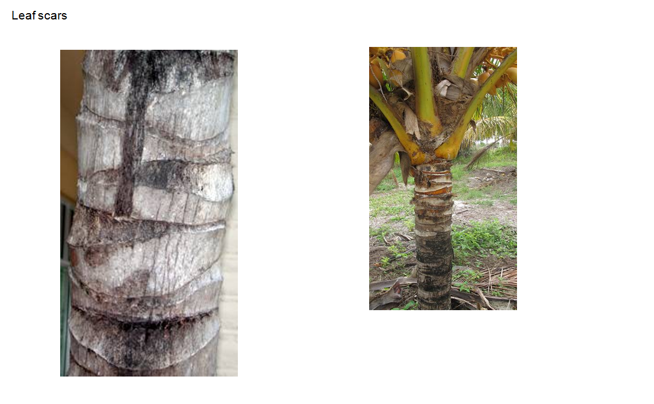
(b) Peduncle and inflorescence: Observations on peduncle and inflorescence should be made after the appearance of the fifth inflorescence, when female flowers are receptive.
(c) Bunch, fruit color and fruit aroma: Observations on the bunch, fruit color and fruit aroma should be made at the time of consumption as coconut water (at 6-7 months age fruit), after the appearance of the sixth bunch onwards.
(d) Fruit, nut, shell and meat. Observations on the fruit, nut, shell and meat should be made at maturity for consumption as fresh meat (at 11-12 months age fruit), after the appearance of the sixth bunch onwards.

8.2 Explanations for individual characteristics

Ad. 1: Young Plant: number of leaves
Should be observed at age 6 months when the plants are around 6 months old.
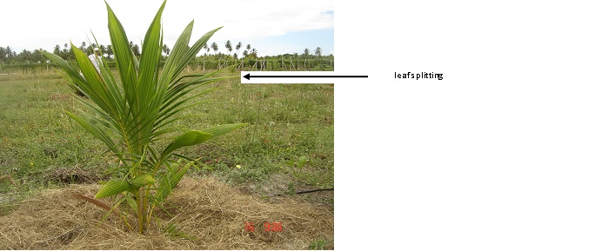

Ad. 2: Plant Young: time of leaf splitting
Should be observed at age 6 months when the plants are around 6 months old.
Ad. 3: Time of appearance of first inflorescence
The time of appearance of first inflorescence should be observed when 50% of the plants have emitted the first inflorescence.

Ad. 4: Leaf: attitude of lower leaves
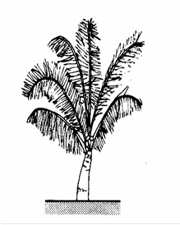
1 - upwards
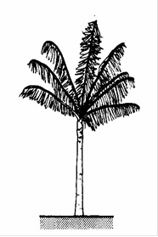
2 - outwards
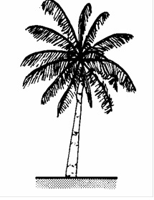
3 - downwards

Ad. 5: Stem: bole
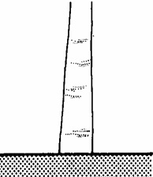
1 - absent
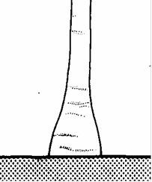
9 - present

Ad. 6: Only varieties with bole:Stem: diameter of bole
The diameter of the bole should be measured at its widest part.

Ad. 7: Stem: height
The stem height should be observed from the ground to the top of the 11th scar (see picture 8.1 (a)

Ad. 8: Stem: width
The stem width should be measured halfway from the ground to the top of the 11th scar.

Ad. 9: Petiole: length
The petiole length should be observed from base to the most proximal leaflet of the rachis.
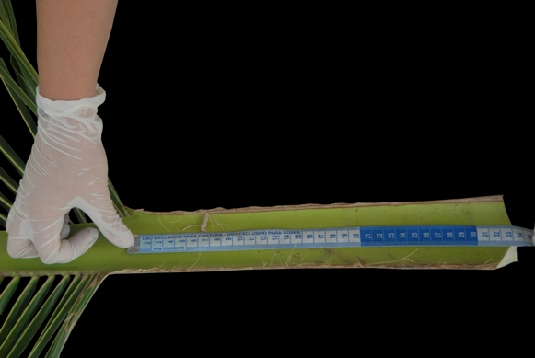
Ad. 10: Petiole: thickness in cross section
The petiole thickness and the petiole width should be observed at the insertion of the first leaflet.
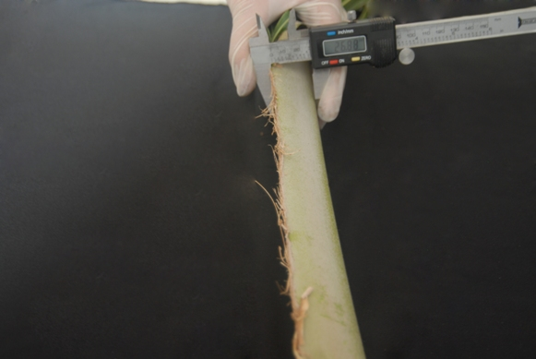

Ad. 11: Petiole: width
The petiole thickness and the petiole width should be observed at the insertion of the first leaflet.
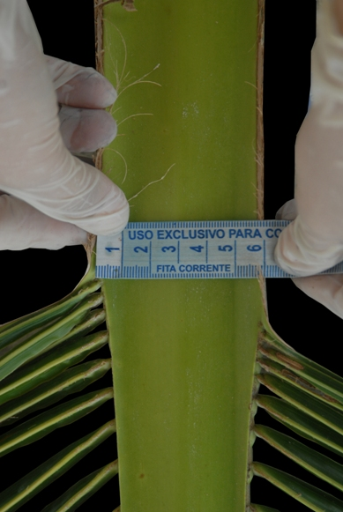

Ad. 13: Leaf: length of rachis
The length of the rachis should be measured from to the most proximal leaflet to the tip of the rachis.
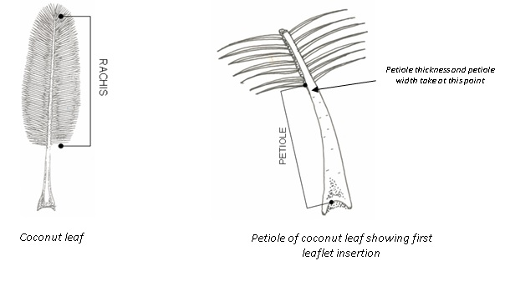
Ad. 15: Leaflet: length
The leaflet length should be measured at the middle of the rachis

Ad. 16: Leaflet: width
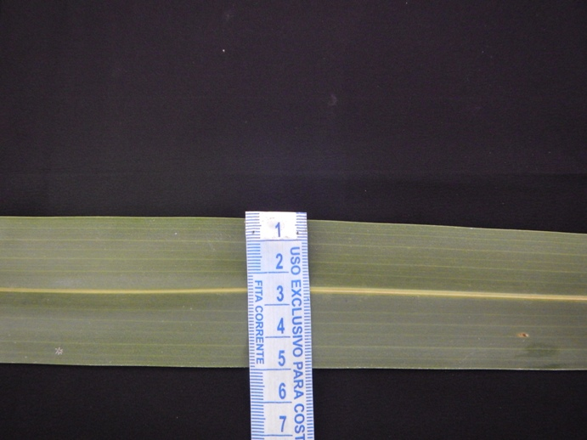

Ad. 18: Peduncle: length
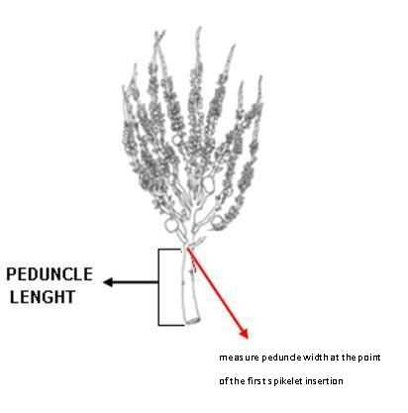

Ad. 19: Peduncle: width

Ad. 20: Inflorescence: length of central axis
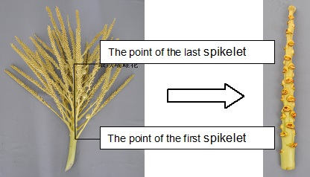

Ad. 21: Inflorescence: number of spikelets
The number of spikelets is assessed by counting after removing them from the inflorescence.
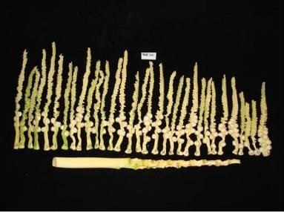

Ad. 22: Inflorescence: number of spikelets with female flowers
The number of spikelets with female flowers is assessed by counting after removing them from the inflorescence
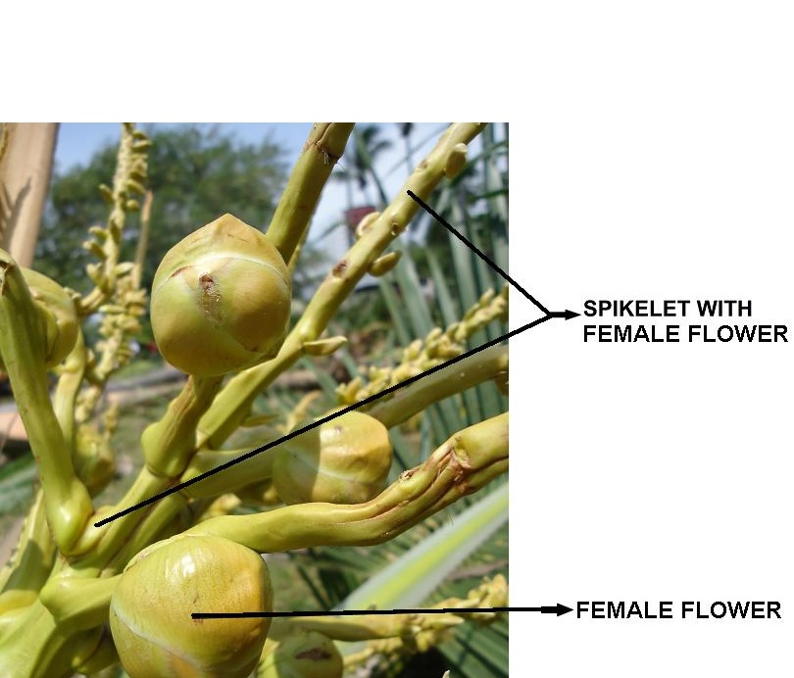
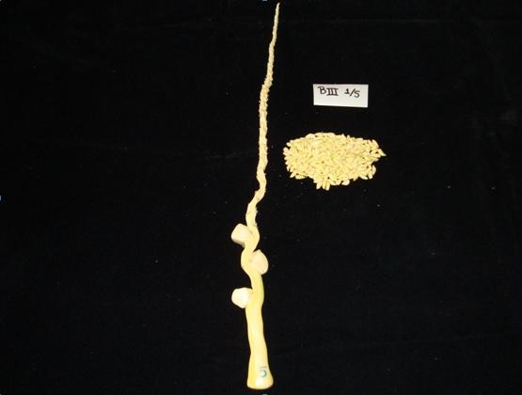

Ad. 23: Inflorescence: length of first spikelet with female flowers
Should be evaluated after the appearance of the fifth inflorescence, on the first spikelet with female flowers counting from the base of the inflorescence

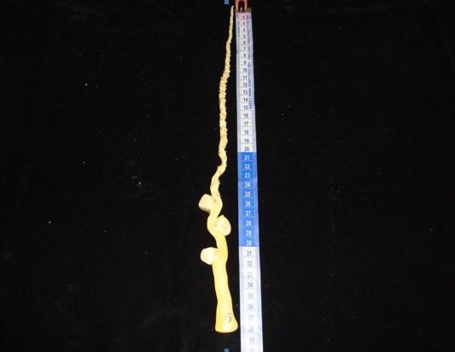

Ad. 26: Fruit shape
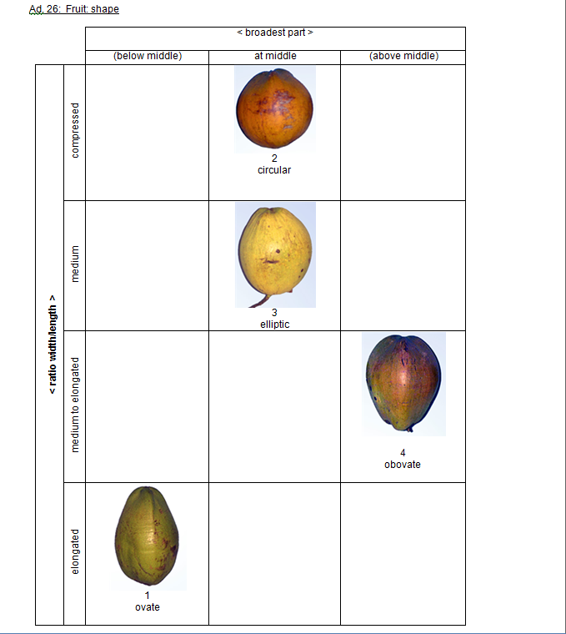

Ad. 27: Fruit: aroma of coconut water
The aroma is assessed by smelling the water at the maturity stage for consumption as water.

Ad. 28: Nut: shape
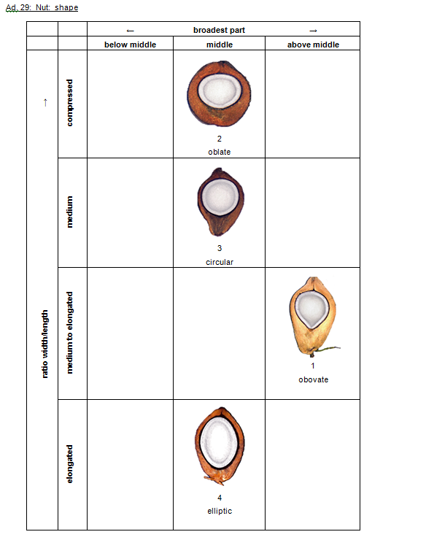

Ad. 29: Shell: thickness
The shell thickness should be measured at the middle part of the nut.
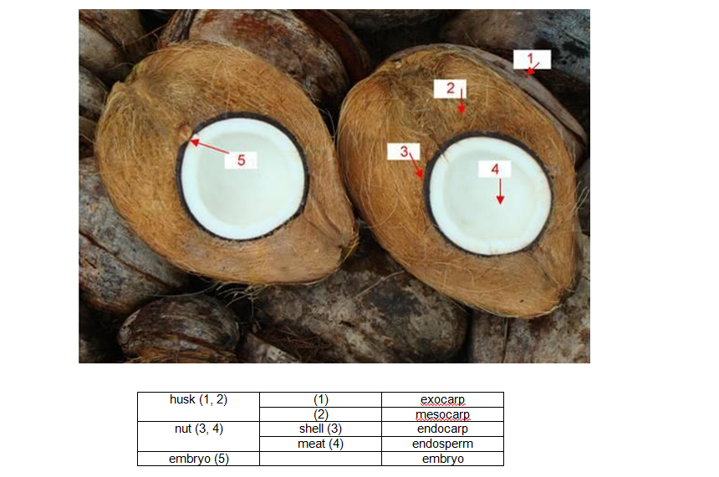

Ad. 30: Meat: thickness
The meat thickness should be measured at the middle part of the nut.
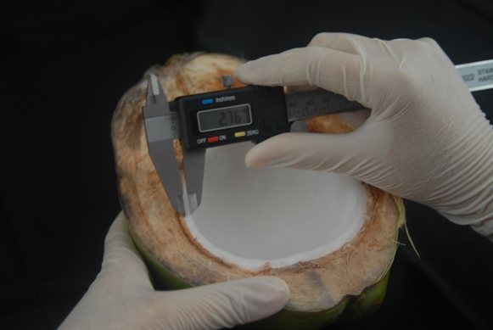

Literature

Aragão, W.M., Ribeiro, F.E., de V. Melo, M.F. 2009: Cultivares de coqueiro para produção de coco seco: coqueiro gigante vs híbridos. In: Cintra, F.L.D., Fontes, H.R., Passos, E.E.M., Ferreira, J.M.S., (Ed.). Fundamentos tecnológicos para a revitalização das áreas cultivadas com coqueiro gigante do Brasil. Aracaju: Embrapa Tabuleiros Costeiros,. 232p.

IPGRI, 1995: Descriptors for Coconut (Cocus nucifera L.). International Plant Genetic Resources Institute. Rome, IT, 61 pp.

Santos, G.A.; Batugal, P.A.; Othaman, A.; Baudouin, L.; Labouisse, J.P. (Ed.) Manual on standardized research techniques in coconut breeding. Rome, IT, IPGRI, 1993, p.irr

Wuidart, W., Rognon, F., 1978: L’analysis de composant de la noix de cocotier: Méthode de determination du coprah. Oléagineux, 33(5): 225-33.

Technical Questionnaire

TECHNICAL QUESTIONNAIRE |  | Page {x} of {y} | Reference Number:
 |  |  | Application date:
 |  |  | (not to be filled in by the applicant)
TECHNICAL QUESTIONNAIRE
to be completed in connection with an application for plant breeders’ rights

1. Subject of the Technical Questionnaire
1.1.1 | Botanical Name | Cocos nucifera L.
1.1.2 | Common Name | Coconut

2. Applicant
Name
Address
Telephone No.
Fax No.
E-mail address
Breeder (if different from applicant)
3. Proposed denomination and breeder’s reference
Proposed denomination
(if available)

Breeder’s reference

TECHNICAL QUESTIONNAIRE |  | Page {x} of {y} | Reference Number:
4. Information on the breeding scheme and propagation of the variety

4.1 Breeding scheme

4.2 Method of propagating the variety

4.2.1 Seed-propagated varieties

(a) Self-pollination [ ]
(b) Cross-pollination [ ]
(c) Other [ ]
(please provide details)
..................................................................................................................................................
: :
: :
:................................................................................................................................................:

4.2.2 Other [ ]

(please provide details)
..................................................................................................................................................
: :
: :
:................................................................................................................................................:

5. Characteristics of the variety to be indicated (the number in brackets refers to the corresponding characteristic in Test Guidelines; please mark the note which best corresponds).

 | Characteristics | Example Varieties | Note
5.1 (3) | Time of appearance of first inflorescence
 | early | Brazilian Green Dwarf Jiqui, Genjah Tebing Tinggi, Malayan Red Dwarf, Malayan Yellow Dwarf | 3[ ]
 | medium | BRS 001, Dalam Mapanget, MATAG Hybrid Green | 5[ ]
 | late | Brazilian Tall Praia do Forte, Dalam Jepara, Malayan Tall, Tagnanan Tall | 7[ ]
5.2 (7) | Stem: height
 | low | Acapulco, Brazilian Green Dwarf Jiqui, Malayan Red Dwarf, Malayan Yellow Dwarf | 3[ ]
 | medium | Híbrido Cancún, Rennel Tall Green | 5[ ]
 | high | Brazilian Tall Praia do Forte, Escondido, Tagnanan Tall | 7[ ]
5.3 (8) | Stem: width
 | narrow | Brazilian Green Dwarf Jiqui, Malayan Red Dwarf, Malayan Yellow Dwarf | 3[ ]
 | medium | Rennel Tall Green | 5[ ]
 | broad | Brazilian Tall Praia do Forte, Malayan Tall, Tagnanan Tall | 7[ ]
5.4 (25) | Fruit: color
 | yellow | Acapulco, Genjah Kuning Bali | 1[ ]
 | green | BRS 001, Brazilian Green Dwarf Jiqui, Genjah Hijau Nias | 2[ ]
 | red | Genjah Merah | 3[ ]
 | brown | BRS 003, Genjah Raja Brown | 4[ ]
5.5 (26) | Fruit shape
 | ovate | Brazilian Green Dwarf Jiqui, West African Tall Green | 1[ ]
 | circular | Costa Chica, Tagnanan Tall Green | 2[ ]
 | eliptic | Acapulco, Malayan Red Dwarf, Malayan Yellow Dwarf | 3[ ]
 | obovate | BRS 001, BRS 002, Brazilian Tall Praia do Forte | 4[ ]
5.6 (28) | Nut: shape
 | obovate |  | 1[ ]
 | oblate | Brazilian Green Dwarf Jiqui, Capi | 2[ ]
 | circular | Acapulco, Malayan Red Dwarf, Malayan Yellow Dwarf | 3[ ]
 | eliptic | BRS 002, Brazilian Tall Praia do Forte, Donaji, West African Tall Green | 4[ ]
6. Similar varieties and differences from these varieties

Please use the following table and box for comments to provide information on how your candidate variety differs from the variety (or varieties) which, to the best of your knowledge, is (or are) most similar. This information may help the examination authority to conduct its examination of distinctness in a more efficient way.

Denomination(s) of variety(ies) similar to your candidate variety | Characteristic(s) in which your candidate variety differs from the similar variety(ies) | Describe the expression of the characteristic(s) for the similar variety(ies) | Describe the expression of the characteristic(s) for your candidate variety
Example
Comments:

7. Additional information which may help in the examination of the variety

7.1 In addition to the information provided in sections 5 and 6, are there any additional characteristics which may help to distinguish the variety?

Yes [ ] No [ ]

(If yes, please provide details)

7.2 Are there any special conditions for growing the variety or conducting the examination?

Yes [ ] No [ ]

(If yes, please provide details)

7.3 Other information

8. Authorization for release

(a) Does the variety require prior authorization for release under legislation concerning the protection of the environment, human and animal health?

Yes [ ] No [ ]

(b) Has such authorization been obtained?

Yes [ ] No [ ]

If the answer to (b) is yes, please attach a copy of the authorization.

TECHNICAL QUESTIONNAIRE | Page {x} of {y} | Reference Number:
9. Information on plant material to be examined or submitted for examination

9.1 The expression of a characteristic or several characteristics of a variety may be affected by factors, such as pests and disease, chemical treatment (e.g. growth retardants or pesticides), effects of tissue culture, different rootstocks, scions taken from different growth phases of a tree, etc.

9.2 The plant material should not have undergone any treatment which would affect the expression of the characteristics of the variety, unless the competent authorities allow or request such treatment. If the plant material has undergone such treatment, full details of the treatment must be given. In this respect, please indicate below, to the best of your knowledge, if the plant material to be examined has been subjected to:

(a) Microorganisms (e.g. virus, bacteria, phytoplasma) Yes [ ] No [ ]

(b) Chemical treatment (e.g. growth retardant, pesticide) Yes [ ] No [ ]

(c) Tissue culture Yes [ ] No [ ]

(d) Other factors Yes [ ] No [ ]

Please provide details for where you have indicated “yes”.

10. I hereby declare that, to the best of my knowledge, the information provided in this form is correct:

Applicant’s name

Signature Date

[End of document]

* These names were correct at the time of the introduction of these Test Guidelines but may be revised or updated. [Readers are advised to consult the UPOV Code, which can be found on the UPOV Website (www.upov.int), for the latest information.]

