E
TG/124/4(proj.2)
ORIGINAL: English
DATE: 2015-07-13
INTERNATIONAL UNION FOR THE PROTECTION OF NEW VARIETIES OF PLANTS
Geneva
DRAFT

 | Chestnut  UPOV Code: CASTA_CRE; CASTA_MOL; CASTA_SAT  Castanea crenata Sieold & Zucc.;  Castanea mollissima Blume;  Castanea sativa Mill. | *

GUIDELINES
FOR THE CONDUCT OF TESTS
FOR DISTINCTNESS, UNIFORMITY AND STABILITY

prepared by (an) expert(s) from Japan

to be considered by the
Technical Working Party for Fruit Crops
at its forty-sixth session
to be held in Mpumalanga, South Africa
from 2015-08-24
to 2015-08-28

Alternative Names:*
Botanical name | English | French | German | Spanish
Castanea crenata Sieold & Zucc. | Japanese chestnut | Châtaignier du Japon | Japanische Kastanie | Castaño del Japón
Castanea mollissima Blume | Chinese Chestnut | Châtaignier de Chine | Chinesische Kastanie | Castaño chino
Castanea sativa Mill., Castanea vesca Gaertn., Castanea vulgaris, Fagus castanea L. | Chestnut | Chataignier | Kastanie

The purpose of these guidelines (“Test Guidelines”) is to elaborate the principles contained in the General Introduction (document TG/1/3), and its associated TGP documents, into detailed practical guidance for the harmonized examination of distinctness, uniformity and stability (DUS) and, in particular, to identify appropriate characteristics for the examination of DUS and production of harmonized variety descriptions.

ASSOCIATED DOCUMENTS
These Test Guidelines should be read in conjunction with the General Introduction and its associated TGP documents.
TABLE OF CONTENTS PAGE

1. Subject of these Test Guidelines 4
2. Material Required 4
3. Method of Examination 4
3.1 Number of Growing Cycles 4
3.2 Testing Place 4
3.3 Conditions for Conducting the Examination 4
3.4 Test Design 4
3.5 Additional Tests 5
4. Assessment of Distinctness, Uniformity and Stability 5
4.1 Distinctness 5
4.2 Uniformity 6
4.3 Stability 6
5. Grouping of Varieties and Organization of the Growing Trial 6
6. Introduction to the Table of Characteristics 6
6.1 Categories of Characteristics 6
6.2 States of Expression and Corresponding Notes 7
6.3 Types of Expression 7
6.4 Example Varieties 7
6.5 Legend 7
7. Table of Characteristics/Tableau des caractères/Merkmalstabelle/Tabla de caracteres 8
8. Explanations on the Table of Characteristics 18
9. Literature 27
10. Technical Questionnaire 28

Subject of these Test Guidelines

These Test Guidelines apply to all varieties of Castanea crenata Sieold & Zucc., Castanea mollissima Blume, Castanea sativa Mill..

These Test Guidelines apply to all varieties of Castanea sativa Mill., Castanea crenata Siebold &amp; Zucc., Castanea mollissima Blume and hybrids among these species.

Material Required

2.1 The competent authorities decide on the quantity and quality of the plant material required for testing the variety and when and where it is to be delivered. Applicants submitting material from a State other than that in which the testing takes place must ensure that all customs formalities and phytosanitary requirements are complied with.

  - The material is to be supplied in the form of dormant shoots for grafting or two-year-old trees grafted on a rootstock selected by the testing authority.

2.3 The minimum quantity of plant material, to be supplied by the applicant, should be:

- 10 dormant shoots
or
- 6 two-year-old- trees.

2.4 The plant material supplied should be visibly healthy, not lacking in vigor, nor affected by any important pest or disease.

2.5 The plant material should not have undergone any treatment which would affect the expression of the characteristics of the variety, unless the competent authorities allow or request such treatment. If it has been treated, full details of the treatment must be given.

Method of Examination

3.1 Number of Growing Cycles

3.1.1 The minimum duration of tests should normally be two independent growing cycles.

3.1.2 The growing cycle is considered to be the duration of a single growing season, beginning with bud burst, flowering and fruit harvest and concluding when the following dormant period ends with the swelling of new season buds.

3.2 Testing Place

Tests are normally conducted at one place. In the case of tests conducted at more than one place, guidance is provided in TGP/9 “Examining Distinctness”.

3.3 Conditions for Conducting the Examination

3.3.1 The tests should be carried out under conditions ensuring satisfactory growth for the expression of the relevant characteristics of the variety and for the conduct of the examination.

3.4 Test Design

3.4.1 Each test should be designed to result in a total of at least 5 trees.

3.4.2 The design of the tests should be such that plants or parts of plants may be removed for measurement or counting without prejudice to the observations which must be made up to the end of the growing cycle.

3.5 Additional Tests

Additional tests, for examining relevant characteristics, may be established.

Assessment of Distinctness, Uniformity and Stability

4.1 Distinctness

4.1.1 General Recommendations

It is of particular importance for users of these Test Guidelines to consult the General Introduction prior to making decisions regarding distinctness. However, the following points are provided for elaboration or emphasis in these Test Guidelines.

4.1.2 Consistent Differences

The differences observed between varieties may be so clear that more than one growing cycle is not necessary. In addition, in some circumstances, the influence of the environment is not such that more than a single growing cycle is required to provide assurance that the differences observed between varieties are sufficiently consistent. One means of ensuring that a difference in a characteristic, observed in a growing trial, is sufficiently consistent is to examine the characteristic in at least two independent growing cycles.

4.1.3 Clear Differences

Determining whether a difference between two varieties is clear depends on many factors, and should consider, in particular, the type of expression of the characteristic being examined, i.e. whether it is expressed in a qualitative, quantitative, or pseudo-qualitative manner. Therefore, it is important that users of these Test Guidelines are familiar with the recommendations contained in the General Introduction prior to making decisions regarding distinctness.

4.1.4 Number of Plants / Parts of Plants to be Examined

Unless otherwise indicated, for the purposes of distinctness, all observations on single plants should be made on 5 plants or parts taken from each of 5 plants and any other observations made on all plants in the test. In the case of observations of parts taken from single plants, the number of parts to be taken from each of the plants should be 2.

4.1.5 Method of Observation

The recommended method of observing the characteristic for the purposes of distinctness is indicated by the following key in the second column of the Table of Characteristics (see document TGP/9 “Examining Distinctness”, Section 4 “Observation of characteristics”):

MG: single measurement of a group of plants or parts of plants
MS: measurement of a number of individual plants or parts of plants
VG: visual assessment by a single observation of a group of plants or parts of plants
VS: visual assessment by observation of individual plants or parts of plants

Type of observation: visual (V) or measurement (M)

“Visual” observation (V) is an observation made on the basis of the expert’s judgment. For the purposes of this document, “visual” observation refers to the sensory observations of the experts and, therefore, also includes smell, taste and touch. Visual observation includes observations where the expert uses reference points (e.g. diagrams, example varieties, side-by-side comparison) or non-linear charts (e.g. color charts). Measurement (M) is an objective observation against a calibrated, linear scale e.g. using a ruler, weighing scales, colorimeter, dates, counts, etc.

For the purposes of distinctness, observations may be recorded as a single record for a group of plants or parts of plants (G), or may be recorded as records for a number of single, individual plants or parts of plants (S). In most cases, “G” provides a single record per variety and it is not possible or necessary to apply statistical methods in a plant-by-plant analysis for the assessment of distinctness.

In cases where more than one method of observing the characteristic is indicated in the Table of Characteristics (e.g. VG/MG), guidance on selecting an appropriate method is provided in document TGP/9, Section 4.2.

4.2 Uniformity

    - It is of particular importance for users of these Test Guidelines to consult the General Introduction prior to making decisions regarding uniformity. However, the following points are provided for elaboration or emphasis in these Test Guidelines:

4.2.2 For the assessment of uniformity, a population standard of 1% and an acceptance probability of at least 95% should be applied. In the case of a sample size of 5 plants, no off-types are allowed.

4.3 Stability

4.3.1 In practice, it is not usual to perform tests of stability that produce results as certain as those of the testing of distinctness and uniformity. However, experience has demonstrated that, for many types of variety, when a variety has been shown to be uniform, it can also be considered to be stable.

Grouping of Varieties and Organization of the Growing Trial

5.1 The selection of varieties of common knowledge to be grown in the trial with the candidate varieties and the way in which these varieties are divided into groups to facilitate the assessment of distinctness are aided by the use of grouping characteristics.

5.2 Grouping characteristics are those in which the documented states of expression, even where produced at different locations, can be used, either individually or in combination with other such characteristics: (a) to select varieties of common knowledge that can be excluded from the growing trial used for examination of distinctness; and (b) to organize the growing trial so that similar varieties are grouped together.

5.3 The following have been agreed as useful grouping characteristics:

(a) Nut: shape (characteristic 32)
(b) Nut: color of skin (characteristic 38)
(c) Nut: size (characteristic 39)
(d) Time of fruit maturity for harvesting (characteristic 46)

5.4 Guidance for the use of grouping characteristics, in the process of examining distinctness, is provided through the General Introduction and document TGP/9 “Examining Distinctness”.

Introduction to the Table of Characteristics

6.1 Categories of Characteristics

6.1.1 Standard Test Guidelines Characteristics

Standard Test Guidelines characteristics are those which are approved by UPOV for examination of DUS and from which members of the Union can select those suitable for their particular circumstances.

6.1.2 Asterisked Characteristics

Asterisked characteristics (denoted by *) are those included in the Test Guidelines which are important for the international harmonization of variety descriptions and should always be examined for DUS and included in the variety description by all members of the Union, except when the state of expression of a preceding characteristic or regional environmental conditions render this inappropriate.

6.2 States of Expression and Corresponding Notes

6.2.1 States of expression are given for each characteristic to define the characteristic and to harmonize descriptions. Each state of expression is allocated a corresponding numerical note for ease of recording of data and for the production and exchange of the description.

6.2.2 In the case of qualitative and pseudo-qualitative characteristics (see Chapter 6.3), all relevant states of expression are presented in the characteristic. However, in the case of quantitative characteristics with 5 or more states, an abbreviated scale may be used to minimize the size of the Table of Characteristics. For example, in the case of a quantitative characteristic with 9 states, the presentation of states of expression in the Test Guidelines may be abbreviated as follows:

State | Note
small | 3
medium | 5
large | 7

However, it should be noted that all of the following 9 states of expression exist to describe varieties and should be used as appropriate:

State | Note
very small | 1
very small to small | 2
small | 3
small to medium | 4
medium | 5
medium to large | 6
large | 7
large to very large | 8
very large | 9

6.2.3 Further explanation of the presentation of states of expression and notes is provided in document TGP/7 “Development of Test Guidelines”.

6.3 Types of Expression

An explanation of the types of expression of characteristics (qualitative, quantitative and pseudo-qualitative) is provided in the General Introduction.

6.4 Example Varieties

Where appropriate, example varieties are provided to clarify the states of expression of each characteristic.

6.5 Legend

(*) Asterisked characteristic – see Chapter 6.1.2

QL Qualitative characteristic – see Chapter 6.3
QN Quantitative characteristic – see Chapter 6.3
PQ Pseudo-qualitative characteristic – see Chapter 6.3

MG, MS, VG, VS – see Chapter 4.1.5

(a)-(g) See Explanations on the Table of Characteristics in Chapter 8.

(+) See Explanations on the Table of Characteristics in Chapter 8.

Table of Characteristics/Tableau des caractères/Merkmalstabelle/Tabla de caracteres

English | français | deutsch | español | Example Varieties Exemples Beispielssorten Variedades ejemplo | Note/ Nota
1. QN VG (+) (b)
Tree: vigor | Arbre : vigueur | Baum: Wuchsstärke | Árbol: vigor
weak | faible | schwach | débil | Hong Mao Zao(C), Toyotamawase(B) | 3
medium | moyenne | mittel | medio | Ibuki(B), Ishizuchi(B), Zhong Chi Li(C) | 5
strong | forte | stark | fuerte | Da Hong Pao(C), Ganne(B), Tsukuba(B) | 7
2. (*) QN VG (+) (b)
Tree: growth habit | Arbre : port | Baum: Wuchsform | Árbol: porte
upright | dressé | aufrecht | erguido |  | 1
semi-upright | demi-dressé | halbaufrecht | semierguido |  | 2
spreading | divergent | breitwüchsig | extendido |  | 3
3. (*) QN MG VG (c)
Current seson's shoot: thickness
thin |  |  |  |  | 3
medium |  |  |  |  | 5
thick |  |  |  |  | 7
4. (*) QN MS VG (c)
Current season's shoot: length of internodes
short |  |  |  |  | 3
medium |  |  |  |  | 5
long |  |  |  |  | 7
5. (*) QN MS VG (c)
Curren:season's shoot: phyllotaxis
one half |  |  |  |  | 1
two fifths |  |  |  |  | 2

English | français | deutsch | español | Example Varieties Exemples Beispielssorten Variedades ejemplo | Note/ Nota
6. (*) QL VG (c)
Current season's shoot: anthocyanin coloration of distal part
absent |  |  |  |  | 1
present |  |  |  |  | 9
7. (*) PQ VG (c)
Current season's shoot: color of upper side
yellow brown |  |  |  |  | 1
brown |  |  |  |  | 2
red brown |  |  |  |  | 3
8. (*) QN VG (+) (c)
Current seson's shoot: density of lebticels
sparse |  |  |  |  | 3
medium |  |  |  |  | 5
dense |  |  |  |  | 7
9. (*) QN MS VG (e)
Male flower: length of filament
very short |  |  |  |  | 1
short |  |  |  |  | 2
medium |  |  |  |  | 3
long |  |  |  |  | 4
very long |  |  |  |  | 5

English | français | deutsch | español | Example Varieties Exemples Beispielssorten Variedades ejemplo | Note/ Nota
10. (*) QN VG (e)
Unisexual catkin: length
shot |  |  |  |  | 3
medium |  |  |  |  | 5
long |  |  |  |  | 7
11. (*) QL MS VG (c)
Young leaf: bronze coloration (distal part of lateral)
absent |  |  |  |  | 1
present |  |  |  |  | 9
12. (*) QN MS VG (+) (d)
Leaf: size
small |  |  |  |  | 3
medium |  |  |  |  | 5
large |  |  |  |  | 7
13. (*) QN VG (+) (d)
Leaf: profile in cross section
straight |  |  |  |  | 1
slightly concave |  |  |  |  | 2
strongly concave |  |  |  |  | 3
14. (*) QN VG (d)
Leaf: symmetry
symmetric |  |  |  |  | 1
slightly asymmetric |  |  |  |  | 2
strongly asymmetric |  |  |  |  | 3

English | français | deutsch | español | Example Varieties Exemples Beispielssorten Variedades ejemplo | Note/ Nota
15. (*) QN MS VG (+) (d)
Leaf: length/width ratio
low |  |  |  |  | 3
medium |  |  |  |  | 5
high |  |  |  |  | 7
16. (*) QN VG (+) (d)
Leaf: attitude compared to shoot
upwards |  |  |  |  | 1
horizontal |  |  |  |  | 2
downwards |  |  |  |  | 3
17. (*) QN VG (d)
Leaf blade: intensity of green color of upper side
light |  |  |  |  | 1
medium |  |  |  |  | 3
dark |  |  |  |  | 5
18. (*) QL VG (d)
Leaf: color of lower side
whitish |  |  |  |  | 1
light green |  |  |  |  | 2
19. (*) PQ VG (+) (d)
Leaf: shape
lanceolate |  |  |  |  | 1
narrow elliptic |  |  |  |  | 2
broad elliptic |  |  |  |  | 3

English | français | deutsch | español | Example Varieties Exemples Beispielssorten Variedades ejemplo | Note/ Nota
20. (*) PQ VG (+) (d)
Leaf: shape of apex
narrow acuminate |  |  |  |  | 1
broad acuminate |  |  |  |  | 2
acute |  |  |  |  | 3
21. (*) PQ VG (+) (d)
Leaf: shape of base
acute |  |  |  |  | 1
obtuse |  |  |  |  | 2
cordate |  |  |  |  | 3
22. (*) QL VG (+) (d)
Leaf: incisions of margin
mucronate |  |  |  |  | 1
dentate |  |  |  |  | 2
23. (*) QN VG (d)
Leaf: symmetry of base
symmetric or slightly asymmetric |  |  |  |  | 1
moderately asymmetric |  |  |  |  | 2
strongly asymmetric |  |  |  |  | 3
24. (*) PQ VG (c)
Leaf: color of petiole
yellow |  |  |  |  | 1
green |  |  |  |  | 2

English | français | deutsch | español | Example Varieties Exemples Beispielssorten Variedades ejemplo | Note/ Nota
25. (*) QN MS VG (+) (d)
Leaf: ratio length of leaf blade/length of petiole
low |  |  |  |  | 3
medium |  |  |  |  | 5
high |  |  |  |  | 7
26. (*) PQ VG (+) (f)
Bur: shape in combination of front view and lateral view
globose |  |  |  |  | 1
obloid |  |  |  |  | 2
cylindric |  |  |  |  | 3
27. (*) QN VG (f)
Bur: density of spines
sparse |  |  |  |  | 1
medium |  |  |  |  | 3
dense |  |  |  |  | 5
28. (*) QL VG (+) (g)
Fruit: embryony
mono-embryonic |  |  |  |  | 1
poly-embryonic |  |  |  |  | 2
29. (*) QN VG (+) (g)
Poly-embryonic varieties only: Fruit: coherence of embryos
week |  |  |  |  | 3
medium |  |  |  |  | 5
strong |  |  |  |  | 7

English | français | deutsch | español | Example Varieties Exemples Beispielssorten Variedades ejemplo | Note/ Nota
30. (*) QL MS VG (+) (c)
Fruit: penetration of seed coat into embryo
absent |  |  |  |  | 1
present |  |  |  |  | 9
31. (*) QN VG (+) (g)
Fruit: degree of penetration of seed coat into embryo
weak |  |  |  |  | 3
medium |  |  |  |  | 5
strong |  |  |  |  | 7
32. (*) PQ VG (+) (g)
Nut: shape
medium ovate |  |  |  |  | 1
ovate |  |  |  |  | 2
circular |  |  |  |  | 3
broad oblate |  |  |  |  | 4
medium oblate |  |  |  |  | 5
33. (*) QN VG (+) (g)
Nut: extent of pubescence on upper part
small |  |  |  |  | 1
medium |  |  |  |  | 3
large |  |  |  |  | 5

English | français | deutsch | español | Example Varieties Exemples Beispielssorten Variedades ejemplo | Note/ Nota
34. (*) QN MS VG (+) (g)
Nut: size of hilum
small |  |  |  |  | 1
medium |  |  |  |  | 3
large |  |  |  |  | 5
35. (*) PQ VG (+) (g)
Nut: shape of border line of hilum and pericarp
straight |  |  |  |  | 1
curved |  |  |  |  | 2
wavy |  |  |  |  | 3
36. (*) QN VG (g)
Nut: conspicuousness of hilum
inconspicuous |  |  |  |  | 1
moderately conspicuous |  |  |  |  | 2
37. (*) QN VG (g)
Nut: glossiness(immediately after opening of involucre)
absent or weak |  |  |  |  | 1
medium |  |  |  |  | 2
38. (*) PQ VG (g)
Nut: color of skin
light brown |  |  |  |  | 1
medium brown |  |  |  |  | 2
dark brown |  |  |  |  | 3
reddish brown |  |  |  |  | 4
blackish brown |  |  |  |  | 5

English | français | deutsch | español | Example Varieties Exemples Beispielssorten Variedades ejemplo | Note/ Nota
39. (*) QN MS VG (g)
Nut: size
small |  |  |  |  | 3
medium |  |  |  |  | 5
large |  |  |  |  | 7
40. (*) QN VG (+) (g)
Seed coat: adherence to kernel (fresh fruit)
weak |  |  |  |  | 1
medium |  |  |  |  | 3
strong |  |  |  |  | 5
41. (*) PQ VG (g)
Kernel: color of flesh
white |  |  |  |  | 1
whitish yellow |  |  |  |  | 2
yellow |  |  |  |  | 3
42. (*) QL VG (g)
Mono-embryonic varieties only: Kernel: inner cavity
absent |  |  |  |  | 1
present |  |  |  |  | 9
43. (*) QN MG VG (+)
Time of leaf bud burst | Époque du débourrement foliaire | Zeitpunkt des Öffnens der Blattknospe | Época de brotación de la yema foliar
very early | très précoce | sehr früh | muy temprana |  | 1
early | précoce | früh | temprana |  | 3
medium | moyenne | mittel | media |  | 5
late | tardive | spät | tardía |  | 7
very late |  |  |  |  | 9

English | français | deutsch | español | Example Varieties Exemples Beispielssorten Variedades ejemplo | Note/ Nota
44. (*) QN MG VG (+)
Time of male flowering | Époque de floraison mâle | Zeitpunkt der männlichen Blüte | Época de floración masculina
very early | très précoce | sehr früh | muy temprana |  | 1
early | précoce | früh | temprana |  | 3
medium | moyenne | mittel | media |  | 5
late | tardive | spät | tardía |  | 7
very late | très tardive | sehr spät | muy tardía |  | 9
45. (*) QN MG VG (+)
Time of female flowering | Époque de floraison femelle | Zeitpunkt der weiblichen Blüte | Época de floración femenina
very early |  |  |  |  | 1
early |  |  |  |  | 3
medium |  |  |  |  | 5
late |  |  |  |  | 7
very late |  |  |  |  | 9
46. (*) QN MG VG (+)
Time of fruit maturity for harvesting | Époque de maturité de cueillette des fruits | Zeitpunkt der Erntereife der Frucht | Época de madurez del fruto para la cosecha
very early | très précoce | sehr früh | muy precoz |  | 1
early | précoce | früh | precoz |  | 3
medium | moyenne | mittel | media |  | 5
late | tardive | spät | tardía |  | 7
very late | très tardive | sehr spät | muy tardía |  | 9

Explanations on the Table of Characteristics

8.1 Explanations covering several characteristics

Characteristics containing the following key in the second column of the Table of Characteristics should be examined as indicated below:
(b) Plant:Obsercations on the plant should be made in the dormant season.
(c) Current seson's shoot: Observations on the current season's shoot should be made on middle thrid shoots in the dormant seson.
(d) Leaf:Observations on the leaf should be made on fully developed leaves. Leaves should be taken from the middle third of bearing shoots.
(e) Flower: Observations on the flower should be made at full flowering time.
(f) Bur: Observations on the bur should be made just before dehiscence.
(g) Fruit: Observations on the fruit should be made on mature fruits for consumption which are at outside in a bur in case of three fruits in it.

8.2 Explanations for individual characteristics

Ad. 1: Tree: vigor
The vigor of the tree should be considered as the overrall aburdarce of vegerative growth.

Ad. 2: Tree: growth habit
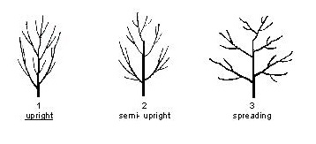

Ad. 8: Current seson's shoot: density of lebticels
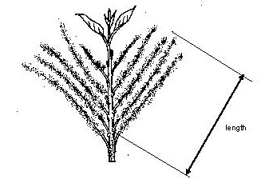

Ad. 12: Leaf: size
The size should observed on the area of leaf blade.

Ad. 13: Leaf: profile in cross section
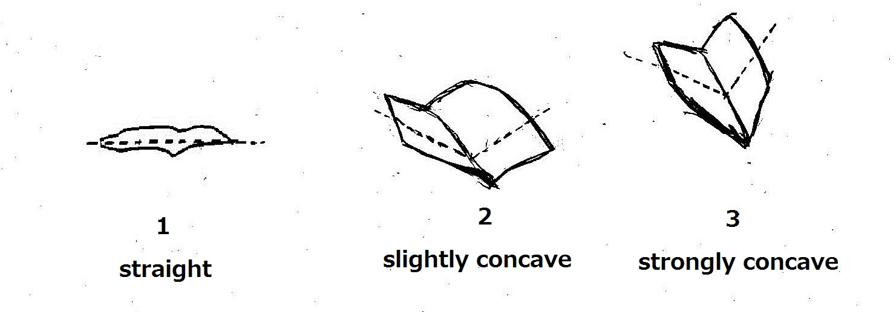

Ad. 15: Leaf: length/width ratio

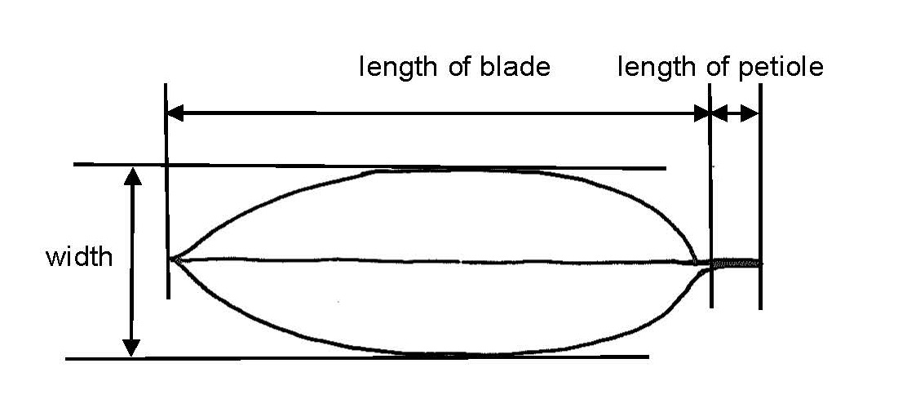

Ad. 16: Leaf: attitude compared to shoot
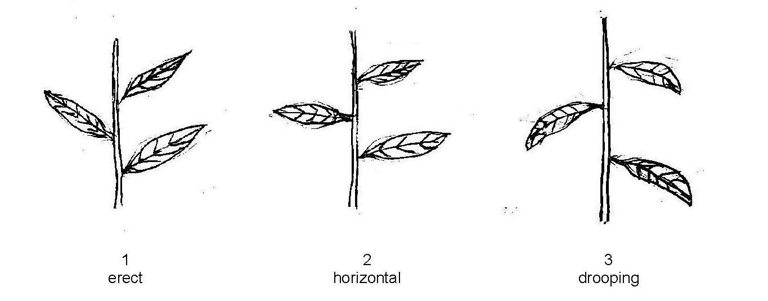

Ad. 19: Leaf: shape
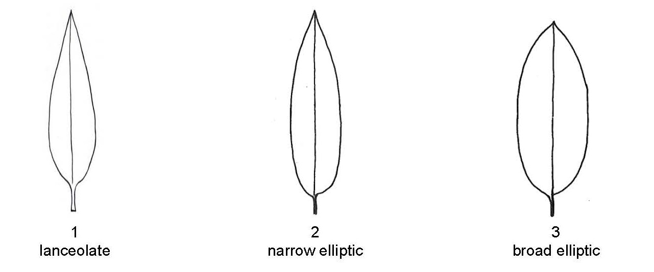

Ad. 20: Leaf: shape of apex
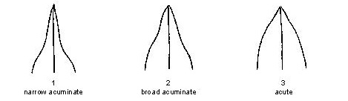

Ad. 21: Leaf: shape of base
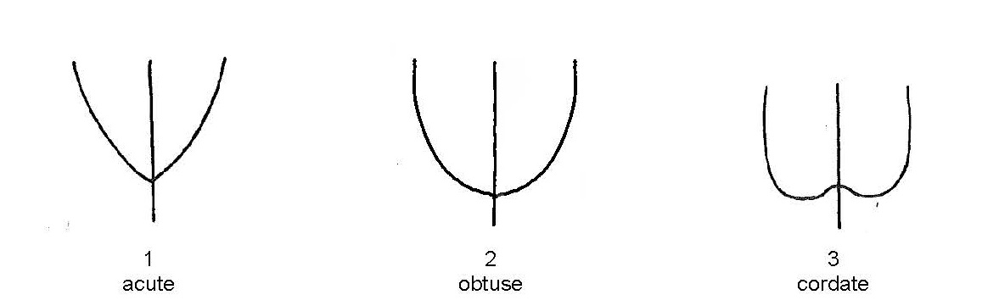

Ad. 22: Leaf: incisions of margin
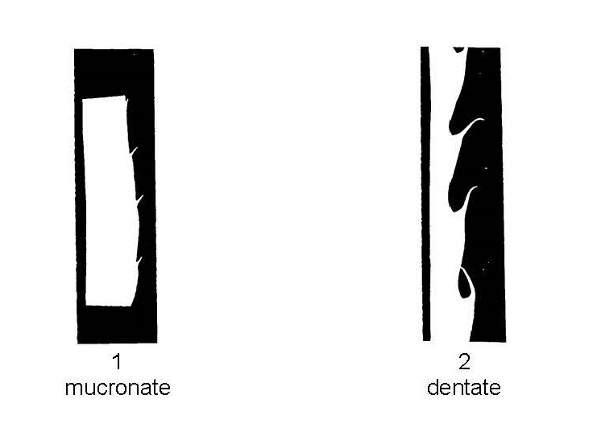

Ad. 25: Leaf: ratio length of leaf blade/length of petiole

Ad. 26: Bur: shape in combination of front view and lateral view
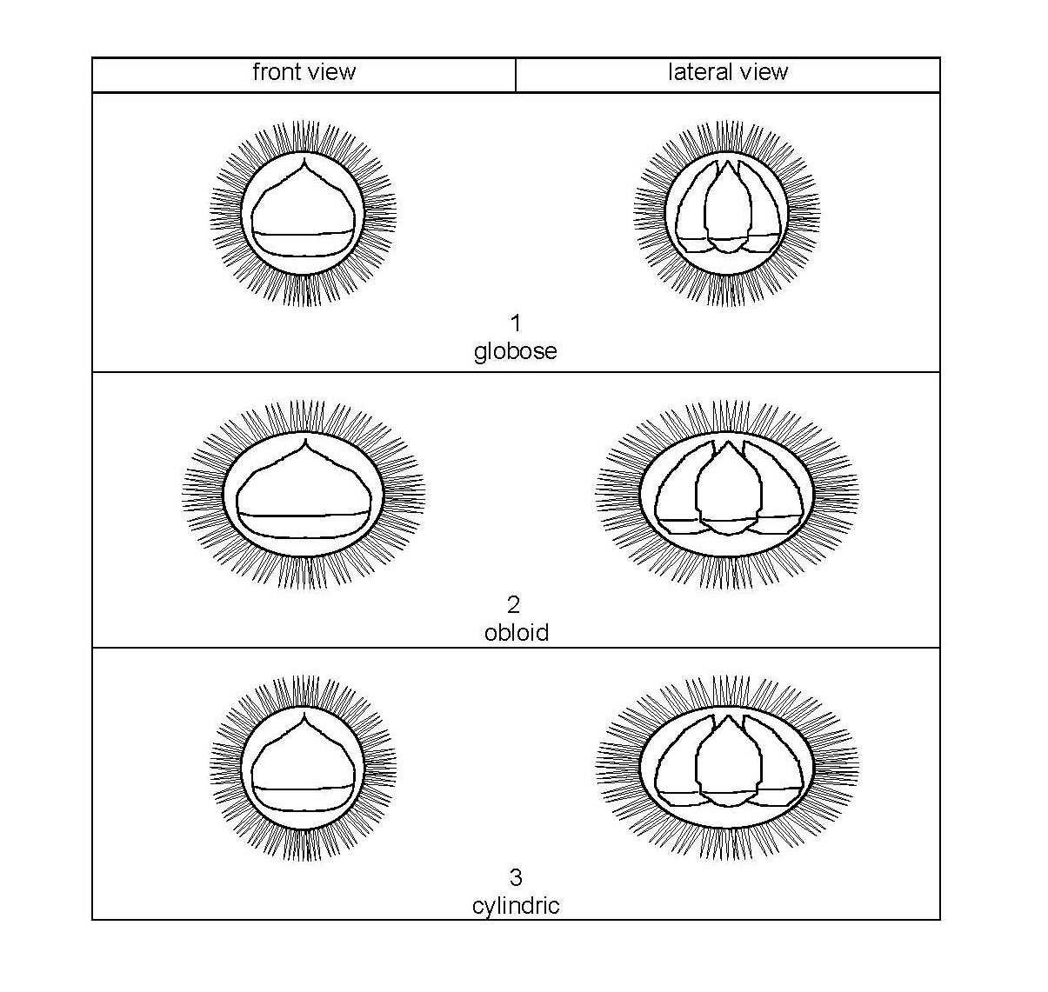
Ad. 28: Fruit: embryony
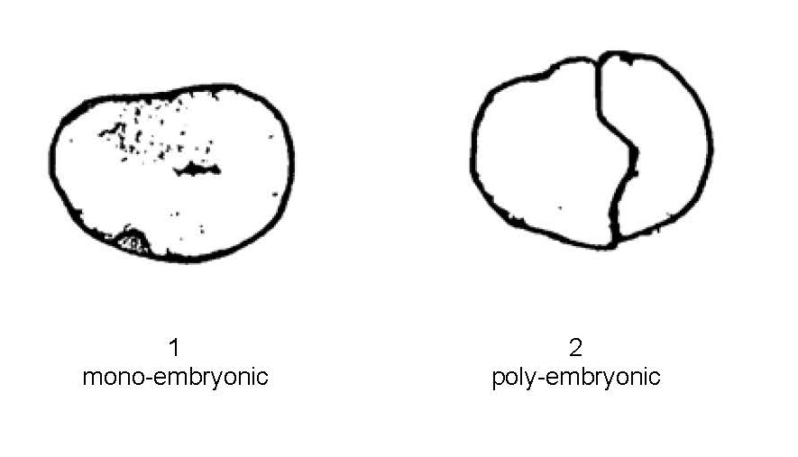

Ad. 29: Poly-embryonic varieties only: Fruit: coherence of embryos

Ad. 30: Fruit: penetration of seed coat into embryo
Ad. 31: Fruit: degree of penetration of seed coat into embryo

Ad. 32: Nut: shape
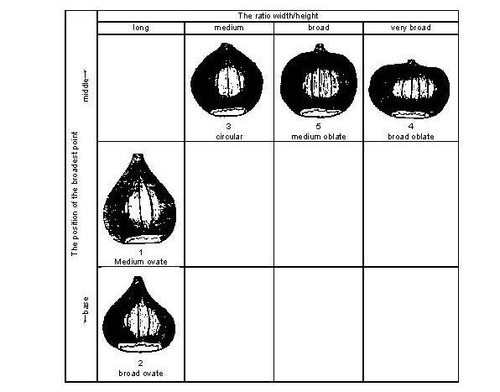

Ad. 33: Nut: extent of pubescence on upper part

Ad. 34: Nut: size of hilum
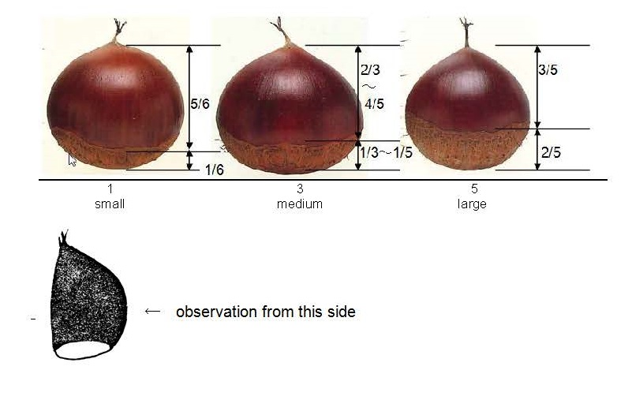

Ad. 35: Nut: shape of border line of hilum and pericarp
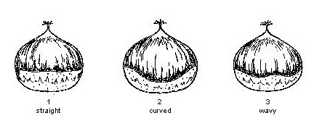
Ad. 40: Seed coat: adherence to kernel (fresh fruit)
The adherence to kernel should be determined by observation of easiness of peeling seed coat by hand after just harvested fruits are steamed for 50 minutes or roasted for 10 to 15 minutes at 200-230c.

Ad. 43: Time of leaf bud burst
The time of leaf bud burst is considered as the time when 20% of buds show green color at the top of bud.

Ad. 44: Time of male flowering
The time of male and female flowering is considered as the middle day when 20% of the flower are fully open and the day when 80% of the flower are fully open.

Ad. 45: Time of female flowering
The time of male and female flowering is considered as the middle day when 20% of the fully open and the day when 80% of the flower are fully open.

Ad. 46: Time of fruit maturity for harvesting
The time of maturity for consumption is considered as the middle day between the day when 20% of fruit is harvested and the day when 100% of fruits is harvested.

Literature

Technical Questionnaire

TECHNICAL QUESTIONNAIRE |  | Page {x} of {y} | Reference Number:
 |  |  | Application date:
 |  |  | (not to be filled in by the applicant)
TECHNICAL QUESTIONNAIRE
to be completed in connection with an application for plant breeders’ rights

1. Subject of the Technical Questionnaire
1.1.1 | Botanical Name | Castanea crenata Sieold & Zucc. |  | [ ]
1.1.2 | Common Name | Japanese chestnut
1.2.1 | Botanical Name | Castanea mollissima Blume |  | [ ]
1.2.2 | Common Name | Chinese Chestnut
1.3.1 | Botanical Name | Castanea sativa Mill. |  | [ ]
1.3.2 | Common Name | Chestnut

2. Applicant
Name
Address
Telephone No.
Fax No.
E-mail address
Breeder (if different from applicant)
3. Proposed denomination and breeder’s reference
Proposed denomination
(if available)

Breeder’s reference

TECHNICAL QUESTIONNAIRE |  | Page {x} of {y} | Reference Number:
4. Information on the breeding scheme and propagation of the variety

4.1 Breeding scheme

Variety resulting from:

4.1.1 Crossing

(a) controlled cross [ ]
(please state parent varieties)

(…………………..……………..…) x (……………..…………………..…)
female parent male parent

(b) partially known cross [ ]
(please state known parent variety(ies))

(…………………..……………..…) x (……………..…………………..…)
female parent male parent

(c) unknown cross [ ]

4.1.2 Mutation [ ]
(please state parent variety)

4.1.3 Discovery and development [ ]
(please state where and when discovered and how developed)

4.1.4 Other [ ]
(please provide details)

4.2 Method of propagating the variety

4.2.1 Other [ ]

(please provide details)
..................................................................................................................................................
: :
: :
:................................................................................................................................................:

5. Characteristics of the variety to be indicated (the number in brackets refers to the corresponding characteristic in Test Guidelines; please mark the note which best corresponds).

 | Characteristics | Example Varieties | Note

6. Similar varieties and differences from these varieties

Please use the following table and box for comments to provide information on how your candidate variety differs from the variety (or varieties) which, to the best of your knowledge, is (or are) most similar. This information may help the examination authority to conduct its examination of distinctness in a more efficient way.

Denomination(s) of variety(ies) similar to your candidate variety | Characteristic(s) in which your candidate variety differs from the similar variety(ies) | Describe the expression of the characteristic(s) for the similar variety(ies) | Describe the expression of the characteristic(s) for your candidate variety
Example
Comments:

7. Additional information which may help in the examination of the variety

7.1 In addition to the information provided in sections 5 and 6, are there any additional characteristics which may help to distinguish the variety?

Yes [ ] No [ ]

(If yes, please provide details)

7.2 Are there any special conditions for growing the variety or conducting the examination?

Yes [ ] No [ ]

(If yes, please provide details)

7.3 Other information

8. Authorization for release

(a) Does the variety require prior authorization for release under legislation concerning the protection of the environment, human and animal health?

Yes [ ] No [ ]

(b) Has such authorization been obtained?

Yes [ ] No [ ]

If the answer to (b) is yes, please attach a copy of the authorization.

TECHNICAL QUESTIONNAIRE | Page {x} of {y} | Reference Number:
9. Information on plant material to be examined or submitted for examination

9.1 The expression of a characteristic or several characteristics of a variety may be affected by factors, such as pests and disease, chemical treatment (e.g. growth retardants or pesticides), effects of tissue culture, different rootstocks, scions taken from different growth phases of a tree, etc.

9.2 The plant material should not have undergone any treatment which would affect the expression of the characteristics of the variety, unless the competent authorities allow or request such treatment. If the plant material has undergone such treatment, full details of the treatment must be given. In this respect, please indicate below, to the best of your knowledge, if the plant material to be examined has been subjected to:

(a) Microorganisms (e.g. virus, bacteria, phytoplasma) Yes [ ] No [ ]

(b) Chemical treatment (e.g. growth retardant, pesticide) Yes [ ] No [ ]

(c) Tissue culture Yes [ ] No [ ]

(d) Other factors Yes [ ] No [ ]

Please provide details for where you have indicated “yes”.

10. I hereby declare that, to the best of my knowledge, the information provided in this form is correct:

Applicant’s name

Signature Date

[End of document]

* These names were correct at the time of the introduction of these Test Guidelines but may be revised or updated. [Readers are advised to consult the UPOV Code, which can be found on the UPOV Website (www.upov.int), for the latest information.]

