E
TWF/45/31 Rev.
ORIGINAL: English
DATE: November 7, 2014
INTERNATIONAL UNION FOR THE PROTECTION OF NEW VARIETIES OF PLANTS
Geneva
Technical working party for fruit cropS
Forty-Fifth Session
Marrakesh, Morocco, from May 26 to 30, 2014

revision to document twf/45/31

PARTIAL REVISION OF THE test guidelines for
Mandarins (Citrus L.-Group 1) (document TG/201/1)
Document prepared by an expert from the European Union

1. This document contains the presentation made by an expert from the European Union with regard to the partial revision of the Test Guidelines for Mandarin (TG/201/1) and the report on developments for the ring test concerning the proposed new characteristic “Fruit: number of seeds (controlled manual cross-pollination)”.

2. Copies of the presentations made at the forty-fifth session of the Technical Working Party for Fruit Crops (TWF) by the participants at the subgroup are reproduced in documents TWF/45/31 Add. and TWF/45/31 Add.2 Rev.

[Annex follows]

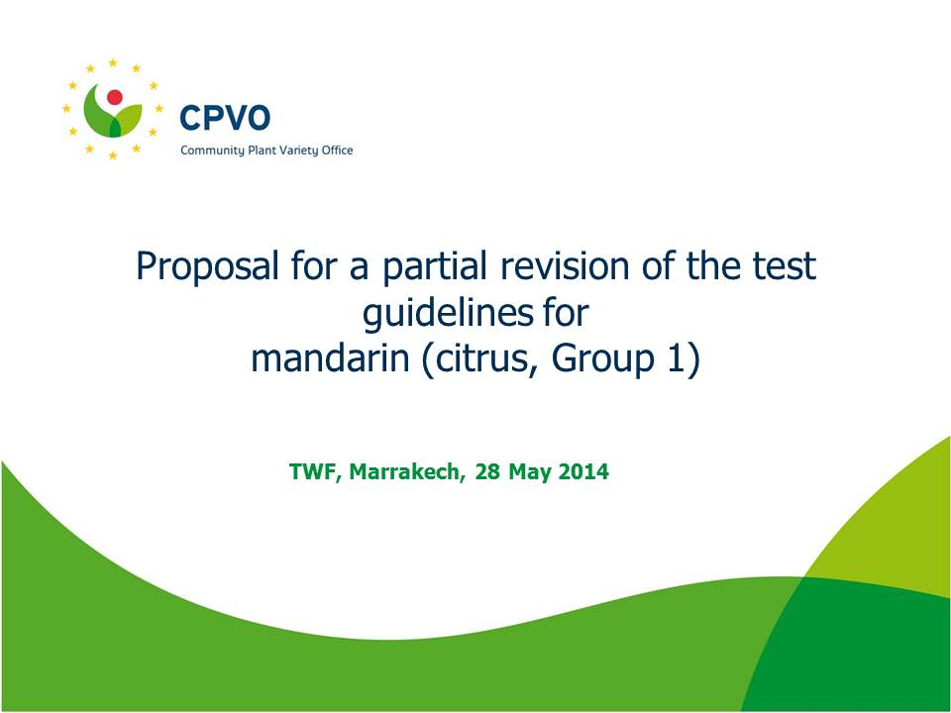

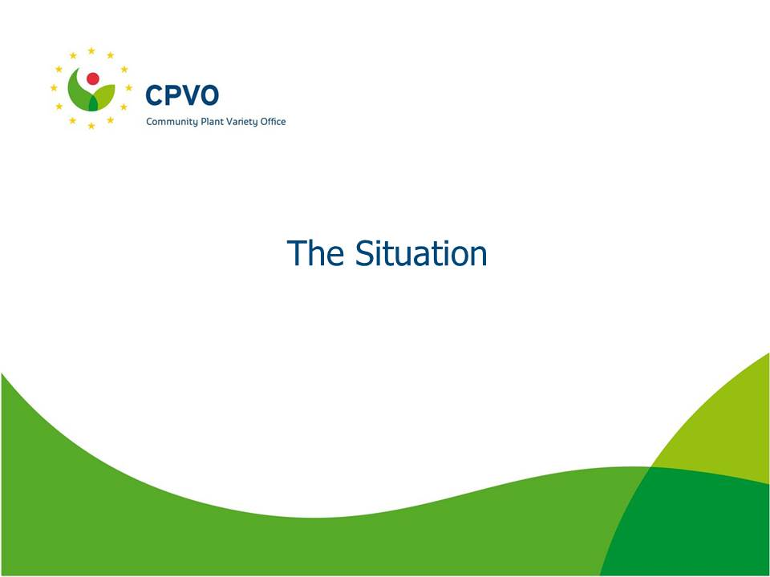

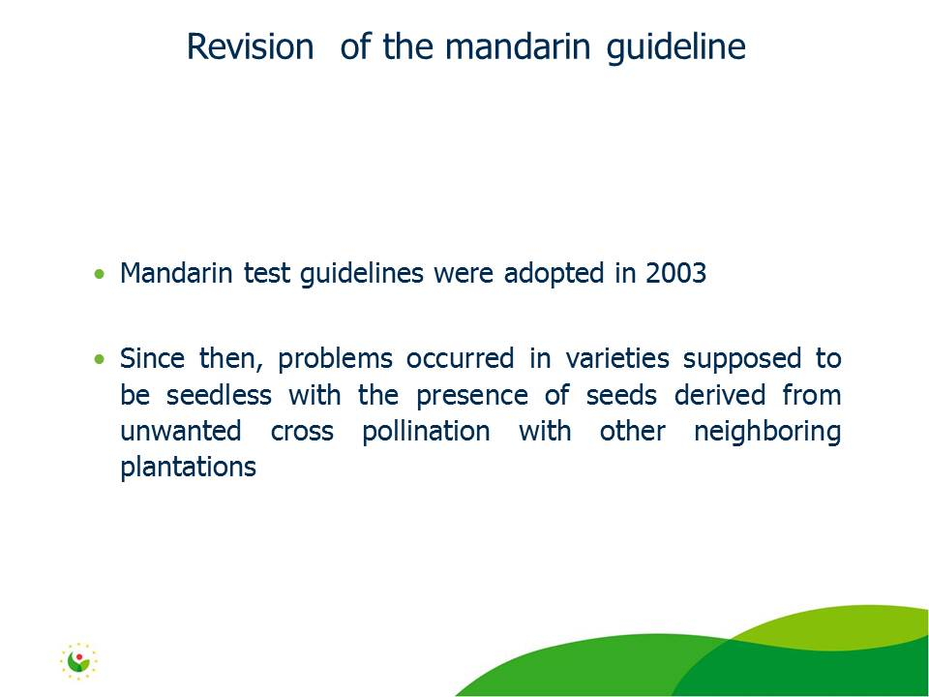

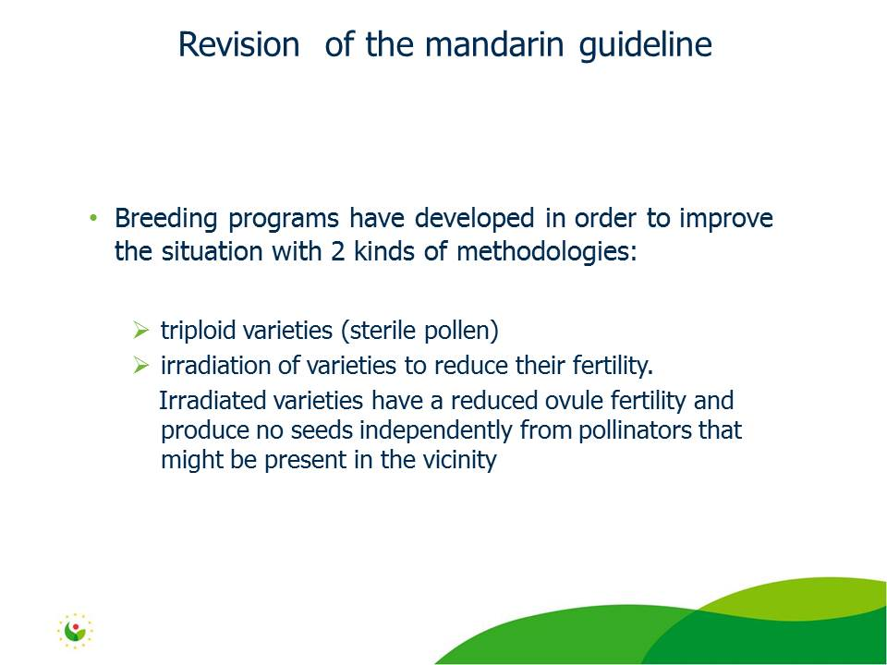

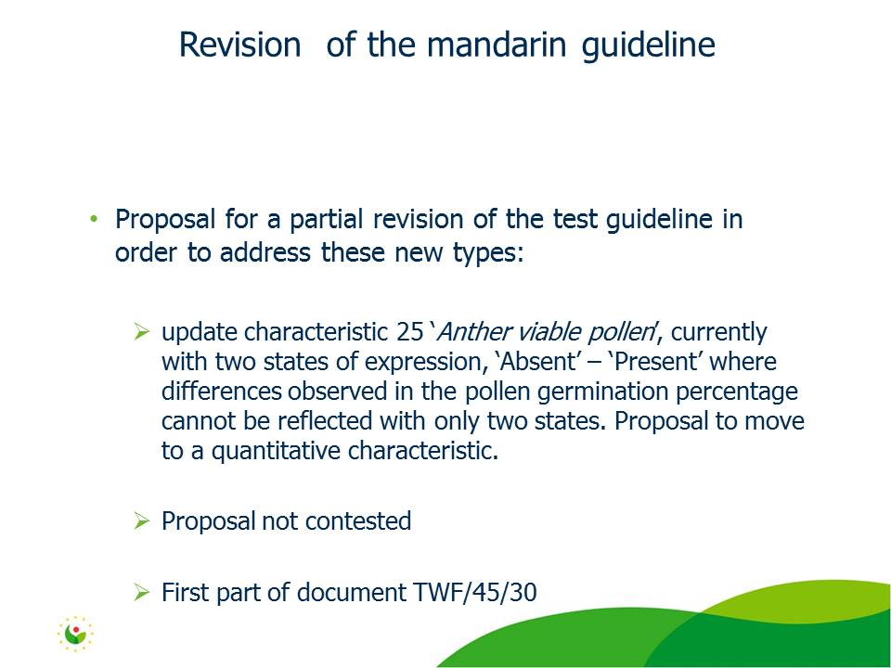

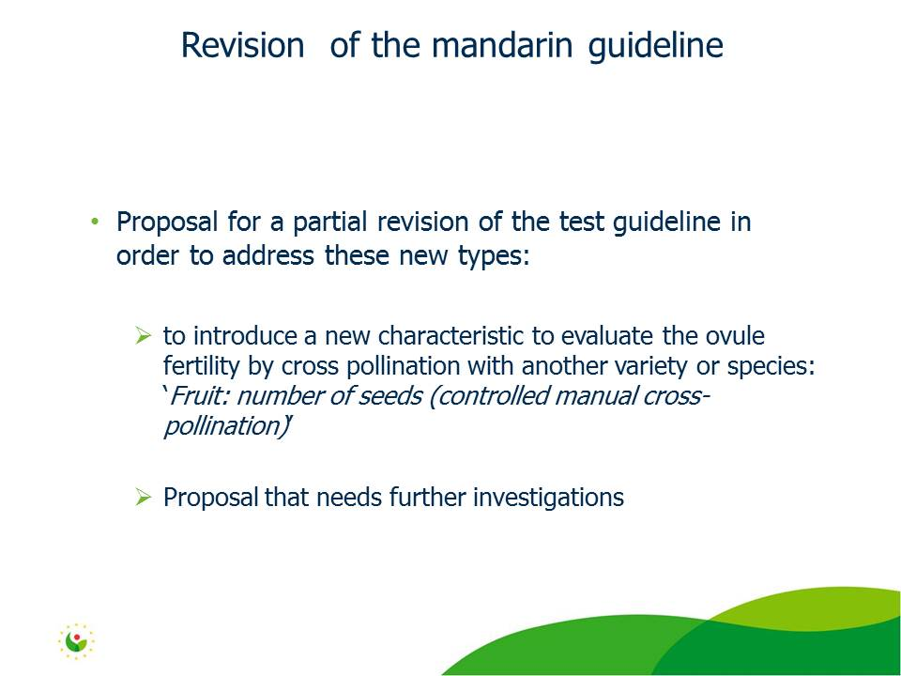

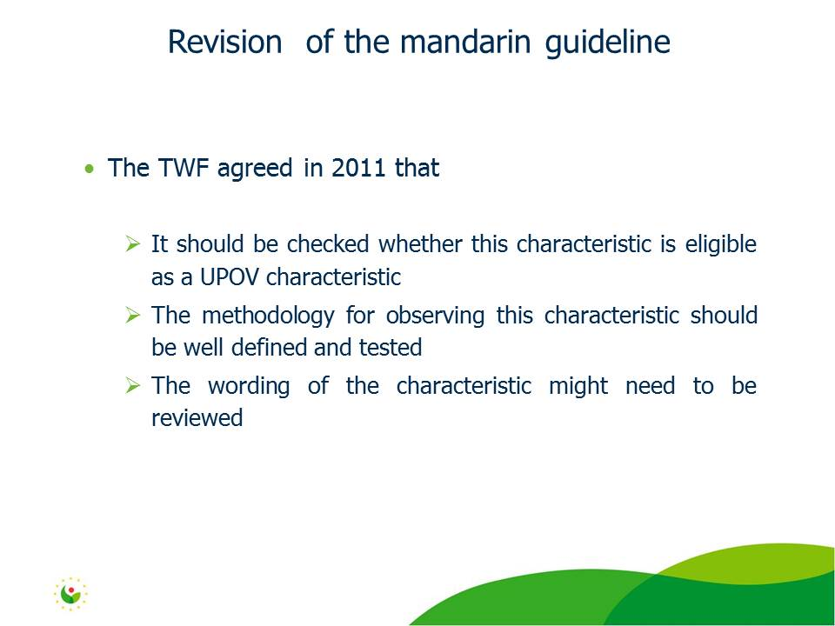

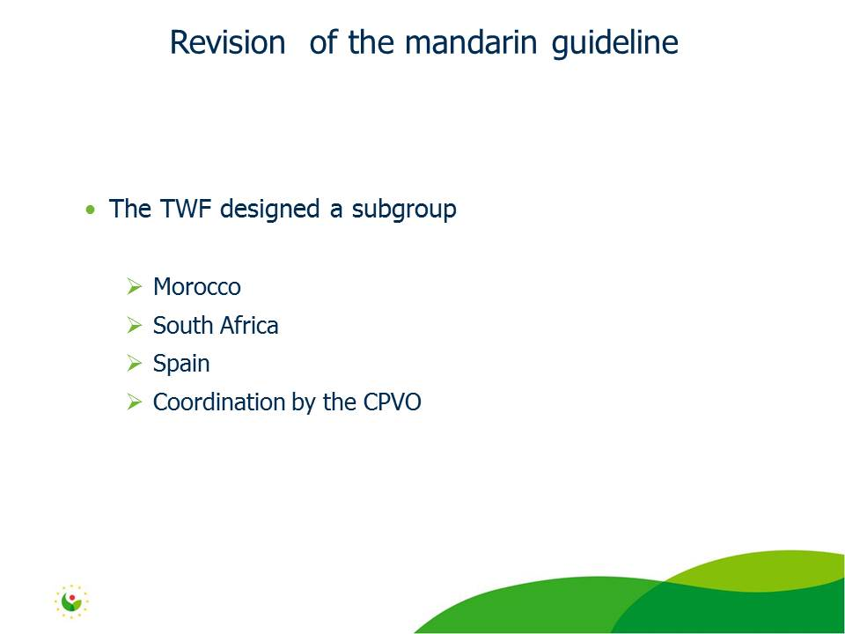

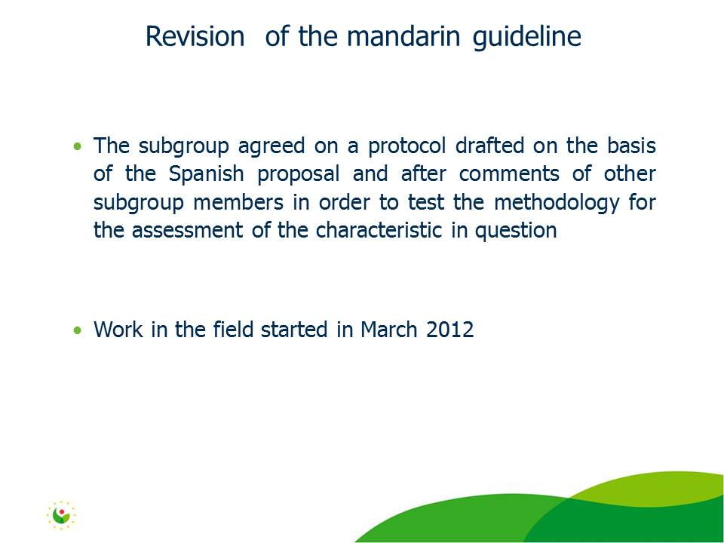

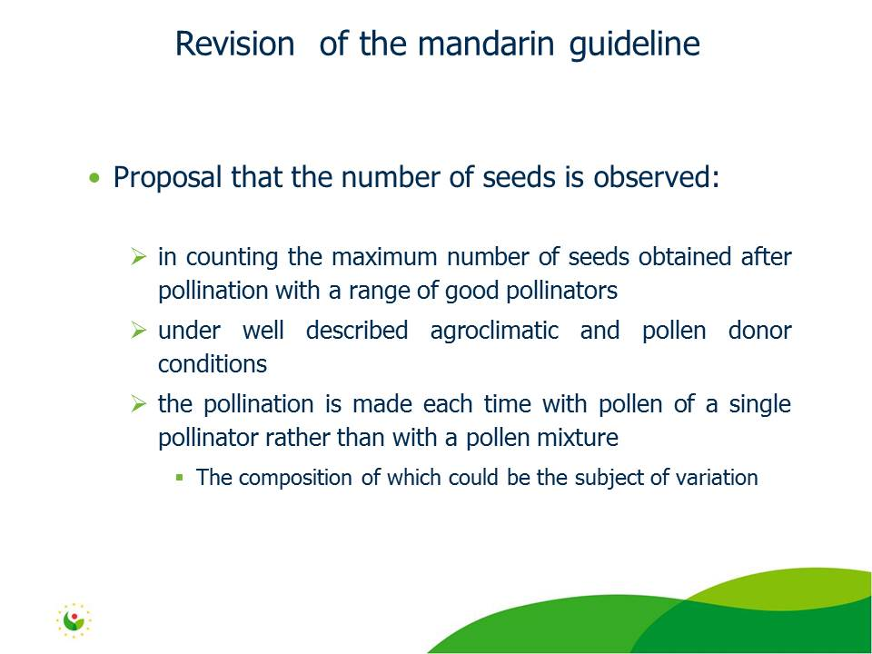

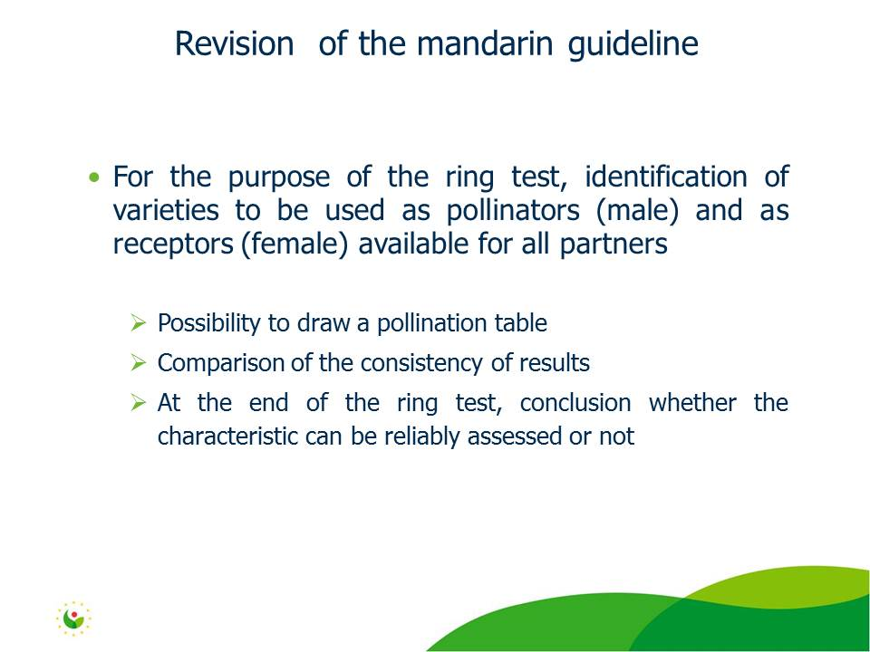

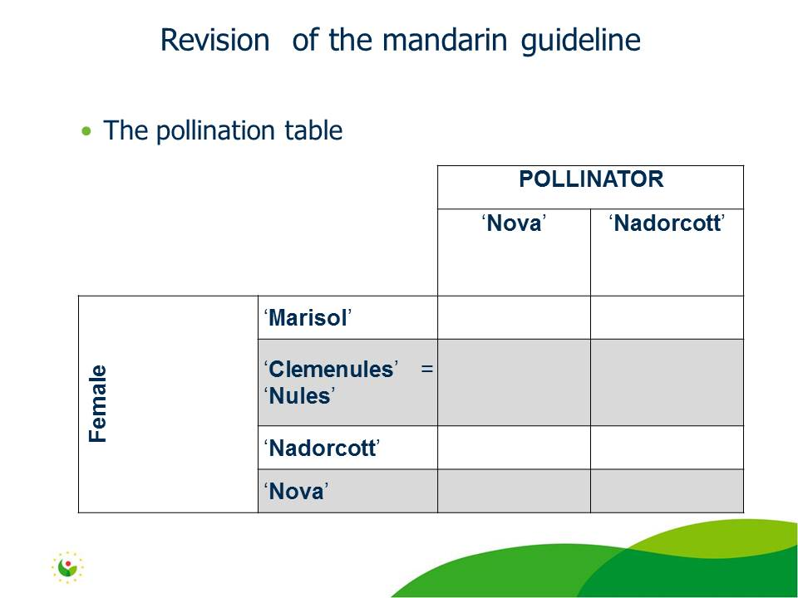

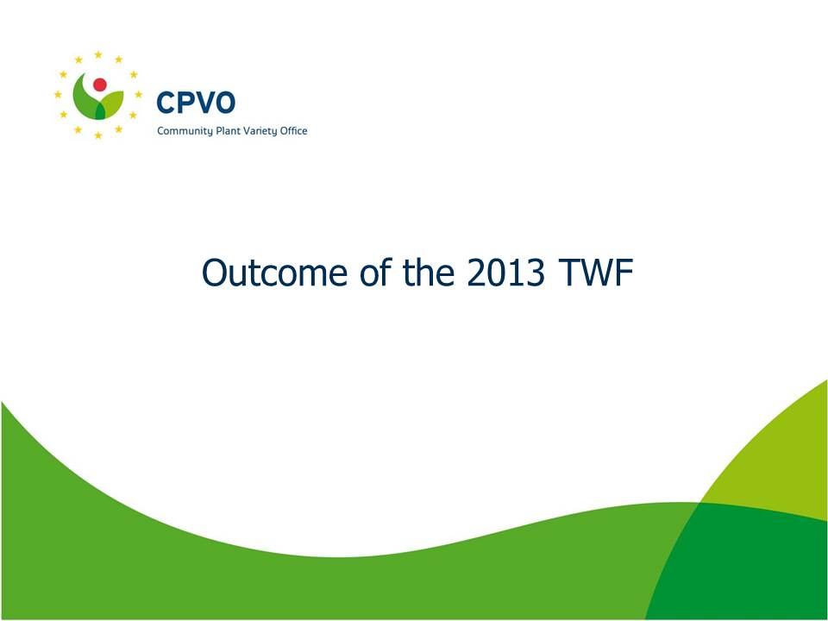

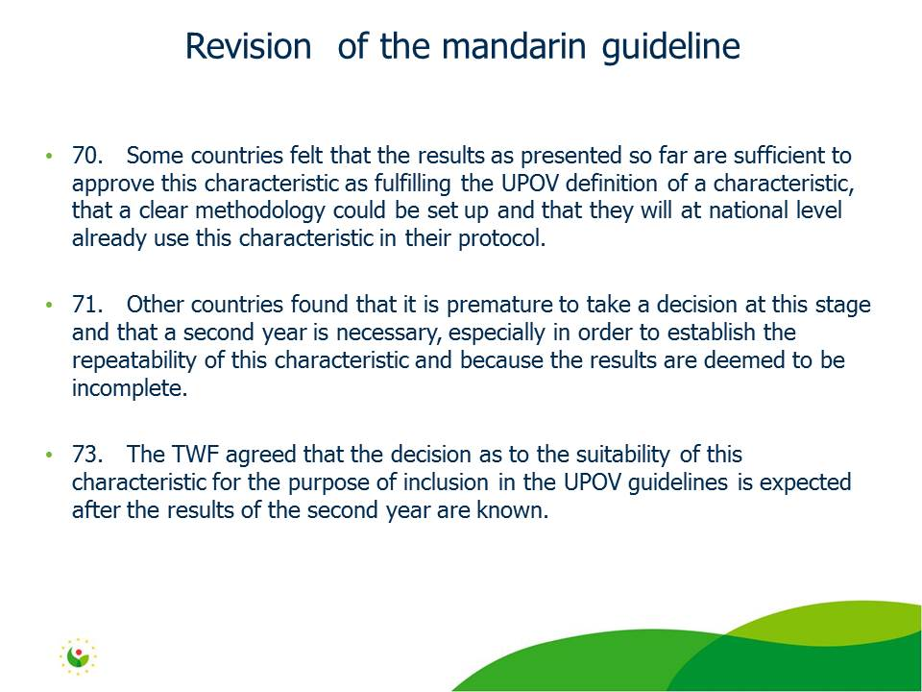

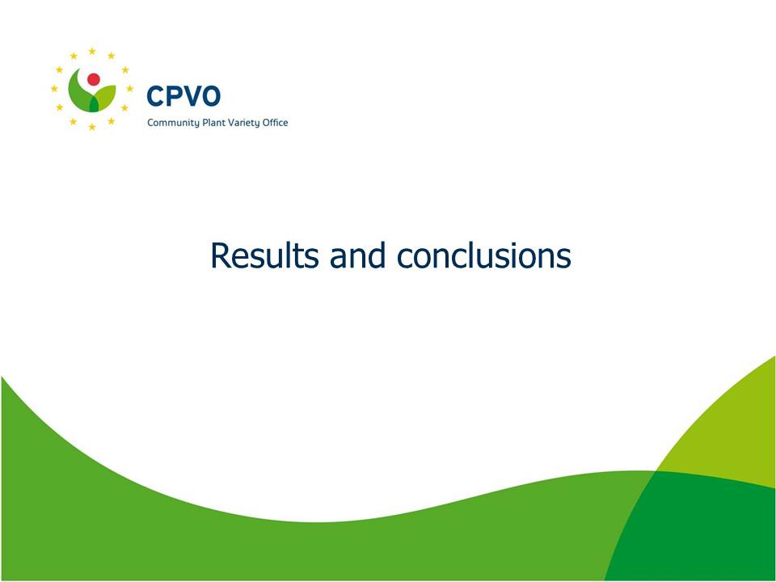

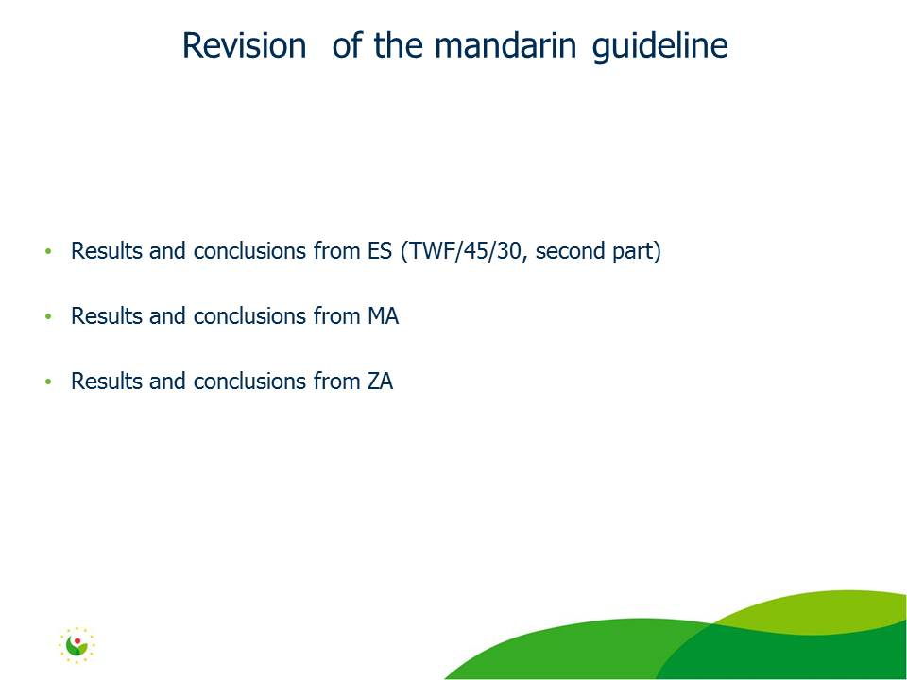

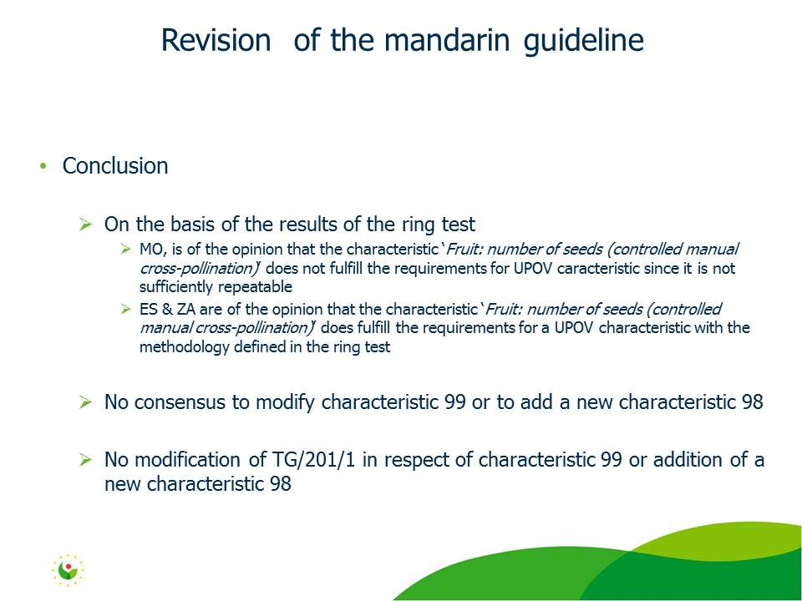

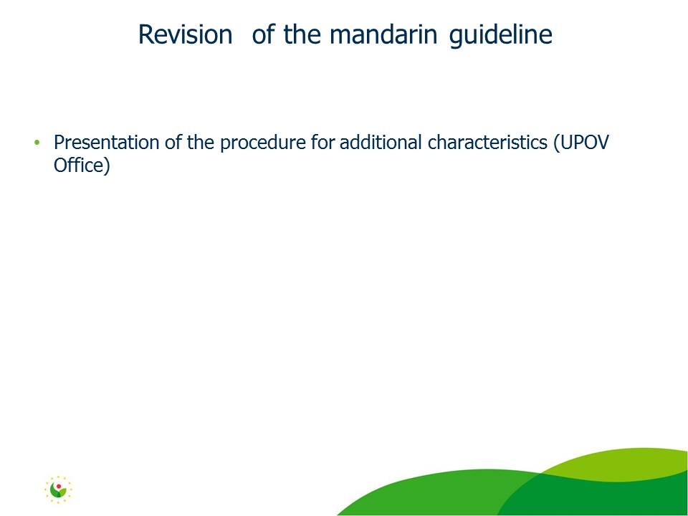

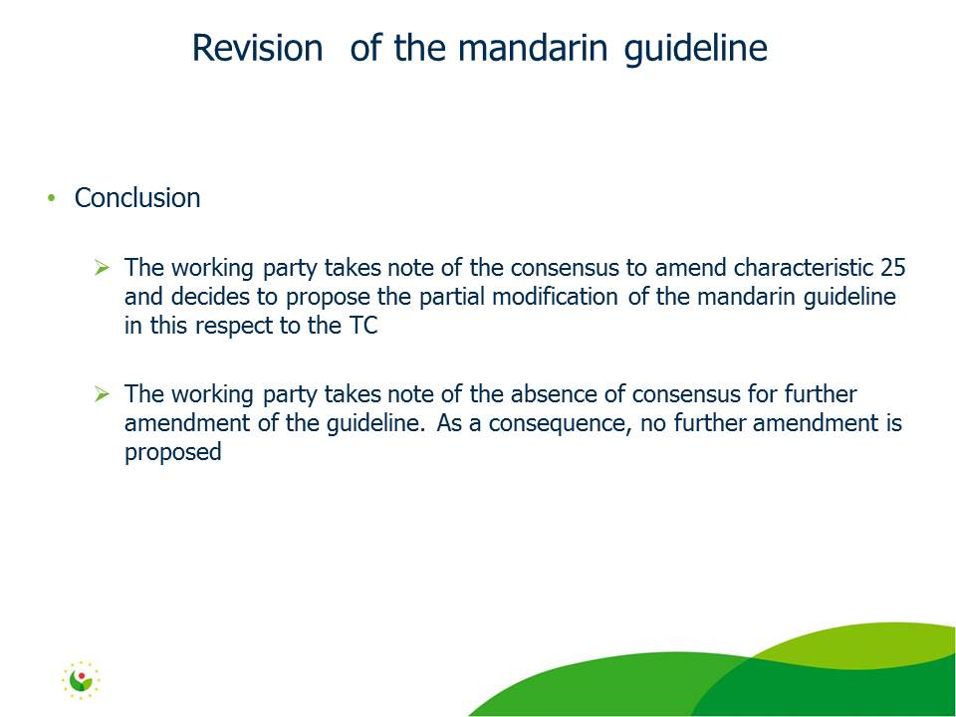

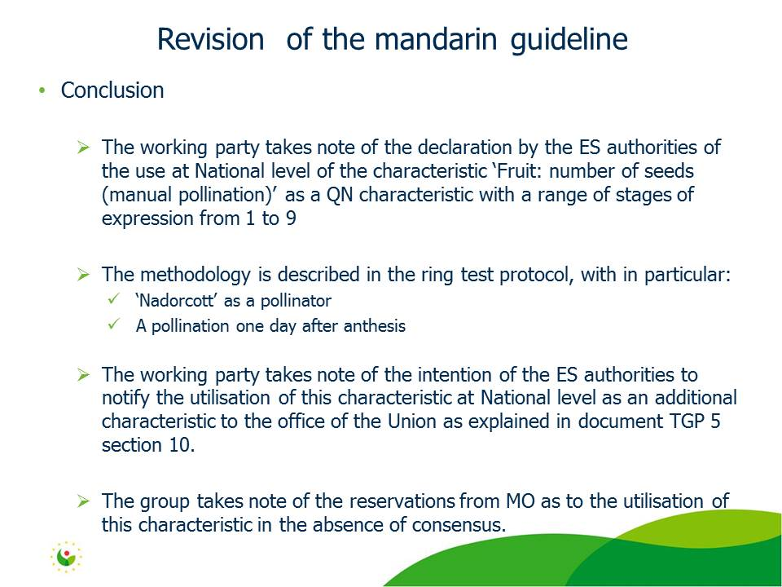

[End Annex and of document]

