E
TWF/45/2 Add.
ORIGINAL: English
DATE: February 26, 2015
INTERNATIONAL UNION FOR THE PROTECTION OF NEW VARIETIES OF PLANTS
Geneva
Technical working party for fruit cropS
Forty-Fifth Session
Marrakesh, Morocco, May 26 to 30, 2014
addendum to document twf/45/2
Molecular techniques
Document prepared by an expert from France
Disclaimer: this document does not represent UPOV policies or guidance
The annex to this document contains a presentation made by an expert from France at the forty-fifth session of the Technical Working Party for Fruit Crops, on “Molecular tools on fruit trees at GEVES France”.

[Annex follows]

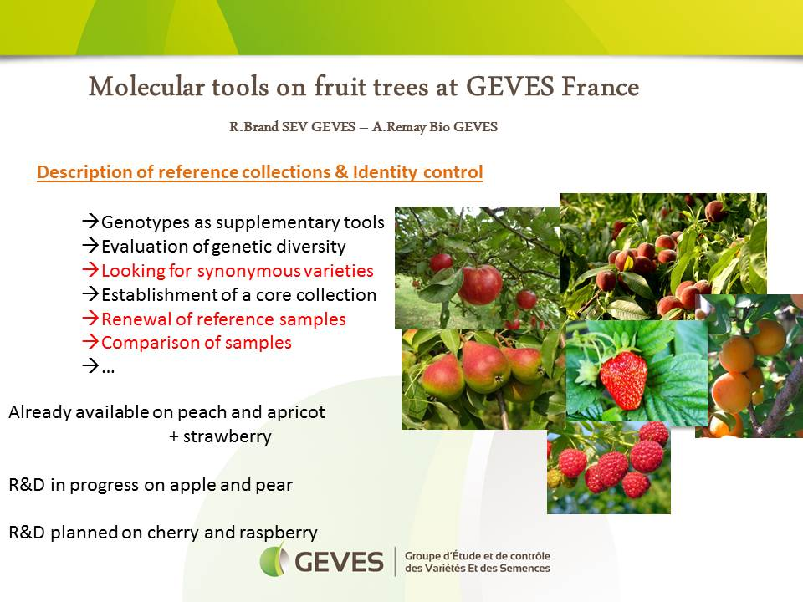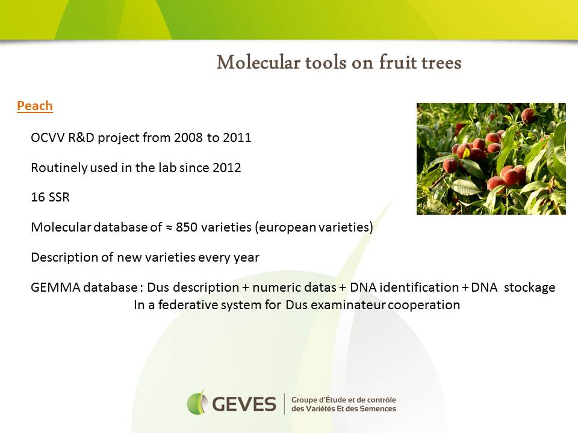

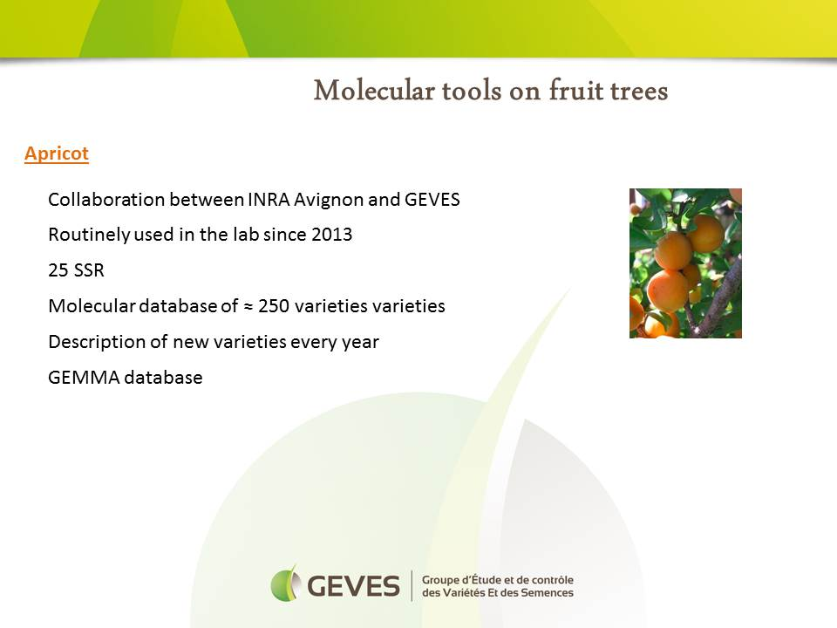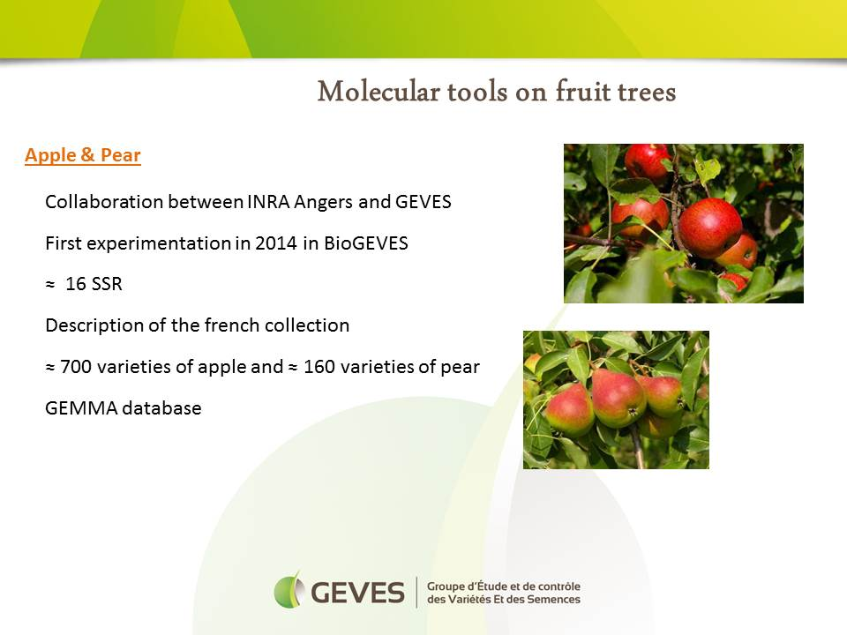

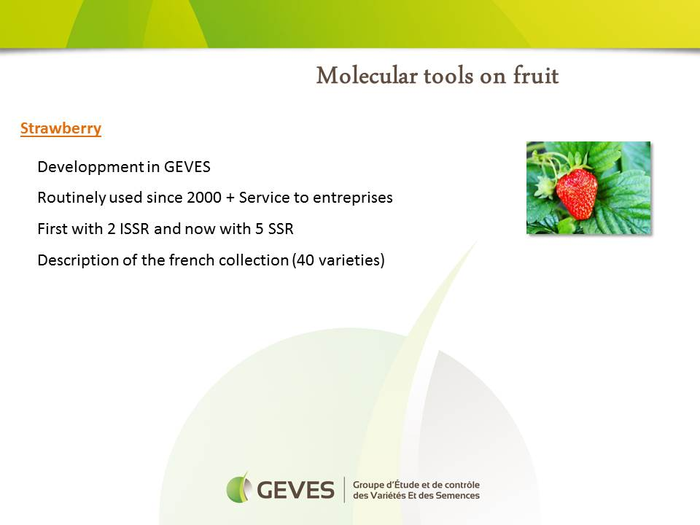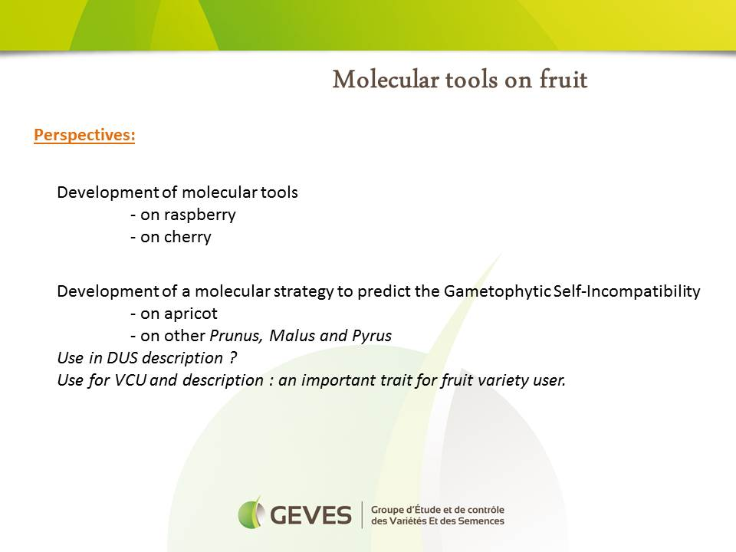

[End of Annex and of document]

