E
TWF/45/27 Add.
ORIGINAL: English
DATE: April 2, 2015
INTERNATIONAL UNION FOR THE PROTECTION OF NEW VARIETIES OF PLANTS
Geneva
Technical working party for fruit cropS
Forty-Fifth Session
Marrakesh, Morocco, May 26 to 30, 2014
addendum to document twf/45/27
DURATION OF DUS TESTS IN THE FRUIT SECTOR
Document prepared by an expert from the European Union and France
Disclaimer: this document does not represent UPOV policies or guidance
The annex to this document contains a presentation made by an expert from the European Union at the forty-fifth session of the Technical Working Party for Fruit Crops, on a Community Plant Variety Office (CPVO) project on “Reducing the number of obligatory observation periods in DUS testing for candidate varieties in the fruit sector”.

[Annex follows]

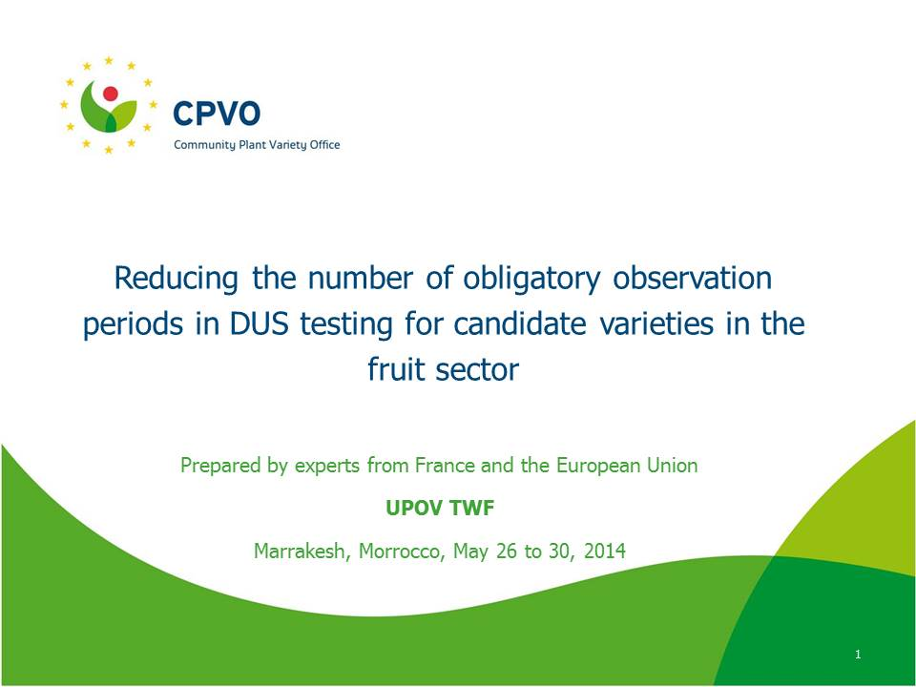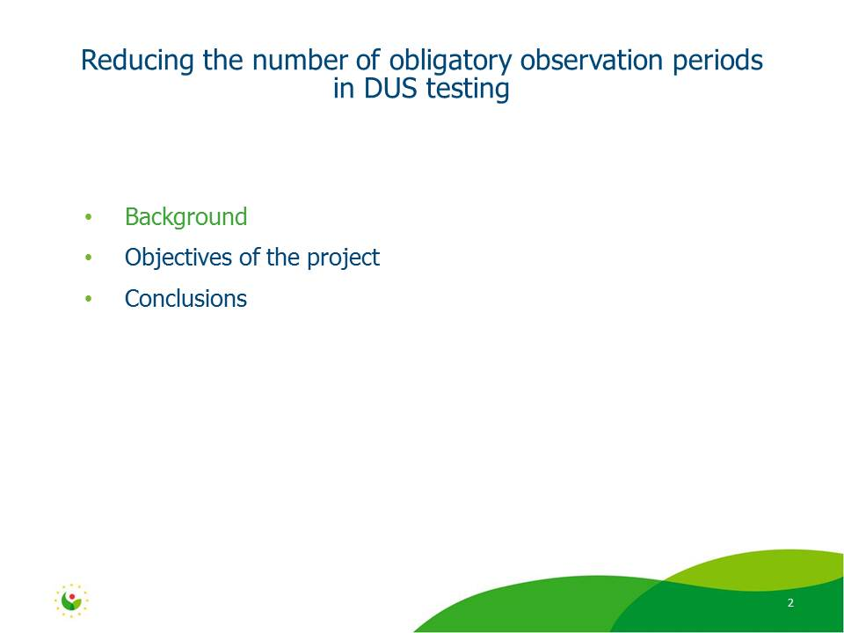

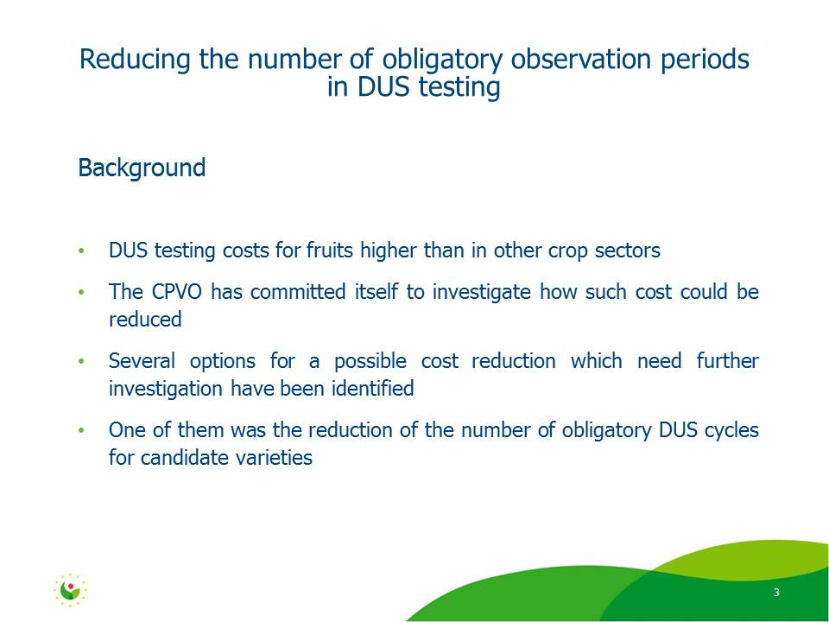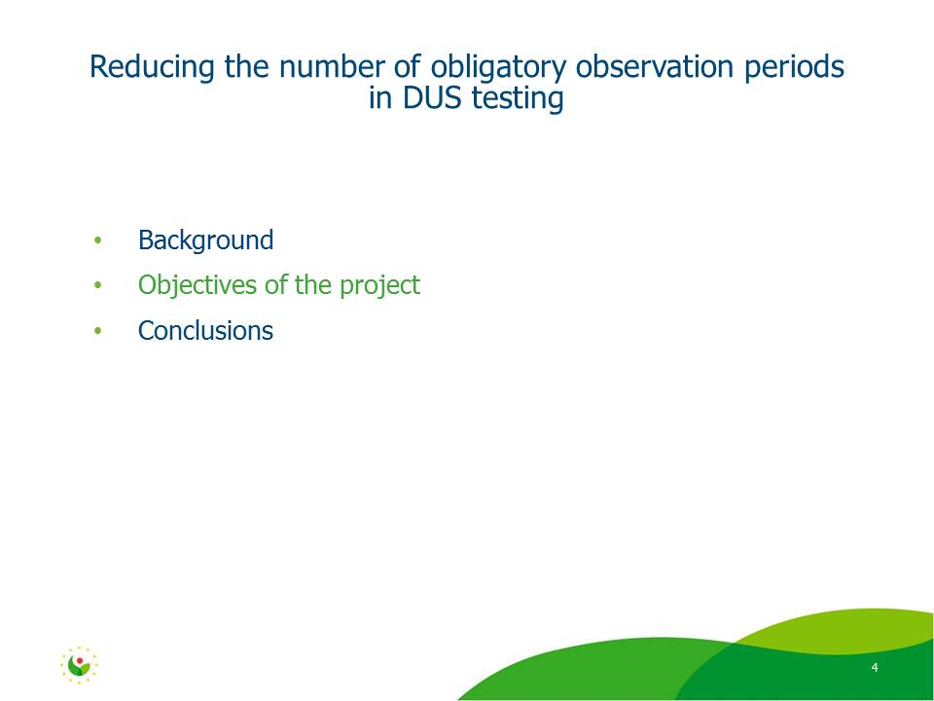

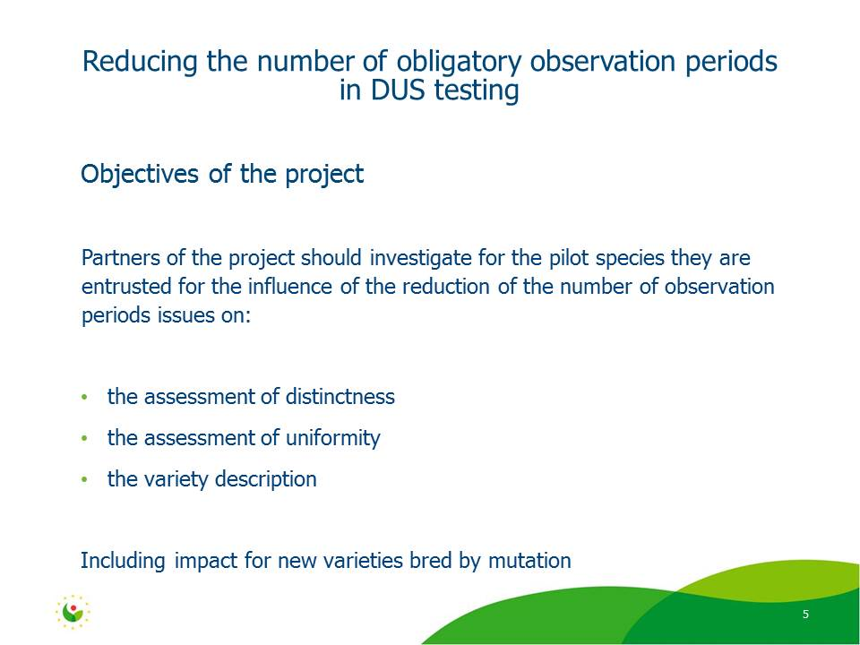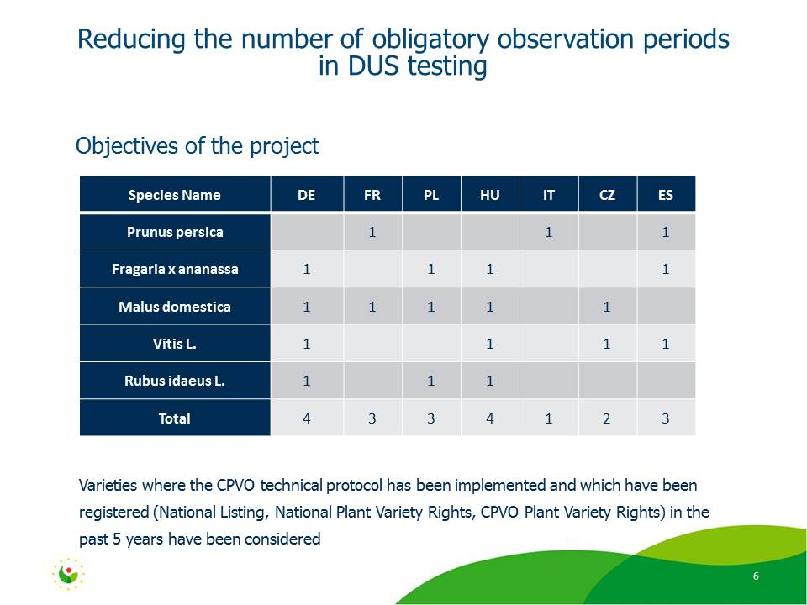
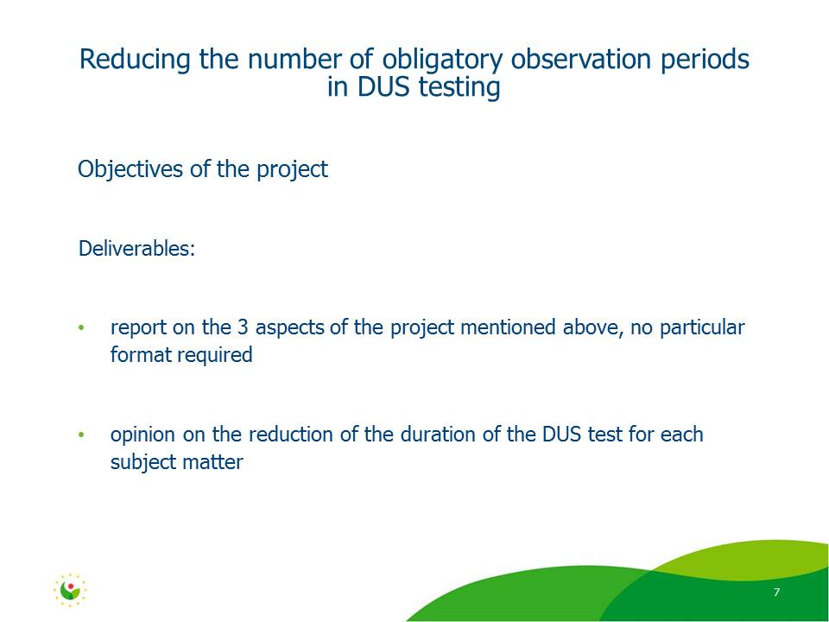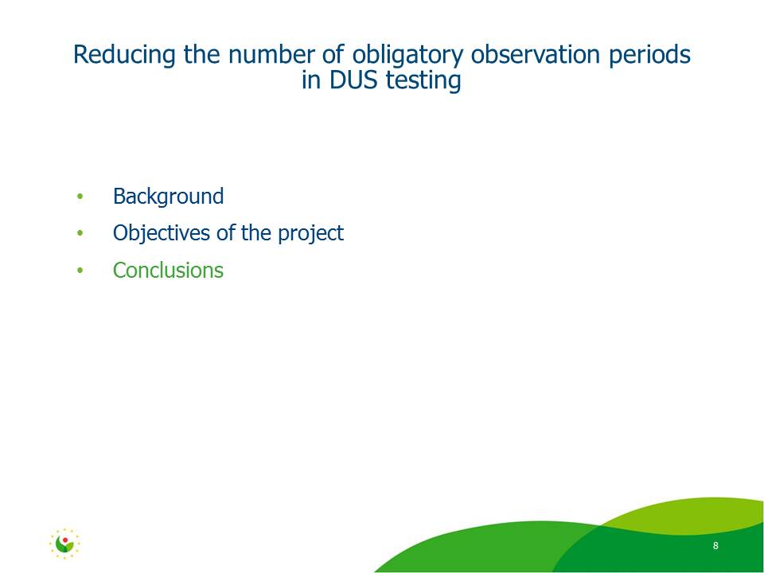

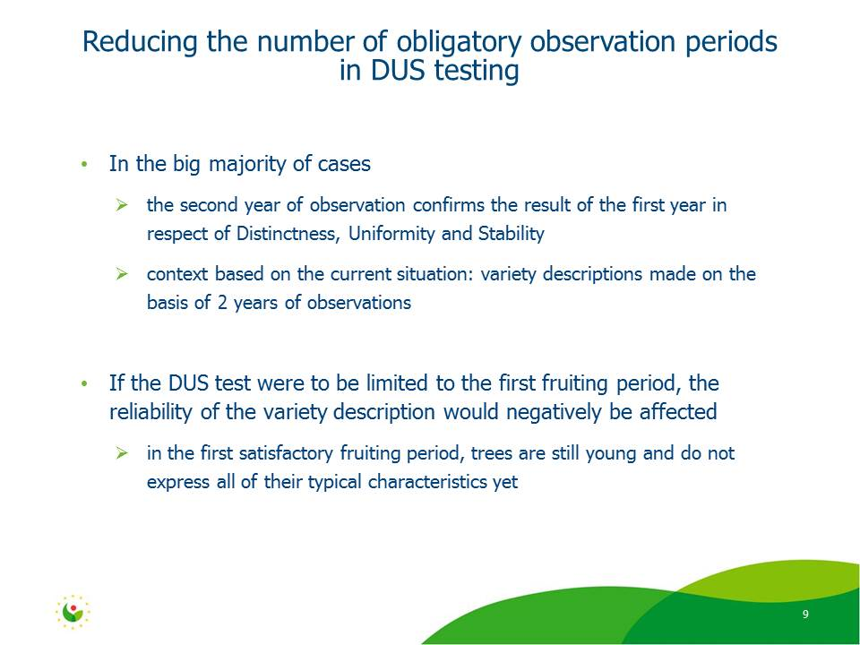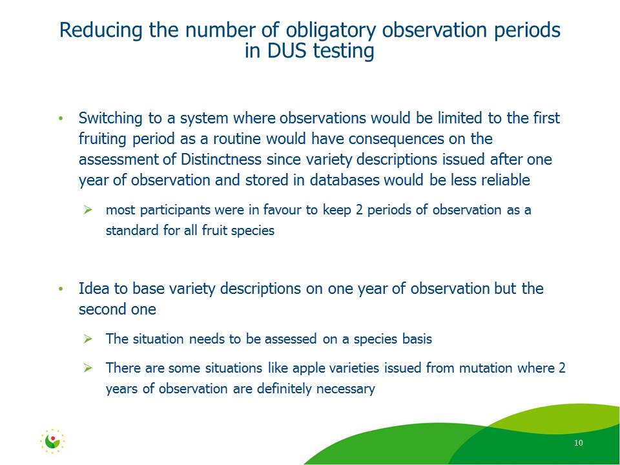

[End of Annex and of document]

