E
TWF/44/29
ORIGINAL: English
DATE: April 18, 2013
INTERNATIONAL UNION FOR THE PROTECTION OF NEW VARIETIES OF PLANTS
Geneva
Technical working party for FRUIT CROPS
Forty-fourth Session
Napier, New Zealand, April 29 to May 3, 2013
PARTIAL REVISION OF THE test guidelines for Peach
(Document TG/53/7)
Document prepared by experts from France
It is proposed that the Test Guidelines for Peach (document TG/53/7) be amended as follows:

Cover page: Alternative names

Current wording:

Botanical name | English | French | German | Spanish
Prunus persica (L.) Batsch,  Persica vulgaris Mill.,  Prunus L. subg. Persica | Peach | Pêcher | Pfirsich | Durazno,  Melocotonero

Proposed new wording:

Botanical name | English | French | German | Spanish
Prunus persica (L.) Batsch,  Persica vulgaris Mill.,  Prunus L. subg. Persica | Peach | Pêcher | Pfirsich | Duraznero,  Melocotonero

Chapter 2.3

Current wording:

The minimum quantity of plant material, to be supplied by the applicant, should be:

5 grafted trees.

Proposed new wording:

The minimum quantity of plant material, to be supplied by the applicant, should be:

3 grafted trees.

Chapter 3.4.1

Current wording:

Each test should be designed to result in a total of at least 5 trees.

Proposed new wording:

Each test should be designed to result in a total of at least 3 trees.

Chapter 3.5 “Number of Plants / Parts of Plants to be Examined”

Current wording:

Unless otherwise indicated, all observations should be made on 5 plants or parts taken from each of 5 plants. In the case of parts of plants, the number to be taken from each of the plants should be 2.

Proposed new wording:

Unless otherwise indicated, all observations should be made on 3 plants or parts taken from each of 3 plants. In the case of parts of plants, the number to be taken from each of the plants should be 5 at least.

Chapter 4.2.2

Current wording:

For the assessment of uniformity, a population standard of 1% and an acceptance probability of at least 95% should be applied. In the case of a sample size of 5 plants, no off-types are allowed.

Proposed new wording:

For the assessment of uniformity, a population standard of 1% and an acceptance probability of at least 95% should be applied. In the case of a sample size of 3 plants, no off-types are allowed.

Chapter 5.3 “Grouping Characteristics”

- Tree: size (characteristic 1)
- Flowering shoot: presence of anthocyanin coloration (characteritic 6)
- Flower: type (characteristic 9)
- Anthers: pollen (characteristic 17)
Ovary: pubescence (characteristic 18)
- Leaf blade: red mid-vein on the lower side (characteristic 28)
- Petiole: nectaries (characteristic 30)
- Petiole: shape of nectaries (characteristic 31)
- Fruit: shape (in ventral view) (characteristic 33)
- Fruit: pubescence of skin (characteristic 44)
- Fruit: carotenoid coloration of flesh (characteristic 51)
- Fruit: acidity (characteristic 57) with the following groups:
- low
- medium
- high
- Fruit: flesh type (TQ characteristic), with the following groups:
- melting
- non-melting (pavies)
- stony hard
Stone: adherence to flesh (characteristic 64)
- Time of beginning of flowering (characteristic 6766)
(n) Time of harvest maturity for consumption (characteristic 6867)

Chapter 6.5 “Legend”

Current wording:

(*) Asterisked characteristic – see Chapter 6.1.2

QL Qualitative characteristic – see Chapter 6.3
QN Quantitative characteristic – see Chapter 6.3
PQ Pseudo-qualitative characteristic – see Chapter 6.3

(a)-(g) See Explanations on the Table of Characteristics in Chapter 8.1
(+) See Explanations on the Table of Characteristics in Chapter 8.2

Proposed new wording:

(*) Asterisked characteristic – see Chapter 6.1.2

QL Qualitative characteristic – see Chapter 6.3
QN Quantitative characteristic – see Chapter 6.3
PQ Pseudo-qualitative characteristic – see Chapter 6.3

MG Single measurement of a group of plants or parts of plants
MS Measurement of a number of individual plants or parts of plants
VG Visual assessment by a single observation of a group of plants or parts of plants
VS Visual assessment by observation of individual plants or parts of plants

(a)-(g) See Explanations on the Table of Characteristics in Chapter 8.1
(+) See Explanations on the Table of Characteristics in Chapter 8.2

Chapter 7 “Table of Characteristics”

Amendments to characteristics for method of observation only: (number of characteristics based on document TG/53/7)

Method of observation | Characteristics
VG | 1, 2, 4, 5, 8, 9, 10, 11, 14, 16, 17, 18, 19, 23, 24, 25, 26, 27, 30, 31, 32, 33, 34, 36, 37, 40, 41, 42, 43, 44, 45, 46, 47, 48, 49, 51, 56, 60, 61, 62,
MS | 50
MG | 57, 59, 66, 67, 59
VG/MS | 12, 13, 20, 21, 22, 29, 38, 39,

Amendments to characteristics for example varieties only:

Char. 1 | state 1 | to add “Bonfire, Pix Zee, Zaino”
Char. 5 | state 1 | to add “Bonfire, Pix Zee, Zaino”
Char. 8 | state 3 | to delete “O’Henry”, to add “Mercil”
Char. 21 | state 7 | to delete “Dixinel”, to add “Dixired”
Char. 24 | state 3 | to delete “Flor de Guaid”, to add “Bailey”
Char. 25 | state 3 | to delete “Merrill Fransiscan”, to add “Merrill Franciscan”
Char. 27 | state 5 | to add “Garnem, Goldcrest”
Char. 32 | state 7 | to delete “Royalglory”, to add “Zaifer”
Char. 34 | state 9 | to delete “Jersey Land”, to add “Jerseyland”
Char. 36 | state 2 | to delete “Brittaney Lane”, to add “Brittney Lane”
 | state 3 | to delete “Precoccissima Moretini”, to add “Precocissima Morettini”
Char. 37 | state 5 | to add “Précoce de Hale, Amsden, May Flower”
Char. 40 | state 2 | to delete “Rubberima”, to add “Ruberrina”
Char. 41 | state 1 | to add “Ghiaccio 1, Zholty”
Char. 43 | state 1 | to delete “Flavorcrest”, to add “Zaitabo”
 | state 2 | to delete “Merill Sundance”, to add “Merrill Sundance”
Char. 45 | state 7 | to delete “Earlyvee”, to add “Erlyvee”
Char. 47 | state 3 | to delete “Royal gem”, to add “Zairegem”
Char. 50 | state 1 | to add “Morettini n°1, Springtime”
 | state 5 | to delete “Redhaven”, to add “Flavorcrest, Redtop”
 | state 7 | to delete “Redtop”, to add “Honey Blaze, Zaitabo”
 | state 9 | to delete “Vivian”, to add “Ghiaccio 2”
Char. 51 | state 6 | to delete “Merill Franciscan”, to add “Merrill Franciscan”
Char. 56 | state 1 | to delete “Merryl Gemfree”, to add “Merrill Gemfree”
Char. 57 | state 1 | to delete “Ambre, Kevine, Nacre, Opale, Zaiboni”, to add “ Monna, Zaibomi, Zaidaso”
 | state 2 | to delete “Felicia, Monprime”, to add “Zaifave, Zaitabo”
 | state 3 | to delete “O’Henry, Ryan Sun, Zaitabo”, to add “Mercil, Monprime, Ryans Sun”
 | state 4 | to delete “Hermione, Primerose”, to add “ Kraprim, Zailice”

Characteristic 3 “Tree: habit”

Current wording:

3.  (*)  (+) |  | Tree: habit | Arbre : port | Baum: Wuchsform | Árbol: porte
QN | (a) | upright | dressé | aufrecht | erecto | Nectarose, Pillar | 1
 |  | upright to spreading | dressé à étalé | aufrecht bis breitwüchsig | erecto hacia extendido | Fairhaven, Redwing | 2
 |  | spreading | étalé | breitwüchsig | extendido | Albertina, Elegant Lady, O’Henry | 3
 |  | drooping | retombant | überhängend | colgante | Charles Roux | 4
 |  | weeping | très retombant | lang überhängend | llorón | Biancopendulo | 5

Proposed new wording:

3.  (*)  (+) | VG | Tree: habit | Arbre : port | Baum: Wuchsform | Árbol: porte
QN | (a) | fastigiate | fastigié | sehr aufrecht | fastigiado | Nectarose, Pillar | 1
 |  | upright | dressé | aufrecht | erecto | Fairhaven, Redwing | 2
 |  | upright to spreading | dressé à étalé | aufrecht bis breitwüchsig | erecto hacia extendido | Albertina, Elegant Lady, Mercil | 3
 |  | spreading | étalé | breitwüchsig | extendido | Charles Roux | 4
 |  | drooping | retombant | überhängend | colgante | Biancopendulo | 5

Ad. 3: Tree: habit

To be observed the year before the main pruning.

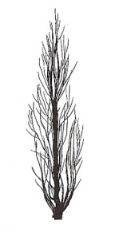 | 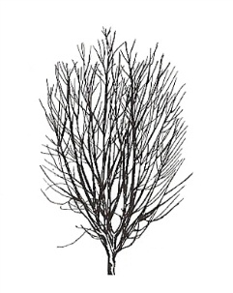 | 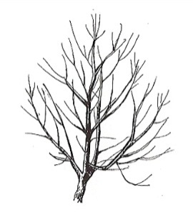 | 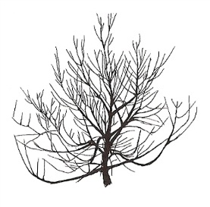 | 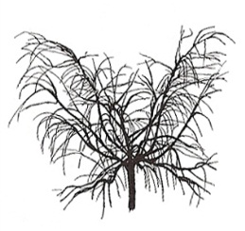
1 | 2 | 3 | 4 | 5
upright | upright to spreading | spreading | drooping | weeping
fastigate | upright | upright to spreading | spreading | drooping

Characteristic 6 “Flowering shoot: presence of anthocyanin coloration”

Current wording:

6. |  | Flowering shoot: presence of anthocyanin coloration | Rameau mixte : présence de la pigmentation anthocyanique | Blütentrieb: Vorhandensein von Anthocyanfärbung | Rama floral: presencia de pigmentación antociánica
QL | (d) | absent | absente | fehlend | ausente | De flor doble blanca | 1
 |  | present | présente | vorhanden | presente | Robin | 9

Proposed new wording:

6.  (*) | VG | Flowering shoot: presence of anthocyanin coloration | Rameau mixte : présence de la pigmentation anthocyanique | Blütentrieb: Vorhandensein von Anthocyanfärbung | Rama floral: presencia de pigmentación antociánica
QL | (d) | absent | absente | fehlend | ausente | De flor doble blanca | 1
 |  | present | présente | vorhanden | presente | Robin | 9

Characteristic 7 “Flowering shoot: intensity of anthocyanin coloration”

Current wording:

7.  (+) |  | Flowering shoot: intensity of anthocyanin coloration | Rameau mixte : intensité de la pigmentation anthocyanique | Blütentrieb: Intensität der Anthocyanfärbung | Rama floral: intensidad de la pigmentación antociánica
QN | (d) | weak | faible | gering | débil | Springtime | 3
 |  | medium | moyenne | mittel | media | Fuzalode | 5
 |  | strong | forte | stark | fuerte | Robin, Sanguine Chanas | 7

Proposed new wording:

7.  (+) | VG | Flowering shoot: intensity of anthocyanin coloration | Rameau mixte : intensité de la pigmentation anthocyanique | Blütentrieb: Intensität der Anthocyanfärbung | Rama floral: intensidad de la pigmentación antociánica
QN | (d) | very weak | très faible | sehr gering | muy débil | Biancopendulo,  De flor doble blanca, | 1
 |  | weak | faible | gering | débil | Springtime | 3
 |  | medium | moyenne | mittel | media | Fuzalode | 5
 |  | strong | forte | stark | fuerte | Robin, Sanguine Chanas | 7

Characteristic 15 “Stamen: position compared to petals”

Current wording:

15.  (+) |  | Stamen: position compared to petals | Étamines : position par rapport aux pétales | Staubgefäße: Stellung im Verhältnis zu den Blütenblättern | Estambre: posición relativa a los pétalos
QN | (d) | below | au-dessous | unterhalb | por debajo | Loring | 1
 | (e) | at same level | au même niveau | auf gleicher Höhe | en el mismo nivel | Robin, Springtime | 2
 |  | above | au-dessus | oberhalb | por encima | Redhaven | 3

Proposed new wording:

15.  (+) | VG | Stamen: position compared to petals | Étamines : position par rapport aux pétales | Staubgefäße: Stellung im Verhältnis zu den Blütenblättern | Estambre: posición relativa a los pétalos
QN | (d) | below | au-dessous | unterhalb | por debajo | Loring | 1
 | (e) | same level | au même niveau | auf gleicher Höhe | en el mismo nivel | Robin, Springtime | 2
 |  | above | au-dessus | oberhalb | por encima | Redhaven | 3

Ad. 15: Stamen: position compared to petals

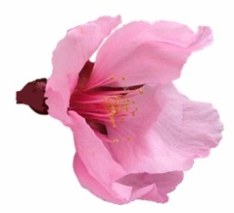 | 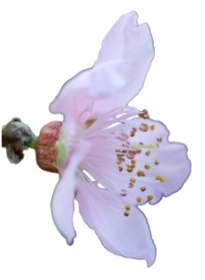 | 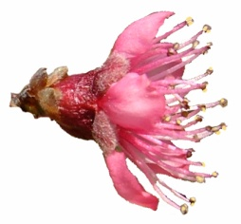
1 | 2 | 3
below | at same level | above
below | same level | above

Characteristic 28 “Flowering shoot: presence of anthocyanin coloration”

Current wording:

28. |  | Leaf blade: red mid-vein on the lower side | Nervure principale rouge face inférieure | Blattspreite: rote Hauptader auf der Unterseite | Limbo: nervio central rojo en el envés
QL | (b) | absent | absente | fehlend | ausente | Redhaven | 1
 |  | present | présente | vorhanden | presente | Sanguine Chanas | 9

Proposed new wording:

28.  (*)  (+) | VG | Leaf blade: red mid-vein on the lower side | Nervure principale rouge face inférieure | Blattspreite: rote Hauptader auf der Unterseite | Limbo: nervio central rojo en el envés
QL | (b) | absent | absente | fehlend | ausente | Redhaven | 1
 |  | present | présente | vorhanden | presente | Sanguine Chanas | 9

Ad. 28: Leaf blade: red mid-vein on the lower side

To be observed during the period of new leaf growth.

Characteristic 35 “Fruit: shape of pistil end (excluding mucron tip)”

Current wording:

35.  (+) |  | Fruit: shape of pistil end (excluding mucron tip) | Fruit : forme de l’extrémité pistillaire (mucron non compris) | Frucht: Form des Kelchendes (außer aufgesetzte Spitze) | Fruto: forma del extremo del pistilo (la punta del mucrón excluida)
 |  | prominently pointed | nettement pointue | deutlich zugespitzt | destacadamente puntiagudo | Jersey Land | 1
 |  | weakly pointed | faiblement pointue | schwach zugespitzt | débilmente puntiagudo | Springtime | 2
 |  | flat | plate | flach | plano | Redhaven | 3
 |  | weakly depressed | faiblement déprimée | schwach eingesenkt | débilmente hundido | Robin | 4
 |  | strongly depressed | fortement déprimée | stark eingesenkt | muy hundido | Bailou, UFO3 | 5

Proposed new wording:

35.  (+) | VG | Fruit: shape of pistil end (excluding mucron tip) | Fruit : forme de l’extrémité pistillaire (mucron exclu) | Frucht: Form des Kelchendes (außer aufgesetzte Spitze) | Fruto: forma del extremo del pistilo (la punta del mucrón excluida)
QN |  | prominently pointed | nettement pointue | deutlich zugespitzt | destacadamente puntiagudo | Jerseyland | 1
 |  | weakly pointed | faiblement pointue | schwach zugespitzt | débilmente puntiagudo | Springtime | 2
 |  | flat | plate | flach | plano | Redhaven | 3
 |  | weakly depressed | faiblement déprimée | schwach eingesenkt | débilmente hundido | Robin | 4
 |  | strongly depressed | fortement déprimée | stark eingesenkt | muy hundido | Bailou, UFO3 | 5
Characteristic 52 “Fruit: anthocyanin coloration of flesh next to skin”

Characteristic 52 to be split into two characteristics.

Current wording:

52.  (*)  (+) |  | Fruit: anthocyanin coloration of flesh next to skin | Fruit : pigmentation anthocyanique sous-épidermique | Frucht: Anthocyanfärbung direkt unter der Haut | Fruto: pigmentación antociánica de la pulpa pegada a la piel
QN | (f) | absent or very weak | absente ou très faible | fehlend oder sehr gering | ausente o muy débil | Redhaven | 1
 |  | weak | faible | gering | débil | Daisy, Dolores, Monco | 2
 |  | strong | forte | stark | fuerte | Monalu, Monof, Rich May, Sanguine Chanas, Sanguine Vineuse, Zairegem | 3

Proposed new wording:

52.  (*)  (+) | VG | Fruit: anthocyanin coloration of flesh next to skin | Fruit : pigmentation anthocyanique sous-épidermique | Frucht: Anthocyanfärbung direkt unter der Haut | Fruto: pigmentación antociánica de la pulpa pegada a la piel
QL | (f) | absent | absente | fehlend | ausente | Springfire | 1
 |  | present | présente | vorhanden | presente | Sanguine Vineuse | 9
NEW  (*)  (+) | VG | Only varieties with anthocyanin coloration of flesh next to skin: present: Fruit: degree of anthocyanin coloration of flesh next to skin | Uniquement variétés avec pigmentation anthocyanique sous-épidermique : présente : Fruit : degré de pigmentation anthocyanique sous-épidermique | Nur Sorten mit Anthocyanfärbung direkt unter der Haut: vorhanden: Frucht: Anthocyanfärbung direkt unter der Haut | Únicamente variedades con pigmentación antociánica de la pulpa pegada a la piel: presente: Fruto: pigmentación antociánica de la pulpa pegada a la piel
QN | (f) | weak | faible | schwach | débil | Daisy, Dolores, Monco | 1
 |  | medium | moyenne | mittel | media | Rich May, Zairegem, Merrill Franciscan | 2
 |  | strong | forte | stark | fuerte | Monalu, Monof,  Sanguine Chanas, Sanguine Vineuse | 3

Ad. 52 NEW: Only varieties with anthocyanin coloration of flesh next to skin: present: Fruit: degree of anthocyanin coloration of flesh next to skin

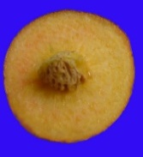 | 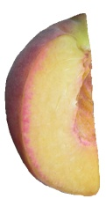 | 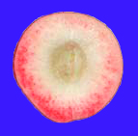
1 | 2 | 3
absent or very weak | weak | strong
weak | medium | strong

Characteristic 53 “Fruit: anthocyanin coloration of flesh in central part of flesh”

Characteristic 53 to be split into two characteristics.

Current wording:

53.  (*)  (+) |  | Fruit: anthocyanin coloration of flesh in central part of flesh | Fruit : pigmentation anthocyanique de la partie centrale de la chair | Frucht: Anthocyanfärbung des Fleisches im mittleren Teil des Fruchtfleisches | Fruto: pigmentación antociánica de la parte central de la pulpa
QN | (f) | absent or very weak | absente ou très faible | fehlend oder sehr gering | ausente o muy débil | Robin | 1
 |  | weak | faible | gering | débil | Dolores, Monco | 2
 |  | strong | forte | stark | fuerte | Monof, Zairegem | 3

Proposed new wording:

53.  (*)  (+) | VG | Fruit: anthocyanin coloration of flesh in central part of flesh | Fruit : pigmentation anthocyanique de la partie centrale de la chair | Frucht: Anthocyanfärbung des Fleisches im mittleren Teil des Fruchtfleisches | Fruto: pigmentación antociánica de la parte central de la pulpa
QL | (f) | absent | absente | fehlend | ausente | Springfire | 1
 |  | present | présente | vorhanden | presente | Monof | 9
NEW  (*)  (+) | VG | Only varieties with anthocyanin coloration of flesh in central part of skin: present: Fruit: degree of anthocyanin coloration of flesh in central part of flesh | Uniquement variétés avec pigmentation anthocyanique dans la partie centrale de la chair : présente : Fruit : degré de pigmentation anthocyanique de la partie centrale de la chair | Frucht: Anthocyanfärbung des Fleisches im mittleren Teil des Fruchtfleisches | Fruto: pigmentación antociánica de la parte central de la pulpa
QN | (f) | weak | faible | schwach | débil | Robin | 1
 |  | medium | moyenne | mittel | media | Dolores, Monco, Suncrest | 2
 |  | strong | forte | stark | fuerte | Monof, Zairegem | 3

Ad. 53 NEW: Only varieties with anthocyanin coloration of flesh in central part of skin: present: Fruit: degree of anthocyanin coloration of flesh in central part of flesh

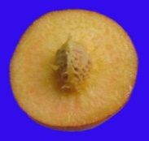 | 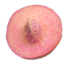 | 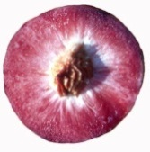
1 | 2 | 3
absent or very weak | weak | strong
weak | medium | strong

Characteristic 54 “Fruit: anthocyanin coloration of flesh around stone”

Characteristic 54 to be split into two characteristics.

Current wording:

54.  (*)  (+) |  | Fruit: anthocyanin coloration of flesh around stone | Fruit : pigmentation anthocyanique de la chair autour du noyau | Frucht: Anthocyanfärbung im Bereich des Steines | Fruto: pigmentación antociánica de la pulpa alrededor del hueso
QN | (f) | absent or weak | absente ou faible | fehlend oder gering | ausente o débil | Springtime | 1
 |  | medium | moyenne | gering | media | Ryan Sun | 2
 |  | strong | forte | stark | fuerte | Summer Lady, Zaipeo | 3

Proposed new wording:
54.  (*)  (+) | VG | Fruit: anthocyanin coloration of flesh around stone | Fruit : pigmentation anthocyanique de la chair autour du noyau | Frucht: Anthocyanfärbung im Bereich des Steines | Fruto: pigmentación antociánica de la pulpa alrededor del hueso
QL | (f) | absent | absente | fehlend | ausente | Springfire | 1
 |  | present | présente | vorhanden | presente | Summer Lady | 9
NEW.  (*)  (+) | VG | Only varieties with anthocyanin coloration of flesh around stone: present: Fruit: degree of anthocyanin coloration of flesh around stone | Uniquement variétés avec pigmentation anthocyanique de la chair autour du noyau : présente : Fruit : degré de pigmentation anthocyanique de la chair autour du noyau | Nur Sorten mit Anthocyanfärbung im Bereich des Steines: vorhanden: Frucht: Anthocyanfärbung im Bereich des Steines | Únicamente variedades con pigmentación antociánica de la pulpa alrededor del hueso: presente: Fruto: pigmentación antociánica de la pulpa alrededor del hueso
QN | (f) | weak | faible | schwach | débil | Andross, Ghiaccio 1 | 1
 |  | medium | moyenne | mittel | media | Ryans Sun | 2
 |  | strong | forte | stark | fuerte | Summer Lady, Zaipeo | 3

Ad. 54 NEW: Only varieties with anthocyanin coloration of flesh around stone: present: Fruit: degree of anthocyanin coloration of flesh around stone

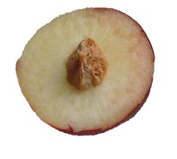 | 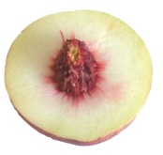 | 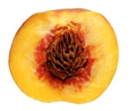
1 | 2 | 3
absent or very weak | medium | strong
weak | medium | strong

Characteristic 55 “Fruit: flesh fiber”

Current wording:

55. |  | Fruit: flesh fiber | Fruit : chair fibreuse | Frucht: Fleischfasern | Fruto: pulpa fibrosa
QN | (f) | absent or weak | absente ou faible | fehlend oder schwach | ausente o débil | Redhaven | 1
 |  | moderate | modérée | mäßig | moderada |  | 2
 |  | strong | forte | stark | fuerte | Sunhigh | 3

Proposed new wording:

55. | VG | Fruit: flesh fiber | Fruit : chair fibreuse | Frucht: Fleischfasern | Fruto: pulpa fibrosa
QN | (f) | absent or weak | absente ou faible | fehlend oder schwach | ausente o débil | Redhaven | 1
 |  | medium | moyenne | mittel | media |  | 2
 |  | strong | forte | stark | fuerte | Sunhigh | 3

Ad. 55: Fruit: flesh fiber

The flesh fiber is evaluated by tasting.

Characteristic 58 “Stone: size compared to fruit”

Current wording:

58.  (*)  (+) |  | Stone: size compared to fruit | Noyau : taille par rapport à celle du fruit | Stein: Größe im Verhältnis zur Frucht | Hueso: tamaño con respecto al fruto
QN | (g) | small | petit | klein | pequeño | Alex, Robin | 3
 |  | medium | moyen | mittel | mediano | Redhaven | 5
 |  | large | gros | groß | grande | Somervee | 7

Proposed new wording:
58.  (*)  (+) | MG | Stone: size in relation to fruit | Noyau : taille par rapport à celle du fruit | Stein: Größe im Verhältnis zur Frucht | Hueso: tamaño con respecto al fruto
QN | (g) | small | petit | klein | pequeño | Alex, Robin | 3
 |  | medium | moyen | mittel | mediano | Redhaven | 5
 |  | large | gros | groß | grande | Somervee | 7

Characterstics 63 “Stone: tendency to split” and 64 “Stone: adherence to flesh”

To be combined.

Current wording:

63.  (+) |  | Stone: tendency to split | Noyau : tendance à fendre | Stein: Tendenz zur Spaltung | Hueso: tendencia a fisurarse
QN | (g) | absent or very low | nul ou très faible | fehlend oder sehr gering | ninguna o muy débil | Fairhaven | 1
 |  | low | faible | gering | débil | Dixired | 3
 |  | medium | moyen | mittel | media | Springold | 5
 |  | high | élevé | groß | elevada | Cardinal | 7
 |  | very high | très élevé | sehr groß | muy elevada | Earlired | 9
64.  (*) |  | Stone: adherence to flesh | Noyau : adhérence a la chair | Stein: Anhaften am Fleisch | Hueso: adherencia a la pulpa
QL | (g) | absent | absente | fehlend | ausente | Fairhaven, Fuzalode | 1
 |  | present | présente | vorhanden | presente | Sweet Gold, Vivian | 9

Proposed new wording:

63.  (*) | VG | Stone: adherence to flesh | Noyau : adhérence a la chair | Stein: Anhaften am Fleisch | Hueso: adherencia a la pulpa
QL | (g) | absent | absente | fehlend | ausente | Fairhaven, Fuzalode | 1
 |  | present | présente | vorhanden | presente | Sweet Gold, Vivian | 9

Characteristic 65 “Stone: degree of adherence to flesh”

Current wording:

65. |  | Stone: degree of adherence to flesh | Noyau : degré d’adhérence a la chair | Stein: Stärke des Anhaftens am Fleisch | Hueso: grado de adherencia a la pulpa
QN | (g) | weak | faible | gering | débil | Dixired | 3
 |  | medium | moyenne | mittel | media | Springcrest | 5
 |  | strong | forte | stark | fuerte | Vivian | 7

Proposed new wording:

64. | VG | Only varieties with stone adherence to flesh present Stone: degree of adherence to flesh | Uniquement variété avec adhérence du noyau à la chair : présente : Noyau : degré d’adhérence a la chair | Nur Sorten mit Anhaften des Steins am Fleisch: vorhanden: Stein: Stärke des Anhaftens am Fleisch | Únicamente variedades con adherencia del hueso a la pulpa: presente: Hueso: grado de adherencia a la pulpa
QN | (g) | weak | faible | gering | débil | Dixired | 3
 |  | medium | moyenne | mittel | media | Springcrest | 5
 |  | strong | forte | stark | fuerte | Vivian | 7

Characteristic 66 “Stone: size compared to fruit”

Current wording:

66.  (+) |  | Time of beginning of leaf bud burst | Époque de début de débourrement foliaire | Zeitpunkt des Aufbrechens der vegetativen Knospe | Época de comienzo de la brotación de la yema folear
QN |  | very early | très précoce | sehr früh | muy temprana | Sunred | 1
 |  | early | précoce | früh | temprana | Springtime | 3
 |  | medium | moyenne | mittel | media | Redhaven | 5
 |  | late | tardive | spät | tardía | Genadix 7 | 7
 |  | very late | très tardive | sehr spät | muy tardía | Philp | 9

Proposed new wording:

65.  (+) | MG | Time of beginning of leaf bud burst | Époque de début de débourrement foliaire | Zeitpunkt des Aufbrechens der vegetativen Knospe | Época de comienzo de la brotación de la yema foliar
QN |  | very early | très précoce | sehr früh | muy temprana | Sunred | 1
 |  | early | précoce | früh | temprana | Springtime | 3
 |  | medium | moyenne | mittel | media | Redhaven | 5
 |  | late | tardive | spät | tardía | Genadix 7 | 7
 |  | very late | très tardive | sehr spät | muy tardía | Reine des Vergers | 9

Characteristic 68 “Time of maturity for consumption”

Current wording:

68.  (*)  (+) |  | Time of maturity for consumption | Époque de maturité pour la consommation | Zeitpunkt der Genußreife | Época de madurez para el consumo
QN |  | very early | très précoce | sehr früh | muy temprana | Rich May,  Springtime, Zaibaro | 1
 |  | very early to early | très précoce à précoce | sehr früh bis früh | de muy temprana a temprana | Zainoar, Zaitani | 2
 |  | early | précoce | früh | temprana | Antonia, Redwing, Rich Lady, Robin | 3
 |  | early to medium | précoce à moyenne | früh bis mittel | de temprana a media | Craucail, Diamond Princess | 4
 |  | medium | moyenne | mittel | media | Fairhaven, Fantasia, Summer Bright, Zee Lady | 5
 |  | medium to late | moyenne à tardive | mittel bis spät | de media a tardía | Maillarbig,  Savana Red, Zaimor | 6
 |  | late | tardive | spät | tardía | Fairlane, Flacara, Veteran, Western red, Zailati, Zairova | 7
 |  | late to very late | tardive à très tardive | spät bis sehr spät | de tardía a muy tardía | Andgold, Tardibelle | 8
 |  | very late | très tardive | sehr spät | muy tardía | Firetime, Rubidoux | 9

Proposed new wording:

67.  (*)  (+) | MG | Time of harvest maturity | Époque de maturité de récolte | Zeitpunkt der Erntereife | Época de madurez para la cosecha
QN |  | very early | très précoce | sehr früh | muy temprana | Rich May,  Springtime, Zaibaro | 1
 |  | very early to early | très précoce à précoce | sehr früh bis früh | de muy temprana a temprana | Zainoar, Zaitani | 2
 |  | early | précoce | früh | temprana | Antonia, Redwing,  Rich Lady, Robin | 3
 |  | early to medium | précoce à moyenne | früh bis mittel | de temprana a media | Craucail, Diamond Princess | 4
 |  | medium | moyenne | mittel | media | Fairhaven, Fantasia, Summer Bright, Zee Lady | 5
 |  | medium to late | moyenne à tardive | mittel bis spät | de media a tardía | Maillarbig,  Savana Red, Zaimor | 6
 |  | late | tardive | spät | tardía | Fairlane, Flacara,  Western Red, Veteran, Zailati, Zairova | 7
 |  | late to very late | tardive à très tardive | spät bis sehr spät | de tardía a muy tardía | Andgold, Tardibelle | 8
 |  | very late | très tardive | sehr spät | muy tardía | Rubidoux | 9
 |  | ultra late | ultra tardive |  | ultra tardia | Calante, Jesca | 10

Ad. 68 67: Time of harvest maturity

Current wording:

The time of maturity for consumption is when the overall appearance, firmness and taste indicate that the fruit is ready for consumption.

Proposed new wording:

The time of harvest maturity for consumption is when the overall appearance, firmness and taste indicate that the fruit is ready for consumption.
Chapter 8.1 “Explanations covering several characteristics”

to add the following after explanations (a) to (g):

- Explanations for the grouping and TQ characteristic “Fruit: flesh type”

Fruits with melting flesh correspond to fruits used for fresh consumption.
Fruits with non-melting flesh correspond to fruits used for canning. The flesh is harder and elastic (clingstones/pavies).

The table below illustrates the principle in greater detail

Definition

type | activity |  |  | explanation
 | ethylene | polygalacturonase
 |  | end-type | exo-type
melting  (standard peaches) | exist | exist | exist | Activity both ethylene and polygalacturonase exists in the flesh. Therefore flesh begins melting quickly after harvest.
non-melting  (clingstones/pavies) | exist | exist | absent | Activity of exo-type polygalacturonase is absent in the flesh. Therefore melting speed of flesh is very slow.
stony hard  (others) | absent | absent | absent | Activity both ethylene and polygalacturonase are absent in the flesh. Therefore flesh dose not begin to melt.  Ex. varieties: Odoroki, Yumyeong

Chapter 8.2 “Explanations for individual characteristics”

Ad. 8 “Flowering shoot: density of flower buds”

Current wording:

To be observed along the shoot on one meter.

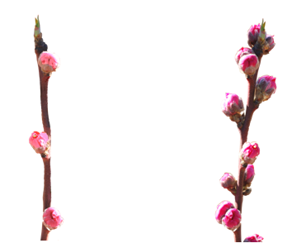
3 | 7
sparse | dense

Proposed new wording:

The density of flower buds is determined by counting the number of flower buds along the length of the current years shoot.
3 | 7
sparse | dense

Ad. 9 “Flower: type”

Current wording:

‘Campanulate’ (bell-shaped) is also referred to as ‘nonshowy’ : these types have small petals and stamens often higher than the petals.

‘Rosette’ (rose-shaped) is also referred to as ‘showy’ : these types have large petals.

 | 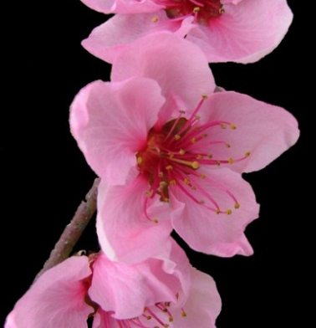
1 | 2
campanulate  (nonshowy) | rosette  (showy)

Proposed new wording:

‘Campanulate’ (bell-shaped) is also referred to as ‘non showy’ : these types have small petals and stamens often higher than the petals.

‘Rosette’ (rose-shaped) is also referred to as ‘showy’ : these types have large petals.

1 | 2
campanulate  (non showy) | rosette  (showy)

Ad. 41 “Fruit: relative area of over color of skin”

Current wording:

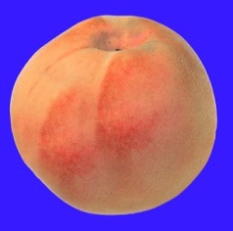 | 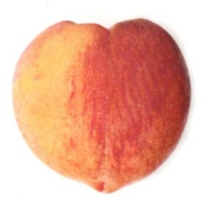 | 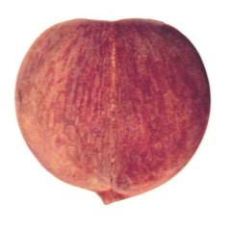
3 | 5 | 7
small | medium | large

Proposed new wording:

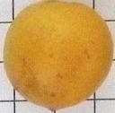
1 | 3 | 5 | 7
absent or very small | small | medium | large

Ad. 48 “Fruit: thickness of skin”
Current wording:

excluding pubescence

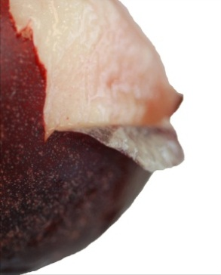

Proposed new wording:

Excluding pubescence

Ad. 50 “Fruit: firmness of flesh”

Current wording:

To be observed at eating ripeness with a penetrometer.

Proposed new wording:

To be observed just before maturity.

Chapter 9 “Literature”

To add following literature references:

Chaparro J.X., Werner D.J., Whetten R.W. and D.M. O'Malley, 1995. Inheritance, genetic interaction and biochemical characterization of anthocyanin phenotypes in peach. J. Hered., 86: 32-38.

Hu D. and R. Scorza, 2009: Analysis of the ‘A72’ peach tree Growth Habit and its inheritance in progeny obtained from crosses of ‘A72’ with columnar peach trees. J. Amer. Sc. Hort. Sci. 134(2):236-243.

Layne D.R. and D. Bassi, 2008. The peach : Botany, production and uses. Ed. By Desmond R. Layne and Daniele Bassi. ISBN 978 1 84593 386 9. CABI, 30 nov. 2008 - 615 pages.

Monet R., Bastard Y. en Gibault B., 1988. Etude génétique du caractère « port pleureur » chez le pêcher. Agronomie, 8(2): 127-132.

Monet R. Guye A. and N. Dachary, 1996. Peach Mendelian genetics: a short review and new results. Agronomie, 16: 321-329.

Sajer O., Scorza R., Dardick C., Zhenbentyayeva T., 2012. Development of sequence-tagged site markers linked to the pillar growth type in peach (Prunus persica). Abbott A.G. and R. Horn, Plant Breeding, doi:10.1111/j.1439-0523.2011.01912.x

Scorza R., Lightner G.W. and A. Liverani, 1989. The pillar peach tree and growth habit analysis of compact x pillar progeny. J. Am. Soc. Hortic. Sci., 114: 991-995.

Takashi Haji, Hideaki Yaegaki, Masami Yamaguchi Department of Breeding, National Institute of Fruit Science: Changes in Ethylene Production and Flesh Firmness of Melting, Nonmelting and Stony hard in Peaches after Harvest: J. Japan. Soc. Hort. Sci 70(4): 458-459 2001.

Takashi Haji, Hideaki Yaegaki, Masami Yamaguchi Department of Breeding, National Institute of Fruit Science: Inheritance and expression of fruit texture melting, non-melting and stony hard in peach. Scientia Horticulture 105 (2005) 241-248.

Werner R.W. Creller M.A. and J.X. Chaparro, 2005. Inheritance of the blood-flesh trait in peach. Hortscience, 33(7): 1243-1246.

Werner R.W. and Chaparro J.X., 2005. Genetic interactions between pillar and weeping peach genotypes. Hortscience 40(1): 18-20.
Chapter 10 “Technical Questionnaire”

To delete the following characteristics from Chapter 5:

Fruit: flesh type (TQ characteristic), with the following groups:
- melting
- non-melting (pavies)
- stony hard
Stone: adherence to flesh (characteristic 64)

To add the following characteristics to Chapter 5:

Tree: size (characteristic 1)
Flowering shoot: presence of anthocyanin coloration (characteritic 6)
Anthers: pollen (characteristic 17)
Ovary: pubescence (characteristic 18)
Leaf blade: red mid-vein on the lower side (characteristic 28)
Petiole: nectaries (characteristic 30)
Fruit: shape (in ventral view) (characteristic 33)

[End of document]

