E
TWF/44/25
ORIGINAL: English
DATE: April 18, 2013
INTERNATIONAL UNION FOR THE PROTECTION OF NEW VARIETIES OF PLANTS
Geneva
Technical working party for fruit cropS
Forty-Fourth Session
Napier, New Zealand, April 29 to May 3, 2013
pea database study
Document prepared by an expert from France
The purpose of this document is to report on developments concerning a pea database study.

The following abbreviations are used in this document:

CAJ: Administrative and Legal Committee
TC: Technical Committee
TC-EDC: Enlarged Editorial Committee
TWA: Technical Working Party for Agricultural Crops
TWC: Technical Working Party on Automation and Computer Programs
TWF: Technical Working Party for Fruit Crops
TWO: Technical Working Party for Ornamental Plants and Forest Trees
TWPs: Technical Working Parties
TWV: Technical Working Party for Vegetables

The structure of this document is as follows:

BACKGROUND 1

Developments in 2013 2
Technical Committee 2
aNNex: REFERENCE COLLECTION AND GROUPING CHARACTERISTICS- EXAMPLE OF THE PEA SPECIES

BACKGROUND

The Technical Committee, at its forty-eighth session held in Geneva from March 26 to 28, 2012, considered document TC/48/9 “Variety Description Databases”. The TC requested the experts from France to continue their work on grouping characteristics and on the development of a database containing Pea variety descriptions of members of the Union, and to report on their work to the TWPs at their sessions in 2012 and to the TC at its forty-ninth session (see document TC/48/22 “Report on the Conclusions”, paragraph 116).

Developments in 2013

Technical Committee

The TC, at its forty-ninth session, held in Geneva from March 18 to 20, 2013, considered document TC/49/9 and received a presentation by Mr. François Boulineau (France) on “Reference Collection and grouping characteristics-example of the Pea species”, as set out in this document.

The TC, at its forty-ninth session, noted that the results of the study on Pea would be presented to the TWA and the TWV in order to:

(i) select characteristics to be used as grouping characteristics according to their qualities (discriminating power, distortion, use);

(ii) develop a procedure to improve the pea database; and

(iii) consider making the pea database available to all examination offices.

The TC agreed that the results of the study should be presented to other TWPs for their comments on the approach for managing variety collections, as presented in document TC/41/9 “Publication of Variety Descriptions” (see document TC/49/41 “Report on the Conclusions”, paragraphs 100 to 103).

The Annex to this document contains a presentation on “Reference Collection and Grouping Characteristics; Example of the Pea Species”, prepared by an expert from France, on the basis of replies from the Questionnaire on Variety Description for Pea (Partial Revision) circulated to UPOV members.

The TWF is invited to consider the approach for managing variety collections, as presented in the Annex to this document.

[Annex follows]

REFERENCE COLLECTION AND GROUPING CHARACTERISTICS
EXAMPLE OF THE PEA SPECIES

BACKGROUND

The Technical Working Party for Vegetables (TWV), at its forty-fifth session held in Monterey, United States of America, from July 25 to 29, 2011, considered document TWV/45/24 “Partial Revision of the Test Guidelines for Pea (document TG/7/10)”, presented by Mr. François Boulineau (France), in conjunction with documents TWV/45/6 “Variety Descriptions Databases” and TWV/45/13 “Concept of a Database Containing Pea Variety Descriptions”. It agreed that Mr. Boulineau should seek variety descriptions from members of the Union for the 2,400 (approximate) varieties of common knowledge that he had identified, to examine if the following characteristics were sufficiently reliable for use as grouping characteristics:

Current grouping characteristics:

Plant: anthocyanin coloration (characteristic 1)
Stem: number of nodes up to and including first fertile node (characteristic 5)
Stipule: flecking (characteristic 20)
Pod: parchment (characteristic 39)
Excluding varieties with pod parchment: entire: Pod: thickened wall (characteristic 40)
Pod: color (characteristic 43)
Immature seed: intensity of green color (characteristic 47)
Seed: type of starch grains (characteristic 49)
Seed: color of cotyledon (characteristic 52)
Only varieties with plant anthocyanin coloration present: Seed: marbling of testa (characteristic 53)
Only varieties with plant anthocyanin coloration present: Seed: violet or pink spots on testa (characteristic 54)
Seed: hilum color (characteristic 55)
Resistance to Fusarium oxysporum f. sp. pisi (characteristic 58.1)

Potential grouping characteristic:

Stem: fasciation (characteristic 3)
Stem: length (characteristic 4)
Foliage: color (characteristic 6)
Leaf: leaflets (characteristic 8)
Time of flowering (characteristic 24
Only varieties with stem fasciation absent: Plant: maximum number of flowers per node (characteristic 25)
Only varieties with plant anthocyanin coloration present: Flower: color of wing (characteristic 26)
Pod: length (characteristic 37)
Pod: width (characteristic 38)
Only varieties with Pod: thickened wall absent: Pod: shape of distal part (characteristic 41)
Pod: curvature (characteristic 42)
Only varieties with pod color green (Char. 43: state 2): intensity of green color (characteristic 44)
Excluding varieties with pod parchment: entire: Pod: suture strings (characteristic 45)
Seed: shape (characteristic 48)
Seed: weight (characteristic 57)
Resistance to Erysiphe pisi Syd. (characteristic 59)
Resistance to Ascochyta pisi, Race C (characteristic 60)

CIRCULAR E_12/079 - QUESTIONNAIRE ON VARIETY DESCRIPTIONS FOR PEA (PARTIAL REVISION)

The TWV agreed that a circular should be prepared by Mr. Boulineau and issued by the Office of the Union to the Technical Committee representative for the following members of the Union, on the basis that they had indicated practical experience in the DUS examination of Pea:

Argentina; Austria; Bulgaria; Canada; China; Czech Republic; Denmark; Estonia; European Union (Community Plant Variety Office (CPVO)); France; Germany; Hungary; Japan; Kenya; Netherlands; New Zealand; Poland; Portugal; Republic of Korea; Republic of Moldova; Romania; Russian Federation; Slovakia; South Africa; Spain; Ukraine; United Kingdom; United States of America;

The TWV agreed that the contributors of variety descriptions should be invited to indicate the status of the variety descriptions provided and, in particular, if they constituted the “official” description of the variety concerned.

UPOV members contribution:
Following the propositions made during TWV/45, concerning the reference collection and the grouping characteristics of pea varieties, two Excel files have been sent.

- Excel File: Pea_Theoretical collection(V31jan2012) which is a compilation of varieties that are considered to be relevant for inclusion in the reference collection. According to the origin of each variety, some information is given on its administrative situation :
Yellow: varieties from the EU list (European Common Catalogue)
Green: varieties from the CPVO database
Blue: varieties from PLUTO, the UPOV Plant Variety Database
Orange: varieties from the OECD list
Pink: varieties under PMA (Provisional Market Authorization) in the EU system

On the right side of this file, three columns were proposed to be completed by UPOV members :
x Relevant variety for the reference collection: According to the administrative information or the knowledge of the variety, should this variety appear in the reference collection ?(Y: yes; N: no)
y Available description: Does the country have a description (at least for grouping characteristics) of this variety ? ?(Y: yes; N: no)
z Reference collection: Is this variety in the reference collection of the country, (seeds available)? (Y: yes; N: no)

- Excel File: Pea_Grouping characteristics which concerns the descriptions for grouping characteristics proposed to be included in the pea guideline. When an available description exists, the country is invited to complete this file.

If the UPOV member consider that any other varieties are relevant for the reference collection, it is pleased to add them at the end of the file.

Completed Excel files have been sent to Mr. François BOULINEAU at francois.boulineau@geves.fr and Ms. Stéphanie CHRISTIEN at stephanie.christien@geves.fr, with a copy to the Office of the Union (upov.mail@upov.int).

RESULTS

Replies to the questionnaire
The Pea theoretical collection is composed of more than 3,100 well known varieties.
7,511 descriptions (complete or partial) were received, concerning 2,524 varieties, which represents more tan 80% of the varieties present in the theoretical collection.

14 UPOV members sent information:

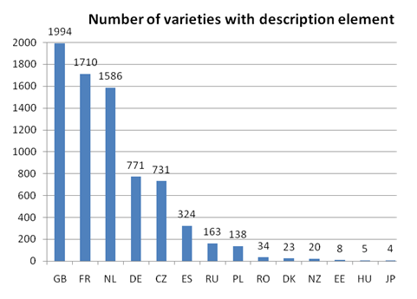

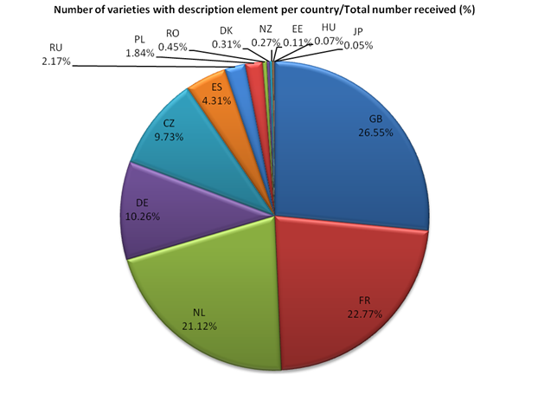

Properties of individual characteristics
Three indicators have been defined :
- Use of the characteristic
Number of times the characteristic is described for the described varieties

- .Discriminating power of the characteristic
Percentage of excluded varieties on the basis of the characteristic

- Distortion of the characteristic
Percentage of distortion for a characteristic corresponds to percentage of varieties for which different levels of expression of the observed characteristic have been recorded (depending on examination conditions, climate, stress, recorder, mistakes, etc.)
- For qualitative or pseudo-qualitative characteristics : number of varieties with different notes among the varieties described for this characteristic;
- For quantitative characteristics: number of descriptions with a note not included in the interval [note medium + or - 1.5] among the descriptions received for the characteristic.

Use of the characteristic

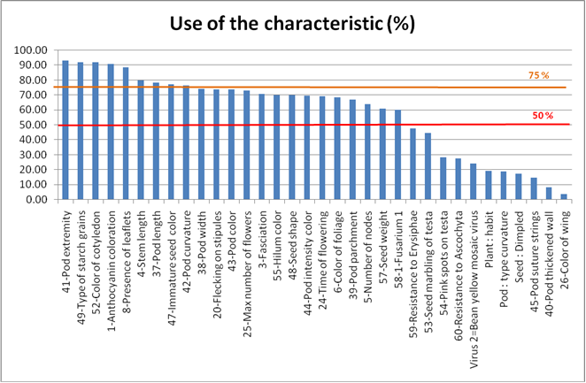

Discriminating power of the characteristic
Qualitative and Pseudo-qualitative characteristics

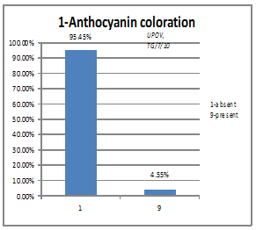 | 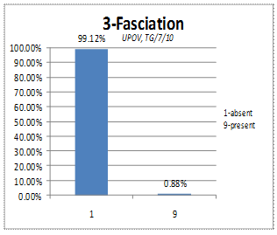
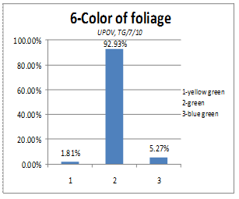 | 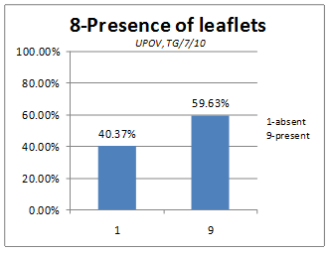
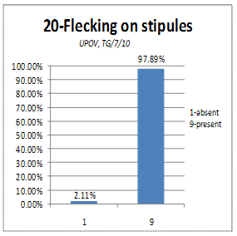 | 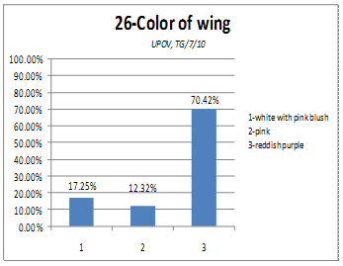
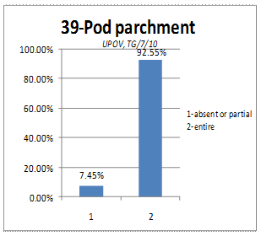 | 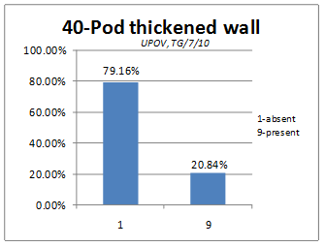
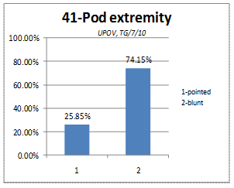 | 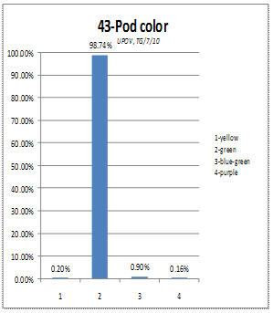
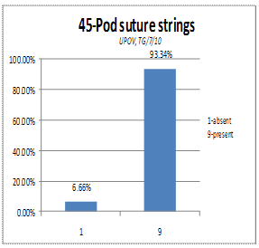 | 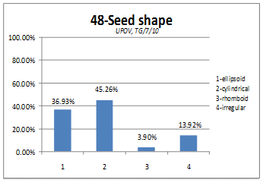
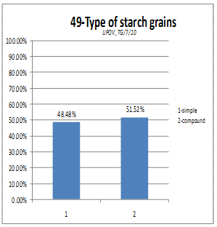 | 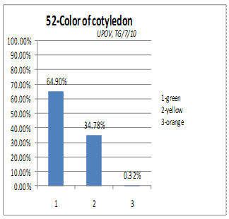
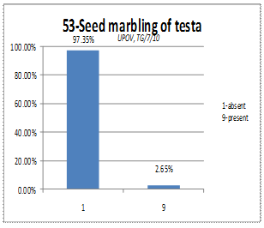 | 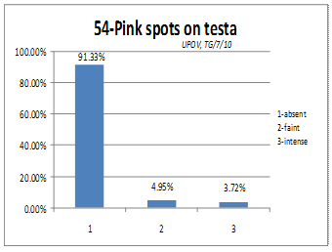
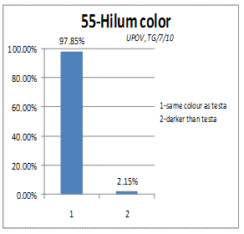 | 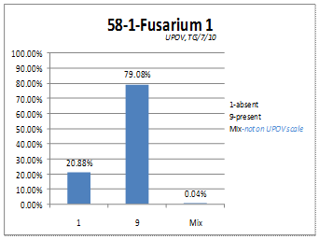
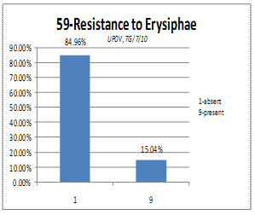 | 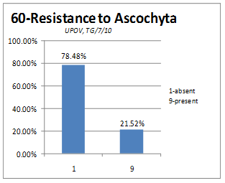
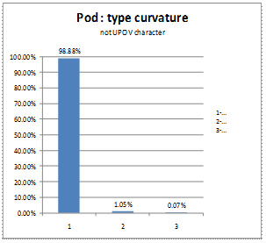 | 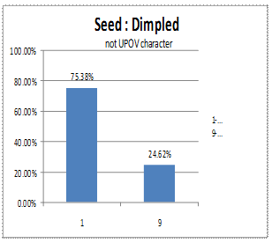
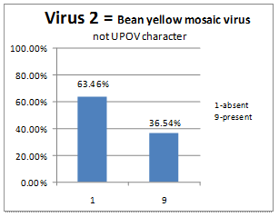

Quantitative characteristics
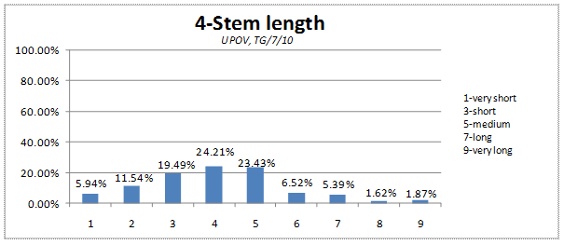
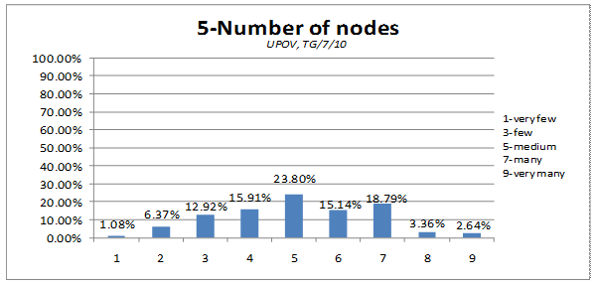
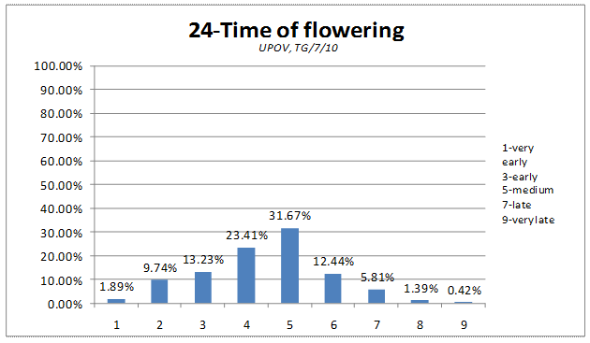
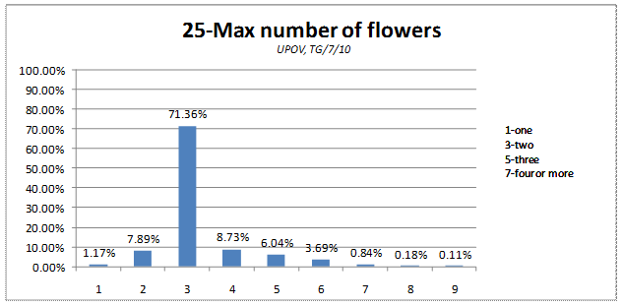
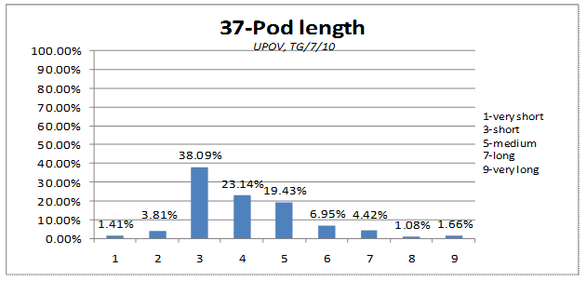
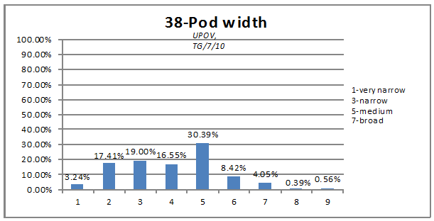
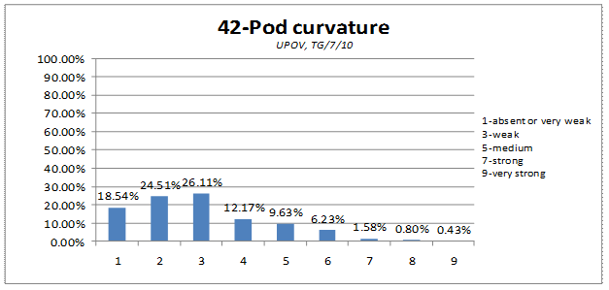
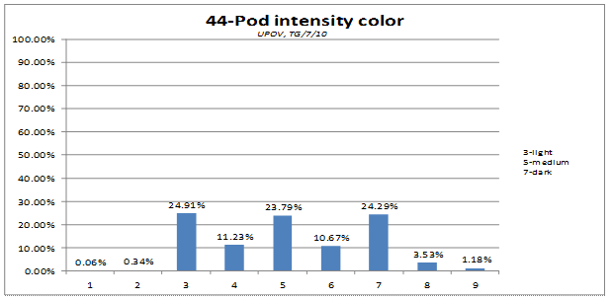
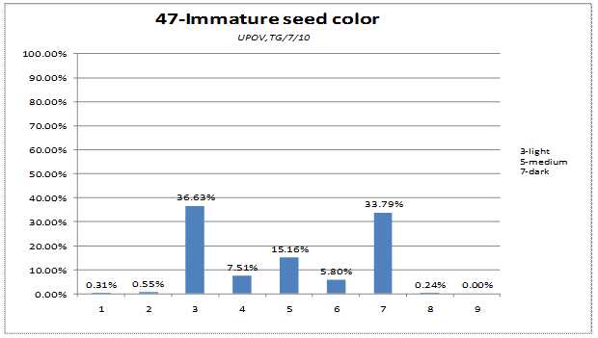
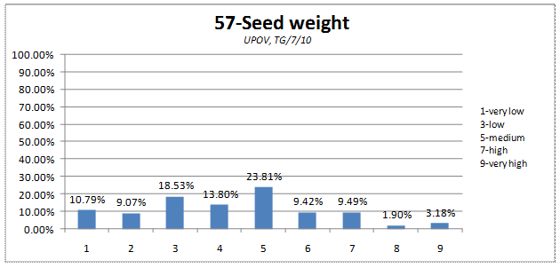
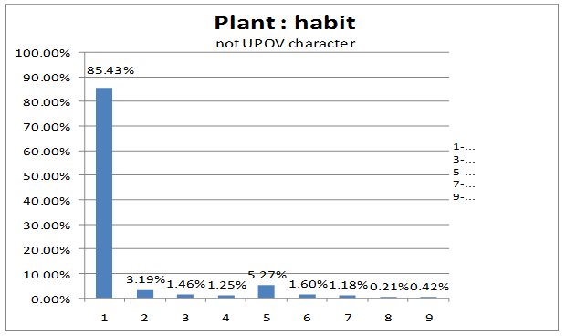
Distortion of the characteristic
Qualitative and Pseudo-qualitative characteristics
Characteristic | TYPE OF EXPRESSION OF  CHARACTERISTICS | Distortion (%)
Pod : type curvature | QL | 0.36%
3-Fasciation | QL | 0.42%
60-Resistance to Ascochyta | QL | 0.62%
53-Seed marbling of testa | QL | 0.72%
1-Anthocyanin coloration | QL | 0.81%
55-Hilum color | QL | 1.03%
8-Presence of leaflets | QL | 1.38%
43-Pod color | PQ | 1.86%
20-Flecking on stipules | QL | 2.04%
45-Pod suture strings | QL | 2.39%
54-Pink spots on testa | QL | 2.39%
59-Resistance to Erysiphae | QL | 2.42%
40-Pod thickened wall | QL | 3.15%
49-Type of starch grains | QL | 3.66%
Virus 2= Bean yellow mosaic virus | QL | 4.22%
6-Color of foliage | PQ | 5.06%
41-Pod extremity | QL | 5.13%
58-1-Fusarium 1 | QL | 5.99%
39-Pod parchment | QL | 6.17%
52-Color of cotyledon | PQ | 7.12%
26-Color of wing | PQ | 9.36%
Seed : Dimpled | QL | 12.46%
48-Seed shape | PQ | 31.51%
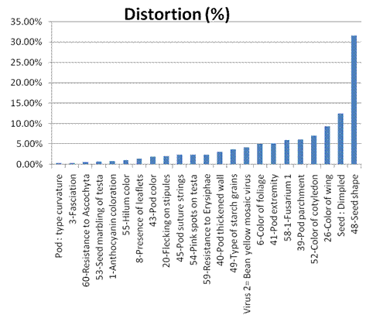
Quantitative characteristics

Characteristics | Distortion (%)
25-Max number of flowers | 2.83%
24-Time of flowering | 4.81%
Plant : habit | 5.00%
57-Seed weight | 5.32%
37-Pod length | 7.08%
44-Pod intensity color | 7.21%
42-Pod curvature | 7.88%
47-Immature seed color | 10.01%
5-Number of nodes | 12.98%
4-Stem length | 17.18%
38-Pod width | 19.23%

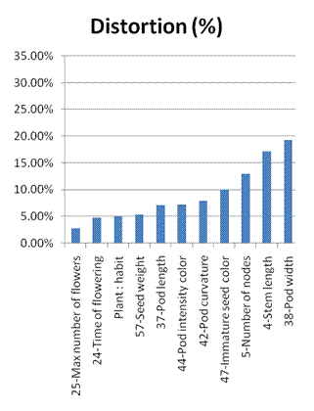
On the basis of the three indicators, each characteristic can be defined as follow
For official grouping characteristics (mentioned in the TG/7/10)

For candidate grouping characteristics

[End of Annex and of document]

