 |  |  |  |  |  |  | E  TG/VANIL(proj.3)  ORIGINAL: English  DATE: 2013-03-19
INTERNATIONAL UNION FOR THE PROTECTION OF NEW VARIETIES OF PLANTS
Geneva
 |  |  | DRAFT
 |  | VANILLA  UPOV Code VANIL_PLA  Vanilla planifolia Jacks. |  |  | *

GUIDELINES

FOR THE CONDUCT OF TESTS

FOR DISTINCTNESS, UNIFORMITY AND STABILITY

prepared by an expert from Mexico

to be considered by the

Technical Working Party for Fruit Crops
at its forty-fourth session, to be held in Napier, New Zealand, from April 29 to May 3, 2013

Alternative Names:*

Botanical name | English | French | German | Spanish
Vanilla planifolia Jacks. | Vanilla | Vanillier | Vanille-Pflanze | Vainilla, Xanath

The purpose of these guidelines (“Test Guidelines”) is to elaborate the principles contained in the General Introduction (document TG/1/3), and its associated TGP documents, into detailed practical guidance for the harmonized examination of distinctness, uniformity and stability (DUS) and, in particular, to identify appropriate characteristics for the examination of DUS and production of harmonized variety descriptions.

ASSOCIATED DOCUMENTS
These Test Guidelines should be read in conjunction with the General Introduction and its associated TGP documents.
TABLE OF CONTENTS PAGE

1. Subject of these Test Guidelines 3
2. Material Required 3
3. Method of Examination 3
3.1 Number of Growing Cycles 3
3.2 Testing Place 3
3.3 Conditions for Conducting the Examination 3
3.4 Test Design 3
3.5 Additional Tests 3
4. Assessment of Distinctness, Uniformity and Stability 4
4.1 Distinctness 4
4.2 Uniformity 5
4.3 Stability 5
5. Grouping of Varieties and Organization of the Growing Trial 5
6. Introduction to the Table of Characteristics 5
6.1 Categories of Characteristics 5
6.2 States of Expression and Corresponding Notes 6
6.3 Types of Expression 6
6.4 Example Varieties 6
6.5 Legend 7
7. Table of Characteristics/Tableau des caractères/Merkmalstabelle/Tabla de caracteres 8
8. Explanations on the Table of Characteristics 13
8.1 Explanations covering several characteristics 13
8.2 Explanations for individual characteristics 13
9. Literature 19
10. Technical Questionnaire 20

ANNEX OBSERVATIONS AND COMMENTS ON DOCUMENT TG/VANIL(PROJ.3)

Subject of these Test Guidelines

These Test Guidelines apply to all varieties of Vainilla planifolia Jacks. and interspecific hybrids.

Material Required

2.1 The competent authorities decide on the quantity and quality of the plant material required for testing the variety and when and where it is to be delivered. Applicants submitting material from a State other than that in which the testing takes place must ensure that all customs formalities and phytosanitary requirements are complied with.

2.2 The material is to be supplied in the form of plants.

2.3 The minimum quantity of plant material, to be supplied by the applicant, should be:

10 plants.

2.4 The plant material supplied should be visibly healthy, not lacking in vigor, nor affected by any important pest or disease.

2.5 The plant material should not have undergone any treatment which would affect the expression of the characteristics of the variety, unless the competent authorities allow or request such treatment. If it has been treated, full details of the treatment must be given.

Method of Examination

3.1 Number of Growing Cycles

3.1.1 The minimum duration of tests should normally be two independent growing cycles. In particular, it is essential that the plants produce a satisfactory crop of fruit in each of the two growing cycles.

3.1.2 The growing cycle is considered to be the period ranging from the beginning of active vegetative growth or flowering, continuing through active vegetative growth or flowering and fruit development and concluding with the harvesting of fruit.

3.2 Testing Place

Tests are normally conducted at one place. In the case of tests conducted at more than one place, guidance is provided in TGP/9 “Examining Distinctness”.

3.3 Conditions for Conducting the Examination

The tests should be carried out under conditions ensuring satisfactory growth for the expression of the relevant characteristics of the variety and for the conduct of the examination. In particular, it is essential that the plants produce a satisfactory crop of fruit in the main fruiting period in each of the two growing years, since the species may have waves of fruiting within a year.

3.4 Test Design

3.4.1 Each test should be designed to result in a total of at least 10 plants.

3.4.2 The design of the tests should be such that plants or parts of plants may be removed for measurement or counting without prejudice to the observations which must be made up to the end of the growing cycle.

3.5 Additional Tests

Additional tests, for examining relevant characteristics, may be established.

Assessment of Distinctness, Uniformity and Stability

4.1 Distinctness

4.1.1 General Recommendations

It is of particular importance for users of these Test Guidelines to consult the General Introduction prior to making decisions regarding distinctness. However, the following points are provided for elaboration or emphasis in these Test Guidelines.

4.1.2 Consistent Differences

The differences observed between varieties may be so clear that more than one growing cycle is not necessary. In addition, in some circumstances, the influence of the environment is not such that more than a single growing cycle is required to provide assurance that the differences observed between varieties are sufficiently consistent. One means of ensuring that a difference in a characteristic, observed in a growing trial, is sufficiently consistent is to examine the characteristic in at least two independent growing cycles.

4.1.3 Clear Differences

Determining whether a difference between two varieties is clear depends on many factors, and should consider, in particular, the type of expression of the characteristic being examined, i.e. whether it is expressed in a qualitative, quantitative, or pseudo-qualitative manner. Therefore, it is important that users of these Test Guidelines are familiar with the recommendations contained in the General Introduction prior to making decisions regarding distinctness.

4.1.4 Number of Plants / Parts of Plants to be Examined

Unless otherwise indicated, for the purposes of distinctness, all observations on single plants should be made on 10 plants or parts taken from each of 10 plants and any other observations made on all plants in the test, disregarding any off-type plants.

In the case of observations of parts taken from single plants, the number of parts to be taken from each of the plants should be 2.

4.1.5 Method of Observation

The recommended method of observing the characteristic for the purposes of distinctness is indicated by the following key in the second column of the Table of Characteristics (see document TGP/9 “Examining Distinctness”, Section 4 “Observation of characteristics”):

MG: single measurement of a group of plants or parts of plants
MS: measurement of a number of individual plants or parts of plants
VG: visual assessment by a single observation of a group of plants or parts of plants
VS: visual assessment by observation of individual plants or parts of plants

Type of observation: visual (V) or measurement (M)

“Visual” observation (V) is an observation made on the basis of the expert’s judgment. For the purposes of this document, “visual” observation refers to the sensory observations of the experts and, therefore, also includes smell, taste and touch. Visual observation includes observations where the expert uses reference points (e.g. diagrams, example varieties, side-by-side comparison) or non-linear charts (e.g. color charts). Measurement (M) is an objective observation against a calibrated, linear scale e.g. using a ruler, weighing scales, colorimeter, dates, counts, etc.

Type of record: for a group of plants (G) or for single, individual plants (S)

For the purposes of distinctness, observations may be recorded as a single record for a group of plants or parts of plants (G), or may be recorded as records for a number of single, individual plants or parts of plants (S). In most cases, “G” provides a single record per variety and it is not possible or necessary to apply statistical methods in a plant-by-plant analysis for the assessment of distinctness.

In cases where more than one method of observing the characteristic is indicated in the Table of Characteristics (e.g. VG/MG), guidance on selecting an appropriate method is provided in document TGP/9, Section 4.2.

4.2 Uniformity

4.2.1 It is of particular importance for users of these Test Guidelines to consult the General Introduction prior to making decisions regarding uniformity. However, the following points are provided for elaboration or emphasis in these Test Guidelines:

4.2.2 For the assessment of uniformity of vegetatively propagated varieties, a population standard of 1% and an acceptance probability of at least 95 % should be applied. In the case of a sample size of 10 plants, one off-type is allowed.

4.3 Stability

4.3.1 In practice, it is not usual to perform tests of stability that produce results as certain as those of the testing of distinctness and uniformity. However, experience has demonstrated that, for many types of variety, when a variety has been shown to be uniform, it can also be considered to be stable.

4.3.2 Where appropriate, or in cases of doubt, stability may be further examined by testing a new plant stock to ensure that it exhibits the same characteristics as those shown by the initial material supplied.

Grouping of Varieties and Organization of the Growing Trial

5.1 The selection of varieties of common knowledge to be grown in the trial with the candidate varieties and the way in which these varieties are divided into groups to facilitate the assessment of distinctness are aided by the use of grouping characteristics.

5.2 Grouping characteristics are those in which the documented states of expression, even where produced at different locations, can be used, either individually or in combination with other such characteristics: (a) to select varieties of common knowledge that can be excluded from the growing trial used for examination of distinctness; and (b) to organize the growing trial so that similar varieties are grouped together.

5.3 The following have been agreed as useful grouping characteristics:

(a) Stem: color (Characteristic 1)
(b) Leaf blade: color (Characteristic 12)
(c) Leaf blade: shape (Characteristic 20)
(d) Fruit: color (Characteristic 29)
(e) Fruit: length (Characteristic 32)

5.4 Guidance for the use of grouping characteristics, in the process of examining distinctness, is provided through the General Introduction and document TGP/9 “Examining Distinctness”.

Introduction to the Table of Characteristics

6.1 Categories of Characteristics

6.1.1 Standard Test Guidelines Characteristics

Standard Test Guidelines characteristics are those which are approved by UPOV for examination of DUS and from which members of the Union can select those suitable for their particular circumstances.

6.1.2 Asterisked Characteristics

Asterisked characteristics (denoted by *) are those included in the Test Guidelines which are important for the international harmonization of variety descriptions and should always be examined for DUS and included in the variety description by all members of the Union, except when the state of expression of a preceding characteristic or regional environmental conditions render this inappropriate.

6.2 States of Expression and Corresponding Notes

6.2.1 States of expression are given for each characteristic to define the characteristic and to harmonize descriptions. Each state of expression is allocated a corresponding numerical note for ease of recording of data and for the production and exchange of the description.

6.2.2 In the case of qualitative and pseudo-qualitative characteristics (see Chapter 6.3), all relevant states of expression are presented in the characteristic. However, in the case of quantitative characteristics with 5 or more states, an abbreviated scale may be used to minimize the size of the Table of Characteristics. For example, in the case of a quantitative characteristic with 9 states, the presentation of states of expression in the Test Guidelines may be abbreviated as follows:

State | Note
small | 3
medium | 5
large | 7

However, it should be noted that all of the following 9 states of expression exist to describe varieties and should be used as appropriate:

State | Note
very small | 1
very small to small | 2
small | 3
small to medium | 4
medium | 5
medium to large | 6
large | 7
large to very large | 8
very large | 9

6.2.3 Further explanation of the presentation of states of expression and notes is provided in document TGP/7 “Development of Test Guidelines”.

6.3 Types of Expression

An explanation of the types of expression of characteristics (qualitative, quantitative and pseudo-qualitative) is provided in the General Introduction.

6.4 Example Varieties

Where appropriate, example varieties are provided to clarify the states of expression of each characteristic.

6.5 Legend

(*) Asterisked characteristic – see Chapter 6.1.2

QL Qualitative characteristic – see Chapter 6.3
QN Quantitative characteristic – see Chapter 6.3
PQ Pseudo-qualitative characteristic – see Chapter 6.3

MG, MS, VG, VS – see Chapter 4.1.5

(a)-(c) See Explanations on the Table of Characteristics in Chapter 8.1
(+) See Explanations on the Table of Characteristics in Chapter 8.2.

Table of Characteristics/Tableau des caractères/Merkmalstabelle/Tabla de caracteres

 |  | English | français | deutsch | español | Example Varieties  Exemples  Beispielssorten  Variedades ejemplo | Note/  Nota
1 | VG | Stem: color
QN | (a) | light |  |  |  | Acamaya | 1
 |  | medium |  |  |  | Oreja de Burro, Princesa, Totonaku | 2
 |  | dark |  |  |  | Amarela, Espada | 3
2. | VG | Stem: variegation
QL | (a) | absent |  |  |  | Totonaku | 1
 |  | present |  |  |  | Acamaya | 9
3.  (+) | VG | Stem: shape in cross section
QN | (a) | round |  |  |  | Acamaya, Totonaku | 1
 |  | round to angular |  |  |  |  | 2
 |  | angular |  |  |  |  | 3
4. | VG/MS | Stem: diameter
QN | (a) | small |  |  |  | Acamaya, Princesa | 3
 |  | medium |  |  |  | Totonaku | 5
 |  | large |  |  |  | Amarela | 7
5. | VG/MS | Stem: internode length
QN | (a) | short |  |  |  | Acamaya, Princesa | 3
 |  | medium |  |  |  | Amarela, Totonaku | 5
 |  | long |  |  |  | Oreja de Burro | 7
6. | VG | Stem: surface
QN | (a) | smooth |  |  |  | Acamaya, Totonaku | 1
 |  | medium |  |  |  | Amarela | 2
 |  | rough |  |  |  |  | 3
7.  (+) | VG | Stem: spots
QL | (a) | absent |  |  |  | Princesa, Totonaku | 1
 |  | present |  |  |  | Espada, Oreja de Burro | 9
8.  (*)  (+) | VG | Leaf blade: conspicuousness of main vein
QN | (a) | weakly visible |  |  |  | Princesa, Totonaku | 1
 |  | slightly visible |  |  |  |  | 2
 |  | clearly visible |  |  |  |  | 3
9.  (*)  (+) | VG | Leaf blade: shape of apex
PQ | (a) | obtuse |  |  |  | Princesa, Totonaku | 1
 |  | acute |  |  |  | Acamaya, Oreja de Burro | 2
 |  | acuminate |  |  |  | Espada | 3
10.  (*) | VG/MS | Leaf: petiole length
QN | (a) | short |  |  |  | Princesa | 3
 |  | medium |  |  |  | Acamaya, Totonaku | 5
 |  | long |  |  |  |  | 7
11.  (+) | VG | Leaf blade: base
QL | (a) | clasping |  |  |  | Oreja de Burro, Totonaku | 1
 |  | tapering |  |  |  | Acamaya, Princesa | 2
12.  (*) | VG | Leaf blade: color
PQ | (a) | yellow white |  |  |  | Acamaya | 1
 |  | light green |  |  |  | Oreja de Burro | 2
 |  | medium green |  |  |  | Totonaku | 3
 |  | dark green |  |  |  | Amarela | 4
13.  (*)  (+) | VG | Leaf blade: variegation
QL | (a) | absent |  |  |  | Oreja de Burro, Totonaku | 1
 |  | present |  |  |  | Acamaya | 9
14. | VG/MS | Leaf blade: length
QN | (a) | short |  |  |  | Acamaya | 3
 |  | medium |  |  |  | Princesa, Totonaku | 5
 |  | long |  |  |  | Oreja de Burro | 7
15. | VG/MS | Leaf blade: width
QN | (a) | narrow |  |  |  | Acamaya | 3
 |  | medium |  |  |  | Princesa, Totonaku | 5
 |  | broad |  |  |  | Oreja de Burro | 7
16.  (+) | VG/MS | Leaf blade: length/width ratio
QN | (a) | moderately compressed |  |  |  | Amarela | 3
 |  | medium |  |  |  | Oreja de Burro, Totonaku | 5
 |  | moderately elongated |  |  |  | Espada | 7
17. | VG | Leaf blade: symmetry
QN | (a) | symmetric or slightly asymmetric |  |  |  | Princesa, Totonaku | 1
 |  | moderately asymmetric |  |  |  | Espada | 2
 |  | strongly asymmetric |  |  |  |  | 3
18.  (*) | VG/MS | Leaf: thickness
QN | (a) | thin |  |  |  | Acamaya | 3
 |  | medium |  |  |  | Princesa, Totonaku | 5
 |  | thick |  |  |  | Oreja de Burro | 7
19.  (+) | VG | Leaf blade: transversal section
QN | (a) | flat or slightly concave |  |  |  | Acamaya, Totonaku | 1
 |  | moderately concave |  |  |  | Espada | 2
 |  | strongly concave |  |  |  | Oreja de Burro | 3
20.  (*)  (+) | VG | Leaf blade: shape
PQ | (a) | narrow ovate |  |  |  | Espada | 1
 |  | medium ovate |  |  |  |  | 2
 |  | elliptic |  |  |  | Princesa | 3
 |  | obovate |  |  |  | Oreja de Burro | 4
 |  | oblong |  |  |  | Acamaya, Totonaku | 5
21. | MG/MG | Inflorescence: number of flowers
QN | (b) | few |  |  |  | Acamaya | 3
 |  | medium |  |  |  | Oreja de Burro, Princesa | 5
 |  | many |  |  |  | Totonaku | 7
22.  (+) | VG | Flower: rostellum width
QN | (b) | narrower than stigma |  |  |  |  | 1
 |  | as broad as stigma |  |  |  |  | 2
 |  | wider than stigma |  |  |  |  | 3
23. | VG | Flower: color of tepals
PQ | (b) | whitish |  |  |  |  | 1
 |  | green yellow |  |  |  | Oreja de burro, Totonaku | 2
 |  | yellow |  |  |  |  | 3
 |  | yellow orange |  |  |  |  | 4
24.  (*)  (+) | VG | Flower: color of label
QL | (b) | white |  |  |  |  | 1
 |  | green |  |  |  |  | 2
 |  | yellow |  |  |  | Amarela, Oreja de Burro, Totonaku | 3
 |  | orange |  |  |  |  | 4
 |  | purple |  |  |  |  | 5
25.  (*)  (+) | VG/MS | Flower: labellum length
QN | (b) | short |  |  |  |  | 3
 |  | medium |  |  |  | Totonaku | 5
 |  | long |  |  |  |  | 7
26.  (+) | VG/MS | Flower: length of gynandrium
QN | (b) | short |  |  |  |  | 3
 |  | medium |  |  |  |  | 5
 |  | long |  |  |  |  | 7
27. | VG/MS | Flower: length of petals
QN | (b) | short |  |  |  |  | 3
 |  | medium |  |  |  | Oreja de Burro, Totonaku | 5
 |  | long |  |  |  |  | 7
28. | VG/MS | Flower: width of petal
QN | (b) | narrow |  |  |  |  | 3
 |  | medium |  |  |  |  | 5
 |  | broad |  |  |  |  | 7
29.  (*) | VG | Fruit: color
PQ | (c) | yellow |  |  |  |  | 1
 |  | greenish yellow |  |  |  |  | 2
 |  | medium green |  |  |  | Princesa, Totonaku | 3
 |  | dark green |  |  |  |  | 4
30.  (+) | VG | Fruit: shape
PQ | (c) | ovate |  |  |  |  | 1
 |  | oblong |  |  |  | Totonaku | 2
 |  | obovate |  |  |  | Amarela | 3
31.  (+) | VG | Fruit: transversal section shape
PQ | (c) | circular |  |  |  |  | 1
 |  | elliptic |  |  |  |  | 2
 |  | medium ovate |  |  |  |  | 3
 |  | broad ovate |  |  |  |  | 4
 |  | trullate |  |  |  |  | 5
 |  | triangular |  |  |  | Amarela | 6
32.  (*) | VG/MS | Fruit: length
QN | (c) | short |  |  |  | Acamaya | 3
 |  | medium |  |  |  | Totonaku | 5
 |  | long |  |  |  | Amarela | 7
33. | VG | Fruit: texture of surface
QN | (c) | smooth |  |  |  | Amarela, Totonaku | 1
 |  | medium |  |  |  |  | 2
 |  | rough |  |  |  |  | 3
34. | VG | Fruit: grooves
QN | (c) | absent or slightly visible |  |  |  | Oreja de Burro, Princesa, Totonaku | 1
 |  | moderately visible |  |  |  |  | 2
 |  | clearly visible |  |  |  |  | 3

Explanations on the Table of Characteristics

8.1 Explanations covering several characteristics

Characteristics containing the following key in the second column of the Table of Characteristics should be examined as indicated below:

(a) Stem and leaf: All observations on stem and fully developed leaves should be made, when the first fruit is fully developed. The observations on stem should be taken at mid-length of the stem.

(b) Inflorescence and flower: All observations which should be made on fully expanded inflorescence.

(c) Fruit: All observations should be made on fruit at physiological maturity.

8.2 Explanations for individual characteristics

Ad. 3: Stem: shape in cross section

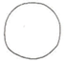 | 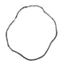 | 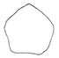
1 | 2 | 3
round | round to angular | angular

Ad. 7: Stem: spots

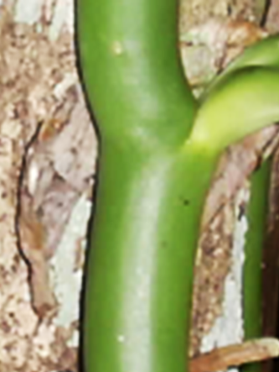 | 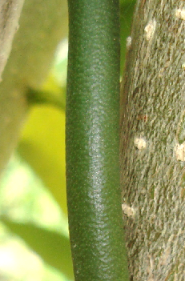
1 | 9
absent | present

Ad. 8: Leaf blade: conspicuousness of main vein

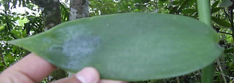 | 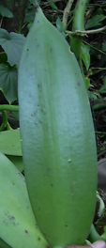 | 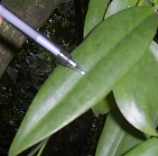
1 | 2 | 3
weakly visible | slightly visible | clearly visible

Ad. 9: Leaf blade: shape of apex

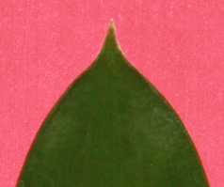 | 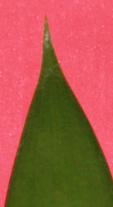 | 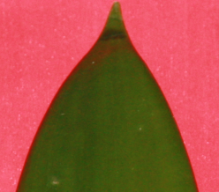
1 | 2 | 3
obtuse | acute | acuminate

Ad. 11: Leaf blade: base

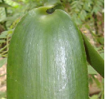 | 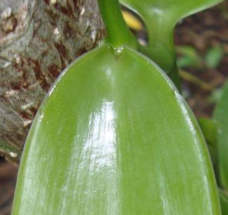
1 | 2
clasping | tapering

Ad. 13: Leaf blade: variegation

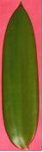 | 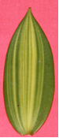
1 | 9
absent | present

Ad. 16: Leaf blade: length/width ratio

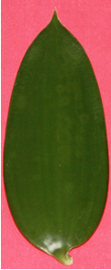 | 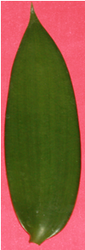 | 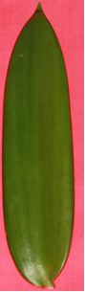
3 | 5 | 7
moderately compressed | medium | moderately elongated

Ad. 19: Leaf blade: transversal section

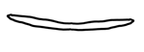 |  | 
1 | 2 | 3
flat or slightly concave | moderately concave | strongly concave

Ad. 20: Leaf blade: shape

 |  | < broadest part >
 |  | (below middle) |  | at middle | (above middle)
< lateral outline > | flat parallel sides |  |  | 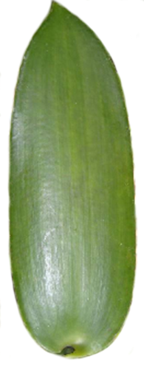  5  oblong
< lateral outline > | rounded | 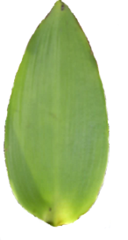  1  narrow ovate | 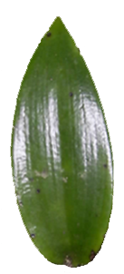  2  medium ovate | 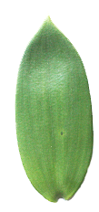  3  elliptic | 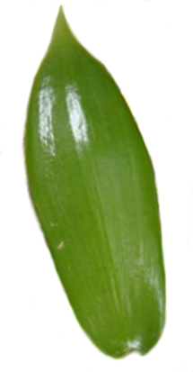  4  obovate

Ad. 22: Flower: rostellum width

SEE COMMENT IN ANNEX

1  narrower than stigma | 2  as broad as stigma | 3  wider than stigma

Ad. 25: Flower: labellum length

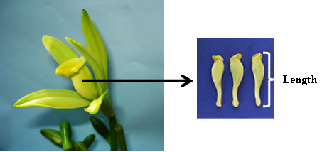

Ad. 26: Flower: length of gynandrium

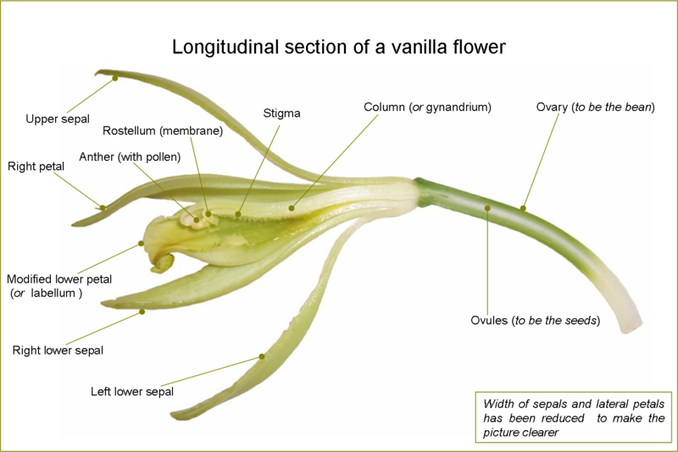

Ad. 30: Fruit: shape

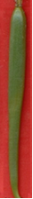 | 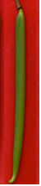 | 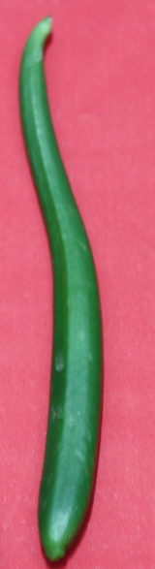
1 | 2 | 3
ovate | oblong | obovate

Ad. 31: Fruit: transversal section shape

 |  | < broadest part >
 |  | (below middle) |  | at middle | (above middle)
< lateral outline > | rounded | 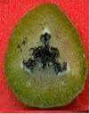  3  medium ovate | 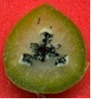  4  broad ovate | 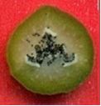1  circular | 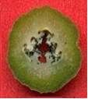2  elliptic
< lateral outline > | angular parts | 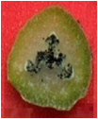5  trullate | 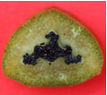  6  triangular

Literature

Bouriquet, G. 1954 : Le Vanillier et la vanille dans le monde. Encyclopédie biologique - XLVI. Editions Paul Lechevalier. Paris. 746 p.

Castillo, M. R. y M. Engleman. 1993: Caracterización de dos tipos de Vainilla planifolia. Acta Bot. Mex. 25: 49-59.

Curti D., E. 1995: Cultivo y beneficiado de la vainilla en México. Folleto Técnico para productores. Organización Nacional de Vainilleros Indigenas. Papantla, Veracruz, México. 96 p.

Lubinsky, P., Cameron, K.M., Molina, M. C., Wong, S. Lepers-Andrzejewski, A.Gómez P. and S.C. Kim. 2008: Neotropical roots of a Polynesian spice: The Hibrid origin of Tahitian vanilla, Vanilla tahitensis (Orchidaceae) Am. J. Bot. 95 (8): 1040-1047

Lubinsky, P., M. Van Dam and A. Van Dam. 2006: Pollination of vanilla and evolution in Orchidaceae. Lindleyana 75:926-929

Lubinsky, P., Bory, S., Hernández, J., Kim, S.C. and A. Gómez P. 2008: Origins and dispersal of cultivated vanilla (Vanilla planifolia Jacks. (Orchidaceae). Econ. Bot. 62(2): 127-138.

Soto A., M. A. 1993: Vainilla odorata, una especie de amplia distribución. Orquidea 13(1-2): 205-300.

Soto. A., M.A. 2006: La Vainilla: Retos y perspectivas de su cultivo. Biodiversitas 66: 2-9.

Technical Questionnaire

TECHNICAL QUESTIONNAIRE |  |  |  | Page {x} of {y} |  | Reference Number:
 |  |  |  |  |  | Application date:
 |  |  |  |  |  | (not to be filled in by the applicant)
TECHNICAL QUESTIONNAIRE
to be completed in connection with an application for plant breeders’ rights

1. Subject of the Technical Questionnaire
1.1 Botanical name |  |  | Vanilla planifolia Jacks.
1.2 Common name |  |  | Vanilla
2. Applicant
Name
Address
Telephone No.
Fax No.
E-mail address
Breeder (if different from applicant)
3. Proposed denomination and breeder’s reference
Proposed denomination
(if available)

Breeder’s reference
#4. Information on the breeding scheme and propagation of the variety

4.1 Breeding scheme

Variety resulting from:

4.1.1 Crossing

(a) controlled cross [ ]
(please state parent varieties)

(…………………..……………..…) x (……………..…………………..…)
female parent male parent

(b) partially known cross [ ]
(please state known parent variety(ies))

(…………………..……………..…) x (……………..…………………..…)
female parent male parent

(c) unknown cross [ ]

4.1.2 Mutation [ ]
(please state parent variety)

4.1.3 Discovery and development [ ]
(please state where and when discovered and how developed)

4.1.4 Other [ ]
(please provide details)

4.2 Method of propagating the variety

4.2.1 Seed-propagated varieties

(a) Self-pollination [ ]
(b) Cross-pollination
(i) population [ ]
(ii) synthetic variety [ ]
(c) Hybrid [ ]
(d) Other [ ]
(please provide details)

4.2.2 Vegetative propagation

(a) cuttings [ ]

(b) in vitro propagation [ ]

(c) grafting [ ]

(d) other (state method) [ ]

5. Characteristics of the variety to be indicated (the number in brackets refers to the corresponding characteristic in Test Guidelines; please mark the note which best corresponds).

 | Characteristics |  |  |  |  |  | Example Varieties |  |  | Note
5.1  (1) | Stem: color
 | light |  |  |  |  |  | Acamaya |  |  | 1[ ]
 | medium |  |  |  |  |  | Oreja de Burro, Princesa, Totonaku |  |  | 2[ ]
 | dark |  |  |  |  |  | Amarela, Espada |  |  | 3[ ]
5.2  (12) | Leaf blade: color
 | yellow white |  |  |  |  |  | Acamaya |  |  | 1[ ]
 | light green |  |  |  |  |  | Oreja de Burro |  |  | 2[ ]
 | medium green |  |  |  |  |  | Totonaku |  |  | 3[ ]
 | dark green |  |  |  |  |  | Amarela |  |  | 4[ ]
5.3  (20) | Leaf blade: shape
 | narrow ovate |  |  |  |  |  | Espada |  |  | 1[ ]
 | medium ovate |  |  |  |  |  |  |  |  | 2[ ]
 | elliptic |  |  |  |  |  | Princesa |  |  | 3[ ]
 | obovate |  |  |  |  |  | Oreja de Burro |  |  | 4[ ]
 | oblong |  |  |  |  |  | Acamaya, Totonaku |  |  | 5[ ]
5.4  (29) | Fruit: color
 | yellow |  |  |  |  |  |  |  |  | 1[ ]
 | greenish yellow |  |  |  |  |  |  |  |  | 2[ ]
 | medium green |  |  |  |  |  | Princesa, Totonaku |  |  | 3[ ]
 | dark green |  |  |  |  |  |  |  |  | 4[ ]
 | Characteristics |  |  |  |  |  | Example Varieties |  |  | Note
5.5  (32) | Fruit: length
 | very short |  |  |  |  |  |  |  |  | 1[ ]
 | very short to short |  |  |  |  |  |  |  |  | 2[ ]
 | short |  |  |  |  |  | Acamaya |  |  | 3[ ]
 | short to medium |  |  |  |  |  |  |  |  | 4[ ]
 | medium |  |  |  |  |  | Totonaku |  |  | 5[ ]
 | medium to long |  |  |  |  |  |  |  |  | 6[ ]
 | long |  |  |  |  |  | Amarela |  |  | 7[ ]
 | long to very long |  |  |  |  |  |  |  |  | 8[ ]
 | very long |  |  |  |  |  |  |  |  | 9[ ]
6. Similar varieties and differences from these varieties

Please use the following table and box for comments to provide information on how your candidate variety differs from the variety (or varieties) which, to the best of your knowledge, is (or are) most similar. This information may help the examination authority to conduct its examination of distinctness in a more efficient way.

Denomination(s) of variety(ies) similar to your candidate variety |  | Characteristic(s) in which your candidate variety differs from the similar variety(ies) |  |  | Describe the expression of the characteristic(s) for the similar variety(ies) |  |  | Describe the expression of the characteristic(s) for your candidate variety
 |  |  |  |  | note 1 |  |  | note 4
Example |  | Fruit: color |  |  | yellow |  |  | dark green
Comments:

#7. Additional information which may help in the examination of the variety

7.1 In addition to the information provided in sections 5 and 6, are there any additional characteristics which may help to distinguish the variety?

Yes [ ] No [ ]

(If yes, please provide details)

7.2 Are there any special conditions for growing the variety or conducting the examination?

Yes [ ] No [ ]

(If yes, please provide details)

7.3 Other information

A representative color image of the variety should accompany the Technical Questionnaire.

8. Authorization for release

(a) Does the variety require prior authorization for release under legislation concerning the protection of the environment, human and animal health?

Yes [ ] No [ ]

(b) Has such authorization been obtained?

Yes [ ] No [ ]

If the answer to (b) is yes, please attach a copy of the authorization.

9. Information on plant material to be examined or submitted for examination.

9.1 The expression of a characteristic or several characteristics of a variety may be affected by factors, such as pests and disease, chemical treatment (e.g. growth retardants or pesticides), effects of tissue culture, different rootstocks, scions taken from different growth phases of a tree, etc.

9.2 The plant material should not have undergone any treatment which would affect the expression of the characteristics of the variety, unless the competent authorities allow or request such treatment. If the plant material has undergone such treatment, full details of the treatment must be given. In this respect, please indicate below, to the best of your knowledge, if the plant material to be examined has been subjected to:

(a) Microorganisms (e.g. virus, bacteria, phytoplasma) Yes [ ] No [ ]

(b) Chemical treatment (e.g. growth retardant, pesticide) Yes [ ] No [ ]

(c) Tissue culture Yes [ ] No [ ]

(d) Other factors Yes [ ] No [ ]

Please provide details for where you have indicated “yes”.

……………………………………………………………

10. I hereby declare that, to the best of my knowledge, the information provided in this form is correct:

Applicant’s name

Signature Date

[Annex follows]
OBSERVATIONS AND COMMENTS ON DOCUMENT TG/VANIL(PROJ.3)

Front page:  Alternative Names: | FRANCE: This wording might be misleading when used for names of the taxa taking into account the particular meaning of “alternative names” according to the International Code of Botanical Nomenclature: “alternative names. Two or more different names based on the same type proposed simultaneously for the same taxon by the same autor”.
2.2 and 2.3 | FRANCE: Proposes to have cuttings instead of plants. MEXICO would like to keep the plants instead of cuttings.
3.1.1 | FRANCE: The 2 growing cycles requested for examination could be performed on the same plant (looped vine) during two different years (= growing cycle), and thus not really independent.  FRANCE: Are they really independent growing cycles (comment of TWC as reported in the document TWO/35/7-TWF/33/15  15. Conclusions: The TWC agreed the following modifications in the text of document TGP/9.6 (additional text underlined and deleted text strikethrough) Paragraph 4 to read as follows: “4. For some crops, such as fruit trees, the same plants are examined over successive years. In this case, the condition of independence of growing cycles is not also satisfied. But, as it would be impossible in practice to plant successive trials, this is accepted”)
Char. 22 | To add (+)  MX: We don´t have variation on this characteristic. It is proposed to delete the characteristic.)
Char. 23 | MX: We don’t have other colors in our varieties. There is no variation in Vanilla planifolia . It is proposed to delete the characteristic.
New Char. 24  Proposed by France | MX: We don’t have other colors in our varieties. There is no variation in Vanilla planifolia.
Char. 25 | MX: We don´t have example varieties for the other states. To delete (*)
Char. 29 | MX: We don´t have example varieties for the other states. To delete (*)
29.  (c) | FRANCE: Fruits at physiological maturity are yellowish to dark brown. This scale seems appropriate for immature fruits only (6-8 months). Distinct stage for examination for Char.29 should be specified in section 8.  MEXICO: In Mexico fruits of 7 to 8 months are considered at physiological maturity and they can be picked, they are not in an immature state. So the description in (c) is the correct.
8.1 (a) | FRANCE: The observations on stem should be taken at mid-length of actively growing stem.  MEXICO: To keep as it is “The observations on stem should be taken at mid-length of the stem.”

[End of document]

* These names were correct at the time of the introduction of these Test Guidelines but may be revised or updated. [Readers are advised to consult the UPOV Code, which can be found on the UPOV Website (www.upov.int), for the latest information.]
# Authorities may allow certain of this information to be provided in a confidential section of the Technical Questionnaire.
# Authorities may allow certain of this information to be provided in a confidential section of the Technical Questionnaire.

