 |  |  |  |  |  |  | E  TG/PGRAN(proj.3)  ORIGINAL: English  DATE: 2012-06-19
INTERNATIONAL UNION FOR THE PROTECTION OF NEW VARIETIES OF PLANTS
Geneva
 |  |  | DRAFT
 |  | POMEGRANATE  UPOV Code: PUNIC_GRA  Punica granatum L. |  |  | *

GUIDELINES

FOR THE CONDUCT OF TESTS

FOR DISTINCTNESS, UNIFORMITY AND STABILITY

prepared by an expert from Spain

to be considered by the
Technical Working Party for Fruit Crops at its forty-third session,
to be held in Beijing, from July 30 to August 3, 2012

Alternative Names:*

Botanical name |  | English |  | French |  | German |  | Spanish
Punica granatum L. | Pomegranate |  | Grenadier |  | Granatapfelbaum;  Granatapfelstrauch;  Granatbaum |  | Granado

The purpose of these guidelines (“Test Guidelines”) is to elaborate the principles contained in the General Introduction (document TG/1/3), and its associated TGP documents, into detailed practical guidance for the harmonized examination of distinctness, uniformity and stability (DUS) and, in particular, to identify appropriate characteristics for the examination of DUS and production of harmonized variety descriptions.

ASSOCIATED DOCUMENTS
These Test Guidelines should be read in conjunction with the General Introduction and its associated TGP documents.
TABLE OF CONTENTS PAGE

1. Subject of these Test Guidelines 3
2. Material Required 3
3. Method of Examination 3
3.1 Number of Growing Cycles 3
3.2 Testing Place 3
3.3 Conditions for Conducting the Examination 3
3.4 Test Design 3
3.5 Additional Tests 4
4. Assessment of Distinctness, Uniformity and Stability 4
4.1 Distinctness 4
4.2 Uniformity 5
4.3 Stability 5
5. Grouping of Varieties and Organization of the Growing Trial 5
6. Introduction to the Table of Characteristics 5
6.1 Categories of Characteristics 5
6.2 States of Expression and Corresponding Notes 6
6.3 Types of Expression 6
6.4 Example Varieties 6
6.5 Legend 7
7. Table of Characteristics/Tableau des caractères/Merkmalstabelle/Tabla de caracteres 8
8. Explanations on the Table of Characteristics 17
8.1 Explanations covering several characteristics 17
8.2 Explanations for individual characteristics 17
9. Literature 24
10. Technical Questionnaire 25

Subject of these Test Guidelines

These Test Guidelines apply to all varieties of Punica granatum L.

Material Required

2.1 The competent authorities decide on the quantity and quality of the plant material required for testing the variety and when and where it is to be delivered. Applicants submitting material from a State other than that in which the testing takes place must ensure that all customs formalities and phytosanitary requirements are complied with.

2.2 The material is to be supplied in the form of one-year-old rooted cuttings.

2.3 The minimum quantity of plant material, to be supplied by the applicant, should be:

5 one-year-old rooted cuttings.

2.4 The plant material supplied should be visibly healthy, not lacking in vigor, nor affected by any important pest or disease.

2.5 The plant material should not have undergone any treatment which would affect the expression of the characteristics of the variety, unless the competent authorities allow or request such treatment. If it has been treated, full details of the treatment must be given.

Method of Examination

3.1 Number of Growing Cycles

    - The minimum duration of tests should normally be two independent growing cycles.

3.1.2 In particular, it is essential that the trees produce a satisfactory crop of fruit in each of the two growing cycles.

3.1.3 The growing cycle is considered to be the duration of a single growing season, beginning with bud burst (flowering and/or vegetative), flowering and fruit harvest and concluding when the following dormant period ends with the swelling of new season buds.

3.2 Testing Place

Tests are normally conducted at one place. In the case of tests conducted at more than one place, guidance is provided in TGP/9 “Examining Distinctness”.

3.3 Conditions for Conducting the Examination

3.3.1 The tests should be carried out under conditions ensuring satisfactory growth for the expression of the relevant characteristics of the variety and for the conduct of the examination. Trees should only be pruned in the year of planting to ensure good branch formation.

3.3.2 The optimum stage of development for the assessment of each characteristic is indicated by a number in the second column of the Table of Characteristics. The stages of development denoted by each number are described in Chapter 8.

3.4 Test Design

3.4.1 Each test should be designed to result in a total of at least 5 plants.

3.4.2 The design of the tests should be such that plants or parts of plants may be removed for measurement or counting without prejudice to the observations which must be made up to the end of the growing cycle.

3.5 Additional Tests

Additional tests, for examining relevant characteristics, may be established.

Assessment of Distinctness, Uniformity and Stability

4.1 Distinctness

4.1.1 General Recommendations

It is of particular importance for users of these Test Guidelines to consult the General Introduction prior to making decisions regarding distinctness. However, the following points are provided for elaboration or emphasis in these Test Guidelines.

4.1.2 Consistent Differences

The differences observed between varieties may be so clear that more than one growing cycle is not necessary. In addition, in some circumstances, the influence of the environment is not such that more than a single growing cycle is required to provide assurance that the differences observed between varieties are sufficiently consistent. One means of ensuring that a difference in a characteristic, observed in a growing trial, is sufficiently consistent is to examine the characteristic in at least two independent growing cycles.

4.1.3 Clear Differences

Determining whether a difference between two varieties is clear depends on many factors, and should consider, in particular, the type of expression of the characteristic being examined, i.e. whether it is expressed in a qualitative, quantitative, or pseudo-qualitative manner. Therefore, it is important that users of these Test Guidelines are familiar with the recommendations contained in the General Introduction prior to making decisions regarding distinctness.

4.1.4 Number of Plants / Parts of Plants to be Examined

Unless otherwise indicated, for the purposes of distinctness, all observations on single plants should be made on 5 plants or parts taken from each of 5 plants and any other observations made on all plants in the test, disregarding any off-type plants. In the case of observations of parts taken from single plants, the number of parts to be taken from each of the plants should be 2.

4.1.5 Method of Observation

The recommended method of observing the characteristic for the purposes of distinctness is indicated by the following key in the second column of the Table of Characteristics (see document TGP/9 “Examining Distinctness”, Section 4 “Observation of characteristics”):

MG: single measurement of a group of plants or parts of plants
MS: measurement of a number of individual plants or parts of plants
VG: visual assessment by a single observation of a group of plants or parts of plants
VS: visual assessment by observation of individual plants or parts of plants

Type of observation: visual (V) or measurement (M)

“Visual” observation (V) is an observation made on the basis of the expert’s judgment. For the purposes of this document, “visual” observation refers to the sensory observations of the experts and, therefore, also includes smell, taste and touch. Visual observation includes observations where the expert uses reference points (e.g. diagrams, example varieties, side-by-side comparison) or non-linear charts (e.g. color charts). Measurement (M) is an objective observation against a calibrated, linear scale e.g. using a ruler, weighing scales, colorimeter, dates, counts, etc.

Type of record: for a group of plants (G) or for single, individual plants (S)

For the purposes of distinctness, observations may be recorded as a single record for a group of plants or parts of plants (G), or may be recorded as records for a number of single, individual plants or parts of plants (S). In most cases, “G” provides a single record per variety and it is not possible or necessary to apply statistical methods in a plant-by-plant analysis for the assessment of distinctness.

In cases where more than one method of observing the characteristic is indicated in the Table of Characteristics (e.g. VG/MG), guidance on selecting an appropriate method is provided in document TGP/9, Section 4.2.

4.2 Uniformity

4.2.1 It is of particular importance for users of these Test Guidelines to consult the General Introduction prior to making decisions regarding uniformity. However, the following points are provided for elaboration or emphasis in these Test Guidelines:

4.2.2 For the assessment of uniformity, a population standard of 1% and an acceptance probability of at least 95% should be applied. In the case of a sample size of 5 plants, no off-types are allowed.

4.3 Stability

4.3.1 In practice, it is not usual to perform tests of stability that produce results as certain as those of the testing of distinctness and uniformity. However, experience has demonstrated that, for many types of variety, when a variety has been shown to be uniform, it can also be considered to be stable.

4.3.2 Where appropriate, or in cases of doubt, stability may be further examined by testing a new plant stock to ensure that it exhibits the same characteristics as those shown by the initial material supplied.

Grouping of Varieties and Organization of the Growing Trial

5.1 The selection of varieties of common knowledge to be grown in the trial with the candidate varieties and the way in which these varieties are divided into groups to facilitate the assessment of distinctness are aided by the use of grouping characteristics.

5.2 Grouping characteristics are those in which the documented states of expression, even where produced at different locations, can be used, either individually or in combination with other such characteristics: (a) to select varieties of common knowledge that can be excluded from the growing trial used for examination of distinctness; and (b) to organize the growing trial so that similar varieties are grouped together.

5.3 The following have been agreed as useful grouping characteristics:

- Calyx: color change (characteristic 17)
(b) Fruit: width (characteristic 24)
(c) Fruit: over color (characteristic 28)
(d) Aril: main color (characteristic 36)
(e) Seed: hardness (characteristic 39)
(f) Time of maturity for consumption (characteristic 41)

5.4 Guidance for the use of grouping characteristics, in the process of examining distinctness, is provided through the General Introduction and document TGP/9 “Examining Distinctness”.

Introduction to the Table of Characteristics

6.1 Categories of Characteristics

6.1.1 Standard Test Guidelines Characteristics

Standard Test Guidelines characteristics are those which are approved by UPOV for examination of DUS and from which members of the Union can select those suitable for their particular circumstances.

6.1.2 Asterisked Characteristics

Asterisked characteristics (denoted by *) are those included in the Test Guidelines which are important for the international harmonization of variety descriptions and should always be examined for DUS and included in the variety description by all members of the Union, except when the state of expression of a preceding characteristic or regional environmental conditions render this inappropriate.

6.2 States of Expression and Corresponding Notes

6.2.1 States of expression are given for each characteristic to define the characteristic and to harmonize descriptions. Each state of expression is allocated a corresponding numerical note for ease of recording of data and for the production and exchange of the description.

6.2.2 In the case of qualitative and pseudo-qualitative characteristics (see Chapter 6.3), all relevant states of expression are presented in the characteristic. However, in the case of quantitative characteristics with 5 or more states, an abbreviated scale may be used to minimize the size of the Table of Characteristics. For example, in the case of a quantitative characteristic with 9 states, the presentation of states of expression in the Test Guidelines may be abbreviated as follows:

State | Note
small | 3
medium | 5
large | 7

However, it should be noted that all of the following 9 states of expression exist to describe varieties and should be used as appropriate:

State | Note
very small | 1
very small to small | 2
small | 3
small to medium | 4
medium | 5
medium to large | 6
large | 7
large to very large | 8
very large | 9

6.2.3 Further explanation of the presentation of states of expression and notes is provided in document TGP/7 “Development of Test Guidelines”.

6.3 Types of Expression

An explanation of the types of expression of characteristics (qualitative, quantitative and pseudo-qualitative) is provided in the General Introduction.

6.4 Example Varieties

Where appropriate, example varieties are provided to clarify the states of expression of each characteristic.

6.5 Legend

(*) Asterisked characteristic – see Chapter 6.1.2

QL Qualitative characteristic – see Chapter 6.3
QN Quantitative characteristic – see Chapter 6.3
PQ Pseudo-qualitative characteristic – see Chapter 6.3

MG, MS, VG, VS – see Chapter 4.1.5

(a)-{g} See Explanations on the Table of Characteristics in Chapter 8.1

(+) See Explanations on the Table of Characteristics in Chapter 8.2.

Table of Characteristics/Tableau des caractères/Merkmalstabelle/Tabla de caracteres

 |  | English | français | deutsch | español | Example Varieties  Exemples  Beispielssorten  Variedades ejemplo | Note/  Nota
1.  (*)  (+) | VG | Plant: vigor |  |  | Planta: vigor
QN | (a) | weak |  |  | débil |  | 3
 |  | medium |  |  | medio |  | 5
 |  | strong |  |  | fuerte |  | 7
2.  (+) | VG | Plant: growth habit |  |  | Planta: hábito de crecimiento
PQ | (a) | upright |  |  | erecto |  | 1
 |  | spreading |  |  | abierto |  | 3
 |  | weeping |  |  | llorón |  | 5
3. | VG | Plant: intensity of grey color of main branches |  |  | Planta: intensidad de color gris de las ramas principales
QN | (a) | light |  |  | claro |  | 1
 |  | medium |  |  | medio |  | 2
 |  | dark |  |  | oscuro |  | 3
4. | VG | One-year-old shoot: color on sunny side |  |  | Rama de un año: color de la parte expuesta al sol
PQ | (b) | green |  |  | verde |  | 1
 |  | green with pink stripes |  |  | verde con estrías rosadas |  | 2
 |  | pink |  |  | rosa |  | 3
 |  | pink purple |  |  | rosa-púrpura |  | 4
 |  | purple |  |  | púrpura |  | 5
5.  (+) | VG | One-year-old shoot: number of shoots ending in thorns |  |  | Rama de un año: número de ramillas terminadas en espina
QN | (b) | none |  |  | ninguna |  | 1
 |  | few |  |  | pocas |  | 2
 |  | medium |  |  | medias |  | 3
 |  | many |  |  | muchas |  | 4
6. | VG | Young shoot: predominant number of leaves per node |  |  | Rama joven: número predominante de hojas por nudo
QN | (b) | two |  |  | dos | Mollar de Elche | 1
 |  | three |  |  | tres |  | 2
 |  | more than three |  |  | más de tres | Porfianca | 3
7. | VG/MS | Leaf blade: length |  |  | Limbo hoja: longitud
QN | (c) | short |  |  | corto | Mollar de Elche, Porfianca | 3
 |  | medium |  |  | medio | Valenciano | 5
 |  | long |  |  | largo | Borde, Wonderful | 7
8. | VG/MS | Leaf blade: width |  |  | Limbo hoja: anchura
QN | (c) | narrow |  |  | estrecho | Wonderful | 3
 |  | medium |  |  | medio |  | 5
 |  | broad |  |  | ancho | Borde, Mollar de Elche | 7
9.  (+) | VG/MS | Leaf blade: ratio length/width |  |  | Limbo: relación longitud/anchura
QN | (c) | moderately elongated |  |  | moderadamente alargado | Wonderful | 3
 |  | medium |  |  | media | Tendral | 5
 |  | moderately compressed |  |  | moderadamente comprimido | Borde | 7
 |  | very compresed |  |  | muy comprimido | Mollar de Albatera | 9
10.  (+) | VG | Leaf blade: shape of apex excluding tip |  |  | Limbo: forma del ápice excluyendo la punta
PQ | (c) | strongly acute |  |  | fuertemente agudo |  | 1
 |  | moderately acute |  |  | moderadamente agudo | Wonderful | 2
 |  | right angle |  |  | ángulo recto | Tendral, Acco | 3
 |  | moderately obtuse |  |  | moderadamente obtuso | Mollar de Elche | 4
 |  | strongly obtuse |  |  | fuertemente obtuso |  | 5
11. | VG | Leaf blade: intensity of green color |  |  | Limbo: intensidad del color verde
QN | (c) | light |  |  | claro |  | 3
 |  | medium |  |  | medio |  | 5
 |  | dark |  |  | oscuro |  | 7
12.  (*) | VG/MS | Petiole: length |  |  | Peciolo: longitud
QN | (c) | short |  |  | corto | Borde | 3
 |  | medium |  |  | medio | Wonderful | 5
 |  | long |  |  | largo | Tendral | 7
13.  (*) | VG | Petiole: anthocyanin coloration |  |  | Peciolo: coloración antociánica
QN | (c) | weak |  |  | ligera | Acco | 1
 |  | medium |  |  | media | Mollar de Elche | 3
 |  | strong |  |  | alta | Borde, Tendral | 5
14.  (+) | VG/MS | Calyx : length |  |  | Cáliz: longitud | .
QN | (d) | short |  |  | corto | Malisi | 3
 |  | medium |  |  | medio | Hicaz Nar | 5
 |  | long |  |  | largo |  | 7
15.  (*)  (+) | VG/MS | Calyx : width |  |  | Cáliz: anchura
QN | (d) | narrow |  |  | estrecho | Malisi | 3
 |  | medium |  |  | medio | Mollar de Elche, Porfianca, Valenciana | 5
 |  | broad |  |  | ancho | Wonderful | 7
16. | VG/MS | Calyx: ratio length/width |  |  | Cáliz: relación longitud/anchura
QN | (e) | moderately elongated |  |  | moderadamente alargado | Bhagwa | 3
 |  | medium |  |  | media | Black | 5
 |  | moderately compressed |  |  | moderadamente comprimido | Wonderful | 7
17.  (+) | VG | Calyx : color |  |  | Cáliz: color
PQ | (d) | orange |  |  | naranja | Mollar de Elche, Valenciana | 1
 |  | orange-red |  |  | naranja rojizo | Wonderful | 2
 |  | pink |  |  | rosa |  | 3
 |  | medium red |  |  | rojo medio |  | 4
 |  | dark red |  |  | rojo oscuro |  | 5
 |  | purple |  |  | púrpura |  | 6
18.  (+)  (*) | VG | Corolla: color |  |  | Corola: color
PQ | (d) | white |  |  | blanco |  | 1
 |  | yellow |  |  | amarillo |  | 2
 |  | pinkish white |  |  | blanco rosado |  | 3
 |  | pink |  |  | rosa |  | 4
 |  | light orange |  |  | naranja claro | Borde | 5
 |  | medium orange |  |  | naranja medio | Mollar de Elche,  Wonderful | 6
 |  | orange-red |  |  | naranja rojizo |  | 7
 |  | medium red |  |  | rojo |  | 8
19.  (*)  (+) | VG/MS | Petal: length |  |  | Pétalo: longitud
QN | (d) | short |  |  | corto | Mollar de Elche, Valenciana | 3
 |  | medium |  |  | medio | Hicaz Nar | 5
 |  | long |  |  | largo |  | 7
20.  (+) | VG/MS | Petal: width |  |  | Pétalo: anchura
QN | (d) | narrow |  |  | estrecho | Black, Hicaz Nar | 3
 |  | medium |  |  | medio | Rosh Hapered, Tendral | 5
 |  | broad |  |  | ancho |  | 7
21. | VG | Petal: structure of surface |  |  | Pétalo:estructura de la superficie
QN | (d) | even |  |  | liso |  | 1
 |  | medium |  |  | medio |  | 3
 |  | wrinkled |  |  | arrugado |  | 5
22. | VG | One-year-old shoot: predominant number of flowers per node |  |  | Brotes de un año: número predominante de flores por nudo
QN | (b) | predominantly one |  |  | predomiantemente 1 |  | 1
 |  | predominantly two |  |  | predomiantemente 2 |  | 2
 |  | predominantly three |  |  | predomiantemente 3 |  | 3
 |  | more than three |  |  | más de 3 |  | 4
23.  (*)  (+) | VG/MS | Fruit: length |  |  | Fruto: longitud
QN | (e) | short |  |  | corto |  | 3
 |  | medium |  |  | medio | Borde | 5
 |  | long |  |  | largo | Wonderful | 7
24.  (*)  (+) | VG/MS | Fruit: width |  |  | Fruto: anchura
QN | (e) | narrow |  |  | estrecho |  | 1
 |  | medium |  |  | medio | Borde | 3
 |  | broad |  |  | ancho | Mollar de Elche, Wonderful | 5
25. | VG/MS | Fruit: ratio length/width |  |  | Fruto: relación longitud/altura
QN | (e) | moderately elongated |  |  | moderadamente alargado | Rosh Hapered | 3
 |  | medium |  |  | media | Wonderful | 5
 |  | moderately compressed |  |  | moderadamente comprimido | Valenciana | 7
26.  (*)  (+) | VG | Fruit: shape in cross section |  |  | Fruto: forma en sección transversal
QN | (e) | circular |  |  | circular | Borde, Wonderful | 1
 |  | circular to angular |  |  | circualar a angular | Malisi | 2
 |  | angular |  |  | angular | Bhagwa, Valenciano | 3
27.  (*)  (+) | VG/MS | Fruit: length of crown |  |  | Fruto: longitud de la corona
QN | (e) | short |  |  | corto |  | 3
 |  | medium |  |  | medio | Mollar de Elche | 5
 |  | long |  |  | largo | Wonderful | 7
28.  (*)  (+) | VG | Fruit: over color |  |  | Fruto: color de la chapa
PQ | (f) | orange |  |  | naranja | Mollar de Albatera, Mollar de Elche | 1
 |  | orange red |  |  | naranja rojo |  | 2
 |  | pink |  |  | rosa |  | 3
 |  | pink red |  |  | rosa rojo | Valenciano | 4
 |  | medium red |  |  | rojo medio | Acco | 5
 |  | red purple |  |  | rojo púrpura |  | 6
 |  | purple |  |  | púrpura | Kamel | 7
 |  | dark purple |  |  | púrpura oscuro |  | 8
29. | VG | Fruit: extent of over color |  |  | Fruto: extensión de la chapa
QN | (f) | very small |  |  | muy pequeño |  | 1
 |  | small |  |  | pequeño | Wonderful | 3
 |  | medium |  |  | medio | Tendral, Valenciano | 5
 |  | large |  |  | grande |  | 7
 |  | very large |  |  | muy grande | Acco, Bhagwa, Black | 9
30. | VG/MS | Fruit: thickness of skin |  |  | Fruto: espesor de la corteza
QN | (f) | thin |  |  | delgada | Acco, Valenciano, Wonderful | 3
 |  | medium |  |  | media |  | 5
 |  | thick |  |  | gruesa | Kamel | 7
31.  (*)  (+) | VG/MS | Fruit: sweetness |  |  | Fruto: contenido en sólidos solubles totales
QN | (e) | low |  |  | bajo |  | 3
 |  | medium |  |  | medio | Rosh Hapered, Valenciano | 5
 |  | high |  |  | alto |  | 7
32.  (+) | VG/MS | Fruit: acidity |  |  | Fruto: acidez
QN | (e) | low |  |  | bajo | Mollar de Elche, Valenciano | 3
 |  | medium |  |  | medio | Acco, Wonderful | 5
 |  | high |  |  | alto |  | 7
33.  (*)  (+) | VG/MS | Fruit: juiciness |  |  | Fruto: contenido en jugo
QN | (e) | low |  |  | bajo | Wonderful | 3
 |  | medium |  |  | medio | Mollar de Elche | 5
 |  | high |  |  | alto | Valenciano | 7
34.  (+) | VG/MS | Aril: length |  |  | Arilo: longitud
QN | (g) | short |  |  | corta |  | 1
 |  | medium |  |  | media | Acco | 2
 |  | long |  |  | larga | Mollar de Elche | 3
35.  (+) | VG/MS | Aril: width |  |  | Arilo: anchura
QN | (g) | narrow |  |  | estrecha |  | 1
 |  | medium |  |  | media | Acco, Wonderful | 2
 |  | broad |  |  | ancha | Piñón tierno de Ojós | 3
36.  (*)  (+) | VG | Aril: main color |  |  | Arilo: color principal
PQ | (g) | white |  |  | blanco | Mollar de Elche | 1
 |  | light pink |  |  | rosa claro | Valenciano | 2
 |  | medium pink |  |  | rosa medio | Tendral | 3
 |  | dark pink |  |  | rosa oscuro |  | 4
 |  | light red |  |  | rojo claro |  | 5
 |  | medium red |  |  | rojo medio |  | 6
 |  | dark red |  |  | rojo oscuro | Wonderful | 7
37.  (+) | VG/MS | Seed: length |  |  | Semilla: longitud
QN | (g) | short |  |  | corta | Valenciano | 1
 |  | medium |  |  | media | Mollar de Elche | 2
 |  | long |  |  | larga |  | 3
38.  (+) | VG/MS | Seed: width |  |  | Semilla: anchura
QN | (g) | narrow |  |  | estrecha |  | 1
 |  | medium |  |  | media | Mollar de Elche, Wonderful | 2
 |  | broad |  |  | ancha |  | 3
39.  (*)  (+) | VG | Seed: hardness |  |  | Semilla: dureza
QN | (g) | soft |  |  | blando | Mollar de Elche, Valenciano | 1
 |  | medium |  |  | media | Wonderful | 2
 |  | hard |  |  | duro | Borde | 3
40.  (*)  (+) | VG | Time of beginning of flowering |  |  | Época de cominezo de la floración
QN |  | early |  |  | temprana |  | 3
 |  | medium |  |  | media |  | 5
 |  | late |  |  | tardía |  | 7
41.  (*)  (+) | VG | Time of maturity for consumption |  |  | Época de maduración para el consumo
QN |  | early |  |  | temprana | Valenciano | 3
 |  | medium |  |  | media | Mollar de Elche, Wonderful | 5
 |  | late |  |  | tardía |  | 7
42.  (*) | VG | Plant: seasonal type |  |  | Planta: tipo estacional
QL |  | deciduous |  |  | caduca |  | 1
 |  | evergreen |  |  | perenne |  | 2

Explanations on the Table of Characteristics

8.1 Explanations covering several characteristics

Characteristics containing the following key in the second column of the Table of Characteristics should be examined as indicated below:

- All observations on the tree should be made in winter, when there are no leaves on the tree.

- All observations on the one-year shoot should be made in winter.

- All observations on the leaf should be made on mature leaves on the middle third of the branch from current season’s shoots and on nodes with low number of leaves.

- All observations on the flower should be made on the hermaphrodite flowers at the time of full flowering and on fully opened flowers.

- All observations on the fruit should be made on 10 fruits selected from a 20 fruits sample, at full maturity for consumption.

- All observations on the peel should be made on the equatorial zone of the fruit.

- All observations on the seed should be made on fresh seeds.

8.2 Explanations for individual characteristics

Ad. 1: Plant: vigor
The vigor of the plant should be considered as the overall abundance of vegetative growth at the top of the plants.

Ad. 2: Plant: growth habit

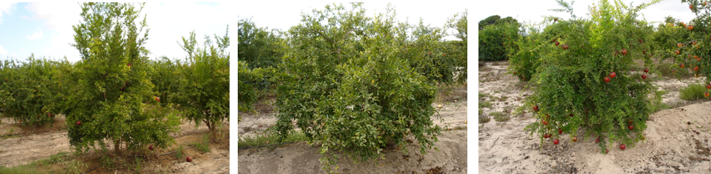

3 | 5 | 7
upright | spreading | weeping

Ad. 5: One-year-old shoot: number of shoots ending in thorns
Quantity of one-year-old shoots are ended with a thorn, it means that whether most of branches are ended with a thorn or not.

Ad. 9: Leaf blade: ratio length/width






3 | 5 | 7 | 9
moderately elongated | medium | moderately compressed | very compressed

Ad. 10: Leaf blade: shape of apex excluding tip
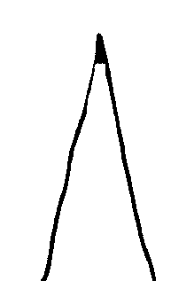
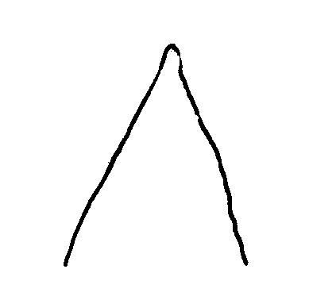

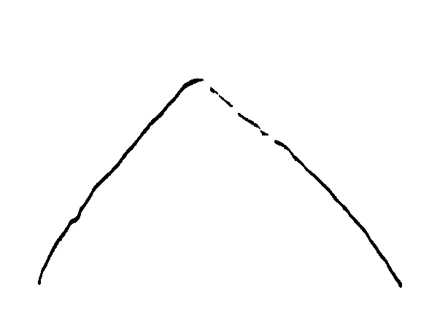
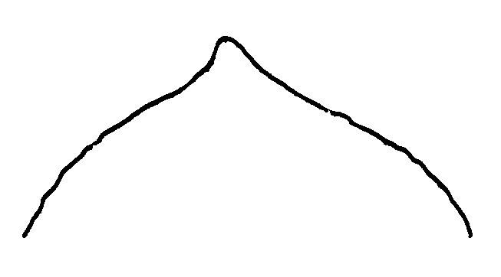
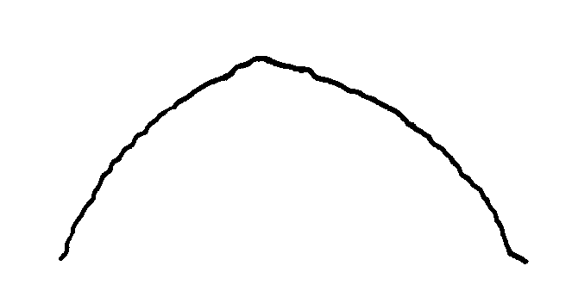

1 | 2 | 3 | 4 | 5
strongly acute | moderately acute | right angle | moderately obtuse | strongly obtuse

Ad. 14: Calyx: length
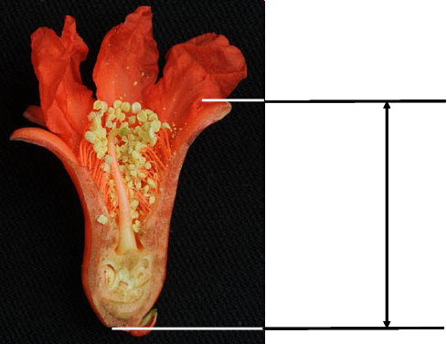

Ad. 15: Calyx: width
Calyx width must be observed approximately in the middle of calyx length.
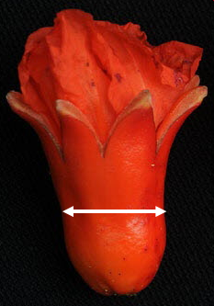

Ad. 17: Calyx: color
Identify the color of the calyx when the sepals are closed.

Ad. 18: Corolla: color
Identify the color of the corolla when the flower is fully open.

Ad. 19: Petal: length
Length of petal must be observed from the union to the calyx.
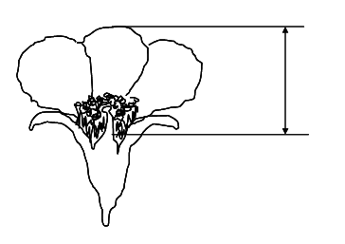

Ad. 20: Petal: width
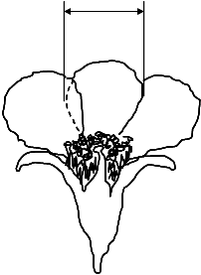

Ad. 23: Fruit: length

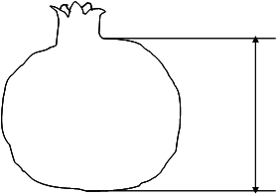

Ad. 24: Fruit: width

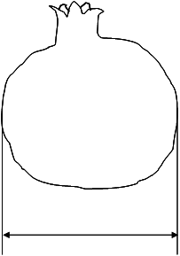
Ad. 26: Fruit: shape in cross section

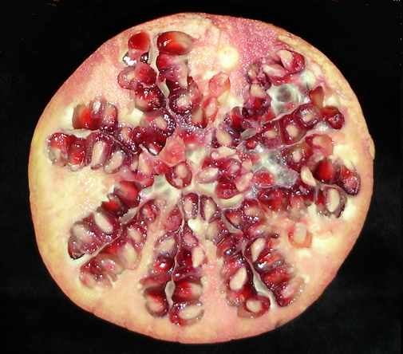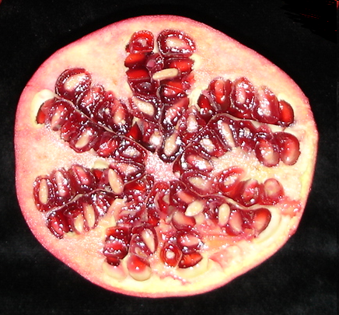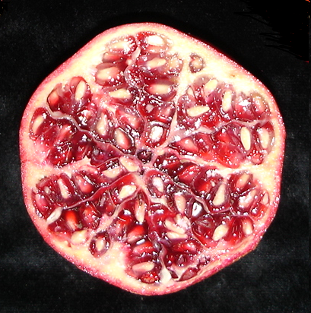
1 | 2 | 3
circular | circular to angular | angular

Ad. 27: Fruit: length of crown

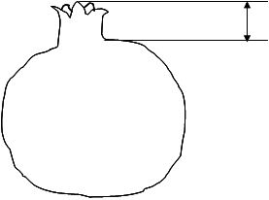

Ad. 28: Fruit: over color
The color of the fruit different from yellow or yellow cream which it is called the ground color.

Ad. 31: Fruit: sweetness
Calculation of total soluble solids measured using a refractometer. The measured unit is the degree Brix (º Brix). One degree Brix corresponds to 1 gram of sucrose in 100 grams of solution.

Ad. 32: Fruit: acidity

Calculation of total titratable acidity of a juice sample. The equation is the following:

Ac (g/l) = ( V₁ * N * me) / V
V = sample volume in ml
V₁ = NaOH volume in ml
N = normality of NaOH
me = equivalent weight of malic acid (67)

Ad. 33: Fruit: juiciness

Juice content expressed as percentage of total fruit weight obtained by squeezing the fruit.

Ad. 34: Aril: length

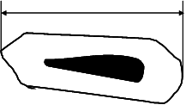

Ad. 35: Aril: width

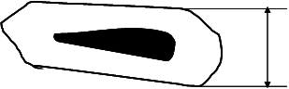

Ad. 36: Aril: main color
The color predominant in the aril surface.

Ad. 37: Seed: length
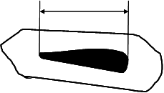

Ad. 38: Seed: width

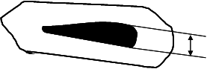

Ad. 39: Seed: hardness

Hardness of tegmen assesed by chewing the arils.

Soft means easy to chew.

Hard means difficult to chew.

Ad. 40: Time of beginning of flowering

When the first flowers are fully open.

Ad. 41: Time of maturity for consumption

When most of the fruits are fully colored.

Literature

Holland, D., Hatib, K., Bar-Ya’akov, I., 2009: Pomegranate: Botany, Horticulture, Breeding. In: Horticultural Reviews. Volume 35. Ed. Janick, J. John Wiley and Sons, Inc. Hoboken. New Jersey, US, pp. 127-191.

Melgarejo, P., Salazar, D., 2003: Tratado de fruticultura para zonas áridasy semiáridas. Volumen II. Algarrobo, grandado y jinjolero. AMV. Ediciones Mundiprensa.

Morton, J., 1987: Pomegranate. In: Fruits of warm climates. Ed. Morton, J. Miami FL. pp. 352-355.

Özgüven, A., 2006: Proceedings of the 1st International Symposyum on Pomegranate and minor Mediterranean Fruits. Acta Horticulturae 818. Adana, TR.

Technical Questionnaire

TECHNICAL QUESTIONNAIRE |  |  |  | Page {x} of {y} |  | Reference Number:
 |  |  |  |  |  | Application date:
 |  |  |  |  |  | (not to be filled in by the applicant)
TECHNICAL QUESTIONNAIRE
to be completed in connection with an application for plant breeders’ rights

1. Subject of the Technical Questionnaire
1.1 Botanical name |  |  | Punica granatum L.
1.2 Common name |  |  | Pomegranate
2. Applicant
Name
Address
Telephone No.
Fax No.
E-mail address
Breeder (if different from applicant)
3. Proposed denomination and breeder’s reference
Proposed denomination
(if available)

Breeder’s reference
#4. Information on the breeding scheme and propagation of the variety

4.1 Breeding scheme

Variety resulting from:

4.1.1 Crossing

(a) controlled cross [ ]
(please state parent varieties)

(…………………..……………..…) x (……………..…………………..…)
female parent male parent

“(b) partially known cross [ ]
(please state known parent variety(ies))

(…………………..……………..…) x (……………..…………………..…)
female parent male parent

(c) unknown cross [ ]

4.1.2 Mutation [ ]
(please state parent variety)

4.1.3 Discovery and development [ ]
(please state where and when discovered and how developed)

4.1.4 Other [ ]
(please provide details)”

4.2 Method of propagating the variety

4.2.1 Vegetative propagation

(a) cuttings [ ]

(b) in vitro propagation [ ]

(c) other (state method) [ ]

4.2.2 Seed [ ]

4.2.3 Other [ ]”
(please provide details)”

5. Characteristics of the variety to be indicated (the number in brackets refers to the corresponding characteristic in Test Guidelines; please mark the note which best corresponds).

 | Characteristics |  |  |  |  |  | Example Varieties |  |  | Note
5.1  (1) | Plant: vigor
 | very weak |  |  |  |  |  |  |  |  | 1[ ]
 | very weak to weak |  |  |  |  |  |  |  |  | 2[ ]
 | weak |  |  |  |  |  |  |  |  | 3[ ]
 | weak to medium |  |  |  |  |  |  |  |  | 4[ ]
 | medium |  |  |  |  |  |  |  |  | 5[ ]
 | medium to strong |  |  |  |  |  |  |  |  | 6[ ]
 | strong |  |  |  |  |  |  |  |  | 7[ ]
 | strong to very strong |  |  |  |  |  |  |  |  | 8[ ]
 | very strong |  |  |  |  |  |  |  |  | 9[ ]
5.2  (13) | Petiole: anthocyanin coloration
 | very weak |  |  |  |  |  |  |  |  | 1[ ]
 | very weak to weak |  |  |  |  |  |  |  |  | 2[ ]
 | weak |  |  |  |  |  | Acco |  |  | 3[ ]
 | weak to medium |  |  |  |  |  |  |  |  | 4[ ]
 | medium |  |  |  |  |  | Mollar de Elche |  |  | 5[ ]
 | medium to strong |  |  |  |  |  |  |  |  | 6[ ]
 | strong |  |  |  |  |  |  |  |  | 7[ ]
 | strong to very strong |  |  |  |  |  | Borde, Tendral |  |  | 8[ ]
 | very strong |  |  |  |  |  |  |  |  | 9[ ]
 | Characteristics |  |  |  |  |  | Example Varieties |  |  | Note
5.3  (18) | Corolla: color
 | white |  |  |  |  |  |  |  |  | 1[ ]
 | yellow |  |  |  |  |  |  |  |  | 2[ ]
 | pinkish white |  |  |  |  |  |  |  |  | 3[ ]
 | pink |  |  |  |  |  |  |  |  | 4[ ]
 | light orange |  |  |  |  |  | Borde |  |  | 5[ ]
 | medium orange |  |  |  |  |  | Mollar de Elche, Wonderful |  |  | 6[ ]
 | orange-red |  |  |  |  |  |  |  |  | 7[ ]
 | medium red |  |  |  |  |  |  |  |  | 8[ ]
5.4  (19) | Petal: length
 | very short |  |  |  |  |  |  |  |  | 1[ ]
 | very short to short |  |  |  |  |  |  |  |  | 2[ ]
 | short |  |  |  |  |  | Mollar de Elche, Valenciana |  |  | 3[ ]
 | short to medium |  |  |  |  |  |  |  |  | 4[ ]
 | medium |  |  |  |  |  | Hicaz Nar |  |  | 5[ ]
 | medium to long |  |  |  |  |  |  |  |  | 6[ ]
 | long |  |  |  |  |  |  |  |  | 7[ ]
 | long to very long |  |  |  |  |  |  |  |  | 8[ ]
 | very long |  |  |  |  |  |  |  |  | 9[ ]
5.5  (24) | Fruit: width
 | narrow |  |  |  |  |  |  |  |  | 1[ ]
 | medium |  |  |  |  |  | Borde |  |  | 5[ ]
 | broad |  |  |  |  |  | Mollar de Elche, Wonderful |  |  | 7[ ]
 | Characteristics |  |  |  |  |  | Example Varieties |  |  | Note
5.6  (28) | Fruit : over color
 | orange |  |  |  |  |  | Mollar de Albatera, Mollar de Elche |  |  | 1[ ]
 | orange red |  |  |  |  |  |  |  |  | 2[ ]
 | pink |  |  |  |  |  |  |  |  | 3[ ]
 | pink red |  |  |  |  |  | Valenciano |  |  | 4[ ]
 | medium red |  |  |  |  |  | Acco |  |  | 5[ ]
 | red purple |  |  |  |  |  |  |  |  | 6[ ]
 | purple |  |  |  |  |  | Kamel |  |  | 7[ ]
 | dark purple |  |  |  |  |  |  |  |  | 8[ ]
5.7  (36) | Aril: main color
 | white |  |  |  |  |  | Mollar de Elche |  |  | 1[ ]
 | light pink |  |  |  |  |  | Valenciano |  |  | 2[ ]
 | medium pink |  |  |  |  |  | Tendral |  |  | 3[ ]
 | dark pink |  |  |  |  |  |  |  |  | 4[ ]
 | light red |  |  |  |  |  |  |  |  | 5[ ]
 | medium red |  |  |  |  |  |  |  |  | 6[ ]
 | dark red |  |  |  |  |  | Wonderful |  |  | 7[ ]
5.8  (39) | Seed: hardness
 | soft |  |  |  |  |  | Mollar de Elche, Valenciano |  |  | 1[ ]
 | medium |  |  |  |  |  | Wonderful |  |  | 2[ ]
 | hard |  |  |  |  |  | Borde |  |  | 3[ ]
 | Characteristics |  |  |  |  |  | Example Varieties |  |  | Note
5.9  (40) | Time of beginning of flowering
 | very early |  |  |  |  |  |  |  |  | 1[ ]
 | very early to early |  |  |  |  |  |  |  |  | 2[ ]
 | early |  |  |  |  |  |  |  |  | 3[ ]
 | early to medium |  |  |  |  |  |  |  |  | 4[ ]
 | medium |  |  |  |  |  |  |  |  | 5[ ]
 | medium to late |  |  |  |  |  |  |  |  | 6[ ]
 | late |  |  |  |  |  |  |  |  | 7[ ]
 | late to very late |  |  |  |  |  |  |  |  | 8[ ]
 | very late |  |  |  |  |  |  |  |  | 9[ ]
5.10  (41) | Time of maturity for consumption
 | very early |  |  |  |  |  |  |  |  | 1[ ]
 | very early to early |  |  |  |  |  |  |  |  | 2[ ]
 | early |  |  |  |  |  | Valenciano |  |  | 3[ ]
 | early to medium |  |  |  |  |  |  |  |  | 4[ ]
 | medium |  |  |  |  |  | Mollar de Elche, Wonderful |  |  | 5[ ]
 | medium to late |  |  |  |  |  |  |  |  | 6[ ]
 | late |  |  |  |  |  |  |  |  | 7[ ]
 | late to very late |  |  |  |  |  |  |  |  | 8[ ]
 | very late |  |  |  |  |  |  |  |  | 9[ ]
5.11  (42) | Plant: seasonal type
 | deciduous |  |  |  |  |  |  |  |  | 1[ ]
 | evergreen |  |  |  |  |  |  |  |  | 2[ ]
6. Similar varieties and differences from these varieties

Please use the following table and box for comments to provide information on how your candidate variety differs from the variety (or varieties) which, to the best of your knowledge, is (or are) most similar. This information may help the examination authority to conduct its examination of distinctness in a more efficient way.

Denomination(s) of variety(ies) similar to your candidate variety |  | Characteristic(s) in which your candidate variety differs from the similar variety(ies) |  |  | Describe the expression of the characteristic(s) for the similar variety(ies) |  |  | Describe the expression of the characteristic(s) for your candidate variety
Example |  | fruit color |  |  | orange |  |  | dark orange
Comments:

#7. Additional information which may help in the examination of the variety

7.1 In addition to the information provided in sections 5 and 6, are there any additional characteristics which may help to distinguish the variety?

Yes [ ] No [ ]

(If yes, please provide details)

7.2 Are there any special conditions for growing the variety or conducting the examination?

Yes [ ] No [ ]

(If yes, please provide details)

  - Other information

What is this variety used for?

Fruit [ ] Ornamental [ ]

A representative color image of the variety should accompany the Technical Questionnaire.

8. Authorization for release

(a) Does the variety require prior authorization for release under legislation concerning the protection of the environment, human and animal health?

Yes [ ] No [ ]

(b) Has such authorization been obtained?

Yes [ ] No [ ]

If the answer to (b) is yes, please attach a copy of the authorization.

9. Information on plant material to be examined or submitted for examination.

9.1 The expression of a characteristic or several characteristics of a variety may be affected by factors, such as pests and disease, chemical treatment (e.g. growth retardants or pesticides), effects of tissue culture, different rootstocks, scions taken from different growth phases of a tree, etc.

9.2 The plant material should not have undergone any treatment which would affect the expression of the characteristics of the variety, unless the competent authorities allow or request such treatment. If the plant material has undergone such treatment, full details of the treatment must be given. In this respect, please indicate below, to the best of your knowledge, if the plant material to be examined has been subjected to:

(a) Microorganisms (e.g. virus, bacteria, phytoplasma) Yes [ ] No [ ]

(b) Chemical treatment (e.g. growth retardant, pesticide) Yes [ ] No [ ]

(c) Tissue culture Yes [ ] No [ ]

(d) Other factors Yes [ ] No [ ]

Please provide details for where you have indicated “yes”.

……………………………………………………………

10. I hereby declare that, to the best of my knowledge, the information provided in this form is correct:

Applicant’s name

Signature Date

[End of document]

* These names were correct at the time of the introduction of these Test Guidelines but may be revised or updated. [Readers are advised to consult the UPOV Code, which can be found on the UPOV Website (www.upov.int), for the latest information.]
# Authorities may allow certain of this information to be provided in a confidential section of the Technical Questionnaire.
# Authorities may allow certain of this information to be provided in a confidential section of the Technical Questionnaire.

