E
International Union for the Protection of New Varieties of Plants

Technical Working Party on Automation and Computer Programs  Thirty-Sixth Session  Hanover, Germany, July 2 to 6, 2018 | TWC/36/5  Original: English  Date: June 19, 2018
experience with two trials/locations in one year for dus decisions
Document prepared by an expert from the Netherlands
Disclaimer: this document does not represent UPOV policies or guidance
The Annex to this document contains a copy of a presentation on “Experience with two trials/locations in one year for DUS decisions”, prepared by an expert from the Netherlands, to be made at the thirty-sixth session of the Technical Working Party on Automation and Computer Programs (TWC).

[Annex follows]

EXPERIENCE WITH TWO TRIALS/LOCATIONS IN ONE YEAR FOR DUS DECISIONS

Presentation prepared by an expert from the Netherlands

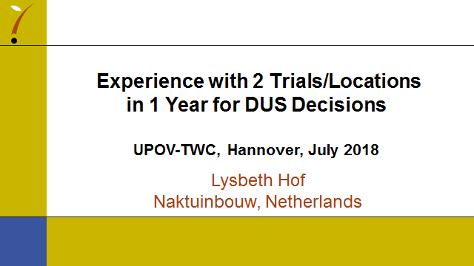

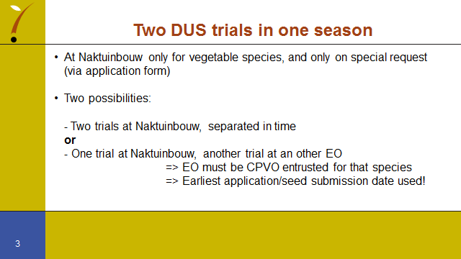

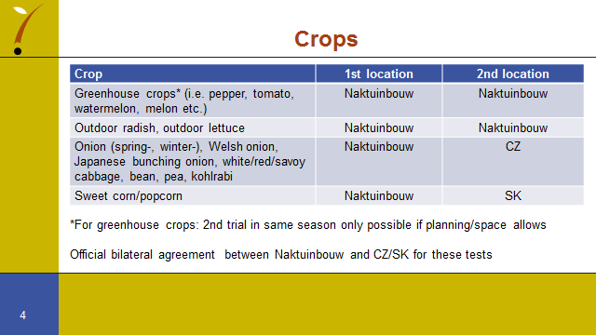

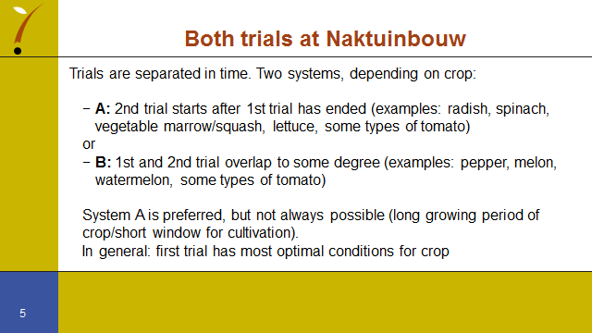

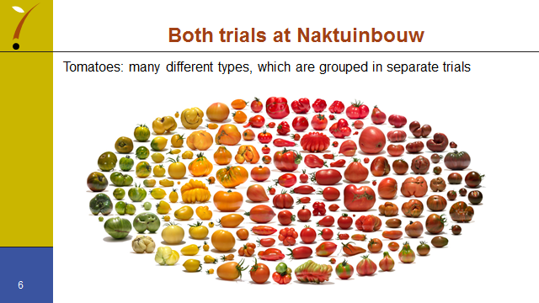

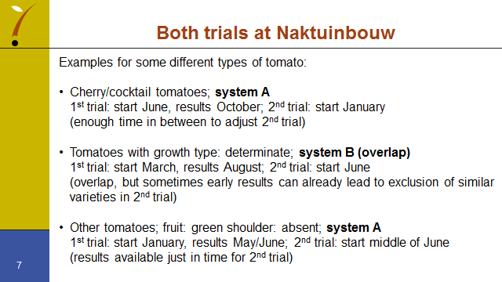

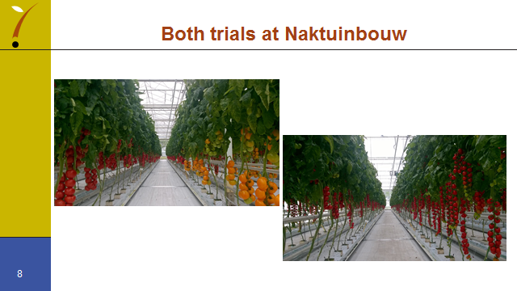

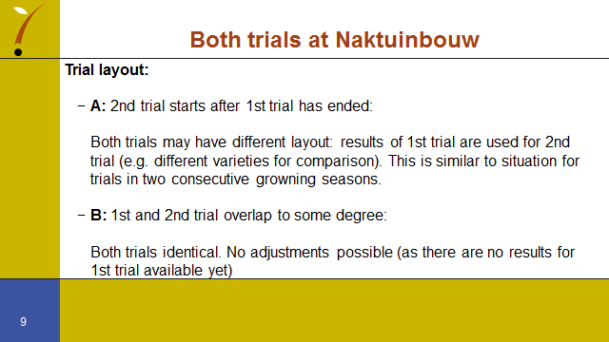

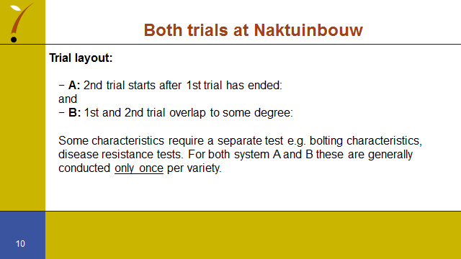

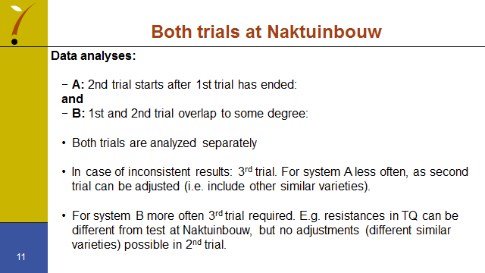

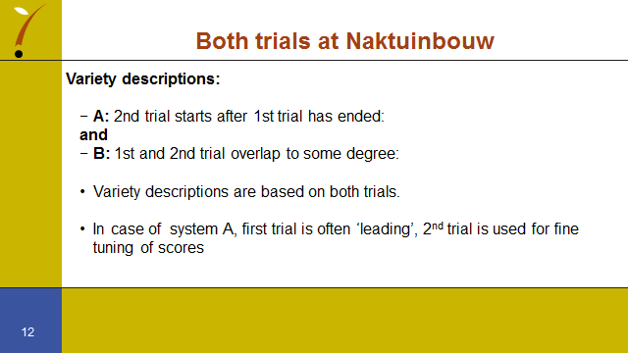

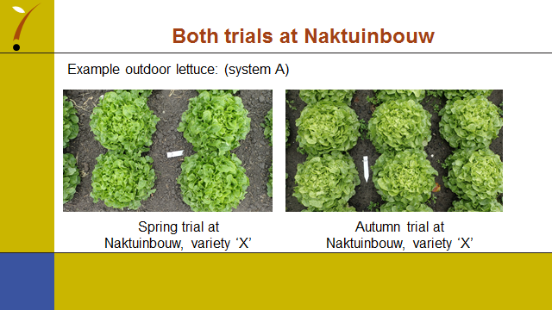

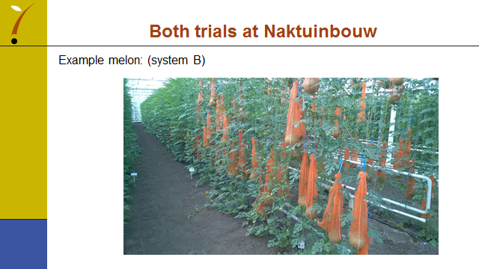

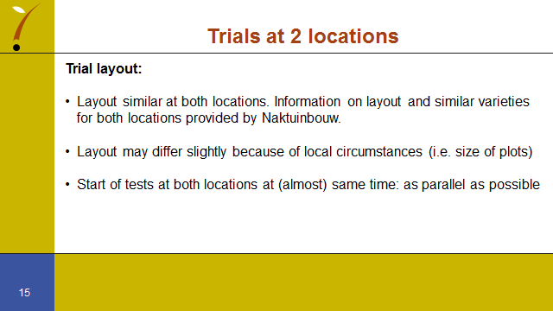

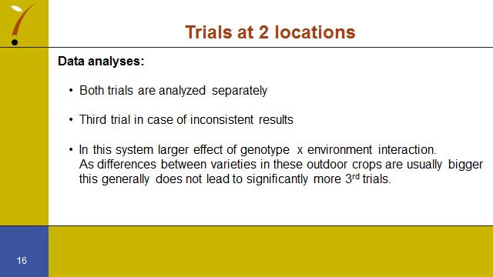

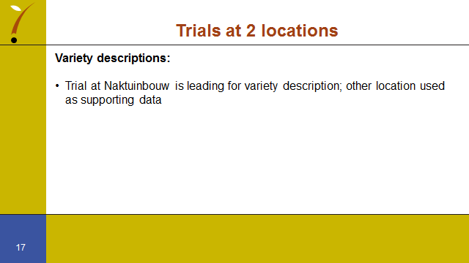

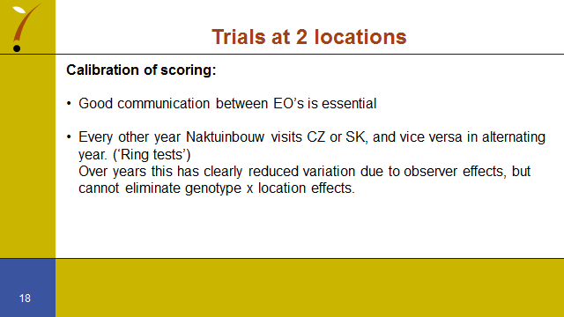

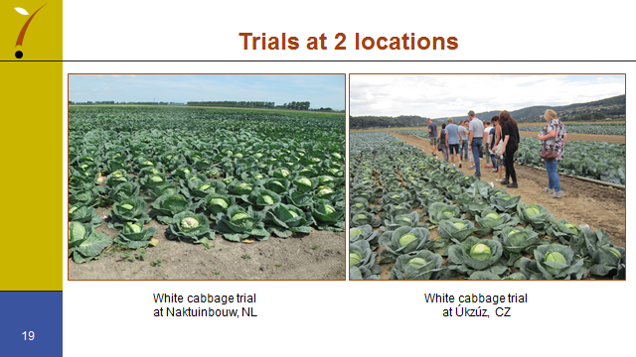

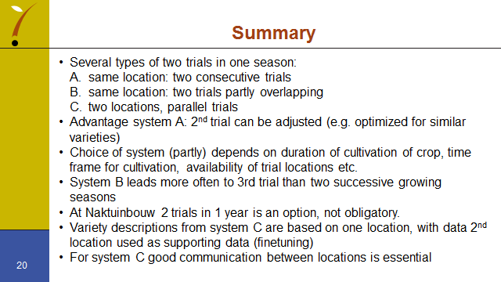

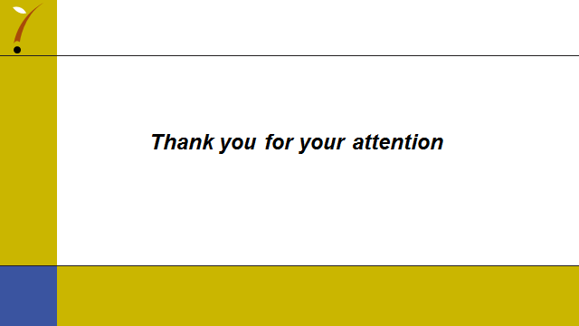

[End of annex and of document]

