E
International Union for the Protection of New Varieties of Plants

Technical Working Party on Automation and Computer Programs  Thirty-Fifth Session  Buenos Aires, Argentina, November 14 to 17, 2017 | TWC/35/5  Original: English  Date: October 23, 2017
Characteristics, Genotype by Environment Interaction (GEI) and DUS trials
Document prepared by experts from Italy and Finland
Disclaimer: this document does not represent UPOV policies or guidance

Genotype by environment interaction takes place when different genotypes respond in a different way to different environments and it produces a phenotype variation (e.g. year and location). Many studies have shown that plant species may produce a broad range of phenotypes in response to the variation of the environment. See Figure 1. The ability of a single genotype to produce multiple phenotypes in response to the environment is called «phenotypic plasticity». When instead a genotype tends to maintain constant characteristics through environments its ability is called «phenotypic stability». The characteristics that are most influenced by the environment are QN and PQ.

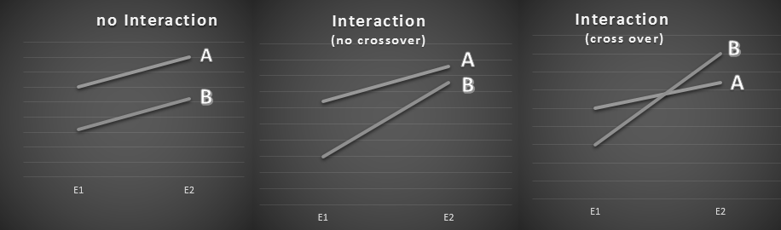
Figure 1 Graphic view of main GEI cases (Environments E1 and E2)

Observations and trials data are based on phenotypes and may change over years because of GEI. To limit the environmental influence and, consequently, the number of the possible phenotypes, the use of one permanent location for DUS trials as «reference location» is recommended.

Example varieties and Delineating reference varieties

Example varieties and Delineating reference varieties are state references that are used as comparisons of varietal descriptions. Their use must be appropriate and carefully evaluated because changes of rank over years are possible when characteristics are influenced by the environment. Example varieties and Delineating reference varieties should be as stable as possible. An estimator of varietal stability over years for QN characteristics is the coefficient of variation (CV). It is defined as the ratio of the standard deviation to the mean and it can also be expressed as a percentage:
𝑪𝑽=(𝑺𝑫/ 𝑴𝒆𝒂𝒏) ∗ 𝟏𝟎𝟎

Use of regional sets of Example varieties

Databases can be increased by adding new data from candidate and reference varieties. Databases should include data of varieties grown and/or tested in a reference location where DUS test takes place. The use of regional sets of Example varieties is preferable because it enables to compare characteristics of all varieties included in a database, as well as to test how stable a variety is in a specific region.

Where large regions are present in the same country because of very different agro-climatic conditions, more than one reference location is conceivable. In this case we could have more than one description for a single variety due to different phenotypes. Only one description should be the official one.

If more than one location is used for DUS trials and more than one description is produced, criteria to choose the official one are needed. Possible criteria for choosing the ‘official Location/description’ are:
- Location in the area with the largest adaptation/cultivation of the species (choice based on the most common phenotype in that area)
- Location where CV range of varieties is the lowest (choice based on stability over years)

Stable averages vs Combining notes

Reference and candidate varieties produce different values over years. The frequency and level of interaction (GEI) of a given variety is unpredictable because they depend on its genetics and on the relative effect of the environment on the set of tested varieties. For each characteristic a stable average of historical means is reached only after several years. Average over years can be considered a good estimation of characteristic measure (even though the ‘median’ could be more logical where historical averages have strong skewed distribution). This method is largely used to transform observations into notes.

Immediate transformation of each year mean into a note and then combining notes of trial years is possible as well. In this case, a loss of information may be possible, because a note can summarize many averages.

Maurizio Giolo (Italy) and Sami Markkanen (Finland)

[End of document]

