E
International Union for the Protection of New Varieties of Plants

Technical Working Party on Automation and Computer Programs  Thirty-Fifth Session  Buenos Aires, Argentina, November 14 to 17, 2017 | TWC/35/4 Add.  Original: English  Date: November 17, 2017
ADDENDUM TO
Information retrieval from UPOV databases using national systems
prepared by the Office of the Union
Disclaimer: this document does not represent UPOV policies or guidance
The Annex to this document contains a copy of a presentation on “Information retrieval from UPOV databases using national systems”, made by the Office of the Union at the thirty-fifth session of the Technical Working Party on Automation and Computer Programs (TWC).

[Annex follows]

TWC/35/4 Add.

ANNEX

INFORMATION RETRIEVAL FROM UPOV DATABASES USING NATIONAL SYSTEMS

Presentation by Ms. Hend Madhour, UPOV

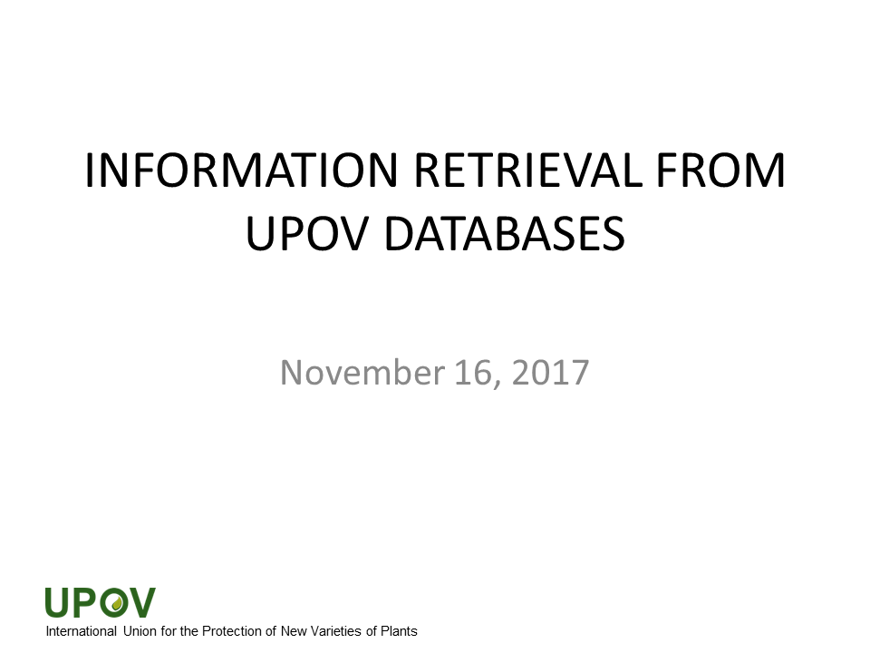

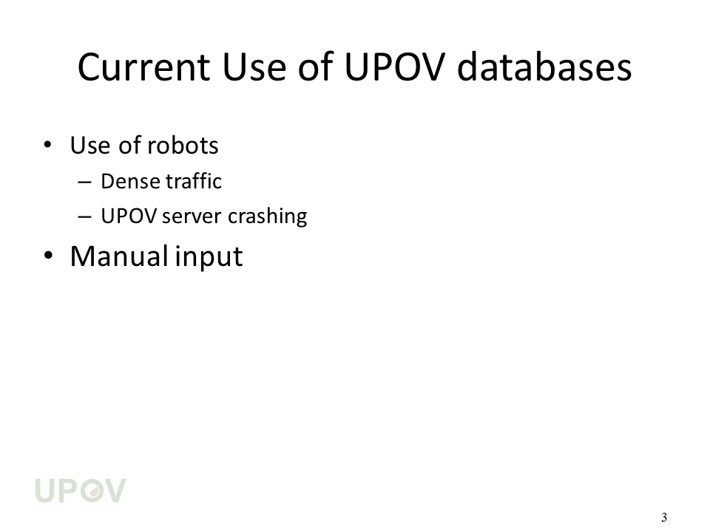

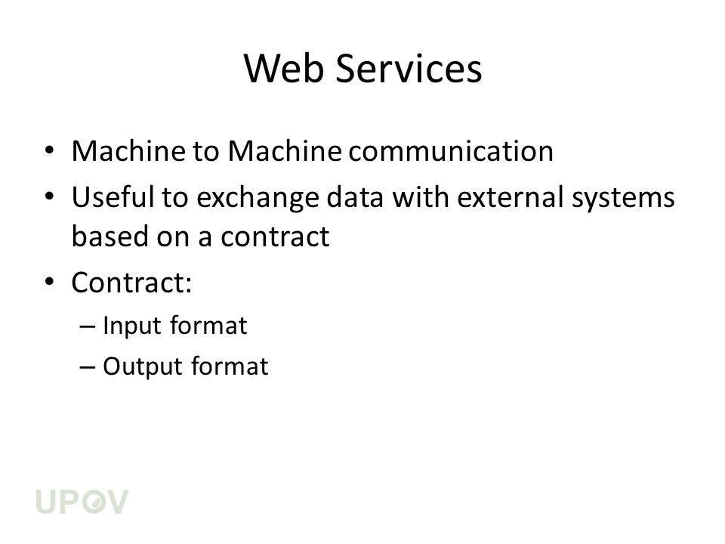

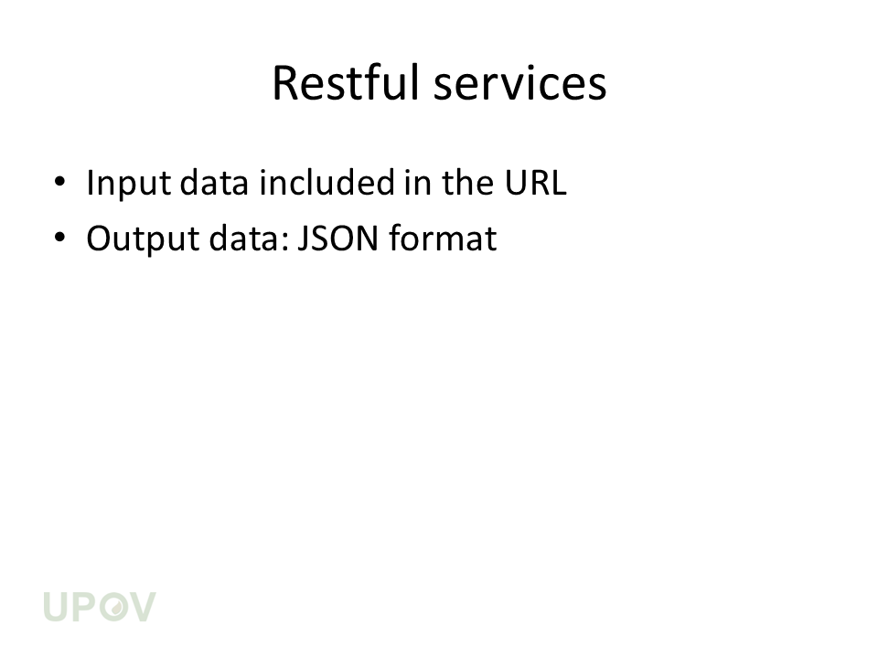

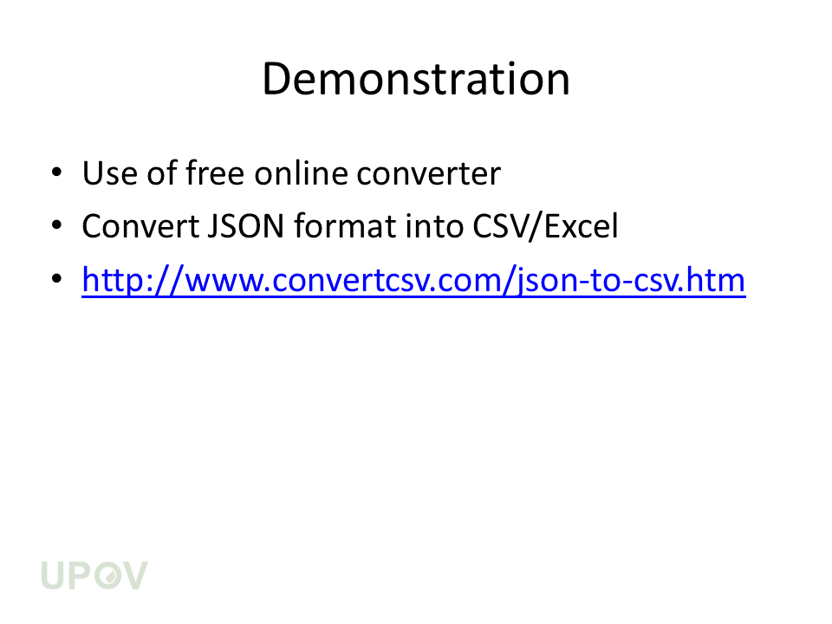

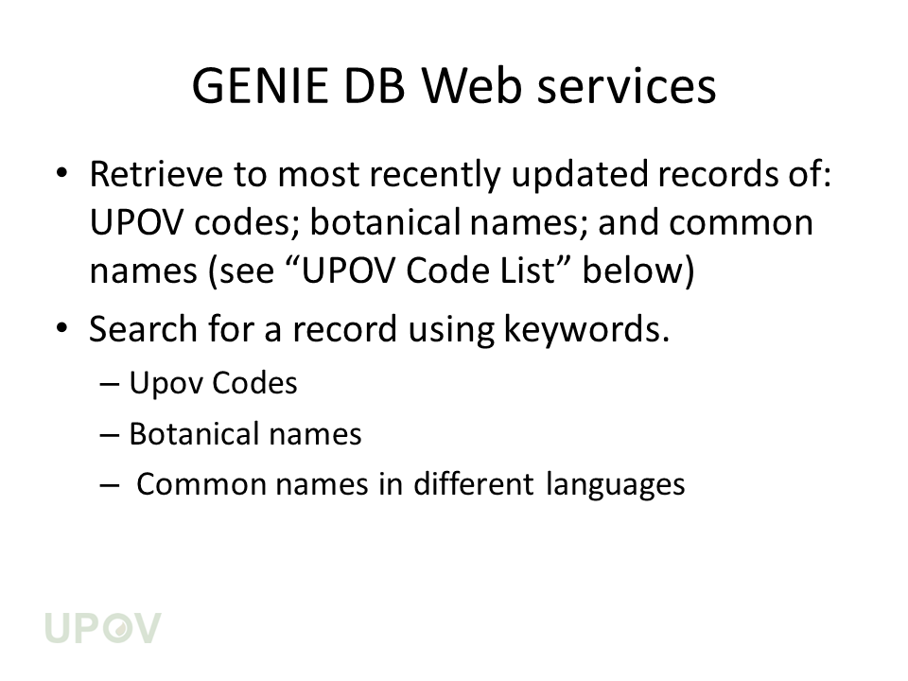

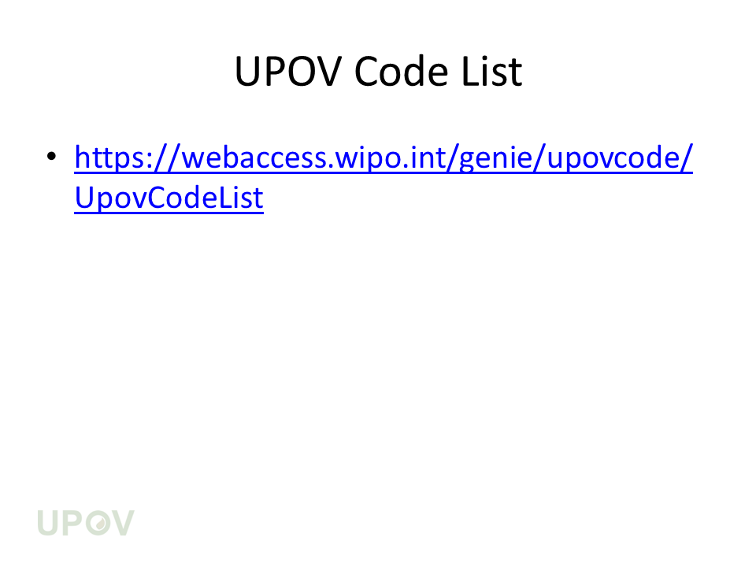

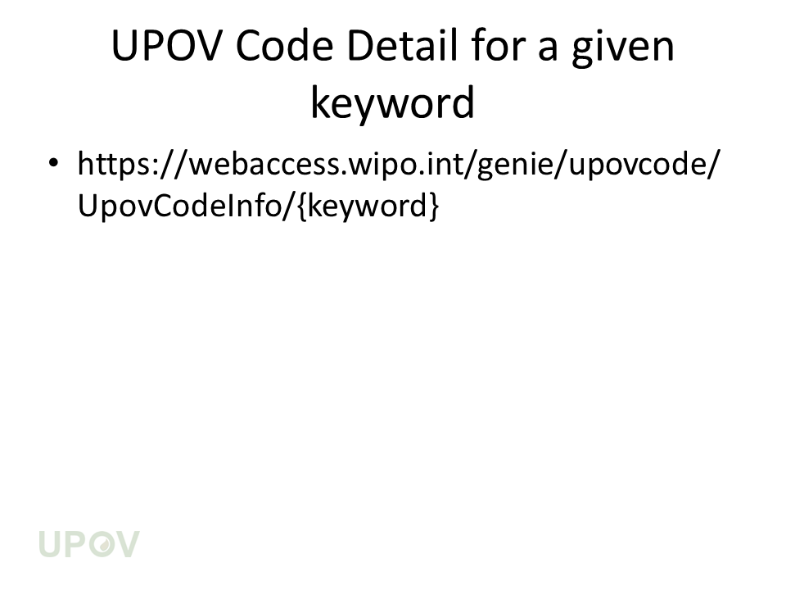

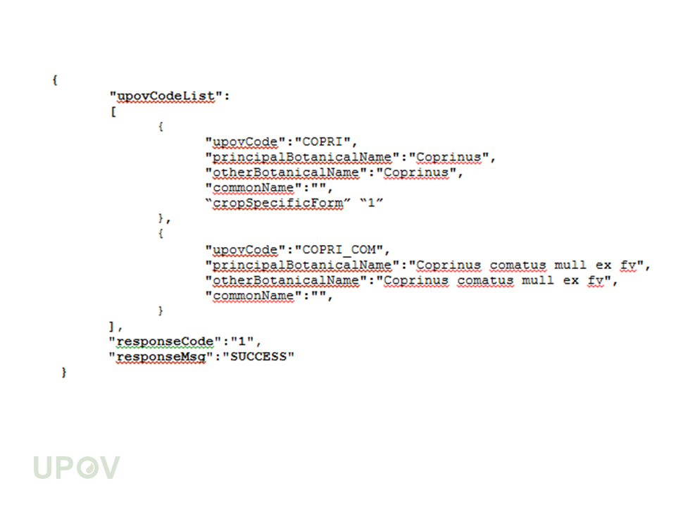

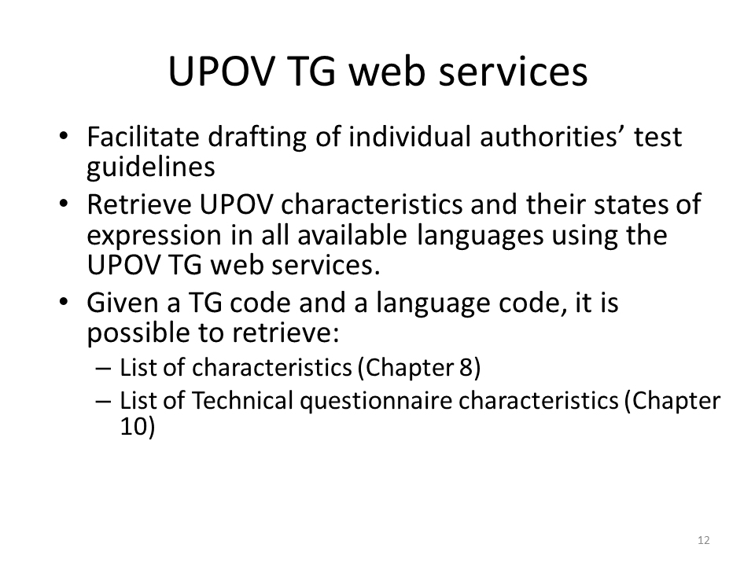

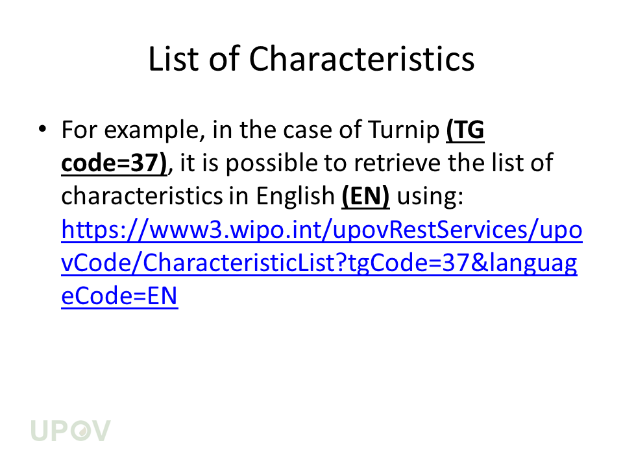

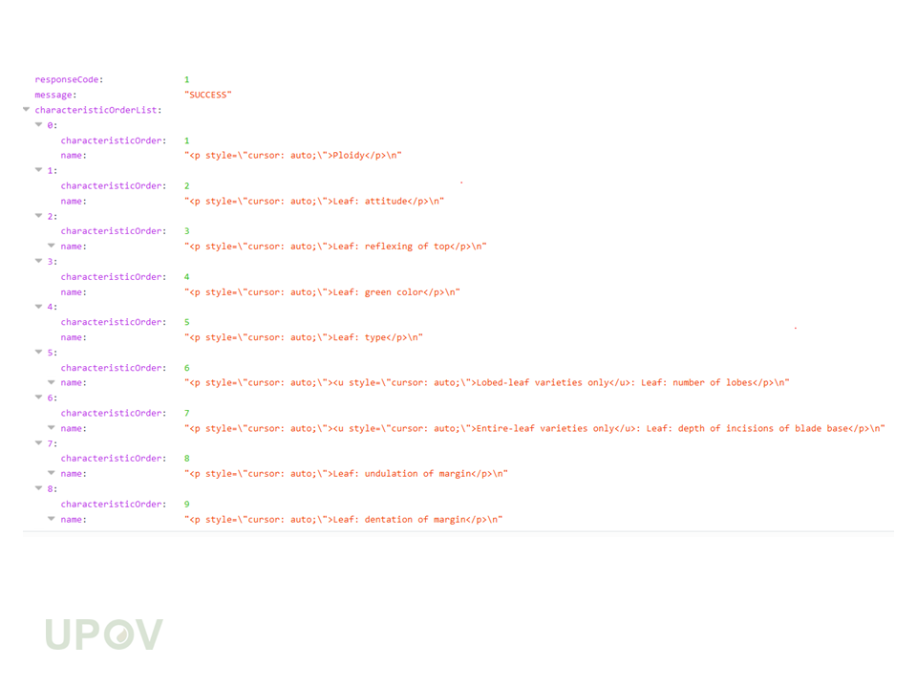

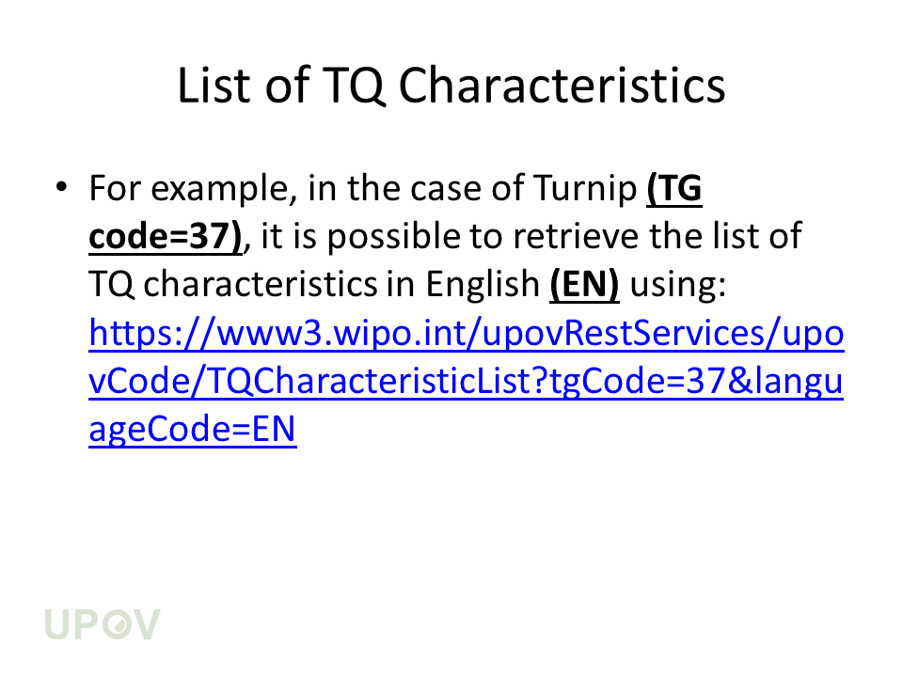

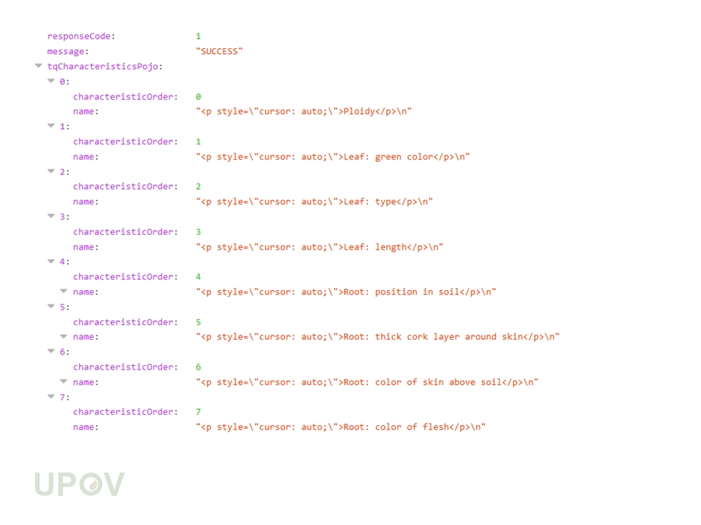

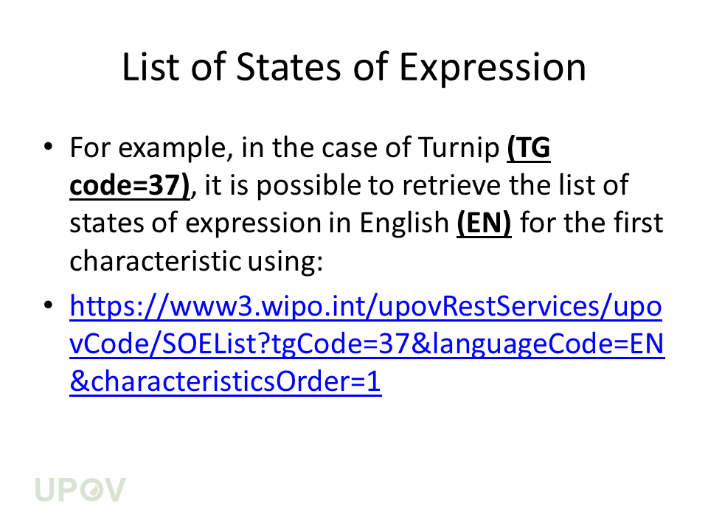

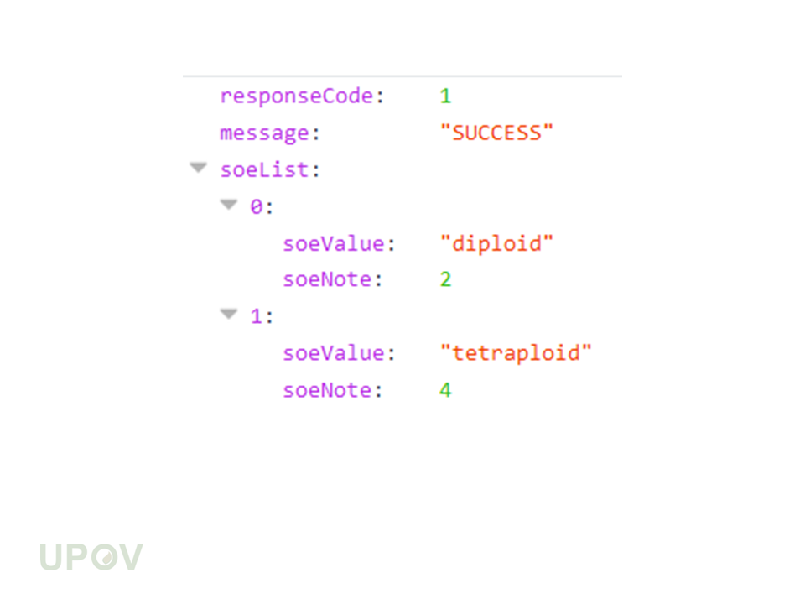

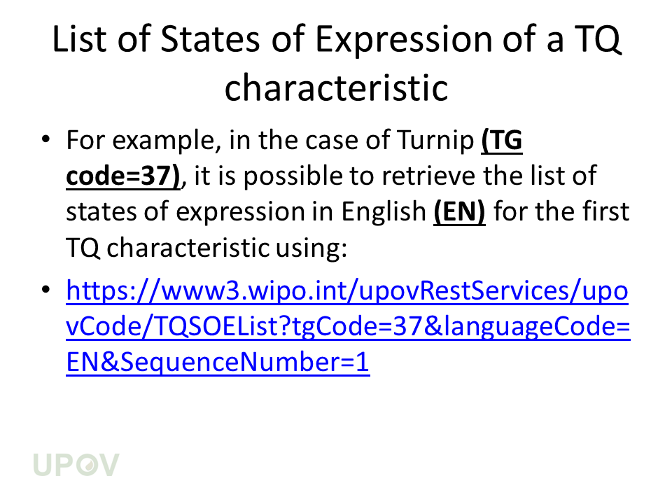

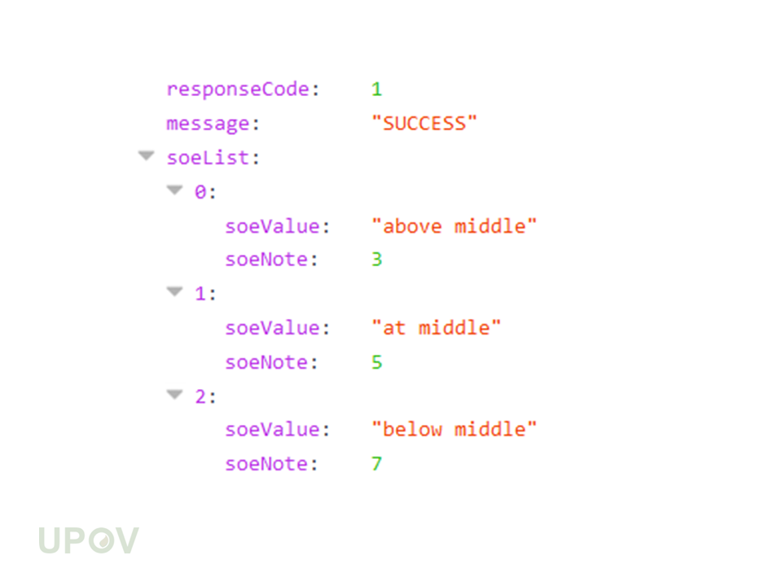

[End of Annex and of document]

