E
International Union for the Protection of New Varieties of Plants

Technical Working Party on Automation and Computer Programs  Thirty-Fifth Session  Buenos Aires, Argentina, November 14 to 17, 2017 | TWC/35/17  Original: English  Date: November 8, 2017
a single tool for dus computation process
Document prepared by an expert from France
Disclaimer: this document does not represent UPOV policies or guidance
The Annex to this document contains a copy of a presentation on “A single tool for DUS computation process”, prepared by an expert from France, to be made at the thirty-fifth session of the Technical Working Party on Automation and Computer Programs (TWC).

[Annex follows]

A SINGLE TOOL FOR DUS COMPUTATION PROCESS

Presentation prepared by an expert from France

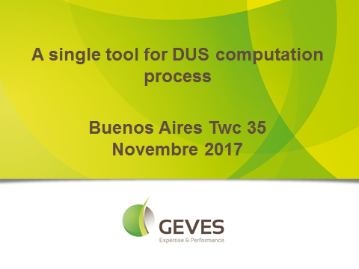

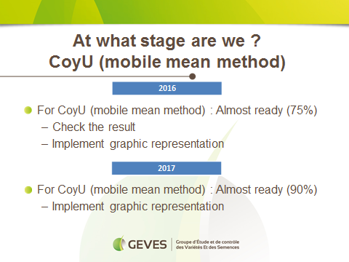

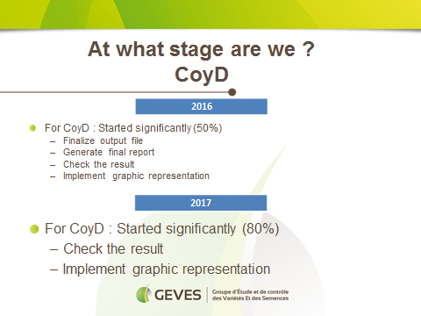

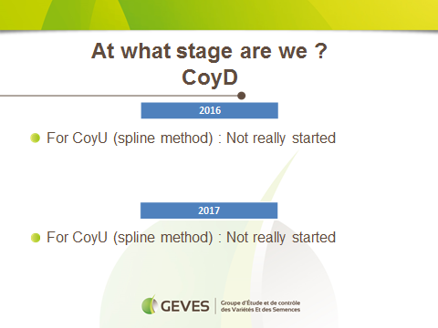

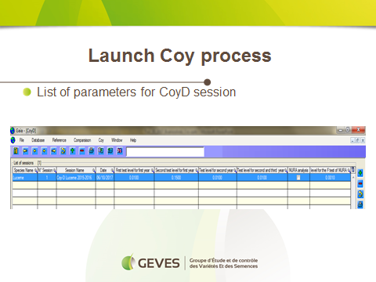

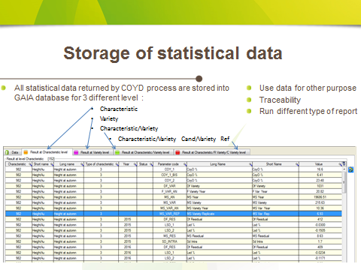

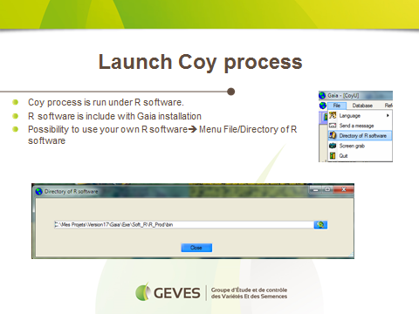

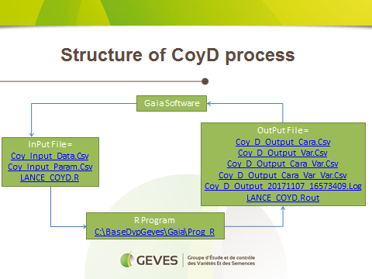

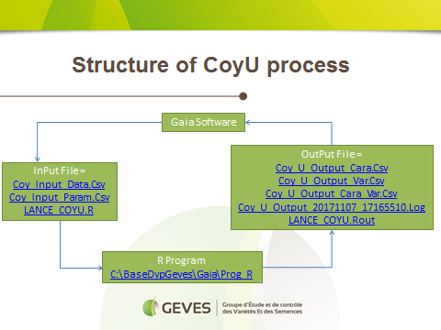

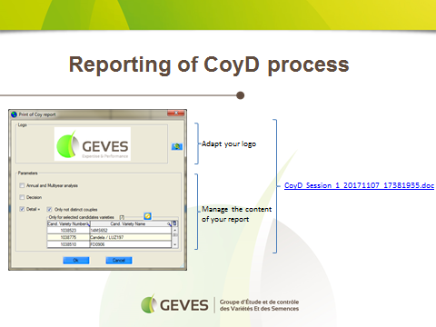

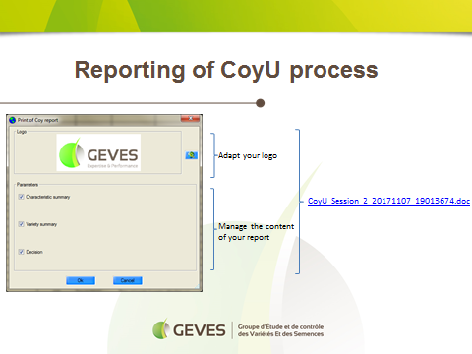

[End of Annex and of document]

